This homework consists of two parts, namely, design and coding convention.

- Design. The template for design is given (see the following pages).
  - You can find explanations regarding each section in the template
  - The UML tool is required to use. Rational Rose/Architect is available at the public lab.
- Coding Convention. You can choose to compose your own coding convention or use existing coding convention (e.g., Sun has coding convention for Java). No matter which way you go, please submit your coding convention document together with the design document.
  - Coding convention is not merely a document. You should stick to it. At the end of this semester, there will be a student peer code-review session. Keep in mind that all the assignments in this semester are competition-based. The teams will be ranked according their performance. The best team will receive the best grade.
  - The student peer code-review questions are given. Hence, when you start to write code, you know what will be evaluated.

Software Design Specification
Version 1.0

Revisions
Version | Primary Author(s) | Description of Version | Date Completed
1.0 | Eliss Glasper | Completion of version 1 | 4/21/2021
1.1 | Eliss Glasper | Added wxPython for our ui | 5/2/2021
Contents
1 Introduction 1
1.1 System Overview 1
1.2 Supporting Materials 1
1.3 Definitions and Acronyms 1
2 Design Considerations 2
2.1 Assumptions 2
2.2 Constraints 2
2.3 Goals and Guidelines 2
3 Architecture 3
3.1 Overview 3
3.2 Strategies 3
3.2.1 Technical Environment 3
3.2.2 Maintainability 3
3.2.3 Performance 3
3.3 Software Specification 3
3.4 Hardware Specification 3
4 System Level Design 5
4.1 Hierarchy Chart Of Components 5
4.2 Sequence Diagrams And Descriptions 5
5 Object Level Design 6
5.1 Component C1 6
5.1.1 Class D1 Of Component C1 6
5.2 Component C2 6
6 User Interface Design 7
6.1 User Interface Design Overview 7
6.2 User Interface Navigation Hierarchy 7
7 Requirements Traceability Matrix 8
8 Appendices 9

Introduction
<Provide an overview of the entire document, including the purpose, the scope and the intended audience of the document. Identify the product using any applicable names and/or version numbers.>

System Overview

<Provide a general description of the software product including its functionality and matters related to the overall system and its design.>
- This Software product is a map navigation program. It would allow a user to get from one building at UCO to another.

Supporting Materials
<Provide references for any other pertinent documents such as related and/or companion documents, prerequisite documents and documents which provide background and/or context for this document.>
wxpython
https://docs.wxpython.org/index.html
gmplot
https://github.com/gmplot/gmplot/wiki/GoogleMapPlotter.marker
cefpython
https://pypi.org/project/cefpython3/#:~:text=CEF%20Python%20is%20an%20open,%2C%20PyGame%2FPyOpenGL%20and%20PyWin32.

Definitions and Acronyms
<Define any important terms, acronyms, or abbreviations.>
Term | Description

Design Considerations

Constraints
<Describe any global limitations or constraints that have a significant impact on the design of the system's software. Such constraints may be imposed by any of the following (the list is not exhaustive): hardware or software environment, end-user environment, availability or volatility of resources, standards compliance, interoperability requirements, interface/protocol requirements, data repository and distribution requirements, security requirements (or other such regulations), memory and other capacity limitations, performance requirements, network communications, and other requirements described in the requirements specification.>

- Must have autofill function
- Must have wheelchair accessibility routes
- Project due 04/30/2021
- Must have a computer
- Wont work on mobile devices
- Program should load no longer than 10 secs
- Should not need more than 5gb of Storage
- Should not need more than 8gb of ram
- API requests shouldn’t take longer than 10 secs

Goals and Guidelines
<Describe any goals, guidelines, principles, or priorities which dominate or embody the design of the system's software. Such goals might be: the KISS principle ("Keep it simple stupid!"), emphasis on speed versus memory use, or working, looking, or "feeling" like an existing product. For each such goal or guideline, unless it is implicitly obvious, describe the reason for its desirability.>

- KISS (keep it simple stupid)
- It should look very simple and clean

Architecture

Overview
< Determine what parts of the application software will be assigned to what hardware. Describe any design decisions and/or strategies that affect the overall organization of the system and its higher-level structures. These strategies should provide insight into the key abstractions and mechanisms used in the system architecture. Describe the reasoning em-ployed for each decision and/or strategy (possibly referring to previously stated design goals and principles) and how any design goals or priorities were balanced or traded-off.>

When designing our system, we chose to go with the layered decomposition architectural style. The higher-level structures involved are the user interface, system management, building search. Layered would make the most since because the UI would talk to both the system management and building search subsystems. In using the layered style, it would allow us to stay on brand with our KISS goal.

Strategies

Architectural Style
<Specify which architectural style you will choose, e.g., layered, Client/Server, Peer-2-Peer>
- Layered

Performance
<The time within which the system must perform its functions; the total and peak number of users and volume of data expected; the extent to which the system will be available to the users and the permissible failure rate due to errors>
- Functions should not take longer than 10 seconds
- 500 request per second (1 request per IP address)
- Very low volume of data
  - Longitude
  - Latitude
  - Building names

Software Specification
<Determine software needs, such as OS, development IDE, JDK version, other SDK version, etc. >
- Windows 10
- MacOS Big Sur
- Python3
- Visual studio code
- Gmplot module
- wxPython

Hardware Specification
<
- Clients
  - Input/output devices employed by users
  - PCs, laptops, handheld devices, cell phones
- Servers
  - Larger computers storing software
  - Accessible by many users
- Network
  - Connects clients and servers>
- Clients
  - PCs, laptops

System Level Design
<Provide a high-level overview of how the functionality and responsibilities of the system were partitioned and then assigned to subsystems or components. Don't go into too much detail about the individual components themselves (there is a subsequent section for detailed component descriptions). The main purpose here is to gain a general understanding of how and why the system was decomposed, and how the individual parts work together to provide the desired functionality.>

Hierarchy Chart Of Components
<Describe the major responsibilities that the software must undertake and the various roles that the system (or portions of the system) must play. Describe how the system was broken down into its components/subsystems (identifying each top-level component/subsystem and the roles/responsibilities assigned to it). Describe how the higher-level components collaborate with each other in order to achieve the required results. Don't forget to provide some sort of rationale for choosing this particular decomposition of the system (perhaps discussing other proposed decompositions and why they were rejected).
Hint: You can use UML package symbol to represent a subysystem>
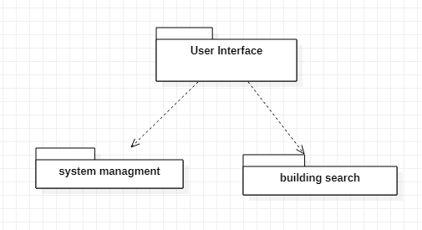
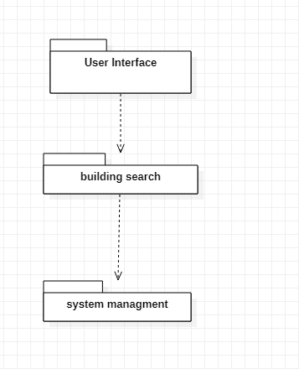
The user interface will interact with the building search subsystem. This would allow the UI to have access to the maps and routes generated by the building search subsystem. Then the building search subsystem will have access to system management subsystem which will aid in getting all buildings in the system.

Sequence Diagrams And Descriptions
<Describe the interaction behavior between subsystems. The typical sequence diagram will depict some or all of the behavior described in a use case. Therefore, sequence diagrams serve as an intermediary between use cases and subsystems. As a result, subsystems can be traced back to the requirements. >
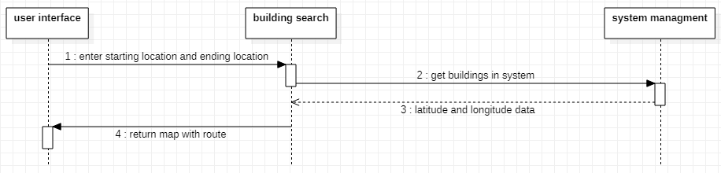

Object Level Design
<Provide more detailed discussion in a subsection/component of the component hierarchy section 4.1. If necessary, describe how the component was further divided into subcomponents, and the relationships and interactions between the subcomponents (similar to what was done for top-level components in Section 4.1).
Use at least two design patterns. Please specify which design patterns you have used.>
MVC/builder

Subsystem User interface
<Provide and describe a class hierarchy diagram that depicts the set of classes for Subsystem xxx>
The user interface is what will display our window and maps to the user and will handle all interactions from the user.

Class display map
< Provide more detailed description of any relevant characteristics of Class xx, including attributes, operations, dynamic characteristics.>
this would display the map generated from our building search class

Subsystem Building search
Building search will handle everything involving the map and route generation.

Class Map
This class will use information from building management to generate a map with a route on it

Subsystem system management
This will handle all the system management

Class Building management
This class will oversee removing, adding, and editing of buildings in the system.

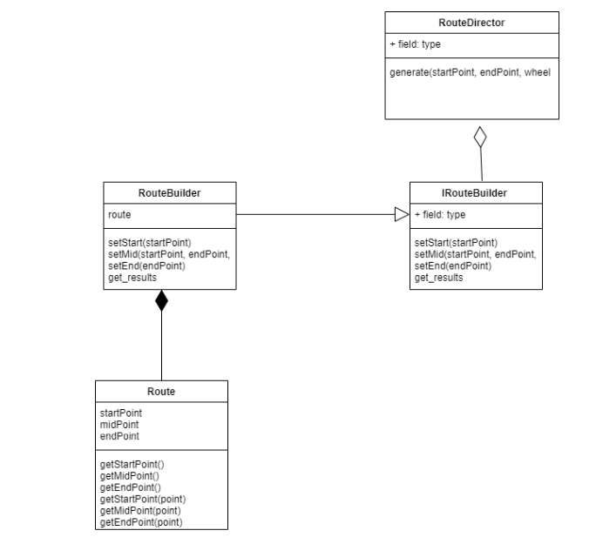

User Interface Design

User Interface Design Overview
<Provide a high-level description of the user interface for this software application. Describe any systems requirements (e.g., performance or usability) associated with all of the user interfaces. >
The user interface of this program will involve a simple window with a text box for input a button for submission and a map generated from the input.

User Interface Navigation Hierarchy
<Provide and describe a diagram of the navigation hierarchy that illustrates how a user moves through the user interface.
Hint: refer to L11: Dynamic modeling Page 46-47>
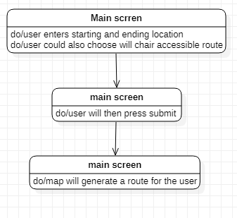

Appendices
<Optional: if you have any appendices. You can also enclose the updated requirement document >

