Step 1: Define the corpus
Suppose we have 3 documents:
- Doc1: "I love machine learning"
- Doc2: "Machine learning is fun"
- Doc3: "I love coding in Python"

Step 2: Preprocess the text
- Convert to lowercase
- Remove punctuation (if any)
- Tokenize (split into words)
After preprocessing:
- Doc1: ['i', 'love', 'machine', 'learning']
- Doc2: ['machine', 'learning', 'is', 'fun']
- Doc3: ['i', 'love', 'coding', 'in', 'python']

Step 3: Calculate Term Frequency (TF)
TF formula:
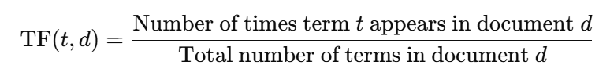
Compute TF for each word in each document.
Doc1: (4 words)
- 'i': 1/4 = 0.25
- 'love': 1/4 = 0.25
- 'machine': 1/4 = 0.25
- 'learning': 1/4 = 0.25
Doc2: (4 words)
- 'machine': 1/4 = 0.25
- 'learning': 1/4 = 0.25
- 'is': 1/4 = 0.25
- 'fun': 1/4 = 0.25
Doc3: (5 words)
- 'i': 1/5 = 0.2
- 'love': 1/5 = 0.2
- 'coding': 1/5 = 0.2
- 'in': 1/5 = 0.2
- 'python': 1/5 = 0.2

Step 4: Calculate Inverse Document Frequency (IDF)
IDF formula (logarithm base 10 or e):
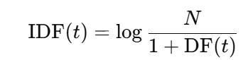
Where:
- N = total number of documents = 3
- DF(t) = number of documents containing term t
Compute DF for each unique word:
Term | DF
I | 2
Love | 2
machine | 2
learning | 2
Is | 1
Fun | 1
Coding | 1
In | 1
python | 1
Compute IDF:
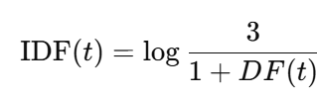
- 'i': log(3 / (1+2)) = log(3/3) = log(1) = 0
- 'love': same = 0
- 'machine': 0
- 'learning': 0
- 'is': log(3 / (1+1)) = log(3/2) ≈ 0.405
- 'fun': ≈ 0.405
- 'coding': ≈ 0.405
- 'in': ≈ 0.405
- 'python': ≈ 0.405
(Using natural logarithm here, could also use log base 10. The concept is the same.)

Step 5: Calculate TF-IDF
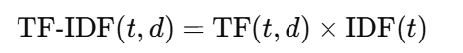
Doc1:
- 'i': 0.25 × 0 = 0
- 'love': 0.25 × 0 = 0
- 'machine': 0.25 × 0 = 0
- 'learning': 0.25 × 0 = 0
Doc2:
- 'machine': 0.25 × 0 = 0
- 'learning': 0.25 × 0 = 0
- 'is': 0.25 × 0.405 ≈ 0.101
- 'fun': 0.25 × 0.405 ≈ 0.101
Doc3:
- 'i': 0.2 × 0 = 0
- 'love': 0.2 × 0 = 0
- 'coding': 0.2 × 0.405 ≈ 0.081
- 'in': 0.2 × 0.405 ≈ 0.081
- 'python': 0.2 × 0.405 ≈ 0.081

Step 6: Interpretation
- Words like 'i', 'love', 'machine', 'learning' appear in multiple documents → low TF-IDF (less informative).
- Rare words like 'python', 'coding', 'fun', 'is' → higher TF-IDF → more significant for that document.

