**Mobile Application Development**

**Axion FBLA**



**Forest Park High School**

Mohamed Musa

Ghedion Beyen

Ryan De Lopez

**Application Overview**

The Axion FBLA mobile application allows local chapters to manage their chapters by providing a central hub for students to view information about FBLA and sign up for the organization and its various events.



**Main features of the application include ability to:**

* Sign up for FBLA
* View information about FBLA
* View a calendar with the dates of upcoming events
* View the Competitive and Current Events
* Sign up for a current event
* View the local officer team
* Track chapter meeting attendance
* Visit website and social media pages of FBLA

**Operating Manual**

**User Operations**

# **Launch the application**

Tap on the  application icon on your iOS device. The app will launch and the splash screen will be displayed.



# 

# 

# After a brief delay, the Greeting Screen will be displayed.

# **Greeting Screen Navigation**

A user can slide left and right to view the two screens of the Greeting Screen. The slider near the bottom of the screen allows for a visualization of which screen the user is currently on. The second screen displays information about FBLA.

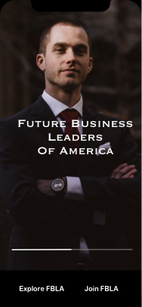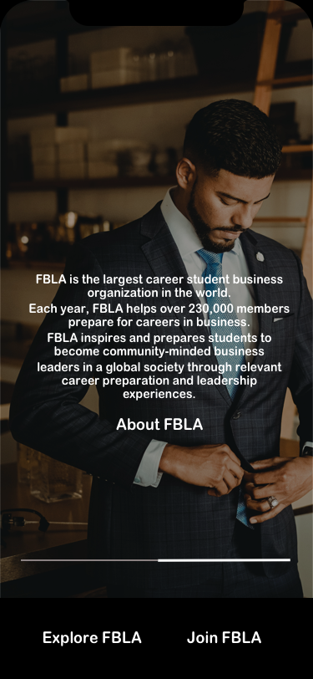

# 

# 

# **Greeting Screen Navigation**

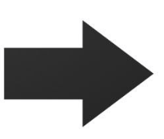

# Clicking on the “Join FBLA” button will redirect the user to a Google Form, in which the user can sign up for their local chapter for FBLA.

# **Greeting Screen Navigation**

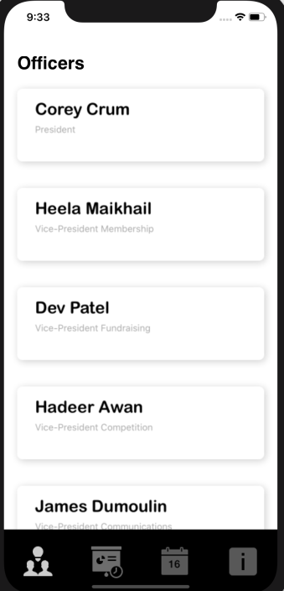

Clicking on the “Explore FBLA” button will redirect the user to the main part of the application, where they will first be greeted with the Local Officers tab.

# **Local Officers Tab**



Users can scroll through and view the Local Officers of their local chapter. This tab can be accessed by tapping on the respective button (in red) from any other parts of the application.

# **Events Tab**



Users can view the FBLA Competitive and Current Events. Pressing the button labeled in orange will direct the user to a Google Form, where they can sign up for an event. This tab can be accessed by tapping on the respective button (in red) from any other parts of the application.

# **Calendar Tab**

Users can view a calendar with the current date highlighted in orange. Users can view the attendance for the day and remove attendees by swiping left on a name and pressing “Delete”. Users can also add attendees by holding down on one of the days on the calendar, entering a name, and tapping “Add”. The name will then pop up in the “Check-In” list. This tab can be accessed by tapping on the respective button (in red) from any other parts of the application.

**Information Tab**



# Users can view information about FBLA and the application. Clicking the button in orange will direct the user back to the Greeting Screen. This tab can be accessed by tapping on the respective button (in red) from any other parts of the application.

# **Information Tab**

Users can view the Terms and Licensing of the application by clicking the button labeled “Terms/Licensing” shown in red.

# **Information Tab**



Users can view ways to contact FBLA by clicking the button labeled “Contact Us” shown in red. This will redirect the user to the FBLA Contact Us website in their browser.

# **Information Tab**



Users can view frequently answered questions on the FBLA website by pressing the button labeled “Q/A” shown in red. This will open up a new tab in the user’s browser.

# **Information Tab**



Users can report bugs by clicking the button labeled “Report a Problem” shown in red. This will open up a Google Form in which users can describe the error they experienced.

**Information Tab**



Users can view the FBLA Twitter page by clicking the Twitter Logo shown in red.

# **Information Tab**



Users can view the FBLA Instagram page by clicking the Instagram Logo shown in red.

# **Information Tab**



Users can view the FBLA Facebook page by clicking the Facebook Logo shown in red.