MovieByMonsters

Revision History

|  |  |  |  |
| --- | --- | --- | --- |
| Version No. | Date | Prepared by / Modified by | Significant Changes |
| 1. |  | Dharshan S |  |
|  |  |  |  |

Glossary

|  |  |
| --- | --- |
| Abbreviation | Description |
|  |  |
|  |  |
|  |  |
|  |  |
|  |  |
|  |  |
|  |  |

Table of contents

Chapter 1: Introduction

* 1. Goal---------------------------------------------------------------------------------------------------------------4
  2. Objective-------------------------------------------------------------------------------------------------------- 4

Chapter 2: Requirement Collection

2.1 Data Requirements------------------------------------------------------------------------------------------- 5

2.2 System Requirements---------------------------------------------------------------------------------------- 5

Chapter 3: Analysis and Design

3.1 Use Case Diagram---------------------------------------------------------------------------------------------6

3.2 Sequence Diagram--------------------------------------------------------------------------------------------7

3.2.1 Sequence Diagram for MovieByMonsters--------------------------------------------------7

3.2.2 Sequence Diagram for Admin------------------------------------------------------------------8

3.2.3 Sequence Diagram for User--------------------------------------------------------------------9

3.4 Class Diagram--------------------------------------------------------------------------------------------------10

3.6 System Architecture-------------------------------------------------------------------------------------------13

Appendix-------------------------------------------------------------------------------------------------------------15

Conclusion ---------------------------------------------------------------------------------------------------------------------18

***CHAPTER-1***

***INTRODUCTION***

This project is aimed at providing the customers' facility to gather information about the movies online anytime, anywhere. The user can easily be able to know about the movies released and then make a choice.

You need to register a new user whenever you first visit our site. In the future, it will be stored in our database permanently, and you can see movie info at any time you want with this username and password.

Project to insert and delete data such as movie descriptions and movie ratings, which will update the related webpage (webpages are dynamic pages that change according to the data in the database) and the admin can check the statistics information from the system.

## ***GOAL***

The goal of the project is to put in place new solutions as per the end user expectations so that the accuracy, speedup, and digitalization of the system will be enhanced. To do this:

* Provide anytime anyplace service for the customer.
* To promote movies, the movies on the web.
* Try to increase profit as much as possible

## ***OBJECTIVE***

The main objective of MovieByMonsters is to develop an enhanced, automated, accurate, user-friendly, and less time-consuming web application.

***CHAPTER-2***

***Requirement Collection***

***2.1 Data Requirements***

The Data Requirements are given as follows: -

* USER MODULE
* ADMIN CONTROL
* MOVIE MODULE

### ***2.2 System Requirement***

Functional Requirement covers the functionality of the product in detail.

* The details of the movies will be generated via a query according to the data selected by the user.
* A way in which users (both customers and admins) can login to the system to perform different operations.
* A method for the customer to commit an order using the "Point and Click" method.

***CHAPTER -3***

***ANALYSIS AND DESIGN***

***3.1 Use case diagram***

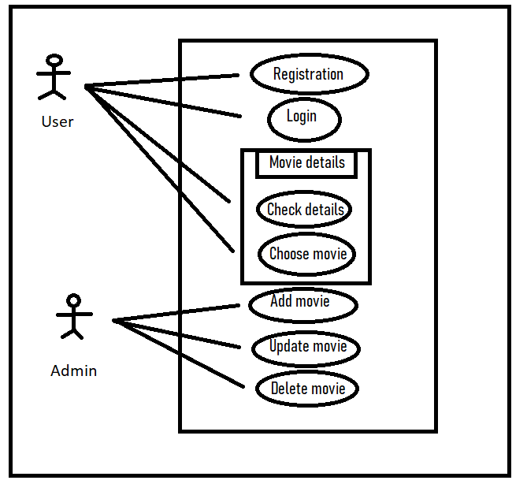

***Figure 3.1: Use-case Diagram of <MovieByMonsters>***

## ***3.3 Sequence Diagrams***

**3.3.1 Sequence Diagram for MovieByMonsters**

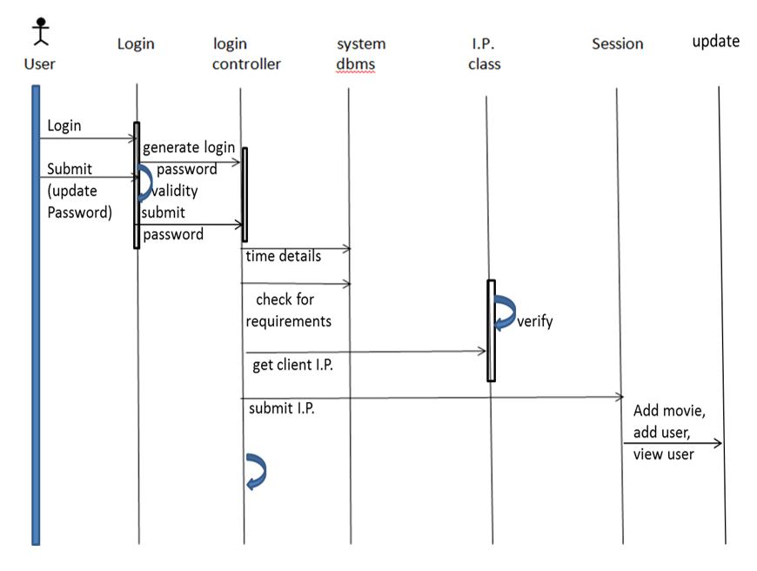

**3.3.2 Sequence diagram for admin**

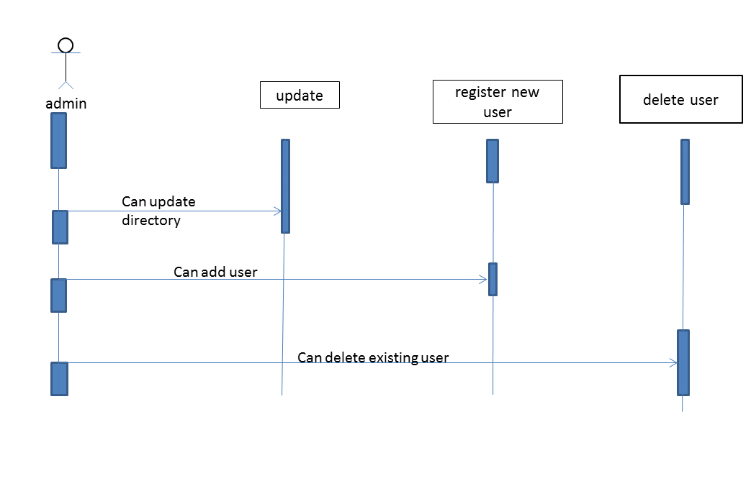

***3.3.3* Sequence diagram for user**

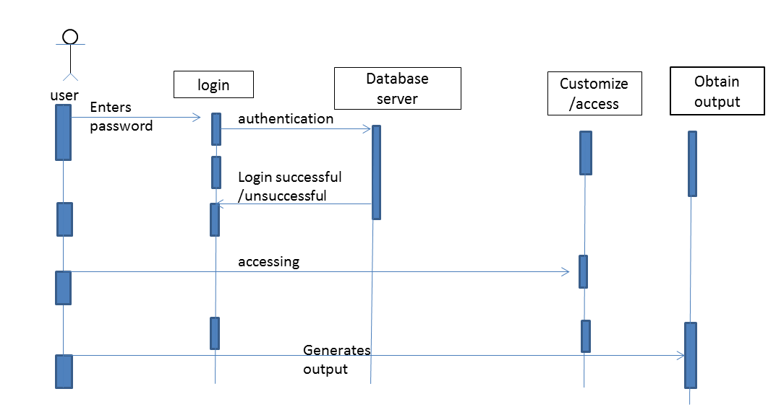

***3.4 CLASS DIAGRAM***

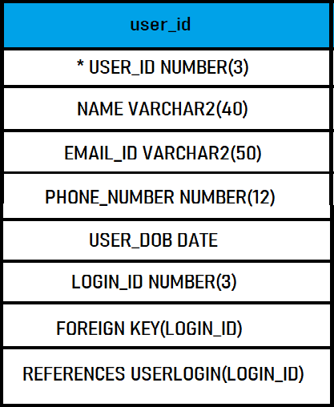

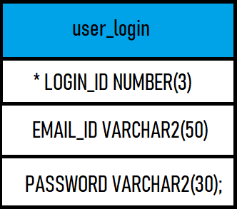

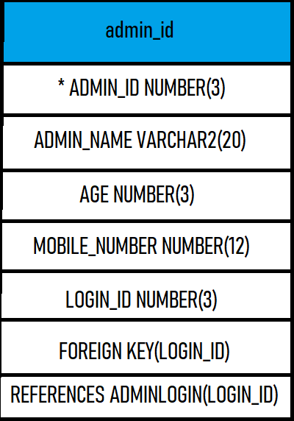

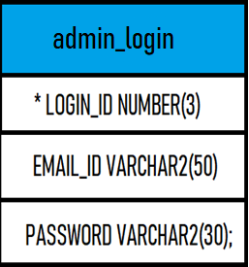

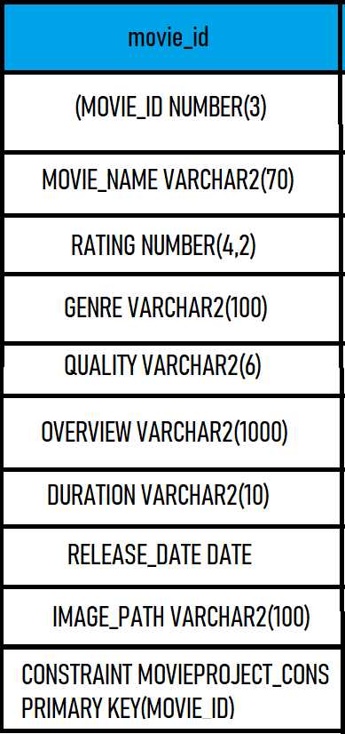

***3.6 System Architecture***

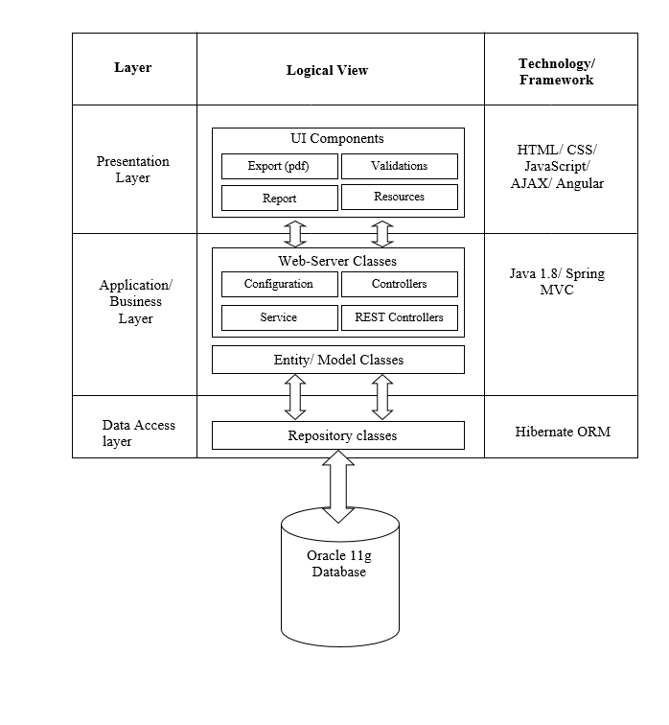

***Presentation Layer:***

This layer consists of all UI components.

* Export component: The plug-in is used to export the reports in pdf format. It helps to reduce the workload on the web/ application server.
* Validation component: All basic level data validations should be done at UI level.
* Report component: All reports to be generated to the user, will be processed and generated at the browser end.
* Resources: All HTML/CSS/ images, which are required for the page design.

**Application Layer:**

This layer comprises of all server and business classes.

* Configuration settings (XML or Class based) will define the application and server configuration.
* Spring Controllers defines the server classes, which are required to process the incoming http requests.
* Service classes are required to perform the required business services.
* REST Controllers to process the HTTP AJAX requests.
* Model classes are used the define the functions of the entities present in the system.

**Data Layer:**

Data layer is implemented through Hibernate ORM. It will contain the repository classes, which provides interface to the table.

Appendix

***User login page***

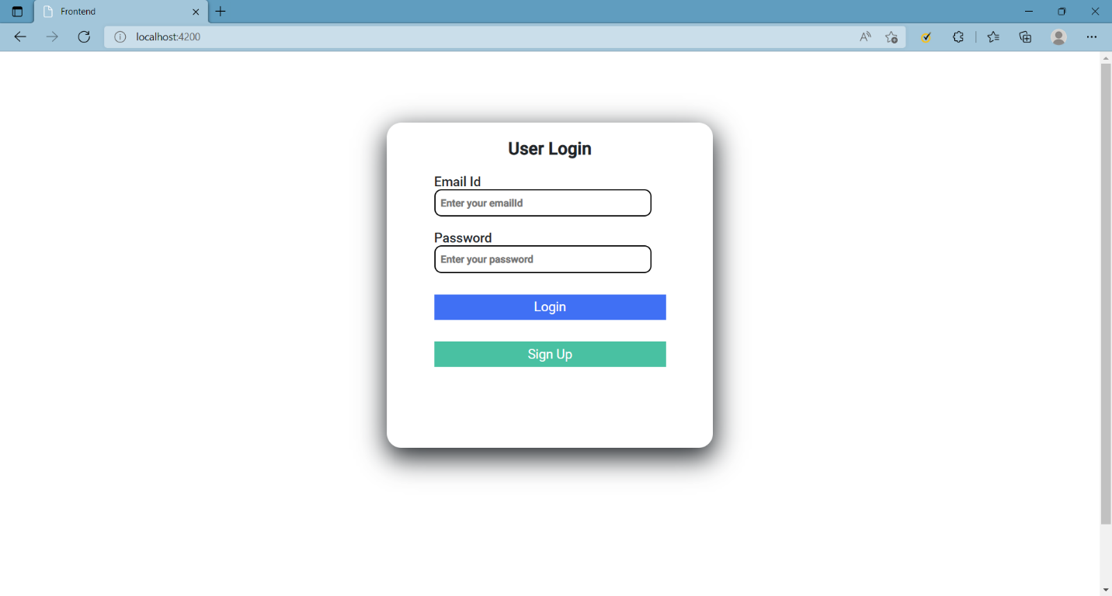

***User Registration***

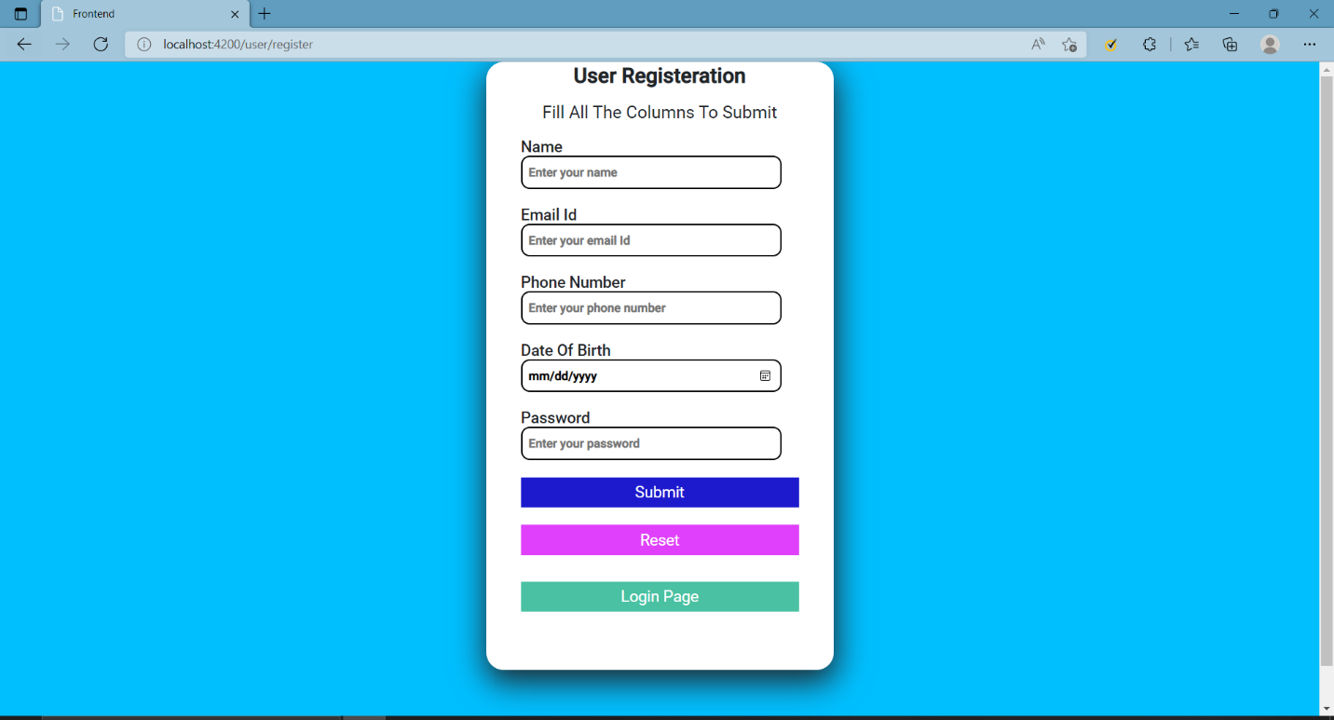

***After login User page (Home page)***

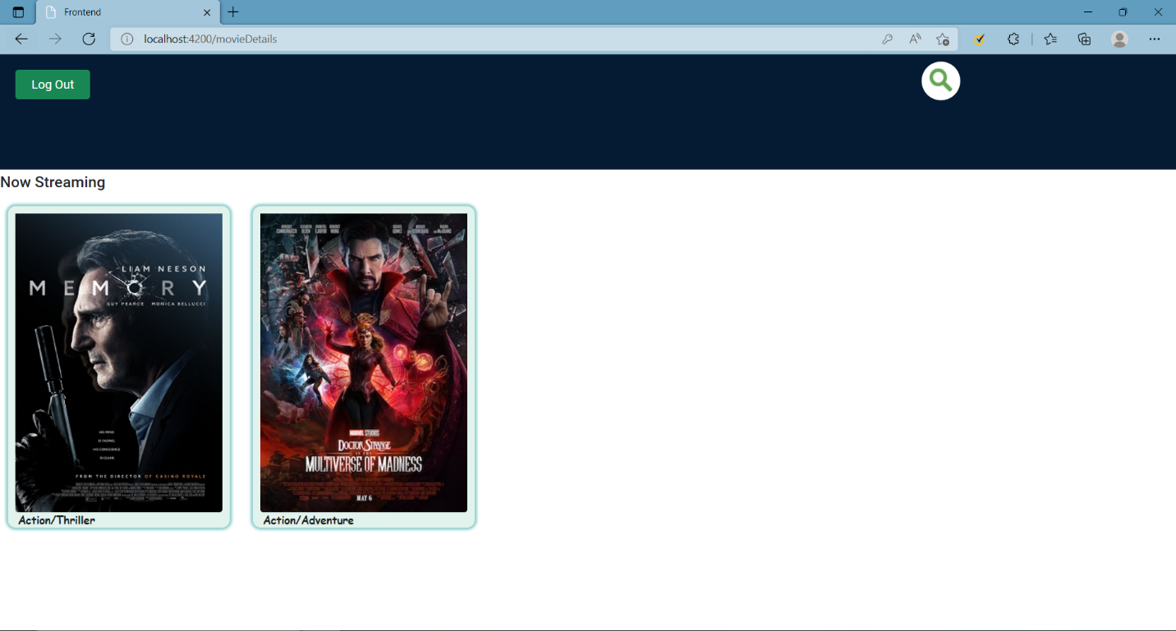

***After clicking on particular movie***

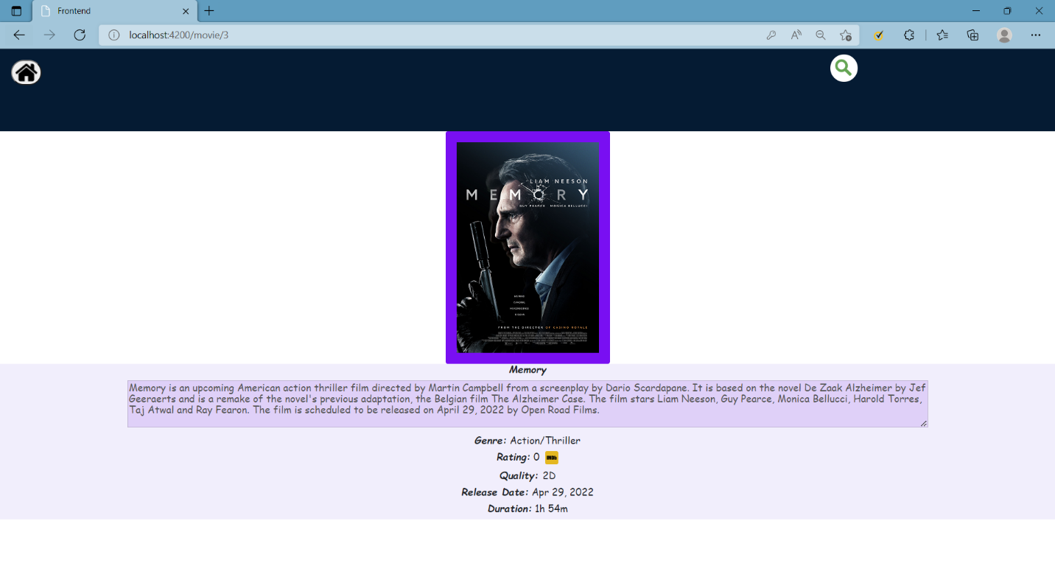

***Admin Login***

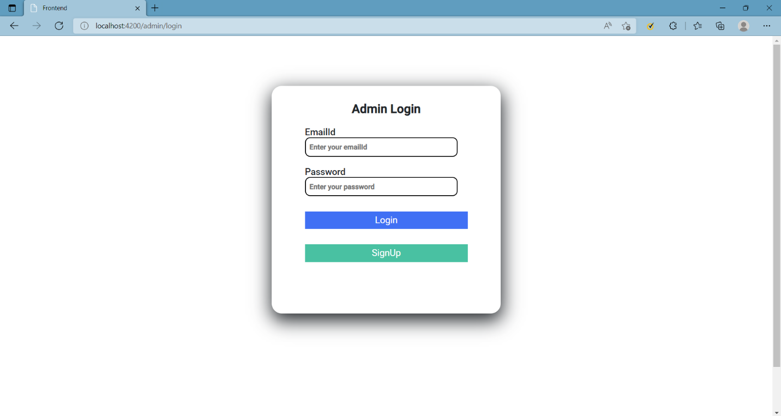

***Admin Registration***

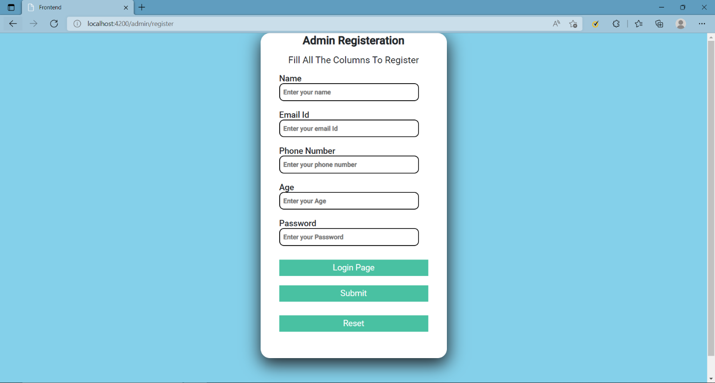

***After Admin Registered***

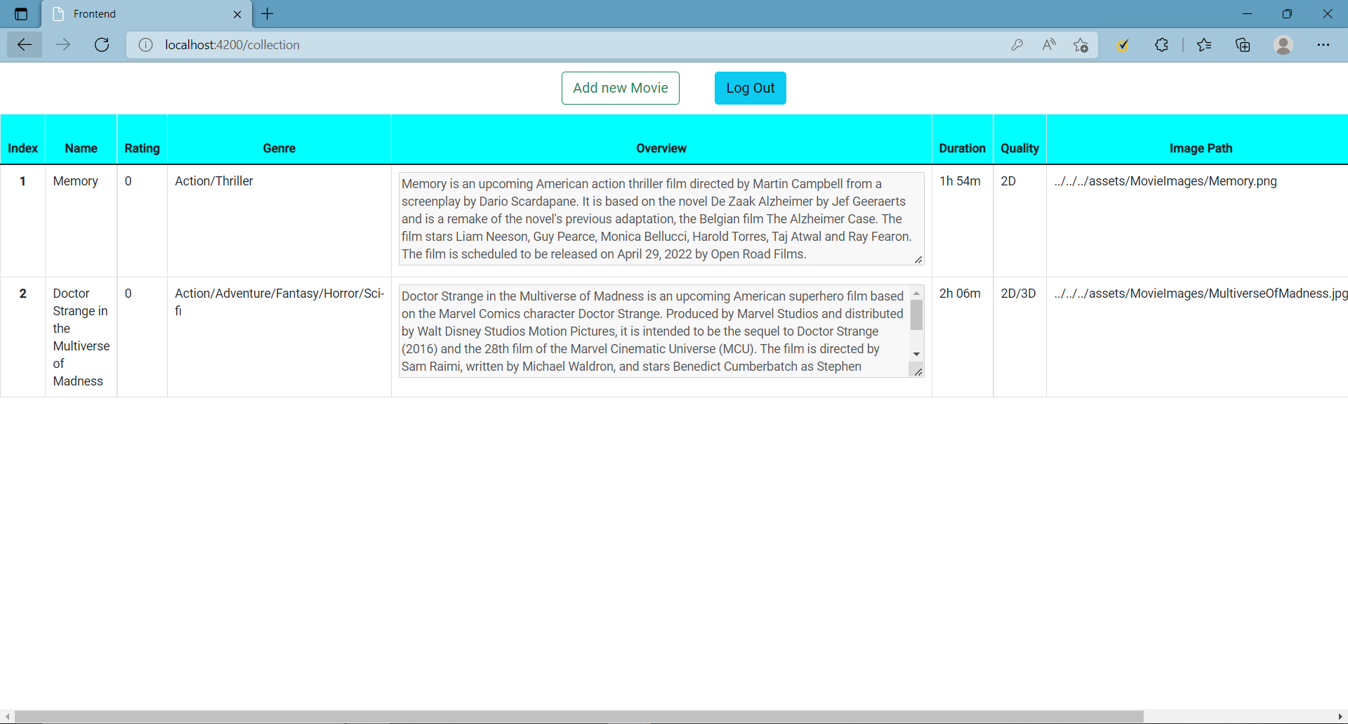

***Conclusion***

This project was developed successfully, and the performance was found to be satisfactory. This project is designed to meet the requirements of assigning jobs. The user will be able to see the movie details using this website.

We have designed the project to provide the user with easy retrieval of data and details of the movie. In this project, the user is provided with a website that can be used to see the movie information online.

With this platform we developed, we are hoping to reduce time wastage, avoid misunderstandings, provide easy data flow, customer pleasure, and less hard work. We believe that we have accomplished our goals and are satisfied with the code we developed.