* Data
  + 20161101 to 20161106
  + List 2
  + Position 3-7
  + Sessions that exist operation type 10 or 11
* Assumption
  + User views all the recommended items
  + The click through rate only depends on the apps, not depends on position
* Experimental Setting
  + Number of recommended apps K = 5
  + Number of apps in the pool pool_size = 393
  + PCA for feature dimension reduction, dimension of feature d=10*10=100
  + Rounds of recommendation T = 2268 (number of sessions)
  + 70% for training, 30% for testing
* Statistics
  + Ctr for session data: 19%
  + Match rate: about 1.10%
* Result
  + 5 times average c3ucb vs random recommend:

CTR (click through rate): #click/#recommend

ER (exploration rate): #recommended apps/#all apps

|  |  |  |
| --- | --- | --- |
|  | C3UCB | random |
| ctr | 25.8±7.09% | 23.4±5.32% |
| er | 75±3% | 100±0% |

* Ctr change with time:

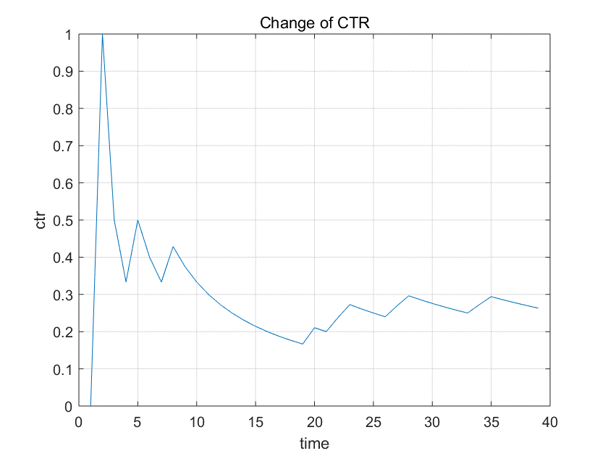

* Observation and Discussion
  + Match rate: match rate is too small, only about 40 times match right now. Thus, more data is needed
  + Parameter optimization: the parameters are roughly set, need optimizing
  + Feature design and reduction: more informative features are needed and more efficient reduction method is needed.