Hai Dang

1/20/17

CIS 3308: Lab 1 Project Proposal & Data Model

1. What is the title of your web application?

Named Space (work in progress)

1. Who will be users of your web application?

• What attributes will you store for each of your users?

People who want to buy a spaceship for interstellar travel.

1. What “other” table will be part of your database?

• What attributes will be stored for each record of this table?

The “other” table will store information for the spaceship entity. It will have attributes such as model name, model year, color, the max capacity, the price.

1. What information will be stored in your associative table (the table that implements a "many to many" relationship between your "other table" and your user table)?

The information that will be stored in the associative table would be the customer id, spaceship id, transaction amount, date of purchase, and quantity.

1. Explain how there is a many-to-many relationship between your user table and your “other” table.

A customer can buy many types of spaceships. Many spaceship models can be bought by many customers.

1. What functionality will your web application provide? Your application will provide the following at a very "mechanical" level, but functionally, how will users benefit from your web app?

* Users will be able to register, log on, and log off.
* Users will be able to insert (edit and delete) "other" records (whatever you decided to keep in your "other" table.

• You can pretend that users will be able to insert (edit/delete) associative records (even if you don't choose to do the "insert associative" challenge).

Users can list spaceships for sale by inserting into the table after logging in. Users will ultimately be able to buy spaceships as well, after registration and choose the type of spaceship they’d like and where it would be built.

1. Write 1-2 paragraphs of “marketing material” that attempts to entice people to become registered users and/or viewers of your web site. This will become the content area of your home page. In your paragraphs, do not explain to me what your web site will be able to do, write text that will entice users to visit your site.

The year is 2217 and humankind have spread out through the stars. Here at Named Space, we are building the future, the future you have in mind. If you’ve ever wanted to find that home away from home then why not on settle on another planet, or a comet, or a satellite, or a star? From the bustling metropolis of Mars to the newly-built outposts in Proxima Centauri b, the universe is your limit. In our various interstellar spaceships, we outperform the competition in price, speed, and comfortability. Cruise through the depths of space in our ships and explore the unknown. What undreamt voyages will you pursue? What new wonders await your discovery? The frontier is everywhere.

Notes:

* Date range is from January 1, 1753, through December 31, 9999 in SQL so this year is feasible.
* In this scenario, all spaceships are not unique but are like products/commodities such as cars.

Data Model Screen Capture:

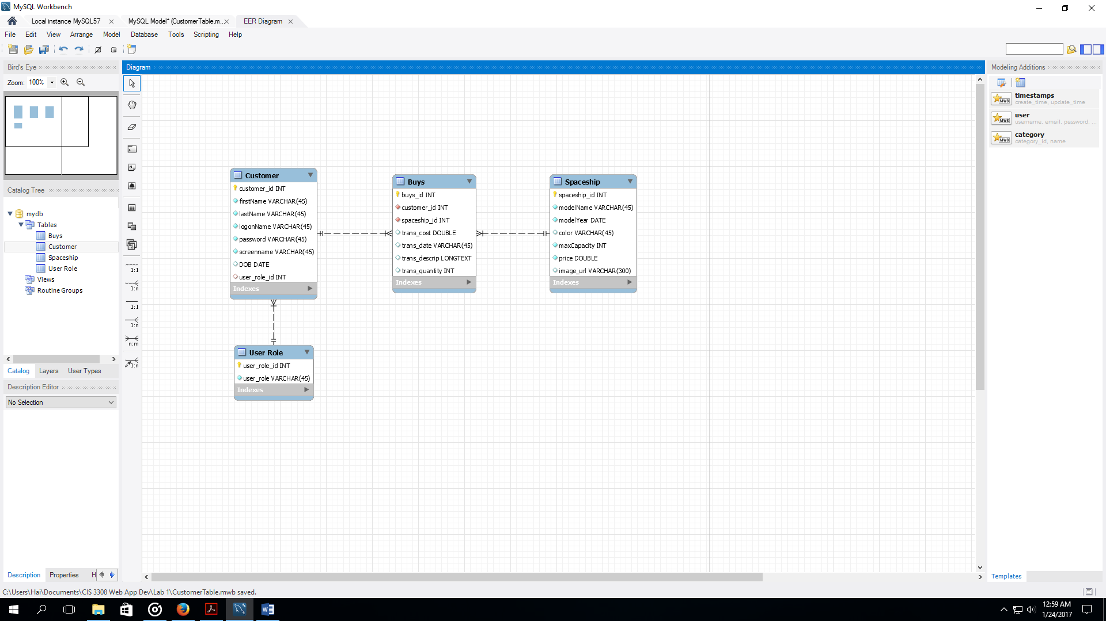

1. Customer Table:

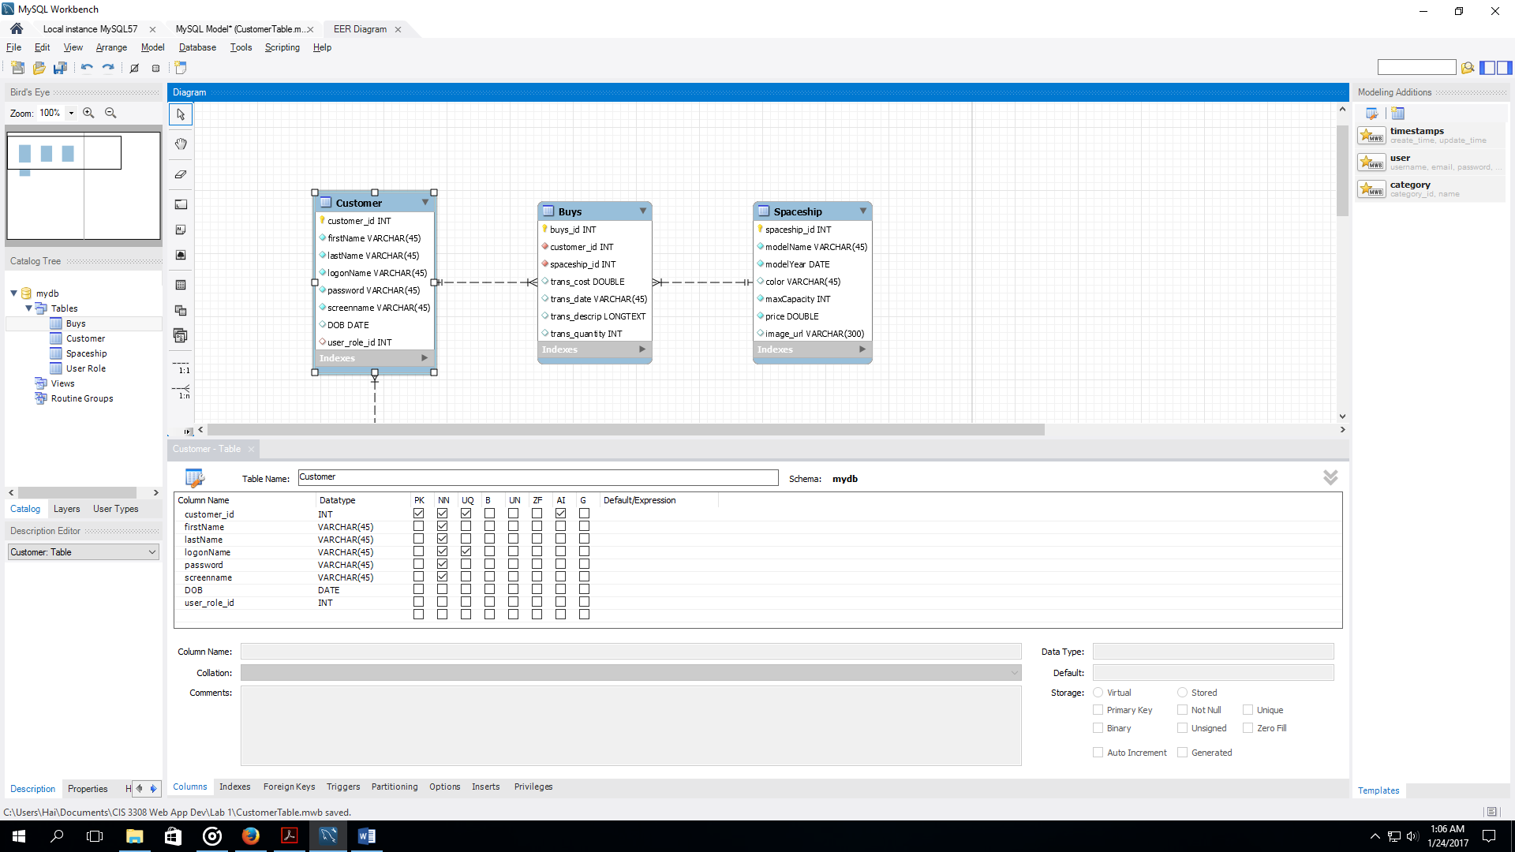

* Foreign Keys:

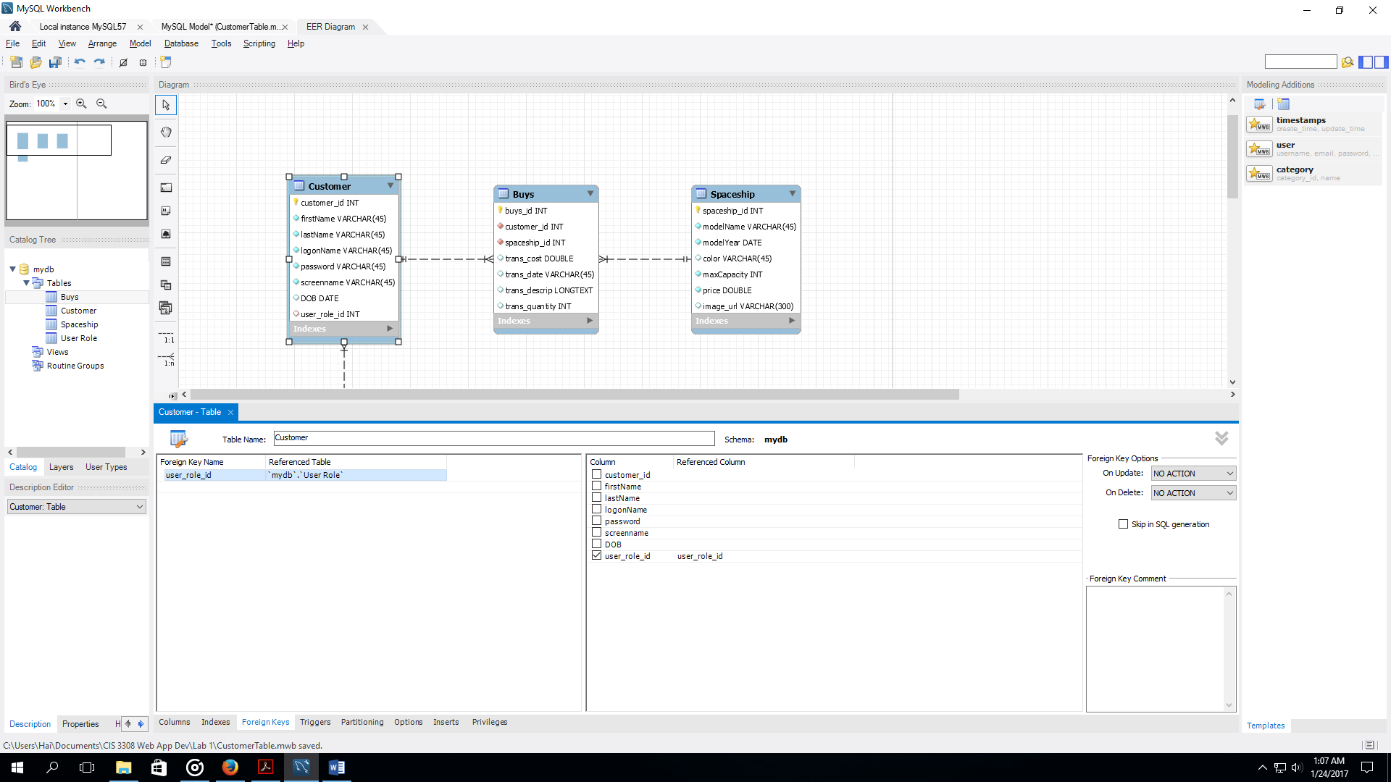

1. User_Role:

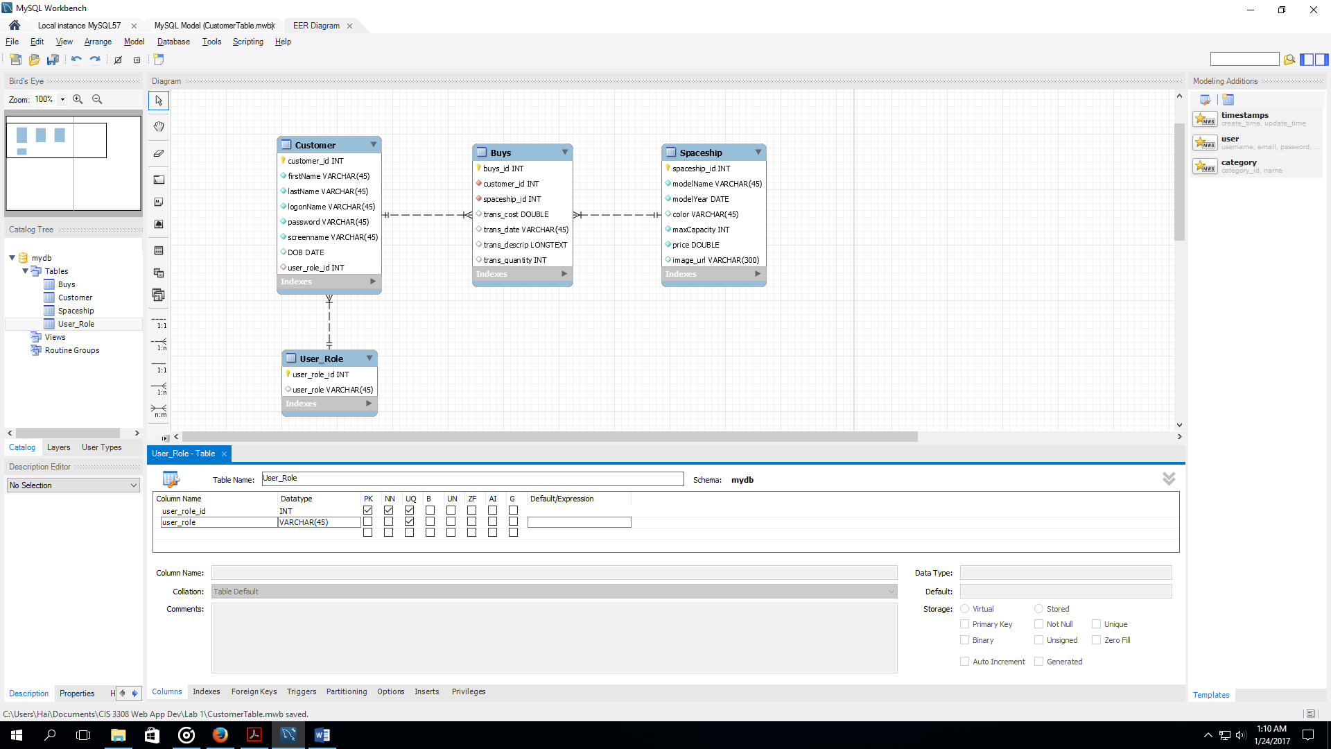

1. Spaceship:

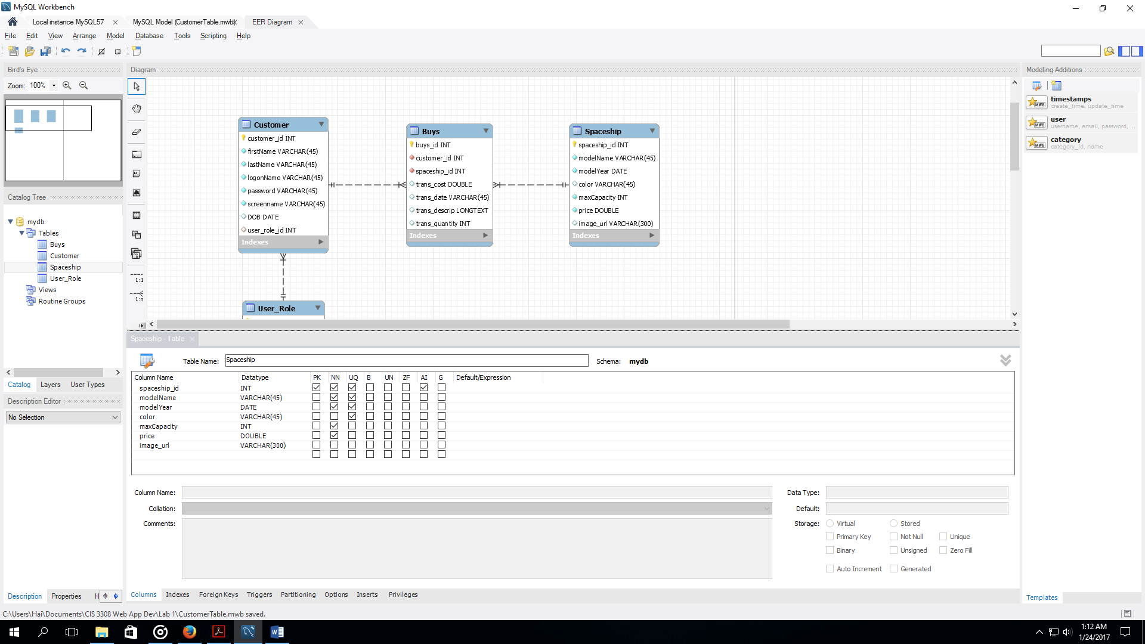

1. Buys:

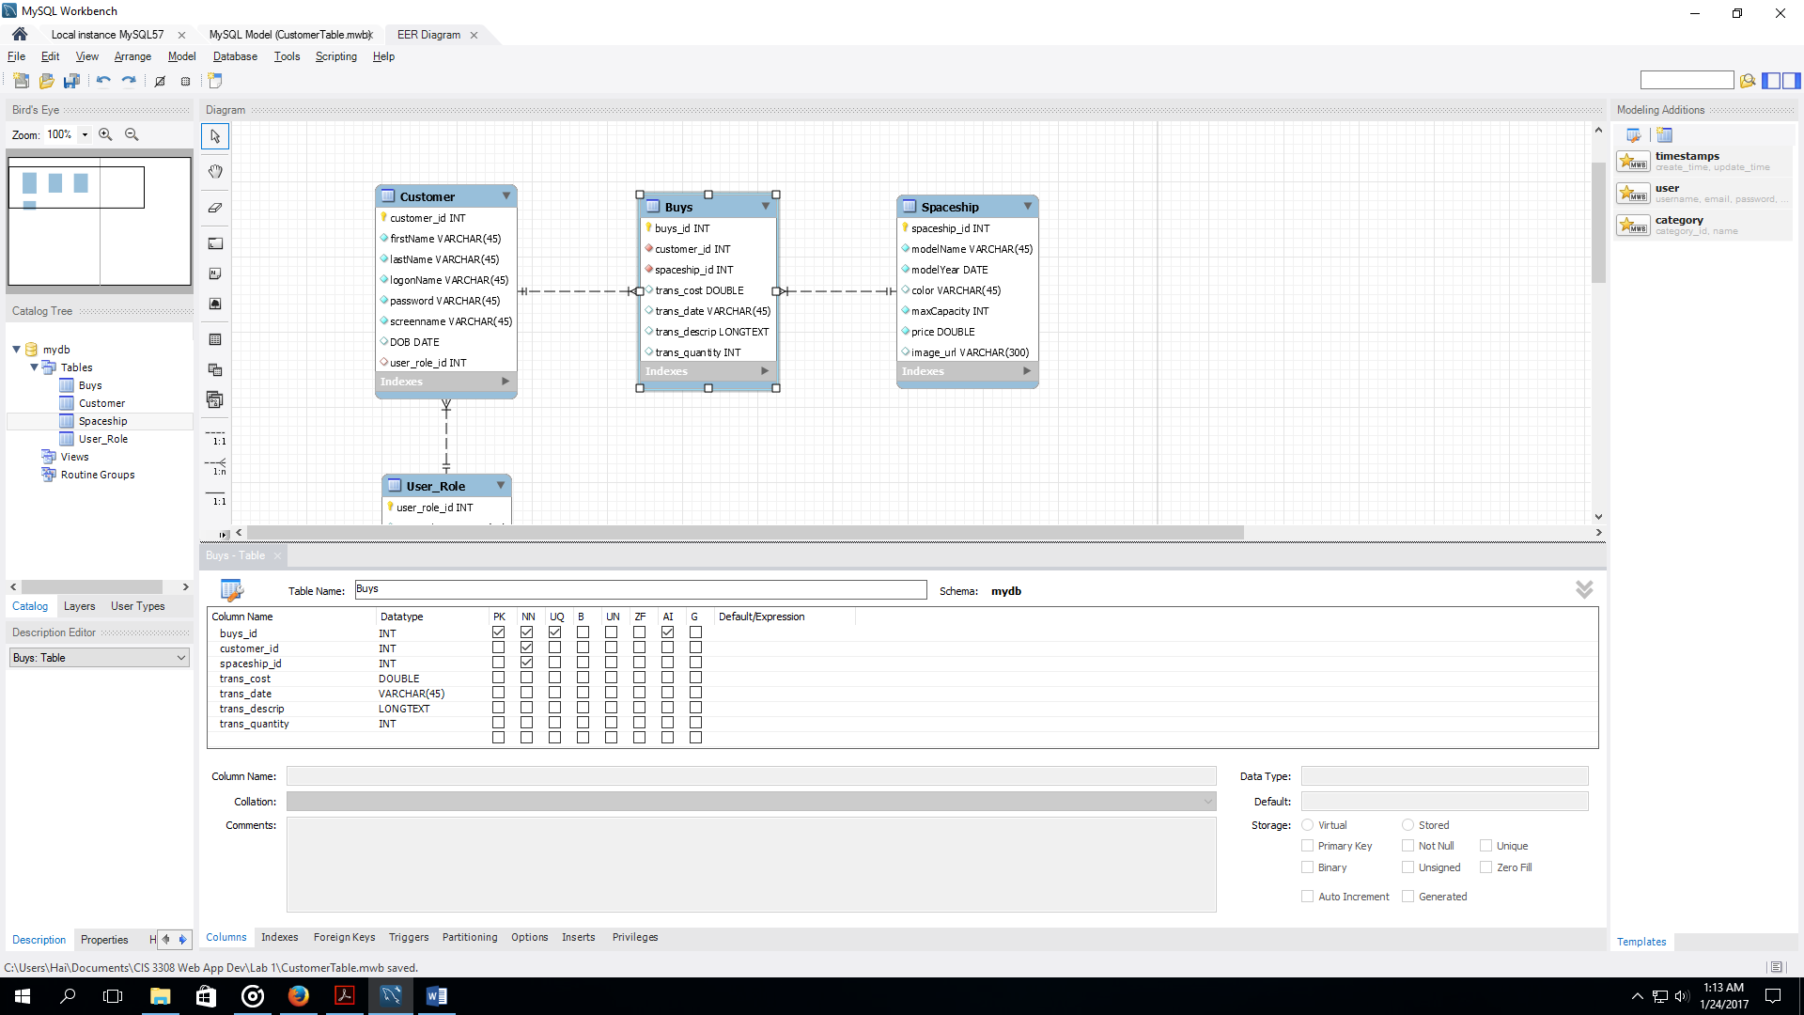

* Foreign Keys

