添加jar包：

add jar /usr/hdp/2.4.0.0-169/hive/aux_lib/fastjson-1.2.7.jar;

add jar /usr/hdp/2.4.0.0-169/hive/aux_lib/demo-hive-0.0.1-SNAPSHOT.jar;

创建函数：

create temporary function row_json as 'com.tx.demo_hive.UDF_JSON';

create temporary function col_json as 'com.tx.demo_hive.UDAF_COL_JSON';

建表结构

create table cluss(class_name string,student_id int,student_name string)

row format delimited fields terminated by '\001' stored as textfile;

建临时表存放行json查询：

create temporary table json_1 as

select class_name as class_name

,row_json(concat('class_name:',class_name)

,concat('student_id:',student_id)

,concat('student_name:',student_name)) as rowJson

from cluss;

Select * from json_1;

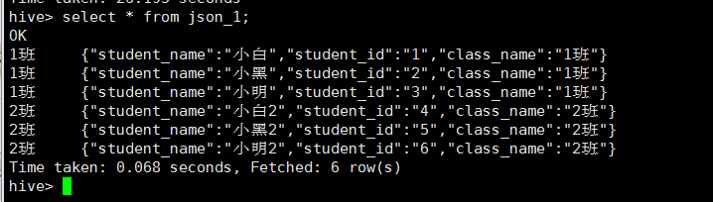

按class_name聚合：

select class_name,col_json(rowJson,",") from json_1 group by class_name;

