AppThere Engineering

Rendering Fidelity at Scale
The ACID 2 parity report for opening real-world documents in Loki

Prepared by the Loki Layout Team · Date 14 July 2026

Contents
1. Introduction 3
1.1 Background and goals 3
2. Measured results 3
2.1 Per-feature scores 4

1. Introduction

1.1 Background and goals
When a reader opens an existing document, the first impression is entirely visual: line spacing, tables, headings, and figures must land where the author put them. This report exercises the constructs that most often drift between suites, measured with SSIM against the canonical Microsoft 365 render. The bulk of divergence historically comes from a handful of features working together, which is exactly what the pages that follow stress.

Scope
- Word-processing layout: spacing, indents, keep-with-next, widows.
  - Tables with merged cells, shading, and repeated header rows.
    - Floating figures and captions with sequence fields.
- Cross-references and fields that update on open.

2. Measured results
The results are summarised in Table 1. Scores at or above the calibrated threshold pass; the total row aggregates the section.
Table 1. Per-feature parity (illustrative).
Feature | Region score
 | SSIM | ΔE | Verdict
Line spacing | 0.99 | 1.2 | Pass
Merged tables | 0.97 | 2.6 | Pass
Total | 0.98 | 1.9 | Pass

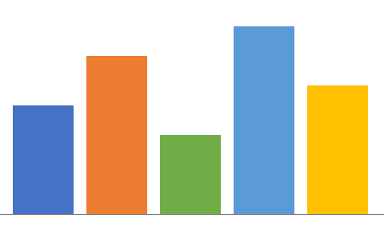
Figure 1. Score distribution across regions.
Parity is not one big feature; it is a hundred small ones that must all be right at once.

Jordan A. Rivera
jordan@example.com • linkedin.com/in/jrivera • San Francisco, CA
Experience
Staff Layout Engineer, AppThere 2023 – Present
Loki word-processing layout & rendering fidelity.
- Drove SSIM parity with Microsoft 365 across the ACID corpus.
- Shipped variable-font instancing and floating-image wrap parity.
Software Engineer, Contoso Docs 2019 – 2023
- Built the OOXML import pipeline for tables and numbering.
Skills
Rust OOXML / ODF Typography

The Loki Ledger
Volume 2, Issue 7 — News from the rendering desk
P
arity work this quarter focused on the constructs users hit first. A floating figure now sits beside the body text, wrapped square, while the columns balance across the page. Small drifts in leading and indent are the ones readers notice, so those got the most attention.

Text flows around the sidebar image on its left, then reclaims the full column width once the image is cleared. The wrap band is exactly the image width plus its distance insets, matching the reference render used by the visual harness for this page.
“The columns balance, the figure wraps, and the leading holds.”
The remaining copy continues in two balanced columns to the foot of the page, exercising the column breaker together with justified text, hyphenation-free wrapping, and the running header and footer that persist across every section of this document.
Sidebar. A floating text box wraps the body copy on its left, with its own border and fill.

INVOICE No. LK-2026-0714
AppThere, Inc. · Terms: Net 30 · Due: 13 August 2026
Description | Qty | Amount
Layout engineering (hours) | 40 | 6,400.00
Conformance harness setup | 1 | 950.50
Total due |  | 7,350.50

Terms and conditions
- Payment. All amounts are due within thirty (30) days of the invoice date.
  - Late payments accrue interest at 1.5% per month.
- Acceptance. Signature below constitutes acceptance of these terms.

Authorised signature Date

Appendix A. Feature matrix
Isolated cells for pinpoint diagnosis. This section also carries a page border and line numbering in its section properties.

A1. Run decorations and effects
single double dotted wave strike dbl-strike super² sub_{n}
highlight char-border char-shading outline shadow emboss imprint

A2. Decimal tabs with dot leader
Subtotal 1,234.50
Tax 98.76
Grand total 1,333.26

A3. Cell shading with a vertically merged label
Fills | 25% pattern | diagonal stripe
 | plain cell | solid fill

A4. Callout box (bordered + shaded paragraph)
Callout. A bordered, shaded paragraph forming a callout box — a four-sided paragraph border, a solid fill, and symmetric side indents, all exercised together and rendered by both Word and Loki.

A5. Special spaces and hyphens
Non-breaking space keeps 10 kg together; a non-breaking-hyphen holds compounds, while an optionalhyphen breaks only when needed.

Structural Similarity Index Measure — a perceptual metric bounded in [0, 1]; Loki's visual harness gates at the calibrated threshold.
All figures are illustrative and generated deterministically at build time.

