GENERAL PHYSICS

Personalized Learning Tutor
  - Conceptual Architecture and Educational Design Framework
━━━━━━━━━━━━━━━━━━━━━━━━━━
Version 0.1
Prepared for collaborative review by educators
Design thesis
The system exists to increase the student's future capacity to reason independently. It should optimize for learning, not answer production.
A course-aware, persistent, adaptive tutoring architecture for algebra-based college physics

PURPOSE

Executive Summary
This document defines what a fully instantiated AI-supported General Physics tutor ought to look like now, independent of whether a single commercial product currently provides every capability. The proposed system is not simply a chatbot with a long memory. It is a longitudinal learning system that combines a course model, a prerequisite knowledge graph, a persistent learner model, adaptive tutoring rules, retrieval scheduling, and clear human escalation pathways.
The central problem is familiar in algebra-based physics. Students may enter a genuine college physics course while still developing foundational quantitative skills such as fraction arithmetic, variables, proportional reasoning, algebraic rearrangement, trigonometry, vectors, rate of change, and dimensional analysis. A conventional course cannot stop and individually rebuild every missing prerequisite. A well-designed AI tutor can potentially provide that individualized support at scale, provided that it is designed to preserve thinking rather than replace it.
Core design question: Given what this particular learner currently understands, what is the smallest and most appropriate intervention that will help the learner become more capable of doing this independently next time?

System Goals
- Diagnose the specific prerequisite or conceptual barrier that is preventing progress.
- Preserve productive cognitive effort and resist unnecessary answer giving.
- Build and update a structured learner model from demonstrated performance.
- Use spaced retrieval and scaffold fading to promote durable, independent competence.
- Maintain continuity across days, weeks, and course topics without requiring students to manually pass context.
- Return actionable, privacy-conscious learning intelligence to students and educators.
- Escalate appropriately when human instruction, advising, or institutional support is more appropriate than additional AI interaction.
A successful tutor should ultimately make itself less necessary.

FOUNDATIONAL DESIGN

1. The Tutor Constitution
Before defining what the system knows, the system should define how it is permitted to teach. These principles act as non-negotiable constraints on model behavior.
- Preserve meaningful cognitive effort.
- Diagnose before remediating.
- Distinguish exposure from demonstrated competence.
- Prefer first-principles reasoning over equation hunting.
- Move backward through prerequisites when necessary and rebuild upward after readiness is demonstrated.
- Adapt assistance to demonstrated need rather than perceived intelligence.
- Treat mistakes as diagnostic evidence.
- Use retrieval and spaced practice to support durable learning.
- Gradually remove scaffolding as competence develops.
- Do not convert temporary difficulty into a permanent judgment about a learner.
- Make important learner-state judgments inspectable and correctable.
- Escalate to human support when additional AI interaction is no longer the best intervention.
- Work toward increasing learner independence over time.
ARCHITECTURE

2. System at a Glance
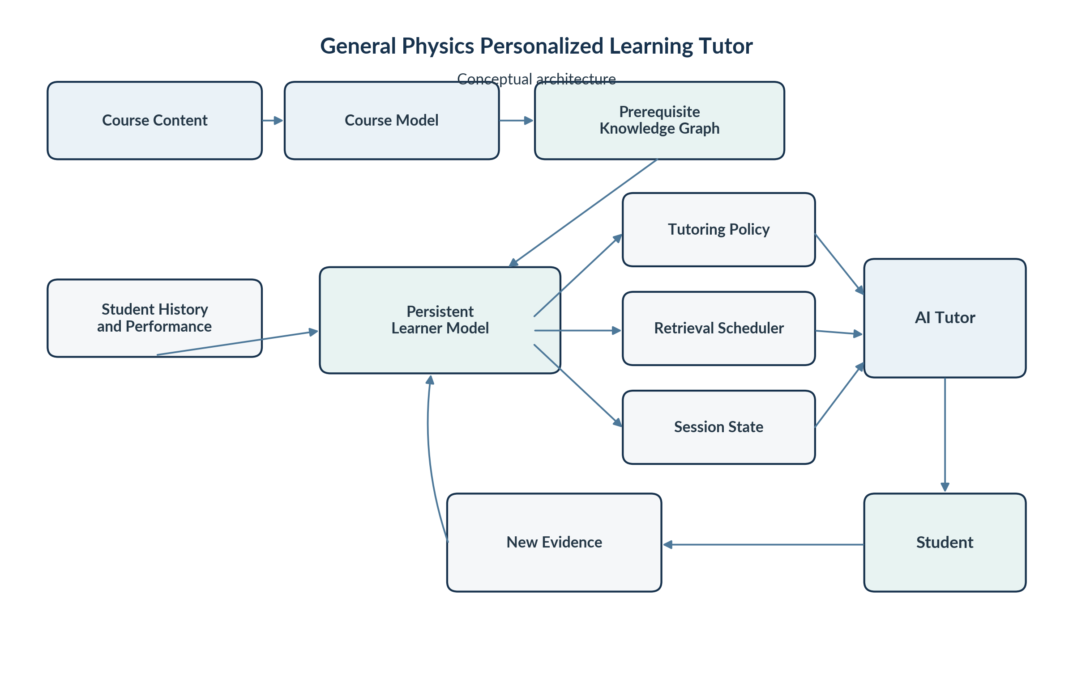
Figure 1. Conceptual architecture. Every meaningful interaction can produce evidence that updates the learner model and changes what the tutor does next.

WHAT THE TUTOR KNOWS

3. The Course Model
The tutor should know the actual course rather than physics in the abstract. The course model can include the weekly sequence, instructor-provided lecture slides, videos or transcripts, learning objectives, problem-solving methodology, notation, textbook alignment, course calendar, and any materials the instructor authorizes for use.
This allows the tutor to answer two distinct questions:
- What is this student supposed to be learning right now?
- What is this student actually ready to learn right now?
The tutor operates at the intersection of those two answers.
Course awareness matters because a generally knowledgeable AI may introduce valid methods or notation that are inconsistent with the instructor's sequence, expectations, or current level of abstraction.

4. The Prerequisite Knowledge Graph
The prerequisite model should not be a flat checklist labeled “algebra” or “trigonometry.” It should be a dependency graph that decomposes the skills far enough to locate the actual missing rung.
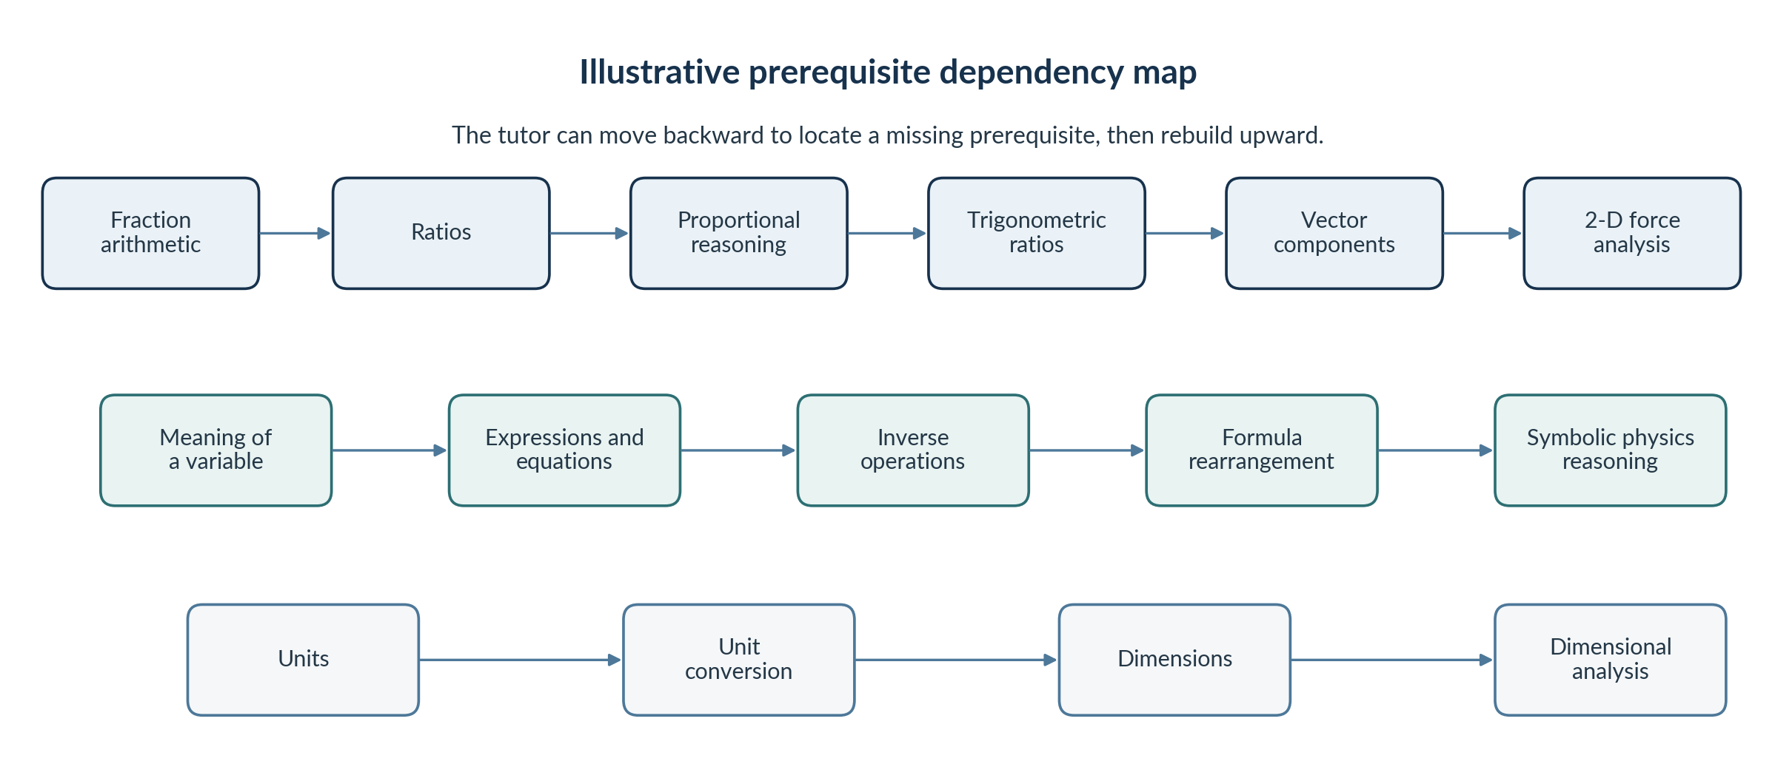
Figure 2. Illustrative prerequisite dependency chains. The mature graph would contain many more nodes and cross-links.
When a learner fails at a higher-level task, the tutor can probe downward. Difficulty with vector components may actually be a trigonometry problem. The trigonometry difficulty may be a ratio problem. The ratio difficulty may reveal a fraction problem. Once the lowest important missing skill is identified, the tutor teaches and verifies that skill before rebuilding upward.

WHAT THE TUTOR LEARNS ABOUT THE STUDENT

5. The Persistent Learner Model
The learner model replaces the need for manual context handoffs. Raw chat history can remain evidence, but the system should maintain a more compact and structured interpretation of what the student has actually demonstrated.
Learner State | Operational Meaning
Not Assessed | Insufficient evidence exists to make a useful judgment.
Encountered | The learner has been exposed to the idea or skill.
Emerging | Some understanding is visible, but substantial support is still required.
Developing | The learner can perform the skill inconsistently or with modest support.
Reliable | The learner repeatedly performs the skill independently in familiar contexts.
Transfer Ready | The learner recognizes and applies the idea independently in a somewhat unfamiliar context.
The model should also record evidence, misconceptions, prompt dependence, and the context in which a skill was demonstrated. For example:
- Correctly isolated a variable independently on 3 of 4 attempts.
- Selected cosine correctly when the angle was measured from the horizontal, but required prompting when the reference angle changed.
- Computed acceleration correctly but interpreted a negative sign as necessarily meaning “slowing down.”
The learner model should describe current instructional state, not identity. Categories such as “weak student,” “low ability,” or “bad at math” have no useful role in the architecture.

6. Evidence Before Confidence
A learner saying “I understand” should carry less weight than a learner demonstrating understanding. The system should distinguish among increasingly strong forms of evidence.
Exposure | Recognition | Explanation | Guided Application | Independent Application | Transfer
Bloom-like progression made operational through observed performance rather than self-report alone.

HOW THE TUTOR DECIDES WHAT TO DO

7. The Tutoring Policy Engine
The tutoring engine determines how much help to provide and when to increase or withdraw support. Its default strategy should be to use the smallest intervention that allows productive progress.
Level | Intervention | Purpose
1 | Retrieval question | Ask the learner to identify the next idea or principle.
2 | Directional hint | Point toward the relevant feature without giving the step.
3 | Explicit scaffold | Narrow the decision and provide a structure to work within.
4 | Analogous example | Work a similar problem with different values or context.
5 | Partial demonstration | Show the next step, then return the problem to the learner.
6 | Prerequisite intervention | Temporarily leave the physics problem and rebuild the missing underlying skill.
Prompt dependence should be part of the evidence model. A correct answer after five increasingly explicit hints is not equivalent to an independently generated solution. On later encounters, the system should intentionally reduce support.

8. Productive-Struggle Controller
The tutor should actively manage the boundary between cognitive offloading and unproductive frustration. Too little struggle can remove the thinking that produces learning. Too much struggle can produce repetition without insight.
Too Easy  Cognitive offloading | Productive Struggle  Desired region | Unproductive Frustration  Increase or change support
Possible responses include reducing assistance, maintaining the current level, increasing scaffolding, changing representation, stepping down to a prerequisite, or changing the activity briefly. Affective cues can guide immediate teaching decisions without becoming permanent psychological labels.

LEARNING ACROSS TIME

9. Retrieval Scheduler
A concept should not disappear simply because a learner succeeded once. Important skills should carry a future retrieval state. Successful retrieval can lengthen the interval before the next check. Failed retrieval can shorten the interval and trigger additional practice.
The system should manage learning across time, not merely respond within a single conversation.
A short future check might be as simple as:
“Before we start today's material, one quick question from last week. If force stays constant and mass doubles, what happens to acceleration?”

That single response can reveal whether an inverse relationship has become part of the learner's working knowledge or remains recently memorized information.

10. Session State and Automatic Continuity
Long-term learner state and the immediate session should remain distinct. When the learner logs in, the system can automatically assemble a compact context packet such as:
Current course location | Week 3: Newton's Laws
Current objective | Apply Newton's second law to one-dimensional systems
Prerequisites of concern | Formula rearrangement; signed quantities; force diagrams
Scheduled retrieval | Inverse proportionality; vector direction
Recent misconception | Negative acceleration interpreted as necessarily slowing down
Last stopping point | Free-body diagrams were correct, but translating the diagram into a symbolic force equation still required prompting
The student should not need to create or upload a handoff in the mature system. The handoff becomes an internal state-management function, with optional export for portability or transparency.

LEARNER-FACING DESIGN

11. The Student Experience
The student interface should remain simple even if the system behind it is sophisticated. Complexity belongs behind the interface rather than in front of the learner.
Welcome back. Last time you were identifying forces correctly, but translating your free-body diagram into an equation was still difficult. We also planned a short check on inverse proportionality today. What would you like to work on?

A small set of learner choices may be sufficient:
- Continue where I stopped
- Help me with today's material
- I have a problem I do not understand
- Practice something I am weak on
- Show me my learning map
- Ask a question

12. The Learning Map
Students should be able to inspect their own learner model. A concept map can show what is secure, what is developing, and what has not yet been assessed without turning the system into another gradebook.
Concept | Current State | Evidence / Note
Fractions | Reliable | Repeated independent performance
Ratios | Reliable | Used correctly in multiple contexts
Proportions | Developing | Inverse cases remain inconsistent
Trigonometric ratios | Developing | Reference-angle changes still require care
Vector components | Emerging | Current focus
2-D force analysis | Not Assessed | Prerequisites not yet stable
The learner should also be able to challenge a judgment. A button such as “I think I know this better than the tutor thinks I do” should trigger an opportunity to demonstrate the skill. The model becomes contestable through evidence rather than fixed by algorithmic labeling.

EDUCATOR-FACING DESIGN

13. Instructor Intelligence Layer
The instructor view should not default to complete private tutoring transcripts. It should surface the information needed to improve instruction, identify bottlenecks, and intervene when appropriate.
Illustrative Class Readiness Signal | Status
Symbolic rearrangement | 62% reliable
Direct proportionality | 78% reliable
Inverse proportionality | 41% reliable
Vector components | 37% reliable
Dimensional analysis | 44% reliable
Illustrative class-wide misconception: A substantial group of learners are treating negative acceleration as equivalent to slowing down regardless of velocity direction.

This creates a closed instructional loop. Individual tutoring generates structured evidence. Aggregated evidence identifies class-wide patterns. Faculty can then adapt examples, pacing, remediation, or future course design.

14. Human Escalation Rules
The tutor should explicitly recognize circumstances in which additional AI interaction is not the best intervention.
- A learner repeatedly fails a prerequisite after multiple representations and carefully scaffolded attempts.
- Substantial mathematical remediation is needed beyond the scope of the current physics session.
- Course materials appear inconsistent or the AI is uncertain about instructor expectations.
- The issue involves grading, accommodations, academic standing, institutional policy, or another human decision.
- The learner is becoming substantially behind expected course progression.
- The learner requests instructor, Math Lab, tutoring, advising, or other human support.
When useful, the system can generate a student-approved summary of the specific difficulty. Instead of arriving at tutoring with “I do not understand physics,” a student might arrive with “I understand the physical principle, but I am having difficulty solving equations when the unknown appears in the denominator.”

GOVERNANCE AND ETHICAL DESIGN

15. Privacy Should Be Architectural
Privacy, transparency, and access should be designed into the system rather than added after implementation. Different information types should have different access expectations.
Information Layer | Design Expectation
Course content | Institution or instructor governed; use only materials authorized for the tutoring system.
Learner-state data | Visible to the learner; used for tutoring continuity and educational adaptation.
Raw tutoring history | More tightly controlled than learner-state summaries; not automatically exposed to faculty.
Instructor analytics | Limited to information needed for teaching, intervention, and course improvement.
Aggregate curriculum analytics | De-identified whenever individual identity is unnecessary.
The learner model should be explainable. If the system classifies a learner as Developing in trigonometry, the learner should be able to ask why and receive a concise evidence-based explanation.
Example: “You correctly calculated components in three problems, but in two problems where the reference angle changed you required a hint to select sine versus cosine. We have not yet tested the skill in a new context.”

16. No Permanent Deficit Labels
The learner model should be dynamic, evidence-based, and erasable through demonstrated growth. Once competence develops, earlier difficulty should become historical context rather than a continuing assumption about the learner. Recent independent success should carry more instructional weight than old failure.

FROM DESIGN TO BUILD

17. Closed-Loop Software Architecture
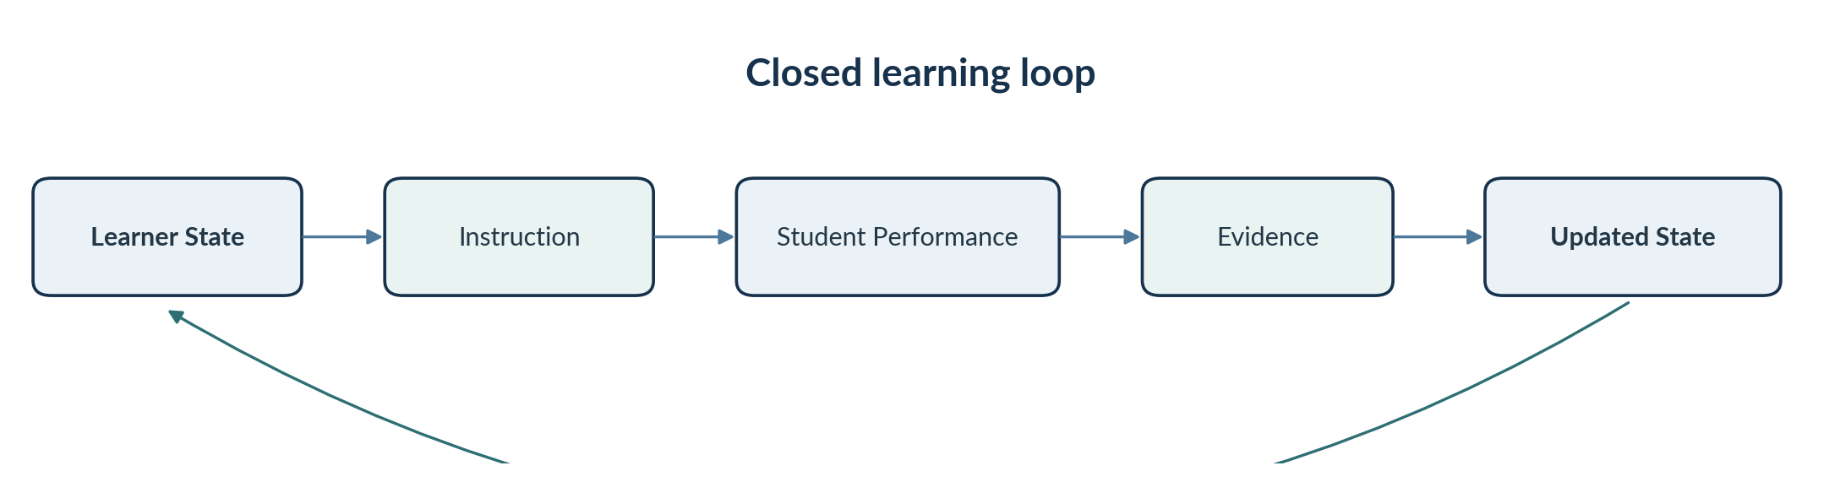
Figure 3. The tutor is a feedback system rather than a sequence of isolated prompts and responses.
The key architectural shift is from a simple prompt-response model to an evidence-driven feedback loop. Every meaningful interaction can alter the state that guides the next intervention.

18. Progressive Implementation Path
Stage | Capability
0. Prompt Prototype | Tutor instructions plus manual Learning Handoffs. This is immediately usable.
1. Structured Tutor | Formal readiness map, learner-state schema, mastery rules, misconception tracking, and retrieval rules.
2. Persistent Prototype | Student login, stored learner model, AI conversation interface, automatic session continuity, and course-material retrieval.
3. Course-Aware Tutor | Weekly course materials, instructor notation, objectives, sequencing, and assignment context incorporated automatically.
4. Adaptive Learning System | Automated prerequisite diagnosis, retrieval scheduling, scaffold fading, mastery estimation, and transfer testing.
5. Instructor Intelligence Layer | Aggregated readiness, misconception detection, curriculum bottlenecks, intervention signals, and longitudinal learning analytics.
Stage 1 is especially important because it does not require software development. It requires us to specify the educational architecture well enough that later software can implement it faithfully.

RECOMMENDED NEXT ARTIFACT

19. Build the General Physics Prerequisite Knowledge Graph
The first major design artifact should be a carefully decomposed prerequisite knowledge graph. It should begin lower than most college physics prerequisite documents normally begin and then build systematically toward application-level physics competencies.
For every node, the design should specify:
- What the learner must understand.
- What the learner must be able to do.
- How the tutor can test the skill quickly.
- Common misconceptions and error signatures.
- What concepts depend upon the skill.
- What the tutor should do if the learner cannot demonstrate it.
- What evidence moves the learner from Emerging to Developing to Reliable to Transfer Ready.
- When and how the skill should reappear through spaced retrieval.
The graph should not begin with “algebra.” It may need to begin with questions such as: What does a variable represent? What does the denominator mean? What does the equals sign assert? What is a ratio? What does it mean for one quantity to vary with another?

20. Illustrative Student Journey
Moment | System Behavior
Login | The student returns in Week 3. No prompt, handoff, or recap is required.
Resume | The tutor recalls that free-body diagrams were correct but symbolic force equations still required prompting.
Retrieve | A 30-second inverse-proportionality check is inserted because the skill is due for retrieval.
Diagnose | A force problem reveals that the student can identify the physics principle but cannot isolate a variable in the denominator.
Remediate | The tutor temporarily removes the physics context, teaches the algebraic prerequisite, and asks the student to demonstrate it.
Rebuild | The tutor returns to the original force problem with less support.
Update | The learner model records new evidence and adjusts both mastery state and future retrieval timing.
Escalate if needed | If the difficulty persists, the system recommends the Math Lab or instructor and prepares a student-approved summary of the specific barrier.
Closing perspective
The mature tutor should not simply remember the student. It should maintain a transparent, evidence-based model of learning, select the next intervention intentionally, revisit fragile knowledge over time, and gradually withdraw support as independence develops. The goal is not to make the AI increasingly indispensable. The goal is to make the learner increasingly capable.

