PERSISTENT AI

Learning Companion
  - A Conceptual Architecture for Longitudinal, Cross-Disciplinary Learning in STEM
━━━━━━━━━━━━━━━━━━━━━━━━━━━━━━━━━━━━
Version 0.1
Prepared for collaborative review by educators, academic leaders, learning scientists, and technology teams
Design thesis
“The mature learning companion should remember the development of the learner, not merely the history of the conversation. Its purpose is to increase the learner’s future capacity to reason, transfer, and act independently.”
From the course-specific tutor to a persistent learning relationship across disciplines and time

PURPOSE

Executive Summary
This whitepaper generalizes the course-level General Physics Personalized Learning Tutor into a longitudinal AI learning companion that can persist across courses, disciplines, and stages of a student’s education. The proposal begins from a simple observation. Most educational systems treat learning as a series of bounded courses, while the learner experiences knowledge cumulatively. Fractions reappear as ratios. Ratios reappear as proportions. Proportions become trigonometric relationships, concentration calculations, rates, scaling laws, dose calculations, and model parameters. A difficulty that appears in one course may have been formed years earlier and may continue to constrain learning long after the original course has ended.
A persistent learning companion would make those dependencies visible. It would maintain a structured, evidence-based model of what the learner has encountered, what the learner can currently do, which misconceptions remain active, which skills require retrieval, and which concepts have successfully transferred into new contexts. It would not simply preserve chat history. It would maintain a longitudinal representation of developing competence.
The architecture proposed here also preserves the central constraint developed in The Agentic Discontinuity. Artificial intelligence becomes educationally consequential when it participates responsively in the learning loop. That responsiveness can support explanation, retrieval, error correction, and guided practice, but it can also substitute for the cognitive work that learning requires. The system must therefore be designed as a scaffold rather than an answer engine. Assistance should be timed, constrained, and progressively withdrawn as competence develops.
The generalized system adds several dimensions that a single-course tutor does not require. It needs cross-disciplinary knowledge graphs, discipline-specific reasoning models, temporal evidence decay, transfer detection, learner-controlled continuity, explicit verification intervals, and governance capable of protecting the meaning of student competence as AI assistance becomes normal. The result is less a chatbot than a persistent learning infrastructure.
Core design question. Given what this learner has demonstrated across prior courses and over time, what is the smallest intervention that will best increase future independent competence in the present task?
CONCEPTUAL PROVENANCE

Relationship to the Working Monograph
This framework is a conceptual synthesis and extension of ideas developed in Matthew Bailey’s working monograph, The Agentic Discontinuity: Health Professions Education in the Age of AI (2026 through 2036), together with the earlier General Physics Personalized Learning Tutor architecture. The monograph supplies the central concepts of the dynamical learning system, scaffolding as a regulator of cognitive effort, the performance-competence divergence, the Disentanglement Principle, governance as credibility architecture, and the revaluation of human judgment when explanation becomes abundant. The longitudinal, cross-course architecture proposed here extends those ideas beyond health professions education and beyond a single discipline. Those extensions should be treated as design hypotheses to be tested rather than as empirical conclusions already established.
SYSTEM GOALS
- Preserve a durable, evidence-based model of learning across courses and time.
- Identify foundational gaps at the lowest useful level and rebuild upward through prerequisite dependencies.
- Adapt tutoring to the reasoning structure of the discipline rather than applying one generic conversational style everywhere.
- Preserve productive cognitive effort while providing enough support to keep difficult learning tractable.
- Use retrieval, interleaving, and transfer checks to make learning durable beyond the current assignment or course.
- Distinguish assisted performance from independent competence through deliberate verification conditions.
- Give learners visibility into, and meaningful control over, the model the system maintains about them.
- Return useful learning intelligence to educators without making private tutoring transcripts the default unit of surveillance.
- Create a technically realizable pathway from a prompt-based tutor today to a persistent institutional learning companion.
A successful companion should become less intrusive as competence grows. Dependence is not the intended endpoint of personalization.

1. From Course Tutor to Longitudinal Learning System
The General Physics tutor is a strong local case because physics makes prerequisite dependency unusually visible. A learner who cannot decompose a force vector may be missing trigonometry. The trigonometry difficulty may expose a ratio problem. The ratio problem may expose fraction arithmetic or a weak conception of what a variable represents. The important generalization is that this structure is not unique to physics. STEM learning is deeply cumulative, even when the dependencies are expressed differently across disciplines.
Traditional educational systems fragment that cumulative process. A course begins, the student completes it, the grade is archived, and the next course starts with only limited access to the reasoning history that produced the grade. The transcript remembers outcomes. It rarely remembers the learner’s conceptual architecture.
A longitudinal companion changes the unit of continuity. The persistent object is not the conversation and not the course. It is the learner’s evolving relationship to concepts, representations, strategies, misconceptions, and forms of reasoning.
The transcript records where the student has been. The learner model should record what the student can presently retrieve, explain, apply, and transfer.

2. The Learning Companion Constitution
The generalized system requires a constitutional layer that governs every domain adapter and every tutoring session. These rules are pedagogical constraints, not stylistic preferences.
- Optimize for future independent competence rather than immediate task completion.
- Preserve the learner’s responsibility for the mental operations the discipline requires.
- Diagnose before remediating and verify before declaring mastery.
- Treat mistakes as evidence about the learner’s current model, not as fixed traits.
- Use the smallest useful intervention and increase assistance only when needed.
- Fade scaffolding as competence grows and reintroduce it when evidence indicates genuine need.
- Distinguish confidence, fluency, and correctness from durable competence.
- Revisit important ideas through spaced retrieval and cross-context transfer.
- Make learner-state judgments inspectable, contestable, and revisable through new evidence.
- Build deliberate intervals in which assistance is withdrawn or constrained so that independent capability remains visible.
- Escalate to human educators when judgment, institutional authority, professional responsibility, or sustained difficulty requires human involvement.
- Protect privacy and minimize the amount of learner data retained beyond what has clear educational value.
The system does not ask, “Can the AI solve this?” It asks, “What must remain the learner’s work if learning is to occur?”

3. First Principles Across STEM
A generalized learning companion cannot simply transplant the logic of physics into every field. First-principles thinking is powerful across STEM, but each discipline defines its foundational objects, valid representations, and standards of justification differently. The architecture therefore needs a common learning engine paired with discipline-specific epistemic profiles.
The common function is to move the learner from surface recognition toward explanation, application, and transfer. The disciplinary adapter determines what counts as a sound explanation and which reasoning moves should be preserved rather than outsourced.
Domain | Reasoning anchors | Common representations
Mathematics | Definitions, axioms, equivalence, proof, counterexample, invariants | symbolic expressions, graphs, tables, geometric representations
Physics | Systems, laws, interactions, conservation, symmetry, limiting cases | diagrams, vectors, graphs, equations, units, verbal models
Chemistry | Conservation of matter and charge, energetics, structure-property relations, equilibrium | molecular models, equations, particulate representations, quantitative relationships
Biology and Physiology | Mechanism, structure-function, regulation, hierarchy, evolution, variability | causal chains, system diagrams, pathways, data, models across scale
Computer Science | Abstraction, decomposition, state, algorithm, invariant, complexity, testing | code, pseudocode, state diagrams, traces, tests, data structures
Engineering | Constraints, models, tradeoffs, uncertainty, optimization, safety, verification | drawings, equations, simulations, requirements, prototypes, test evidence

The domain profile also prevents a subtle form of overgeneralization. A student who learns that every scientific problem has one governing equation has not learned first-principles reasoning. The companion must teach the epistemology appropriate to the task. Sometimes the relevant foundation is a conservation law. Sometimes it is a definition. Sometimes it is a mechanistic causal chain, a proof obligation, a model assumption, or an engineering constraint.
ARCHITECTURE

4. System at a Glance
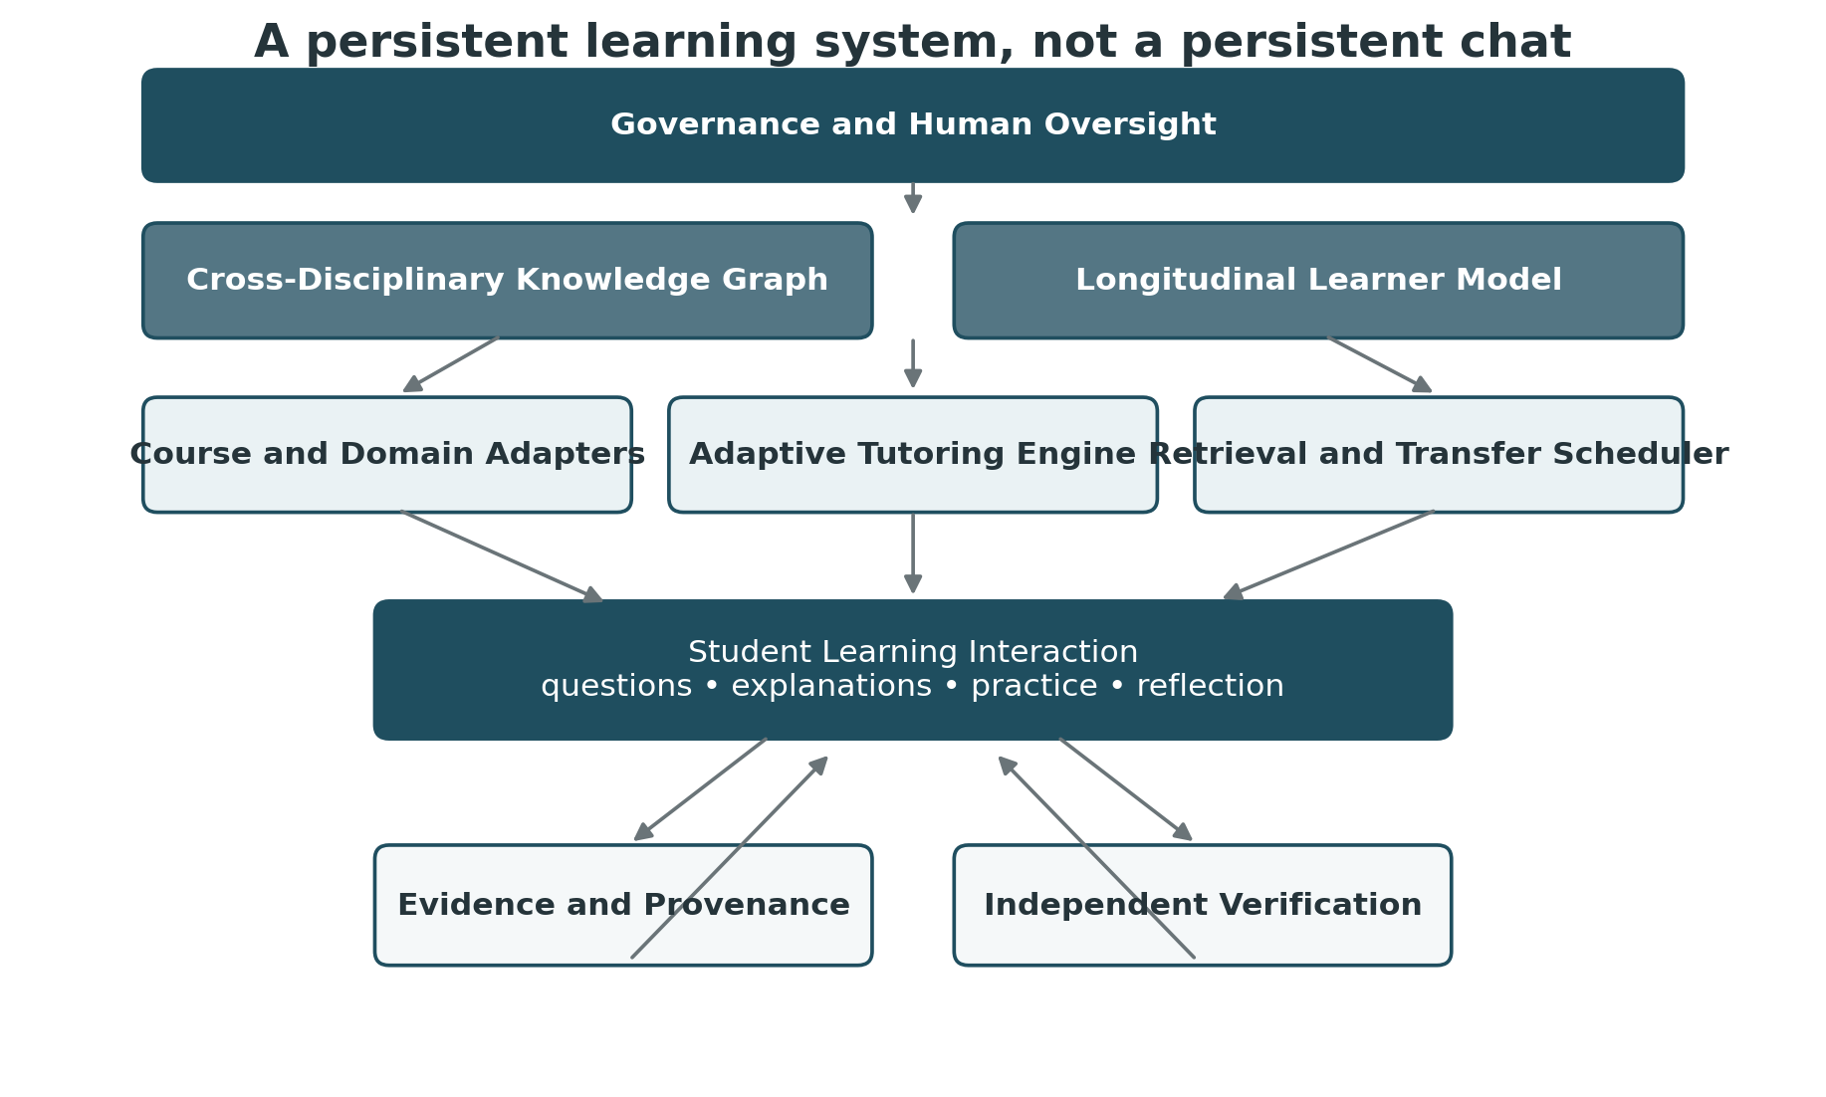
Figure 1. General architecture of the Persistent AI Learning Companion. The language model is only one component. The educational system is created by the layers that constrain, inform, and verify its interaction with the learner.
The architecture separates concerns that ordinary chat systems tend to collapse. Course content is distinct from learner state. Learner state is distinct from raw history. Tutoring policy is distinct from the model’s general capability. Verification is distinct from practice. Governance surrounds the system rather than appearing as an afterthought.

5. The Cross-Disciplinary Knowledge Substrate
The generalized companion requires more than one prerequisite graph. It needs a layered knowledge substrate with at least four linked structures.
- A domain knowledge model that represents the concepts, practices, representations, and standards of reasoning within each discipline.
- A prerequisite graph that identifies what must usually be understood before a higher-level concept becomes learnable.
- A transfer graph that links the same underlying reasoning structure across disciplines, even when the notation or vocabulary changes.
- A misconception model that records common and learner-specific incorrect representations, together with evidence that can distinguish among them.
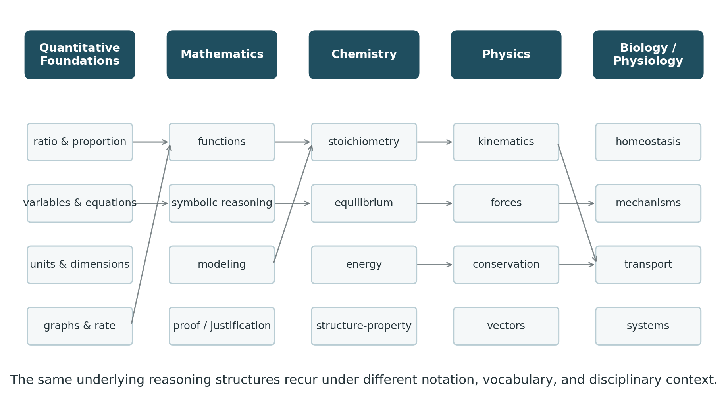
Figure 2. Illustrative cross-course transfer graph. A mature companion would recognize that quantitative and representational structures recur under different disciplinary surfaces.
The transfer graph is what turns a collection of course tutors into a longitudinal learning companion. The system should recognize, for example, that proportional reasoning demonstrated in chemistry is relevant evidence when the learner later encounters scaling in physics or concentration gradients in physiology. It should not assume transfer merely because the underlying structure is similar. It should test whether the learner can recognize and mobilize that structure under the new representation.
Concept identity should persist across courses, while mastery remains context-sensitive. Knowing a ratio in one setting is evidence, not proof, that proportional reasoning will transfer everywhere.

6. The Longitudinal Learner Model
The learner model is the central persistent object. It should be compact enough to remain interpretable, rich enough to guide instruction, and dynamic enough to stop treating old weaknesses as current facts. The model should preserve evidence rather than permanent labels.
Learner state | Operational meaning
Not Assessed | Insufficient evidence exists to make a useful judgment.
Encountered | The learner has been exposed to the concept or practice.
Emerging | Partial understanding is visible, but substantial support remains necessary.
Developing | The learner performs inconsistently or with modest scaffolding.
Reliable | The learner repeatedly performs independently in familiar contexts.
Transfer Ready | The learner recognizes and applies the idea in meaningfully different contexts.
Needs Refresh | Prior evidence was strong, but enough time or failure has passed that current accessibility should be rechecked.

Each state should be supported by an evidence ledger rather than a single hidden score. Evidence can include independent responses, explanations, transfer attempts, error patterns, hint dependence, time since last successful retrieval, and the conditions under which the task was completed.
- Correct after a full solution is shown is weak evidence.
- Correct after a directional hint is stronger but still scaffolded evidence.
- Correct without prompting in a familiar problem is evidence of independent application.
- Correct in a novel representation is stronger evidence of transfer.
- Correct again after a meaningful delay is stronger evidence of durability.
- An old failure should lose weight after repeated recent success.
The learner model should be time-sensitive and forgiving. It should remember enough to help, but not so much that it freezes the learner inside an old description of who they were.

7. Evidence, Misconceptions, and Metacognition
A longitudinal system must distinguish what the learner says about understanding from what the learner demonstrates. Self-report remains useful because confidence, uncertainty, and perceived difficulty shape help-seeking, but self-report should not become a proxy for competence.
Evidence level | Example | Instructional interpretation
Exposure | The learner read or watched an explanation. | Do not infer mastery.
Recognition | The learner identifies the correct idea among alternatives. | Useful but vulnerable to cueing.
Explanation | The learner explains the concept in their own words. | Tests conceptual organization.
Guided application | The learner succeeds with hints or structured prompts. | Evidence of developing competence.
Independent application | The learner solves or explains without support. | Strong evidence in the present context.
Transfer | The learner recognizes the structure in a new context. | Strongest evidence that the concept is becoming usable knowledge.
Delayed retrieval | The learner reconstructs the idea after time has passed. | Evidence of durability rather than immediate fluency.

Misconceptions should be represented explicitly when they are educationally useful. A system that only records wrong answers misses the reason the answer was wrong. A recurring sign error, confusion between correlation and causation, a belief that equilibrium means equal amounts, or the assumption that a function is merely a formula each requires a different instructional response.
Metacognition belongs in the same architecture. The companion should occasionally ask the learner to predict difficulty, explain confidence, identify the source of an error, and compare current understanding to earlier attempts. The goal is not continuous introspection. It is the gradual development of a learner who can recognize when understanding is fragile and choose an appropriate strategy.

8. The Adaptive Tutoring Engine
The tutoring engine converts learner state and domain requirements into the next educational move. It should not maximize helpfulness in the ordinary assistant sense. It should regulate assistance so that the learner remains responsible for the central cognitive operation.
Level | Intervention | Purpose
1 | Retrieval question | Ask the learner to generate the next idea or representation.
2 | Directional hint | Point toward the relevant feature without giving the step.
3 | Explicit scaffold | Narrow the decision space or simplify peripheral complexity.
4 | Analogous example | Model the reasoning on a different problem or context.
5 | Partial demonstration | Show only the missing step, then return the task to the learner.
6 | Prerequisite repair | Move downward to the missing foundational skill and rebuild upward.
7 | Human escalation | Recognize when more AI interaction is no longer the best intervention.

The companion should also change representation when repetition fails. A verbal explanation can become a diagram. A symbolic expression can become a numerical example. A molecular process can become a causal sequence. Code can become a state trace. Repetition is not adaptation if the learner continues to encounter the same explanation in different words.
Pedagogical restraint is a capability. The most advanced tutor is not the one that can always answer. It is the one that knows when answering would interfere with learning.

9. Productive Struggle and Psychological Support
The companion must regulate two failure modes. Too little difficulty encourages offloading. Too much difficulty produces frustration without useful learning. The desired region lies between them and moves as the learner develops.
This regulation should remain educational rather than diagnostic in a clinical or psychological sense. The system does not need to infer stable emotional traits. It needs to recognize interaction patterns that matter for learning. Repeated failed attempts, escalating confusion, or an abrupt drop in task complexity may justify a smaller step, a new representation, a prerequisite check, a short retrieval success, or a recommendation to seek human support.
Encouragement should be evidence-based. Rather than offering generic praise, the companion can point to demonstrated growth. It can remind the learner that a skill once requiring several hints is now being performed independently, or that a previously isolated concept has transferred into a new course. This makes progress visible without pretending that difficult work is easy.

10. Learning Across Time
The defining advantage of a longitudinal companion is that it can manage learning across intervals that are longer than a single conversation. Important concepts should carry a future retrieval state. Successful retrieval lengthens the interval. Failure shortens it or triggers a prerequisite probe. Transfer success changes the kinds of future prompts the system selects.
- Same-day reconstruction can confirm that an explanation was actually encoded.
- Next-day retrieval can expose immediate forgetting before it becomes invisible.
- Weekly retrieval can strengthen durable access.
- Interleaving can mix older and newer concepts so that recognition depends less on chapter order.
- Cross-course retrieval can test whether prior knowledge remains usable when vocabulary and representation change.
- Longer-term verification can identify knowledge that has become dormant and should be refreshed rather than relearned from the beginning.
The system should therefore maintain more than “mastered” or “not mastered.” Learning is temporal. A concept can be secure, fragile, dormant, or reactivated. The retrieval scheduler should treat those states differently.

11. Entanglement and Disentanglement
If AI becomes an ordinary part of learning, assistance and cognition become entangled during practice. That condition does not invalidate the learning process. It changes what must happen for competence to remain interpretable. Periodic disentanglement becomes necessary.
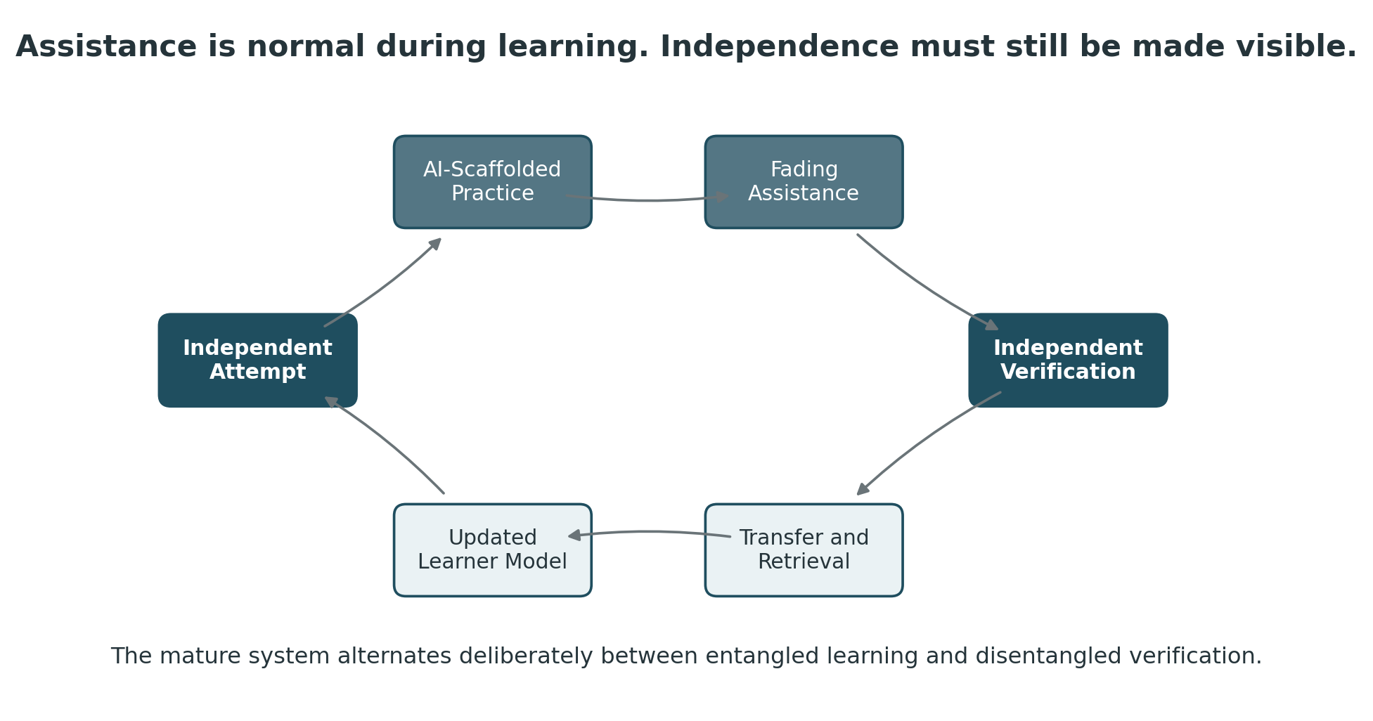
Figure 3. The companion alternates deliberately between AI-supported formation and independent verification. The purpose of verification is not to recreate a pre-AI world. It is to preserve evidence of what the learner can still do when assistance is withdrawn or constrained.
A mature curriculum can therefore distinguish among several conditions. Learners can learn with AI, practice with AI, practice with progressively less AI, and demonstrate important competencies under defined independent conditions. The companion should know which mode it is currently operating in and should never quietly turn a verification task into assisted practice.
The more deeply assistance is embedded in ordinary learning, the more deliberately independence must be made visible.

12. The Student Experience Over an Educational Journey
The interface should remain simple even as the underlying model becomes richer. A first-semester student may experience the companion as a patient tutor that remembers where learning stopped. A second-year student may experience it as a cross-course bridge that notices when prior mathematics or chemistry should be reactivated. A later learner may use it as a rehearsal partner that increasingly asks for justification, transfer, and evaluation of AI-generated work.
Illustrative return message. “Last semester you became reliable with direct proportionality, but inverse relationships remained fragile. Your chemistry work strengthened unit conversion and scientific notation. Today’s physiology topic uses both proportional reasoning and rates, so I would like to check one short relationship before we begin.”
The student should be able to inspect the learning map, ask why the system holds a particular judgment, request a fresh demonstration, and export a compact learning state. Continuity should help the learner, not trap the learner inside an opaque profile.
- Continue where I stopped
- Help me prepare for this week
- Find the prerequisite I am missing
- Practice something that is getting rusty
- Show me how this connects to another course
- Let me prove I know this better than the model thinks I do
- Show me my learning map
- Help me prepare a question for my instructor

13. Educator, Program, and Institutional Intelligence
The learner companion becomes educational infrastructure when structured evidence can improve the environment around the individual student. The instructor-facing system should therefore emphasize patterns and actionable readiness rather than defaulting to complete transcript access.
Level | Useful intelligence | What should normally remain out of view
Student | Personal learning map, evidence, retrieval needs, progress over time | Hidden scoring logic that cannot be explained
Instructor | Course readiness, common misconceptions, prerequisite bottlenecks, escalation requests | Routine access to every private tutoring exchange
Program | Cross-course transfer failures, curriculum gaps, sequence-level patterns | Unnecessary identifiable conversation detail
Institution | Equity of access, system performance, verification quality, governance compliance | Data not needed for a defined educational or legal purpose

At the program level, this can reveal problems that gradebooks rarely expose. A chemistry course may appear successful while students repeatedly fail to transfer proportional reasoning into physiology. A mathematics prerequisite may produce passing grades while formula rearrangement remains a recurring bottleneck in physics. A biology sequence may support recall while students struggle to construct causal mechanisms in later clinical science. These are curriculum questions, not merely student deficits.
The educator remains the architect of the conditions under which assistance is permitted, delayed, withdrawn, and verified. AI can extend practice and feedback. It cannot assume institutional responsibility for what the curriculum claims a graduate can do.

14. Governance, Attribution, and Learner Control
Persistent personalization increases the importance of governance because the value of the system depends on retaining information about the learner. That information should not become a permanent, invisible dossier. The architecture should retain only what has a clear educational function and should make consequential inferences inspectable.
- Learner state should be based on evidence and be correctable through new demonstration.
- Old evidence should decay in instructional weight when it no longer reflects current performance.
- Raw conversation data should have stricter retention and access controls than structured learning summaries.
- Course materials and institutional intellectual property should remain inside approved retrieval environments.
- Learners should know what kinds of data are stored, how long they are stored, and who can see them.
- Cross-course sharing should follow defined educational purposes rather than unlimited institutional visibility.
- Assessment records should indicate the assistance conditions under which performance occurred.
- Important competency claims should be supported by independent or clearly constrained verification.
- The system should preserve provenance so that AI-supported work can be interpreted rather than guessed at.
The governance problem is ultimately one of attribution. Who did the reasoning, under what conditions, with what assistance, and what can the learner still demonstrate when assistance changes?

15. What Remains Distinctively Human
As explanation, computation, drafting, and routine feedback become abundant, the scarce educational outcome moves elsewhere. Across STEM, the enduring value lies increasingly in warranted judgment. The exact form differs by discipline, but the learner must be able to decide whether a result is plausible, whether assumptions hold, whether evidence supports a claim, whether a model applies, whether an algorithm is appropriate, whether uncertainty matters, and whether a conclusion can be defended.
The learning companion should therefore cultivate not only the ability to obtain correct results but also the ability to interrogate results, including results generated by the companion itself. Error identification, counterexample generation, model criticism, uncertainty analysis, assumption checking, and explanation under questioning should become ordinary forms of practice.
The learner should graduate not merely able to use AI, but able to know when AI-supported output deserves trust, revision, rejection, or escalation.

16. How This Can Be Realized Today
The complete vision does not require a new foundation model or a breakthrough in artificial general intelligence. A credible prototype can be assembled from components that already exist. The difficult work is primarily architectural and pedagogical. The institution must decide what the system should remember, how evidence changes learner state, how assistance is constrained, how course content is retrieved, and where independent verification remains necessary.
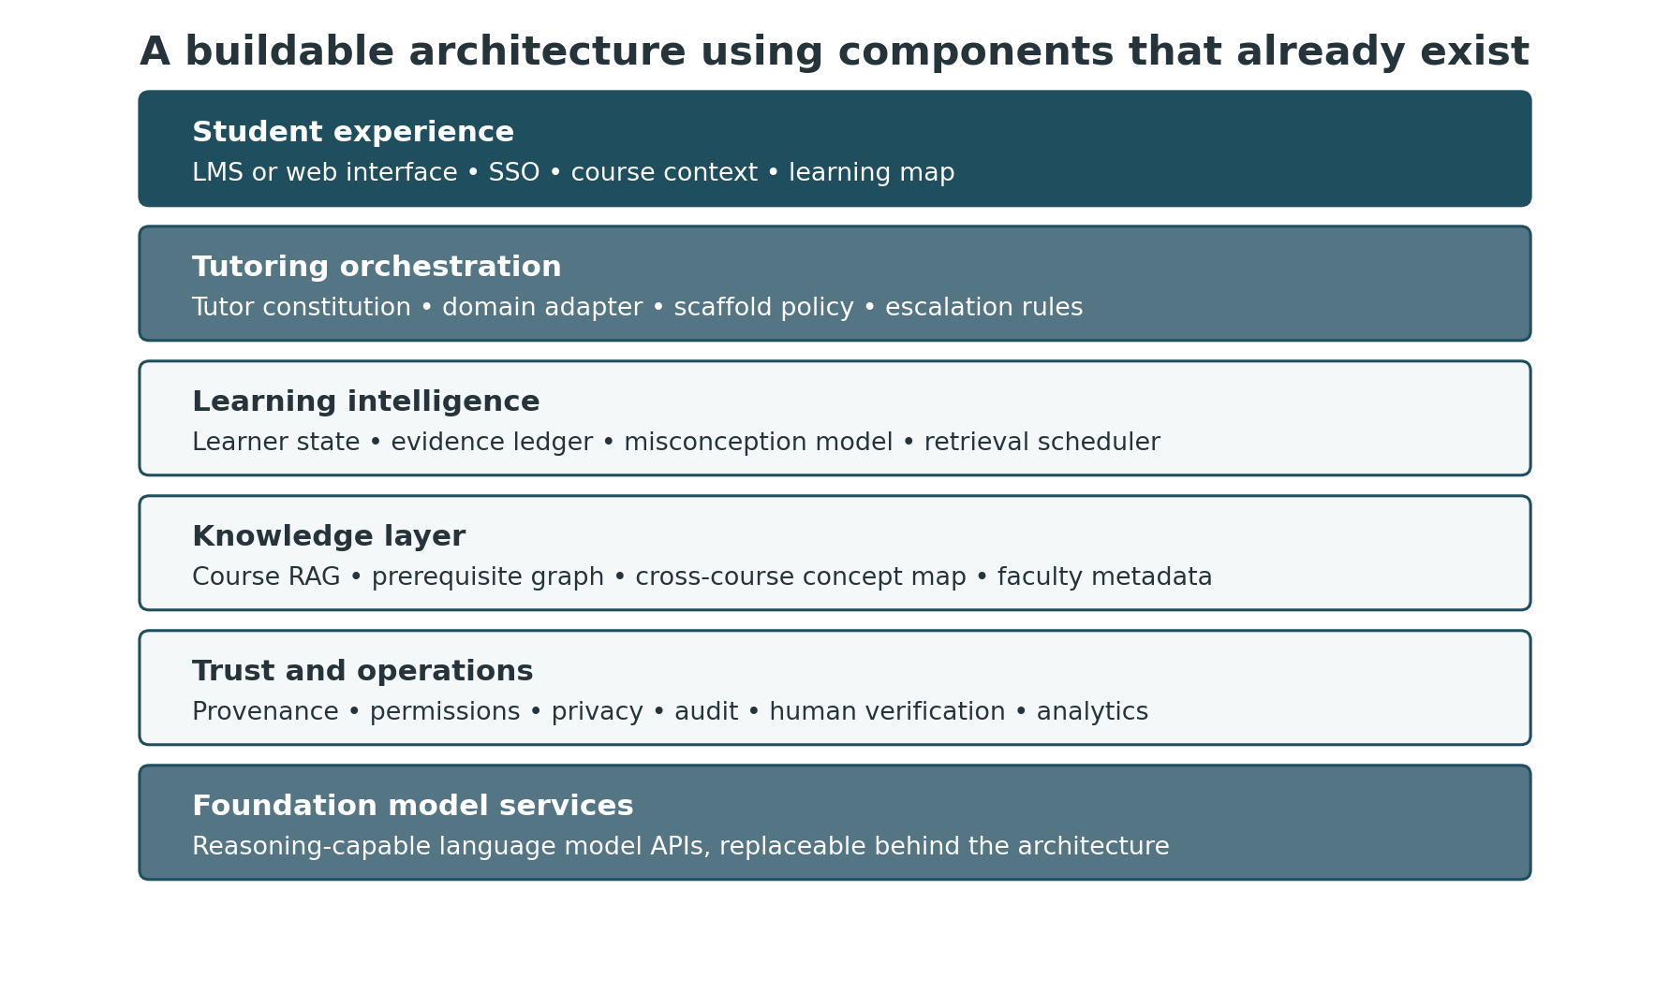
Figure 4. A contemporary implementation stack. The model provider can change without requiring the educational architecture to change with it.
A practical implementation can use the following components.
- A student-facing web or LMS interface with institutional sign-on.
- A reasoning-capable language model accessed through a replaceable model layer.
- A tutoring orchestrator that applies the constitution, domain profile, scaffold policy, and escalation rules before generating a response.
- A retrieval layer that gives the model access to approved course materials, faculty guidance, learning objectives, terminology, and examples.
- A structured learner-state database containing competency states, evidence, misconceptions, retrieval schedules, and learner preferences.
- A prerequisite and transfer graph that connects course concepts to foundational skills and to analogous structures in other disciplines.
- An event and provenance log that records which evidence changed the learner model and under which assistance conditions.
- A scheduler that reintroduces concepts for retrieval, interleaving, and transfer at appropriate future intervals.
- An assessment mode that can deliberately reduce or remove assistance and record independent evidence.
- Instructor and program dashboards that aggregate learning patterns while respecting privacy boundaries.
- Governance controls for permissions, retention, intellectual property, accessibility, auditability, and model changes.
The foundation model is replaceable. The learner model, knowledge graph, tutoring policy, evidence rules, and governance architecture are the enduring educational assets.

17. A Staged Path from Prompt to Infrastructure
Stage | Capabilities | Primary purpose
Stage 0. Prompt prototype | Master tutor prompt, course materials, manual Learning Handoff | Available immediately; validates tutoring behavior and student workflow.
Stage 1. Persistent course companion | Login, course RAG, structured learner ledger, retrieval scheduler | Removes manual handoffs inside one course and creates inspectable learner state.
Stage 2. Cross-course companion | Shared concept graph, transfer links, time-sensitive evidence | Carries relevant learning state from mathematics into science and among science courses.
Stage 3. Program-scale system | Faculty dashboards, curriculum intelligence, human escalation, verification modes | Makes prerequisite bottlenecks and cross-course transfer visible at program level.
Stage 4. Institutional learning companion | Governed longitudinal profile, portable learning map, multi-program adapters | Supports learning continuity across years while separating private tutoring from institutional evidence.
Stage 5. Learner-controlled portability | Exportable standardized learner state and evidence summary | Allows continuity beyond one institution without requiring raw conversation history to travel.

A sensible pilot should not begin at Stage 4. It should begin with one or two courses where prerequisite structure is well understood and where faculty can define the reasoning they want the system to preserve. The system should earn the right to persist more data only after the educational value of that persistence is demonstrated.

18. Minimum Viable Pilot
A small institutional pilot could be built around a linked sequence such as College Algebra, General Chemistry, and General Physics, or around another sequence in which transfer is expected and frequently fails. The pilot would not attempt to model the whole curriculum. It would focus on a finite set of high-leverage concepts and reasoning practices.
- Approximately 30 to 50 foundational competencies with explicit prerequisites.
- Course-specific adapters for two or three participating courses.
- A learner ledger with evidence, hint dependence, misconception notes, and timestamps.
- A retrieval scheduler that can reintroduce concepts across course boundaries.
- Two assistance modes, scaffolded practice and independent verification.
- A student learning map with a challenge-and-retest mechanism.
- An instructor dashboard showing aggregate readiness and recurring misconceptions.
- A privacy model that keeps raw conversation history separate from structured educational state.
- A defined evaluation plan comparing assisted performance, unaided competence, retention, transfer, help-seeking, and student experience.
The first pilot should test the architecture, not merely whether students like the chatbot.

19. What Should Be Evaluated
A system designed around durable competence should be evaluated using outcomes that can reveal both benefit and dependency. Immediate assignment performance is necessary but insufficient.
Evaluation domain | Illustrative question
Independent competence | Can the learner still perform when AI assistance is absent or constrained?
Retention | Does successful performance remain accessible after meaningful delay?
Transfer | Can the learner recognize and apply the same structure in a new representation or discipline?
Scaffold dependence | How much assistance is required, and does that requirement decrease over time?
Metacognition | Does the learner become better at predicting uncertainty and choosing an appropriate strategy?
Help-seeking | Does the system lower barriers to useful help without discouraging human contact when it is needed?
Equity | Do benefits and dependencies differ across student groups, prior preparation, or access conditions?
Faculty value | Does the system reveal actionable learning patterns that improve instruction?
Governance | Can the institution explain how learner data, AI assistance, and competency evidence are being used?

The architecture should also remain falsifiable. If structured tutoring does not improve independent competence, if longitudinal memory does not improve transfer, or if learner modeling produces more misclassification than educational value, the corresponding design assumptions should be revised. The purpose of the framework is not to defend AI. It is to define claims precisely enough that they can fail.

20. An Illustrative Longitudinal Journey
Consider a learner who begins college with weak fraction arithmetic, limited understanding of variables, and substantial anxiety around mathematics. In the first term, the companion discovers that direct proportion is developing while inverse proportion remains fragile. It also learns that diagrams and concrete numerical examples are effective bridges into abstraction.
In chemistry, the learner becomes reliable with scientific notation and unit conversion. Stoichiometry strengthens ratios, but the learner still relies heavily on procedural templates. The companion records that distinction. Months later in physics, it does not begin by reteaching every prerequisite. It briefly verifies the relevant skills, discovers that inverse proportionality remains unstable, and targets that one dependency before the learner begins force and acceleration problems.
In a later physiology course, pressure, flow, resistance, and concentration gradients appear under unfamiliar vocabulary. The companion does not assume that prior success transfers. It uses short probes to test whether the learner can recognize the underlying relationships. When transfer succeeds, the learner model becomes stronger. When transfer fails, the system makes the connection explicit and asks the learner to reconstruct it.
By the second year, the companion is offering less procedural support and more evaluation. It asks the learner to critique model-generated explanations, identify assumptions, compare competing mechanisms, and defend conclusions. The personalization has changed because the learner has changed. The system remembers that development without forcing the student to carry a transcript of every earlier conversation.
The mature companion does not merely know the student’s past. It uses the past to choose a better next learning experience, then allows new evidence to overwrite the past when the student grows.

21. Design Risks That Must Remain Visible
- False precision. A learner model can appear more certain than the evidence warrants.
- Over-persistence. Historical weakness can become a self-fulfilling label if old evidence is not allowed to decay.
- Domain flattening. Generic tutoring rules can distort disciplines whose standards of reasoning differ.
- Cognitive substitution. Personalization can become a more efficient way to provide answers rather than a better way to preserve learning.
- Surveillance creep. Educationally useful persistence can expand into unnecessary monitoring.
- Equity inversion. A system intended to support underprepared learners can widen gaps if higher-quality access is uneven.
- Faculty displacement of judgment. Analytics can become directives rather than evidence for professional interpretation.
- Model drift. Changes in the underlying AI can alter tutoring behavior unless the surrounding policy and evaluation layers remain stable.
- Credential ambiguity. Assisted artifacts can be mistaken for independent competence if verification conditions are not explicit.

22. Questions for Research and Collaborative Design
- What amount and type of evidence should move a concept from Developing to Reliable or Transfer Ready?
- How should time decay affect prior evidence without forcing unnecessary reassessment?
- Which concepts are genuinely transferable across disciplines, and which similarities are only superficial?
- How should the system distinguish a misconception from an arithmetic slip, notation error, or momentary inattention?
- When should the companion withhold assistance, and when does delay become unproductive?
- What aspects of learner state should belong solely to the student, and what can legitimately become institutional data?
- How should students correct, contest, or export the model maintained about them?
- What forms of independent verification are sufficient for different levels of educational and professional consequence?
- How should faculty configure domain adapters without creating unsustainable authoring burdens?
- How do we measure whether the companion is making itself less necessary rather than producing increasingly dependent learners?

23. Conclusion
The course-level AI tutor is a useful beginning, but the larger possibility is a learning relationship that persists as the learner moves through a curriculum. Such a system would not remember everything. It would remember what matters educationally. It would maintain a transparent model of demonstrated competence, connect concepts across disciplinary boundaries, reintroduce fragile knowledge at useful intervals, preserve productive struggle, and deliberately remove assistance when independent capability must be made visible.
This changes the role of AI from a source of answers to an infrastructure for learning continuity. It also changes the role of the educator. When explanation is continuously available, faculty value moves further toward the design of conditions, the interpretation of evidence, the cultivation of synthesis, and the verification of what learners can actually do.
The architecture can begin now in a modest form. The current prompt and handoff approach already approximates several of its functions manually. A persistent course companion can automate continuity. A cross-course graph can make transfer explicit. A retrieval scheduler can manage learning across time. A verification layer can protect the distinction between supported practice and independent competence. None of these components requires waiting for a future model to become intelligent enough to teach.
The deeper challenge is deciding what kind of educational relationship we want the technology to instantiate. If that relationship is designed carefully, the persistent AI learning companion can become something more consequential than an always-available tutor. It can become a longitudinal partner in the development of increasingly independent thought, while leaving human educators responsible for the conditions, standards, and judgments through which that development acquires educational meaning.
The mature system should not make the learner permanently dependent on an always-on tutor. It should use continuity, adaptation, and memory to help the learner require less tutoring for the same class of problem over time.

Appendix A. Minimum Learner-State Schema
Field | Purpose
Concept / skill ID | Stable identifier shared across courses and domain adapters.
Current state | Not Assessed, Encountered, Emerging, Developing, Reliable, Transfer Ready, or Needs Refresh.
Evidence summary | Compact human-readable reason for the current judgment.
Evidence events | Timestamped demonstrations with context and assistance level.
Misconceptions | Active or recently observed incorrect representations.
Hint dependence | Amount of scaffolding required for successful performance.
Last independent success | Recency marker for durable access.
Transfer contexts | Disciplines or representations in which the concept has been successfully applied.
Scheduled retrieval | Next planned check and the reason for it.
Preferred representations | Instructional formats that have helped, without treating preference as fixed learning style.
Escalation status | Whether human support has been recommended or requested.
Learner annotations | Student-visible notes, corrections, or challenges to the current model.

Appendix B. Minimum Data Boundaries
Data class | Example | Default treatment
Course content | Slides, objectives, worked examples, instructor guidance | Institution-controlled retrieval; access follows course permissions.
Structured learner state | Competency states, evidence summaries, retrieval schedule | Persistent with defined retention; student-visible and correctable.
Raw tutoring dialogue | Full conversational exchanges | More restrictive retention; not the default instructor view.
Verification evidence | Independent responses, oral or written demonstrations, assessment conditions | Retained according to educational and institutional requirements.
Program analytics | Aggregated bottlenecks, misconceptions, transfer patterns | Prefer de-identified or minimally identifiable reporting when possible.
Sensitive personal information | Health, disability, private circumstances not required for tutoring | Do not infer or retain unless explicitly required and governed for a legitimate purpose.

Selected References
The following references are carried forward from the working monograph because they directly inform the learning architecture summarized in this whitepaper. This document is a conceptual design paper rather than a complete literature review.
Bailey, M. (2026). The Agentic Discontinuity: Health Professions Education in the Age of AI (2026 through 2036) [Unpublished working monograph].
Bastani, H., Bastani, O., Sungu, A., Ge, H., Kabakcı, Ö., & Mariman, R. (2025). Generative AI without guardrails can harm learning: Evidence from high school mathematics. Proceedings of the National Academy of Sciences of the United States of America, 122(26), e2422633122. https://doi.org/10.1073/pnas.2422633122
Bjork, E. L., & Bjork, R. A. (2011). Making things hard on yourself, but in a good way: Creating desirable difficulties to enhance learning. In M. A. Gernsbacher, R. W. Pew, L. M. Hough, & J. R. Pomerantz (Eds.), Psychology and the Real World: Essays Illustrating Fundamental Contributions to Society (pp. 56–64). Worth Publishers.
Bloom, B. S. (1984). The 2 sigma problem: The search for methods of group instruction as effective as one-to-one tutoring. Educational Researcher, 13(6), 4–16. https://doi.org/10.3102/0013189X013006004
Chi, M. T. H., Bassok, M., Lewis, M. W., Reimann, P., & Glaser, R. (1989). Self-explanations: How students study and use examples in learning to solve problems. Cognitive Science, 13(2), 145–182. https://doi.org/10.1207/s15516709cog1302_1
Fischer, M., Rau, H. A., & Rilke, R. M. (2025). AI tutoring enhances student learning without crowding out reading effort (IZA Discussion Paper No. 18338). Institute of Labor Economics.
Kapur, M. (2008). Productive failure. Cognition and Instruction, 26(3), 379–424. https://doi.org/10.1080/07370000802212669
Karpicke, J. D., & Blunt, J. R. (2011). Retrieval practice produces more learning than elaborative studying with concept mapping. Science, 331(6018), 772–775. https://doi.org/10.1126/science.1199327
Kestin, G., Miller, K., Klales, A., Milbourne, T., & Ponti, G. (2025). AI tutoring outperforms in-class active learning: An RCT introducing a novel research-based design in an authentic educational setting. Scientific Reports, 15, Article 17458. https://doi.org/10.1038/s41598-025-97652-6
Roediger, H. L., III, & Karpicke, J. D. (2006). Test-enhanced learning: Taking memory tests improves long-term retention. Psychological Science, 17(3), 249–255. https://doi.org/10.1111/j.1467-9280.2006.01693.x
Sweller, J. (1988). Cognitive load during problem solving: Effects on learning. Cognitive Science, 12(2), 257–285. https://doi.org/10.1207/s15516709cog1202_4
VanLehn, K. (2011). The relative effectiveness of human tutoring, intelligent tutoring systems, and other tutoring systems. Educational Psychologist, 46(4), 197–221. https://doi.org/10.1080/00461520.2011.611369
Wood, D., Bruner, J. S., & Ross, G. (1976). The role of tutoring in problem solving. Journal of Child Psychology and Psychiatry, 17(2), 89–100. https://doi.org/10.1111/j.1469-7610.1976.tb00381.x

