Post-PoC Project Documentation Package
Project Name: speckit-app
Document Date: 2026-05-28
Document Type: Enterprise Post-PoC Delivery Report

Table of Contents
- 1. Executive Summary
- 2. Project Background
- 3. Proof of Concept Overview
- 4. Solution Architecture
- 5. Functional Requirements
- 6. Technical Implementation Details
- 7. Testing and Validation
- 8. Risks and Limitations
- 9. Recommendations
- 10. Conclusion
- 11. Appendices

1. Executive Summary
Overview of the PoC
The provided documentation describes speckit-app as a fully implemented, production-ready premium airline booking web application with successful build status. [Source: QUICK_START.md - Status/Build; speckit_architecture_document.md - Application Overview]
Business problem addressed
Based on available information, the application addresses the need for a seamless platform to search, filter, view, and progress through flight booking-related user journeys. [Source: speckit_architecture_document.md - Application Overview]
Proposed solution summary
A Next.js 14+ (App Router) and TypeScript-based web application with Tailwind CSS, Framer Motion, Lucide Icons, React Hooks, and static mock flight data has been implemented. [Source: QUICK_START.md - Technology Stack; speckit_architecture_document.md - Technology Stack, Data and State Management]
Key outcomes
- Core routes and workflows implemented: /, /flights, /flights/[id], /about, /faq, /not-found. [Source: QUICK_START.md - Pages Available; speckit_architecture_document.md - Core Pages]
- Documented quality outcomes: TypeScript errors = 0, ESLint errors = 0, accessibility target WCAG 2.1 AA, successful build. [Source: QUICK_START.md - Key Statistics/Accessibility; speckit_architecture_document.md - Key Statistics]
Overall recommendation
Proceed to formal production readiness assessment with focus on currently identified future enhancements (authentication, backend integration, payment processing, user management, admin dashboard) before enterprise production rollout. [Source: speckit_architecture_document.md - Future Enhancements]

2. Project Background
Business context
The project is documented as a premium airline booking platform. [Source: QUICK_START.md title; speckit_architecture_document.md title]
Existing challenges
Information not available in the provided documents.
Objectives of the PoC
Deliver a feature-complete flight booking web application with strong UX, responsiveness, accessibility, and code quality. [Source: speckit_architecture_document.md - Application Overview, Features]
Scope definition
Scope includes implemented pages, search/filter/sort/pagination flows, details view, theme support, responsive behavior, accessibility target, and e2e framework setup. [Source: QUICK_START.md; README.md; speckit_architecture_document.md]
Stakeholders involved
Information not available in the provided documents.

3. Proof of Concept Overview
PoC goals
Create a production-ready, feature-complete web application for airline booking with modern architecture and test framework support. [Source: speckit_architecture_document.md - Application Overview, Testing]
Success criteria
Documented indicators include build success, zero TypeScript errors, zero ESLint errors, and implementation of listed pages/features. [Source: QUICK_START.md - Key Statistics/Status; speckit_architecture_document.md - Key Statistics]
Assumptions
The provided files do not clearly specify formal PoC assumptions.
Constraints
Current data is mock/static; future capabilities such as authentication, backend integration, and payments are not yet implemented. [Source: speckit_architecture_document.md - Data Source, Future Enhancements]
Dependencies
Documented dependencies include Node/npm command tooling, Chromium for Playwright execution, and Vercel/Docker/Node hosting options for deployment. [Source: README.md - Install/Run; QUICK_START.md - Deployment Options; speckit_architecture_document.md - Deployment]

4. Solution Architecture
High-level architecture
Frontend web application built with Next.js App Router and TypeScript, organized under src/ with app/components/data/types/hooks/lib/styles/constants. [Source: QUICK_START.md - Project Structure; speckit_architecture_document.md - Architecture and Project Structure]
Component interactions
Primary flow: landing page -> search submission -> flights results -> filter/sort -> flight details -> booking modal. [Source: speckit_architecture_document.md - Application Flow]
Infrastructure overview
Deployment paths documented for Vercel, Docker (Node 20 Alpine image), and generic Node.js hosts. [Source: QUICK_START.md - Deployment Options; speckit_architecture_document.md - Deployment]
Technology stack
Next.js 14+, TypeScript (strict mode), Tailwind CSS, Framer Motion, Lucide Icons, React Hooks. [Source: QUICK_START.md - Technology Stack; speckit_architecture_document.md - Technology Stack]
Data flow
The provided files do not clearly specify a formal data-flow diagram; data source is static mock data in src/data used by search/results/details workflows. [Source: speckit_architecture_document.md - Data and State Management]
Integration points
Documented integration point: Jenkins pipeline support for test framework via Jenkinsfile. [Source: README.md - Playwright Test Automation Framework]
Security considerations
No validated information was found regarding implemented security controls, threat model, encryption standards, or compliance certifications.
Architecture diagrams
A user journey flowchart is referenced in source documentation. Placeholder: [Insert architecture/user-flow diagram from speckit_architecture_document.md Section 4.2].

5. Functional Requirements
Functional Area | Documented Capability | Status in Source Docs | Traceability
Landing Page | Hero/search/destinations/offers/branding | Implemented | QUICK_START.md - What is Ready
Flight Search | Advanced search, filter, sort, pagination | Implemented | QUICK_START.md - Flight Search; Architecture Doc - Core Pages
Flight Details | Detailed info + booking confirmation modal | Implemented | QUICK_START.md - Flight Details; Architecture Doc - Core Pages
About Page | Company information sections | Implemented | QUICK_START.md - About
FAQ | Accordion-based FAQ interactions | Implemented | QUICK_START.md - FAQ
Not Found | Custom 404 handling | Implemented | QUICK_START.md - Pages Available; Architecture Doc - Core Pages
User workflows
Search and booking workflow is explicitly documented from landing to booking modal. [Source: speckit_architecture_document.md - Application Flow]
Feature validation
Features are described as fully implemented in provided documents. Independent execution evidence is not included in the provided files. [Source: QUICK_START.md; speckit_architecture_document.md]
Use cases covered
Smoke/positive/negative e2e sample features are documented under tests/e2e. [Source: README.md - Playwright Test Automation Framework]
Acceptance criteria status
Formal acceptance criteria definitions are not available in the provided documents.

6. Technical Implementation Details
APIs used
No validated information was found regarding external API endpoints or contracts; application currently uses static mock data. [Source: speckit_architecture_document.md - Data Source]
Services implemented
Frontend application services/components and custom hooks are documented; backend services are not documented as implemented. [Source: QUICK_START.md - Project Structure; speckit_architecture_document.md - Future Enhancements]
Database usage
Information not available in the provided documents.
Cloud services
Vercel deployment is recommended; additional hosting via Docker or generic Node.js hosts is documented. [Source: QUICK_START.md - Deployment Options; speckit_architecture_document.md - Deployment]
Authentication mechanisms
Authentication is listed as a future enhancement and is not documented as implemented. [Source: speckit_architecture_document.md - Future Enhancements]
Deployment process
Documented commands include npm run build and npm start for Node hosts, vercel deploy for Vercel, and Dockerfile-based container startup. [Source: QUICK_START.md; speckit_architecture_document.md - Deployment]
CI/CD setup
Jenkins pipeline support is documented through Jenkinsfile for e2e framework. [Source: README.md - Playwright Test Automation Framework]
Configuration details
TypeScript strict mode and framework/tooling setup are documented; detailed environment configuration values are not provided. [Source: QUICK_START.md - Constitutional Compliance/Technology Stack]
Logging and monitoring
No validated information was found regarding application logging, observability stack, or production monitoring.

7. Testing and Validation
Testing strategy
Documented strategy includes Playwright + Cucumber e2e testing with smoke, positive, and negative scenarios and parallel execution support. [Source: README.md; speckit_architecture_document.md - Testing]
Validation Dimension | Documented Evidence | Status | Source
Build | Compiles without errors | Documented as Success | QUICK_START.md; Architecture Doc - Application Overview
TypeScript Quality | TypeScript errors = 0 | Documented | QUICK_START.md - Key Statistics
Lint Quality | ESLint errors = 0 | Documented | QUICK_START.md - Key Statistics
E2E Framework | Playwright + Cucumber with command set | Documented | README.md; Architecture Doc - Testing
Reports | HTML + JSON + diagnostics artifact locations | Documented | README.md - Reports
Defects/issues identified
No validated defect log or issue list is included in the provided documents.
Resolution status
No validated issue resolution tracker is included in the provided documents.
Performance observations
Documented performance observations: landing page <3s, details <2s, search <5s, animations 60 FPS. [Source: QUICK_START.md - Performance]
Security validation
Information not available in the provided documents.

8. Risks and Limitations
- Current implementation relies on static mock data; no validated backend integration is documented.
- Authentication, payment processing, user management, and admin dashboard are future enhancements and represent functional gaps for full product readiness.
- No validated security control documentation was found.
- No validated production monitoring/logging approach was found.
- No formal stakeholder register, timeline baseline, or governance approvals were found in provided documents.

9. Recommendations
- Define and implement backend API integration strategy and data contracts.
- Implement authentication and authorization model before production rollout.
- Implement payment processing workflow with compliance and security controls.
- Establish formal non-functional testing evidence (load, resilience, security testing reports).
- Add observability baseline (application logs, metrics, alerts, dashboarding).
- Formalize acceptance criteria, stakeholder sign-off workflow, and release governance artifacts.
All recommendations above are based on documented future enhancements and identified information gaps in provided files. [Source: speckit_architecture_document.md - Future Enhancements; QUICK_START.md; README.md]

10. Conclusion
Based on available information, the PoC demonstrates strong technical feasibility for core flight-search and booking-oriented user journeys using a modern web stack, with documented build and code-quality outcomes. Business value is evidenced by complete UI journey coverage and testing framework readiness. However, enterprise production readiness requires closure of currently documented future enhancements and missing governance/security operational evidence.

11. Appendices

Glossary
Term | Definition
PoC | Proof of Concept
WCAG | Web Content Accessibility Guidelines
E2E | End-to-End Testing
CI/CD | Continuous Integration / Continuous Delivery

Acronyms
See glossary table above.

Reference Links / Source Files
- QUICK_START.md
- README.md
- speckit_architecture_document.md

API References
Information not available in the provided documents.

Environment Details
- Framework: Next.js 14+ (App Router)
- Language: TypeScript (strict mode)
- Styling: Tailwind CSS
- Animations: Framer Motion
- Testing framework: Playwright + Cucumber

Supporting Screenshots
Information not available in the provided documents.

Logs
Information not available in the provided documents.

Additional Technical Notes
The provided files do not clearly specify backend architecture, API contracts, database schema, security model, and operational SLO/SLI definitions.

Architecture Addendum (Diagram Included)
This addendum explicitly includes architecture diagrams based only on information documented in QUICK_START.md and speckit_architecture_document.md.

A. High-Level Architecture Diagram
Components shown: user browser, Next.js App Router (TypeScript), UI components/custom hooks, and static mock data in src/data.
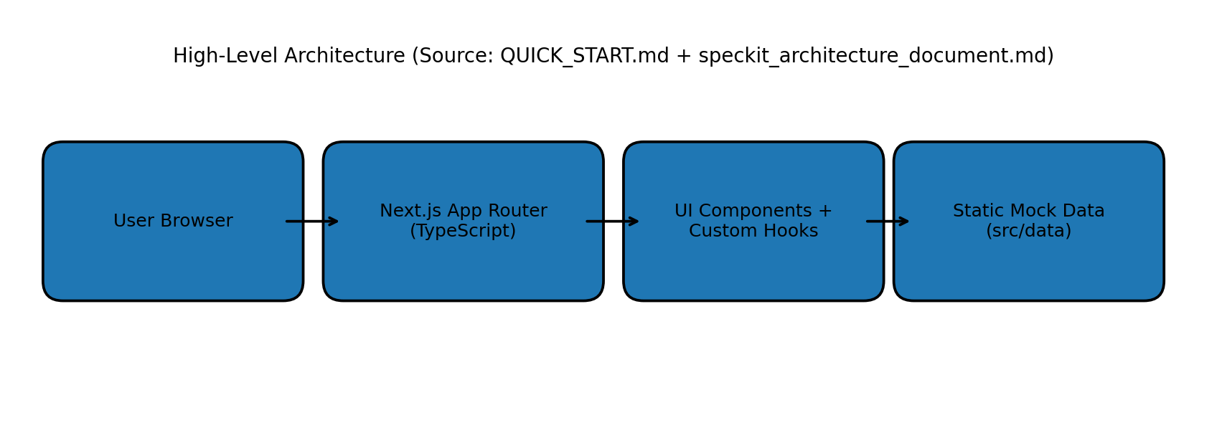

B. User Journey Architecture Flow
Flow shown: Landing Page -> Search Submission -> /flights Results -> Filter/Sort -> /flights/[id] Details -> Booking Modal.
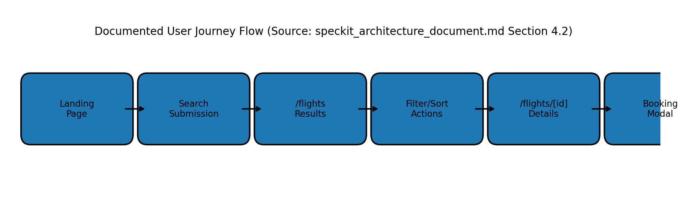

C. Architecture Traceability Notes
- Source for architecture and structure: speckit_architecture_document.md (Sections 3 and 4), QUICK_START.md (Project Structure, Technology Stack).
- Source for flow sequence: speckit_architecture_document.md (Section 4.2, mermaid flow).
- No additional architecture components beyond provided documents were added.

