Test Strategy

SCS Core – Sopra Crypto Solutions

Document Information
Project Name: | SCS Core (Sopra Crypto Solutions)
Document Type: | Test Strategy
Version: | 0.1
Status: | Draft
Author: | Test Team
Date: | June 1, 2026

────────────────────────────────────────────────────────────

Document Control

Revision History
Version | Date | Author | Description
0.1 | June 1, 2026 | Test Team | Initial Draft

Document Approval
Role | Name | Signature | Date
Test Manager
Project Manager
Product Owner
Business Representative

Distribution List
Name | Role | Organization
 | Test Lead | Sopra Steria
 | Product Owner | Bank
 | Development Lead | Sopra Steria
 | Security Lead | Sopra Steria

1. Purpose
This document is the Test Strategy for the SCS Core (Sopra Crypto Solutions) project. It contains the testing requirements and the high-level approach of testing planned for the project. The test strategy helps to ensure that testing is carried out systematically based on the agreed testing approach.
The purpose of this Test Strategy document is to:
- Define overall testing approach that will be taken by the SCS testing team
- Document and achieve agreement to the high-level testing approach for testing of SCS Core
- Clarify the testing activities, roles and responsibilities, Defect Management, Risk Management
- Ensure compliance with banking regulations (KYT, AML, Travel Rule)

2. Intended Audience
This document will be circulated for use by various stakeholders:
Role | Description
Test Manager / Test Lead | Manage testing activities, ensure compliance with strategy
Test Engineers / QA Team | Execute test cases and test governance
Business Analysts | Provide requirements, validate test scenarios
Developers | Support testing, fix defects, provide technical guidance
Product Owner | Review and approve testing approach, accept deliverables
Project Manager | Oversee project delivery, manage risks and escalations
Bank Representatives | UAT execution and validation
Security Team | Security testing oversight, compliance validation
Compliance Team | KYT/AML/Travel Rule validation

3. Project Overview

3.1 Business Description
SCS Core (Sopra Crypto Solutions) is a banking solution developed by Sopra Steria that enables banks to deploy a crypto-account offering for their customers. It provides end-to-end management of digital asset accounts, orders (buy/sell), transactions (deposits/withdrawals), and integration with custodians, order management systems, and exchange venues.

3.2 User Stories
- As a bank customer, I want to create a crypto-account so that I can hold and manage digital assets
- As a bank customer, I want to buy digital assets so that I can invest in cryptocurrencies
- As a bank customer, I want to sell digital assets so that I can convert them to fiat currency
- As a bank customer, I want to deposit digital assets so that I can transfer them to my account
- As a bank customer, I want to withdraw digital assets so that I can transfer them to external addresses
- As a bank user, I want to manage customer accounts so that I can provide support and oversight
- As a bank user, I want to view dashboards so that I can monitor bank positions and operations

3.3 Technology Stack
Component | Technology
Frontend | Web UI (customer and bank user interfaces)
Backend | AWS EKS (Kubernetes microservices architecture)
Database | AWS DocumentDB, S3, EFS
API Type | REST API
Cloud Infrastructure | AWS (EKS, Cognito, API Gateway, WAF, GuardDuty)
Container Orchestration | Kubernetes with Cluster Autoscaler and HPA
Authentication | AWS Cognito with OAuth2, MFA, enterprise SSO
Encryption | TLS 1.3 for data in transit, AWS KMS for data at rest

3.4 External Integrations
System | Provider | Purpose
Custodians | Fireblocks, Taurus | Blockchain interactions, wallet management
Order Management System | Wyden | Order routing and execution
Exchange Venues | Kraken, Coinbase | Order execution
KYT/AML Provider | Chainalysis | Transaction screening, compliance
Core Banking System | Bank CBS | Account information, fiat operations

4. Project Scope

4.1 In Scope

4.1.1 Account Management
Test Area | Process Flow Reference
Customer request to open digital asset account | Figure 7
Customer accesses digital asset dashboard | Figure 8
Customer login | Figure 9
One account per customer limit validation | Acceptance Criteria

4.1.2 Order Management
Test Area | Process Flow Reference
Initiation of buying order | Figure 10
Execution of buying order | Figure 11
Initiation of selling order | Figure 12
Execution of selling order | Figure 13
Customer request cancellation of order | Figure 22
Order Integration Module | Figure 27
Order status transitions | Figure 33

4.1.3 Transaction Management
Test Area | Process Flow Reference
New deposit address request | Figure 14
Deposit receipt | Figure 15
Whitelisted address creation | Figure 16
Customer initiates withdrawal | Figure 17
Withdrawal execution | Figure 18
Internal withdrawal execution | Figure 19
Account-based withdrawal execution | Figure 20
Batch execution for UTXO assets (BTC) | Figure 21
Withdrawal status transitions | Figure 34
Deposit status transitions | Figure 35

4.1.4 Compliance & Monitoring
Test Area | Process Flow Reference
Continuous monitoring | Figure 23
Travel Rule data management | Figure 24
KYT Task Management | Figure 25
Document upload for KYT issue | Figure 32

4.1.5 Additional Features
Test Area | Process Flow Reference
Price management | Figure 26
Limit update management | Figure 28
Tax-related data computation | Figure 29
Tax reports / Statement report generation | Figure 30
Create bank position | Figure 31

4.1.6 Security Testing
- TLS 1.3 enforcement validation
- JWT token validation (structure, claims, expiration, signature)
- SQL injection and XSS attack prevention (WAF rules)
- CORS policy enforcement
- Rate limiting effectiveness
- Unauthorized access attempts (cross-customer access)
- Role-Based Access Control (RBAC)
- Asset-link based access control

4.1.7 API Testing
Method | Endpoint | Description
POST | /accounts | Create account opening request
GET | /accounts | Retrieve account details
POST | /orders | Create buy/sell order
GET | /orders | Retrieve orders
POST | /transactions | Create deposit/withdrawal transaction
GET | /transactions | Retrieve transactions
POST | /bank-user-access-controls | Verify bank user access

4.2 Out of Scope
- Core Banking System (CBS) implementation and internal testing
- Bank-specific authentication provider implementation
- Exchange venue internal logic and testing
- Custodian internal security mechanisms
- Production infrastructure deployment and verification
- Third-party systems not owned by Sopra Steria
- Non-supported browsers or legacy environments

4.3 Assumptions
- Requirements are documented in the SCS Reference Document
- Test environments will be available as per schedule with AWS infrastructure
- Test data will be prepared including JWT tokens with all required claims
- Custodian sandbox/test environments (Fireblocks, Taurus) will be available
- OMS test environment (Wyden) will be accessible
- Mock services for CBS API endpoints will be provided
- Chainalysis test environment will be available for KYT testing
- Digital assets (BTC, ETH, SHIB) will be configured in test environment

4.4 Dependencies
Dependency | Owner | Impact if Not Met
AWS Environment (EKS, Cognito, API Gateway) | DevOps Team | Testing cannot proceed
Custodian Test Environment | External Vendor | Integration testing blocked
OMS Test Environment (Wyden) | External Vendor | Order execution testing blocked
Chainalysis Test Environment | External Vendor | KYT/AML testing blocked
DocumentDB with seed data | DevOps Team | Test data unavailable
JWT Token generation capability | Security Team | Authentication testing blocked
CBS Mock Services | Development Team | CBS integration testing blocked

5. Testing Approach

5.1 Testing Methodology
SCS project is being run in Agile SCRUM methodology. The project is divided into sprints of 2-3 weeks each.

Sprint Testing Process
- Scope Freeze – Pre-condition phase to have better quality
- Sprint Planning – Sprint plans are created for completing product backlog items
- Test Case Creation + BA Review – Detailed test cases are created and reviewed
- Test Execution and Bug Fixing – Execution is performed and fixing is done
- Sprint Retrospective – Lessons learned are captured

Testing Phases
Phase | Description | Entry Criteria | Exit Criteria
Unit Testing | Developer testing | Code complete | All unit tests pass
API Testing | REST API validation | UT complete | All API contracts verified
Integration Testing | External service integration | API testing complete | All integrations verified
System Testing | End-to-end functional testing | SIT complete | All test cases executed
Security Testing | JWT, RBAC, encryption validation | ST in progress | Security requirements met
Performance Testing | Load and stress testing | Core functionality stable | Performance targets met
Compliance Testing | KYT, AML, Travel Rule validation | ST complete | Compliance requirements met
UAT | Bank user acceptance testing | All testing complete | Business sign-off

5.2 Types of Testing

5.2.1 Functional Testing
Testing Type | Description | Coverage
Smoke Testing | Verify critical functionalities after each build | Login, Account, Order
Sanity Testing | Quick validation after bug fixes | Affected functionality
Regression Testing | Ensure existing functionality is not impacted | Full regression suite
Integration Testing | Verify integrations with external systems | Custodians, OMS, CBS
End-to-End Testing | Validate complete business workflows | All user stories
User Acceptance Testing | Bank validation of business requirements | All acceptance criteria
API Testing | REST API contract validation | All endpoints
State Transition Testing | Validate status flow transitions | Order, Withdrawal, Deposit

5.2.2 Non-Functional Testing
Testing Type | Description | Coverage
Performance Testing | Validate API response times | All critical APIs
Security Testing | JWT, TLS, injection prevention | All security requirements
Accessibility Testing | WCAG compliance | Customer and Bank User UI
Usability Testing | User experience evaluation | Key user journeys
Compatibility Testing | Cross-browser testing | Chrome, Firefox, Safari, Edge
Compliance Testing | KYT/AML/Travel Rule validation | All compliance workflows

5.3 Test Design Techniques
Technique | Application
Equivalence Class Partitioning | Valid/invalid JWT tokens, digital assets, amounts
Boundary Value Analysis | Trade limits (min, max), withdrawal limits, precision
Decision Table Testing | Role-based access combinations, order status transitions
State Transition Testing | Order statuses (Fig 33), Withdrawal (Fig 34), Deposit (Fig 35)
Use Case Testing | All user stories, end-to-end workflows
Error Guessing | Edge cases based on domain knowledge
Exploratory Testing | Unscripted testing for defect discovery
API Contract Testing | OpenAPI specification validation

6. Test Deliverables
Deliverable | Description | Owner | Timeline
Test Strategy | High-level testing approach | Test Manager | Project Start
Test Plan | Detailed test planning per sprint | Test Lead | Before Test Design
Test Scenarios | High-level scenarios for each flow | Test Analyst | Test Design Phase
Test Cases/Scripts | Detailed test steps | Test Engineer | Test Design Phase
Test Data | JWT tokens, customer data | Test Analyst | Before Execution
API Test Collections | Postman collections | Test Engineer | Test Design Phase
Security Test Scripts | Security automation scripts | Security Tester | Test Design Phase
Performance Test Scripts | JMeter/Gatling scripts | Performance Tester | Test Design Phase
Defect Reports | Logged defects | Test Engineer | During Execution
Test Execution Report | Daily/Weekly status | Test Lead | During Execution
Test Completion Report | Final summary with metrics | Test Manager | End of Testing
Compliance Test Report | KYT/AML/Travel Rule results | Compliance Tester | End of Testing

7. Entry and Exit Criteria

7.1 Entry Criteria
Category | Criteria | Verification
Environment | AWS EKS environment stable | Health check
Environment | AWS Cognito configured | Login test
Environment | AWS API Gateway accessible | API health check
Environment | DocumentDB has seed data | Data verification
Test Data | JWT tokens prepared | Token generation test
Test Data | Customer accounts created | Account verification
Test Data | Digital assets configured | Configuration check
Test Cases | Test cases reviewed and approved | Sign-off
Build | Build deployed and smoke tested | Smoke test pass
Defects | Severity 1/2 defects resolved | Defect report
Integrations | Custodian sandbox accessible | Integration test
Integrations | OMS test environment accessible | Integration test

7.2 Exit Criteria
Category | Criteria | Target
Execution | All planned test cases executed | 100%
Pass Rate | Test pass rate meets threshold | ≥95%
Critical Defects | No open Critical (S1) defects | 0
High Defects | Open High (S2) defects | ≤2 (with workarounds)
Security | All security test cases passed | 100%
Integration | All integration tests passed | 100%
Compliance | All KYT/AML/Travel Rule tests passed | 100%
Documentation | Test completion report prepared | Approved
Sign-off | Stakeholder sign-off obtained | Signed

8. Defect Management

8.1 Defect Management Process
The standard Sopra Steria defect management process will be followed. The Test Lead will perform the role of Defect Manager. The purpose is to manage recording, tracking, progression and fixing of defects found during testing.

Defect Workflow
- Identification – Defect identified during test execution
- Logging – Defect logged in JIRA with all required details
- Triage – Defect reviewed and prioritized in triage meeting
- Assignment – Defect assigned to developer
- Resolution – Developer fixes the defect
- Retest – Tester verifies the fix
- Regression – Verify no side effects
- Closure – Defect closed upon successful verification

8.2 Defect Logging Standards
All defects must include:
- Title: Clear, concise description
- Description: Detailed steps to reproduce
- Expected Result: What should happen
- Actual Result: What actually happened
- Environment: Environment name, browser, API endpoint
- Attachments: Screenshots, API responses, logs
- Severity: As per definitions
- Priority: As per definitions
- Linked User Story: Reference to requirement

8.3 Defect Triage
A defect triage meeting will be scheduled twice weekly to discuss progress of defects, identify which defects should be fixed first and discuss blockers.
Participants: Test Lead, Dev Lead, BA, Product Owner

9. Roles and Responsibilities
Role | Responsibilities
Test Manager | Project oversight, compliance with Test Strategy, testing schedule
Test Lead | Compliance with Test Plan, defect management, issue resolution
Test Analyst | Testing scope agreement, estimates, test case development
Test Engineer | Test execution, defect logging, evidence collection
Automation Engineer | Automation framework, script development and maintenance
Performance Tester | Performance test design, execution, analysis
Security Tester | Security test design, JWT validation, penetration testing
Business Analyst | Requirements clarification, test scenario review
Developer | Defect resolution, test support, technical guidance
Product Owner | Acceptance criteria, UAT execution, sign-off
DevOps Engineer | Environment setup, deployment, infrastructure support

10. Test Environment

10.1 Environment Overview
Environment | Purpose | Infrastructure | Integrations | Refresh
DEV | Development testing | AWS EKS (Dev) | Mocks only | On-demand
TEST | System testing | AWS EKS (Test) | Custodian sandbox, OMS test | Weekly
STAGING | Pre-production | AWS EKS (Staging) | All external integrations | Per release
UAT | User acceptance | AWS EKS (UAT) | All external integrations | Per release

10.2 AWS Infrastructure Requirements
Component | Specification | Purpose
AWS EKS | Kubernetes cluster | Application hosting
AWS Cognito | Identity provider | Authentication, JWT generation
AWS API Gateway | API management | Rate limiting, WAF integration
AWS WAF | Web application firewall | Security rules
AWS DocumentDB | NoSQL database | Data persistence
AWS S3 | Object storage | Document storage
AWS CloudWatch | Monitoring | Logging, metrics
AWS GuardDuty | Threat detection | Security monitoring
AWS Secrets Manager | Secrets management | API keys, credentials
AWS KMS | Key management | Encryption keys

10.3 Browser/Client Requirements
Browser | Version | Primary/Secondary
Chrome | Latest | Primary
Firefox | Latest | Secondary
Safari | Latest | Secondary (Mac)
Edge | Latest | Secondary (Windows)

10.4 External Integration Environments
System | Environment | Connectivity | Purpose
Fireblocks | Sandbox | HTTPS/API | Custodian integration
Taurus | Sandbox | HTTPS/API | Custodian integration
Wyden | Test | HTTPS/API | OMS integration
Chainalysis | Test | HTTPS/API | KYT/AML screening
CBS Mock | Test | Internal | Core Banking simulation

11. Test Data

11.1 Test Data Strategy
- Sensitive data will be anonymized as per GDPR requirements
- JWT tokens will be generated with all required claims
- Digital assets (BTC, ETH, SHIB) will be configured
- Test customer and bank user accounts will be pre-created

11.2 Authentication Test Data
Data Type | Value/Format | Purpose
Valid JWT Token | Token with claims: sub, iat, exp, client, customer, role | Happy path
Expired JWT Token | Token with past exp timestamp | Token expiration test
Invalid JWT Token | Malformed/corrupted token | Security test
Missing Claims JWT | Token without customer claim | Validation test
Invalid Signature JWT | Token with wrong signature | Security test
Customer Role Token | role = "CUSTOMER" | Customer access test
Bank User Role Token | role = "BANK_USER" | Bank user access test

11.3 Business Test Data
Data Type | Value/Format | Purpose
Valid Customer ID | UUID format | Account operations
Valid Account ID | UUID format | Transaction/Order operations
Valid Idempotency-Key | UUID format | Idempotency test
Duplicate Idempotency-Key | Same UUID as previous | Idempotency validation
Valid Digital Asset | BTC, ETH, SHIB | Order creation tests
Invalid Digital Asset | XYZ (unsupported) | Validation test
Amount within limits | Based on configured limits | Happy path
Amount exceeding limits | Above configured limits | Limit validation
simulationIndicator=true | Query parameter | Simulation mode
simulationIndicator=false | Query parameter | Normal execution
Valid whitelisted address | Blockchain address | Withdrawal test
Invalid blockchain address | Malformed address | Validation test

12. Test Tools

12.1 Test Management Tools
Tool | Purpose | Usage
JIRA | User story management, defect tracking | Daily
Confluence | Documentation repository | Daily
Xray for JIRA | Test case management, execution tracking | Daily

12.2 Testing Tools
Tool | Purpose | Test Type
Postman | API testing, JWT validation | API Testing
REST Assured | API automation | API Automation
Selenium / Cypress | UI automation | UI Automation
JMeter | Performance testing, load testing | Performance
Gatling | Performance testing, stress testing | Performance
OWASP ZAP | Security scanning | Security
Burp Suite | Security testing, request interception | Security
AWS CloudWatch | Log analysis, monitoring | Monitoring

13. Test Suspension and Resumption

13.1 Suspension Criteria
Testing will be suspended if:
- Any eventuality which results in the Test environment becoming unstable
- There are issues in the deployment of the build
- More than 30% of test cases fail in smoke testing
- Critical defects block further testing progress
- External integration services unavailable for >4 hours
- Security vulnerabilities discovered requiring immediate attention
- Data breach or compliance violation detected

13.2 Resumption Criteria
Testing will resume when:
- Issues causing suspension are resolved
- Environment is rolled back to previous acceptable state
- Sanity testing passes on fixed build (100% pass)
- External integrations are restored
- Security issues are remediated and verified
- Approval received from Test Lead/Manager
- Root cause documented and communicated

14. Risk Management

14.1 Risk Identification and Mitigation
Risk ID | Risk Description | Probability | Impact | Mitigation
R001 | AWS environment unavailability | Medium | High | Backup environment, escalation
R002 | Delayed requirement delivery | Medium | High | Buffer in schedule
R003 | Custodian sandbox unavailability | Medium | High | Mock services, vendor escalation
R004 | OMS integration issues | Medium | High | Early integration testing
R005 | Test data unavailability | Medium | High | Early data preparation
R006 | Resource unavailability | Medium | Medium | Cross-training, backup
R007 | Scope changes | Medium | High | Change control process
R008 | Security vulnerabilities | Low | Critical | Early security testing
R009 | Performance issues | Medium | High | Early performance testing
R010 | KYT/AML compliance failure | Low | Critical | Early compliance testing
R011 | JWT token generation issues | Low | High | Pre-generate tokens
R012 | Vendor response delays | Medium | Medium | SLA agreements

14.2 Risk Monitoring
- All project related risks will be maintained in Risk Register
- Risks reviewed in weekly testing progress meetings
- Risk status updated weekly
- Escalation path: Test Lead → Test Manager → Project Manager → Steering Committee

15. Reporting and Communication

15.1 Communication Plan
Communication | Frequency | Participants | Medium
Daily Standup | Daily | Test Team, Dev Team | Teams/In-person
Test Status Report | Weekly | All stakeholders | Email + Confluence
Defect Triage | Twice Weekly | Test Lead, Dev Lead, BA, PO | Meeting
Sprint Review | End of Sprint | All stakeholders | Meeting
Risk Review | Weekly | Test Lead, PM | Meeting
Steering Committee | Bi-weekly | Leadership | Meeting

15.2 Metrics Tracked
Metric | Description | Target
Test Execution Progress | % tests executed vs. planned | 100%
Test Pass Rate | % tests passed vs. executed | ≥95%
Defect Density | Defects per test case | ≤0.1
Defect Resolution Time | Average time to fix defects | ≤2 days (P1/P2)
Test Coverage | % requirements covered | ≥100%
Automation Coverage | % regression tests automated | ≥70%
Defect Leakage | Defects found in UAT/Prod | 0
Blocked Test Ratio | % tests blocked | ≤5%

16. Appendices

Appendix A – Defect Priority Definitions
Priority is about how important it is to the business to fix the problem. Priority is assigned to a defect to help designate the order in which defects should be fixed.
Priority | Definition | Response Time | Fix Timeline
P1 - Critical | System cannot go live. Many test cases blocked. | Immediate | Within 4 hours
P2 - High | Significant impact. Material impact on customer service. | Within 4 hours | Within 24-48 hours
P3 - Medium | Moderate impact. Not enough to prevent going live. | Within 24 hours | Within current release
P4 - Low | No significant impact. Minor or no impact to plan. | Within 48 hours | Future release

Appendix B – Defect Severity Definitions
Severity is a measure of the technical impact on the system if the defect was introduced.
Severity | Definition | Examples
S1 - Critical | Show-stopper. System unavailable. No workaround. | System crash, unauthorized access
S2 - High | Substantial loss of function. Inoperable for majority cases. | Order fails, JWT bypass
S3 - Medium | Minor loss of functionality. Reasonable workaround available. | Non-core issues, UI display
S4 - Low | Easy workaround. Cosmetic problems. | Spelling errors, minor alignment

Appendix C – Test Case Life Cycle
Status | Description
Unexecuted | Default status when test case is added
WIP | Tester has picked up test case for execution
Passed | Expected result matches actual result
Failed | Expected result does not match actual result
Blocked | Cannot execute due to defect or missing functionality
De-Scoped | Functionality obsolete or removed

Appendix D – API Error Codes Reference
HTTP Code | Message | Description
200 | OK | Successful request
206 | Partial Content | Results limited due to pagination
400 | Bad Request | Invalid input data
401 | Unauthorized | Invalid or missing JWT token
403 | Forbidden | Access denied
404 | Not Found | Resource does not exist
429 | Too Many Requests | Rate limit exceeded
500 | Internal Server Error | Technical issues
502 | Bad Gateway | External service unavailable
503 | Service Unavailable | Temporarily unavailable

Appendix E – Business Error Codes
Return Code | Description | HTTP Status
ACCOUNT_ALREADY_EXIST | Customer already has an account | 400
CUSTODIAN_NOT_AVAILABLE | Fireblocks/Taurus API failed | 502
INVALID_DIGITAL_ASSET | Unsupported digital asset | 400
LIMIT_EXCEEDED | Trade or withdrawal limit exceeded | 400
INSUFFICIENT_BALANCE | Insufficient funds | 400
KYT_SCREENING_FAILED | Transaction failed KYT screening | 403
INVALID_ADDRESS | Invalid blockchain address | 400
ADDRESS_NOT_WHITELISTED | Address not whitelisted | 403

Appendix F – Validation Rules
Field | Rule | Error if Invalid
JWT Token | Required with valid signature | 401 Unauthorized
Idempotency-Key | Required for POST, UUID format | 400 Bad Request
simulationIndicator | Optional, boolean | 400 Bad Request
Customer ID | Must match JWT claim | 403 Forbidden
Account ID | Must belong to customer | 403 Forbidden
Trade Amount | Must be within limits | LIMIT_EXCEEDED
Withdrawal Amount | Must be within limits | LIMIT_EXCEEDED
Digital Asset | Must be in enabled list | INVALID_DIGITAL_ASSET
Blockchain Address | Valid format for asset | INVALID_ADDRESS

Appendix G – Glossary
Term | Definition
SCS | Sopra Crypto Solutions
JWT | JSON Web Token - authentication token format
RBAC | Role-Based Access Control
KYT | Know Your Transaction - compliance checking
AML | Anti-Money Laundering
OMS | Order Management System
CBS | Core Banking System
EKS | Elastic Kubernetes Service (AWS)
HPA | Horizontal Pod Autoscaler
UAT | User Acceptance Testing
SIT | System Integration Testing
NFR | Non-Functional Requirements
UTXO | Unspent Transaction Output (Bitcoin model)
MFA | Multi-Factor Authentication
TLS | Transport Layer Security
WAF | Web Application Firewall
PII | Personally Identifiable Information
GDPR | General Data Protection Regulation
Fiat | Traditional government-issued currency
Custodian | Entity managing blockchain interactions
Whitelisted Address | Pre-approved withdrawal destination
Travel Rule | Regulatory requirement for transaction info sharing

Appendix H – Process Flow Diagrams

Architecture Diagrams
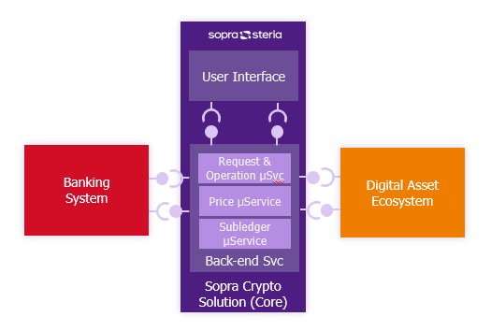
Figure 1 - Overview of the Solution

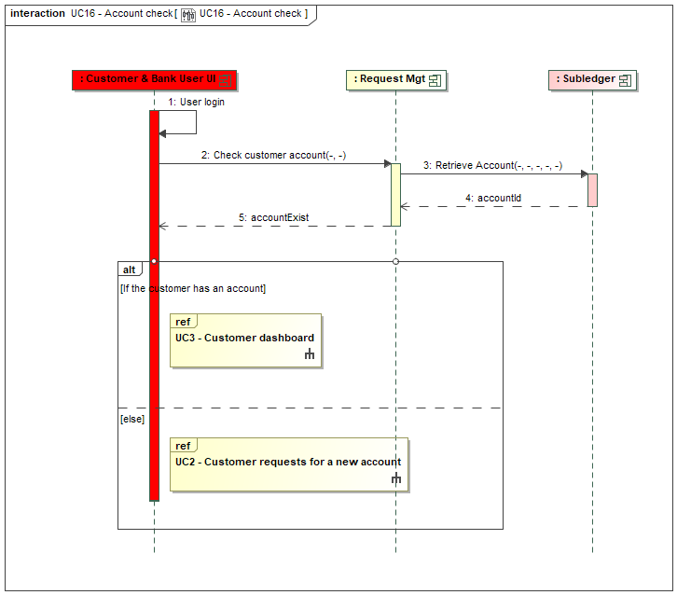
Figure 2 - Capability Map

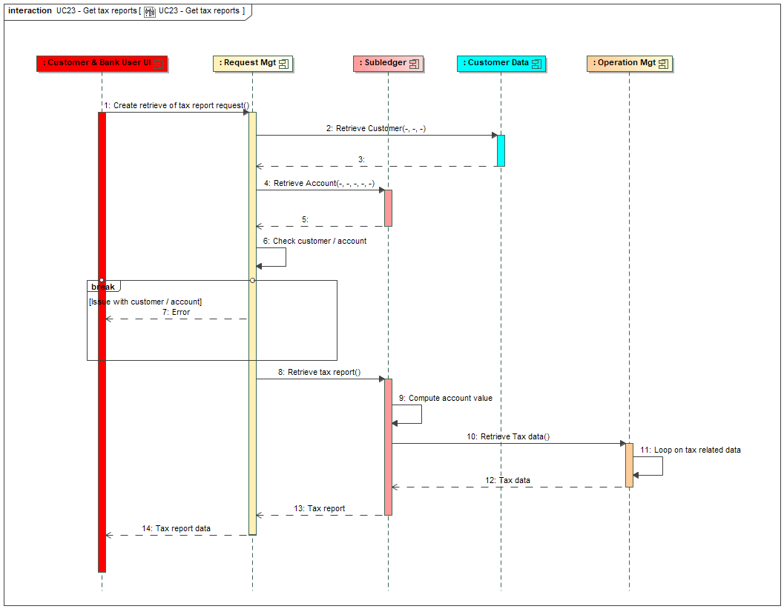
Figure 3 - Subledger Concepts

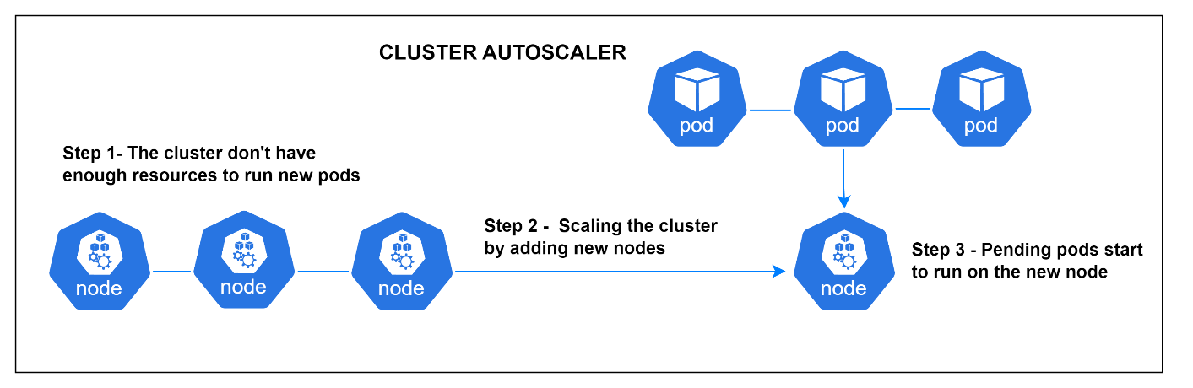
Figure 4 - Application Architecture

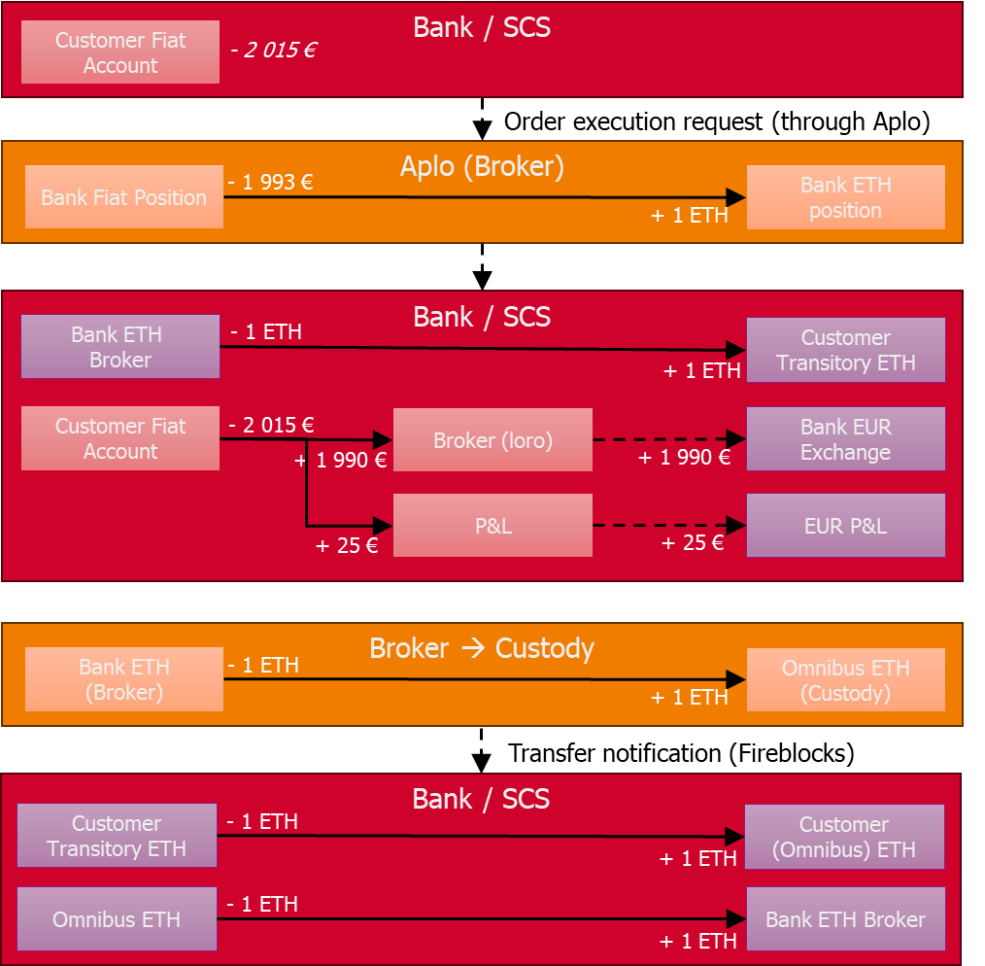
Figure 5 - Deployment

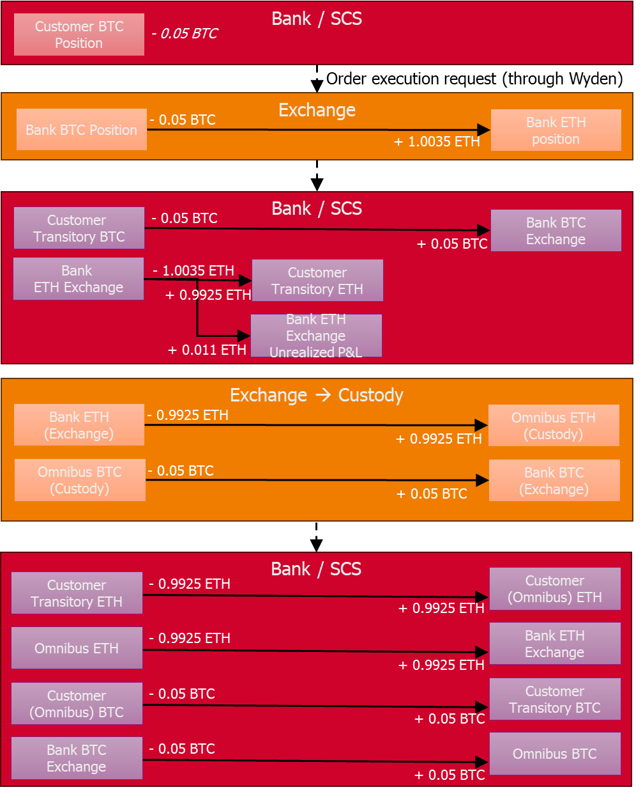
Figure 6 - Link Components vs Capabilities

Account Management Process Flows
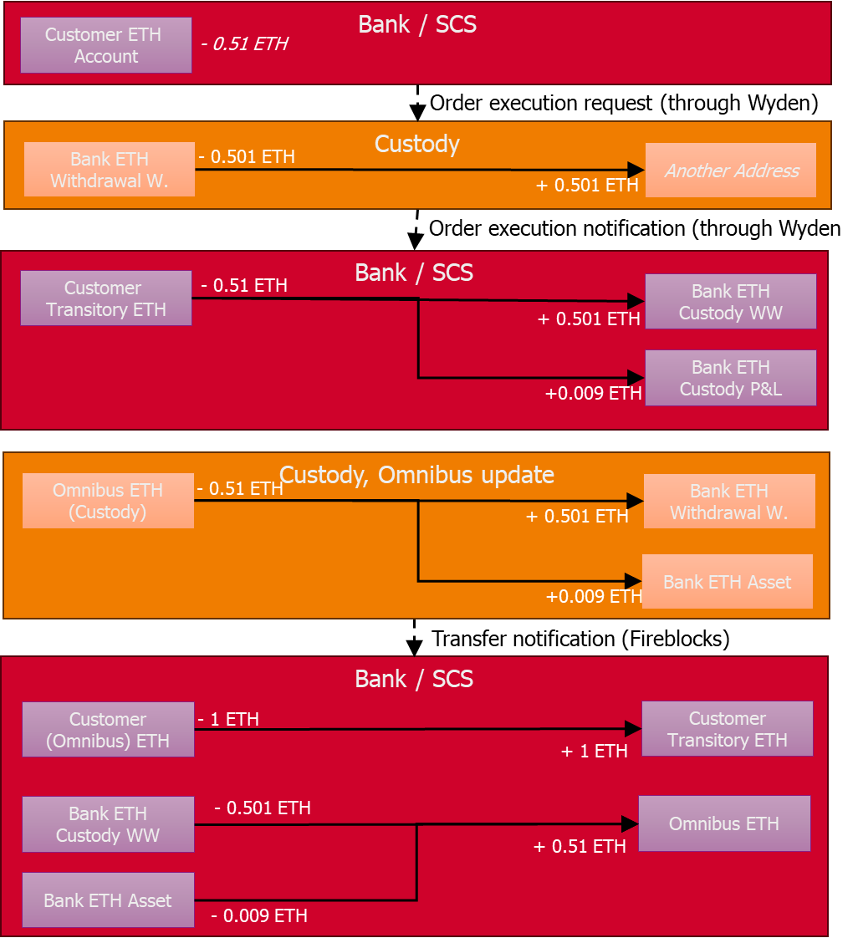
Figure 7 - Customer Request to Open a Digital Asset Account

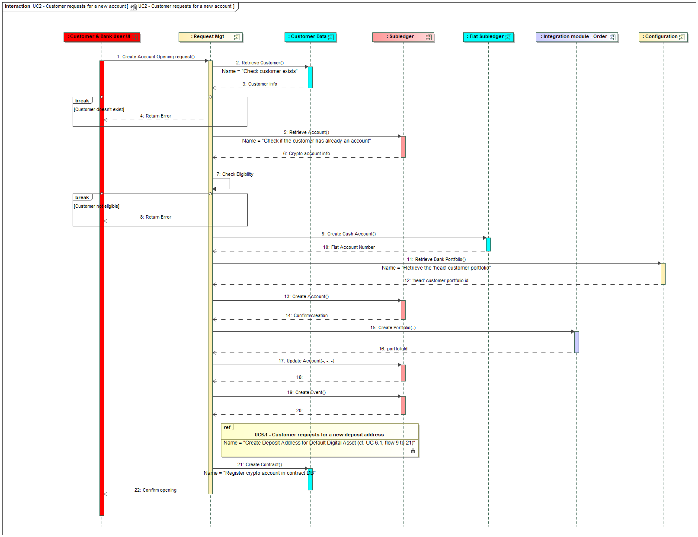
Figure 8 - Customer Accesses a Digital Asset Dashboard

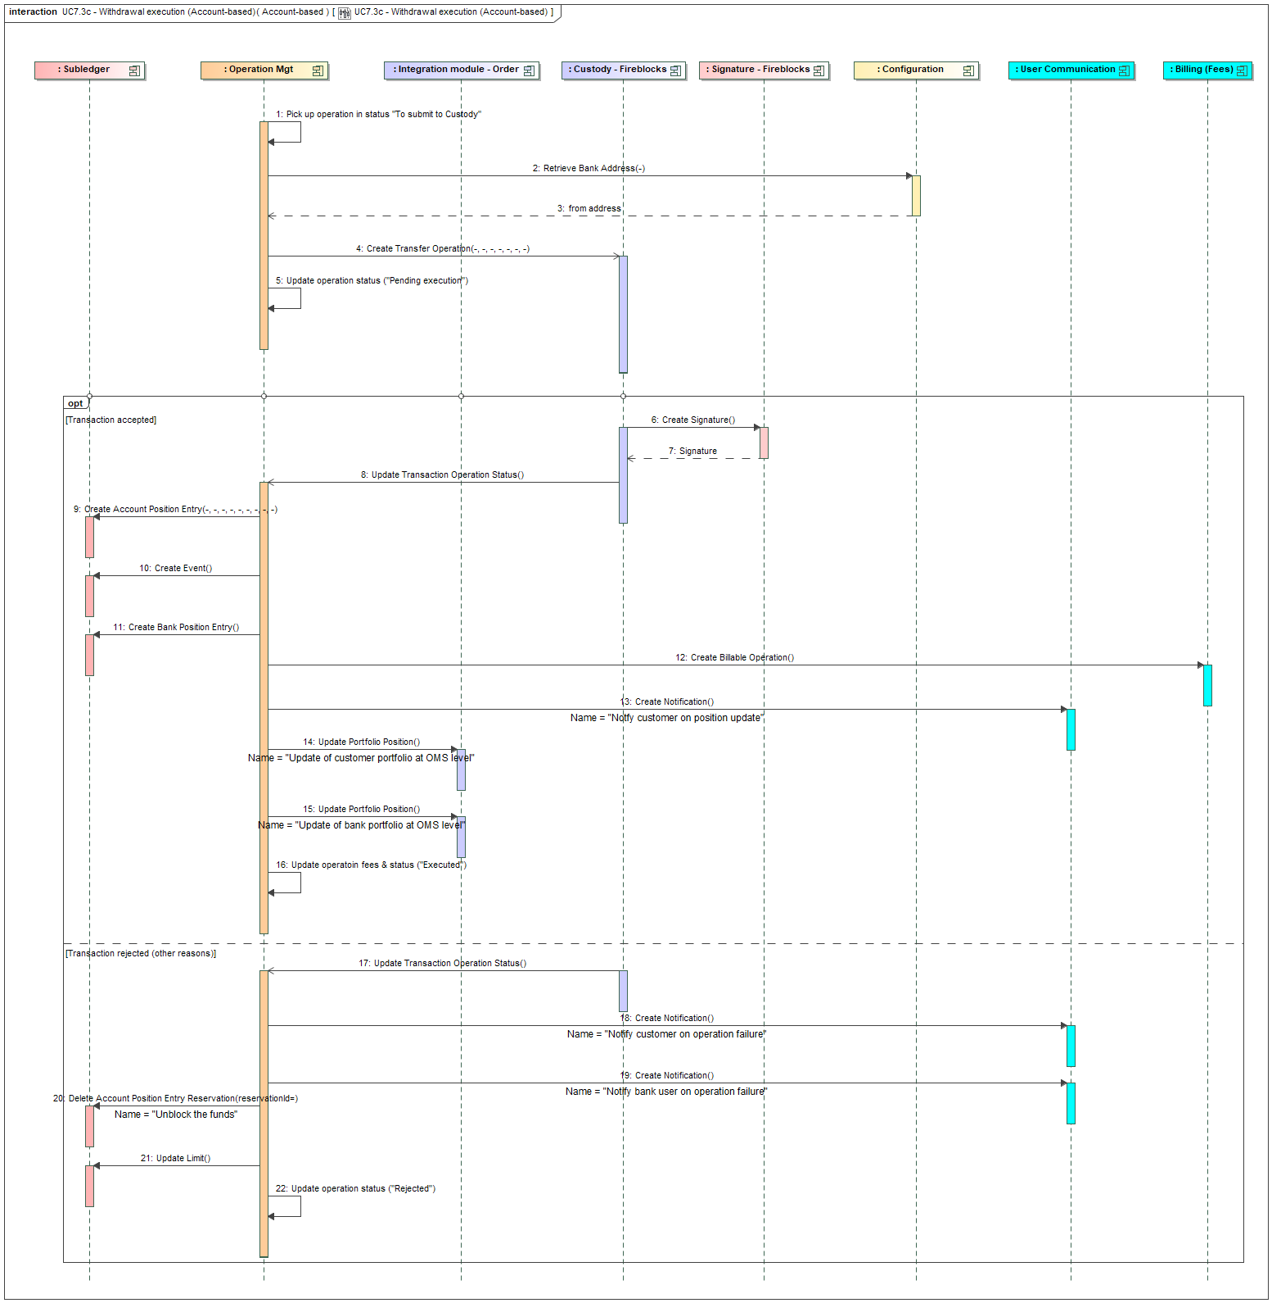
Figure 9 - Customer Logs In

Order Management Process Flows
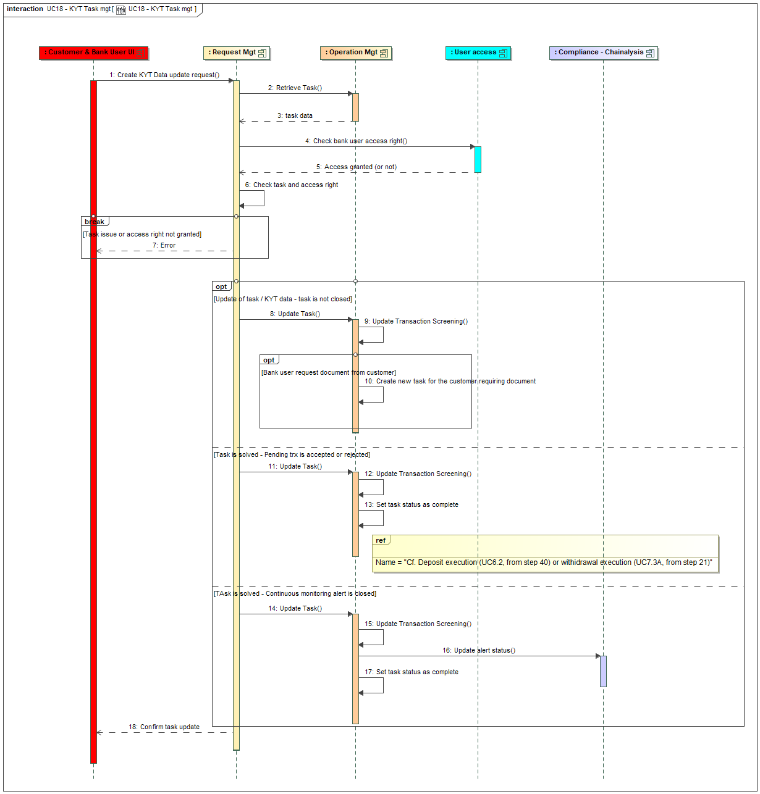
Figure 10 - Initiation of the Buying Order

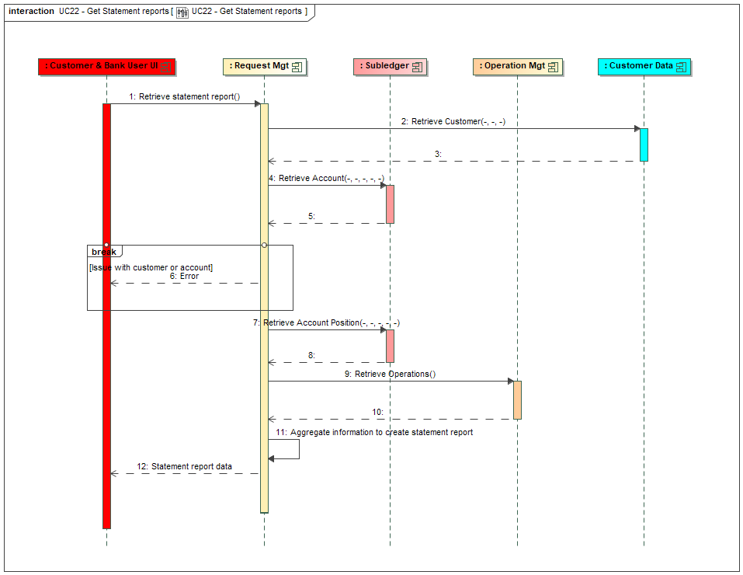
Figure 11 - Execution of a Buying Order

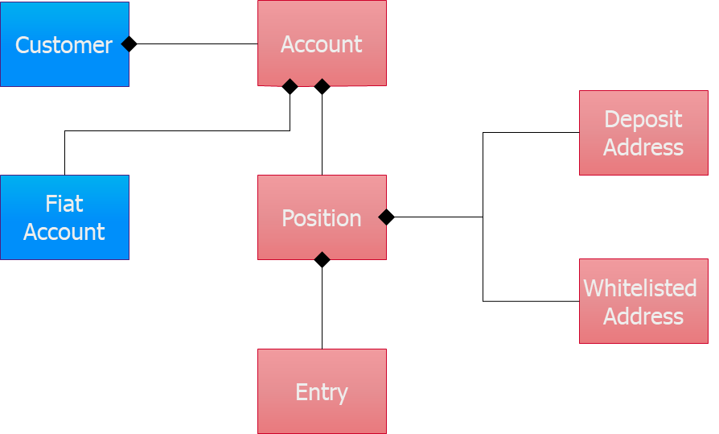
Figure 12 - Initiation of a Selling Order

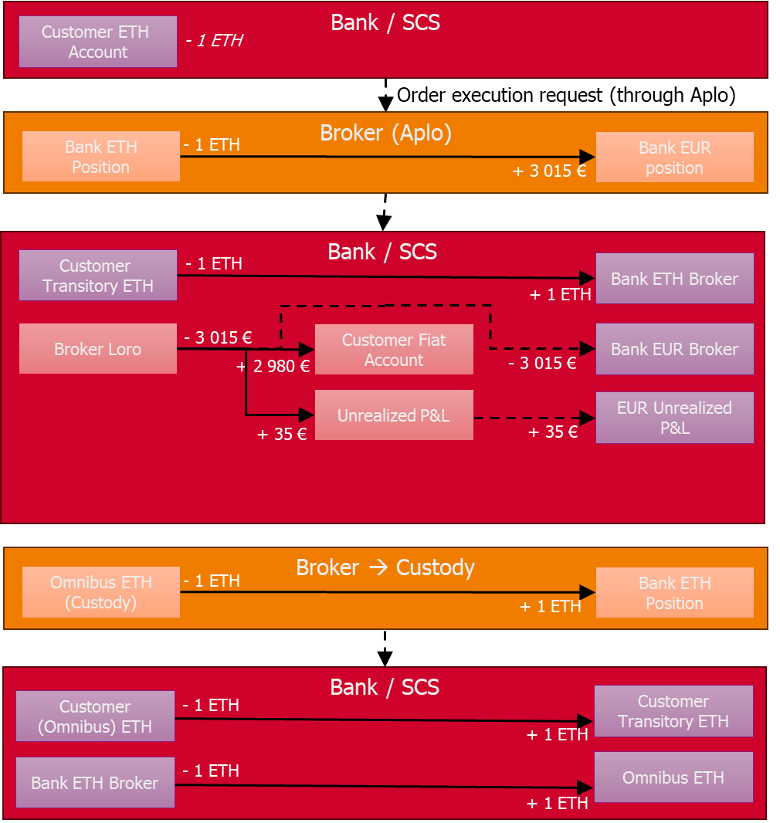
Figure 13 - Execution of a Selling Order

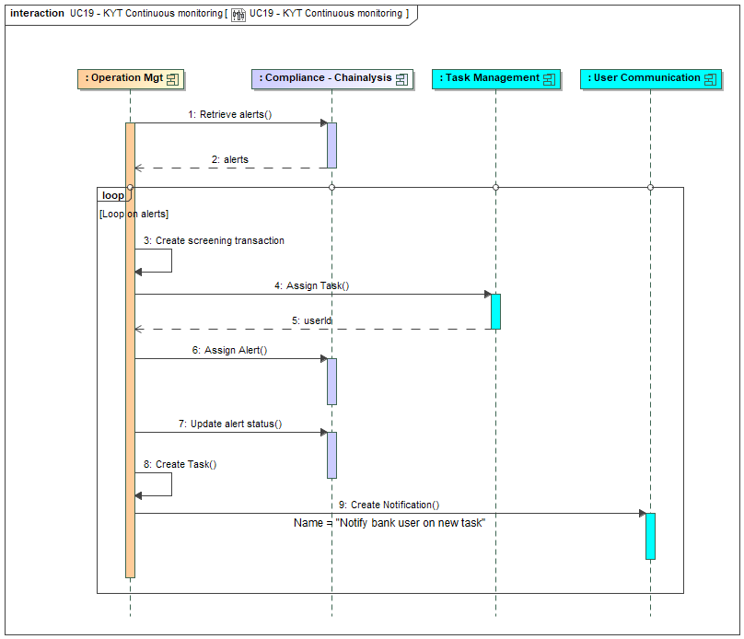
Figure 22 - Customer Request Cancellation of an Order

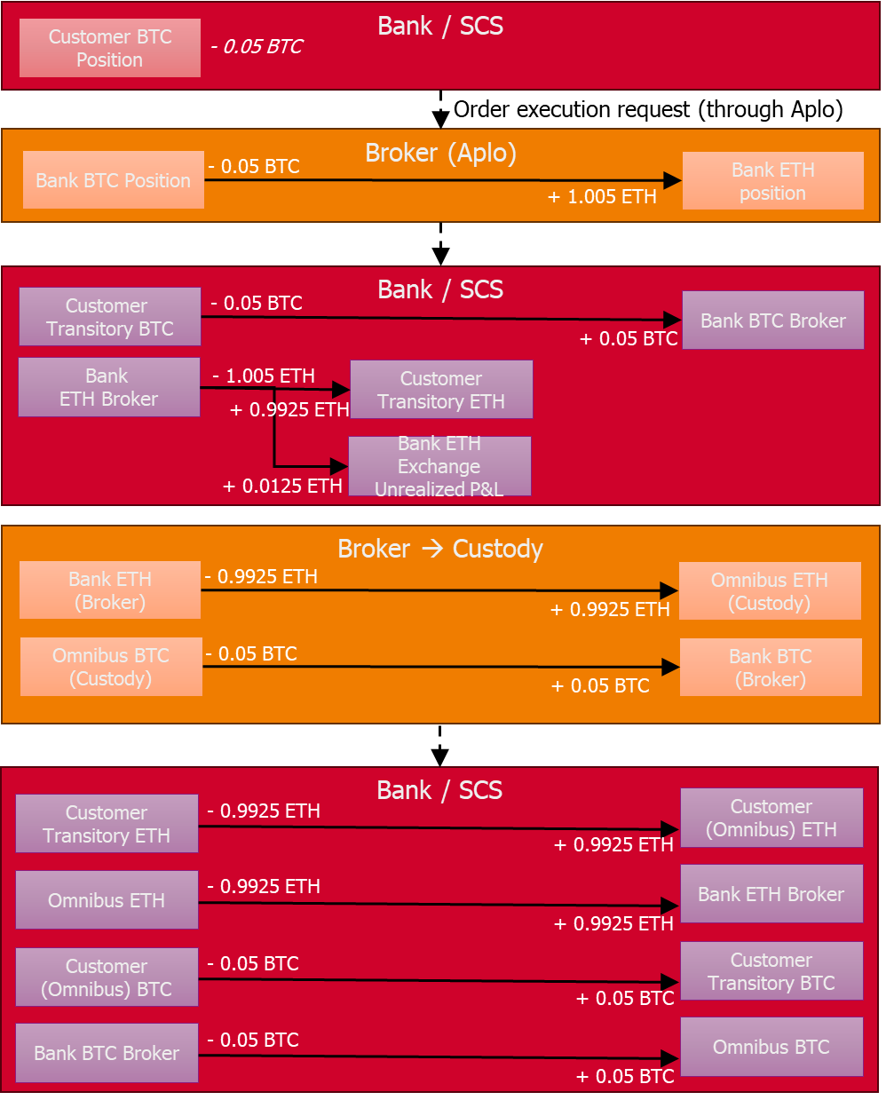
Figure 27 - Order Integration Module

Transaction Management Process Flows
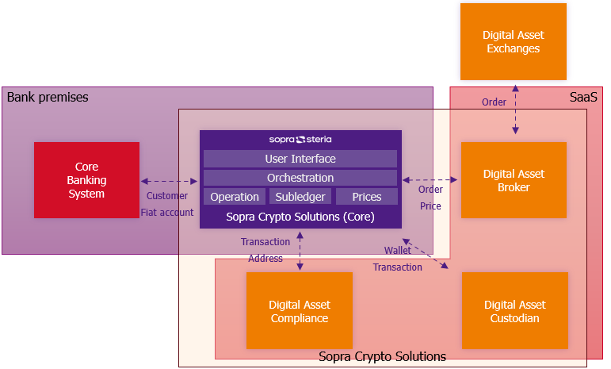
Figure 14 - New Deposit Address Request

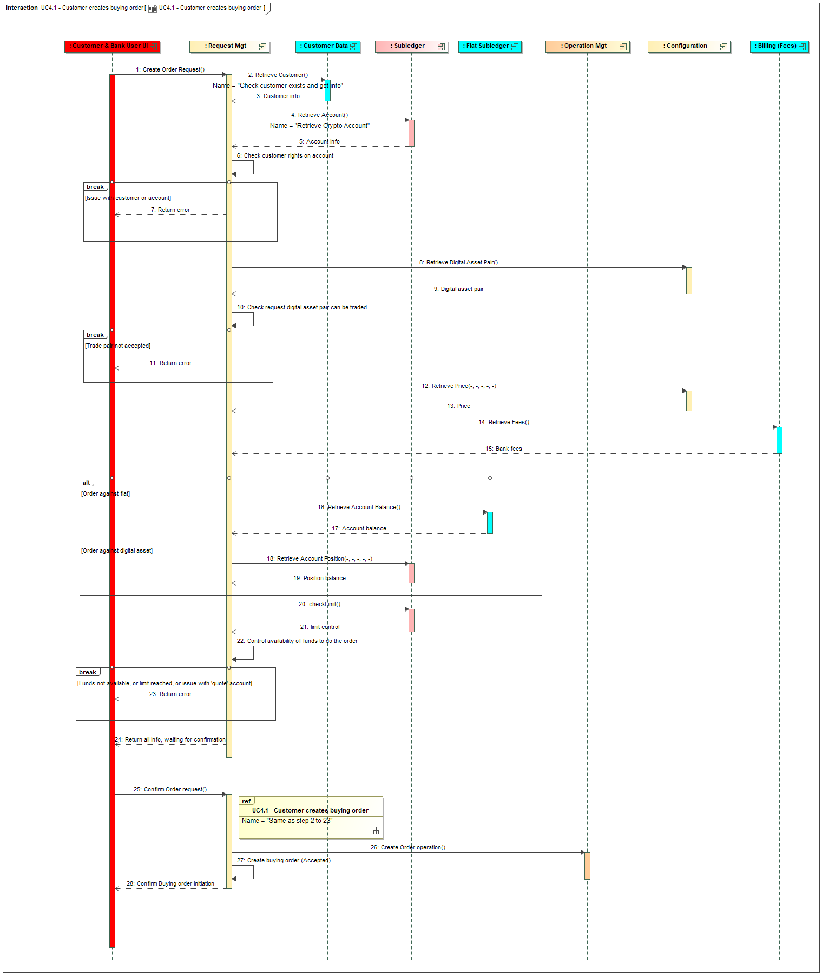
Figure 15 - Deposit Receipt

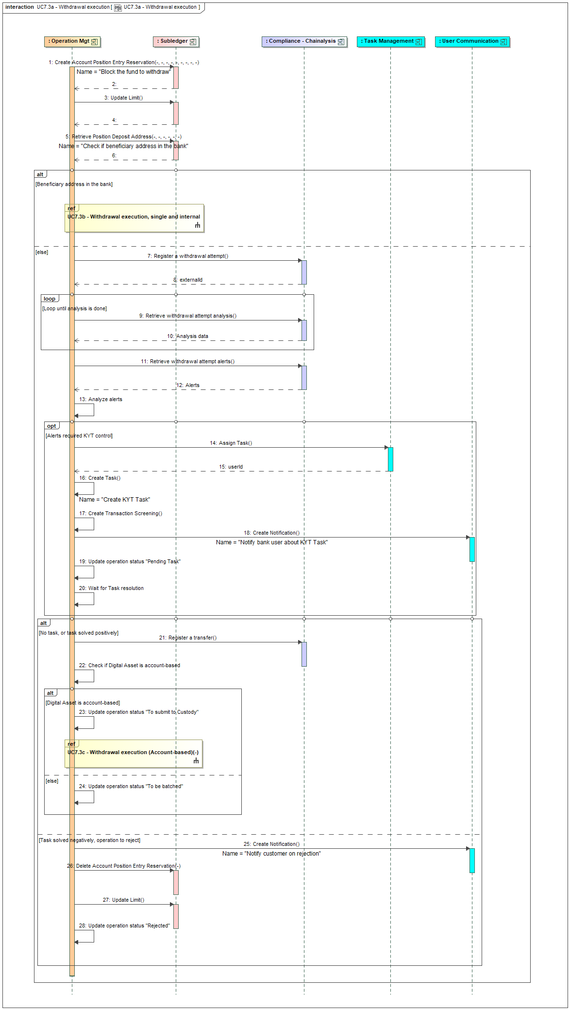
Figure 16 - Whitelisted Address Creation

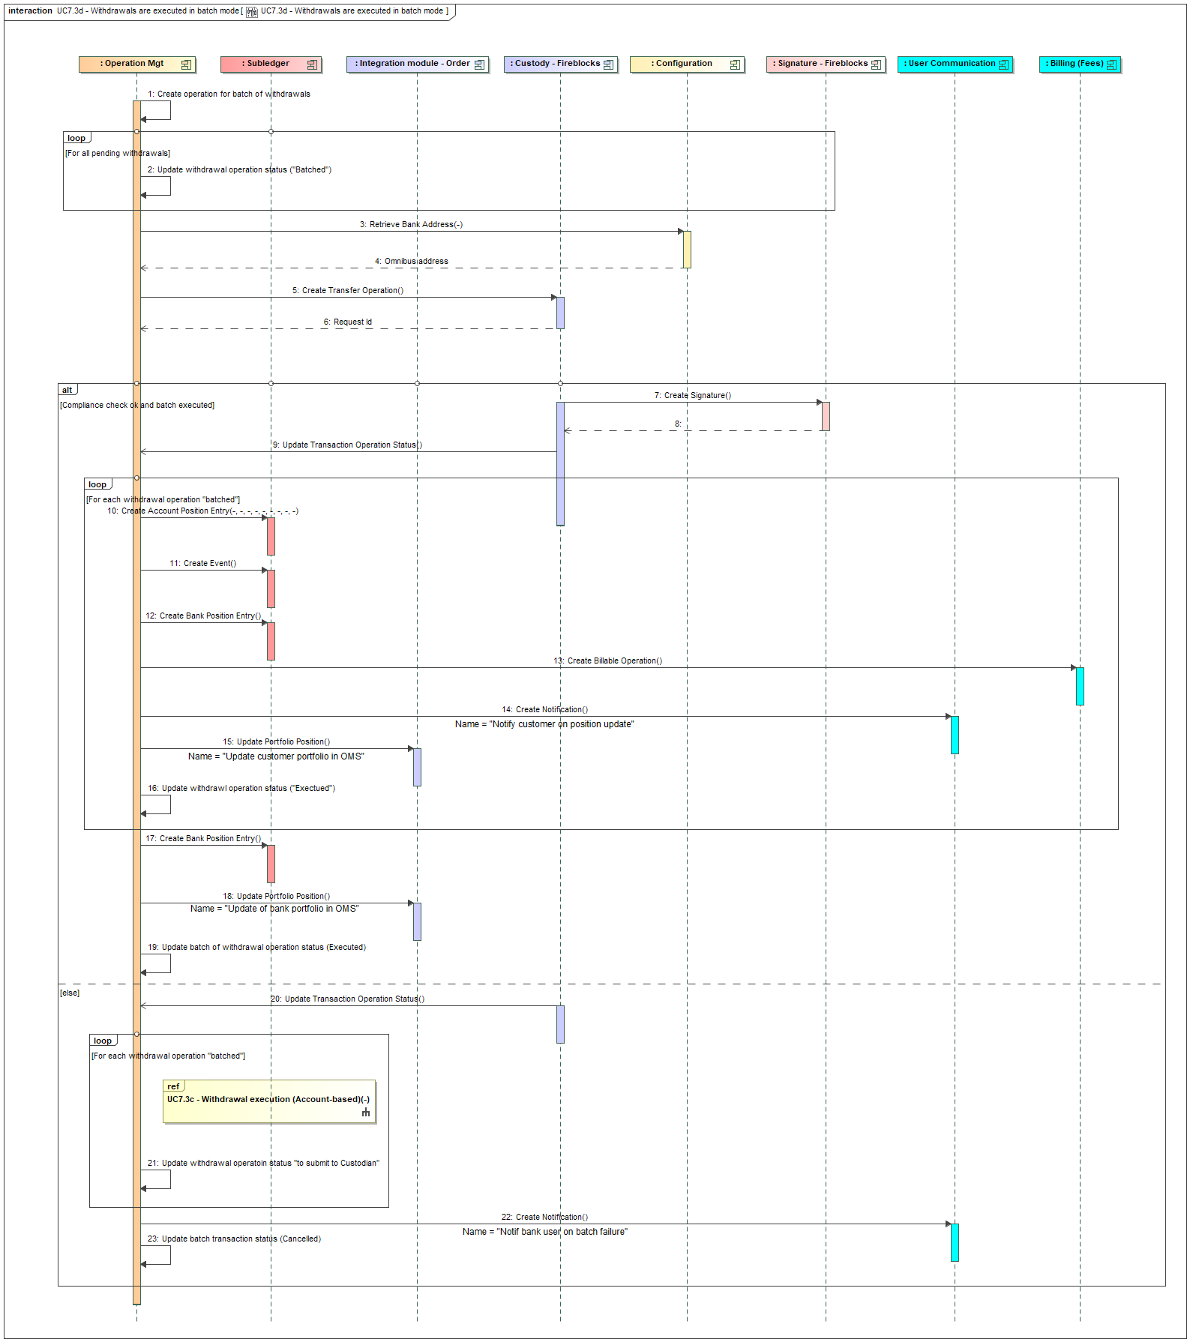
Figure 17 - Customer Initiates Withdrawal

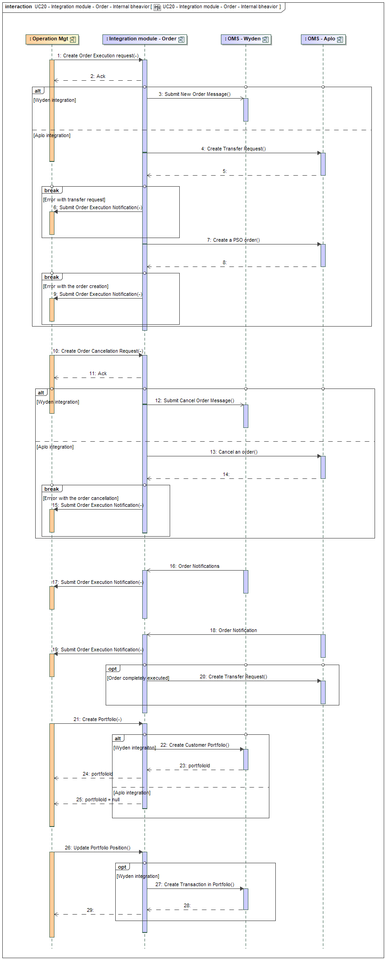
Figure 18 - Withdrawal Execution

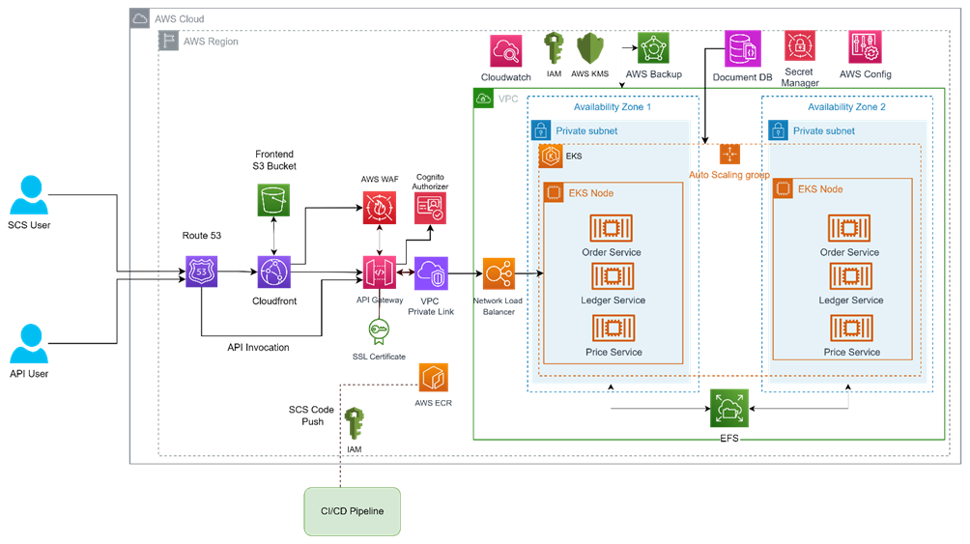
Figure 19 - Internal Withdrawal Execution

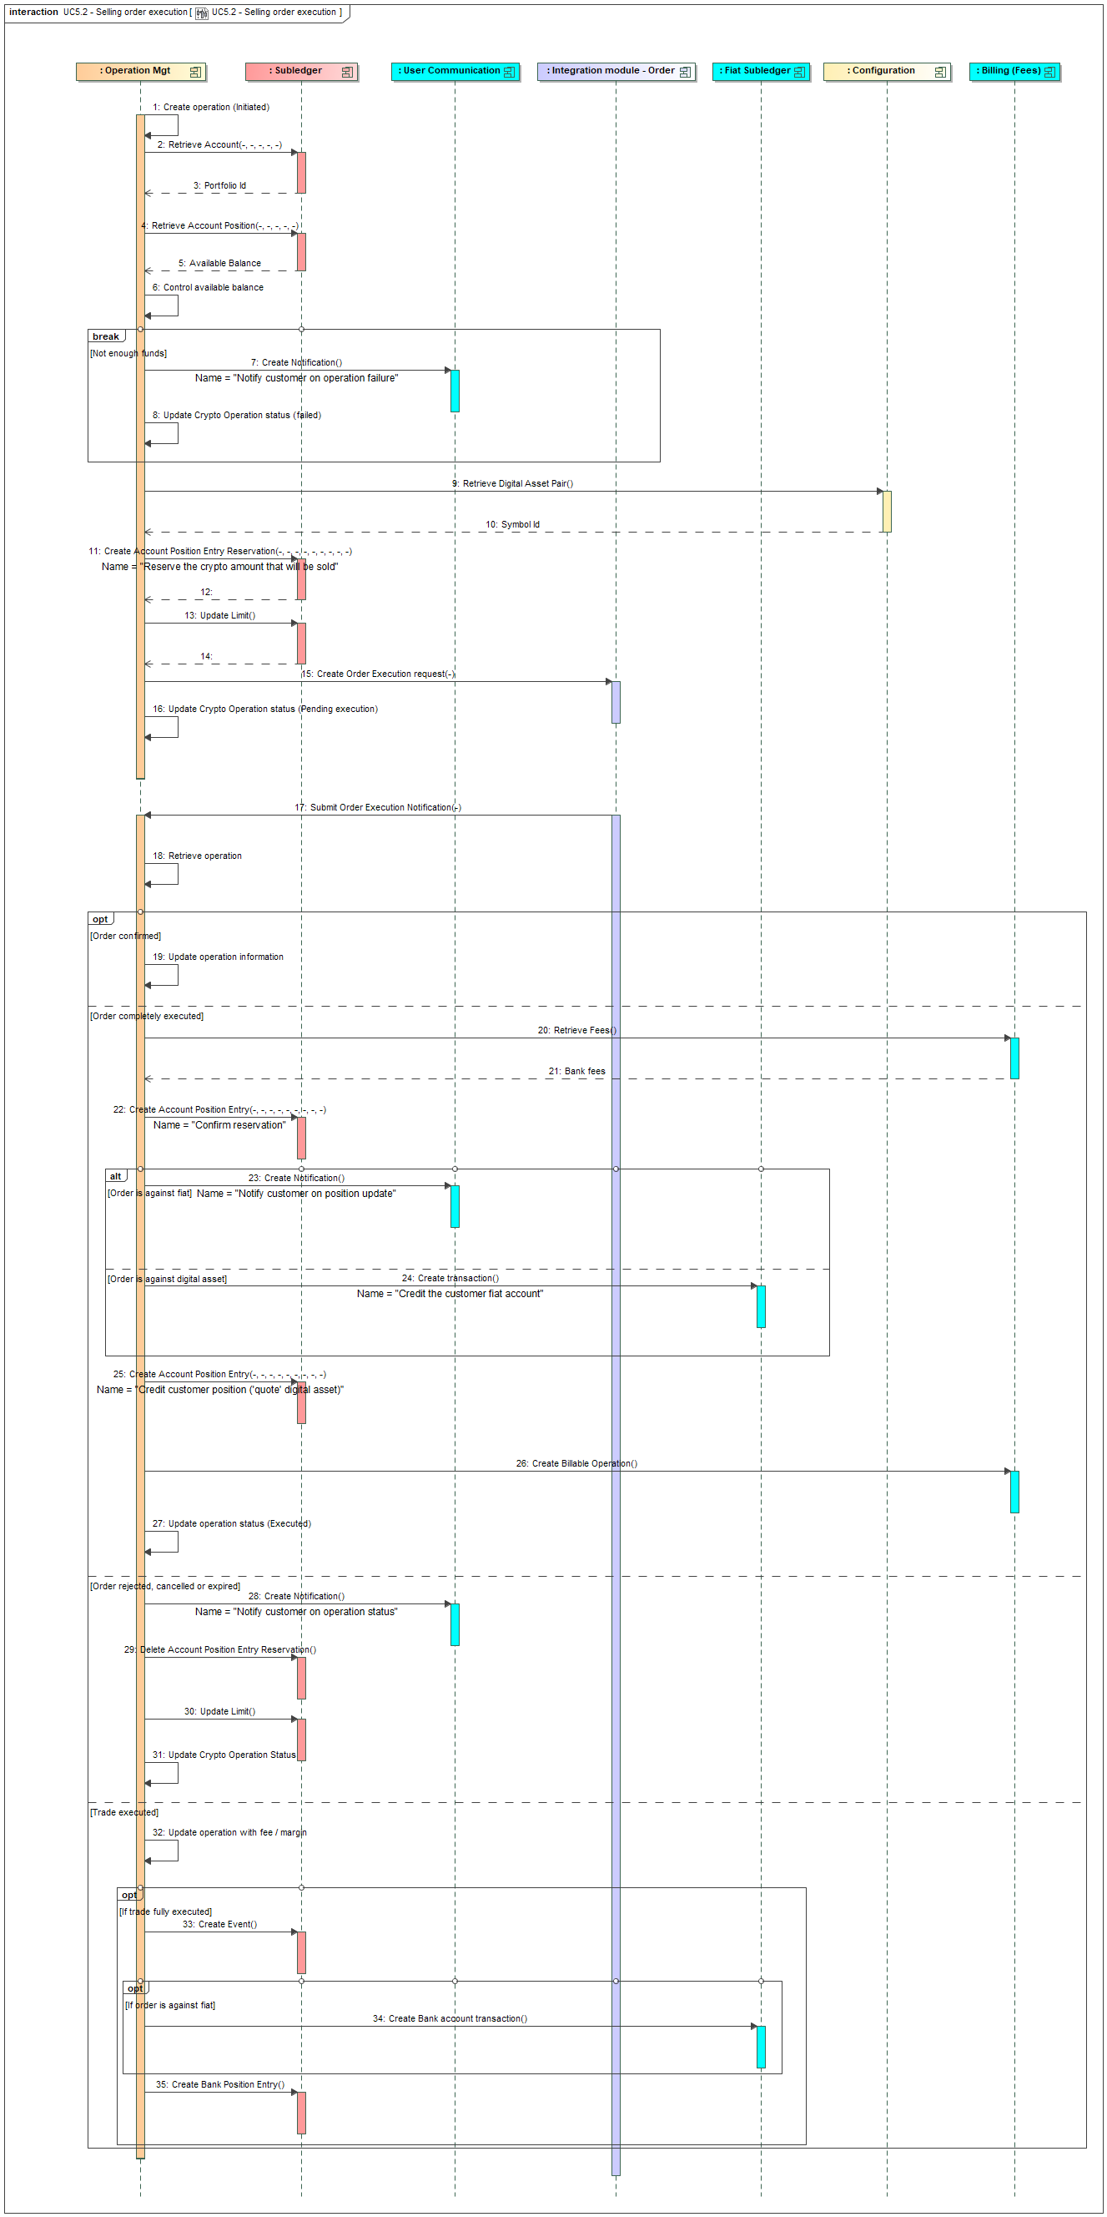
Figure 20 - Account-based Withdrawal Execution

Compliance & Monitoring Process Flows
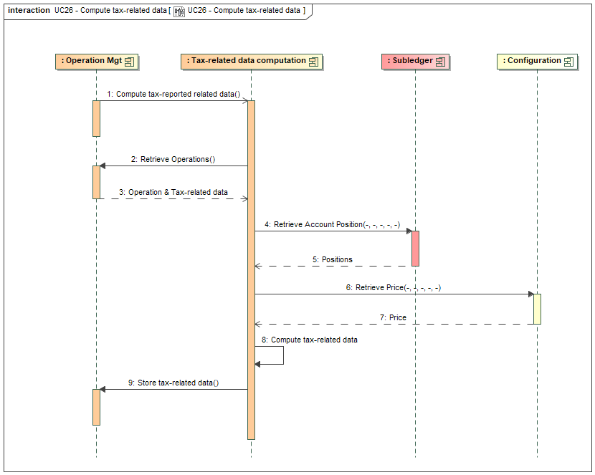
Figure 23 - Continuous Monitoring

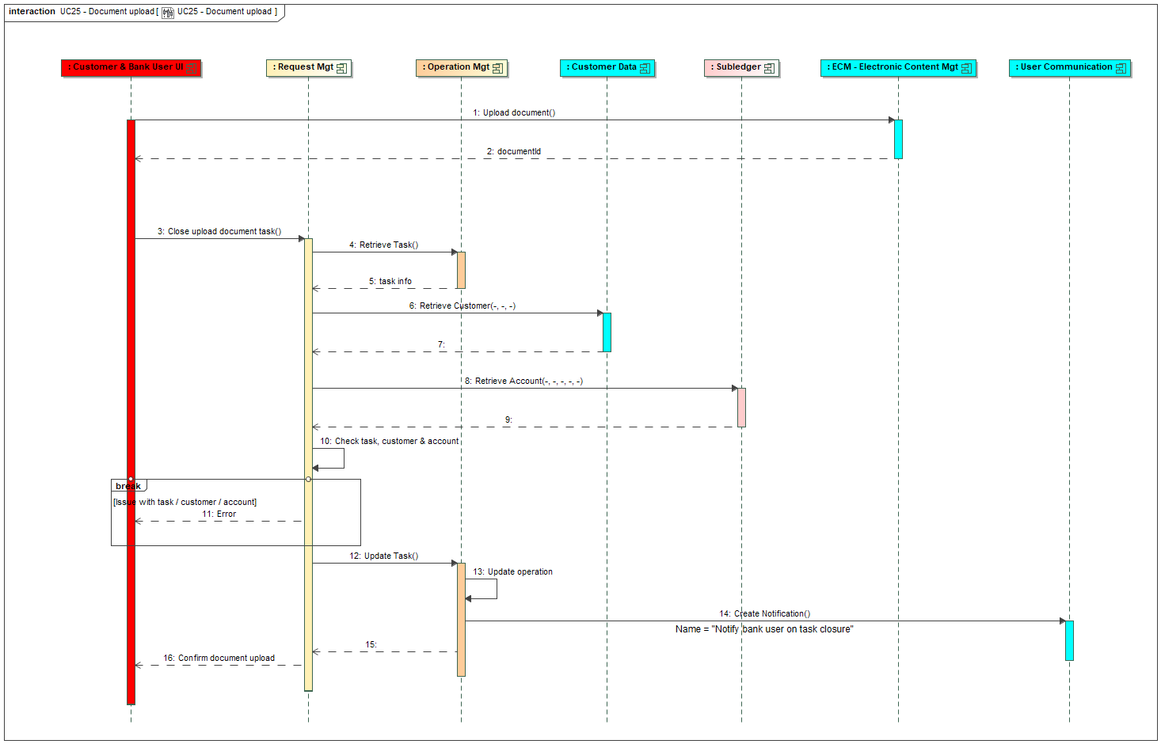
Figure 24 - Travel Rule Data Management

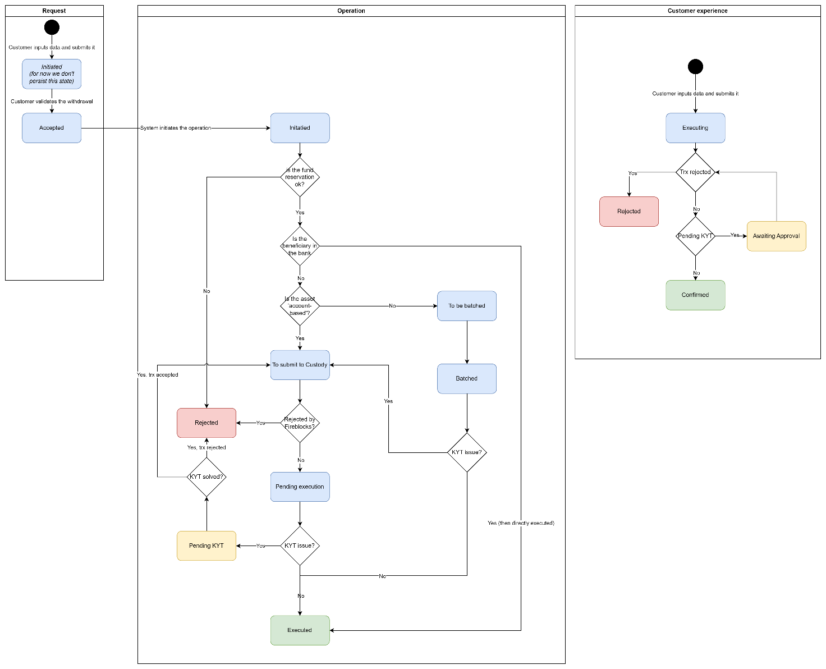
Figure 25 - KYT Task Management

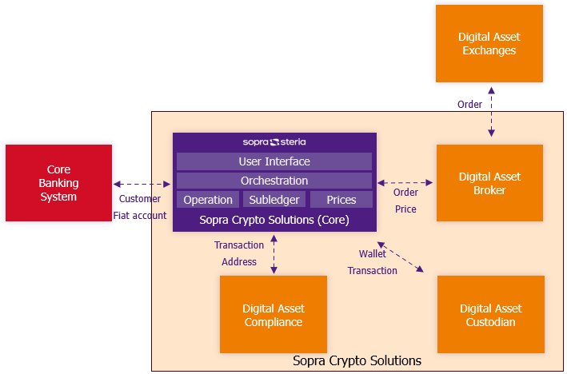
Figure 32 - Document Upload for KYT Issue

Additional Feature Process Flows
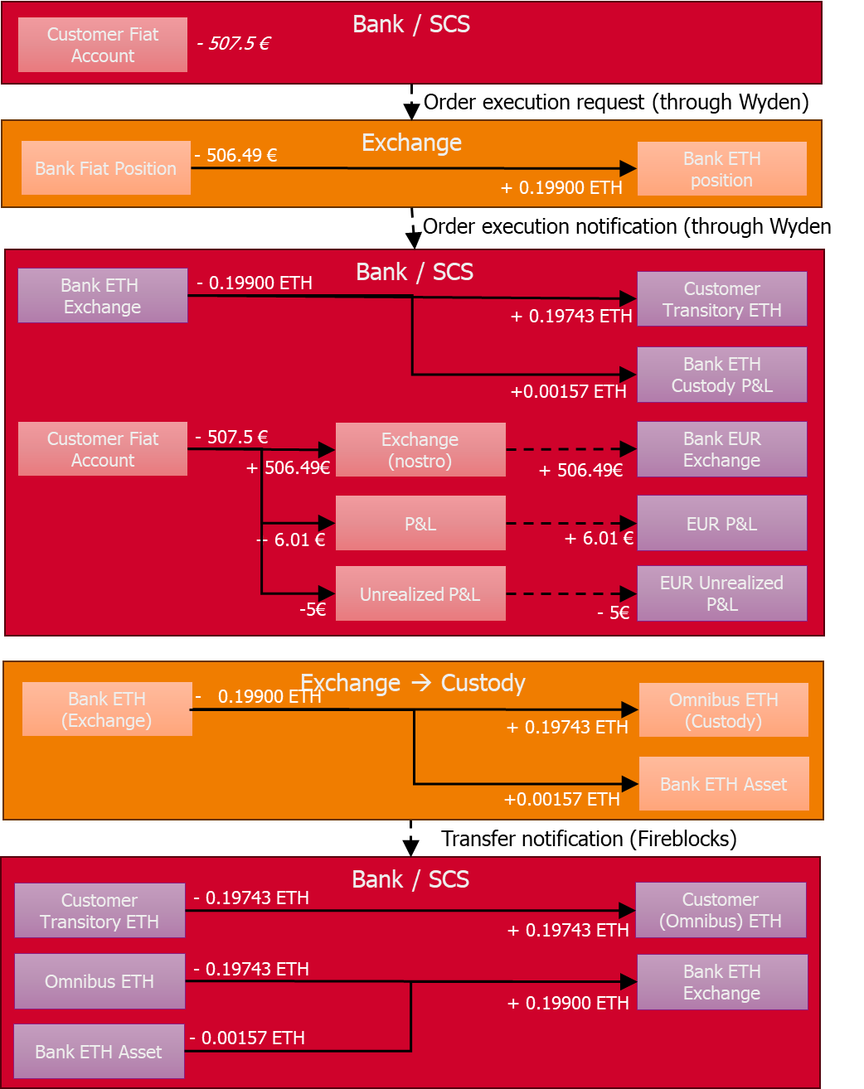
Figure 26 - Price Management

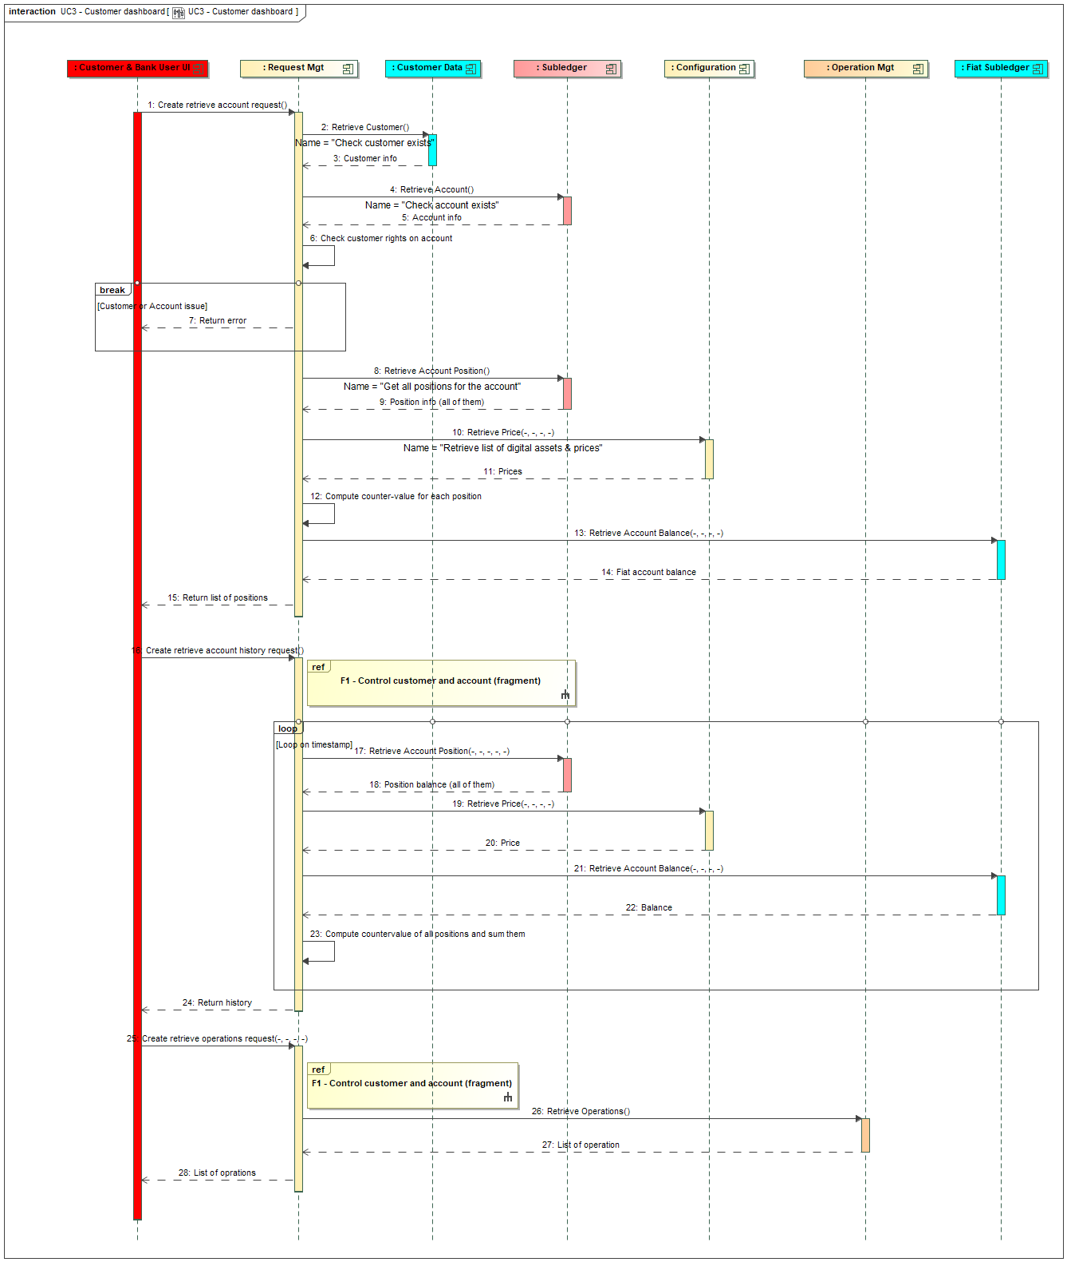
Figure 28 - Limit Update Management

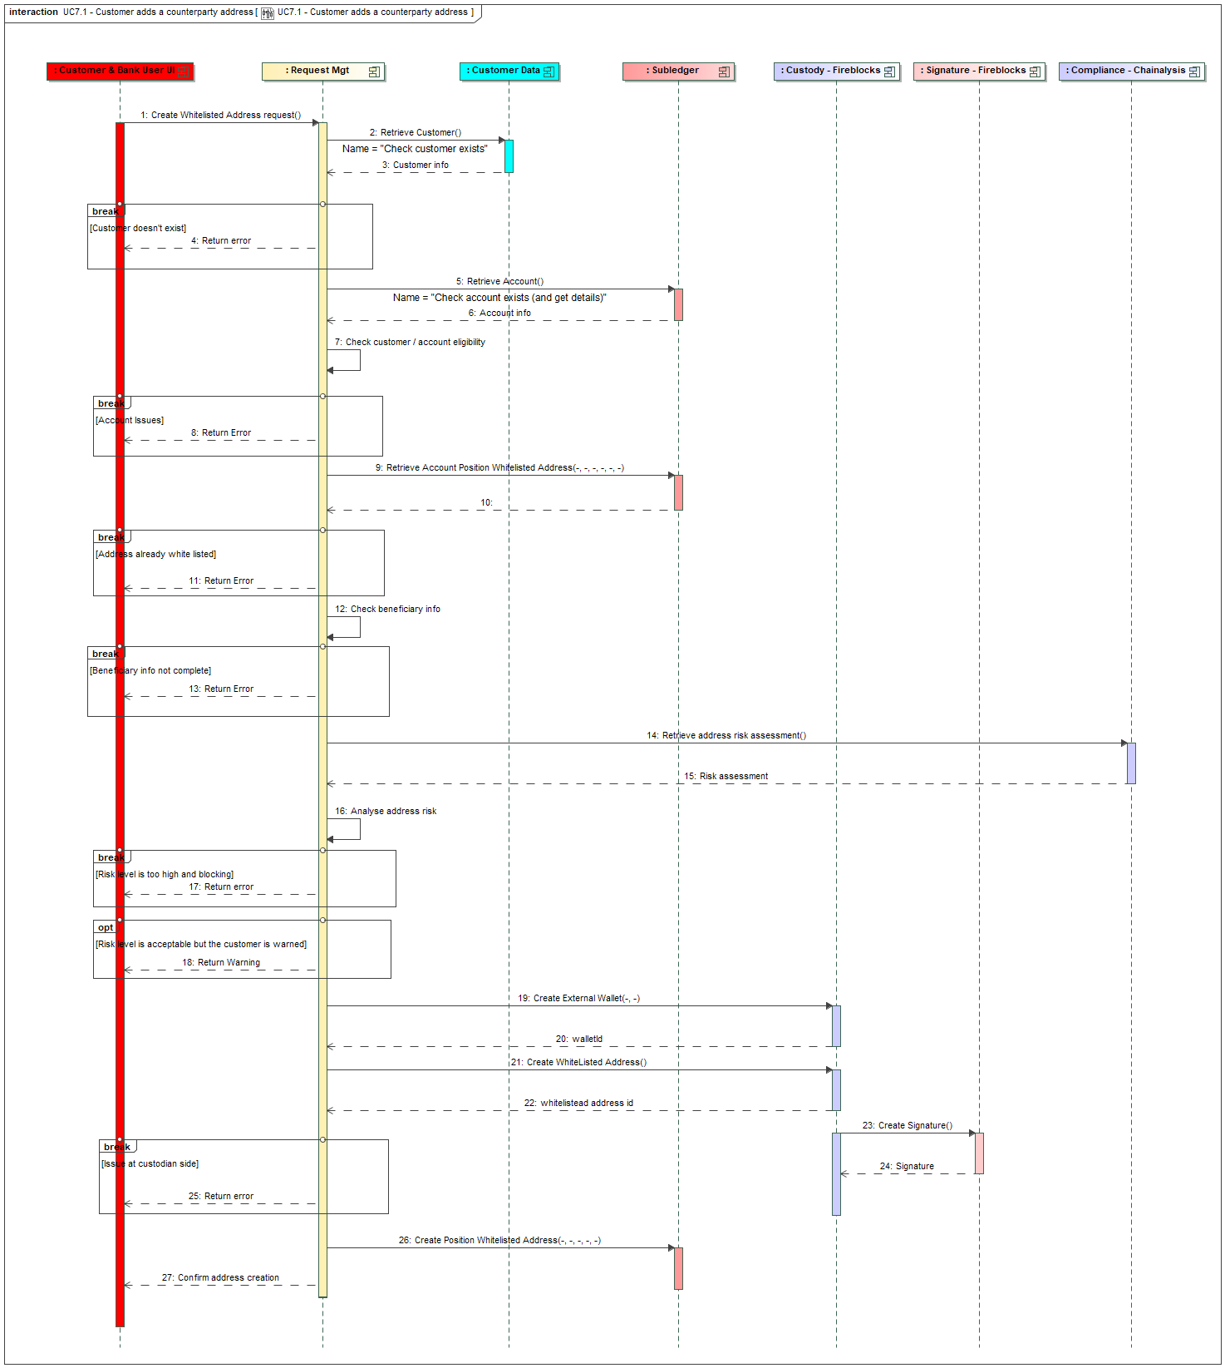
Figure 29 - Tax-related Data Computation

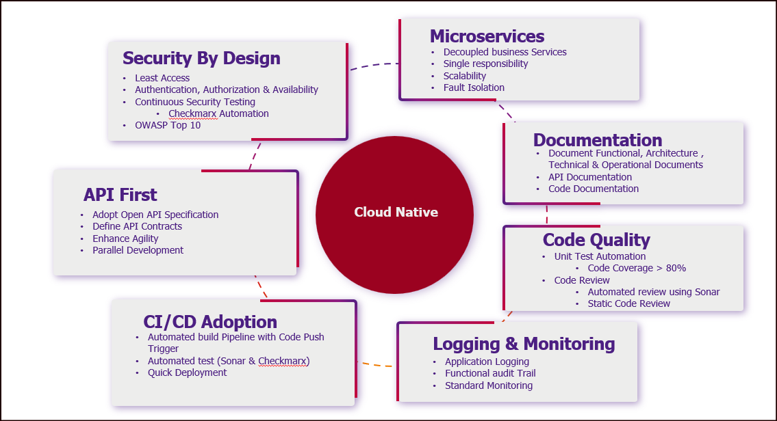
Figure 30 - Retrieve Tax Reports / Statement Report Generation

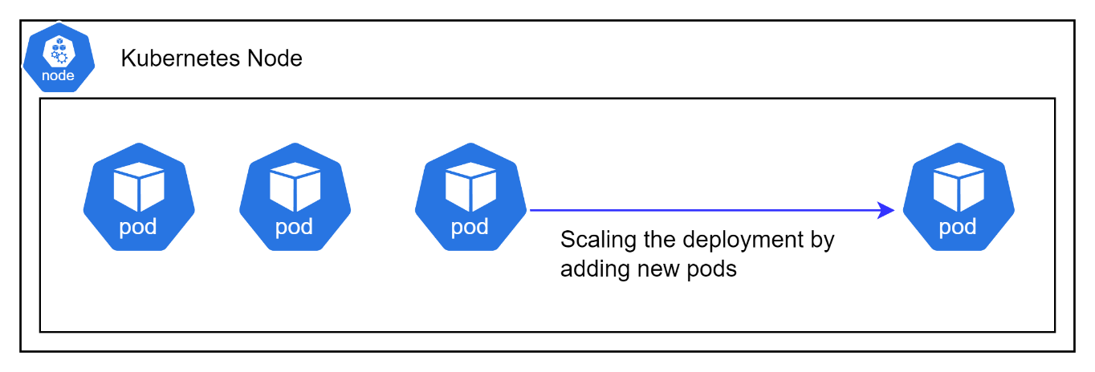
Figure 31 - Create Bank Position

Status Flow Diagrams
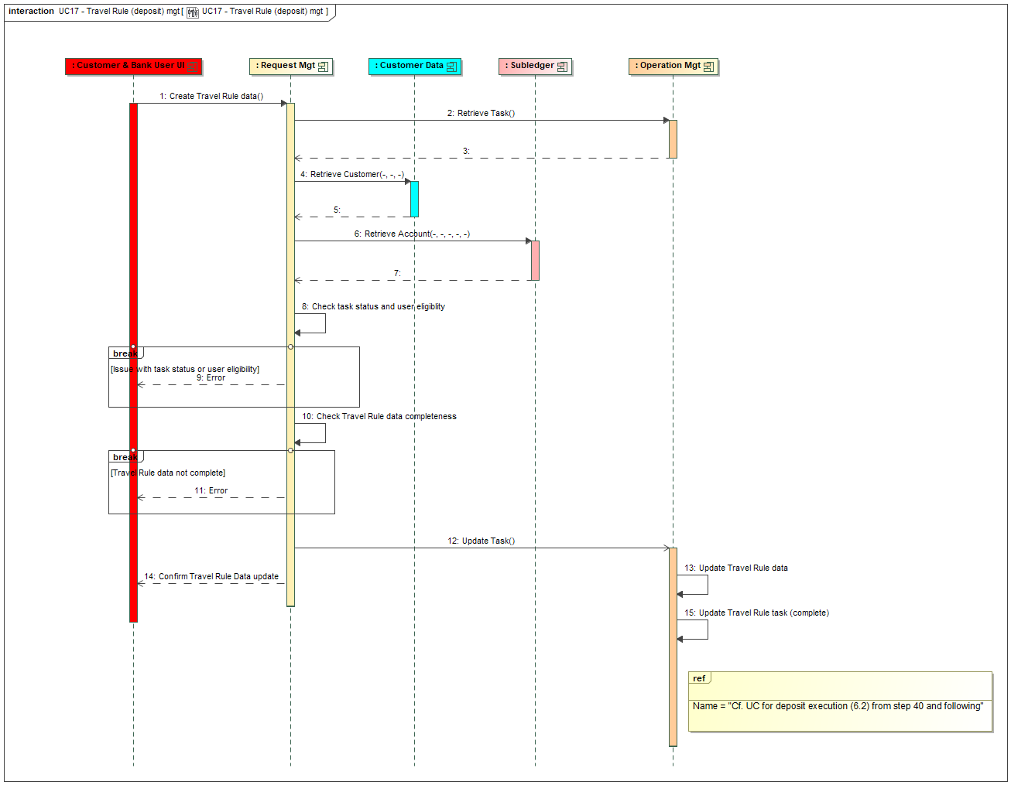
Figure 33 - Buy/Sell Order Statuses

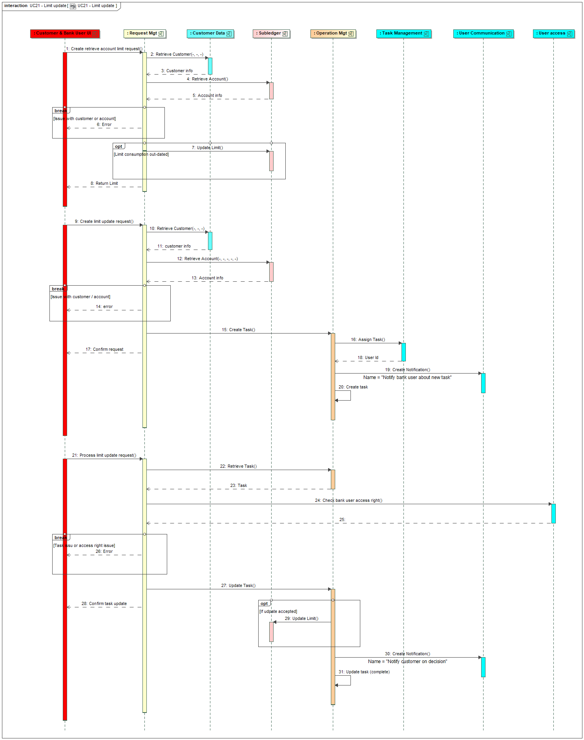
Figure 34 - Withdrawal Statuses

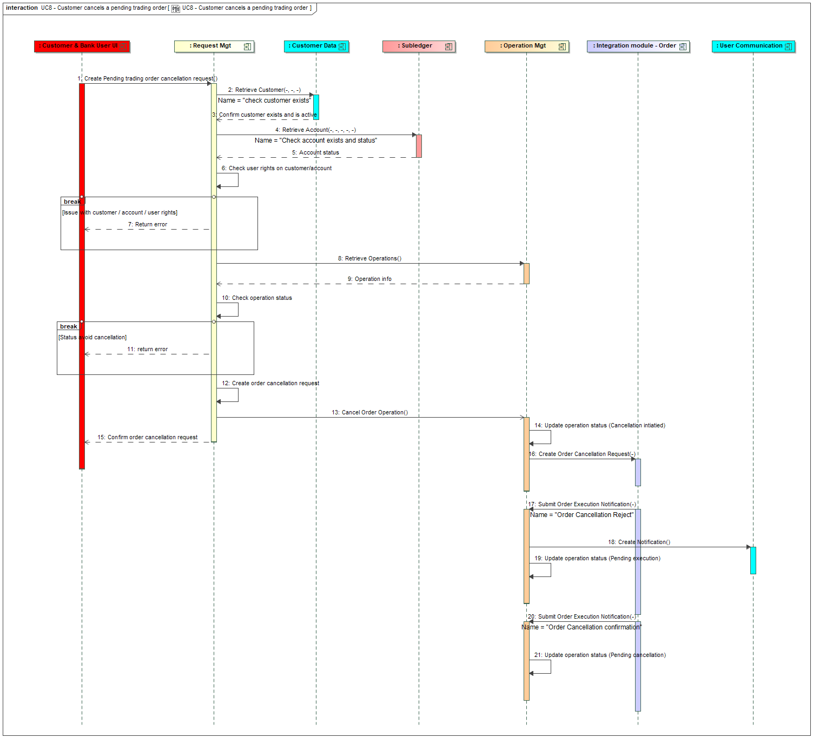
Figure 35 - Deposit Statuses

Infrastructure Diagrams
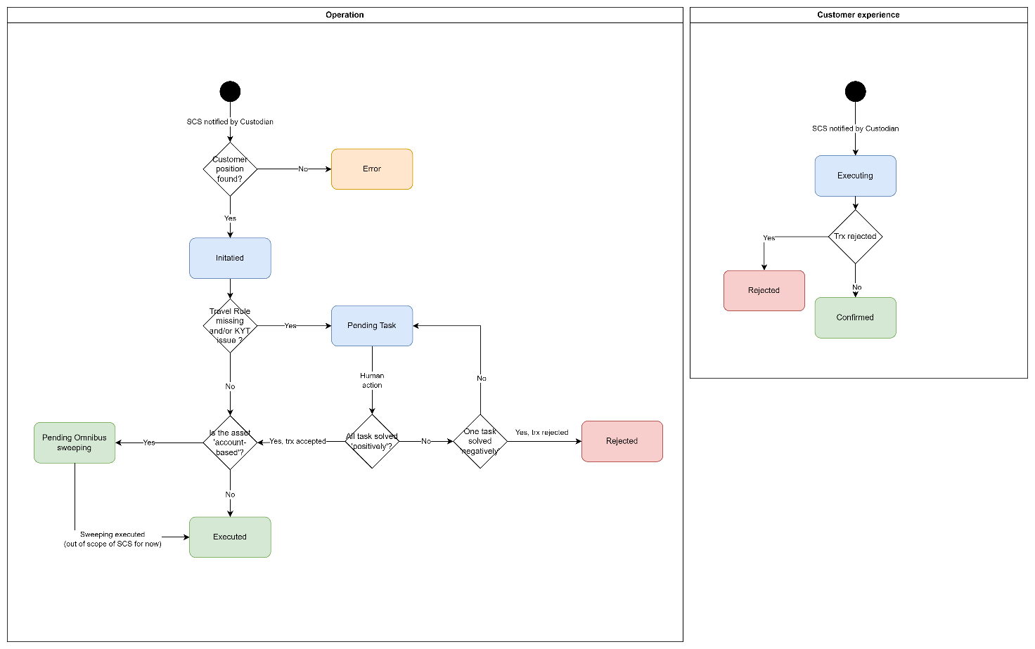
Figure 36 - Architecture Principles

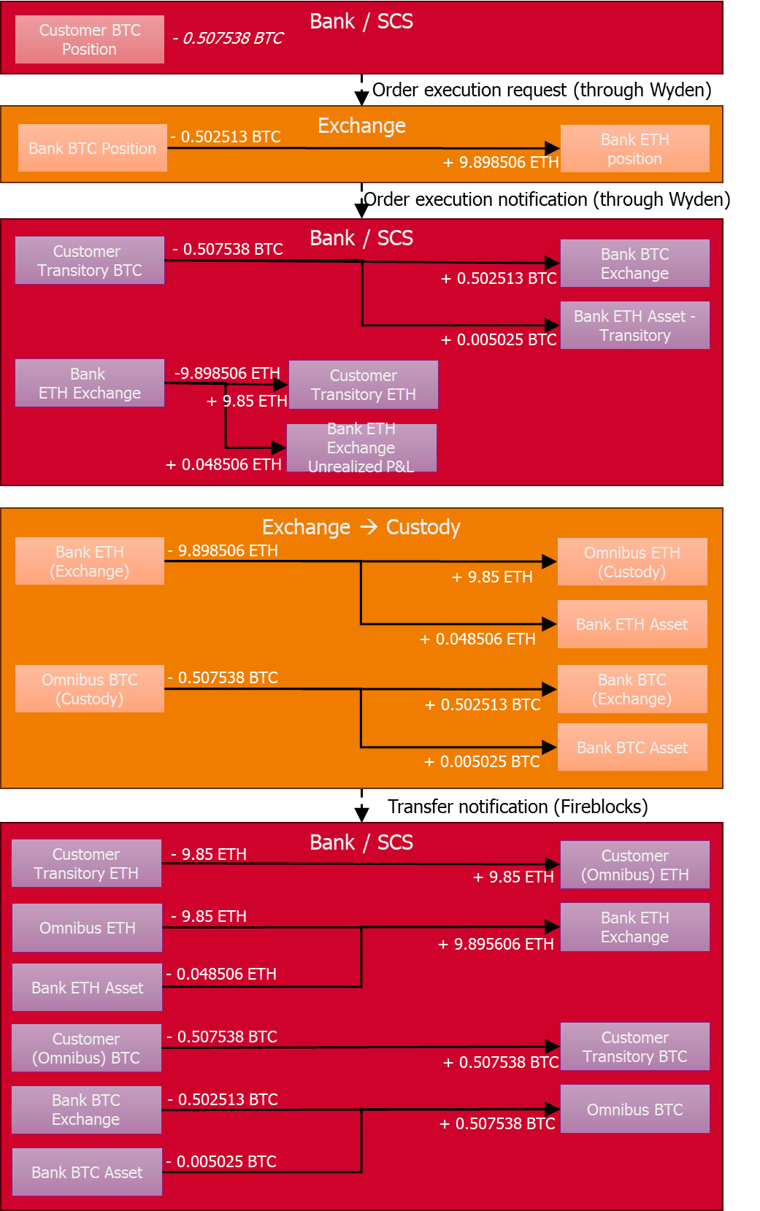
Figure 37 - Technology Stack

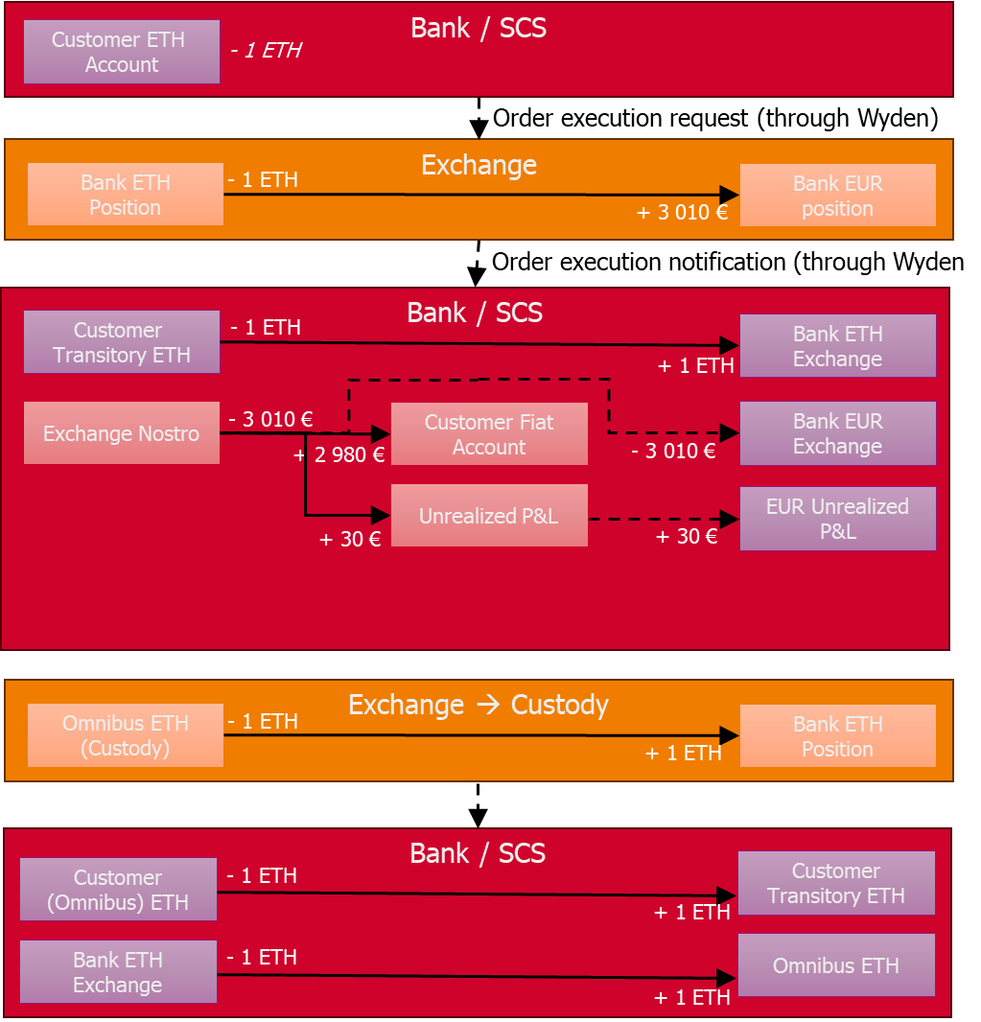
Figure 38 - Current Infrastructure

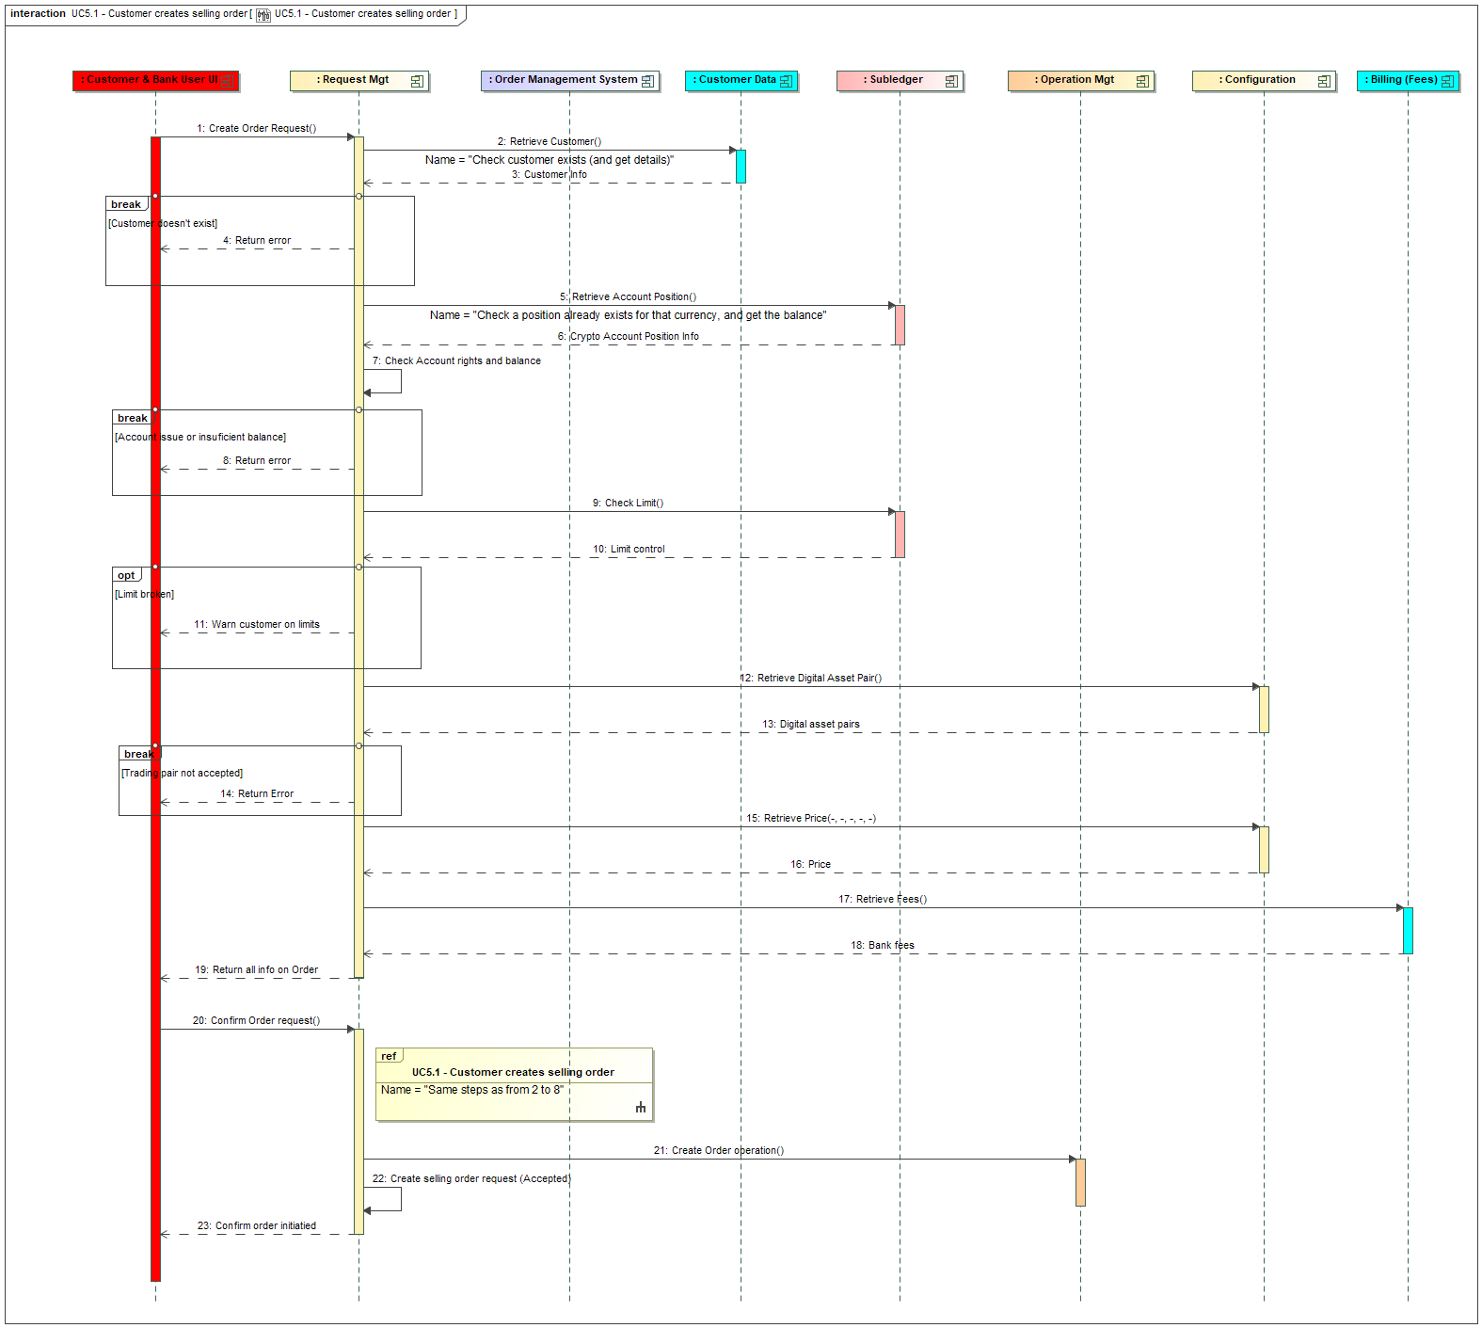
Figure 39 - Target Infrastructure

Figure 40 - Cluster Autoscaler

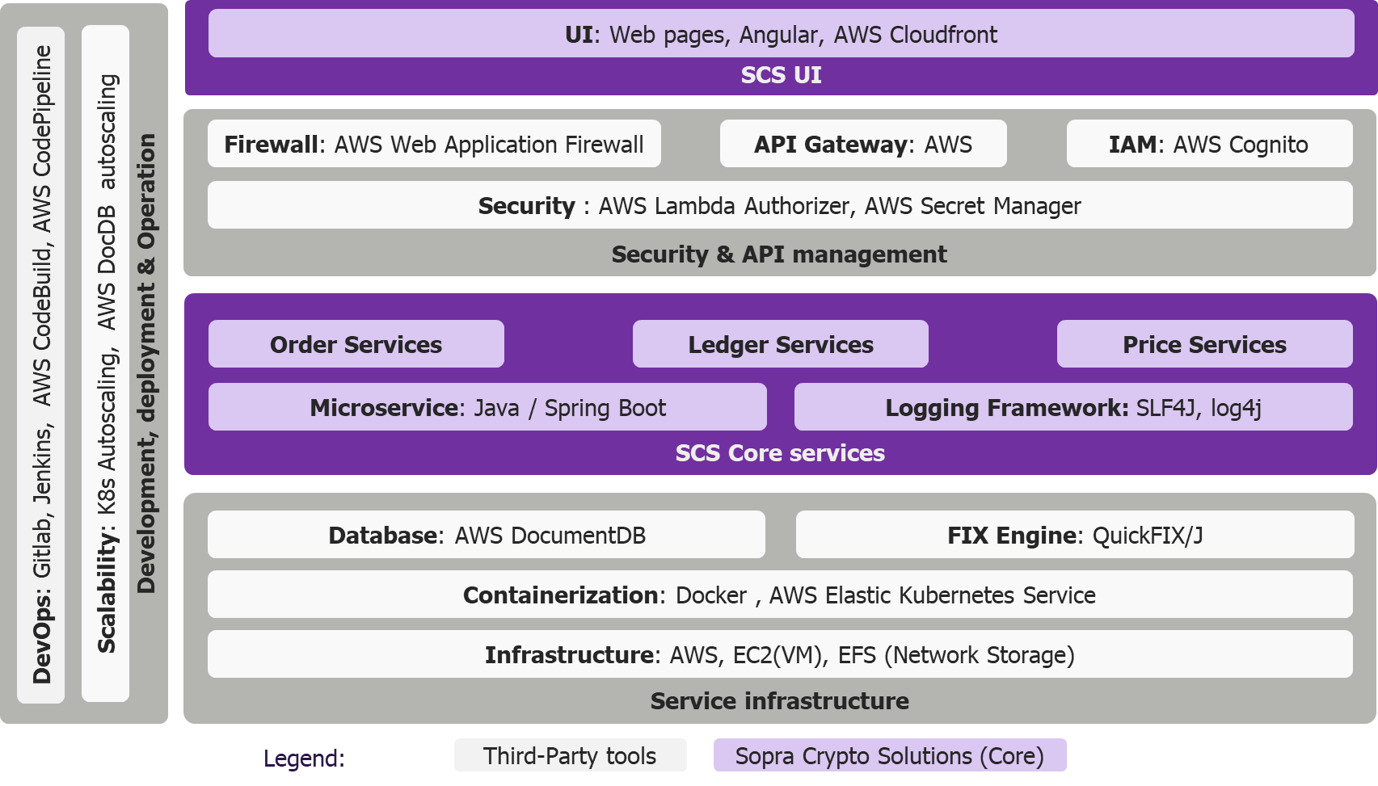
Figure 41 - Horizontal Pod Autoscaler

Sign-Off
Role | Name | Signature | Date
Test Manager
Project Manager
Product Owner
Business Representative
Security Lead

────────────────────────────────────────────────────────────
This Test Strategy document is subject to change based on project requirements and stakeholder feedback.

Document Version: 0.1
Generated on: June 1, 2026

