Steria Liquidity Suite (SLS)

Test Strategy

Document Owner | Manish Singhal
Date | 14th Sep 2020
State / Version | 0.1 Draft

Table of Contents

1. Document Control 3
1.1. Approval Record 3
1.2. Document Summary 3
1.3. Document History 3
1.4. References 3
2. Introduction 5
2.1. Background 5
2.2. Purpose and scope of this document 5
3. System Overview 6
3.1. Context Diagram 6
3.2. Systems involved: 6
3.3. Business use cases in-scope: 6
3.4. Business Events linked to the Business Use Cases 7
3.5. Product use case: 9
3.6. Front end design: 9
3.7. Current requirements backlog: 10
4. Scope of testing 10
4.1. Items in scope 10
4.2. Items out of scope 10
5. Test Approach 11
5.1. Test Design 11
5.1.1. API Testing 12
5.1.2. GUI / Functional testing 12
5.2. Test Execution 12
5.3. Test Automation 12
5.3.1. API Testing using Automation 12
5.3.2. Functional Automation Testing 13
5.3.3. Regression Testing 14
5.3.4. Cross Browser testing 14
5.4. Non-functional testing 15
5.5. Types of Testing 15
5.6. Test phases 17
5.7. Test Deliverables 17
5.8. Entry and Exit Criteria 18
6. Defect Management 21
7. Reporting 21
8. Meetings 22
9. Quality 22
10. High Level Test Schedule 22
11. Roles and Responsibilities 24
12. Test Environment 25
13. Test Data 25
14. Test Tools / Frameworks 26
15. Suspension and resumption criteria 27
15.1. Suspension criteria 27
15.2. Resumption criteria 27
16. Risk Management 27
17. Staffing and Training Need 27
Appendix A – Glossary 28
Appendix B – Defect Priority and Severity Definitions 29
Appendix C – Test Case Life Cycle 31

Document Control

Approval Record

Role | Name | Role | Signature/Date
Author(s) | Manish Singhal | Test Manager
Approvers |  | Product Owner
Reviewers |  | Product Owner
 |  | Scrum Master
 |  | Onshore Manager
 |  | Business Analyst
 | Prabhanjan Mishra | Offshore Delivery Manager, Germany DU

Document Summary

This document is the test strategy for the SLS project with various customers involved (CoBa, HVB, BAYLB, DZ). It contains the testing requirements and the high level approach of testing planned for the project. The test strategy helps to ensure that testing is carried out systematically based on the agreed testing process and plans.

Document History
Date | Version | Type | Reason for Change
18/06/2020 | 0.1 | Draft | Initial version of the document

References

No | Title | Document Reference (Path)
1 | Confluence
2 | Requirements

Introduction

Background

The purpose of this Test Strategy document is to define overall Testing approach that will be taken by SLS testing team, referenced as Quality Assurance teams (QA) delivering testing services to be adapted in Steria Liquidity Suite (SLS) project implementation. The document helps to clarify the testing activities, roles and responsibilities, Defect Management, Risk, Stakeholder Management, Reporting processes and practice to be used and ensure quality of testing.

Purpose and scope of this document

The purpose of this test strategy is to document and achieve agreement to the high-level testing approach to be followed for the testing of SLS. This document is not meant to outline the application/project specific resources and specific timelines, which will be covered by the project plan.

This document will cover at high level:

- Scope of testing
- Testing Approach
- Types of testing
- Test Environments & Test data requirements
- Test Schedule and deliverables
- Risk Management process
- Project meetings
- Entry & Exit criteria for different phases

Intended Audiences
The document will be circulated for use by various stakeholders who are as follows:

Sr.No | Audience | Purpose
1 | Offshore and onshore management | To validate the overall Business needs for SLS.
2 | Offshore Testing and Development team | To refer for the adherence of applicable process and guidelines.
3 | Onshore BA & Functional Team | To implement and execute process and guidelines.
4 | QA Team (Manual and Automation team) | To execute the test cases and test governance using ALM & UFT according to process and guidelines.
5 | UAT team | Business user to execute and validate the implemented process supported by Onsite team (no engagement from offshore).

System Overview

Sopra Steria Liquidity Suite (SLS) is Bank’s Intraday Liquidity Management, Payment and Settlement system software solution developed by Sopra Steria, used by various financial Institutions and European banks (Bayerische Landesbank, COMMERZBANK, DZ Bank, HVB UniCredit Bank ) in Germany. Intraday Liquidity Management solution includes the management of Nostro account as well as it also provides view of European Payments and Balances throughout the day.
It consists of 2 main components :

1 Nostro Cash Manager – Cash Management application for short term management of Nostro Accounts in a particular foreign currency accounts.

2 Euro Cash Manager – ECM is used for monitoring, management and forecasting of Euro currency at particular time.

SLS Flow

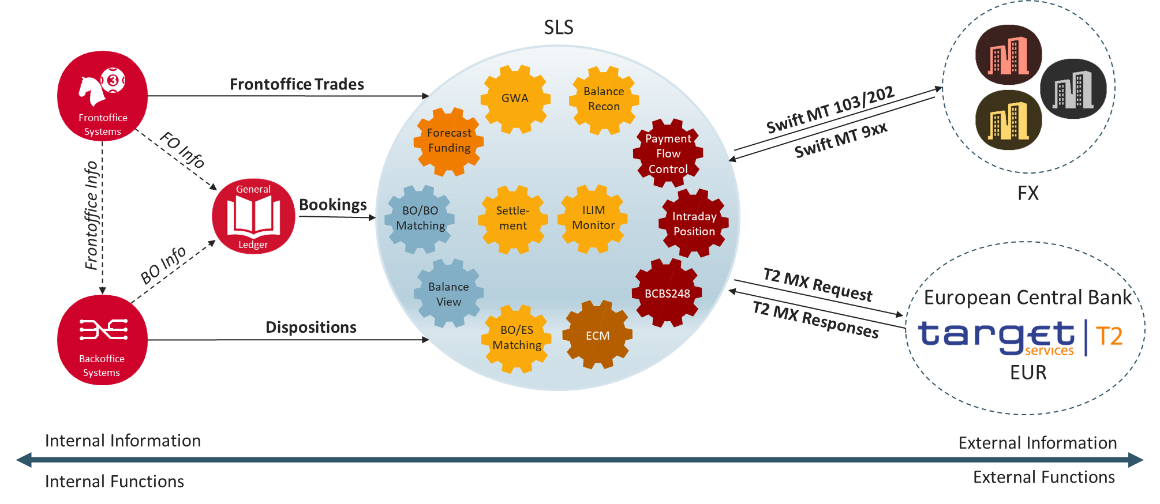
This is basically interaction of SLS with other entities/systems, in middle its whole SLS World, it has several modules they interact with some other modules, basically SLS is communicating with other systems and is collecting data.

SLS is combining two different worlds:
Internal World- Let’s talk aboit one customer (like BAYLB performing calculations) having Front Office systems, Back Office systems, General Ledger entries, Dispositions, Bookings. If actions made in Back office systems, dispositions gets created and SLS is collecting disposition data and they also send information to GL to create Bookings depending on Modules. Front office Trades- Trader working with Front office enter trades, also send information to GL .

External World- BaYLB has accounts in other currencies in Correspondent Banks, so whatever calculations are done in Banks they will also needs to show to external Side. So SLS is generating payment instruction slike MT103, MT 202 , and receiving reponses in MT9xx. Also euro message sare communicated to Target 2 systems via MX Messages.

Modules involved:
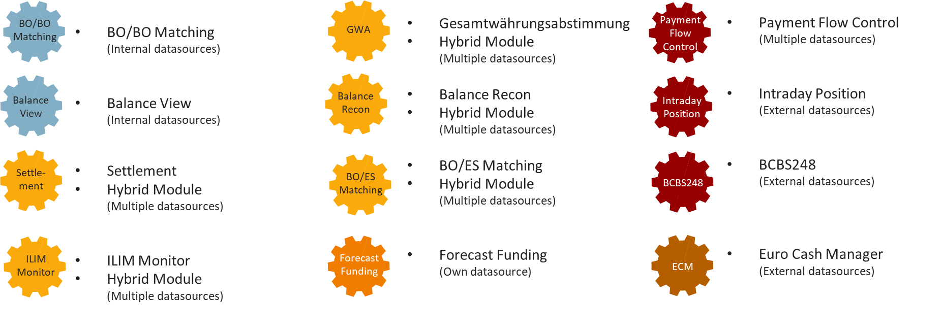
SLS is available for various customers so various modules are created, mainly divided into different data sources. So colours are being provided meant as :

- Blue- Internal Data source to work around these modules, means no external output is required for these modules.
- Yellow- Data input from multiple data sources.
- Red- External Data sources
So these data sources can be related to SLS Flow shown above via Internal, External World.

SLS Services: 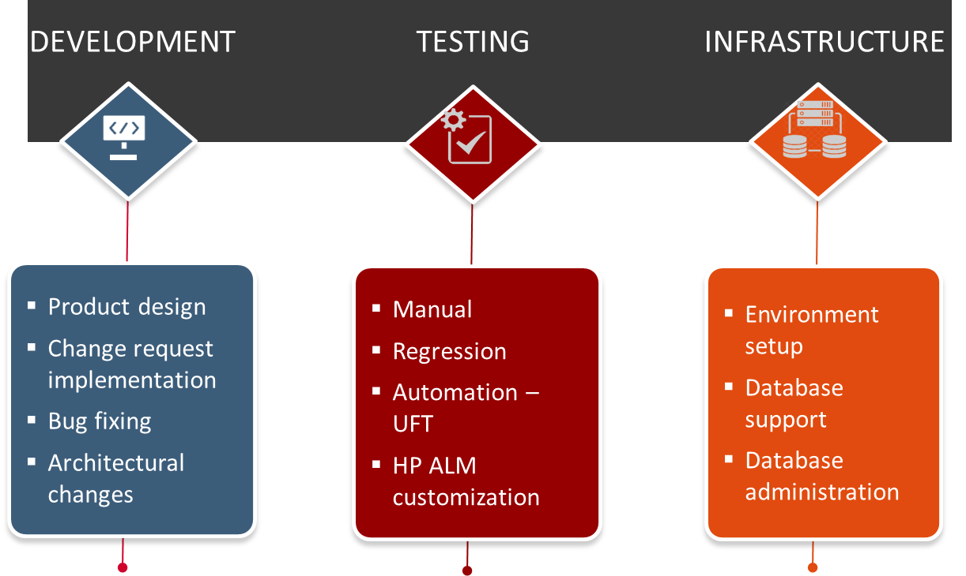
Contribution of all above Services is mainly around :
- Project Development
- Continuous Integration
- Agile Scrum
- Quality Assurance
- Automation Testing
- Multivendor

Business Event Name | Input and Output | Summary of Business Use Case
1 - The user wants to register on ZWEO to start an online registration request for a vehicle | Input: Personal information and information regarding the legal entity the user belongs to incl. the VERIMI account information for later ID authorizations.  Output: Confirmation or registration via e-mail including the relevant URL for further processing | User registration - Provide registration form, process the information of the user and store them into the database to enable the user to use the platforms functionality.
2 - The user wants to login into the ZWEO-account to display the current registration request and/or forward them to KDO. | Input: Login information  Output: Access to the platform for further activities | User login - Provide access to the platform after validating the login information.
3 - The user wants to have an overview of all of his registration request | Input: Login information  Output: Access to an overview of all relevant registration requests (Vorgangsliste) | Display registration requests – Display, sort and highlight registration request from one user in a central view (Vorgangsliste)
4 - Submission of a vehicle registration request including the necessary information from VWFS or its customers | Input: Indication what kind of registration request is requested and all relevant information for the specific registration process via XML message type 0707.  Output: New request stored with the corresponding information on ZWEO database. | Receive registration request - Receive and store a given vehicle registration request for further processing.
5 - The current users will need to login via VERIMI to verify and approve the user’s identification | Input: Login information of the user.  Output: Verification result and Verimi authorization token if successful. | ID authorization via Verimi - Provide access to user ID verification and store the authorization token for further processing.
6 - The user wants to forward of the registration request including the necessary information to KDO | Input: Indication what kind of registration request is requested, all relevant information for the specific registration process and authorization token from Verimi Login via XML message type 0707.  Output: Synchronous reply of KDO containing the statue of the submitted request (e.g. code 00000 “OK / Kein Fehler) via XML message type 0002. | Send registration request to KDO - Forward the registration request, all relevant information, and the authorization token to KDO to initiate the registration process and change the status of the request in the database.
7 - Time to request a status update from KDO | Input: Send a status update request concerning a specific registration request including the reference to that request and the authorization token from Verimi Login via XML message type 0705.  Output: Synchronous reply of KDO containing the statue of the submitted request (e.g. code 00000 “OK / Kein Fehler) via XML message type 0002 in case of no new update or the processed registration request with the final information regarding registration and the vehicle as XML message type | Send status request to KDO - Submit a status update for a specific registration request to initiate the response from KDO to forward it to the VWFS.  Store the response including all Informationen in the database and change the status accordingly.
8 - Submission of the result of the registration request including the necessary information from KDO | Input: Results of registration requests from KDO including all relevant information and vehicle data from KDO via XML message type 0707.  Output: Received XML message type 0707 in DWM system of VWFS | Forward registration request response to VWFS - Store the response including all relevant information in the database and forward the result of the registration request, all relevant information concerning the request including the vehicle data to VWFS for further internal processes.

Product use case details are at confluence page:
https://constellation.soprasteria.com/confluence2/pages/viewpage.action?pageId=281094635

The below diagram talks about the product use case linkage to different business use cases ad interaction to different third party systems.
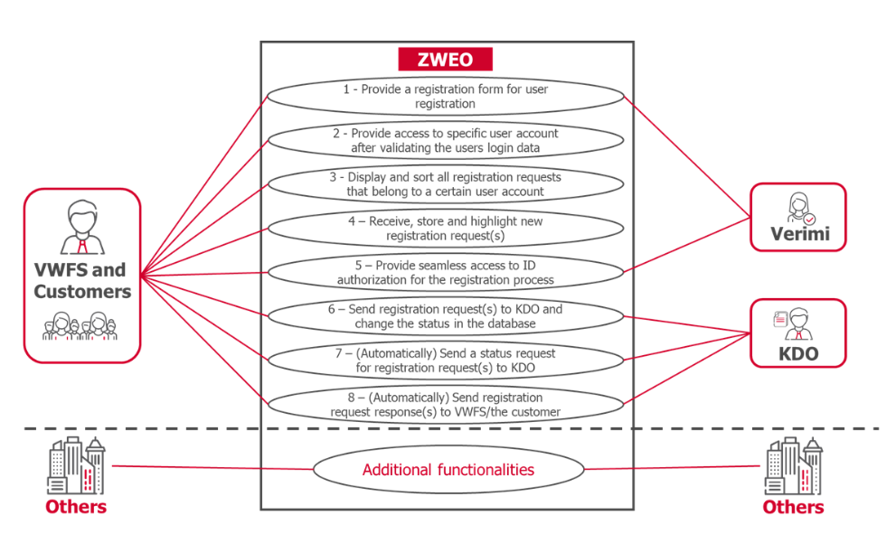

Product use case table:
https://constellation.soprasteria.com/confluence2/display/ZWE/Product+Use+Case+Summary+Table

https://constellation.soprasteria.com/confluence2/display/ZWE/2.6+Frontend+Design

High Level Architecture

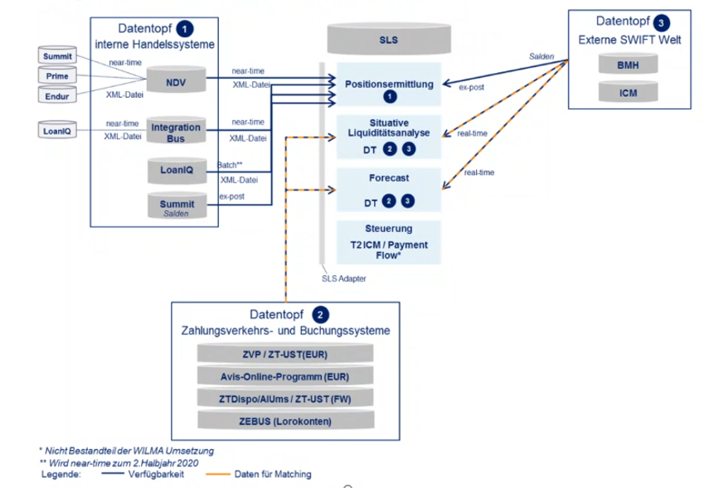
Systems in first block 1 are Front Offices where customer submits requests like Trading etc . whereas systems in second block denoted with 2 are Back Offices /Banking applications, these ere middle Layer systems b/w Front offices and SLS, Back offices performs some action based on requests submitted by Front office. These are input for SLS for day to day business, then output shared with third parties like Target 2 and other Central banks where access is available for SLS, different transactions are being performed like Liquidity Calculation.
Block with denomination 3 are SWIFT systems from where responses are coming back.

Scope of testing

Items in scope

There is a weekly/daily team meeting conducted between onshore and offshore team which provides the details of offshore engagement. During these meeting scope of Release is discussed within team. Offshore engagement is also discussed during the meeting and conveyed to offshore team either on email or verbally. However HP ALM/Jira is updated with these details which defines the offshore scope for any release. There is no estimation exercise is done at offshore. Offshore SLS team works based on scope defined in ALM/Jira or discussed in weekly meetings, in case any deviation expected in any release due to environment issue or any other unexpected error, the impact is conveyed to onsite team with revised timelines.

Following testing types will be in scope of the user stories:

- System Testing ( Manual + Automa
- Regression testing ( Manual + Automated )
- Automation Testing
- Performance testing

  - Items out of scope

The following activities are defined as out-of-scope and will not be included:
- All functionality not specifically indicated in the ‘In Scope’, above
- Non Functional testing (Security)
- Testing of Operational Procedures (OAT)
- Validation of Business Policies
- Performance of PCs, network, legacy System and production environments
- Business activities and dependencies during the end-to-end processes

Test Approach - Methodology, Scope identification
User story Understanding –
In the provided plan, User Story with Specification is provided to Tester sometimes User Stories are provided with UML , but it’s not provided for every user Story so there is difficult situation as it is not really easier for Tester to design the test cases.
Sometimes Expectation Sheet is provided to Testers from the Business Analyst like some Calculations etc which are available in the User Story. Expectation Sheet is provided by Business Analyst where basically Expected Results are mentioned in that sheet and correspondingly test Data needs to be prepared in the mentioned way.
When User stories written by Business Analyst are provided to Testers then Testers has to start working parallel instead of waiting for the User Story to get finished .
Before the beginning of the release detailed session will be provided for the user stories by Business Analyst / Developer . Once User stories are created and Tasks are assigned, besides implementation is still going on, tester needs to starts working on the User Stories .
As this project is working in Agile way but this needs to be followed in more appropriate way as in many of the sprints it is running in Waterfall Way, still Development is running. As all pending tickets from old Sprints got moved in last Sprint . Both Development and Testing Team should both work in Agile Way.

As far as talking about Releases, Every Planned Release has following phases:
- Functional Specification
- Internal Kickoff Meeting –Kickoff includes what is to include in the release.
- Scope Freeze –This pre-condition phase will always be present to have better quality.
- Implementation- Development Team will perform all these tasks.
- Sprint Planning- Sprints initial plans are created for completing product backlog item to test the code. Timelines are divided for each task.
- Code Freeze- After bug Fixing second code Freeze.
- Test Case Creation+ BA Review – Detailed Test cases are created in this phase and are being reviewed.
- Test Execution and Bug Fixing – Execution is performed and corresponding fixing of bug raised.
- Customer Regression Test
- Delivery
- UAT
- Go Live

Test Design

At the start of each sprint, sprint planning sessions / grooming sessions will take place. These sessions will be owned by business analyst. In these sessions, Business analyst will explain the created user stories.

User stories relevant to testing team will have sub – tasks assigned to testing members for test design.

Testing team members will review the user stories as per grooming session and create a query list These queries will be discussed with BA as per agreed sessions ( There will be with in sprint grooming sessions to discuss the sprint scope and queries ) Test scenario for each user story (in scope of testing) will be created walkthrough is done for review. Once review is done and test scenario are agreed, test scripts will be created. Test design will always be done for nth sprint.

Test scripts will be created in JIRA via X-Ray Tool and will be mapped to user stories.

Test data for each test script will be created. Please refer to section Test Data for more details. .

On completion of every Release, another Bug Fix Release is being performed where scope is mainly around defects raised from Customers, not closed User stories, Open tasks, so Test Sets are being created covering existing issues and then assigned to Testers then Testing Life Cycle will be followed. Based on these updates , Regression pack test cases will be updated.
Sometimes Release notes are also checked to identify outstanding activities from customers.

ZWEO ←→ Verimi
ZWEO ←→KDO

Hence, in system testing, we need to test these APIs individually using SOAP/Rest UI to validate the response. Testing will be done to test the communication / data transfer between different systems.

GUI / Functional testing

For different functionality of SLS Desktop application, GUI / front end testing will be done.

In the initial sprints, GUI / functional testing will be done manually.

Test Execution

Once all the user stories are developed, build will be deployed to test environment

Test cases will be run and test results will be uploaded to test cases. Any failed test cases will result in defects being logged as issues in JIRA. Defect workflow will be created in JIRA. Please refer to section Defect Management for defect workflow.

As the test cases are being automated, test execution will be done using automation framework.

There is Test Plan created to have the overview of all test cases of corresponding Release as User stories are part of Development Project so separate Test Sets has been created QA Project.

Test Automation

Sopra Steria Testing Practice Test Automation Services are engaged by SLS team to automate the SLS application. It is planned that as we go further in other Sprints we will automate functional testing using Sopra Steria in-house automation frameworks

Functional Automation Testing

To automate SLS functional test cases, we will use Sopra Steria Automation shared service in-house testing framework of UFT. Setup is done via CI/CD pipeline, test cases will run on 2 different environments.
Tracking is done via Jira Dashboards.

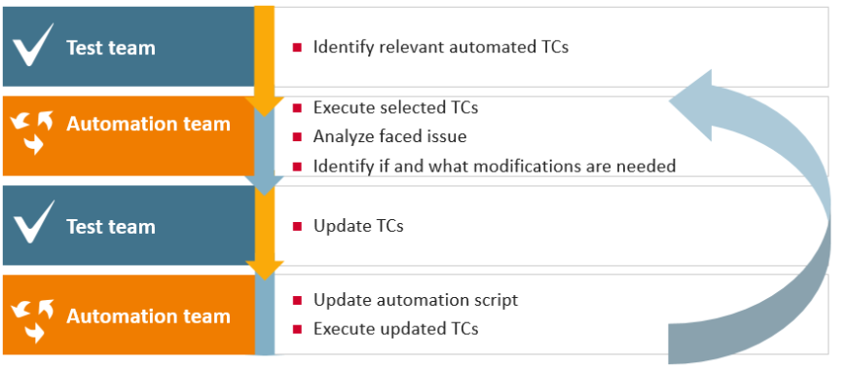

As various customers are part of SLS , so Automation Scripts are not created separately for every customer , Switch –case functionality is opted to cover all possible in single Script.

Regression Testing
Regression pack will be created as per the test scripts from each sprint. As we go further in sprint, regression test pack will be updated and stored in JIRA. Automation team will automate the regression test pack. In the nth sprint, all regression tests up to n-1 spring will be run.
Till the time complete regression pack is not automated, regression testing will be done manually if required. If there are time constraints, regression pack will be done as per impact analysis of the current sprint functionality changes.
‘Must have criteria’ related Test Cases should be covered . Already so many Tet Cases are available. Whenever new Version is installed , Regression is being performed beforehand for that release, if this is not performed it may also results in delayed delivery due to environmental issues. So results should be successful , only priority bugs will be discussed with Developers , fixes will be done in very short time, again Regression run is being performed, all Milestones are always planned.

Non-functional testing
Test approach for performance testing is defined as follows:
There are no separate NFR Requirements, So wherever code is changing , module is identified , then messages are loaded in identified queue for corresponding requirement. Input is taken from Functional Testing for testing any functionality like Disposition, lots of XML messages ae processed basically 30,000 messages are processed. Putting large number of messages ,pushing same messages at a same time, checking processing time from queue.
Requirements are coming from Functional User Story, separate test case is created under same Test Set, then results are updated in Excel , in case processing results are not ok then Bug is being raised .
Python code is used to generate put messages, so analyses are done like processing time is checked from Db , whenever Time is updated in DB then its verified that messages are getting processed. Based on same results are updated in JIRA, also separate sheet is maintained where all till time results are processed. BY verifying data like I displayed means messages re imported then we take up with Dev Team for further analysis in case of any issues.
Going forward there is plan to create separate requirements for Performance.

Types of Testing

An overview of the different types of testing being planned for the project is mentioned below. Both functional and non-functional testing will be conducted.

Types of Testing | Description | Objective
UT | Unit Testing | The testing performed by the development team for each new or changed module being delivered as part of the project. The Development lead is the owner of unit testing.
ST | System testing | Functional & System testing of business scenarios, as defined in the manual test cases, will be performed and the scope of the testing that will be included as system testing as shared and agreed. The high level test scenarios/test cases will be created by Functional team and automated test scripts will be created and executed by Offshore test team. Offshore test team peer reviews their test cases and results.
Regression Testing | Regression testing/ Automation Testing | Regression testing will be done with in the sprint to ensure that new changes have not caused impact in any existing functionality / previous sprint functionality. Regression test pack will be updated after each sprint. Automation test analyst will automation the regression test pack and automated regression pack will be run twice ST is completed with-in each sprint.
PT | Performance testing | Performance testing forms part of Non-functional testing and is carried out on infrastructure architecture and sized for production.  Performance testing requirements are not defined separately. CURRENT performance test approachis defined Please refer to section Non-Functional Link for defect workflow.

Test phases

The following test phases will be conducted during each SPRINT.

Test Phase | Testing Tasks | Deliverables
Test Planning | SLS test strategy will be created at the start of project. This will be reviewed by project stakeholders and once signed off, will be stored in confluence for reference.  During the start of the planning phase, grooming session will happen to get walkthrough of user stories.  Estimation done in Excel Sheet by Onshore Manager. This will include effort for functional test design, manual test execution, automation test design and execution. | - Test Strategy  - Test estimates ( for each sprint )
Test Preparation | Test Scenario and test script preparation will be completed during this phase. Reviews of test scenarios will be performed as part of Walkthrough by the business analyst to ensure that all relevant functionality has been covered.  Any updates to regression test pack will also be done during test preparation phase.  Performance / test design will be done as per the user story requirement in the sprint. | - Test scenarios  - Test scripts  - Daily/Weeklu update Calls
Test Execution | A successful entry gateway review will mark the start of test execution.  Test execution will be done for the test cases during the test execution phase.  Regression testing also will be performed as per identified regression tests. Regression testing will be done using automation scripts.  Defect re-testing and related regression testing will be done as required.  Performance will be done as per the user story requirement in the sprint. | - Test Results (in JIRA)  - Test evidences (attached to test scripts in JIRA)
Test Completion | A test completion report will be created at the end of each SPRINT to demonstrate the results. It will provide a summary of testing and recommendations based on the results of testing done to confirm exit from the test execution phase. | - Test Completion Report

Test Deliverables

The following testing deliverables will be produced for both functional and non-functional types of testing during the SLS project:

- Test Strategy
- Test Scenarios ( created by functional test lead)
- Test Cases

- Test Results, including evidences (maintained in JIRA)

- Test Completion Report (for each sprint )
- Performance Testing Approach,
- Automation test scripts
- Non-functional test scripts

Entry and Exit Criteria

The entry and exit criteria for both functional and non-functional test execution is as below,

Testing type | Entry | Exit
System Testing / | - Unit testing is complete  - All Severity 1 or 2 defects raised during UT have been resolved, re-tested and passed.  - Any outstanding Severity 3 or 4 UT defects agreed by Testing and Project Management as being acceptable for fixing later  - User stories in scope of testing are developed and deployed in test environment.  - Test environment is ready for test execution.  - Test Scenarios and Test Scripts are complete and reviewed with requirement traceability.  - All Test Scripts are loaded into JIRA.  - The Test Team consisting of sufficient resources to achieve planned delivery dates.  All required access must be available for testing team in SLS environment, | - All planned test cases have been executed and have sufficient evidence attached to prove success. Hence, 100% of tests executed or set to “no run” or “N/A”, with an explanation attached and details included in the Test Completion Report.  - Any non-executed test cases are documented in the Test Completion Report with the reasons why and any corresponding mitigation actions and approval from the Test Manager.  - All defects logged, managed and documented in Quality Center. Max number of outstanding bugs: There is no specific criteria defined by customer or onshore team as sometimes the Releases are deployed with open defects with agreement between onsite team and customer depending on severity, impact on release. Howeever a standard approach for Exit criteria of system testing can be defined as below:  - 0% critical / P1  - 0% major / P2  - 5% minor / P3  - 5% trivial / P4 of Total number of Bugs  - Evidence of success attached to all ‘Passed’ tests using screen shots or other means. If no evidence is available, a reason must be provided in the Test Completion Report.  - All Severity 1 or 2 defects resolved, re-tested and passed, with evidence attached along with the corresponding failed test script.  - Any outstanding Severity 3 or 4 defects do not represent an unacceptable risk to the Business. The outstanding errors should be reviewed by the Development Team, Test Manager, Product owner.  - A Test Completion Report produced by the Test Lead and signed-off by relevant stakeholders.
Regression Testing | - QA test environment environment should be available for regression testing.  - Delivered package/process should have been deployed.  - System testing should have been executed successfully and all the Open defects should be reported in release note as known issues and agreed by onsite/customer.  - No critical defects in Open status from system testing. | - All the test cases mentioned in test scenario document are uploaded in ALM/Jira.  - Regression Test execution record should be in ALM.  - Bugs found during ST / Regression Testing should be logged in ALM/Jira.  - Max number of outstanding bugs: There is no specific criteria defined by customer or onshore team as sometimes the Releases are deployed with open defects with agreement between onsite team and customer depending on severity, impact on release. Howeever a standard approach for Exit criteria of Regression Testing can be defined as below:  - 0% critical / P1  - 0% major / P2  - 5% minor / P3  - 5% trivial / P4  - 100% test cases executed  - Test cases pass rate:  - 100% critical priority passed  - 100% major priority passed  - 95% minor priority passed
Performance Testing (PT) | - Full Test environment ready with pipe clean tested and all code deployed  - The application is not having any major functional defect  - All performance testing test scripts are developed as agreed  - Test Data available along with test scripts.  - Testing resource(s) available.  - Test environments fully accessible to all test team members.  - Monitoring setup is agreed and created, enabled  - Environment sharing is agreed between functional testing and performance testing team member. | - All performance tests must have been executed, such that:  - 100% of test scripts are executed & passed.  - No Severity 1 or 2 defects outstanding. For Sev 3 and 4 defects, resolution and next steps are agreed, documented in test completion report.  - Test result and test report with final analysis note is approved  - Test Completion report is reviewed & approved by key stakeholders

Note : As mentioned above UAT testing activities are managed at onsite and there is no visibility of these test phases at offshore.

Defect Management

The standard Sopra Steria defect management process will be followed during the project which includes the procedures used to manage defects.

The Test lead/Onshore Manager will perform the role of Defect Manager during the project. The Defect Management process involves compiling and processing information on defects found during testing and analysing that information so that trends and significant events can be recognised and acted upon. The purpose of Defect Management is to implement the processes to manage the recording, tracking, progression and fixing of defects found during testing. Any recorded defect will pass through a series of lifecycle stages which are already defined in JIRA.
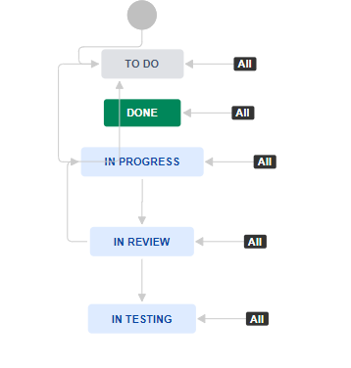
Defects raised are linked to User story and it’s nice to have them linked to the User Story.
As Test cases are created in Test Set and execution being performed in Test Execution so wherever functionality failed, Bug should be raised instead of Sub Task, currently Sub-Task is being raised . And bug should be linked in test case step and should be linked with Test Set as well and should get automatically linked to the User Story(Requirement by Gueral).
Status Overview is not getting cleared from current process, as every test case need to be visited to get clear picture of linked issues whether closed or not.
Also currently User story Description is not Cleary defined as after checking the user story it is not getting cleared, defect is being raised for which part of Requirement in User story. (Requirement by Gueral). Going forward improvement is required in User Story creation process for-
- Story Structure:
- Goal
- Technical part of story
- Testing Impacted Areas
- Data Base Structure
Basically while describing Acceptance Criteria of User Story requirements needs to be numbered to have proper Traceability.

Customer Incident Workflow-These are Incident opened by Service desk which are in Open status, these incidents can also be raised by Tester /BA /Developer it’s should be based on User story, so if BA has same opinion then it will be assigned to Developer to fix or can be rejected/Accepted, if accepted then after deployment it can be assigned to Tester. If bugs comes again after fixed, it needs to be reopened again. (not happening currently)
Refer Confluence - https://sls-confluence.hosting.it-economics.de/display/SLSWIKI/Incidents+workflow

A defect triage meeting will be scheduled twice weekly to discuss the progress of defects, identify which defects should be fixed first and also to discuss if there are any defects which needs to be deferred to next SPRINT. The frequency may vary depending upon the number and severity of defects found during test execution.

Refer to Appendix B for defect severity and priority definitions.

Reporting

Dashboard is being used for reporting purposes, to view the status, no report is being shared in email. Weekly V1 is being scheduled with Aida/Dirk (Product Owners) to provide status to owners. And Lena (Product Lead) is responsible for customer reporting of BAYLB on release completion. She has access to all the reports and all the situation/status updates are being discussed in Weekly Call to discuss any Blockers.
In Weekly V1 new opportunities, any projects in pipeline, any general projects being managing, any new Customers , all are being discussed.
OneNote tool is being used to create Reports. Meetings are being arranged weekly or on need basis, to discuss the activities going on various areas(Restructuring , Automation ,Test Case Updating, Migration). Status reporting is being tracked as part of JIRA Dashboards, this indicates picture of Task happening in corresponding Release, all kind of issues are discussed in Weekly/Daily Call.
We need to check on Report to just highlight the tasks /issue?

Following testing progress report will be created during the SLS project

- SCRUM Test completion report: After completion of each sprint, test completion report will be created. This will have status of all the user stories planned in the sprint including defects summary and test case status.

Templates for SCRUM test completion report are attached here.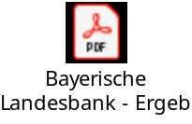

Meetings

SLS project is following AGILE SCRUM methodology. Following meetings are proposed to be done during each sprint.
- Daily stand up meeting: This is to access the progress of last period, current day activities, any impediments
- Grooming meetings: This is done for each sprint. The requirements / user stories are explained in this session, queries related to requirements are discussed and story points are estimated using scrum poker methods. It is also agreed that what all user stories will be developed / tested in the current sprint
- Sprint review meeting
- Sprint retrospective meeting
- Product backlog refinement
- Testing progress meeting: Weekly testing progress meeting will be scheduled between offshore test manager and Onshore Manager to access the testing progress, resource requirements, discuss testing risks and any test environment issues. This will also be used to discuss the plan for next sprints, user acceptance testing requirements.
- Defect triage meetings: During test execution, defect triage meetings will be scheduled to discuss high priority defects. The meeting will be between Test lead, Product owner, Dev lead and Business analyst.

Quality

The test lead will conduct quality gateway review and witness all the test activities of the testing teams at pre-defined verification points during the testing life cycle. The project schedule will be used as a basis to determine and agree the timetable for the quality gateway reviews.

To ensure proper test coverage and quality of testing the processes identified below will be followed:

- Testing Gateway Checklist: There will be a gateway meeting both at the commencement and completion of test execution phase to ensure that testing can proceed to the next level. The entry and exit criteria will be used as a basis of this checkpoint. Based on the agreed decision the next set of activities will commence accordingly. The gateway checklist will also be used for entry and exit into UAT phase. Checklist Document 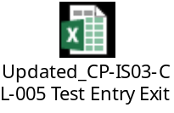

Reviews – A peer review is performed after completion of Test Case creation, Walkthorugh session are arranged with BA for each story where responsible tester provides complete understanding of test Scenarios, Techniques followed, where BA provides verbal feedback says OK , good to go , but each test case is not being reviewed by BA.

High Level Test Schedule

SLS project will be completed in 12 sprints. The sprint dates are available on confluence on
https://constellation.soprasteria.com/confluence2/display/ZWE/Project+Plan

Roles and Responsibilities (As per Workshop this will be checked from Test Plan)

The roles and responsibilities for the relevant stakeholders for testing are mentioned below.
Also , responsibilities of Test Manger .

Responsivities | Onshore | Offshore
Provides project oversight to ensure compliance with Sopra Steria Testing Practice capability standards, test processes and methods | Y | Y
Supports and facilitates the availability of required testing resources | Y | Y
Facilitates communication and collaboration with in the testing team | Y | Y
Manages and ensures compliance with the Test Plan, including the testing schedule, for each project release | Y | Y
Produces Test Plan as required | N | Y
Review Test Plan | Y | Y
Manages test scenario and test case development, maintenance and storage | N | Y
Performs defect management and monitors and tracks the resolution of defects identified during all testing phases | Y | Y
Generates and delivers regularly scheduled reports on testing progress | N | Y
Ensure all deliveries are done on time and with good quality | Y | Y
Ensure that Test management tools is updated with the status on periodic issues | Y | Y
Ensure that any testing related issues are resolved internally and if required discussion with onsite team, raises it on time and work towards resolving them. | Y | Y
Ensure all deliverables are reviewed as per review process. | Y | Y
Ensure that the team is adequately skilled for performing their test activities, maintain skill matrix and cross trainings with in the account. | N | Y
Manages testing issues, including appropriate escalation | Y | N
Conducts close-down of testing activities for each release, ensuring that lessons learnt are captured as input to test planning, preparation and execution on subsequent releases | Y | Y
Effective communication with all project stakeholders. | Y | Y
Agreement on testing scope, provide test estimates for releases, conduct testing workshops | Y | Y

Role/Position | Description of the role in the Testing Process
Test Manager  Manish Singhal | - Provides testing oversight for the project  - Manages and ensures compliance with the Test Strategy, including the testing schedule, for the project  - Manages testing issues, including appropriate escalation  - Perform reviews for the test deliverables  - Supports the testing team members ( functional / non-functional ) as required  - Ensures all test deliverables are done on time
Test Lead | - Apply Sopra Steria test process as appropriate  - Deliver work to agreed estimates and timescales  - Develop and maintain high level test cases (scenarios) and test scripts include expected results for complex scenarios in line with the strategy.  - Create and manage test data and specify testing environments  - Ensures that test environment is made available to testing team as per sprint requirements.  - Support and execute all levels of testing by actively co-coordinating other parties involved in the project  - Document and verify test results  - Perform defect management activities  - Conduct gateway checks between test phases  - Undertake impact analysis of change requests or changing priorities, assisting in the implementation of change control and configuration management as appropriate  - Analysis of results and draft test reports
Test Automation Engineer  ( TBC ) | - Identify the relevant automation framework to be used in project , customize it to suit ZWEO requirements  - Develops and maintains standard, reusable automated scripts  - Produces all test data required by automated scripts  - Executes all automated scripts according to schedule
Non-functional test analysts  (TBC ) | - Conduct feasibility study to decide on the tool for performance / security testing  - Create performance / security testing scenarios / test cases as per the user stories  - Perform test execution, conduct results analysis  - Create test reports

Test Environment

Various environments are available under SLS, One Environments is fixed for Performance Testing. One environment is available on Laptop. Cloud Environments are updated by Dev Team depending on bug Fixes. But all other environments like Auto, NCM are being updated by Automated Scripts.

Staging: http://baylb-staging.sterialiquiditysuite.ml:9080/NCMWebApp [ Works without pulse]

Auto : http://ncm01x.ncm.steria-mummert.de:9080/NCMWebApp [Works with pulse only]

BAYLB BANK version of SLS Application in Cloud: http://baylbstaging.sterialiquiditysuite.ml:9080/NCMWebApp

Main1: http://ncm01x.ncm.steria-mummert.de:9084/NCMWebApp

Laptop Environment – It is laptop environment in office in Germany, it’s like server where all environments are stored.

Considering customer- DZB , BAYLB environments are on cloud , HVB, COBA are local notebook environments in office , basically not linked to Server.
Going forward, everybody will have their own Environment called Docker Environment in their Database where image will be uploaded in container so corresponding version will get installed, he needs to load within Docker containers in their system, then everybody can have their own environment. Basically Test data issues will get resolved as this environment is available on cloud, updated version will be available on Cloud so as required per Release , tester can configure the corresponding Environment and can perform Testing.In case of issues related to Environment so we need to contact Development Team.

Test Environments in the Cloud - Details available on Confluence page……
https://sls-confluence.hosting.it-economics.de/display/SLSWIKI/Test+Environments+in+the+Cloud

Other Test Environments;
https://sls-confluence.hosting.it-economics.de/display/SLSWIKI/Test+Environments+in+the+Cloud ….

Test Data

Test data Repository is not available, test data used in functional testing needs to be updated in test scripts for Automation.
Test Data creation effort is covered in Test Estimation efforts, respective to the User Story. In future Repository will be created to cover all types of Test Data used in various SLS Modules, though there are few generators available like MT Generator for creation of MT Files , Disposition Generator for creation of Dispositions, Fix length format excel for Bookings , Header Block Generator for MT headers( but this is still in Progress.)
.

Test Tools / Frameworks

Sopra Steria constellation will be used for following tools.

JIRA: JIRA will be used for user stories management, defect management and reporting.
https://sls-jira.hosting.it-economics.de/projects

Confluence: Confluence will be used for requirements management and for project documentation.
https://sls-confluence.hosting.it-economics.de/

X-Ray: Xray for Jira is a complete, full-featured Atlassian verified test management add-on for Jira. Xray supports both manual and automated tests and a complete testing life cycle

Performance Testing Scripts written in Python code are used to run test scripts.

ALM : Till the time data is not moved from ALM to JIRA we will continue using ALM for Incidents creation for Customers COBA, HBV. For other Customers we are using JIRA.

http://alm12prod.corp.sopra:8080/qcbin/start_a.jsp

UFT : To automate SLS Desktop application, UFT is being used .

Suspension and resumption criteria

General criteria for the suspension and resumption testing will be as follows.

Suspension criteria
- Any error found that stops testing
- Any major change implemented by the business
- Any eventuality which results in the Test environment becoming unstable or unusable or unavailable.
- Test execution will be suspended if there are issues in the deployment of the build solution into the test environments.
- Test execution will be suspended if more than accepted number of tests cases fail. This is based on criticality of test case and their impact on Release.
- When the issues triggering the suspension are rectified, testing will resume. The test environment would need to be rolled back to the previous acceptable state.

Resumption criteria
- In the event that testing is suspended, resumption criteria will be specified and agreed with the product owner and test manager.
- Testing will not re-commence until the software fulfils these criteria.
- .

Risk Management

Daily Meetings are done in Sprints, Tickets Prioritization can be done in order to meet the Milestone. Risks are reported directly in meetings.

Any Risk which we foresee at offshore we will be communicated to Team Leads and to Gueral during our daily/Weekly Team meetings, then Gueral will discuss further with Product owners, same will be tracked in the weekly meeting with Onshore Members and MOM/Report.

Offshore Risks and Onshore are tracked in weekly V1 report and offshore will communicate in email , and can be documented in RAID Log at Offshore.

Staffing and Training Need

- Availability of testing resources as per sprint user stories:
  - Functional tester
  - Non-functional tester ( to cover performance requirements )
  - Automation tester ( to do automation of regression test pack) )
  - Test Manager ( as and when required for support )
- Knowledge of JIRA, ( Internal training sessions held on these topics )

Appendix A – Glossary

Acronym | Detail
SIT
UAT | User Acceptance Testing
PT | Performance Testing
PROD | Production
ST | System testing

Appendix B – Defect Priority and Severity Definitions

Priority

Priority is about how important it is to the business to fix the problem. Priority is assigned to a defect to help designate the order in which defects should be fixed. It can be for reasons of test scheduling (if a defect is holding up testing it should probably be dealt with first) or for reasons revolving around dependencies in development (for example, one fix may need to be in place before another can be started).

Level | Priority | Business Impact Level | Impact to Business
1 | Critical | Severe Impact | The system/release cannot “go live” with this defect outstanding as it would cause severe or total loss of business.  Severe impact to plan, cannot continue until fix supplied  Must be fixed now (usually for blocking defects)
2 | High | Significant Impact | Significant impact. For example - many test cases are blocked.  The system / release could be prevented from “going live” by such defects.  A defect is high-priority if one or more of the following is true:  - material impact on customer service, that could cause attrition; impact on customer service which leads to a public relations risk  - significant operations impact (e.g. >£25k per year)  - Breakdown in function causing client attrition in short term (measured in weeks).
3 | Medium | Moderate Impact | Only moderate or slight impact to plan. Only single test case affected and waiting fix to continue. Not necessarily enough to prevent “going live”, but impacts non-core system functionality. Medium priority defects should have a resolution plan. If possible fix before final release
4 | Low | Minor Impact | No significant impact on the customer. No impact on business processes. Minor or no impact to plan. For example test can continue without fix. Fix could be left until after go-live

Severity

Severity is a measure of the technical impact on the system if the defect was in the live environment.

Level | Severity | System Available | Severity of Function  Degrade | Work Around  Available | Impact
1 | Critical | No | Severe | No | Show-stopper. System unavailable / workaround unavailable / the function is inoperable and / or the defect blocks execution of all or >75% of remaining tests.
2 | High | Yes | High | No | Unacceptable. Not a fatal problem, but severe enough to cause substantial loss of function or business. System is available, but the function is inoperable for the majority of cases (or the function is inoperable for some cases but no workaround is available).
3 | Medium | Yes | Medium | Yes | Survivable. Minor loss of functionality in a non- critical area or would cause some inconvenience or small amount of embarrassment if promoted to a live system. The function is inoperable for the majority of cases but a reasonable workaround is available (or functions inoperable for a minority of cases but with a more difficult workaround).
4 | Low | Yes | Low | Yes | Easy workaround available. Also covers cosmetic problems. Examples include: wrong font or text size; Minor spelling or grammatical mistake; incorrect positioning on screen used for internal use only.

Appendix C – Test Case Life Cycle

JIRA provides us the facility to maintain life cycle of a test case. For a test case JIRA will have 6 states:
- Unexecuted
- WIP
- Pass
- Fail
- Blocked
- De-Scoped

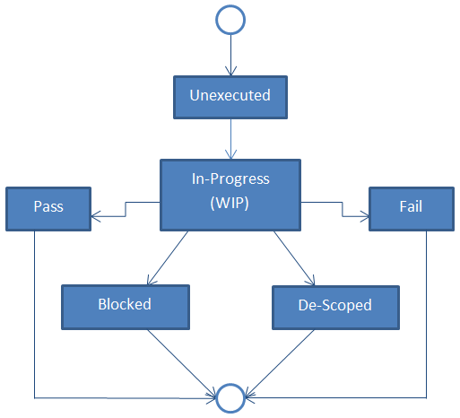

Details of each state are illustrated below:

State | Description
Unexecuted | By default, test cases are marked as ‘Unexecuted’, so when a test case is added to JIRA it should be in ‘Unexecuted’ phase.
WIP | When a tester picks up a test case for execution it is marked as “WIP” meaning it is in progress.
Pass | If the test case is working as intended, then it is marked as “Pass”.
Fail | If the expected result does not match the actual result, the test case is marked as “Fail”.
Blocked | If the test case cannot be executed due to a defect or functionality not available, it will be marked as “Blocked”
De-Scoped | If any functionality gets obsolete or is removed for some reason, the test case is marked as “De-Scoped”.

