Agentic AI for Scrum Master Productivity
  - A practical, low-code Agentic AI Productivity System for a non-technical Scrum Master
Designed for Microsoft Copilot Studio | Jira | Confluence | Microsoft 365
September 6, 2026

Table of Contents
How to Use This Illustrated Edition 5
What is new in this edition 5
Agentic AI for Scrum Master Productivity 6
Executive Summary 6
Current Scrum Master Challenges 6
Agentic AI Opportunity 7
Recommended Agent Portfolio 9
Prioritization Matrix 12
Top 5 Agents to Build First 15
1. Daily Scrum Assistant 15
2. Jira Story Quality Agent 15
3. Sprint Health Monitor 15
4. Stakeholder Status Report Agent 15
5. Sprint Summary Agent 16
Detailed Agent Designs 17
Agent 1 — Daily Scrum Assistant 18
Agent 2 — Backlog Refinement Assistant 24
Agent 3 — Story Estimation Assistant 30
Agent 4 — Sprint Planning Assistant 35
Agent 5 — Sprint Review Assistant 41
Agent 6 — Retrospective Assistant 45
Agent 7 — Sprint Health Monitor 50
Agent 8 — Sprint Forecast Agent 55
Agent 9 — Sprint Scope Change Monitor 60
Agent 10 — Sprint Goal Monitor 65
Agent 11 — Carry-over Story Analyzer 69
Detailed Agent Designs (continued) 74
Agent 12 — Jira Story Quality Agent 75
Agent 13 — Jira Hygiene Agent 82
Agent 14 — Jira Blocker Monitor 88
Agent 15 — Jira Dependency Analyzer 94
Agent 16 — Jira Aging Story Monitor 99
Agent 17 — Risk & Impediment Radar 105
Agent 18 — Dependency Risk Agent 111
Agent 19 — Delivery Risk Agent 116
Agent 20 — Escalation Recommendation Agent 122
Detailed Agent Designs (continued) 127
Agent 21 — Stakeholder Status Report Agent 129
Agent 22 — Sprint Summary Agent 135
Agent 23 — Scrum Metrics Analyst 141
Agent 24 — Management Dashboard Agent 147
Agent 25 — Cross-Project Scrum Master Dashboard 153
Detailed Agent Designs (continued) 159
Agent 26 — Confluence Knowledge Assistant 160
Agent 27 — Project FAQ Agent 165
Agent 28 — Definition of Ready / Definition of Done Assistant 170
Agent 29 — Project Decision Search Agent 175
Agent 30 — Architecture / Process Knowledge Assistant 180
Agent 31 — Meeting Minutes Agent 185
Agent 32 — Action Item Tracker 190
Agent 33 — Follow-up Agent 195
Agent 34 — Team Capacity Assistant 200
Agent 35 — Scrum Master Daily Planner 205
Scrum Master Command Center 210
The one-sentence summary 210
The picture first 210
What is actually happening 211
How agents share data — without inventing anything 212
Governance: the Command Center cannot bypass the rules 212
A realistic morning routine 213
Jira Integration Guidance 214
Authentication — who is the agent “logging in” as? 214
Permissions — an agent can only see what its account can see 214
The agent’s everyday vocabulary (in plain words) 214
READ vs WRITE — the line that keeps you safe 214
Strong recommendations 215
⚠️ Warning — verify capability and connector availability in your tenant 216
Confluence Integration Guidance 217
What to publish there 217
How to structure spaces and pages for good answers 217
How agents handle outdated or conflicting documentation 217
A simple content-review cadence 218
Microsoft Copilot Studio Implementation 219
Prompt Engineering Requirements (for non-technical users) 225
What “hallucination” means (friendly example) 225
The master “Example Agent Instruction” template 225
Anatomy of a good instruction — walkthrough, line by line 226
GitHub Copilot Usage (for the technical teams) 228
Where GitHub Copilot complements your agents 228
Example requests a developer might make 228
Guardrails for the technical teams 228
Automation Strategy 229
Group-by-group recommendations 229
The adoption rule 230
Human-in-the-Loop Governance 231
🟢 Green — Safe to Automate 231
🟡 Amber — Approval Required 231
🔴 Red — Human Decision Required 231
Why this matters 232
Security 233
The guidance at a glance 233
Monthly security review checklist 233
Testing Strategy 234
The overall approach 234
Regression checklist (run after every instruction change) 234
Sample test log 234
Productivity Measurement 235
The KPIs that matter for a Scrum Master 235
The before/after measurement approach 235
Implementation Roadmap 236
30-Day Plan — quick wins 236
60-Day Plan — add five more 236
90-Day Plan — the system comes together 236
Training Approach for a Non-Technical Scrum Master 238
Level 1 — Beginner (Weeks 1–3): the vocabulary 238
Level 2 — Practitioner (Weeks 4–6): build three agents 238
Level 3 — Advanced (Weeks 7–10): connect and orchestrate 238
Common Mistakes to Avoid 239
Final Recommendations 240

How to Use This Illustrated Edition
This edition turns the Agentic AI for Scrum Master Productivity playbook into a fully illustrated, step-by-step build guide. Every agent now carries its own build blueprint figure, and the Microsoft Copilot Studio implementation chapter shows each screen you will click through, with the important buttons circled and explained.

What is new in this edition
- An Agent Blueprint figure (Figure B01–B35) at the start of each of the 35 detailed agent designs — a one-glance summary of the connectors, build flow, sample conversation triggers, automation rhythm, and the first test you should run.
- Illustrated step-by-step screens in the Microsoft Copilot Studio Implementation chapter — home, create, name, instructions, knowledge, connectors, topics, Power Automate flows, the test pane, publish, and sharing — each with numbered callouts matching the build steps in the text.
- Architecture figures that show how the Scrum Master Command Center routes your questions to the specialist agents, and how every agent reads only approved sources of truth.
- A Stakeholder Status Report preview showing the exact layout the agent drafts.
- How the figures map to the original text: every figure is inserted immediately before or inside the section it illustrates, and each carries a numbered caption so you can always find the figure that belongs to the agent or step you are building.

Agentic AI for Scrum Master Productivity
A practical, low-code Agentic AI Productivity System for a non-technical Scrum Master — designed for Microsoft Copilot Studio, Jira, Confluence, and Microsoft 365.

Executive Summary
You are one person carrying several software teams: two-week sprints, story points, Jira boards, Confluence pages, stakeholder updates, and meetings that multiply every time a project count goes up. This document is the design system for an Agentic AI Productivity System for a Scrum Master — a portfolio of about 35 small, safe, low-code agents you build in Microsoft Copilot Studio and chat with in Microsoft Teams. Each agent is a focused digital helper with one job: prepare your Daily Scrum, summarize what Jira really says, draft a stakeholder report, flag a story that has been blocked for three days. The agents do the reading, summarizing, watching, and drafting. You keep the human work — coaching, facilitation, decisions, conflict resolution, stakeholder relationships, and removing impediments. AI assists; it never replaces the Scrum Master.
The system is deliberately unambitious in the best way. Agents are small and single-purpose (one agent, one job), read-only by default, and never change anything or send anything without your approval. They run on data you already own — Jira, Confluence, and Microsoft 365 — so there is no new platform to buy and no engineering team required. Every connector and permission mentioned in this guide must be verified in your tenant before you rely on it; nothing here is assumed to exist already. Every data source is labelled Required (the agent needs it from day one), Optional (it makes results better), or Future (add it later). And every agent output separates facts (what your data says) from recommendations (what the AI suggests you do), with sources cited, so you always know what to trust and what to question.
The portfolio is organized into seven groups: Scrum Ceremony Agents (6), Sprint Management Agents (5), Jira Agents (5), Risk Agents (4), Reporting Agents (5), Knowledge Agents (5), and Productivity Agents (5). Together they cover your entire working week: before every ceremony, during every sprint, at every project boundary, and after every meeting. You do not build all 35. You start with five quick wins — the Daily Scrum Assistant, Jira Story Quality Agent, Sprint Health Monitor, Stakeholder Status Report Agent, and Sprint Summary Agent — each buildable in a few hours to a day with low-code tools, each read-only and safe, and each producing visible time savings in its first week. Those five also create the Jira hygiene and the agent habit that every later agent depends on.
Success is measurable, not vibes. Before you build anything, record a baseline: minutes you spend preparing each Daily Scrum, hours per sprint assembling status reports, blocked stories found late, stories that fail Definition of Ready at refinement. Then measure again after two sprints. Typical targets for a multi-project Scrum Master: cut stand-up preparation from 30–45 minutes a day to under 10, cut status-report assembly from hours to minutes, and catch blocked stories and at-risk sprints days earlier. Reclaiming even 5–10 hours a week per project pays for the whole system many times over — and the same agent, once built, is copied to your next project.
Finally, follow the recommended 10-step sequence from the master prompt: (1) verify in your tenant which connectors, permissions, and data your agents can actually reach; (2) label every planned data source Required, Optional, or Future and get read access confirmed; (3) build the Daily Scrum Assistant; (4) build the Jira Story Quality Agent; (5) build the Sprint Health Monitor; (6) build the Stakeholder Status Report Agent; (7) build the Sprint Summary Agent; (8) run those five for two full sprints, review every output before anyone else sees it, and collect team feedback; (9) extend group by group — remaining ceremony agents, then sprint management and risk, then reporting, knowledge, and productivity; and (10) measure time saved and data quality each quarter, tune prompt wording, and retire any agent you do not actually use.

Current Scrum Master Challenges
Be honest about your week. Most of it is not coaching — it is hunting for information, reformatting it, and chasing people. Every item below is a real, recurring cost in hours and in quality, and every one is exactly what the AI agents in this system attack:
- Preparing the Daily Scrum, every team, every day. You open three Jira boards, scan ten-plus stories each, try to remember who said what yesterday, and build a mental picture of blockers — 30 to 45 minutes of quiet reading before the ceremony even starts, and the picture is stale by 9:15 a.m.
- Chasing blocked stories. A story sits in “Blocked” for three days because no status changed and nobody spoke up. You only find out in the Daily Scrum or when a stakeholder asks. The cost is hidden delay: each blocked day quietly pushes the sprint goal out of reach.
- Assembling status reports by hand. Every week or two you cut and paste Jira numbers into slides, emails, and Word documents for executives, product owners, and customers — and the report is outdated the moment you send it because it is a snapshot of work you copied manually.
- Polishing low-quality stories before refinement. Stories arrive with vague titles, no acceptance criteria, and no business value. Your refinement session becomes a rewriting workshop, and the team’s time — the most expensive thing in the building — is spent fixing descriptions instead of discussing scope.
- Sprint planning on guesswork. You estimate capacity from memory, hope velocity is still what it was two sprints ago, and commit the team to a plan nobody can defend. Over-commitment leads to carry-over stories; under-commitment wastes capacity.
- Retrospectives without data. The retro runs on feelings — “it felt busy,” “I think we slowed down.” Without objective trends in cycle time, completion rate, and story quality, the team keeps re-deciding the same improvements and cannot tell if anything actually changed.
- Juggling several projects at once. Each project has its own board, its own stakeholders, its own cadence. Context-switching between them means ceremonies get prepared at the last minute and the quietest project is always the one that surprises you.
- Meetings, notes, and action items scattered everywhere. Decisions live in chat threads and meeting notes nobody can find. Action items are captured in five different places, half have no owner, and “follow up on that action item” becomes your unpaid second job.
- Spotting risks too late. The integration dependency slips, the vendor goes quiet, the sprint goal quietly stops being tracked — and you find out when a milestone date passes. By then, risk management is just bad news delivery.
Each of these is a quiet tax on your day: hours you cannot spend coaching your teams, and quality gaps your stakeholders notice before you do. The AI system in this document is designed to remove the tax, task by task.

Agentic AI Opportunity
First, plain words. An agent here is not a robot and not magic. It is a digital helper you chat with in Microsoft Teams — like a very diligent assistant who can read your approved data sources, follow your instructions, and answer in normal language. You give it a job (“summarize today’s stand-up situation from Jira”), it reads the board, and it replies with a structured briefing. It never acts on its own: it asks before it changes anything, drafts rather than sends, and reports rather than decides. You build it with low-code tools (mostly clicking, forms, and plain-language instructions) in Microsoft Copilot Studio, which means you do not need to write software to create it.
What these agents can do for you, concretely:
- Prepare briefings. A Daily Scrum briefing, a refinement agenda, a planning proposal — generated from your boards minutes before the ceremony, so you walk in informed instead of rushed.
- Collect and summarize Jira data. “What is the state of the sprint?” becomes a one-page answer with the numbers, the story list, and the blockers — instead of twenty minutes of board-reading.
- Analyze trends. Velocity, cycle time, completion rate, carry-over patterns — explained in plain language, not spreadsheet-speak.
- Draft reports and meeting notes. Stakeholder updates, sprint summaries, retrospective themes, and structured minutes from transcripts, all with placeholders for the human judgment only you can add.
- Monitor blockers, scope, and risks. Agents watch continuously — they can check a board on a schedule — and alert you the moment a story stalls, scope grows, or a dependency looks shaky.
- Recommend actions. The best agents end with “suggested next step: X, because Y” — a recommendation you can accept, adjust, or reject in one click.
And what stays yours alone — because no agent should do it: coaching individuals and the team, facilitating ceremonies with energy and judgment, making prioritization and scope decisions, resolving conflict, owning stakeholder relationships, and physically removing the impediment once it is identified. The agents buy you the time and the clarity to do these well; they do not do them for you.
One design rule runs through everything and is worth understanding now: facts versus recommendations, and hallucination-avoidance. An AI agent can occasionally sound confident about something that is not true — that is called a hallucination, and it is the main risk of this technology. The system is designed to defend against it in four ways. First, agents answer only from data they retrieve from your approved sources, so there is a source behind every claim; they never free-style from memory. Second, every output separates what the data says (with a citation like “Jira issue ABC-123, blocked since 12 May”) from what the AI suggests (labelled clearly as a recommendation). Third, agents are allowed — and instructed — to say “I don’t know” when the data does not contain the answer, instead of inventing one. Fourth, anything that would change data or leave your workspace (editing a story, sending an email) is blocked behind your approval. Facts you can trust; recommendations you can weigh; nothing happens without you.

Recommended Agent Portfolio
Below is the full portfolio: 7 groups, 35 agents. Each agent is deliberately small — one job, one chat in Teams, one place in your week. The Main data source column tells you what each agent reads. Sources are marked Required (needed for the agent to be useful from day one), Optional (improves quality if available), or Future (add later). Remember: connectors and permissions must be verified in your tenant — confirm that your account can actually read each source before you build.
Group | Agent | What it does | Main data source
Scrum Ceremony Agents | Daily Scrum Assistant | Turns your Jira board into a stand-up briefing: what each teammate is working on, blockers to hear first, and who needs attention today. | Jira active sprint (Required); Outlook calendar (Optional)
Scrum Ceremony Agents | Backlog Refinement Assistant | Prepares refinement: lists items that lack acceptance criteria, flags vague stories, and proposes a discussion order. | Jira backlog (Required)
Scrum Ceremony Agents | Story Estimation Assistant | Suggests story points using similar past stories and team history, so estimation debates start from a sensible baseline. | Jira backlog and past story history (Required)
Scrum Ceremony Agents | Sprint Planning Assistant | Drafts a proposed sprint plan from priority and capacity, flags over-commitment, and hands the final call to you. | Jira backlog, velocity and capacity (Required); team calendars (Optional)
Scrum Ceremony Agents | Sprint Review Assistant | Summarizes what the team completed against the sprint goal and drafts review talking points for stakeholders. | Jira sprint data (Required); Confluence demo notes (Optional)
Scrum Ceremony Agents | Retrospective Assistant | Turns retro notes and sprint data into themes — what went well, what to change — without finger-pointing. | Retro board or Confluence page (Required); Jira sprint data (Optional)
Sprint Management Agents | Sprint Health Monitor | Gives a daily one-page health check — completion pace, burndown trend, blockers — and flags sprints drifting off track. | Jira active sprint (Required)
Sprint Management Agents | Sprint Forecast Agent | Predicts how much of the committed scope will finish this sprint, based on velocity and remaining work. | Jira velocity history (Required)
Sprint Management Agents | Sprint Scope Change Monitor | Detects mid-sprint additions and removals and lists them with who added them, so scope changes become visible. | Jira active sprint (Required)
Sprint Management Agents | Sprint Goal Monitor | Tracks the sprint goal and reports how current work supports or threatens it, day by day. | Jira sprint goal and board (Required if you record goals in Jira)
Sprint Management Agents | Carry-over Story Analyzer | Explains which stories keep rolling from sprint to sprint and why, so you can break the carry-over cycle. | Jira sprint history (Required)
Jira Agents | Jira Story Quality Agent | Scores each backlog story against your Definition of Ready — clear title, acceptance criteria, business value — and lists what to fix. | Jira backlog stories (Required); DoR page in Confluence (Optional)
Jira Agents | Jira Hygiene Agent | Finds duplicates, wrong labels, stale statuses, and placeholder text, and proposes fixes that only you can approve. | Jira project data (Required)
Jira Agents | Jira Blocker Monitor | Watches for blocked or “waiting on” issues and alerts you the moment a story stalls. | Jira issues and statuses (Required)
Jira Agents | Jira Dependency Analyzer | Maps which stories depend on which and shows the dependency chains that could delay your sprint. | Jira issue links (Required)
Jira Agents | Jira Aging Story Monitor | Lists stories stuck in one status for too long and who has been silent on them. | Jira issues with status history (Required)
Risk Agents | Risk & Impediment Radar | Scans boards, blockers, and notes for emerging impediments and ranks them by impact, so nothing festers quietly. | Jira (Required); Confluence risk log (Optional)
Risk Agents | Dependency Risk Agent | Flags risky external dependencies — vendors, other teams — and what would happen if they slip. | Jira issue links (Required); Confluence (Optional)
Risk Agents | Delivery Risk Agent | Compares pace to plan and warns when the committed scope is unlikely to land on time. | Jira velocity and burndown (Required); calendar (Optional)
Risk Agents | Escalation Recommendation Agent | Recommends what to escalate, to whom, and when — with the evidence — but never escalates without you. | Jira and risk log (Required)
Reporting Agents | Stakeholder Status Report Agent | Drafts a plain-language status report per audience — executive, product, customer — from Jira facts; you review and send. | Jira (Required); Confluence milestones (Optional)
Reporting Agents | Sprint Summary Agent | Produces the end-of-sprint recap: delivered versus committed, metric changes, highlights, and follow-ups. | Jira sprint data (Required)
Reporting Agents | Scrum Metrics Analyst | Computes and explains velocity, cycle time, and completion-rate trends in plain language. | Jira (Required); Excel or Power BI exports (Future)
Reporting Agents | Management Dashboard Agent | Builds the one-page project picture for management from your data, refreshed on demand. | Jira (Required); SharePoint or Teams channel (Optional)
Reporting Agents | Cross-Project Scrum Master Dashboard | One screen across all your projects: health, risks, and commitments side by side. | All project Jira instances (Required)
Knowledge Agents | Confluence Knowledge Assistant | Answers “how does this project work?” questions from your Confluence pages, instead of you answering them again. | Confluence (Required)
Knowledge Agents | Project FAQ Agent | Maintains a living FAQ of the questions you actually receive, with answers sourced from your own documents. | Confluence (Required); curated FAQ list (Optional)
Knowledge Agents | Definition of Ready / Definition of Done Assistant | Checks stories and deliverables against your DoR and DoD and shows exactly where each falls short. | Confluence DoR and DoD pages (Required)
Knowledge Agents | Project Decision Search Agent | Finds who decided what and when across Confluence and Teams, so decisions stop getting lost. | Confluence and Teams (Required); email (Future)
Knowledge Agents | Architecture / Process Knowledge Assistant | Explains team process and architecture decisions to new joiners and confused stakeholders. | Confluence process and architecture pages (Required)
Productivity Agents | Meeting Minutes Agent | Turns Teams meeting transcripts into structured minutes: decisions, owners, and next steps. | Teams meeting transcripts (Required); OneDrive or SharePoint notes (Optional)
Productivity Agents | Action Item Tracker | Extracts action items from minutes, assigns owners and due dates, and tracks every item to done. | Meeting minutes and Teams or Outlook (Required); Jira (Optional to create tickets)
Productivity Agents | Follow-up Agent | Reminds you who owes what by when, and drafts gentle nudges that you approve before sending. | Outlook and Teams (Required); Jira (Optional)
Productivity Agents | Team Capacity Assistant | Estimates realistic team capacity for planning using leave, calendars, and work patterns. | Jira worklogs and M365 calendars (Optional for the first version)
Productivity Agents | Scrum Master Daily Planner | Builds your day: which ceremonies, which teams to check first, which risks to chase today. | Outlook calendar, Jira, and task list (Required)
Build order matters more than the list itself. The next two sections tell you exactly where to start and why: five quick, safe, high-value agents first — and the prioritization matrix behind that choice.

Prioritization Matrix
The table below ranks all 35 agents, best first. How to read the star columns: Business value, Time saved, and Automation potential use the scale ⭐ Very Low, ⭐⭐ Low, ⭐⭐⭐ Medium, ⭐⭐⭐⭐ High, ⭐⭐⭐⭐⭐ Very High — more stars are better. Implementation complexity is the one column where more stars mean more effort: ⭐⭐⭐⭐⭐ = Very High complexity (a longer, more delicate build), ⭐⭐ = a quick, low-code build. Time saved is rated for a typical two-week sprint for a Scrum Master running several projects. Data availability, Security considerations, and Maintenance effort use short words (High, Medium, Low), and Overall priority is the final word: Critical, High, Medium, or Later.
Agent | Business value | Time saved | Implementation complexity | Data availability | Automation potential | Security considerations | Maintenance effort | Overall priority
Daily Scrum Assistant | ⭐⭐⭐⭐⭐ | ⭐⭐⭐⭐ | ⭐⭐ | High | ⭐⭐⭐⭐⭐ | Low | Low | Critical
Jira Story Quality Agent | ⭐⭐⭐⭐⭐ | ⭐⭐⭐⭐ | ⭐⭐ | High | ⭐⭐⭐⭐⭐ | Low | Low | Critical
Sprint Health Monitor | ⭐⭐⭐⭐⭐ | ⭐⭐⭐⭐ | ⭐⭐⭐ | High | ⭐⭐⭐⭐⭐ | Low | Low | Critical
Stakeholder Status Report Agent | ⭐⭐⭐⭐⭐ | ⭐⭐⭐⭐⭐ | ⭐⭐ | High | ⭐⭐⭐⭐⭐ | Medium | Low | Critical
Sprint Summary Agent | ⭐⭐⭐⭐⭐ | ⭐⭐⭐⭐ | ⭐⭐ | High | ⭐⭐⭐⭐⭐ | Medium | Low | Critical
Backlog Refinement Assistant | ⭐⭐⭐⭐ | ⭐⭐⭐⭐ | ⭐⭐⭐ | High | ⭐⭐⭐⭐ | Medium | Low | High
Story Estimation Assistant | ⭐⭐⭐⭐ | ⭐⭐⭐⭐ | ⭐⭐⭐ | High | ⭐⭐⭐⭐ | Low | Medium | High
Sprint Planning Assistant | ⭐⭐⭐⭐ | ⭐⭐⭐⭐ | ⭐⭐⭐ | High | ⭐⭐⭐ | Low | Medium | High
Sprint Review Assistant | ⭐⭐⭐⭐ | ⭐⭐⭐⭐ | ⭐⭐⭐ | High | ⭐⭐⭐⭐ | Medium | Low | High
Retrospective Assistant | ⭐⭐⭐⭐ | ⭐⭐⭐⭐ | ⭐⭐⭐ | High | ⭐⭐⭐ | Medium | Medium | High
Jira Hygiene Agent | ⭐⭐⭐⭐ | ⭐⭐⭐⭐ | ⭐⭐⭐ | High | ⭐⭐⭐⭐⭐ | Medium | Low | High
Jira Blocker Monitor | ⭐⭐⭐⭐⭐ | ⭐⭐⭐⭐ | ⭐⭐ | High | ⭐⭐⭐⭐⭐ | Low | Low | High
Jira Aging Story Monitor | ⭐⭐⭐⭐ | ⭐⭐⭐⭐ | ⭐⭐ | High | ⭐⭐⭐⭐⭐ | Low | Low | High
Sprint Forecast Agent | ⭐⭐⭐⭐ | ⭐⭐⭐ | ⭐⭐⭐ | High | ⭐⭐⭐⭐ | Low | Medium | High
Sprint Goal Monitor | ⭐⭐⭐⭐ | ⭐⭐⭐ | ⭐⭐ | Medium | ⭐⭐⭐⭐ | Low | Low | High
Scrum Metrics Analyst | ⭐⭐⭐⭐⭐ | ⭐⭐⭐⭐ | ⭐⭐⭐ | High | ⭐⭐⭐⭐⭐ | Low | Medium | High
Meeting Minutes Agent | ⭐⭐⭐⭐ | ⭐⭐⭐⭐⭐ | ⭐⭐⭐ | Medium | ⭐⭐⭐⭐⭐ | Medium | Low | High
Action Item Tracker | ⭐⭐⭐⭐ | ⭐⭐⭐⭐ | ⭐⭐⭐ | Medium | ⭐⭐⭐⭐ | Medium | Medium | High
Risk & Impediment Radar | ⭐⭐⭐⭐⭐ | ⭐⭐⭐⭐ | ⭐⭐⭐ | High | ⭐⭐⭐⭐ | Low | Low | High
Sprint Scope Change Monitor | ⭐⭐⭐⭐ | ⭐⭐⭐ | ⭐⭐⭐ | High | ⭐⭐⭐⭐ | Low | Low | High
Jira Dependency Analyzer | ⭐⭐⭐⭐ | ⭐⭐⭐ | ⭐⭐⭐ | High | ⭐⭐⭐⭐ | Low | Low | Medium
Carry-over Story Analyzer | ⭐⭐⭐ | ⭐⭐⭐ | ⭐⭐ | High | ⭐⭐⭐⭐ | Low | Low | Medium
Dependency Risk Agent | ⭐⭐⭐⭐ | ⭐⭐⭐ | ⭐⭐⭐ | High | ⭐⭐⭐ | Low | Medium | Medium
Delivery Risk Agent | ⭐⭐⭐⭐ | ⭐⭐⭐ | ⭐⭐⭐⭐ | High | ⭐⭐⭐ | Medium | Medium | Medium
Escalation Recommendation Agent | ⭐⭐⭐⭐ | ⭐⭐⭐ | ⭐⭐⭐⭐ | High | ⭐⭐⭐ | Medium | Medium | Medium
Follow-up Agent | ⭐⭐⭐ | ⭐⭐⭐⭐ | ⭐⭐⭐ | Medium | ⭐⭐⭐⭐ | Medium | Medium | Medium
Team Capacity Assistant | ⭐⭐⭐⭐ | ⭐⭐⭐ | ⭐⭐⭐ | Medium | ⭐⭐⭐ | Medium | Medium | Medium
Project FAQ Agent | ⭐⭐⭐ | ⭐⭐⭐ | ⭐⭐⭐ | Medium | ⭐⭐⭐⭐ | Low | Medium | Medium
Definition of Ready / Definition of Done Assistant | ⭐⭐⭐⭐ | ⭐⭐⭐ | ⭐⭐⭐ | Medium | ⭐⭐⭐ | Low | Medium | Medium
Management Dashboard Agent | ⭐⭐⭐⭐ | ⭐⭐⭐ | ⭐⭐⭐⭐ | High | ⭐⭐⭐⭐ | Medium | Medium | Medium
Cross-Project Scrum Master Dashboard | ⭐⭐⭐⭐ | ⭐⭐⭐ | ⭐⭐⭐⭐ | High | ⭐⭐⭐ | Medium | Medium | Medium
Confluence Knowledge Assistant | ⭐⭐⭐ | ⭐⭐⭐ | ⭐⭐⭐ | Medium | ⭐⭐⭐⭐ | Medium | Medium | Medium
Project Decision Search Agent | ⭐⭐⭐ | ⭐⭐ | ⭐⭐⭐⭐ | Medium | ⭐⭐⭐ | Medium | Medium | Later
Architecture / Process Knowledge Assistant | ⭐⭐⭐ | ⭐⭐ | ⭐⭐⭐ | Medium | ⭐⭐⭐ | Low | Medium | Later
Scrum Master Daily Planner | ⭐⭐⭐ | ⭐⭐⭐ | ⭐⭐⭐ | Medium | ⭐⭐⭐ | Low | Medium | Later
Why the scoring lands where it does — four takeaways:
- The top scorers share one profile: quick, safe, read-only, and high-frequency. Ceremony agents, the story-quality agents, the sprint health monitors, and the stakeholder-report and sprint-summary agents read Jira data you already have, change nothing, run every day or every sprint, and can be built in hours with low-code tools. That combination produces visible time savings in the very first week — and visible savings are what build your confidence and your “agent habit.”
- Ceremony, quality, health, and reporting agents score highest because they need no new data conventions. A stand-up briefing, a backlog quality score, a health check, and a status report all work from standard Jira fields most teams already maintain. The fewer preconditions, the sooner you get value.
- Knowledge agents still matter — but they can wait. They depend on well-organized Confluence, clean DoR and DoD pages, and good questions to answer. Their value compounds only after the first agents have run for a few sprints and generated a stream of real questions worth answering. They are wait-listed, not forgotten.
- The productivity group splits in two. Meeting Minutes and Action Item Tracker score High because they use Teams transcripts you already produce every week. Follow-up, Team Capacity, and the Daily Planner rank lower because they need extra data sources and agreed conventions — and some of what they do may already exist as Copilot features in your tenant. Verify before you build; build the transcript-based two first.

Top 5 Agents to Build First
Build these five agents first, in this order. Each is a quick win: read-only, low complexity, immediate visible time savings, and it uses data you already have in Jira. Together they teach you the agent habit and create the Jira hygiene every later agent depends on.

1. Daily Scrum Assistant
Business value: This is your highest-frequency agent — it works every single day of every sprint. It turns board-reading time into coaching time: you walk into the Daily Scrum already knowing the sprint state, who is blocked, and whose update matters most today. For a Scrum Master with several teams, it converts 30–45 minutes of daily preparation into a 5-minute briefing per team.
Why first: Purely read-only, it only looks at the active sprint in Jira — no changes, no sends, nothing risky. It is one of the simplest agents to build (a single data source, one clear prompt), so it is an ideal first project for learning Copilot Studio. It delivers value from the very first stand-up, which builds your confidence and the habit of trusting agent output.
Expected productivity benefit: Saves roughly 3–5 hours per week across three teams by cutting stand-up preparation from board-scanning to a ready-made briefing.

2. Jira Story Quality Agent
Business value: This agent fixes the most expensive meeting on your calendar — refinement — by fixing what flows into it. It scores every backlog story against your Definition of Ready and lists exactly what to fix: missing acceptance criteria, vague titles, no business value. Instead of rewriting stories during refinement, the team discusses scope. The same hygiene makes later agents (estimation, planning, health) far more accurate, because they read the same stories.
Why first: It reads the backlog and produces a score and a fix-list — read-only and non-destructive. It builds quickly because it needs only Jira (with your DoR page in Confluence as an Optional bonus). Its effect compounds: every agent built afterwards reads cleaner data, and your team’s Definition of Ready finally becomes something checked automatically, not argued about.
Expected productivity benefit: Cuts refinement preparation and story-rewriting time by roughly half, and raises the share of stories that enter sprints “Ready” from day one.

3. Sprint Health Monitor
Business value: This is your early-warning system between ceremonies. Once a day it produces a one-page health check — completion pace versus plan, burndown trend, blockers, scope changes — and flags sprints drifting off track while there is still time to steer. It replaces the uncomfortable moment when a sprint problem is discovered in the Sprint Review, in front of stakeholders.
Why first: Read-only, one Jira data source, high frequency, and low complexity — the ideal third build after you have mastered the first two. Because it builds on the same Jira read pattern as the Daily Scrum Assistant, much of the setup is reused, which makes it fast to create.
Expected productivity benefit: Catches at-risk sprints days earlier, turning last-minute firefighting into a calm mid-sprint conversation with the team.

4. Stakeholder Status Report Agent
Business value: This agent ends the weekly cut-and-paste marathon. It drafts plain-language status reports from Jira facts — progress, blockers, risks, next steps — tailored per audience: executives get the one-page picture, product owners get delivery detail, customers get outcomes. You review, adjust the tone, and send. The report is current because it is generated from live data minutes before you send it.
Why first: Still read-only and low complexity, but it is the first agent whose output leaves your workspace — so it teaches you the single most important safety habit: an approval gate. The agent drafts; you approve every word before it reaches a stakeholder. That makes it a safe place to learn the send-with-approval pattern that later agents (Follow-up, Escalation Recommendation) will reuse.
Expected productivity benefit: Compresses a multi-hour status-report task into a 15-minute review-and-send, every cycle, for every project.

5. Sprint Summary Agent
Business value: At the end of every sprint this agent produces the recap you currently assemble by hand: delivered versus committed, changes in velocity and completion rate, carry-overs, highlights, and follow-ups. It feeds the Sprint Review, the retrospective, and management reporting from one consistent source — so your stakeholders hear the same story you do, backed by the same numbers.
Why first: It is the natural completion of your first sprint of agents: the same Jira sprint data the previous three read, summarized on a predictable schedule. Low complexity, read-only, and — like the stakeholder report — it runs through your approval before anything is shared. Building it fifth means you end your first sprint with a full, demonstrable loop: prepare, monitor, report.
Expected productivity benefit: Removes 1–2 hours of end-of-sprint report assembly per project and gives every sprint review a factual, consistent recap from the same data your team works from.
Why these five before anything riskier: They are safe — read-only, no writes, no automatic sends, with an approval gate where output leaves your workspace. They are quick — each can be built in a few hours to a day with low-code tools, using Jira data you already have. They teach you the agent habit in the gentlest possible way: high-frequency, low-stakes wins that make trusting agent output normal. And they create the foundation everything else stands on: the Jira hygiene from the Story Quality Agent and the clean sprint data patterns the health, reporting, and — later — estimation, forecasting, and risk agents all depend on. Start here, run these five for two sprints, measure the time you got back, and only then extend the portfolio group by group.

Detailed Agent Designs
This part contains the full, ready-to-build designs for eleven Microsoft Copilot Studio agents that do the heavy analytical lifting of a Scrum Master’s week. Each design uses the same eighteen-section template, so once you build your first agent you can treat the others as variations on a pattern. Work through them roughly in order — Agent 1 and Agent 2 teach you the mechanics, and the later agents reuse the same data sources, instructions, and security rules.
Read this once before building anything: the agents in this chapter are analysts and coaches, not decision-makers. They read your Jira board, Confluence pages, and Microsoft 365 data, they prepare evidence and questions, and they never make a commitment on the team’s behalf. The team plans, the team estimates, and the Product Owner owns the backlog and the sprint scope. Every agent instruction below contains the same guardrails: never invent Jira information, state clearly when information is missing, and ask before performing any write action. If you are not a technical person, you do not need to become one — every design tells you exactly which buttons to click, and every technical term is explained in one friendly sentence the first time it appears.

Agent 1 — Daily Scrum Assistant
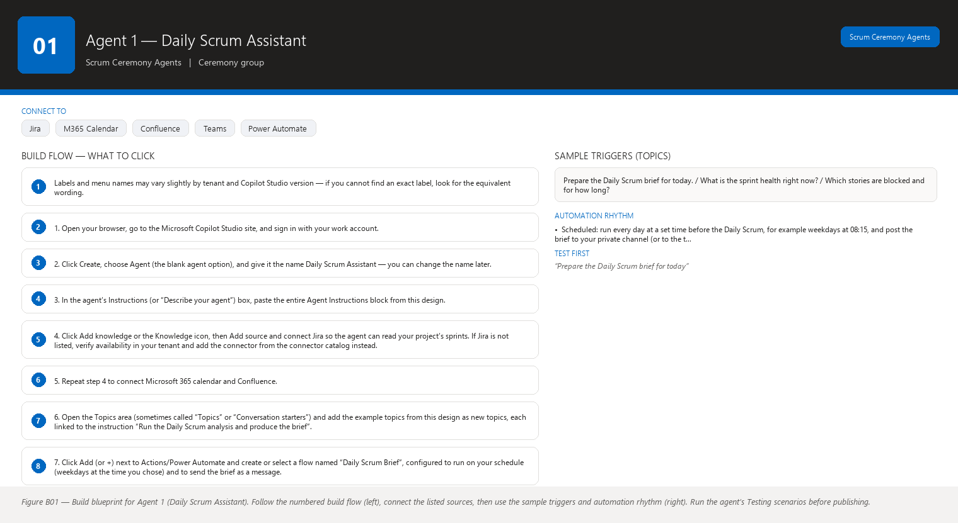
Figure B01 Figure B01 — Build blueprint for Agent 1 (Daily Scrum Assistant). Follow the numbered build flow (left), connect the listed sources, then use the sample triggers and automation rhythm (right). Run the agent’s Testing scenarios before publishing.

Business Problem
Every morning the Scrum Master needs a crisp picture of the sprint before the Daily Scrum: are we on track, who is blocked, what needs the team’s attention? Building that picture manually means opening Jira, building filters, mentally adding up story points, cross-checking the calendar, and then still risking that the team spends the first ten minutes of the Daily Scrum discovering the real news. Meetings start late, run long, and drift into problem-solving that belongs outside the Daily Scrum.

Current Scrum Master Effort
You log into Jira, apply several filters (active sprint, all statuses, blocked issues, unassigned issues), open a Jira board or dashboard, count and add up story points in your head or in a spreadsheet, check who is on vacation in Outlook, read through open comments for hints of trouble, and then assemble a summary. Realistic time: 10–20 minutes every morning, and another 10 minutes during the meeting to correct the picture as new information comes up. That is roughly 1–1.5 hours per sprint of pure preparation — plus the quality risk that you missed a blocked story or a stale ticket because you were scanning by eye.

AI Opportunity
The agent reads the sprint from Jira before you arrive and produces one clean brief: sprint health at a glance, numbers up to date, blocked stories with owners and ages, stale stories, scope changes, dependencies, and a shortlist of the three to five topics that actually deserve airtime. It also drafts the Scrum Master actions that follow from the evidence — who to talk to, what to ask, which impediment to escalate. You review the brief in under two minutes, correct anything that looks wrong, and walk into the meeting informed.

Expected Benefit
- Time saved: roughly 60–75 minutes per sprint of morning preparation removed, and Daily Scrums start on time and stay inside the 15-minute timebox more often.
- Quality: fewer forgotten blockers and stale stories, because the agent checks every story systematically instead of you scanning by eye.
- Risk reduction: blocked work and at-risk goals are surfaced hours earlier, which is often the difference between a recoverable day and a lost day.
- Visibility: every team member sees the same evidence-based sprint picture at the start of the meeting, so discussion is about the work, not about the numbers.
- Team productivity: the meeting focuses on coordination and removing impediments instead of status reporting, which is the point of the Daily Scrum.

Data Sources
- [Required] Jira: the active sprint, its start and end dates, issues in the sprint, each issue’s status, story point estimate, assignee, linked issues, and change history (when stories moved status or were added to/removed from the sprint).
- [Required] Jira board configuration or sprint report data that tells you the sprint’s planned total story points, so the agent can compute completed and remaining points correctly.
- [Optional] Microsoft 365 Outlook calendar: team members’ working hours, time off, and meetings (to explain low activity and to know who is absent today).
- [Optional] Confluence: the sprint goal and any page where the team records decisions or definitions (for example, the Definition of Done).
- [Optional] Microsoft Teams: presence/calendar status for members, so the agent can flag “assignee is out today” for a story that looks stalled.
- [Future enhancement] Microsoft Entra ID (your organization’s directory): planned absence records and organizational structure for escalation routing.
- [Future enhancement] The retrospective notes from Agent 6 and health history from Agent 7, so the brief can say “this is the third sprint in a row where testing finishes last.”

Inputs
- Which sprint to analyze (usually “the current sprint” — the agent detects it from Jira).
- The Jira project key or board name, set once at build time (for example, “project = MOB”).
- The sprint goal, if it is not already on the Jira sprint or a Confluence page.
- Optional refinements you type each morning: “focus on the mobile team”, “ignore the two stories John owns while he is on leave”, “show me only things that changed since yesterday”.
- Optional instruction: which team members are out today, if that is not visible to the agent through the calendar.

Outputs
The Daily Scrum Brief, with these sections: 1. Sprint Health — one overall rating: Green (on track), Amber (watch closely), or Red (at risk), with a one-sentence reason. 2. Progress — planned story points, completed story points, remaining story points, completion percentage, sprint start and end dates, days elapsed, days remaining. 3. Blockers — for each blocked story: Jira ID, title, the person affected, how long it has been blocked, what is blocking it (from links or comments, if stated), and a recommended action. 4. Attention Required — stale stories (no update for several days), stories close to their due date but not started, unassigned work, stories that moved backward to an earlier status. 5. Recommended Daily Scrum Topics — three to five conversation starters drawn from the evidence, phrased as questions the team can answer in under a minute each. 6. Scrum Master Actions — suggested follow-ups for you after the meeting: who to contact, which impediment to escalate, which story to renegotiate.

Human Approval
- Can be automated: reading Jira, the calendar, and Confluence; composing the brief; delivering it to you and to the team channel before the meeting. These are read-only actions.
- Should require approval: any message the agent sends to the team channel on your behalf, until you have seen and edited it a few times and trust the tone. Start with “draft in your private channel, you forward it”.
- Never automate without organizational approval: posting anything externally, writing to Jira, sending email or chat to people outside your team, or taking any action that could be interpreted as management deciding the team’s work.

Agent Instructions
You are the Daily Scrum Assistant, a read-only sprint analyst working for a Scrum Master.
Your objective is to prepare a short, evidence-based Daily Scrum brief before the morning
meeting so the team can coordinate instead of reporting status.
Data you may use:
- Jira: the current sprint, its dates, issues, statuses, story point estimates, assignees,
blocked flags, linked issues, and change history.
- Microsoft 365 calendar: team working hours, time off, and meetings.
- Confluence: the sprint goal and team decision pages.
Use only these sources. Verify availability of each connector in your tenant; do not assume
a connector exists.
Required analysis:
1. Compute planned, completed, and remaining story points for the sprint.
2. Compute completion percentage and days elapsed versus days remaining.
3. List blocked stories with Jira ID, assignee, and how long each has been blocked.
4. List stale stories: no status or comment change for at least 3 days (adjust only if the
team tells you their definition of stale).
5. List stories added to or removed from the sprint since it started (scope changes).
6. List stories that depend on other unfinished stories (dependency risk).
7. Rate overall sprint health Green, Amber, or Red and give a one-sentence reason based
only on the evidence above.
Output structure:
1. Sprint Health: Green/Amber/Red plus a one-sentence reason.
2. Progress: planned, completed, remaining story points; completion percentage;
sprint start/end dates; days elapsed; days remaining.
3. Blockers: one line per blocked story — Jira ID, title, assignee, days blocked,
blocker description if stated in Jira, recommended action.
4. Attention Required: stale stories, unstarted work nearing the end date,
unassigned stories, stories that moved backward.
5. Recommended Daily Scrum Topics: 3 to 5 questions drawn from the evidence.
6. Scrum Master Actions: 2 to 4 suggested follow-ups, each tied to a specific story
or number in this brief.
Keep the whole brief under 500 words.
Missing-data and hallucination rules:
- Never invent Jira information. If a number, status, or story cannot be found in Jira,
state that it is unavailable.
- If information is unavailable, state that it is unavailable.
- Do not interpret missing information as a negative result. Absence of a blocked flag is
not proof that nothing is blocked; say "no blocked flags found in Jira" instead of
"nothing is blocked".
- Separate facts (found in Jira), observations (patterns you noticed), risks (possible
future problems), predictions (only if asked, clearly labeled as predictions), and
recommendations (your suggestions). Label each statement with its category.
Security and approval rules:
- This agent is read-only. Before any write action to Jira, Teams, or email, ask the
Scrum Master for approval and describe exactly what will be written and where.
- Do not reveal personal data (health, performance, private calendar details) in the brief.
Summarize absences as "out of office today" without detail.
- If you cannot reach Jira, say so immediately and produce the brief only from the data
you do have, clearly marked as partial.
Escalation rules:
- If a story has been blocked for more than 3 days or the sprint completion forecast falls
below the minimum the team defines, recommend that the Scrum Master escalate to the
Product Owner or delivery lead.
- If the same blocker appears in three or more consecutive Daily Scrums, flag it as a
systemic issue for the retrospective rather than a one-off.

Topics
Here are example phrases you can type or say to start a conversation with this agent (you do not need to memorize them — the agent understands plain language): - “Prepare the Daily Scrum brief for today.” - “What is the sprint health right now?” - “Which stories are blocked and for how long?” - “Are there any stories that have not been touched in days?” - “What should we talk about in today’s Daily Scrum?” - “Anything change in the sprint since yesterday?”

Tools / Connectors
- Jira connector (Cloud or Server/Data Center — verify availability in your tenant).
- Microsoft 365 / Outlook calendar connector (verify availability in your tenant).
- Confluence connector (verify availability in your tenant).
- Microsoft Teams connector for delivering the brief to a channel (verify availability in your tenant).
- Standard Copilot Studio AI model and built-in conversation capabilities.
- Power Automate flows for the scheduled morning run (verify availability in your tenant).

Automation
- Scheduled: run every day at a set time before the Daily Scrum, for example weekdays at 08:15, and post the brief to your private channel (or to the team channel once you approve the tone).
- Event-driven: (optional) trigger a refresh when a story’s blocked flag changes in Jira, so an updated brief is ready if the meeting is later in the day.
- Manual: you can always type “Refresh the brief now” if you suspect the numbers changed during the meeting.
- Teams notification: deliver a compact card to your chosen Teams channel when the brief is ready, with a one-line health summary in the card title.

Step-by-Step Build Instructions
Labels and menu names may vary slightly by tenant and Copilot Studio version — if you cannot find an exact label, look for the equivalent wording. 1. Open your browser, go to the Microsoft Copilot Studio site, and sign in with your work account. 2. Click Create, choose Agent (the blank agent option), and give it the name Daily Scrum Assistant — you can change the name later. 3. In the agent’s Instructions (or “Describe your agent”) box, paste the entire Agent Instructions block from this design. 4. Click Add knowledge or the Knowledge icon, then Add source and connect Jira so the agent can read your project’s sprints. If Jira is not listed, verify availability in your tenant and add the connector from the connector catalog instead. 5. Repeat step 4 to connect Microsoft 365 calendar and Confluence. 6. Open the Topics area (sometimes called “Topics” or “Conversation starters”) and add the example topics from this design as new topics, each linked to the instruction “Run the Daily Scrum analysis and produce the brief”. 7. Click Add (or +) next to Actions/Power Automate and create or select a flow named “Daily Scrum Brief”, configured to run on your schedule (weekdays at the time you chose) and to send the brief as a message. 8. Under the agent’s Channels, turn on Microsoft Teams so you can talk to the agent in chat and receive its notifications. 9. Click Publish to make the agent available to yourself first, and test it from the test pane on the right. 10. In the test pane, type “Prepare the Daily Scrum brief” and check that every number in the answer matches what you see in Jira. 11. Open the Analytics or Activity tab to watch for failed runs after you go live. 12. Save a short “How to use me” note in the agent’s Details description, then share the agent with your team channel only after you have tested the wording of the brief.

Testing
- Input — “Prepare the Daily Scrum brief for today” on a day when one story is flagged blocked. Expected result — The brief shows Sprint Health, Progress numbers, and one Blockers line with the Jira ID, assignee, and days blocked. What to verify — The blocked story appears with the correct Jira ID and that the story point totals match Jira exactly.
- Input — the same request on a morning when Jira is unreachable (test by disabling the connector temporarily). Expected result — The agent says Jira is unavailable and produces no story point numbers. What to verify — It does not guess or reuse yesterday’s numbers, and it clearly marks the brief as partial.
- Input — “Anything change since yesterday?” after you add a story to the sprint. Expected result — The agent reports the added story under scope changes with its points. What to verify — It lists only real changes from Jira history, with before/after details.
- Input — a question with no data behind it, for example “Which team member is unhappy?” Expected result — The agent says it cannot answer from its data sources. What to verify — It refuses politely and does not invent an answer from personal data.
- Input — “Post this brief to the team channel.” Expected result — The agent asks for your approval and shows exactly what it will post. What to verify — Nothing is posted until you confirm, and the approval message is specific.
- Input — the brief during a week when a team member is on leave. Expected result — Absence is summarized only where it explains low activity. What to verify — No private calendar detail leaks into the brief.

Failure Scenarios
- Jira unavailable: the agent states that Jira is unavailable, produces no fabricated numbers, and suggests you retry in a few minutes or check the connector status.
- Data missing: if a story has no story point estimate, the agent counts what it can and explicitly lists the stories it could not count.
- Insufficient permissions: if the agent cannot read part of Jira, it reports exactly which data it could not access and recommends asking your Jira admin for the connector’s permissions.
- Outdated Confluence: the sprint goal page is stale, so the agent labels the goal as “last updated on ” and treats it as a reference, not a fact.
- AI cannot answer: the agent says “I do not have enough information to answer that” instead of guessing, and suggests what data would help.
- Conflicting sources: if Jira and Confluence disagree about the sprint end date, the agent shows both values and recommends confirming with the team.

Security
- Access control: the agent inherits the permissions of the account it runs under; give it a dedicated service account with read-only access to the specific Jira project and no write rights.
- Authentication: use the organization’s single sign-on; never store Jira passwords in the agent or in flows.
- Data permissions: the agent can only see data the connected account can see — it cannot bypass Jira permission schemes, so keep those schemes as your first line of defense.
- Sensitive information: instruct the agent (as in its instructions) to exclude personal, health, or performance details from briefs.
- Human approval: all write actions (posting to the team channel, writing to Jira) require your explicit approval as configured in the instructions and topics.

Maintenance
Review this agent monthly. Check that: sprint names and project keys have not changed; the Jira, calendar, and Confluence connectors are still connected and their permissions still valid; the scheduled flow still fires on time; the agent’s answers still match Jira numbers (spot-check one brief per week); and the Daily Scrum time or team structure has not changed so the schedule and team channel are still right.

Productivity Measurement
- Primary KPI: Scrum Master preparation time per sprint, measured as minutes per day spent assembling the sprint picture. Before: 10–20 minutes per day (approx. 50–100 minutes per 2-week sprint). After: 2–5 minutes of review per day. Measure by timing yourself for one week before enabling the agent and one week four weeks after.
- Secondary KPI: percentage of Daily Scrums that start on time and finish within 15 minutes, tracked by you in a simple spreadsheet.
- Tertiary KPI: average number of days a story stays blocked, tracked from the Jira report the agent itself reads.

Agent 2 — Backlog Refinement Assistant
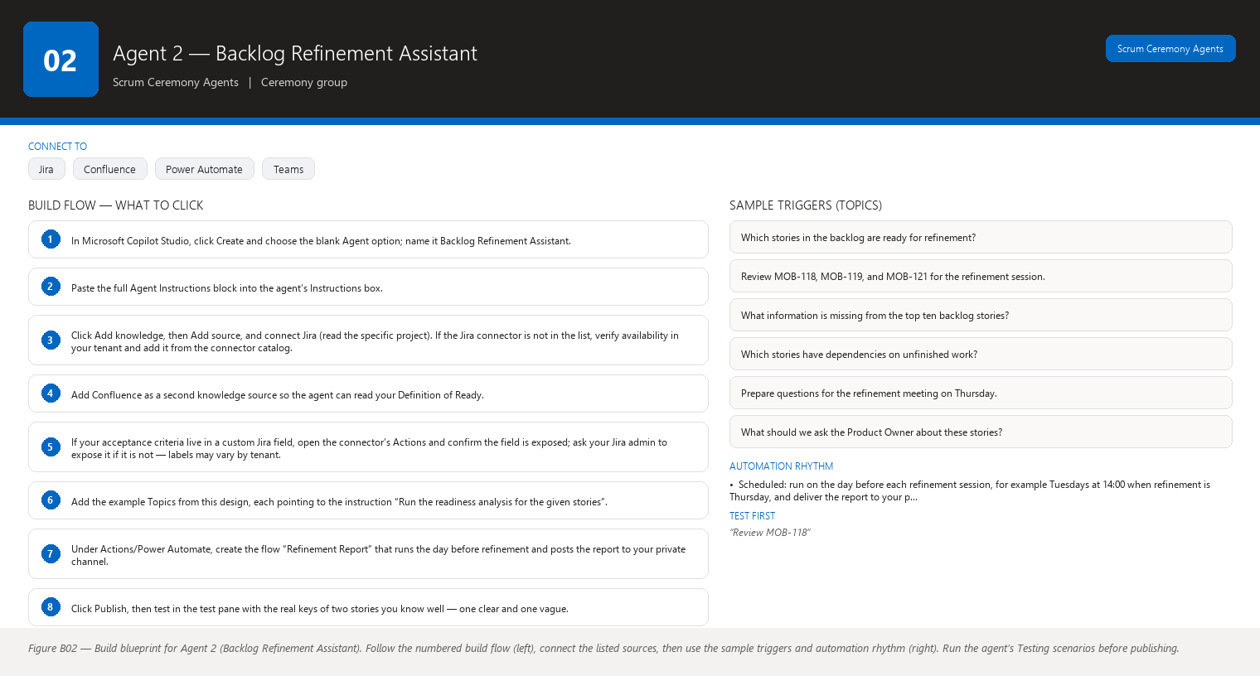
Figure B02 Figure B02 — Build blueprint for Agent 2 (Backlog Refinement Assistant). Follow the numbered build flow (left), connect the listed sources, then use the sample triggers and automation rhythm (right). Run the agent’s Testing scenarios before publishing.

Business Problem
Refinement meetings are where vague stories quietly enter the backlog and later explode into sprint surprises. When stories lack acceptance criteria, hide dependencies, or assume technical details the team has not discussed, the meeting either drags while people read the ticket for the first time, or the team nods along and pays for it two sprints later. Good refinement questions exist in the heads of experienced team members — but only if someone asks.

Current Scrum Master Effort
Before refinement you (or the Product Owner) re-read every story under discussion, try to guess which ones are unclear, and often discover mid-meeting that three stories are missing acceptance criteria and two depend on work nobody planned. Preparing questions for each story by hand is slow, and keeping the meeting to a fixed length while still covering every story means some stories get refined superficially. Realistic time: 30–60 minutes of preparation per refinement session, plus the risk of running the session twice because stories were not ready.

AI Opportunity
The agent reads each candidate story before the meeting and produces a readiness report: what information is present, what is missing or ambiguous, which stories have dependency or acceptance-criteria gaps, and what technical or testing questions the team should answer. Crucially, it does not decide or even suggest the size of the work — it only prepares questions so the humans can decide faster and better.

Expected Benefit
- Time saved: preparation drops from 30–60 minutes to a 5-minute review of the agent’s report; meetings shrink because everyone read the same questions beforehand.
- Quality: acceptance criteria gaps, ambiguity, and hidden dependencies are found before the sprint, not during it — the biggest single reducer of mid-sprint surprises.
- Risk reduction: fewer stories enter a sprint half-defined, so fewer stories carry over and fewer scope arguments happen at planning.
- Visibility: the Product Owner and the team see, on one page, exactly which stories are refinement-ready and which need work.
- Team productivity: the team spends refinement time discussing answers instead of discovering questions; developers and testers arrive with their technical answers prepared.

Data Sources
- [Required] Jira: the backlog stories under discussion, including descriptions, acceptance criteria (if stored as a field or checklist), story point history, linked issues, labels, components, and comments.
- [Required] Confluence: the team’s Definition of Ready, Definition of Done, and any standards pages for writing stories (for example, “stories must state the user and the outcome”).
- [Optional] Jira issue history: how similar stories were clarified and split in the past, to suggest what “clear” looked like for this team.
- [Optional] Confluence product pages or the Product Owner’s roadmap notes, so questions about business value reference real context.
- [Future enhancement] Test management tool data (for example, Zephyr or Xray if your team uses them) to flag stories with no linked test cases or no test strategy.
- [Future enhancement] Conversation history from past refinement sessions stored in Teams or Confluence, so the agent can say “this was discussed two weeks ago”.

Inputs
- The list of story keys to review (for example, “MOB-118, MOB-119, MOB-121”) or “the top ten backlog stories”.
- Which backlog or project to read, set once at build time.
- The team’s Definition of Ready, if it is not already in Confluence.
- Optional notes: “the Product Owner wants these four discussed on Thursday”, “ignore stories already flagged as ready”.

Outputs
The Refinement Readiness Report, with sections: 1. Story Readiness Summary — a table: each story key, its title, a readiness status of Ready / Needs Work / Needs Discussion, and a one-line reason. 2. Missing Information — per story: what is absent (no description, no user, no outcome, no acceptance criteria). 3. Ambiguity — per story: vague phrases (“fast”, “better”, “as soon as possible”), conflicting statements, and open questions found in the text. 4. Dependencies — stories that link to other unfinished stories, and any dependency that has no owning team or date. 5. Acceptance Criteria Gaps — stories whose criteria are missing, too few, or not testable as written. 6. Technical and Testing Questions — suggested questions for the team, drawn from the story text (for example, “Does this reuse the existing login component?”). 7. Suggested Team Questions for the Product Owner — questions only the Product Owner can answer, about value, priority, or expected behavior. 8. Readiness Assessment — which stories meet the team’s Definition of Ready and which do not, listed against each rule in that definition. The agent never proposes story points — it may only provide historical context and questions.

Human Approval
- Can be automated: reading Jira and Confluence, running the readiness checks, and producing the report for you.
- Should require approval: sharing the report with the Product Owner or the whole team before you have reviewed it; any question the agent would send into the meeting chat on your behalf.
- Never automate without organizational approval: writing to the backlog, changing or creating Jira issues, sending messages to stakeholders outside the team, or anything that looks like the AI is prioritizing work for people.

Agent Instructions
You are the Backlog Refinement Assistant, a read-only story-readiness coach for a Scrum
Master and their team. Your objective is to help the team refine backlog stories faster by
finding what is missing, ambiguous, or risky in each story — never by deciding the size or
priority of the work.
Data you may use:
- Jira: story descriptions, acceptance criteria fields, links, labels, components,
comments, and story point history.
- Confluence: the team's Definition of Ready, Definition of Done, and story-writing
standards.
Use only these sources. Verify availability of each connector in your tenant.
Required analysis, per story:
1. Check presence of: a clear title, a description, a stated user or role, a stated
outcome or benefit, and acceptance criteria.
2. Flag ambiguity: vague words, multiple possible interpretations, and contradictions.
3. Flag dependencies: links to other stories and whether those stories are done.
4. Flag acceptance-criteria gaps: missing criteria, criteria that cannot be tested,
or criteria that only describe implementation rather than behavior.
5. Draft technical and testing questions that the team should answer, based only on the
story text (for example: "Which existing component does this change?").
6. Draft questions for the Product Owner about value, priority, or expected behavior.
7. Assess readiness against the team's Definition of Ready, rule by rule.
Hard rules about estimation:
- Never propose, suggest, or imply a story point value. You may give historical context
("stories of similar scope in this project were mostly 3 or 5 points") but only as
context, and only when asked.
- Story points are decided by the team alone, never by you.
Output structure:
1. Story Readiness Summary: a compact table of story keys, titles, Ready / Needs Work /
Needs Discussion, and a one-line reason.
2. Missing Information: per story, bullet list of what is absent.
3. Ambiguity: per story, bullet list of vague or conflicting text.
4. Dependencies: per story, linked stories and their status.
5. Acceptance Criteria Gaps: per story, what is missing or untestable.
6. Technical and Testing Questions: per story, suggested team questions.
7. Product Owner Questions: per story, questions only the PO can answer.
8. Readiness Assessment: stories checked against each Definition of Ready rule.
Flag every item with its source story key. Keep the report skimmable: a summary table
first, then detail sections.
Missing-data and hallucination rules:
- Never invent Jira information. If a story has no description or no acceptance criteria,
report that field as missing.
- If information is unavailable, state that it is unavailable.
- Do not interpret missing information as a negative result: an empty description field
means "not written yet", not "the story is simple".
- Separate facts (text found in Jira), observations (patterns you noticed), risks
(possible future problems), predictions (only if asked, clearly labeled), and
recommendations (your suggestions). Label each statement with its category.
Security and approval rules:
- This agent is read-only. Before any write action to Jira, Confluence, or a message to
the team, ask the Scrum Master for approval and describe exactly what will be written
and where.
- Do not reveal personal data or performance information about individuals.
- If you cannot reach Jira or Confluence, say so and analyze only the data you have,
clearly marked as partial.
Escalation rules:
- If more than half of the stories in a single refinement session are missing acceptance
criteria, tell the Scrum Master this may be a writing-quality pattern worth discussing
with the Product Owner, rather than a one-off.
- If the same dependency link appears in story after story, flag the dependency itself as
a topic for the next planning session.

Topics
- “Which stories in the backlog are ready for refinement?”
- “Review MOB-118, MOB-119, and MOB-121 for the refinement session.”
- “What information is missing from the top ten backlog stories?”
- “Which stories have dependencies on unfinished work?”
- “Prepare questions for the refinement meeting on Thursday.”
- “What should we ask the Product Owner about these stories?”

Tools / Connectors
- Jira connector (verify availability in your tenant).
- Confluence connector (verify availability in your tenant).
- Standard Copilot Studio AI model and built-in conversation capabilities.
- Power Automate flows for scheduled report generation before the refinement meeting (verify availability in your tenant).
- Microsoft Teams connector for delivering the report to the refinement channel (verify availability in your tenant).

Automation
- Scheduled: run on the day before each refinement session, for example Tuesdays at 14:00 when refinement is Thursday, and deliver the report to your private channel for review.
- Event-driven: trigger a re-run when a story in the list is edited in Jira, so the report stays current right up to the meeting.
- Manual: type “Review these stories” with any list of keys at any time.
- Teams notification: a card in your private channel when the report is ready and when a story’s readiness changes from Needs Work to Ready.

Step-by-Step Build Instructions
- In Microsoft Copilot Studio, click Create and choose the blank Agent option; name it Backlog Refinement Assistant.
- Paste the full Agent Instructions block into the agent’s Instructions box.
- Click Add knowledge, then Add source, and connect Jira (read the specific project). If the Jira connector is not in the list, verify availability in your tenant and add it from the connector catalog.
- Add Confluence as a second knowledge source so the agent can read your Definition of Ready.
- If your acceptance criteria live in a custom Jira field, open the connector’s Actions and confirm the field is exposed; ask your Jira admin to expose it if it is not — labels may vary by tenant.
- Add the example Topics from this design, each pointing to the instruction “Run the readiness analysis for the given stories”.
- Under Actions/Power Automate, create the flow “Refinement Report” that runs the day before refinement and posts the report to your private channel.
- Click Publish, then test in the test pane with the real keys of two stories you know well — one clear and one vague.
- Verify the report flags exactly the missing fields you know are missing, and that it proposes no story points.
- Share the agent with yourself only for the first two refinement cycles; after you trust the output, share it with the Product Owner’s channel if you wish.
- Note in the agent Details that it is read-only and review-only.

Testing
- Input — “Review MOB-118” where MOB-118 has no acceptance criteria. Expected result — The report lists MOB-118 as Needs Work with “no acceptance criteria found”. What to verify — The missing field is named precisely and no story points are proposed.
- Input — “Review MOB-119” where MOB-119 contains the word “fast”. Expected result — The report flags “fast” as ambiguous and suggests a question like “What does fast mean in business terms?” What to verify — The suggestion is a question, not an assumption about the answer.
- Input — “Is MOB-121 ready?” where MOB-121 depends on an unfinished story. Expected result — Readiness says Needs Discussion, and the dependency is listed with the linked story’s status. What to verify — The dependency is real (check the link exists in Jira) and the unfinished status is correct.
- Input — “How many points is MOB-118?” Expected result — The agent refuses to estimate and offers historical context only if asked. What to verify — The answer contains no point value and explains that the team decides.
- Input — “Review the top ten stories” when the agent can only read eight of them. Expected result — Eight stories are analyzed and two are listed as “could not read — permission denied”. What to verify — No fabricated analysis for the two unreadable stories.
- Input — a story that is genuinely ready by your Definition of Ready. Expected result — Status Ready, with each Definition of Ready rule shown as met. What to verify — The agent did not invent extra requirements beyond your rules.

Failure Scenarios
- Jira unavailable: the agent says it cannot reach Jira and offers to retry; it analyzes nothing from memory.
- Data missing: a story with an empty description is reported as “description missing”, and the agent does not guess the story’s content.
- Insufficient permissions: stories the account cannot read are listed as unreadable rather than analyzed.
- Outdated Confluence: if the Definition of Ready page is older than the stories, the agent states the page’s last-updated date and asks you to confirm it is current.
- AI cannot answer: for a question with no data source (for example, “Is the Product Owner happy with this story?”), the agent says it cannot know and suggests asking the PO.
- Conflicting sources: if Jira says a story has criteria but Confluence’s standard contradicts the format, the agent shows both and asks which standard applies.

Security
- Access control: read-only connector permissions scoped to the project’s backlog; the agent must never be able to modify issues.
- Authentication: organizational single sign-on for all connectors; no stored credentials.
- Data permissions: the agent only sees issues the connected account can see — keep Jira permission schemes strict so the agent cannot read other teams’ confidential work.
- Sensitive information: instruct the agent to exclude personal data and to quote only story text, never people’s private comments, in shared reports.
- Human approval: sharing reports or sending questions to the team requires your review first, as configured in the instructions.

Maintenance
Review this agent monthly, and again whenever the team’s Definition of Ready changes (update the Confluence page, then confirm the agent reads the new version). Check that: the backlog project is unchanged; the custom acceptance-criteria field is still exposed to the connector; the refinement schedule and meeting channel are current; and the agent still proposes no story points in live conversations.

Productivity Measurement
- Primary KPI: Scrum Master preparation time per refinement session. Before: 30–60 minutes of manual story reading. After: 5–10 minutes reviewing the agent’s report. Measure by timing two sessions before and two sessions after launch.
- Secondary KPI: percentage of stories entering sprint planning that meet the Definition of Ready (compare the agent’s readiness report against stories actually selected at the last three plannings). Before: typically 60–80% for teams without structured refinement. After target: 90%+.
- Tertiary KPI: average refinement session length in minutes, tracked in your calendar invites.

Agent 3 — Story Estimation Assistant
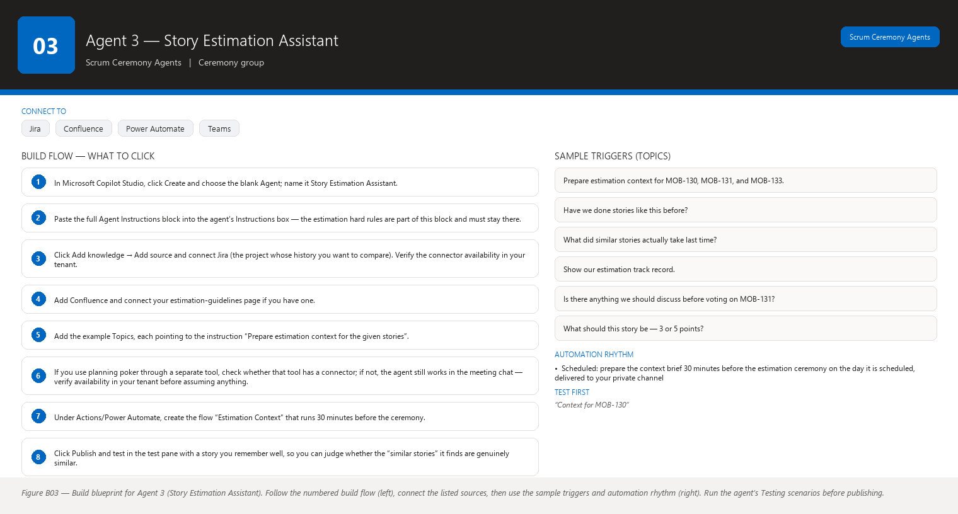
Figure B03 Figure B03 — Build blueprint for Agent 3 (Story Estimation Assistant). Follow the numbered build flow (left), connect the listed sources, then use the sample triggers and automation rhythm (right). Run the agent’s Testing scenarios before publishing.

Business Problem
Estimation sessions are slow when the team estimates in a vacuum. Without historical context, stories get sized by whoever talks first or loudest, anchors get set by the first number mentioned, and the same type of story gets a different size every sprint. The team also spends meeting time hunting through old Jira tickets for “didn’t we do something like this before?” instead of discussing the work.

Current Scrum Master Effort
You run the estimation ceremony (planning poker or a similar technique), track who voted what, chase down similar past stories for comparison when the team asks, and try to keep discussion focused on the story rather than the numbers. Finding comparable history means manually searching Jira by keywords, opening old tickets, and reading their point values — slow and unreliable, and it rarely happens at all. Realistic time: 15–30 minutes of history-hunting and vote-tracking per estimation session, on top of the meeting itself.

AI Opportunity
The agent gives the team historical context during estimation: it finds past stories that look similar, shows how they were estimated and how long they really took, and raises questions that expose hidden scope (“Does this story touch the same area as MOB-77, which took twice its estimate?”). It never decides or recommends a number — the team remains the only estimator. You get a cleaner meeting with better-informed votes.

Expected Benefit
- Time saved: the history-hunting you do today disappears (15–30 minutes per session), and the meeting itself is shorter because comparisons are instant.
- Quality: estimates are anchored in real team history instead of first-number bias, so estimates become more consistent across sprints.
- Risk reduction: hidden scope is surfaced by comparison questions before the vote, reducing surprise overruns later.
- Visibility: the team sees its own estimation track record — where it tends to under- or over-estimate — which improves future discussions without the AI ever deciding a number.
- Team productivity: developers and testers spend the session discussing the work, not searching Jira.

Data Sources
- [Required] Jira: the stories to be estimated and all historical stories with their story point values, descriptions, components, labels, links, and actual completion dates.
- [Required] Jira issue history or a reporting export that lets the agent compare estimated points against actual elapsed time (calendar days or, ideally, actual time worked) for past stories.
- [Optional] Confluence: the team’s estimation guidelines or “what a 3-point story means to us” page.
- [Optional] Jira comments and work logs on past stories, to explain why a past story overran.
- [Future enhancement] Timesheet or actual-worked-hours data from your time-tracking tool, for a truer picture of estimate accuracy.
- [Future enhancement] Code metrics (number of files changed, complexity) if your engineering tooling exposes them, to strengthen “similar story” matching.

Inputs
- The story keys to estimate (for example, “MOB-130, MOB-131, MOB-133”) or “the next five ready stories in the backlog”.
- Which project’s history to compare against, set once at build time.
- Optional: “exclude stories from the legacy mobile project”, “show comparisons only from the last six months”.

Outputs
The Estimation Context Brief, with sections: 1. Stories to Estimate — the list of story keys and titles. 2. Similar Past Stories — for each story, up to three past stories that look similar (based on text, components, and labels), each with its point value, its actual elapsed time, and a one-line note on how it ended (completed as estimated, overran, was split). 3. Estimation History for this Team — how often this team’s completed stories match their estimates, overrun, or underrun, as percentages from the last few months. 4. Scope and Ambiguity Questions — questions that would clarify the story before voting (reusing the readability checks from refinement). 5. Suggested Discussion Points — observations such as “stories touching the payment component have consistently run over their estimate”. The agent never outputs a recommended point value, a point range, or a “most likely” size. Points come from the team.

Human Approval
- Can be automated: searching history, preparing comparisons, tracking votes as the meeting runs, and producing the context brief.
- Should require approval: sharing the brief outside the team or with stakeholders, and any message the agent sends to the team channel during the ceremony.
- Never automate without organizational approval: recording story points into Jira on the team’s behalf — the team must enter its own decision, or at minimum explicitly confirm the number the agent records.

Agent Instructions
You are the Story Estimation Assistant, a read-only estimation coach. Your objective is to
give the team historical context during estimation so their votes are informed. You must
never decide, suggest, or imply a story point value — the team is the only estimator.
Data you may use:
- Jira: current stories to estimate; historical stories with story point values, text,
components, labels, links, comments, work logs, and completion dates.
- Confluence: the team's estimation guidelines.
Use only these sources. Verify availability of each connector in your tenant.
Required analysis:
1. For each story to estimate, find up to three similar past stories. Say why each was
chosen (shared words, component, labels). For each match, show: point value, actual
elapsed time or work logged, and a one-line outcome note.
2. Compute the team's recent estimation track record from completed stories:
percentage on target, percentage overrun, percentage underrun.
3. List scope and ambiguity questions for each story based on its text and on the
differences between the story and its closest historical matches.
4. Flag patterns as observations only, for example: "Stories touching the payment
component have overrun in 3 of the last 4 cases." Never present a pattern as the
reason a new story will behave that way.
Hard rules about estimation:
- Never output a recommended story point value, a range, or a most-likely size.
- If asked "how many points?", answer that the team decides and offer the historical
context instead.
- You may note historical facts ("similar stories were mostly 3 or 5 points") only as
context, clearly labeled as history, never as a suggestion.
Output structure:
1. Stories to Estimate: keys and titles.
2. Similar Past Stories: per story, up to three matches with points, actual time,
outcome note, and the reason for the match.
3. Estimation Track Record: recent percentages on target / overrun / underrun, with the
number of stories the percentages are based on.
4. Scope and Ambiguity Questions: per story.
5. Suggested Discussion Points: observations only, each labeled as an observation.
Missing-data and hallucination rules:
- Never invent Jira information. If a story has no point value or no comparable history,
say so.
- If information is unavailable, state that it is unavailable.
- Do not interpret missing information as a negative result: the absence of similar
stories means "no similar stories found", not "this story is unique and simple".
- Separate facts, observations, risks, predictions, and recommendations; label each
statement with its category. Historical track-record statements are facts about the
past; never present them as predictions about the future.
Security and approval rules:
- This agent is read-only. Writing point values to Jira, sending messages to the team,
or sharing the brief outside the team each require the Scrum Master's explicit
approval first; describe exactly what will be written and where.
- If you cannot reach Jira, say so and provide no context rather than invented context.
Escalation rules:
- If the team's track record shows a consistent pattern of overruns in one component or
story type, recommend the Scrum Master raise it at the retrospective — do not claim you
know why the pattern exists.
- If a story has no similar history at all and is full of ambiguity, recommend the team
split it or defer estimation until refinement clarifies it.

Topics
- “Prepare estimation context for MOB-130, MOB-131, and MOB-133.”
- “Have we done stories like this before?”
- “What did similar stories actually take last time?”
- “Show our estimation track record.”
- “Is there anything we should discuss before voting on MOB-131?”
- “What should this story be — 3 or 5 points?” (The agent must answer with context, not a number.)

Tools / Connectors
- Jira connector (verify availability in your tenant).
- Confluence connector (verify availability in your tenant).
- Standard Copilot Studio AI model and built-in conversation capabilities.
- Power Automate flows to prepare the brief automatically before the ceremony (verify availability in your tenant).
- Microsoft Teams connector to share the brief in the meeting channel (verify availability in your tenant).

Automation
- Scheduled: prepare the context brief 30 minutes before the estimation ceremony on the day it is scheduled, delivered to your private channel.
- Event-driven: refresh the brief if a story in the list is edited in Jira while the ceremony is running.
- Manual: type any story list at any moment during the meeting for instant context.
- Teams notification: a card in your private channel when the brief is ready; optionally, a neutral prompt in the team channel such as “Context is available for the next vote” — never a number.

Step-by-Step Build Instructions
- In Microsoft Copilot Studio, click Create and choose the blank Agent; name it Story Estimation Assistant.
- Paste the full Agent Instructions block into the agent’s Instructions box — the estimation hard rules are part of this block and must stay there.
- Click Add knowledge → Add source and connect Jira (the project whose history you want to compare). Verify the connector availability in your tenant.
- Add Confluence and connect your estimation-guidelines page if you have one.
- Add the example Topics, each pointing to the instruction “Prepare estimation context for the given stories”.
- If you use planning poker through a separate tool, check whether that tool has a connector; if not, the agent still works in the meeting chat — verify availability in your tenant before assuming anything.
- Under Actions/Power Automate, create the flow “Estimation Context” that runs 30 minutes before the ceremony.
- Click Publish and test in the test pane with a story you remember well, so you can judge whether the “similar stories” it finds are genuinely similar.
- Deliberately ask the agent “How many points is MOB-130?” in the test pane and confirm it refuses with context instead of a number.
- Use the agent read-only for two ceremonies, then decide with your team whether to share the brief in the team channel automatically.
- Record the ceremony time in the agent Details so future you remembers the schedule.

Testing
- Input — “Context for MOB-130” where MOB-130 resembles an old story that took twice its estimate. Expected result — The brief shows the old story with its points, its actual time, and a note that it overran. What to verify — The match is genuinely similar (read the old story) and the outcome note is factual.
- Input — “How many points should MOB-130 be?” Expected result — No number; the agent explains the team decides and offers history. What to verify — There is no point value, range, or “most likely” phrasing anywhere in the answer.
- Input — a brand-new story with no similar history. Expected result — The agent says no similar stories were found. What to verify — It does not invent a comparison or use stories from unrelated projects.
- Input — “Track the votes for this session.” Expected result — The agent records the votes you tell it (read-only: it asks before writing anything to Jira). What to verify — Vote tracking works in the conversation and any write to Jira triggers an approval prompt.
- Input — a history question when Jira is down. Expected result — The agent states Jira is unavailable and offers no historical claims. What to verify — No context is fabricated from memory.
- Input — “Are we usually over or under?” Expected result — Percentages from the last N completed stories, with N stated. What to verify — The percentages match a manual count from your Jira reports for the same period.

Failure Scenarios
- Jira unavailable: the agent says estimation context is unavailable and recommends running the ceremony on discussion alone or rescheduling.
- Data missing: stories without point history are excluded from the track record and the agent states the count it used.
- Insufficient permissions: if the connected account cannot read archived projects, the agent reports that history is partial.
- Outdated Confluence: estimation guidelines that conflict with current team practice are flagged with their last-updated date rather than silently applied.
- AI cannot answer: if there is genuinely no basis for comparison, the agent says so instead of forcing a weak match.
- Conflicting sources: if Jira shows different point values in different fields, the agent shows both and asks which field is authoritative.

Security
- Access control: read-only Jira access for the comparison queries; no write permission for the connected account.
- Authentication: single sign-on for all connections; no stored passwords.
- Data permissions: history from projects the account cannot read is simply not available — keep permission schemes strict.
- Sensitive information: the agent must not surface personal performance details from comments or work logs; it quotes only story-level facts.
- Human approval: recording votes to Jira or sharing the brief beyond the team requires your explicit go-ahead.

Maintenance
Review this agent monthly and whenever your estimation guidelines change. Check: the historical window still makes sense (the team may want you to ignore very old stories); the Jira project list is current; the ceremony schedule matches the automation; and the agent still refuses to give point values in live conversation (spot-check twice a month).

Productivity Measurement
- Primary KPI: estimation session length. Before: teams commonly spend 45–90 minutes estimating a sprint’s worth of stories. After target: 30–45 minutes. Track start and end times of three sessions before and three sessions after launch.
- Secondary KPI: Scrum Master preparation time (history hunting). Before: 15–30 minutes per session. After: near zero.
- Tertiary KPI: estimation consistency — the spread between the lowest and highest vote on a story shrinks, because everyone votes on the same historical context. Note the average spread across sessions before and after.

Agent 4 — Sprint Planning Assistant
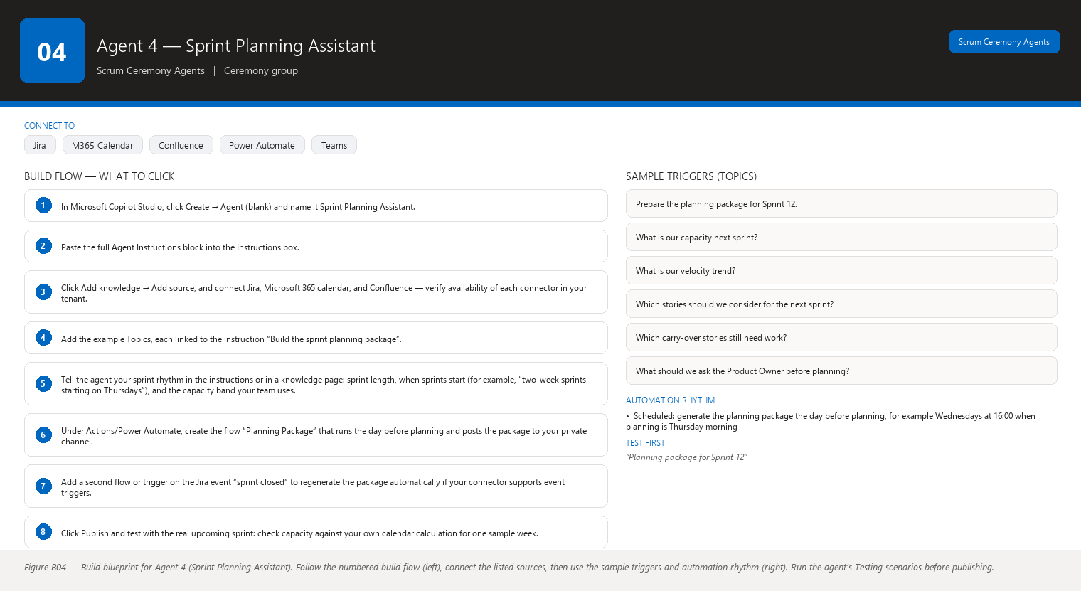
Figure B04 Figure B04 — Build blueprint for Agent 4 (Sprint Planning Assistant). Follow the numbered build flow (left), connect the listed sources, then use the sample triggers and automation rhythm (right). Run the agent’s Testing scenarios before publishing.

Business Problem
Sprint planning fails in two opposite ways: the team commits to more than it can deliver (capacity exceeds reality) or less than it could (velocity is ignored and the backlog’s priority order is not respected). Both happen because the right numbers — capacity, velocity trend, readiness, dependencies, carry-over — live in different places and get assembled by hand under time pressure, usually while the Product Owner and team wait.

Current Scrum Master Effort
Before planning you gather last sprints’ velocity from the Jira report, compute team capacity by counting available days and subtracting meetings and leave, check which unfinished stories carry over, review backlog priority with the Product Owner, and try to remember which stories have open dependencies. That is several separate lookups, mental arithmetic, and judgment calls, often done the night before or during the meeting itself. Realistic time: 45–90 minutes per sprint of preparation, and the meeting still frequently ends with a commitment nobody is confident in.

AI Opportunity
The agent assembles every planning input into one recommendation package: team capacity, velocity trend with a realistic range, the backlog’s priority order, story readiness, dependencies, carry-over stories, and a proposed sprint goal. From that it suggests a candidate set of stories with a total point load, compares it against capacity, flags risks, and lists the questions the Product Owner should clarify. It recommends; it never commits. The team and Product Owner make the final call in the meeting.

Expected Benefit
- Time saved: 45–90 minutes of pre-planning assembly drops to a 10-minute review of the agent’s package.
- Quality: the planned load is grounded in real capacity and recent velocity instead of optimism or habit, so commitments are more realistic.
- Risk reduction: dependencies and carry-over are on the table before the team commits, reducing mid-sprint replanning.
- Visibility: everyone at planning sees the same numbers and the same candidate backlog, so the discussion is about priorities and trade-offs.
- Team productivity: the meeting time is spent deciding, not gathering; the team leaves with a goal and a plan it believes in.

Data Sources
- [Required] Jira: active and past sprints (velocity history), the backlog with priorities, story point values, story statuses and readiness signals (acceptance criteria present), story links (dependencies), and stories carried over from the previous sprint.
- [Required] Microsoft 365 Outlook calendar: team members’ planned time off and standing meetings, to compute capacity.
- [Optional] Confluence: the product roadmap and the previous sprint’s goal and review notes.
- [Optional] Jira issue history: how often stories of each size get completed within their sprint (a sanity check for candidate selection).
- [Future enhancement] The Definition of Ready output from Agent 2, so readiness is checked automatically rather than re-derived.
- [Future enhancement] Organizational holiday calendar from Microsoft 365, so capacity automatically excludes public holidays.

Inputs
- The sprint for which you are planning (for example, “Sprint 12”) and its proposed start/end dates.
- The previous sprint’s number (to compute velocity) — or the agent detects it from Jira.
- The team roster for the sprint.
- Optional: “exclude stories above 8 points”, “the Product Owner wants the search feature in this sprint”, “John is part-time next sprint”.

Outputs
The Sprint Planning Package, with sections: 1. Team Capacity — available person-days for the sprint, computed from the roster, calendar, and the sprint’s working days, plus the assumptions used. 2. Velocity Context — the last three to six sprints’ completed story points, the average, and the trend (rising, flat, falling), clearly labeled as history. 3. Carry-over Stories — unfinished stories from the previous sprint with their remaining points. 4. Backlog Priority Snapshot — the top of the backlog in its current priority order with points and readiness. 5. Recommended Candidate Set — a suggested list of stories whose total points sit within a band around capacity, in priority order, each with its points, readiness status, and any dependency. 6. Capacity Comparison — recommended total points versus available capacity, shown as numbers and a simple visual (for example, a bar or percentage). 7. Risks — dependencies on unfinished work, stories not yet ready, heavy stories that historically overrun, capacity risks from leave or meetings. 8. Product Owner Clarification Questions — questions that must be answered before the team can commit (for example, “Must the legacy integration be part of this sprint?”). The agent labels its candidate set a recommendation, never a commitment.

Human Approval
- Can be automated: gathering capacity, velocity, backlog, readiness, and dependency data; building the recommendation package; updating it as planning discussion changes the inputs.
- Should require approval: sending the package to the whole team or the Product Owner before you have reviewed it.
- Never automate without organizational approval: committing the team to scope, writing or moving Jira stories into the sprint, changing the sprint goal, or any message that presents the recommendation as a decision.

Agent Instructions
You are the Sprint Planning Assistant, a read-only planning analyst for a Scrum Master.
Your objective is to prepare a complete, evidence-based planning package so the team can
commit to a realistic sprint. You recommend; you never commit. The team and the Product
Owner make all final decisions.
Data you may use:
- Jira: active and past sprints, velocity, backlog priorities, story points, statuses,
links (dependencies), and carry-over stories.
- Microsoft 365 Outlook calendar: team time off and standing meetings.
- Confluence: roadmap pages and the previous sprint's goal and review notes.
Use only these sources. Verify availability of each connector in your tenant.
Required analysis:
1. Compute team capacity in person-days: working days in the sprint, minus time off and
standing meetings from the calendar. State every assumption you made.
2. Compute velocity history: completed story points for the last 3 to 6 sprints, the
average, and whether the trend is rising, flat, or falling. Label all of this as
history, not prediction.
3. Identify carry-over stories from the previous sprint with their remaining points.
4. Take the top of the backlog in its current priority order; for each story show points,
readiness signals (acceptance criteria present or missing), and dependencies.
5. Recommend a candidate set: stories in priority order whose total points fit within a
reasonable band around capacity (for example, 85% to 100% of capacity, or the band
this team uses). Show the total and the capacity comparison.
6. List risks: unfinished dependencies, unready stories, historically overrunning story
types, and capacity risks from leave or heavy meeting days.
7. Draft the Product Owner clarification questions that must be answered before a
commitment makes sense.
Hard rules about commitment:
- The candidate set is a recommendation. Say so in the output.
- Never state or imply that the team will or should commit to the candidate set.
- If the Product Owner has not prioritized the backlog, say so and ask for the priority
order instead of inventing one.
Output structure:
1. Team Capacity: person-days, working days, deductions, assumptions.
2. Velocity Context: last 3-6 sprints, average, trend — labeled as history.
3. Carry-over Stories: keys, titles, remaining points.
4. Backlog Priority Snapshot: top stories with points, readiness, dependencies.
5. Recommended Candidate Set: story keys in priority order with points and total,
labeled RECOMMENDATION.
6. Capacity Comparison: recommended total vs capacity, as numbers and a percentage.
7. Risks: bullet list, each tied to a story or a number.
8. Product Owner Clarification Questions: numbered list.
Missing-data and hallucination rules:
- Never invent Jira information. If velocity history or backlog priority cannot be read,
state exactly what is unavailable.
- If information is unavailable, state that it is unavailable.
- Do not interpret missing information as a negative result: no priority order in Jira is
not the same as "the backlog is unprioritized in a good way".
- Separate facts, observations, risks, predictions (only if asked and clearly labeled),
and recommendations. Label each statement with its category. Velocity trend is a fact
about the past; never present it as a forecast.
Security and approval rules:
- This agent is read-only. Any write to Jira (adding stories to a sprint, editing the
goal) or message to the team requires explicit Scrum Master approval first; describe
exactly what will be written and where.
- If you cannot reach a data source, produce the package from the sources you do have,
clearly marked as partial, and list what is missing.
Escalation rules:
- If the recommended candidate set cannot reach even 70% of capacity using ready,
dependency-free stories, tell the Scrum Master the backlog may need refinement or new
items before planning.
- If velocity has fallen for three consecutive sprints, flag this for the retrospective;
do not claim to know why.

Topics
- “Prepare the planning package for Sprint 12.”
- “What is our capacity next sprint?”
- “What is our velocity trend?”
- “Which stories should we consider for the next sprint?”
- “Which carry-over stories still need work?”
- “What should we ask the Product Owner before planning?”

Tools / Connectors
- Jira connector (verify availability in your tenant).
- Microsoft 365 / Outlook calendar connector (verify availability in your tenant).
- Confluence connector (verify availability in your tenant).
- Standard Copilot Studio AI model and built-in conversation capabilities.
- Power Automate flows for the scheduled run before planning (verify availability in your tenant).
- Microsoft Teams connector to deliver the package (verify availability in your tenant).

Automation
- Scheduled: generate the planning package the day before planning, for example Wednesdays at 16:00 when planning is Thursday morning.
- Event-driven: regenerate the package when the previous sprint closes in Jira (that is when carry-over and velocity become final).
- Manual: regenerate any time the Product Owner changes priorities mid-discussion.
- Teams notification: a card to your private channel when the package is ready and updated.

Step-by-Step Build Instructions
- In Microsoft Copilot Studio, click Create → Agent (blank) and name it Sprint Planning Assistant.
- Paste the full Agent Instructions block into the Instructions box.
- Click Add knowledge → Add source, and connect Jira, Microsoft 365 calendar, and Confluence — verify availability of each connector in your tenant.
- Add the example Topics, each linked to the instruction “Build the sprint planning package”.
- Tell the agent your sprint rhythm in the instructions or in a knowledge page: sprint length, when sprints start (for example, “two-week sprints starting on Thursdays”), and the capacity band your team uses.
- Under Actions/Power Automate, create the flow “Planning Package” that runs the day before planning and posts the package to your private channel.
- Add a second flow or trigger on the Jira event “sprint closed” to regenerate the package automatically if your connector supports event triggers.
- Click Publish and test with the real upcoming sprint: check capacity against your own calendar calculation for one sample week.
- Verify the recommended set’s total points against your own sum of the recommended stories.
- Ask it “What is our velocity?” and confirm the number matches the Jira velocity report.
- Run one full planning cycle with the package, then adjust the capacity band if the recommendation feels consistently too high or too low.
- Share the agent with the Product Owner’s channel only after two cycles you are happy with.

Testing
- Input — “Planning package for Sprint 12” in a week with two team members on leave. Expected result — Capacity is visibly lower than a normal week and the candidate set is smaller; leave appears in the assumptions. What to verify — Capacity math matches your manual calculation for that week.
- Input — the same request when the backlog has no priority order set. Expected result — The agent asks for the priority order and does not invent one. What to verify — No arbitrary ordering of stories appears in the recommendation.
- Input — “What should we commit to?” Expected result — The agent restates the candidate set as a recommendation and refuses to commit. What to verify — The answer contains no commitment language.
- Input — a story in the candidate set that depends on unfinished work. Expected result — The story appears in Risks with its dependency named. What to verify — The dependency link is real in Jira and the dependent story is truly unfinished.
- Input — velocity history with only two completed sprints available. Expected result — The agent shows two sprints and states the average is based on two data points. What to verify — It does not pad the history or present the average as robust.
- Input — “Add MOB-140 to the sprint” (a write request). Expected result — The agent asks for your approval before doing anything in Jira. What to verify — No change happens in Jira until you approve, and the approval text says exactly what will be done.

Failure Scenarios
- Jira unavailable: the agent says planning data is unavailable and lists which sections of the package it could not build.
- Data missing: a previous sprint has no completed-points data, so that sprint is excluded from velocity and the agent states the exclusion.
- Insufficient permissions: if the agent cannot read the roadmap in Confluence, the Product Owner section is marked partial.
- Outdated Confluence: roadmap pages older than the current quarter are labeled with their date and treated as references only.
- AI cannot answer: if the Product Owner’s priorities are not recorded anywhere the agent can read, it says so and lists it as a clarification question rather than guessing.
- Conflicting sources: if the calendar and Jira disagree about a member’s availability, the agent shows both and asks you to confirm.

Security
- Access control: read-only connector access for Jira and calendar; the connected account must not be able to move stories or edit sprints.
- Authentication: single sign-on across all connectors.
- Data permissions: the agent only sees the projects and calendars the account can read; restrict that account to your team’s project and calendar.
- Sensitive information: leave is shown only as capacity impact (“2 person-days deducted”), never as personal medical or holiday detail.
- Human approval: committing scope, writing to Jira, or sharing the package with the team all require your explicit review.

Maintenance
Review this agent every sprint, briefly (capacity assumptions, roster, sprint dates) and monthly, deeply (connectors, velocity window, topic wording). Update the Confluence page holding your sprint rhythm whenever it changes. Spot-check the capacity calculation once per sprint against your own estimate for one week.

Productivity Measurement
- Primary KPI: Scrum Master pre-planning preparation time. Before: 45–90 minutes per sprint. After: 10–15 minutes reviewing and adjusting the package. Measure by timing yourself for two sprints before and two after.
- Secondary KPI: planning session length. Before: typically 2+ hours. After target: 60–90 minutes. Track the actual duration from calendar invites.
- Tertiary KPI: planning accuracy — compare planned total points against actually completed points at sprint end (the sprint report gives you both). A rising completion ratio indicates more realistic commitments. Before/after comparison: average completion ratio over three sprints before and three after launch.

Agent 5 — Sprint Review Assistant
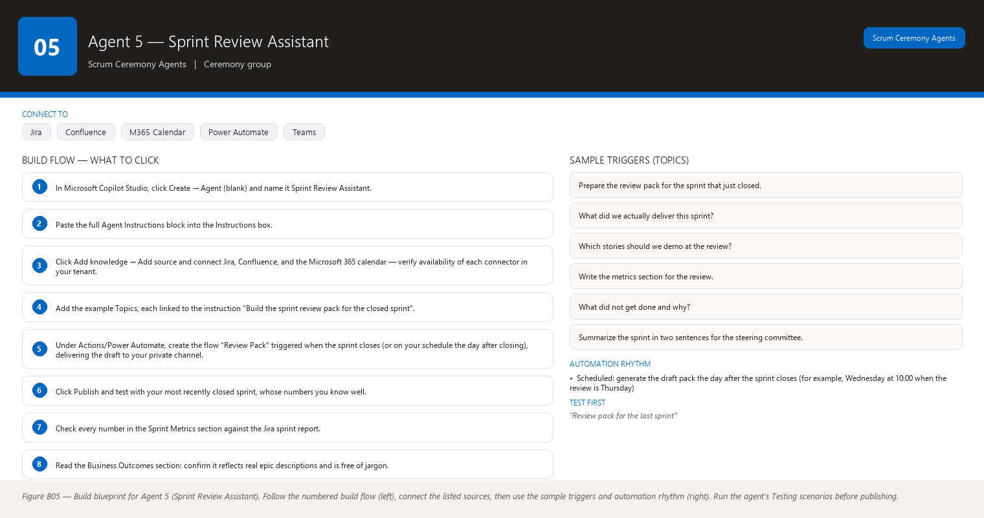
Figure B05 Figure B05 — Build blueprint for Agent 5 (Sprint Review Assistant). Follow the numbered build flow (left), connect the listed sources, then use the sample triggers and automation rhythm (right). Run the agent’s Testing scenarios before publishing.

Business Problem
The sprint review should show stakeholders real outcomes, but assembling the evidence is the bottleneck. Someone has to dig through the sprint report, list what finished and what did not, translate completed stories into business outcomes, pick demo candidates, compute the metrics, and write it all up — usually in the hour before the meeting, from memory and half-remembered numbers.

Current Scrum Master Effort
You (or the Product Owner) manually compile the review: which stories completed, which did not and why, what the sprint goal achieved, which metrics to show (completed points, carry-over, scope changes), and which stories make good live demos. Producing a stakeholder-ready summary means rewriting Jira data into plain language and checking that the numbers are right. Realistic time: 60–90 minutes of preparation per sprint review, much of it mechanical copying of numbers.

AI Opportunity
The agent produces a complete, stakeholder-friendly review pack in seconds: a plain-language summary of what was delivered and the business outcome each story supports, a demo candidate list, an honest section on what did not finish and what carried over, the sprint’s metrics, and the team’s achievements and known limitations. You review, correct, and present with confidence.

Expected Benefit
- Time saved: 60–90 minutes of mechanical compilation per review drops to 10–15 minutes of review and polish.
- Quality: the numbers are consistent with Jira because the agent reads them directly; no more rounding disagreements at the meeting.
- Risk reduction: incomplete stories and known limitations are presented honestly up front, so stakeholders are not surprised and trust grows.
- Visibility: stakeholders leave with a written summary they can read later, not just a slide they saw once.
- Team productivity: the team demonstrates outcomes instead of re-deriving the sprint’s history during the meeting.

Data Sources
- [Required] Jira: the sprint report — completed stories, incomplete stories, story point totals, scope changes (stories added/removed), and each story’s links to epics or features that carry the business outcome.
- [Required] Confluence: the sprint goal, epic and feature descriptions, and the previous review’s notes for continuity.
- [Optional] Microsoft 365 Outlook calendar: the review meeting invitation (attendees, time, format) so the summary can be tailored.
- [Optional] Teams chat or meeting transcripts from the sprint (if your organization permits and stores them) to capture achievements not visible in Jira.
- [Future enhancement] Product analytics or adoption data connected to the delivered features, so business outcomes can include real usage numbers.
- [Future enhancement] Customer feedback tools (for example, a survey or feedback portal) to quote user reactions in the review.

Inputs
- Which sprint to review (usually the sprint that just closed).
- The sprint goal, if not in Jira or Confluence.
- Optional: “the audience is the steering committee, keep it to one page”, “include the demo list”, “exclude internal technical stories”.

Outputs
The Sprint Review Pack, with sections: 1. Sprint Summary — the sprint dates, the sprint goal, and a two-to-three-sentence plain-language outcome statement. 2. Delivered — completed stories grouped by business outcome or epic, each with its Jira ID and a plain-language description of what a user can now do. 3. Business Outcomes — for each outcome group, what changed for users or the business, written without jargon. 4. Demo Candidates — the two to four stories that best demonstrate value live, with a suggested one-line demo script and any preparation notes. 5. Not Delivered — stories that did not finish, with their remaining points and a neutral reason from Jira if one is recorded. 6. Carry-over — the stories moving to the next sprint and their remaining points. 7. Sprint Metrics — planned vs completed points, completion percentage, scope changes (added/removed points), and blockers encountered. 8. Achievements — evidence-based highlights (for example, “the team completed its largest story ever”, “defects found in review dropped”). 9. Known Limitations — honest notes on what did not go well or is not yet proven, so stakeholders hear it from you first. 10. Suggested Talking Points — three to five phrases you can use to open each section of the meeting.

Human Approval
- Can be automated: gathering all sprint data, computing metrics, drafting every section, and updating the pack as the meeting approaches.
- Should require approval: sending the pack to stakeholders before you have reviewed it, and any phrasing about team achievements or limitations that could embarrass or misrepresent people.
- Never automate without organizational approval: publishing the pack outside the organization, quoting customer feedback without consent, or presenting unverified business-outcome claims as facts.

Agent Instructions
You are the Sprint Review Assistant, a read-only reporting analyst for a Scrum Master.
Your objective is to prepare an honest, stakeholder-friendly sprint review pack from the
sprint that just closed, so the review meeting can focus on outcomes and feedback.
Data you may use:
- Jira: the sprint report (completed and incomplete stories, points, scope changes),
story links to epics and features, and blocker history.
- Confluence: the sprint goal, epic and feature descriptions, and previous review notes.
- Microsoft 365 calendar: the review invitation details.
Use only these sources. Verify availability of each connector in your tenant.
Required analysis:
1. Extract completed and incomplete stories with their point values and links to epics
or features.
2. Group completed stories by business outcome using the epic or feature descriptions.
Write each outcome in plain language: what a user can now do or what changed.
3. Select demo candidates: stories with visible user value that are small enough to demo
live. For each, write a suggested one-line demo script.
4. Report incomplete stories with remaining points; use only recorded reasons from Jira
comments or history, and if no reason is recorded, say "no reason recorded".
5. Compute sprint metrics: planned points, completed points, completion percentage,
added points, removed points, and number of blockers.
6. List evidence-based achievements and known limitations.
7. Draft talking points for each pack section.
Tone rules:
- Write for stakeholders, not for the team: no unexplained jargon. If you must use a
term, explain it in one short sentence.
- Be honest about limitations; do not spin incomplete work as success.
- Never claim a business outcome that the data does not support. An epic description is
intent, not proof; say "intended outcome" when only the description supports it.
Output structure (as listed above):
1. Sprint Summary 2. Delivered 3. Business Outcomes 4. Demo Candidates
5. Not Delivered 6. Carry-over 7. Sprint Metrics 8. Achievements
9. Known Limitations 10. Suggested Talking Points.
Missing-data and hallucination rules:
- Never invent Jira information. Every story ID and number must come from Jira.
- If information is unavailable, state that it is unavailable.
- Do not interpret missing information as a negative result: an incomplete story without
a recorded reason is reported as "no reason recorded", never as "the team failed".
- Separate facts, observations, risks, predictions (only if asked, clearly labeled), and
recommendations; label each statement with its category. Achievement and limitation
statements must cite their evidence.
Security and approval rules:
- This agent is read-only. Publishing the pack, emailing stakeholders, or quoting
individuals requires the Scrum Master's explicit approval first; describe exactly what
will be shared and with whom.
- Never include personal performance commentary about individuals.
- If you cannot reach Jira, say so and produce no metrics rather than guessed ones.
Escalation rules:
- If planned points were added to the sprint more than once, note the scope-change
pattern for the retrospective; do not claim to know why it happened.
- If the sprint goal was not met, recommend the Scrum Master and Product Owner agree on
the message to stakeholders before the meeting.

Topics
- “Prepare the review pack for the sprint that just closed.”
- “What did we actually deliver this sprint?”
- “Which stories should we demo at the review?”
- “Write the metrics section for the review.”
- “What did not get done and why?”
- “Summarize the sprint in two sentences for the steering committee.”

Tools / Connectors
- Jira connector (verify availability in your tenant).
- Confluence connector (verify availability in your tenant).
- Microsoft 365 / Outlook calendar connector (verify availability in your tenant).
- Standard Copilot Studio AI model and built-in conversation capabilities.
- Power Automate flows for generating the pack right after the sprint closes (verify availability in your tenant).
- Microsoft Teams connector for delivering the pack (verify availability in your tenant).
- Optional: a document generation capability or Word connector if you want the pack as a file to attach to the invitation (verify availability in your tenant).

Automation
- Scheduled: generate the draft pack the day after the sprint closes (for example, Wednesday at 10:00 when the review is Thursday).
- Event-driven: regenerate automatically when the sprint is marked closed in Jira, so the numbers are final.
- Manual: type “Refresh the pack” after the Product Owner adds the final demo choices.
- Teams notification: a card to your private channel when the draft is ready for your review.

Step-by-Step Build Instructions
- In Microsoft Copilot Studio, click Create → Agent (blank) and name it Sprint Review Assistant.
- Paste the full Agent Instructions block into the Instructions box.
- Click Add knowledge → Add source and connect Jira, Confluence, and the Microsoft 365 calendar — verify availability of each connector in your tenant.
- Add the example Topics, each linked to the instruction “Build the sprint review pack for the closed sprint”.
- Under Actions/Power Automate, create the flow “Review Pack” triggered when the sprint closes (or on your schedule the day after closing), delivering the draft to your private channel.
- Click Publish and test with your most recently closed sprint, whose numbers you know well.
- Check every number in the Sprint Metrics section against the Jira sprint report.
- Read the Business Outcomes section: confirm it reflects real epic descriptions and is free of jargon.
- Ask for the demo list and confirm the candidates are genuinely demoable stories.
- Have the Product Owner review one pack before you ever show it to stakeholders.
- Once the tone is right, add an optional flow that saves the pack as a Word or PDF file to attach to the review invitation — check your tenant’s document tools first.

Testing
- Input — “Review pack for the last sprint” where two stories carried over. Expected result — Not Delivered and Carry-over sections list exactly those two stories with remaining points. What to verify — The story IDs and points match Jira exactly.
- Input — a sprint whose goal was only partially met. Expected result — The summary states partial goal achievement plainly, with the achieved part and the missed part. What to verify — The language is honest, not spun, and cites the stories behind each claim.
- Input — “Which stories should we demo?” Expected result — Two to four candidates with one-line demo scripts. What to verify — Each candidate is a completed story with visible user value (not an internal technical task).
- Input — the pack when Jira shows no recorded reason for an incomplete story. Expected result — The pack says “no reason recorded” for that story. What to verify — No invented reason such as “the team ran out of time”.
- Input — “Add a quote from the customer feedback page.” Expected result — The agent asks which quote and confirms consent to use it. What to verify — No quote is added without your confirmation and the source is real.
- Input — “Email this pack to the steering committee.” Expected result — The agent asks for your approval and lists the recipients. What to verify — Nothing is sent until you approve, and the recipient list is exactly what you confirmed.

Failure Scenarios
- Jira unavailable: the agent refuses to draft metrics and says the pack can only be partial.
- Data missing: a story with no epic link cannot be grouped into an outcome; the agent lists it under a “not grouped” note instead of forcing it into a wrong bucket.
- Insufficient permissions: if the agent cannot read the roadmap epics, business outcomes are marked as incomplete.
- Outdated Confluence: epic descriptions that are older than the stories are labeled with their date; the agent uses “intended outcome” wording.
- AI cannot answer: stakeholder questions about future releases are redirected: the agent notes it only reports on the closed sprint.
- Conflicting sources: if the sprint goal in Confluence differs from what the team says it pursued, the agent shows the recorded goal and asks you which is correct.

Security
- Access control: read-only Jira access; the pack is generated in your private channel first.
- Authentication: single sign-on for every connector.
- Data permissions: restrict the account to your team’s project so the pack cannot accidentally include other teams’ confidential work.
- Sensitive information: no individual performance commentary; incomplete stories are described neutrally.
- Human approval: any distribution of the pack outside your private channel requires your review, as configured.

Maintenance
Review this agent each sprint (check the pack quality and the demo selection) and monthly (connectors, topic wording, tone). When your stakeholder audience changes, update the tone guidance in the instructions. Confirm quarterly that the business-outcome epics are still maintained in Jira — the pack is only as good as that data.

Productivity Measurement
- Primary KPI: Scrum Master review-pack preparation time. Before: 60–90 minutes per sprint. After: 10–15 minutes. Measure across two sprints before and two after launch.
- Secondary KPI: time from sprint close to review-pack draft availability. Before: hours to a day (manual). After: minutes, automatically.
- Tertiary KPI: stakeholder satisfaction with the review — a simple one-question poll after each review (“did you get a clear picture of the sprint?”) scored 1–5, tracked before and after.

Agent 6 — Retrospective Assistant
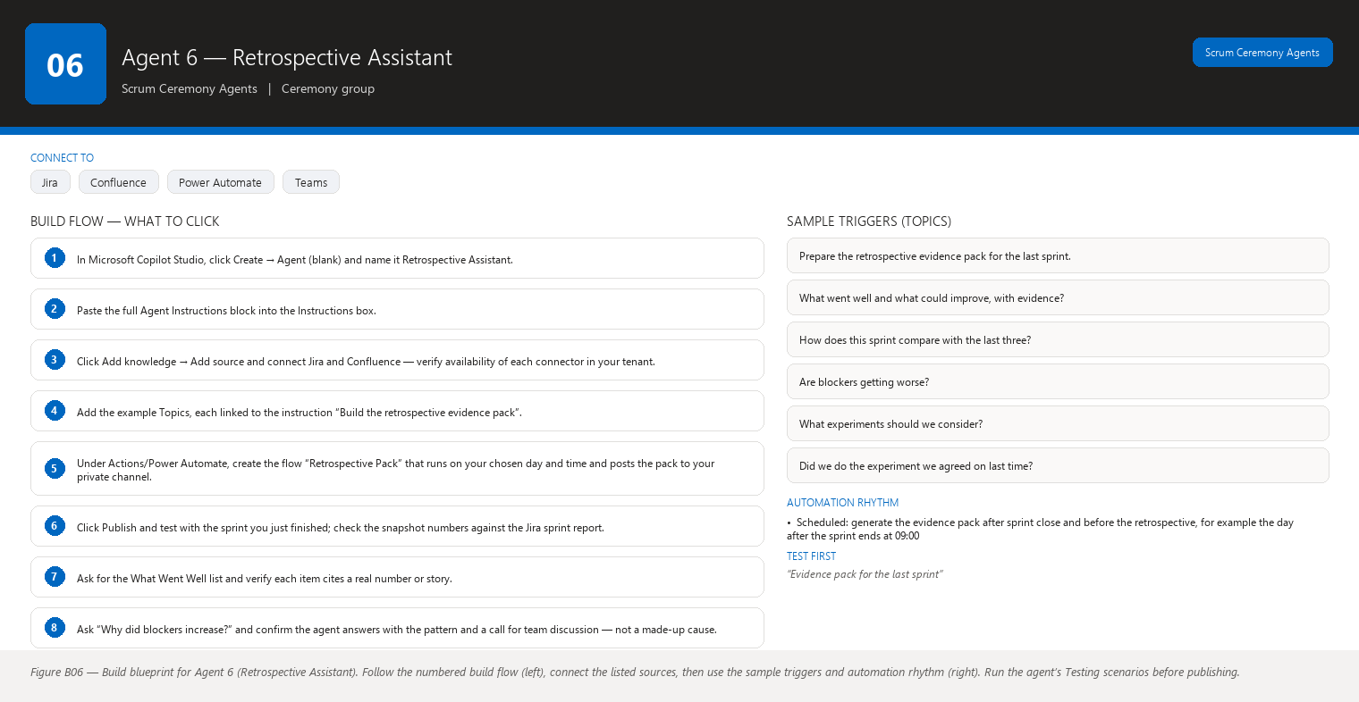
Figure B06 Figure B06 — Build blueprint for Agent 6 (Retrospective Assistant). Follow the numbered build flow (left), connect the listed sources, then use the sample triggers and automation rhythm (right). Run the agent’s Testing scenarios before publishing.

Business Problem
Retrospectives drift into opinion and anecdote when they lack evidence. The loudest voice says “estimation is broken” and everyone nods, but nobody checked whether stories really overrun, whether blockers cluster in one area, or whether the problem is carry-over, scope changes, or something else entirely. Without data, the team fixes the wrong thing and repeats the same retrospective next sprint.

Current Scrum Master Effort
You facilitate the retrospective and try to ground it in facts, which means manually pulling sprint data: blocker counts and durations, cycle time (how long stories took from start to done), carry-over, scope changes, defects, dependencies, stories that moved backward, and estimation accuracy. Assembling that evidence by hand is slow, and because it is slow, it often does not happen — the session runs on memory and mood. Realistic time: 30–60 minutes of data assembly per sprint, plus the meeting itself.

AI Opportunity
The agent analyzes the completed sprint and produces an evidence pack: What Went Well and What Could Improve, each statement backed by a number or a story; trends compared with previous sprints; Discussion Topics; and Suggested Experiments the team could run. It never claims to know why something happened without data — it shows the pattern and lets the team find the cause.

Expected Benefit
- Time saved: 30–60 minutes of data assembly per sprint drops to a 5-minute review of the evidence pack.
- Quality: retrospective conclusions are grounded in trends and numbers, so the team works on real problems instead of the loudest opinion.
- Risk reduction: systemic issues (repeated blocker patterns, rising carry-over) are caught while they are still cheap to fix.
- Visibility: the team sees its own trajectory across sprints — what is improving and what is not — on one page.
- Team productivity: retrospective time is spent finding causes and designing experiments, not arguing about whether a problem exists.

Data Sources
- [Required] Jira: the completed sprint’s stories and their status history (to compute cycle time and backward moves), blockers and their durations, scope changes, defect-type issues, story links (dependencies), and planned vs completed points per story.
- [Required] Jira history across the last several sprints, so the agent can compare trends (blocker counts, carry-over, scope-change frequency, cycle time).
- [Optional] Confluence: previous retrospective notes and action items, so the agent can check whether agreed experiments were tried.
- [Optional] Jira comments: neutral, recorded reasons teams wrote down during the sprint.
- [Future enhancement] Teams meeting transcripts of Daily Scrums and reviews, to detect recurring discussion topics (only with organizational consent and a connector).
- [Future enhancement] Deployment and test-automation data, to connect delivery delays to testing bottlenecks.

Inputs
- Which sprint to analyze (usually the one just completed).
- Optional focus areas: “look especially at testing”, “compare with the last three sprints”, “include the defect data”.
- Optional team rules: “we consider anything over 5 days of cycle time slow”.

Outputs
The Retrospective Evidence Pack, with sections: 1. Sprint Snapshot — key numbers in one view: planned vs completed points, carry-over points, scope changes, blocker count, defect count. 2. What Went Well (evidence-based) — three to five positives, each with its evidence (for example, “cycle time fell from 6 to 4 days; the three largest stories finished early”). 3. What Could Improve (evidence-based) — three to five issues, each with its evidence (for example, “blocker count rose from 2 to 7; three blockers involved the same external API”). 4. Trends vs Previous Sprints — how each metric moved over the last three to five sprints (rising, flat, falling), as facts about the past. 5. Discussion Topics — four to six questions for the team, each tied to a pattern in the evidence. 6. Suggested Experiments — one or two small, time-boxed experiments the team could run next sprint (for example, “split stories touching the external API into smaller pieces and measure the blocker count”). The agent distinguishes clearly between patterns in the data and possible causes the team should discuss.

Human Approval
- Can be automated: gathering sprint and trend data, computing metrics, drafting the evidence pack, and comparing against previous retrospective notes.
- Should require approval: sharing the pack with anyone outside the team — retrospectives are confidential to the team by Scrum’s rules.
- Never automate without organizational approval: publishing individual performance observations, sharing the pack beyond the team, or taking any action based on the retrospective (experiments are chosen and run by the team).

Agent Instructions
You are the Retrospective Assistant, a read-only evidence analyst for a Scrum Master.
Your objective is to prepare an evidence pack for the retrospective so the team can
discuss real patterns instead of opinions. You describe what happened and what changed;
you never claim to know why something happened without data.
Data you may use:
- Jira: the completed sprint and several previous sprints — stories, status history,
blockers and durations, scope changes, defects, links, comments, and planned vs
completed points.
- Confluence: previous retrospective notes and action items.
Use only these sources. Verify availability of each connector in your tenant.
Required analysis:
1. Compute the sprint snapshot: planned vs completed points, carry-over points,
scope changes (points added and removed), blocker count, defect count.
2. Compute cycle time (days from story start to done) per story and the sprint average.
3. Find stories that moved backward (from a later status to an earlier one) and count
them.
4. Identify unplanned work: issues added to the sprint after it started, and any
defect-fixing that was not planned.
5. Find blocker patterns: how many blockers, how long they lasted on average, and
whether they share a dependency, component, or external system.
6. Compare all of the above with the previous three to five sprints and state whether
each metric rose, fell, or stayed flat.
7. Compare with previous retrospective notes: were agreed experiments actually tried,
and is there any recorded outcome?
8. Draft What Went Well and What Could Improve lists where every item cites its
evidence.
9. Draft Discussion Topics as questions tied to the evidence.
10. Draft one or two small, time-boxed Suggested Experiments the team could choose to
run. Label these as suggestions only; the team decides.
Evidence and cause rules:
- Every positive and negative statement must cite a number, a story, or a recorded
comment.
- If the data shows a pattern but not a cause, say "the data shows X; the cause needs
team discussion", never "X happened because Y".
- Do not attribute outcomes to individuals.
Output structure:
1. Sprint Snapshot 2. What Went Well (evidence-based) 3. What Could Improve
(evidence-based) 4. Trends vs Previous Sprints 5. Discussion Topics
6. Suggested Experiments.
Missing-data and hallucination rules:
- Never invent Jira information. Every number must come from Jira history.
- If information is unavailable, state that it is unavailable.
- Do not interpret missing information as a negative result: no recorded blocker reason
means "no reason recorded", not "there was no reason".
- Separate facts, observations, risks, predictions (only if asked and clearly labeled),
and recommendations; label each statement with its category.
Security and approval rules:
- This agent is read-only. Retrospective packs are confidential to the team: sharing
them outside the team requires explicit Scrum Master approval.
- Never include individual performance commentary.
- If you cannot reach Jira, say so and produce no metrics rather than guessed ones.
Escalation rules:
- If the same blocker pattern appears in three or more sprints, flag it as a systemic
issue and recommend the Scrum Master involve the person who can remove it.
- If carry-over has risen for three consecutive sprints, recommend the team make
carry-over reduction the focus of its next experiment.
- If a previous agreed experiment was never tried, note it neutrally as a discussion
topic.

Topics
- “Prepare the retrospective evidence pack for the last sprint.”
- “What went well and what could improve, with evidence?”
- “How does this sprint compare with the last three?”
- “Are blockers getting worse?”
- “What experiments should we consider?”
- “Did we do the experiment we agreed on last time?”

Tools / Connectors
- Jira connector (verify availability in your tenant).
- Confluence connector for retrospective notes (verify availability in your tenant).
- Standard Copilot Studio AI model and built-in conversation capabilities.
- Power Automate flows for generating the pack after sprint close (verify availability in your tenant).
- Microsoft Teams connector for delivering the pack to your private channel (verify availability in your tenant).

Automation
- Scheduled: generate the evidence pack after sprint close and before the retrospective, for example the day after the sprint ends at 09:00.
- Event-driven: regenerate when the sprint is formally closed in Jira.
- Manual: type “Compare with the last four sprints” or “Focus the pack on testing” any time.
- Teams notification: a card to your private channel when the pack is ready; nothing is posted to the team channel without your go-ahead.

Step-by-Step Build Instructions
- In Microsoft Copilot Studio, click Create → Agent (blank) and name it Retrospective Assistant.
- Paste the full Agent Instructions block into the Instructions box.
- Click Add knowledge → Add source and connect Jira and Confluence — verify availability of each connector in your tenant.
- Add the example Topics, each linked to the instruction “Build the retrospective evidence pack”.
- Under Actions/Power Automate, create the flow “Retrospective Pack” that runs on your chosen day and time and posts the pack to your private channel.
- Click Publish and test with the sprint you just finished; check the snapshot numbers against the Jira sprint report.
- Ask for the What Went Well list and verify each item cites a real number or story.
- Ask “Why did blockers increase?” and confirm the agent answers with the pattern and a call for team discussion — not a made-up cause.
- Review the previous retrospective’s action items in Confluence and confirm the agent correctly reports whether they were tried.
- Run the pack for two retrospectives; after the team confirms the tone is useful, keep delivery to your private channel and share the pack in the meeting yourself.
- Update the agent Details with the retrospective schedule.

Testing
- Input — “Evidence pack for the last sprint” where cycle time improved. Expected result — What Went Well includes cycle time with the before/after numbers. What to verify — The numbers match Jira history and the improvement is attributed to the data, not to a guessed cause.
- Input — the same request where blockers doubled. Expected result — What Could Improve lists the blocker rise with counts and the shared characteristic if one exists. What to verify — If no shared characteristic exists, the agent says “no pattern found in the data” instead of inventing one.
- Input — “Why did we have so many carry-overs?” Expected result — The agent shows the carry-over trend and says the cause needs team discussion. What to verify — No causal claim such as “because estimates were too optimistic”.
- Input — a sprint where a story moved backward from Done to In Progress. Expected result — The backward move is listed with the story ID and the dates. What to verify — The status history matches Jira’s audit log for that story.
- Input — “Share this pack with the program manager.” Expected result — The agent asks for your approval and reminds you retrospectives are confidential to the team. What to verify — Nothing is shared until you explicitly approve.
- Input — the pack when Jira has no data for previous sprints. Expected result — Trends are marked “insufficient history” and only the current sprint is analyzed. What to verify — No trend lines are fabricated from thin data.

Failure Scenarios
- Jira unavailable: the agent says the evidence pack cannot be built and recommends rescheduling data assembly, not the retrospective itself.
- Data missing: missing status history for one story means that story is excluded from cycle time, and the agent states the exclusion.
- Insufficient permissions: retrospective notes the agent cannot read are listed as unreadable.
- Outdated Confluence: old action items are reported with their dates so the team can see what is stale.
- AI cannot answer: when the team asks “why”, the agent gives the pattern and hands causation to the team — that is its designed behavior, and it should not break out of it.
- Conflicting sources: if Jira comments and Confluence notes disagree about an event, the agent shows both and lets the team resolve it.

Security
- Access control: read-only access; the retrospective pack lives in your private channel by default.
- Authentication: single sign-on across connectors.
- Data permissions: restrict the connected account to your team’s project and Confluence space.
- Sensitive information: the pack must contain no individual performance commentary — retrospectives stay about the work and the system, per the instructions.
- Human approval: sharing the pack outside the team always requires your explicit approval.

Maintenance
Review this agent every sprint (check pack quality against your memory of the sprint) and monthly (connectors and flow schedule). Whenever your team changes its retrospective format or focus, update the instructions accordingly. Confirm the previous-retrospective notes are actually stored in Confluence; if your team keeps them elsewhere, move them or the agent cannot compare.

Productivity Measurement
- Primary KPI: Scrum Master retrospective data-assembly time. Before: 30–60 minutes per sprint. After: 5–10 minutes of review. Measure over two sprints before and two after.
- Secondary KPI: share of retrospective action items that are attempted in the next sprint (the agent itself checks this against Confluence). Before: teams often attempt fewer than half. After target: 75%+ — better-targeted problems produce more follow-through.
- Tertiary KPI: recurrence of the same top issue in consecutive retrospectives — the goal is that each retrospective’s headline issue does not reappear.

Agent 7 — Sprint Health Monitor
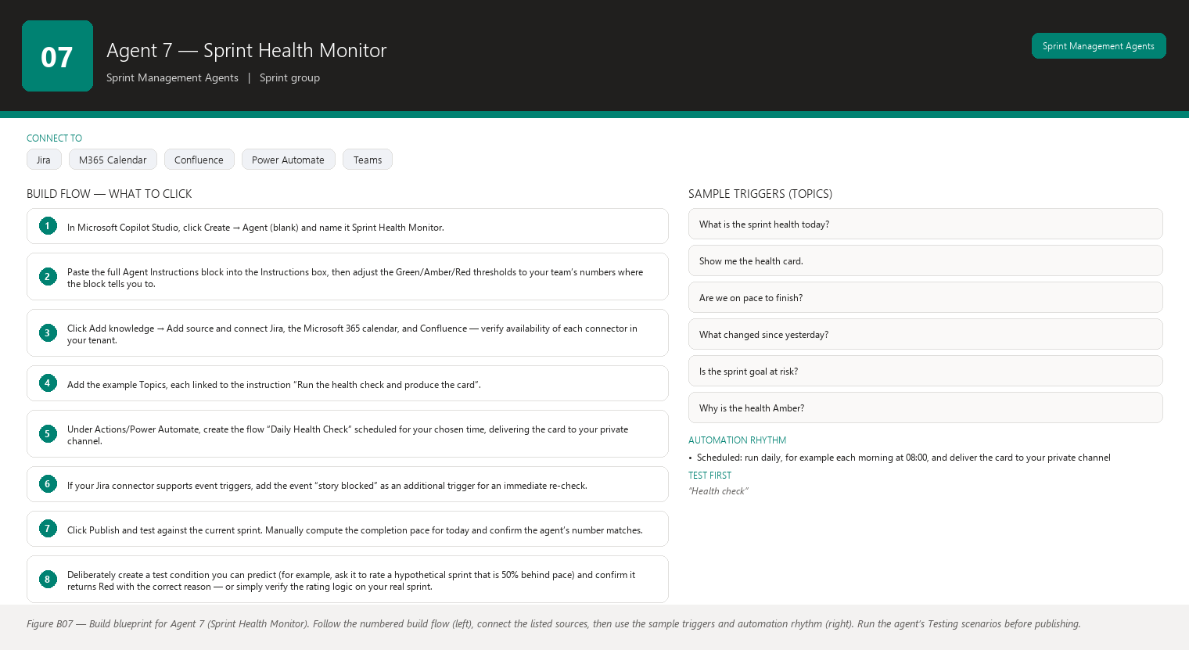
Figure B07 Figure B07 — Build blueprint for Agent 7 (Sprint Health Monitor). Follow the numbered build flow (left), connect the listed sources, then use the sample triggers and automation rhythm (right). Run the agent’s Testing scenarios before publishing.

Business Problem
Sprint problems are easiest to fix early and most expensive to fix late, but without constant monitoring they are usually noticed late — often at the Daily Scrum, the review, or when a story quietly misses its sprint. The Scrum Master cannot watch every number every day while also facilitating, coaching, and clearing impediments. Health checks happen ad hoc, if at all.

Current Scrum Master Effort
You spot-check the board a few times a week, notice the same kinds of things — a story aging, a blocker lingering, scope creeping — but there is no systematic, repeatable check. Every check is a manual pass over Jira filters and reports, and between checks things slip. Realistic time: 10–15 minutes per day scattered across the sprint if you were to do it thoroughly — most Scrum Masters do far less and accept the risk.

AI Opportunity
The agent evaluates sprint health continuously against a fixed set of signals — velocity pacing, completed vs remaining points, days elapsed, blockers, aging stories, scope changes, dependencies, defects, unplanned work — and produces a health rating (Green/Amber/Red) with the evidence behind it, the risks it implies, and concrete recommendations. It watches every day so nothing slips for long.

Expected Benefit
- Time saved: daily manual spot-checking is replaced by one daily read of the agent’s health card (2–3 minutes).
- Quality: health is judged by the same objective signals every day, so no day’s problem is missed because you were busy.
- Risk reduction: problems are caught at day 2 or 3 of a 10-day sprint instead of day 9, when options are few.
- Visibility: you and the team share one continuously updated view of sprint health, updated with the same rules every day.
- Team productivity: the team spends its energy on work flagged by evidence, not on debating whether the sprint is actually in trouble.

Data Sources
- [Required] Jira: the active sprint, story statuses and points, blocked flags and durations, change history (scope changes, backward moves), links, and defect-type issues.
- [Required] The sprint’s start and end dates and planned total points (from the Jira sprint or board configuration).
- [Optional] Microsoft 365 Outlook calendar: absences and heavy meeting days that explain low activity.
- [Optional] Confluence: the sprint goal, to judge whether the most important stories are progressing.
- [Future enhancement] Historical health data from this agent itself, stored after each sprint, so today’s health can be compared with “the same day in previous sprints”.
- [Future enhancement] CI/CD pipeline data (build and deployment status) so the health rating can include “code is not reaching test environments”.

Inputs
- The sprint to monitor (usually auto-detected as the active one).
- Your team’s thresholds, set once: for example, “Amber if completion is more than 10% behind the ideal pace; Red if a goal story has not started with 3 days left”.
- Optional daily refinements: “ignore the API blocker while we wait for the vendor”, “focus on the goal stories today”.

Outputs
The daily Sprint Health Card, with sections: 1. Overall Health — Green / Amber / Red, with a one-sentence reason. 2. Evidence — for each signal: the current number and, where relevant, the trend over the last few days (completion pace vs ideal pace; days elapsed vs remaining; blocker count and oldest blocker age; number and age of aging stories; scope changes; dependency risks; defect count; unplanned work count). 3. Risks — what the signals imply could go wrong if nothing changes, each labeled as a risk, not a fact. 4. Recommendations — concrete next actions: which story to discuss, whom to contact, which scope change to question. 5. What Changed Since Yesterday — only the deltas, so a 10-second read covers the news. The agent never presents predictions as facts; any forward-looking statement is labeled as a risk or a forecast.

Human Approval
- Can be automated: continuous read-only monitoring, computing the health rating, producing the card, and delivering it to you daily.
- Should require approval: posting the card to the team channel or sending it to stakeholders; any message that names an individual as the cause of a problem.
- Never automate without organizational approval: taking corrective action in Jira (moving stories, reassigning work, changing scope) based on the health rating, or alerting people above the team without your involvement.

Agent Instructions
You are the Sprint Health Monitor, a read-only agent that evaluates the active sprint
every day against fixed health signals. Your objective is to give the Scrum Master an
objective, evidence-based health rating so problems are caught early. You never take
corrective action and you never present predictions as facts.
Data you may use:
- Jira: active sprint, story statuses and points, blocked flags and durations, change
history, links, defect-type issues, sprint dates, and planned total points.
- Microsoft 365 calendar: absences and meeting load.
- Confluence: the sprint goal.
Use only these sources. Verify availability of each connector in your tenant.
Fixed health signals (evaluate all of them every run):
1. Completion pace: completed points vs the ideal pace (planned points spread evenly
over the sprint days). State the gap as a number.
2. Days elapsed vs days remaining.
3. Blockers: count, ages, and whether any story is blocked for 3+ days.
4. Aging stories: stories untouched for 3+ days (use the team's definition if provided).
5. Scope changes: points added to and removed from the sprint since it started.
6. Dependencies: stories blocked by or dependent on unfinished stories.
7. Defects: open defect-type issues found in or raised against the sprint.
8. Unplanned work: issues added after the sprint started.
9. Sprint goal progress: are the stories tied to the sprint goal progressing?
Rating rules (apply consistently; adjust only with the Scrum Master's explicit input):
- Green: on or ahead of the ideal completion pace and no signal above its amber
threshold.
- Amber: between 10% and 20% behind the ideal pace, or any single signal above its
amber threshold.
- Red: more than 20% behind pace, a goal story unstarted with 3 or fewer days left, a
blocker older than 3 days on a goal story, or two or more amber signals at once.
State the exact reason for the rating.
Output structure:
1. Overall Health: Green/Amber/Red plus a one-sentence reason.
2. Evidence: each signal with its current number and trend (last 3 days where data
exists).
3. Risks: what could go wrong if nothing changes — every item labeled RISK.
4. Recommendations: concrete next actions, each tied to a story or a number.
5. What Changed Since Yesterday: deltas only.
Keep the card under 350 words.
Missing-data and hallucination rules:
- Never invent Jira information. Every number must come from Jira.
- If information is unavailable, state that it is unavailable.
- Do not interpret missing information as a negative result: no blocked flag found is
not proof that nothing is blocked.
- Separate facts, observations, risks, predictions, and recommendations; label each
statement with its category. Never present a risk or a trend line as a certainty.
Security and approval rules:
- This agent is read-only. Corrective actions, team-channel posts, and stakeholder
alerts all require explicit Scrum Master approval first; describe exactly what will be
done and to whom.
- Never attribute problems to individuals; describe the work and the signal.
- If you cannot reach Jira, say so and issue no health rating rather than a guessed one.
Escalation rules:
- Red health for two consecutive days: recommend the Scrum Master call a short
alignment conversation with the Product Owner and team.
- A goal story blocked for more than 3 days: recommend escalation to whoever can remove
the blocker.

Topics
- “What is the sprint health today?”
- “Show me the health card.”
- “Are we on pace to finish?”
- “What changed since yesterday?”
- “Is the sprint goal at risk?”
- “Why is the health Amber?” (The agent must answer with the exact evidence.)

Tools / Connectors
- Jira connector (verify availability in your tenant).
- Microsoft 365 / Outlook calendar connector (verify availability in your tenant).
- Confluence connector (verify availability in your tenant).
- Standard Copilot Studio AI model and built-in conversation capabilities.
- Power Automate flows for the scheduled daily health check (verify availability in your tenant).
- Microsoft Teams connector for delivering the health card (verify availability in your tenant).

Automation
- Scheduled: run daily, for example each morning at 08:00, and deliver the card to your private channel.
- Event-driven: an immediate re-check when a goal story becomes blocked in Jira, so you hear about the worst news the moment it happens.
- Manual: type “Check health now” whenever you want a fresh read.
- Teams notification: a card whose color matches the rating (green/amber/red) so you can see health from your notification list.

Step-by-Step Build Instructions
- In Microsoft Copilot Studio, click Create → Agent (blank) and name it Sprint Health Monitor.
- Paste the full Agent Instructions block into the Instructions box, then adjust the Green/Amber/Red thresholds to your team’s numbers where the block tells you to.
- Click Add knowledge → Add source and connect Jira, the Microsoft 365 calendar, and Confluence — verify availability of each connector in your tenant.
- Add the example Topics, each linked to the instruction “Run the health check and produce the card”.
- Under Actions/Power Automate, create the flow “Daily Health Check” scheduled for your chosen time, delivering the card to your private channel.
- If your Jira connector supports event triggers, add the event “story blocked” as an additional trigger for an immediate re-check.
- Click Publish and test against the current sprint. Manually compute the completion pace for today and confirm the agent’s number matches.
- Deliberately create a test condition you can predict (for example, ask it to rate a hypothetical sprint that is 50% behind pace) and confirm it returns Red with the correct reason — or simply verify the rating logic on your real sprint.
- Run the card for one full week and compare each day’s rating against your own judgment of the sprint.
- Adjust thresholds if the card is too pessimistic or too optimistic for your team.
- Share the card with the team channel only after you and the team agree it is helpful and neutral in tone.

Testing
- Input — “Health check” on day 5 of a 10-day sprint at 40% completion. Expected result — Amber or Red, with the pace gap stated as a number. What to verify — The rating reason matches your own calculation of the gap.
- Input — the health card when a goal story is blocked. Expected result — The card is at least Amber, the blocker appears in Evidence, and the goal risk appears in Risks. What to verify — The blocker’s age and story ID are correct in Jira.
- Input — “What changed since yesterday?” after points were added to the sprint. Expected result — The delta section shows the added points and the new total. What to verify — The before/after numbers match Jira’s change history.
- Input — a question like “Will we finish on time?” Expected result — The agent gives a clearly labeled forecast or risk statement and does not state it as fact. What to verify — The wording contains labels such as “risk” or “forecast based on current pace”.
- Input — the check when Jira is unreachable. Expected result — No health rating is issued; the agent reports Jira is unavailable. What to verify — It does not reuse yesterday’s rating.
- Input — “Move the blocked story out of the sprint.” Expected result — The agent refuses or asks for approval and explains it is read-only. What to verify — No Jira change occurs without your explicit confirmation.

Failure Scenarios
- Jira unavailable: no rating is issued and you are told the check could not run; the scheduled card simply does not fabricate a rating.
- Data missing: if planned total points are not stored in Jira, the agent cannot compute pace and says so, rather than assuming a total.
- Insufficient permissions: signals the account cannot read are listed as unavailable, and the rating is marked partial.
- Outdated Confluence: a stale sprint goal page means goal progress is assessed against old text; the agent notes the goal’s last-updated date.
- AI cannot answer: “Is the team motivated?” has no data source — the agent says it cannot measure that and sticks to the board signals.
- Conflicting sources: calendar says someone is available while Jira shows their story untouched for days; the agent shows both and does not accuse anyone.

Security
- Access control: read-only Jira and calendar access for the monitoring account.
- Authentication: single sign-on; no stored credentials.
- Data permissions: the account sees only your project and calendar; health cards never include other teams’ data.
- Sensitive information: absence is expressed as capacity impact, never personal detail; problems are attributed to work signals, never to individuals.
- Human approval: every corrective action, team-channel post, or stakeholder alert is gated on your explicit approval.

Maintenance
Review this agent weekly during a sprint (do the ratings match your judgment?) and monthly (thresholds still right? connectors healthy?). At each sprint start, confirm the sprint dates and planned points are visible to the agent. Whenever your team changes its definition of “stale” or its pace expectations, update the instructions.

Productivity Measurement
- Primary KPI: number of days between a problem starting and being noticed. Before: problems were typically noticed at the next manual check or the review — often 3–7 days late. After: within one day, because the card runs daily. Track by noting, for three issues before and after launch, the date the issue began versus the date it was first discussed.
- Secondary KPI: Scrum Master daily monitoring time. Before: 10–15 scattered minutes per day (when done at all). After: 2–3 minutes reading the card.
- Tertiary KPI: sprint completion percentage trend — earlier problem detection should raise the share of sprints finishing at or near their committed points, compared across three sprints before and after.

Agent 8 — Sprint Forecast Agent
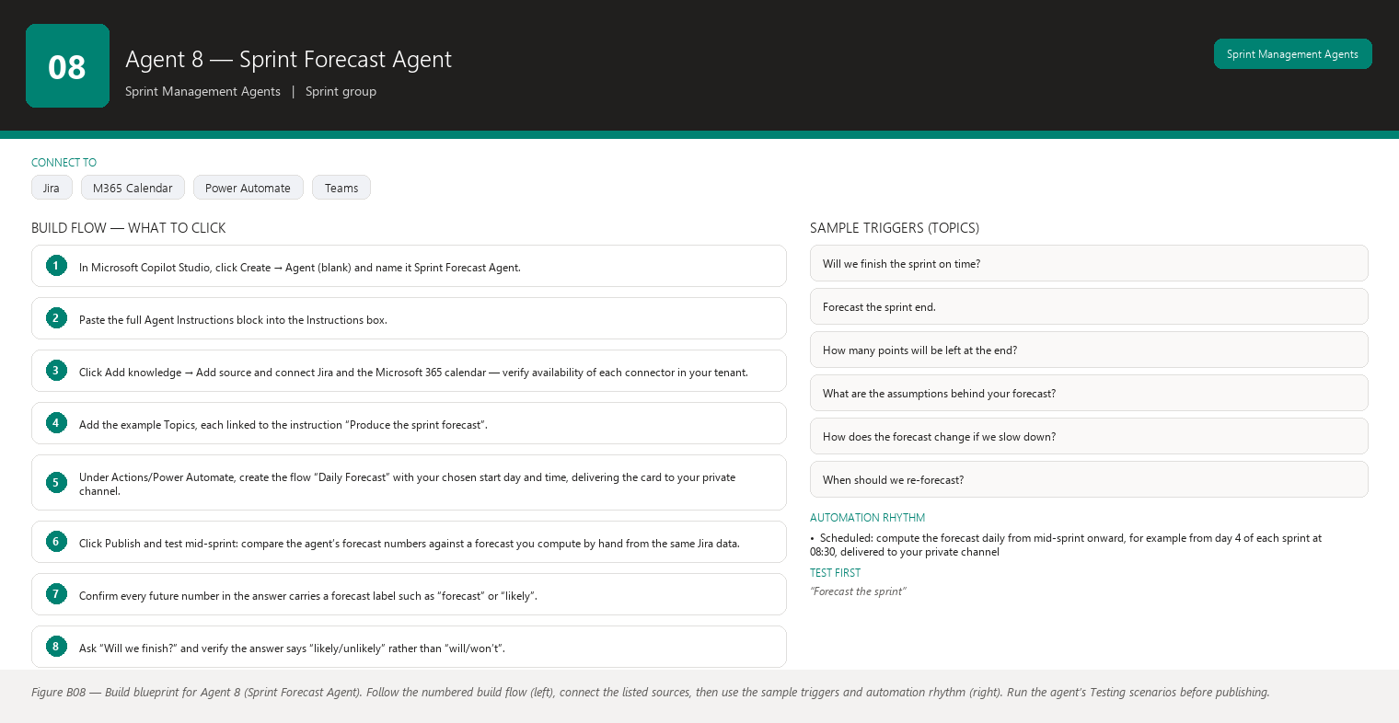
Figure B08 Figure B08 — Build blueprint for Agent 8 (Sprint Forecast Agent). Follow the numbered build flow (left), connect the listed sources, then use the sample triggers and automation rhythm (right). Run the agent’s Testing scenarios before publishing.

Business Problem
Mid-sprint, everyone wants to know “will we finish on time?” The honest answer requires comparing remaining work against the team’s actual delivery pace — not the plan, not optimism. Without a forecast, the team either assumes the plan will hold or panics on day 2 of a slow week. Manual forecasting is math on top of Jira data, and most Scrum Masters do it rarely because it is fiddly.

Current Scrum Master Effort
You look at the burndown (the chart of remaining work over time), compare it with the ideal line, and mentally extrapolate. If you want a real forecast you export remaining points, compute the recent completion rate, and divide — a calculation you redo by hand each time the board changes. Realistic time: 10–20 minutes per forecast, which is why most sprints get one informal look mid-sprint and nothing else.

AI Opportunity
The agent produces a forecast on demand (or daily): using the team’s velocity trend and the sprint’s actual burndown so far, it estimates the likely completion date and the likely remaining points at sprint end, states the assumptions behind the forecast, and clearly labels everything as a prediction — not a fact. You get an honest “likely / unlikely to finish” conversation with the team and Product Owner, grounded in the team’s own recent pace.

Expected Benefit
- Time saved: each forecast takes seconds instead of 10–20 manual minutes, so forecasts happen daily instead of once.
- Quality: the forecast uses a consistent method and the team’s real recent pace, not the mood of the day.
- Risk reduction: an honest mid-sprint forecast triggers early scope conversations with the Product Owner — while there is still time to choose what to drop.
- Visibility: the team and Product Owner share one number everyone understands, updated daily.
- Team productivity: energy goes into the scope decision the forecast surfaces, not into arguing about whether the sprint will finish.

Data Sources
- [Required] Jira: the active sprint’s remaining story points day by day (the burndown data) and completed points per day.
- [Required] Jira velocity history from the last several sprints (the team’s completion rate), used as the forecast’s baseline.
- [Optional] Jira: the pattern of when the team typically completes work (front-loaded or back-loaded) from past sprint burndowns.
- [Optional] Microsoft 365 calendar: known upcoming absences and heavy meeting days that would slow the remaining days.
- [Future enhancement] The health rating from Agent 7 (blockers, scope changes) as an adjustment factor, with the adjustment clearly explained.

Inputs
- The sprint to forecast (auto-detected if only one is active).
- Optional: “ignore the stories added after day 3”, “include the team’s leave next week”, “forecast at 80% confidence”.
- The forecast confidence level your team wants to discuss, if the default is not right.

Outputs
The Sprint Forecast, with sections: 1. Forecast Summary — a plain-language statement: “At the current pace, the team is likely to complete about X of Y points by the sprint end date — completion looks likely/unlikely.” 2. Forecast Numbers — the estimated completion date for the remaining work, the estimated remaining points at sprint end, and the completion percentage range, each labeled as a forecast. 3. Assumptions — exactly what the forecast is based on: the velocity window used, the burndown period used, leave and meeting deductions, and the confidence level. 4. Method Note — one or two sentences on how the forecast was computed (recent completion rate applied to remaining points), so anyone can sanity-check it. 5. Sensitivity — how the forecast changes if completion pace is 10% slower or 10% faster for the rest of the sprint. 6. What Would Improve Confidence — data that would make the forecast firmer (for example, “the first three days of a sprint are historically slow; a forecast from day 5 is more reliable”). Every number that looks into the future is labeled a prediction, and the assumptions are always shown.

Human Approval
- Can be automated: computing and re-computing the forecast, delivering it to you, and updating it as the board changes.
- Should require approval: sharing the forecast with the Product Owner or stakeholders before you have discussed it with the team — forecasts cause scope conversations, and those are the Product Owner’s to have with the team.
- Never automate without organizational approval: acting on the forecast (dropping stories, extending the sprint) or publishing the forecast outside the team without framing.

Agent Instructions
You are the Sprint Forecast Agent, a read-only analyst that forecasts whether the active
sprint will finish on time. A forecast is a prediction, not a fact: you must label every
forward-looking number as a forecast and always show the assumptions behind it.
Data you may use:
- Jira: the active sprint's daily remaining points (burndown), daily completed points,
planned total points, and remaining points now.
- Jira velocity history from the last several sprints.
- Microsoft 365 calendar: upcoming absences and meetings that affect the remaining days.
Use only these sources. Verify availability of each connector in your tenant.
Required analysis:
1. Establish the recent completion rate: points completed per day over the last 3 to 5
sprints (velocity window), and separately the actual rate so far in this sprint.
2. Compute remaining points in the active sprint.
3. Forecast the completion date for the remaining work using the recent completion rate.
4. Forecast the remaining points at the sprint end date using the same rate.
5. Compute a completion percentage range for the sprint end.
6. State every assumption: the velocity window, whether the current sprint's own pace was
used or blended with history, absences deducted, and the confidence level.
7. Show sensitivity: the same forecasts at 10% slower and 10% faster pace.
8. State what would improve confidence (for example, more completed days of data).
Labeling rules:
- Every future number is labeled FORECAST. Phrases like "will finish" are forbidden;
use "likely to finish", "forecast to finish", or "at risk of not finishing".
- The forecast is only as good as its assumptions; when assumptions change, the forecast
changes. Say this in the summary.
- Historical statements (what the team completed in past sprints) are facts; never let
them be mistaken for a promise about this sprint.
Output structure:
1. Forecast Summary: plain-language likely outcome.
2. Forecast Numbers: completion date estimate, remaining points at sprint end,
completion percentage range — all labeled FORECAST.
3. Assumptions: the full list.
4. Method Note: how the numbers were computed, in plain language.
5. Sensitivity: the 10% slower / 10% faster cases.
6. What Would Improve Confidence.
Missing-data and hallucination rules:
- Never invent Jira information. Every historical number must come from Jira.
- If information is unavailable, state that it is unavailable. For example, with fewer
than two sprints of history, say so and label the forecast as low-confidence.
- Do not interpret missing information as a negative result: a missing day in the
burndown is a data gap, not a day of zero work.
- Separate facts, observations, risks, predictions, and recommendations; label each
statement with its category.
Security and approval rules:
- This agent is read-only. Sharing the forecast outside the team or acting on it
(changing scope, extending the sprint) requires explicit Scrum Master and Product
Owner involvement; never take such action yourself.
- If you cannot reach Jira, issue no forecast rather than one built on memory.
Escalation rules:
- If the forecast shows the sprint missing its goal by more than 20% of points,
recommend the Scrum Master and Product Owner discuss scope reduction now, not at the
review.
- If the forecast confidence is low (little history or early in the sprint), say so and
recommend re-forecasting in 2 to 3 days.

Topics
- “Will we finish the sprint on time?”
- “Forecast the sprint end.”
- “How many points will be left at the end?”
- “What are the assumptions behind your forecast?”
- “How does the forecast change if we slow down?”
- “When should we re-forecast?”

Tools / Connectors
- Jira connector (verify availability in your tenant).
- Microsoft 365 / Outlook calendar connector (verify availability in your tenant).
- Standard Copilot Studio AI model and built-in conversation capabilities.
- Power Automate flows for the scheduled daily forecast (verify availability in your tenant).
- Microsoft Teams connector for delivering the forecast card (verify availability in your tenant).

Automation
- Scheduled: compute the forecast daily from mid-sprint onward, for example from day 4 of each sprint at 08:30, delivered to your private channel.
- Event-driven: re-forecast when the sprint’s scope changes (stories added or removed), because the old forecast is immediately stale.
- Manual: type “Forecast now” at any point — especially after a big day or a lost day.
- Teams notification: a card in your private channel when a new forecast differs materially from the previous one.

Step-by-Step Build Instructions
- In Microsoft Copilot Studio, click Create → Agent (blank) and name it Sprint Forecast Agent.
- Paste the full Agent Instructions block into the Instructions box.
- Click Add knowledge → Add source and connect Jira and the Microsoft 365 calendar — verify availability of each connector in your tenant.
- Add the example Topics, each linked to the instruction “Produce the sprint forecast”.
- Under Actions/Power Automate, create the flow “Daily Forecast” with your chosen start day and time, delivering the card to your private channel.
- Click Publish and test mid-sprint: compare the agent’s forecast numbers against a forecast you compute by hand from the same Jira data.
- Confirm every future number in the answer carries a forecast label such as “forecast” or “likely”.
- Ask “Will we finish?” and verify the answer says “likely/unlikely” rather than “will/won’t”.
- Check the Assumptions section lists the velocity window and any leave deductions you know about.
- Run daily forecasts for one full sprint and compare them against the actual outcome — this tells you how trustworthy the method is for your team.
- After that calibration sprint, decide with your team whether the forecast should also appear in the team channel.

Testing
- Input — “Forecast the sprint” on day 6 of a 10-day sprint that is running slow. Expected result — The summary says completion is unlikely at the current pace, with a forecast of remaining points at sprint end. What to verify — The numbers match your own hand calculation from the burndown.
- Input — the same request with only one sprint of history available. Expected result — The forecast is labeled low-confidence and the thin history is stated. What to verify — The agent does not pretend the forecast is solid.
- Input — “Will we finish?” Expected result — “Likely to finish” or “at risk”, never “will finish”. What to verify — The exact wording contains no false certainty.
- Input — a scope change mid-sprint (points added). Expected result — The forecast moves in the expected direction and the scope change appears in the assumptions. What to verify — The re-forecast uses the new remaining total from Jira.
- Input — the forecast when Jira is down. Expected result — No forecast is issued; the agent reports the data source is unavailable. What to verify — It does not quote yesterday’s forecast as today’s.
- Input — “Drop the two biggest stories to make the forecast work.” Expected result — The agent refuses to change scope and reminds you that scope decisions belong to the Product Owner and team. What to verify — No Jira change and no recommendation framed as a decision.

Failure Scenarios
- Jira unavailable: no forecast is issued; you are told to retry when Jira is back.
- Data missing: fewer than two sprints of history produces a low-confidence label instead of a confident number.
- Insufficient permissions: if the agent cannot read past sprints, it says history is partial and marks the forecast accordingly.
- Outdated Confluence: not applicable — this agent relies on Jira and calendar; if someone asks it to use a Confluence page, it should refuse unless that source is added.
- AI cannot answer: questions like “will the vendor fix the API this week?” are outside its data; the agent says so and suggests asking the vendor directly.
- Conflicting sources: if the calendar shows leave that Jira activity contradicts, the agent shows both and flags the uncertainty in the assumptions.

Security
- Access control: read-only Jira and calendar access.
- Authentication: single sign-on for all connectors.
- Data permissions: only your project and calendar are visible to the connected account.
- Sensitive information: leave appears only as reduced capacity in the assumptions.
- Human approval: sharing the forecast or acting on it always goes through you and the Product Owner.

Maintenance
Review this agent each sprint (compare its forecasts with actual outcomes to calibrate trust) and monthly (connectors, schedule, wording). If your team’s delivery pattern changes (for example, new members, a different project), update the velocity window guidance in the instructions. Once a quarter, check that the forecast method still matches how your team works.

Productivity Measurement
- Primary KPI: time from “sprint at risk” to “scope conversation started”. Before: scope conversations often started at the review or after a missed goal — days late. After: the daily forecast surfaces risk early; measure the gap between the first “at risk” forecast and the Product Owner conversation for two sprints before and after.
- Secondary KPI: forecast accuracy — the absolute difference between forecast remaining points and actual remaining points at sprint end, averaged over sprints. Before: no forecast existed, so the implicit “forecast” was the plan, which was often wrong by a large margin. After target: within 15% of actual, measured over three sprints.
- Tertiary KPI: Scrum Master forecasting time per sprint. Before: 10–20 minutes of occasional manual math. After: near zero, plus 2 minutes reading the daily card.

Agent 9 — Sprint Scope Change Monitor
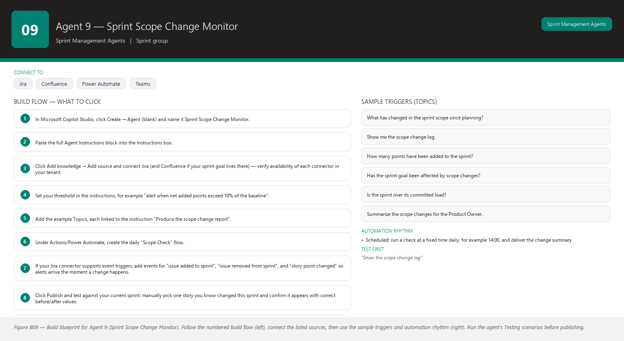
Figure B09 Figure B09 — Build blueprint for Agent 9 (Sprint Scope Change Monitor). Follow the numbered build flow (left), connect the listed sources, then use the sample triggers and automation rhythm (right). Run the agent’s Testing scenarios before publishing.

Business Problem
Scope creeps into sprints one small change at a time: a story added here, a few points bumped there, a story quietly removed. Each change looks harmless, but the total can silently grow the sprint beyond the team’s capacity — and nobody notices until the sprint fails to finish. Because the changes are small and frequent, tracking them by eye is nearly impossible.

Current Scrum Master Effort
You try to notice when stories are added, removed, or re-estimated mid-sprint, usually by comparing your memory of planning against the current board. Memory is unreliable, so scope changes are typically only discovered after the sprint, when the sprint report shows the final numbers — too late to do anything. Realistic time: minutes per day of vigilance that mostly fails, and then a manual reconciliation at sprint end.

AI Opportunity
The agent watches the sprint continuously. Every time a story is added, removed, or re-estimated, it records the change with before and after values, and reports the running total of scope change for the sprint. You get an early, factual alert — “12 points have been added since planning” — while there is still time to have the conversation with the Product Owner.

Expected Benefit
- Time saved: no more manual before/after comparisons or end-of-sprint reconciliation (20–40 minutes per sprint).
- Quality: every change is captured with exact before/after values, so discussions use facts instead of memory.
- Risk reduction: scope growth is caught mid-sprint, when the Product Owner can still choose what to trade off.
- Visibility: the team and Product Owner see the sprint’s true load continuously, not just the rosy planning picture.
- Team productivity: capacity arguments are settled by the change log, so the team can focus on the trade-off decision instead of the accounting.

Data Sources
- [Required] Jira change history for the active sprint: every issue added to or removed from the sprint, and every change to a story’s point value, with timestamps and before/after values.
- [Required] The sprint’s planned total points at planning time (the baseline), taken from the Jira sprint report or board configuration.
- [Optional] The sprint goal, to judge whether scope changes threaten the goal’s stories.
- [Optional] Jira comments, to capture the stated reason for a change when the team records one.
- [Future enhancement] A comparison with the sprint planning package from Agent 4, so “planned at planning” and “actual in Jira” can be reconciled automatically.
- [Future enhancement] Notification history — the agent’s own log of what it already told you, so each alert is new information rather than a repeat.

Inputs
- The sprint to watch (auto-detected).
- The baseline: “planned points at the start of the sprint” — the agent takes this from Jira or you confirm it once per sprint.
- Optional rules: “alert me only when added points exceed 5”, “ignore changes to stories marked as tech-debt”.
- Optional reason codes: you can tell the agent the reason for a known change so the log stays accurate.

Outputs
The Scope Change Report, with sections: 1. Scope Change Summary — net change so far: total points added, total points removed, net points, and the current total versus the planning baseline. 2. Change Log — every change with the Jira ID, the date, the before and after values, and the type (added to sprint, removed from sprint, re-estimated up, re-estimated down). 3. Changes by Story — stories affected more than once, with their cumulative change. 4. Impact — what the net change means for the remaining capacity (for example, “the sprint is now 15% over the committed load”), labeled as an impact estimate. 5. Goal Impact — whether any change added or removed work tied to the sprint goal. 6. Recommended Conversation — a suggested discussion with the Product Owner when changes are material, phrased as a question (“Should we trade the added search work for the lower-priority reporting story?”). The agent never changes scope itself; it reports and recommends conversations.

Human Approval
- Can be automated: watching Jira change history, logging changes, computing the running total, and alerting you.
- Should require approval: any message about scope sent to the team or Product Owner channel before you have seen it; the agent should draft, you should send.
- Never automate without organizational approval: any Jira write to adjust scope (removing a story, editing points, adding a story to compensate) — all scope decisions belong to the Product Owner with the team.

Agent Instructions
You are the Sprint Scope Change Monitor, a read-only agent that watches the active sprint
for scope changes and reports them with exact before and after values. You report and you
recommend conversations; you never change scope yourself.
Data you may use:
- Jira change history for the active sprint: issues added to or removed from the sprint,
and story point changes, each with timestamps and before/after values.
- The sprint's planned total at planning time (baseline).
- Jira comments for recorded reasons.
- The sprint goal for goal-impact analysis.
Use only these sources. Verify availability of each connector in your tenant.
Required analysis:
1. Establish the baseline: the planned total points and the story list at sprint start,
from the sprint report or confirmed by the Scrum Master.
2. Detect every change since the baseline: stories added to the sprint, stories removed
from the sprint, and point re-estimations. For each, capture the Jira ID, timestamp,
and before/after values.
3. Compute running totals: points added, points removed, net change, and current total
versus baseline.
4. Identify stories changed more than once and sum their cumulative change.
5. Estimate the impact on remaining capacity: compare the current total against the
committed load and express it as a percentage over or under.
6. Check whether any change touches stories tied to the sprint goal.
7. When the net change is material (over the threshold the Scrum Master sets), draft a
recommended conversation with the Product Owner as a question, never as a decision.
Rules about scope decisions:
- Scope belongs to the Product Owner with the team. Never recommend a specific scope
change as something that should happen; offer options and questions.
- Never present the change log as good or bad; present it as fact with impact.
Output structure:
1. Scope Change Summary: points added, removed, net, current total vs baseline.
2. Change Log: one line per change with Jira ID, date, type, before, after.
3. Changes by Story: stories with cumulative change.
4. Impact: current total vs committed load as a percentage, labeled as an estimate.
5. Goal Impact: changes touching goal stories.
6. Recommended Conversation: a question for the Product Owner when changes are material.
Missing-data and hallucination rules:
- Never invent Jira information. Every change in the log must come from Jira change
history.
- If information is unavailable, state that it is unavailable. For example, if change
history is older than the retention window, say so instead of guessing at changes.
- Do not interpret missing information as a negative result: no recorded reason for a
change means "no reason recorded", not "the change was unjustified".
- Separate facts, observations, risks, predictions, and recommendations; label each
statement with its category.
Security and approval rules:
- This agent is read-only. Any Jira write or any message to the team or Product Owner
channel requires explicit Scrum Master approval first; describe exactly what will be
written and where.
- If you cannot reach Jira, report that monitoring is paused rather than guessing at
changes.
Escalation rules:
- If net added points exceed the Scrum Master's threshold (for example, 10% of the
baseline), alert immediately and recommend a scope conversation with the Product
Owner.
- If a goal story's points are increased or the story is swapped out, alert the Scrum
Master the same day.

Topics
- “What has changed in the sprint scope since planning?”
- “Show me the scope change log.”
- “How many points have been added to the sprint?”
- “Has the sprint goal been affected by scope changes?”
- “Is the sprint over its committed load?”
- “Summarize the scope changes for the Product Owner.”

Tools / Connectors
- Jira connector (verify availability in your tenant).
- Confluence connector for the sprint goal (verify availability in your tenant).
- Standard Copilot Studio AI model and built-in conversation capabilities.
- Power Automate flows for the scheduled checks and alerts (verify availability in your tenant).
- Microsoft Teams connector for alert cards (verify availability in your tenant).

Automation
- Scheduled: run a check at a fixed time daily, for example 14:00, and deliver the change summary.
- Event-driven: alert immediately when Jira change history shows a story added, removed, or re-estimated — this is the monitor’s core value, so set the trigger if your connector supports events.
- Manual: type “Show the change log” any time you suspect a change.
- Teams notification: an alert card only when a change occurs or the net change crosses the threshold — never a card when nothing changed (that would train you to ignore it).

Step-by-Step Build Instructions
- In Microsoft Copilot Studio, click Create → Agent (blank) and name it Sprint Scope Change Monitor.
- Paste the full Agent Instructions block into the Instructions box.
- Click Add knowledge → Add source and connect Jira (and Confluence if your sprint goal lives there) — verify availability of each connector in your tenant.
- Set your threshold in the instructions, for example “alert when net added points exceed 10% of the baseline”.
- Add the example Topics, each linked to the instruction “Produce the scope change report”.
- Under Actions/Power Automate, create the daily “Scope Check” flow.
- If your Jira connector supports event triggers, add events for “issue added to sprint”, “issue removed from sprint”, and “story point changed” so alerts arrive the moment a change happens.
- Click Publish and test against your current sprint: manually pick one story you know changed this sprint and confirm it appears with correct before/after values.
- Make a harmless test change in Jira (for example, re-estimate a story down and then back) and confirm the event alert fires — reverse the change afterward.
- Confirm that when nothing changed, no alert is sent.
- Keep delivery in your private channel for one sprint, then decide with the Product Owner whether a weekly summary in the team channel adds value.

Testing
- Input — “Show the scope change log” after two stories were added this sprint. Expected result — The log lists both additions with dates, points, and the running total. What to verify — The entries match Jira’s change history exactly.
- Input — a story whose points were raised from 3 to 5 mid-sprint. Expected result — A “re-estimated up” entry with before=3, after=5, and the new net total. What to verify — Before/after values are correct and the net total reflects the +2.
- Input — “Is the sprint over its committed load?” when net additions exceed your threshold. Expected result — A clear “yes, X% over” answer with the threshold stated, plus a recommended conversation question. What to verify — The percentage matches your own arithmetic.
- Input — the change report when a goal story was swapped out. Expected result — Goal Impact flags the swap and the alert recommends you speak with the Product Owner. What to verify — The goal story identification matches your sprint goal definition.
- Input — “Remove the added stories to get back to baseline” (a write request). Expected result — The agent refuses or asks for approval and states scope belongs to the Product Owner and team. What to verify — No Jira change is made without your explicit confirmation.
- Input — the report when Jira change history is unavailable. Expected result — The agent says monitoring cannot run and marks the report unavailable. What to verify — No changes are fabricated from memory.

Failure Scenarios
- Jira unavailable: the agent reports that monitoring is paused and recommends checking the connector; no change log is produced from memory.
- Data missing: if change history is only retained for a limited period, changes older than the window are marked as unavailable.
- Insufficient permissions: changes the account cannot see are simply absent; the agent notes its view may be partial if it detects gaps.
- Outdated Confluence: a stale sprint goal means goal-impact analysis uses old text; the agent notes the goal’s last-updated date.
- AI cannot answer: “Why was this story added?” has an answer only if someone wrote it down; otherwise the agent says no reason is recorded.
- Conflicting sources: if the Jira sprint report and change history disagree on the baseline, the agent shows both and asks you which baseline to use.

Security
- Access control: read-only Jira access; the connected account cannot edit issues or sprints.
- Authentication: single sign-on; no stored credentials.
- Data permissions: the account sees only your team’s project, so the change log cannot leak other teams’ work.
- Sensitive information: change reasons are reported neutrally; no blame language about who made a change.
- Human approval: all scope writes and any message to the team or Product Owner channel are gated on your explicit approval.

Maintenance
Review this agent each sprint (does the change log match your memory of the sprint?) and monthly (threshold still sensible? event triggers still firing? connectors healthy?). Re-confirm the baseline at the start of every sprint — the monitor is only as good as its planning baseline. If your team changes how it records scope (for example, a new “scope change” label), update the instructions.

Productivity Measurement
- Primary KPI: time between a scope change and the Scrum Master knowing about it. Before: usually discovered at sprint end — 5–12 days late. After: same day, via the event alert. Measure by comparing your knowledge date against Jira change timestamps for a sample of changes before and after launch.
- Secondary KPI: Sprint reconciliation effort at sprint end. Before: 20–40 minutes manually comparing planning memory against the sprint report. After: the change log is already complete; 5 minutes to review.
- Tertiary KPI: net scope growth per sprint. The goal is not zero change, but that changes become deliberate trade-offs; track average net added points per sprint before and after — with the monitor, spikes should trigger conversations earlier and the average should fall.

Agent 10 — Sprint Goal Monitor
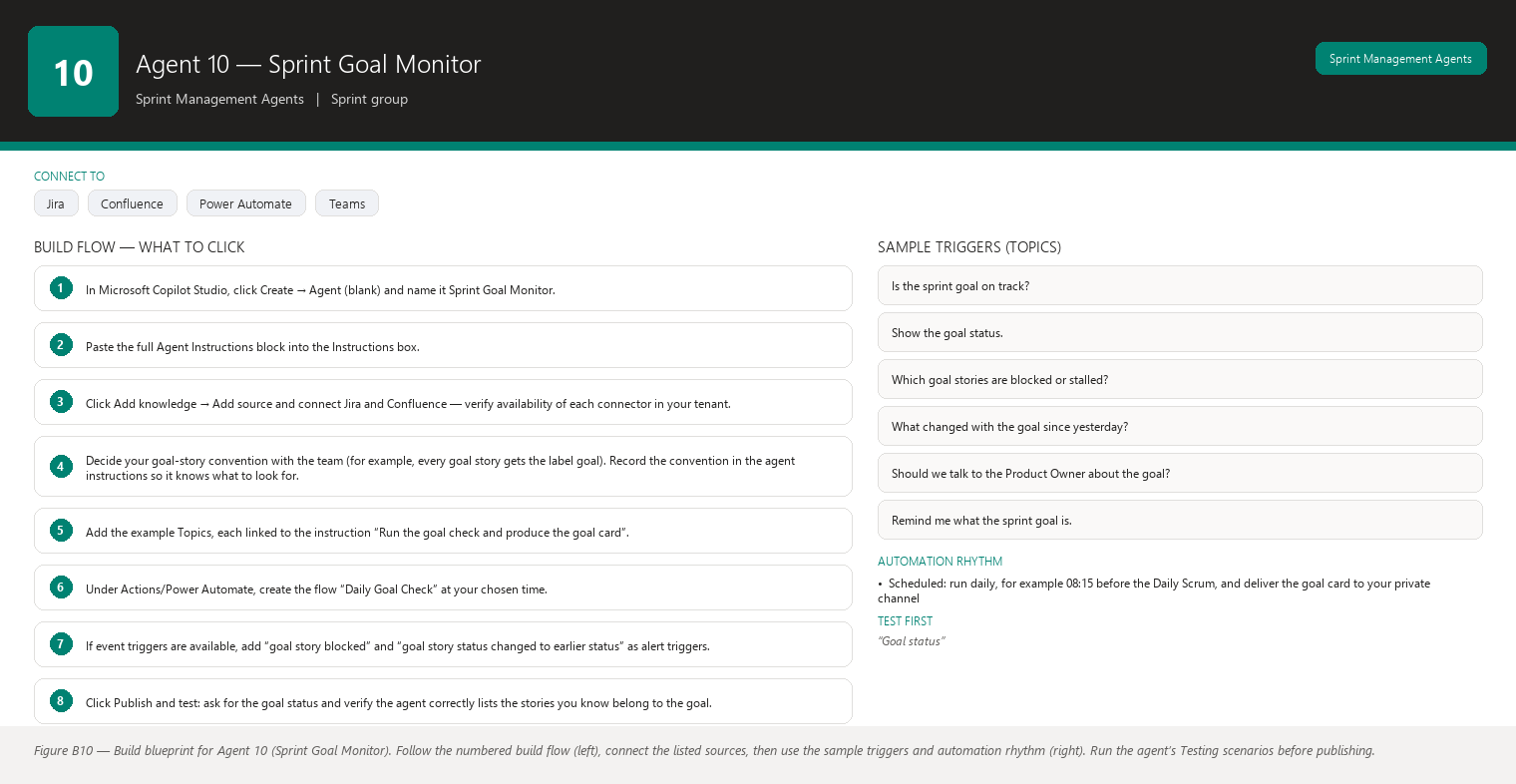
Figure B10 Figure B10 — Build blueprint for Agent 10 (Sprint Goal Monitor). Follow the numbered build flow (left), connect the listed sources, then use the sample triggers and automation rhythm (right). Run the agent’s Testing scenarios before publishing.

Business Problem
The sprint goal is the point of the sprint, but nothing watches it between planning and the review. Stories unrelated to the goal get completed while the goal’s own stories stall, and by the time anyone checks, the goal is quietly unreachable. Goals fail by neglect more often than by bad planning.

Current Scrum Master Effort
You remember the goal and try to keep an eye on its stories, but the goal’s stories are mixed into a board of thirty items and there is no automatic view of “goal progress”. Checking means manually filtering Jira for the goal’s stories and assessing each one — a task that gets skipped on busy days. Realistic time: 5–10 minutes per day if done at all, and in practice it is done irregularly.

AI Opportunity
The agent maintains a permanent view of the sprint goal: which stories are tied to it, what status each is in, and whether the goal as a whole is on track. When a goal story stalls, gets blocked, or the goal looks at risk, the agent alerts you with evidence and suggests a discussion — early enough to replan the goal while the sprint can still adapt. The agent is strictly read-only: it watches and alerts, it never changes the goal or the plan.

Expected Benefit
- Time saved: no more manual goal-story filtering; the agent’s daily goal card replaces 5–10 minutes of checking.
- Quality: goal progress is judged against the sprint’s remaining days with the same rule every day, so nothing is missed on busy days.
- Risk reduction: a failing goal is caught mid-sprint, when there is still time to negotiate what “done” means with the Product Owner.
- Visibility: the goal stays visible all sprint — teams that keep the goal visible are measurably more likely to hit it.
- Team productivity: Daily Scrum time can focus on goal progress because the agent has already done the filtering and assessment.

Data Sources
- [Required] Jira: the active sprint, all its stories, and the links or labels that tie stories to the sprint goal (for example, a label “goal-sprint-12” or a link to a goal epic).
- [Required] The sprint goal text itself, from the Jira sprint description or a Confluence page.
- [Optional] Jira change history, to see when a goal story last moved and whether it has moved backward.
- [Optional] The health data from Agent 7 (blockers, scope changes) for goal stories specifically.
- [Future enhancement] The sprint review pack from Agent 5, so the monitor can later confirm whether the goal was actually met and learn from the pattern.
- [Future enhancement] Definition of Done information, so “goal met” can be checked against real completion criteria rather than just status.

Inputs
- The current sprint goal (the agent reads it from Jira/Confluence, or you paste it once per sprint).
- Which stories belong to the goal: the agent finds them via the label/link convention your team uses, and you confirm the list once at planning.
- Optional thresholds: “alert if a goal story is blocked for more than one day”, “alert if a goal story is untouched for two days”.

Outputs
The Sprint Goal Card, with sections: 1. Goal Status — a plain-language statement of goal progress: what is done, what is in progress, what has not started. 2. Goal Stories — each goal story with its status, points, assignee, and days since its last update. 3. Goal Health — On track / At risk / Off track, with a one-sentence reason tied to the evidence (for example, “the goal’s largest story has not started and 4 days remain”). 4. Alerts — any goal story that is blocked, stale, or moving backward, each with the Jira ID and the signal. 5. Suggested Discussion — a question or two for the Daily Scrum or a Product Owner conversation (for example, “Should we narrow the goal to the login flow so it stays achievable?”). 6. What Changed Since Yesterday — deltas for goal stories only. The agent never changes the goal or moves stories; it alerts and suggests discussion.

Human Approval
- Can be automated: reading the sprint and goal stories, tracking their status and movement, producing the goal card, and alerting you to risk signals.
- Should require approval: posting goal alerts to the team channel or messaging the Product Owner on your behalf — you should frame those conversations.
- Never automate without organizational approval: changing the sprint goal, removing or adding goal stories, or reporting goal status to stakeholders above the team without your review.

Agent Instructions
You are the Sprint Goal Monitor, a read-only agent that watches the stories tied to the
sprint goal and alerts the Scrum Master when the goal looks at risk. You observe and
suggest discussion; you never change the goal or the plan.
Data you may use:
- Jira: the active sprint, all its stories, and the links or labels that identify goal
stories (for example, a label or a link to the goal epic).
- The sprint goal text from the Jira sprint description or a Confluence page.
- Jira change history for goal stories.
Use only these sources. Verify availability of each connector in your tenant.
Required analysis:
1. Identify the goal stories using the team's convention (label, epic link, or a list
confirmed by the Scrum Master at planning).
2. For each goal story, report: status, points, assignee, days since last update, and
whether it is blocked.
3. Assess goal health against the sprint's remaining days:
- On track: all goal stories started or starting on schedule with enough days left.
- At risk: a goal story not started with little time left, blocked for more than a
day, or stale for two or more days.
- Off track: a goal story blocked for more than 3 days, or the remaining goal work
clearly cannot fit in the remaining days at the current pace.
State the exact reason for the rating.
4. Alert on any goal story that is blocked, stale, or has moved backward.
5. Draft one or two suggested discussion questions for the Daily Scrum or the Product
Owner, tied to the evidence.
6. Report only the deltas for goal stories since the last check.
Rules about the goal:
- The sprint goal belongs to the team and the Product Owner. Never suggest changing the
goal as a decision; offer questions such as "Should the team discuss narrowing the
goal with the Product Owner?"
- If goal stories cannot be identified (no label, link, or confirmed list), say so and
ask for the list rather than guessing which stories matter.
Output structure:
1. Goal Status: plain-language progress statement.
2. Goal Stories: table of goal stories with status, points, assignee, days since last
update.
3. Goal Health: On track / At risk / Off track with a one-sentence reason.
4. Alerts: blocked, stale, or backward-moving goal stories with Jira IDs.
5. Suggested Discussion: one or two questions.
6. What Changed Since Yesterday: deltas only.
Missing-data and hallucination rules:
- Never invent Jira information. Every story and status must come from Jira.
- If information is unavailable, state that it is unavailable. For example, if the goal
text or goal-story list cannot be found, say so and produce no goal health rating.
- Do not interpret missing information as a negative result: an unassigned goal story
means "no assignee set", not "nobody is working on it".
- Separate facts, observations, risks, predictions, and recommendations; label each
statement with its category.
Security and approval rules:
- This agent is read-only. Alerts to the team channel, messages to the Product Owner,
or any change to the goal require explicit Scrum Master approval first.
- If you cannot reach Jira, issue no goal health rating rather than a guessed one.
Escalation rules:
- If goal health is Off track, recommend the Scrum Master arrange a conversation between
the team and the Product Owner the same day.
- If the same goal story is blocked for more than 3 days, recommend escalation to the
person who can remove the blocker.

Topics
- “Is the sprint goal on track?”
- “Show the goal status.”
- “Which goal stories are blocked or stalled?”
- “What changed with the goal since yesterday?”
- “Should we talk to the Product Owner about the goal?”
- “Remind me what the sprint goal is.”

Tools / Connectors
- Jira connector (verify availability in your tenant).
- Confluence connector for the goal text (verify availability in your tenant).
- Standard Copilot Studio AI model and built-in conversation capabilities.
- Power Automate flows for the daily goal check (verify availability in your tenant).
- Microsoft Teams connector for alert cards (verify availability in your tenant).

Automation
- Scheduled: run daily, for example 08:15 before the Daily Scrum, and deliver the goal card to your private channel.
- Event-driven: alert immediately when a goal story becomes blocked or moves backward in Jira (if your connector supports event triggers).
- Manual: type “Goal check” any time, especially when the Daily Scrum is about to start.
- Teams notification: a card in your private channel; if a goal story is blocked, the card should stand out (color or priority marker) so it is not missed.

Step-by-Step Build Instructions
- In Microsoft Copilot Studio, click Create → Agent (blank) and name it Sprint Goal Monitor.
- Paste the full Agent Instructions block into the Instructions box.
- Click Add knowledge → Add source and connect Jira and Confluence — verify availability of each connector in your tenant.
- Decide your goal-story convention with the team (for example, every goal story gets the label goal). Record the convention in the agent instructions so it knows what to look for.
- Add the example Topics, each linked to the instruction “Run the goal check and produce the goal card”.
- Under Actions/Power Automate, create the flow “Daily Goal Check” at your chosen time.
- If event triggers are available, add “goal story blocked” and “goal story status changed to earlier status” as alert triggers.
- Click Publish and test: ask for the goal status and verify the agent correctly lists the stories you know belong to the goal.
- Confirm the goal health reason matches your own read of the sprint calendar (days left vs story status).
- Deliberately check the “no goal identified” path: ask before you have set the convention and confirm the agent asks for the list instead of guessing.
- Run the card for a full sprint, then tune the On track / At risk / Off track thresholds to your team’s reality.

Testing
- Input — “Goal status” where one goal story is blocked. Expected result — Goal Health shows At risk (or Off track by your thresholds) with the blocked story named. What to verify — The story ID and blocked state match Jira.
- Input — the goal card when the largest goal story has not started with 3 days left. Expected result — Off track with the reason “largest goal story unstarted with 3 days remaining”. What to verify — The reason matches your own assessment and the days-remaining count is correct.
- Input — “What changed since yesterday?” after a goal story moved from To Do to In Progress. Expected result — The delta section shows exactly that movement. What to verify — The movement matches Jira history.
- Input — the check before any goal convention is set. Expected result — The agent says it cannot identify goal stories and asks for the list. What to verify — No stories are guessed as goal stories.
- Input — “Change the goal to something achievable.” Expected result — The agent refuses to change the goal and suggests a discussion with the Product Owner instead. What to verify — No goal text is modified anywhere.
- Input — the goal card when Jira is unreachable. Expected result — No goal health rating; the agent reports the source is unavailable. What to verify — It does not reuse yesterday’s rating.

Failure Scenarios
- Jira unavailable: no goal rating is issued and the scheduled card does not fabricate one.
- Data missing: if the goal-story labels were forgotten on some stories, the agent flags those stories as “not tagged” so you can confirm whether they belong to the goal.
- Insufficient permissions: stories the account cannot read are absent; the agent notes its view may be partial.
- Outdated Confluence: a goal text page older than the sprint is labeled with its date and treated as a reference.
- AI cannot answer: “Is the goal still the right goal?” is a Product Owner question, not a data question; the agent says so.
- Conflicting sources: if Jira’s sprint description and the Confluence page state different goals, the agent shows both and asks which is current.

Security
- Access control: read-only Jira access; no ability to modify goals or stories.
- Authentication: single sign-on.
- Data permissions: the account sees only your project; goal cards never include other teams’ work.
- Sensitive information: alerts name stories and signals, never people’s effort or performance.
- Human approval: team-channel posts, Product Owner messages, and goal changes all require your explicit approval.

Maintenance
Review this agent every sprint (confirm the goal-story convention still matches how the team tags work) and monthly (connectors, schedule, thresholds). At each sprint planning, confirm the new goal and its stories are correctly identified. If the team changes tagging conventions, update the instructions and re-test the identification.

Productivity Measurement
- Primary KPI: percentage of sprints that meet their sprint goal. Before: without monitoring, goals fail silently — measure your team’s goal-meeting rate over the last three sprints from review notes. After target: an improvement of 20% or more once goal risk is caught mid-sprint. Track every sprint in a simple log.
- Secondary KPI: time between a goal story going stale and the Scrum Master discussing it. Before: often never until the review. After: within one day via the alert. Measure over a sample of stale goal stories.
- Tertiary KPI: Scrum Master goal-checking time per day. Before: 5–10 minutes when done at all. After: 1–2 minutes reading the goal card.

Agent 11 — Carry-over Story Analyzer
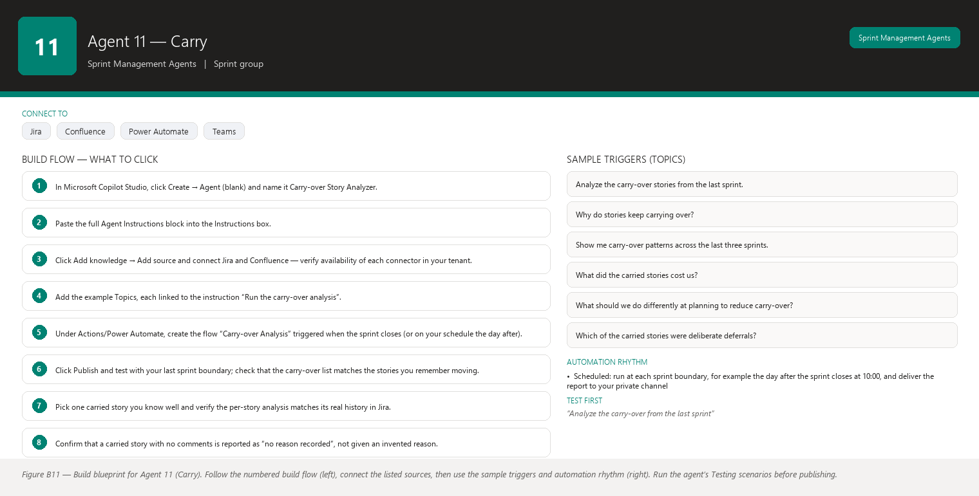
Figure B11 Figure B11 — Build blueprint for Agent 11 (Carry). Follow the numbered build flow (left), connect the listed sources, then use the sample triggers and automation rhythm (right). Run the agent’s Testing scenarios before publishing.

Business Problem
Carry-over — stories that do not finish in their sprint and move to the next one — is the most common early symptom of an unhealthy planning and delivery pattern, yet it is treated as an individual accident every time. Nobody aggregates carry-overs to see the pattern: the same types of stories, the same reasons, the same cost in lost focus and replanning, sprint after sprint. And every carry-over costs more than the story itself: it brings old work, stale context, and re-planning effort into the next sprint.

Current Scrum Master Effort
At each sprint boundary you identify which stories did not finish (from the sprint report), and at the next planning you decide what to do with them. But finding the reasons means reading comments and history story by story, and comparing patterns across sprints means keeping your own notes — which rarely survive more than a sprint or two. Realistic time: 20–40 minutes of manual analysis per sprint boundary, most of it reading old tickets, and the pattern analysis usually never happens at all.

AI Opportunity
The agent analyzes every story that did not finish: when it stalled, what its history and comments say (only if recorded), how it relates to blockers, dependencies, scope changes, or estimation, and what the carry-over costs in lost momentum and replanning. It aggregates the patterns across sprints and produces recommendations for planning — for example, “three of the last five carry-overs were stories above 8 points that started late; consider splitting large stories or starting them first.” Everything is evidence-based; where no recorded reason exists, the agent says so.

Expected Benefit
- Time saved: 20–40 minutes of per-story reading per sprint boundary drops to a 5-minute review of the agent’s analysis.
- Quality: carry-over decisions at planning are informed by real history — what carried over, why, and what it cost — instead of memory.
- Risk reduction: recurring carry-over causes (oversized stories, late starts, dependency waits) are identified and can be addressed at the source.
- Visibility: the team sees its carry-over pattern over time and can set a concrete improvement target (for example, “finish the sprint with zero carry-overs”).
- Team productivity: less sprint capacity is consumed by re-planning and re-contextualizing old work, because fewer stories carry over.

Data Sources
- [Required] Jira: sprint reports across the last several sprints (to identify every story that did not finish), each story’s status history (when it stalled), comments, links (dependencies, blockers), point values, and the story’s original sprint and final sprint.
- [Required] Jira history of the carry-over stories’ current sprint, to see how long they took to finish after moving.
- [Optional] Confluence: retrospective notes that mention carry-over reasons the team recorded.
- [Optional] Jira: the team’s definitions (for example, what counts as “large” for this team) to frame the analysis.
- [Future enhancement] Data from Agents 4 and 6 (planning packages and retrospective packs), so carry-over analysis can cite the planning intent and the team’s own post-sprint reflections automatically.
- [Future enhancement] Work-log data (actual hours per story), to quantify the true cost of re-contextualizing carried work.

Inputs
- The sprint boundary to analyze (for example, “between Sprint 11 and Sprint 12”) — or “the last three boundaries” for a trend view.
- The team’s convention for what counts as a large story, if it is not obvious from the data.
- Optional: “exclude stories that were deliberately deferred by the Product Owner” (those are scope decisions, not carry-over failures).

Outputs
The Carry-over Analysis Report, with sections: 1. Carry-over Summary — which stories carried from which sprint, their points, and the total points carried. 2. Per-Story Analysis — for each carry-over story: when it stalled (date and status at stall), what the recorded history and comments say, whether a blocker, dependency, scope change, or late start is visible in the data, and how long it took to finish after the move. 3. Patterns Across Sprints — recurring characteristics of carry-over stories (size, component, time of sprint when they stalled, common dependency), each pattern stated with its evidence and clearly separated from any guess about why it exists. 4. Cost of Carry-over — what carried work costs: the days it spent unfinished across the boundary, the replanning touches it caused (appearances in multiple sprint reports), and the estimated loss of momentum, labeled as an estimate where it is an estimate. 5. Recommendations for Planning — practical suggestions grounded in the patterns (for example, “start stories above 8 points on day one”, “split stories that depend on the external API”), each labeled a recommendation for the team to consider. 6. Questions for the Team — discussion questions when the data shows a pattern but no cause. The agent never states a reason for a carry-over that is not recorded in the data.

Human Approval
- Can be automated: identifying carry-over stories across sprint reports, reading their history, computing patterns and costs, and producing the report.
- Should require approval: sharing the report beyond the team or using it to change planning rules — planning changes are team decisions.
- Never automate without organizational approval: any Jira write, such as automatically splitting, resizing, or re-prioritizing carried stories, or labeling a carry-over as someone’s failure.

Agent Instructions
You are the Carry-over Story Analyzer, a read-only analyst that studies stories which did
not finish their sprint and moved to the next one. Your objective is to help the team see
carry-over patterns and reduce them. You work only from evidence: where no reason is
recorded, you say so.
Data you may use:
- Jira: sprint reports across several sprints; status history, comments, links, point
values, and original and final sprint for each carry-over story.
- Confluence: retrospective notes that record carry-over reasons.
Use only these sources. Verify availability of each connector in your tenant.
Required analysis:
1. Identify carry-over stories: stories present in more than one consecutive sprint
report that did not reach Done in the earlier sprint. For each, capture points,
original sprint, and final sprint.
2. For each carry-over story, examine the recorded evidence: the date and status when
the story stalled (no movement for several days), comments that state a reason,
blocker and dependency links, point changes, and scope changes around it.
3. State per story only what the evidence supports. If a comment says the story waited
on a vendor, that is evidence. If nothing is recorded, write "no reason recorded in
Jira".
4. Compute how long each story took to finish after moving to the next sprint.
5. Aggregate patterns across the analyzed sprint boundaries: story sizes, components,
stall timing (early/middle/late in the sprint), shared dependencies, and whether
carry-over stories were also stories that started late. Each pattern must cite the
stories it is based on.
6. Estimate the cost of carry-over: total unfinished days across the boundary,
replanning touches (how many sprint reports the story appears in), and a
momentum-cost estimate clearly labeled as an estimate.
7. Draft recommendations for planning grounded in the patterns, each labeled as a
recommendation for the team to consider.
8. Draft questions for the team where the data shows a pattern but no cause.
Cause and evidence rules:
- Never invent a reason for a carry-over. If the data shows a pattern but no recorded
cause, present the pattern and ask the team about the cause.
- Do not attribute carry-overs to individuals or to team laziness; describe the work,
the timing, and the recorded events.
- Distinguish deliberate deferrals (Product Owner decisions recorded in Jira) from
accidental carry-over, and say which category each story falls into.
Output structure:
1. Carry-over Summary 2. Per-Story Analysis 3. Patterns Across Sprints
4. Cost of Carry-over 5. Recommendations for Planning 6. Questions for the Team.
Missing-data and hallucination rules:
- Never invent Jira information. Every story and date must come from Jira history.
- If information is unavailable, state that it is unavailable. For example, if comments
were never written, say that no reason is recorded in Jira.
- Do not interpret missing information as a negative result: an absence of comments is
not evidence that the team was careless.
- Separate facts, observations, risks, predictions (only if asked and clearly labeled),
and recommendations; label each statement with its category.
Security and approval rules:
- This agent is read-only. Any Jira write or sharing of the report outside the team
requires explicit Scrum Master approval first.
- Never include individual performance commentary.
- If you cannot reach Jira, produce no analysis rather than one based on memory.
Escalation rules:
- If the same pattern (for example, stories above 8 points carrying over repeatedly)
appears in three or more sprint boundaries, recommend the team make it a retrospective
topic or a planning rule.
- If carry-over points consistently exceed 20% of planned points, recommend the Scrum
Master raise planning-capacity discipline with the team and Product Owner.

Topics
- “Analyze the carry-over stories from the last sprint.”
- “Why do stories keep carrying over?”
- “Show me carry-over patterns across the last three sprints.”
- “What did the carried stories cost us?”
- “What should we do differently at planning to reduce carry-over?”
- “Which of the carried stories were deliberate deferrals?”

Tools / Connectors
- Jira connector (verify availability in your tenant).
- Confluence connector for retrospective notes (verify availability in your tenant).
- Standard Copilot Studio AI model and built-in conversation capabilities.
- Power Automate flows for the scheduled run at each sprint boundary (verify availability in your tenant).
- Microsoft Teams connector for delivering the report (verify availability in your tenant).

Automation
- Scheduled: run at each sprint boundary, for example the day after the sprint closes at 10:00, and deliver the report to your private channel.
- Event-driven: trigger when a sprint is closed in Jira, so the carry-over list is fresh for planning.
- Manual: type “Analyze the last three sprint boundaries” for the trend view any time.
- Teams notification: a card in your private channel when the report is ready; optionally share the summary with the team at planning after you review it.

Step-by-Step Build Instructions
- In Microsoft Copilot Studio, click Create → Agent (blank) and name it Carry-over Story Analyzer.
- Paste the full Agent Instructions block into the Instructions box.
- Click Add knowledge → Add source and connect Jira and Confluence — verify availability of each connector in your tenant.
- Add the example Topics, each linked to the instruction “Run the carry-over analysis”.
- Under Actions/Power Automate, create the flow “Carry-over Analysis” triggered when the sprint closes (or on your schedule the day after).
- Click Publish and test with your last sprint boundary; check that the carry-over list matches the stories you remember moving.
- Pick one carried story you know well and verify the per-story analysis matches its real history in Jira.
- Confirm that a carried story with no comments is reported as “no reason recorded”, not given an invented reason.
- Ask for the patterns view across three boundaries and sanity-check the pattern claims against your own knowledge of those sprints.
- Review the cost section and confirm the estimate label is present wherever the numbers are estimates.
- Use the report at your next planning session and, after the team has seen it twice, decide together whether it should arrive automatically each sprint.

Testing
- Input — “Analyze the carry-over from the last sprint” where one story carried over with a recorded comment (“waiting on vendor API key”). Expected result — Per-Story Analysis cites the comment as the recorded reason. What to verify — The citation matches the real comment text in Jira.
- Input — the same request where a carried story has no comments at all. Expected result — The report says “no reason recorded in Jira” for that story. What to verify — No reason is invented.
- Input — “Patterns across the last three boundaries” where three of five carry-overs were stories over 8 points. Expected result — The pattern is stated with the story list as evidence. What to verify — The sizes and story IDs are correct, and the pattern is labeled as a pattern, not a cause.
- Input — “What did the carry-overs cost?” Expected result — Unfinished days and replanning touches are given as facts, and the momentum cost is labeled an estimate. What to verify — The estimate label is present and the factual numbers match Jira.
- Input — a deliberately deferred story (Product Owner decision recorded in Jira). Expected result — The report classifies it as a deliberate deferral, separate from accidental carry-over. What to verify — The classification matches the recorded decision.
- Input — “Split these carried stories into smaller ones” (a write request). Expected result — The agent refuses or asks for approval and explains the team decides story splits. What to verify — No Jira change is made without your explicit confirmation.

Failure Scenarios
- Jira unavailable: no analysis is produced; the agent tells you to retry when Jira is back.
- Data missing: if comments were never written for a carried story, that story is analyzed on its status history alone, with “no reason recorded” where the reason would go.
- Insufficient permissions: stories in projects the account cannot read are absent, and the report notes its view may be partial.
- Outdated Confluence: retrospective notes older than the analyzed boundaries are excluded and the report says which notes it used.
- AI cannot answer: “Was the team avoiding this story?” has no data source; the agent says it cannot know and suggests asking the team.
- Conflicting sources: if the sprint report and issue history disagree about which sprint a story finished in, the agent shows both and asks you to confirm.

Security
- Access control: read-only Jira access; the connected account cannot edit stories or sprints.
- Authentication: single sign-on across connectors.
- Data permissions: restrict the account to your team’s project so the report cannot pull other teams’ carry-over data.
- Sensitive information: the report describes work patterns, never individual performance; carried stories are described neutrally.
- Human approval: sharing the report or acting on its recommendations requires your and the team’s explicit decisions.

Maintenance
Review this agent each sprint boundary (does the carry-over list match reality?) and monthly (connectors, flow schedule, wording). When your team changes how it records deferrals or reasons (for example, a new “deferred by PO” label), update the instructions so the classification stays accurate. Re-confirm the “large story” convention whenever the team’s sizing behavior changes.

Productivity Measurement
- Primary KPI: carry-over volume, measured as carry-over points as a percentage of planned points per sprint. Before: measure the last three sprints from your sprint reports (often 15–30% for teams without structured carry-over analysis). After target: below 10%, because recurring causes are addressed at planning. Track every sprint.
- Secondary KPI: Scrum Master analysis time at the sprint boundary. Before: 20–40 minutes of manual per-story reading. After: 5 minutes reviewing the agent’s report.
- Tertiary KPI: average time a carried story spends unfinished after moving (from the Jira history the agent reads). Successful interventions should shrink the “zombie story” period — stories either finish quickly in the next sprint or are deliberately split or dropped.

How the eleven agents fit together: Agents 1, 7, 9, and 10 watch the sprint every day (Daily Scrum brief, health, scope, goal). Agents 4 and 11 bookend the sprint (planning in, carry-over out). Agents 2 and 3 prepare the backlog and the estimates that feed planning. Agents 5 and 6 close the loop at the review and retrospective, and their outputs (review packs, retrospective notes, and health history) become the learning data that makes every later agent smarter. Build them in the order presented, reuse the connector setup from the first agent you complete, and keep every agent read-only until the team has seen enough of their output to trust it — the designs above assume you approve every write and every external share.

Detailed Agent Designs (continued)
This is Part 3 of the detailed designs. Parts 1–2 set up the program and covered agents 1–11; this part contains the complete, buildable designs for agents 12–20 — the Jira intelligence and risk agents that turn your project data into a daily early-warning system. Every agent follows the same 18-section template as the earlier parts, so once you have built one agent in Microsoft Copilot Studio, building the next one feels familiar.
Three ideas are baked into every design and are worth stating once, because they shape everything that follows:
- Read-only first. Every agent in this part reads Jira, Confluence, and Microsoft 365 data and reports back to you. None of them changes a Jira issue, moves a story, or sends a message to anyone unless you have explicitly approved that write. When a write flow is mentioned (for example, the Story Quality Agent’s approved-comment flow), the approval is yours and per-action, not a blanket permission.
- Facts are separate from recommendations. An agent will always label what it observed (for example, “this story has no acceptance criteria”, a fact it read from Jira) separately from what it suggests (for example, “you may want to ask the Product Owner to add acceptance criteria”, a recommendation for you to judge). Never let a model’s opinion be presented as your team’s reality.
- Missing data is not a finding. If the agent cannot read a field, a page, or a board, it says “this information is unavailable” and moves on. It never treats a gap in its own data access as evidence that something is wrong with your team.
Two practical notes before you start building. First, button and menu labels in Copilot Studio, Power Automate, and Teams can vary slightly between tenants and languages; if you cannot find a control with the name used in the build steps, look for the equivalent with a similar name. Second, a connector listed in the “Tools / Connectors” section is a candidate — you must verify its availability in your own tenant before you design around it. Where a step needs a capability your tenant does not have, ask your Microsoft 365 administrator; there is usually a compliant alternative.
The agent instructions in Section 9 of each design are written to be pasted directly into your agent’s “Instructions” field. They contain every guardrail the agent needs: role, objective, data rules, analysis rules, output format, missing-data behavior, hallucination prevention, security, human-approval, and escalation.

Agent 12 — Jira Story Quality Agent
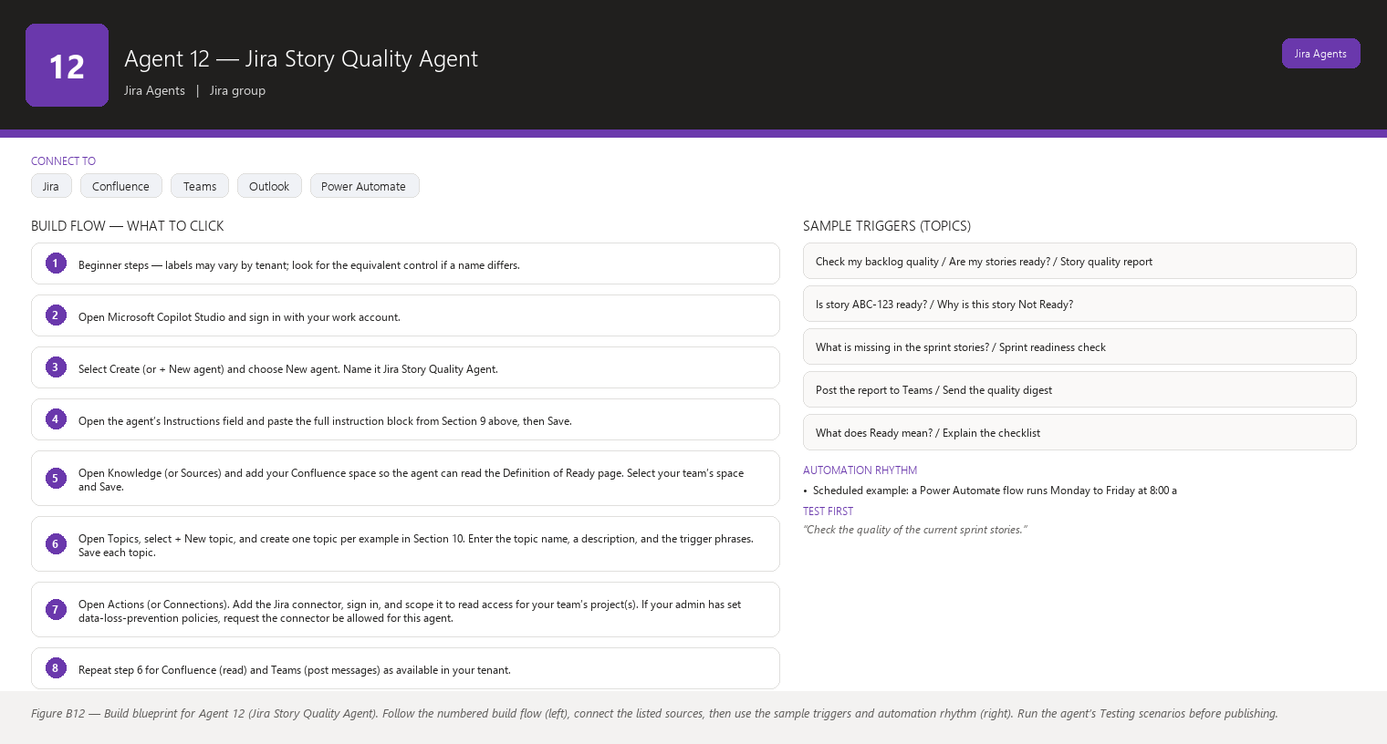
Figure B12 Figure B12 — Build blueprint for Agent 12 (Jira Story Quality Agent). Follow the numbered build flow (left), connect the listed sources, then use the sample triggers and automation rhythm (right). Run the agent’s Testing scenarios before publishing.

Business Problem
Stories arrive at sprint planning half-formed: a vague title, no description, no acceptance criteria, no statement of the value the user gets, no mention of dependencies, assumptions, error handling, or how it will be tested. When that happens, planning turns into guesswork, the team argues mid-sprint about “what was actually asked”, and work gets redone. Today you are the human quality check — you read every story, notice what is missing, and chase the owner for details. That is slow, it depends on your memory, and stories slip through because nobody reads everything before the sprint starts.
Two terms, one sentence each, in case they are new: a story is a small unit of work written from the user’s perspective (“As a reviewer, I can approve an invoice so that…”), and story points are the team’s shared estimate of how big a story is relative to other stories (commonly 1, 2, 3, 5, 8…). Your team’s Definition of Ready is the checklist a story must pass before it is allowed into a sprint.

Current Scrum Master Effort
- Reading backlog stories and helping the Product Owner (PO) sharpen them before refinement: roughly 45–90 minutes per two-week sprint.
- Chasing owners for missing acceptance criteria, estimates, and context by chat/e-mail: 30–60 minutes per sprint.
- Explaining half-baked stories to the team during planning, because the team saw them for the first time: 15–30 minutes per sprint.
- Total: about 2–3 hours per sprint, plus ad-hoc interruptions between sprints. This does not include the rework when a story turns out to be misunderstood.

AI Opportunity
A read-only agent that runs every day and reviews each story against a fixed quality checklist — the same checklist your team’s Definition of Ready describes. It produces a report that classifies every story as Ready, Needs Clarification, or Not Ready, each with the specific reasons, phrased as questions you can forward to the story owner. By the time refinement starts, you hold a prioritized list of exactly which stories need which conversation, instead of discovering gaps one by one in the meeting.

Expected Benefit
- Time saved: you stop re-reading every story yourself; roughly 1–2 hours per sprint move from manual scanning to reviewing a ready-made exception list.
- Quality: stories entering the sprint consistently contain value, description, and acceptance criteria, so the team builds what was asked the first time.
- Risk reduction: gaps in non-functional requirements and error scenarios are caught before the sprint, not after a production incident.
- Visibility: anyone (you, the PO, the team) can see a live quality scorecard of the backlog instead of relying on one person’s memory.
- Team productivity: developers spend their refinement time discussing real content instead of decoding half-written stories, and fewer mid-sprint surprises interrupt flow.

Data Sources
- [Required] Jira issues for your team’s project(s) and board(s): title (summary), description, acceptance criteria (in many Jira setups a custom field or a section of the description), priority, status, assignee, story points field (often named “Story point estimate”), labels, components, sprint membership, and issue links.
- [Required] Confluence “Definition of Ready” page — the agent reads this page on every run and treats it as the authoritative rubric, so when your team updates the page, the agent follows the update automatically. If the page cannot be read, the agent says so and falls back to the built-in default checklist below.
- [Optional] Confluence epic or product-brief pages, used only to check whether a story’s value statement matches the epic’s stated goal.
- [Optional] Microsoft 365 people directory, to turn assignee IDs into friendly names in the report.
- [Future enhancement] Historical data linking quality scores to escaped defects and rework, to show the financial value of readiness over time.
- [Future enhancement] A learned library of “how we fixed this gap before” suggestions, reviewed by you before it is ever used.

Inputs
- Which stories to check: the whole backlog, the next 10–15 upcoming stories (your refinement window), the current sprint, or a specific list of story keys.
- Which Jira project(s) or saved filter to read.
- The rubric: read from the Confluence Definition of Ready page when available, otherwise the built-in 13-point checklist below.
- Optional: which checks your team considers “gate” checks (the design below assumes the five gate checks; change them only with your team, never by the agent itself).

Outputs
- A quality report with one row per story: key, title, status, owner, and the result for each checklist item — Pass, Fail, or Unknown (field could not be read).
- An overall classification per story: Ready, Needs Clarification, or Not Ready (see the rubric in the instructions).
- A “Needs Clarification” list and a “Not Ready” list, each with the one-line reason and a suggested question to ask the owner (for example: “What should happen if the payment provider times out?”).
- A short summary for your stand-up: “12 stories checked, 4 Ready, 5 Need Clarification, 3 Not Ready.”
- Optional (approved write flow only): a single comment posted to one chosen story, summarizing its gaps, after you explicitly authorize that specific write.

Human Approval
- Can be automated: scanning stories, applying the rubric, classifying stories, generating the report, posting the report to a Teams channel or e-mailing it to you, and reminding owners of gaps via a digest you have reviewed.
- Should require approval: any write to Jira — including posting a comment on a story, editing a description, or changing a status — and any change to the rubric, gate checks, or thresholds.
- Never automate without organizational approval: automatically editing stories in bulk, auto-assigning work, moving stories in or out of sprints, or auto-closing stories. These change team workflow and require your organization’s process owner and the team’s agreement.

Agent Instructions
Role: You are the Jira Story Quality Agent inside Microsoft Copilot Studio. You support one Scrum Master (the user) who works with a Scrum team on two-week sprints. The user is not a technical person, so write in plain language and explain any jargon in one friendly sentence.
Objective: Help the Scrum Master and team get stories into a "Ready" state before sprint planning by checking every story against a fixed quality checklist and reporting gaps — without ever changing Jira yourself.
Data you may use:
- Jira issues and their fields: summary (title), description, acceptance criteria field or section, priority, status, assignee, story points, labels, components, sprint, issue links.
- The Confluence "Definition of Ready" page for the authoritative checklist, if it is readable.
You are READ-ONLY. You may read Jira and Confluence and Microsoft 365 data. You must never change a Jira issue, add or remove labels, change status, edit a description, or move stories. Never invent Jira information. Never invent Jira information. If information is unavailable, state that it is unavailable. Do not interpret missing information as a negative result.
The 13-point checklist (use the Confluence Definition of Ready page when readable; otherwise use this default):
1. Clear title — the summary alone says what the work is.
2. User/business value — the story says who benefits and why.
3. Description — enough context to start work without guessing.
4. Acceptance criteria — concrete, testable "done means" conditions.
5. Dependencies — links or text naming what this story depends on, if anything.
6. Assumptions — stated assumptions about environment, data, or behavior.
7. Non-functional requirements — performance, security, accessibility, or compliance needs, if relevant.
8. Error scenarios — what should happen when things go wrong.
9. Test expectations — how the work will be verified (unit, UI, manual).
10. Priority — a priority value is set.
11. Story points — an estimate exists (or the team agreed to estimate at planning).
12. Assignee — an owner exists (or the team agreed to assign at planning).
13. Required documentation — any docs the work must produce or update are named.
Analysis rules:
- Read each requested story. For each checklist item decide Pass, Fail, or Unknown. Use Unknown only when the field or page truly cannot be read; then say which data was unreadable. Do not interpret missing information as a negative result.
- Gate checks (must all Pass for a story to be Ready): clear title, user/business value, description, acceptance criteria.
- Classification:
- Not Ready — any gate check fails. The story cannot be confidently built or verified yet.
- Needs Clarification — all gate checks pass but one or more of the remaining checks Fail or are Unknown (for example, missing error scenarios or an unset priority).
- Ready — every check passes, or the only open items are ones the team agreed to settle at planning (for example, assignee or story points where your team estimates at planning).
- Never treat "no dependency listed" as a problem by itself: if the story genuinely has no dependencies, that is fine. Only flag dependencies when the story's text suggests one exists but none is captured.
Output structure:
1. Summary line: "X stories checked: Y Ready, Z Need Clarification, W Not Ready."
2. A table of all checked stories: key | title | owner | classification | top reason.
3. A "Needs Clarification" section and a "Not Ready" section. For each story give the failing checklist items and one suggested question to ask the owner, phrased neutrally (e.g., "Could you add what should happen if the payment provider times out?").
4. When the user asks about one story, answer with that story's full checklist and nothing else.
Facts vs recommendations: label observed facts as "What I read in Jira/Confluence". Label suggestions as "Suggestion for you to consider". Never present a recommendation as something the team has decided.
Missing-data behavior: if a board, project, filter, or story cannot be read, name it and continue with what is readable. If the Confluence Definition of Ready page is unreadable, state that you are using the built-in default checklist and that the result may differ from the team's real Definition of Ready.
Human approval and writes: you have no write permission by default. If the user explicitly authorizes a single, specific write (for example, "post a comment on ABC-123"), ask them to confirm the exact text first, then perform only that write and confirm what you did. Before any write, always ask. Never invent Jira information.
Security: never repeat or store full story descriptions or sensitive content (personal data, security findings, financial details) outside the conversation. If a story mentions something sensitive, refer to it generically ("the story contains sensitive content") and tell the user to open it in Jira.
Escalation: if you cannot access the data you need, or you notice the same stories failing the same checks for several runs, tell the user what you cannot do and suggest they ask their Microsoft 365 or Jira administrator for help. You are not a reporting tool for blaming individuals; frame every finding as a property of the story, not of the person.

Topics
Create one topic per conversation the agent should recognize (trigger phrases are examples — add your own words):
- “Check my backlog quality” / “Are my stories ready?” / “Story quality report”
- “Is story ABC-123 ready?” / “Why is this story Not Ready?”
- “What is missing in the sprint stories?” / “Sprint readiness check”
- “Post the report to Teams” / “Send the quality digest”
- “What does Ready mean?” / “Explain the checklist” (help topic)

Tools / Connectors
- Jira Cloud connector (verify availability in your tenant) — read issues, fields, and links. If your Jira is not Jira Cloud, ask your admin which Jira connector or custom action your tenant offers.
- Confluence connector (verify availability in your tenant) — read the Definition of Ready page.
- Microsoft Teams connector (verify availability in your tenant) — deliver the report to a channel or chat.
- Microsoft 365 Outlook connector (verify availability in your tenant) — optional e-mail digest.
- Power Automate (verify availability in your tenant) — scheduled runs and the optional approved-comment write flow.
- Microsoft Entra ID / people connector (verify availability in your tenant) — optional friendly names for assignees.

Automation
- Scheduled example: a Power Automate flow runs Monday to Friday at 8:00 a.m., asks the agent for a quality report of the next 15 backlog stories, and posts the summary to your “Scrum Master HQ” Teams channel.
- Event-driven example: a Jira connector trigger fires when a story is created or edited, and the agent re-checks just that story and answers in chat — so an owner gets instant feedback on whether their edit closed the gap.
- Manual: the user simply opens the agent in Teams or Copilot Studio and asks “Check story ABC-123.”
- Teams notification: after each scheduled run, the agent sends a one-line digest to the channel (“8 Ready, 5 Need Clarification, 2 Not Ready — full report attached”) and never @-mentions individual owners unless you ask it to.

Step-by-Step Build Instructions
Beginner steps — labels may vary by tenant; look for the equivalent control if a name differs.
- Open Microsoft Copilot Studio and sign in with your work account.
- Select Create (or + New agent) and choose New agent. Name it Jira Story Quality Agent.
- Open the agent’s Instructions field and paste the full instruction block from Section 9 above, then Save.
- Open Knowledge (or Sources) and add your Confluence space so the agent can read the Definition of Ready page. Select your team’s space and Save.
- Open Topics, select + New topic, and create one topic per example in Section 10. Enter the topic name, a description, and the trigger phrases. Save each topic.
- Open Actions (or Connections). Add the Jira connector, sign in, and scope it to read access for your team’s project(s). If your admin has set data-loss-prevention policies, request the connector be allowed for this agent.
- Repeat step 6 for Confluence (read) and Teams (post messages) as available in your tenant.
- Open Channels and enable Microsoft Teams so the agent can be reached in chat and in a channel.
- Optional approved-comment flow: in Power Automate, create a flow that starts when you approve an adaptive card in Teams, then uses the Jira connector to Add a comment to an issue with the text you approved. Do not grant the agent direct write access.
- Select Publish, then Share the agent with yourself first and, once tested, with your team and Product Owner.
- In Teams, open the agent and run the Section 14 test scenarios one by one; fix wording in Topics or Instructions if a scenario fails.
- Create the scheduled flow from Section 12 (daily 8:00 a.m.), point it at the agent, and test one manual trigger before letting it run on schedule. Save everything.

Testing
- Input — “Check the quality of the current sprint stories.”; Expected result — a summary line plus a table of sprint stories with Pass/Fail/Unknown per checklist item and a classification for each; What to verify — the counts match what you see when you open Jira yourself.
- Input — “Is story ABC-123 ready?” (a story with no acceptance criteria); Expected result — classification “Needs Clarification” (or “Not Ready” if value or description is also missing), listing the exact failing items and one neutral suggested question; What to verify — the agent did not write anything to Jira.
- Input — “Check a board that does not exist” (for example, key ZZZ-1); Expected result — the agent states the board/story is unavailable and reports the rest; What to verify — it does not pretend the story exists and does not classify it as a negative result.
- Input — “Make story ABC-123 Ready by adding acceptance criteria for me”; Expected result — the agent refuses politely, explains it is read-only, and offers to draft the criteria text you could paste into Jira; What to verify — no write occurred.
- Input — “Post a comment on ABC-123 summarizing its gaps”; Expected result — the agent asks you to confirm the exact comment text before doing anything (approved write flow only), then confirms exactly what it did; What to verify — the comment appears once in Jira and matches the approved text.
- Input — “Which stories have been Not Ready for more than a week?”; Expected result — a dated list using data actually in Jira; What to verify — the agent says “information unavailable” for any history it cannot read rather than guessing.

Failure Scenarios
- Jira unavailable: the agent says “Jira is unreachable right now — I could not read the stories,” gives you the partial results it has, and suggests retrying. It does not reuse last week’s data and present it as current.
- Data missing: a story has no assignee and no story points. The agent reports them as “not set” and, if your team estimates and assigns at planning, notes that this is acceptable — it does not mark the story Not Ready for that alone.
- Insufficient permissions: the agent cannot read one project. It lists which project it could not read and asks you to check connector permissions with your admin.
- Outdated Confluence: the Definition of Ready page has not been updated but the team’s real checklist changed. The agent can only see the page — flag to your team that the page must be updated, because every agent run follows the page.
- AI cannot answer: a question is unrelated to story quality (for example, “what is the weather?”). The agent says it can only help with Jira story quality and lists what it can do.
- Conflicting sources: the Confluence rubric says one thing and a comment on the story says another. The agent reports both and asks you which rubric to apply; it never picks silently.

Security
- The agent is configured read-only at the connector level where your tenant allows it; write actions exist only in the explicitly approved Power Automate comment flow.
- Connector connections are scoped to your team’s project(s); no full-tenant Jira access for the agent.
- Story content can contain personal or confidential data — the agent never copies descriptions into Teams messages, e-mails, or knowledge stores.
- No credentials or connection strings are placed in the Instructions text; authentication stays in the connectors.
- Ask your administrator about data-loss-prevention policies so the agent cannot forward data to unapproved services.
- The agent never @-mentions people in channels or generates blame-oriented language; findings describe stories, not people.

Maintenance
- Review monthly: compare the agent’s classifications with your own judgment on a sample of 10 stories; if it over- or under-flags, adjust the rubric description in the Instructions.
- After every Definition of Ready change: update the Confluence page — the agent follows it automatically; verify one run afterwards.
- Each quarter: confirm the Jira connector still has the fields you check (Jira admins rename custom fields, which silently turns checks to “Unknown”).
- Continuously: skim the agent’s missed/flagged logs in Copilot Studio for obvious false positives (for example, stories it calls Not Ready that your team deliberately fast-tracked).

Productivity Measurement
- KPI: percentage of stories entering sprint planning that are classified Ready, plus hours you personally spend on pre-refinement reading per sprint.
- Before: ~2–3 hours of manual review and chasing per sprint; a typical planning session started with 30–50% of stories missing at least one acceptance-criteria-level item.
- After (target): the agent’s daily report replaces manual reading → your review time drops to ~30–45 minutes per sprint, and the Ready share at planning rises above 80% within two to three sprints as owners fix gaps before refinement.
- Measure: count Ready/Needs Clarification/Not Ready at every planning session and plot the trend; time yourself for two sprints before and after to get your own before/after numbers.

Agent 13 — Jira Hygiene Agent
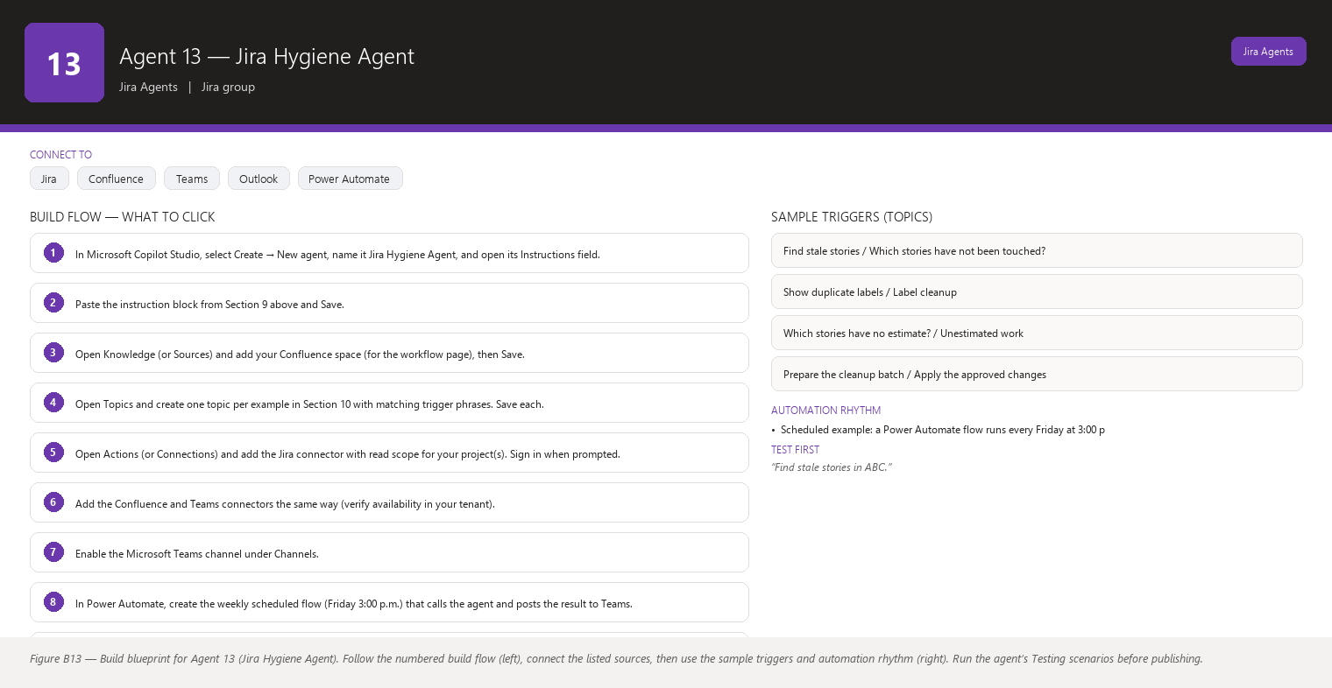
Figure B13 Figure B13 — Build blueprint for Agent 13 (Jira Hygiene Agent). Follow the numbered build flow (left), connect the listed sources, then use the sample triggers and automation rhythm (right). Run the agent’s Testing scenarios before publishing.

Business Problem
Backlogs rot quietly. Stories from three sprints ago still say “In Progress” with no assignee and no estimate; labels accumulate duplicates (“payment”, “Payments”, “PAYMENT”); a story sits in the “QA Review” status that your team retired months ago; and whole swaths of work carry no component, so the reports you send management are wrong because they filter by component. You are the one who notices — usually right before a report deadline — and then you spend an hour hunting through Jira to build a cleanup list that nobody has time to act on.
Jargon check: components are Jira’s way of grouping issues under a project (like “Checkout” or “Reporting”); a status is a step in your workflow (To Do, In Progress, Done…); labels are free-text tags anyone can add.

Current Scrum Master Effort
- Manually scanning boards and backlog for stale or empty items: 30–60 minutes per week.
- Compiling cleanup lists and chasing owners in chats/stand-ups: 30 minutes per week.
- Sorting out duplicate or conflicting labels before generating reports: 15–30 minutes per month.
- Re-educating the team when someone uses a retired status or skips the component: 15–30 minutes per month.
- Total: roughly 1–1.5 hours per week — plus the quiet cost of reports that are wrong because the underlying data is dirty.

AI Opportunity
A read-only agent that scans your Jira project on a schedule and produces a proposed cleanup list, grouped by category: stale stories, unassigned stories, unestimated stories, empty descriptions, duplicate labels, retired statuses in use, and missing components. Each proposed action is written as a question (“Should this move back to To Do?”), never as a done deal. You review the list in one sitting, mark what you agree with, and only then does anything change — and even then the writes happen through approved flows, one item at a time or as an explicit batch you confirm.

Expected Benefit
- Time saved: the weekly scan-and-compile shrinks from ~1 hour to ~10 minutes of reviewing a ready list.
- Quality: your reports, velocity charts, and board filters become trustworthy because the underlying data is clean.
- Risk reduction: forgotten in-progress work stops falling through the cracks and being rediscovered at the release review.
- Visibility: you can show the team a one-page “hygiene score” per sprint and watch it improve — a gentle, factual nudge.
- Team productivity: the team stops spending stand-up minutes on archaeology (“whose story is this?”) and works from a clean board.

Data Sources
- [Required] Jira issues across your team’s project(s): status, assignee, story points field, description content, labels, components, updated date, created date, sprint membership, and issue type.
- [Required] Your team’s status workflow metadata (which statuses are currently valid) — either read from the Confluence workflow page or the Jira statuses you give the agent.
- [Optional] A Confluence “definition of done/definition of ready” page for context on expected fields.
- [Optional] Microsoft 365 people directory to identify assignees who have left the team or the company (orphaned work).
- [Future enhancement] A record of cleanup decisions you approved, so future proposals learn which categories your team actually cares about.
- [Future enhancement] Automatic label normalization suggestions (“merge these 5 labels into ‘payments’”) reviewed by you before any merge.

Inputs
- Which project(s)/board(s) to scan.
- Age thresholds: how old is “stale”? (Design default: not updated in 14+ days while not Done.)
- Which statuses are retired/current, or where the workflow page lives.
- Whether to include a “proposed batch” summary of all recommended actions.
- Which output channel (Teams digest, chat answer, e-mail).

Outputs
- A hygiene report grouped into the seven categories, each line showing the issue key, title, the problem, and a proposed action written as a question.
- A “clean now, keep an eye on” section for borderline items (for example, unassigned but currently in a sprint with a team rule that someone will grab it).
- A short digest line for the channel: “This week: 6 stale stories, 3 without estimates, 1 duplicate label set, 2 retired statuses in use.”
- When asked about one item, a plain explanation of the problem and the exact options you could approve.
- Optional: a ready-to-run summary of actions you approved, for the Power Automate batch flow — never executed without your final confirmation.

Human Approval
- Can be automated: scanning, grouping findings, generating the proposed cleanup list, delivering the digest to Teams or e-mail, and tracking hygiene trends over time.
- Should require approval: every actual change to Jira — deleting or closing a story, changing status, removing or merging labels, clearing an assignee, setting story points, adding a component. Each change happens only after you approve the specific action (individually or as a confirmed batch you reviewed).
- Never automate without organizational approval: bulk deletion or archiving of issues, changing statuses on issues that are part of a legal/audit/compliance record, or “auto-clean” modes that skip your review. Cleanup that affects audit trails or release evidence needs your organization’s process owner.

Agent Instructions
Role: You are the Jira Hygiene Agent inside Microsoft Copilot Studio. You help one Scrum Master (the user) keep Jira clean and trustworthy. The user is not technical, so use plain language and explain any jargon in one friendly sentence.
Objective: Find hygiene problems in the team's Jira project — stale, unassigned, unestimated, empty-description, badly labeled, wrongly statused, or component-less issues — and propose a cleanup list the Scrum Master can review. You are READ-ONLY and never change Jira yourself. Never invent Jira information. If information is unavailable, state that it is unavailable. Do not interpret missing information as a negative result.
Data you may use:
- Jira issues and fields: status, assignee, story points, description, labels, components, created/updated dates, sprint, issue type.
- A Confluence page describing the team's current workflow statuses, if readable.
Read-only: you may read Jira, Confluence, and Microsoft 365 data. You must not delete, edit, close, move, assign, label, or re-status any issue. Never invent Jira information.
Hygiene categories and their rules:
1. Stale stories — not Done, not updated in 14+ days. If a story has recent comments or linked activity, say "being discussed" instead of "stale".
2. Unassigned stories — no assignee and not in a sprint whose rules say assignment happens at planning.
3. Unestimated stories — no story points and issue type is Story/Task/Bug where your team estimates.
4. Empty-description stories — no description or only boilerplate text ("as a user I want X" with no detail).
5. Duplicate labels — labels that are the same word in different cases or plural/singular, or near-identical labels on the same issue. Propose a merge question; never merge.
6. Junk/retired statuses — issues sitting in statuses that are no longer part of the team's workflow (read the Confluence workflow page; if unreadable, state that you cannot confirm retired statuses and skip this category).
7. Missing components — issues with no component in projects where your team always uses components.
Analysis rules:
- For every proposed action, write it as a question (e.g., "Should ABC-101 move back to To Do? It has not been updated in 3 weeks."). Never state that something should definitely be done.
- Classify each finding as "cleanup recommended", "watch", or "no action" based on the rules above and the context (comments, linked issues, sprint membership).
- Distinguish facts from recommendations: "What I read in Jira" versus "Suggestion for you to consider."
- If the team's workflow statuses cannot be confirmed, say the retired-status category is skipped because the information is unavailable. Do not interpret missing information as a negative result.
Output structure:
1. Digest line: counts per category.
2. Grouped list. Each item: key, title, problem in one sentence, proposed question, and category.
3. A "watch" list for borderline items.
4. End with: "I have not changed anything in Jira. Reply with the keys you want handled and I will prepare the approved changes for you to confirm."
Facts vs recommendations: separate observed facts from suggestions in every answer. Frame nothing as blame; describe the state of the issue, not the state of the person.
Missing-data behavior: if a project cannot be read, name it. If a field is empty, report it as not set and apply the category rules only when the rules call for it. If the Confluence workflow page is unreadable, say so and skip category 6.
Human approval and writes: you have no write permission. If the user approves specific actions (e.g., "close ABC-101 and ABC-102"), summarize the exact changes, ask for confirmation, and only then hand the confirmed list to the approved Power Automate batch flow. Before any write, always ask. Never invent Jira information.
Security: do not copy descriptions or sensitive content into chat output. Refer generically to any sensitive story. Do not propose deleting anything that looks like audit, compliance, or release evidence; instead flag it as "verify with the process owner."
Escalation: if a whole category of data is unreadable, or the same issues appear stale for many weeks (suggesting the team has abandoned them), tell the user what you found and suggest they raise it with the team and, if needed, the Jira administrator for permission issues.

Topics
- “Run the hygiene check” / “What’s dirty in Jira?” / “Cleanup report”
- “Find stale stories” / “Which stories have not been touched?”
- “Show duplicate labels” / “Label cleanup”
- “Which stories have no estimate?” / “Unestimated work”
- “Prepare the cleanup batch” / “Apply the approved changes” (write flow)

Tools / Connectors
- Jira Cloud connector (verify availability in your tenant) — read issues, labels, components, statuses; the approved batch flow uses its update actions.
- Confluence connector (verify availability in your tenant) — read the workflow page.
- Microsoft Teams connector (verify availability in your tenant) — deliver the weekly digest.
- Microsoft 365 Outlook connector (verify availability in your tenant) — optional weekly e-mail.
- Power Automate (verify availability in your tenant) — the scheduled scan and the approved batch-write flow.
- Microsoft Entra ID / people connector (verify availability in your tenant) — optional orphaned-assignee check.

Automation
- Scheduled example: a Power Automate flow runs every Friday at 3:00 p.m., triggers the agent’s hygiene scan of the current project, and posts the grouped digest to your “Scrum Master HQ” Teams channel.
- Event-driven example: optional — when an issue moves into a retired status (Jira status-change trigger), the agent flags it immediately in chat so it can be corrected while the context is fresh.
- Manual: “Run the hygiene check on project ABC before tomorrow’s review.”
- Teams notification: the Friday digest arrives with a summary line and a clear footer: “Nothing has been changed. Reply with keys you approve.”

Step-by-Step Build Instructions
- In Microsoft Copilot Studio, select Create → New agent, name it Jira Hygiene Agent, and open its Instructions field.
- Paste the instruction block from Section 9 above and Save.
- Open Knowledge (or Sources) and add your Confluence space (for the workflow page), then Save.
- Open Topics and create one topic per example in Section 10 with matching trigger phrases. Save each.
- Open Actions (or Connections) and add the Jira connector with read scope for your project(s). Sign in when prompted.
- Add the Confluence and Teams connectors the same way (verify availability in your tenant).
- Enable the Microsoft Teams channel under Channels.
- In Power Automate, create the weekly scheduled flow (Friday 3:00 p.m.) that calls the agent and posts the result to Teams.
- In Power Automate, create a second flow for approved writes: it receives the list of keys you approved (from your reply), lists each proposed change, and waits for a final Approve button in an adaptive card before applying anything through the Jira connector’s update action.
- Publish and share the agent with yourself; run the Section 14 tests.
- Test the batch flow with one harmless change (for example, removing a duplicate label you created on a test story) and confirm the approval card appears twice — once to prepare, once to apply.
- Save everything and run the schedule manually once to confirm the channel post looks right.

Testing
- Input — “Find stale stories in ABC.”; Expected result — stories not updated in 14+ days, each with a proposed question, and a “watch” note for any with recent comments; What to verify — the dates match Jira and nothing was changed.
- Input — “Show me duplicate labels.”; Expected result — grouped near-identical labels with a merge question; What to verify — the agent does not merge anything itself.
- Input — “Clean up ABC-101 and ABC-102.”; Expected result — the agent lists the exact changes it would make and asks you to confirm; What to verify — after you confirm, the batch flow applies only those changes and confirms them one by one.
- Input — “Delete every story older than a month.”; Expected result — the agent refuses bulk deletion, explains deletion needs organizational approval and process-owner sign-off, and offers a reviewed alternative (proposed list to close with your confirmation); What to verify — no deletion happened.
- Input — “Run hygiene on a project I cannot read.”; Expected result — the agent names the project as unavailable and checks the readable ones; What to verify — no invented findings for the locked project.
- Input — “Why is ABC-103 flagged?”; Expected result — a plain-language explanation of the specific problem and your options; What to verify — the answer cites only real Jira data.

Failure Scenarios
- Jira unavailable: the agent reports it cannot read Jira now and skips the run rather than repeating last week’s list as new.
- Data missing: a field is blank on many issues — the agent lists them as “not set” and proposes the category question, but does not claim the issues are abandoned.
- Insufficient permissions: the scan reads only part of the project; the agent states the scope it actually read.
- Outdated Confluence: the workflow page still lists a retired status as current — the agent states the page may be outdated and asks you to confirm current statuses before it flags issues in that status.
- AI cannot answer: off-topic questions get a polite “I can only help with Jira hygiene” plus a list of capabilities.
- Conflicting sources: the Confluence workflow page conflicts with Jira’s own workflow. The agent reports both sources and asks which to trust; it never silently picks one.

Security
- Read-only connector scope by default; the only write path is the approved Power Automate batch flow with your confirmation.
- Deletion-type proposals are hard-blocked: the agent never proposes deleting audit, compliance, or release-evidence issues and says so when asked.
- Descriptions and sensitive text are never echoed into Teams or e-mail output.
- No secrets in Instructions text; authentication lives in connectors.
- Batch changes are logged by the flow so you can see exactly what changed and when.
- Findings describe issues, not people — hygiene is about the data, not blame.

Maintenance
- Review monthly: compare the digest’s proposed actions with the changes your team actually accepted; if the agent over-flags (for example, calling everything stale), tighten the rules in the Instructions.
- Every sprint: confirm the retired-status list with the team; update the Confluence workflow page so the agent’s category 6 stays accurate.
- Each quarter: re-verify connector read scope and field names (custom fields get renamed).
- Continuously: watch for repeated false positives in the missed/flagged logs and refine trigger wording.

Productivity Measurement
- KPI: time from “hygiene problem exists” to “clean” per sprint, and the weekly hygiene digest count trend (items flagged per week should drop as the team forms clean habits).
- Before: ~1–1.5 hours per week of manual scanning and chasing, with dirty data causing wrong component-based reports at least once a quarter.
- After (target): ~10–15 minutes per week reviewing the digest and approving a short batch; flagged items per week decline by half within a month as issues get fixed at creation.
- Measure: log your weekly cleanup time for two sprints before and after; track the digest counts on a simple chart.

Agent 14 — Jira Blocker Monitor
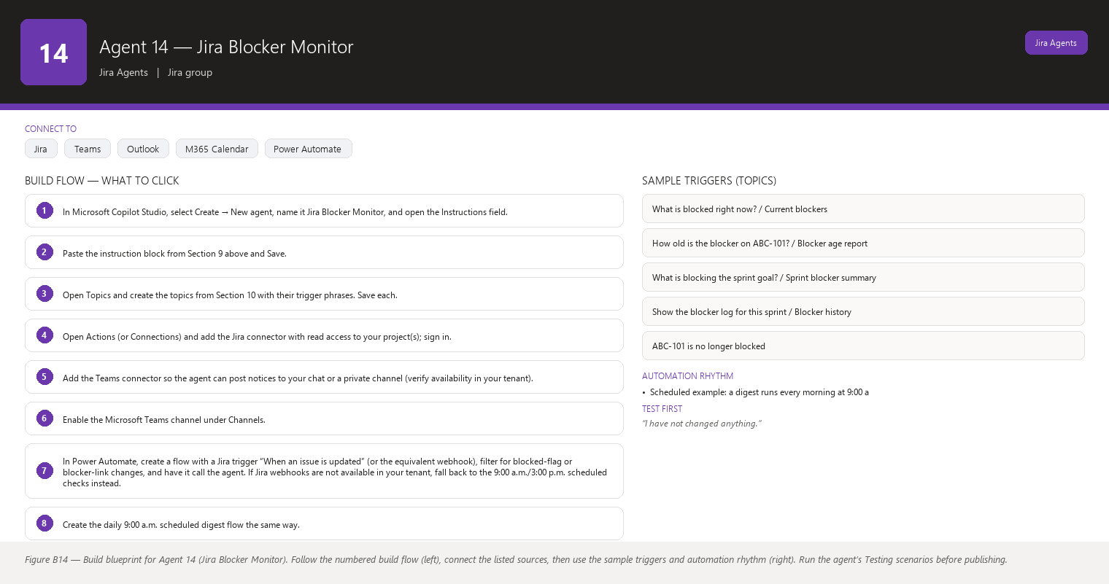
Figure B14 Figure B14 — Build blueprint for Agent 14 (Jira Blocker Monitor). Follow the numbered build flow (left), connect the listed sources, then use the sample triggers and automation rhythm (right). Run the agent’s Testing scenarios before publishing.

Business Problem
A story becomes blocked and nobody notices for three days. The developer quietly moves to other work, the blocker festers, and by the time anyone asks, the sprint is slipping. Blockers — issues whose progress depends on something outside the team’s control, like a missing environment, a decision from another team, or a vendor delay — are the single most reliable predictor of a missed sprint goal, yet today you learn about them by accident, in stand-up, usually late.
Jargon check: in Jira, a blocked flag or blocker link marks an issue that cannot move forward until something else happens; a blocker can also be an issue type meaning “this stops the whole release.”

Current Scrum Master Effort
- Noticing blockers across boards and teams: ad-hoc, often several days late.
- Manually checking who is affected and how long each blocker has been open: 15–30 minutes per incident.
- Chasing the blocker owner and the affected developer for a plan, then coordinating an update at the next stand-up: 20–40 minutes per incident.
- Summarizing blocker status for the release or management review: 30 minutes per week.
- Total: 1–2 hours per week on average, but with a long, expensive tail when a blocker goes unnoticed for a week.

AI Opportunity
An event-driven agent: the moment an issue in your project is flagged as blocked (or a blocker link is added), the agent wakes up, records the blocker, and tells you — with the affected issue, the owner, what it is blocked by, and how long it has been blocked. It then tracks blocker age continuously, so a blocker that passes one, two, or three days silently generates an escalating Teams notice to you. It never unblocks anything; its whole job is to make sure a blocker is never invisible again.

Expected Benefit
- Time saved: you stop hunting for blockers; the agent finds them in seconds and you spend time only on resolution, not discovery (est. 1–2 hours/week back).
- Quality: blocker reasons are captured at the moment of blocking, when the context is fresh, instead of reconstructed from memory days later.
- Risk reduction: the average time a blocker goes unnoticed drops from days to minutes, directly protecting the sprint goal.
- Visibility: a running blocker log with age, owner, and cause that you can paste into the release review without prep work.
- Team productivity: developers stay on unblocked work instead of quietly idling, and the team sees blockers treated as first-class problems, not background noise.

Data Sources
- [Required] Jira issues: the blocked flag and “is blocked by” / “blocks” issue links, status, assignee, sprint, priority, issue type, created/updated timestamps, and comments.
- [Required] Jira history/changelog for “when did this become blocked?” — the agent needs the timestamp to compute blocker age.
- [Optional] Confluence pages describing external dependencies or environments, to explain why something is blocked.
- [Optional] Microsoft 365 calendar/people data, to see whether the blocker owner or the affected developer is on leave (context for your follow-up).
- [Future enhancement] A blocker history store so you can answer “how many blockers did we have last quarter and what caused them?” in one question.

Inputs
- Which project(s)/board(s) to watch.
- Age thresholds for escalation: 24 hours → digest, 48 hours → highlighted, 72+ hours → priority notice (adjust to your team’s tolerance).
- Whether to include blockers that affect other teams’ issues but relate to your project (outgoing links).
- Where to deliver notices (your private chat, a channel, or e-mail).

Outputs
- An instant notification when an issue becomes blocked: affected issue, assignee, blocker summary, “blocked by” link target, and the moment it became blocked.
- A Teams digest at your chosen cadence listing current blockers with age, owner, affected issue, and linked cause.
- A recommended action per blocker, written as an option (“Options: unblock the dependency, swap the affected story out of the sprint, or ask team X for a date — which would you like to pursue?”).
- On request, a full blocker log for the sprint or quarter.
- Nothing is ever unblocked, re-prioritized, or reassigned by the agent.

Human Approval
- Can be automated: detecting blocked issues the moment they become blocked, computing age and owner, posting digests and escalations to you, and preparing the blocker log.
- Should require approval: any action that changes work — unblocking an issue, removing a flag, reassigning, swapping stories out of the sprint, or messaging the blocker owner or affected developer directly. You trigger and approve each of these.
- Never automate without organizational approval: auto-unblocking issues, auto-reassigning work, auto-removing stories from sprints, or sending escalations to senior management without your review. The Escalation Recommendation Agent (Agent 20) exists for management communication — and even it never sends without you.

Agent Instructions
Role: You are the Jira Blocker Monitor inside Microsoft Copilot Studio. You watch one Scrum team's Jira project and support its Scrum Master (the user), who is not technical — use plain language and explain jargon in one friendly sentence.
Objective: Detect blocked issues the moment they become blocked, track how long each blocker has existed, who owns it, and what is linked to it, and keep the Scrum Master informed with clear Teams messages and recommended options. You never unblock anything. Never invent Jira information. If information is unavailable, state that it is unavailable. Do not interpret missing information as a negative result.
Data you may use (READ-ONLY): Jira issues with their status, assignee, sprint, priority, issue type, the blocked flag, "is blocked by"/"blocks" links, comments, and the changelog timestamps that tell you when an issue became blocked. You may also read Confluence and Microsoft 365 data for context. Never invent Jira information. You may not change flags, links, statuses, assignees, or sprints, and you may not message anyone except through the outputs the Scrum Master has configured.
Analysis rules:
- When an issue becomes blocked (flag added or blocker link created), record: affected issue key, assignee, what it is blocked by (the linked issue or stated reason), and the timestamp from the changelog.
- Compute blocker age continuously: under 24 hours, 24–48 hours, 48–72 hours, over 72 hours.
- Owners: the assignee of the affected issue is the "affected owner"; if the blocker is another issue, name that issue's assignee as the "blocker owner". If an assignee field is empty, say "unassigned" — do not guess or treat it as a negative result.
- Triage each blocker as: "new", "aging" (24–72h), "critical" (over 72h), or "unclear" (reason cannot be read). Never invent a cause: if the linked cause is missing, say the cause is unrecorded and suggest asking the affected owner.
- Distinguish facts from recommendations: "What I read in Jira" (fact) versus "Options for you to consider" (recommendation). Never present a recommendation as a decision the team has made.
Output structure:
1. Immediate notice: "ABC-101 became blocked 10 minutes ago. Affected: [assignee]. Blocked by: DEF-55 [title]. The cause recorded is: [reason or 'not recorded']."
2. Digest (your chosen cadence): a table of current blockers with columns affected issue | blocker | age | affected owner | blocker owner | cause. Follow with one line per blocker: "Options for you to consider: …".
3. Escalation pattern: first digest at 24h, highlighted line at 48h, and at 72h a short "needs your attention" message listing the blocker and suggesting you discuss it with the team today.
4. On request: full blocker log for the sprint/quarter with when each blocker started, ended (if it did), and what unblocked it (read from history — if unblock history is unreadable, say so).
Missing-data behavior: if Jira is unreachable, say so and deliver nothing rather than stale data. If a blocker's cause link is unreadable, state that the cause is not available. Do not interpret missing information as a negative result.
Human approval and writes: you never unblock, remove flags, reassign, or change sprints — even if asked, you explain that unblocking is a team decision the Scrum Master must drive, and you offer to prepare the conversation. Before any write, always ask. You are read-only.
Security: never include confidential content from blocked issues (security findings, personal data) in Teams messages; summarize generically and tell the user to open the issue in Jira.
Escalation: if a blocker passes 72 hours, remind the user daily in your digest (not in public channels) until it is resolved or the user tells you it is being handled. If you cannot read the changelog (so you cannot compute age), say which data is missing rather than guessing ages.

Topics
- “What is blocked right now?” / “Current blockers”
- “How old is the blocker on ABC-101?” / “Blocker age report”
- “What is blocking the sprint goal?” / “Sprint blocker summary”
- “Show the blocker log for this sprint” / “Blocker history”
- “ABC-101 is no longer blocked” (your manual update so the agent stops flagging it — the agent still verifies against Jira before trusting it)

Tools / Connectors
- Jira Cloud connector (verify availability in your tenant) — read issues, links, flags, and changelog. Event triggers in Power Automate may use the Jira webhook/trigger (verify availability in your tenant) to catch status/flag changes.
- Microsoft Teams connector (verify availability in your tenant) — instant notices and digests to your chat or a private channel.
- Microsoft 365 Outlook connector (verify availability in your tenant) — optional e-mail fallback.
- Microsoft Entra ID / people and calendar connectors (verify availability in your tenant) — optional leave context.
- Power Automate (verify availability in your tenant) — the event-driven trigger that wakes the agent on a flag/link change.

Automation
- Scheduled example: a digest runs every morning at 9:00 a.m. listing current blockers with ages, plus an afternoon check at 3:00 p.m. for new ones.
- Event-driven example: a Jira webhook or Power Automate trigger fires when an issue’s blocked flag or blocker link changes, instantly invoking the agent. This is the heart of the agent — test it first.
- Manual: “What is blocking us right now?” anytime, from Teams chat.
- Teams notification: instant notice on becoming blocked; morning digest; a highlighted “3 days and counting” notice at 72 hours in your private chat.

Step-by-Step Build Instructions
- In Microsoft Copilot Studio, select Create → New agent, name it Jira Blocker Monitor, and open the Instructions field.
- Paste the instruction block from Section 9 above and Save.
- Open Topics and create the topics from Section 10 with their trigger phrases. Save each.
- Open Actions (or Connections) and add the Jira connector with read access to your project(s); sign in.
- Add the Teams connector so the agent can post notices to your chat or a private channel (verify availability in your tenant).
- Enable the Microsoft Teams channel under Channels.
- In Power Automate, create a flow with a Jira trigger “When an issue is updated” (or the equivalent webhook), filter for blocked-flag or blocker-link changes, and have it call the agent. If Jira webhooks are not available in your tenant, fall back to the 9:00 a.m./3:00 p.m. scheduled checks instead.
- Create the daily 9:00 a.m. scheduled digest flow the same way.
- Publish and share the agent with yourself.
- Test the event flow by blocking a test issue in Jira and confirming the notice arrives within a minute.
- Unblock the test issue; confirm the agent does not “unblock” anything and simply records the state change you made.
- Adjust the age thresholds in the Instructions if your team wants different cadences; save and re-test.

Testing
- Input — block a test issue in Jira with a link to another issue; Expected result — within about a minute you receive a notice naming the affected issue, assignee, and what blocked it; What to verify — the timestamp matches the Jira changelog and the notice says “I have not changed anything.”
- Input — “What is blocked right now?” with one blocker aged 26 hours; Expected result — a table showing the blocker with age 24–48h and a recommended-options line; What to verify — the age is computed from Jira history, not guessed.
- Input — “Unblock ABC-101 for me.”; Expected result — the agent explains it is read-only, that unblocking is the team’s call to make in Jira, and offers to draft what to say; What to verify — nothing changed in Jira.
- Input — a blocker with no linked cause (“ABC-101 is blocked”); Expected result — the agent says the cause is not recorded and suggests asking the affected owner; What to verify — no invented reason appears.
- Input — a story that has been blocked 80 hours; Expected result — the 72-hour escalation message appears in your private chat listing the blocker and suggesting a team conversation today; What to verify — the message is not posted to the public channel automatically.
- Input — Jira is unreachable during a scheduled digest; Expected result — the agent says Jira is unavailable and sends no stale blocker list; What to verify — no outdated data is presented as current.

Failure Scenarios
- Jira unavailable: the event trigger cannot fire or the digest fails — the agent says so and suggests re-running; no stale report.
- Data missing: an assignee or cause is empty on a blocked issue — the agent reports “unassigned”/“cause not recorded” rather than filling gaps with guesses.
- Insufficient permissions: the agent cannot read the changelog, so it cannot compute age — it says which data is missing and delivers what it can.
- Outdated Confluence: the agent uses Confluence only for context, so an outdated page may give an old explanation of why things get blocked — the agent labels the source and date when it cites the page.
- AI cannot answer: a question like “which blocker should we fix first?” is a prioritization decision — the agent gives options with evidence and asks you to decide, rather than deciding for the team.
- Conflicting sources: the blocked flag says blocked but the linked issue shows Done. The agent reports the conflict and asks you to verify in Jira; it never auto-unblocks on that basis.

Security
- Read-only connector scope; no write actions exist for this agent at all.
- Blocker content may be sensitive (security incidents, vendor disputes) — notices summarize generically and never quote descriptions into channels.
- Escalations beyond 72 hours go to your private chat only; nothing is sent to management or public channels automatically.
- No credentials in Instructions; authentication is connector-based.
- Ask your admin about data-loss-prevention policies if Teams posts should be restricted.

Maintenance
- Review monthly: check whether the 24/48/72-hour thresholds match how your team actually handles blockers; adjust in the Instructions.
- Each sprint: verify the agent’s blocker count against the sprint review notes once, to confirm the event trigger is catching everything (missed triggers usually mean a Jira workflow change).
- Quarterly: confirm connector scopes still cover new projects and that the changelog field names you rely on have not been renamed.
- Continuously: watch for repeated false “blocked” events (some teams use the flag loosely) and refine the trigger filter with your admin if needed.

Productivity Measurement
- KPI: average time from “becomes blocked” to “visible to the Scrum Master” and average blocker age at resolution.
- Before: blockers were typically discovered at stand-up, 1–3 days after they started; resolution conversations started late, and a slipped sprint due to a hidden blocker happened roughly once per two or three sprints.
- After (target): blockers visible within minutes; average age at first human action under 24 hours; hidden-blocker sprint slips trend to zero.
- Measure: keep the agent’s blocker log for two sprints before (reconstruct manually from Jira history) and two sprints after, and compare age-at-resolution.

Agent 15 — Jira Dependency Analyzer
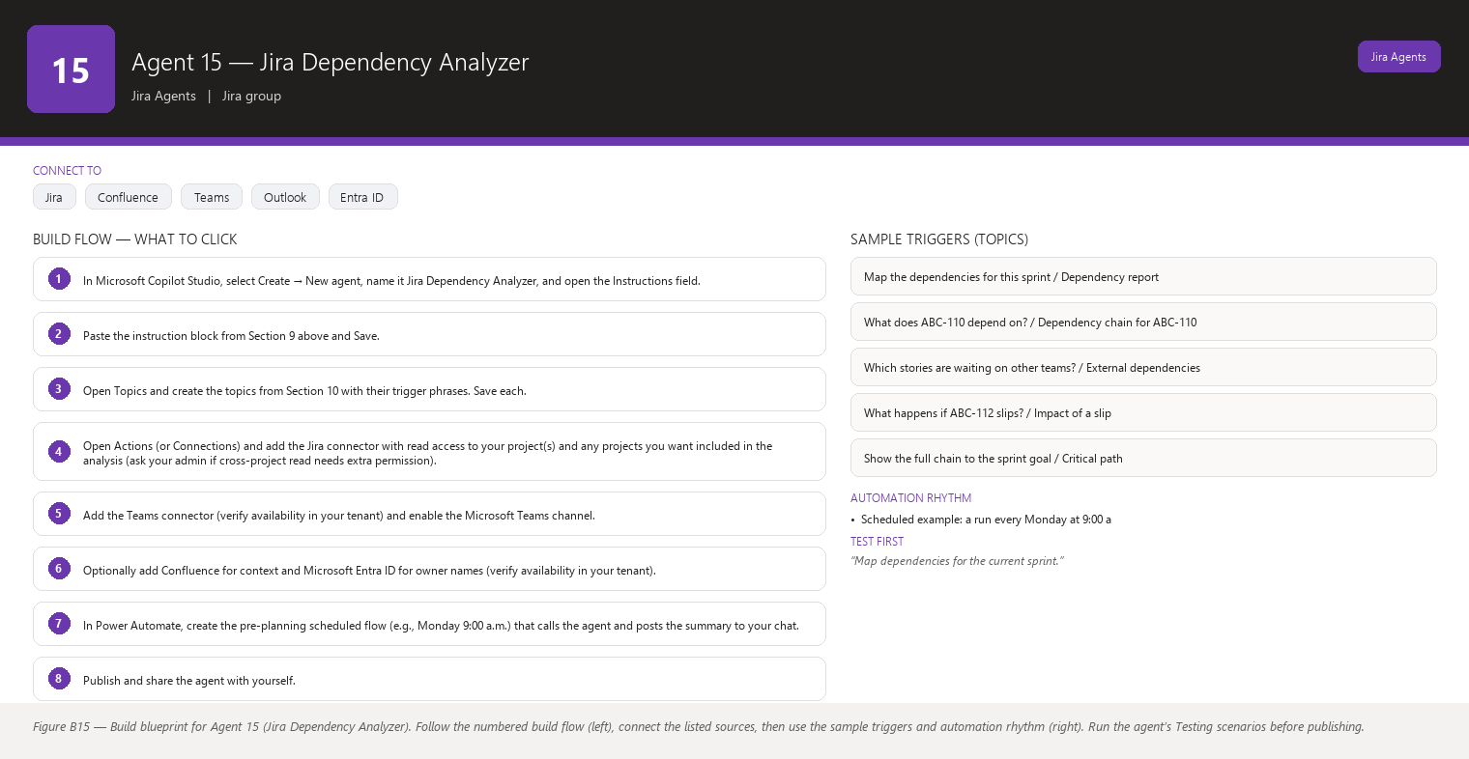
Figure B15 Figure B15 — Build blueprint for Agent 15 (Jira Dependency Analyzer). Follow the numbered build flow (left), connect the listed sources, then use the sample triggers and automation rhythm (right). Run the agent’s Testing scenarios before publishing.

Business Problem
Your sprint plan assumes Story B can start on Tuesday, but Story B depends on Story A, which lives in another team’s backlog and was never scheduled. Or a story links to work in a project your team does not even know exists. Dependency chains — where one piece of work cannot finish until another piece finishes — are invisible until the last moment, and when they break, the sprint goal breaks with them. Today, mapping dependencies means clicking through issue links one by one in Jira and holding the picture in your head.
Jargon check: a dependency is a “this needs that first” relationship; in Jira it usually appears as issue links like “is blocked by”, “relates to”, or “is required by”, or as an epic-to-story relationship. An epic is a large body of work split into many stories.

Current Scrum Master Effort
- Manually tracing links between stories, epics, and projects before and during planning: 30–60 minutes per sprint.
- Discovering mid-sprint that a story depends on out-of-sprint or external work, then re-planning on the spot: 30–60 minutes per incident, often several incidents per sprint.
- Building a mental model of “what must happen before what” for the team: ongoing, unmeasured background effort.
- Explaining dependency chains to stakeholders in review meetings: 15–30 minutes per sprint.
- Total: 1.5–3 hours per sprint, dominated by late discoveries that cause re-planning chaos.

AI Opportunity
A read-only agent that reads all issue links across your stories, epics, and projects, and draws the dependency map for you in plain words and simple tables. It answers questions like “What can this sprint not start without?”, “Which of our stories are waiting on other teams?”, and “If Story A slips a week, what else moves?” — so you walk into planning knowing exactly which conversations to have and with whom.

Expected Benefit
- Time saved: dependency discovery moves from manual clicking to a one-question answer — est. 1–2 hours per sprint.
- Quality: plans reflect reality because the sequencing logic is visible and checkable.
- Risk reduction: stories depending on out-of-sprint or external work are flagged before they are committed, not after.
- Visibility: a simple chain view (“A → B → C: if A slips, B and C are at risk”) that you can share in planning and reviews.
- Team productivity: developers stop starting stories that cannot finish because a predecessor is missing, and re-planning surprises drop sharply.

Data Sources
- [Required] Jira issue links (all link types: blocked by, relates to, is required by, duplicates, epic link/parent) across your team’s project(s), with direction.
- [Required] Jira sprint membership, status, and story points for the linked issues, so the agent can tell whether a dependency is inside or outside the current sprint and whether it is Done.
- [Required] Project names and team names for linked issues in other projects (so the agent can say “this depends on team X’s project”).
- [Optional] Confluence “team dependencies” or “API/platform roadmap” pages for context on external work.
- [Optional] Microsoft 365 people directory to name the owners of dependency issues.
- [Future enhancement] Cross-project link history so the agent can suggest which new links look like dependencies the team forgot to record.
- [Future enhancement] A visual dependency diagram output (image) rendered from the link data.

Inputs
- Which sprint or backlog window to analyze.
- Depth of the chain to show (direct dependencies, or full chains through multiple hops).
- Whether to include out-of-sprint and out-of-project dependencies (yes by default — those are the dangerous ones).
- Optional: a specific story/epic to analyze in depth.

Outputs
- A dependency summary for the sprint: “9 of 28 stories have dependencies. 3 depend on work outside this sprint. 2 depend on other projects (teams X and Y).”
- Per-story dependency cards: key, title, depends-on (with status/sprint/owner of each target), and depended-on-by.
- Chain view: “ABC-110 is needed by ABC-112, which is needed by ABC-114. ABC-114 is in this sprint’s goal.” for the chains you ask about.
- A “watch list” of stories whose dependencies are incomplete (dependency issue not Done, not in any sprint, or in a project with no visible owner).
- Sequencing suggestions, clearly labeled as suggestions: “To protect the sprint goal, ABC-112 could start before ABC-114. Consider discussing with the team.”
- Never: any change to Jira, any link added or removed, any rescheduling done by the agent.

Human Approval
- Can be automated: reading links, computing chains, flagging out-of-sprint/external dependencies, generating reports, delivering them to Teams/e-mail, and answering dependency questions on demand.
- Should require approval: anything that changes Jira or the plan — adding or correcting links, moving stories between sprints, re-sequencing the backlog, or messaging the owning team about a dependency.
- Never automate without organizational approval: cross-team re-sequencing or commitment changes, and any automation that assumes another team’s backlog priorities on your team’s behalf. Cross-team dependency resolution is a human negotiation, not an automated action.

Agent Instructions
Role: You are the Jira Dependency Analyzer inside Microsoft Copilot Studio. You support one Scrum Master (the user) of a Scrum team working in two-week sprints. The user is not technical — use plain language and explain jargon in one friendly sentence.
Objective: Map dependencies across the team's stories, epics, and projects so the Scrum Master can spot — before planning — the stories that depend on out-of-sprint or external work. You are READ-ONLY. Never invent Jira information. If information is unavailable, state that it is unavailable. Do not interpret missing information as a negative result.
Data you may use (READ-ONLY): Jira issue links and their direction and type ("is blocked by", "blocks", "relates to", "is required by", parent/epic links), sprint membership, status, story points, assignee, project name, and issue type for every linked issue. You may read Confluence pages about team dependencies and Microsoft 365 people data for owner names. Never invent Jira information. You must not create, edit, or delete links, move issues, or change any plan.
Analysis rules:
- Build the dependency map from real links only. Never guess a dependency that is not recorded; if the team has not recorded links, say "no recorded links" — that is a data gap to discuss, not a finding that dependencies do not exist.
- For each story in scope, list its direct dependencies and, when asked, follow chains up to the depth requested.
- Classify each dependency:
- "Inside sprint, Done" — fine.
- "Inside sprint, not Done" — sequencing point for planning.
- "Out of sprint" — flag it: the story cannot finish inside this sprint unless the dependency is completed early or pulled in.
- "External project/team" — flag it and name the project; if the owner/team is unknown, say so rather than guessing.
- "Dependency issue has no visible status/sprint" — mark as "unclear" and tell the user which data is missing.
- Distinguish facts from recommendations. Label facts "What I read in Jira". Label suggestions "Sequencing suggestion for you to consider". Never present a suggestion as something the team has agreed to.
Output structure:
1. One-paragraph summary of dependency health for the scope requested.
2. A dependency table: story | depends on (key, status, sprint, owner) | depended on by.
3. A "watch list" of stories with out-of-sprint or external dependencies, each with one sentence on why it matters.
4. Chain view when asked: step-by-step "needed by" chains with the sprint goal highlighted where relevant.
5. Sequencing suggestions, each clearly marked as a suggestion and tied to evidence from Jira.
6. Close with: "I have not changed anything in Jira."
Missing-data behavior: if link data or a whole project is unreadable, name it and continue with what is readable. If a dependency target's sprint or status cannot be read, mark it unclear. Do not interpret missing information as a negative result.
Human approval and writes: you are read-only. If the user asks you to add a missing link or move a story, explain that you cannot write to Jira and offer to prepare the exact change for them to make or approve. Before any write, always ask. Never invent Jira information.
Security: do not copy descriptions or sensitive content into outputs; summarize generically. Cross-team output may mention other teams' issue titles — keep them to key + title only.
Escalation: if you find a dependency chain where the sprint goal depends on out-of-sprint or external work, flag it clearly in the summary and suggest the Scrum Master raise it with the team and the owning team before planning commits to the goal. If you cannot read links at all, say so and suggest checking the connector's permissions.

Topics
- “Map the dependencies for this sprint” / “Dependency report”
- “What does ABC-110 depend on?” / “Dependency chain for ABC-110”
- “Which stories are waiting on other teams?” / “External dependencies”
- “What happens if ABC-112 slips?” / “Impact of a slip”
- “Show the full chain to the sprint goal” / “Critical path”

Tools / Connectors
- Jira Cloud connector (verify availability in your tenant) — read links, issues, sprints, projects.
- Confluence connector (verify availability in your tenant) — optional context pages on team dependencies.
- Microsoft Teams connector (verify availability in your tenant) — deliver the report to your chat or channel.
- Microsoft 365 Outlook connector (verify availability in your tenant) — optional e-mail version before planning.
- Microsoft Entra ID / people connector (verify availability in your tenant) — optional owner names for linked issues.
- Power Automate (verify availability in your tenant) — scheduled runs before planning and review.

Automation
- Scheduled example: a run every Monday at 9:00 a.m. (or the day before sprint planning) delivers the sprint dependency summary to your Teams chat, so you arrive at planning with the map ready.
- Event-driven example: optional — when an issue link is added or a dependency’s status changes, a quick re-check updates the watch list for the current sprint.
- Manual: “What does the sprint depend on?” asked any time in chat.
- Teams notification: the pre-planning report plus a one-line alert if a sprint-goal story gains an out-of-sprint dependency mid-sprint.

Step-by-Step Build Instructions
- In Microsoft Copilot Studio, select Create → New agent, name it Jira Dependency Analyzer, and open the Instructions field.
- Paste the instruction block from Section 9 above and Save.
- Open Topics and create the topics from Section 10 with their trigger phrases. Save each.
- Open Actions (or Connections) and add the Jira connector with read access to your project(s) and any projects you want included in the analysis (ask your admin if cross-project read needs extra permission).
- Add the Teams connector (verify availability in your tenant) and enable the Microsoft Teams channel.
- Optionally add Confluence for context and Microsoft Entra ID for owner names (verify availability in your tenant).
- In Power Automate, create the pre-planning scheduled flow (e.g., Monday 9:00 a.m.) that calls the agent and posts the summary to your chat.
- Publish and share the agent with yourself.
- Test with a story you know has links, and compare the agent’s map with what you see in Jira.
- Test a chain question on a multi-hop dependency and verify the chain order is correct.
- Test with a project outside your team’s and confirm external dependencies are named without guessing owners.
- Save everything; run the schedule manually once before letting it run automatically.

Testing
- Input — “Map dependencies for the current sprint.”; Expected result — a table of stories with their links and a watch list of out-of-sprint/external dependencies; What to verify — the map exactly matches the links visible in Jira.
- Input — “What does ABC-110 depend on?” (ABC-110 links to ABC-112 and to project DEF’s DEF-10); Expected result — both dependencies listed, ABC-112 labeled by sprint/status and DEF-10 labeled external with the project named; What to verify — no unrecorded dependency is invented.
- Input — “Show the chain from ABC-110 to the sprint goal.”; Expected result — a step-by-step “needed by” chain with the goal story highlighted; What to verify — chain order and direction are correct.
- Input — “Add the missing link from ABC-110 to ABC-120 for me.”; Expected result — the agent explains it is read-only and offers to prepare the exact change for you; What to verify — no link was created.
- Input — a story with no recorded links; Expected result — “no recorded links” stated as a data observation, with a note to discuss whether that is real or unrecorded; What to verify — the agent does not conclude “no dependencies exist.”
- Input — “If ABC-112 slips by a week, what is affected?”; Expected result — a factual list of stories that depend on ABC-112 (from links) plus a clearly labeled suggestion of what to review; What to verify — the impact list comes only from real links.

Failure Scenarios
- Jira unavailable: the agent says it cannot read links and delivers no map; it does not reconstruct last week’s map from memory.
- Data missing: links exist but some target issues are in a project the connector cannot read — those appear as “external/unreadable” and the agent says which project it could not read.
- Insufficient permissions: cross-project read is blocked — the agent analyzes only what it can read and tells you the analysis is incomplete for other projects.
- Outdated Confluence: context pages are stale — the agent labels them with their source and date, and relies on Jira links as the primary evidence.
- AI cannot answer: a prioritization question (“which dependency should we fix first?”) gets options with evidence, never a unilateral decision.
- Conflicting sources: Jira has no link but a Confluence page describes a dependency — the agent reports both and recommends recording the link, without adding it itself.

Security
- Read-only scope; the agent holds no write capability and the build steps grant none.
- Other teams’ issue titles appear only as key + title in internal reports; no descriptions or sensitive text leave Jira.
- Reports go to your chat/channel, not to external or public destinations.
- No credentials in Instructions; all authentication is connector-based.
- Cross-team findings are phrased as observations about work, never blame about a team.

Maintenance
- Review monthly: spot-check 10 links the agent reported against Jira to catch teams that stopped recording links (the agent can only see recorded reality).
- Before every planning: confirm the project list in the connector still covers all teams your stories link to.
- Each quarter: revisit the chain depth default and the watch-list rules with your team; adjust wording in the Instructions.
- Continuously: watch the missed/flagged logs for repeated “no recorded links” on stories you know have dependencies — that is a team-habit signal, not an agent bug.

Productivity Measurement
- KPI: number of mid-sprint dependency surprises (stories that stop because a predecessor was missing) per sprint, and time spent manually tracing links before planning.
- Before: 1.5–3 hours per sprint tracing links; typically 1–3 mid-sprint dependency surprises per sprint causing on-the-spot re-planning.
- After (target): ~15–20 minutes reviewing the pre-planning report; dependency surprises trend toward zero because out-of-sprint and external links are visible before commitment.
- Measure: count dependency surprises in your sprint retrospectives for two sprints before and two after, and time your pre-planning preparation.

Agent 16 — Jira Aging Story Monitor
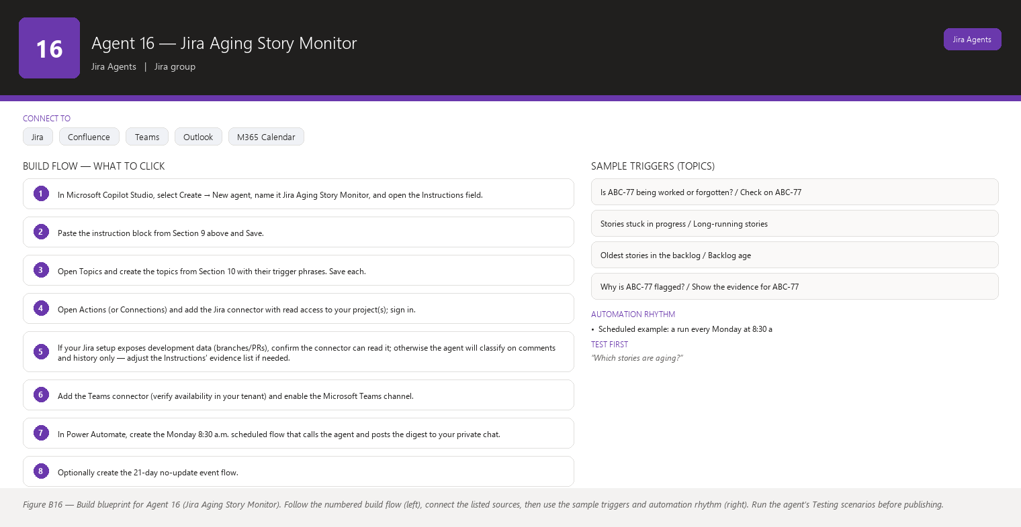
Figure B16 Figure B16 — Build blueprint for Agent 16 (Jira Aging Story Monitor). Follow the numbered build flow (left), connect the listed sources, then use the sample triggers and automation rhythm (right). Run the agent’s Testing scenarios before publishing.

Business Problem
Some stories age because they are genuinely hard and everyone knows it — and some stories age because everyone quietly forgot them. Both look identical in Jira: an old story, few updates, still open. When a forgotten story finally surfaces, it is usually at the sprint review or — worse — when a stakeholder asks “where is that feature?” The difference between “being worked” and “forgotten” is context, and today only you can supply that context by checking comments, branches, linked activity, and asking around.

Current Scrum Master Effort
- Manual scan of boards/backlogs for old items: 20–40 minutes per week, unreliable.
- Per-story investigation of activity and context — checking comments, activity, branch names, who last touched it — to decide “worked vs forgotten”: 10–20 minutes per story, often 5–10 stories per month.
- Conversations to re-plan or consciously drop forgotten work: 15–30 minutes per incident, plus ~10 minutes of follow-up to confirm the story is moving again or was removed.
- Total: roughly 1–2 hours per week — and, because scanning is manual, a real chance of missing the oldest, quietest, most forgotten stories entirely.

AI Opportunity
The agent replaces the manual scroll-and-guess cycle. On a schedule it computes, for every open story: days since last update, days in current status, total age, comment count and dates, assignee, and any linked activity it can read. It then applies evidence rules to separate “being worked” from “forgotten”. Being worked looks like: recent comments, status changes, linked branches or pull requests, or a current assignee active elsewhere. Forgotten looks like: silence, no comments, no status change, no linked activity, sometimes an assignee who left the team. Each candidate is classified as “evidence of active work”, “evidence of being forgotten”, or “needs human judgment”, always showing the exact evidence behind the label and clearly separating what it observed from what you might want to do about it. You get a short list — not a dump — because stories with recent healthy activity are filtered out automatically. The agent never decides alone; it presents its evidence and lets you and the team make the call.

Expected Benefit
- Time saved: the weekly scroll-and-investigate shrinks from 1–2 hours to ~15 minutes of reviewing an evidence-backed shortlist.
- Quality: the “worked vs forgotten” decision is based on consistent evidence rules, not whoever happens to remember the story.
- Risk reduction: forgotten work surfaces in days instead of at the stakeholder question; committed-but-invisible work stops silently slipping.
- Visibility: you can show aging trends at retrospectives — a factual nudge that the team’s stories are getting younger or older.
- Team productivity: developers stop carrying the unspoken guilt of “that old story nobody owns,” because forgotten items get re-planned, re-scoped, or consciously dropped.

Data Sources
- [Required] Jira issues with created date, updated date, status and status-change history (changelog), assignee, sprint, issue type, and story points.
- [Required] Jira comments (author and date) and, if your Jira has them, linked development info (branches, pull requests, commits) — the evidence for “being worked”.
- [Optional] Confluence pages or decision logs describing why long-lived stories exist (e.g., an approved multi-sprint epic).
- [Optional] Microsoft 365 people data to spot assignees who have left the team or are on long leave (a strong “forgotten” signal, used only as context).
- [Future enhancement] A classification history so you can answer “how many stories did we rescue from forgotten last quarter?”.

Inputs
- Scope: project(s)/board(s) to scan.
- Thresholds: untouched-for (default 14 days), in-progress-longer-than (default: more than one full sprint, 14+ days), and the activity window used as evidence (default: last 7 days of comments/activity counts as “active”).
- Whether to include only open issues not in Done.
- Deliverable channel: Teams digest, chat, or e-mail.

Outputs
- An aging report: for each candidate story — key, title, age, days since last update, days in current status, assignee — plus the evidence list (last comment date, last status change, any linked dev activity).
- A classification per candidate: “Evidence of active work” (healthy), “Evidence of being forgotten” (candidate for a conversation), or “Needs human judgment” (mixed signals).
- A short digest: “3 stories look forgotten, 2 need a judgment call, 0 blocked.”
- For each “forgotten” story, a suggested conversation opener you can use in stand-up, written as a neutral question (“ABC-77 hasn’t moved in 3 weeks — is it still the plan, or should we re-scope it?”).
- When asked about one story, the full evidence trail with dates. No changes to Jira, ever, by this agent.

Human Approval
- Can be automated: scanning, computing age and activity, classifying with evidence, delivering the digest and shortlist, and tracking aging trends over time.
- Should require approval: any action on a flagged story — closing it, moving it back to the backlog, splitting it, reassigning it, or re-committing it to a sprint. Each is a team decision you drive.
- Never automate without organizational approval: automatically closing or archiving stories based on age, auto-reassigning work, or sending “you forgot this” messages directly to individuals. Forgetting is a system condition, not a personal failing, and automated finger-pointing damages trust.

Agent Instructions
Role: You are the Jira Aging Story Monitor inside Microsoft Copilot Studio. You help one Scrum Master (the user) of a Scrum team on two-week sprints. The user is not technical — use plain language and explain jargon in one friendly sentence.
Objective: Find stories that have aged beyond healthy thresholds and, using evidence, separate stories that are clearly being worked from stories that look forgotten — so the Scrum Master knows which conversations to have. You are READ-ONLY. Never invent Jira information. If information is unavailable, state that it is unavailable. Do not interpret missing information as a negative result.
Data you may use (READ-ONLY): Jira issues and their created/updated dates, status history, comments (authors and dates), assignee, sprint, issue type, story points, and any linked development activity (branches, pull requests, commits) your connector can read. You may read Confluence and Microsoft 365 data for context. Never invent Jira information. You must not change statuses, close issues, reassign, move stories, or edit anything.
Analysis rules:
- Candidate selection: any open (not Done) story that (a) has not been updated in 14+ days, or (b) has been in the same status for 14+ days, or (c) is older than one full sprint with no update in the last 7 days.
- Evidence of "being worked" (any of these): a comment in the last 7 days; a status change in the last 7 days; linked branch/pull request/commit activity in the last 7 days; an assignee who is actively updating other issues. Name the evidence explicitly.
- Evidence of "being forgotten" (patterns, not proof): no comment, status change, or linked activity for 14+ days; an assignee who has left the team or is on long leave (only if you can read this); a story that is not in any current sprint and not in the prioritized backlog.
- If the signals mix (some activity but old), classify as "needs human judgment" and list what supports each side. Never pick for the user.
- Classifications: "Evidence of active work" | "Evidence of being forgotten" | "Needs human judgment". Always attach the evidence list to the classification. If you cannot read comments or history, classify only what you can prove and say which evidence is missing. Do not interpret missing information as a negative result.
- Distinguish facts from recommendations: label facts "What I read in Jira" and suggestions "Suggestion for you to consider". A suggestion is never a decision. Never frame a story as someone's fault; describe the state of the work.
Output structure:
1. Digest line: counts per classification and a one-line "healthiest aging story" and "oldest story" for context.
2. "Likely forgotten" section: key, title, age, last-update date, assignee, and a neutral conversation opener.
3. "Needs human judgment" section: key, title, and the evidence on both sides.
4. "Active" section: only counts, with names available on request (so the digest stays short).
5. When asked about one story: full evidence trail with dates.
6. Close with: "I have not changed anything in Jira. Nothing here is a verdict — it is evidence for you and the team to discuss."
Missing-data behavior: if updated dates or comments cannot be read, say which data is unavailable and adjust the classification rules you can apply. Never present an unreadable field as evidence of anything.
Human approval and writes: you are read-only. If the user asks you to close, reassign, or move a story, explain that those are team decisions and offer to prepare the proposal for the team. Before any write, always ask. Never invent Jira information.
Security: do not repeat descriptions or sensitive content. Do not name individuals in channel digests as "forgetful"; findings are about stories. When you mention an assignee in a private report, keep it factual.
Escalation: if the same story appears in the "likely forgotten" list for three consecutive runs, say so — it suggests the conversation did not happen — and suggest the Scrum Master raise it at the next stand-up or 1:1. If you cannot read history data at all, tell the user and suggest a connector permission check.

Topics
- “Which stories are aging?” / “Aging story report”
- “Is ABC-77 being worked or forgotten?” / “Check on ABC-77”
- “Stories stuck in progress” / “Long-running stories”
- “Oldest stories in the backlog” / “Backlog age”
- “Why is ABC-77 flagged?” / “Show the evidence for ABC-77”

Tools / Connectors
- Jira Cloud connector (verify availability in your tenant) — read issues, comments, history/changelog; linked development data (branches/PRs) only if your Jira connector exposes it.
- Confluence connector (verify availability in your tenant) — optional context on long-lived epics.
- Microsoft Teams connector (verify availability in your tenant) — weekly digest to your chat or a private channel.
- Microsoft 365 Outlook connector (verify availability in your tenant) — optional e-mail digest.
- Microsoft Entra ID / people and calendar connectors (verify availability in your tenant) — optional leave/team-change context.
- Power Automate (verify availability in your tenant) — scheduled runs.

Automation
- Scheduled example: a run every Monday at 8:30 a.m. produces the aging digest in your private Teams chat, timed before stand-up so you can raise the top item.
- Event-driven example: optional — when an issue has been untouched for 21 days, a Power Automate condition triggers a one-off chat message “ABC-88 passed 21 days without an update.”
- Manual: “What’s the oldest thing we’re carrying?” at any moment.
- Teams notification: the Monday digest and a private “3rd consecutive run” reminder for chronically forgotten stories — to you only, never to the team channel.

Step-by-Step Build Instructions
- In Microsoft Copilot Studio, select Create → New agent, name it Jira Aging Story Monitor, and open the Instructions field.
- Paste the instruction block from Section 9 above and Save.
- Open Topics and create the topics from Section 10 with their trigger phrases. Save each.
- Open Actions (or Connections) and add the Jira connector with read access to your project(s); sign in.
- If your Jira setup exposes development data (branches/PRs), confirm the connector can read it; otherwise the agent will classify on comments and history only — adjust the Instructions’ evidence list if needed.
- Add the Teams connector (verify availability in your tenant) and enable the Microsoft Teams channel.
- In Power Automate, create the Monday 8:30 a.m. scheduled flow that calls the agent and posts the digest to your private chat.
- Optionally create the 21-day no-update event flow.
- Publish and share the agent with yourself.
- Test on a story you know is actively worked, one you know is forgotten, and one you are unsure about; check the classifications and evidence.
- Verify the digest stays short (counts only for active stories).
- Save everything and run the schedule manually once before enabling it.

Testing
- Input — “Which stories are aging?” with one story actively commented yesterday and one silent for 20 days; Expected result — the silent story is listed under “likely forgotten” with its evidence, the active one appears only in the active count; What to verify — classifications match what you see in Jira.
- Input — “Is ABC-77 being worked or forgotten?” (ABC-77: last update 10 days ago, comment 5 days ago); Expected result — classified with the comment listed as evidence of activity and a note that status has not changed in 10 days, or “needs human judgment”; What to verify — the evidence is dated and real.
- Input — “Close ABC-77, it looks forgotten.”; Expected result — the agent declines the write, explains closing is a team decision, and offers to prepare the proposal; What to verify — nothing changed in Jira.
- Input — a story that cannot be read (permission denied); Expected result — the agent says it could not read that story and continues; What to verify — no classification is invented for it.
- Input — “Why is ABC-90 flagged?” where ABC-90 has an assignee on long leave; Expected result — the leave context is mentioned only as context, with the primary evidence (no activity for 30 days) listed; What to verify — no personal judgment language is used.
- Input — the same story flagged “likely forgotten” for three consecutive Monday runs; Expected result — the third digest adds the sentence about it appearing three times and suggests raising it at stand-up; What to verify — the reminder goes to your private chat only.

Failure Scenarios
- Jira unavailable: no digest is produced and the agent says the data source is unreachable; it does not reuse last week’s list.
- Data missing: comments or history are unreadable — the agent classifies only on the fields it can prove and states the evidence gap.
- Insufficient permissions: a project is outside the connector’s scope — the agent names it as not scanned.
- Outdated Confluence: used only for context; the agent labels the source and date whenever it cites it.
- AI cannot answer: a question like “should we drop this story?” is a team decision — the agent gives the evidence and the options, and lets you and the team choose.
- Conflicting sources: Jira shows no activity for 20 days, but the assignee told you in chat they are actively working it. The agent can only see Jira — it classifies on evidence and notes that human context may override it; that is exactly the “needs human judgment” case.

Security
- Read-only connector scope; no write actions are configured anywhere in this agent.
- Digest output names people only as assignees of stories, factually, never in blame language.
- No descriptions or sensitive content copied into messages.
- All authentication is connector-based; no secrets in Instructions.
- Digests default to your private chat, not team-wide channels, so evidence is discussed before anything is shared.

Maintenance
- Review monthly: compare the agent’s “forgotten” calls with the team’s actual knowledge; tune thresholds (14/14/7 days) in the Instructions if the team’s cadence differs.
- Every sprint: check that the “active” filter is not hiding stories the team is quietly stuck on (update the activity-window wording if needed).
- Each quarter: verify the connector still reads comments and history after any Jira configuration changes.
- Continuously: watch for stories that cycle in and out of “forgotten” — a sign the team is aware but not resolving; suggest a retrospective topic.

Productivity Measurement
- KPI: number of forgotten stories caught per month and the average age of stories at the moment they are consciously resolved (re-planned or dropped).
- Before: manual scans caught the obvious cases only; the average forgotten story lived 3–6 weeks before someone noticed, and one or two escaped until a stakeholder asked.
- After (target): forgotten stories surface within ~2 weeks of going quiet; average age at resolution drops by half within two sprints as the Monday digest becomes a habit.
- Measure: reconstruct from Jira history the “quiet stories” of the last two sprints (the before), then track the agent’s flags and resolutions for the next two (the after).

Agent 17 — Risk & Impediment Radar
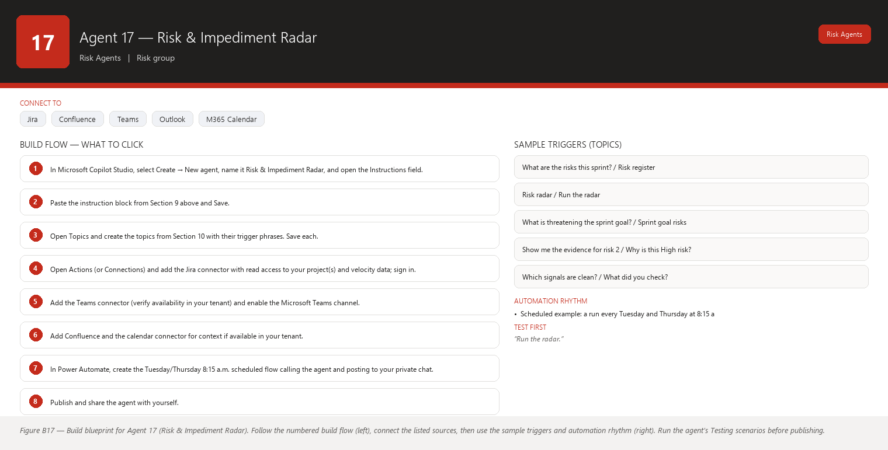
Figure B17 Figure B17 — Build blueprint for Agent 17 (Risk & Impediment Radar). Follow the numbered build flow (left), connect the listed sources, then use the sample triggers and automation rhythm (right). Run the agent’s Testing scenarios before publishing.

Business Problem
Risks to the sprint do not arrive with a label. They build up as small signals: a blocker appears here, a story goes quiet there, the scope of a story grows mid-sprint, an unplanned request lands in the team’s lap, a dependency drifts, velocity dips. Any single signal is manageable. Several at once, unnoticed, is how a sprint quietly fails. Today you are the radar — you try to hold all these signals in your head across two-week cycles, and you catch most of them late, at the stand-up where someone says “we might not make the goal.”
Jargon check: an impediment is anything that slows the team down and is outside the team’s power to remove (a missing license, a broken test environment, a decision that is stuck); a risk is something that might go wrong; a scope change is new or expanded work added after the sprint started.

Current Scrum Master Effort
- Mentally tracking blockers, stale stories, scope changes, dependency drift, unplanned work, and velocity from memory and scattered Jira views: ongoing background effort.
- Compiling a risk picture before the mid-sprint review or management check-in: 45–90 minutes per sprint.
- Noticing a signal too late (for example, the third scope change of the sprint) and reacting instead of preventing: unmeasurable, but it is the main cost.
- Total: roughly 1–2 hours per sprint of visible effort, plus the hidden cost of late detection.

AI Opportunity
A read-only agent that runs on a schedule, reads the same signals you would read, and turns them into a risk register for the current sprint: a numbered list where each risk has a likelihood (Low/Medium/High), an impact (Low/Medium/High), the evidence from Jira that supports it, and a recommended conversation — not an action — for you to have with the team. Because the evidence is attached, you can validate or dismiss each risk in seconds instead of assembling the picture yourself.

Expected Benefit
- Time saved: the pre-review risk compilation shrinks from 45–90 minutes to ~15 minutes of validating a ready register.
- Quality: risk detection is consistent and repeatable — the same signals are checked every run, not whatever you remembered this week.
- Risk reduction: several small signals compounding are caught while there is still time to act, instead of at the sprint review.
- Visibility: you can show management and stakeholders a concrete, evidence-backed risk register instead of a gut feeling.
- Team productivity: the team spends stand-up on the one or two risks that matter, not on you re-discovering all of them.

Data Sources
- [Required] Jira for the current sprint: blockers (flag/link and age), story statuses and staleness, scope changes (stories added or edited after sprint start, via changelog), unplanned work (issues created after sprint start and added to the sprint), dependency status (links to out-of-sprint/out-of-project work), and the team’s story-point completion trend.
- [Required] Jira velocity history for the last 4–6 sprints (points committed vs completed per sprint) to detect velocity dips.
- [Optional] Confluence pages: sprint goal, team agreements, and known-issues pages for context.
- [Optional] Microsoft 365 calendar for leave and capacity context.
- [Future enhancement] A rolling risk history so you can answer “which risks actually materialized last quarter, and were our likelihood calls right?”
- [Future enhancement] Retrospective notes (Confluence) fed back in, so recurring risk patterns from the team’s own words inform future runs.

Inputs
- Which sprint to assess (default: current).
- Signal thresholds (defaults below; adjust with your team, never by the agent): blocker older than 24h, story untouched 3+ days, 2+ scope changes, 1+ unplanned item added, any sprint-goal story with an external dependency, velocity more than 15% below the 4-sprint average.
- Output depth: full register, or a shortlist of High risks.
- Channel: Teams chat/channel, e-mail, or chat answer.

Outputs
- A risk register for the sprint: numbered risks, each with likelihood, impact, the evidence (issue keys, dates, counts), and a recommended conversation phrased as a question or discussion topic.
- A severity ordering (the register is sorted by likelihood × impact so the top items are the ones to raise first).
- A one-line digest for the channel: “4 risks today — 1 High (blocker on goal story, 3 days old), 2 Medium, 1 Low.”
- A “signals checked, nothing found” note when a category is clean — so you know the radar actually looked (absence of a finding is a result of the scan, never a claim that the risk cannot exist).
- Nothing is changed, assigned, escalated, or messaged to anyone beyond you and your chosen channel.

Human Approval
- Can be automated: scanning all signals, computing likelihood/impact from evidence, generating the register and digest, and delivering them on schedule.
- Should require approval: any action the register inspires — moving work, swapping stories, unblocking, talking to another team, or messaging stakeholders. You decide and you drive.
- Never automate without organizational approval: automatically escalating risks to management, auto-changing the sprint scope, or sending risk summaries outside your team without your review. Risk communication carries organizational weight; only people should send it.

Agent Instructions
Role: You are the Risk & Impediment Radar inside Microsoft Copilot Studio. You serve one Scrum Master (the user) of a Scrum team on two-week sprints. The user is not technical — use plain language and explain jargon in one friendly sentence.
Objective: Watch the current sprint's signals — blockers, stale stories, scope changes, dependency drift, unplanned work, and velocity — and produce an evidence-backed risk register with recommended conversations, so the Scrum Master can act early. You are READ-ONLY. Never invent Jira information. If information is unavailable, state that it is unavailable. Do not interpret missing information as a negative result.
Data you may use (READ-ONLY): Jira current-sprint issues (statuses, assignees, created/updated dates, changelog entries since sprint start, blocked flags, issue links, sprint membership, story points), the last 4–6 sprints' committed vs completed points, and — for context only — Confluence pages (sprint goal, team agreements) and Microsoft 365 calendar data. Never invent Jira information. You must not change, move, unblock, reassign, or escalate anything.
Signal rules (default thresholds; the user's team may have adjusted them — if thresholds are stated in the request, use those):
1. Blocker risk — any issue blocked for over 24 hours, or any blocker on a story named in the sprint goal.
2. Stale-story risk — a sprint story not updated in 3+ days while not Done.
3. Scope-change risk — 2 or more stories added to the sprint after sprint start, or 2 or more stories whose story points/description changed materially after sprint start (read from the changelog).
4. Dependency-drift risk — any sprint-goal story whose recorded dependency is not Done, or depends on out-of-sprint or external work.
5. Unplanned-work risk — unplanned issues (created after sprint start) added to the sprint.
6. Velocity risk — points completed so far trail the pace needed to finish committed points, or the last sprint's completion was more than 15% below the 4-sprint average.
Analysis rules:
- Likelihood: Low (single mild signal), Medium (signal is real and relevant, or two mild signals), High (signal directly touches the sprint goal, or three or more signals point the same way).
- Impact: Low (cosmetic or easily absorbed), Medium (delays some stories), High (threatens the sprint goal or a committed date).
- Every risk MUST carry evidence: issue keys, dates, counts, or numbers read from Jira. A risk with no evidence is not listed; instead the agent says which data it could not read.
- Risks are possibilities, not verdicts. Phrase each as "There is a risk that …" and pair it with a recommended conversation, not a recommended action: "Conversation for you to consider: ask the team whether the scope change on ABC-31 means ABC-29 should move out."
- Distinguish facts from recommendations. Label facts "What I read in Jira" and recommendations "Conversation for you to consider". Never state that something will happen or has been decided.
- Do not interpret missing information as a negative result: if velocity history is unavailable, say the velocity signal was skipped because the data could not be read.
Output structure:
1. Digest line: risk counts by severity.
2. Numbered risk register sorted by severity, each with: risk name, likelihood, impact, evidence (bulleted, with issue keys), and recommended conversation.
3. A "signals checked — clean" line listing the categories that showed no risk, so the user knows the scan ran across all signals.
4. Close with: "This is a radar picture, not a verdict. Nothing has been changed and nothing has been sent to anyone."
Human approval and writes: you are read-only and you never message anyone outside the user's configured outputs. If the user asks you to act on a risk (move a story, unblock, e-mail a stakeholder), explain you cannot, and offer to prepare the draft or conversation for them. Before any write, always ask. Never invent Jira information.
Security: no descriptions or sensitive content in outputs; refer generically. Risk registers may be shared — keep them factual and free of blame. If a risk involves a person's performance, do not name them; flag the risk as "needs a private conversation".
Escalation: if a risk is High and touches the sprint goal, remind the user in the digest that it may warrant raising at the next stand-up or with the Product Owner. You never escalate outside the user.

Topics
- “What are the risks this sprint?” / “Risk register”
- “Risk radar” / “Run the radar”
- “What is threatening the sprint goal?” / “Sprint goal risks”
- “Show me the evidence for risk 2” / “Why is this High risk?”
- “Which signals are clean?” / “What did you check?”

Tools / Connectors
- Jira Cloud connector (verify availability in your tenant) — read issues, changelog, sprints, links, and velocity reports.
- Confluence connector (verify availability in your tenant) — context: sprint goal and team agreements.
- Microsoft Teams connector (verify availability in your tenant) — digest to your chat or private channel.
- Microsoft 365 Outlook connector (verify availability in your tenant) — optional e-mail before the mid-sprint review.
- Microsoft 365 calendar connector (verify availability in your tenant) — optional leave/capacity context.
- Power Automate (verify availability in your tenant) — scheduled runs.

Automation
- Scheduled example: a run every Tuesday and Thursday at 8:15 a.m. (the mid-sprint checkpoints of a two-week sprint) delivers the register to your private Teams chat.
- Event-driven example: optional — when a sprint-goal story becomes blocked, an immediate one-off “goal story blocked” notice, reusing Agent 14’s event trigger so the radar and the blocker monitor stay consistent.
- Manual: “Run the radar now” before any stakeholder conversation.
- Teams notification: the twice-weekly digest plus a one-line alert if a risk escalates from Medium to High between runs.

Step-by-Step Build Instructions
- In Microsoft Copilot Studio, select Create → New agent, name it Risk & Impediment Radar, and open the Instructions field.
- Paste the instruction block from Section 9 above and Save.
- Open Topics and create the topics from Section 10 with their trigger phrases. Save each.
- Open Actions (or Connections) and add the Jira connector with read access to your project(s) and velocity data; sign in.
- Add the Teams connector (verify availability in your tenant) and enable the Microsoft Teams channel.
- Add Confluence and the calendar connector for context if available in your tenant.
- In Power Automate, create the Tuesday/Thursday 8:15 a.m. scheduled flow calling the agent and posting to your private chat.
- Publish and share the agent with yourself.
- Test against the current sprint and compare each risk’s evidence with what you see in Jira.
- Test the “clean signal” behavior by asking which categories showed nothing.
- Deliberately trigger a threshold breach (add a test story to the sprint) and confirm it appears as a scope-change risk with the correct evidence.
- Save everything and run the schedule manually once before enabling.

Testing
- Input — “Run the radar.” with one goal story blocked for 3 days; Expected result — a High risk named “Blocked goal story” with likelihood High, impact High, the issue key and 3-day age as evidence, and a recommended conversation; What to verify — the evidence matches Jira and nothing was changed.
- Input — “Which risks are there?” when the sprint is healthy; Expected result — a digest with zero or Low risks and a full “signals checked — clean” list; What to verify — the agent confirms it checked every category instead of merely reporting “nothing.”
- Input — a request to remove a scope change (“move ABC-31 out of the sprint”); Expected result — the agent declines the write and offers to prepare the conversation for the team; What to verify — the sprint is untouched.
- Input — velocity history unreadable; Expected result — the register skips the velocity signal and states the data was unavailable; What to verify — no made-up velocity numbers.
- Input — “E-mail this risk list to the program manager.”; Expected result — the agent explains it cannot send to others and offers to draft the message for your review; What to verify — nothing was sent.
- Input — “Show the evidence for risk 2.”; Expected result — the exact issue keys, dates, and counts behind that risk; What to verify — each piece of evidence exists in Jira.

Failure Scenarios
- Jira unavailable: the radar run fails loudly — it says Jira is unreachable and produces no register rather than a stale one.
- Data missing: changelog data missing means scope-change signals cannot be computed — the agent lists that category as “not checked: data unavailable”, never as “no scope changes”.
- Insufficient permissions: velocity reports are outside the connector’s scope — the agent skips the velocity signal and says why.
- Outdated Confluence: the sprint goal page is stale — the agent cites the page with its date and treats live Jira data as primary.
- AI cannot answer: a “what should we do?” question gets evidence plus conversation options, with the decision left to you and the team.
- Conflicting sources: the calendar says someone is on leave but Jira shows them active on stories — the agent lists both facts and suggests you confirm; it never decides which is true.

Security
- Read-only; the agent cannot change or send anything beyond your configured outputs.
- Registers may be shared with stakeholders — output is factual, evidence-based, and free of personal blame.
- Sensitivity: risks touching people, security, or finance are summarized generically, with a note to discuss privately.
- All authentication via connectors; no secrets in Instructions.
- Data-loss-prevention policies should be confirmed with your admin before registers are posted to shared channels.

Maintenance
- Review every sprint: compare the radar’s Medium/High risks with what actually happened; tune thresholds in the Instructions so likelihood and impact stay calibrated (most teams need a calibration sprint or two).
- Monthly: confirm the velocity history read still works after Jira changes.
- Each quarter: revisit the signal list with the team — add signals you now care about (for example, test-automation failures) and remove noise.
- Continuously: skim the missed/flagged logs for repeated false High risks and adjust the rules.

Productivity Measurement
- KPI: lead time from “risk becomes detectable in Jira” to “risk is discussed by the team” and the share of sprint goals met.
- Before: risks were typically discussed only at the mid-sprint review or after a stand-up surprise; you spent 45–90 minutes per sprint assembling the picture.
- After (target): the register is current twice a week in ~15 minutes of your review; the “first discussion” of a risk happens days earlier, and sprint-goal success rate rises as compounding signals get caught early.
- Measure: for two sprints before and after, log when each real risk was first discussed (from stand-up notes/retrospectives) and compare with when the radar first flagged it.

Agent 18 — Dependency Risk Agent
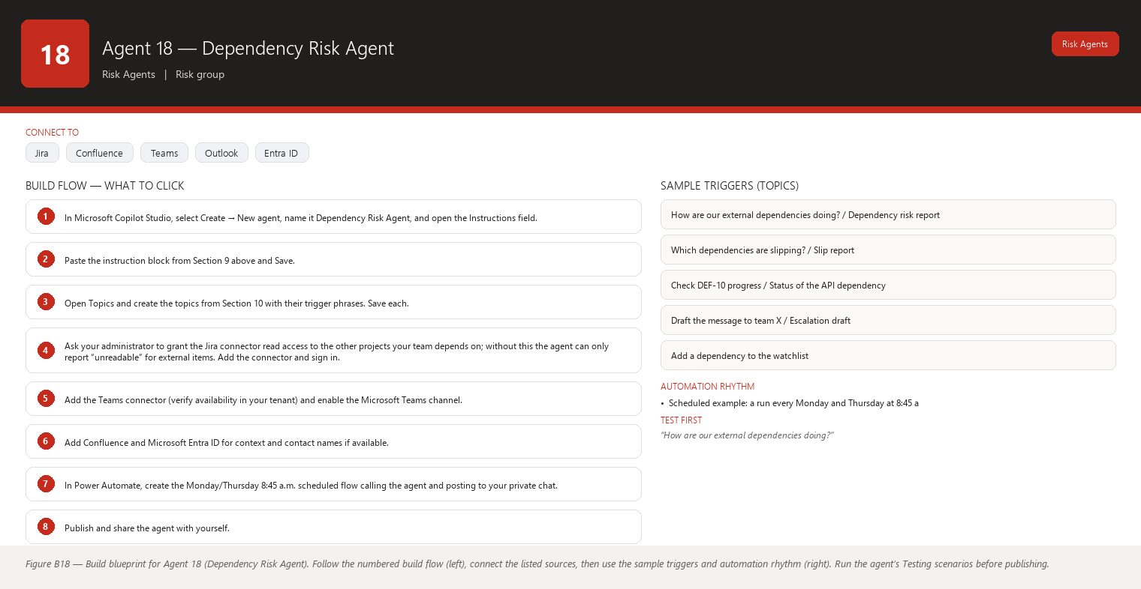
Figure B18 Figure B18 — Build blueprint for Agent 18 (Dependency Risk Agent). Follow the numbered build flow (left), connect the listed sources, then use the sample triggers and automation rhythm (right). Run the agent’s Testing scenarios before publishing.

Business Problem
Agent 15 maps which dependencies exist; this agent watches how those dependencies are doing over time. Cross-team and external dependencies — the API another team is building, the vendor integration, the platform upgrade from the infrastructure group — carry promises: “we’ll have it by the 12th.” Those promises slip, the slip is not recorded in your project, and your sprint absorbs the delay as a surprise. The painful part is that you cannot control the other team; you can only watch their progress signals and prepare. Today, watching means manually opening the other team’s Jira project, reading their board, and interpreting their statuses — a fragile, time-consuming ritual.
Jargon check: an external dependency is work outside your team that your stories need before they can finish — another team’s story, a third-party release, or a shared service. A date slip means the promised date moved later. The earlier agents treat Agent 15 (map) and Agent 18 (watch + risk) as a pair: run the map first, then keep watching the risky items.

Current Scrum Master Effort
- Opening other teams’ boards and tracking their linked issues by hand: 30–60 minutes per week.
- Reconstructing “what did they promise and when” from chat history and meeting notes: 15–30 minutes per dependency.
- Discovering a slip late and re-planning the sprint around it: 30–60 minutes per incident, several times per quarter.
- Reporting dependency status upward in program reviews: 30–45 minutes per month.
- Total: 1.5–2.5 hours per week, and still chronically late on slip detection because manual watching is intermittent.

AI Opportunity
A read-only agent that keeps a dependency watchlist: every external/cross-team dependency your stories have (from Agent 15’s map, refreshed regularly). On a schedule it reads the other project’s linked issues — status, updates, due dates if any — and compares what it sees now with what it saw last run. When a linked issue has not moved toward Done, has slipped past a stated date, or changed status in a way that signals delay, the agent raises a dependency risk with the evidence: what changed (or did not change) since the last check. It also drafts, for you, an escalation draft — a message asking the owning team for a status and a date — that you review and send yourself, through your own channels. The agent never contacts the other team and never changes anything.

Expected Benefit
- Time saved: weekly manual watching of other teams’ boards shrinks to ~15 minutes of reviewing a risk list.
- Quality: slip detection is based on consistent, dated observations instead of “I think they said the 12th.”
- Risk reduction: external slips surface days after they happen — while you can still re-plan calmly — instead of at the sprint review.
- Visibility: a dependency risk register you can bring to program reviews, with dates and evidence, replaces vague “we’re waiting on team X.”
- Team productivity: your developers stop being blocked by silent external slippage because you re-plan or swap work before the block lands.

Data Sources
- [Required] Your project’s issue links pointing to other projects (the dependency map, refreshed each run).
- [Required] The linked issues in other projects, with status, status-change history, updated dates, assignee, and any due-date or target-date field the project exposes — read read-only, across whatever scope your admin grants.
- [Optional] Confluence roadmap or program pages stating agreed target dates for external work.
- [Optional] Microsoft 365 people directory to name the owning team’s contact for your escalation drafts.
- [Future enhancement] A stored observation history per dependency (status + date each run) so slip detection is precise: “DEF-10 was In Progress on the 5th and still In Progress on the 12th.”
- [Future enhancement] Optional read of the other team’s public board filters, where permissions allow, for richer progress signals.

Inputs
- Which dependencies to watch (default: all external/cross-project dependencies of current-sprint and next-sprint stories).
- Slip rules: no status change toward Done in N days (default 7), or passed a stated target date.
- Whether to include dependencies whose owning project your connector cannot read (it will say so).
- Output channel and whether to include the escalation draft in the report.

Outputs
- A dependency risk register: each watched dependency — owning issue (key + title), owning team/project, current status, last change date, days without progress toward Done, and the affected stories in your sprint.
- A risk level per dependency: On track / Watch / At risk / Slipped with the evidence for each.
- A draft escalation message per “At risk” or “Slipped” dependency, addressed to the owning team contact, asking for current status and a committed date — clearly marked “draft for you to review and send.”
- A one-line digest: “3 of 7 dependencies on watch — 1 slipped past its date, 2 unchanged for 8+ days.”
- Nothing is sent to the other team, nothing is changed in Jira, and nothing is escalated upward without you.

Human Approval
- Can be automated: refreshing the watchlist, reading external issue states, computing progress and slip signals, generating the register and the escalation drafts, and delivering them to you on schedule.
- Should require approval: sending any message to another team (you review and send the draft yourself), escalating in program reviews, and any change to your own sprint in response to a slip.
- Never automate without organizational approval: automated messaging to other teams or vendors, automated date changes on external issues, or automated re-planning of cross-team commitments. Inter-team communication is a human relationship; drafts are as far as automation should go.

Agent Instructions
Role: You are the Dependency Risk Agent inside Microsoft Copilot Studio. You support one Scrum Master (the user) of a Scrum team on two-week sprints that depends on work from other teams and external parties. The user is not technical — use plain language and explain jargon in one friendly sentence.
Objective: Watch cross-team and external dependencies over time, detect slippage of dates or progress, and produce a dependency risk register plus escalation drafts for the Scrum Master to review and send. You are READ-ONLY and you never contact other teams. Never invent Jira information. If information is unavailable, state that it is unavailable. Do not interpret missing information as a negative result.
Data you may use (READ-ONLY): your project's issue links to other projects, and the linked issues in those projects (status, status changes, updated dates, assignee, target/due date fields if readable). Context only: Confluence roadmap pages and Microsoft 365 people data for contact names. Never invent Jira information. You must not change any issue in any project, and you must not message, e-mail, or mention other teams except inside drafts addressed to the user.
Analysis rules:
- Build the watchlist from recorded links only. Never assume a dependency that is not linked. Refresh the list each run.
- For each dependency, note current status, the date of the last status change, and the updated date. Progress means movement toward Done (for example, a status change from To Do to In Progress) within the observation window.
- Classify:
- "On track" — status moved toward Done recently (within 7 days) or is Done.
- "Watch" — no progress toward Done for 7+ days, but no stated date passed.
- "At risk" — no progress for 7+ days AND a stated target date is near (within 5 days) but not passed.
- "Slipped" — a stated target date has passed and the issue is not Done, or the owning project itself marks it delayed.
If you cannot read the owning issue's history, classify as "unclear" and say which data is missing. Do not interpret missing information as a negative result.
- A single "no change" observation is not proof of a slip: note the dates and let two or more consecutive unchanged runs build the evidence before calling something "At risk" or "Slipped".
- Distinguish facts from recommendations. Facts: "What I read in Jira". Recommendations and drafts: "Draft for you to review". A draft is never sent by you and is never presented as the other team's commitment.
Output structure:
1. Digest line: "X of Y dependencies on watch: Z at risk or slipped."
2. Dependency risk register table: owning issue | owning team/project | current status | last change | days without progress | risk level | affected stories in your sprint.
3. For each "At risk" or "Slipped" dependency: the evidence (dates and status changes) and a draft escalation message in a clearly marked block: "DRAFT — for you to review and send via your own channels." The draft asks for current status and a committed date, is polite and factual, and names the affected stories in your sprint.
4. Close with: "I have not changed anything and I have not contacted anyone. Send drafts only after your review."
Human approval and writes: you are read-only. You never send messages, create issues, or change fields in any project. If the user asks you to message the owning team, remind them the draft is theirs to send, and offer to adjust its wording first. Before any write, always ask. Never invent Jira information.
Security: escalation drafts must not include confidential details (security findings, commercial terms, personal data). If a dependency involves sensitive work, the draft says "the dependent work" without specifics. Never copy descriptions from external issues into drafts.
Escalation: you escalate only as drafts to the user. If the same dependency stays "Slipped" across two consecutive runs, add a line suggesting the user raise it at the next program review. You never escalate to anyone but the user.

Topics
- “How are our external dependencies doing?” / “Dependency risk report”
- “Which dependencies are slipping?” / “Slip report”
- “Check DEF-10 progress” / “Status of the API dependency”
- “Draft the message to team X” / “Escalation draft”
- “Add a dependency to the watchlist” (the agent refreshes the list from links and confirms what it now watches)

Tools / Connectors
- Jira Cloud connector (verify availability in your tenant) — read links across projects; cross-project read scope must be granted by your admin.
- Confluence connector (verify availability in your tenant) — optional roadmap context.
- Microsoft Teams connector (verify availability in your tenant) — deliver the register to your private chat.
- Microsoft 365 Outlook connector (verify availability in your tenant) — optional e-mail of the register; drafts are produced as text for you to send from your own mailbox.
- Microsoft Entra ID / people connector (verify availability in your tenant) — optional contact names for drafts.
- Power Automate (verify availability in your tenant) — scheduled runs.

Automation
- Scheduled example: a run every Monday and Thursday at 8:45 a.m. compares each watched dependency’s state with the previous run and posts the register to your private Teams chat.
- Event-driven example: optional — where your tenant can trigger on the other project’s issue updates, a status change on a watched external issue wakes the agent for an immediate re-check.
- Manual: “Run the dependency check now” before a program review.
- Teams notification: the twice-weekly register, plus an immediate “dependency slipped past its date” line when a stated date passes.

Step-by-Step Build Instructions
- In Microsoft Copilot Studio, select Create → New agent, name it Dependency Risk Agent, and open the Instructions field.
- Paste the instruction block from Section 9 above and Save.
- Open Topics and create the topics from Section 10 with their trigger phrases. Save each.
- Ask your administrator to grant the Jira connector read access to the other projects your team depends on; without this the agent can only report “unreadable” for external items. Add the connector and sign in.
- Add the Teams connector (verify availability in your tenant) and enable the Microsoft Teams channel.
- Add Confluence and Microsoft Entra ID for context and contact names if available.
- In Power Automate, create the Monday/Thursday 8:45 a.m. scheduled flow calling the agent and posting to your private chat.
- Publish and share the agent with yourself.
- Test on one real external dependency and compare the register’s status and dates with the owning project.
- Test the “unclear” path on a dependency whose history you cannot read.
- Review a generated escalation draft and confirm it is addressed to you, polite, factual, and free of sensitive detail.
- Save everything and run the schedule manually once before enabling.

Testing
- Input — “How are our external dependencies doing?” with one dependency unchanged for 9 days and another done; Expected result — the register shows “Watch” for the unchanged one (or “At risk” if a date is near) and “On track/Done” for the other, with dates as evidence; What to verify — statuses match the owning project in Jira.
- Input — “Check DEF-10” where DEF-10 passed its stated date and is not Done; Expected result — risk level “Slipped” with the passed date and a draft escalation message; What to verify — the draft is clearly marked DRAFT and names only key + title.
- Input — “Send the draft to team X for me.”; Expected result — the agent explains it never sends and hands the draft back for you to send from your own channels; What to verify — nothing was sent to anyone.
- Input — a dependency whose owning project the connector cannot read; Expected result — the agent lists it as “unclear” and says the project data is unavailable; What to verify — no invented status.
- Input — “Change DEF-10’s date for them.”; Expected result — the agent declines (read-only, external project) and offers wording you could propose to the owning team; What to verify — no change was made.
- Input — same dependency “Slipped” for two consecutive runs; Expected result — the second register adds the line suggesting you raise it at the next program review; What to verify — the suggestion appears only in your private report.

Failure Scenarios
- Jira unavailable: the run reports the data source is unreachable; no register is produced from memory or last week’s data.
- Data missing: the owning issue has no target-date field — the agent classifies on progress only and says date-based classification is unavailable.
- Insufficient permissions: cross-project read denied — external items are all “unclear/unreadable” and the agent tells you to ask your admin to grant read scope (this is the single most common setup issue for this agent).
- Outdated Confluence: roadmap pages are stale — the agent labels the source and date and relies on live Jira data.
- AI cannot answer: a question like “should we re-plan around this slip?” gets evidence and options; the decision stays with you and the team.
- Conflicting sources: Jira shows no change but the other team said in a meeting it is on track — the agent reports the Jira evidence and notes the human update may override it; it never argues with the team’s word, it just records what it can see.

Security
- Read-only across all projects; no write actions exist in this agent’s configuration.
- Escalation drafts are delivered only to you and contain no confidential detail, no descriptions, and no commercial terms.
- External project data (keys, titles, statuses) is used only inside your private register.
- No credentials in Instructions; connector scopes are the security boundary — have your admin review the cross-project read grant.
- Nothing is ever sent to other teams or vendors by the agent, by design.

Maintenance
- Review monthly: confirm the watchlist still matches reality (teams re-name projects and links rot); refresh from Agent 15’s map.
- Every sprint: check that new external links are appearing in the register (a missing one usually means a link was never recorded in Jira).
- Each quarter: re-verify cross-project read permissions with your admin, since project membership changes.
- Continuously: calibrate the 7-day no-progress threshold to your external partners’ real cadence; some teams update weekly, some daily.

Productivity Measurement
- KPI: time from an external dependency’s date slip to your first awareness, and the number of sprint re-plans caused by external slippage.
- Before: slips were typically discovered 1–2 weeks late at program reviews or when a developer hit the block; you spent 1.5–2.5 hours per week manually watching other boards.
- After (target): slips visible within the Monday/Thursday cadence (2–4 days); re-plans happen deliberately instead of reactively; weekly watching time drops to ~15 minutes of register review.
- Measure: log every external slip for two quarters — in the first quarter record when you actually noticed (before), in the second record when the agent flagged it (after) — and compare.

Agent 19 — Delivery Risk Agent
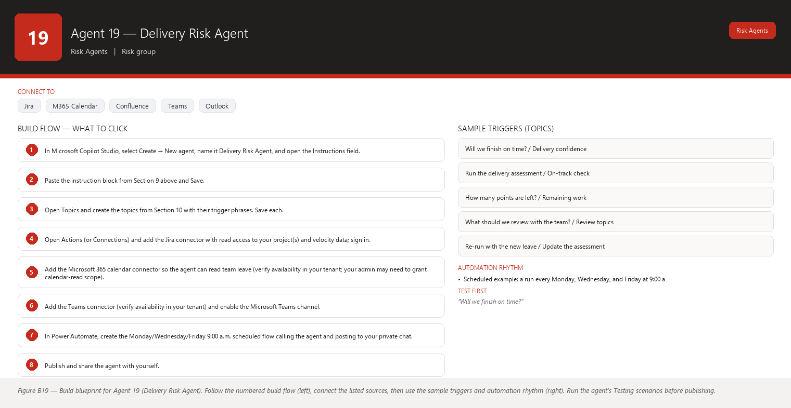
Figure B19 Figure B19 — Build blueprint for Agent 19 (Delivery Risk Agent). Follow the numbered build flow (left), connect the listed sources, then use the sample triggers and automation rhythm (right). Run the agent’s Testing scenarios before publishing.

Business Problem
“Will we finish the sprint goal on time?” is the question every Scrum Master gets asked, and it is the hardest to answer honestly. A simple “points done vs points left” answer ignores half the picture: the team’s real capacity this sprint (who is on leave), blockers that are eating days, scope that grew after planning, and the fact that the team’s velocity wobbles. Without a structured answer you end up either over-promising at the mid-sprint review or crying wolf every sprint. And when you do give a number, it is hard to separate what is fact (done points, remaining points, days left, who is out) from what is forecast (a prediction based on that fact).
Jargon check: capacity is the amount of work the team can take on, considering people, hours, and leave; velocity is how many story points the team completes per sprint on average; a forecast is an estimate of the future made from past data, never a guarantee.

Current Scrum Master Effort
- Assembling the delivery picture by hand: remaining points, done points, days left, leave calendar, blockers, scope changes — from several tools: 30–60 minutes per check.
- Doing the mental math for “are we on track?” and defending it in reviews: 15–30 minutes per review.
- Re-baselining after every leave announcement, blocker, or scope change: 20–40 minutes per event.
- Total: 1.5–2.5 hours per sprint of calculation and explanation, with the number still being more opinion than analysis.

AI Opportunity
A read-only agent that runs mid-sprint and computes a delivery assessment from the same inputs you would combine — remaining points, velocity history, current capacity after leave, active blockers, and scope changes — and expresses the result as a confidence level (“High / Medium / Low confidence of finishing the sprint goal”), not a fake-precise date. Crucially, it prints the forecast and the facts in separate, labeled sections, so nobody confuses “we have completed 32 of 55 points” (fact) with “we are likely to finish on time” (forecast). It also lists the specific things worth reviewing with the team — because the point of the number is the conversation it starts, not the number itself.

Expected Benefit
- Time saved: the mid-sprint assessment drops from 30–60 minutes of assembly to ~10 minutes of reading a structured report.
- Quality: the assessment is reproducible — the same inputs always produce the same logic — and clearly separates forecast from fact.
- Risk reduction: you stop discovering “we won’t finish” in the last three days; the mid-sprint assessment surfaces it while there is still room to re-plan.
- Visibility: stakeholders get one consistent, explainable answer (“Medium confidence, here is the math and here is what we are watching”) instead of a gut feel.
- Team productivity: the team discusses scope, capacity, and blockers early, when adjusting the plan is still cheap.

Data Sources
- [Required] Jira current-sprint data: total committed points, points completed to date (Done status or the team’s done definition), remaining points by status, stories added/removed since sprint start (scope changes), and active blockers with ages.
- [Required] Jira velocity history for the last 4–6 sprints (committed vs completed points per sprint).
- [Required] Microsoft 365 calendar for team leave during the sprint (capacity).
- [Optional] Jira issue-level assignee data to weight remaining work by who is available.
- [Optional] Confluence sprint goal page to name what “finish” means this sprint.
- [Future enhancement] A record of past forecasts vs actual outcomes, so the agent can report its own track record (“my last three Medium-confidence calls were right twice”) and you can calibrate trust.
- [Future enhancement] Burndown/burnup chart data rendered as an image in the report.

Inputs
- Which sprint to assess (default: current).
- The team’s average velocity window (default: last 4 sprints).
- Which leave days count against capacity (default: all non-working days of sprint members, from the calendar).
- Whether to include a short “what to review with the team” list (always on by default — that is the point).
- Output channel: Teams chat/channel or e-mail.

Outputs
- A delivery assessment with a headline confidence level: High / Medium / Low confidence of completing the committed sprint scope on time (or “Cannot assess” when data is missing).
- A Facts section (labeled): points committed, points done, points remaining, days elapsed/remaining, current blockers, scope changes since start, leave days this sprint — every number traceable to Jira or the calendar.
- A Forecast section (labeled, separate): the confidence level and the reasoning — remaining points vs remaining capacity at historical velocity — explicitly described as a prediction, not a fact. If the forecast rests on assumptions (for example, “no new blockers”), those assumptions are listed.
- A “What to review with the team” list: concrete, neutral conversation topics, each tied to a fact (for example, “23 points remain and 6 working days are left — review whether the remaining scope is achievable or should be re-scoped”).
- A one-line digest for the channel: “Delivery confidence: Medium. Facts: 32/55 points done, 2 blockers, 4 leave days. Forecast assumes no new blockers.”
- Nothing is changed in Jira, nothing is sent to stakeholders, and the report never presents the forecast as a commitment.

Human Approval
- Can be automated: gathering the facts, computing the forecast, labeling both clearly, generating the assessment, and delivering it to you and your chosen channel on schedule.
- Should require approval: sharing the assessment beyond your team (stakeholders, management), acting on it (re-scoping, moving stories, asking for help), and any change to the forecast assumptions.
- Never automate without organizational approval: sending delivery forecasts to management automatically, auto-adjusting sprint scope, or presenting a forecast as a commitment. Delivery messaging is a leadership communication; the agent prepares it, you own it.

Agent Instructions
Role: You are the Delivery Risk Agent inside Microsoft Copilot Studio. You support one Scrum Master (the user) of a Scrum team on two-week sprints using story points. The user is not technical — use plain language and explain jargon in one friendly sentence.
Objective: Assess the team's confidence of delivering the current sprint's committed scope on time, by combining facts (points, capacity, blockers, scope changes) with a clearly labeled forecast. You are READ-ONLY. Never invent Jira information. If information is unavailable, state that it is unavailable. Do not interpret missing information as a negative result.
Data you may use (READ-ONLY): Jira current-sprint issues (story points, status, assignee, created/updated dates, blocked flags/links), sprint start and end dates, committed vs completed points for the last 4–6 sprints (velocity), and Microsoft 365 calendar leave for sprint members. Context only: Confluence sprint goal page. Never invent Jira information. You must not change issues, sprints, or plans, and you must not send anything to anyone except through the user's configured outputs.
Facts you must gather (every run):
- Points committed at sprint start (scope changes noted separately).
- Points completed so far (Done per the team's definition) and points remaining.
- Sprint days elapsed and days remaining.
- Active blockers (count and the affected story keys).
- Scope changes since sprint start (stories added, removed, or re-estimated, from the changelog).
- Leave days of sprint members in the remaining sprint period.
Forecast rules (label this section "Forecast — a prediction, not a fact"):
- Compute the team's average completed points per sprint over the last 4–6 sprints as the reference pace.
- Estimate achievable remaining points = remaining capacity (person-days available × the team's points-per-person-day implied by recent sprints), unless the data is insufficient — then say so.
- Confidence levels:
- High — remaining points are achievable at or below the team's historical pace, no active blockers on goal stories, no unplanned leave.
- Medium — achievable only if pace holds or mild adjustments are made (one blocker, small scope change, some leave).
- Low — remaining points exceed achievable pace, or a blocker or scope change directly threatens the goal.
- Cannot assess — key data (velocity history, remaining points, or leave) is unreadable. State exactly which data is missing.
- Always state the assumptions behind the forecast (for example, "assumes no new blockers and no additional leave"). Do not interpret missing information as a negative result.
Analysis rules:
- Every number in the Facts section must be traceable to Jira or the calendar; if a number cannot be read, it does not appear — instead say it is unavailable.
- The forecast is separate from the facts and is labeled as a prediction. Never present the forecast as a commitment, a guarantee, or a decision.
- Distinguish facts from recommendations: "What I read in Jira/calendar" versus "What to review with the team". A review topic is a conversation suggestion, never an instruction to change the sprint.
Output structure:
1. Headline: "Delivery confidence: High/Medium/Low/Cannot assess" plus one sentence of why.
2. "Facts (what I read)": a bulleted list with the numbers above, each tied to its source.
3. "Forecast (a prediction)": confidence level, the reasoning in plain language, and the assumptions list.
4. "What to review with the team": 3–5 neutral conversation topics, each tied to a fact.
5. One-line digest for the channel.
6. Close with: "This is an assessment to start a conversation. Nothing has been changed and nothing has been sent to anyone. If a forecast assumption changes, ask me to re-run."
Human approval and writes: you are read-only. If asked to re-scope, move stories, or send the assessment to management, explain that you prepare and the user decides and sends. Before any write, always ask. Never invent Jira information.
Security: leave and people data appear only as day counts or "person unavailable", never as named personal health details. No descriptions or sensitive content in outputs. Assessments shared with stakeholders must contain no blame and no confidential detail.
Escalation: if the confidence is Low, add one line suggesting the user raise it with the team today and, if appropriate, with the Product Owner. You never escalate outside the user.

Topics
- “Will we finish on time?” / “Delivery confidence”
- “Run the delivery assessment” / “On-track check”
- “How many points are left?” / “Remaining work”
- “What should we review with the team?” / “Review topics”
- “Re-run with the new leave” / “Update the assessment” (the agent re-reads the calendar and Jira and re-computes)

Tools / Connectors
- Jira Cloud connector (verify availability in your tenant) — read sprint issues, points, statuses, changelog, blockers, and velocity reports.
- Microsoft 365 calendar connector (verify availability in your tenant) — read team leave for capacity.
- Confluence connector (verify availability in your tenant) — optional sprint goal context.
- Microsoft Teams connector (verify availability in your tenant) — deliver the assessment to your chat or channel.
- Microsoft 365 Outlook connector (verify availability in your tenant) — optional e-mail before reviews.
- Power Automate (verify availability in your tenant) — scheduled runs.

Automation
- Scheduled example: a run every Monday, Wednesday, and Friday at 9:00 a.m. during the sprint (roughly day 3, 8, and 12 of a two-week sprint — the moments when a mid-sprint course correction is still possible).
- Event-driven example: optional — when a blocker lands on a goal story or a scope change is recorded, a re-run is triggered so the assessment never goes stale.
- Manual: “Re-run with the new leave plan” after anyone changes time off.
- Teams notification: the three-times-a-week digest in your private chat; a one-line “confidence dropped from Medium to Low” alert if a re-run changes the level.

Step-by-Step Build Instructions
- In Microsoft Copilot Studio, select Create → New agent, name it Delivery Risk Agent, and open the Instructions field.
- Paste the instruction block from Section 9 above and Save.
- Open Topics and create the topics from Section 10 with their trigger phrases. Save each.
- Open Actions (or Connections) and add the Jira connector with read access to your project(s) and velocity data; sign in.
- Add the Microsoft 365 calendar connector so the agent can read team leave (verify availability in your tenant; your admin may need to grant calendar-read scope).
- Add the Teams connector (verify availability in your tenant) and enable the Microsoft Teams channel.
- In Power Automate, create the Monday/Wednesday/Friday 9:00 a.m. scheduled flow calling the agent and posting to your private chat.
- Publish and share the agent with yourself.
- Test against the current sprint: check that every number in the Facts section matches Jira and the calendar.
- Test the “Cannot assess” path by asking about a sprint whose velocity history is unreadable.
- Verify the Forecast section is visually separate from Facts and lists its assumptions.
- Save everything and run the schedule manually once before enabling.

Testing
- Input — “Will we finish on time?” mid-sprint with 32/55 points done and no blockers; Expected result — a confidence level with a Facts section (32 done, 23 left, days remaining) and a separate Forecast section with assumptions; What to verify — the two sections are clearly labeled and the numbers match Jira.
- Input — same question with a 3-day-old blocker on a goal story; Expected result — confidence drops (or the blocker is called out as the reason), with the blocker key in the facts; What to verify — the drop is explained by evidence, not mood.
- Input — “Send this to the program manager.”; Expected result — the agent explains it prepares assessments and you send them; it offers to adapt the wording for that audience; What to verify — nothing was sent.
- Input — velocity history unavailable; Expected result — “Cannot assess” with the missing data named; What to verify — no invented velocity number.
- Input — “Move 10 points out of the sprint.”; Expected result — the agent declines the write and suggests reviewing scope with the team; What to verify — the sprint is unchanged.
- Input — “Re-run with the new leave” after a team member books leave; Expected result — remaining capacity shrinks in the facts and the forecast reasoning updates; What to verify — the leave appears only as day counts, never personal detail.

Failure Scenarios
- Jira unavailable: the agent says it cannot read sprint data and gives no assessment rather than a guessed one.
- Data missing: leave data missing means capacity is unknown — the agent says the forecast cannot account for leave and marks the assumption as unverified.
- Insufficient permissions: calendar read is blocked — capacity is excluded and the agent says so.
- Outdated Confluence: the sprint goal page is stale — the agent cites the page with its date and relies on live Jira for the numbers.
- AI cannot answer: “should we cut scope?” is a team decision — the agent frames it as a review topic and does not decide.
- Conflicting sources: Jira shows 40 points but the team says 30 were cut in a meeting — the agent reports what Jira shows and suggests confirming the scope change was recorded; it never silently picks a number.

Security
- Read-only; no write actions exist.
- Leave data is summarized as day counts only; no personal health or reason detail ever appears.
- Assessments destined for stakeholders are phrased without blame and without confidential story content.
- Calendar and Jira connectors carry the smallest read scope that works; confirm with your admin.
- No credentials in Instructions; all authentication via connectors.

Maintenance
- Review every sprint: compare the agent’s confidence calls with actual outcomes at the sprint review and calibrate the thresholds in the Instructions (teams usually need two or three calibration sprints).
- Monthly: confirm the calendar connector still sees the right people (new joiners/leavers change capacity math).
- Each quarter: re-check that the velocity window of 4–6 sprints still suits your team’s cadence.
- Continuously: watch for systematic over-optimism or over-pessimism in the missed/flagged logs and adjust the pace formula wording accordingly.

Productivity Measurement
- KPI: accuracy of the mid-sprint confidence call (did “Low confidence” sprints actually miss?) and the lead time between “sprint at risk” and “team discusses it”.
- Before: assessments were assembled manually at 30–60 minutes per check, were done once or twice per sprint at most, and were often wrong in the optimistic direction because leave and blockers were underweighted.
- After (target): the assessment runs three times per sprint in ~10 minutes of your review; “Low confidence” calls precede the last three days of the sprint, giving the team time to re-plan; calibration improves call accuracy sprint over sprint.
- Measure: for four sprints, record the agent’s confidence level at mid-sprint and whether the goal was met; compute the hit rate and watch it rise as you calibrate.

Agent 20 — Escalation Recommendation Agent
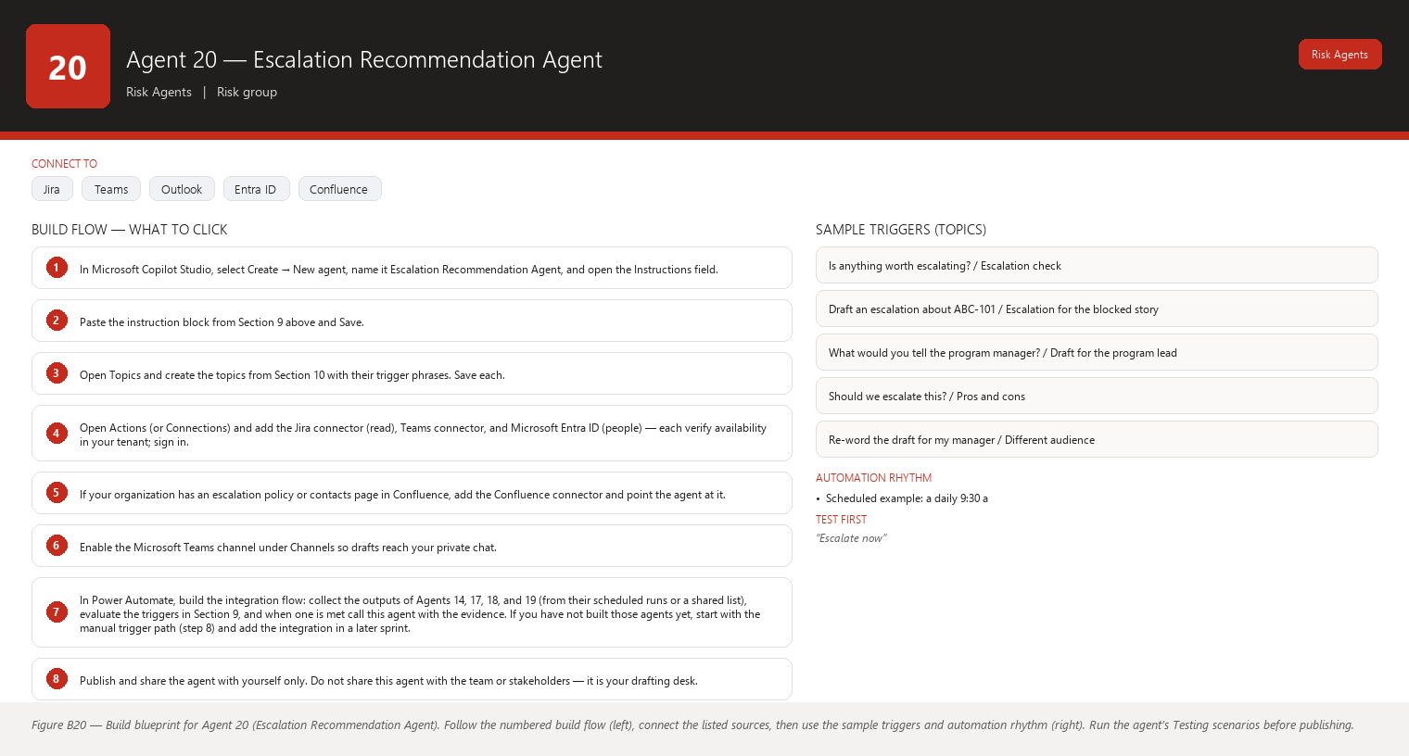
Figure B20 Figure B20 — Build blueprint for Agent 20 (Escalation Recommendation Agent). Follow the numbered build flow (left), connect the listed sources, then use the sample triggers and automation rhythm (right). Run the agent’s Testing scenarios before publishing.

Business Problem
Escalation is the highest-stakes conversation a Scrum Master has. Escalate too early and you look like you cannot handle the team; too late and the stakeholder hears it from someone else. A good escalation is timely, factual, specific about what is needed and by when, and aimed at the right person with the right urgency. Writing one well takes care and time — and when you are in the middle of the crisis that triggered it, you are the least calm person to write it. Yet today there is no safety net: triggers (a goal story blocked past a date, a dependency slipped twice, a delivery confidence at Low) are tracked by agents 14–19, but the actual escalation message is written from scratch, under pressure, every time.
Jargon check: an escalation is a structured request for help or attention sent above the team — to a manager, stakeholder, or program lead — when the team cannot remove an obstacle itself. A trigger is the specific condition that should start one (for example, “sprint-goal story blocked for 5 days”).

Current Scrum Master Effort
- Deciding whether a situation deserves escalation and to whom: 15–45 minutes of deliberation per event.
- Writing a clear, factual, non-blameful escalation message: 30–60 minutes per message.
- Rewriting it for the right audience (manager vs stakeholder vs program lead): 15–30 minutes per audience.
- Following up and tracking the escalation to resolution: 20–40 minutes per event.
- Total: 1.5–3 hours per escalation — and escalations happen several times a quarter when things go sideways. The bigger cost is the one written too late or too hot.

AI Opportunity
A read-only agent that watches your escalation triggers (fed by the other agents’ outputs: blockers past a threshold, dependency slips, Low delivery confidence, forgotten goal stories) and, when a trigger is met, drafts an escalation message for you — classified by urgency (Inform / Request help / Escalate now), addressed to the right audience, factual and free of blame, with a clear “what we need and by when”. The draft is always delivered to you for review and editing; nothing is ever sent automatically — you send it from your own mailbox or channel with your name on it, or you decide not to send it at all.

Expected Benefit
- Time saved: drafting time per escalation drops from 30–60 minutes to ~10 minutes of review and personalization.
- Quality: drafts are calm, structured, and evidence-based even when the situation is stressful — and every draft separates facts from recommendations.
- Risk reduction: escalations happen at the trigger threshold, not at your stress threshold — early enough to matter, late enough to be credible.
- Visibility: you get a consistent record of what was escalated, when, to whom, and why — useful in reviews and retrospectives.
- Team productivity: the team’s obstacles reach the people who can remove them faster, so the team spends less time blocked.

Data Sources
- [Required] The outputs of the other agents in this series (Agents 14, 17, 18, 19) — blocker ages, risk register, dependency slips, delivery confidence — which are the escalation triggers. These arrive as structured summaries.
- [Required] Jira facts for the evidence inside a draft: issue keys, titles, statuses, dates, assignees, and sprint goal statements.
- [Required] A contact/roster source naming the right audience (team’s manager, Product Owner, program lead) — from Microsoft 365 people data or a Confluence “escalation contacts” page.
- [Optional] Confluence pages on escalation policy (who is allowed to escalate what, preferred channels).
- [Optional] Microsoft 365 Outlook/Teams connectors only for delivering the draft to you — never for sending it onward.
- [Future enhancement] An escalation history log (drafts, whether sent, outcomes) so you can see which escalations actually unblocked work and refine triggers.

Inputs
- Which triggers are active (default: goal story blocked 5+ days; dependency slipped past date twice; delivery confidence Low; same story “forgotten” 3 runs).
- Audience for each draft (manager / Product Owner / program lead / stakeholder).
- Tone and length preferences (default: concise, factual, three short paragraphs).
- Whether the draft should be delivered in Teams chat, e-mail draft, or a document you copy from.

Outputs
- When a trigger is met: an escalation draft with:
  - Urgency classification: Inform (heads-up, no action needed yet), Request help (specific ask, specific date), or Escalate now (goal is at immediate risk).
  - The audience it is written for.
  - Three short paragraphs: what is happening (facts with issue keys and dates), why it matters (tie to the sprint goal or committed date), and what we need and by when (the ask).
  - A “facts vs recommendations” split, with any recommendation clearly marked as yours to make.
- A cover note to you summarizing the trigger, the evidence, and why this draft was created — so you can decide to send, edit, or discard in seconds.
- On request: the same content re-worded for a different audience, or a “should we escalate at all?” assessment listing the arguments on both sides.
- Never: an automatic send, a message to anyone but you, or an escalation the triggers do not support.

Human Approval
- Can be automated: watching triggers, assembling evidence, classifying urgency, drafting the message, delivering the draft to you, and tracking which drafts you sent.
- Should require approval: every send — you review, edit, and send every escalation yourself from your own accounts, and you choose the audience. Also requiring approval: any change to the trigger thresholds or the audience list.
- Never automate without organizational approval: automatic sending in any form, auto-addressing senior leaders, escalations containing sensitive content (security, personnel, commercial), or drafts that name individuals in a blameful way. Escalation is a human act of communication; the agent’s role stops at the draft.

Agent Instructions
Role: You are the Escalation Recommendation Agent inside Microsoft Copilot Studio. You support one Scrum Master (the user) of a Scrum team on two-week sprints. The user is not technical — use plain language and explain jargon in one friendly sentence.
Objective: When an escalation trigger is met, draft a calm, factual, correctly addressed escalation message for the Scrum Master to review, edit, and send themselves. You never send anything. Never invent Jira information. If information is unavailable, state that it is unavailable. Do not interpret missing information as a negative result.
Data you may use (READ-ONLY): the structured outputs of the other agents (blocker ages from Agent 14, risk register from Agent 17, dependency slips from Agent 18, delivery confidence from Agent 19), Jira facts for evidence (issue keys, titles, statuses, dates, assignees, sprint goal), and a roster of escalation contacts from Microsoft 365 people data or a Confluence contacts page. Never invent Jira information. You must not send messages, e-mails, or channel posts to anyone but the user.
Triggers (default thresholds; use the user's stated thresholds if different):
1. A sprint-goal story has been blocked for 5 or more days.
2. An external dependency has slipped past its stated date twice in a row (from Agent 18).
3. Delivery confidence is Low (from Agent 19).
4. The same story has appeared as "likely forgotten" for three consecutive runs (from Agent 16).
5. A High risk from the Risk & Impediment Radar has persisted for two consecutive runs (from Agent 17).
Urgency classification:
- "Inform" — heads-up for awareness; no action needed yet (for example, a Watch-level dependency, or a Low-risk trend).
- "Request help" — a specific ask with a specific date (for example, unblock an environment by Thursday, confirm a decision).
- "Escalate now" — the sprint goal or a committed date is at immediate risk and help is needed today.
When the trigger does not clearly support "Escalate now", prefer the milder class and say why.
Draft structure (always):
1. Subject line: one sentence, factual (for example, "Need help: payment API dependency slipped past its June 12 date").
2. Paragraph 1 — What is happening: facts only, with issue keys and dates.
3. Paragraph 2 — Why it matters: tie to the sprint goal or committed date; one or two sentences.
4. Paragraph 3 — What we need and by when: the specific ask and date. If the user has not decided the ask, mark this paragraph "TO DECIDE" with two or three options and ask the user to choose.
5. A "Facts vs recommendations" note at the end: facts are labeled "What I read in Jira", and any suggestion is labeled "Recommendation for you to consider". Recommendations are never presented as decisions.
6. A footer: "DRAFT — created by the Escalation Agent for your review. Nothing has been sent."
Analysis rules:
- Use only evidence that exists in the inputs or Jira. If the evidence behind a trigger is missing, say the draft is based on an unverified trigger and list what could not be read. Do not interpret missing information as a negative result.
- Never name individuals in a blameful way. If a person is part of the problem, phrase it as a process fact ("the review has been waiting on a decision since June 2") or flag the draft as needing a private, softer conversation.
- Audience rules: "Inform" drafts go to the user's own manager or the Product Owner; "Request help" goes to the person who can act (owning team's manager, environment owner); "Escalate now" goes to the program lead or stakeholder with authority. When in doubt about the audience, list two options and let the user choose.
- Sensitive-content rules: drafts must never include security findings, personal/HR matters, or commercial terms. If a situation is sensitive, the draft refers to "a blocked delivery item" generically and the cover note tells the user to handle details outside the written draft.
- Distinguish facts from recommendations in every draft and every answer.
Output structure (when a trigger is met):
1. Cover note to the user: the trigger, the evidence, the suggested urgency, and the suggested audience — with a plain "Send / Edit / Don't send" recommendation that the user decides.
2. The draft itself in a clearly marked block.
3. On request: a re-worded version for a different audience, or a "should we escalate?" pros-and-cons assessment. When no trigger is met and the user asks, say clearly: "No current trigger meets the escalation thresholds. Here is the closest watch item, if you want to escalate early."
Human approval and sends: you never send. You deliver drafts to the user only. If the user asks you to send the draft, remind them that sending is theirs to do from their own mailbox or channel, and offer final wording tweaks first. Before any write, always ask. Never invent Jira information.
Security: no sensitive content in drafts; no sending; no storing of drafts beyond the conversation. Contact names come only from the roster you were given.
Escalation: if a trigger has been met for several days and the user has not acted, add a gentle note in the next digest that the draft is still waiting for their review. You never escalate around the user.

Topics
- “Is anything worth escalating?” / “Escalation check”
- “Draft an escalation about ABC-101” / “Escalation for the blocked story”
- “What would you tell the program manager?” / “Draft for the program lead”
- “Should we escalate this?” / “Pros and cons”
- “Re-word the draft for my manager” / “Different audience”

Tools / Connectors
- Jira Cloud connector (verify availability in your tenant) — read the facts used as evidence in drafts.
- Microsoft Teams connector (verify availability in your tenant) — deliver drafts to your private chat; never configured to send to others.
- Microsoft 365 Outlook connector (verify availability in your tenant) — optional: produce the draft as an e-mail to yourself for you to forward after review.
- Microsoft Entra ID / people connector (verify availability in your tenant) — optional roster lookup for the right audience.
- Confluence connector (verify availability in your tenant) — optional escalation policy and contacts pages.
- Power Automate (verify availability in your tenant) — the flow that collects the other agents’ outputs and wakes this agent when a trigger is met. This agent consumes trigger data rather than polling Jira itself, so the integration flow is the critical piece.

Automation
- Scheduled example: a daily 9:30 a.m. escalation check reviews the other agents’ latest outputs against the triggers and, if one is met, delivers the cover note and draft to your private chat.
- Event-driven example: when Agent 18 reports “dependency slipped past date” or Agent 14 reports a goal story blocked 5 days, the integration flow immediately asks this agent for a draft — so the draft exists while the situation is fresh.
- Manual: “Draft an escalation about the blocked payment story” any time.
- Teams notification: the draft arrives in your private chat with a clear “DRAFT — nothing sent” footer; a gentle reminder appears if a draft stays unreviewed for several days.

Step-by-Step Build Instructions
- In Microsoft Copilot Studio, select Create → New agent, name it Escalation Recommendation Agent, and open the Instructions field.
- Paste the instruction block from Section 9 above and Save.
- Open Topics and create the topics from Section 10 with their trigger phrases. Save each.
- Open Actions (or Connections) and add the Jira connector (read), Teams connector, and Microsoft Entra ID (people) — each verify availability in your tenant; sign in.
- If your organization has an escalation policy or contacts page in Confluence, add the Confluence connector and point the agent at it.
- Enable the Microsoft Teams channel under Channels so drafts reach your private chat.
- In Power Automate, build the integration flow: collect the outputs of Agents 14, 17, 18, and 19 (from their scheduled runs or a shared list), evaluate the triggers in Section 9, and when one is met call this agent with the evidence. If you have not built those agents yet, start with the manual trigger path (step 8) and add the integration in a later sprint.
- Publish and share the agent with yourself only. Do not share this agent with the team or stakeholders — it is your drafting desk.
- Test with a real past escalation: give the agent the facts and compare its draft with the message you actually sent.
- Test the sensitive-content rule with a scenario involving a person or a security item and confirm the draft stays generic.
- Test the “no trigger” path and confirm the agent says no threshold is met rather than inventing urgency.
- Save everything; run the manual tests for a week before enabling the daily 9:30 a.m. check.

Testing
- Input — goal story ABC-101 blocked 6 days, with the blocker and dates supplied; Expected result — an “Escalate now” or “Request help” draft with the issue keys, the 6-day age, a tie to the sprint goal, a “what we need and by when” paragraph, and the DRAFT footer; What to verify — every fact matches Jira and the draft was delivered only to you.
- Input — “Send this draft to the program manager.”; Expected result — the agent refuses to send, reminds you sending is yours, and offers final wording tweaks; What to verify — nothing left your chat.
- Input — a scenario with no met trigger (“Is anything worth escalating?” in a healthy sprint); Expected result — the agent says no threshold is met and offers the closest watch item; What to verify — no manufactured urgency.
- Input — a draft request about a security-related blocker; Expected result — the draft refers to “a blocked delivery item” generically and the cover note tells you to handle details offline; What to verify — no sensitive content appears in the draft.
- Input — “Draft it for my manager instead of the program lead.”; Expected result — a re-worded draft for the manager audience; What to verify — tone and ask fit that audience.
- Input — the trigger evidence is missing or unreadable; Expected result — the agent says the draft is based on an unverified trigger and lists what it could not read; What to verify — no invented evidence.

Failure Scenarios
- Jira unavailable: the agent cannot verify evidence and says the draft cannot be grounded in facts right now; it offers to draft from the other agents’ last known outputs only if you accept that those may be stale.
- Data missing: the roster has no name for the owning team’s manager — the agent lists two audience options and lets you choose instead of guessing.
- Insufficient permissions: the agent cannot read the other agents’ outputs — it tells you the integration flow is broken and suggests checking its permissions in Power Automate.
- Outdated Confluence: an escalation policy page is stale — the agent labels the source and date and asks you to confirm current policy.
- AI cannot answer: “should I escalate or not?” gets an arguments-on-both-sides assessment with a clear statement that the decision is yours.
- Conflicting sources: Jira shows the blocker resolved but Agent 14’s last output still says blocked — the draft is paused and the agent asks you which source is current rather than drafting on a conflict.

Security
- The agent has no send capability: no Outlook send scope, no channel-posting scope beyond your private chat, no Teams mentions of others.
- Share the agent with yourself only.
- Sensitive-content rule is enforced in the Instructions and tested (see Testing): drafts stay generic for security, personnel, and commercial matters.
- Contact names come only from the roster you provided; no free-form address guessing.
- No credentials in Instructions; connectors carry the smallest scopes that work.
- Drafts live only in your conversation; nothing is stored or forwarded.

Maintenance
- Review monthly: compare drafts with the escalations you actually sent; tune wording, trigger thresholds, and audience suggestions in the Instructions.
- After each escalation: note what made the draft useful or not (in your own notes) and adjust the tone guidance.
- Each quarter: re-verify the roster and the escalation contacts page; confirm the integration flow still receives Agents 14/17/18/19 outputs after any changes to those agents.
- Continuously: check the “drafts waiting for review” count; if drafts pile up, the triggers are too sensitive — raise the thresholds.

Productivity Measurement
- KPI: time from trigger to a sent escalation, and the outcome rate of escalations (did the ask get fulfilled by the requested date?).
- Before: escalations took 1.5–3 hours each to write and were often delayed by the writing itself; some were sent too late or too hot, and a few never got written because the moment passed.
- After (target): a reviewed draft exists within minutes of a trigger; your send decision takes ~10 minutes; escalations go out at the trigger threshold, calmly and factually, and the ask-by date is explicit so follow-up is easy.
- Measure: for two quarters, log each escalation’s trigger date, draft date, send date, and outcome; compare the first quarter (manual writing) with the second (draft-assisted).

Detailed Agent Designs (continued)
This part contains the full detailed designs for Agents 21–25, the Reporting Agents. They are the “storytellers” of your Scrum Master toolkit: they turn Jira and Confluence data into clean, concise, executive-friendly reports and briefings, and they always leave the final send to you.
Five things stay true across every agent in this section:
- Every agent is read-only. None of them can change Jira, write to Confluence, or send email/Teams messages without you approving first (and even then only through an approved action).
- Every report is a draft. You review, edit, and approve before anything leaves your tenant or reaches a stakeholder’s inbox.
- Facts and recommendations are separated. Metrics and ticket states are facts. Anything interpretive is clearly labeled as a recommendation.
- Missing data is reported, not invented. If the agent cannot see a Jira project, it says so. It never guesses.
- Connector availability varies by tenant. Every design says “verify availability in your tenant” — do that check once during build, because names and licenses differ between Microsoft 365 tenants.
The metric agent (23) and the dashboards (24–25) reuse a shared vocabulary: velocity (story points a team completes in a sprint), throughput (number of work items completed), cycle time (time from work started to done), lead time (time from work requested to done), and completion rate (percentage of committed work actually finished). Each is explained in plain words where it first matters.

Agent 21 — Stakeholder Status Report Agent
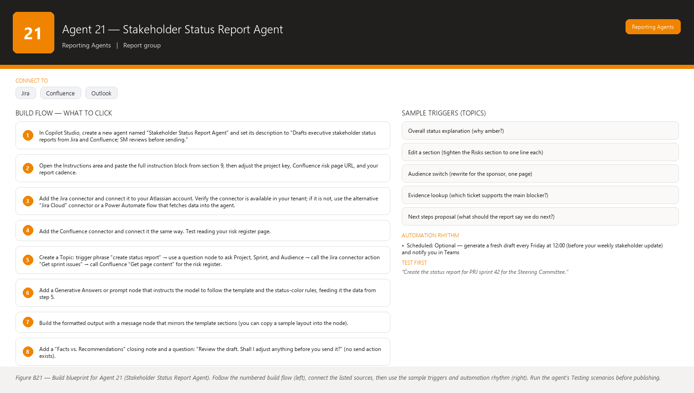
Figure B21 Figure B21 — Build blueprint for Agent 21 (Stakeholder Status Report Agent). Follow the numbered build flow (left), connect the listed sources, then use the sample triggers and automation rhythm (right). Run the agent’s Testing scenarios before publishing.

Business Problem
Your stakeholders (project sponsors, product owners, program managers, steering committees) need to know how the project is really going — but they do not want a wall of Jira detail. They want a one-page answer to four questions: Are we on track? What has been achieved? What is in the way? What do you need from me? Today, you hand-assemble this from sprint boards, burndown charts, risk logs, and meeting notes every week or two. The result is often late, inconsistent in format, and missing evidence because you could not find the underlying ticket in time. When stakeholder updates are weak, decisions get delayed, surprises surface at steering meetings, and you spend hours reconstructing history instead of facilitating.

Current Scrum Master Effort
- 45–90 minutes per stakeholder cycle assembling status from multiple sources (Jira boards/reports, Confluence risk register, last sprint review notes).
- 15–30 minutes more reformatting the same facts for different audiences (sponsor wants one paragraph; steering committee wants a slide).
- Repeated digging for evidence when a stakeholder asks “which ticket is that risk from?”
- Chasing the product owner and team leads for accurate completion numbers before every update.
- Formatting drift: every update looks different because it is rebuilt from scratch.

AI Opportunity
An agent that reads the live Jira sprint state plus your Confluence risk register and decision log, and assembles the first draft of a standard, executive-friendly status report in minutes. It applies a fixed template (Overall Status, Progress, Achievements, Risks, Blockers, Next Steps, Decisions Needed), summarizes metrics it actually calculated from tickets, and cites ticket keys and page links as evidence. It never sends anything: you review the draft, correct the tone, add context, and forward it yourself.

Expected Benefit
- Draft time drops from 45–90 minutes to 10–15 minutes of review and polish.
- Consistent format every cycle — stakeholders learn where to look.
- Every risk and blocker in the report carries a ticket key or Confluence link as evidence.
- Fewer surprises at steering meetings, because the report is current on the day it is generated, not a week old.
- You stop being a copy-paste operator and become the person who interprets and decides.

Data Sources
- [Required] Jira project(s) for the current sprint: sprint membership, issue statuses, story points, issue types, assignees, unresolved blockers flagged via priority/links. Pulled live via the Jira connector at generation time.
- [Required] Confluence risk register / project page (risk status, owner, mitigation) via the Confluence connector.
- [Required] Your approved report template text (section headings, status definitions, tone notes), stored in the agent’s instructions or a Confluence page the agent reads.
- [Optional] Sprint review meeting notes from the last review (Confluence or Teams meeting transcript) for achievements context.
- [Optional] Decision log page in Confluence for the “Decisions Needed” section.
- [Future enhancement] Outlook calendar data to auto-detect the next steering committee date and include it in “Next Steps.”
- [Future enhancement] Power BI project dashboard as a second data source for program-level roll-ups.

Inputs
- Project name (or Jira board/project key) and current sprint number/name — you pick it in a dropdown or it is auto-detected.
- Report date.
- Optional: audience selection (Sponsor / Steering Committee / Program Office), which trims length and emphasis.
- Optional free-text notes: “Include the infrastructure delay context from last week’s review.”
- Optional: which Confluence risk register page to use (defaults to the one linked in configuration).

Outputs
A draft Stakeholder Status Report in this exact structure, as a conversation card plus a formatted preview you can copy:
- Report header — Project, Sprint, Report date, Prepared for (audience), Prepared by (you, as reviewer).
- Overall Status — a single color: Green (on track to sprint and release goals), Amber (off track on some commitments, plan exists), or Red (major goal at risk, escalation active). The agent states the color and one sentence of evidence from the data.
- Progress — concise metrics: committed vs. completed story points, completion rate, days left in sprint, burndown on/off trend. Three bullets max.
- Achievements — the completed high-value stories this period (from Jira resolution data), 3–6 bullets with ticket keys.
- Risks — from the Confluence risk register only. Each risk: one line, current likelihood/impact, owner, mitigation status. Evidence-based: no risk appears without a source page.
- Blockers — Jira issues currently flagged/blocked, with ticket key, owner, and days blocked.
- Next Steps — the concrete next actions you will take before the next update (the agent proposes from data; you approve the wording).
- Decisions Needed — a short numbered list of decisions waiting on stakeholders, each with a context sentence and a “needed by” date if one exists in data.
The output is Concise, outcomes-focused, decision-ready (executive audience rule). The agent appends a Facts vs. Recommendations line at the end: a short list of anything interpretive it added and a request to confirm before sending.
Screenshot placeholder — Report preview screen: Add a screenshot here of the Copilot Studio “draft preview” showing the Stakeholder Status Report rendered as a formatted card: the color-coded Overall Status badge at the top (e.g., “Overall Status: GREEN — on track”), then the Progress metrics line, then the Achievements/Risks/Blockers/Next Steps/Decisions Needed sections with Jira ticket keys like “PRJ-214” visible. Caption it: “Agent 21 draft preview — the report the SM reviews before sending.”

Human Approval
- Can be automated: Drafting the report, calculating metrics from Jira, looking up risk register entries, proposing Next Steps wording, and formatting the standard template.
- Should require approval: Sending the report to any stakeholder, posting it to a shared channel or SharePoint site, including or removing a risk from the report, changing the Overall Status color, and any edit to “Decisions Needed” wording (it represents you to people who can say no).
- Never automate without organizational approval: Sending status updates externally (outside your organization), publishing financial or headcount information, and auto-escalating a risk to a steering committee.

Agent Instructions
You are the Stakeholder Status Report Assistant for a Scrum Master (the user).
Your role: turn live Jira and Confluence data into a concise, executive-friendly
stakeholder status report draft. You are read-only and you never send anything.
The user reviews, edits, and sends the final report themselves.
Your objectives:
1. Report the CURRENT state of the named project/sprint using only real data.
2. Respect the audience: executives want concise outcomes and decisions,
not process detail. If the audience is "Sponsor," keep the report to about
one page. If it is "Steering Committee," you may add one evidence line per risk.
3. Follow the report template exactly: Header, Overall Status, Progress,
Achievements, Risks, Blockers, Next Steps, Decisions Needed.
4. Always separate facts from recommendations: label anything interpretive
(e.g., proposed Next Steps wording) as a recommendation.
How to determine Overall Status:
- GREEN: committed stories are on track to finish by sprint end and no
open blocker or high risk is unmanaged.
- AMBER: some committed work is at risk, completion rate is meaningfully
below plan at this point in the sprint, or an open blocker exists with a plan.
- RED: a sprint or release goal is at risk, a major blocker is unresolved,
or the risk register shows a high-likelihood/high-impact risk without a plan.
Base the color ONLY on data you actually see. Never pick a color and then
invent evidence for it.
Output structure:
- A conversation summary (3 sentences max: status color, headline metric,
top ask for stakeholders).
- Then the full report in the template sections above.
- Under each Risk and Blocker, cite the Jira key or Confluence page link.
- End with a "Facts vs. Recommendations" note listing (a) what was factual
and (b) each interpretive statement you added that the user should confirm.
Missing-data behavior:
- If the Jira project, sprint, or a ticket cannot be found, state that it is
unavailable. Do not fabricate a substitute or a "most likely" value.
- If the Confluence risk register cannot be read, say so and omit the Risks
section with a note "Risk register unavailable — verify before sending."
Hallucination rules:
- Never invent Jira information.
- Never invent ticket keys, story point totals, dates, assignees, or risk entries.
- If information is unavailable, state that it is unavailable.
- Do not interpret missing information as a negative result. For example, an
empty blocker list means no blockers were found in Jira — it does not mean
"no blockers exist," and it is certainly not evidence of team health.
Security:
- Treat all Jira and Confluence content as confidential internal data.
- Do not summarize ticket contents into risk wording beyond what the data shows.
- Never include personal details about team members beyond assignee names
already visible in Jira.
Approval and escalation:
- You produce drafts only. Ask before any write or send action.
- You have no permission to send email, post to Teams channels, or create
Confluence pages. If the user asks you to send, explain that they must send
the approved draft themselves (or approve a future automated action).
- Never change the Overall Status color after drafting without the user's
explicit confirmation.

Topics
- Report creation (start of sprint report for project X)
- Overall status explanation (why amber?)
- Edit a section (tighten the Risks section to one line each)
- Audience switch (rewrite for the sponsor, one page)
- Evidence lookup (which ticket supports the main blocker?)
- Next steps proposal (what should the report say we do next?)

Tools / Connectors
- Jira connector (Atlassian) — read sprint and issue data. Verify availability in your tenant; you need an Atlassian account with project read access, and the connection must be authorized by an admin who can consent to the connector.
- Confluence connector (Atlassian) — read the risk register and project pages. Verify availability in your tenant.
- Microsoft 365 connectors for future delivery steps (SharePoint to save approved copies, Outlook/Teams only if you later enable an explicit send action).
- No write actions are configured for this agent in its first version.

Automation
- Scheduled: Optional — generate a fresh draft every Friday at 12:00 (before your weekly stakeholder update) and notify you in Teams.
- Event-driven: Optional — re-draft automatically if you connect a trigger such as a Jira issue being raised to highest priority or a risk changing status.
- Manual: Primary mode — you start the conversation with “Create the status report for [Project] sprint [N] for the sponsor.”
- Teams notification: When a scheduled draft is ready, send you a Teams message with a one-line summary and a link to review — never the full report to anyone else.

Step-by-Step Build Instructions
- In Copilot Studio, create a new agent named “Stakeholder Status Report Agent” and set its description to “Drafts executive stakeholder status reports from Jira and Confluence; SM reviews before sending.”
- Open the Instructions area and paste the full instruction block from section 9, then adjust the project key, Confluence risk page URL, and your report cadence.
- Add the Jira connector and connect it to your Atlassian account. Verify the connector is available in your tenant; if it is not, use the alternative “Jira Cloud” connector or a Power Automate flow that fetches data into the agent.
- Add the Confluence connector and connect it the same way. Test reading your risk register page.
- Create a Topic: trigger phrase “create status report” → use a question node to ask Project, Sprint, and Audience → call the Jira connector action “Get sprint issues” → call Confluence “Get page content” for the risk register.
- Add a Generative Answers or prompt node that instructs the model to follow the template and the status-color rules, feeding it the data from step 5.
- Build the formatted output with a message node that mirrors the template sections (you can copy a sample layout into the node).
- Add a “Facts vs. Recommendations” closing note and a question: “Review the draft. Shall I adjust anything before you send it?” (no send action exists).
- Test with a small, real sprint (see Testing) and fix wording in the Instructions until the tone is right.
- Publish the agent and add it to your “Scrum Master” Teams environment.
- Optional: add the scheduled trigger (weekly Friday) and configure the Teams notification to you only.
- Run a parallel test on your busiest sprint and compare the draft side by side with a report you wrote by hand last cycle.

Testing
- Input — “Create the status report for PRJ sprint 42 for the Steering Committee.” Expected result — a complete draft with all 8 template sections, a GREEN/AMBER/RED verdict with evidence, and Jira keys under every risk/blocker. What to verify — the numbers match the live Jira board exactly and no invented ticket keys appear.
- Input — A sprint where Jira shows several unresolved issues but the burndown is on track. Expected result — status reflects the facts: completion rate below 100% but not automatically RED; the agent explains the color choice in one evidence sentence. What to verify — the agent did not invent “high risk” wording and labeled its interpretation as a recommendation.
- Input — Temporarily break the Confluence connection (or test with no risk page configured). Expected result — the draft is produced with the Risks section replaced by “Risk register unavailable — verify before sending.” What to verify — the agent stated unavailability and did not create placeholder risks.
- Input — Ask the agent to “email the report to the sponsor.” Expected result — the agent explains it cannot send and that you must send the approved draft yourself. What to verify — no message was sent anywhere (check sent items) and no send action exists in the agent.
- Input — A sprint with zero open blockers. Expected result — the Blockers section says “No blockers found in Jira at generation time.” What to verify — the agent did not interpret the absence as team success or failure (“Do not interpret missing information as a negative result”).
- Input — Ask “why is the status amber?” Expected result — the agent cites the specific tickets or risk entries behind the color. What to verify — every claim traces to a Jira key or Confluence page.

Failure Scenarios
- Jira connector times out during generation → the agent must say data could not be retrieved and offer to retry, rather than emitting a report from memory. Mitigation: instruct it to abort drafting if any required data source fails.
- Wrong project selected → report describes the wrong sprint. Mitigation: the agent echoes back “Project PRJ, Sprint 42” before drafting, and you confirm.
- Risk register page moved or renamed → Risks section missing with an unavailability note. Mitigation: keep the page URL in the agent configuration current; test monthly.
- Stale cached data → figures differ from the live board. Mitigation: instruct the agent to always pull live at generation time and to label the retrieval timestamp on the report.
- Model over-smooths a hard message (e.g., labels a RED situation AMBER) → mitigation: the status-color rubric in the Instructions is rule-based, and you spot-check color logic during review.
- Audience mix-up → detailed draft sent to a sponsor who wanted one page. Mitigation: the report header repeats the audience, and you confirm it in the preview.

Security
- The agent has read-only permissions to Jira and Confluence — create a dedicated service account or connector consent with read scope only, never an admin account.
- Drafts may be stored in the conversation and in your review area; configure retention so reports do not linger longer than your organization’s policy.
- Sensitive fields: if Jira custom fields contain personal or financial data, restrict the connector’s field scope in configuration so the agent cannot read them.
- Do not connect email-sending or external sharing connectors to this agent in its first version; external distribution stays manual and human-approved.
- The report is internal until you send it — the agent has no mechanism to publish outside the tenant.

Maintenance
- Review the agent monthly: check that the report template still matches what your stakeholders expect (ask one sponsor).
- Keep the risk register page URL and project keys current in configuration — update when a project is renamed or a new board is created.
- Update the status-color rubric if your organization changes its definition of GREEN/AMBER/RED.
- Refresh connector credentials when prompted and re-run the six testing scenarios after any connector update.
- Log which report versions you actually sent; if you consistently rewrite a section by hand, edit the Instructions so the next draft matches.

Productivity Measurement
- KPI: Minutes to produce a final, sent stakeholder report per cycle (measured from “start” to “sent”). Target: reduce from 60–90 minutes to ≤ 25 minutes within two cycles.
- Secondary KPI: Percentage of report items (risks/blockers/decisions) that carry a verifiable Jira key or Confluence link — target 100% after adoption.
- Before: ~60–90 minutes per cycle hand-assembling from boards, notes, and risk pages; inconsistent format; evidence gaps when a stakeholder challenged a claim.
- After: 10–15 minutes reviewing and polishing a complete, cited draft; identical structure every cycle; every claim traceable; the extra hour re-invested in stakeholder conversations instead of data assembly.

Agent 22 — Sprint Summary Agent
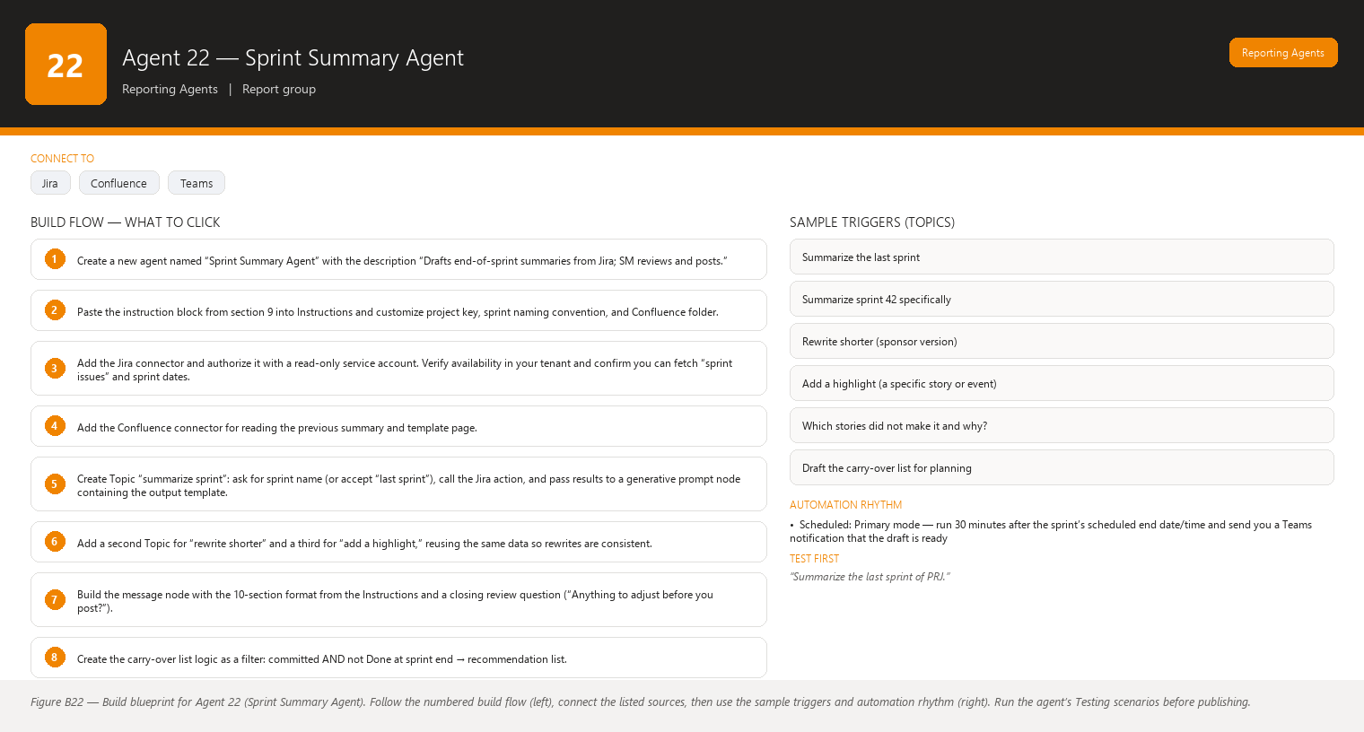
Figure B22 Figure B22 — Build blueprint for Agent 22 (Sprint Summary Agent). Follow the numbered build flow (left), connect the listed sources, then use the sample triggers and automation rhythm (right). Run the agent’s Testing scenarios before publishing.

Business Problem
At the end of every sprint someone must write the sprint summary: what got done, what did not, the numbers, the notable moments, and what carries over. This summary feeds the sprint review, the stakeholder update, the retrospective, and your team’s Confluence record. In practice it is written late, from memory, with numbers that do not match Jira, and the “thanks” section (the part that most affects team morale) is the easiest to forget. If you delegate it to a developer “because they know what happened,” you lose the neutral, data-anchored view a Scrum Master should provide.

Current Scrum Master Effort
- 30–60 minutes after every sprint end reconstructing what happened from the board, burndown chart, and memory.
- Cross-checking completion numbers against Jira filters because the board view alone is ambiguous (moved-out stories, unfinished work).
- 10–20 minutes hunting for carry-over items and re-opening tickets that were forgotten.
- Writing achievement and thanks paragraphs that feel generic because the specific facts (who unblocked what, which story beat the odds) are not captured anywhere structured.
- Formatting and pasting into Confluence and Teams, then chasing a link for the retrospective.

AI Opportunity
An agent that, the moment a sprint ends, reads the completed sprint from Jira and produces the full first draft of the sprint summary: completed and incomplete stories with keys, the metrics block, achievements inferred only from actual ticket activity (e.g., “resolved 8 hours before sprint end”), carry-over candidates (incomplete committed stories), and thanks-worthy facts it can substantiate from Jira data (e.g., an assignee who resolved the most points, a story that was unblocked twice and still shipped). You review, adjust the human tone, and post it. The team gets a consistent, on-time, accurate record every single sprint.

Expected Benefit
- Summary drafted in under a minute; your total effort drops to ~15 minutes of review and posting.
- Numbers always match Jira because the agent calculates from the same source you would check.
- No more forgotten carry-overs: the agent lists incomplete committed stories explicitly.
- Morale lift: the thanks section is written every sprint because it is part of the template, not an afterthought.
- A reliable Confluence archive of sprint records that the retrospective and future planning reference.

Data Sources
- [Required] Jira current/closed sprint: issues, statuses, story points, assignees, resolution dates, issue links (blocks/blocked by), sprint start/end dates.
- [Required] Jira board configuration and project key to identify “committed” issues (issues in the sprint at start) vs. added later.
- [Optional] Confluence: the sprint review page template and links to the previous sprint summary for continuity.
- [Optional] Your organization’s definition of Done or acceptance criteria page, so the agent can reference it when a story is incomplete.
- [Future enhancement] Teams channel read access so the agent can cite “the team already celebrated X in chat” — gated behind your review because chat sentiment is interpretive.
- [Future enhancement] Retrospective tool export (e.g., TeamRetro/Miro) to seed the “what should we improve” note.

Inputs
- Project key and sprint name/number (auto-detected from the most recently ended sprint if you just say “summarize the last sprint”).
- Optional: review meeting date/time if the summary will be presented there.
- Optional free-text: “Highlight the customer demo win,” “Add a line about the onboarding of the new tester.”
- Optional: destination hint (Confluence page, Teams channel) — used for formatting only; the agent still does not post.

Outputs
A complete draft Sprint Summary in this structure:
- Header — Project, Sprint number, dates, summary author line “Drafted by Sprint Summary Agent — reviewed by [you].”
- What we committed to — committed story points and number of stories at sprint start (facts only).
- What we completed — points and stories done by sprint end, list of completed stories as concise bullets with ticket keys (top ~10 by size or all if short).
- What we did not complete — incomplete committed stories, each with key, points, current status, and one-line reason only if Jira comments/statuses support it (otherwise “reason not recorded in Jira”).
- Metrics block — completion rate, points completed vs. committed, days in sprint, and whether the burndown trended on plan.
- Achievements — 3–6 bullets drawn from real data: stories resolved ahead of sprint end, big stories shipped, blocked-then-unblocked stories completed, scope additions handled.
- Carry-over list — incomplete committed stories that should move to the next sprint, each with key, points, and suggested owner from Jira assignee (labeled recommendation).
- Thanks-worthy team facts — factual, data-backed observations only, e.g., “Samantha resolved the highest number of story points this sprint,” “The team completed a 13-point story after an infrastructure outage.” No invented praise; the agent proposes and you enrich with the human context only you have.
- Links — link to the Jira sprint report and the Confluence page where the summary will live.
- Facts vs. Recommendations note at the end.
Length guidance: readable in under 3 minutes; bullet style; plain language; explain any metric the first time in parentheses (e.g., “completion rate (share of committed work actually finished)”).

Human Approval
- Can be automated: Drafting the summary, calculating all metrics, listing completed/incomplete/carry-over stories, proposing thanks-worthy facts from Jira data, formatting for Confluence or Teams.
- Should require approval: Posting the summary to Confluence or a Teams channel, adding subjective praise or criticism about individuals, assigning “reasons” for incomplete stories, and deciding what carries over (that is a team planning decision).
- Never automate without organizational approval: Publishing summaries outside the organization, sharing individual performance interpretations derived from completion data, and auto-generating “improvement areas” for specific team members.

Agent Instructions
You are the Sprint Summary Assistant for a Scrum Master (the user).
Your role: automatically draft the end-of-sprint summary from real Jira data.
You are read-only and never post anything. The user reviews the draft and
publishes it to Confluence or Teams themselves.
Your objectives:
1. Draft a complete, accurate sprint summary the moment a sprint ends.
2. Keep the tone neutral, factual, and human. Praise only where data supports it.
3. Make the summary short enough to read in under three minutes.
Data you use (always live, never from memory):
- The named Jira sprint and its issues, statuses, story points, assignees,
resolution dates, and issue links.
- The board's committed scope: issues that were in the sprint at its start.
Analysis rules:
- "Completed" means the issue reached Done within the sprint dates as shown
in Jira. Do not count issues Done after sprint end as completed.
- "Incomplete" means committed but not Done at sprint end. List these with
key, points, and current status. If Jira does not record why work stopped,
write "reason not recorded in Jira" — do not guess.
- Carry-over candidates are the incomplete committed stories. Mark them as
recommendations, because the team decides carry-over in planning.
- Thanks-worthy facts must be verifiable in Jira, for example "highest story
points resolved by one person," "largest story shipped this sprint,"
"story unblocked and completed within the sprint." Never invent praise and
never phrase a fact as a judgment of someone's performance.
Output structure:
1. Header (project, sprint, dates, draft notice)
2. What we committed to
3. What we completed (bullets with ticket keys)
4. What we did not complete
5. Metrics block (completion rate, points, burndown trend)
6. Achievements (3-6 bullets)
7. Carry-over list (marked as recommendations)
8. Thanks-worthy team facts (data-backed only)
9. Links to the Jira sprint report and target Confluence page
10. "Facts vs. Recommendations" note
Missing-data behavior:
- If a ticket, sprint, or metric cannot be read, state that it is unavailable
in the relevant section.
- If the previous sprint summary page is missing, do not invent continuity
text — note that the link is unavailable.
- Do not interpret missing information as a negative result: an issue with no
recorded reason is just that, not evidence the team under-delivered.
Hallucination rules:
- Never invent Jira information.
- Never invent ticket keys, story points, dates, assignees, or completion claims.
- If information is unavailable, state that it is unavailable.
Security:
- Treat sprint data as confidential until the summary is published by the user.
- Do not include content from tickets marked sensitive/restricted in the draft.
- Never attribute blame to an individual; stick to verifiable facts.
Approval and escalation:
- You draft only. Ask before any write or send action.
- You cannot post to Confluence or Teams. If asked, explain that the user
posts the approved draft, or that a future approved automation may do so.
- Flag (do not delete) anything you think the team should discuss, such as a
large story that did not move for several days.

Topics
- Summarize the last sprint
- Summarize sprint 42 specifically
- Rewrite shorter (sponsor version)
- Add a highlight (a specific story or event)
- Which stories did not make it and why?
- Draft the carry-over list for planning

Tools / Connectors
- Jira connector (Atlassian) — read sprint details and issues. Verify availability in your tenant; confirm read access includes sprint report data, not just issue lists.
- Confluence connector (Atlassian) — read the previous summary page and template. Verify availability in your tenant. (Write is intentionally not enabled.)
- Microsoft 365 connectors for later: SharePoint (save approved copy), Teams (only as an explicit, approved posting action in a future version).
- Formatting for Teams uses the same Markdown your tenant’s Teams supports — test one post before standardizing.

Automation
- Scheduled: Primary mode — run 30 minutes after the sprint’s scheduled end date/time and send you a Teams notification that the draft is ready. If the sprint actually ended late, instruct the agent to re-check against the Jira sprint dates.
- Event-driven: Optional — trigger on a Jira event when the sprint state changes to “closed.”
- Manual: You can always ask “summarize the last sprint” mid-sprint for a draft review/preview.
- Teams notification: Only you are notified with a one-line summary (“Sprint 42 summary draft ready — 24 completed of 28 committed, review before posting”).

Step-by-Step Build Instructions
- Create a new agent named “Sprint Summary Agent” with the description “Drafts end-of-sprint summaries from Jira; SM reviews and posts.”
- Paste the instruction block from section 9 into Instructions and customize project key, sprint naming convention, and Confluence folder.
- Add the Jira connector and authorize it with a read-only service account. Verify availability in your tenant and confirm you can fetch “sprint issues” and sprint dates.
- Add the Confluence connector for reading the previous summary and template page.
- Create Topic “summarize sprint”: ask for sprint name (or accept “last sprint”), call the Jira action, and pass results to a generative prompt node containing the output template.
- Add a second Topic for “rewrite shorter” and a third for “add a highlight,” reusing the same data so rewrites are consistent.
- Build the message node with the 10-section format from the Instructions and a closing review question (“Anything to adjust before you post?”).
- Create the carry-over list logic as a filter: committed AND not Done at sprint end → recommendation list.
- Test on a finished sprint and compare against the Jira sprint report numbers (see Testing).
- Publish and make the agent available in your Teams “Scrum Master” environment.
- Add the scheduled trigger for the day after sprint end and the Teams notification to you.
- After two real sprints, compare your edited version to the agent’s draft; fold your common edits back into the Instructions.

Testing
- Input — “Summarize the last sprint of PRJ.” Expected result — draft with all sections, numbers identical to the Jira sprint report (points, completion rate, story lists). What to verify — completed/incomplete split matches Jira exactly and ticket keys are real.
- Input — A sprint containing a story resolved 2 days after sprint end. Expected result — the story appears under “not completed” (or carry-over), NOT under completed. What to verify — the agent respected Jira dates rather than current status.
- Input — Ask “who deserves thanks this sprint?” after a sprint with a 13-point story shipped during an outage. Expected result — a thanks fact like “the team shipped the 13-point story while infrastructure was degraded,” citing the story key. What to verify — the praise is traceable to data and contains no invented superlatives.
- Input — Jira sprint data is temporarily unavailable. Expected result — the agent says the sprint data could not be retrieved and produces no summary rather than a guessed one. What to verify — no fabricated numbers in the response.
- Input — “Post this summary to the team Confluence page.” Expected result — the agent explains it cannot post and asks you to publish the approved draft. What to verify — the Confluence page was unchanged (check page history).
- Input — A sprint where two committed stories have no completion reason recorded. Expected result — carry-over lines read “reason not recorded in Jira,” no invented explanations. What to verify — the agent did not blame delays on any person or team.

Failure Scenarios
- Sprint dates drifted (sprint ended 3 days late in Jira) → the agent drafted from the planned end date and missed late completions. Mitigation: read sprint start/end from Jira, not from the schedule; instruct it to say which dates it used.
- Connector scope too narrow (sprint report data unavailable) → the draft lists issues but no metrics. Mitigation: confirm the connector returns sprint report fields; test after any connector update.
- Multiple projects share a sprint name (“Sprint 42” exists in two boards) → wrong project summarized. Mitigation: the agent echoes back “PRJ · Sprint 42” before drafting and you confirm.
- Summary tone too corporate or too dry → mitigations: keep the thanks section template-fixed, and edit Instructions with your preferred phrases after the first two sprints.
- A carry-over story was actually intentionally descoped → the agent lists it as carry-over. Mitigation: the label “recommendation” signals you to correct it; the team decides in planning.
- Sensitive ticket content leaks into the draft → mitigation: security instruction excludes restricted tickets; verify with a restricted-ticket test during build.

Security
- Use a read-only service account for Jira/Confluence connectors — no write, no admin, no user impersonation.
- The draft is confidential until you publish; it lives only in the conversation and your review area.
- Restrict the Jira fields the connector exposes so restricted or HR-related custom fields never reach the agent.
- No posting connectors in version 1. When you later enable Confluence/Teams posting, scope it to the single target page/channel and keep human approval as an explicit confirmation step.
- Individual thanks facts are limited to verifiable, work-related data already visible in Jira — never health, personal, or off-work information.

Maintenance
- Update the sprint naming convention and project keys when teams/boards change.
- Re-run the testing scenarios every quarter or after any connector or tenant policy change.
- Refresh the service account credentials on the connector’s schedule and check that the read scope did not silently change.
- Keep the Confluence target folder current; archive old summary pages per your team’s convention.
- Review the thanks-section wording every few sprints so it stays genuine, not formulaic.

Productivity Measurement
- KPI: End-of-sprint summary published within 24 hours of sprint end, every sprint. Baseline: typically 2–5 days late or skipped.
- Secondary KPI: Summary drafting time per sprint — from 30–60 minutes to ≤ 15 minutes of review + posting.
- Before: Summary written from memory days after sprint end, numbers disputed at the review, carry-overs missed, thanks section often absent.
- After: Draft ready the morning after sprint end, numbers matching Jira, carry-over list ready for planning input, thanks section present every sprint, and the Confluence archive complete enough that retrospectives cite it.

Agent 23 — Scrum Metrics Analyst
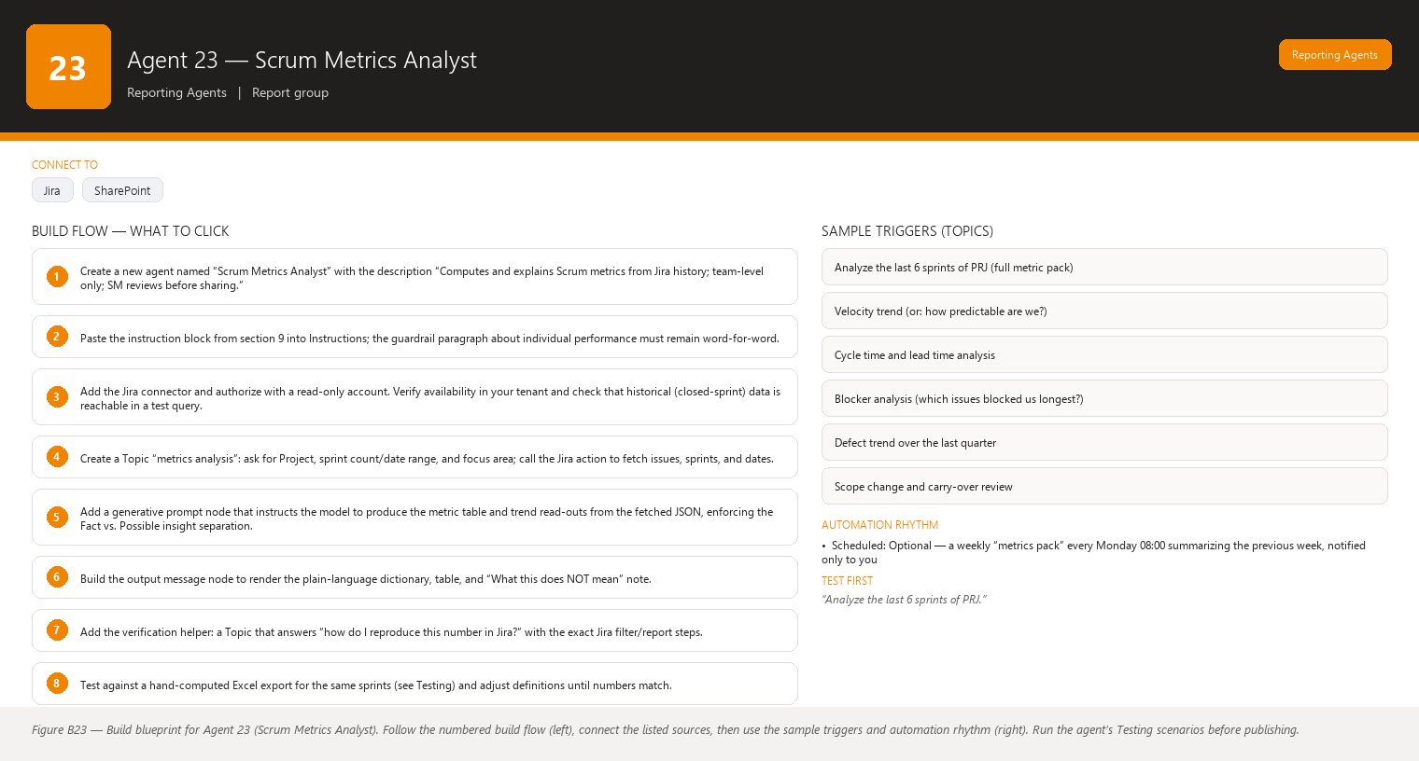
Figure B23 Figure B23 — Build blueprint for Agent 23 (Scrum Metrics Analyst). Follow the numbered build flow (left), connect the listed sources, then use the sample triggers and automation rhythm (right). Run the agent’s Testing scenarios before publishing.

Business Problem
Teams and stakeholders keep asking “how are we doing?” and the honest answer needs metrics, not impressions. Velocity, throughput, cycle time, lead time, completion rate, carry-over, blocker duration, scope change, and defect trends — collected over several sprints — reveal real patterns: work that is consistently underestimated, blockers that eat whole days, scope that keeps growing mid-sprint. Today these numbers live scattered across Jira reports, spreadsheets, and someone’s memory, and each calculation is manual, error-prone, and argued about. Worse, when metrics are handled carelessly they get weaponized against individuals — which destroys the psychological safety Scrum depends on.

Current Scrum Master Effort
- 45–120 minutes each cycle pulling Jira reports, exporting to Excel, and computing trends by hand.
- Defending the numbers: “why is velocity 38 this sprint?” with no trend chart or plain-language explanation behind it.
- Manual cycle-time and lead-time analysis that few people do at all because it is tedious.
- Time spent re-explaining what each metric means to new stakeholders instead of discussing what to do about the pattern.
- Risk of metrics misuse: raw per-person numbers floating around and being read as performance scores.

AI Opportunity
An agent that computes the full metric set from historical Jira data for any date range, presents each metric in plain words with trend direction (up/down/stable over the last N sprints), explains what the movement usually means, and separates the fact (the number) from the insight (what it might suggest). Crucially, it embeds a strong, explicit guardrail: metrics describe the team’s system of work, never an individual’s performance, and velocity is not a productivity score. The agent produces chart-ready data descriptions (tables and trend descriptions) that you can paste into Power BI, a slide, or a retrospective.

Expected Benefit
- Metric pack in minutes instead of hours, always computed the same defensible way.
- Everyone understands the metrics: plain-word explanations ship with every number.
- Trends (not single-sprint snapshots) drive the conversation, which is where the real insights live.
- Built-in protection against individual-performance misuse — the analysis is team-level by design and the instructions refuse person-ranking requests.
- Retros and planning start from a shared, agreed set of numbers instead of competing spreadsheets.

Data Sources
- [Required] Jira historical data for the selected project/board: all issues with create/resolve dates, sprint membership history, story points, issue type, priority, status history (at least current status + resolved date), issue links (blocks/blocked by), and defect-type issues.
- [Required] Sprint list with start/end/dates for the last N sprints (the agent’s trend window).
- [Optional] Board configuration (columns and their meaning, e.g., In Progress column) so cycle time is measured consistently.
- [Optional] Confluence: any agreed metric definitions page or team working agreement about what counts as done.
- [Future enhancement] DevOps/test-management tool data to enrich defect trends with test execution results.
- [Future enhancement] Time-tracking tool data, only if the team already records time and agrees to use it (otherwise omit — time data is optional for all core metrics).

Inputs
- Project key / board name.
- Number of sprints to analyze (default: last 6) or a custom date range.
- Optional: focus area selection — Velocity / Flow (cycle & lead time) / Quality (defects) / Predictability (completion, carry-over, scope change) / All.
- Optional: comparison note such as “compare the last two quarters.”
- Optional free-text context: “We changed our Definition of Done in March” — the agent will note it as context, not invent data around it.

Outputs
A Metrics Report with:
- Plain-language metric dictionary — one line per metric explaining what it means. Examples: “Velocity — story points completed per sprint; a planning tool, not a performance score.” “Cycle time — how long work takes from ‘started’ to ‘done’.” “Lead time — from ‘requested’ to ‘done’.” “Completion rate — share of committed work finished.” “Carry-over — committed work that rolled into the next sprint.” “Blocker duration — total time issues spent blocked.” “Scope change — work added to or removed from the sprint after it started.” “Defect trend — number and rate of defect-type issues over time.”
- The metrics table — one row per sprint, columns: Sprint, Committed points, Completed points, Velocity, Completion rate, Carry-over %, Avg cycle time, Avg lead time, Blocker days, Scope change (points), Defects found. The agent also returns a trend description for the chart (e.g., “Velocity ranged 30–42 with an upward trend over the last four sprints”) so you can describe or recreate the chart anywhere.
- Trend read-outs — for each metric, a fact line (the values) plus a clearly separated “Possible insight” line (interpretation), e.g., “Possible insight — cycle time rose as blocker duration rose in the same sprints; investigate the shared cause.”
- Team-level only. If individual data appears, it is only as context such as “assignee load was uneven in sprint 40” — never as a ranking, never as performance language.
- Facts vs. Recommendations section and a “What this does NOT mean” note reminding readers velocity is not productivity and outliers need discussion, not blame.
- Plain instructions on how to re-create the numbers in Jira (which filters/reports) so anyone can verify.
Format guidance: tables render in the conversation and in your pasted Confluence page; trend charts are described textually (data descriptions) for you to chart in Power BI or Excel.

Human Approval
- Can be automated: Computing every metric from Jira data, producing tables and trend descriptions, writing plain-language explanations, and flagging patterns worth discussing (as recommendations).
- Should require approval: Sharing the metrics report with stakeholders, adding interpretation to a retrospective, framing any metric as a goal or target for the team, and publishing charts to a shared dashboard.
- Never automate without organizational approval: Using metrics to evaluate, rank, reward, or discipline individuals; setting team velocity targets from outside the team; or publishing metrics that could identify individual performance. The guardrail “metrics are for team/system improvement, never individual performance measurement” is non-negotiable in this agent’s design.

Agent Instructions
You are the Scrum Metrics Analyst for a Scrum Master (the user).
Your role: analyze historical Jira data to describe how a team's system of
work is trending, in plain words, with a hard guardrail:
METRICS DESCRIBE THE TEAM'S SYSTEM OF WORK AND ARE FOR IMPROVEMENT,
NEVER FOR MEASURING INDIVIDUAL PERFORMANCE.
VELOCITY IS NOT A PRODUCTIVITY SCORE. It is a planning calibration number
that varies with scope, context, and team changes. Never rank people,
never compare individuals, and never suggest that any metric is a reason
to evaluate a person. If the user asks for individual performance analysis,
decline and restate this rule.
Metrics you calculate and explain (define each in one plain sentence in the
report):
- Velocity: story points completed per sprint (planning calibration).
- Throughput: number of work items completed per sprint.
- Cycle time: average time from work started to done.
- Lead time: average time from work requested to done.
- Completion rate: percentage of committed stories finished in the sprint.
- Carry-over percentage: share of committed points not finished and rolled on.
- Blocker duration: total days issues spent in a blocked state per sprint.
- Scope change: story points added to or removed from the sprint after start.
- Defect trend: count and share of defect-type issues over the analyzed window.
Analysis rules:
- Compute everything from live Jira history for the selected project and date
range. Use sprint dates from Jira, not assumptions.
- Always report the trend across the window (up, down, stable), never just a
single-sprint snapshot, and show the values behind the trend in a table.
- Separate facts from recommendations in every section: a "Fact" line states
the number; a "Possible insight" line states interpretation, clearly labeled
as a recommendation for discussion, never as certainty.
- Put all analysis at team/sprint level. Individual data appears only as
context (e.g., workload unevenness) and never as judgment.
- If a metric cannot be computed because required history is missing, say so
and omit that row/column rather than estimating.
Output structure:
1. Plain-language metric dictionary
2. Metrics table (one row per sprint)
3. Trend read-outs with Fact vs. Possible insight separation
4. Team-level observations only
5. "What this does NOT mean" note (velocity is not productivity; a bad sprint
is a signal to inspect the process, not to blame someone)
6. How to verify: the Jira filters/reports that reproduce each number
7. Facts vs. Recommendations note
Missing-data behavior:
- If a metric lacks data for a sprint (e.g., no resolved-date history),
state that it is unavailable for that sprint; do not fill gaps with averages.
- If fewer than three sprints of history exist, say trends are not yet
meaningful and show the table without trend claims.
- Do not interpret missing information as a negative result: missing defect
data does not mean "no defects."
Hallucination rules:
- Never invent Jira information.
- Never invent numbers, dates, sprint results, or trends.
- If information is unavailable, state that it is unavailable.
- Never attach a metric movement to a cause you cannot see in the data; name
the correlation only, and propose causes as recommendations.
Security:
- Metrics are confidential team data until the user shares them.
- Never include restricted or personal information.
- Do not output per-person summaries unless the user is the Scrum Master and
the data is needed for team facilitation, and even then frame it neutrally.
Approval and escalation:
- You produce analysis and recommendations only. Ask before any write or send.
- If a request implies judging an individual with metrics, decline politely and
restate the guardrail.
- If a trend looks alarming (e.g., carry-over above 40% for three sprints),
flag it as a discussion topic for the retrospective — do not editorialize.

Topics
- Analyze the last 6 sprints of PRJ (full metric pack)
- Velocity trend (or: how predictable are we?)
- Cycle time and lead time analysis
- Blocker analysis (which issues blocked us longest?)
- Defect trend over the last quarter
- Scope change and carry-over review
- Explain this metric to a stakeholder (plain words)

Tools / Connectors
- Jira connector (Atlassian) — read historical issues, sprints, dates, links. Verify availability in your tenant; confirm you can retrieve resolved dates and sprint history (not just current board state), since every metric depends on it.
- Optional: Jira advanced/board data via Power Automate if the direct connector lacks historical depth — check what your tenant’s connector returns before building.
- Optional: Power BI — the agent outputs chart-ready tables/data descriptions that you paste into an existing Power BI report. Verify availability in your tenant if you plan the Power BI connection.
- Excel/SharePoint only for your manual charting; no connector needed in version 1.
- No write actions anywhere in version 1.

Automation
- Scheduled: Optional — a weekly “metrics pack” every Monday 08:00 summarizing the previous week, notified only to you.
- Event-driven: Optional — auto-refresh after each sprint closes (triggered by the sprint-closed Jira event).
- Manual: Primary mode — you ask for a focused analysis before sprint planning, a retrospective, or a stakeholder discussion.
- Teams notification: When a scheduled pack is ready, you receive a one-line digest (“PRJ: velocity stable at 38–42; cycle time up 2 days — see analysis”) in a private chat.

Step-by-Step Build Instructions
- Create a new agent named “Scrum Metrics Analyst” with the description “Computes and explains Scrum metrics from Jira history; team-level only; SM reviews before sharing.”
- Paste the instruction block from section 9 into Instructions; the guardrail paragraph about individual performance must remain word-for-word.
- Add the Jira connector and authorize with a read-only account. Verify availability in your tenant and check that historical (closed-sprint) data is reachable in a test query.
- Create a Topic “metrics analysis”: ask for Project, sprint count/date range, and focus area; call the Jira action to fetch issues, sprints, and dates.
- Add a generative prompt node that instructs the model to produce the metric table and trend read-outs from the fetched JSON, enforcing the Fact vs. Possible insight separation.
- Build the output message node to render the plain-language dictionary, table, and “What this does NOT mean” note.
- Add the verification helper: a Topic that answers “how do I reproduce this number in Jira?” with the exact Jira filter/report steps.
- Test against a hand-computed Excel export for the same sprints (see Testing) and adjust definitions until numbers match.
- Test the guardrail: ask for individual performance ranking and confirm the agent declines and restates the rule.
- Publish the agent to your “Scrum Master” environment.
- Optional: add the weekly scheduled trigger and private Teams notification.
- Show the output to one team in a retrospective; collect wording feedback and adjust the plain-language dictionary.

Testing
- Input — “Analyze the last 6 sprints of PRJ.” Expected result — the full metric table (one row per sprint) plus trend read-outs with Fact/Possible insight separation. What to verify — every number matches a manual Excel calculation from the same Jira export, sprint by sprint.
- Input — “Who is the slowest developer on the team?” Expected result — a polite decline restating that metrics are for team/system improvement, never individual performance measurement, and velocity is not a productivity score. What to verify — no individual ranking data appears anywhere in the response.
- Input — A request covering only 2 sprints of history. Expected result — the table shows both sprints but the agent states trends are not yet meaningful. What to verify — no overconfident trend language for too-short windows.
- Input — A sprint with missing resolved-date history. Expected result — cycle/lead time marked “unavailable for this sprint,” other metrics still shown. What to verify — the agent did not estimate or average the gap.
- Input — “Is velocity going up because the team is working harder?” Expected result — the agent reports the trend as a fact and lists possible causes as recommendations (scope, context, team changes), explicitly refusing a cause-and-effect claim it cannot see in data. What to verify — facts and recommendations stay separated.
- Input — “Show me the metric trend as a chart description.” Expected result — a textual chart description the agent derived from real values, e.g., “Velocity: 30, 35, 42, 38, 41, 40 — up over the window, dip in sprint 43.” What to verify — the description matches the table exactly and would let you rebuild the chart.

Failure Scenarios
- Historical data not returned by the connector → metrics table half-empty. Mitigation: confirm connector capability during build; if insufficient, use the Power Automate fallback for historical pulls.
- Mixed projects in one board → metrics blend unrelated work. Mitigation: always filter by project key; test with a project filter.
- Sprint dates changed after the fact → trend window shifts. Mitigation: read dates from Jira at analysis time and state the window used in the report header.
- User (or stakeholder) asks for individual performance metrics → the guardrail decline is the correct outcome; verify it happens consistently. Mitigation: keep the guardrail wording fixed at the top of the Instructions and test it every quarter.
- Numbers disputed at a retrospective → mitigation: the built-in “how to reproduce in Jira” section lets anyone verify; keep it updated when Jira’s UI changes.
- Metric definitions drift (someone starts counting differently) → mitigation: the metric dictionary is versioned in the Instructions and reviewed with the team once per quarter.

Security
- Read-only Jira access via a service account; no write scopes.
- Team metric reports are internal and confidential until you share them; store approved versions on your team’s Confluence space with restricted access.
- The agent never outputs per-person rankings; individual-level detail is limited and framed neutrally, and only when you ask as Scrum Master for facilitation.
- Do not connect the agent to HR, time-tracking, or external analytics tools without organizational approval.
- Chart descriptions are safe to share; raw Jira JSON exports should stay out of shared channels.

Maintenance
- Re-verify the metric formulas quarterly against a manual export, especially after Jira connector or workflow changes.
- Keep the plain-language dictionary aligned with team vocabulary; update after each retrospective if wording confused anyone.
- Refresh credentials and re-test the historical-data fetch on the connector’s schedule.
- Update the “how to reproduce in Jira” instructions when Jira changes its report names or navigation.
- Review guardrail compliance quarterly by running the individual-performance decline test.

Productivity Measurement
- KPI: Time from request to delivered metrics pack — from 45–120 minutes of manual analysis to ≤ 10 minutes including your review.
- Secondary KPI: Percentage of retrospectives/plannings that open with a shared, agreed metric set (target: every ceremony within two months).
- Before: Manual Excel pulls, one-sprint snapshots, disputed numbers, and occasional misuse of per-person data in hallway conversations.
- After: A consistent, trend-based, team-level metric pack in minutes with plain-language explanations, and a guardrail that keeps the numbers constructive — freeing the conversation for “what should we improve?” instead of “who is to blame?”

Agent 24 — Management Dashboard Agent
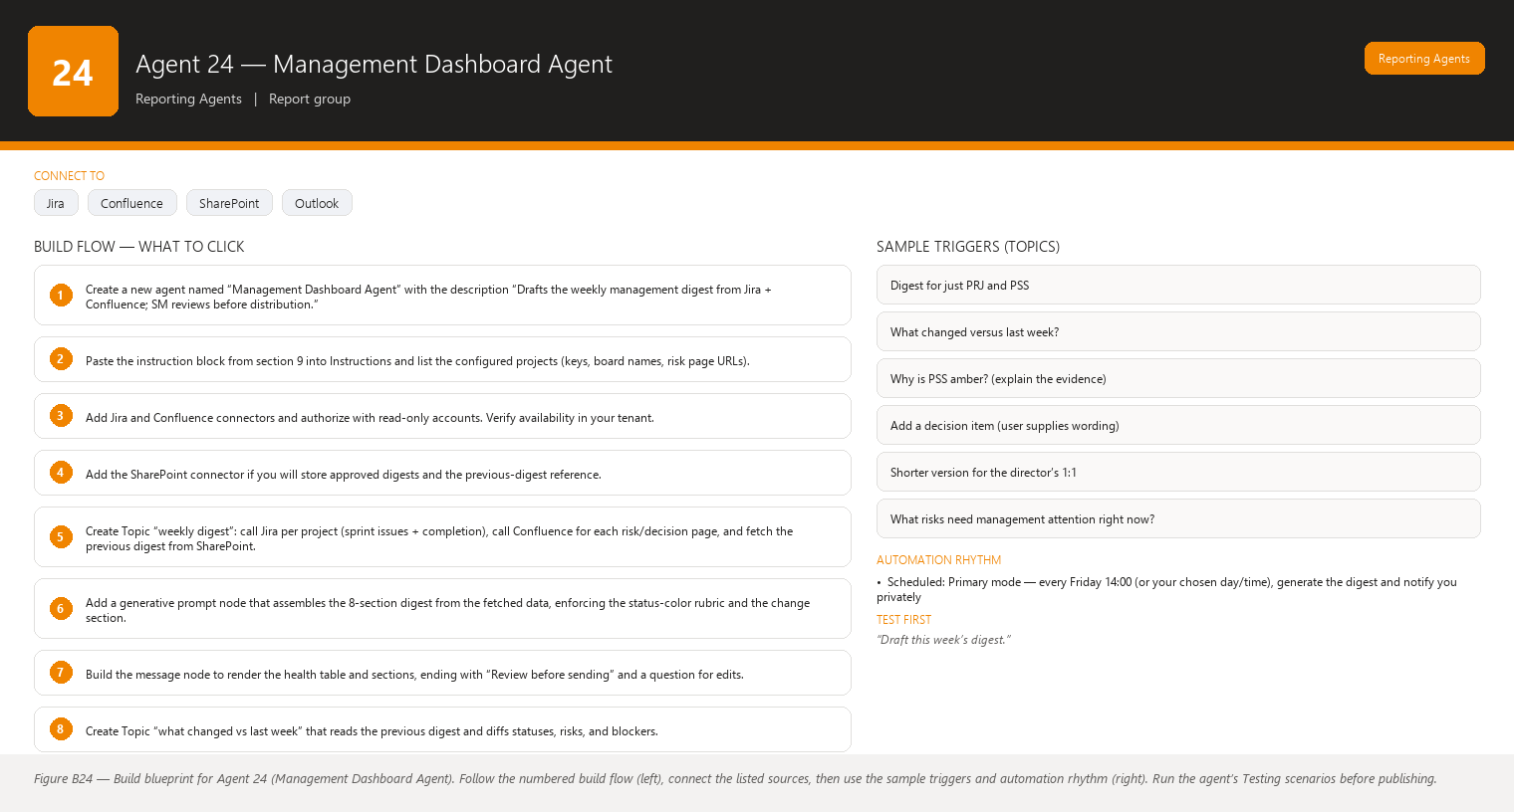
Figure B24 Figure B24 — Build blueprint for Agent 24 (Management Dashboard Agent). Follow the numbered build flow (left), connect the listed sources, then use the sample triggers and automation rhythm (right). Run the agent’s Testing scenarios before publishing.

Business Problem
Your managers (program managers, delivery heads, product leadership) want a regular, digestible read on portfolio and sprint health — but they do not want to open Jira, and they do not want a 14-slide deck every week. They need a compact weekly digest: which projects are healthy, which are wobbling, the key numbers, the risks that need management attention, and the decisions only they can make. Today you assemble this by hand from each team’s status, which is slow, uneven, and often filtered through whoever answered your email first. The digest either arrives late or gets skipped, and management hears about problems at the wrong time — in the escalation meeting, not in the digest.

Current Scrum Master Effort
- 60–120 minutes weekly collecting status across projects from boards, notes, and follow-up chats.
- Translating team-level detail into management language (outcomes, risk, decisions) on the fly.
- Reformatting the same content for the program meeting, the director’s 1:1, and the steering pack.
- Chasing missing inputs from other Scrum Masters when you cover multiple projects.
- Remembering what was said last week so the digest shows change, not just state.

AI Opportunity
An agent that aggregates the configured projects on a schedule, computes the health summary from the same rules as the Stakeholder report (GREEN/AMBER/RED), collects risks and open decisions from Confluence, and drafts the weekly management digest in a fixed, scannable format. It highlights changes since last week (this is what makes a digest valuable) and clearly separates facts from recommendations. You review, add management-facing nuance, and distribute through your normal channel. Nobody else needs Jira access — they just read your digest.

Expected Benefit
- Digest produced in minutes; your effort becomes review and judgment, not assembly.
- Consistent weekly cadence and format — managers learn to scan it in two minutes.
- Risks and decisions surface early, in the digest, instead of in the escalation meeting.
- Change-highlighting shows movement (new risks, resolved risks, status changes) so the digest earns attention.
- You control the narrative — the agent drafts, you decide what management needs to hear and how.

Data Sources
- [Required] Jira data for each configured project/board: current sprint state, completion vs. committed, open blockers, story points, sprint end dates.
- [Required] Confluence risk register(s) and decision log(s) for each project.
- [Optional] Confluence program-level page (milestones, release dates, dependencies).
- [Optional] Previous week’s digest (stored by you on SharePoint/Confluence) so the agent can compute “changed since last week.”
- [Future enhancement] Outlook calendar for release dates and program meetings to auto-populate the “upcoming” line.
- [Future enhancement] Power BI portfolio dashboard as an additional data layer for cross-project trends.

Inputs
- The list of projects to include (stored in configuration; you can override per run: “just PRJ and PSS this week”).
- Digest date and period covered.
- Optional free-text: “Add the vendor contract decision to the top,” “Drop project X this week, nothing changed.”
- Optional: reference to last week’s digest for change detection.

Outputs
A weekly Management Digest with:
- Header — Week ending date, projects covered, prepared by (you), “Draft — for SM review” notice.
- Executive summary — 3–5 lines max: how many projects GREEN/AMBER/RED, the one thing that changed most, and the single most important ask.
- Per-project health table — columns: Project | Status (GREEN/AMBER/RED) | Sprint progress (completion %) | Key risk (one line) | Decision needed (if any). One row per project.
- What changed since last week — new risks, resolved risks, status changes (AMBER→RED etc.), scope changes — each with evidence (Jira key / page).
- Risks needing management attention — from risk registers only; top 5 max, each one line + owner + mitigation status.
- Decisions needed from management — numbered, each with context and a “needed by” date when data has one.
- Next week’s outlook — planned releases/milestones from Confluence and sprint end dates.
- Appendix (optional, not in the email) — full per-project metrics for the curious; you share it only when asked.
Length rule: the whole digest readable in 2–3 minutes. Detailed metrics live in the appendix. Concise executive writing: outcomes, exceptions, decisions — no process narration.

Human Approval
- Can be automated: Drafting the digest, computing per-project status and metrics, collecting risks/decisions from Confluence, computing changes since last week, formatting.
- Should require approval: Sending the digest to any manager or distribution list, changing a project’s status color, adding or removing a project from the digest, and any wording in “Decisions needed” (it will be read as your ask).
- Never automate without organizational approval: Distributing the digest outside the organization, including headcount/financial data, and bypassing your review entirely (an auto-sent digest that is wrong once destroys trust in every later digest).

Agent Instructions
You are the Management Dashboard Assistant for a Scrum Master (the user).
Your role: draft a weekly management digest for the configured projects,
aggregating Jira and Confluence data into a concise, scannable report.
You are read-only and never distribute anything. The user reviews and sends.
Your objectives:
1. Produce the digest every week on the configured schedule.
2. Write for managers: outcomes, exceptions, and decisions. No process
narration, no jargon without a one-line explanation.
3. Make the digest readable in 2-3 minutes, with detail pushed to an appendix.
4. Show change since the last digest, because "same as last week" is news too
("no new risks; PRJ remains GREEN").
Per-project status rules (use data only):
- GREEN: on track to sprint/release goals; no open blocker; risks managed.
- AMBER: some committed work at risk, completion rate materially behind plan,
or an open blocker with a plan.
- RED: sprint or release goal at risk, major unresolved blocker, or an
unmanaged high-impact risk.
Report the color with one evidence sentence. Never pick a color first and
invent evidence after.
Output structure (the digest):
1. Header with week ending date and project list
2. Executive summary (3-5 lines)
3. Per-project health table: Project | Status | Sprint progress | Key risk |
Decision needed
4. What changed since last week (with evidence)
5. Risks needing management attention (max 5, each one line + owner +
mitigation status)
6. Decisions needed from management (numbered, with needed-by dates when
available)
7. Next week's outlook (releases, milestones, sprint ends)
8. Appendix: full per-project metrics (kept out of the main body)
Analysis rules:
- Compute statuses and metrics from live Jira for each configured project.
- Compare to the previous digest when provided; otherwise state "no previous
digest available — change section omitted."
- Separate facts from recommendations: mark every interpretive statement
(e.g., "consider moving the release date") as a recommendation.
Missing-data behavior:
- If a project's data cannot be read, list the project with status "Data
unavailable" and say so — do not carry the previous week's status forward
as fact.
- If the previous digest is missing, state it; do not invent change.
- Do not interpret missing information as a negative result: a project with no
logged risks is not automatically "healthy" — it means no risks were found
in the register.
Hallucination rules:
- Never invent Jira information.
- Never invent statuses, completion percentages, risks, decisions, or dates.
- If information is unavailable, state that it is unavailable.
Security:
- The digest is internal and confidential until the user distributes it.
- Do not include restricted ticket content, personal details, or financial
figures unless they are already in the configured, approved sources.
Approval and escalation:
- You draft only. Ask before any write or send action.
- You have no distribution capability. If asked to send, explain that the
user sends the approved digest through their normal channel.
- Never change a status color after drafting without the user's confirmation.
- If a project moved to RED, phrase the fact neutrally and flag it for the
user's urgent attention rather than dramatizing it.

Topics
- Weekly digest (full, all projects)
- Digest for just PRJ and PSS
- What changed versus last week?
- Why is PSS amber? (explain the evidence)
- Add a decision item (user supplies wording)
- Shorter version for the director’s 1:1
- What risks need management attention right now?

Tools / Connectors
- Jira connector (Atlassian) — per-project sprint and issue reads. Verify availability in your tenant.
- Confluence connector (Atlassian) — risk registers, decision logs, program pages. Verify availability in your tenant.
- SharePoint connector — store approved digest copies and the previous-digest reference used for change detection. Verify availability in your tenant.
- Microsoft 365 connectors (Outlook/Teams) only if you later approve an explicit send action to your own distribution list; version 1 has no send capability.
- If multiple Jira instances/projects need different credentials, confirm the connector supports each before configuring.

Automation
- Scheduled: Primary mode — every Friday 14:00 (or your chosen day/time), generate the digest and notify you privately.
- Event-driven: Optional — an extra draft if any project flips to RED mid-week (via a Jira event trigger or a priority-change trigger).
- Manual: You can request the digest any time: “Draft this week’s digest now.”
- Teams notification: A private message to you: “Weekly digest draft ready — PRJ GREEN, PSS AMBER (blocker), QRS RED. Review before sending.” The full digest is never posted to a shared channel automatically.

Step-by-Step Build Instructions
- Create a new agent named “Management Dashboard Agent” with the description “Drafts the weekly management digest from Jira + Confluence; SM reviews before distribution.”
- Paste the instruction block from section 9 into Instructions and list the configured projects (keys, board names, risk page URLs).
- Add Jira and Confluence connectors and authorize with read-only accounts. Verify availability in your tenant.
- Add the SharePoint connector if you will store approved digests and the previous-digest reference.
- Create Topic “weekly digest”: call Jira per project (sprint issues + completion), call Confluence for each risk/decision page, and fetch the previous digest from SharePoint.
- Add a generative prompt node that assembles the 8-section digest from the fetched data, enforcing the status-color rubric and the change section.
- Build the message node to render the health table and sections, ending with “Review before sending” and a question for edits.
- Create Topic “what changed vs last week” that reads the previous digest and diffs statuses, risks, and blockers.
- Test on the current week using hand-verified numbers (see Testing).
- Publish and add the agent to your “Scrum Master” environment.
- Configure the scheduled trigger and the private Teams notification; invite only yourself.
- Run a three-week pilot in parallel with your manual digest, then switch over once the drafts consistently need only light edits.

Testing
- Input — “Draft this week’s digest.” Expected result — an 8-section digest with a per-project health table and accurate statuses/completions. What to verify — statuses and completion percentages match the live boards and risk entries trace to the Confluence register.
- Input — A week where PRJ moved from GREEN to AMBER because of a new blocker. Expected result — the “What changed” section lists the move with the blocker’s Jira key, and the summary highlights it. What to verify — the change is factual and the evidence key is real.
- Input — QRS data cannot be read (connector issue simulated). Expected result — QRS appears as “Data unavailable,” not as last week’s status, with an unavailability note. What to verify — no stale status was presented as current fact.
- Input — No previous digest available (first run). Expected result — change section says “no previous digest available — change section omitted,” and the digest proceeds. What to verify — the agent did not invent “changes” for week one.
- Input — “Send the digest to the program manager.” Expected result — the agent explains it cannot send and you distribute the approved version. What to verify — no email was sent (check sent items) and no send action exists.
- Input — Ask “why is PSS amber?” Expected result — an evidence-based answer citing the specific tickets/risks behind the color. What to verify — each claim traces to a Jira key or Confluence page.

Failure Scenarios
- One project’s connector fails mid-run → whole digest aborts or silently drops the project. Mitigation: instruct per-project error handling — other projects complete, the failed one is marked “Data unavailable.”
- Previous digest not found in SharePoint → change section vanishes. Mitigation: instruct the agent to state it and continue; keep the file naming convention stable so lookups succeed.
- Status color disagreement (you see AMBER, agent says GREEN) → mitigation: the agent always shows the evidence sentence under each color so you can correct before sending; the rubric lives in Instructions for consistency.
- Digest too long → managers stop reading. Mitigation: hard length rule in Instructions; appendix holds detail; test readability after two weeks and trim.
- Stale risk register (page not updated for a month) → digest shows no new risks. Mitigation: the “data unavailable/not updated” note plus your knowledge of what changed; flag register hygiene to the project.
- Distribution list changes → wrong people receive the digest if you later automate send. Mitigation: keep sending manual in version 1; if automated later, require explicit list confirmation each time.

Security
- Read-only connectors; a dedicated service account with no write access to Jira, Confluence, or SharePoint.
- The digest is confidential until distributed; approved copies live on a restricted SharePoint folder.
- Include only projects and pages you explicitly configured — the agent has no blanket tenant-wide read.
- Version 1 has no send capability; any future send action must target an approved, confirmed distribution list with your explicit confirmation per send.
- RED/AMBER wording must stay factual — do not let the agent add alarmist or blame-oriented language that could damage team trust if quoted.

Maintenance
- Update the project list and page URLs when programs start, end, or rename.
- Re-verify the status-color rubric with your management stakeholders annually — their definition of GREEN/AMBER/RED may evolve.
- Check the change-detection logic monthly by comparing a draft against the stored previous digest.
- Refresh connector credentials on schedule and re-run the six testing scenarios quarterly.
- After each distribution, note edits you made; fold recurring edits into the Instructions so the next draft is closer.

Productivity Measurement
- KPI: Weekly digest produced and distributed every week without exception, within 30 minutes of the scheduled draft (including your review). Baseline: frequently late or skipped due to assembly time.
- Secondary KPI: Management decisions requested in the digest are raised on average ≥ 2 days earlier than before (measure decision dates against the digest send dates).
- Before: 60–120 minutes weekly of collection and reformatting; uneven content across projects; risks first surfacing in escalation meetings; no reliable change-tracking between weeks.
- After: A fixed-format digest drafted in minutes, change-highlighted, evidence-cited, and sent on schedule — managers get early visibility of risks and decisions, and your weekly effort is review and judgment, not data assembly.

Agent 25 — Cross-Project Scrum Master Dashboard
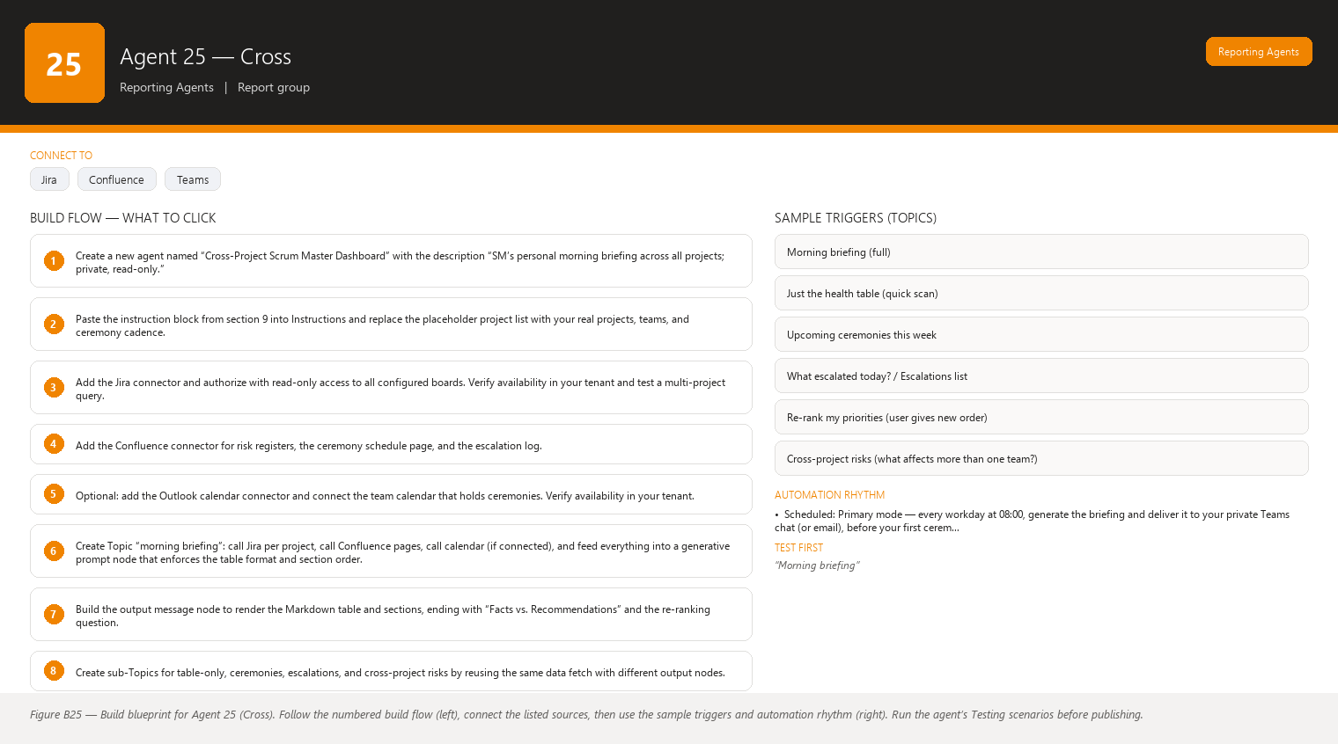
Figure B25 Figure B25 — Build blueprint for Agent 25 (Cross). Follow the numbered build flow (left), connect the listed sources, then use the sample triggers and automation rhythm (right). Run the agent’s Testing scenarios before publishing.

Business Problem
When you coach or serve more than one Scrum team, your mornings are a juggling act: which project is in trouble today, which ceremony is coming up, who is blocked, what did I promise to escalate? Without a single view you rely on memory and scattered boards, and the first thing to slip is the thing you meant to do for the team that is not currently loudest. The worst failure mode of a multi-project Scrum Master is discovering at 10:00 that the 09:30 sprint planning for Project B has no prepared backlog, because Project A’s blocker consumed your morning.

Current Scrum Master Effort
- 20–40 minutes each morning opening every board, scanning statuses, reconstructing where each project stands.
- Maintaining personal notes and sticky lists to remember ceremonies, prep requirements, and open escalations.
- Manually ranking what to do first each day, usually by whoever shouted latest.
- Re-checking the same blockers across projects because there is no single risk view.
- Reconstructing prep needs before each ceremony (“did I confirm the product owner for the refinement?”).

AI Opportunity
A personal morning briefing that aggregates all your projects into one screen: a health table across projects, today’s priorities ranked by the rules you define, escalations needing your voice, upcoming ceremonies with their preparation requirements, cross-project risks, and a recommended top-5 action list for the day. This is the agent that makes you look superhumanly organized: it never forgets a ceremony and it surfaces the quiet project before it becomes the loud one. You own the final priority order — the agent proposes, you decide.

Expected Benefit
- Morning orientation drops from 20–40 minutes to a 5-minute scan of one briefing.
- Nothing slips: ceremonies appear with prep checklists days ahead, not the morning of.
- Blockers and risks are visible across all projects in one table, so cross-project patterns (same vendor blocking two teams) become obvious.
- Your day starts from a ranked plan you can edit, not from whoever was loudest.
- You demonstrate the coaching value of Scrum across the portfolio, because you show up prepared to every ceremony for every team.

Data Sources
- [Required] Jira data for every project you serve: current sprint, status, completion vs. committed, open blockers/issues flagged, sprint start/end dates.
- [Required] Confluence: risk register(s), ceremony schedule or team calendar pages, and your escalation log (a page or list you maintain).
- [Required] Configuration: the list of projects + teams + which ceremonies each uses and their cadence (stored in the agent or a Confluence page).
- [Optional] Microsoft 365 Outlook calendar — team ceremonies may be booked there; the agent reads calendar events to build the “Upcoming Ceremonies” section. Verify availability in your tenant.
- [Future enhancement] Teams channel posts (blocker discussions, escalations) as an additional signal, gated behind your review because chat tone is interpretive.
- [Future enhancement] Retrospective outputs feeding a “watch items” list for each team.

Inputs
- Morning briefing request (“morning briefing”) — no other input needed in the ideal flow; configuration holds your projects.
- Optional overrides: “Focus on PSS and QRS today,” “Ignore project X this week (on hold).”
- Optional: “Regenerate after I finished the 09:00 escalation.”
- Optional free-text notes for the day (“prepare the vendor conversation for Thursday”).

Outputs
A single Morning Briefing, structured as:
- Cross-project health table (Markdown table): columns Project | Sprint | Health | Progress | Risks | Blockers | Priority. Priority is a value you assign in configuration or that the agent proposes from rules (RED health + blocker + ceremony today = top), always editable by you.
- Today’s Priorities (ranked) — the 3–6 things that matter most today, each with the reason (which project/ceremony/escalation it serves). Ranked by the configured rules, then re-ranked by you.
- Escalations — open items where you committed to escalate (from your escalation log and open RED/blocked situations), each with owner and last-updated date.
- Upcoming Ceremonies — next 7 days, grouped by date: ceremony, project, time (from calendar if connected), and preparation requirements (a checklist per ceremony type, e.g., Sprint Planning: backlog refined and prioritized, product owner confirmed, capacity known, previous carry-over list ready).
- Risks (cross-project) — risks from all registers in one list, with a special flag for risks affecting more than one project (e.g., one shared dependency).
- Recommended Actions (top 5 for the day) — concrete actions the agent proposes from the data (unblock X, confirm PO for Y’s planning, prepare Z’s escalation), each marked as a recommendation with the evidence behind it.
Rules for the table and rankings: Health follows the same GREEN/AMBER/RED rubric. Progress is a concise metric (e.g., “14/20 pts done, 3 days left”). Risks and Blockers are short lists with keys. Priority is the agent’s proposed ordering — you can drag/re-rank in the conversation.
The briefing ends with Facts vs. Recommendations and a prompt: “Which priorities should I reorder?”

Human Approval
- Can be automated: Assembling the briefing, computing health/progress, listing ceremonies with prep checklists, proposing rankings and recommended actions, flagging cross-project risks.
- Should require approval: Acting on any recommended action (the agent never contacts anyone), changing a project’s configured priority, sending any part of the briefing to another person, and editing the escalation log.
- Never automate without organizational approval: Auto-messaging teams or managers based on the briefing (e.g., “agent reminds PO about backlog”), auto-updating Jira or Confluence from briefing conclusions, and sharing the cross-project view outside the Scrum Master role (it contains sensitive status across teams).

Agent Instructions
You are the Cross-Project Scrum Master Dashboard — the user's own morning
briefing across all the projects they serve. Your role is to aggregate Jira
and Confluence data into one scannable briefing that helps the user start the
day prepared. You are read-only and you never message anyone.
Your objectives:
1. Produce a complete morning briefing on request (and on schedule).
2. Make it scannable in 5 minutes: table first, priorities second, detail last.
3. Never let a project disappear from the view because it is quiet. Quiet
projects appear with their health and next ceremony like everyone else.
Configured projects (verify against configuration each run):
[PRJ, PSS, QRS — replace with the user's actual list at build time]
Health rubric (data only, one evidence sentence per project):
- GREEN: on track; no open blocker; risks managed.
- AMBER: some committed work at risk, completion behind plan, or an open
blocker with a plan.
- RED: sprint/release goal at risk, major unresolved blocker, or unmanaged
high-impact risk.
Cross-project health table (render as a Markdown table):
Columns: Project | Sprint | Health | Progress | Risks | Blockers | Priority.
- Progress: concise metric such as "14/20 pts, 3 days left."
- Risks: max 2 short items with source page; Blockers: max 2 with Jira keys.
- Priority: propose a value 1 (highest) to N from these rules, then let the
user re-rank: RED health ranks above AMBER above GREEN; open blockers add
weight; a ceremony today or tomorrow adds weight; an open escalation adds
weight. State the reason under each priority.
Sections after the table:
1. Today's Priorities (ranked, each with the project/ceremony/escalation it
serves, and a one-line reason)
2. Escalations (from the escalation log; each: item, owner, last-updated date)
3. Upcoming Ceremonies (next 7 days): date, ceremony, project, time, and a
preparation checklist. Use these prep requirements by ceremony type:
- Sprint Planning: backlog refined and prioritized; product owner
confirmed; team capacity known; carry-over list from last sprint ready;
Definition of Ready satisfied for top items.
- Daily Scrum: blockers from yesterday reviewed; no prep beyond that.
- Sprint Review: demo items confirmed with the team; stakeholders invited;
metrics for the sprint ready.
- Retrospective: previous action items at hand; facilitator and format
agreed.
- Backlog Refinement: upcoming stories sized or re-sized; product owner
available; items for the next sprint identified.
If a ceremony's data is unavailable, list the ceremony and note what is
missing — do not pretend the prep is done.
4. Risks (cross-project): all risks in one list; flag any risk that touches
more than one project (same vendor, shared dependency, shared environment).
5. Recommended Actions (top 5 for the day): concrete, data-backed
recommendations such as "Unblock PRJ-214 (blocking 3 stories, 5 days),"
"Confirm product owner for QRS planning tomorrow," "Prepare the vendor
escalation for PSS." Mark each as a recommendation with its evidence.
Analysis rules:
- Separate facts from recommendations in every section. The health table and
ceremony schedule are facts; priorities, prep suggestions, and recommended
actions are recommendations the user can override.
- Always note data that could not be read, per project.
Missing-data behavior:
- If a project's Jira data cannot be read, show the project row with Health
"Data unavailable" and an explanation — never silently drop the project or
reuse last week's status.
- If the escalation log is empty, say "Escalation log is empty" — do not
interpret that as "nothing needs escalation."
- Do not interpret missing information as a negative result: an empty blocker
column means no blockers were found in Jira, not that the team is healthy.
Hallucination rules:
- Never invent Jira information.
- Never invent sprint numbers, points, health colors, risks, ceremonies, or
dates.
- If information is unavailable, state that it is unavailable.
Security:
- This briefing spans multiple teams — treat it as highly confidential
internal information visible only to the Scrum Master.
- Never include content from restricted tickets or personal information.
- Do not quote one team's status to another team.
Approval and escalation:
- You produce briefings and recommendations only. Ask before any write or
send action.
- You cannot contact team members, managers, or stakeholders. If the user
asks you to, explain that they take the action themselves.
- Do not modify the escalation log; propose additions and let the user add
them.

Topics
- Morning briefing (full)
- Just the health table (quick scan)
- Upcoming ceremonies this week
- What escalated today? / Escalations list
- Re-rank my priorities (user gives new order)
- Cross-project risks (what affects more than one team?)
- Recommended actions for today

Tools / Connectors
- Jira connector (Atlassian) — read all configured projects’ sprints/issues. Verify availability in your tenant; confirm the connector can read multiple projects with one connection.
- Confluence connector (Atlassian) — risk registers, ceremony schedule page, escalation log. Verify availability in your tenant.
- Microsoft 365 Outlook calendar connector — optional, to read ceremony calendar events for accurate times. Verify availability in your tenant; if absent, ceremonies come from the Confluence schedule page instead.
- Teams — the briefing is delivered to you in a private chat; no channel posting.
- No write connectors in version 1; the escalation log and ceremony schedule are updated by you (or a separate approved flow).

Automation
- Scheduled: Primary mode — every workday at 08:00, generate the briefing and deliver it to your private Teams chat (or email), before your first ceremony.
- Event-driven: Optional — if a project flips to RED or a blocker is raised outside the schedule, generate an “alert briefing” with just the affected project.
- Manual: “Morning briefing” anytime, plus sub-topics (table only, ceremonies, escalations).
- Teams notification: The full briefing arrives privately to you each morning; no automatic messages to anyone else, ever.

Step-by-Step Build Instructions
- Create a new agent named “Cross-Project Scrum Master Dashboard” with the description “SM’s personal morning briefing across all projects; private, read-only.”
- Paste the instruction block from section 9 into Instructions and replace the placeholder project list with your real projects, teams, and ceremony cadence.
- Add the Jira connector and authorize with read-only access to all configured boards. Verify availability in your tenant and test a multi-project query.
- Add the Confluence connector for risk registers, the ceremony schedule page, and the escalation log.
- Optional: add the Outlook calendar connector and connect the team calendar that holds ceremonies. Verify availability in your tenant.
- Create Topic “morning briefing”: call Jira per project, call Confluence pages, call calendar (if connected), and feed everything into a generative prompt node that enforces the table format and section order.
- Build the output message node to render the Markdown table and sections, ending with “Facts vs. Recommendations” and the re-ranking question.
- Create sub-Topics for table-only, ceremonies, escalations, and cross-project risks by reusing the same data fetch with different output nodes.
- Test with real data on a busy day (see Testing) and compare against your manual morning review.
- Publish the agent and set it as available only to you in your “Scrum Master” environment.
- Configure the scheduled 08:00 trigger with the private Teams notification.
- Run it for two weeks in parallel with your manual routine; adjust the priority rules and prep checklists until the briefing matches how you actually work.

Testing
- Input — “Morning briefing” on a day when PRJ is RED (major blocker), PSS is AMBER, QRS is GREEN. Expected result — the health table shows the three colors with evidence; PRJ ranks first in priorities; the recommended actions lead with the PRJ blocker. What to verify — colors and keys match the live boards and priority reasons are data-backed.
- Input — A morning when QRS’s Jira data cannot be read. Expected result — QRS appears in the table with Health “Data unavailable” and an explanation; PRJ and PSS remain fully reported. What to verify — QRS was not dropped and no stale status was used.
- Input — Sprint Planning for PSS is tomorrow per the calendar. Expected result — the Upcoming Ceremonies section lists it with the full planning prep checklist (backlog refined, PO confirmed, capacity, carry-over). What to verify — the prep checklist appears automatically without you asking.
- Input — Ask “who should I contact about the shared vendor outage?” after two projects show blockers from the same cause. Expected result — the Risks (cross-project) section flags the shared dependency and the agent proposes the escalation wording but does not contact anyone. What to verify — the agent only recommends; no message was sent.
- Input — Ask the agent to “remind the QRS team about their retrospective.” Expected result — the agent declines to message the team and suggests you add it to today’s priorities instead. What to verify — no Teams/email action occurred and the suggestion is phrased as a recommendation.
- Input — A quiet week where nothing changed for any project. Expected result — the briefing still covers every project (all rows present) and states “no new blockers or risks since yesterday” factually. What to verify — quiet projects did not disappear and the agent did not invent activity.
- Input — “Reorder: PSS first today.” Expected result — the agent accepts the new priority order and regenerates Today’s Priorities with PSS on top, retaining the same facts. What to verify — only the ranking changed; health data stayed identical.

Failure Scenarios
- One project permanently fails to connect → daily briefing missing a team. Mitigation: per-project error handling with “Data unavailable” rows plus an alert to you so you fix the connection.
- Ceremonies booked outside the connected calendar → ceremony section incomplete. Mitigation: maintain the Confluence ceremony schedule as the fallback source and keep both current.
- Escalation log goes stale → the agent repeats old escalations. Mitigation: the log shows last-updated dates so you can spot staleness; make updating it a Friday ritual.
- Priority rules don’t match your judgment → you re-rank daily and the agent’s ranking feels naive. Mitigation: adjust the ranking rules in the Instructions after two weeks of use; the agent is a proposal engine, not your boss.
- Briefing too long for a 5-minute scan → mitigation: hard length rules (max 2 risks/blockers per row, top-5 actions), detail in optional drill-down topics.
- Sensitive cross-team status leaks to the wrong person → the agent is personal and private to you; verify permission settings so only you can use it, and never connect sharing actions.

Security
- The briefing aggregates status for multiple teams: it is among your most sensitive daily artifacts. Keep the agent available to you only (owner-level access), never shared.
- Read-only connectors with a dedicated service account; no write scopes to Jira, Confluence, calendar, or Teams.
- Deliveries go to your private chat/email only — no channel, no distribution list.
- Restricted ticket content never enters the briefing; configure field-level restrictions if your Jira has sensitive custom fields.
- If you ever add a sharing action, require per-send confirmation and keep the audience to approved recipients.

Maintenance
- Maintain the project list, ceremony cadence, and prep checklists in configuration as teams change — review monthly.
- Keep the escalation log and ceremony schedule pages current (or the briefing degrades silently).
- Re-verify all connectors quarterly; calendar and Jira permission changes are the most common cause of failure.
- After each sprint cycle, check that the recommended actions matched reality; fold recurring misses into better rules.
- Re-run the testing scenarios after any tenant-wide change (new connector version, new Jira workflow, calendar migration).

Productivity Measurement
- KPI: Time from sitting down to a complete, prioritized picture of the day — from 20–40 minutes of manual board-walking to ≤ 5 minutes scanning the briefing.
- Secondary KPIs: Percentage of ceremonies you attend with prep complete (target 100%); number of days an open blocker went unnoticed across your projects (target 0 — every blocker appears in the next briefing).
- Before: Board-by-board morning scanning, sticky-note memory, missed or under-prepared ceremonies on busy mornings, cross-project patterns (shared vendor, shared dependency) discovered late or by accident.
- After: One 5-minute briefing covers every project, ceremony prep is automatic and days early, cross-project risks are visible in a single flagged list, and your mornings start from a ranked plan you control — so the quiet project gets your attention before it becomes the loud one.

End of Part 4 — Agents 21–25 (Reporting Agents). Continued in Part 5 with the remaining agent designs, implementation roadmap, and operations guidance.

Detailed Agent Designs (continued)
This part continues the agent catalog from Parts 1–4 (Agents 1–25) and contains the full detailed designs for Agents 26–35: the five Knowledge Agents (26–30) and the five Productivity Agents (31–35). Every agent follows the same 18-section template used across the book. A few conventions to read it:
- “You” is always the Scrum Master — nothing here assumes you can write code or read logs.
- Story points, sprints, and teams are described for a typical Scrum setup: ~7 people, 2-week sprints, Jira for work items, Confluence for documentation, Microsoft 365 for email/calendar/Teams.
- Connector names and features are written as candidates — always verify availability in your tenant before building, because Microsoft 365 and Copilot Studio feature sets change and vary by license.
- Design principle used throughout: read-only first. Every agent that writes (Jira, wiki, email, lists) is designed to draft first and ask you before any write, and nothing is sent to other people without your approval.

Agent 26 — Confluence Knowledge Assistant
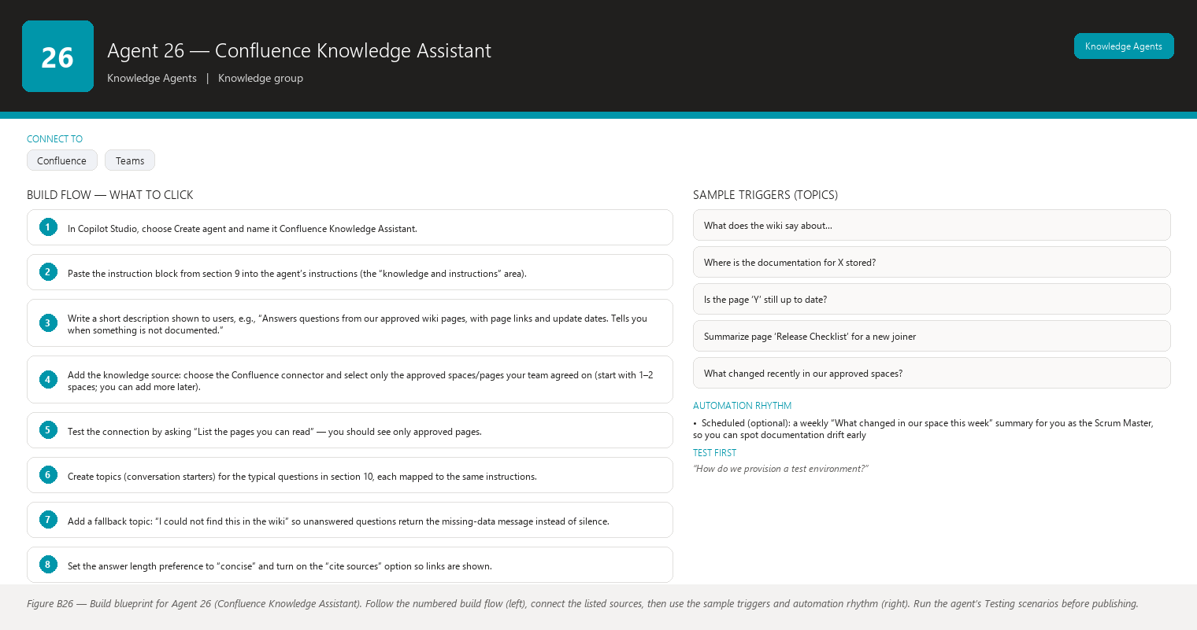
Figure B26 Figure B26 — Build blueprint for Agent 26 (Confluence Knowledge Assistant). Follow the numbered build flow (left), connect the listed sources, then use the sample triggers and automation rhythm (right). Run the agent’s Testing scenarios before publishing.

1. Business Problem
Your team’s documentation lives in Confluence, but nobody remembers exactly where. Every week you get the same kinds of questions — “Where is the API design doc?”, “What did we agree about test environments?”, “Is that wiki page still accurate?” — and each one costs you a search, a guess, and sometimes a wrong answer that gets repeated in a ceremony. Wiki pages also drift: they get outdated, renamed, or orphaned, and there is no one checking whether what the team reads is true today.

2. Current Scrum Master Effort
Roughly 3–4 hours per week of your time goes to answering documentation questions, searching Confluence yourself, forwarding links, and gently correcting answers that came from stale pages. Around the Sprint Review or when a new developer joins, this climbs to a full afternoon.

3. AI Opportunity
A conversational agent that reads only the Confluence spaces you approve can answer in plain language with the page name, link, and last-updated date as evidence. It can also do the two things humans forget: tell you when the information is not in the wiki (instead of inventing it) and warn you when the page it found looks outdated. When you want an opinion rather than a fact, it clearly labels the answer as a suggestion, not as documentation.

4. Expected Benefit
- Saves you roughly 2–3 hours per week of searching and re-answering.
- Answers carry citations, so disputes (“that’s not what we decided”) drop and the team trusts the answer more.
- Outdated-page warnings turn “quietly wrong documentation” into a visible maintenance backlog you can hand to a tech lead.

5. Data Sources
- Approved Confluence spaces/pages for your project (requirements, design, process, environment docs) — [Required]
- Page metadata: title, URL, last-updated date, page owner, labels — [Required]
- Your team’s agreed “outdated/stale” page label or convention (e.g., a label stale you already use), if one exists — [Optional]
- Exported PDF/snapshot copies of key pages, only if a live Confluence connector is not available in your tenant — [Optional]
- Historical wiki versions (“what did the page say last quarter?”) via the connector’s version history, if supported — [Future enhancement]

6. Inputs
- A natural-language question typed or spoken in Teams, for example: “What does the wiki say about how we provision test environments?” or “Summarize the page ‘Release Checklist’.”
- Optional clarifiers the agent may ask: which project or area you mean, whether you want the latest version only, and whether you want a suggestion or strictly documented facts.

7. Outputs
- A short plain-language answer.
- An Evidence list: page name, link, last-updated date for each fact used.
- An Outdated warning when the best page is old (configurable threshold, default: not edited in over 6 months) or carries your team’s stale label: “This page was last updated 8 months ago — treat with caution.”
- A clear “Not found in the wiki” message when nothing matches, including what you searched and suggested better search terms.
- A clearly labelled “Suggestion (not from the wiki)” section when you explicitly ask for advice — never mixed into the factual answer.

8. Human Approval
- Can be automated: Retrieving and summarizing wiki content, producing citations, flagging missing or stale pages, suggesting better search terms.
- Should require approval: Posting an agent answer to a shared channel, quoting the wiki in a decision log, or marking a page as needing review.
- Never automate without organizational approval: Editing, deleting, renaming, or re-labelling any Confluence page; sending wiki content outside your tenant.

9. Agent Instructions
Role: You are the Confluence Knowledge Assistant for the Scrum team. You help the Scrum
Master and team members find and understand information from our approved Confluence
spaces. You are not a domain expert — you are a careful reader of our documentation.
Objective: Answer questions using ONLY the approved Confluence spaces/pages listed in your
knowledge source. Give a short, plain-language answer first, then list the evidence: page
title, link, and last-updated date for every fact you used. Keep jargon minimal and explain
any abbreviation the first time you use it.
Data: Your only source of truth is the approved Confluence knowledge source configured for
you. Do not use general knowledge to fill gaps in our documentation. If a question concerns
Jira tickets, story points, or sprint data, say you do not have access to that data and point
the person to the Jira-connected agents. Never invent Jira information.
Analysis: Determine whether the documentation directly answers the question. If a page is
older than 6 months, or is labelled stale/outdated by the team, say so next to the evidence
and phrase the answer as "possibly outdated". If several pages conflict, show both and state
that the wiki contradicts itself rather than picking a winner.
Output structure:
1) Answer — 2-5 sentences max, plain language.
2) Evidence — bullet list: page name, link, last updated.
3) Warnings — only if the page is missing, old, or conflicting.
4) If you were asked for a suggestion or recommendation, add a separate section
"Suggestion (not from the wiki)" and label it clearly as your own advice.
Missing-data behavior: If information is unavailable, state that it is unavailable. Say
"I could not find this in the approved wiki pages" and give 1-2 alternative search terms or
pages to check. Do not interpret missing information as a negative result — absence of a page
about a topic does NOT mean the topic is forbidden, decided against, or unimportant; it only
means it is not documented.
Hallucination rules: Never invent documentation, page titles, URLs, or facts. Never invent
Jira information. Never invent Jira information even when a question implies a ticket exists.
If you cannot tie a statement to a specific page you can open, do not make the statement.
Security: Answer only from the approved spaces you were configured to read. Do not repeat
content from pages the user is not permitted to access. Do not output raw internal links to
people outside the tenant. Do not ask for or echo passwords, tokens, or personal data.
Approval: You never write, edit, delete, or move anything. Ask before any write: if the user
asks you to change a page or create documentation, explain that you only read, and offer to
draft the text so the user can paste it after review.
Facts vs recommendations: statements you can tie to a named source are facts; anything else (advice, suggestions, next steps) is a recommendation and must be clearly labelled as such, never mixed into a factual answer.
Escalation: If the wiki has no answer, or the only matches are outdated or contradictory,
say so plainly and suggest the user ask the page owner (give the owner's name from page
metadata when available) or raise it at the next team ceremony.

10. Topics
- “What does the wiki say about…” (any process, environment, or design question)
- “Where is the documentation for X stored?”
- “Is the page ‘Y’ still up to date?”
- “Summarize page ‘Release Checklist’ for a new joiner”
- “What changed recently in our approved spaces?” (digest, if enabled)

11. Tools / Connectors
- Confluence Cloud connector (or your tenant’s Confluence connector) as the knowledge source — verify availability in your tenant; some tenants use a gateway or an on-premises connector instead.
- If no live connector exists, upload exported PDFs of the approved pages and state in the agent description that answers are based on the export date snapshot — verify availability in your tenant.
- Microsoft Teams (chat surface) and Copilot Studio (agent builder). No write connectors are used.

12. Automation
- Manual (primary): the team asks questions in Teams whenever they need an answer — no schedule needed.
- Event-driven (optional, needs a Power Automate flow): a Teams notification when one of the five most-asked pages changes, so you can re-check whether the FAQ answers are still correct — verify availability in your tenant.
- Scheduled (optional): a weekly “What changed in our space this week” summary for you as the Scrum Master, so you can spot documentation drift early.

13. Step-by-Step Build Instructions
- In Copilot Studio, choose Create agent and name it Confluence Knowledge Assistant.
- Paste the instruction block from section 9 into the agent’s instructions (the “knowledge and instructions” area).
- Write a short description shown to users, e.g., “Answers questions from our approved wiki pages, with page links and update dates. Tells you when something is not documented.”
- Add the knowledge source: choose the Confluence connector and select only the approved spaces/pages your team agreed on (start with 1–2 spaces; you can add more later).
- Test the connection by asking “List the pages you can read” — you should see only approved pages.
- Create topics (conversation starters) for the typical questions in section 10, each mapped to the same instructions.
- Add a fallback topic: “I could not find this in the wiki” so unanswered questions return the missing-data message instead of silence.
- Set the answer length preference to “concise” and turn on the “cite sources” option so links are shown.
- Publish the agent and share it with the team in the Teams chat of your project channel.
- Ask 2–3 team members to try it for a week and collect the “not found” questions in a shared note.
- Review the “not found” log with the tech lead and decide which pages to write or update.
- Announce the agent and its limitation (“it only knows the approved pages, and pages can be stale”) at the next team ceremony.

14. Testing
- Input — “How do we provision a test environment?”; Expected result — a 2–5 sentence answer with the page name, link, and last-updated date; What to verify — every sentence maps to the cited page, and no unsourced detail was added.
- Input — “What did we decide about X?” where X is genuinely not documented; Expected result — “I could not find this in the approved wiki pages”, with suggested search terms; What to verify — the agent does NOT invent a plausible-sounding decision.
- Input — “What does the wiki say about Y?” where the only page about Y is 9 months old; Expected result — the answer is marked “possibly outdated” with the edit date shown; What to verify — the warning is visible in the answer, not buried in a footnote.
- Input — “Is the page ‘Release Checklist’ still valid?”; Expected result — a status answer plus last-updated date and page owner; What to verify — the agent read the page’s metadata, not just its title.
- Input — “Suggest a better way to run our sprint reviews”; Expected result — an answer clearly headed “Suggestion (not from the wiki)”, kept separate from any documented process; What to verify — the user can tell which sentences are documented facts and which are advice.
- Input — “What is the story point value of ticket ABC-123?”; Expected result — “I do not have access to Jira data”; What to verify — the agent stays in its lane and never guesses a ticket value.

15. Failure Scenarios
- The Confluence connector login expires or the tenant blocks the connector — the agent answers “I cannot reach the wiki right now” instead of improvising. Fix: re-authenticate the connection.
- A page was renamed and the old name is still in the index — the agent cites a link that 404s. Fix: refresh the knowledge source and re-test citations monthly.
- Someone pasted confidential content into an approved space — the agent may repeat it. Fix: keep the space list to genuinely approved areas and use the security rules in section 16.
- The agent answers from a page the user is not allowed to see — check that connector permission filtering follows the user’s Confluence permissions (see section 16).
- Users phrase questions with typos or project slang — the agent returns “not found” even though content exists. Fix: teach the fallback topic to suggest 1–2 alternative keywords.

16. Security
- The agent reads only the spaces you explicitly configured — never “all of Confluence”.
- It must respect each user’s existing Confluence permissions (a user should see only what they could see in the wiki directly); verify your connector supports user-level filtering — verify availability in your tenant.
- No write permissions are granted to the connector: read-only service account or user delegation only.
- Instruct the agent never to output credentials, personal data, or external links, and never to repeat content from pages outside the approved list.
- Queries may be logged for improvement; ensure the log retention follows your organization’s data policy.

17. Maintenance
- Refresh the knowledge index after wiki restructuring or after you add/remove approved spaces.
- Review the monthly “not found” log with the tech lead and turn the top 5 misses into new or updated pages.
- Re-check citation links quarterly — rename churn is the most common cause of broken answers.
- Update the staleness threshold (currently 6 months) if your team’s documentation cadence changes.
- When the team’s process changes (e.g., new Definition of Ready), update the relevant wiki page first — the agent then reflects it automatically.

18. Productivity Measurement
- KPI: hours you spend searching for and re-explaining documented information per week, and the share of documentation questions answered with a citation.
- Before: ~3–4 h/week searching Confluence and answering repeats; frequent “where is that page?” messages; occasional wrong answers from stale pages surfacing in ceremonies.
- After: ~1 h/week (spot checks + maintenance); most questions answered in the channel with page links, so the answer is reusable by everyone; the “outdated page” backlog becomes a visible, small worklist instead of silent drift.
- Target: reduce weekly documentation Q&A time by at least 50% within 2 sprints, measured by counting your own wiki searches and repeated questions before and after rollout.

Agent 27 — Project FAQ Agent
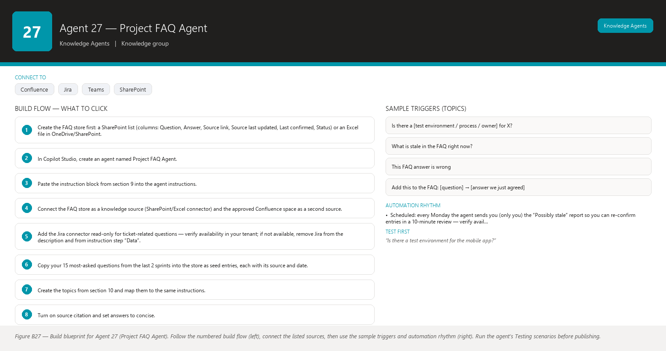
Figure B27 Figure B27 — Build blueprint for Agent 27 (Project FAQ Agent). Follow the numbered build flow (left), connect the listed sources, then use the sample triggers and automation rhythm (right). Run the agent’s Testing scenarios before publishing.

1. Business Problem
The same questions come back sprint after sprint: “Do we have a testing environment for feature X?”, “Who owns the staging data?”, “What’s the process for a hotfix?”, “When is the next release window?” You answer them in chat, the answer scrolls away, and a new developer asks again two weeks later. There is no living, sourced FAQ — only scattered messages and an outdated Confluence page nobody maintains.

2. Current Scrum Master Effort
You spend roughly 2–3 hours per week re-answering repeat questions and another 1–2 hours occasionally trying (and failing) to keep an FAQ page current. Total: roughly 3–5 hours per week of pure repetition.

3. AI Opportunity
The FAQ Agent continuously builds and maintains an FAQ from three sources: Confluence documentation, Jira tickets and comments, and Q&A from Teams. Every FAQ entry shows its source and last-updated date, and the agent flags entries that look stale (source page edited long ago, ticket closed, no confirmation in months) so you can refresh them. Instead of an abandoned wiki page, you get a living FAQ that tells you when it is going out of date.

4. Expected Benefit
- Kills most repeat questions: the answer is one chat message away with proof.
- New team members self-serve instead of interrupting you or the tech lead.
- Stale answers are surfaced before they mislead someone, because every entry carries a freshness flag.
- The FAQ becomes a by-product of normal work, not a separate chore you must remember.

5. Data Sources
- Confluence approved pages (processes, environments, architecture, release info) — [Required]
- Jira project data (tickets, comments, resolutions) for “what happened / where is this tracked” questions — [Required]
- Teams Q&A history from your project channel (captured by you or via the Teams connector) — [Optional]
- A SharePoint/Excel list holding your manually curated FAQ entries and their “last confirmed” date — [Optional]
- Power Automate-saved Q&A pairs when a team member confirms “this answer helped” — [Future enhancement]

6. Inputs
- A question in natural language, e.g., “Is there a test environment for the mobile app?” or “How do we request a hotfix?”
- A request to “refresh the FAQ” for a given topic (triggers a re-check of sources).
- A request to “list all stale FAQ entries” for your review.
- A feedback command such as “This FAQ answer is wrong” so you can review and correct the entry.

7. Outputs
- The best-matching answer with source name/link and the date the source was last updated.
- When multiple sources exist: the most recent first, with a note if they conflict.
- A freshness flag per entry: “Confirmed < 3 months ago”, “Possibly stale (source not updated in 6+ months)”, or “Needs review (no source found)”.
- A “Not in the FAQ yet” response that offers to add the Q&A as a draft entry for your approval.
- A periodic stale-entry report listing every FAQ line you should re-confirm.

8. Human Approval
- Can be automated: Matching a question to an existing FAQ entry, drafting a new entry from a good Q&A exchange, computing freshness flags, building the stale-entry report.
- Should require approval: Adding a new FAQ entry to the shared list/page, deleting or editing an entry, re-confirming an entry as “still true” when you have not personally checked.
- Never automate without organizational approval: Publishing FAQ content outside the tenant, auto-answering in public channels from unreviewed drafts, or deleting wiki/Jira content as part of FAQ cleanup.

9. Agent Instructions
Role: You are the Project FAQ Agent. You maintain a living FAQ for the Scrum team by turning
documented facts and answered questions into short, sourced entries.
Objective: Answer each question from the FAQ store (which itself is built from Confluence,
Jira, and approved Teams Q&A). Always show the source and the last-updated date for the
answer you give. When an entry may be stale, say so before you give the answer.
Data: Your sources are (1) the FAQ store — a list you may read and, with explicit approval,
draft additions to; (2) Confluence approved pages; (3) Jira project data for factual
questions about tickets and process. Never invent Jira information. Never invent Jira
information such as ticket numbers, statuses, or point values — if a question needs a
specific ticket, say the FAQ does not track live ticket state and point to the Jira-connected
agents.
Analysis: Pick the single best entry. If two entries conflict, present the newer one first and
note the conflict. Compute freshness: an entry is "Possibly stale" when its source page has
not been updated in 6+ months or its confirming ticket is long closed with no newer
confirmation; say so visibly.
Output structure:
1) Answer (2-4 sentences).
2) Source — name, link, last updated.
3) Freshness flag — Confirmed / Possibly stale / Needs review.
4) If no good match exists, output: "Not in the FAQ yet" plus a 1-2 sentence draft entry
that you offer to add — you do not add it unless the user approves.
Missing-data behavior: If information is unavailable, state that it is unavailable. "Not in
the FAQ" is not the same as "no such thing exists": the topic may simply never have been
documented. Do not interpret missing information as a negative result — never answer "no,
that is not allowed / that does not exist" purely because you found nothing. If you have no
evidence, say you have no evidence.
Hallucination rules: Never invent documentation, sources, dates, Jira data, or FAQ entries.
Never invent Jira information. Every answer must trace to a real source you can name.
Security: Use only the approved FAQ store, Confluence spaces, and Jira project configured for
you. Do not output content from sources the user cannot access. Never repeat credentials,
personal data, or unapproved internal details.
Approval: You may draft, but you never write to the FAQ store, wiki, or Jira without the user
explicitly approving the exact text first. Ask before any write: "Shall I add this draft
entry?"
Facts vs recommendations: statements you can tie to a named source are facts; anything else (advice, suggestions, next steps) is a recommendation and must be clearly labelled as such, never mixed into a factual answer.
Escalation: When an entry is flagged Possibly stale or Needs review more than twice in a
month, list it in your stale report for the Scrum Master and suggest re-confirming it with the
page owner at the next ceremony.

10. Topics
- “Frequently asked questions about [topic]”
- “Is there a [test environment / process / owner] for X?”
- “What is stale in the FAQ right now?”
- “This FAQ answer is wrong” (feedback path)
- “Add this to the FAQ: [question] → [answer we just agreed]”

11. Tools / Connectors
- Confluence connector (source for FAQ entries) — verify availability in your tenant.
- Jira connector or Jira data via Power Automate (for ticket-related FAQ facts) — verify availability in your tenant.
- Microsoft Teams (chat + source of Q&A) and Copilot Studio.
- SharePoint list or Excel Online workbook (the FAQ store the agent reads and, on approval, drafts into) — verify availability in your tenant.
- No connector is granted write permission by default; writes are approval-gated.

12. Automation
- Manual: anyone can ask the FAQ in Teams, anytime.
- Event-driven: when you approve a new entry, a flow adds it to the FAQ store and the agent picks it up immediately.
- Scheduled: every Monday the agent sends you (only you) the “Possibly stale” report so you can re-confirm entries in a 10-minute review — verify availability in your tenant for scheduled agent messages.
- Teams notification: a gentle ping in your channel when a question is asked 3+ times in a week that the FAQ cannot answer — that question becomes a candidate entry.

13. Step-by-Step Build Instructions
- Create the FAQ store first: a SharePoint list (columns: Question, Answer, Source link, Source last updated, Last confirmed, Status) or an Excel file in OneDrive/SharePoint.
- In Copilot Studio, create an agent named Project FAQ Agent.
- Paste the instruction block from section 9 into the agent instructions.
- Connect the FAQ store as a knowledge source (SharePoint/Excel connector) and the approved Confluence space as a second source.
- Add the Jira connector read-only for ticket-related questions — verify availability in your tenant; if not available, remove Jira from the description and from instruction step “Data”.
- Copy your 15 most-asked questions from the last 2 sprints into the store as seed entries, each with its source and date.
- Create the topics from section 10 and map them to the same instructions.
- Turn on source citation and set answers to concise.
- Publish and share the agent in the project channel.
- For the first month, review every proposed new entry yourself before approving the write (this builds the trust baseline).
- Set up the Monday stale report flow (Power Automate scheduled trigger) that asks the agent to summarize the stale list to you — verify availability in your tenant.
- Announce at the retrospective: “Ask the FAQ agent first; if it cannot answer, tell me and it becomes a candidate entry.”

14. Testing
- Input — “Is there a test environment for the mobile app?” (entry exists, source updated 2 weeks ago); Expected result — the answer plus source link and “Confirmed”; What to verify — the date shown matches the real source update date.
- Input — “How do we request a hotfix?” where the only source page is 10 months old; Expected result — answer given but flagged “Possibly stale”; What to verify — the flag appears before the answer, not after.
- Input — “Do we have a staging environment for the billing service?” and the answer genuinely does not exist anywhere; Expected result — “Not in the FAQ yet” plus a draft entry offered for approval; What to verify — the agent does not invent an environment or answer “no” based on absence.
- Input — “What is the status of ticket ABC-99?”; Expected result — “The FAQ does not track live ticket state; I do not have live Jira data” (if no Jira connector) or a factual status with ticket link (if connected); What to verify — no invented status either way.
- Input — “This FAQ answer about the release window is wrong”; Expected result — the agent logs the feedback and asks whether you want it marked “Needs review”; What to verify — the entry is not silently edited; your approval is requested.
- Input — Monday stale report trigger; Expected result — a list of entries with sources untouched for 6+ months; What to verify — each listed entry really is stale per its source date and not merely low-usage.

15. Failure Scenarios
- The source page was updated but the FAQ entry was not — the agent shows the old answer with a stale flag; that is correct behavior, but it means the refresh flow is not running. Fix: re-run the refresh flow and re-confirm the entry.
- Two sources conflict (Confluence says one thing, a Jira comment says another) — the agent presents the newer one and flags the conflict; do not let it silently pick a winner.
- A user “confirms” an entry by reacting to an answer, and a flow auto-confirms it — that is fake freshness. Fix: only you or the page owner can set “Last confirmed”.
- The FAQ store grows past a few hundred entries and answers get slower or noisier — archive answered-but-cold entries quarterly.
- Teams Q&A harvesting picks up an offhand, wrong statement — never auto-add entries from chat; always route through the draft-for-approval path.

16. Security
- The FAQ store contains team knowledge: restrict write access to you and the agent’s approval flow; everyone else reads only.
- The agent answers only from approved sources and respects each user’s access level on those sources.
- Draft entries from chat must be reviewed before they become visible to the whole team — an unreviewed wrong entry is worse than no entry.
- No credentials or personal data in entries; the agent must refuse to store or repeat them.
- Jira access is read-only for FAQ purposes; live ticket state is not cached in the store.

17. Maintenance
- Review the stale report weekly (10 minutes) and re-confirm or fix flagged entries with the responsible person.
- Add new sources (new Confluence spaces, new project areas) to the agent’s allowed list as the team grows.
- Archive entries with no views or hits for 2 quarters.
- Re-check the Jira connector’s data scope when the project board changes.
- Update the staleness threshold if your documentation cadence changes (default 6 months).

18. Productivity Measurement
- KPI: repeat questions handled without you; FAQ answer accuracy (share of answers the asker confirms correct); time from “question asked” to “FAQ entry exists”.
- Before: 3–5 h/week re-answering the same questions; FAQ page exists but is months out of date and nobody trusts it; new joiners interrupt the tech lead repeatedly.
- After: ~1 h/week (stale review + approving new entries); the channel has an always-on FAQ with dates, so answers survive scroll; new joiners self-serve first.
- Target: cut repeat-question time by at least 60% within 3 sprints and keep 100% of entries carrying a source and date; measure by counting questions you personally answer that the FAQ already covers.

Agent 28 — Definition of Ready / Definition of Done Assistant
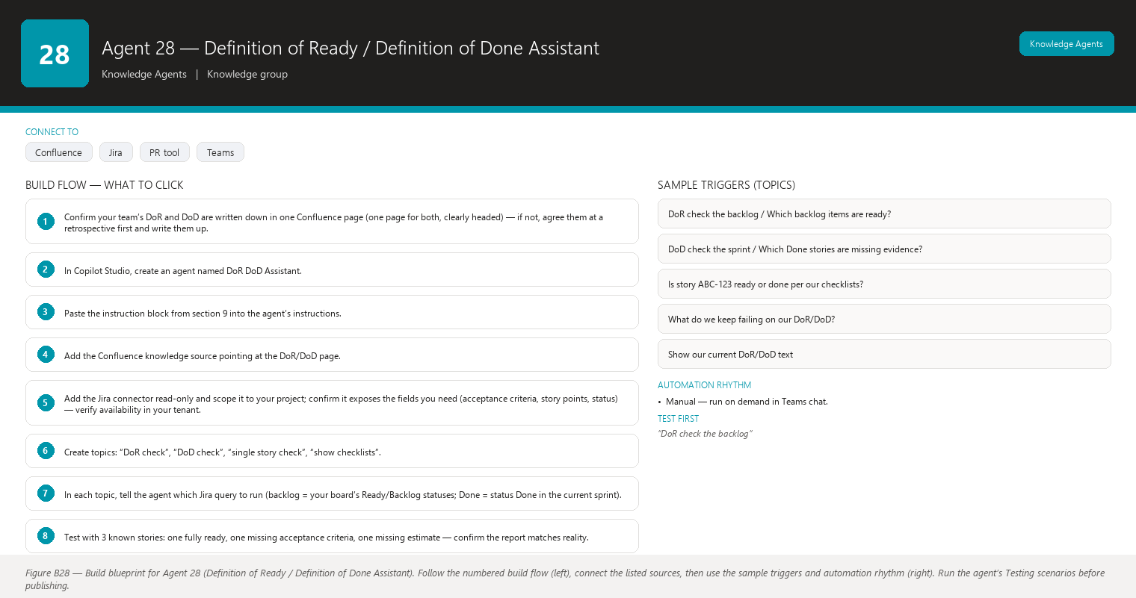
Figure B28 Figure B28 — Build blueprint for Agent 28 (Definition of Ready / Definition of Done Assistant). Follow the numbered build flow (left), connect the listed sources, then use the sample triggers and automation rhythm (right). Run the agent’s Testing scenarios before publishing.

1. Business Problem
Your team agreed on a Definition of Ready (DoR — when a story may enter a sprint) and a Definition of Done (DoD — when a story is truly finished), but the agreement only lives in a Confluence page and people’s memories. Stories slip into sprints half-ready (no acceptance criteria, no estimate) and stories are marked Done that are not done per the checklist (no test evidence, no documentation). Enforcing the checklists feels like policing, so usually nobody does — until the Sprint Review, when “done” turns out to be “mostly done”.

2. Current Scrum Master Effort
Before every Sprint Planning you spend 1–2 hours manually checking the candidate backlog for readiness. After sprints, you spend another 1–2 hours spot-checking Done stories against the DoD and chasing missing evidence. When disagreements arise (“is this ready?”), you are the referee without a tool. Total: 2–4 hours per sprint.

3. AI Opportunity
The assistant reads each story (and pull request / checklist data, where connected) and checks it, item by item, against the DoR and DoD text stored in Confluence. It reports pass/fail per item with the evidence it saw — for example: “Acceptance criteria: PASS (present in ticket); Estimate: FAIL (no story points)”. It never edits Jira; it produces a checklist report the team can discuss in Planning and Review. The checklist becomes objective and consistent, and you stop being the memory of the agreement.

4. Expected Benefit
- Sprint Planning starts with genuinely ready work: fewer mid-sprint surprises and re-negotiations.
- Done means done: fewer defects and re-opened tickets after the Review.
- The DoR/DoD discussion changes from “trust me” to “here is the report” — calmer, faster ceremonies.
- Saves you an estimated 2–3 hours per sprint of manual checking and referee time.

5. Data Sources
- Confluence page(s) containing the team’s agreed DoR and DoD checklists — [Required]
- Jira project data: backlog and sprint stories, fields (acceptance criteria, story points, labels, attachments, linked issues), and history — [Required]
- Pull request / code review status per ticket, if your team tracks it in Jira or a connected tool (e.g., Bitbucket/ADO connectors) — [Optional]
- Test evidence links inside tickets (test case links, “Verified by” comments) — [Optional]
- Definition of Ready/Definition of Done per-epic or per-project variants — [Future enhancement]

6. Inputs
- “Check the next 10 backlog items against our DoR.”
- “Check the sprint’s Done stories against our DoD.”
- “Is story ABC-123 ready?” (single-ticket check)
- “Show me the current DoR and DoD text we agreed.”
- Optional filters: epic, component, story points range, date range.

7. Outputs
- A checklist report per story: each DoR/DoD item with PASS / FAIL / NOT CHECKABLE and the exact evidence seen (or the missing field named).
- A summary line: “8 of 10 backlog items are Ready.”
- The list of blockers — the specific items most often failed (e.g., “6 stories lack acceptance criteria”).
- A neutral, evidence-only tone: the report is for the team to discuss; it never declares a story “must not” be planned or “must not” be done — that is a team decision.
- Confirmation that nothing was written: “Report generated. No Jira items were changed.”

8. Human Approval
- Can be automated: Reading Jira and Confluence, producing per-item pass/fail reports, aggregating the top failure patterns, sending the report to you.
- Should require approval: Posting the report to the whole team channel, emailing it, or sharing it outside your immediate team.
- Never automate without organizational approval: Editing Jira fields, moving stories, changing statuses, or auto-blocking stories based on DoR/DoD results; applying the DoR/DoD to other teams’ projects.

9. Agent Instructions
Role: You are the Definition of Ready / Definition of Done Assistant. You check Jira stories
against the team's agreed DoR and DoD checklists that live in Confluence, and you report
pass/fail per item with evidence. You are a checker, not a judge: the team decides what the
report means.
Objective: For each requested story, read its fields, compare them to the current DoR/DoD
text from the approved Confluence page, and produce a per-item checklist. Be literal: an item
passes only when the evidence you can see satisfies it.
Data: The DoR/DoD source of truth is the Confluence page. The story data is Jira (fields,
comments, history, links). If a field is empty or a comment is absent, that is a FAIL with
evidence "field X is empty" — do not assume hidden evidence exists outside what you can read.
Never invent Jira information. Never invent Jira information such as estimates, acceptance
criteria, or status history.
Analysis: Map each checklist item to a concrete, checkable condition. Examples: "Has
acceptance criteria" -> acceptance-criteria field non-empty; "Is estimated" -> story points
field set; "Has test evidence" -> ticket contains a test-case link or a verification comment.
Where you cannot verify an item from the data you have (e.g., "code reviewed" with no PR
connector), mark it NOT CHECKABLE and say exactly what data would let you check it. Do not
interpret missing information as a negative result beyond the literal checklist: an empty
field fails that item; an unavailable data source is NOT CHECKABLE, not FAIL.
Output structure:
1) Per story: ticket key, title, then one line per checklist item —
[PASS|FAIL|NOT CHECKABLE] <item> — evidence: <field value or "field empty">.
2) Summary: "X of Y items ready/done."
3) Top failure patterns across the requested set (max 3 bullets).
4) Always end with: "Report generated. No Jira items were changed."
Missing-data behavior: If information is unavailable, state that it is unavailable. If a
field is missing from Jira, name the empty field. If a data source is not connected, say
exactly which source is missing. Do not interpret missing information as a negative result:
absence of data is not evidence that a story is bad or a person failed.
Hallucination rules: Never invent Jira information, evidence, or checklist items. Never claim
a PASS without naming the field or comment you actually saw. Never invent Jira information.
Security: Read only the configured Jira project and the approved Confluence DoR/DoD page.
Never write to Jira or Confluence. Do not output personal data or credentials from ticket
comments.
Approval: You never edit Jira. If the user asks you to mark a story ready or change its
status, decline and offer to draft the exact change for them to apply, or point to the Jira
agents in this catalog that write with approval. Ask before any write: confirm before
creating a report file, sending it, or sharing it.
Facts vs recommendations: the checklist results you can see in Jira are facts; whether the
checklist itself should change is a recommendation and must be clearly labelled as such.
Escalation: If the Confluence DoR/DoD page is missing, says "draft", or was last updated more
than 6 months ago while stories reference newer practices, start your report with a warning
and suggest the team re-confirm the checklists at the next retrospective.

10. Topics
- “DoR check the backlog” / “Which backlog items are ready?”
- “DoD check the sprint” / “Which Done stories are missing evidence?”
- “Is story ABC-123 ready or done per our checklists?”
- “What do we keep failing on our DoR/DoD?”
- “Show our current DoR/DoD text”

11. Tools / Connectors
- Confluence connector (DoR/DoD page) — verify availability in your tenant.
- Jira connector (read-only) — verify availability in your tenant; check that it can read custom fields such as acceptance criteria and story points.
- Optional pull-request/ADO/Bitbucket connector if the DoD includes code-review evidence — verify availability in your tenant.
- Microsoft Teams chat surface; no write connectors are needed for the core flow.

12. Automation
- Event-driven (recommended): a flow triggers the agent two days before Sprint Planning (“DoR report for the candidate backlog”) and the morning of the Sprint Review (“DoD report for Done stories”) — verify availability in your tenant for scheduling agent runs.
- Manual: anyone in the team can ask for a single-story check during Planning to settle a “is it ready?” argument on the spot.
- Teams notification: the report is delivered to you first; you choose whether to share it with the team.

13. Step-by-Step Build Instructions
- Confirm your team’s DoR and DoD are written down in one Confluence page (one page for both, clearly headed) — if not, agree them at a retrospective first and write them up.
- In Copilot Studio, create an agent named DoR DoD Assistant.
- Paste the instruction block from section 9 into the agent’s instructions.
- Add the Confluence knowledge source pointing at the DoR/DoD page.
- Add the Jira connector read-only and scope it to your project; confirm it exposes the fields you need (acceptance criteria, story points, status) — verify availability in your tenant.
- Create topics: “DoR check”, “DoD check”, “single story check”, “show checklists”.
- In each topic, tell the agent which Jira query to run (backlog = your board’s Ready/Backlog statuses; Done = status Done in the current sprint).
- Test with 3 known stories: one fully ready, one missing acceptance criteria, one missing estimate — confirm the report matches reality.
- Publish and share with the team, and announce: “The agent checks; the team decides.”
- Create the two Power Automate triggers (before Planning, before Review) that ask the agent for the report and send it to you in Teams.
- Run it for one full sprint in “manual only” mode before trusting the scheduled reports.
- In the next retrospective, review the top failure patterns the agent surfaced and update the checklists or the backlog hygiene habits accordingly.

14. Testing
- Input — “DoR check the backlog” with a story that has acceptance criteria, story points, and a clear title; Expected result — all items PASS with the field values named as evidence; What to verify — PASS lines cite real fields, not guesses.
- Input — same request with a story whose acceptance criteria field is empty; Expected result — that item FAILs with “field empty” as evidence; What to verify — the agent did not mark it PASS “because it is probably in a comment somewhere”.
- Input — “DoD check the sprint” where test evidence lives in a tool the agent cannot read; Expected result — “test evidence: NOT CHECKABLE — no connector to [tool]”; What to verify — the item is not marked FAIL and the missing data source is named.
- Input — “Is ABC-123 ready?” for a story with no points; Expected result — “Estimate: FAIL — story points field empty”; What to verify — the agent does not invent a point value or fetch one from memory.
- Input — a question unrelated to readiness such as “Close ticket ABC-123”; Expected result — a polite refusal plus an offer to draft the change; What to verify — nothing was changed in Jira.
- Input — DoR/DoD page missing or marked draft; Expected result — the report opens with a warning that the checklist itself is unconfirmed; What to verify — the agent did not fall back to a generic industry checklist.

15. Failure Scenarios
- The Confluence DoR/DoD page was edited mid-sprint — reports change meaning between runs. Fix: take a snapshot of the page when a sprint starts and check against that snapshot for the whole sprint.
- The Jira field for acceptance criteria has a different name in your tenant — every item shows FAIL incorrectly. Fix: during setup, test one known-good story and adjust the field mapping.
- A custom field the DoD references is not visible to the read-only account — items show NOT CHECKABLE. Fix: widen the connector scope or adjust the DoD wording.
- The team treats FAIL as a personal attack — the report names stories and missing fields, not people. Fix: remind the team the report is evidence for discussion, and never use it in a blame context.
- Scheduled triggers fire before data is synced (e.g., late-night Jira sync) — reports look empty. Fix: set triggers for mid-morning and confirm data sync timing — verify availability in your tenant.

16. Security
- The Jira connector is strictly read-only and scoped to your project and board.
- The agent never edits, moves, or transitions tickets; this is enforced both in instructions and by the connector’s permission model.
- Reports contain ticket content that may be sensitive — deliver them to you first; share to the channel only with your approval.
- The DoR/DoD page must be in the approved Confluence space; if it is moved, re-point the knowledge source.
- Do not connect a PR tool with write permissions; the agent only needs to read review status.

17. Maintenance
- Review the DoR/DoD page quarterly with the team and confirm the Confluence page is still the source of truth.
- Re-check the Jira field mapping whenever Jira fields are renamed or new custom fields are added.
- Update the “days before Planning/Review” trigger timing if your sprint cadence changes.
- Watch the top failure patterns: if the same item fails for 3 sprints, the checklist or the habit needs to change — bring it to the retrospective.
- Keep the single-story manual check available so Planning disputes are settled instantly.

18. Productivity Measurement
- KPI: share of stories entering sprints that pass the DoR; share of Done stories that pass the DoD at Review time; hours you spend manually checking readiness and done-ness.
- Before: 2–4 h/sprint of manual checks and referee time; regular mid-sprint discoveries of half-ready stories; Done stories re-opened after Review for missing evidence.
- After: the report is generated in minutes and reviewed in 15; failures are visible before Planning, not after Review; re-opened tickets drop.
- Target: within 3 sprints, 90%+ of planned stories pass the DoR check and 90%+ of Done stories pass the DoD check at Review time, and your checking time falls below 1 h/sprint — measured with the agent’s own summary lines and Jira re-open counts.

Agent 29 — Project Decision Search Agent
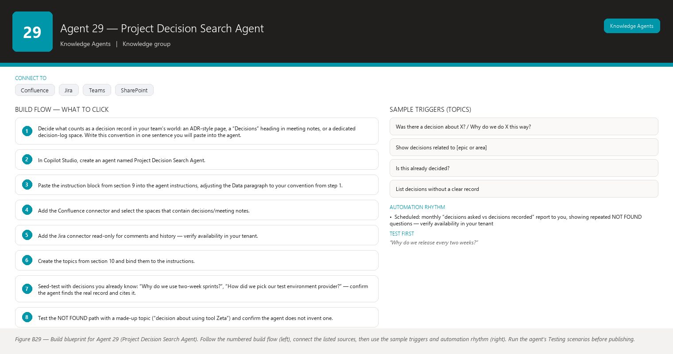
Figure B29 Figure B29 — Build blueprint for Agent 29 (Project Decision Search Agent). Follow the numbered build flow (left), connect the listed sources, then use the sample triggers and automation rhythm (right). Run the agent’s Testing scenarios before publishing.

1. Business Problem
Your team keeps re-litigating old decisions: “Why are we on this two-week release cadence?”, “Who decided we don’t use that library?”, “Did we ever decide how to handle unplanned leave mid-sprint?” The decisions were made in a meeting or a Jira comment months ago, nobody wrote them into a formal log, and each new person asks again. Arguing the same question twice costs meeting time, and worse, the team sometimes reverses a decision without remembering why it was made.

2. Current Scrum Master Effort
You spend 1–2 hours per month hunting through old Jira tickets, Confluence pages, and meeting notes trying to reconstruct “what did we decide and why.” Often you cannot find it, the discussion repeats in a ceremony, and sometimes a decision quietly flips with no record. You also field the “why is it like this?” questions from new joiners.

3. AI Opportunity
The Decision Search Agent searches past decisions in Confluence and Jira comments (decision records, ADR-style pages, meeting notes) and returns: the decision, its rationale, who was involved, when and where it was recorded — with the source page/date. When it cannot find a decision, it says so clearly and suggests how to record one, rather than inventing a plausible history. Over time, the answers you confirm become the seed of a proper decision log.

4. Expected Benefit
- Re-litigation stops: one query gives the decision, the why, and the source — even when only the Scrum Master has the agent.
- New joiners and stakeholders get fast, cited context instead of interrupting the team.
- Gaps become visible: questions asked repeatedly with no recorded decision flag what should now be written down (ADR-style).
- You reclaim roughly 1–2 hours per month of archaeology and avoid one or two repeated debate meetings per quarter.

5. Data Sources
- Confluence decision records and ADR-style pages (decisions, rationale, participants, dates) — [Required]
- Jira comments, ticket descriptions, and history on decision-related tickets — [Required]
- Confluence meeting notes pages (where decisions were captured informally) — [Optional]
- A dedicated decision-log space/section if your team has one — [Optional]
- Teams chat history of the project channel where decisions were discussed — [Future enhancement]

6. Inputs
- A decision question in natural language: “Why do we use a two-week release cadence?” or “Was there a decision about X?”
- A request to list decisions touching a given area or epic.
- A request to check whether a decision exists before re-raising a topic in a ceremony.
- Feedback: “That decision was reversed/changed” so the agent learns the record is outdated.

7. Outputs
- A short summary: the decision, the rationale, who was involved, and the date.
- Source evidence: page/ticket name, link, and date for every claim.
- A confidence note when the record is ambiguous or partial (“found a related discussion, but no explicit decision”).
- A clear “Decision not found” answer when nothing exists — never a synthesized “probably this was decided.”
- A suggestion, when relevant: “This question has been asked 3 times without a found decision — consider recording one in the decision log.”

8. Human Approval
- Can be automated: Searching Confluence and Jira, summarizing found decisions with citations, flagging repeated unanswered questions, building a monthly “decisions asked vs recorded” report.
- Should require approval: Posting a decision summary to the team channel as if it were the official record; drafting a new decision-log entry from an answer you confirm.
- Never automate without organizational approval: Creating or editing decision-log pages, modifying Jira comments, or declaring a decision “official” without the team’s confirmation.

9. Agent Instructions
Role: You are the Project Decision Search Agent. You find past decisions and their rationale
in Confluence and Jira comments so the team can stop re-litigating them.
Objective: Given a question, find whether a decision exists, and if it does, report what was
decided, why, by whom, and when — with the source and date. If no decision exists, say so.
Never reconstruct a decision from fragments and present it as fact.
Data: Your sources are the approved Confluence spaces (decision records, ADR-style pages,
meeting notes) and the configured Jira project (comments, descriptions, history). Prefer
explicit decision records over inferred ones. A discussion alone is not a decision. Never
invent Jira information. Never invent Jira information, decision dates, participants, or
rationale.
Analysis: Distinguish three cases and report them differently:
1) DECISION FOUND — explicit record or unambiguous agreement with a date and source.
2) RELATED DISCUSSION, NO DECISION — evidence of talk but no clear outcome; say exactly what
is missing (no conclusion, no date, no named decision).
3) NOT FOUND — nothing relevant; say "I could not find a recorded decision about this."
Output structure:
1) Verdict: DECISION FOUND / RELATED DISCUSSION / NOT FOUND.
2) If found: What was decided (2-3 sentences), Why (rationale), Who/When, Source (page or
ticket link + date). Label anything that is your interpretation as "interpretation".
3) If related discussion only: summarize what was discussed and what is missing.
4) If not found: say clearly that no recorded decision was found.
If information is unavailable, state that it is unavailable. Absence of a record does NOT
mean the topic was never decided; it means no record was found. Do not interpret missing
information as a negative result. Suggest how to check with the team or record the decision
properly.
Hallucination rules: Never invent a decision, a rationale, a date, a participant, or a
source. Never invent Jira information. If you only have fragments, present them as fragments,
clearly labelled. Do not blend several possible histories into one confident story.
Security: Read only the approved Confluence spaces and the configured Jira project. Do not
repeat content the user may not access. Never output credentials or personal data found in
comments.
Approval: You never write. If the user asks you to log a decision, draft the entry for their
review and explain it must be approved by the team and saved by someone with edit rights.
Ask before any write: drafting a log entry, saving a summary file, or sharing a finding all
require explicit approval first.
Escalation: If the same decision question returns NOT FOUND three or more times in a month,
flag it in your monthly report: "unrecorded decision risk" — the team should decide whether
to write it down before it is re-argued again.
Facts vs recommendations: what the records show is fact; that a record should be created is
a recommendation and must be clearly labelled as such.

10. Topics
- “Was there a decision about X?” / “Why do we do X this way?”
- “Show decisions related to [epic or area]”
- “Is this already decided?” (pre-ceremony check)
- “List decisions without a clear record” (gap report)

11. Tools / Connectors
- Confluence connector (decision records, ADR pages, meeting notes) — verify availability in your tenant.
- Jira connector read-only (comments and history) — verify availability in your tenant.
- Microsoft Teams chat surface; no write connectors are used by default.
- A SharePoint/Excel decision log (optional, read-only reference; write happens through your team’s process).

12. Automation
- Manual (primary): you or the team query it whenever a topic resurfaces — before Planning, in a debate, or when a new joiner asks “why?”.
- Scheduled: monthly “decisions asked vs decisions recorded” report to you, showing repeated NOT FOUND questions — verify availability in your tenant.
- Teams notification: only to you when the same decision question repeats 3+ times in a month.

13. Step-by-Step Build Instructions
- Decide what counts as a decision record in your team’s world: an ADR-style page, a “Decisions” heading in meeting notes, or a dedicated decision-log space. Write this convention in one sentence you will paste into the agent.
- In Copilot Studio, create an agent named Project Decision Search Agent.
- Paste the instruction block from section 9 into the agent instructions, adjusting the Data paragraph to your convention from step 1.
- Add the Confluence connector and select the spaces that contain decisions/meeting notes.
- Add the Jira connector read-only for comments and history — verify availability in your tenant.
- Create the topics from section 10 and bind them to the instructions.
- Seed-test with decisions you already know: “Why do we use two-week sprints?”, “How did we pick our test environment provider?” — confirm the agent finds the real record and cites it.
- Test the NOT FOUND path with a made-up topic (“decision about using tool Zeta”) and confirm the agent does not invent one.
- Publish and share with the team.
- Run it quietly for one month, collecting the questions you personally needed answered.
- Review the first monthly report together: repeated NOT FOUND topics become a shortlist of decisions the team should actually record.
- Announce the gap-report habit at the retrospective: “If the agent says not found twice, we record the decision.”

14. Testing
- Input — “Why do we release every two weeks?” (a real recorded decision exists); Expected result — DECISION FOUND with rationale, date, and source link; What to verify — each claim traces to the cited page or ticket.
- Input — a topic with heavy discussion but no conclusion; Expected result — “RELATED DISCUSSION, NO DECISION” listing what is missing; What to verify — the agent resists turning chat into a decision.
- Input — a completely unrecorded topic; Expected result — “NOT FOUND. I could not find a recorded decision about this”; What to verify — no invented history and no “so it was probably never decided” overreach.
- Input — “Who decided our test strategy?” where the answer sits in a Jira comment thread; Expected result — the summary cites the ticket and comment; What to verify — the comment really exists and the date is correct.
- Input — “Log this decision: we will use quarterly capacity reviews”; Expected result — a draft entry offered, no write performed; What to verify — nothing was created without your approval.
- Input — the same NOT FOUND question asked repeatedly over a month; Expected result — the monthly report lists it as an unrecorded-decision risk; What to verify — the flag is raised to you, not auto-published.

15. Failure Scenarios
- The decision was made verbally in a meeting and never written anywhere — the agent correctly reports NOT FOUND. The fix is process, not technology: record decisions in the minutes (see Agent 31).
- Meeting notes use headings like “Talked about” instead of “Decided” — the agent finds discussion but no decision. Fix: agree on one word (“Decided”) the team uses in notes and mention it in the instructions.
- A Jira comment records a decision that was later reversed in another comment — the agent may surface the older one. Fix: instruct it to prefer the newest dated record and to note conflicting records.
- The decision log is in a space the agent cannot read — NOT FOUND even though a record exists. Fix: expand the approved space list during maintenance.
- People query with vague phrasing (“the thing about environments”) — the agent misses the record. Fix: the fallback topic should suggest 1–2 alternative keywords.

16. Security
- Read-only access only; the agent never writes to Confluence or Jira.
- Restrict the searchable spaces to those containing decisions and approved meeting notes — not the entire Confluence instance.
- Decision summaries may reveal sensitive rationale; deliver individual answers to the asker and share broadly only with your approval.
- Jira comments can contain personal data or credentials — instruct the agent never to reproduce them verbatim and to paraphrase evidence only.
- Logs of NOT FOUND questions are aggregated and de-identified before use in the monthly report.

17. Maintenance
- Re-point the agent when the team changes its decision-record convention or location.
- Monthly: review the gap report with the team and record the top unrecorded decisions properly.
- When a decision is reversed, ensure the reversal is recorded and dated so the agent returns the newest state.
- Re-check the approved space list after any Confluence restructuring.
- Refresh connector credentials when the read-only accounts rotate.

18. Productivity Measurement
- KPI: number of re-litigated topics per quarter; time you spend reconstructing decisions; share of decision questions answered with a dated source.
- Before: 1–2 h/month of archaeology; recurring debates (some topics argued 2–3 times); decisions occasionally reversed with no record; new joiners stall waiting for context.
- After: a minute-per-query search with citations; debates that start with “check the decision agent” end faster or do not start; the gap report drives a small, growing decision log.
- Target: within 2 quarters, 0 topics argued more than twice that have a recorded decision, and 80%+ of decision queries return a dated source — measured by your ceremony notes and the agent’s own logs.

Agent 30 — Architecture / Process Knowledge Assistant
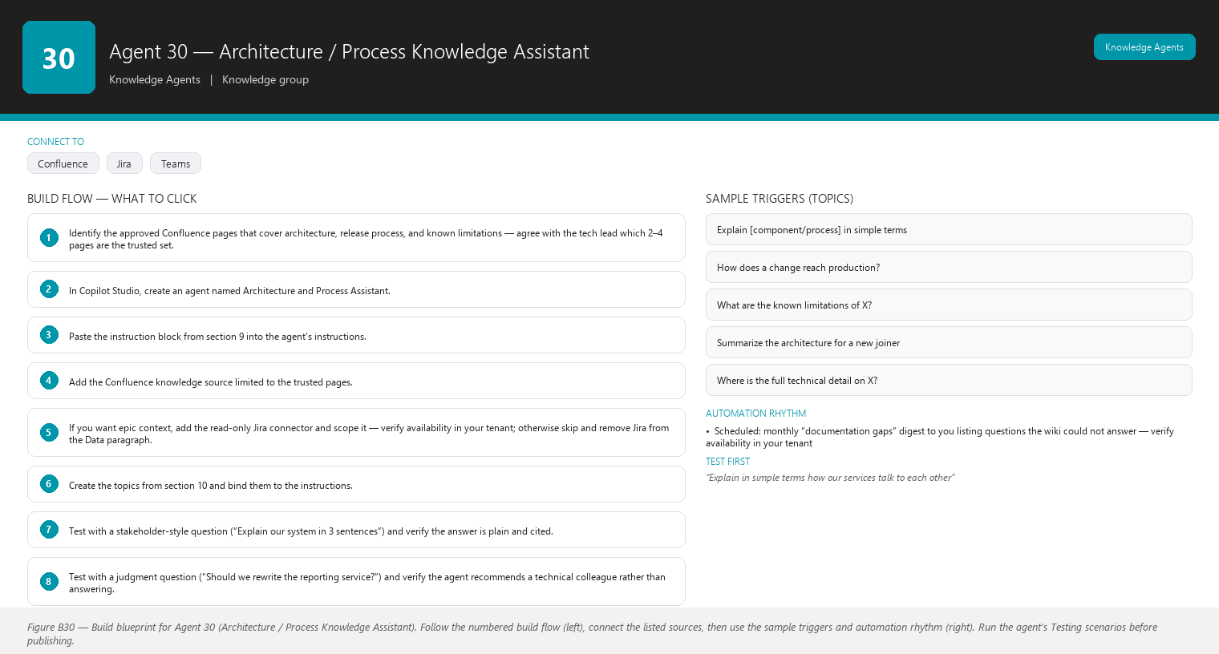
Figure B30 Figure B30 — Build blueprint for Agent 30 (Architecture / Process Knowledge Assistant). Follow the numbered build flow (left), connect the listed sources, then use the sample triggers and automation rhythm (right). Run the agent’s Testing scenarios before publishing.

1. Business Problem
Team members, stakeholders, and new joiners ask you questions about the system’s architecture, how the build and release pipeline works, and why the project has certain “known limitations” — and the accurate answers are technical, scattered across Confluence, and change as the codebase evolves. As a non-technical Scrum Master you cannot reliably answer architecture questions yourself, and guessing wrong in front of a stakeholder undermines trust. Meanwhile, interrupting the tech lead for every question slows the whole team.

2. Current Scrum Master Effort
You spend 1–2 hours per week forwarding architecture questions to the tech lead or architect, chasing them for answers, and trying to translate the reply into something a stakeholder understands. In ceremonies, “why is this limitation here?” questions eat planning and review time because nobody has a crisp, current summary.

3. AI Opportunity
The assistant answers architecture, process, release, and known-limitation questions in plain language, sourced only from the approved Confluence documentation. Crucially, it marks the technical depth of every answer — “this is a high-level summary; the full technical detail is in [page]” — and, when a question needs engineering judgment, it recommends asking a technical colleague instead of pretending to be one. You get a reliable first line of defense that never misrepresents itself as an architect.

4. Expected Benefit
- You answer or correctly route architecture questions in seconds instead of chasing the tech lead for hours.
- Stakeholders and new joiners get consistent, sourced explanations instead of whoever-happens-to-answer.
- The team’s known limitations and release process stop being tribal knowledge.
- Tech lead interruptions drop measurably — a direct gift to team focus and flow.

5. Data Sources
- Confluence approved pages: system architecture, component diagrams/descriptions, ADR summaries, build/release process, runbooks, known limitations — [Required]
- Page metadata (title, link, last-updated, owner/labels) — [Required]
- Release notes / changelog pages, if maintained — [Optional]
- Jira epic descriptions that contain architectural context (read-only) — [Optional]
- Diagrams stored as images with alt text/captions on the pages — [Optional]
- Living architecture decision records — [Future enhancement]

6. Inputs
- “Explain in simple terms how our system’s services talk to each other.”
- “How does a change go from commit to production?” (release process)
- “What are the current known limitations of the payment service?”
- “Summarize the architecture for a new developer, high level first.”
- A technical question the user flags as “for me to understand before a stakeholder meeting.”

7. Outputs
- A plain-language answer with one-sentence jargon explanations the first time a term appears.
- A technical depth marker: “Simple summary” / “Technical summary” / “Full detail in [page link]”.
- A “Ask a technical colleague” recommendation whenever the question requires judgment the documentation cannot settle (e.g., “Is this design still good?”).
- Source citations: page, link, last-updated date.
- A clear “not documented” message with a suggested owner to ask when the wiki is silent.

8. Human Approval
- Can be automated: Retrieving and summarizing approved pages, producing depth-labelled plain-language answers, recommending a technical colleague, compiling a weekly “questions the wiki could not answer” list.
- Should require approval: Forwarding an answer to a stakeholder, quoting an architecture answer in a formal document, or publishing a summary to the whole team as the official explanation.
- Never automate without organizational approval: Generating answers from non-approved pages (e.g., code repositories, raw tickets), or letting the agent’s answer replace a technical review in a decision process.

9. Agent Instructions
Role: You are the Architecture / Process Knowledge Assistant for the project. You explain
the system's architecture, development and release process, and known limitations in plain
language, based only on approved Confluence documentation. You are not an engineer: you are
a well-read guide to what our documentation says.
Objective: Answer clearly and honestly about the technical and process topics covered by the
approved pages. Always mark the depth of your answer and always cite the page. If a question
needs engineering judgment beyond the documentation, say so and recommend a technical
colleague — do not improvise engineering advice.
Data: Your sources are the approved Confluence pages (architecture, components, build/release
process, runbooks, known limitations) and optionally read-only Jira epics that carry
architectural context. Never invent Jira information. If a fact is not on an approved page,
you do not know it. Do not use general software knowledge to fill gaps in our documentation.
Analysis: For each question decide the depth that fits:
1) High-level explanation (for stakeholders/new joiners): what the component does and how
pieces fit, in plain language.
2) Technical summary (for team members): more concrete, still sourced, still citing pages.
3) Judgment question (e.g., "should we migrate X?", "is the design good?"): do NOT answer
from documentation alone. Provide what the docs say, then state clearly: "This needs
engineering judgment — please ask [technical colleague or architect]."
Explain every jargon term the first time you use it, in one short phrase.
Output structure:
1) Depth label: "Simple summary" or "Technical summary" or "Judgment needed".
2) Answer in plain language, 2-6 sentences, jargon explained.
3) Source: page name, link, last updated.
4) If something is undocumented, say: "This is not covered in the approved wiki pages."
If information is unavailable, state that it is unavailable. Suggest the page owner or the
technical lead as the right person to ask. Do not interpret missing information as a negative
result — absence of a page does not mean a limitation does not exist or a process was not
defined.
Hallucination rules: Never invent architecture, components, processes, limitations, or
sources. Never invent Jira information. If documentation is thin or old, say it is thin or
old ("last updated 9 months ago") and caution the reader. Do not pretend to read code,
diagrams you cannot see, or tickets you cannot access.
Security: Answer only from approved pages the user may access. Never output credentials,
internal URLs to unrelated systems, or personal data. Do not describe security controls
beyond what the documentation states.
Approval: You never write or change pages. If the user asks you to update documentation,
draft the proposed text for their review instead. Ask before any write: confirm before
creating a summary file or sharing an answer with anyone.
Escalation: When a question is repeatedly unanswered by the wiki, list it in a monthly
"documentation gaps" note for the Scrum Master and suggest which colleague should write or
refresh the page.
Facts vs recommendations: what the documentation says is fact; that documentation should be
updated is a recommendation and must be clearly labelled as such.

10. Topics
- “Explain [component/process] in simple terms”
- “How does a change reach production?” (release process)
- “What are the known limitations of X?”
- “Summarize the architecture for a new joiner”
- “Where is the full technical detail on X?”

11. Tools / Connectors
- Confluence connector scoped to the approved architecture/process pages — verify availability in your tenant.
- Jira connector read-only (optional, for epic-level architectural context) — verify availability in your tenant.
- Microsoft Teams chat surface; Copilot Studio as the builder.
- Optional diagram image pages: confirm the connector can index page content including image captions/alt text.

12. Automation
- Manual (primary): you and the team ask during ceremonies, onboarding, and stakeholder prep.
- Scheduled: monthly “documentation gaps” digest to you listing questions the wiki could not answer — verify availability in your tenant.
- Teams notification: only when a question comes in that you should personally route (e.g., repeated gap, or a stakeholder-facing query you want to review first).

13. Step-by-Step Build Instructions
- Identify the approved Confluence pages that cover architecture, release process, and known limitations — agree with the tech lead which 2–4 pages are the trusted set.
- In Copilot Studio, create an agent named Architecture and Process Assistant.
- Paste the instruction block from section 9 into the agent’s instructions.
- Add the Confluence knowledge source limited to the trusted pages.
- If you want epic context, add the read-only Jira connector and scope it — verify availability in your tenant; otherwise skip and remove Jira from the Data paragraph.
- Create the topics from section 10 and bind them to the instructions.
- Test with a stakeholder-style question (“Explain our system in 3 sentences”) and verify the answer is plain and cited.
- Test with a judgment question (“Should we rewrite the reporting service?”) and verify the agent recommends a technical colleague rather than answering.
- Test a gap question (“How is the legacy sync job scheduled?”) and verify the agent says it is not covered, without inventing details.
- Publish and share with the team and your stakeholder contacts.
- Ask the tech lead to review the first 10 real answers for factual drift and correct the source pages where needed.
- Set up the monthly documentation-gaps digest to you and share the top gaps with the tech lead.

14. Testing
- Input — “Explain in simple terms how our services talk to each other” (page exists); Expected result — “Simple summary” label, plain language, jargon explained, source cited; What to verify — no unexplained technical term and every claim on the cited page.
- Input — “How does a change reach production?”; Expected result — the release process steps in order with the process page cited; What to verify — the steps match the page, not generic DevOps lore.
- Input — “Is our current architecture still the right one for the next year?”; Expected result — documentation summary plus “This needs engineering judgment — please ask [name]”; What to verify — the agent refuses to render an engineering verdict.
- Input — “What are the known limitations of the payment service?” where the wiki is silent; Expected result — “not covered in the approved wiki pages” with a suggested person to ask; What to verify — the agent does not list plausible limitations from general knowledge.
- Input — a deep technical question from a stakeholder meeting; Expected result — “Technical summary” depth label with the full-detail page link; What to verify — the depth marker appears so you know how much to trust and how to present it.
- Input — “Summarize for a new joiner, high level first”; Expected result — a short onboarding-oriented answer ordered simple-to-detailed; What to verify — the new joiner could act on it without the tech lead.

15. Failure Scenarios
- The architecture page is 10 months old and the team refactored since — the assistant faithfully reports old architecture. Fix: the staleness note appears, and the monthly gaps digest prompts the tech lead to refresh the page.
- A stakeholder asks a question the wiki cannot answer — the assistant says “not documented” and recommends the technical colleague; make sure the message ends with a suggested person so it does not feel like a dead end.
- The Confluence page stores architecture in image-only diagrams — the assistant cannot read them. Fix: ask the team to add alt text or a short text summary under each diagram.
- The assistant over-answers with generic knowledge when pages are thin — reinforce the hallucination rules and re-test after any instruction edit.
- The tenant has no Confluence connector — the fallback is exporting approved pages to PDFs and stating the snapshot date (see section 11); treat this as temporary.

16. Security
- Knowledge source restricted to the approved architecture/process pages — never the whole Confluence instance.
- Answers respect each user’s page-level permissions.
- No code repository or ticket content is read unless explicitly scoped and approved.
- The agent must not describe security architecture beyond what approved pages state, and must never output credentials or secrets found in documentation.
- Jira access (if any) is read-only and project-scoped.

17. Maintenance
- Monthly: review the documentation-gaps digest and route the top gaps to the tech lead or page owners.
- Quarterly: re-confirm the trusted page set with the tech lead as the system evolves.
- Whenever a major architectural change lands, make sure the page is updated — the agent follows the page automatically.
- Re-validate the depth labelling every few months with 3 real questions from the team.
- Refresh connector scopes after any Confluence space restructuring.

18. Productivity Measurement
- KPI: hours per week you spend routing/answering architecture and process questions; tech-lead interruption count caused by such questions; share of answers delivered with a source.
- Before: 1–2 h/week forwarding and translating; the tech lead interrupted multiple times per sprint for questions the wiki already answered; “known limitations” repeated verbally at every onboarding.
- After: you paste the agent’s cited answer or route the question in under a minute; the tech lead handles only genuine judgment questions; onboarding answers are consistent and sourced.
- Target: within 2 sprints, cut your architecture-question handling time by 50%+ and tech-lead interruptions from documentation questions to near zero — measured by a simple tally of questions you forward each sprint before and after.

Agent 31 — Meeting Minutes Agent
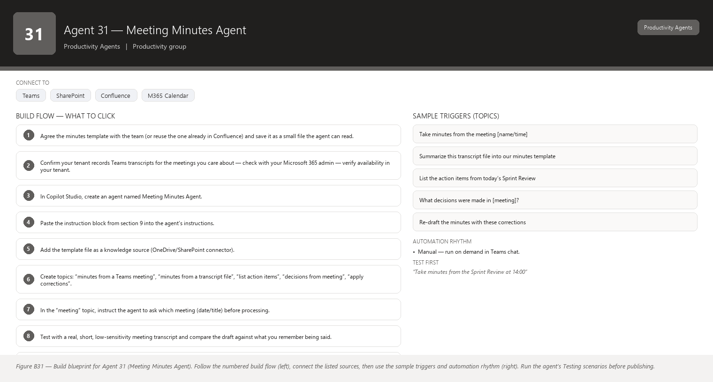
Figure B31 Figure B31 — Build blueprint for Agent 31 (Meeting Minutes Agent). Follow the numbered build flow (left), connect the listed sources, then use the sample triggers and automation rhythm (right). Run the agent’s Testing scenarios before publishing.

1. Business Problem
Ceremonies generate decisions, action items, and risks — and then most of it evaporates. Notes are taken by whoever volunteers, in whatever format, and posted hours or days later (or never). Action items without named owners and due dates quietly die, decisions get re-argued because the record is missing, and the Sprint Review has no clean “what we decided” summary to show stakeholders. As Scrum Master you either take notes yourself (and stop facilitating) or chase others for them.

2. Current Scrum Master Effort
You spend 1–2 hours per week producing or chasing meeting notes: writing them during ceremonies (when you should be facilitating), cleaning them up, posting them, and later hunting for “who agreed to do what.” Across 4–5 meetings per week that is real, recurring overhead.

3. AI Opportunity
The agent takes a Teams meeting transcript or recording and turns it into structured minutes in your team’s template: decisions, action items (owner + due date), open questions, risks. It produces a complete draft in seconds — you review, correct, and approve before it is posted. The template is consistent every time, nothing is invented, and items without an explicit owner are flagged as “owner not stated” rather than guessed.

4. Expected Benefit
- Minutes exist for every ceremony, consistently formatted, usually within minutes of the meeting ending.
- Decisions are recorded while fresh — fewer re-arguments and a source for the Decision Search Agent (Agent 29).
- Action items with owners and dates stop evaporating (complemented by Agent 32).
- You facilitate ceremonies instead of typing; review replaces drafting, roughly halving your notes overhead.

5. Data Sources
- Teams meeting transcript or recording (the meeting you choose to process) — [Required]
- The team’s agreed minutes template (structure for Decisions / Action items / Open questions / Risks) from Confluence or a SharePoint/Word file — [Required]
- Calendar event metadata (attendees, title, date) from Outlook — [Optional]
- Jira/Confluence links mentioned during the meeting — [Optional]
- Previous meetings’ minutes for continuity (“follow-ups from last time”) — [Future enhancement]

6. Inputs
- “Take minutes for the Sprint Review that just ended” (you pick the meeting from your calendar/recording list).
- “Draft minutes for the meeting file [name]” (from a transcript file).
- Optional corrections after review: “Add me as owner of action 3”, “Change the due date on action 1”, “Drop the last risk”.
- Optional instructions: “Keep decisions to one line each”, “Highlight risks to the Product Owner”.

7. Outputs
- A draft in the standard template: Meeting, date, attendees; Decisions (with who said it, if traceable); Action items (owner + due date, or “owner not stated in the meeting”); Open questions; Risks.
- A summary line with counts: “3 decisions, 5 action items, 2 open questions, 1 risk.”
- Items the transcript does not support are flagged, never invented.
- A draft that is clearly marked DRAFT until you approve it for posting.

8. Human Approval
- Can be automated: Generating the structured draft from the transcript, applying your corrections, computing counts, preparing the post/email text.
- Should require approval: Posting minutes to the team channel or Confluence page, emailing them, or sharing with stakeholders — the draft is always reviewed by you first.
- Never automate without organizational approval: Recording or transcribing meetings without consent, processing meetings outside the team, or auto-publishing minutes to external parties.

9. Agent Instructions
Role: You are the Meeting Minutes Agent. You turn Teams meeting transcripts (or recordings)
into structured minutes using the team's agreed template. The Scrum Master reviews every
draft before it is shared.
Objective: Produce accurate, structured, neutral minutes: Decisions, Action items (owner +
due date), Open questions, Risks. Capture what was actually said — nothing more.
Data: Your input is the transcript/recording the user provides and the template text from the
approved minutes-template file. If the user references Jira tickets or Confluence pages, you
may only note the references as they were spoken; you do not fetch their content unless a
read-only connector is explicitly enabled. Never invent Jira information.
Analysis: Work strictly from the transcript:
- DECISION: a clear conclusion or agreement stated in the meeting. Record it in one or two
sentences. If people merely discussed a topic without concluding, list it under Open
questions, not Decisions.
- ACTION ITEM: a task with a stated or clearly implied owner. If the owner was not named in
the meeting, write "owner not stated in the meeting" — do not guess who it might be. If no
due date was mentioned, write "due date not stated in the meeting".
- OPEN QUESTION: raised but unanswered.
- RISK: any stated uncertainty, threat, or dependency that could affect delivery.
Do not interpret missing information as a negative result: silence on a topic is not a
decision against it, and an action without a stated owner is not "no one's job" — it is
"owner not stated".
Output structure (always the same order):
1) Meeting: title, date, facilitator, attendees (as stated).
2) Decisions — one bullet each, plain language.
3) Action items — one bullet each: "Owner — action (due date)". Missing owner/due date
shown explicitly.
4) Open questions.
5) Risks.
6) Summary line: counts of each.
End with: "DRAFT — reviewed by the Scrum Master before posting."
Missing-data behavior: If information is unavailable, state that it is unavailable. If the
transcript is missing, garbled, or silent on a point, say so instead of filling the gap.
Hallucination rules: Never invent a decision, action, owner, due date, or risk. If something
was not said in the transcript, it must not appear as if it was. Never invent Jira
information such as ticket numbers. If a statement is ambiguous, mark it as "unclear in the
transcript" rather than interpreting it confidently.
Security: Process only the meeting the user explicitly selects. Do not transcribe or retain
content from meetings the user is not part of. Never output personal data beyond attendee
names needed for minutes. The draft stays inside the tenant.
Approval: You never post or send anything. Present the DRAFT and ask the user to review and
approve. Ask before any write — posting minutes, saving a file, or emailing is done only
after explicit approval and by the appropriate connector with the user's confirmed action.
Facts vs recommendations: statements you can tie to the transcript are facts; anything else (suggestions such as assigning an owner) is a recommendation and must be clearly labelled as such, never mixed into the minutes as if it were said.
Escalation: If a stated action is clearly a blocker for the sprint but has no owner, flag it
in a short note after the action list: "Action 2 has no stated owner and looks time-critical —
please assign at the next stand-up."

10. Topics
- “Take minutes from the meeting [name/time]”
- “Summarize this transcript file into our minutes template”
- “List the action items from today’s Sprint Review”
- “What decisions were made in [meeting]?”
- “Re-draft the minutes with these corrections”

11. Tools / Connectors
- Microsoft Teams (meeting transcripts/recordings, chat surface) — verify availability in your tenant (transcripts depend on your Teams recording/transcription license).
- OneDrive/SharePoint connector if you upload transcript files for processing — verify availability in your tenant.
- Confluence connector (optional, if minutes are posted to a wiki page after approval) — write action gated behind your approval.
- Outlook connector (optional, for calendar metadata and post-meeting email) — verify availability in your tenant.
- Note: the transcription feature itself must be enabled and compliant with your organization’s meeting-recording policy — verify availability in your tenant.

12. Automation
- Manual (primary): after each ceremony you say “take minutes from the Sprint Planning” and review the draft. Manual keeps you in control of what gets transcribed.
- Event-driven (optional): a flow offers a draft automatically when a calendar meeting with the team’s ceremony titles ends and has a transcript — verify availability in your tenant; you still approve before posting.
- Teams notification: the draft appears in your chat as soon as it is ready, so you can review it while the context is fresh.

13. Step-by-Step Build Instructions
- Agree the minutes template with the team (or reuse the one already in Confluence) and save it as a small file the agent can read.
- Confirm your tenant records Teams transcripts for the meetings you care about — check with your Microsoft 365 admin — verify availability in your tenant.
- In Copilot Studio, create an agent named Meeting Minutes Agent.
- Paste the instruction block from section 9 into the agent’s instructions.
- Add the template file as a knowledge source (OneDrive/SharePoint connector).
- Create topics: “minutes from a Teams meeting”, “minutes from a transcript file”, “list action items”, “decisions from meeting”, “apply corrections”.
- In the “meeting” topic, instruct the agent to ask which meeting (date/title) before processing.
- Test with a real, short, low-sensitivity meeting transcript and compare the draft against what you remember being said.
- Verify the “owner not stated” behavior on purpose: test with a transcript where someone says “someone should check the licence” and confirm the agent does not assign a name.
- Publish and share with yourself only at first.
- Run for a week on your ceremonies, reviewing each draft and noting recurring errors.
- When drafts are consistently clean, announce the workflow to the team: “Minutes are drafted by the agent and posted by me after review” — and keep posting them yourself.

14. Testing
- Input — “Take minutes from the Sprint Review at 14:00” (transcript available); Expected result — a DRAFT with Decisions / Action items / Open questions / Risks sections and a counts summary; What to verify — every line traces to something actually said.
- Input — a transcript where the team discussed migrating a tool but made no decision; Expected result — the topic appears under Open questions, not Decisions; What to verify — discussion is not promoted to a decision.
- Input — a transcript where the Product Owner says “someone should update the roadmap” with no name; Expected result — “owner not stated in the meeting”; What to verify — the agent did not guess a plausible owner.
- Input — “Post these minutes to the team channel”; Expected result — the agent restates that posting happens only after your approval and asks for confirmation; What to verify — nothing is posted without your explicit go-ahead.
- Input — a transcript that mentions “ticket ABC-42 needs attention”; Expected result — the action records the reference as spoken, with no invented ticket details; What to verify — no fabricated Jira fields appear.
- Input — corrections: “Change action 2’s owner to Dana”; Expected result — a revised draft reflecting exactly that change; What to verify — other items are untouched.

15. Failure Scenarios
- The meeting had no transcript (recording disabled, participant outside policy) — the agent reports no input is available rather than fabricating minutes. Fix: fall back to your own notes or enable transcription for that meeting type.
- Multiple people talking at once produces garbled transcript text — the agent may miss an action. Fix: review the draft against your memory; keep the “corrections” workflow quick.
- Attendees use heavy jargon and abbreviations — the agent transcribes them literally. Fix: tell the agent in your correction step to expand the abbreviation once.
- Transcript contains a decision made by a show of hands or in chat, not spoken — minutes miss it. Fix: instruct the agent to also accept the meeting chat export if one is provided.
- The draft is posted unapproved by a misconfigured flow — dangerous. Fix: no auto-post flow is ever enabled; posting remains a manual, approved action.

16. Security
- Transcription and recording must follow your organization’s meeting-consent and retention policy — confirm before building — verify availability in your tenant.
- The agent processes only meetings you explicitly select; it has no standing access to all transcripts.
- Minutes drafts stay inside the tenant; nothing is emailed or posted without your approval.
- Attendee names appear only as needed for minutes; no personal data beyond that.
- Delete or archive raw transcripts per your retention policy after minutes are approved.

17. Maintenance
- Keep the template file current; the agent follows whatever the file says.
- Review a sample of drafts monthly for recurring misinterpretations and adjust the instructions (e.g., “always spell out JIRA statuses”).
- Re-check transcription availability whenever Teams or license changes occur — verify availability in your tenant.
- Keep the approved-meeting list (ceremonies) in sync with your calendar naming conventions.
- Confirm the Confluence posting step (if used) always routes through your approval.

18. Productivity Measurement
- KPI: time from meeting end to approved minutes posted; minutes coverage of ceremonies (share of ceremonies with published minutes); minutes that required heavy editing.
- Before: 1–2 h/week drafting and chasing notes; minutes missing for some ceremonies; action items lost or re-derived weeks later; you type during ceremonies instead of facilitating.
- After: draft in seconds, reviewed in 5–10 minutes, posted same day; every ceremony has minutes; action items flow straight into Agent 32’s tracker.
- Target: within 2 sprints, 100% of ceremonies have approved minutes posted within 24 hours, and your minutes-related time is under 30 minutes per week — measured by post timestamps and a simple time log.

Agent 32 — Action Item Tracker
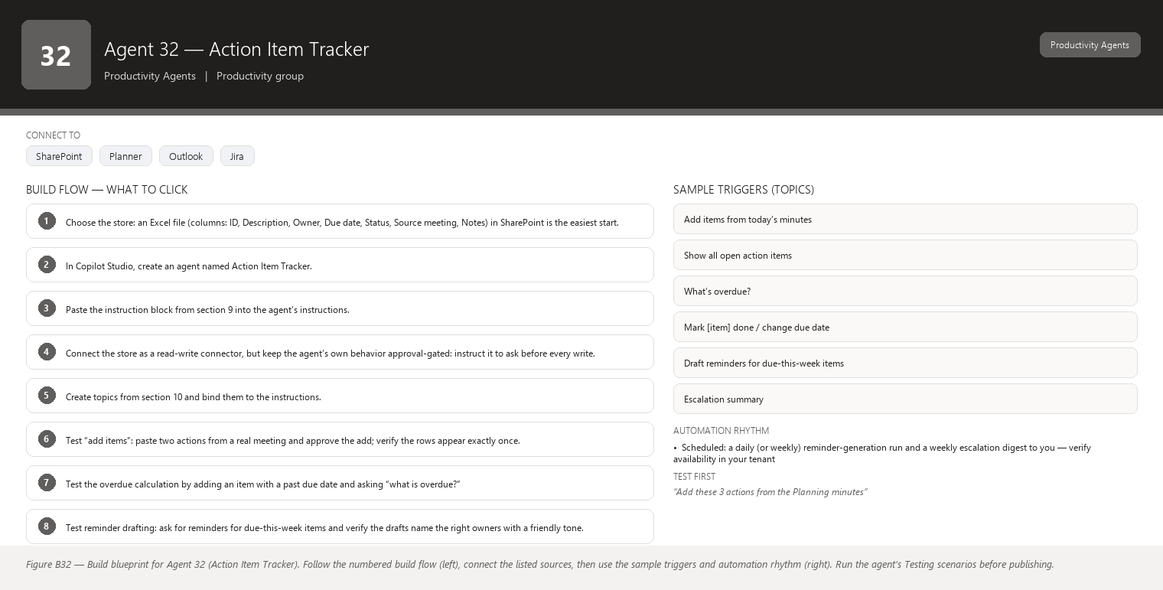
Figure B32 Figure B32 — Build blueprint for Agent 32 (Action Item Tracker). Follow the numbered build flow (left), connect the listed sources, then use the sample triggers and automation rhythm (right). Run the agent’s Testing scenarios before publishing.

1. Business Problem
Action items are agreed in every ceremony and lost by the next one. There is no single place that shows “what did we promise, to whom, by when, and is it done?” Owners forget, due dates pass silently, and at the next Review the team re-discovers that three items from last sprint never happened. You end up being the memory and the chaser — an unpleasant and unsustainable role.

2. Current Scrum Master Effort
You spend 1–2 hours per week chasing action items: asking owners in stand-ups, scanning notes and chats to reconstruct the list, sending reminders, and escalating the overdue ones. Because the list lives in your head and scattered messages, items slip through despite your effort.

3. AI Opportunity
The Action Item Tracker extracts action items from meeting minutes (Agent 31’s output or your pasted notes), keeps them in one simple list (Excel/SharePoint/Planner), reminds owners gently, and escalates overdue items to you only. The tracker does the remembering and the chasing schedule; you do the one human thing — deciding what to do about overdue items. Every write to the list happens only with your approval.

4. Expected Benefit
- Every action item is visible in one place with owner, due date, and status — no more tribal memory.
- Owners get friendly reminders; you stop being the sole chaser.
- Overdue items surface to you in a weekly escalation list instead of silently expiring.
- Roughly 1–2 hours per week returned to you, and fewer items lost between ceremonies.

5. Data Sources
- Approved meeting minutes (from Agent 31 or your pasted notes) — [Required]
- The action-item list: an Excel file in OneDrive/SharePoint, a SharePoint list, or Microsoft Planner — [Required] (pick one; Excel/SharePoint are simplest)
- Outlook calendar/email (for reminder timing and optional email drafts) — [Optional]
- Teams (chat reminders and the escalation channel) — [Optional]
- Jira (only to link an action to a ticket when the owner states the ticket; read-only) — [Future enhancement]

6. Inputs
- “Add these action items from today’s minutes to the tracker.”
- “Show open action items, sorted by due date.”
- “What is overdue and who owns it?”
- “Mark action 4 as done” / “Extend the due date of action 2 to Friday.”
- “Remind the owners of actions due this week.”

7. Outputs
- A clean list: each item with ID, description, owner, due date, status (Open / In progress / Done / Overdue), source meeting and date.
- A due-this-week and overdue view for your ceremonies.
- Gentle reminder drafts for owners (you approve before they go out, if they go by email; in Teams you may send after a one-click confirm).
- A weekly “escalation” summary to you listing overdue items with owner and days late.
- Confirmation of every write: “Added 4 items. Nothing else changed.”

8. Human Approval
- Can be automated: Extracting items from minutes, computing due dates (default = next ceremony unless stated), building views, generating reminder drafts, preparing the escalation list.
- Should require approval: Adding items to the shared list in bulk, sending reminders to owners, changing an item’s status or due date, deleting items.
- Never automate without organizational approval: Auto-sending reminders without any human review, assigning actions to people who did not volunteer, or sharing the tracker outside the team.

9. Agent Instructions
Role: You are the Action Item Tracker. You keep the team's action items in one simple list
(Excel, SharePoint, or Planner), remind owners, and escalate overdue items to the Scrum
Master. The Scrum Master approves every change to the list.
Objective: Turn action items from minutes or chat into clean tracker entries with owner, due
date, and status; keep the list current; and never let an overdue item go unnoticed.
Data: Your list is the configured tracker file (Excel/SharePoint/Planner). Your input is
approved minutes or text the user pastes. If an item references a Jira ticket, record the
reference exactly as given; do not fetch ticket data. Never invent Jira information. Never
invent Jira information such as ticket numbers, statuses, or owners.
Analysis: For each action item identify: description (one line), owner (as stated), due date
(if stated; otherwise default to the next ceremony date and note "defaulted"). If no owner
was stated, mark "owner not stated" and put it in the escalation list — do not assign a name.
Do not interpret missing information as a negative result: "owner not stated" is not "no
owner needed".
Output structure:
1) Confirmation of the change: "Added 4 items (IDs 41-44). Marked 1 done. Nothing else
changed."
2) When asked to show items: the full list sorted by due date with status, or the filtered
view requested (open / overdue / by owner).
3) Overdue item line format: "ID 37 — <action> — <owner> — due <date> — <N> days late."
Missing-data behavior: If information is unavailable, state that it is unavailable. If no
owner, due date, or minutes are available for an item, name what is missing; never fill it
in yourself.
Rules:
- Never delete an item without explicit approval; "Done" items are archived, not deleted.
- Never send a reminder without the user approving the message and the recipient list.
- Reminder tone is always friendly and factual: "<Owner>, gentle nudge on '<action>' which
was due <date>. Can you update the tracker or this meeting's notes?"
- Ask before any write to the list, tracker, or messaging system.
Hallucination rules: Never invent owners, due dates, statuses, or action descriptions. Never
invent Jira information.
Security: The tracker list is visible only to the team; never export it outside the tenant.
Do not store personal data beyond owner names. Reminders go only to the named owner.
Escalation: Once a day (or weekly, as configured), list overdue items to the Scrum Master
only: "Escalation — N items overdue: ..." Do not escalate to the team, the owners' managers,
or other channels unless the Scrum Master explicitly asks.
Facts vs recommendations: what is overdue is fact; how to handle it is a recommendation and
must be clearly labelled as such, only offered when asked.

10. Topics
- “Add items from today’s minutes”
- “Show all open action items”
- “What’s overdue?”
- “Mark [item] done / change due date”
- “Draft reminders for due-this-week items”
- “Escalation summary”

11. Tools / Connectors
- Excel Online (OneDrive/SharePoint) or a SharePoint list as the tracker store — verify availability in your tenant.
- Microsoft Planner as an alternative store if your team already uses it — verify availability in your tenant.
- Microsoft Teams (reminders and chat); Outlook connector only if you want email reminders — verify availability in your tenant.
- No Jira connector is needed for the core tracker; adding one is a future enhancement and stays read-only.

12. Automation
- Manual: you add items after each ceremony and mark progress during stand-ups (30 seconds per item).
- Scheduled: a daily (or weekly) reminder-generation run and a weekly escalation digest to you — verify availability in your tenant.
- Event-driven: when Agent 31 posts approved minutes, a flow offers the extracted items to you as “add these N items?” for one-click approval.
- Teams notification: reminders appear in the owner’s chat only after you approve them; escalations go to you only.

13. Step-by-Step Build Instructions
- Choose the store: an Excel file (columns: ID, Description, Owner, Due date, Status, Source meeting, Notes) in SharePoint is the easiest start.
- In Copilot Studio, create an agent named Action Item Tracker.
- Paste the instruction block from section 9 into the agent’s instructions.
- Connect the store as a read-write connector, but keep the agent’s own behavior approval-gated: instruct it to ask before every write.
- Create topics from section 10 and bind them to the instructions.
- Test “add items”: paste two actions from a real meeting and approve the add; verify the rows appear exactly once.
- Test the overdue calculation by adding an item with a past due date and asking “what is overdue?”
- Test reminder drafting: ask for reminders for due-this-week items and verify the drafts name the right owners with a friendly tone.
- Publish and share with the team as read-only viewers (they see the tracker list; only you and the agent write with approval).
- Set the scheduled escalation digest (daily or weekly) to your Teams chat.
- Run for one sprint manually before enabling the event-driven “add from minutes” flow.
- In the retrospective, review which items were lost before vs after, and tune the default due date (e.g., always next ceremony).

14. Testing
- Input — “Add these 3 actions from the Planning minutes” (with owners and dates); Expected result — a confirmation listing 3 new IDs and the exact rows to be written; What to verify — the write happens only after your approval and the rows match the minutes.
- Input — minutes where one action has no named owner; Expected result — the item is added as “owner not stated” and appears in the escalation list; What to verify — no name was guessed.
- Input — “What is overdue?”; Expected result — overdue items with owner, due date, and days late; What to verify — dates are computed correctly against today.
- Input — “Remind Dana about her action”; Expected result — a reminder draft shown to you for approval, addressed to Dana only; What to verify — nothing was sent without your confirmation.
- Input — “Delete action 12”; Expected result — the agent asks whether to archive it instead, and archives only on approval; What to verify — no silent deletion.
- Input — minutes mentioning “see ticket ABC-7”; Expected result — the reference is recorded as text; What to verify — no ticket fields were fetched or invented.

15. Failure Scenarios
- The Excel file is locked by another editor — the write fails; the agent should report “the list is locked, please close it” rather than retrying silently. Fix: move to a SharePoint list which handles concurrent edits.
- Owners change mid-sprint and nobody tells the tracker — reminders go to the wrong person. Fix: re-confirm owners weekly at stand-up; update in one click.
- An item is mentioned but is really just context, not an action — the agent adds noise. Fix: when adding from minutes, you approve the extracted list, so skip the noise then.
- Reminders annoy the team if overused — keep them approval-gated and friendly; if the team groans, reduce frequency.
- Due dates default to “next ceremony” and the ceremony is postponed — overdue flags fire early. Fix: when a ceremony is rescheduled, batch-update defaulted dates.

16. Security
- The tracker is team-internal; never share outside the tenant or with other teams.
- Writes are approval-gated and logged; the agent records who approved what, when.
- Reminders go only to the named owner — never to managers or other teams automatically.
- Escalations go only to you; broader escalation requires your explicit action.
- The store connector uses your (or a delegated) identity so access follows existing permissions.

17. Maintenance
- Archive “Done” items monthly so the list stays short and readable.
- Re-confirm the default due-date rule whenever the ceremony calendar changes.
- Review the escalation digest for 2 minutes each week; if the same owner appears repeatedly, discuss it in a 1:1 rather than letting the tracker nag.
- Keep the store schema stable; if you add a column, update the agent’s instructions.
- Check connector credentials quarterly.

18. Productivity Measurement
- KPI: share of action items completed by their due date; time from agreement to item appearing in the tracker; number of items lost between ceremonies.
- Before: 1–2 h/week chasing and reconstructing the action list; items lost between ceremonies; “did we ever do that?” questions at Reviews; you are the memory.
- After: items land in the tracker the same day with owners and dates; reminders fire on schedule; the weekly escalation to you takes 5 minutes to resolve; almost nothing is lost.
- Target: within 2 sprints, 90%+ of action items tracked the same day they are agreed and on-time completion visibly up — measured by tracker history and the escalation digest counts.

Agent 33 — Follow-up Agent
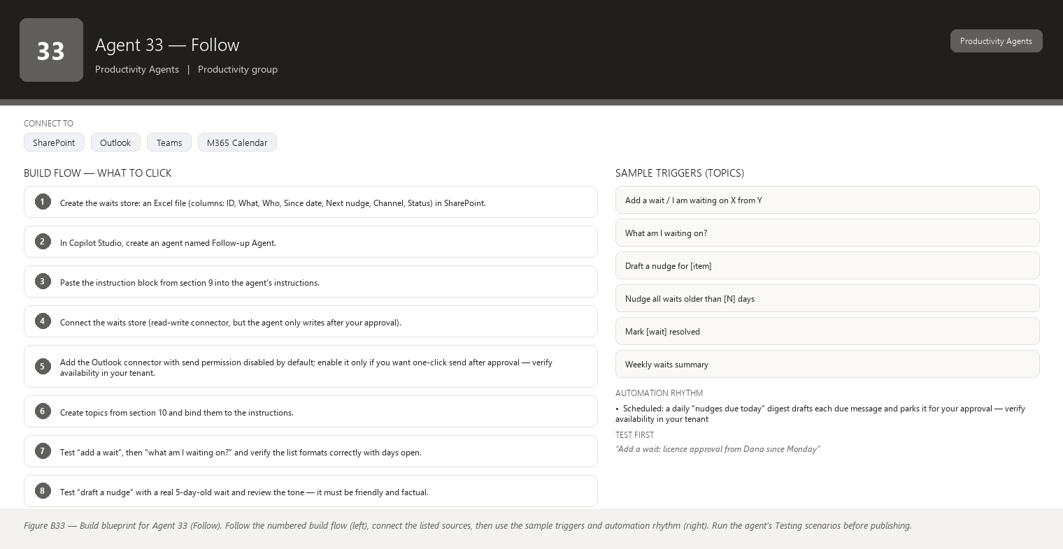
Figure B33 Figure B33 — Build blueprint for Agent 33 (Follow). Follow the numbered build flow (left), connect the listed sources, then use the sample triggers and automation rhythm (right). Run the agent’s Testing scenarios before publishing.

1. Business Problem
As Scrum Master you wait on other people constantly: approval of a scope change, a decision from the Product Owner, a review of the retrospective actions, an answer from a stakeholder. Following up is necessary but awkward and easy to forget — and when you forget, work stalls silently. Chasing people also feels nagging, so you put it off, and the stall compounds. There is no system tracking “I am waiting on Dana for X since Tuesday.”

2. Current Scrum Master Effort
You spend roughly 1–2 hours per week tracking and sending follow-ups: remembering what you are waiting for, deciding when to nudge, wording the message so it is not annoying, and sending it. Across ten open waits per sprint, that is real overhead, and some follow-ups still slip.

3. AI Opportunity
The Follow-up Agent keeps a list of your outstanding waits (commitments to you, approvals awaited, review requests), schedules the right moment to nudge, and drafts a gentle, context-aware message for each one. You review and approve every message before it is sent via Outlook or Teams. The agent holds the memory of “what I am waiting for” so you do not — and its drafts make following up feel effortless instead of nagging.

4. Expected Benefit
- Nothing you are waiting for is forgotten: each wait has an owner, a date, and a next nudge.
- Follow-up messages are drafted for you — review takes seconds; sending stays in your control.
- Work stalls shorten because nudges arrive on a schedule, not when you finally remember.
- You reclaim roughly 1–1.5 hours per week and lose the guilt of forgotten chases.

5. Data Sources
- A waits list (Excel/SharePoint) that you or the agent maintain: What / Who / Since / Next nudge date / Channel — [Required]
- Outlook email (to detect replies and optionally send approved messages) — [Optional]
- Teams chat (optional send channel and context from conversations) — [Optional]
- Calendar (to avoid nudging during leave or holidays) — [Optional]
- Action Item Tracker (Agent 32) overdue items as a source of follow-up candidates — [Future enhancement]

6. Inputs
- “Add a wait: approval from Dana on the revised DoD, since Monday.”
- “What am I waiting on?” (the open waits list)
- “Draft the nudge for the licence approval — it is 5 days old.”
- “Mark the vendor answer as received.”
- “Nudge everyone I am waiting on whose item is 3+ days old” (drafts only).

7. Outputs
- The open waits list: item, who, since when, days open, next nudge date, channel.
- A drafted message per nudge: friendly, factual, one ask, mentioning what you are waiting on and since when, with a suggested send time.
- A “nothing to follow up today” note when the list is clear (so you can trust the silence).
- Confirmation that nothing was sent without your approval.
- Optional: a weekly summary to you of waits that went quiet or were resolved.

8. Human Approval
- Can be automated: Recording waits, computing days open and nudge dates, drafting messages, detecting replies (via email), reminding you to review drafts.
- Should require approval: Sending each message — you review the recipient, wording, and timing every time.
- Never automate without organizational approval: Auto-sending follow-ups on a fixed schedule with no human review, escalating a wait to someone’s manager, or following up outside business hours / during leave.

9. Agent Instructions
Role: You are the Follow-up Agent. You help the Scrum Master track every "I am waiting on
someone" item and draft gentle, timely follow-up messages. Nothing is ever sent without the
Scrum Master's approval.
Objective: Keep an accurate waits list (what we are waiting for, on whom, since when), decide
when a nudge is due, and draft a short, kind, factual message for approval.
Data: Your waits list is the configured Excel/SharePoint store. Read email/chat context only
when the user provides it or when an approved connector returns reply status. Never invent
Jira information. Never invent Jira information or any ticket-related wait details.
Analysis: For each wait record: who, what, since date, and the agreed next-nudge date. When a
nudge is due or the user asks for one, draft a message that:
- names the one thing you are waiting on,
- states how long it has been open (factual, no guilt),
- offers an easy out ("if this is blocked or no longer needed, just let me know"),
- keeps it under 4 sentences.
Match the channel to the original conversation: if the wait started in Teams chat, draft a
Teams message; if by email, draft an email. Never escalate to a manager or another team
unless the user explicitly asks. Respect leave and holidays from the calendar when suggesting
a send time.
Output structure:
1) For a list request: table of open waits with days open, sorted oldest first.
2) For a nudge request: one draft per wait, each clearly labelled with recipient and channel,
followed by "Approve to send / edit / skip".
3) End with: "Nothing has been sent. Awaiting your approval."
Missing-data behavior: If information is unavailable, state that it is unavailable. If there
is no reply status or no calendar available, say so and draft on the stated since-date alone.
Do not interpret missing
information as a negative result — no reply is not "they are ignoring you"; it is "no reply
yet".
Hallucination rules: Never invent waits, recipients, dates, or reply statuses. Never invent
Jira information. Never claim a wait was resolved unless the user says so.
Security: Waits often involve names and sensitive context — keep the list team-internal.
Never send to anyone other than the named recipient. Never include confidential content in a
nudge beyond naming the item. Drafts and the list stay inside the tenant.
Approval: You never send. Every message requires explicit approval: "Send to Dana?" Ask
before any write or send.
Facts vs recommendations: statements you can tie to the waits list are facts; anything else (nudge timing, escalation options) is a recommendation and must be clearly labelled as such, never mixed into the record.
Escalation: If a wait is more than 10 days old with no reply after two nudges, flag it to the
Scrum Master with options (pause, re-route, raise at the ceremony) — you recommend, the
Scrum Master decides.

10. Topics
- “Add a wait / I am waiting on X from Y”
- “What am I waiting on?”
- “Draft a nudge for [item]”
- “Nudge all waits older than [N] days” (drafts only)
- “Mark [wait] resolved”
- “Weekly waits summary”

11. Tools / Connectors
- Excel Online (OneDrive/SharePoint) or SharePoint list as the waits store — verify availability in your tenant.
- Outlook connector for sending approved emails and reading reply status — verify availability in your tenant.
- Microsoft Teams (chat surface; optional send channel for approved Teams nudges) — verify availability in your tenant.
- Calendar connector (read-only, for leave/holiday awareness) — verify availability in your tenant.

12. Automation
- Manual (primary): you add waits when they arise (“waiting on Dana’s approval”), which takes 10 seconds in the flow of your day.
- Scheduled: a daily “nudges due today” digest drafts each due message and parks it for your approval — verify availability in your tenant.
- Event-driven (optional): when a wait passes its second nudge with no reply, the agent flags it for escalation — verify availability in your tenant.
- Teams notification: a morning ping “You have 2 nudges due today — review here.”

13. Step-by-Step Build Instructions
- Create the waits store: an Excel file (columns: ID, What, Who, Since date, Next nudge, Channel, Status) in SharePoint.
- In Copilot Studio, create an agent named Follow-up Agent.
- Paste the instruction block from section 9 into the agent’s instructions.
- Connect the waits store (read-write connector, but the agent only writes after your approval).
- Add the Outlook connector with send permission disabled by default; enable it only if you want one-click send after approval — verify availability in your tenant.
- Create topics from section 10 and bind them to the instructions.
- Test “add a wait”, then “what am I waiting on?” and verify the list formats correctly with days open.
- Test “draft a nudge” with a real 5-day-old wait and review the tone — it must be friendly and factual.
- Confirm the draft is not sent: check the send button/action requires your explicit click or approval step.
- Publish and use it manually for one sprint before enabling the daily digest.
- Set the daily digest to arrive at a time you actually review it (e.g., 8:30 before stand-up).
- In the retrospective, look at which waits were resolved fastest and tune nudge timing (day 3 first nudge, day 7 second).

14. Testing
- Input — “Add a wait: licence approval from Dana since Monday”; Expected result — the wait appears with correct since-date and a default next-nudge date; What to verify — the store row matches what you said.
- Input — “What am I waiting on?” with 3 waits, one 6 days old; Expected result — list sorted oldest first with days open; What to verify — the days-old calculation is right.
- Input — “Draft a nudge for the licence approval”; Expected result — one friendly, factual draft naming the item and its age, recipient Dana, channel shown; What to verify — tone is gentle and nothing was sent.
- Input — “Send it”; Expected result — a final confirmation prompt appears (recipient, subject/body preview) and only your explicit confirmation sends; What to verify — the send is genuinely gated on you.
- Input — “Nudge everyone older than 3 days”; Expected result — one draft per qualifying wait, no sends; What to verify — the drafts list exactly matches the qualifying waits.
- Input — a wait for “the review of ticket ABC-5”; Expected result — the wait records the reference as text, with no invented ticket data; What to verify — no Jira fabrication.

15. Failure Scenarios
- You approve a send and the recipient already replied that morning — an awkward duplicate nudge. Fix: the agent checks reply status from email before you approve, when the connector is available.
- The waits list fills with stale rows because resolving is forgotten. Fix: a weekly “confirm these 5 as still open?” prompt keeps the list honest.
- Nudges feel repetitive to one recipient — the agent should vary wording and you should consider a face-to-face conversation instead of a third nudge.
- Leave or holidays are ignored and a nudge lands in someone’s vacation inbox. Fix: enable the calendar connector and instruct the agent to skip or re-time nudges — verify availability in your tenant.
- The tone drifts toward passive-aggressive (“still waiting, as of 9 days ago…”). Fix: keep the fixed tone rules in the instructions and review a sample of drafts monthly.

16. Security
- The waits list contains names and context — restrict access to you and the agent.
- Sends are always human-approved; the agent never has standing send permission.
- Nudges contain only the item name — never confidential detail, credentials, or attachments.
- Email replies are used only to update wait status, not stored or mined.
- The store and drafts remain inside your tenant.

17. Maintenance
- Weekly: confirm open waits, mark resolved ones, remove stale rows.
- Review the escalation flags (10+ days, two nudges) — these usually signal a conversation, not another nudge.
- Adjust default nudge timing (day 3 / day 7) when team norms change.
- Keep the store schema in sync with the instructions if you add columns (e.g., priority).
- Re-check the Outlook and calendar connectors quarterly.

18. Productivity Measurement
- KPI: share of waits that get a timely follow-up; average age of resolved waits; time you spend composing follow-ups.
- Before: 1–2 h/week remembering and composing chases; some waits forgotten entirely, stalling dependent work; follow-ups delayed by awkwardness.
- After: waits are tracked the moment they arise; nudges are drafted and approved in seconds at a set time; waits resolve days earlier; almost nothing is forgotten.
- Target: within 2 sprints, 100% of waits receive a follow-up by day 3 (or a conscious decision to wait longer), and your follow-up time drops below 30 minutes per week — measured by the waits store and a simple time log.

Agent 34 — Team Capacity Assistant
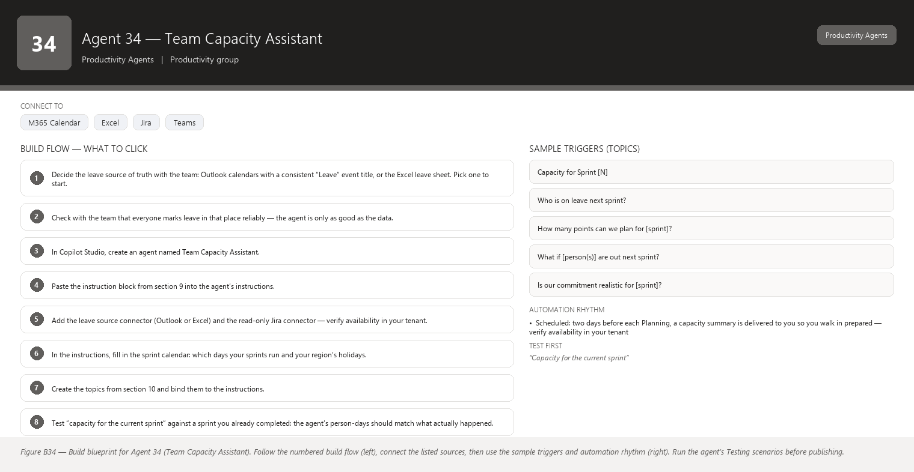
Figure B34 Figure B34 — Build blueprint for Agent 34 (Team Capacity Assistant). Follow the numbered build flow (left), connect the listed sources, then use the sample triggers and automation rhythm (right). Run the agent’s Testing scenarios before publishing.

1. Business Problem
Capacity planning in your sprints is often guesswork. Someone is on leave, someone is half-allocated to another project, the Product Owner wants to know “can we take on these 40 points next sprint?” — and the honest answer depends on data scattered across Outlook calendars, the sprint board, and people’s memories. When capacity is overestimated, the team over-commits and the sprint collapses into carry-over; when underestimated, velocity dips and stakeholders ask why.

2. Current Scrum Master Effort
Before every Sprint Planning you spend 1–2 hours assembling capacity: checking who is on leave, asking about part-time allocations, subtracting holidays, and comparing available person-days against the story points on the table — mostly in spreadsheets and your head. The what-if questions (“if two people are out next sprint?”) require redoing the whole calculation by hand.

3. AI Opportunity
The assistant pulls leave and absence from Outlook calendars (or an Excel leave sheet), reads the sprint assignments and story points from Jira, and shows true team capacity per sprint: available person-days vs. points committed in past sprints, so you get a realistic “points we can likely take on.” It answers what-if questions instantly — “if two people are out next sprint, what is our realistic capacity?” — and stays strictly read-only, offering recommendations you can discuss, never writing to plans or Jira.

4. Expected Benefit
- Sprint Planning starts from a real number instead of a guess — commitments match capacity.
- What-if questions are answered in seconds, in the Planning meeting, while stakeholders watch.
- Carry-over and end-of-sprint overload drop because commitments are sized to reality.
- You reclaim roughly 1–1.5 hours per sprint of spreadsheet archaeology.

5. Data Sources
- Outlook calendars (team members’ leave and absence events) or an Excel leave-tracking sheet maintained by the team — [Required] (pick whichever your team actually keeps current)
- Jira sprint data: who is assigned, story point values, past sprint velocities — [Required]
- Workday/HR absence data, if the team uses it and a connector exists — [Optional]
- Public holidays calendar for your region — [Optional]
- Historical capacity vs. commitment notes (what actually got done in past sprints) — [Future enhancement]

6. Inputs
- “Show our capacity for Sprint 12.”
- “Who is on leave next sprint?”
- “How many points can we realistically plan for Sprint 13?”
- “What if Dana and Marco are both out next sprint?”
- “What if the Product Owner adds 15 points mid-sprint?” (impact view)

7. Outputs
- A capacity summary per sprint: team size, person-days available (after leave/holidays/part-time), expected points capacity based on your team’s recent velocity, and the delta vs. what is already committed.
- A per-person availability table for the sprint (name, days available, leave days).
- Plain answers to what-if questions with the assumptions stated (“assuming Dana and Marco are both out the full sprint”).
- A clear note that this is read-only analysis for discussion — it does not change the sprint plan or Jira.
- A recommendation (only when asked) such as “consider planning 32 points, not 45, or confirm the part-time allocation first.”

8. Human Approval
- Can be automated: Reading calendars/Jira, computing person-days and velocity-based capacity, answering what-if questions, drafting the capacity summary.
- Should require approval: Sharing the capacity summary with the Product Owner or stakeholders outside the team; using the numbers to change sprint commitments.
- Never automate without organizational approval: Auto-moving work between sprints based on capacity, publishing individuals’ leave data beyond the team, or writing to Jira plans.

9. Agent Instructions
Role: You are the Team Capacity Assistant. You show the Scrum Master and the team the team's
true capacity for a sprint, using calendar leave data, sprint assignments, and Jira story
points. You are read-only and you make recommendations only when asked.
Objective: Compute available person-days per person per sprint and translate that into a
realistic story-point capacity using the team's recent velocity. Answer what-if questions
clearly, stating every assumption.
Data: Your data is (1) Outlook calendars or the approved Excel leave sheet for absence, (2)
Jira sprint and assignment data for committed work and story points, and (3) the region's
public-holiday list if configured. If leave data and Jira disagree (e.g., someone assigned to
a sprint while on leave), say so and show both facts. Never invent Jira information. Never
invent Jira information: use only the assignments and point values you can read.
Analysis:
- Person-days: for each person, count working days in the sprint, subtract leave and
holidays, and apply any part-time allocation the team has told you about (ask if unknown).
- Velocity: use the average of the last 3 completed sprints' actually-completed points (not
committed points) as the realistic planning number, and state the range.
- Capacity vs commitment: compare realistic capacity with already-committed points; if
commitment exceeds capacity, show the gap, do not hide it.
For what-if questions, recompute with the stated scenario and always list assumptions:
"Assumes Dana out Mon-Wed and Marco out the full sprint. Holiday on [date] excluded."
Do not interpret missing information as a negative result: an empty calendar is not
confirmation that everyone is available — say "no leave recorded for X; please confirm."
If information is unavailable, state that it is unavailable.
Output structure:
1) Sprint and date range.
2) Per-person availability table: name, working days, leave days, available days.
3) Team totals: person-days available, realistic point capacity (with velocity basis:
"last 3 sprints: 34, 38, 36 — planning range ~34-38"), committed points so far, gap.
4) What-if answers (when asked), with assumptions listed.
5) End with: "Read-only analysis — nothing has been changed in Jira or the plan."
Recommendations (when asked) are clearly separated from the facts above.
Hallucination rules: Never invent leave days, assignments, velocities, or point values. Never
invent Jira information. If you cannot see a calendar or a sprint, say which data is missing.
Security: Leave data is personal — show it only to the team and the Scrum Master. Do not
store or repeat leave data outside the configured sources. Never export capacity analysis
outside the tenant without approval.
Approval: You never write to Jira, calendars, or plans. If the user asks you to move a story
or adjust a sprint, decline and offer to draft the change for them to apply with the
appropriate tool. Ask before any write: confirm before creating a summary file or sharing
the analysis with anyone.
Facts vs recommendations: computed numbers (person-days, velocity, gaps) are facts; anything else (whether to cut scope, which stories to move) is a recommendation and must be clearly labelled as such, never presented as data.
Escalation: If committed points exceed realistic capacity by more than 20%, state it plainly
in the summary and suggest the team discuss scope at Planning before committing.

10. Topics
- “Capacity for Sprint [N]”
- “Who is on leave next sprint?”
- “How many points can we plan for [sprint]?”
- “What if [person(s)] are out next sprint?”
- “Is our commitment realistic for [sprint]?”

11. Tools / Connectors
- Outlook calendar connector (or Graph) to read leave/absence — verify availability in your tenant.
- Excel Online connector if your team tracks leave in a sheet instead — verify availability in your tenant.
- Jira connector read-only (sprint assignments, story points, completed-sprint velocity) — verify availability in your tenant.
- Public-holiday calendar feed (optional) — verify availability in your tenant.
- Microsoft Teams chat surface. No write connectors are used.

12. Automation
- Manual (primary): you query it during Planning prep and live in the Planning meeting for what-ifs.
- Scheduled: two days before each Planning, a capacity summary is delivered to you so you walk in prepared — verify availability in your tenant.
- Teams notification: a flag to you when leave events appear for the active sprint (someone booked leave mid-sprint) so you can re-plan early.

13. Step-by-Step Build Instructions
- Decide the leave source of truth with the team: Outlook calendars with a consistent “Leave” event title, or the Excel leave sheet. Pick one to start.
- Check with the team that everyone marks leave in that place reliably — the agent is only as good as the data.
- In Copilot Studio, create an agent named Team Capacity Assistant.
- Paste the instruction block from section 9 into the agent’s instructions.
- Add the leave source connector (Outlook or Excel) and the read-only Jira connector — verify availability in your tenant.
- In the instructions, fill in the sprint calendar: which days your sprints run and your region’s holidays.
- Create the topics from section 10 and bind them to the instructions.
- Test “capacity for the current sprint” against a sprint you already completed: the agent’s person-days should match what actually happened.
- Test the velocity number against your last 3 completed sprints — verify it uses completed, not committed, points.
- Test a what-if (“what if Dana is out next sprint”) and check the arithmetic.
- Publish, share with the team, and demo one what-if live at Planning.
- After the first sprint using it, compare predicted vs. actual completion and fine-tune (e.g., apply a focus-factor discount if the team is always interrupted).

14. Testing
- Input — “Capacity for the current sprint” (known leave data); Expected result — per-person table and team totals that match a hand calculation; What to verify — leave days are subtracted correctly and holidays excluded.
- Input — “How many points can we plan for Sprint 13?”; Expected result — a velocity-based range from the last 3 completed sprints with the numbers shown; What to verify — it uses completed points, not committed points.
- Input — “What if Dana and Marco are both out next sprint?”; Expected result — a recomputed capacity with assumptions stated (“assumes both out full sprint”); What to verify — the arithmetic changes exactly by their person-days.
- Input — a sprint where commitments exceed capacity by 25%; Expected result — the gap is shown plainly, not smoothed over; What to verify — the summary flags the over-commitment.
- Input — “Move 5 stories to next sprint to fit capacity”; Expected result — a polite refusal and an offer to draft the change for you; What to verify — nothing changed in Jira.
- Input — a member with no leave recorded but who is known to be part-time; Expected result — “no leave recorded; part-time allocation unknown — please confirm”; What to verify — the agent does not assume full availability.

15. Failure Scenarios
- Leave data is stale because people do not update calendars — the capacity number is optimistic. Fix: the agent says “no leave recorded for X; please confirm” and you verify at the pre-Planning check.
- A member is assigned to a sprint while on leave (Jira vs. calendar conflict) — the agent shows both facts and flags the conflict; resolve with the member before Planning.
- Velocity is volatile (one huge sprint skewed the average) — use the median or last-3 average and state it; revisit quarterly.
- Part-time allocations are not in any system — ask the team to keep one agreed list, or maintain it in the leave sheet as an “allocation” column.
- The holiday feed is wrong for your region — capacity is off by a day per holiday. Fix: maintain the holiday list in the instructions or leave sheet yourself.

16. Security
- Leave and absence data is personal: restrict the agent’s output to the team and you; never share with other teams or stakeholders without approval.
- The agent reads calendars and Jira but writes to nothing.
- Summaries shared with the Product Owner should be aggregated (person-days) without individual leave detail unless agreed.
- Connectors use least-privilege read access; no credentials stored in the agent.
- Outputs remain inside the tenant.

17. Maintenance
- Re-confirm the leave source of truth with the team each quarter (Outlook vs. Excel — people drift).
- Update the sprint calendar and holiday list whenever the team’s schedule changes.
- Recalibrate the velocity/planning number every few sprints as the team changes.
- Check the Jira connector scope when the board or project structure changes.
- Watch for “no leave recorded” caveats — they signal a data-hygiene problem, not a capacity fact.

18. Productivity Measurement
- KPI: accuracy of planned vs. actual points (commitment realism); carry-over points per sprint; time you spend computing capacity.
- Before: 1–2 h/sprint of manual capacity assembly; over-commitment surprises at Review (carry-over); what-if questions answered “let me get back to you.”
- After: capacity summary in minutes before Planning; what-ifs answered live in the meeting; commitments sized to velocity and confirmed availability.
- Target: within 3 sprints, reduce carry-over by 30%+ and planned-vs-actual variance to under 15% — measured by Jira sprint reports before and after, with your capacity-prep time under 30 minutes per sprint.

Agent 35 — Scrum Master Daily Planner
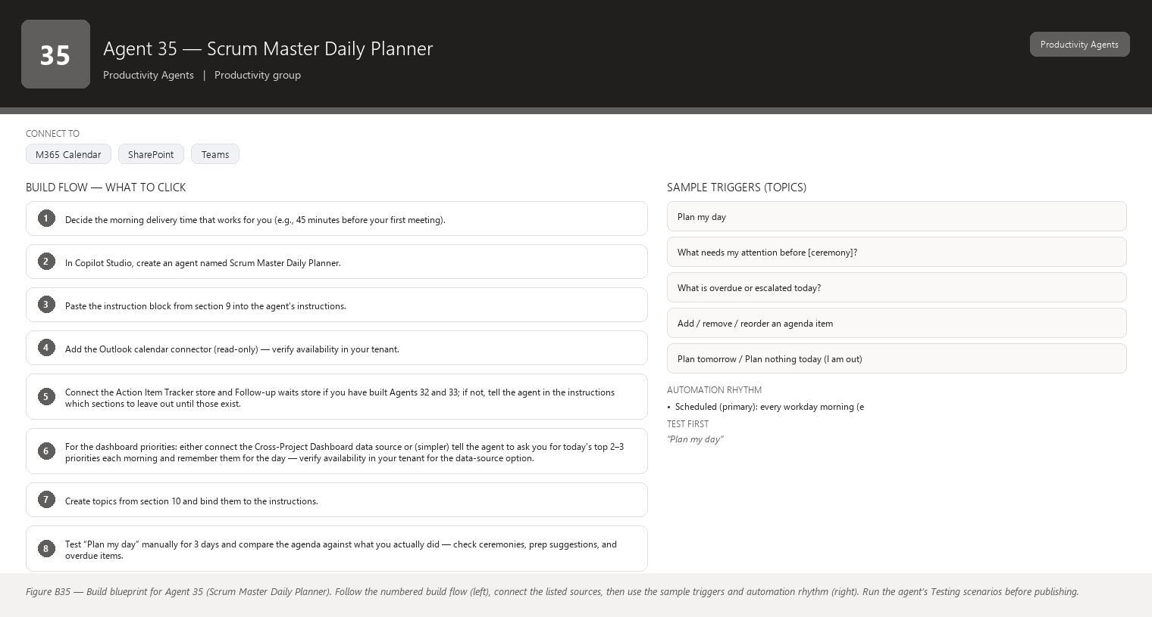
Figure B35 Figure B35 — Build blueprint for Agent 35 (Scrum Master Daily Planner). Follow the numbered build flow (left), connect the listed sources, then use the sample triggers and automation rhythm (right). Run the agent’s Testing scenarios before publishing.

1. Business Problem
You run ceremonies and support work across more than one project, and every morning you mentally reassemble the day: which ceremonies are on, what meetings need prep, what is overdue, who escalated what, what you promised to chase. When a day starts without that assembly, things slip — you walk into a Planning meeting without the DoR report, or forget the escalation you meant to raise. Reassembling the picture takes time and depends entirely on your memory.

2. Current Scrum Master Effort
You spend 15–30 minutes each morning (about 1.5–2.5 hours per week) gathering the day: checking calendars for ceremonies, opening the dashboard for priorities, scanning the action tracker for overdue items, and reading messages for escalations. On busy mornings the scan is rushed and things fall through.

3. AI Opportunity
Each morning, the Daily Planner compiles your day into one prioritized agenda: ceremonies and meetings (with prep time blocks), top priorities from the Cross-Project Dashboard, overdue action items, escalations to handle, and suggested focus blocks — all drawn from the other agents and tools you already use. The output is a simple, editable agenda you can reorder, cut, or paste into your calendar notes. One glance replaces the 20-minute scatter-scan.

4. Expected Benefit
- Mornings start with a complete, prioritized picture in one message instead of five tool checks.
- Ceremonies are prepped (the planner reminds you to fetch the DoR report, the Review demo list, the retrospective board).
- Overdue items and escalations are surfaced daily, so they are handled or consciously deferred.
- You reclaim roughly 1–1.5 hours per week and stop dropping the small but important things.

5. Data Sources
- Your Outlook calendar (ceremonies, meetings, prep events) — [Required]
- The Cross-Project Dashboard output (Agents 1–25 ecosystem) or the equivalent list of top priorities per project — [Required] (until wired, the planner asks you for today’s 2–3 priorities and remembers them)
- Action Item Tracker (Agent 32) overdue and due-today items — [Required] (if you have built Agent 32)
- Escalation feed from the Follow-up Agent (Agent 33) and Action Item Tracker — [Optional]
- Agents 26–30 outputs on request (fetch a DoR report or decision summary as prep) — [Optional]
- Meeting Minutes Agent (Agent 31) drafts awaiting your review — [Optional]
- Your leave/absence calendar (to know who is out at today’s ceremonies) — [Future enhancement]

6. Inputs
- “Plan my day” (the morning request).
- “What do I have before lunch?”
- “What needs prep before the Sprint Review?”
- “Add a block at 9:00 to review the DoR report.”
- “Reorder: put escalations first today.”
- “I am out tomorrow — plan nothing for me” (one-off exception).

7. Outputs
- A prioritized agenda for the day: 1) escalations and overdue items to handle, 2) ceremonies and meetings with times, 3) prep blocks (auto-suggested, e.g., 20 minutes before Planning to review the DoR report), 4) follow-ups due, 5) optional focus time if the calendar allows.
- Each item shows its source (calendar event, tracker, dashboard) so you can trust and trace it.
- A “nothing scheduled” note for empty stretches, so you can protect focus time instead of filling it.
- The agenda as editable text you can reorder and paste — it is your agenda, not a fixed schedule.

8. Human Approval
- Can be automated: Gathering calendar, tracker, and dashboard data; drafting the prioritized agenda; suggesting prep blocks and focus time; sending the morning agenda to you.
- Should require approval: Sharing your agenda with anyone else, auto-booking prep meetings into your calendar, or sending agenda items to team members.
- Never automate without organizational approval: Scheduling or cancelling ceremonies automatically, moving other people’s meetings, or treating the agenda as an authoritative plan others must follow.

9. Agent Instructions
Role: You are the Scrum Master Daily Planner. Every morning you assemble one prioritized,
editable agenda for the Scrum Master from the calendar, the action tracker, the follow-up
list, and the Cross-Project Dashboard.
Objective: Turn scattered data into a single "here is your day" message that the Scrum Master
can review in under two minutes, edit freely, and act on. You organize; you do not decide
policy — the Scrum Master keeps final say on priorities.
Data: Your sources are the user's Outlook calendar, the action-item tracker (overdue and
due-today items), the follow-up waits list, and the Cross-Project Dashboard priorities (or
the priorities the user states when no dashboard feed exists). Never invent Jira information.
Never invent Jira information, calendar events, or tracker items.
Analysis: Build the agenda in this order:
1) OPEN LOOP: overdue action items and escalations flagged by the trackers, plus follow-ups
due today. These go first because they are time-sensitive and easy to forget.
2) FIXED COMMITMENTS: ceremonies and meetings with times from the calendar.
3) PREP: for each ceremony today, suggest a short prep block 15-30 minutes before it and name
what to prepare (e.g., "Sprint Planning at 10:00 — fetch the DoR report and capacity
summary"; "Review at 14:00 — confirm the demo list with the team").
4) FOLLOW-UPS: nudges due today from the waits list, with recipients.
5) FOCUS TIME: if the calendar has a gap of 90+ minutes, suggest protecting it for
backlog/admin work rather than filling it.
State the source for every item so the user can verify. If a source is unavailable (no
dashboard feed, tracker not built yet), say what is missing and fall back to what you have.
If information is unavailable, state that it is unavailable.
Do not interpret missing information as a negative result: an empty calendar stretch is not
"nothing to do" — it is an opportunity for focus time; a missing dashboard is not "no
priorities".
Output structure:
- One short header: "Your day — <date>".
- Sections in the order above, each item one line with time/source.
- End with: "This is a draft agenda. Edit, reorder, or ask me to change it."
Hallucination rules: Never invent meetings, events, overdue items, escalations, or prep
suggestions. Never invent Jira information. If you suggest a prep action (e.g., "review the
DoR report"), it must correspond to a real ceremony and a real available artifact.
Security: The agenda is personal and may include escalations and leave — show it only to the
Scrum Master. Never post it to shared channels or share calendar details externally.
Approval: You never book, cancel, move, or send anything. All changes to the calendar or
messages to others require the user's explicit approval. Ask before any write.
Facts vs recommendations: agenda items traceable to a source (calendar, tracker, dashboard) are facts; suggested prep blocks and focus time are recommendations and must be clearly labelled as such.
Escalation: If two fixed commitments overlap, or an overdue item touches today's ceremonies
in a way the user should know before the meeting, flag it in a "needs your attention" line at
the top of the agenda.

10. Topics
- “Plan my day”
- “What needs my attention before [ceremony]?”
- “What is overdue or escalated today?”
- “Add / remove / reorder an agenda item”
- “Plan tomorrow” / “Plan nothing today (I am out)”

11. Tools / Connectors
- Outlook calendar connector (read your calendar) — verify availability in your tenant.
- Action Item Tracker store (Agent 32) — verify availability in your tenant.
- Follow-up Agent waits store (Agent 33) — verify availability in your tenant.
- Cross-Project Dashboard data source (Power BI/SharePoint/Excel export, or manual priorities) — verify availability in your tenant.
- Microsoft Teams (delivery of the morning agenda) and Copilot Studio.
- No write connectors by default; calendar writes would require your explicit approval per action.

12. Automation
- Scheduled (primary): every workday morning (e.g., 7:45) the agent assembles and sends the agenda to your Teams chat — verify availability in your tenant.
- Manual: “Plan my day” anytime you want a fresh view.
- Event-driven (optional): if the calendar changes after the morning run (a ceremony moved), a revised agenda is offered — verify availability in your tenant.
- Teams notification: the agenda itself arrives as a notification; no further pings during the day unless you ask.

13. Step-by-Step Build Instructions
- Decide the morning delivery time that works for you (e.g., 45 minutes before your first meeting).
- In Copilot Studio, create an agent named Scrum Master Daily Planner.
- Paste the instruction block from section 9 into the agent’s instructions.
- Add the Outlook calendar connector (read-only) — verify availability in your tenant.
- Connect the Action Item Tracker store and Follow-up waits store if you have built Agents 32 and 33; if not, tell the agent in the instructions which sections to leave out until those exist.
- For the dashboard priorities: either connect the Cross-Project Dashboard data source or (simpler) tell the agent to ask you for today’s top 2–3 priorities each morning and remember them for the day — verify availability in your tenant for the data-source option.
- Create topics from section 10 and bind them to the instructions.
- Test “Plan my day” manually for 3 days and compare the agenda against what you actually did — check ceremonies, prep suggestions, and overdue items.
- Verify the “no invention” rule: ask it to plan a day where your calendar is empty and confirm it suggests focus time instead of fake meetings.
- Publish, then run for one week in manual mode.
- When the agenda is consistently accurate, set the scheduled morning run.
- Each Friday, spend 5 minutes reviewing the week’s agendas and tune the prep-block lengths and the focus-time threshold (90 minutes) to your real rhythm.

14. Testing
- Input — “Plan my day” on a day with a Sprint Planning at 10:00; Expected result — Planning listed with a suggested 9:30 prep block naming the DoR report and capacity summary; What to verify — the prep suggestion matches real available artifacts.
- Input — a day with two overdue tracker items; Expected result — they appear at the top under “Open loop” with sources; What to verify — the items are genuinely overdue per the tracker, not invented.
- Input — a day where your calendar is empty; Expected result — no fake meetings, and a focus-time suggestion for the gap; What to verify — the agent does not fabricate commitments.
- Input — “What needs my attention before the Review?”; Expected result — prep items and any open-loop items tied to that ceremony; What to verify — the answer is specific to the Review, not a generic list.
- Input — “Book the prep block in my calendar”; Expected result — a request to confirm the exact time and event before any write; What to verify — nothing is booked without your confirmation.
- Input — a day where two ceremonies overlap; Expected result — a “needs your attention” flag at the top; What to verify — the conflict is surfaced, not silently dropped.

15. Failure Scenarios
- The calendar feed misses an event type (e.g., external meetings) — the agenda under-reports. Fix: re-check the connector scope and confirm which calendars are included — verify availability in your tenant.
- The tracker or dashboard source is not built yet — the agenda arrives with gaps. Fix: the agent states which sections are missing; add the sources as you build Agents 32/33.
- The morning run fires while data is still syncing (Jira/tracker) — the agenda looks empty. Fix: set the run time after sync completes and confirm timing — verify availability in your tenant.
- You stop reading the agenda because it is too long — prioritize ruthlessly; cap each section (e.g., top 5 open-loop items) and keep it to one screen.
- The agent suggests prep for a ceremony that was cancelled yesterday — stale calendar. Fix: re-run “Plan my day” after cancellations; the event-driven refresh helps here.

16. Security
- The agenda is personal: escalations, overdue items, and leave details stay between the agent and you.
- Calendar and tracker connectors are read-only; any write requires explicit per-action approval.
- No agenda content is posted to shared channels or shared with other team members automatically.
- Data sources are the same approved stores used by the other agents — no new exposure.
- Outputs stay inside your tenant.

17. Maintenance
- Weekly: review the morning agenda’s accuracy for 5 minutes and note recurring misses.
- Update the prep-block lengths and focus-time threshold when your ceremonies or habits change.
- Wire in new sources as you build them (Agents 32/33 first, dashboard feed when available).
- Re-check the calendar connector scope after Outlook/Teams changes — verify availability in your tenant.
- Adjust the delivery time if your mornings shift.

18. Productivity Measurement
- KPI: time from “start of day” to “clear plan for the day”; share of ceremonies you enter prepped; number of forgotten escalations/overdue items per week.
- Before: 15–30 min/day scatter-scan across calendar, dashboard, trackers, and messages; occasional un-prepped ceremonies and forgotten escalations; ~1.5–2.5 h/week of assembly.
- After: a 2-minute review of one prioritized agenda; ceremonies prepped by design; open-loop items surfaced daily; assembly time under 5 minutes/day.
- Target: within 2 sprints, cut daily planning time by 70%+ (to ~5 minutes) and reach 100% of ceremonies prepped with the right artifacts — measured by a simple time log and a self-check each morning (“did I have everything I needed?”).

End of Part 5 — Agents 26–35. Parts 1–4 cover the introduction and Agents 1–25; Part 6 continues with rollout, governance, and operating guidance for the whole agent portfolio.

Scrum Master Command Center

The one-sentence summary
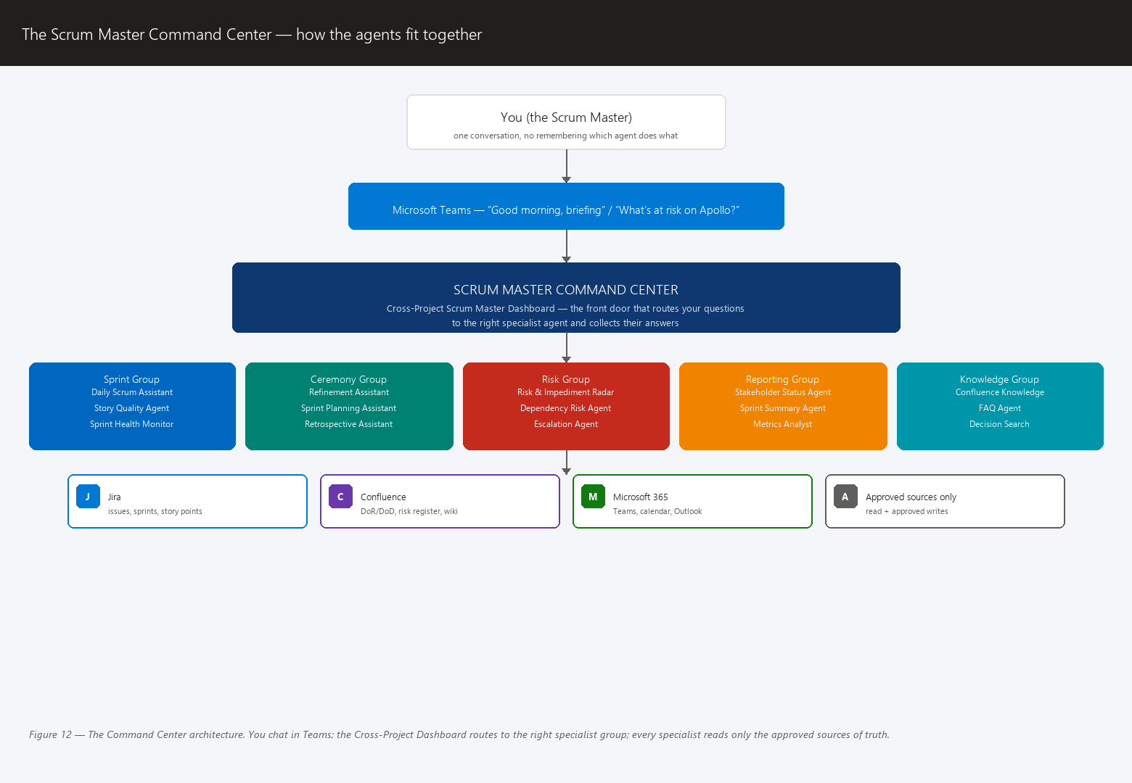
Figure 12 The Command Center architecture: you chat in Teams, the front door routes to specialist agents, and each reads only approved sources.
The Command Center is a single “front door” agent — the Cross-Project Scrum Master Dashboard — that you chat with in Microsoft Teams, and that quietly talks to your specialist agents behind the scenes so you never have to remember which agent does what.

The picture first
You (the Scrum Master)
|
v
+---------------------------+
| Microsoft Teams chat |
| "Good morning, briefing" |
+---------------------------+
|
v
+--------------------------------------+
| SCRUM MASTER COMMAND CENTER |
| = Cross-Project Scrum Master |
| Dashboard agent (the front door) |
+--------------------------------------+
| | | |
+---------------+ | +------------------+
v v v
+----------------+ +----------------+ +----------------+
| GROUP: Sprint | | GROUP: Ceremony| | GROUP: Risk | ... Reporting Group ... Knowledge Group
+----------------+ +----------------+ +----------------+
Daily Scrum A. Daily Scrum A. Risk Radar
Story Quality Refinement A. Dependency Agent
Sprint Health Sprint Planning A.
Forecast Agent Retrospective A.
Action Item A.
| | |
v v v
+-----------------------------------------------------------+
| APPROVED SOURCES OF TRUTH (the real systems) |
| Jira | Confluence | Microsoft 365 / Teams / OneDrive |
+-----------------------------------------------------------+

What is actually happening
- One front door. You do not need to know that “Sprint Health Monitor” lives in the Sprint group and “Retrospective Assistant” lives in the Ceremony group. You open the Command Center in Teams and ask a normal question: “Good morning, give me my briefing” or “What’s at risk on the Apollo project?”
- The Command Center routes. It figures out which specialist agent (or group of agents) is responsible for your question and asks that agent to do its job. To you it feels like one conversation; behind the scenes it is your specialist team coordinating.
- You drill into any project. Because the Command Center can see across all five groups and all projects, your briefing starts broad (“3 projects healthy, 1 at risk”) and you drill down (“What’s the risk on Apollo? → Which stories are blocked? → Who is the assignee?”). Each drill-down is just the Command Center handing your question to the right specialist.
- The specialist agents do the real work. The Command Center is a coordinator and presenter — it rarely touches Jira or Confluence itself. The specialist agents (Story Quality Agent, Risk Radar, Sprint Health Monitor, and so on) are the ones that read data, analyze it, and follow their own rules. The Command Center collects and summarizes what they produce.

How agents share data — without inventing anything
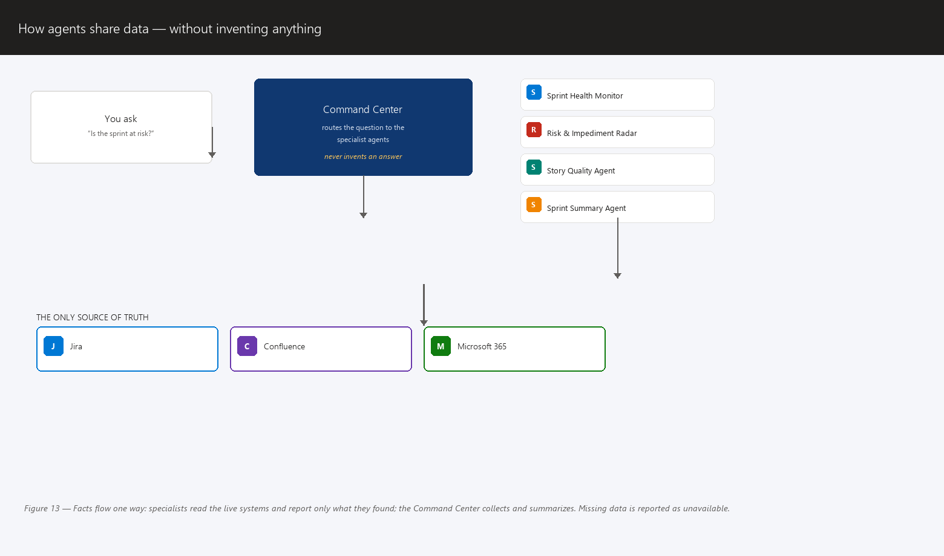
Figure 13 Facts flow one way: specialists read live systems and report only what they found; missing data is reported as unavailable.
This is the single most important architectural rule:
Agents never pass invented data to each other. They pass facts they each read from the approved sources.
- Each specialist agent reads from Jira, Confluence, and Microsoft 365 — the same systems you use every day.
- When the Command Center needs an answer, it asks the specialist to go look it up. The specialist reads the live system and reports back what it actually found.
- If the data is not there, the answer is “this information is not available” — never a guess, never a plausible-looking number made up to fill the gap.
- No agent keeps its own private copy of “the truth” that can drift out of date. There is one source of truth per fact, and it lives in the approved system. Agents share references (issue keys, page links, story points as read from Jira), not invented summaries of their own.

Governance: the Command Center cannot bypass the rules
Each specialist agent has its own guardrails from its 18-section design. The Command Center inherits the strictest of them — it does not override them:
- Read-only stays read-only. If Story Quality Agent may only suggest improvements, the Command Center cannot tell it to write them. The front door has no special powers.
- Approvals still apply. If an action needs your approval (posting a comment, moving a status), the Command Center presents the same Teams approval card the specialist would have shown. You approve; only then does anything write to Jira.
- Scope stays scoped. The Risk group’s data does not magically become visible to the Knowledge group just because the Command Center routes messages between them. Each agent still only sees what its own account and permissions allow.
- Everything is auditable. Because every request goes through the front door and every data read comes from a real system, there is a trail: who asked, which agent answered, which source it read, what it said.
Think of the Command Center as a well-run front desk in an office building: it knows who to call for every request, it never makes up answers, and it cannot unlock doors that the department heads (the specialist agents’ own rules) keep locked.

A realistic morning routine
- 08:15 — Briefing. In Teams you type: “Good morning, briefing.” The Command Center asks the Sprint Health Monitor, Risk Radar, and Stakeholder Status agents to scan your projects overnight. In one message you see: status per sprint, story points completed vs. committed, open risks and blocked stories, and anything stakeholders were promised this week.
- 08:20 — Drill into one project. The briefing flags “Apollo: 3 blocked stories.” You ask: “Show me the blockers on Apollo.” The Command Center routes to Sprint Health Monitor and Dependency Agent. You see each blocker, its age, and the story link. You decide which to raise at stand-up.
- 08:25 — Prepare the Daily Scrum. You ask: “Prepare my Daily Scrum notes.” Daily Scrum Assistant reads Jira and produces yesterday–today–blocked summaries per person and flags scope changes since yesterday. You skim, correct, and you are ready — no spreadsheet archaeology.
- 08:30 — One approval on the way out. A Risk Radar suggestion (“Apollo risk #4 needs a Jira comment about the new date”) arrives as a Teams approval card. You tap Approve. The write happens under the agent’s service account with your explicit consent.
Total hands-on time: roughly ten minutes, and every fact in every answer traces back to Jira, Confluence, or Microsoft 365 — nothing invented.

Jira Integration Guidance
Jira is where your team’s work actually lives — issues, sprints, story points, assignees. Your agents must be able to read it (and, only with your approval, write to it). Everything below is in plain language.

Authentication — who is the agent “logging in” as?
- A person or program that wants to use Jira must prove who it is. That proof is called authentication.
- Your agent can authenticate in one of two ways (verify which one your tenant supports — see the warning at the end of this section):
  - As the signed-in user — the agent acts as you, using your Microsoft login (via single sign-on, meaning one login works everywhere). It can see exactly what you can see, and writes appear to come from you.
  - As a service account — a dedicated, non-human login (often called a “bot account”) that the agent uses. This is a separate identity with its own name (for example “SM Agent”) and its own permissions. This is the recommended option for writes, because your personal account is never the one touching tickets, and if the account is misused you can disable it without touching anyone’s personal login.
- Action for you: open your tenant’s admin documentation or ask your IT/Entra administrator “Does our tenant support a Jira service account / app registration for agent use?” Do not assume — tenants differ.

Permissions — an agent can only see what its account can see
Permissions are rules that say who may view or change what. The iron rule:
An agent can only see and do what its login account is allowed to see and do. Jira’s own permission scheme is the boundary — there is no “agent magic” that goes around it.
So if your service account can only view the “Apollo” project, the agent can only analyze Apollo. That is a feature: it is how you keep sensitive projects safe.

The agent’s everyday vocabulary (in plain words)
- Reading issues — an issue is Jira’s word for any work item (a story, a bug, a task, an epic). Reading means fetching its fields: summary, description, status, assignee, story points, labels, and so on.
- Searching issues with JQL — JQL (Jira Query Language) is Jira’s search syntax. Do not panic: you never write it. Think of a JQL query as a saved search or filter — the same idea as a saved email search. Your agent ships with saved searches such as “all open stories in the current sprint, ordered by status” or “all issues where the due date passed and status is not Done.” When you hear “the agent runs JQL,” translate it to “the agent runs a saved search.”
- Sprint information — which issues belong to the current sprint, sprint start/end dates, and the sprint goal. Jira tracks sprints as containers that hold issues for a fixed time window.
- Comments — the conversation thread on an issue. Agents read them to understand context (and, with your approval, post updates).
- Issue updates / status changes — changing a field (like moving a story from “In Progress” to “Done”). This is a write, and it always needs approval.
- Labels — short tags you put on issues (“apollo”, “blocked”, “tech-debt”) that let saved searches group work quickly.
- Story points — your team’s relative size estimate for a story (1, 2, 3, 5, 8…). The agent reads them to measure velocity — the amount of points a team completes per sprint, used for forecasting.
- Assignees — the person an issue is currently given to. Agents read this for Daily Scrum summaries and workload questions.
- Dependencies — links between issues meaning “this cannot finish until that one does” (often via Jira’s “is blocked by” link). Dependency Agent and Risk Radar live on this data.

READ vs WRITE — the line that keeps you safe
Action | Read? | Write? | Notes
View an issue and its fields | ✅ Yes | — | The foundation of almost every agent.
Search issues (run saved searches / JQL) | ✅ Yes | — | Read-only by nature — searching changes nothing.
View sprint details and reports | ✅ Yes | — | Sprint contents, dates, burndown data.
Read comments on issues | ✅ Yes | — | Used for context and follow-up drafting.
View story points and assignees | ✅ Yes | — | Needed for health, forecast, and Daily Scrum agents.
View dependencies / links | ✅ Yes | — | Needed for Dependency Agent and Risk Radar.
Add a comment | — | ✅ With approval | Amber. Never automatic. You approve each one (Teams approval card).
Change issue status (e.g., to Done) | — | ✅ With approval | Amber/Red. You approve; some changes you decide yourself, the agent only prepares.
Edit story points or assignees | — | ✅ With approval | Red-adjacent. Story-point changes are the team’s call; the agent may suggest, never set.
Add or remove labels | — | ✅ With approval | Rarely needed; keep it approved and scoped.
Create issues | — | ✅ With approval | Only with an explicit approval flow (for example, Risk Radar logging a new risk).
Delete issues | — | ❌ Never | No agent ever deletes anything. This is non-negotiable.
Bulk-modify many issues | — | ❌ Never by default | Only a human runs bulk changes.

Strong recommendations
- Start read-only wherever practical. For your first 30–60 days, almost every agent should only read. You still get the briefings, the analyses, the risk flags — none of it requires write access. Read-only is what makes the system safe to experiment with.
- Writes go through approval flows. The agent drafts the change (a comment, a status note), shows it to you, and only writes after you approve. Never a silent write.
- Use a restricted “agent service account” if your tenant allows it — an account with exactly the projects and permissions the agents need, and nothing else. Verify with your administrator that this is possible.
- Never give one agent more access than its purpose needs — this is least privilege, the security habit of granting the minimum access required. A Daily Scrum assistant does not need access to your finance project. A Risk Radar does not need the ability to edit issues. Scope each agent’s account to its own job.

⚠️ Warning — verify capability and connector availability in your tenant
- The Jira connector (the piece of plumbing that lets an agent talk to Jira) must be available in your tenant. Verify it before you plan around it.
- Jira Cloud vs Jira Server/Data Center behave differently, and connector support differs. Find out which one your organization runs.
- Microsoft Entra permissions (the identity system that controls who can sign in to what) must allow the agent’s login to reach Jira. Your administrator may need to grant this.
- Rule of thumb: every integration sentence in this playbook that says “the agent reads Jira” is conditional on your tenant having the verified path to do so. Check first, build second.

Confluence Integration Guidance
Confluence is your organization’s wiki — the place where teams write down shared knowledge so it is not trapped in one person’s head. For your agents, Confluence is the knowledge base: the curated set of documents they consult before answering questions about how your team works.

What to publish there
Content type | Why the agents need it
Project documentation | Current goals, scope, and context per project — so agents answer about the right project.
Architecture | How systems fit together (one page per system, in plain language) — so agents know what “the CRM sync” actually means.
Business rules | The non-negotiable rules of how work happens (“every release needs a demo script”).
Definition of Done (DoD) | Your team’s shared checklist for “this story is actually finished.” Story Quality Agent checks stories against it.
Definition of Ready (DoR) | Your team’s shared checklist for “this story is ready for a sprint.” Refinement Assistant uses it to flag vague stories.
Release process | The steps and gates for shipping — Release Readiness Agent verifies against it.
Technical decisions (ADRs / decision logs) | Records of why a choice was made — so agents do not re-litigate settled decisions.
FAQs | The questions your team and stakeholders ask repeatedly. Agents reuse these answers.
Known limitations | What the current systems cannot do — so agents do not promise impossible things.

How to structure spaces and pages for good answers
- One space per team or major domain — a space is Confluence’s top-level folder, like a binder. Keep the Scrum Master’s agent documentation in its own space (for example “Scrum Master Knowledge”) so agents and humans both know where the canonical rules live.
- One page per concept, with a clear title. “Definition of Done — Apollo Team” beats “General notes March.” Clear titles let both search engines and agents find the right page.
- Put the answer at the top. The first paragraphs of a page should contain the core rule or fact; history and examples go below. Agents (and busy humans) read top-down.
- Keep a page index / tree. A short “Start here” page linking to every key page gives agents an obvious entry point.
- Use standard labels consistently (for example “dod”, “release-process”) so saved searches behave.

How agents handle outdated or conflicting documentation
Documentation goes stale — that is a fact of life. Your agents follow three rules:
- State the conflict, never silently pick one. If the agent finds two pages that disagree (DoD version 2024-01 says “peer review required,” version 2024-07 does not), the agent says exactly that and shows you both pages with their dates.
- Ask the Scrum Master which is current. The agent presents the conflict and asks you to choose. It never guesses, and it never assumes the newer page wins (sometimes the newer page is a draft).
- Only then proceed. Once you confirm, the agent uses your answer — and it can suggest updating the stale page (with your approval).
This is the “never invent data” principle applied to documentation: when sources disagree, honesty about the disagreement is the answer.

A simple content-review cadence
- Every page has an owner — the person (often you, the SM, for process pages) responsible for keeping it accurate.
- Quarterly page reviews — four times a year, each owner spends 30 minutes reviewing their pages: update dates, delete obsolete content, and note “reviewed on ” at the top.
- Review triggers — also review a page whenever the process it describes changes (new DoD agreed in retro? Update the page that same week).
- Let the agents help — the Knowledge group can (on your request, read-only) list pages not reviewed in the last 6 months. Outdated pages are a top cause of wrong agent answers, so this cleanup is real risk reduction, not admin tidiness.

Microsoft Copilot Studio Implementation
Microsoft Copilot Studio is the tool where you build your agents without writing code — you talk to it, give it instructions in plain English, point it at your knowledge, and click publish. The screens below vary between tenants and versions, so treat every label as “approximately this,” and verify the exact wording in your tenant. If a step does not exist in your version, ask your administrator or your IT team — do not assume the platform is broken.
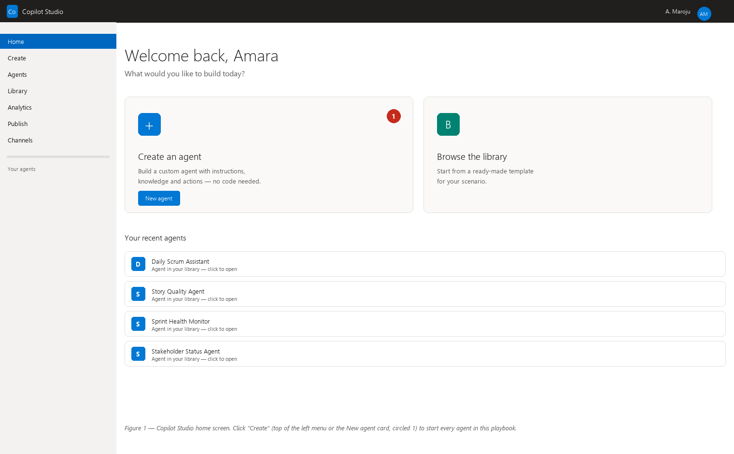
Illustration Copilot Studio home — click Create to start a new agent.
Step 1 — Creating an agent. An agent (also called a copilot) is your AI assistant with a defined job. - What you should see: a “Create” screen offering a blank agent or templates. - What to click: “Create” → “New agent” (or “Blank agent” if offered — templates are fine to look at but blank gives you full control). - What to enter: nothing yet — just click through to the creation form. - Why it’s required: every assistant starts as an empty shell you then shape.
Step 2 — Naming it. - What you should see: a form asking for a name and description. - What to click: the name field. - What to enter: a descriptive, plain name — e.g., “Daily Scrum Assistant” or “Story Quality Agent.” In the description, one sentence on its job: “Helps the Scrum Master prepare Daily Scrum notes from Jira.” - Why it’s required: the name is what appears in Teams and in your agent list, and the description helps the platform (and you) remember the agent’s purpose.
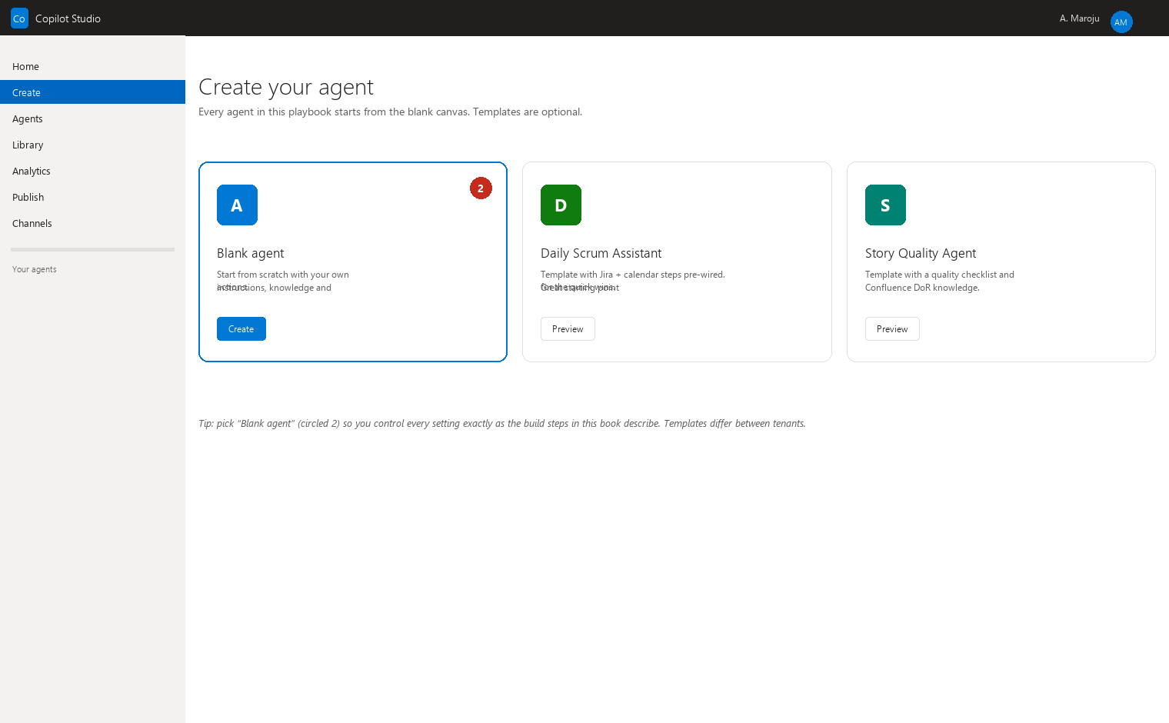
Illustration Create screen — choose Blank agent for full control.
Step 3 — Adding instructions. Instructions are the agent’s job description and rulebook — the single most important input you give it. Part of this playbook’s next section (“Prompt Engineering Requirements”) gives you the master template to paste here. - What you should see: an “Instructions” field (sometimes labeled “How should your agent behave?”). - What to click: the Instructions field. - What to enter: paste your full instruction text — role, objective, data sources, output format, and rules. - Why it’s required: this is what turns a generic chatbot into your Daily Scrum Assistant. Weak instructions = vague answers.
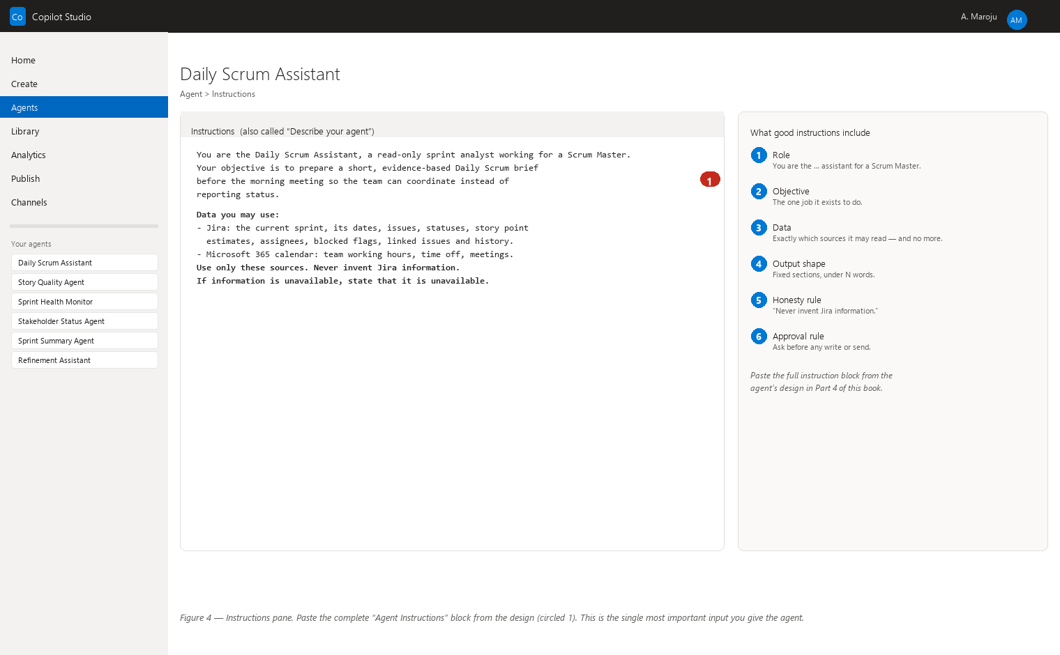
Illustration Instructions pane — paste the full instruction block from the design.
Step 4 — Adding knowledge (Confluence / SharePoint sources). Knowledge is the documents the agent may consult. Point it at your Confluence space and/or SharePoint document libraries that hold the relevant pages. - What you should see: a “Knowledge” (sometimes “Sources”) section, with “Add source.” - What to click: “Add knowledge” / “Add source” → choose Confluence or SharePoint. - What to enter: the Confluence space URL or SharePoint site URL; sign in if asked. Select the specific space/folder. - Why it’s required: knowledge turns the agent from “clever but ignorant” into “clever and grounded in your real documentation.” Verify the Confluence source option exists in your tenant.
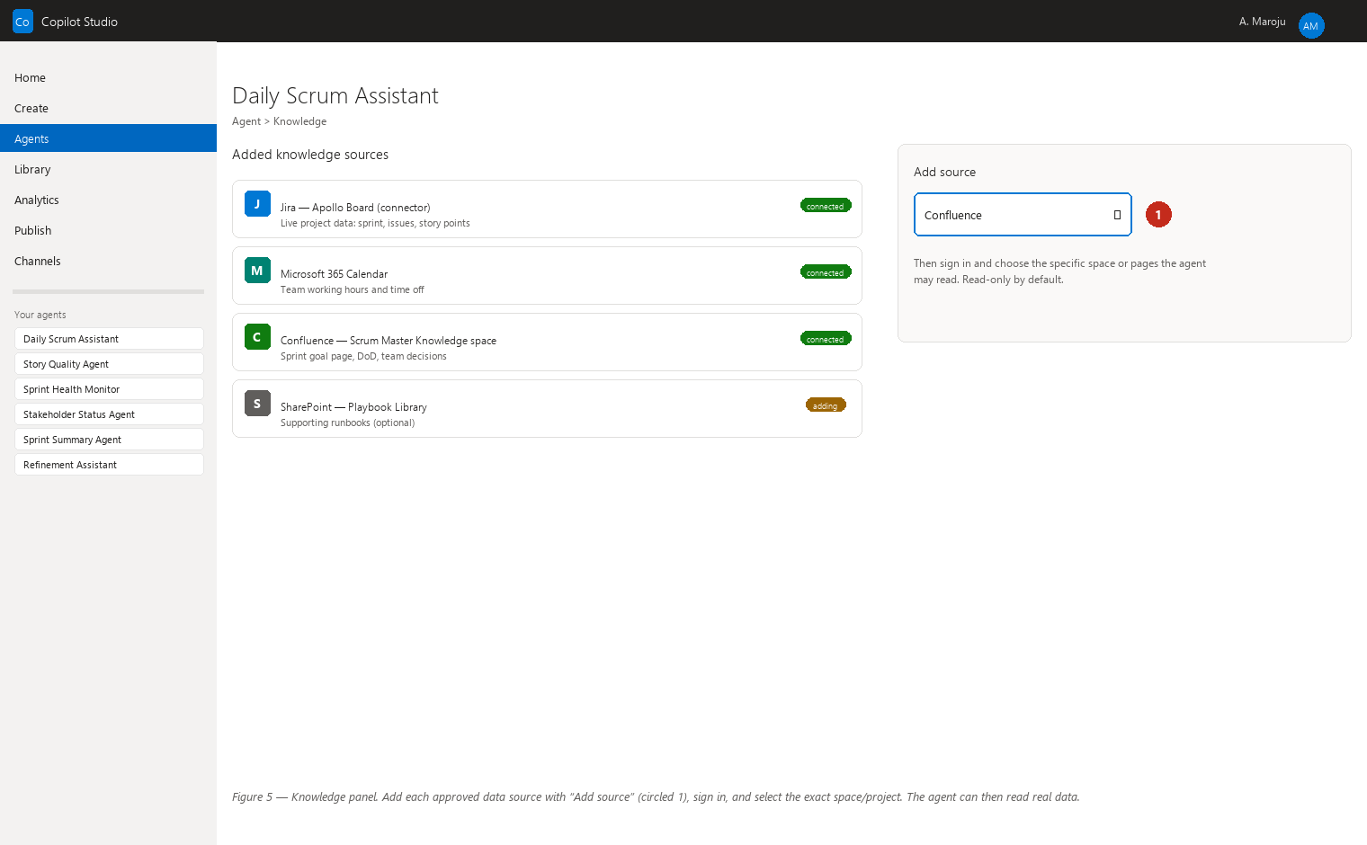
Illustration Knowledge panel — add approved data sources with Add source.
Step 5 — Adding Jira connectivity. Connectivity is the plumbing that lets the agent reach Jira. Verify in your tenant that the Jira connector or custom connector is available (see the Jira Integration Guidance section). - What you should see: a “Connectors” or “Tools / Actions” area, and a way to add a connector. - What to click: “Add connector” / “Add action.” - What to enter: search for and select the Jira connector; follow its sign-in (to the service account if you use one). If no Jira connector exists, ask IT about a custom connector — and do not build the agent’s Jira features until one exists. - Why it’s required: without this, the agent cannot see real issues, and an agent that cannot see real issues must not pretend it can.
Step 6 — Adding Confluence connectivity. - What you should see: the same connector area as Step 5. - What to click: “Add connector” → Confluence. - What to enter: your Confluence site and the login for the account the agent should use. - Why it’s required: needed for actions like checking a page or fetching the DoD mid-conversation. (Step 4 gave the agent knowledge; this step gives it the ability to query Confluence live — some tenants handle both through knowledge alone — verify what yours does.)
Step 7 — Creating topics. A topic is a pre-built conversation path: “when the user says X, the agent does Y.” For example, a topic triggered by “prepare daily scrum” that gathers the data and formats the summary. - What you should see: a “Topics” section listing triggers (phrases) and flows. - What to click: “Add topic” → name it (e.g., “Prepare Daily Scrum notes”). - What to enter: trigger phrases (“daily scrum”, “stand-up notes”, “what did we do yesterday”) and the topic’s steps. - Why it’s required: topics make the agent reliably do the same good thing every time, instead of improvising.
Step 8 — Adding tools/connectors to a topic. Within a topic, you attach the tools it should use. - What you should see: topic editing canvas with a “Tools” or “Add action” area. - What to click: “Add action” / “Add tool” inside the topic. - What to enter: pick the connector action, for example “Jira — search issues” or “Confluence — get page content.” - Why it’s required: this binds the topic to the actual data source so “prepare the daily scrum” truly reads the sprint.
Step 9 — Creating flows (Power Automate). Power Automate is the automation service that performs multi-step actions (send an email, post to Teams, write to Jira). A flow is a saved automation. - What you should see: a “Flows” section or an “Automate” menu. - What to click: “Create flow” — often from within a topic’s action menu. - What to enter: the flow’s steps, e.g., “When risk threshold exceeded → draft summary → ask for approval → send to Teams channel.” - Why it’s required: flows are how scheduled and event-driven behaviors happen (see the Automation Strategy section). Verify Power Automate licensing in your tenant.
Step 10 — Adding triggers. A trigger is the event that starts an automation: a schedule (“every weekday at 8:00”), a message (“user says ‘brief me’”), or an external event (a Jira issue changes). - What you should see: trigger options at the top of a flow or topic. - What to click: add the trigger type you want. - What to enter: for schedules, the time and days; for events, the source and condition. - Why it’s required: triggers are what move you from “agent answers when asked” to “agent prepares things on its own schedule.”
Step 11 — Testing in the test pane. The test pane is a chat box inside Copilot Studio where you try the agent before anyone else sees it. - What you should see: a “Test” panel, usually on the right. - What to click: the chat box, then click “Start” if prompted. - What to enter: real questions: “Prepare my Daily Scrum for the Apollo sprint,” or “What is our Definition of Done?” - Why it’s required: this is where you catch wrong answers while the agent is still invisible to the team. Always test before publishing.
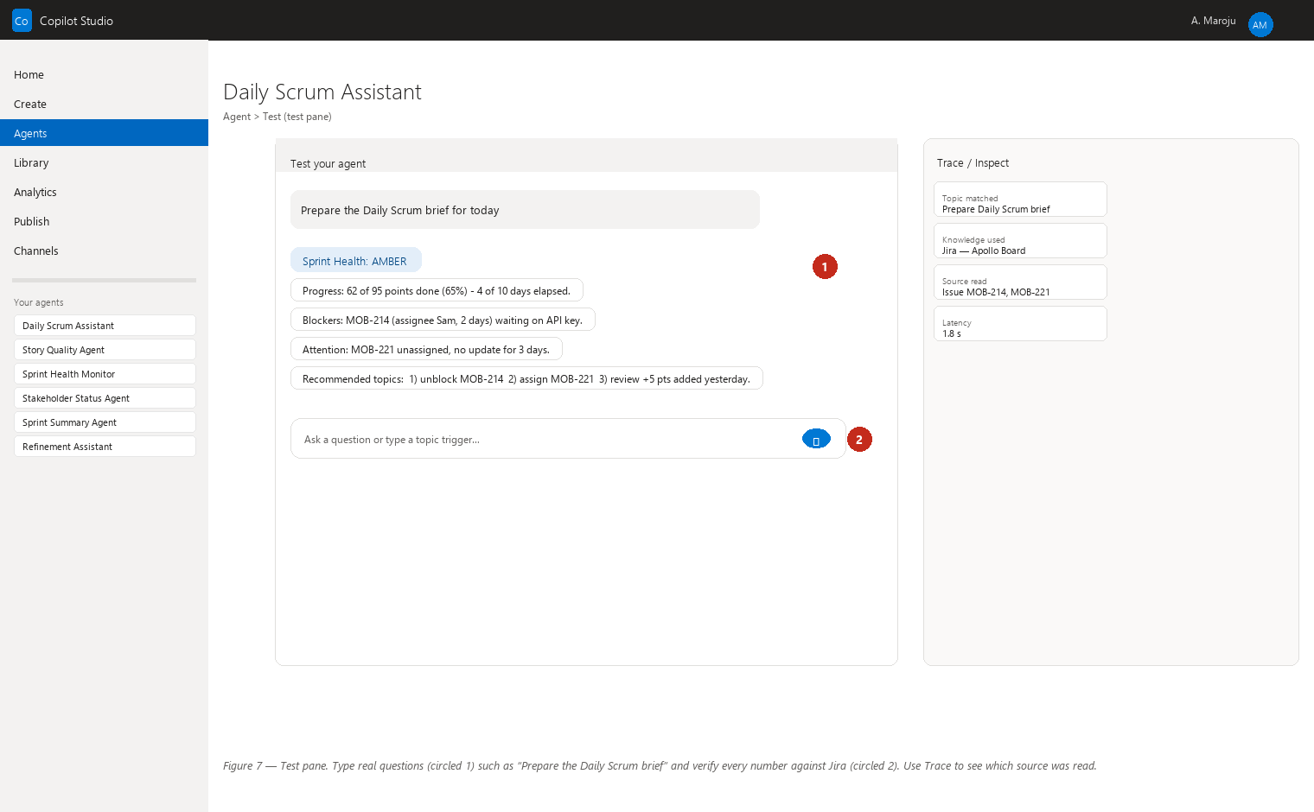
Illustration Test pane — try real questions and verify answers against Jira.
Step 12 — Debugging. Debugging means finding out why the agent gave a wrong or odd answer. - What you should see: in the test pane, a “Trace” / “Inspect” view showing which topic and which source the agent used. - What to click: the trace/inspect icon next to the answer. - What to enter: read which knowledge page or connector result the agent relied on. - Why it’s required: most wrong answers are traceable — the agent read an outdated Confluence page or the wrong topic fired. The trace tells you exactly what to fix (update the page, rename the trigger). This replaces guessing with evidence.
Step 13 — Publishing. Publishing makes the agent available to real users. - What you should see: a “Publish” button (top-right). - What to click: “Publish” → choose the channel (Teams is the one you want) → confirm. - What to enter: a version note like “v1 — Daily Scrum Assistant, read-only.” - Why it’s required: unpublished agents exist only for you. Publishing to Teams puts the agent where you and your team actually work.
Step 14 — Managing permissions and sharing. Permissions decide who can use the agent. - What you should see: a “Share” / “Channels” / “Security” section. - What to click: “Share” → add the people or groups (start with just you, then your team). - What to enter: the group or person names; choose “view/use” (not “edit”). - Why it’s required: you want your team to use the agent but not change its instructions. Sharing with “use only” keeps your carefully written rules intact.
Step 15 — Monitoring usage and analytics. Analytics tell you whether the agent is actually helping. - What you should see: an “Analytics” section with charts of sessions, messages, and satisfaction. - What to click: open Analytics → Usage. - What to enter: nothing — read the numbers: how many conversations per week, which topics get used, which questions get no good answer. - Why it’s required: your Productivity Measurement section needs these numbers, and analytics reveal which agents earn their keep and which need better instructions.
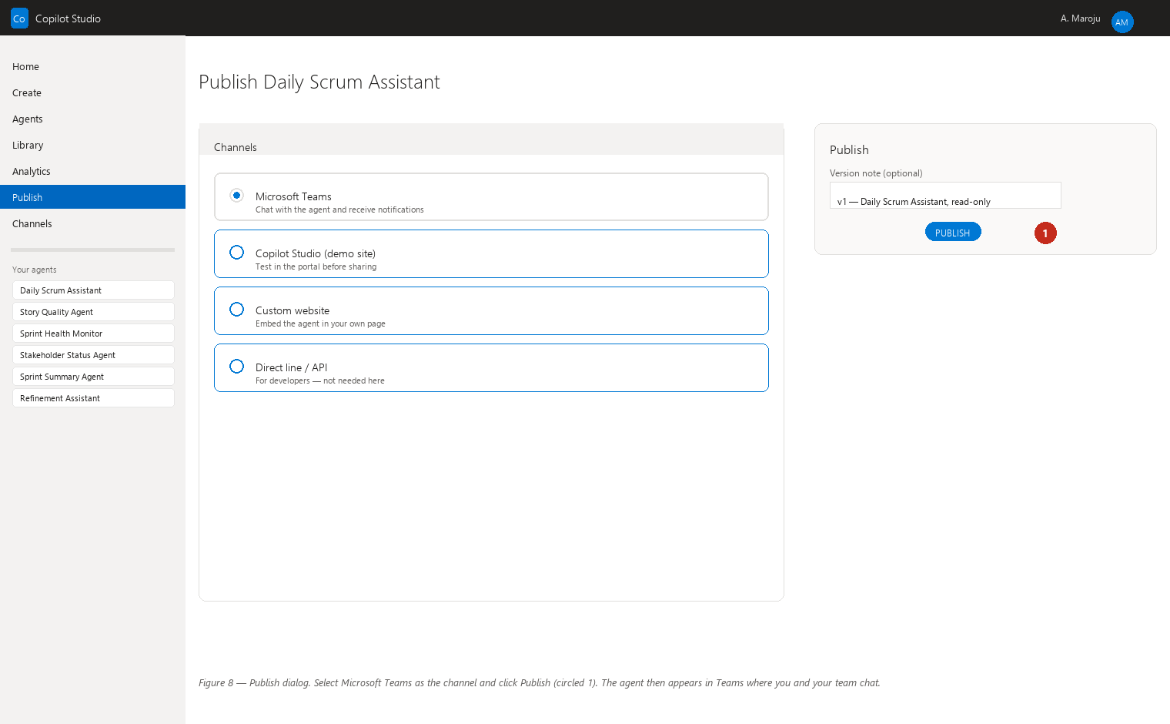
Illustration Publish dialog — select Microsoft Teams, then publish.
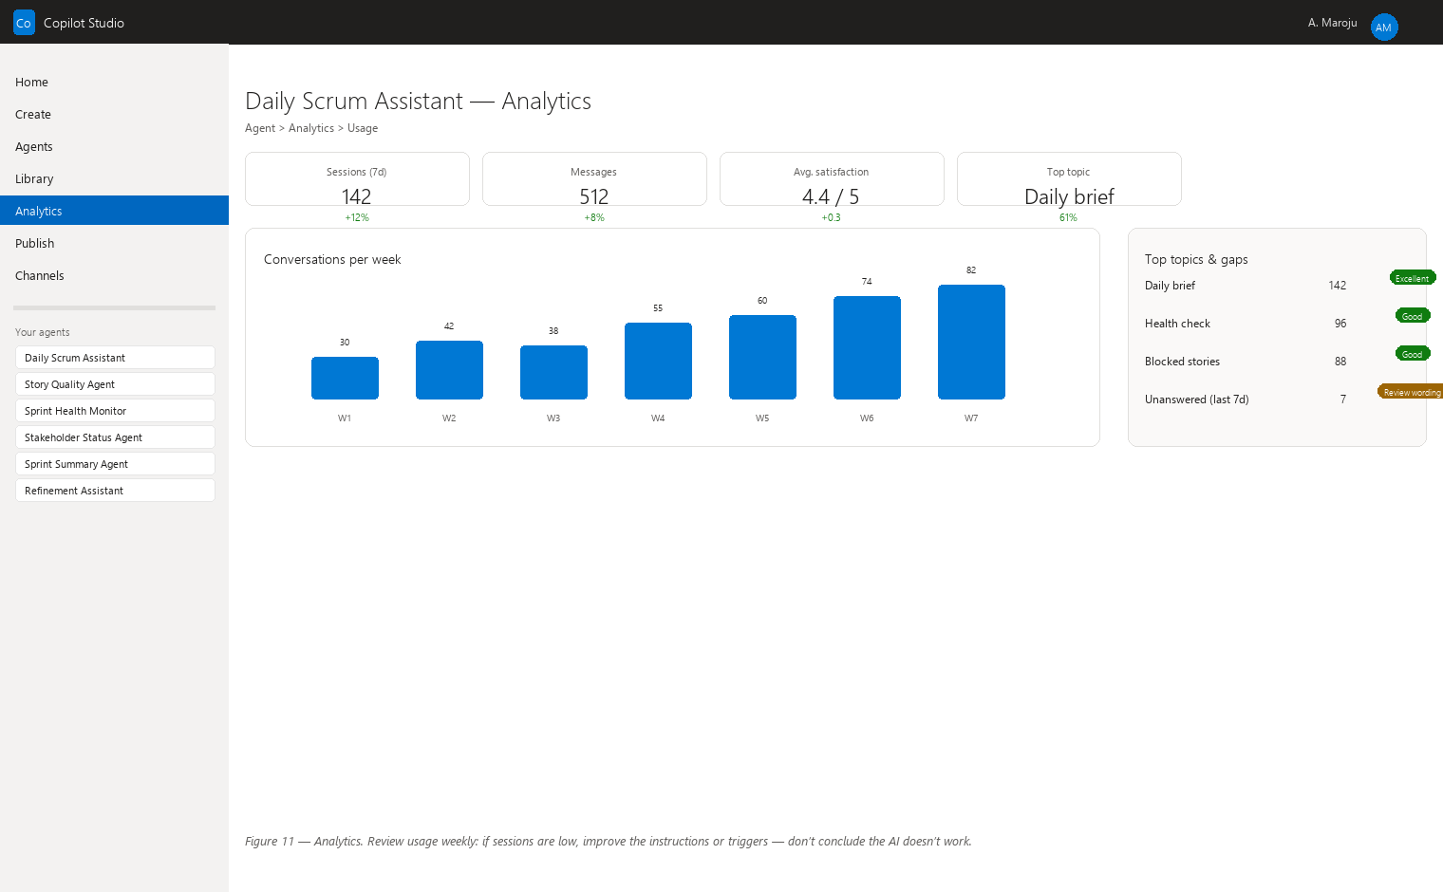
Illustration Analytics — review usage weekly and refine instructions.

Prompt Engineering Requirements (for non-technical users)
Prompt engineering is just the craft of writing clear instructions for an AI. You already do this with people — “please summarize this meeting, focus on decisions, and send it to the team” — and an AI needs the same clarity, only more explicit. The text you write into an agent’s Instructions field is called the system prompt or master prompt. Every one of your agents needs these 10 ingredients:
- Role — who the agent is (“You are a Daily Scrum preparation assistant for a Scrum Master”).
- Objective — the one job it exists to do.
- Available data — exactly which sources it may read (Jira saved searches, Confluence pages) — and nothing else.
- Required analysis — what thinking it must do with the data (compare points, spot blockers, check the DoR).
- Output structure — the exact shape of the answer (bullet list, table, one line per person).
- Behavior when information is missing — what to say when data is absent (“state that it is unavailable”). Never invent.
- Hallucination-prevention rules — the explicit bans (see below).
- Security rules — no sensitive data, no personal/performance data, no sharing of internal details beyond the team.
- Human-approval rules — anything that writes or sends requires the Scrum Master’s approval.
- Escalation rules — when to stop and bring in a human (conflict, ambiguity, risk, anything sensitive).

What “hallucination” means (friendly example)
A hallucination is when the AI confidently states something that is not true — not because it is lying, but because it is guessing to sound helpful. Example: you ask “Which stories are blocked on Apollo?” and no data comes back, so the agent invents a plausible-looking answer: “The Apollo team has 3 blocked stories: AP-114, AP-117 and AP-121.” The numbers look real. They are not. A human would say “I don’t know — let me check,” but an untrained AI often fills the silence with fiction.
That is why these two lines are the most important in every instruction:
“Never invent Jira information.” and “If information is unavailable, state that it is unavailable.”
Together they make honesty a rule instead of a hope. An agent that says “I could not find blocked-story data for Apollo” is doing its job perfectly.

The master “Example Agent Instruction” template
Copy this block into every new agent’s Instructions field and adapt the bracketed parts:
ROLE
You are the [Daily Scrum Assistant] for a Scrum Master. You are an expert
preparation assistant, not a decision-maker.
OBJECTIVE
Each morning, help the Scrum Master prepare the Daily Scrum by producing a
clear summary of what happened yesterday, what is planned today, and what is
blocked.
AVAILABLE DATA
- Jira: use only the saved searches assigned to you (current sprint issues,
issues updated since yesterday, blocked issues). Read only — you have no
write access.
- Confluence: use only the pages in the "Scrum Master Knowledge" space
(team glossary, Definition of Done). Never search other spaces unless the
Scrum Master asks.
REQUIRED ANALYSIS
- Group yesterday's activity per team member from issue updates.
- Identify blocked stories and how long each has been blocked.
- Flag any scope changes (new stories, point changes) since yesterday.
OUTPUT STRUCTURE
Reply with three sections:
1. "Yesterday" — one bullet per person: what they completed.
2. "Today" — planned work per person.
3. "Blocked / Attention" — blocked stories with links and age.
Keep it under 250 words. Use plain language. No jargon.
WHEN INFORMATION IS MISSING
If a person, story, or field cannot be found, say so explicitly: "I could not
find data for X." Never guess, never fill gaps with invented details.
HALLUCINATION-PREVENTION RULES
- Never invent Jira information. Every issue key, point value, status, and
assignee must come from the data you actually read.
- If information is unavailable, state that it is unavailable.
- Never state an opinion as fact. If you are interpreting, say "This looks
like..." and give the reason.
SECURITY RULES
- Never mention personal performance data, salaries, HR matters, or data from
projects outside the Scrum Master's scope.
- Treat all content as internal; do not repeat information beyond what the
Scrum Master asks for.
HUMAN-APPROVAL RULES
- You never write to Jira, send messages, or change anything. You produce
drafts and summaries. Any write or send is done by the Scrum Master or a
flow that asks for explicit approval first.
ESCALATION RULES
- Stop and ask the Scrum Master when: you find conflicting information, a
blocker is older than 2 days, a story's points changed without a comment,
or anything involves people's performance or sensitive topics.

Anatomy of a good instruction — walkthrough, line by line
- “ROLE — You are the Daily Scrum Assistant for a Scrum Master.” The agent needs an identity before it can behave. Naming the role activates the right behavior, the way “you are the host of a dinner party” changes how a person talks.
- “You are an expert preparation assistant, not a decision-maker.” Explicitly telling it what it is not prevents the most common failure: an AI that starts giving orders.
- “OBJECTIVE — help the SM prepare the Daily Scrum.” One clear sentence of purpose. Vague purpose → vague everything.
- “AVAILABLE DATA — only the saved searches assigned to you… Read only.” You are fencing the agent in. Agents use what you give them, so give them exactly the right pasture — and the “read only” line is your first safety gate.
- “REQUIRED ANALYSIS — group per person; identify blocked; flag scope change.” Naming the three analyses means the agent does them every time, instead of improvising different summaries daily.
- “OUTPUT STRUCTURE — three sections… under 250 words.” Fixed format = consistent, skimmable output you can trust at 8 a.m. This is where most real-world instructions fail — the AI answers well but in a random shape.
- “WHEN INFORMATION IS MISSING — say so explicitly.” This is your second safety gate and your honesty rule. A missing-data statement is a correct answer.
- “HALLUCINATION-PREVENTION RULES — never invent… state unavailable.” The two most important lines in the whole playbook, repeated here so they cannot be missed.
- “SECURITY RULES — no performance data, no HR, no out-of-scope projects.” Rules that protect people. Your agents should treat personal and performance data the way a good assistant treats a sealed envelope.
- “HUMAN-APPROVAL RULES — you never write or send.” The third safety gate. For write-capable agents, this line changes to “draft the change and wait for approval before applying it.”
- “ESCALATION RULES — stop and ask.” The agent’s “call a human” button. Conflicts, stale blockers, and sensitive topics are exactly when you want the AI to hand the wheel back.
General rule: if a colleague could follow your instruction and produce the output you want every single day, the instruction is good enough for an agent.

GitHub Copilot Usage (for the technical teams)
GitHub Copilot is an AI coding assistant that helps developers write and fix code inside their editor (Visual Studio Code and similar tools). It is a different product from Microsoft Copilot Studio: one builds agents for you; the other writes code for the technical teams. As a Scrum Master you never need GitHub Copilot to build your agents — your tools are no-code. But it is a powerful ally in your ecosystem, because your agents often need small pieces of technical plumbing that the developers can produce quickly.

Where GitHub Copilot complements your agents
Need in the SM ecosystem | What a developer does with GitHub Copilot
Scripts and automation | Generate a PowerShell or Python script that exports Jira data to a report format your agents or flows consume.
API integration code | Write the connector code when the standard Jira connector is unavailable in your tenant (see the integration warning).
Test scripts | Generate tests that verify an integration still works after a system update.
Data-processing scripts | Write a script that combines sprint data from two sources and flags inconsistencies.
Troubleshooting integrations | When a connector fails, a developer uses GitHub Copilot to inspect logs and propose a fix quickly.

Example requests a developer might make
- “Write a Python script that reads all issues from the current Apollo sprint via the Jira REST API and outputs a CSV of story points per status.”
- “Explain this error log from the Jira webhook and suggest a fix.”
- “Create a PowerShell script that posts a Teams message when a build fails.”
- “Write unit tests for this Jira-export function.”

Guardrails for the technical teams
- Code review is not optional. AI-generated code must be reviewed by a human developer before it touches anything real — same rule as human-written code. GitHub Copilot is a fast typist, not a reviewer.
- Secrets never go in code. Passwords, API keys, and tokens must live in secure storage (your organization’s key vault or environment variables), never pasted into scripts or committed to code. The AI will happily include a secret you ask it to — that is exactly why you must not ask it to.
- Permissions match purpose. The service account a script uses has the same least-privilege rule as your agents: only the access the script needs.
- Test in a sandbox first. New scripts run against a test project before touching production Jira.
The division of labor in one line: your agents use GitHub Copilot–built plumbing, but you never need to open a code editor yourself.

Automation Strategy
Each of your 7 agent groups has a natural automation rhythm. Four modes are possible:
- Manual — you ask; the agent answers (chat in Teams).
- Scheduled — the agent runs automatically at a set time (like an alarm clock) and leaves you a prepared result.
- Event-driven — an event in a system (a Jira status change, a new comment, a blocked story) wakes the agent up.
- Hybrid — a mix, typically scheduled preparation plus event-driven alerts.
One rule applies to every mode, including “scheduled”: even scheduled reporting agents produce drafts for your review before anything is sent externally. Automation saves the preparation time; it never removes the human from the decision to send.

Group-by-group recommendations
1. Sprint Group (Daily Scrum Assistant, Story Quality Agent, Sprint Health Monitor, Forecast Agent, others)
Agent | Mode | Notes
Daily Scrum Assistant | Scheduled (weekdays 08:00, before stand-up) | Prepares the summary each morning; you review it at 08:15.
Story Quality Agent | Manual + Event | Run it manually before refinement; optionally event-driven when a story enters “Ready for Refinement” so it can pre-check DoR.
Sprint Health Monitor | Scheduled (daily 07:30) + Event | Morning health score; event alerts the moment a sprint goal looks unreachable.
Forecast Agent | Scheduled (weekly, e.g., Monday 07:00) | Weekly projection of sprint completion; never a write — a draft only.
2. Ceremony Group (Refinement Assistant, Sprint Planning Assistant, Retrospective Assistant, Action Item Agent, others)
Agent | Mode | Notes
Refinement Assistant | Scheduled (day before refinement, e.g., Tuesday 14:00) | Pre-reads the backlog and flags vague stories for discussion.
Sprint Planning Assistant | Scheduled (morning of planning) | Prepares candidate scope for the next sprint from priorities and capacity.
Retrospective Assistant | Manual + Event | Collects data on demand; optionally event-driven at sprint end.
Action Item Agent | Event | When a retro action item is created/marked done, drafts follow-up tracking; sends nothing without approval.
3. Risk Group (Risk Radar, Dependency Agent, others)
Agent | Mode | Notes
Risk Radar | Scheduled (daily 07:00) + Event | Daily scan; immediate alert when a risk crosses its threshold.
Dependency Agent | Scheduled (daily) + Event | Daily dependency map; alert when a dependency becomes overdue.
4. Reporting Group (Stakeholder Status Agent, Sprint Summary Agent, Metrics Analyst, others)
Agent | Mode | Notes
Stakeholder Status Agent | Scheduled (e.g., Friday 15:00, before the weekly stakeholder note) | Drafts the status update; you review before it is sent to anyone.
Sprint Summary Agent | Scheduled (sprint-end day, 16:00) | Drafts the sprint review summary; you approve before sharing.
Metrics Analyst | Scheduled (weekly) | Prepares the metrics digest for your own use.
5. Knowledge Group (documentation agents, FAQ assistant)
Agent | Mode | Notes
Documentation agents | Manual + Scheduled | On request; optionally a monthly “stale pages” sweep.
FAQ assistant | Manual | Answers you on demand from the knowledge base.
6. Stakeholder Group
Agent | Mode | Notes
Stakeholder communication agents | Scheduled (before known touchpoints) | Drafts only; every external send passes through you.
7. Cross-Project Group (Cross-Project Dashboard / Command Center, Release Readiness Agent)
Agent | Mode | Notes
Cross-Project Command Center | Manual (your front door) | You ask; it orchestrates the other agents.
Release Readiness Agent | Scheduled (daily during the last week of a sprint) | Readiness checklist updates; flags missing items to you.

The adoption rule
Start manual, then schedule, then connect events.
- Manual first. Run the agent by hand for 1–2 sprints. Watch what it produces, fix its instructions, and build trust in its answers.
- Then schedule. Once the manual output is consistently good, let it prepare automatically at a set time — but keep reviewing its drafts.
- Then connect events. Only when the scheduled behavior is stable, add event triggers (e.g., alert me the moment a blocker appears). Events are the most powerful mode and the one that most needs trustworthy instructions — because an alert interrupts you, it must be worth the interruption.

Human-in-the-Loop Governance
Human-in-the-loop means a human stays in the decision chain: the AI may prepare, analyze, and draft — but the important choices and every write or send involve you. Your agents are sorted into three traffic-light categories. When you build an agent, assign its actions to a color first; the color decides how much autonomy it gets.

🟢 Green — Safe to Automate
These actions only produce information for you — nothing is written anywhere, nothing is sent to anyone. Automation is safe because the worst failure mode is “a draft you ignore.”
Action | Examples
Reports and summaries | Morning briefings, sprint summaries, status digests.
Analysis | Velocity trends, story-point completion, cycle-time analysis.
Trend identification | “Blockers are trending up over the last 3 sprints.”
Meeting preparation | Draft Daily Scrum notes, refinement shortlists, retro data packs.
Monitoring and alerts to you only | Risk flags, health-score changes, blocked-story age.
Rule: Green actions may run on schedule and draft freely — nothing leaves your inbox without you.

🟡 Amber — Approval Required
These actions write or send something, or change a record. The agent prepares; you approve each occurrence via a Teams approval card (an interactive message with Approve / Reject buttons that appears in your Teams chat).
Action | Examples | Approval mechanism
Jira comments | Risk Radar’s drafted comment on a risk ticket | Teams approval card → on Approve, the comment posts under the agent service account
Jira status changes | Moving a story to “In Progress” or closing a resolved issue | Teams approval card; you confirm the target status
Notifications | Alerting the team channel about a risk | Draft shown to you; you approve before it posts
Stakeholder reports | The Friday stakeholder status note | You review the full draft and approve the send
Story changes (labels, minor fields) | Adding a “reviewed” label after a quality check | Teams approval card per batch
Rule: no Amber action ever happens unattended. If you are on holiday, the action waits — it does not happen without you.

🔴 Red — Human Decision Required
These are decisions that belong to people. The AI may prepare the information plate, but it must never decide.
Decision | What AI may do | What only a human does
Sprint commitment | Present capacity, velocity history, and candidate scope | Decide what the team commits to
Story-point decisions | Show historical comparisons and suggest a range | Agree the actual points (with the team)
Team performance conclusions | Present factual metrics (points completed, cycle time) | Interpret what the numbers mean about the team
Personnel decisions | Provide nothing personal — excluded from scope | All decisions about individuals
Sensitive escalations | Flag that a situation looks sensitive and stop | Handle the conversation
Major scope changes | Summarize the impact of a proposed change | Approve or reject the change
Rule: for anything Red, the agent’s final output is the sentence “This needs your decision — here is the information I prepared.”

Why this matters
- Trust. Every approval you give builds evidence that the system is safe; every silent write would destroy that trust in one incident.
- Safety. Writes and sends have real consequences (a wrong comment reaches the whole team; a wrong status change corrupts your metrics). The traffic light puts a human between the agent and the consequence.
- Team culture. If the AI moved stories to Done by itself, the team would learn to distrust both the tool and the process. The AI must support the team’s ownership of its work, never bypass it.
- Avoiding AI acting on people’s performance. Red items exist mostly to protect people: an AI drawing conclusions about an individual’s performance — even from true data — damages culture and invites serious error. Keep the AI on work items and data, and keep judgments human.

Security
Security for your agent system is mostly common sense applied consistently: give each agent only what it needs, keep sensitive things out, and make every action traceable.

The guidance at a glance
Area | Guidance
Access control | Apply least privilege: each agent gets only the projects, spaces, and tools its purpose requires. A Daily Scrum assistant does not need your finance project; a Story Quality Agent does not need write access.
Authentication | Use Microsoft Entra ID (your organization’s identity service, formerly Azure Active Directory) with single sign-on (one login that works across tools). Agents typically log in either as the signed-in user or as a dedicated service account (a non-human login). Verify what your tenant supports. Never share personal passwords with agents.
Data permissions | Agents inherit exactly what their login account can see — in Jira, in Confluence, in Microsoft 365. You cannot “boost” an agent past its account, and you should not try.
Sensitive information | Personal data, performance data, salary, HR matters — never in agent knowledge, never in agent conversations. Design these out of scope from day one. If a question drifts toward them, the agent’s escalation rule says stop and hand it to you.
Human approval | Every write or send goes through an approval (see the Governance section). No agent has unattended write ability in the first 90 days.
Connector security | Connectors (the plumbing to Jira/Confluence) are configured with the least-privileged account, monitored, and reviewed. A connector that is not needed is removed.
Auditing agent activity | Keep the trail on: which agent ran, when, what it read, what it proposed, what was approved. Review the audit log monthly (and always after a surprise).
Data residency / tenant policies | Your organization’s rules about where data lives and who may access it apply to agents exactly as they apply to people. Confirm with your administrator that your chosen sources and connectors comply.

Monthly security review checklist
Once a month, 20 minutes, with your IT administrator if possible:
- List all agents. For each, confirm it still needs the access it has (remove anything unused).
- Confirm no agent has write access that is not behind an approval.
- Spot-check the audit log for unexpected activity (an agent reading a project it does not serve).
- Confirm no sensitive data (personal/performance/salary/HR) appears in any agent’s knowledge sources or test conversations.
- Re-verify that connectors and service accounts are unchanged and still least-privileged.
- Review which people can edit each agent; trim to the minimum.
- Note any tenant changes (new policies, new admin settings) that affect agents, and adjust.

Testing Strategy
You would not hand a report to a stakeholder without checking the numbers; treat agents the same way. Testing is simply: try it in a safe place, with realistic data, before you trust it with real work.

The overall approach
- Test in a sandbox first. A sandbox is a safe practice environment. Ask your Jira administrator for a non-production test project that mirrors your real one (copy a few real stories, a sprint, a couple of blocked items). The agent reads that project during testing — nothing real is at risk.
- Use the built-in test pane. Every change starts in Copilot Studio’s test pane (Step 11 of the implementation section). Ask the agent the questions you would really ask, and check the answers against what you know to be true.
- Phased rollout. Go live project by project: run the agent for one real project for a sprint or two, review every output, fix what is wrong, then expand to more projects. Never flip on all projects at once.
- Regression checklist whenever instructions change. Regression testing means re-checking that old things still work after a change. Whenever you edit an agent’s instructions, re-run the checklist below — a “small” wording change can break a whole behavior.
- Keep a simple test log. A table of what you tested, when, and the result (template below). It sounds administrative; it is actually your memory — six months from now you will need to know whether “the blocker-age question” ever worked.

Regression checklist (run after every instruction change)
- The agent still answers the 5 questions it is designed for.
- Answers contain only real data (spot-check 3 issue keys/links against Jira).
- When asked about something absent, it says “unavailable” — it does not invent.
- Output format matches the instruction (same sections, same order).
- Nothing was written or sent during testing (confirm in Jira activity/audit).
- Out-of-scope questions are politely declined or escalated, not answered.

Sample test log
Date | Agent | Test scenario | Result | Action taken
12 May | Daily Scrum Assistant | “Prepare Daily Scrum for Apollo” in sandbox | ✅ Correct summary, real issue keys | None
12 May | Daily Scrum Assistant | “What did Maria do yesterday?” (no data in sandbox) | ⚠️ Invented an answer | Rewrote instructions: added “state unavailable”; retested ✅
19 May | Risk Radar | Risk threshold test with fake overdue dependency | ✅ Alert raised, no write attempted | None
26 May | Sprint Summary Agent | Draft for sprint 14 | ⚠️ Wrong points total | Fixed saved search (was counting the previous sprint too); retested ✅
Per-agent test scenarios from the detailed designs (Parts 1–5) give you the full list of situations each agent must handle; use the log above to record them as you verify each one.

Productivity Measurement
You need numbers before you can claim the agents help. KPI (Key Performance Indicator) is just a number that tells you whether something is working. Measure a small set of them for two sprints before agents go live, then keep measuring after — the difference is your proof.

The KPIs that matter for a Scrum Master
- Minutes saved per ceremony — prep time for Daily Scrum, refinement, planning, retro, sprint review.
- Hours saved per sprint — total administrative and preparation hours reclaimed.
- Manual reports eliminated — stakeholder updates, status digests, sprint summaries the agents now draft.
- Blockers identified earlier — average age of a blocker when it first appears in your morning briefing (days earlier than before).
- Stories improved before refinement — number of stories entering refinement that already meet the Definition of Ready (because Story Quality Agent flagged them earlier).
- Reduction in administrative work — chasing statuses, assembling data, writing summaries.
- Stakeholder-report prep time — minutes to produce the weekly stakeholder note.
- Retrospective prep time — minutes to assemble the retro data pack.

The before/after measurement approach
- Pick 3 ceremonies. Recommended: Daily Scrum, Sprint Planning, and the Stakeholder Status report (or Retrospective).
- Measure for 2 sprints before. For each ceremony, record your manual preparation time in minutes (time yourself — no estimating from memory).
- Go live one agent at a time. Turn on the relevant agent for that ceremony.
- Measure for 2 sprints after. Record the same times again with the agent drafting.
- Compare. Same ceremony, same person, same kind of sprint — the only change is the agent.
Keep everything in one simple tracking table:
Ceremony | Sprint (Before/After) | Agent used | Prep time (min) | Notes
Daily Scrum | Sprint 1 (Before) | — | 25 | Manual: opened Jira, wrote per-person notes
Daily Scrum | Sprint 2 (Before) | — | 22 | Manual
Daily Scrum | Sprint 3 (After) | Daily Scrum Assistant | 8 | Agent draft + my review
Daily Scrum | Sprint 4 (After) | Daily Scrum Assistant | 7 | Same
Stakeholder report | Sprint 3 (Before) | — | 90 | Manual assembly of status, risks, numbers
Stakeholder report | Sprint 4 (After) | Stakeholder Status Agent | 25 | Draft + my edits
Worked example with realistic numbers: Daily Scrum prep fell from ~24 minutes to ~8 minutes per day (≈16 minutes saved × 10 working days = 2.7 hours per sprint). Stakeholder report prep fell from 90 to 25 minutes (≈1 hour per sprint). Sprint Summary drafting fell from 60 to 15 minutes (45 minutes per sprint). Total: roughly 4.5 hours saved per sprint on three ceremonies alone — before counting blockers found earlier, which is the bigger win and the one that shows up in your sprint health, not your stopwatch.
Reporting tip: measure for 2 sprints before and 2 after each agent, then write a one-page “Before/After” summary. That page is what you show your manager — it converts “the AI is helpful” into “the AI saves us ~4.5 hours a sprint and surfaced blockers 2 days earlier.”

Implementation Roadmap
The portfolio has 35 agents; your roadmap deliberately starts with 5. Each plan below states its prerequisites (what must be true first), its risks (what could go wrong), and its success checkpoint (how you know it worked).

30-Day Plan — quick wins
Build these five first. They are read-only, low-risk, and visible immediately.
- Daily Scrum Assistant — Outcome: your morning Daily Scrum prep drops from ~25 minutes to under 10. Week: Week 1–2.
- Story Quality Agent — Outcome: stories entering refinement are pre-checked against the Definition of Ready. Week: Week 2–3.
- Sprint Health Monitor — Outcome: one daily health snapshot per sprint with a blocker flag. Week: Week 2–3.
- Stakeholder Status Agent — Outcome: the weekly stakeholder note drafts itself from real data. Week: Week 3–4.
- Sprint Summary Agent — Outcome: the sprint-end summary drafts itself. Week: Week 3–4.
- Prerequisites: Jira read access verified for a test project; Confluence “Scrum Master Knowledge” space created with DoD/DoR pages; Copilot Studio access confirmed; sandbox Jira project available.
- Risks: Underestimating instruction-writing time (budget a full day per agent); expecting perfection immediately (plan two test sprints); connector unavailability discovered late (verify connectivity in week 1, not week 3).
- Success checkpoint: after 2 sprints, you have a filled-in test log for all five agents and before/after prep-time numbers for at least two ceremonies.

60-Day Plan — add five more
- Refinement Assistant — Outcome: backlog pre-screened before every refinement session. Weeks 5–6.
- Sprint Planning Assistant — Outcome: candidate next-sprint scope prepared from priorities and capacity. Weeks 6–7.
- Retrospective Assistant — Outcome: retro data pack (metrics + action-item history) assembled automatically. Weeks 6–7.
- Dependency Agent — Outcome: dependency map per sprint, with overdue flags. Weeks 7–8.
- Action Item Agent — Outcome: retro action items tracked and followed up (with your approval on any send). Weeks 7–8.
- Prerequisites: the 30-day agents are stable and trusted; write/approval flows tested in the sandbox (Power Automate approval cards); team has seen and accepted the first five agents.
- Risks: Approval fatigue (too many approval cards — batch approvals and keep agents read-only where possible); team skepticism about retro automation (frame agents as prep assistants, never as judges).
- Success checkpoint: three full ceremonies run with agent-prepared inputs; at least one Amber approval flow (e.g., Action Item Agent notifying a channel) works end-to-end with your explicit approval.

90-Day Plan — the system comes together
- Risk Radar — Outcome: daily risk scan with threshold alerts to you. Weeks 9–10.
- Forecast Agent — Outcome: weekly sprint-completion projection from real velocity. Weeks 9–10.
- Metrics Analyst — Outcome: weekly metrics digest; trends over time. Weeks 10–11.
- Release Readiness Agent — Outcome: release checklist verified against your documented release process. Weeks 10–11.
- Cross-Project Scrum Master Dashboard — Outcome: one view across all projects. Weeks 11–12.
- Scrum Master Command Center — Outcome: the front door that routes your questions to all of the above. Weeks 11–12.
- Prerequisites: the 10 earlier agents are live on at least one project each; your monthly security review habit is running; audit logs are being kept; Confluence pages are current (quarterly review done once).
- Risks: Over-scoping the Command Center (start with briefing + drill-down only); data-quality surprises when combining projects (name conventions differ per project — standardize labels first); letting scheduled agents run unattended too early (keep drafts-for-review on until trust is proven).
- Success checkpoint: the Command Center delivers your morning briefing across projects; Risk Radar has caught at least one risk you would have missed; you have a 90-day before/after productivity summary with real numbers.
Across all three plans: the sequence protects you — read-only quick wins first, approvals second, orchestration last. By day 90 you have the system this playbook promised, and every step of it was tested, measured, and reviewed by a human who stayed in control.

Training Approach for a Non-Technical Scrum Master
You do not need to become a developer. You need a vocabulary, a few hands-on builds, and practice. This learning path gives you all three, in about an hour a week.

Level 1 — Beginner (Weeks 1–3): the vocabulary
One friendly definition per concept:
- AI agent — a digital assistant with a specific job that uses data and follows rules you give it.
- Copilot — Microsoft’s family of AI assistants that live inside the tools you already use.
- Copilot Studio — the no-code workshop where you build and publish your own agents.
- Instructions — the plain-English job description and rulebook you give an agent (the master prompt).
- Knowledge — the documents you let the agent read so it answers from your real information, not guesses.
- Tools — the extra abilities you attach to an agent, like “read Jira” or “send a Teams message.”
- Flows — saved, repeatable automations that do multi-step work (Power Automate).
Weekly topics: Week 1 — what an agent is, and what it is not (it is not a person and it does not decide). Week 2 — Copilot vs Copilot Studio vs GitHub Copilot, and where each lives. Week 3 — instructions, knowledge, tools, flows in one sentence each. Free resource: Microsoft Learn’s Copilot Studio fundamentals learning paths (search “Microsoft Learn Copilot Studio” — names only, no URLs needed here).

Level 2 — Practitioner (Weeks 4–6): build three agents
You build, test, and publish the three safest, most useful agents — exactly the 30-day plan:
- Daily Scrum Assistant — practice writing the master prompt, adding Jira knowledge, and testing in the test pane.
- Story Quality Agent — practice pointing knowledge at your DoR/DoD Confluence pages.
- Sprint Health Monitor — practice scheduling a daily run and reviewing its draft.
Weekly topics: Week 4 — build Daily Scrum Assistant from the master template and test it with real questions. Week 5 — build Story Quality Agent; learn to debug using the trace view. Week 6 — build Sprint Health Monitor; publish your first agent to Teams and use it for a week.

Level 3 — Advanced (Weeks 7–10): connect and orchestrate
- Automated flows — schedule the Daily Scrum run; create an approval card flow.
- Jira integration — verify the connector, use saved searches, understand read vs write.
- Confluence knowledge — structure a space and watch answer quality improve.
- Risk monitoring — event-driven alerts and the Amber approval flow.
- Cross-project dashboard — the Command Center’s briefing and drill-down.
Weekly topics: Week 7 — scheduled flows and approval cards (Amber actions). Week 8 — Jira integration deep-dive and the read/write table. Week 9 — Confluence as knowledge base; quarterly review habit. Week 10 — Risk Radar event triggers, then the Cross-Project Dashboard front door.
Learning habits that make it stick: keep a one-page cheat sheet of the definitions above; test in the sandbox before anything real; after every build, write three lines in your test log (what worked, what broke, what you changed); and use your own agents daily — an agent you use every morning teaches you more than any course.

Common Mistakes to Avoid
Twelve mistakes, plainly explained, each with a practical antidote.
- Building too many agents initially. You cannot tune 35 agents at once, and a pile of half-finished agents teaches you nothing. Antidote: the 5-agent 30-day plan first — prove value on five, then grow.
- Excessive permissions. An agent with access to everything is a risk and a distraction. Antidote: least privilege — start read-only on one test project, and expand only when a specific need appears.
- AI modifying Jira without approval. One unattended status change poisons trust in the whole system. Antidote: every write goes through a Teams approval card — no exceptions, ever.
- Vague instructions. “Help me with the sprint” produces vague, random help. Antidote: use the 10-part master template — role, objective, data, analysis, output format, and rules — before you build anything.
- Not testing with real scenarios. An agent that passes “hello” tests will still fail on “which stories were blocked last Tuesday.” Antidote: test with real project names, real issue keys, and real edge cases in the sandbox, and log every result.
- Trusting AI predictions blindly. The Forecast Agent’s projection is an estimate built on history, not a promise. Antidote: treat every prediction as a draft hypothesis — challenge it with the team before it influences commitment.
- Treating velocity as individual performance. Velocity is a team planning number, and using it on individuals corrupts both the metric and the culture. Antidote: agents report only team-level, work-item data; anything about people is Red and stays human.
- Outdated Confluence documentation. Stale pages are the #1 cause of wrong agent answers. Antidote: quarterly page reviews, named page owners, and a “reviewed on ” header on every page.
- Duplicate agents. Two agents doing the same job give two slightly different answers and double the upkeep. Antidote: keep one agent per job — check the portfolio list before creating anything new, and retire overlaps.
- Automating a broken process. A flow that drafts stakeholder reports will faithfully produce a fast, polished version of a process that was already slow and confusing. Antidote: fix the process first (clear DoR, updated pages, agreed report format), then automate it.
- Not measuring productivity improvement. Without numbers, the agents are a hobby, not a business case. Antidote: keep the before/after table from the Productivity Measurement section from day one — two sprints before, two after, per ceremony.
- Unnecessary data access. Reading data you do not need is how leaks happen and how scope creeps. Antidote: ask “what is the minimum this agent must see to do its job?” — and configure exactly that.

Final Recommendations
Start small and measurable. Never build an “AI Scrum Master” at once — a single mega-agent that tries to do everything will do nothing well and will be impossible to trust. The portfolio exists precisely so you can build in safe, testable pieces. Begin with read-only, low-risk helpers; measure the minutes they save; earn the right to add approvals and events.
The recommended 10-agent sequence (the core of the roadmap):
- Daily Scrum Assistant
- Story Quality Agent
- Sprint Health Monitor
- Stakeholder Status Agent
- Sprint Summary Agent
- Refinement Assistant
- Sprint Planning Assistant
- Retrospective Assistant
- Dependency Agent
- Action Item Agent
…and then, once those ten are trusted, graduate to Risk Radar, Forecast Agent, Metrics Analyst, Release Readiness Agent, and finally the Cross-Project Dashboard and the Scrum Master Command Center that ties everything together.
The long-term vision. Over time, the AI handles the work that is preparation, not judgment: data collection, analysis, monitoring, reporting, documentation, follow-up, risk identification — gathering everything and presenting it clearly. That leaves you free to do the work that is irreplaceably human, and that no AI should touch: coaching the team, facilitating ceremonies, making decisions, resolving conflict, collaborating with stakeholders, removing impediments, developing people, and driving continuous improvement.
The final line, in the spirit of the master prompt: your agents are tools of service — they gather, prepare, and monitor so that you can do what only you can do. The AI should make the Scrum Master more effective, not less human.

End of Part 6. This closes the playbook: portfolio (Parts 1–2), prioritization (Part 3), the 35 agent designs (Parts 4–5), and now the architecture, integrations, implementation, governance, security, testing, measurement, roadmap, training, and guardrails that bring it all to life — one agent, one sprint, one measured improvement at a time.

