1. Create a table EMPLOYEE with following schema:

(Emp_no, E_name, E_address, E_ph_no, Dept_no, Dept_name, Job_id, Salary)

* 1. Add a new column; HIREDATE to the existing relation.
  2. Change the datatype of JOB_ID from char to varchar2.
  3. Change the name of column/field Emp_no to E_no.
  4. Modify the column width of the job field of emp table.

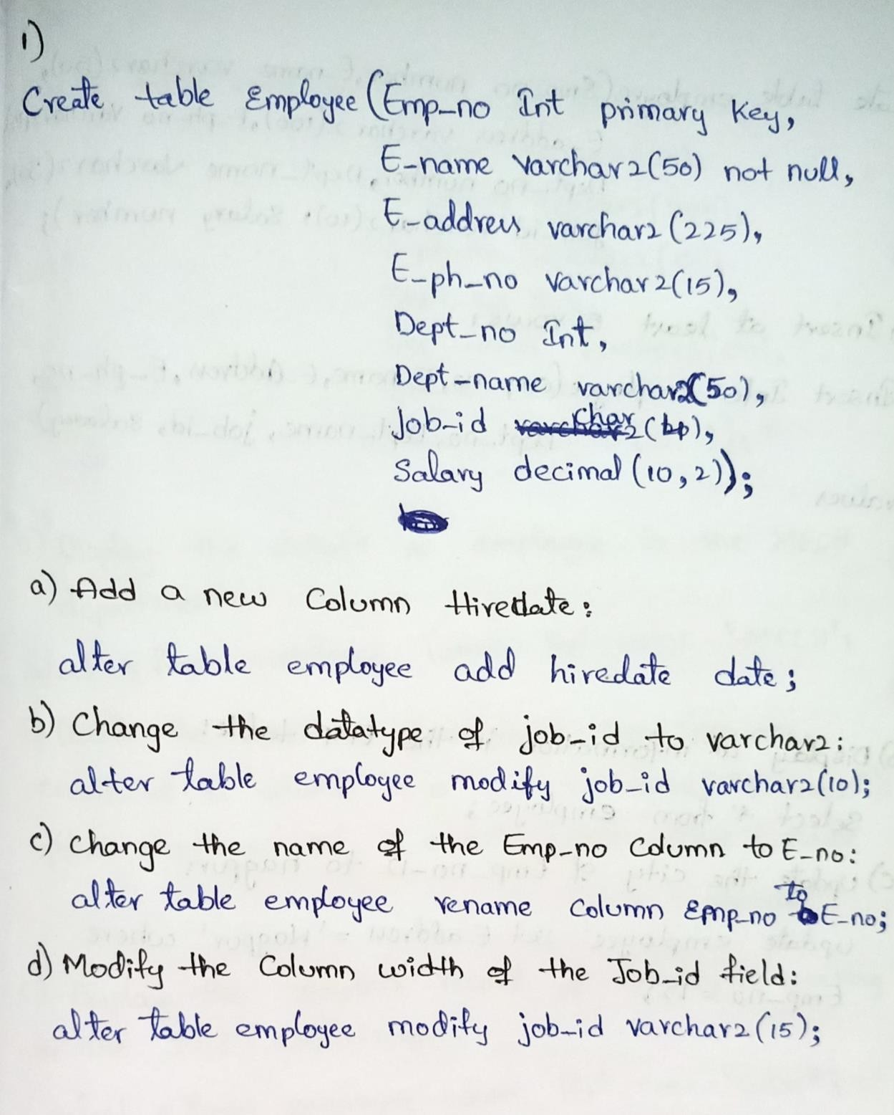

1. Insert a least 5 rows in the table.
2. Display all the information of EMP table.
3. 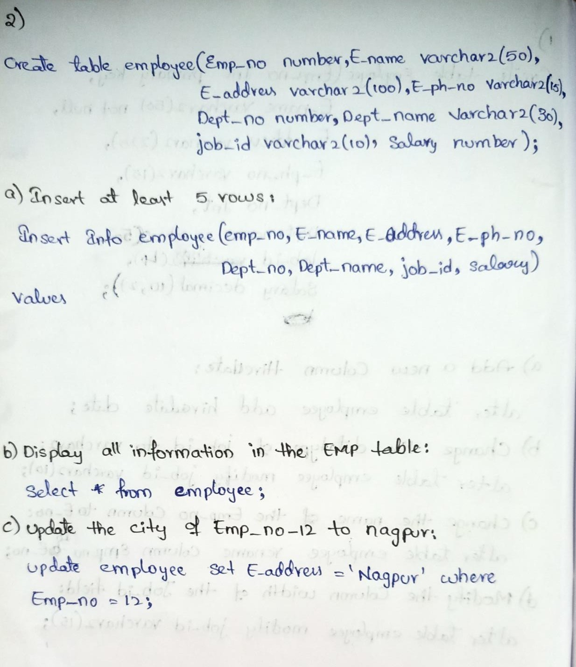Update the city of Emp_no-12 with current city as Nagpur.
4. Display the details of Employee who works in department MECH.
5. Delete the email_id of employee James.
6. Display the complete record of employees working in SALES Department.

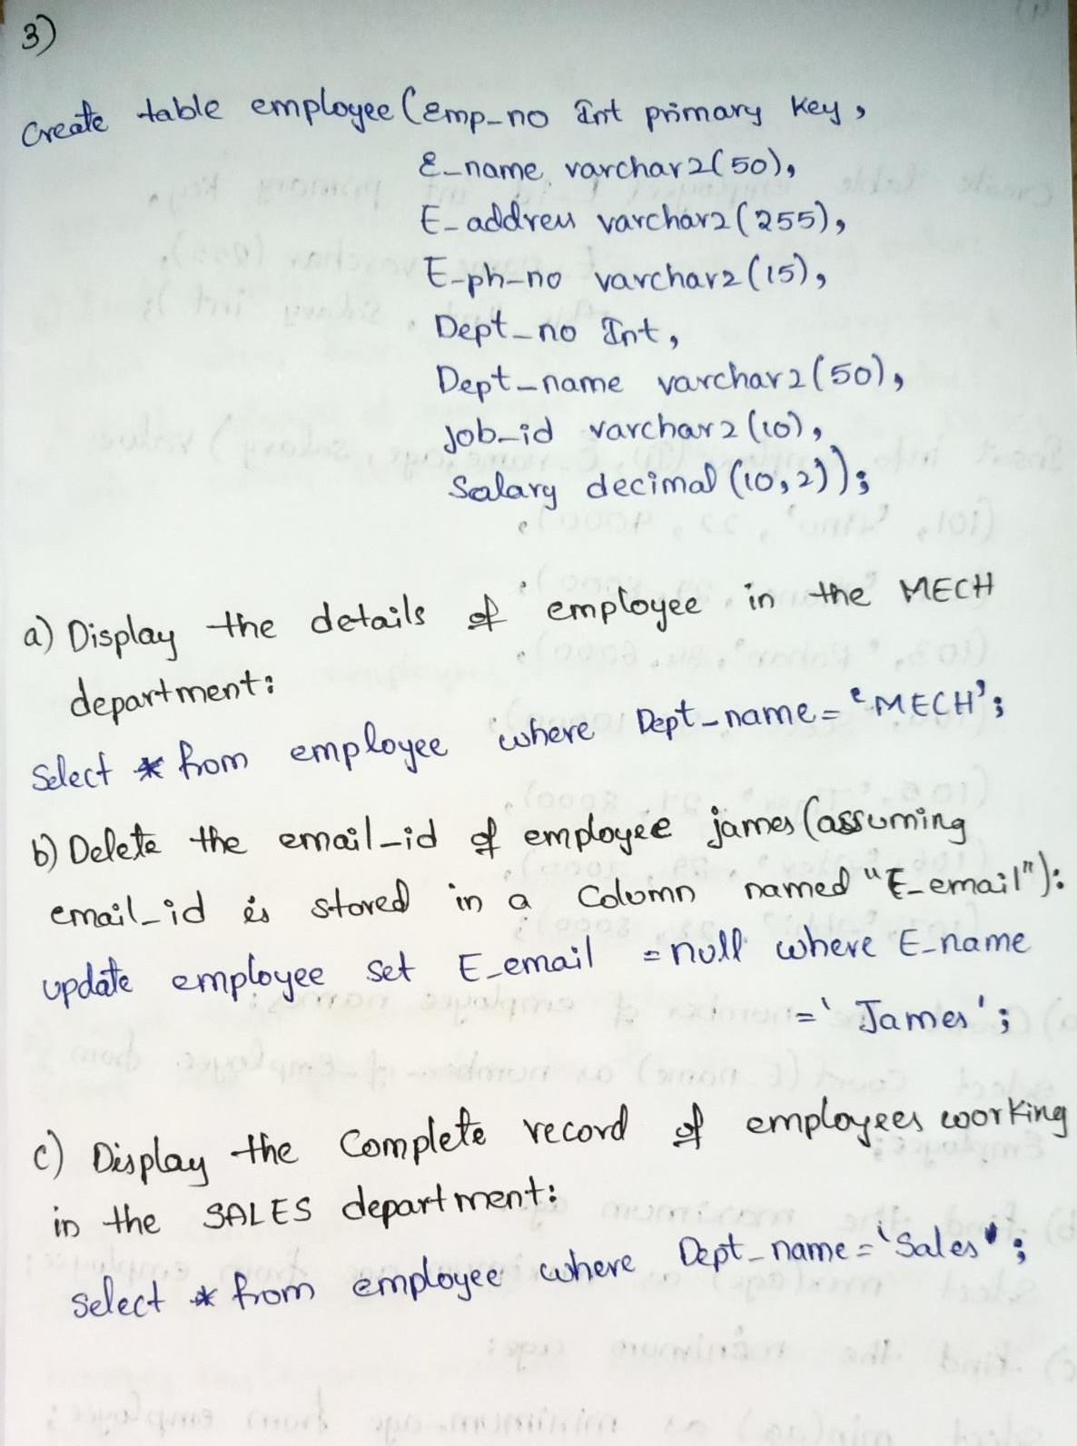

Write SQL queries for following question:

* 1. Count number of employee names from employee table.
  2. Find the Maximum age from employee table.
  3. 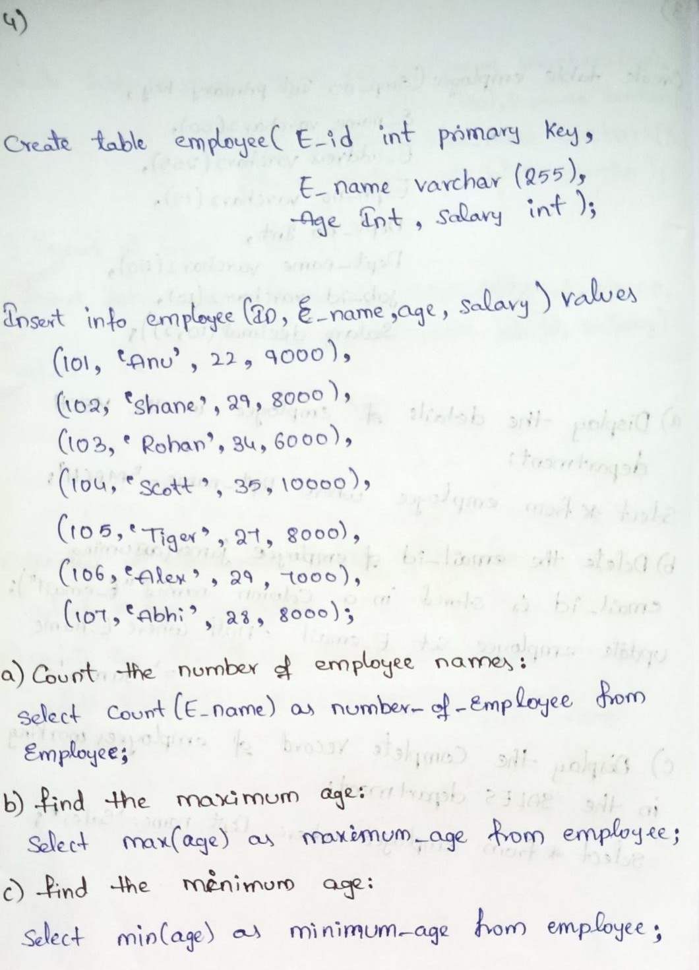Find the Minimum age from employee table.

1. Find grouped salaries of employees. (group by clause)
2. Find salaries of employee in Ascending Order. (order by clause)
3. 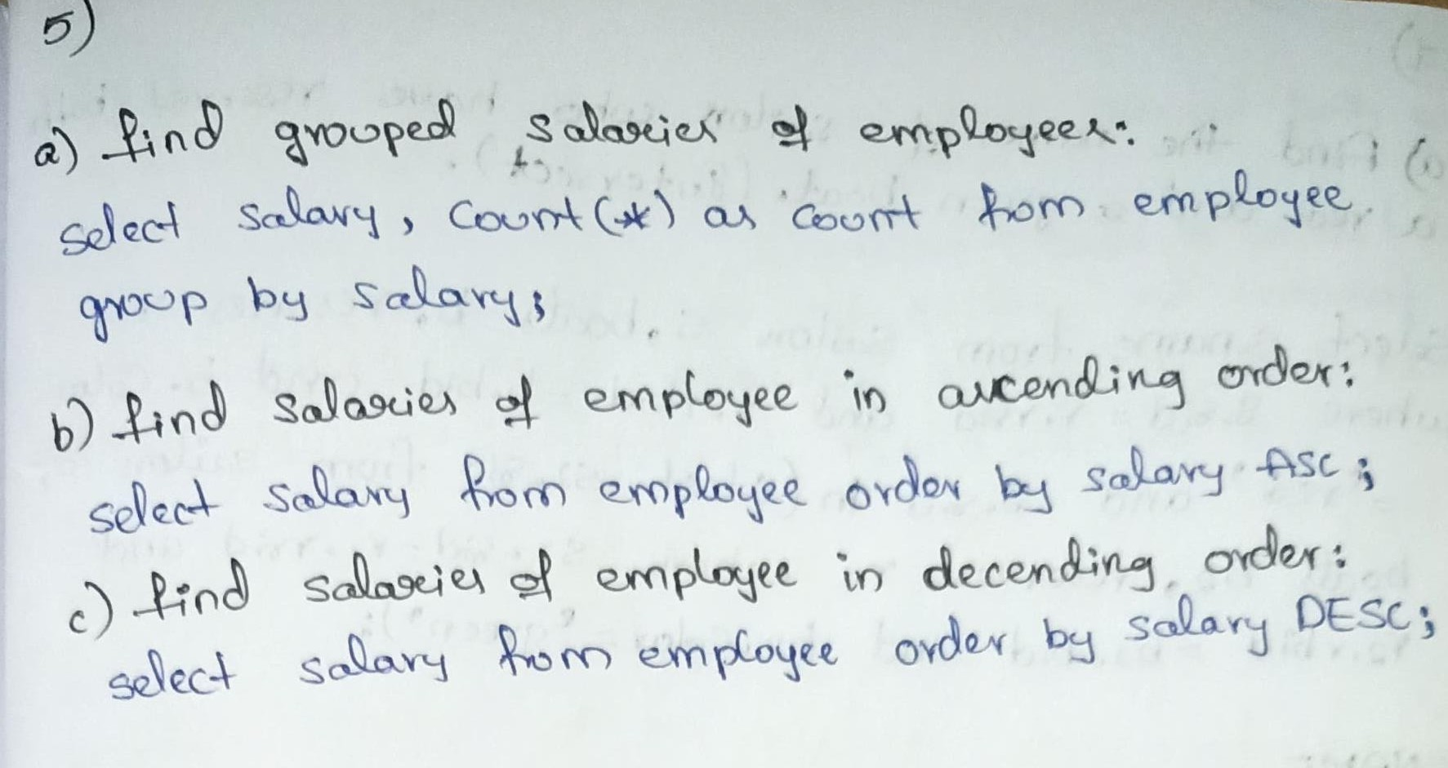Find salaries of employee in Descending Order.

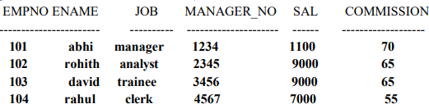

1. Insert the any three records in the employee table and use rollback. Check the result.
2. Add primary key constraint and not null constraint to the employee table.
3. Insert null values to the employee table and verify the result.

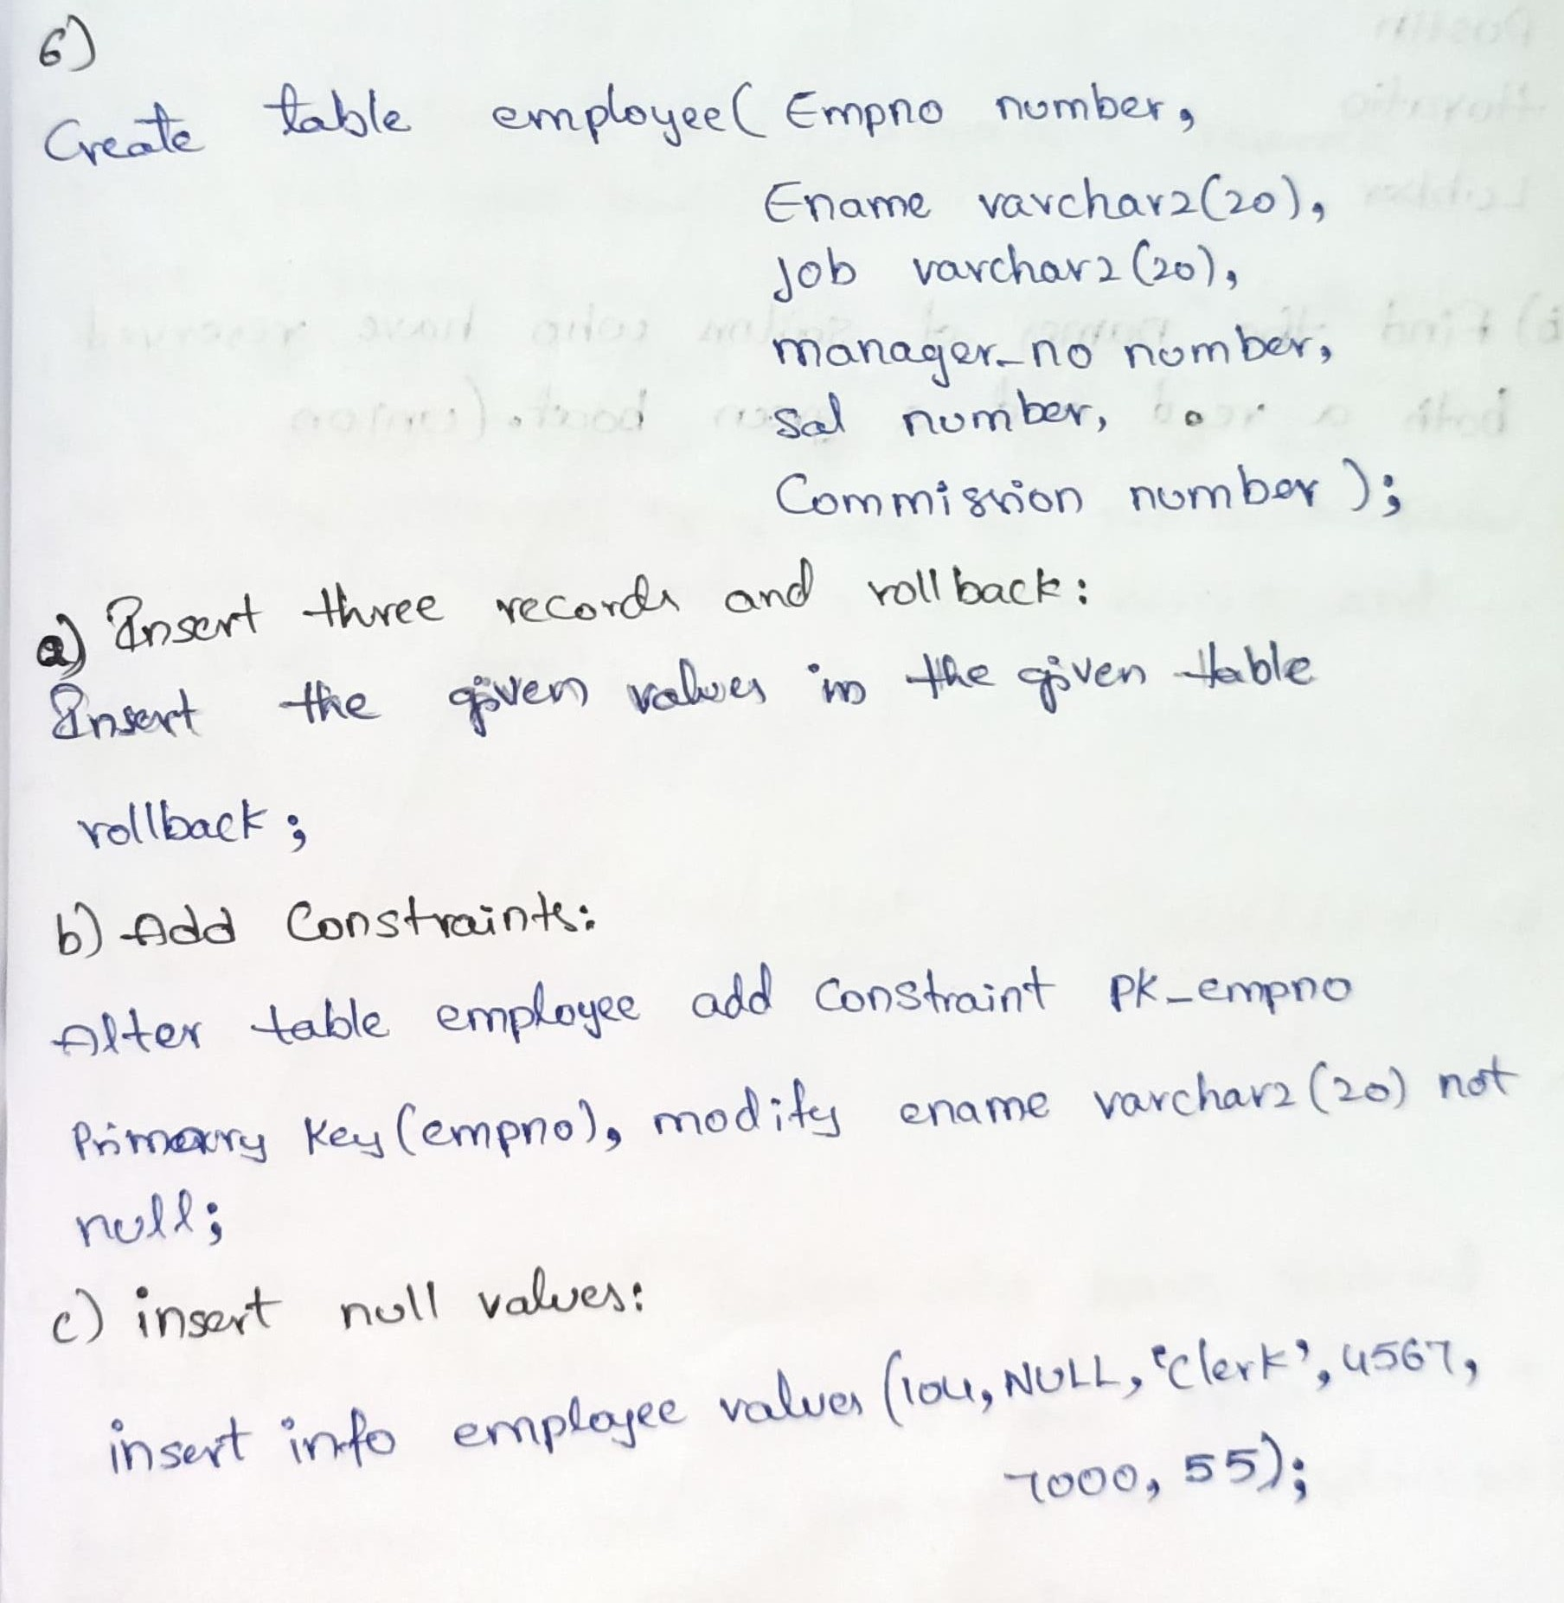

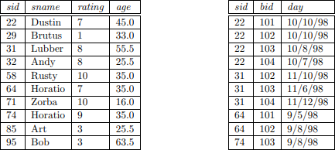 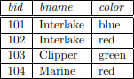

1. Find the names of sailors who have reserved both a red and a green boat. (Intersect)
2. Find the names of sailors who have reserved both a red and a green boat. (union all)
3. 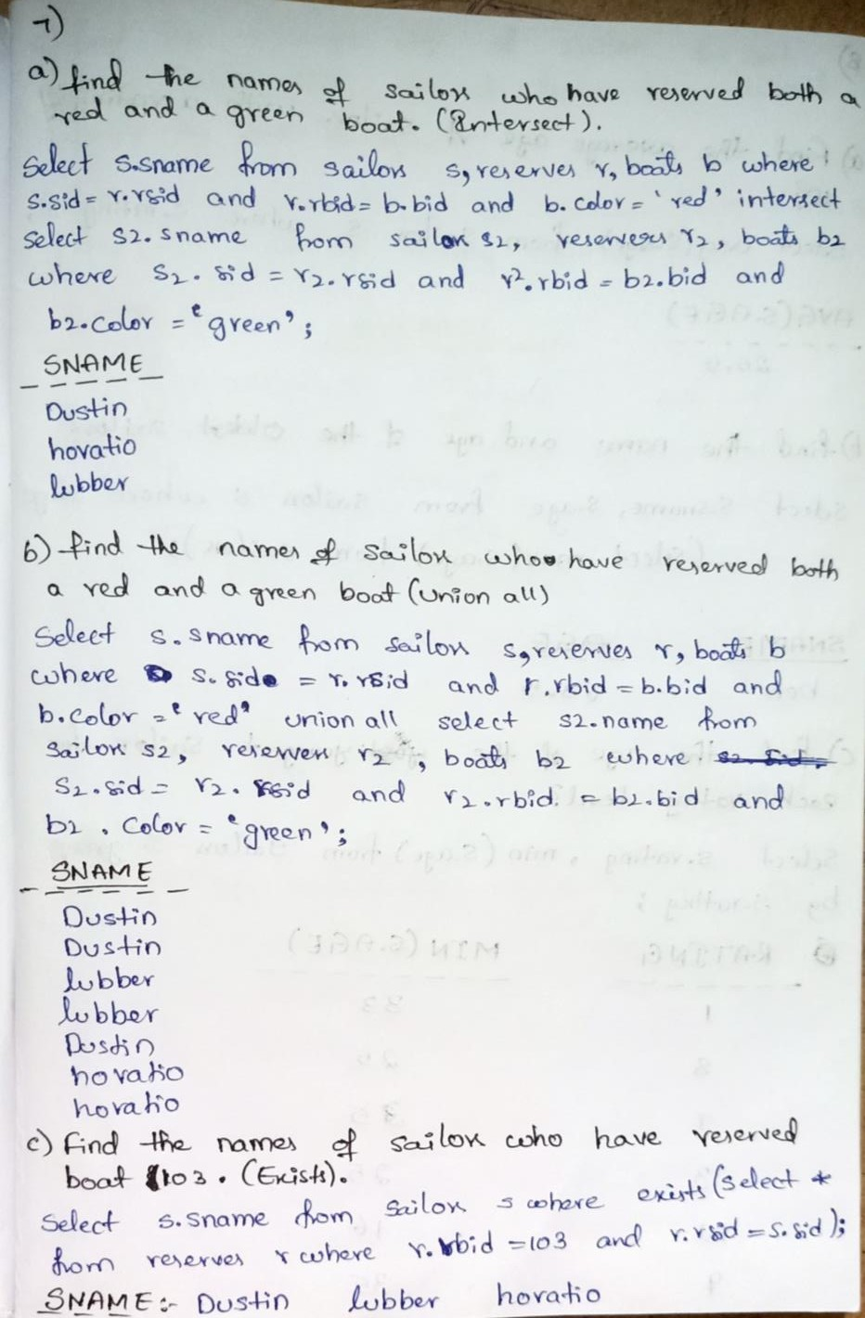Find the names of sailors who have reserved boat 103. (Exists)

 

1. Find the average age of sailors with a rating of 10?
2. Find the name and age of the oldest sailor?
3. Find the age of the youngest sailor for each rating level?
4. Find the average age of sailors for each rating level that has at least two sailors? (group by and Having)

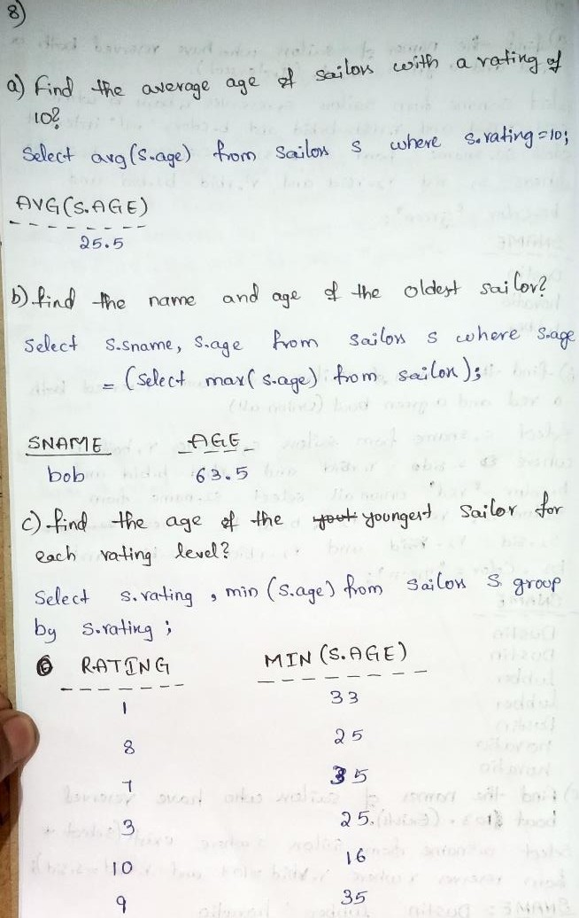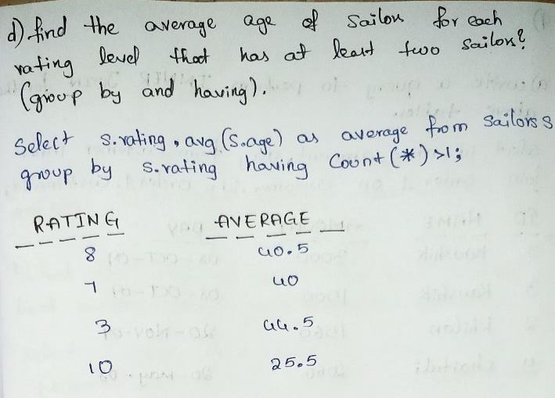

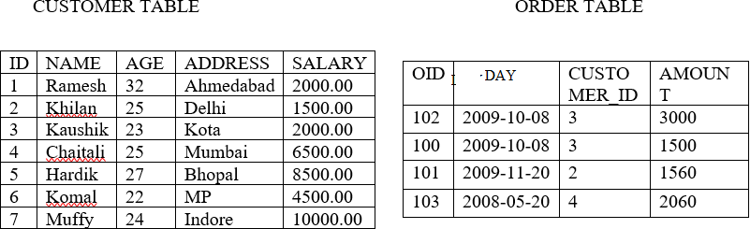

* 1. Write a query to perform INNER JOIN for the above tables.
  2. Write a query to perform LEFT OUTER JOIN for the above tables.
  3. 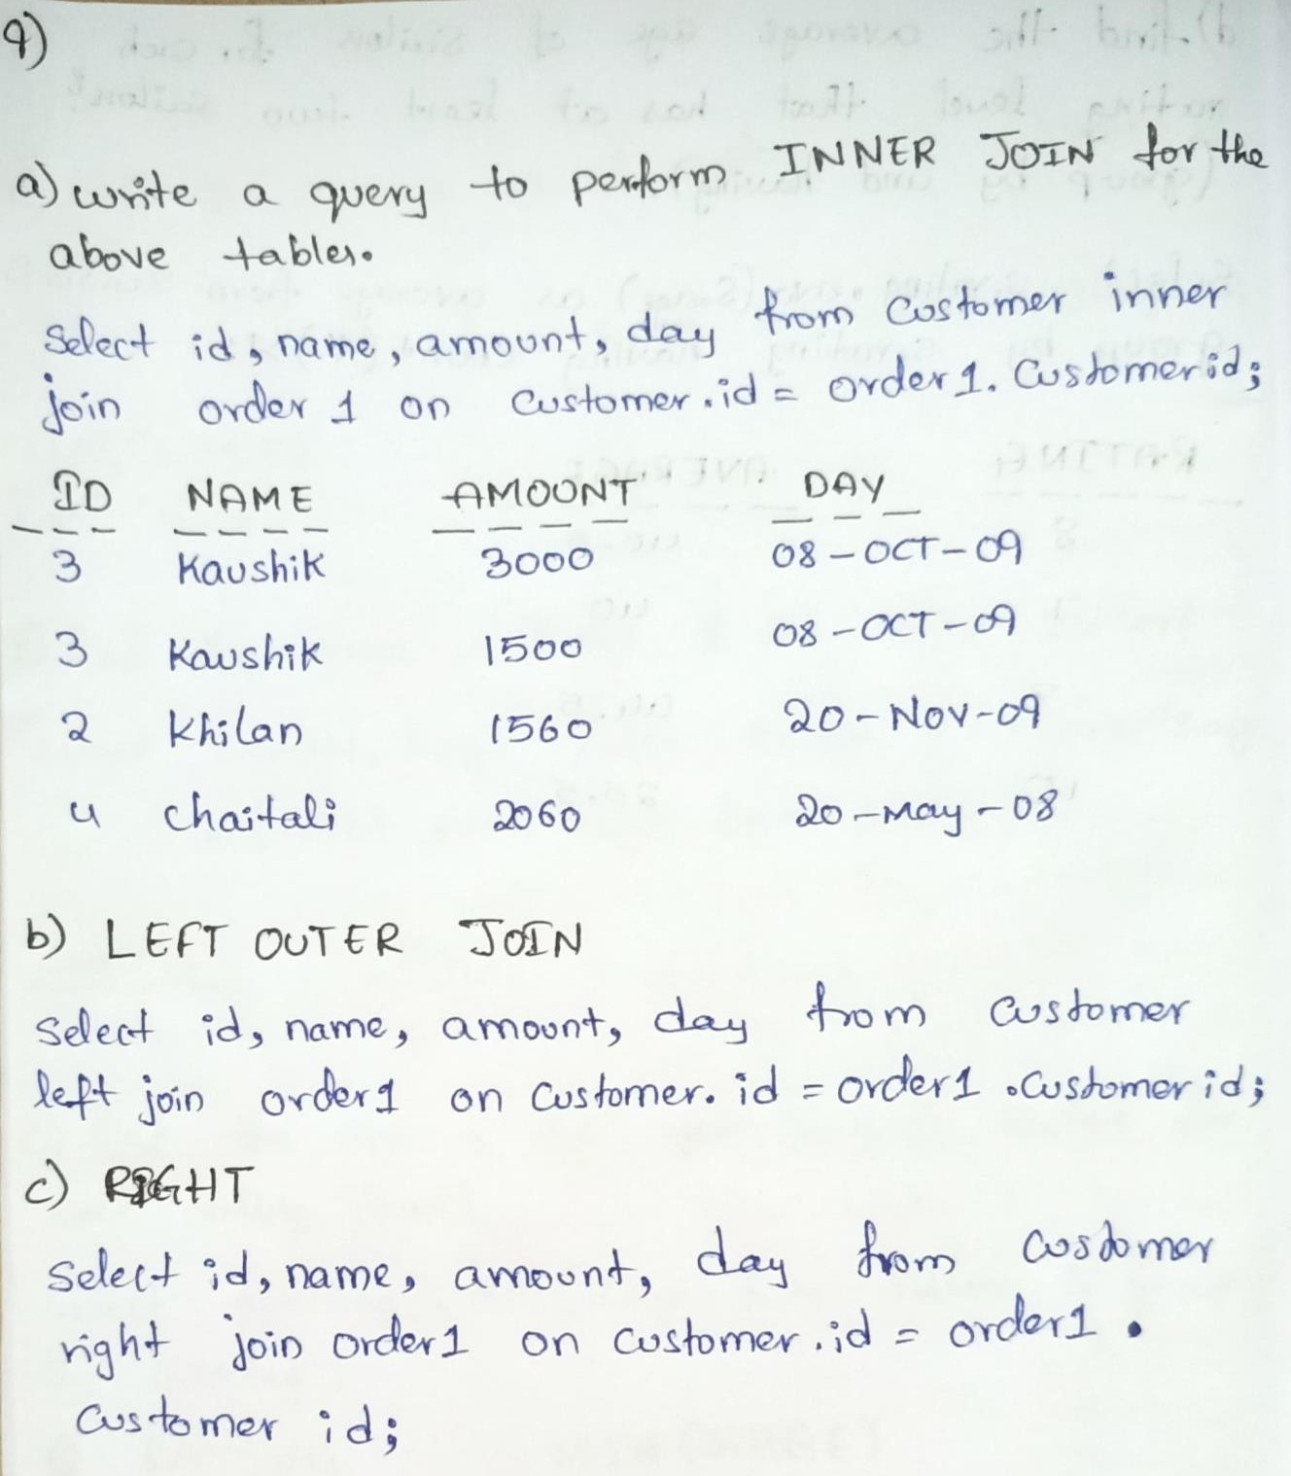Write a query to perform RIGHT OUTER JOIN for the above tables.

 

1. Find the names of sailors who have reserved red boat. (Nested Query)
2. Find the names of sailors who have reserved boat number 103. (correlated Nested Query)

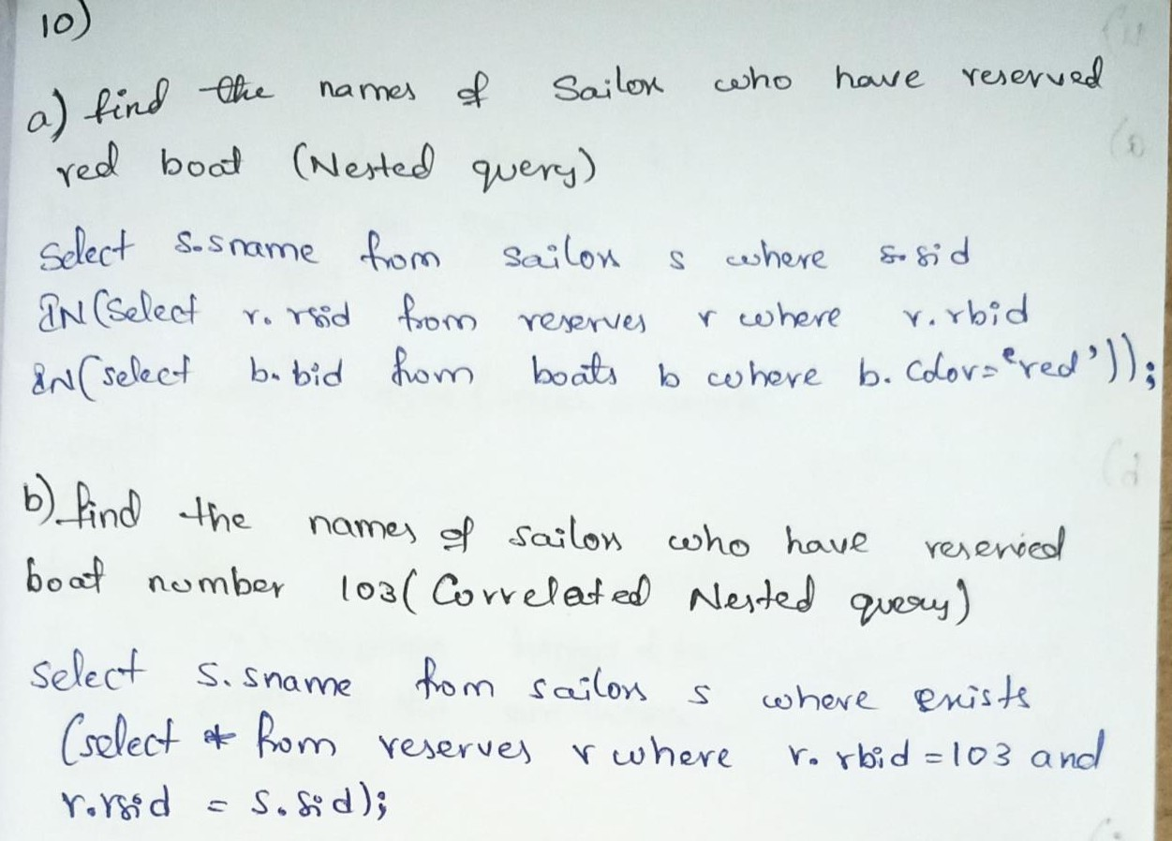

 

* 1. Find sailors whose rating is better than some sailor called Horatio. (Any)
  2. Find the sailors with the highest rating. (All)
  3. Find the names of sailors who have reserved a red and a green boat. (Union)

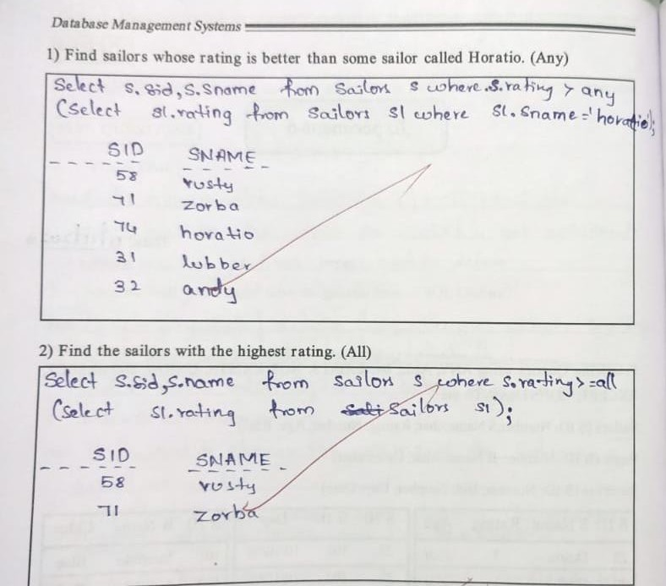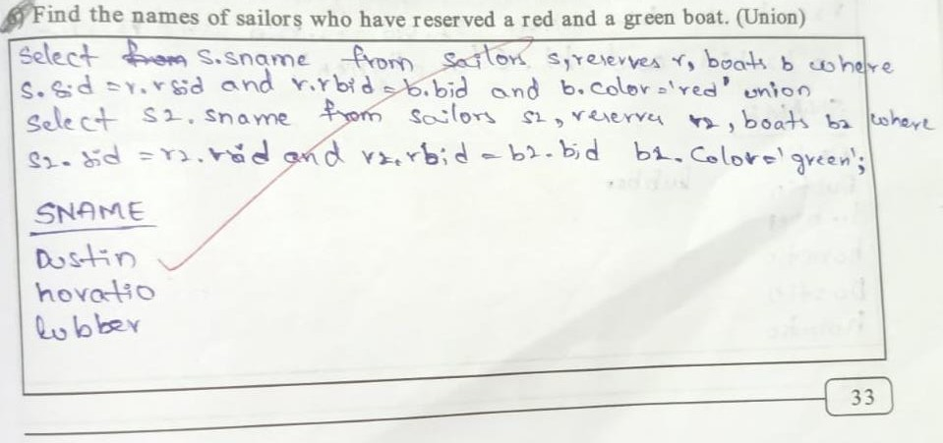

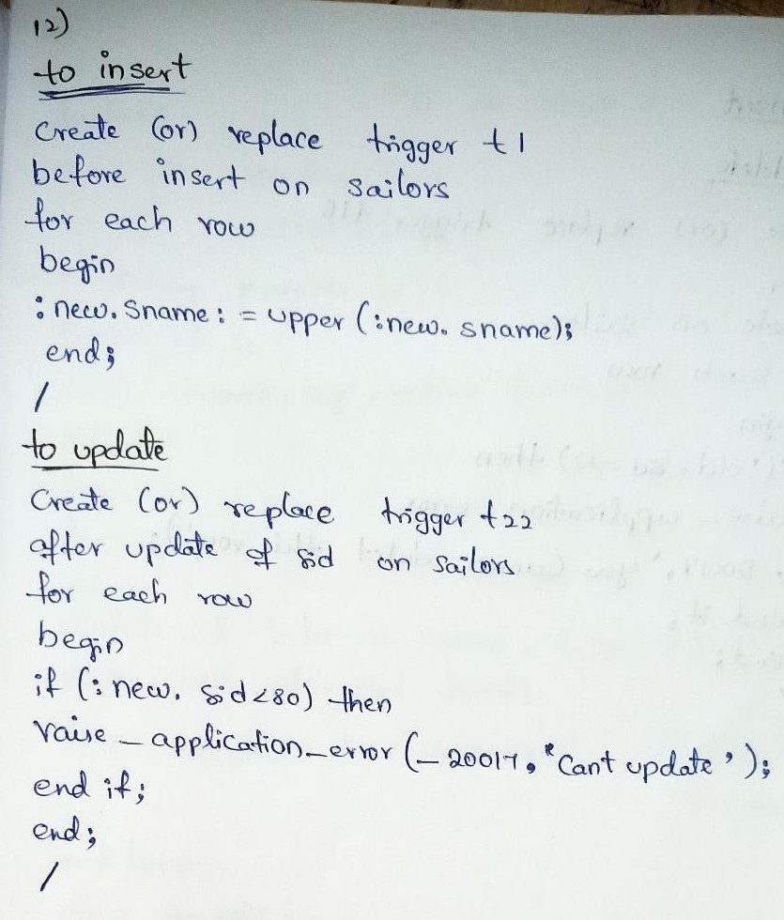

13. Write a PL/SQL code for creation of Trigger to insert and to delete data into a table

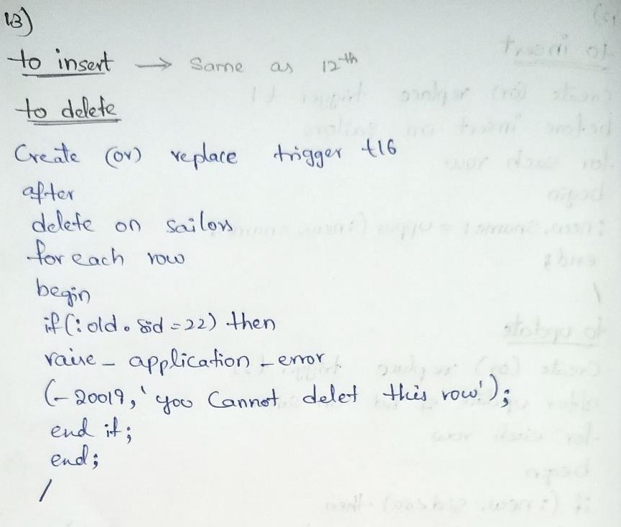

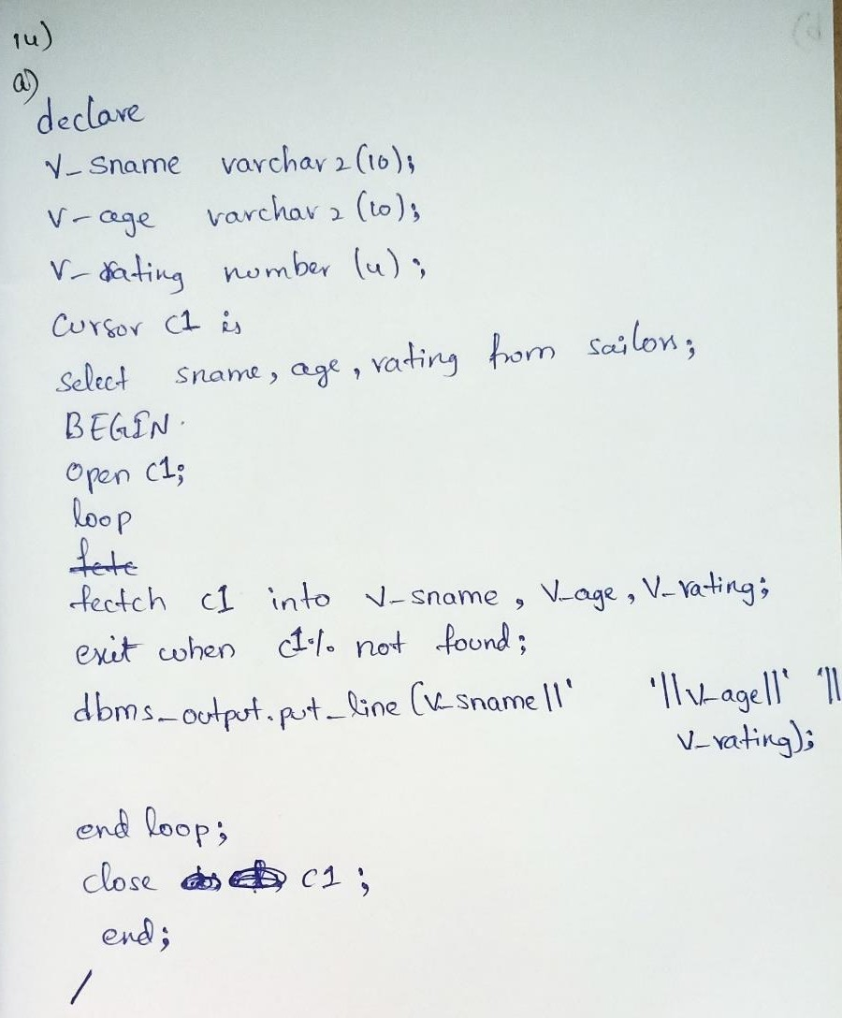

b) Write a PL/SQL program for displaying multiplication of any number

DECLARE

num NUMBER := 7; -- Replace with the desired number range NUMBER := 12; -- Replace with the desired range BEGIN

FOR i IN 1..range LOOP

dbms_output.put_line(num || ' x ' || i || ' = ' || num * i); END LOOP;

END;

/

1. a) Write a PL/SQL code for modification of procedure to view some specified columns from a table.

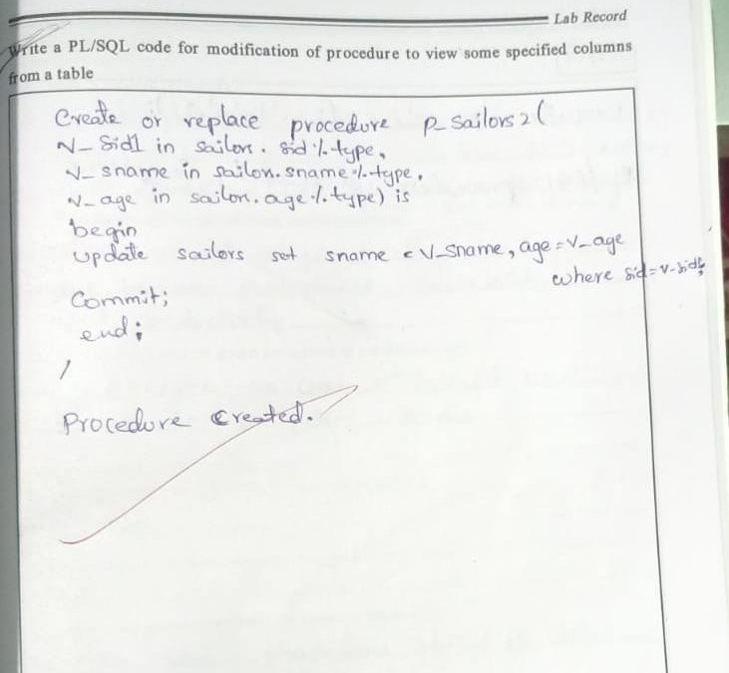

b) Write a PL/SQL program for displaying multiplication of any number

DECLARE

num NUMBER := 7; -- Replace with the desired number range NUMBER := 12; -- Replace with the desired range BEGIN

FOR i IN 1..range LOOP dbms_output.put_line(num || ' x ' || i || ' = ' || num * i); END LOOP;

END;

/

1. a) Write a PL/SQL code for creation of procedure to view some specified columns from a table.

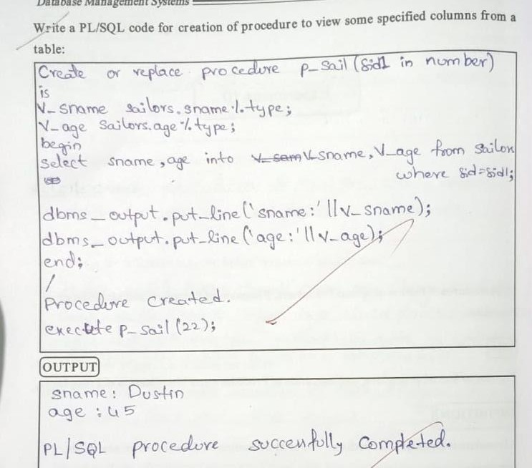

b) Write a PL/SQL program for displaying factorial of any number.

DECLARE

num NUMBER := 6; -- Replace with the desired number fact NUMBER := 1;

BEGIN

FOR i IN 1..num LOOP

fact := fact * i; END LOOP;

dbms_output.put_line('Factorial of ' || num || ' is ' || fact); END;

/

1. Converting ER Model to Relational Model (Represent entities and relationships in Tabular form, represent attributes as columns, identifying keys)

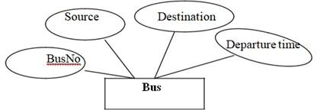

1.

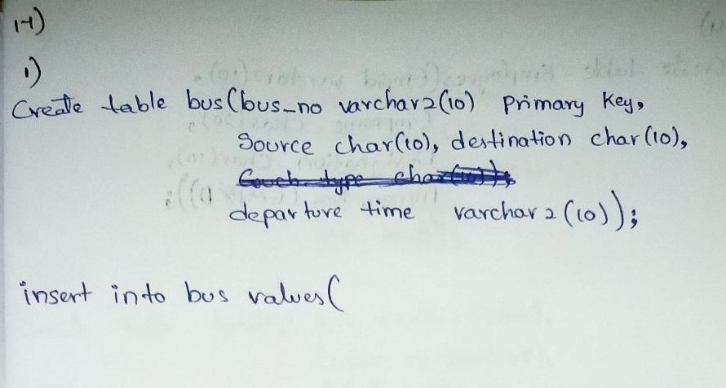

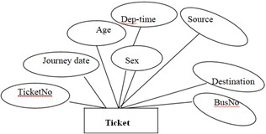

2.

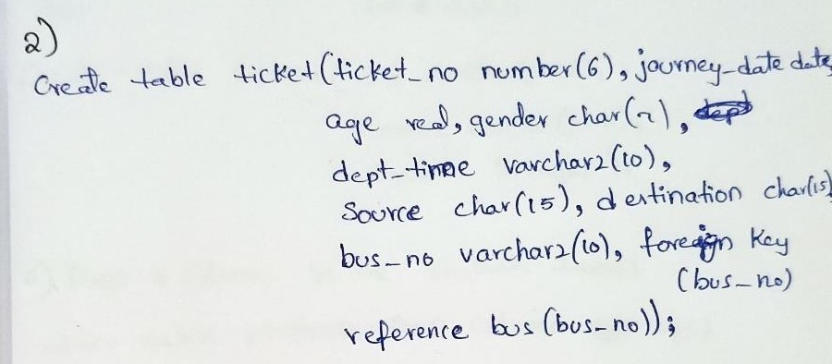

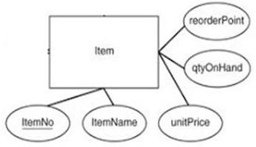

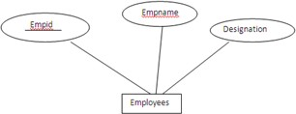3.

CREATE TABLE Item ( itemno INT PRIMARY KEY,

itemname VARCHAR(255) NOT NULL, unitprice DECIMAL(10,2) NOT NULL, reorderpoint INT,

qtyonhand INT

);

4.

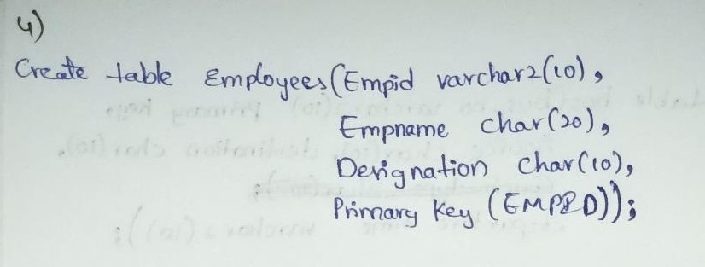

1. Create tables for following schemas

Students (*sid: string*, *name:* string, *login:* string, *age:* integer, *gpa:* real) Faculty (*fid:* string, *fname:* string, *sal:* real)

Courses (*cid:* string, *cname:* string, *credits:* integer)

* 1. write a sql query to drop a column in students table.
  2. Write a query to rename table students to STUDENT
  3. Write a query to insert three rows in each table

