
Append HMI Studio
User Manual
Designing, testing and deploying HMI applications,
illustrated with the LiquidWeighHMI example

Version 1.1 · October 2026
Append Automation

Contents
1 Introduction 4
1.1 How an HMI application is organized 4
2 The Studio window 5
2.1 The HMI menu 6
3 Application settings 7
4 Devices 9
5 Tags 10
5.1 Tag fields 11
5.2 Alarms on a tag 12
6 Screens and windows 13
6.1 Window properties 13
6.2 Navigation 15
7 Drawing objects 15
8 Animation links 16
8.1 A valve: status color, fault blink and faceplate 18
8.2 The weigh hopper: percent fill 19
8.3 Hopper pressure: value display and alarm colors 20
8.4 Setpoints: user input 21
8.5 Commands: pushbutton and enable 22
9 Expressions and scripts 23
9.1 Window scripts 23
9.2 Action scripts 25
9.3 Function reference 26
10 Alarms and security 28
10.1 Alarms 28
10.2 Users and access levels 29
11 Recipes 30
11.1 Recipe books 30
11.2 The Recipes screen 33
11.3 The Recipe List object 35
11.4 Selecting a recipe in a window 36
11.5 When a recipe function fails 37
11.6 Where recipes are kept 37
12 Testing 38
12.1 Validate 38
12.2 Run 38
13 Deploying 43
13.1 Publish 43
13.2 Append HMI Desktop 44
13.3 Append HMI Web 45
14 Tips and troubleshooting 47
Appendix A Command-line automation 48

1 Introduction
Append HMI Studio designs operator screens (HMIs) for PLCs, runs them against live equipment and publishes them for the plant floor. This manual shows how to build an HMI application with it, step by step, using a complete, working example: LiquidWeighHMI, the operator interface of a liquid weigh-up system that meters three plasticizers into a weigh hopper and discharges each batch to a mixer.
The example is included with Append HMI Studio as examples/LiquidWeighHMI.ahmi. Open it with File > Open and follow along; every screenshot in this manual was taken from it, the run-mode ones with the application connected to its ControlLogix controller.
Table 1. What the LiquidWeighHMI example contains
Part | In the example
Target screen | 1920 × 1080, full screen
PLC | One ControlLogix controller (EtherNet/IP), 419 I/O tags
Screens | Process, Batch, Supply, Devices, Setpoints, Recipes, Alarm History and IO Sim
Popup windows | A faceplate for each of 11 valves and 3 pumps, and 4 confirmation dialogs
Alarms | 34 alarmed tags, an Active Alarms list on every screen and an Alarm History screen
Security | Three users (Operator, Maintenance, Engineer) with access levels
Recipes | A recipe book of plasticizer blends with five starting recipes, and a Recipes screen to select, edit, save and download them
Scripts | Window scripts that turn the sequence step number into text, and action scripts that call the login and recipe functions

1.1 How an HMI application is organized
An Append HMI Studio project (.ahmi file) holds everything the operator station needs:
- Devices: the PLCs the application talks to (Allen-Bradley Logix, SLC 500 and MicroLogix, Modbus TCP, or the built-in simulator).
- Tags: named values, either read from and written to a PLC (I/O tags) or kept by the HMI itself (memory tags). Tags carry engineering units, ranges and alarm limits.
- Windows: each page of the drawing is a window of the application, either a full screen or a popup such as a faceplate.
- Objects and animation links: the shapes on the screens, and the links that tie them to tags: colors that follow a state, levels that fill, values that display, buttons that write.
- Application settings: the target screen resolution, the windows that open at start-up, how the published application runs, and its users.
The usual order of work, which this manual follows, is: application settings, devices, tags, screens and windows, animation, alarms and security, then testing with Run and deploying.

2 The Studio window
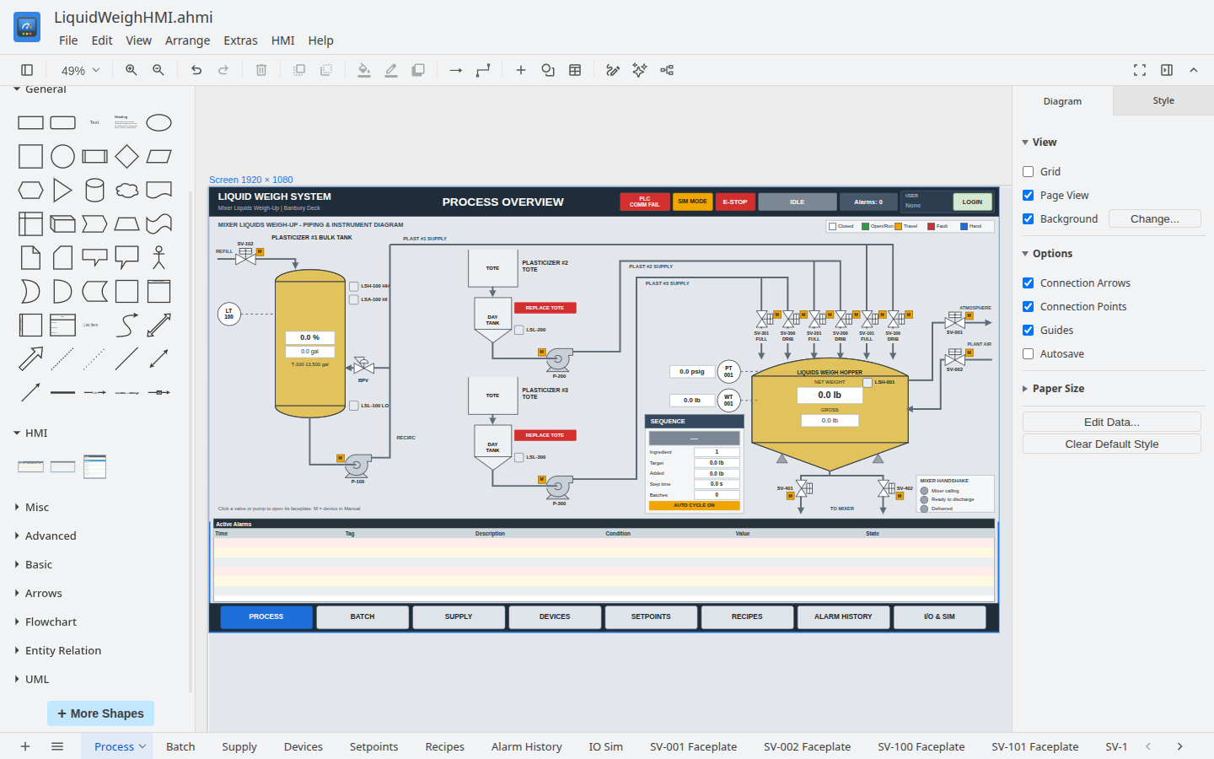
Figure 1. Append HMI Studio with the LiquidWeighHMI Process screen open
Table 2. Parts of the Studio window
Area | What it is for
Menu bar | File, Edit, View, Arrange and Extras from the drawing editor, plus the HMI menu for everything specific to HMI applications
Toolbar | Zoom, undo, delete, arrange, and quick access to fill, line and shadow
Shapes | Shape libraries (General, Misc, Advanced and more under More Shapes, including the P&ID libraries) and the HMI palette with the Alarm List and Alarm History objects
Canvas | The page being edited. The dashed Screen frame shows the target screen (1920 × 1080 here)
Format panel | Style, Text and Arrange for the selected object, and the Animation tab for its links
Page tabs | One tab per window of the application; + adds one

2.1 The HMI menu
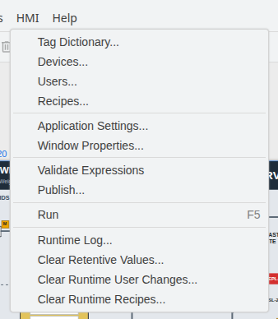
Figure 2. The HMI menu
Table 3. HMI menu commands
Command | Use
Tag Dictionary... | Create and edit tags (chapter 5)
Devices... | Configure the PLCs (chapter 4)
Users... | Users, passwords and access levels (chapter 10)
Recipes... | Recipe books: the tags a recipe holds and the starting recipes (chapter 11)
Application Settings... | Target screen, start-up windows, runtime and security settings (chapter 3)
Window Properties... | Type, position, size and scripts of the current window (chapter 6)
Validate Expressions | Check every link, script and address for errors (chapter 12)
Publish... | Build a Windows installer of the application (chapter 13)
Run / Stop (F5) | Run the application in the Studio against live or simulated data (chapter 12)
Runtime Log... | Messages from the last runs: connections, writes, script errors
Clear Retentive Values... | Forget the saved values of retentive tags on this computer
Clear Runtime User Changes... | Forget user changes made while running on this computer
Clear Runtime Recipes... | Forget the recipes saved while running on this computer

3 Application settings
Start a new application by setting its target screen: the resolution of the operator station it will run on. Open HMI > Application Settings.
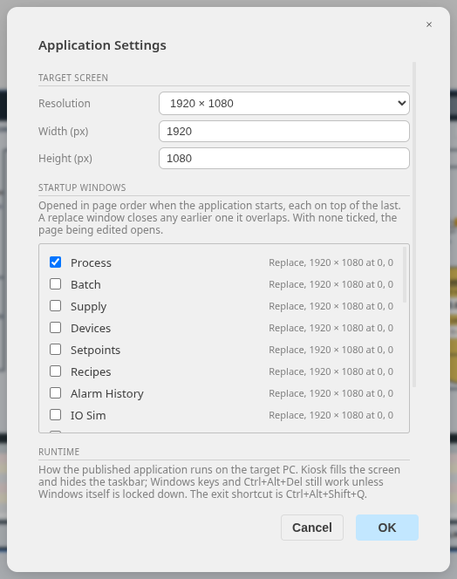
Figure 3. Application Settings: target screen and start-up windows
- Resolution: choose a common size or type the width and height. LiquidWeighHMI targets a 1920 × 1080 panel PC. The dashed Screen frame on every page follows this size.
- Startup windows: the windows that open when the application starts, in page order. LiquidWeighHMI opens the Process screen. With none ticked, the page being edited opens.
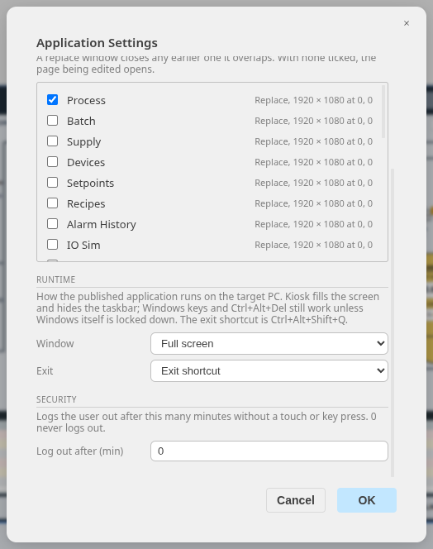
Figure 4. Application Settings: runtime and security
- Window: how a published application runs on the target PC: Kiosk (full screen, locked, taskbar hidden), Full screen, or a window at the target resolution. LiquidWeighHMI uses Full screen.
- Exit: the exit shortcut Ctrl+Alt+Shift+Q; the shortcut followed by a password; or never (the PC must be shut down to stop it).
- Log out after (min): logs the operator out after this many minutes without a touch or key press. 0 never logs out.

4 Devices
Devices are the PLCs the application communicates with. Open HMI > Devices, click Add, and fill in the connection. LiquidWeighHMI has one device, LiquidWeighPLC, a ControlLogix controller.
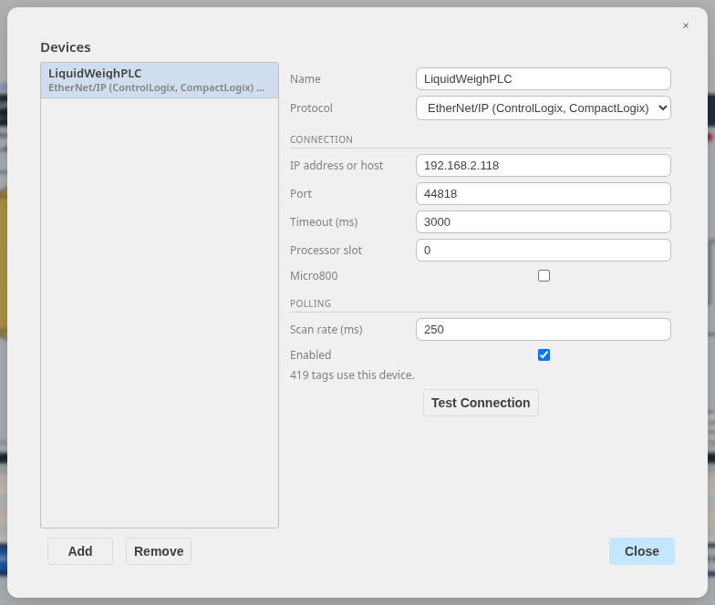
Figure 5. The Devices dialog with the LiquidWeighPLC controller
- Protocol: the communication driver (Table 4).
- IP address or host, Port (44818 for EtherNet/IP, 502 for Modbus TCP) and Timeout.
- Processor slot: the controller's slot in the chassis (0 for a CompactLogix).
- Scan rate: how often subscribed tags are read, 250 ms here.
- Test Connection checks that the PLC answers before any screen is built.
Table 4. Protocols and address examples
Protocol | Controllers | Address examples
EtherNet/IP (Logix) | ControlLogix, CompactLogix, Micro800 | PT_001.Value  Program:Main.Pump.Run  Recipe[3]  Status.5
PCCC (SLC) | SLC 5/05, MicroLogix | N7:0  B3:1/4  F8:2  T4:0.ACC
Modbus TCP | Any Modbus TCP device | HR:0  HR:10:FLOAT  CO:5  IR:3
Simulator | None (built in) | Simulated values for testing

Note: Communication runs through a small companion program, the hmi-comms server, which the Studio starts by itself. Device states and errors appear in HMI > Runtime Log.

5 Tags
Tags are the named values the screens show and change. Open HMI > Tag Dictionary. The list on the left shows every tag with its type; type in Filter to find one. Select a tag to edit it, or choose a type under New tag... to create one.
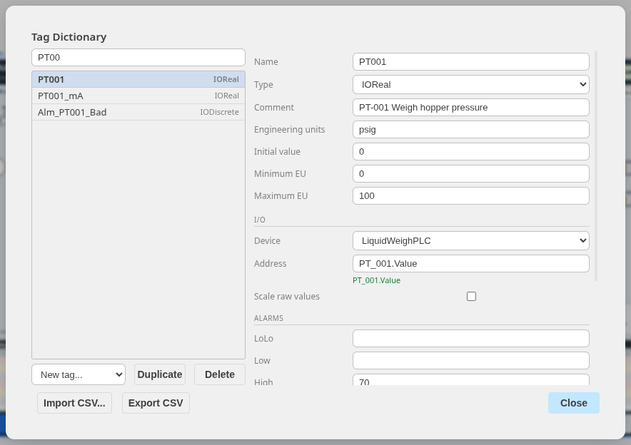
Figure 6. The Tag Dictionary with PT001, the weigh hopper pressure
Table 5. Tag types
Type | Holds | LiquidWeighHMI example
IODiscrete | On/off from a PLC | SV001_Opened (valve open limit)
IOInteger | Whole number from a PLC | SV001_Status (0 closed, 1 open, 2 travel, 3 fault)
IOReal | Real number from a PLC | PT001 (hopper pressure, psig)
IOMessage | Text from a PLC | Recipe or product names
MemoryDiscrete, MemoryInteger, MemoryReal, MemoryMessage | A value kept by the HMI | StepText (sequence step description)
IndirectDiscrete, IndirectAnalog, IndirectMessage | No value of its own: stands for the tag a script links it to with LinkIndirectTag | One faceplate serving every valve

5.1 Tag fields
Table 6. Tag fields
Field | Meaning
Name | Letters, digits and underscores; not case-sensitive. LiquidWeighHMI names tags after the device and signal, such as SV001_Status and PT001
Comment | A description. For an alarmed tag it is the alarm text operators see
Engineering units, Minimum EU, Maximum EU | Units and range, used by fills, bars and value displays
Initial value | Starting value of a memory tag
Device, Address | For an I/O tag: the PLC and the address in its syntax. The address is checked as you type (green when valid)
Scale raw values | Maps a raw integer range (for example 0 to 4095) to the engineering range
Retentive | For a memory tag: keeps its last value between runs
Simulation | A simulated value (sine, ramp, random, toggle) for testing without the PLC

5.2 Alarms on a tag
Scroll down to Alarms to give a tag alarm limits. PT001 alarms at High 70 psig and HiHi 85 psig, with a deadband of 2 so the alarm clears only below 68 psig. A discrete tag instead has Alarm when On or Off: SV001_Fault alarms when it is on.
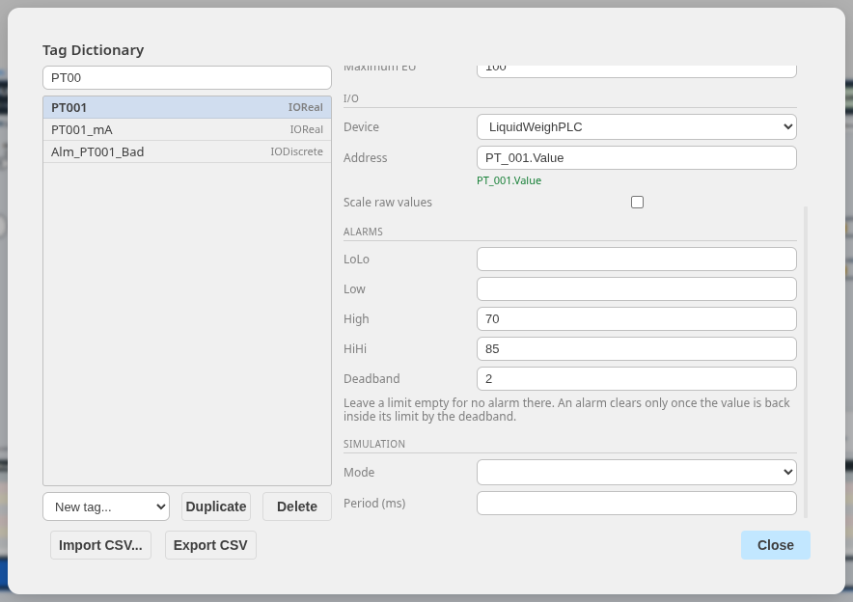
Figure 7. Alarm limits and deadband for PT001
Tags can also be exported to and imported from CSV (Export CSV, Import CSV...), which is the fastest way to create hundreds of tags from a PLC tag list: LiquidWeighHMI's 420 tags were entered that way.

6 Screens and windows
Each page of the drawing is a window of the application, named by its page tab. LiquidWeighHMI has seven full screens and eighteen popups.
Figure 8. Page tabs: every page is a window
Table 7. Window types
Type | Behavior | Used in LiquidWeighHMI for
Replace | Closes any window it overlaps when it opens | The seven main screens
Overlay | Opens on top and leaves other windows open | Information panels
Popup (modal) | Stays on top; nothing beneath it can be touched until it closes | Faceplates and confirmations

6.1 Window properties
Select a page and open HMI > Window Properties. For the SV-001 faceplate the window is a popup with a title bar, 460 × 560 pixels at 730, 150 on the screen. The preview shows where it appears.
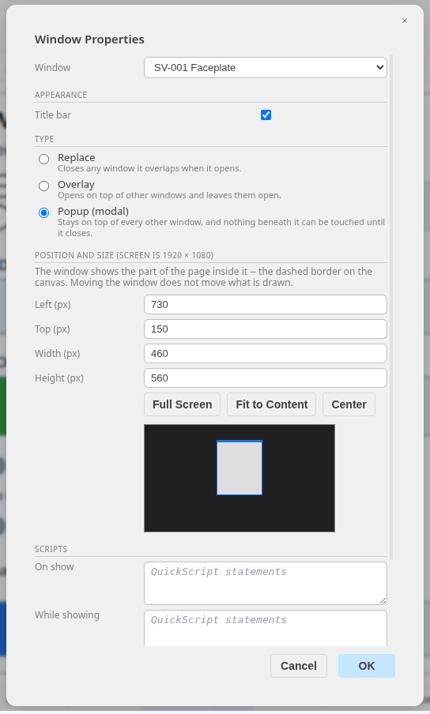
Figure 9. Window Properties of the SV-001 Faceplate popup
A window shows the part of its page under its rectangle, so a popup's objects are drawn at the popup's position on its page. Figure 10 shows the SV-001 faceplate page in the editor.
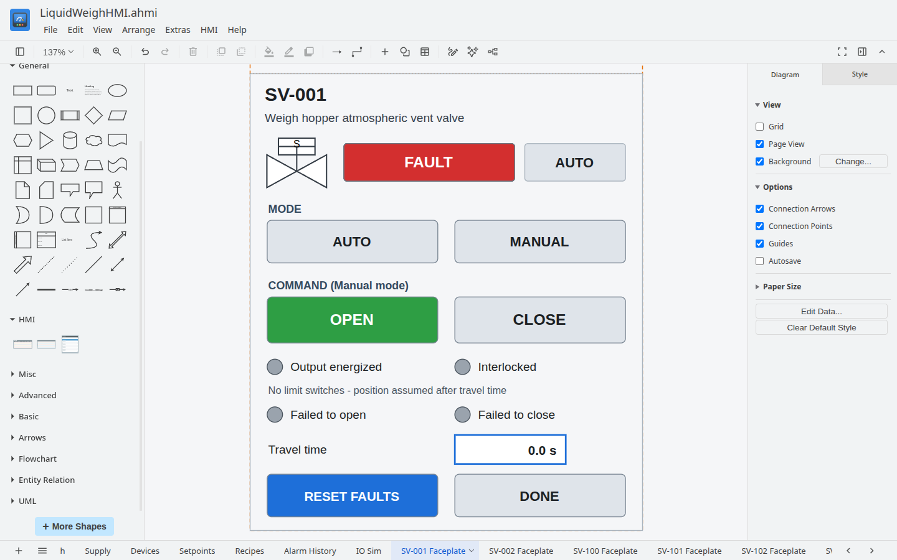
Figure 10. The SV-001 faceplate page in the editor

6.2 Navigation
The navigation bar at the bottom of every LiquidWeighHMI screen is a row of buttons, each with a Show Window link to one screen. Because the main screens are Replace windows, opening one closes the current screen. Faceplates open the same way from the valve and pump symbols, and close with a Hide Window link on their DONE button.

7 Drawing objects
Screens are drawn with the editor's shapes: drag a shape from the Shapes panel onto the canvas, then set its fill, line and text in the Format panel. LiquidWeighHMI uses:
- Rectangles and rounded rectangles for panels, buttons and value boxes.
- Process symbols from More Shapes > P&ID (valves, pumps, vessels) and plain shapes for tanks and totes.
- Lines and connectors for piping.
- Text for labels and titles.
The HMI palette adds two objects: the Alarm List, the live list of active alarms at the bottom of every LiquidWeighHMI screen, and the Alarm History, used on the Alarm History screen.
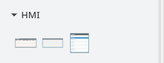
Figure 11. The HMI palette: Alarm List and Alarm History
Note: Keep objects inside the Screen frame, and group repeated symbols (a valve with its tag label) so they can be copied with their links.

8 Animation links
Animation links make objects live. Select an object and open the Animation tab of the Format panel. The top of the tab lists every link type; click one to add it. Links already on the object are marked, and their settings appear below.
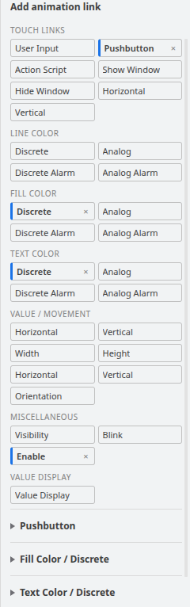
Figure 12. The Animation tab for the START button, with its links marked
Table 8. Animation link families
Family | Links | What they do
Touch links | User Input, Pushbutton, Action Script, Show Window, Hide Window, Slider Horizontal and Vertical | Operator actions: enter a value, set or toggle a tag, run a script, open or close a window, drag a slider
Line, Fill and Text Color | Discrete, Analog, Discrete Alarm, Analog Alarm | Color from an on/off value, from value bands, or from a tag's alarm state
Value / Movement | Location, Width, Height, Percent Fill, Orientation | Move, size, fill or rotate an object in proportion to a value
Miscellaneous | Visibility, Blink, Enable | Show or hide, flash, and allow or block touch
Value Display | Value Display | Show a value or text in place of the object's label

Numbers in links (ranges, limits) are expressions too, so they can come from tags. The sections below walk through the links LiquidWeighHMI uses.

8.1 A valve: status color, fault blink and faceplate
Each valve symbol on the Process screen carries three links. SV-102 is selected in Figure 13.
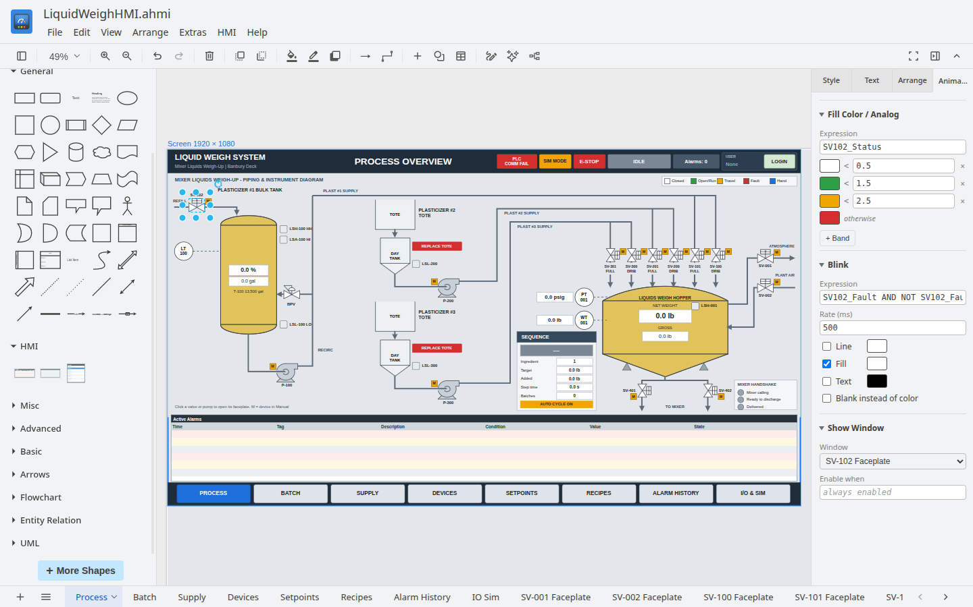
Figure 13. The SV-102 valve and its links
- Fill Color / Analog on SV102_Status: below 0.5 (closed) white, below 1.5 (open) green, below 2.5 (travel) amber, otherwise (fault) red. The first band whose limit the value is below wins.
- Blink on SV102_Fault AND NOT SV102_FaultAck: flashes the fill while a fault is unacknowledged.
- Show Window SV-102 Faceplate: touching the valve opens its faceplate.

8.2 The weigh hopper: percent fill
The hopper vessel fills with its net weight. Percent Fill / Vertical maps WT001 from 0 to 150 lb to 0 to 100 % fill, from the bottom up.
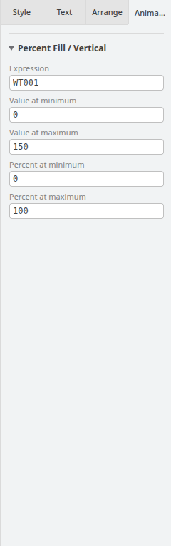
Figure 14. Percent Fill on the weigh hopper
Note: Percent Fill draws only the filled part of the object, outline included. Place an identical shape with no fill on top as the vessel outline, as LiquidWeighHMI does.

8.3 Hopper pressure: value display and alarm colors
The pressure box shows PT001 with one decimal and the suffix psig (Value Display), and its fill follows the tag's alarm state (Fill Color / Analog Alarm): normal white, High amber, HiHi red. The limits come from the tag in the Tag Dictionary, so they are set in one place.
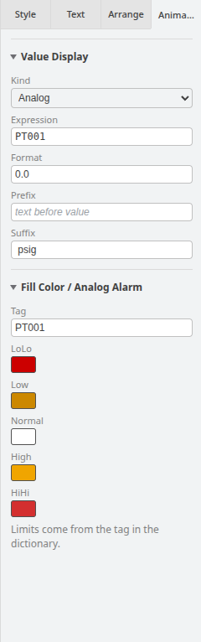
Figure 15. Value Display and Fill Color / Analog Alarm on PT001

8.4 Setpoints: user input
On the Batch screen the operator enters the batch volume by touching its value. User Input (analog) on Rcp_TotalVol accepts 0 to 12 gallons with the prompt "Total batch volume (gal, max 12)" and shows an on-screen keypad. A Value Display on the same object shows the current value.
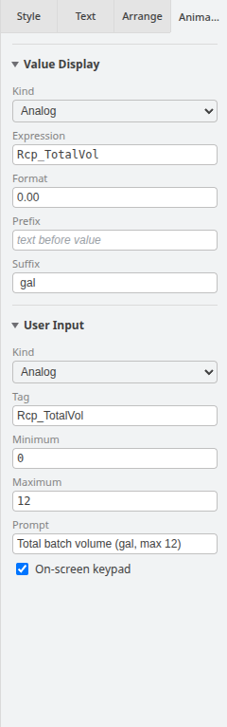
Figure 16. User Input and Value Display on the batch volume

8.5 Commands: pushbutton and enable
The START button on the Batch screen is a Pushbutton that sets PB_Start when touched, allowed only while Seq_Idle AND Seq_StartPerm (Enable when). Its fill and text colors show when it is available. An Enable link on _AccessLevel > 0 blocks it until someone is logged in (chapter 10).
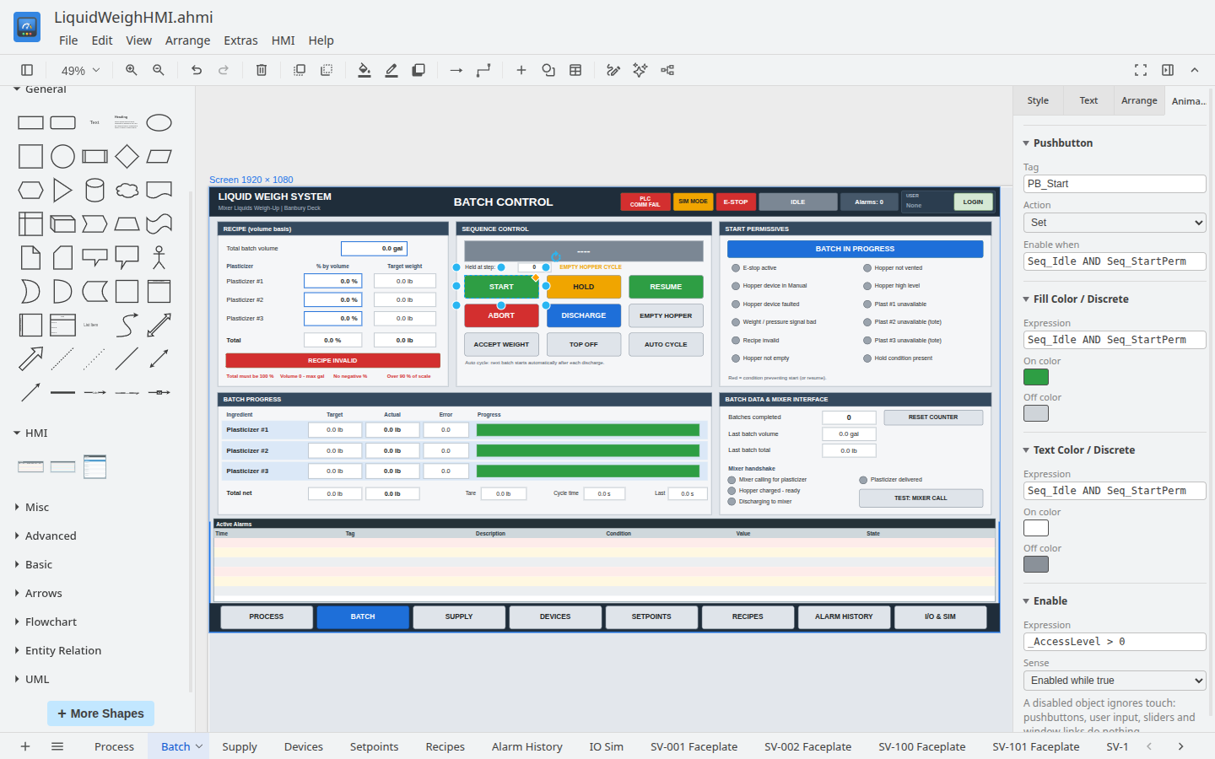
Figure 17. The START button: Pushbutton, colors and Enable
Table 9. Pushbutton actions
Action | Effect
Toggle | Inverts the tag on each touch
Set | Writes 1 (START, HOLD, RESUME in LiquidWeighHMI)
Reset | Writes 0
Direct | 1 while pressed, 0 when released (jog buttons)

9 Expressions and scripts
Links use expressions, and scripts (Action Script links and window scripts) use statements, both in the InTouch QuickScript style.
Table 10. Expression syntax
Element | Examples
Tags and dotfields | PT001, SV001_Status, PT001.InAlarm, PT001.Acked, PT001.MaxEU
Operators | + - * / MOD, == <> < <= > >=, AND OR NOT, parentheses
Literals | 12.5, "IDLE"
Functions | Abs(x), Round(x), Text(value, "0.00") and the others in section 9.3
Statements (scripts) | Pump_Run = 1; IF cond THEN ... ELSE ... ENDIF;

Table 11. System tags
Tag | Value
_AlarmsActive | Number of active alarms (the Alarms: n box in LiquidWeighHMI's header)
_AlarmsUnacked | Number of unacknowledged alarms
_AckAll | Write 1 to acknowledge every alarm
_Username | Logged-in user, or None
_AccessLevel | Logged-in user's access level, or 0

9.1 Window scripts
A window can run a script when it opens (On show), repeatedly while it is open (While showing, every n ms) and when it closes (On hide). Every LiquidWeighHMI screen turns the PLC's sequence step number into the text shown in the header, four times a second:
IF Seq_Step == 0 THEN StepText = "IDLE"; ENDIF;
IF Seq_Step == 5 THEN StepText = "TARE"; ENDIF;
IF Seq_Step == 11 THEN StepText = "PLAST #1 FAST FILL"; ENDIF;
...

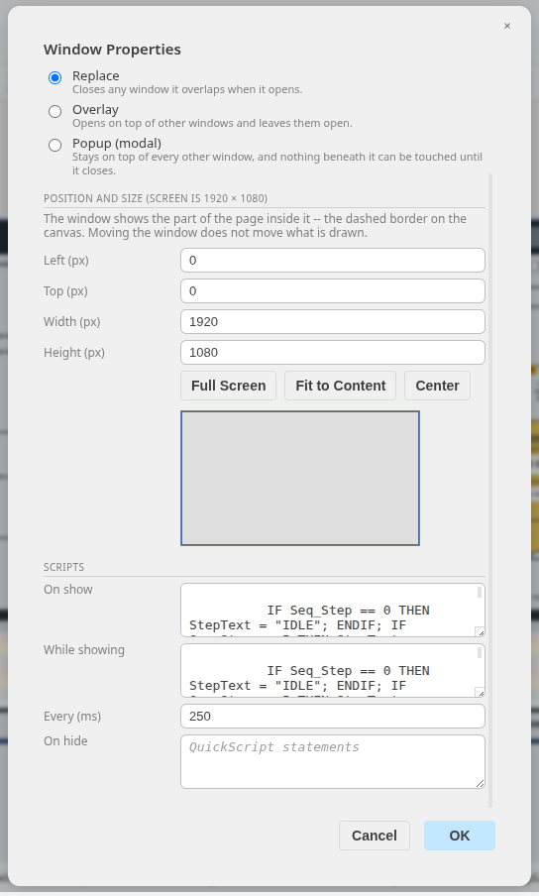
Figure 18. Window scripts of the Process screen (While showing every 250 ms)

9.2 Action scripts
An Action Script link runs statements when the object is pressed (On down), repeatedly while held (While down) and when released (On up). The LOGIN button in LiquidWeighHMI's header logs in or out:
IF _Username == "None" THEN ShowLogin(); ELSE Logout(); ENDIF;

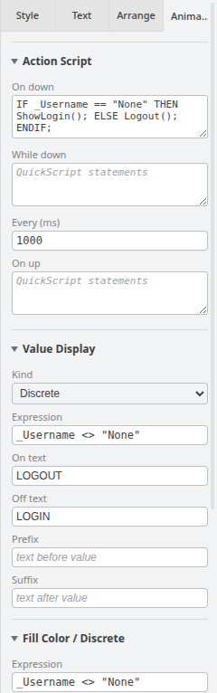
Figure 19. The LOGIN button: Action Script, Value Display and colors

9.3 Function reference
Functions take their arguments in parentheses, separated by commas. Any argument can be a literal (12.5, "Standard Blend"), a tag or a whole expression. Function names are not case-sensitive.
- Math and text functions return a value and can be used anywhere: in animation links and in scripts.
- Security, indirect tag and recipe functions do something (open a window, log in, link or write tags), so they can be called only from scripts: Action Scripts and window scripts. Validate reports one used in an animation link.
- Functions that succeed or fail return 1 or 0, so a script can test them: IF Login(LoginName, LoginPassword) THEN ... ENDIF;.
Table 12. Math and text functions (links and scripts)
Function | Arguments | What it does
Abs(x) | x: a number | The absolute value of x. Abs(-3.5) is 3.5
Sqrt(x) | x: a number, 0 or more | The square root of x
Sqr(x) | x: a number | x squared (x × x)
Int(x) | x: a number | x with its fraction dropped. Int(7.9) is 7 and Int(-7.9) is -7
Round(x) | x: a number | x rounded to the nearest whole number; a half rounds up. Round(2.5) is 3
Min(a, b) | a, b: numbers | The smaller of a and b. Min(PT001, 50) is never more than 50
Max(a, b) | a, b: numbers | The larger of a and b
StringLen(text) | text: text | The number of characters in text. StringLen(RecipeName) == 0 is true when no recipe is selected
Text(value, format) | value: a number  format: text | The number as text, formatted by a picture such as "0.00". The digits after the point in format give the decimals, and the digits before it the minimum number of whole digits, padded with zeros. Text(3.14159, "0.00") is "3.14" and Text(7, "000") is "007"

Table 13. Security functions (scripts only)
Function | Arguments | What it does
ShowLogin() | None | Opens the login window: user name, masked password and an on-screen keyboard. The window checks the password and logs the user in. Returns 1
Login(name, password) | name, password: text | Logs in when the name and password match a user. Returns 1, or 0 when they do not. For custom login screens
Logout() | None | Logs the current user out: _Username becomes None and _AccessLevel 0. Returns 1
ChangePassword(old, new) | old, new: text | Changes the logged-in user's password from old (the current password) to new (not empty), saved on this computer. Returns 1, or 0 when old is wrong or new is empty
ShowUserManager() | None | Opens the Users window while running, to add, change or remove users on this computer (section 10.2). Returns 1

Table 14. Indirect tag function (scripts only)
Function | Arguments | What it does
LinkIndirectTag(indirect, tag) | indirect, tag: tag names as text | Points the indirect tag at the tag, replacing any earlier link; reading or writing the indirect tag then reads or writes that tag, in every window. The names can be built: LinkIndirectTag("FP_Status", "SV" + Text(Unit, "000") + "_Status"). Returns 1, or 0 with an Indirect Tag Error window when a name is unknown or the types do not match

In the recipe functions, book is the name of a recipe book defined in HMI > Recipes and name the name of a recipe in it: text of 1 to 64 characters. Names are not case-sensitive. Chapter 11 shows them at work.
Table 15. Recipe functions (scripts only)
Function | Arguments | What it does
RecipeSave(book, name) | book, name | Saves the current values of the book's Save/Load tags as recipe name, replacing a recipe of that name. Fails if any of the values has bad quality
RecipeLoad(book, name) | book, name | Writes the recipe's values to the book's Save/Load tags
RecipeDownload(book, name) | book, name | Copies each Save/Load tag's value to its Upload/Download tag, usually sending the recipe to the PLC. name is not used: give "" or the selected recipe
RecipeUpload(book, name) | book, name | Copies each Upload/Download tag's value back to its Save/Load tag, usually bringing the PLC's values into the HMI. name is not used
RecipeExport(book, name) | book, name | Writes the recipe to a CSV file that the operator chooses (in Append HMI Web, the browser downloads it). Returns 1 when the file window opens
RecipeImport(book, name) | book, name | Reads a recipe CSV file that the operator chooses and saves it as recipe name. Returns 1 when the file window opens
RecipeDelete(book, name, confirm) | book, name  confirm: optional | Deletes the recipe. With confirm 1, a Yes/No window asks the operator first; No returns 0
RecipeRename(book, name, newName) | book, name, newName | Renames the recipe to newName, which must not already be in the book
ShowRecipeSelect(book, x, y, w, h) | book  x, y, w, h: optional | Opens a window listing the book's recipes, with up and down arrow buttons, Select and Cancel, and returns the chosen name, or "" for Cancel. The script waits until the operator chooses, so it must be a statement on its own or the whole right side of an assignment: Pick = ShowRecipeSelect("B");. x, y, w, h place the window: position and size in screen pixels

The recipe functions other than ShowRecipeSelect return 1 when they succeed and 0 when they fail. A failure also opens the Recipe Error window (section 11.5).

10 Alarms and security

10.1 Alarms
Alarms come from the limits set on tags (chapter 5). While the application runs, every alarmed tag is watched, whether or not a screen shows it:
- Entering alarm, or escalating (High to HiHi), raises an alarm that needs acknowledging.
- An alarm stays in the Alarm List until it has returned to normal and been acknowledged (ISA-18.2).
- The Alarm List object has an Ack All button and an Ack button on each row. A script can acknowledge with _AckAll = 1; or Tag.Acked = 1;.
- Every alarm event is written to a daily history file kept for 90 days; the Alarm History object shows it (Figure 37).

10.2 Users and access levels
Open HMI > Users to define who can log in. Each user has a name, a password (stored only as a salted hash) and an access level from 0 to 9999.
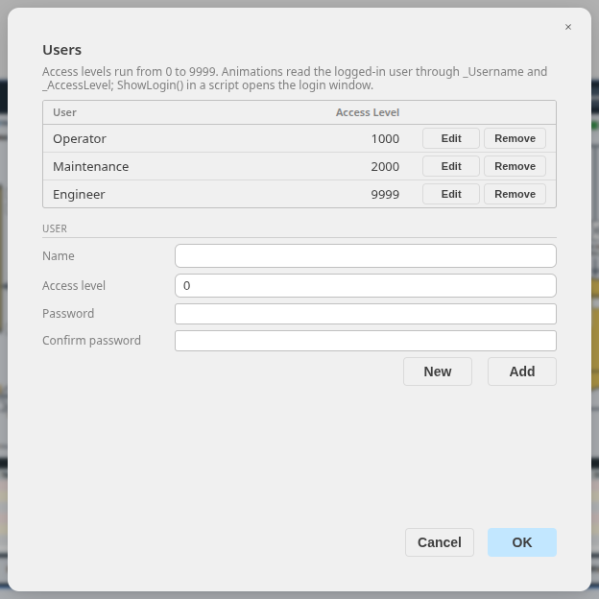
Figure 20. The Users dialog with LiquidWeighHMI's three users
Table 16. LiquidWeighHMI users
User | Access level | Can
Operator | 1000 | Run batches
Maintenance | 2000 | Also operate devices in manual
Engineer | 9999 | Everything, including setpoints and simulation

Screens use _AccessLevel to protect controls: an Enable link such as _AccessLevel >= 2000 blocks touch on an object, and a Visibility link can hide it. The script function ShowLogin() opens the built-in login window (Figure 21); Login(name, password), Logout(), ChangePassword(old, new) and ShowUserManager() support custom login screens.
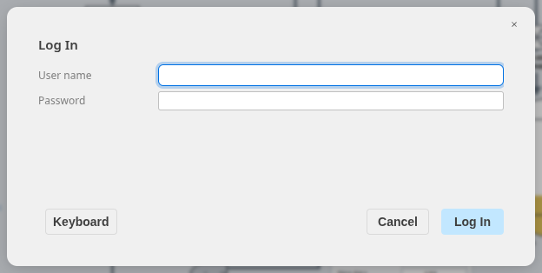
Figure 21. The login window opened by ShowLogin()

11 Recipes
A recipe is a named set of tag values that an operator saves and later loads again: the settings of a product, a grade or a batch size. Recipes are kept in recipe books. A book lists the tags its recipes hold:
- Save/Load tags: the values a recipe stores, usually memory tags that the operator edits on screen. RecipeSave reads them and RecipeLoad writes them.
- Upload/Download tags (optional): a second tag paired with each Save/Load tag, usually the PLC tag the value is meant for. RecipeDownload copies the Save/Load values to them and RecipeUpload copies them back.
Keeping the edited values in memory tags means the operator can prepare a recipe without disturbing the PLC, and send it with one Download when the process is ready.

11.1 Recipe books
Open HMI > Recipes to define the books. LiquidWeighHMI has one, Plasticizer Blends, that holds the Batch screen's recipe: the total batch volume and the share of each of the three plasticizers.
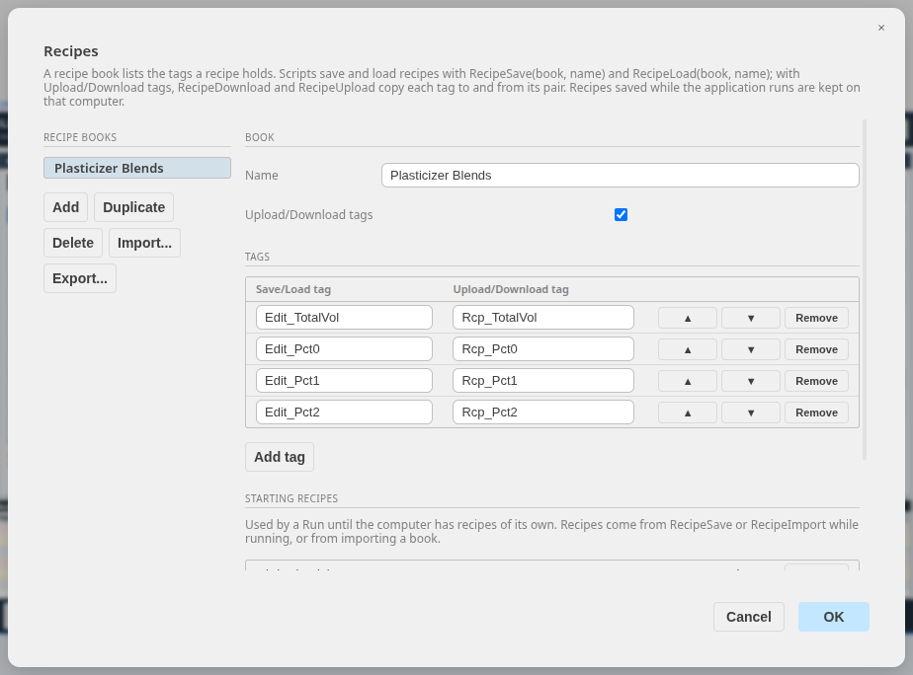
Figure 22. HMI > Recipes: the Plasticizer Blends book and its tags
- Add, Duplicate and Delete manage the books; Name renames the selected one.
- Upload/Download tags adds the second column of tags.
- Add tag adds a row. The arrow buttons reorder the rows and Remove deletes one. A tag that is not in the Tag Dictionary is marked.
- Import... and Export... read and write books, with their starting recipes, as a JSON file, to copy them between projects.
- OK checks every book and saves them into the project. Validate also reports books whose tags no longer exist.
Table 17. The tags of the Plasticizer Blends book
Save/Load tag | Upload/Download tag | Holds
Edit_TotalVol | Rcp_TotalVol | Total batch volume, gal (PLC tag Recipe.TotalVol_gal)
Edit_Pct0 | Rcp_Pct0 | Plasticizer #1, % by volume (Recipe.Pct[0])
Edit_Pct1 | Rcp_Pct1 | Plasticizer #2, % by volume (Recipe.Pct[1])
Edit_Pct2 | Rcp_Pct2 | Plasticizer #3, % by volume (Recipe.Pct[2])

The Edit_ tags are retentive memory tags, so the recipe being edited survives a restart. The PLC works out each plasticizer's target weight from the volume, the percentages and the densities on the Setpoints screen.
A book can also carry starting recipes: recipes stored in the project, which a computer uses until it saves recipes of its own. LiquidWeighHMI ships with five.
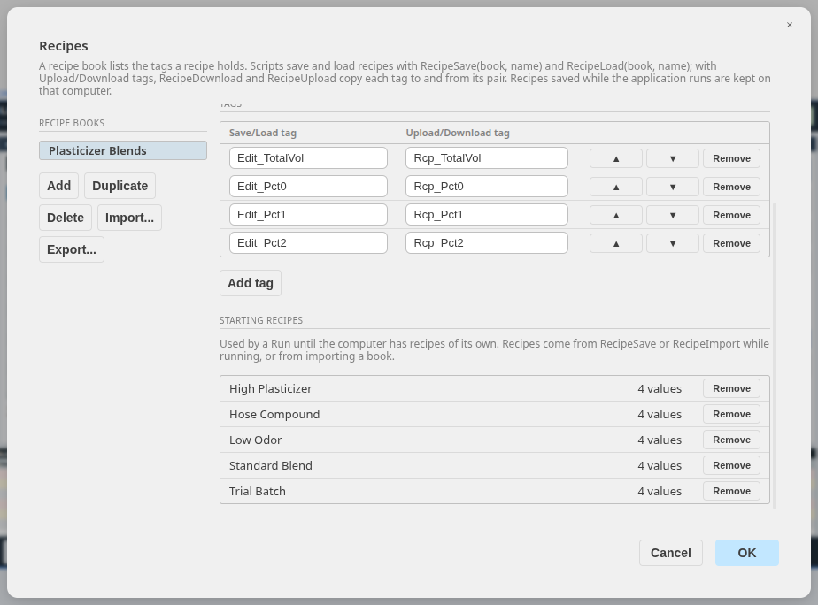
Figure 23. The starting recipes of Plasticizer Blends, below its tags
Table 18. LiquidWeighHMI's starting recipes
Recipe | Volume (gal) | Plasticizer #1 (%) | Plasticizer #2 (%) | Plasticizer #3 (%)
Standard Blend | 10 | 60 | 25 | 15
High Plasticizer | 10 | 70 | 20 | 10
Hose Compound | 9 | 45 | 35 | 20
Low Odor | 8 | 50 | 50 | 0
Trial Batch | 4 | 40 | 30 | 30

11.2 The Recipes screen
LiquidWeighHMI's Recipes screen, on the RECIPES button of the navigation bar, puts the recipe functions to work. It is built only from standard objects, links and scripts, so it can be copied into other applications.
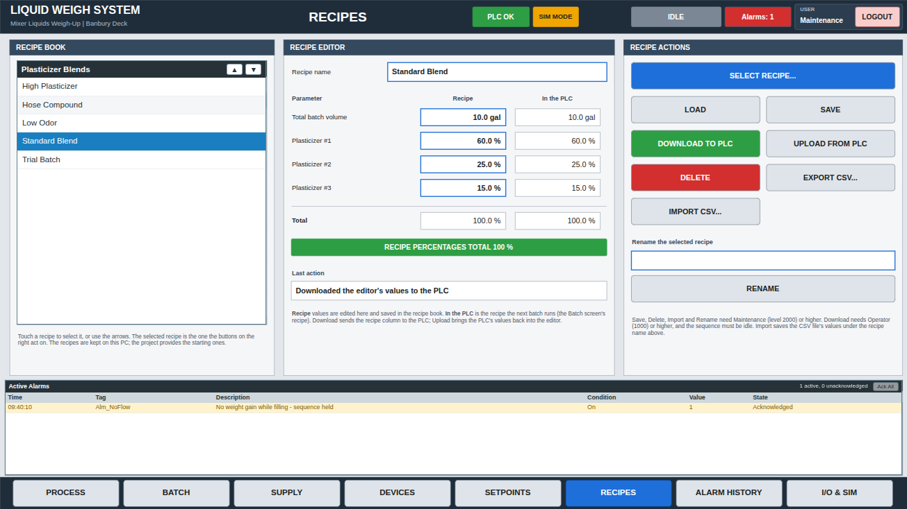
Figure 24. The Recipes screen at Run: Standard Blend selected, loaded and downloaded to the PLC
- Recipe book (left): a Recipe List object showing the book's recipes. Touching one, or the arrow buttons in its heading, selects it by writing its name to the message tag RecipeName.
- Recipe editor (center): the recipe name, and for each value the editable Save/Load tag (Recipe column) beside its PLC tag (In the PLC column). The total and the green or red banner check that the percentages add up to 100 %. Last action shows the result of the last button.
- Recipe actions (right): one button for each recipe function, acting on the recipe named in RecipeName.
Table 19. The Recipes screen's buttons
Button | Calls | Allowed for
SELECT RECIPE... | ShowRecipeSelect, then RecipeLoad | Everyone
LOAD | RecipeLoad: the recipe into the editor | Everyone
SAVE | RecipeSave: the editor's values as the recipe | Maintenance and up
DOWNLOAD TO PLC | RecipeDownload: the editor's values to the PLC | Operator and up, sequence idle
UPLOAD FROM PLC | RecipeUpload: the PLC's values into the editor | Everyone
DELETE | RecipeDelete, asking first | Maintenance and up
EXPORT CSV... | RecipeExport | Everyone
IMPORT CSV... | RecipeImport, saving under the name in the editor | Maintenance and up
RENAME | RecipeRename to the name typed above it | Maintenance and up

Each button is an Action Script. Where access is limited, an Enable link (for example _AccessLevel >= 2000) blocks touch, and fill and text color links gray the button out. SAVE reports its result in the Last action box:
IF RecipeSave("Plasticizer Blends", RecipeName) THEN
RecipeMsg = "Saved " + RecipeName;
ENDIF;

DOWNLOAD TO PLC is enabled by _AccessLevel >= 1000 AND Seq_Step == 0, so a recipe cannot change while a batch runs. DELETE passes 1 as the third argument, so the operator confirms first:
IF RecipeDelete("Plasticizer Blends", RecipeName, 1) THEN
RecipeMsg = "Deleted " + RecipeName;
RecipeName = "";
ENDIF;

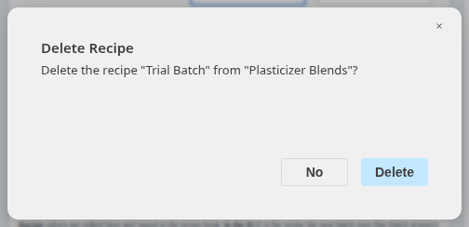
Figure 25. RecipeDelete with confirm: the operator answers before anything is deleted

11.3 The Recipe List object
Recipe List, in the HMI palette, shows a book's recipes while the application runs. Select it and open the Animation tab to set it up:
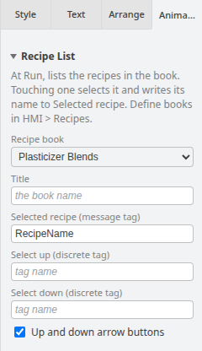
Figure 26. The Recipe List settings of the Recipes screen's list
Table 20. Recipe List settings
Setting | Meaning
Recipe book | The book listed
Title | The heading; empty shows the book's name
Selected recipe | A message tag. The highlighted row follows its value, and touching a row writes the row's name to it
Select up, Select down | Discrete tags. Each change from 0 to 1 moves the selection up or down, for selection from PLC pushbuttons. With nothing selected, down selects the first recipe and up the last
Up and down arrow buttons | Draws arrow buttons in the heading that move the selection the same way

The list is sorted by name and updates as soon as a recipe is saved, renamed or deleted.

11.4 Selecting a recipe in a window
ShowRecipeSelect opens a window listing a book's recipes, for screens without a Recipe List or for a popup choice. The operator touches a recipe, or uses the arrow buttons, then Select; the function returns the chosen name, or "" for Cancel. LiquidWeighHMI's SELECT RECIPE... button loads the chosen recipe into the editor:
RecipePick = ShowRecipeSelect("Plasticizer Blends");
IF RecipePick <> "" THEN
RecipeName = RecipePick;
RecipeLoad("Plasticizer Blends", RecipeName);
RecipeMsg = "Loaded " + RecipeName + " into the editor";
ENDIF;

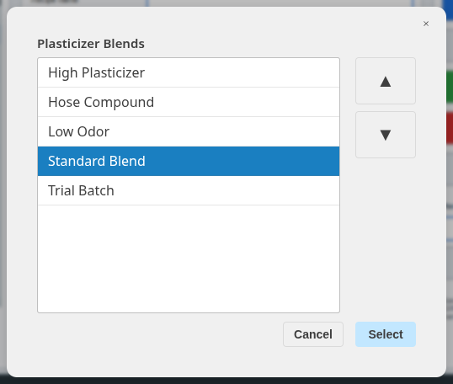
Figure 27. The window opened by ShowRecipeSelect
- The script waits at ShowRecipeSelect until the operator chooses, then continues with the result. It must therefore be a statement on its own or the whole right side of an assignment, as above; Validate reports it inside an IF condition or an expression.
- The window is centered. ShowRecipeSelect(book, x, y, w, h) places it instead, at x, y with width w and height h in screen pixels, scaled with the screen.
- Assigning the result to a separate tag, as above, keeps the current selection when the operator cancels.

11.5 When a recipe function fails
A recipe function that cannot do its job returns 0 and shows the Recipe Error window. The window names the call with its arguments and gives the reason, such as an empty recipe name, a recipe that does not exist, or PLC values with bad quality because the controller is not connected. Pressing SAVE with no recipe name gives:
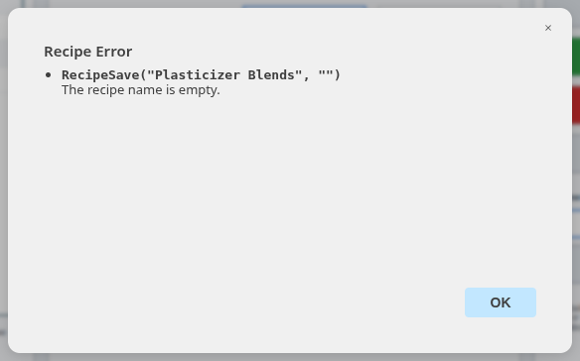
Figure 28. The Recipe Error window
- The window opens after the script finishes, so the rest of the script still runs.
- Further failures before OK is pressed join the same window (up to 10, then "and n more"); a failure repeated by a While showing script is counted rather than repeated.
- The operator's own choices are not errors: Cancel in the select window, No when deleting and cancelling a file window return 0 or "" without one.
- Every failure is also written to the runtime log.

11.6 Where recipes are kept
The project holds the books and their starting recipes. Recipes saved while running (RecipeSave, RecipeRename, RecipeDelete, RecipeImport) are kept on the computer running the application, book by book: once a computer saves a recipe in a book, its own list replaces that book's starting recipes there.
Table 21. Where saved recipes are kept
Running in | File
Append HMI Studio (Run) | recipes\<project>.json in the Studio's settings folder
A published application | %APPDATA%\<Product>\recipes\<Product>.json
Append HMI Desktop, Append HMI Web | recipes\<application>.json in their settings folder

- HMI > Clear Runtime Recipes (with the Run stopped) forgets the recipes the Studio saved, so Run starts again from the starting recipes.
- In Append HMI Web all browsers share the server's recipes; one saved in one browser appears in the others within a few seconds.
- A recipe CSV file has a #Recipe,<book>,<name> line, then Tag,Value and one line per tag. Importing takes only the book's Save/Load tags and reports any others.

12 Testing

12.1 Validate
HMI > Validate Expressions checks every link, script and PLC address and lists any problem with the page and object; click a problem to go to it. Validate before every Run and Publish.
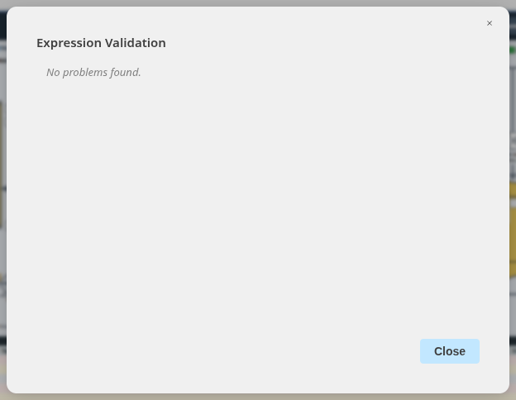
Figure 29. Validation of LiquidWeighHMI: no problems found

12.2 Run
HMI > Run (F5) runs the application inside the Studio: the drawing is locked, the start-up windows open, and the application connects to its PLCs. A green RUNNING banner shows that the screen is live and that touching it operates real equipment. HMI > Stop returns to editing.
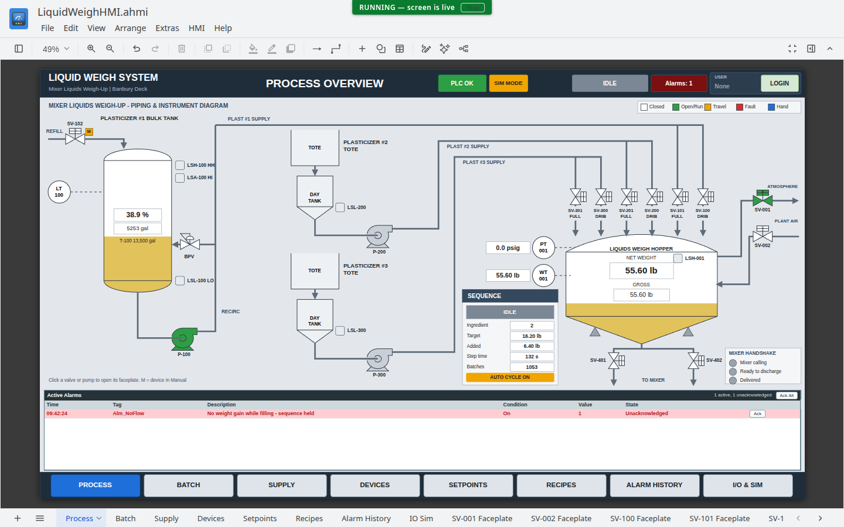
Figure 30. LiquidWeighHMI running in the Studio
The screens below were captured while LiquidWeighHMI ran against its controller, between batches.
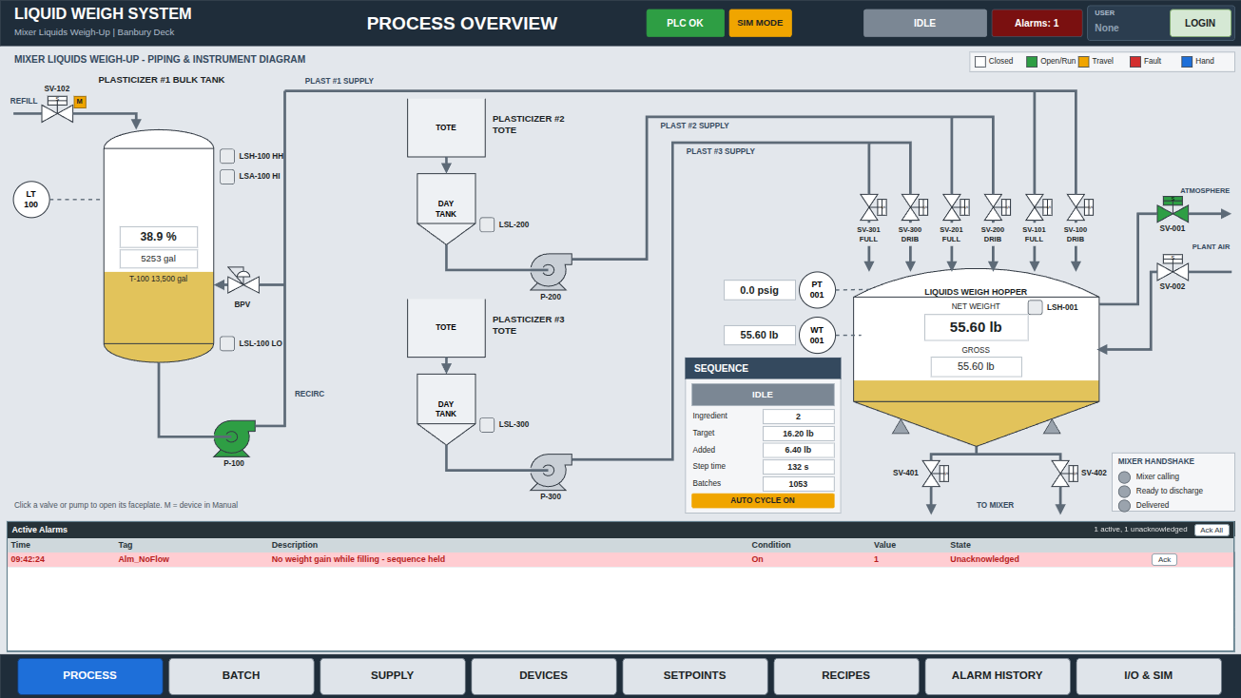
Figure 31. Process screen: tank and hopper levels, valve states, sequence and active alarms
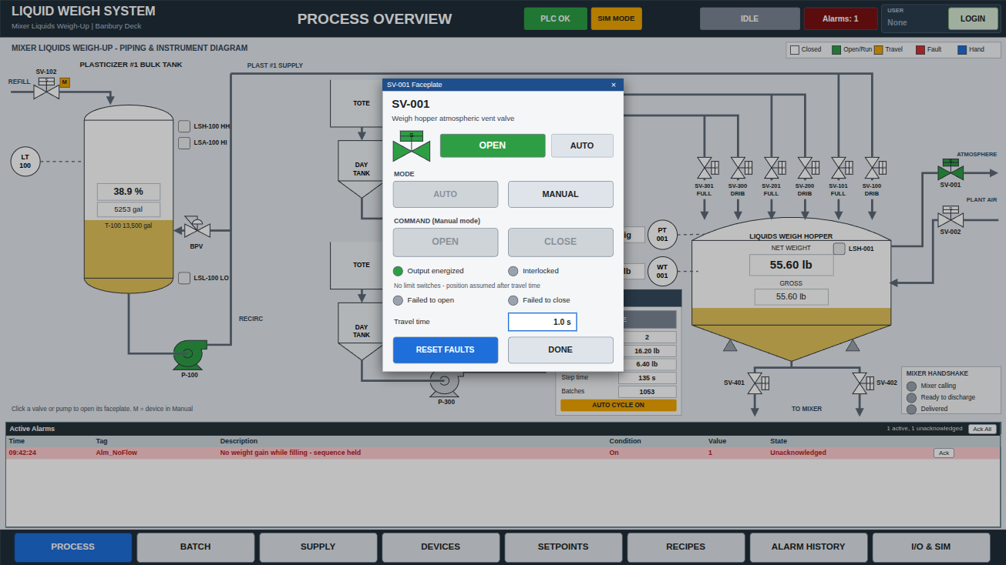
Figure 32. SV-001 faceplate: mode, commands, interlocks and fault reset
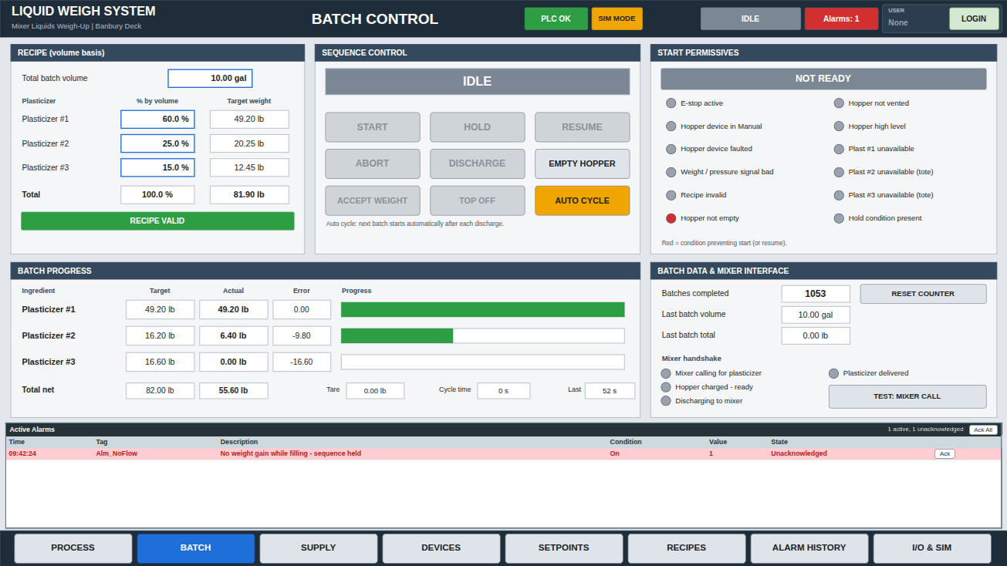
Figure 33. Batch screen: recipe, sequence control, start permissives and batch progress
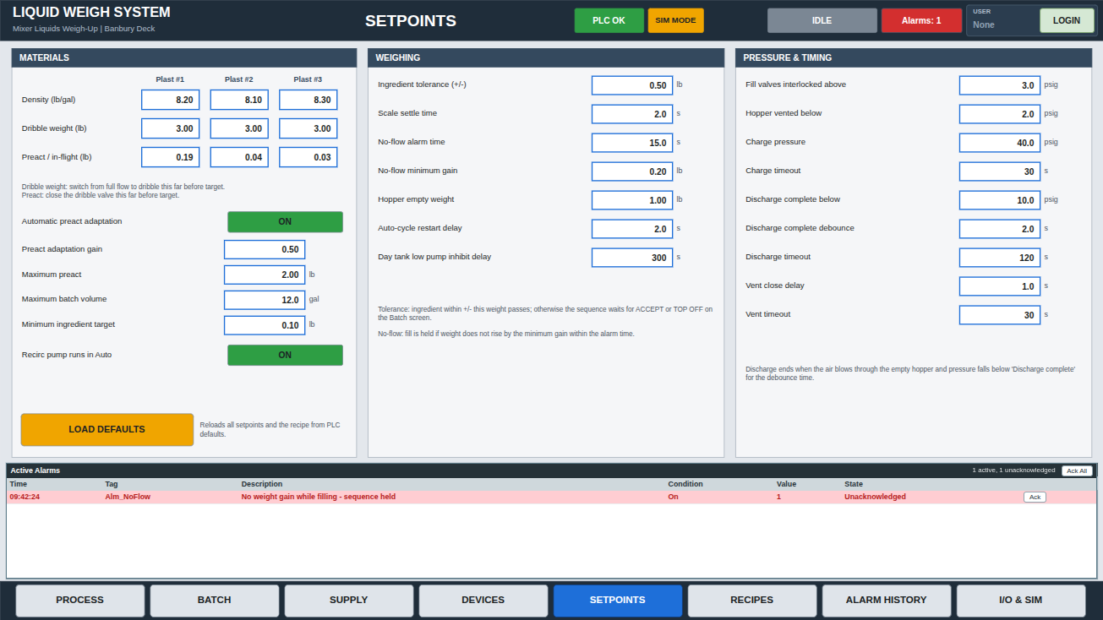
Figure 34. Setpoints screen: materials, weighing, pressure and timing
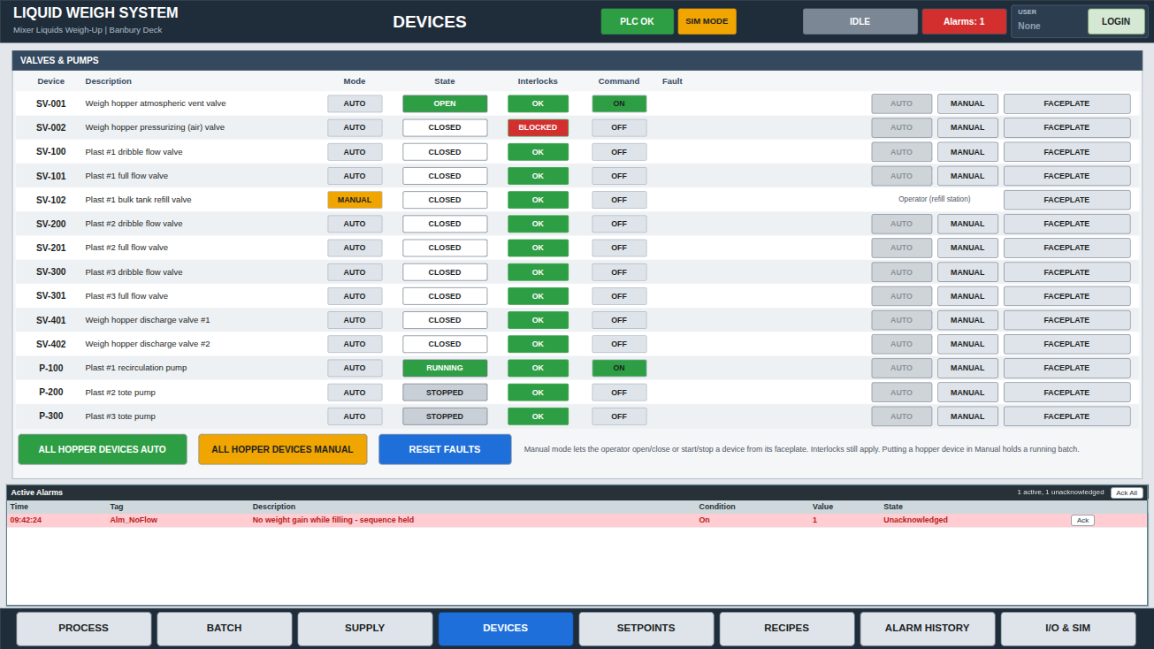
Figure 35. Devices screen: every valve and pump with mode, state and faceplate
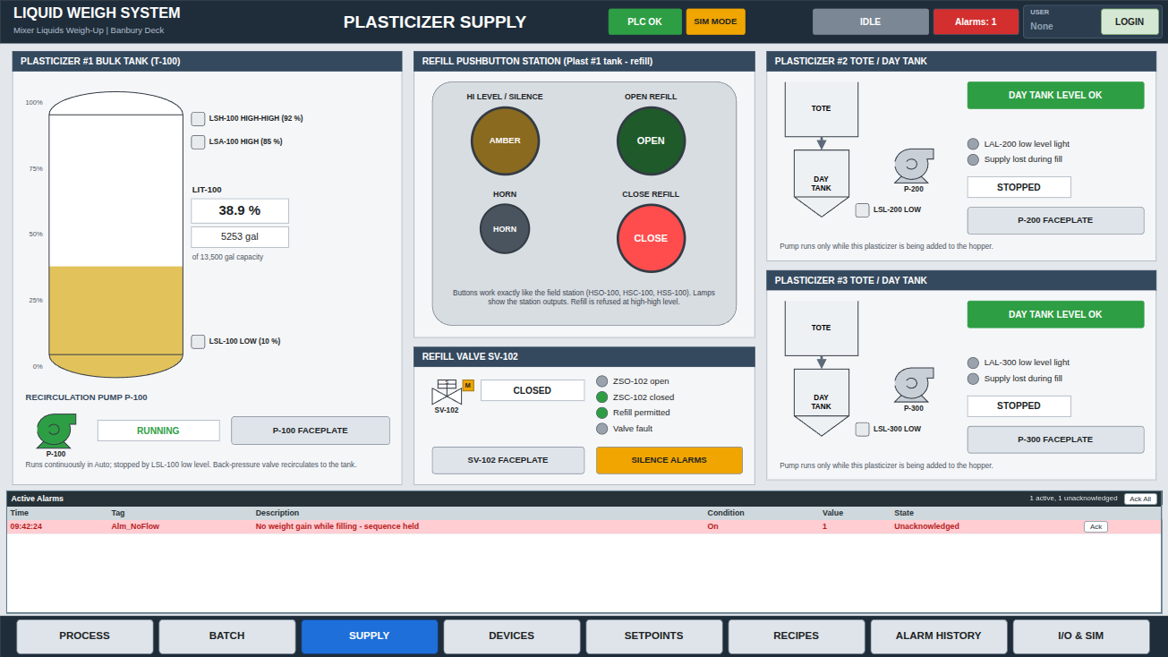
Figure 36. Supply screen: plasticizer tank, refill station and totes
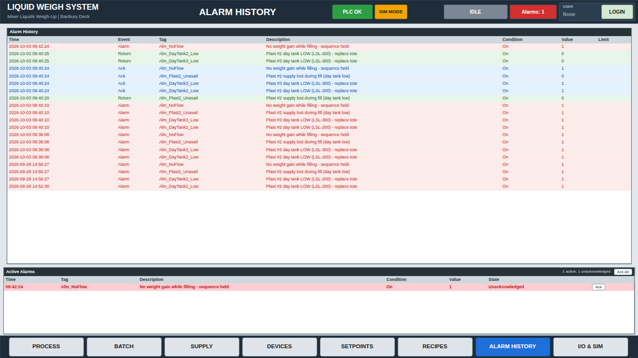
Figure 37. Alarm History screen
Note: HMI > Runtime Log lists connections, device errors, writes and script errors from the run.

13 Deploying
An application can reach the plant floor in three ways.
Table 22. Deployment options
Option | What the target gets | Best for
HMI > Publish | A Windows installer of this one application, with its own name and icon, starting straight into it | A dedicated, locked-down operator station
Append HMI Desktop | One runner installed once; runs any .ahmi file, from shortcuts or at log-in | Stations whose projects change often; Linux
Append HMI Web | A web server; operators open the application in any browser | Viewing and operating from tablets, laptops and control-room PCs

13.1 Publish
HMI > Publish builds a Windows installer from the open project. Give the product name, version and publisher, choose an icon, whether it installs for all users, and whether it adds a desktop shortcut or starts with Windows. Run the Setup.exe on the target PC; the application then starts full screen as set in Application Settings.
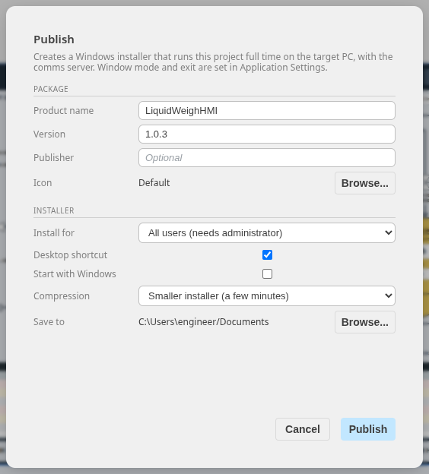
Figure 38. The Publish dialog

13.2 Append HMI Desktop
Append HMI Desktop runs .ahmi files without the editor. Choose an application, then Run now, create a desktop shortcut or menu entry, or tick Run this application automatically when I log in. From the command line: append-hmi-desktop LiquidWeighHMI.ahmi.
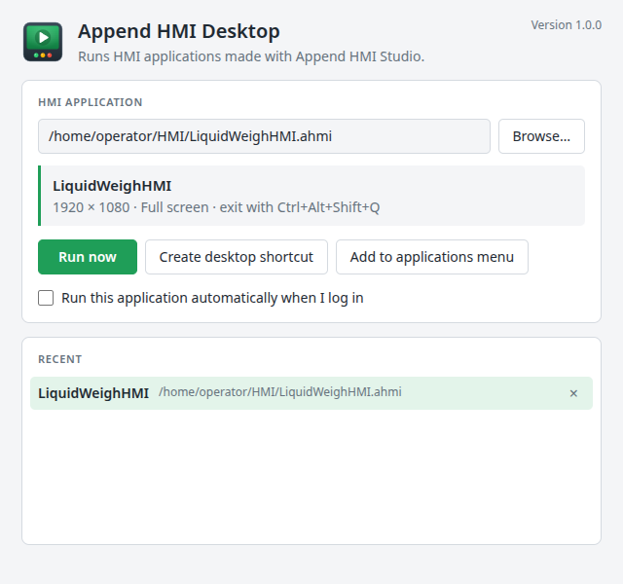
Figure 39. The Append HMI Desktop launcher with LiquidWeighHMI selected

13.3 Append HMI Web
Append HMI Web serves an application to web browsers on the plant network. Choose the application and a port (8480 by default), then Start web server; the launcher shows the link to share, with a Copy button. If the port is already in use on the PC (by another web server, or another application being served), choose another. In the browser, the view button in the corner fits the screen to the window, maximizes it, or shows it at its original size with scroll bars.
The Running list shows every Append HMI Web server on the PC, including ones started in the background from the command line (--headless). Each has Restart, which starts it again with the same settings and reads the project file afresh (do this after saving changes in Studio; browsers reload by themselves), and Stop.
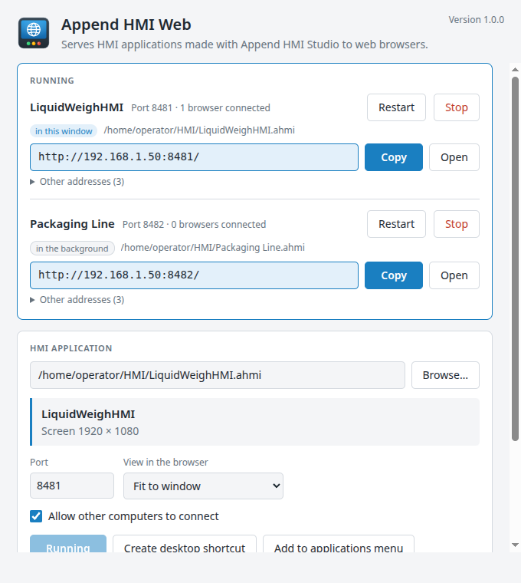
Figure 40. The Append HMI Web launcher: LiquidWeighHMI served on port 8481 to one browser, and a second application running in the background
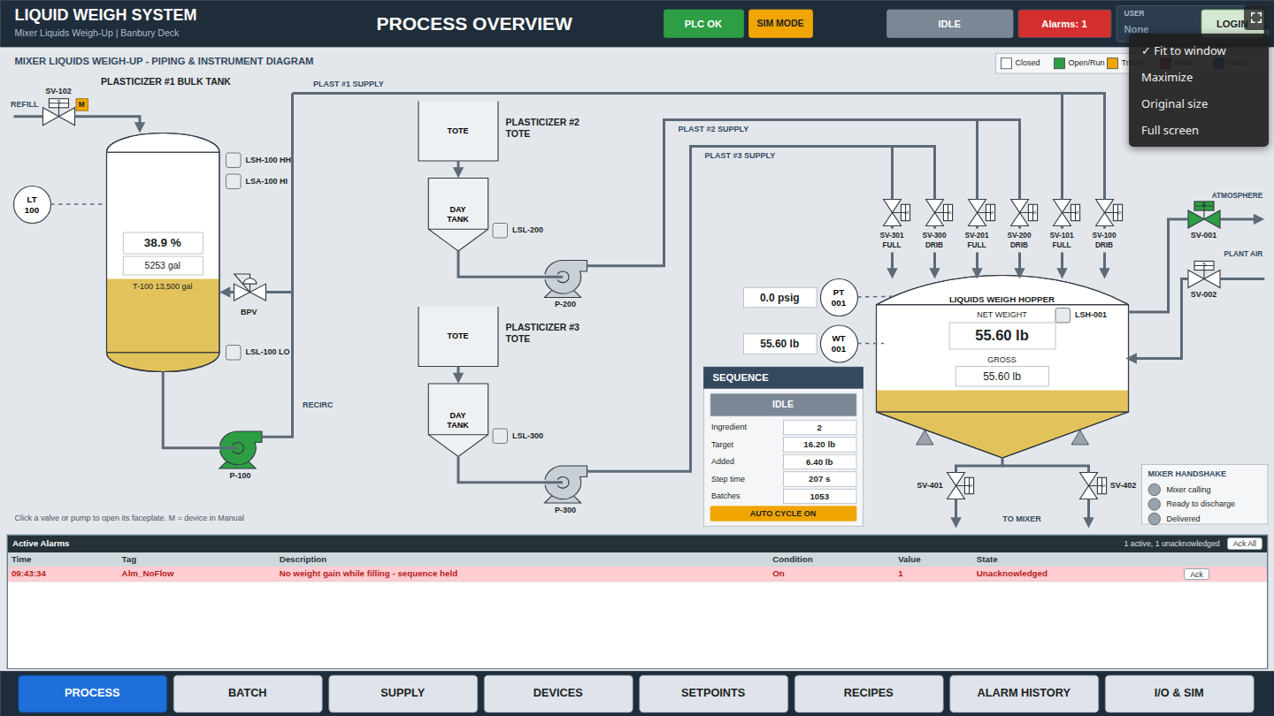
Figure 41. LiquidWeighHMI in a web browser, with the view menu open

14 Tips and troubleshooting
Table 23. Common problems
Symptom | Cause and remedy
Values show #### | The tag has bad quality: the PLC is not connected or the address is wrong. Check HMI > Runtime Log and Test Connection in HMI > Devices
PLC COMM FAIL in the header | The device is unreachable. Check the IP address, slot and network
A button does nothing | An Enable or Pushbutton "Enable when" condition is false, or nobody with the access level is logged in
Validate reports an expression error | Expressions take no ";" (only script statements do); tag names must exist in the Tag Dictionary
A popup opens in the wrong place | Its objects must be drawn at the window's position on its page (Window Properties > Left, Top)
Retentive values are not what you expect | Use HMI > Clear Retentive Values to start from the initial values again
A recipe button does nothing | Its Enable condition is false (access level, or the sequence is running), or the function failed: the Recipe Error window and HMI > Runtime Log give the reason
Run shows old recipes | Recipes saved on this computer replace the starting ones. Use HMI > Clear Runtime Recipes to start from the project's recipes again

Build a symbol once, with its links, group it, and copy it: links travel with the copy. The Animation tab can also copy links from one object and paste them onto others.

Appendix A Command-line automation
Append HMI Studio can build, check, render and publish applications without its window, for scripting and for AI agents:
Table 24. Command-line modes
Command | Does
--hmi-build spec.json -o app.ahmi | Builds a project from a JSON description
--hmi-check app.ahmi | Validates it (exit code 2 when problems are found)
--hmi-render app.ahmi -o folder | Renders every page to PNG
--hmi-dump app.ahmi -o spec.json | Writes a project back out as JSON
--hmi-publish app.ahmi --product "Name" --app-version 1.0.0 -o folder | Builds the Windows installer

The JSON format is documented in doc/HMI_AUTOMATION.md in the Append HMI Studio repository.

