**SDA SENIOR HIGH SCHOOL, BEKWAI-ASHANTI**

**P.O.BOX 45 BEKWAI-ASHANTI**

**ADMISSION LETTER**

I am happy to inform you that on the basis of your performance in 2023 BECE EXAMINATIONS, you have been offered a place in SHS ‘1’ to pursue **GENERAL SCIENCE** programme for the 2023/2024 Academic year as **BOARDING** student. Your admission number is **BA024. And your house is AMEYAW**. Submit your CSSPS Placement form and a copy of your BECE Result slip to the school. You should also fill the Admission/Personal Record Form and submit to the school secretary with two passport-size photographs attached to the completed Admission /Personal Record Form. Please come to school with your **NATIONAL HEALTH INSURANCE CARD.** Note that the school stands for moral and academic excellence and therefore live up to expectation.

Accept my congratulations

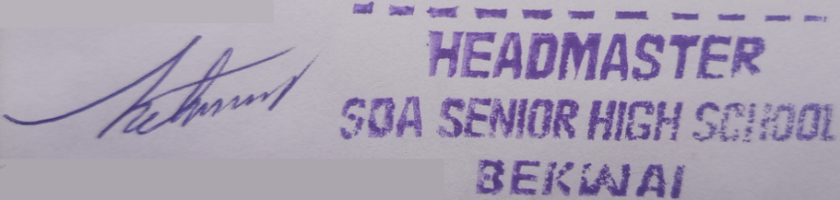

PETER BOATING (MR.)  
(HEADMASTER)

**SARPONG SAMUEL ANSONG**

**P.O.BOX 180, BANTAMA, KUMASI**

1st December, 2023