**SDA SENIOR HIGH SCHOOL, BEKWAI-ASHANTI**

**P.O.BOX 45 BEKWAI-ASHANTI**

**ADMISSION LETTER**

I am happy to inform you that on the basis of your performance in 2022 BECE EXAMINATIONS, you have been offered a place in SHS ‘1’ to pursue **${program}** programme for the 2022/2023 Academic year as **${status}** student. Your admission number is **${admission}. And your house is ${studentHouse}**. Submit your CSSPS Placement form and a copy of your BECE Result slip to the school. You should also collect and complete Admission/Personal Record Form, fill and submit to the school secretary with two passport-size photographs attached to the completed Admission /Personal Record Form. Please come to school with your **NATIONAL HEALTH INSURANCE CARD.** Note that the school stands for moral and academic excellence and therefore live up to expectation.

Accept my congratulations

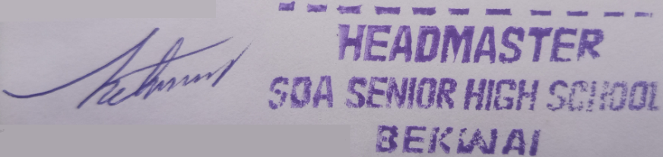

PETER BOATING (MR.)  
(HEADMASTER)

**${studentfullname}**

**${guardianaddress}**

${recdate}