Individual Exercise 2: Normalization

Student Name: _______< … > ________

Before you begin, review the concepts: https://www.essentialsql.com/database-normalization/

EmployeeClients

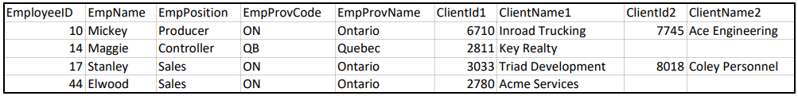

The table provided shows the list of clients for each employee. For example, Mickey has two clients and Maggie has one client.

Steps to normalize:

- [2 points] The un-normalized table above is not in 1NF due to repeating columns. What are the repeating columns?

Answer:

Column 1: _______< … > ________

Column 2: _______< … > ________

Column 3: _______< … > ________

Column 4: _______< … > ________

- [2 points] Describe the un-normalized table by filling out the blanks for UNF below. Hint: Fill out the repeating columns you identified in Step 1 above.

UNF:
EmployeeClients (
EmployeeID,
EmpName, EmpPosition,
EmpProvCode, EmpProvName,

[ (_______< … > ________ , _______< … > ________) ,

(_______< … > ________ , _______< … > ________ ) ]
)

- [2 points] Eliminate the repeating columns and fill out the blanks for 1NF below.

1NF:

EmployeeClients (

_______< … > ________ ,

_______< … > ________ , _______< … > ________ ,

_______< … > ________ , _______< … > ________ ,

_______< … > ________ , _______< … > ________
)

- [2 points] The EmployeeClients table in 2NF below should have a composite key. Make sure you underline them properly.

After identifying the composite key, there are several attributes, which does not completely depend on the entire composite key. This means that the 1NF table is not in 2NF (i.e., all non-key columns are dependent on the entire composite key).

To fix this issue, move the columns to new Employee and Client tables by filling out the blanks in 2NF below. The keys for each of the newly added tables are pre-assigned.

2NF:

Employee (

EmployeeID,

_______< … > ________ , _______< … > ________ ,

_______< … > ________ , _______< … > ________
)

Client (

ClientID, _______< … > ________
)

EmployeeClients (

_______< … > ________ , _______< … > ________
)

- [2 points] Observe that the Employee table from 2NF is not in 3NF because there are non-key columns that depends on other non-key columns. Fix this issue by filling out the blanks for 3NF below. The key for the Province table is pre-assigned.

3NF:

Province (

ProvCode, _______< … > ________
)

Employee (

EmployeeID,

_______< … > ________ , _______< … > ________ ,

_______< … > ________
)

Note: No change to Client and EmployeeClients tables in 2NF.

Optional: Manually check that the tables in 3NF can store all the original data values (and no more!) by creating tables manually (e.g., on a scratch pad).

