
THE HONG KONG POLYTECHNIC UNIVERSITY
DEPARTMENT OF LANGUAGE SCIENCE AND TECHNOLOGY

CBS5504 AI-Driven Cross-Cultural Linguistic Exploration: Preserving, Translating, and Interpreting Chinese and Bilingual Heritage

Group Project Report

Title of the Group Project

Mandarin Orange: A Semantic Evolution Spanning Three Thousand Years— A Digital Humanities Analysis of Cultural Symbolism from Pre-Qin to Modern Era

Submitted by
Name of the Students
Ba Yuxin (Student ID: 25056849G)
Lu Zhengping (Student ID: 25041182G)
Yang Yuqing (Student ID: 25005802G)
Yang Yulai (Student ID: 25123727G)

Date of Submission

2025-12-03

TABLE OF CONTENTS
Abstract 3
1. Introduction 4
1.1 Research Topic & Background 4
1.2 Problem Definition 4
1.3 Research Objectives and Thesis 4
2. Literature Review 5
2.1 Review of Existing Scholarship 5
2.2 Research Gaps and Innovation 5
3. Data Collection and Data Processing 6
3.1 Corpus Curation: A Multi-Genre Archive 6
3.2 Chronological Segmentation: The Eight-Era Framework 7
3.3 NLP Data Processing Pipeline 8
3.3.1 Semantic Fusion Strategy 8
3.3.2 Tokenization and Noise Reduction 8
3.3.3 Entity Normalization and Preservation 8
4. Feature Representation and Construction 9
4.1 Statistical Feature Construction: TF-IDF Weights 9
4.2 Semantic Vector Construction: Word Embeddings 10
4.3 Topological Features (Co-occurrence Matrices) 11
5. AI Techniques and Semantic Network Implementation 11
5.1 Keyword Extraction Algorithm (TF-IDF Implementation) 11
5.2 Semantic Shift Modeling (Word2Vec Architecture) 11
5.3 Network Visualization and Analysis (NetworkX) 12
6. Interpretation and Findings 12
6.1 Phase I: The Spiritual Identity & The Moral Mirror (Pre-Qin to Han) 13
6.2 Phase II: Institutionalization & The Political Token (Tang to Song) 13
6.3 Phase III: The Practical Turn & Global Commodification (Ming-Qing to Modern) 14
7. Conclusion and Future Work 15
7.1 Summary of Findings 15
7.2 Theoretical Contribution 16
7.3 Future Work & Reflection 16
Reference 17

Abstract
This study examines the semantic evolution of the Mandarin orange in Chinese culture over 3,000 years. To overcome the fragmentation of traditional qualitative research, we employ Digital Humanities methods—NLP and semantic network analysis—to quantitatively trace the fruit’s shifting identity across 470 historical texts. Our findings reveal a tripartite trajectory of “Cultural Disenchantment”: the Mandarin evolved from a “Moral Mirror” (virtue personification) in the Pre-Qin era, to a “Political Token” (institutionalized tribute) in the Tang–Song dynasties, and finally to a “Practical Resource” (medicine and commodity) in the Ming–Qing and modern periods. This study shows how computational distant reading can uncover macro-historical patterns beyond traditional close reading.
Keywords: Mandarin, Digital Humanities, Semantic Evolution, Word2Vec, Distant Reading

1. Introduction

1.1 Research Topic & Background
The Mandarin orange (Citrus reticulata), hereafter the “Mandarin,” occupies a unique place in Chinese civilization. Native to the Yangtze River basin, it transcends its botanical identity to serve as a “cultural container.” Over three millennia, its symbolism shifted from the moral Junzi in the Pre-Qin era to medicinal Chenpi in the Ming–Qing dynasty, making the Mandarin a “cultural palimpsest” that reflects evolving ideologies across historical epochs.

1.2 Problem Definition
Despite its cultural significance, existing scholarship remains fragmented. Literary studies focus on aesthetic symbolism, while agricultural and medical histories examine technique and utility in isolation. Furthermore, traditional research relies heavily on qualitative "close reading," lacking macro-level, quantitative evidence to trace the Mandarin's continuous semantic drift across the longue durée.

1.3 Research Objectives and Thesis
To address these gaps, this study employs a Digital Humanities (DH) approach. By analyzing a curated corpus of 470 historical records using Natural Language Processing (NLP) techniques—specifically TF-IDF and Word2Vec—we aim to quantify the Mandarin's changing semantic environment.
This research identifies a tripartite evolutionary trajectory of "Cultural Disenchantment":
- Personification: A spiritual symbol of virtue (Pre-Qin).
- Institutionalization: A political token of tribute (Tang-Song).
- Commodification: A practical resource for medicine and trade (Ming-Qing to Modern).

2. Literature Review
The Mandarin orange (Citrus reticulata) occupies a singular position in Chinese cultural history, functioning simultaneously as a moral totem for the elite and a pragmatic resource for the populace. Current scholarship on Mandarin is extensive but fragmented across disciplinary lines.

2.1 Review of Existing Scholarship
Research on the Mandarin typically falls into four isolated categories:
- Literary Imagery Studies: The dominant strain of research focuses on the "Bide" (comparing virtue) tradition rooted in the Pre-Qin era. Scholars have exhaustively analyzed Qu Yuan’s Ode to the Orange, interpreting the fruit as a symbol of the Junzi (noble gentleman) characterized by unyielding integrity and loyalty (Hawkes, 2011). However, these studies often overlook how this moral symbolism evolved or diluted in later dynasties.
- Art Historical Research: Attention in visual culture is frequently directed toward artifacts like Wang Xizhi’s Feng Ju Tie. These studies effectively frame the Mandarin as a currency of aristocratic social exchange during the Wei-Jin period but tend to isolate the aesthetic object from its broader economic contexts.
- Agricultural History: Historians of science have rigorously documented the agronomic breakthroughs in Han Yanzhi’s Ju Lu (Song Dynasty), the world's first citrus monograph (Han, 1985). While valuable for understanding production and tribute systems, this technical focus rarely converges with cultural analysis.
- Medical and Economic History: Scholarship on the Ming-Qing era pivots to the commodification of Chenpi (aged peel) and the "Medicine and Food Homology" theory (Li, 2003). These studies excel in detailing economic value but often treat the "medical turn" as a purely practical evolution, neglecting its cultural significance as a form of disenchantment.

2.2 Research Gaps and Innovation
Despite the rich accumulation of individual studies, critical gaps remain. First, existing research is fragmented; literary, agricultural, and medical histories rarely intersect. Second, most studies are synchronic, focusing on specific "golden ages" rather than tracing a continuous diachronic evolution over the longue durée. Finally, there is a lack of quantitative verification. Traditional conclusions rely on subjective close reading, lacking empirical evidence to measure the structural shifts in the Mandarin’s meaning.
This project addresses these gaps through a Digital Humanities framework. Using NLP techniques (TF-IDF, Word2Vec) on 470 historical texts, we move from subjective interpretation to “distant reading” (Moretti, 2013). We quantitatively map the Mandarin’s semantic trajectory, visualizing its shift from spiritual symbol to material resource, and reconstruct a holistic “cultural biography” of the fruit.

3. Data Collection and Data Processing
To trace the semantic evolution of Mandarin across three millennia, this study moves beyond traditional close reading and builds a structured, multi-dimensional corpus for computational analysis. The data work followed a strict three-stage pipeline: corpus curation, chronological segmentation, and NLP pre-processing.

3.1 Corpus Curation: A Multi-Genre Archive
We built a specialized dataset of 470 historical records selected to capture Mandarin’s shifting identity across social contexts. Unlike studies limited to literary texts, our “full-spectrum” corpus integrates four categories of primary sources:
- Classical Literature (Literary): Texts like ChuCi and Tang poetry, capturing the fruit’s aesthetic and moral symbolism.
- Official Histories & Geography (Political): Excerpts from XinTangShu《新唐书》 and ShiJi《史记》, documenting imperial tribute and citrus economic geography.
- Agricultural Monographs (Technical): Works such as Han Yanzhi’s JuLu《橘录》, detailing cultivation, varietal classification, and preservation.
- Medical Compendia (Practical): Texts like Li Shizhen’s BenCaoGangMu《本草纲目》, recording pharmacological uses of Chenpi and Qingpi, reflecting the fruit’s medical application.
This diverse sourcing ensures that our analysis captures the Mandarin's complete cultural profile—from a poetic image to a taxable commodity and a medicinal resource.

3.2 Chronological Segmentation: The Eight-Era Framework
To facilitate diachronic analysis, the raw corpus was strictly segmented into eight historical eras based on dynastic timelines and major cultural shifts :
- Prehistoric & Ancient (Pre-Xia/Shang/Zhou): Focus on biological origins and domestication.
- Pre-Qin (Spring & Autumn/Warring States): The genesis of moral personification (Virtue).
- Qin-Han (221 BC - 220 AD): The emergence of mythology and early economic valuation.
- Wei-Jin Northern & Southern Dynasties (220 - 589): The rise of social gifting and aesthetic appreciation.
- Sui-Tang (581 - 907): The peak of institutionalized tribute and poetic imagery.
- Song-Yuan (960 - 1368): The consolidation of agricultural knowledge and variety standardization.
- Ming-Qing (1368 - 1911): The "Medical Turn" and the establishment of the Chenpi system.
- Modern (1912 - Present): The era of globalization, scientific analysis, and commercial export.
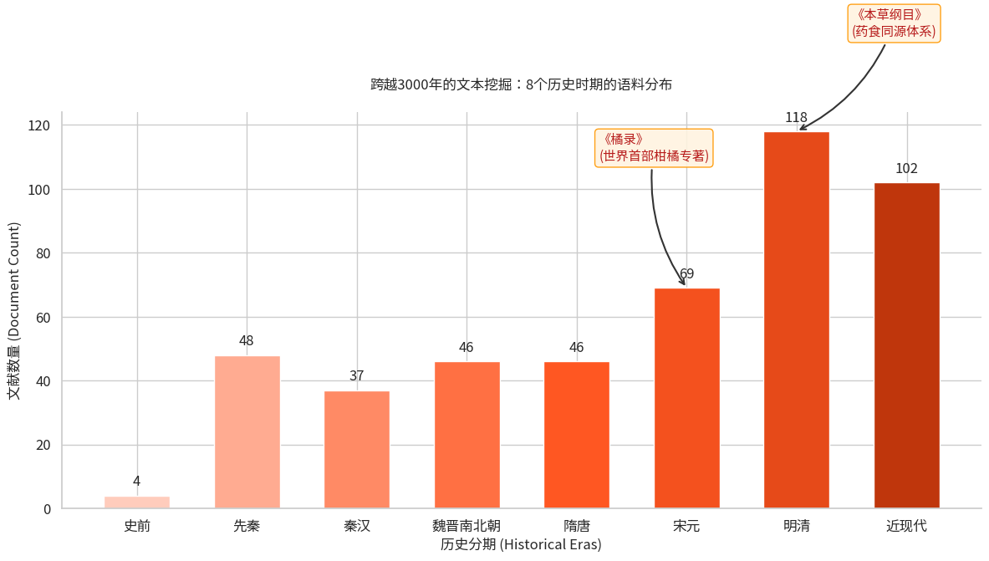Figure 1. Distribution of the historical corpus across eight eras.

3.3 NLP Data Processing Pipeline
In order to convert unstructured historical texts into a machine-readable format for Word2Vec and Network analysis, we implemented a specialized NLP pipeline :

3.3.1 Semantic Fusion Strategy
A key innovation was the creation of a “super-context” for each entry. Instead of analysing the text alone, we merged four columns: Text (Original Classical Chinese), Keyword (Entity Tags), Symbolism (Abstract Categories), and Description (Modern Interpretations). This fusion bridges the gap between archaic language and modern analytical concepts, allowing the model to capture both explicit mentions (e.g., “eating an orange”) and implicit meanings (e.g., “filial piety”).

3.3.2 Tokenization and Noise Reduction
We utilized Jieba, a Python-based Chinese text segmentation module, to tokenize the fused text. A customized Stop-Word List was developed to filter out:
- Syntactic Noise: Common classical particles (e.g., 之, 乎, 者, 也) that carry no semantic weight.
- Academic Noise: Generic research terms (e.g., "record," "describe," "source") that appeared frequently in the metadata but added no cultural value.

3.3.3 Entity Normalization and Preservation
To ensure the accuracy of the semantic network, we applied specific rules for the entity:
- Synonym Unification: Variations of the fruit's name—such as Ju (橘), Gan (柑), Cheng (橙), and You (柚)—were unified into the single token "Mandarin" (橘) where appropriate, to consolidate semantic weight for the vector model.
- Single-Character Preservation: Unlike standard NLP pipelines that often discard single-character words, we strictly preserved the character "橘" (Ju) to ensure it remained the central node in our topological analysis.
Through this process, the 470-text collection was transformed into a structured, high-dimensional dataset, ready for semantic network and evolutionary trajectory analysis.

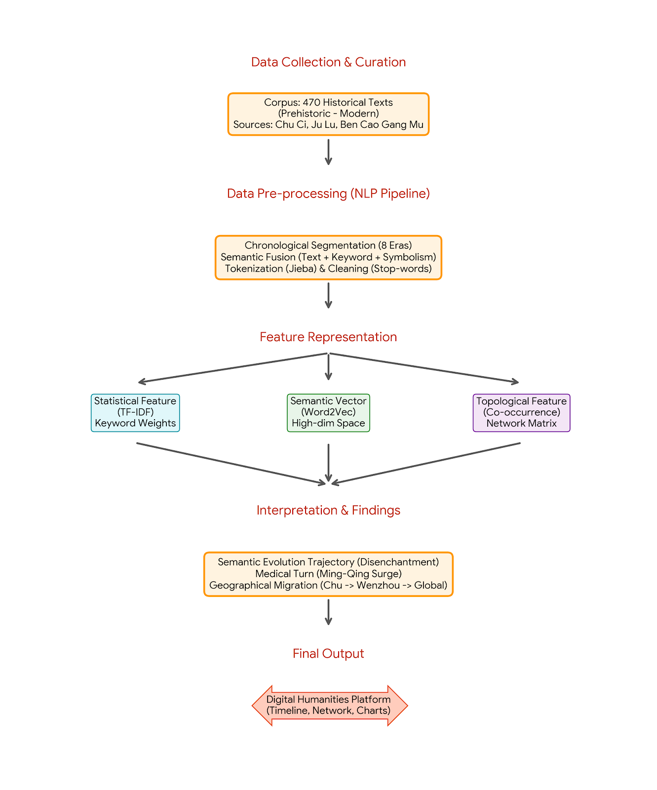
Figure 2. The methodological workflow of the Digital Humanities analysis, illustrating the transformation from raw historical corpus to quantitative semantic features and final interpretive findings

4. Feature Representation and Construction
To move from qualitative reading to quantitative analysis, raw texts were transformed into computable features. We created three feature types to capture Mandarin’s linguistic and semantic properties over history: keyword statistics, distributed semantic vectors, and relational co-occurrence matrices.

4.1 Statistical Feature Construction: TF-IDF Weights
We used TF-IDF to capture the distinctiveness of cultural concepts across eras. Unlike simple word counts, which favor common words, TF-IDF highlights era-specific terms while downweighting ubiquitous ones. For a term t in a document d (representing a specific era) within corpus D, the feature weight is calculated as:
$TF-IDF(t,d) = tf(t,d)×log(\frac{|D|}{|\{d∈D:t∈d\}|})$
This feature construction allowed us to identify the "representative keywords" for each period (e.g., "Jiangpu" for Pre-Qin vs. "Li Shizhen" for Ming-Qing), effectively isolating the dominant cultural themes from background noise.
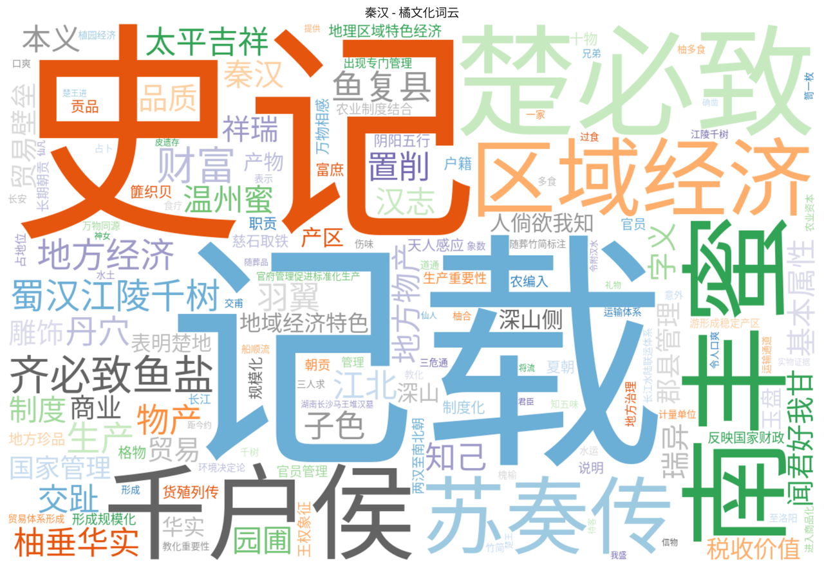
Figure 3. Feature representation using TF-IDF: Key semantic clusters in the Pre-Qin era.

4.2 Semantic Vector Construction: Word Embeddings
To capture the subtle shifts in meaning, we utilized Word Embeddings to map the Mandarin into a high-dimensional vector space.
- Vector Construction: Using the Word2Vec algorithm, each cultural keyword was converted into a dense vector $v∈ R^{n}$ (where $n=100$ in our model).In this space, the semantic relationship between words is represented by geometric distance.
- Quantifying Shift: This feature allows us to mathematically calculate the "Semantic Drift." We can measure how the vector $v_{mandarin}$ moves away from the cluster of moral terms ($v_{virtue}$, $v_{loyalty}$) in the Pre-Qin era and gravitates towards medical terms ($v_{medicine}$) in the Ming-Qing era.

4.3 Topological Features (Co-occurrence Matrices)
To reconstruct the relational structure of the Mandarin's cultural environment, we generated Co-occurrence Matrices for each historical era. We defined a symmetric matrix $M$ where each entry $M_{ij}$ represents the frequency with which term $i$ (e.g., "Mandarin") and term $j$ (e.g., "Tribute") appear within the same context window. These matrices form the basis for our semantic network graphs, enabling visualization of the Mandarin’s “social circle” density and centrality over three millennia.

5. AI Techniques and Semantic Network Implementation
Building upon the constructed features, we orchestrated a suite of computational methods specifically tailored to handle the nuances of classical Chinese texts..

5.1 Keyword Extraction Algorithm (TF-IDF Implementation)
To identify each era’s defining vocabulary, we used TF-IDF rather than simple frequency counts, which overemphasize common words. TF-IDF downweights ubiquitous function words and highlights era-specific cultural markers, distinguishing, for example, Pre-Qin moral vocabulary from Modern commercial terms and ensuring keywords reflect each period’s zeitgeist.

5.2 Semantic Shift Modeling (Word2Vec Architecture)
To trace semantic change, we trained era-specific neural network models using Word2Vec.
- Model configuration: Given the brevity and density of classical Chinese, we chose the Skip-gram architecture over CBOW, as it better captures rare semantic relations in small datasets.
- Parameter Optimization: We set a context window of 5 and trained for 150 epochs to force deeper semantic learning within our specialized corpus, enabling precise cosine-distance comparisons between “Mandarin” and concepts such as “Virtue” and “Commerce” across millennia.

5.3 Network Visualization and Analysis (NetworkX)
We employed NetworkX (Python) to extract topological features and render them into interpretable Semantic Co-occurrence Networks.
- Node & Edge Rendering: Nodes were sized by degree centrality (importance), and edges were weighted by co-occurrence frequency.
- Layered Visualization: We applied hierarchical visualization, grouping nodes into thematic categories (e.g., Symbolism, Medicine, Commerce) with color coding. This revealed a structural shift in Mandarin’s semantic network—from vertical oriented structure(Man–God/Man–King relations) in early eras to horizontally oriented structure(Man–Object/Commodity relations) in later periods.
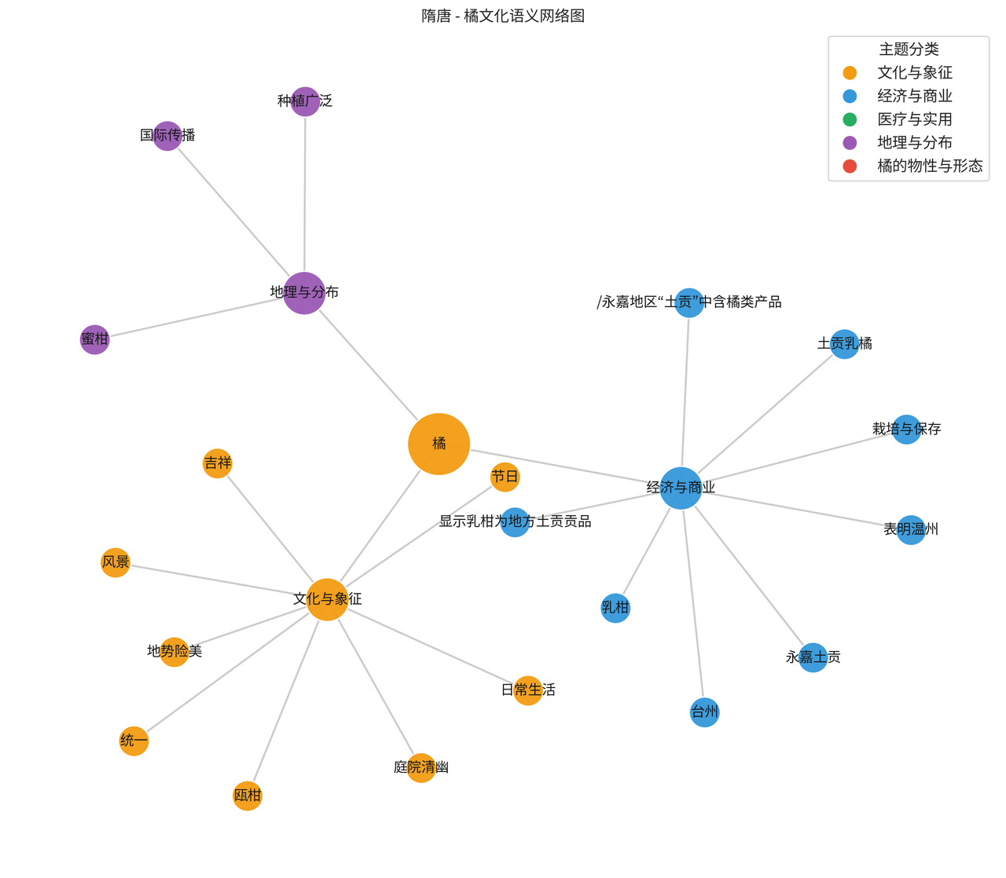
Figure 4. Semantic Co-occurrence Network construction (Sample: Sui, Tang Dynasty)

6. Interpretation and Findings
Drawing on the NLP-derived quantitative features and the Word2Vec semantic models, this study identifies a tripartite evolutionary trajectory for the Mandarin orange over three millennia. The data shows a structural shift from spiritual personification to political institutionalization, and ultimately to practical commodification.

6.1 Phase I: The Spiritual Identity & The Moral Mirror (Pre-Qin to Han)
- Quantitative Evidence: TF-IDF analysis of the Pre-Qin corpus reveals that the highest-weighted keywords are "Virtue" (德), "Jiangpu" (江浦), "Nan Guo" (Southern Land), and "Junzi" (Nobleman). In the semantic network, the node "Mandarin" forms a dense, exclusive cluster with concepts of "Loyalty" (忠) and "Independence" (独立).
- Interpretation: In this early phase, the Mandarin was defined by identity rather than utility, functioning as a “moral mirror” for the literati. Frequent geographical terms such as “Jiangpu” and “Nan Guo” reinforce the fruit’s symbolic “rootedness”: just as the orange tree refuses to grow north of the Huai River, the virtuous gentleman refuses to compromise integrity. The Mandarin thus served as a spiritual totem of Chu culture, embodying political resistance and ethical purity, rather than a mere commodity.
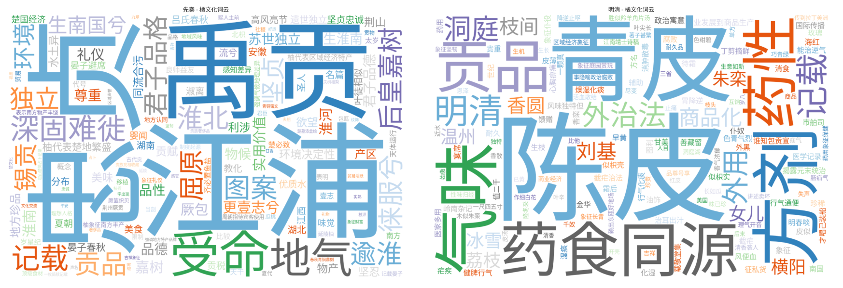
Figure 5. demonstrates the stark contrast in high-frequency vocabulary. The Pre-Qin era (left) is dominated by abstract moral terms, while the Ming-Qing era (right) is dominated by concrete material terms.

6.2 Phase II: Institutionalization & The Political Token (Tang to Song)
- Quantitative Evidence: Moving into the Tang and Song dynasties, the semantic landscape shifts dramatically.
  - Network Centrality: The term "Tribute" (贡/土贡) emerges as the central node in the co-occurrence network, linking "Mandarin" to "Imperial Court" (宫) and "Emperor" (御).
  - Geographical Migration: Our Geo-Heatmap shows a massive spike in data points for "Wenzhou" (温州) and "Wu Region" (吴地) during the Song dynasty.
- Interpretation: The Mandarin underwent Institutionalization. It transitioned from a personal moral symbol to a state-controlled resource.
  - Political Function: The prevalence of “Tribute” shows that the Mandarin became a “political token,” reinforcing the feudal hierarchy between local regions and the central government.
  - Agricultural Systematization: The emergence of provenance keywords like “Wenzhou” and “Haihong” aligns with Ju Lu (The Orange Record), marking the rise of systematic agronomy, where the Mandarin was valued for standardized quality and “brand reputation” rather than just metaphorical meaning.
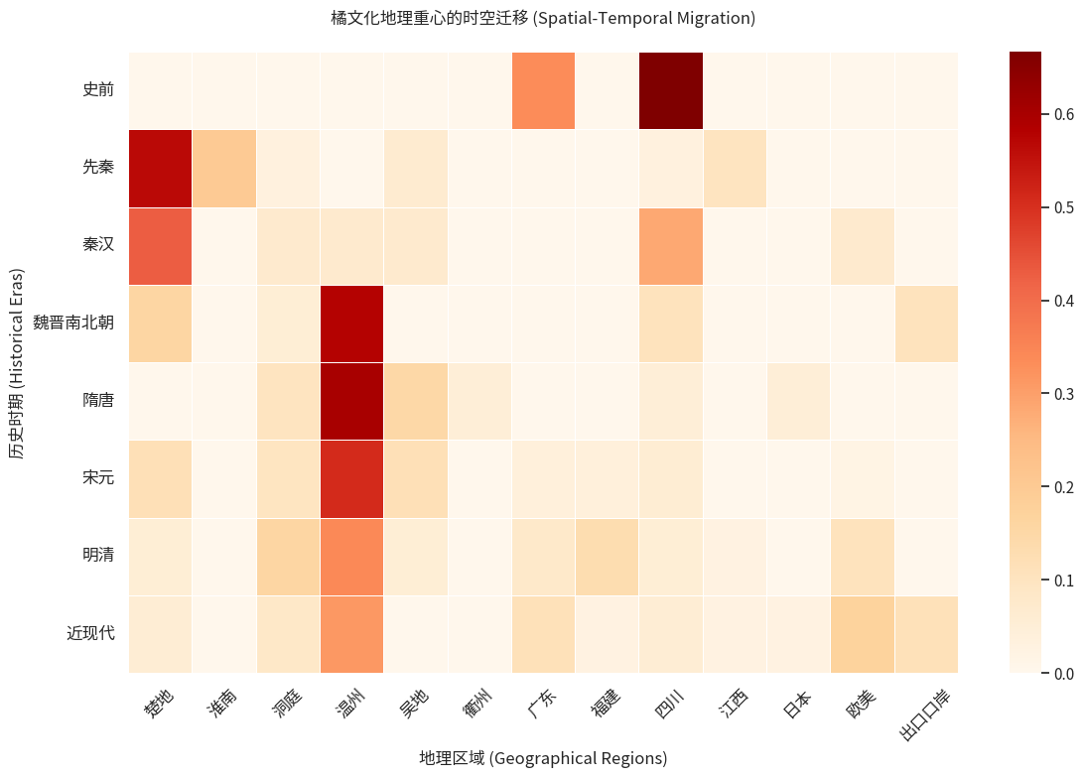
Figure 6. Spatial migration of the Mandarin's cultural center from Chu to Wenzhou and beyond

6.3 Phase III: The Practical Turn & Global Commodification (Ming-Qing to Modern)
- Quantitative Evidence: The most significant semantic rupture occurs in the Ming-Qing period, which we define as the "Medical Turn".
  - LDA Topic Modeling: The topic intensity chart shows an explosive growth in the "Medicine" topic (Green Bar) during the Ming-Qing era, suppressing the "Culture" topic.
  - Word2Vec Neighbors: The nearest semantic neighbors for "Mandarin" shift to "Li Shizhen" (李时珍), "Chenpi" (陈皮), "Peel" (皮), and "Flavor/Nature" (性味).
  - Modern Lexicon: In the modern corpus, terms like "Export", "Brand", and "Origin" dominate.
- Interpretation: The Mandarin was Deconstructed and Secularized.
  - The Medical Gaze: The medical perspective shifted focus from the fruit as an aesthetic whole to its functional parts (peel, seeds, pith). Its strong association with “Li Shizhen” reflects the rise of the “medicine and food homology” system, turning the Mandarin into a tool for bodily healing rather than spiritual cultivation.
  - Commodification: In the modern era, the semantic focus shifts to economic exchange. The Mandarin is stripped of its mythological aura to become a standardized commodity circulating in the global market, completing its journey from the altar to the shelf.
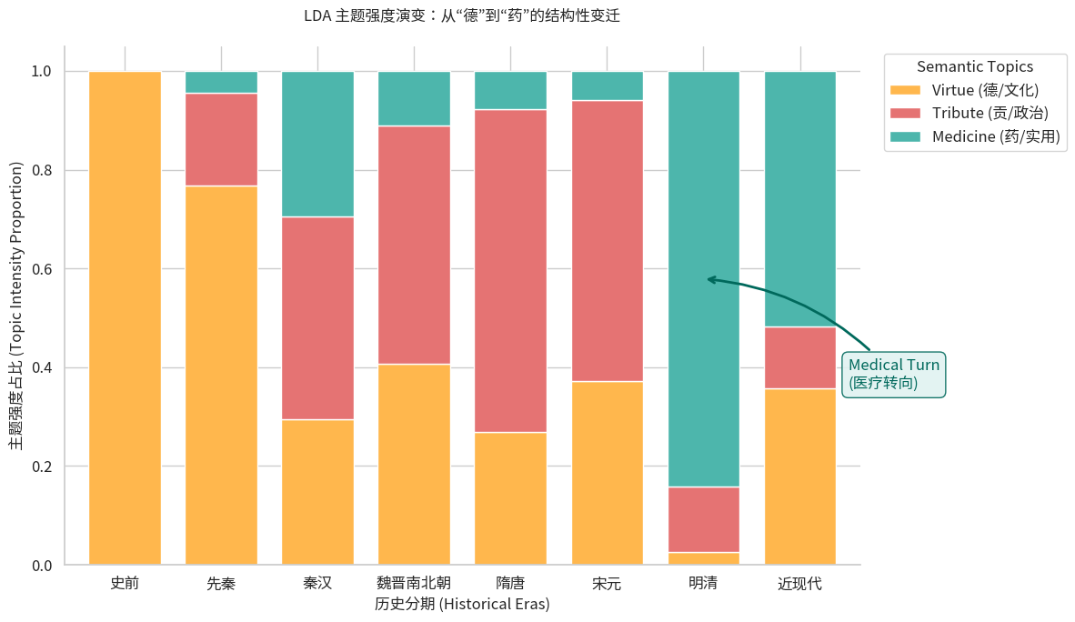
Figure 7. The "Medical Turn": Quantitative visualization of the surge in medicinal keywords during the Ming-Qing era.

7. Conclusion and Future Work

7.1 Summary of Findings
This study has successfully reconstructed the 3,000-year semantic biography of the Mandarin orange using Digital Humanities methods. Our findings confirm a tripartite evolutionary trajectory:
- Personification (Pre-Qin): A sacred symbol of Virtue.
- Institutionalization (Tang-Song): A political symbol of Power.
- Utility (Ming-Qing/Modern): A material resource for Health and Trade.

7.2 Theoretical Contribution
Beyond the fruit’s history, this study illustrates a macro-historical logic of “Cultural Disenchantment” (祛魅). The Mandarin’s trajectory reflects China’s secularization—from elite idealism to imperial pragmatism, and finally to popular materialism—surviving by continually re-contextualizing itself across eras, from poetry to medicine and commerce.

7.3 Future Work & Reflection
From Data Analysis to Cultural Education: Despite a limited timeline and a 470-entry sample, this full-cycle Digital Humanities project demonstrates the power of our methodology, yielding significant historical insights. The study of the Mandarin provides a valuable “spark” for traditional Chinese cultural studies, showing how quantitative evidence can illuminate qualitative history.
Educational Vision: We aim to transform our analysis platform into a public educational tool. By visualizing the “Romance of the Mandarin” through interactive timelines and networks, we hope to share Chinese cultural history with a broader audience, bridging academic research and public knowledge.
Unearthing Hidden Treasures: Through “distant reading,” we observed the rich cultural significance embodied in a single fruit, sparking our curiosity. If the Mandarin reflects ideological shifts over three millennia, countless other narratives await discovery. We aim to apply these computational methods to uncover further “humanistic treasures” in Chinese historical records and trace the evolution of other cultural symbols.

Reference
陈寿. 三国志. (Original work published ca. 3rd century)
韩衍. 橘录. (Original work published 1178)
李时珍. 本草纲目 (L. Xiwen, Trans.). (Original work published 1596)
屈原. 楚辞 (D. Hawkes, Trans.). (Original work published ca. 3rd century BCE)
司马迁. 史记 (B. Watson, Trans.). (Original work published ca. 91 BCE)
王羲之. 奉橘帖. (Original work produced ca. 4th century)
晏子. 晏子春秋. (Original work published Warring States Period)
欧阳修, & 宋祁. 新唐书. (Original work published 1060)
Mikolov, T., Sutskever, I., Chen, K., Corrado, G. S., & Dean, J. (2013). Distributed representations of words and phrases and their compositionality. Advances in Neural Information Processing Systems, 26, 3111–3119.
Moretti, F. (2013). Distant reading. Verso.
Schafer, E. H. (1963). The golden peaches of Samarkand: A study of T’ang exotics. University of California Press.
Project Team. (2024). Mandarin cultural corpus (Step1_clean_era_fixed.csv) [Data set]. Unpublished raw data.

