Analyzing Customer Feedback on Amazon to Reveal Sentiment Trends using Machine Learning
Dr. J. Krishna1[0000-0001-9283-4595] | A. Lakshmi Narayana2 | Shaik Mahammad Khaja Juber ³ | Pavan Kumar .V ⁴ | Mothilal Yadav .Y ⁵| Siva Karthik .G ⁶
1 Associate Professor, Dept. of AI & ML Annamacharya University, Rajampet, AP, India, krishna.j.jk@gmail.com
2, 3, 4, 5 UG Scholar, Department of AI&ML, Annamacharya Institute of Technology and Sciences , Rajampet, Andhra Pradesh, India.
appireddylucky973@gmail.com, jubershaik878@gmail.com, pavankumarvootla1@gmail.com, yarravulamothilalyadav@gmail.com, sgunti097@gmail.com
Abstract: Online reviews on platforms like Amazon provide valuable insights into customer experiences, but manually processing this data is time-consuming and impractical. This paper “Analyzing Customer Feedback on Amazon to Reveal Sentiment Trends using Machine Learning” delves into the providing details of sentiment analysis on Amazon reviews, utilizing machine learning techniques. This paper aims to automate the classification of reviews based on both topic classification (product-based review or service-based review) and sentiment (positive review, negative review, neutral review). This study examines the application of machine learning techniques to analyze customer feedback from Amazon, with a focus on separately classifying product and service reviews, followed by sentiment analysis for each category. The results highlight key trends in customer experiences and demonstrate the effectiveness of machine learning in multi-level sentiment analysis. By the use of Naïve Bayes Classifier, the model achieves the accuracy of range 80% to 90%.
Keywords: Sentiment Analysis, Machine Learning, Topic Classification, Product Reviews, Amazon Reviews, Naïve Bayes Classifier.

Introduction:
Social media has evolved into an excellent networking tool, and practically every segment of society now uses it [1]. Most of the social media content is created through online markets. As the rapid growth of online retailing knowledge takes place, the wide range of customers choose to purchase online. These e-commerce sites have eased shopping. With the vast number of products and services available on a platform, customer feedback acts as an important factor for both consumers and manufacturers. This customer feedback is available in many forms like text reviews, ratings, images, emojis etc. They influence purchasing decisions, provide valuable insights for companies or manufacturers aiming to improve their products and services. But the volume of data taken as customer feedback is so huge that manually analyzing these reviews is neither sufficient nor scalable. This is why we need machine learning algorithms that simplify this task. Sentiment analysis is defined as the study of human ideas, sensations, attitudes, and emotions. Large amounts of unstructured data can be automatically analyzed by machine learning models utilizing an aspect of natural language processing (NLP), sentiment analysis, which then categorizes the customer evaluations as neutral, negative, or positive [2]. Such models not only do sentiment classification but also help to uncover patterns and trends present in the customer feedback, providing deeper insights into major aspects like product quality, service efficiency, or brand reputation. According to several studies, sentiment analysis is usually carried out at three levels: phrase-, document-, and sentence-level [3].
Data mining is an area of research extensively pursued. This study thus crossed the boundary of science that includes those areas of management and the social science. With the rapid development associated to sites like Twitter, microblogging, and chatting rooms, sentiment analysis remained a powerful tool [5]. Such an enormous amount of opinions could be digitally obtained and analyzed today and more than ever before. Opinions are the base of all human activities, and for this reason alone, the sentiment analysis technologies are widely used both in commercial and non-profit activities. Thus, it plays a very important role in determining how we behave. A vision that the opinion and beliefs of everything else create determines what we think, feel, and ultimately decide. That is the reason why people usually seek out the opinions of others whenever a decision must be reached. It benefits both consumerism and manufacturers. Customers on Amazon will rate and review the products and services. The reviews vary according to the kind of product and assist companies in enhancing their products while listening to people who have left unfavorable comments.
Over the past ten years, machine learning has been more important in sentiment analysis [6]. For efficient classification, a variety of tools and classification methods are available. Enhanced natural language processing (NLP) techniques, information mining to obtain predictive analysis, and context-specific understanding are among the current research issues in SA [7]. A word vector network was used to evaluate sentiment on Amazon across 5.2 million reviews in beauty, books, electronics, and home categories [8].
The 50k IMDb a review information set, with a well-balanced 1:1 ratio, was one of three datasets tested alongside conformal prediction based on density.
A critical stage of NLP, text preprocessing, was applied through the help of NLTK [4], string and regex libraries of Python to improve the quality attributes of data in turn improving the performance of the machine learning algorithms [17]. Pre-recorded preprocessing consisted of the removal of the numbers and then the removal of markings of non-informative sentences, followed by the tokenization of words according to the problem statement. After that, removal of stop words via NLTK removed common but non-informative words, and punctuations were also removed using the string library. After that, lemmatization standardized words into their base form that is, lemmas, followed by stemming reduced words into root forms. Then, TF-IDF, W2V, and BoW were applied for feature engineering in extracting features from raw data.
This study examines sentiment classification using several machine learning techniques and offers an evaluation of the dataset consisting of Amazon reviews. By using different kind of techniques, like Bag-Of-Words, TF-IDF (Term Frequency and Inverse Document Frequency), and Glove, the reviews were first converted into vector representation. Next, we trained the model in a distinct number of AI and ML algorithms [15]. The suggested approach is carried out in a probabilistic manner. The Naïve Bayes Classifier is employed for analysis in the suggested approach. The Cross-Entropy Loss Function, Accuracy, F1-
Score, Precision, and Recall were then used to evaluate the models. We then analyzed the sentiment categorization of the top performing model. We re-trained the top-performing model on binary classification after doing the experiment on multiclass classifications.

Literature Survey:
The study "Semantic Analysis and Implicit Target Extraction of Comments from Ecommerce Websites" by Hui Song et al. In contrast to implicit features, the traditional method always emphasizes obvious or detailed features. The following list of factors and their characteristics were noted through the client on multiple occasions, indicating that we are concerned about the electrical devices when making an online laptop purchase through an electronic commerce site, the buyer and the website's organizing firm needs to be aware of the consumer reviews for the specific item [18].
To find out what factors most affect Amazon's stock price, researchers Vollero et al. [22] used social media comments left by Amazon consumers. To ascertain the degree to which the service characteristics of these retailers were linked to Amazon- related customer dissatisfaction, they employed natural language processing (NLP) techniques to examine the sentiment and content of the user comments taken throughout a two-year period from the Facebook sites of three major Italian merchants (2016–2018). Consumer electronics retailers have received a lot of feedback from customers regarding Amazon's impact on pricing, customer service, in-store employees, and post-purchase assistance. Customers' unfavourable remarks on Facebook, in contrast to similar reviews posted on the Amazon site in Italian, demonstrate Amazon's requirements for customer service have increased the demands of consumers and lowered customer contentment in their dealings with other companies' businesses. They suggest more research to clarify Amazonification in the framework of wider customer aggravation and dissatisfaction, going beyond the well-known aspects of pricing and logistics.
In their study, Venkataraman and Jadhav [24] aimed to classify consumer evaluations of mobile phones into various star categories, evaluate the reviews, and determine how well the ratings captured the mood. This was only possible once the data had been pre-processed and cleaned. The unstructured text was then transformed into numeric values by using techniques like the TF-IDF and word embedding. The accuracy of their performance was ultimately examined using a variety of techniques, including ensemble models, logistic regression models, and support vector machines. Recall, accuracy, precision, and F1-Score are among the many metrics used for assessment. When using Unigram, a balanced classifier performs better.
Using K Mean, Yadav, M. P., et al. described consumer behavior for e-commerce businesses in their work titled "Mining the customer behavior using web usage mining in ecommerce." Because of the WWW's explosive growth, users may now search, extract, filter, and assess anything they want with ease. Servers may now choose from a supermarket thanks to technological advancements. Therefore, the e-commerce industry used a number of strategies to win over customers, including offering "cash on delivery" and providing product ratings that allowed users to recommend products to friends, family, and colleges based on reviews and other information about the products available on the e-commerce website [19].
Under the title "An approach towards feature specific opinion mining and sentimental analysis across e-commerce websites," Prashast Kumar Singh's research focuses on gathering user opinions about a product and using that information to analyze it, gather geographical data, and retrieve reviews from a variety of sources. This technique has assisted in gathering millions of critiques on social networking platforms by utilizing online slang phrases and idioms [20].
In their work "Web Mining Techniques in E-Commerce Applications," Ahmad Tasnim Siddiqui et al. argued that because it offers millions of options, purchases have increased in comparison to window shopping. Because businesses are able to draw in the majority of their clientele. The fundamental strategy can be carried out by safeguarding the data as time progresses. In addition, the technology was changing quickly every few years. As a result of the extra expenses, users from the previous century have become accustomed to paying the supplier a large sum [21].
In their paper titled "Adapting Naive Bayes to Domain Adaptation for Sentiment Analysis," Songbo Tan et al. [25] described to the sentiment analysis community how the classifiers are determined to determine the specific condition of the classifier in order to identify the token word based on the consumer's feedback and classify the particular segment. The e-commerce industry can provide premium products and services that enable customers to recommend the product to others and satisfy their expectations when they purchase it online through an e-commerce website.

Methodology:

Architecture
This section gives the summary of methodical procedure for carrying out the Sentiment Analysis on Amazon reviews. Figure 1 shows the steps of the process. It starts with data collection and then moves on to preprocessing the data. Following that, feature extraction techniques are used, and trained Machine learning algorithms such as Naive Bayes Classifier. Finally, the models' outcomes are assessed. We improved and changed the schema described in [9] to establish a new template that was specific to our investigation.

Data Collection
Kaggle is the source of the dataset. The Amazon customer feedback dataset, which includes reviews from people who have bought One Plus phones, was gathered for this project. After being gathered, the dataset is transformed into the format of a CSV file then utilized for categorization. The D working directory is where the gathered dataset is kept. Following that, the dataset is imported and used in the categorization procedure. There are 6723 reviews in all.

Exploratory Analysis
Exploratory data analysis (EDA), John W. Tukey introduced the phrase, which refers to the method of closely analyzing data to identify patterns and insights without assuming anything [10]. In data analysis, it's a crucial initial step. The way people rated things with stars was the main focus of our investigation. This is what we found: A clear breakdown of the star ratings among the evaluations is depicted by the statistics in Figure 2. The majority, approximately 61.2%, were rated with five stars,

demonstrating the high degree of reviewers' satisfaction. Four stars were awarded to about 15.4% of reviews, signifying high satisfaction. Approximately 7.8% of the comments were rated with three stars, suggesting that the quality was moderate. A smaller percentage, about 5.2%, got two stars, suggesting that they were less satisfied.
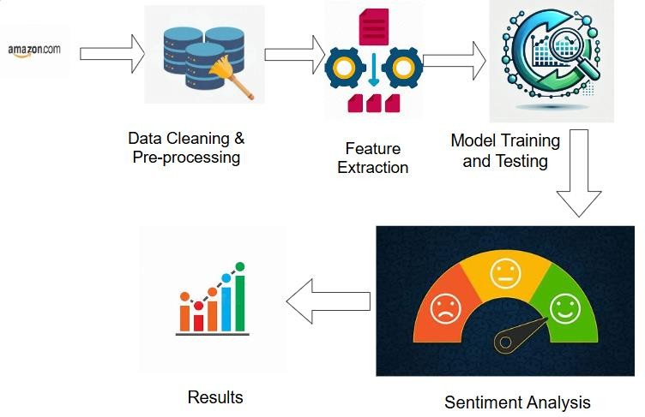
Figure 1: Architecture Proposed

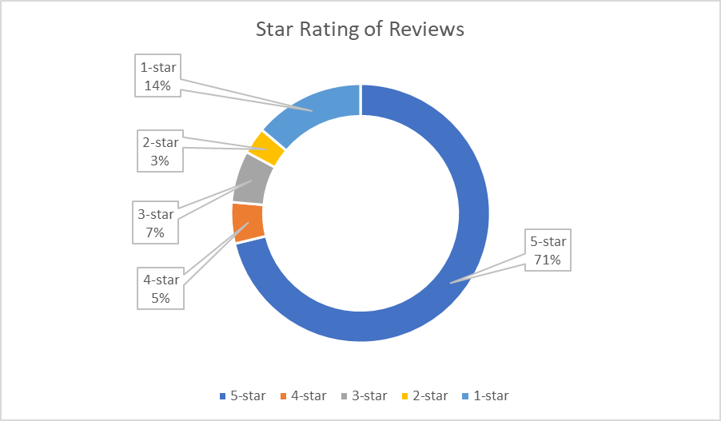
Figure 2: Distribution of the star ratings for reviews

Data Preprocessing
Data preparation is an important stage in NLP activities that improves their efficacy of knowledge acquisition. Techniques for preparing data, including reduction, transformation, integration, and cleaning, aim to enhance datasets for efficient analysis [11]. Figure 3 depicts all of the preprocessing processes used in this research.
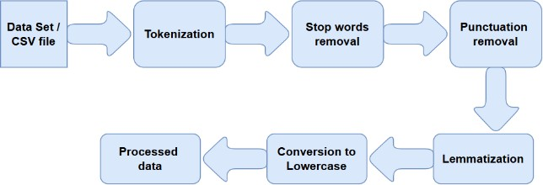
Purpose of Pre-Processing step: Pre-processing, also known as data cleanup, is crucial to preventing overloading and storage issues. Because the dataset is large, extraneous values and other symbols that are not needed for classification purposes are eliminated prior to processing.
Figure 3: Data Pre-Processing Steps

Feature Extraction
A vital step in the field of natural language processing (NLP) is information retrieval, which converts plain context to quantitative structure that machine learning methods can understand easily. Here, we have used the TF-IDF and BOW extraction methods in this research.
Word2Vec [12], a neurological word-to-vector model, that predicts a needed word's vector based on its neighbouring words. The Word2Vec incorporated model typically uses two training procedures: skip-grams and CBOW. This CBOW approach employs the present term to fill in gaps between contextual terms, thus the order of nearby words remains constant, as opposed to the skip-gram planning, resulting in prefers local phrases over far-off ones. CBOW and skip-gram generate complementary vector drawings for each word using local context. GloVe [16] neurological word incorporation considers the complete the

context of terms, as opposed to Word2Vec. GloVe word embedding separates a matrix of words into word vectors using a neural network.
The frequency of words among the simple and reliable techniques for figuring out a text's context is Inverse Document Frequency (TF-IDF) analysis [23]. To identify relevant information and key words and phrases in a longer text, employ term frequency and inverse document frequency. The TF-IDF technique transforms text into a useful mathematical representation that is subsequently fitted to a classification Deep learning algorithm. A parameter used to assess the significance of an expression in a document is the TF-IDF.
𝑇𝐹 − 𝐼𝐷𝐹(𝑡, 𝑑) = 𝑇𝐹(𝑡, 𝑑) × 𝐼𝐷𝐹(𝑡) − − − − − − − − − − − − − −(1) (𝑁𝑢𝑚𝑏𝑒𝑟 𝑜𝑓𝑡𝑖𝑚𝑒𝑠 𝑡𝑒𝑟𝑚 𝑡 𝑎𝑝𝑝𝑒𝑎𝑟𝑠 𝑖𝑛 𝑑𝑜𝑐𝑢𝑚𝑒𝑛𝑡 𝑑)

Algorithm
𝑇𝐹(𝑡, 𝑑) =

𝐼𝐷𝐹(𝑡) =
(𝑇𝑜𝑡𝑎𝑙 𝑛𝑢𝑚𝑏𝑒𝑟 𝑜𝑓𝑡𝑒𝑟𝑚𝑠 𝑖𝑛 𝑑𝑜𝑐𝑢𝑚𝑒𝑛𝑡 𝑑) − − − − − (2)
log(𝑡𝑜𝑡𝑎𝑙 𝑛𝑜. 𝑜𝑓 𝑑𝑜𝑐𝑢𝑚𝑒𝑛𝑡𝑠)
− − − − − − − − − (3)
𝑁𝑜. 𝑜𝑓 𝑑𝑜𝑐𝑢𝑚𝑒𝑛𝑡𝑠 𝑐𝑜𝑛𝑡𝑎𝑖𝑛𝑖𝑛𝑔 𝑡𝑒𝑟𝑚 𝑡

As a probabilistic approach (Naive Bayes content categorization), the Bayesian configuration is applied similarly [13]. A very simple classification model is the Naive Bayes Classifier. It is simple and useful for classifying texts. It is a probabilistic classification that uses high independence assumptions and the Bayes theorem. With all of its features independent of the value of the class variable, this is the most fundamental kind of Bayesian network. It's called conditional independence. It assumes that all of the class's characteristics are conditionally independent of one another.
The Bayes rule is defined as
𝑃(𝑎|𝑏) = 𝑃(𝑎) ∗ 𝑃(𝑏/𝑎)/𝑃(𝑏) − − − − − − − − − − − − − − − − − − − − − − − (4)
Where a is a specific class, and b is the text to be classified. The prior probability for this class and text are P(a) and P(b). P(b|a) represents the likelihood that the text will occur given this class. In this case, class a may have a POSITIVE or NEGATIVE value, and t is only a phrase. The objective is to maximize P(a|b) by selecting a value for c. Naive Bayes is a numerical-based technique with numerous benefits, including simplicity, speed, and consistency.

Pseudocode of Naive Bayes Approach:
Source:
The mobile device product evaluation dataset D Result:
A matrix with both true and false scores in it.
Implementation:
- Analyze the source information set D.
- Divide the information set into training t and testing t1 Where, (t, t1) ∈ D.
- The Function of Naïve Bayes (NB).
- Assume t1 as data segments.
- Evaluate the Prior Probability (P1) = Mi/M,
Mi → Indicates the number of matching classes in the dataset. M →Indicates the no. of both the classes in the dataset.
- Evaluate Posterior Probability (Po) P2= max (P(p),P(n))
P(p) = P(x1|certain)*P(x2|certain) *…P(xn |certain) P(n)=P(x1|uncertain)*P(x2|uncertain)*…P(xn |uncertain)
Where, ((x1, x2 ……xn) ∈X) ((x1, x2 ……xn ), terms in the group of objects) X, array of terms in the group of objects.
- When P(p) and P(n) are compared, the higher-ranking category is chosen as the outcome.
- Get the outcome.
- End of the function.

Model Training and Testing
The labelled data's training and testing sets are separate from one another. The learning information is utilized to instruct the chosen machine learning model. Seventy to eighty percent of the data is used for training, while twenty to thirty percent is used for testing.
A structured data set including text specimens and the corresponding sentiment values (such as positive, negative, or neutral)
—is required in order to train our sentiment analysis algorithm. We can either use an existing dataset or create our own, depending on the availability and relevance of the data for our project. To create our own dataset, we need to collect text samples from our data sources, including online communities, surveys, comments, or blogs, and annotate them manually or with the help of tools. we also need to ensure that our dataset is balanced, diverse, and representative of our target domain.
To test the model, we need to apply it to new and unseen data and compare its results with the expected outcomes. We can use a hold-out set, a split of your original dataset that we did not use for training or optimization, or a new dataset from a different source or time period. We can also use qualitative methods, such as user feedback, expert review, or case study analysis, to assess the usability, reliability, and impact of model.

Results and Discussion

Accuracy, F-score, recall, and precision are measures used to evaluate categorization algorithms. These factors are important for determining the success rate of supervised machine learning approaches. The confusion matrix, also known as a contingency table [14], presents a split with fake positives, fake negatives, genuine positives, and genuine negatives, providing for a thorough evaluation of how well the model performed.
Accuracy: It assesses the generalizability of the model by looking at how well it performs in various class types. When each decision is meaningful and practical, estimation performs at its peak.
𝐴𝑐𝑐𝑢𝑟𝑎𝑐𝑦 = ((𝑇𝑃 + 𝑇𝑁))/((𝑇𝑃 + 𝑇𝑁 + 𝐹𝑃 + 𝐹𝑁)) − − − − − − − − − (5)
Precision: It determines the accuracy of the model's positive trial classification [33]. This figure is determined by separating the entire amount of positive instances by the overall amount of samples through beneficial results that were correctly or incorrectly recognized.
Pr 𝑒 𝑐𝑖𝑠𝑖𝑜𝑛 = 𝑇𝑃/(𝑇𝑃 + 𝐹𝑃) − − − − − − − − − − − − − − − − − − − (6)
Recall: This score demonstrates the design's capacity to categorize certain values. The percentage is calculated by dividing the amount of true instances by the overall amount of genuine tests which were accurately classified as true.
𝑅𝑒𝑐𝑎𝑙𝑙 = 𝑇𝑃(𝑇𝑃 + 𝐹𝑁) − − − − − − − − − − − − − − − − − − − − − (7)
F1-measure: It is a measure of a model’s accuracy on a dataset. It is used to evaluate binary classification systems.
𝐹1 − 𝑚𝑒𝑎𝑠𝑢𝑟𝑒 = (2×𝑝𝑟𝑒𝑐𝑖𝑠𝑖𝑜𝑛×𝑟𝑒𝑐𝑎𝑙𝑙) − − − − − − − − − − − − − − − (8)
(Pr𝑒𝑐𝑖𝑠𝑖𝑜𝑛+𝑟𝑒𝑐𝑎𝑙𝑙)
Table 1: Performance of Naïve bayes Classifier

Model Name | Accuracy | Precision | Recall | F1-measure
Naive Bayes  Classifier | 87% | 85% | 87% | 87%
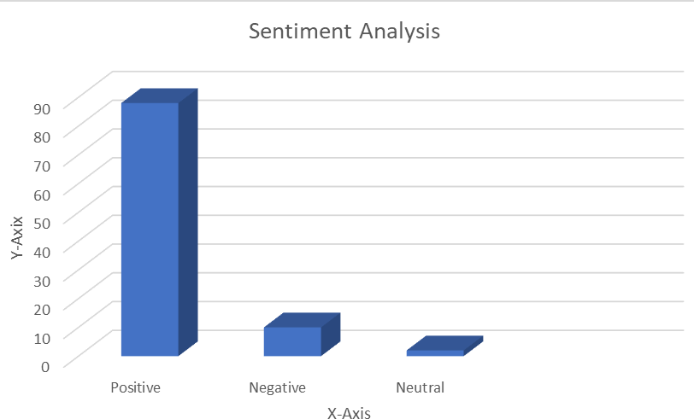
Figure 4: Sentiment Classification

Conclusion and Future work
The classifier is very scalable and requires only a few parameters. Naive Bayes is a straightforward classification approach. While there are numerous machine learning approaches available for evaluation, Naive Bayes is among most effective and offers accurate categorization results. The proposed method compatible for might be used to review any type of dataset. The work might possibly be developed to include a higher degree of input set.
This approach addresses a fundamental challenge in sentimental analysis by properly preparing the dataset. For better results, managing negation and word similarity will be handled in the future. The approach might be expanded to include other datasets, thereby increasing accuracy levels further.

References:
- S. M. AlQahtani, ‘‘Product sentiment analysis for Amazon reviews,’’ Int. J. Comput. Sci. Inf. Technol. (IJCSIT), vol. 13, no. 3, pp. 15–30, 2021.
- Rashid and C. Huang, ‘‘Sentiment analysis on consumer reviews of Amazon products,’ Int. J. Comput. Theory Eng., vol. 13, no. 2, p. 7, 2021, doi: 10.7763/IJCTE.2021.V13.1287.
- S. Wassan, X. Chen, T. Shen, M. Waqar, and N. Z. Jhanjhi, ‘‘Amazon product sentiment analysis using machine learning techniques,’’ Revista Argentina de Clínica Psicológica, vol. 30, no. 1, p. 695, 2021, doi: 10.24205/03276716.2020.2065.
- E. Loper and S. Bird, “Nltk: The natural language toolkit,” arXiv Prepr. cs/0205028, 2002.
- A. Dadhich and B. Thankachan, ‘‘Sentiment analysis of Amazon product reviews using hybrid rule-based approach,’’ in Smart Systems: Innova tions in Computing (SSIC). Singapore: Springer, 2022, pp. 173–193, doi: 10.1007/978-981- 16-2877-1_17.
- Y. Xiao, C. Qi, and H. Leng, ‘‘Sentiment analysis of Amazon prod uct reviews based on NLP,’’ in Proc. 4th Int. Conf. Adv. Electron. Mater., Comput. Softw. Eng. (AEMCSE), Mar. 2021, pp. 1218–1221, doi: 10.1109/AEMCSE51986.2021.00249.

- M. Hawladar, A. Ghosh, Z. K. Raad, W. A. Chowdhury, and M. S. H. Shehan, ‘‘Amazon product reviews sentiment analysis using supervised learning algorithms,’’ Ph.D. dissertation, Dept. Comput. Sci. Eng., Brac Univ., Dhaka, Bangladesh, 2021.
- D. A. J. Daniel and M. J. Meena, ‘‘A novel sentiment analysis for Amazon data with TSA based feature selection,’’ Scalable Comput., Pract. Exper., vol. 22, no. 1, pp. 53–66, Feb. 2021, doi: 10.12694/scpe.v22i1.1839.
- P˘av˘aloaia, V.D.; Teodor, E.M.; Fotache, D.; Danile¸ t, M. Opinion mining on social media data: sentiment analysis of user preferences. Sustainability 2019, 11, 4459. [CrossRef]
- Morgenthaler, S. Exploratory data analysis. Wiley Interdiscip. Rev. Comput. Stat. 2009, 1, 33–44. [CrossRef]
- Alasadi, S.A.; Bhaya, W.S. Review of data preprocessing techniques in data mining. J. Eng. Appl. Sci. 2017, 12, 4102–4107.
- T.Mikolov,I.Sutskever, K. Chen,G.S.Corrado,andJ.Dean,‘‘Distributed representations of words and phrases and their compositionality,’’ in Proc. Adv. Neural Inf. Process. Syst., vol. 26, 2013, pp. 1–9.
- Neetu, “Hierarchical classification of web content using Naïve Bayes approach”, International Jouranal on Computer Science and Engineering (IJCSE), Vol. 5, No. 05, May 2013
- N.GargandK.Sharma,‘‘Textpre-processingofmultilingualforsentiment analysis based on social network data,’’ Int. J. Elect. Comput. Eng., vol. 12, no. 1, pp. 2088–8708, 2022, doi: 10.11591/ijece.v12i1.
- Madana Kumar Reddy, C., Krishna, J. (2024). “A Study on Predicting Skilled Employees Using Machine Learning Techniques”. In: Gunjan, V.K., Kumar, A., Zurada, J.M., Singh, S.N. (eds.) Computational Intelligence in Machine Learning. ICCIML 2022, Lecture Notes in Electrical Engineering, vol 1106. Springer, Singapore.
- J. Pennington, R. Socher, and C. D. Manning, ‘‘Glove: Global vectors for word representation,’’ in Proc. Conf. Empirical Methods Natural Lang. Process. (EMNLP), Oct. 2014, pp. 1532–1543.
- S. Sarraf, A. Sarraf, D. D. DeSouza, J. A. E. Anderson, M. Kabia, and A. D. N. Initiative, “OViTAD: Optimized vision transformer to predict various stages of Alzheimer’s disease using resting-state fMRI and structural MRI data,” Brain Sci., vol. 13, no. 2, p. 260, 2023.
- Song, H., Chu, J., Hu, Y. and Liu, X., 2013, December. Semantic Analysis and Implicit Target Extraction of Comments from E-Commerce Websites. In Software Engineering (WCSE), 2013 Fourth World Congress on (pp. 331-335). IEEE.
- Yadav, M.P., Feeroz, M. and Yadav, V.K., 2012, July. Mining the customer behavior using web usage mining in e- commerce. In Computing Communication & Networking Technologies (ICCCNT), 2012 Third International Conference on (pp. 1-5). IEEE.
- Singh, P.K., Sachdeva, A., Mahajan, D., Pande, N. and Sharma, A., 2014, September. An approach towards feature specific opinion mining and sentimental analysis across e-commerce websites. In Confluence The Next Generation Information Technology Summit (Confluence), 2014 5th International Conference- (pp. 329-335). IEEE.
- Siddiqui, A.T. and Aljahdali, S., 2013. Web mining techniques in e-commerce applications. arXiv preprint arXiv:1311.7388.
- A. Vollero, D. Sardanelli, and A. Siano, ‘‘Exploring the role of the Amazon effect on customer expectations: An analysis of user-generated content in consumer electronics retailing,’’ J. Consum. Behav., vol. 22, no. 5, pp. 1062– 1073, 2023, doi: 10.1002/cb.1969.
- Krishna, J., Tejaswini, S., Viswa Sai Reddy, N., Susmitha, S., Sohail, S., Prasanna, G. (2024). “A Novel Dish Recognition Method Using Deep Learning”. In: Kumar, A., Mozar, S. (eds.) Proceedings of the 6th International Conference on Communications and Cyber Physical Engineering. ICCCE 2024, Lecture Notes in Electrical Engineering, vol 1096. Springer, Singapore.
- T. K. Venkataraman and A. Jadhav, ‘‘Classifying the sentiment polarity of Amazon mobile phone reviews and their ratings,’’ in Proc. AIP Conf., Jan. 2023, vol. 2523, no. 1, Art. no. 020123, doi: 10.1063/5.0110605.
- Tan, S., Cheng, X., Wang, Y., Xu, H. (2009). Adapting Naive Bayes to Domain Adaptation for Sentiment Analysis. In: Boughanem, M., Berrut, C., Mothe, J., Soule-Dupuy, C. (eds) Advances in Information Retrieval. ECIR 2009. Lecture Notes in Computer Science, vol 5478. Springer, Berlin, Heidelberg. https://doi.org/10.1007/978-3-642-00958- 7_31

