Cloud Migration Assessment

For



February 13, 2019

Synectiks Inc.
300 Alexander Park Drive, Suite 215
Princeton, NJ 08540
USA

Contents
1. Introduction 3
1.1. Purpose 3
1.2. Background and Goals 3
2. Business Readiness 3
2.1. Business Environment 3
2.1.1. Business Transformation Challenges 3
2.1.2. Pain Points 3
2.1.3. Risk Tolerance 3
2.1.4. Resistance to Change 3
2.2. Business Impact 4
2.2.1. Customer Experience 4
2.2.2. Revenue 4
2.2.3. Cost 4
2.2.4. Time to Market 4
2.3. Business Process 4
2.3.1. Procurement 4
2.3.2. IT Process 4
3. Existing Infrastructure and Application Review 5
3.1. Current Infrastructure 5
3.2. Expected Key Benefits of Migration 6
4. Migration Path 6
4.1. Proposed Solution Architecture 6
4.1.1. AWS Service Mapping 6
4.1.2. Total Deployment Architecture with AD Replica 7
4.1.3. Total Deployment Architecture with AD Connector 8
4.1.4. Database Architecture Diagram 9
4.1.5. Backup Architecture Diagram 9
4.1.6. WorkSpace Access Architecture Diagram 10
4.1.7. Network Mapping Architecture 10
4.2. RoadMap 10
4.2.1. High Level Future State 10
4.2.2. Project Execution Roadmap 11
4.3. Security and Compliance Risk Report 11
4.4. Cut-Over Strategy 11
4.5. TCO & ROI Analysis 11
5. Estimated Effort and Cost 13
5.1. Migration Services 13
5.2. Managed Services 13
6. Acceptance 14

Introduction

  - Purpose

The purpose of this document is to detail the review findings and different plans for cloud migration readiness program for Argus Research infrastructure at London office.

  - Background and Goals

There is a business need to consolidate and centralize hardware infrastructure that exist in London offices and use cloud native services to reduce CAPEX & OPEX and improve quality SLA’s. Our goal is to have a detail review and plan to asses:

- Business Readiness
- Existing Infrastructure and Applications Review
- Risk Mitigation Plan
- Migration Path
- Target Architectures
- Implementation Plan

Business Readiness

  - Business Environment

    - Business Transformation Challenges

- Increase agility to accelerate business - Ability to bring changes rapidly.
- Increase optimization and be in control of costs - a need to do more with less spending
- Modernize the Application and Database stack to improve quality SLA’s
- Location Transparent - Make all business process location transparent.
- Reduce risk - the need to improve the availability, security governance, and the compliance of business support system (BSS) and operational support system (OSS) applications and standardize the IT infrastructure.

    - Pain Points

- Significantly high CAPEX / OPEX on Hardware / License and Operation Team.
- Legacy Application and Database stack, affecting business SLA’s.
- Current services are difficult to scale horizontally or vertically.

    - Risk Tolerance

- As part of risk mitigation, we recommend the following:
  - The main domain controller for entire Argus Research is located in US colocation and users resides under a single OU. We need to make sure that we have a reliable network connection between AWS EU London region and US colocation where primary domain controller resides. We recommend doing some performance benchmarking prior to the execution of actual migration and incorporate any changes in target architecture if required.
  - The business largely uses terminal servers and desktops. We recommend to do reliability check and performance benchmarking of the VPN connectivity between AWS London region and Argus Research London office and check user experience with 1 small size terminal server and 1 desktop in AWS workspace.

    - Resistance to Change

- We observed cultural readiness towards cloud transformation amongst the stakeholders.

  - Business Impact

    - Customer Experience

- Response time is deterministic within Performance SLA
- Elastic infrastructure, grows and shrink with demand, System Scales horizontally as well as vertically to any workload
- Operate in auto pilot mode, maximum automation achieved
- Enable faster time to market to deliver new content and features quickly
- Robust and secure authentication and authorization via AWS native services
- Establish Continuous Integration and Continuous Delivery Pipeline

    - Revenue

- Elastic infrastructure will reduce 60% existing hardware expenses.
- The Automation effort would reduce 80% operation expense.
- The proposed architecture has no assumption of software license, this will reduce 100% license cost.
- It will deliver 10X agility, 5X reliability, and 10X operational efficiency.
- Reduce TCO at 50% (because of 80% operation cost, 60% Hardware Cost, 100% License cost saving. Please refer to detail TCO breakdown.

    - Cost

- The complete migration project would take 2-MAN Months effort. (Detail effort estimation sheet attached)

    - Time to Market

- It will reduce the current release cycle to an extent of 40%.

  - Business Process

    - Procurement

- Either Argus Research team can provide us the AWS account details or synectiks can maintain the AWS account for POC and execution phases. Incase Synectiks provide the AWS account details, Synectiks will invoice AWS resource usage cost in actual.

    - IT Process

- Procure AWS environment from either Argus Research or Synectiks team.
- Use scripted automation scripts to create RBAC environment and network setup along with AWS native services setup.
- Perform POC followed by actual migration paths in AWS environment (As per the details plan)
- Transition the operations to Argus Research support team or Synectiks delivers managed services to maintain the operations.

Existing Infrastructure and Application Review

  - Current Infrastructure

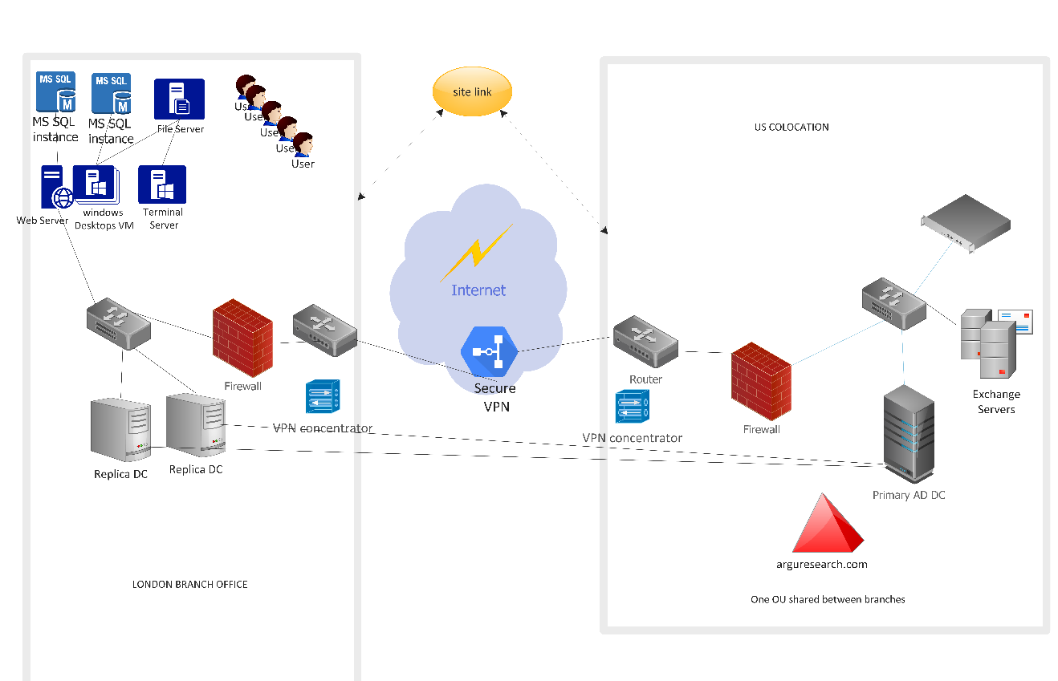

Key Notes:

- The Primary DC is hosted in US co-location. The entire organization is under one active directory OU (arguresearch.com) - the London branch office two DC’s (ADC11 & ADC7) is both the replica of PDC in US location. The two sites are connected through secure VPN gateway. Both the current DC’s are running Windows 2012.

- There are currently two MS-SQL server instances (Data12/Data8), 1 is used for critical business applications data, and another 1 is for Dev/Test environment. Both the database server configuration is as below:

Instance: Data12

OS - Windows 2012
SQL Server - 12.0.52XX
Data Size < 1 TB, ~700 GB
No blob data is currently stored in the database.
Max concurrent Users -30
HA SLA - Standalone

Instance: Data8

OS - Windows 2008 -R2 Sever
SQL Server - 12.0.52XX
Data Size < 1 TB, ~480 GB
No blob data is currently stored in the database.
Max concurrent Users -30
HA SLA - Standalone

- There are two windows desktop client VM (avawin8-07v_wq-clone && InnovationBoxV2_AT), that is primarily used for Dev / Test purpose by sales / analyst / data entry / developer team. They are currently having Microsoft Windows 8 (64-bit). They are currently not hosting any critical application data and they could be re provisioned from standard template (detailed in migration path). The maximum concurrent user is anticipated around 15 and so there could be maximum 15 terminal required for sales / analyst / data entry / developer team.

- There is one terminal server (TSAV3), running on windows 2012 server. The terminal server is currently hosting the multiple sessions of (two tired .Net application). There are maximum 6 concurrent sessions currently run in the terminal server.

- There is one fileserver (FILE9) that is running on windows 2008, hosting around 700 GB of total file capacity. Those files are primary generated from mobile workforce and internal team and some ETL jobs are run to process those files and upload in database records. The files are mostly accessed by UNC path. Currently they are maintained in two folders, public & users. The fileserver has some critical business applications setup apart from those files which is critical for business operation. The applications accessing those files mostly access by UNC path and that is configurable in the application. In case, after the migration, those paths changes, it would be possible to make the configuration changes in application and redirect them to a new path.

- There is one webserver (WEB12) running IIS server for internal DEV/ TEST team. The OS is Microsoft Windows Server 2012 (64-bit). The Web12 server currently hosting some ETL jobs also and they are run from them. Considering its complex setup of jobs, it could an initial candidate for AS-IS migration.

  - Expected Key Benefits of Migration

Scalability | Horizontal and Vertical scalability at infrastructure and services. The server pool will be provisioned in autoscaling group and it could be scaled horizontally as well as vertically.
High Availability | N-Node failover ability at node, services and filesystem data
Management | 80% reduction on Operation, 70% reduction on Hardware expense, repeated platform provisioning through code, 1-touch release upgrade without downtime, hardware changes happens in controlled manner, achieves agility in releases through integration of deployment and test process.
Security | SDN based network security and IAM based access control improves secure access. Authentication and Authorization are primarily done through the existing primary DC at US colocation. For MFA, AWS native services will be used.
Performance | Will upgrade the OS / Database / Application Stack, and Elastic infrastructure should cater the required performance SLA.
Backup & DR | Migration architecture takes care of cross zone (not region) recovery objective. The DR objectives are not fully described in this assessment.

Migration Path

  - Proposed Solution Architecture

    - AWS Service Mapping

ADC11 / ADC7 (Existing DC’s) | AD Connector (1-2)
avawin8-07v_wq-clone InnovationBoxV2_AT | AWS workspace (Currently only 2, but in last meeting we discussed that maximum concurrent users are 15, so may need 15 concurrent AWS workspace terminals? Let’s verify). The target OS could be Windows 10.
Data12 / Data8 - MSSQL | Mapped to initially 2 MSSQL 2016, instances, gradually consolidated to only 1 instance.
File9 (File Server) | Important files will go to AWS workdocs. Rest of the files will go to s3. We need to do some processing to filter out old files that are not used. The machine has some important programs / utilities also, so we need to do ASIS migration of this instance to a low capacity instance with EBS snapshots enabled.
TSAV3 | Migrate to EC2 Windows 2016 Server, with EBS snapshot enabled.
Web12 (Web Server) | Migrate to EC2 Windows 2016 Server.

    - Total Deployment Architecture with AD Replica

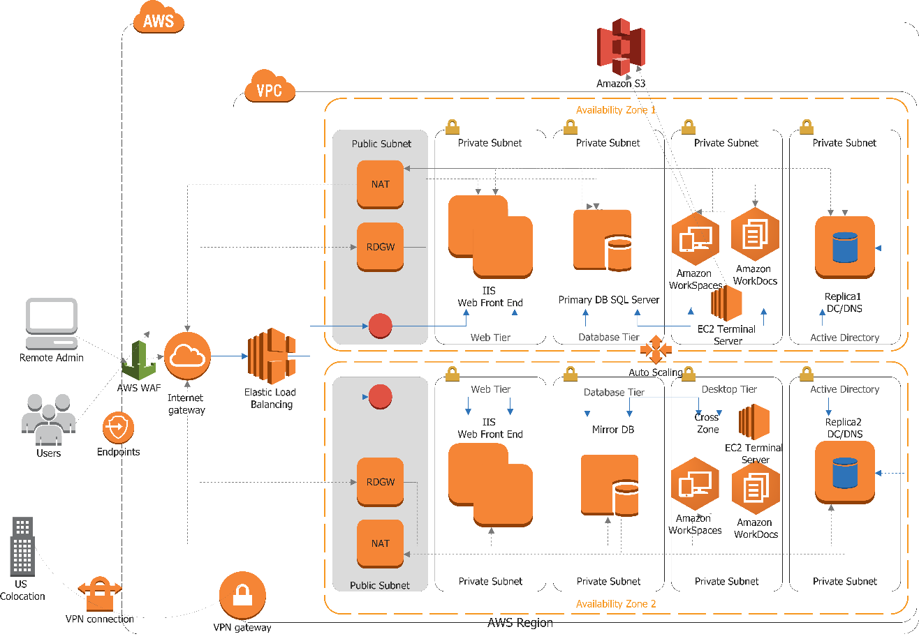
1
2
3
5
4
6

AZ1 - EU-WEST2A, AZ2 - EU-WEST2B

1 | AD replica servers are pooled in an autoscaling group spanned across two AZ’s. Though for better HA purpose, two copies are shown, we could probably keep 1 copy to reduce the cost.
2 | In this private subnet, all desktop and terminal server exist, we could use AWS workdocs service for important documents. This pool is also distributed across two AZ’s.
3 | In this private subnet, MSSQL database instances reside. For HA. we recommend to have a mirrored copy in different AZ2.
4 | In this subnet, we will be placing webserver (web12), which runs some web related Dev / Test workload along with ETL batch jobs. To access the websites, depending on cost factor, we could put an ELB, or we may not use the ELB to lower cost. ELB is recommended.
5 | In public subnet, remote desktop gateway and NAT gateway is placed. NAT GW, is to enable web access of workspace client / terminal server.
6 | A secure VPN connection between AWS VPC and US colocation.

    - Total Deployment Architecture with AD Connector

- AD Connector give an easy way to establish a trusted relationship between US colocation Active Directory and AWS. It’s easier to configure and more economic. AD Connector cannot be used with your custom applications, as it is only used for secure AWS integration for the Amazon WorkSpaces, Amazon WorkDocs, and Amazon WorkMail. If our .Net stack is not using authentication from US colocation active directory, we should probably go with the following AD connector architecture.

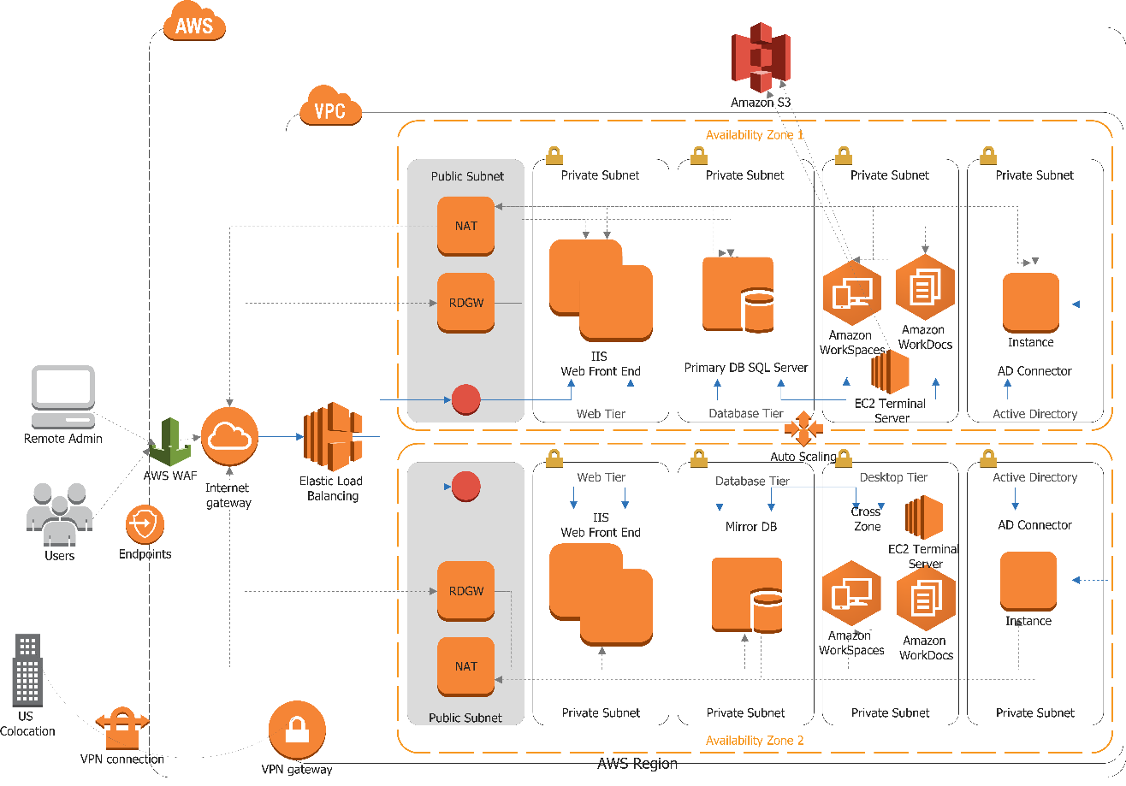

Following diagram shows the workflows for AS Connector.

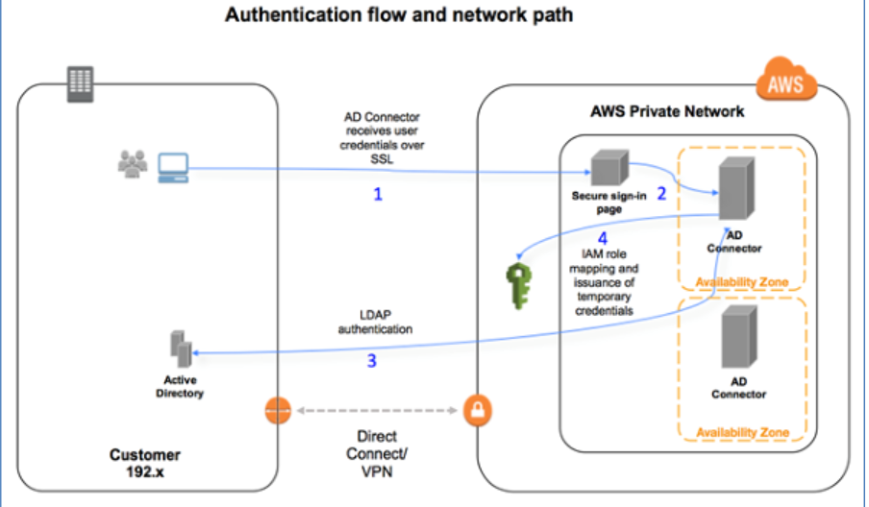
    - Database Architecture Diagram

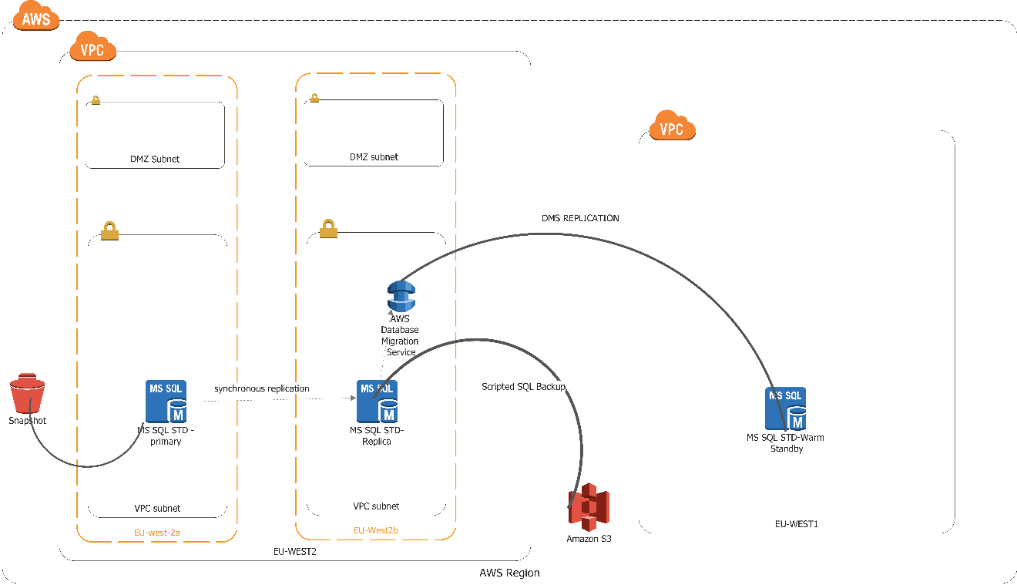

The following options are recommended depending on Cost:

- L1 HA - MSSQL Standard standalone instance is created in EU-West2A region. Periodic snapshots (twice daily) are taken and 30 days snapshots are retained. Also, once a week, the full SQL backup is taken through scripts and stored in S3. This is also retained for 2 months.
- L2 HA - Database is created in Multi Availability Zone model where synchronous replication takes place between the EU-West2A & EU-West2B regions.
- L3 HA - Through DMS tool, every day cross region incremental backup takes place into a standby database located in EU-West1 region.

    - Backup Architecture Diagram

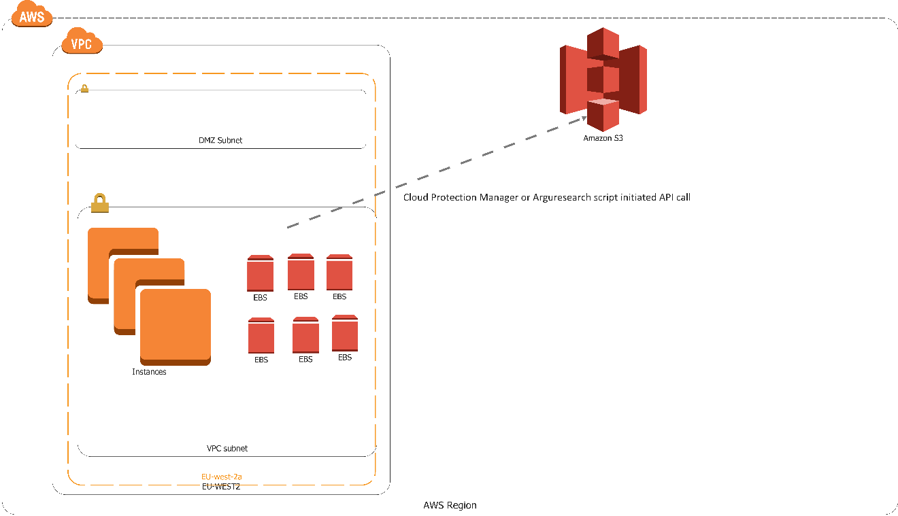
- For Web Server and File Server and terminal server (existing web12 & File9, TSAV3), which has more critical application & data and we decided to do perform ASIS migration, we recommend to take periodic EBS snapshots in s3 either via Veeam N2WS cloud protection manager or through our own custom scripts. The frequency and retention period of EBS snapshot backup is recommended as once per day for a week respectively.
- For AWS WorkSpaces, as they could be spawned from AMI templates and no important data is retained there, we may not take them as a candidate for EBS snapshot-based backup.

    - WorkSpace Access Architecture Diagram

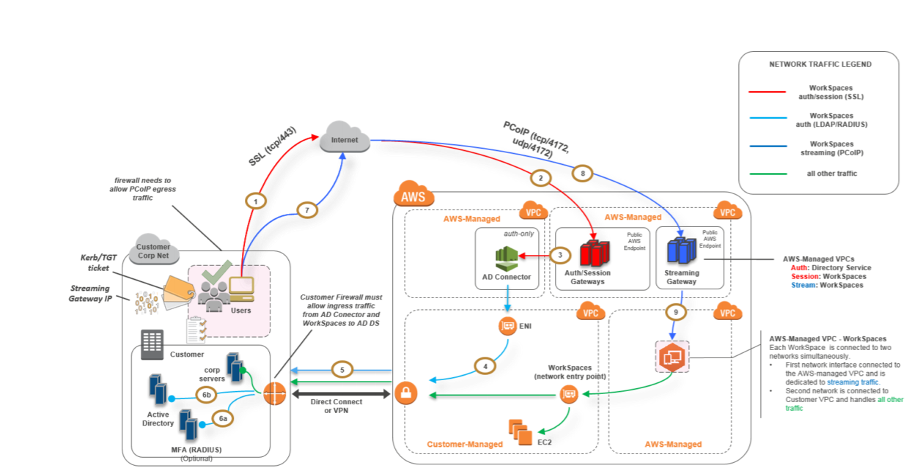

Notes: For MFA requirement, we could also use AWS in-built Radius services

For WorkSpace client, we recommend to use PCoIP Zero Clients.

Since primary DC is located in US colocation, we might need only one VPN connection from AWS EU-West2 location to US location. If there is no compliance requirement, we would recommend not to have any VPN connection from London branch office to AWS London location. PCoIP Zero clients maintain a highly secure session for every connection.

    - Network Mapping Architecture

While considering the network mapping, we recommend to maintain AWS subnet mapping same to the existing subnet so that existing applications having any IP assumption still work without any changes.

  - RoadMap

    - High Level Future State

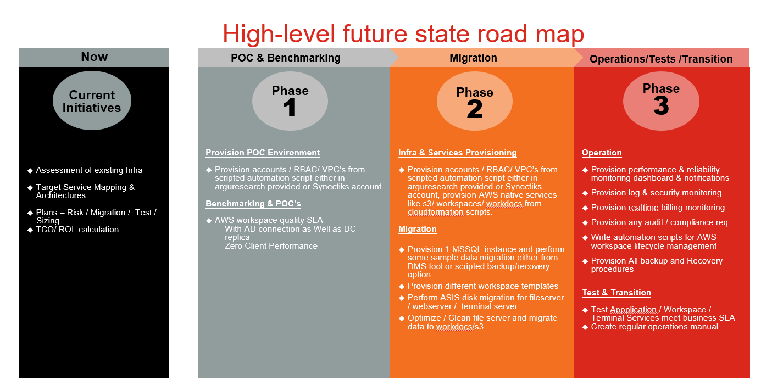
    - Project Execution Roadmap

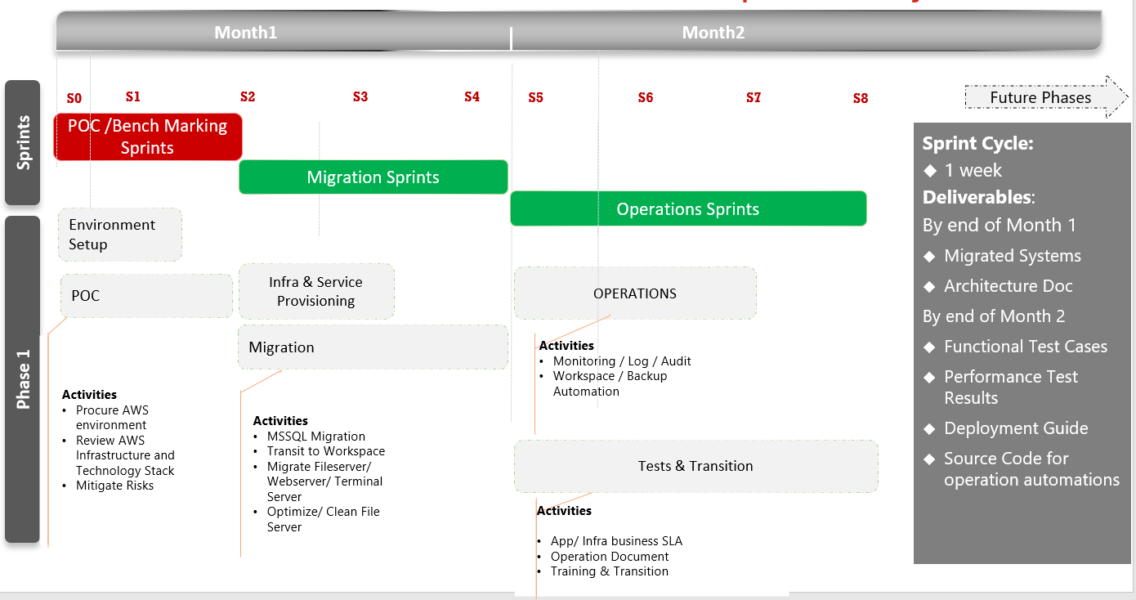

  - Security and Compliance Risk Report

TBD

  - Cut-Over Strategy

- Provision the cloud environment in parallel to the on-premise equipment. Then test the function by migrating some test databases and test files. Run this in parallel for a brief period. Then copy over the databases or files to the cloud environment and retire the instances on-prem. Some of the servers gets migrated using migration tools.

  - TCO & ROI Analysis

Per Month Pricing (No Upfront)

Base Price – 1451$
Backup Tool + Network Xfer + VPN Traffic - $300
Total Cost – 1451+300=1751$/month

Notes:
- This is calculated from AWS calculator, by adding the resources depicted in architecture.
- 2 Workspace Terminal to start with, and gradually we could add more.
- 2 Mssql instances, both are as follows:

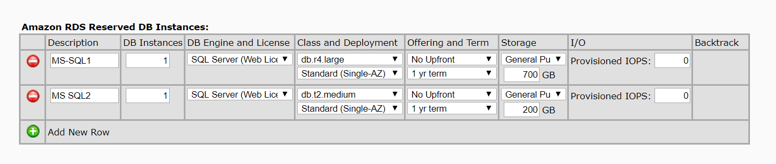

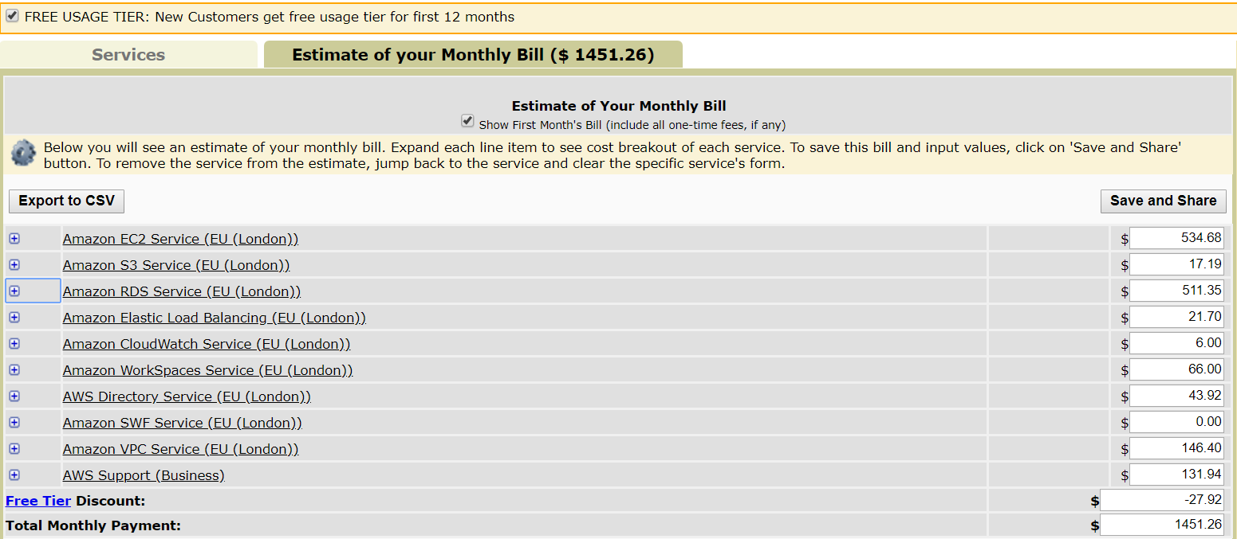

Possible Multi-Year Discounts:

Per Month Pricing (1 Yr. Up-front payment) -
Total One Time Payment – 9528 /Year
Base Price/ Month – 537$
Backup Tool + Network Xfer + VPN Traffic - $300
Total Cost – 537+300=837$/month ( First month +100$)

Per Month Pricing (3 Yr. Up-front payment) -
Total One Time Payment – 23455 / 3 Year
Base Price/ Month – 537$
Backup Tool + Network Xfer + VPN Traffic - $300
Total Cost – 537+300=837$/month

Estimated Effort and Cost

  - Migration Services

- Below is an estimate on Time & Material basis to perform the Migration to AWS (Migration Services).

Estimated Time (Hours) | DevOps Engineer / Hour | Estimated Total Cost
240 | $40.00 | $9,600.00

Note: Statement of Work for the AWS Cloud Transition to be determined.

  - Managed Services

After successful migration both parties (SYNECTIKS & Argus Research) need to agree on the Managed Services scope (deliverables as part of Managed Services). The below charges are to cover bare minimum infrastructure service as per the SLA’s agreed. All other changes to the infrastructure after migration will be billed at $40/Hour (Time & Material).

Managed Services Cost per Month | 15% of AWS Cloud Monthly Billing, with a minimum guaranteed of $500

Acceptance

As a duly authorized representative, I hereby acknowledge, accept and authorize this Assessment Report and Agree to move forward with Migration Services.

Accepted & Agreed To:
ARGUS Research | SYNECTIKS, Inc.
Signature : | Signature :
Name: Bill Lehn | Name: Jithendra B Kolluru
Title: VP Technology | Title: Director - Cloud Services & Operations
Date: 2/13/2019 | Date: 2/13/2019

