Table of Contents
Introduction 1
Alerts Solution 1
Features 2
Users 3
Create User 3
Create Team 4
Concepts and Workflow 5
Important concepts 5
Basic Workflows 6
Create an alert rule 6
Create an alert condition 7
Alert Rule 7
Modify and search alert rules 7
Alert Conditions 8
Create Conditions 8
Set threshold 8
When you create Alerts condition, you set thresholds that determine what will open a violation. 9
Modify condition 10
10
Alert 11
Alert to Individual, Group 11
Action 12
Ticket Create 12
Close 12
Action – Bulk action 13
Bulk Close 13
Bulk Close as Duplicate 13
All Tickets 14
Assign to 14
Action - Automated Job 15
Automated Job Details 16
Ticket Details 16
Ticket - Activity Log 18
Ticket Closed 19
Alert Remediation 20
Automation 20

Introduction

Synectiks Alerting gives timely awareness to problems in your organization so you can resolve the problems quickly.
Synectiks is a monitoring platform that collects metrics from monitored targets by scraping metrics HTTP endpoints on these targets.

Alerts Solution
Alerts provide a way for to automatically notify users about a serious problem or condition that requires a quick resolution to ensure that the production continues operating normally. When properly configured Synectiks generates alerts for potentially serious problems and should not generate any alerts caused by normal variations in the production performance.
Typically, users only check for a problem after it has had a noticeable impact on the production’s performance. Once you have configured alerts to notify users automatically, alerts may make it possible to resolve issues before they have a serious impact on performance and become critical problems.
Synectiks can automatically send an alert to users when specified thresholds are exceeded, when specified events occur, or when user code explicitly generates alerts. You can process alerts in several ways:
A simple alert notification system, where all alerts get sent to a list of users.
Routing alert notification where selected alerts are sent to different users depending on the kind of alert and the component that generated it.
An alert management framework that notifies users about alerts, escalates unresolved alerts, and documents the current state and history of actions taken to resolve the alert.
In configuring any alert notification system, it is important to calibrate the level that triggers the alert and ensure that the users being notified understand the alert and know how to respond. If the trigger level is set too high, problems may already have a significant impact on performance before notifies users. But, if the trigger level is set too low, sends out many notifications during the normal operation of the production and users tend to ignore these notifications and may not respond to the few critical ones among them.

Features
- Modern and efficient
- Multi-dimensional data model
- Synectiks stores alerts in the log
- Collection via “pull” model
- Powerful query language and HTTP API
- Service discovery
- Alerting toolkit and integrations
- Primarily for metrics.
- More powerful query language, alerting, and notification functionality.
- Higher availability and uptime for graphing and alerting

Users

Create User
Users are the main individuals in Synectiks Monitoring Platform needed during account configuration and the responders to Synectiks Monitoring Platform events.

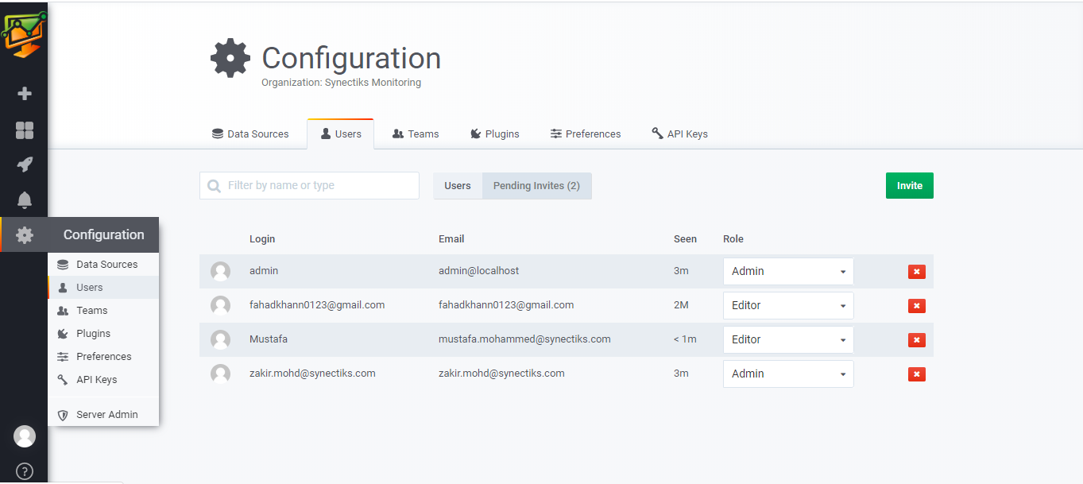
- Open the Users Page by selecting Users from the settings menu.
- Click the Invite button in the right corner of the section where existing users are listed.
- Enter the e-mail address of the user in the "E-mail" field.
- Enter the name of the user in the "Name" field.
- Click Add to add users and send invitation e-mails to them.

Create Team
Creating Team and adding members to Team
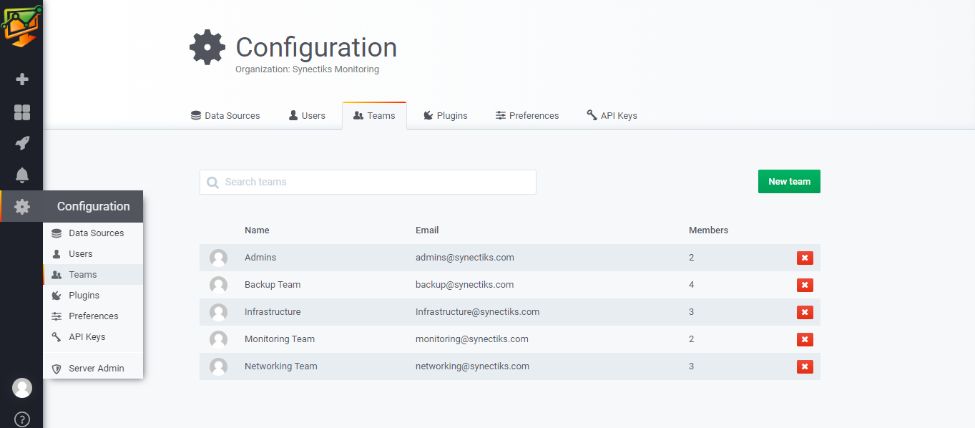
- Open the Teams Page by selecting Teams from the settings menu.
- Click the New Team button in the right corner of the section.
- Enter the name and email of the Team

Concepts and Workflow

Important concepts
The below concept describes workflow and what action needs to be taken to the target resource, and basically it depends on alert rule
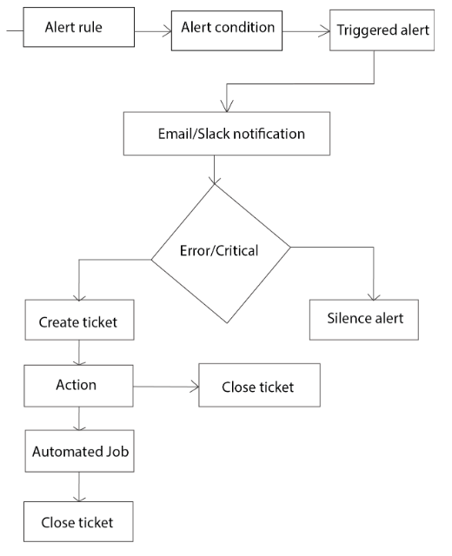

Basic Workflows
Creating an alert rule and an alert condition attached to the rule:

Create an alert rule
- When we create a rule, we will give it a meaningful name. For example: the group or team's name, or the set of resources or services the alert rule targets.
- Set the incident preference, which determines how violations become incidents.

Create an alert condition
- Alert condition will be attached to the rule. Steps involved in creating a condition includes
- Choose a data source that will be monitored
- Set the thresholds that define what behavior will produce a violation.

Alert Rule
Creating alert rule

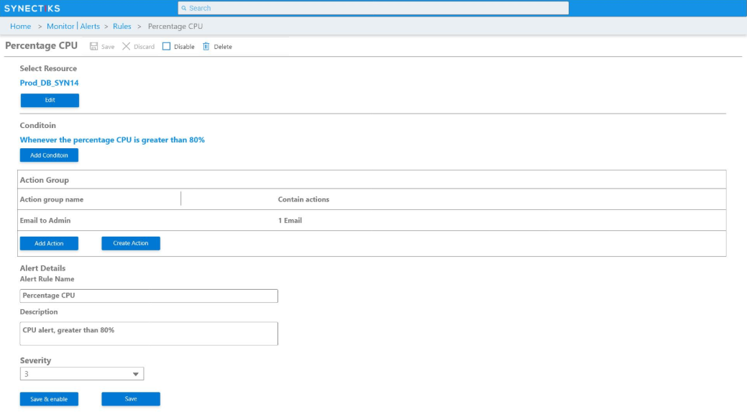

Modify and search alert rules
An alert rule is a group of one or more alert conditions. Set up for specific individuals may be useful when they want to personally keep an eye on a resource or metric. This provides them the freedom to add and remove conditions as well as adjust thresholds whenever they want, without having to communicate those changes to others.
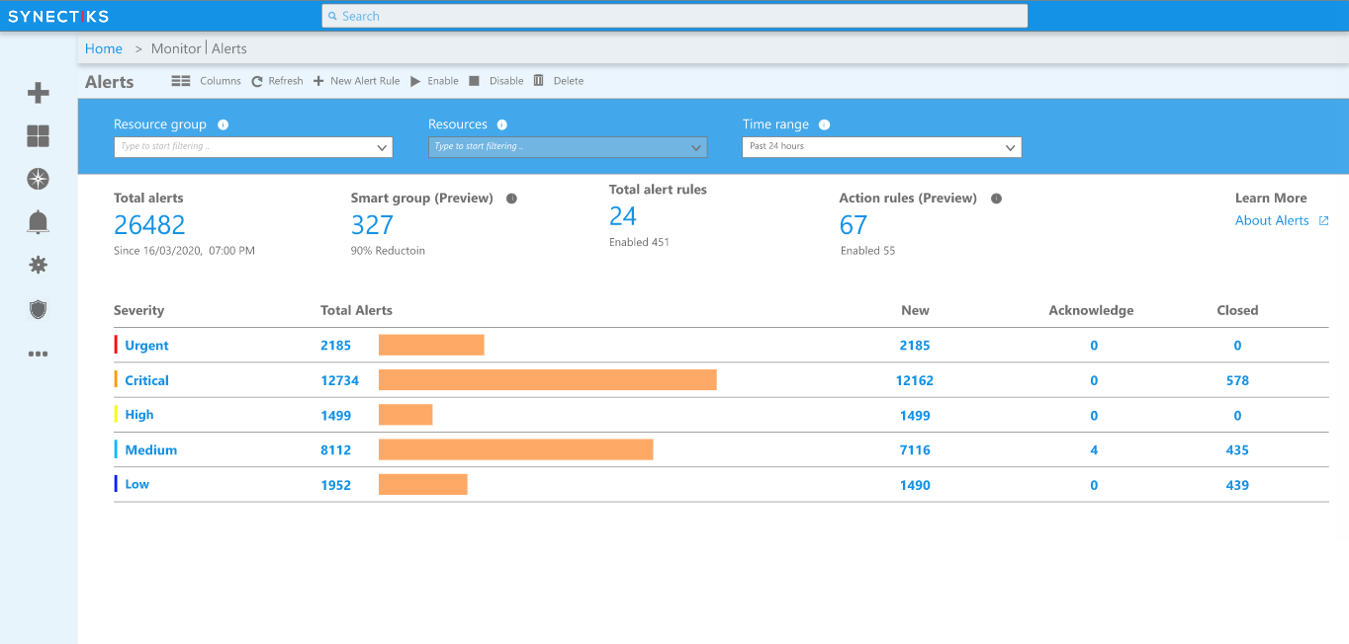

Alert Conditions

Create Conditions
An alert condition describes a monitored data source and the behavior of that data source that will be considered a violation.
- Selecting a product/data-source
- Selecting a condition type
- Defining thresholds
Set the thresholds for alert rule's conditions to meaningful levels for our environment. Here are some suggested guidelines:

Set threshold

When you create Alerts condition, you set thresholds that determine what will open a violation.
For an alert condition, thresholds are the settings that determine what opens a violation. Depending on an alert rule's incident preference, a violation may result in:
- The creation of an incident.
- Notifications being sent.
- Examples of thresholds:
- Set a CPU alerting threshold of 75% for 5 minutes on your servers
Besides a mandatory critical threshold level, you can also set thresholds for a less serious warning level, which does not generate an incident or send a notification.
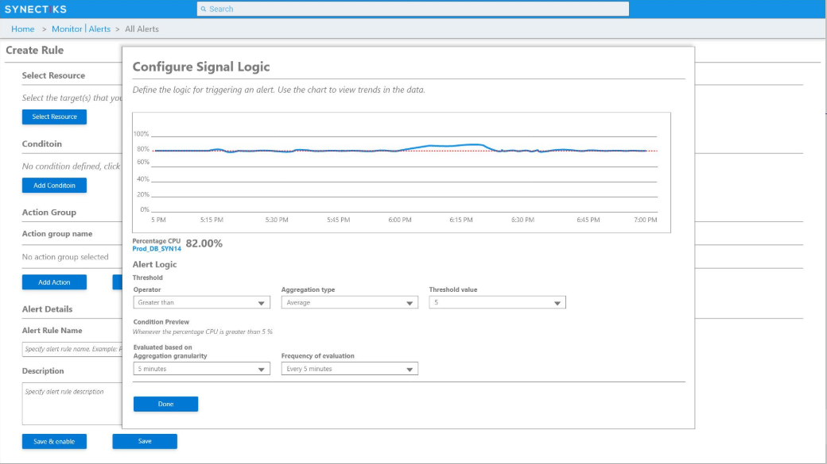

Modify condition
After you save the alert condition, the currently selected alert rules lists all alert conditions that apply to it.
- Repeat the steps to add more conditions to the rules.
- Continue the alert rules setup process by adding one or more notification channels to it.
- Change the condition's name, the entities it's scoped to, or the critical and warning thresholds.
- Rename the alert rule.
- Disable any conditions in the rule or delete the alert rule.

Alert

Alert to Individual, Group
Set the notification channels for User Group members. These include group or individual email addresses, and Slack channels. When User Groups are used in an Alert Notification Rule or in a Workflow Notification Strategy, these channels will be used to notify the group members.

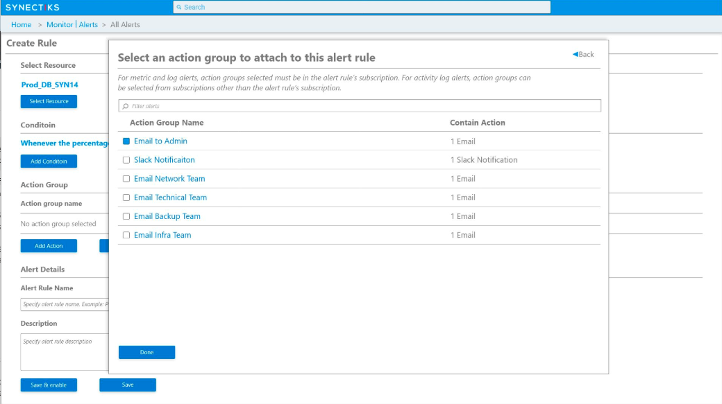

Action

Create Ticket

Close

Once an Alert is created it needs to be managed. The Alert Actions provided by Synectiks.
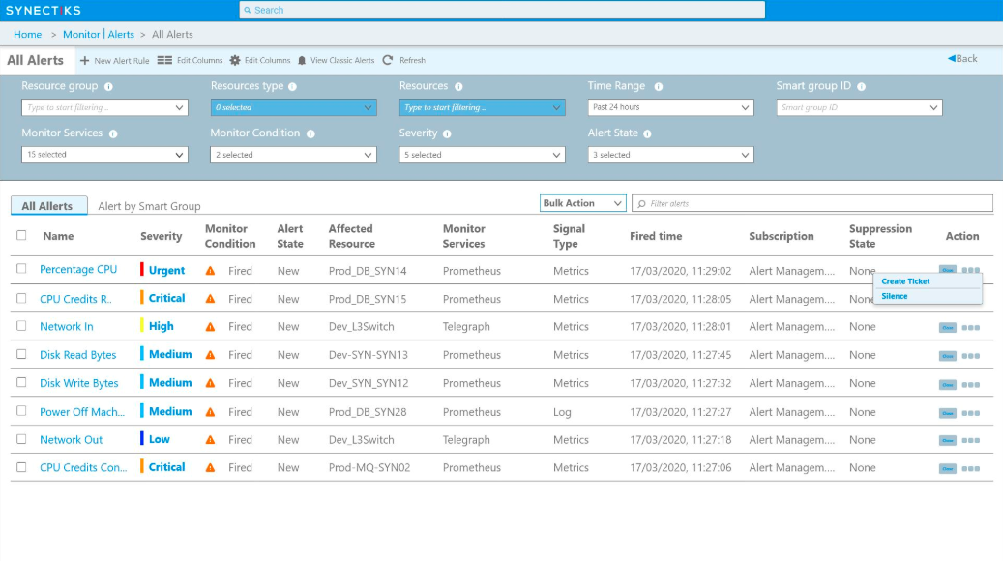

Action – Bulk action

Bulk Close

Bulk Close as Duplicate

On the Alerts page, select one or multiple alerts for bulk actions to be taken. This includes all available actions from the details page of an alert, aside from executing custom alert actions. The advantage of the alerts page is the ability to execute these actions on multiple alerts. It is possible, for example, to select multiple alerts and close or close as duplicate all with a single button.
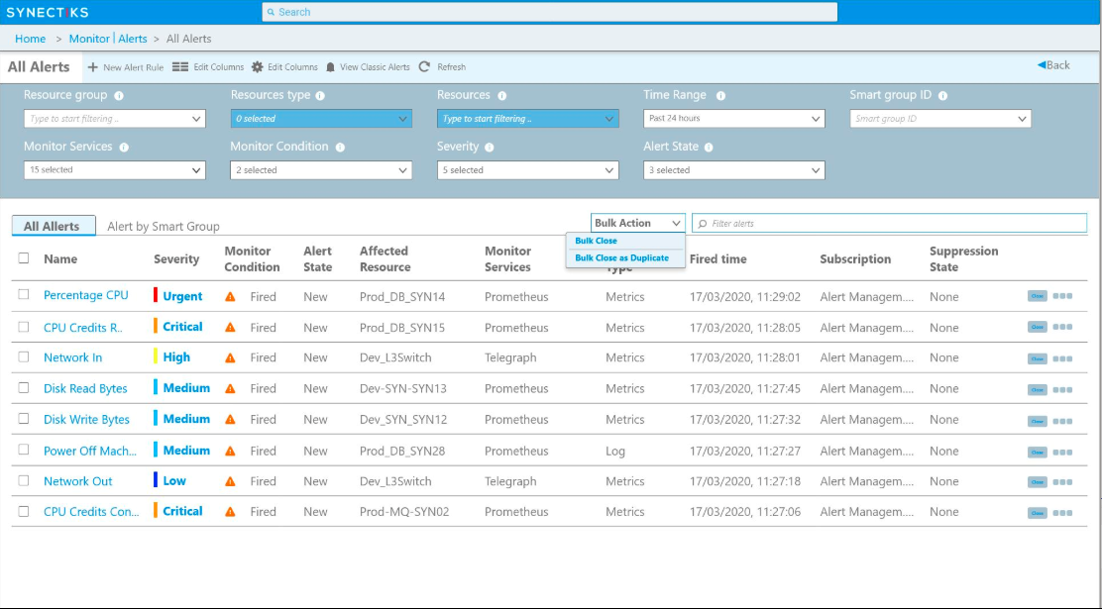

All Tickets

Ticket page is the list page for all tickets that are visible or assigned to a user. Apply filters, or execute bulk actions, close multiple tickets, take action.
Clicking on Ticket's number opens the details window for that ticket.
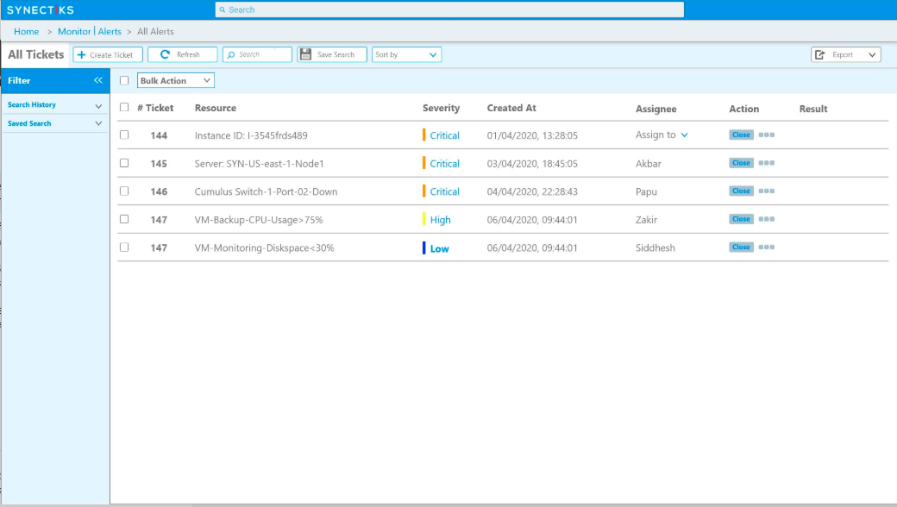

Assign to

User
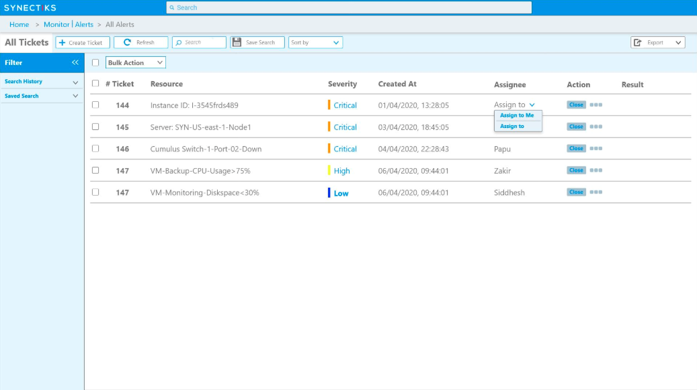

Action - Automated Job
Actions are triggered automatically using predefined action automated jobs, opening the potential for “self-healing” services that can take action to solve issues before involving any on-call responders.
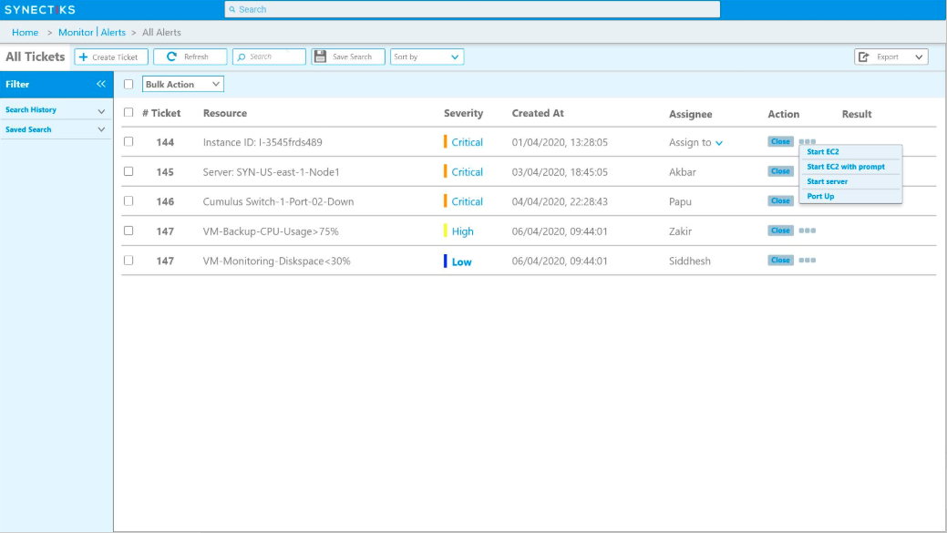

Automated Job Details
Configured an action to automatically run the action when an alert met our criteria.
To run automation job, monitoring platform should have minimum authentication.
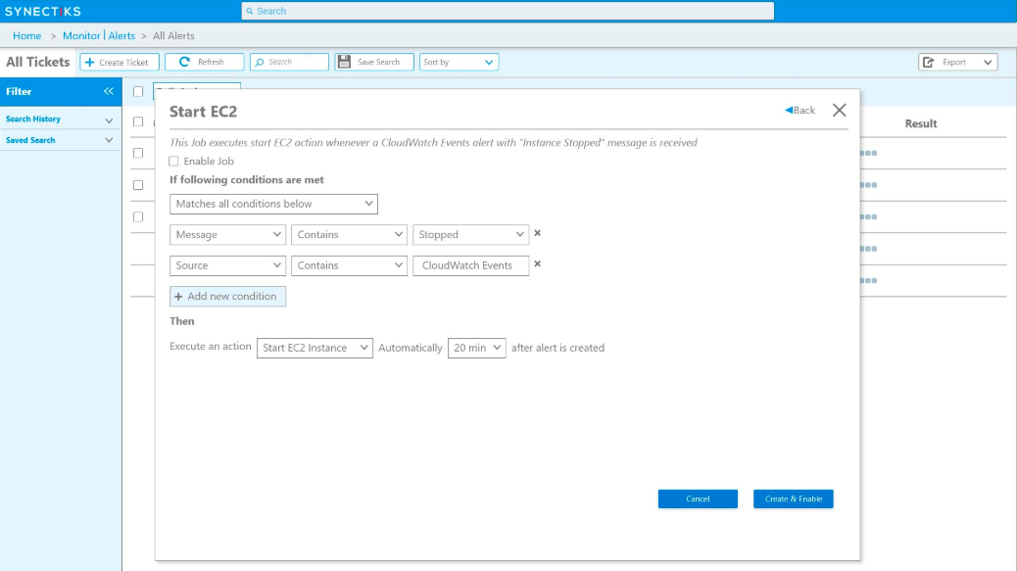

Ticket Details
Clicking on ticket number will open the details window for ticket.
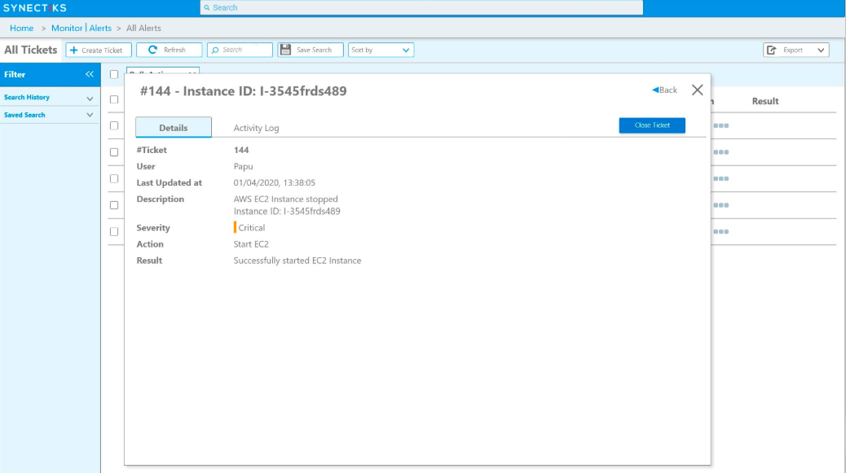

Ticket - Activity Log
Logs of each ticket are displayed in the "Activity Log" tab of the details window. Activity logs are very useful to determine:
- Which user created the ticket
- The notifications that were sent for the ticket
- Updates to the ticket, example who work/closed the ticket etc.
- Which actions were run to solve/close the ticket
- Possible errors that were encountered in the ticket life cycle

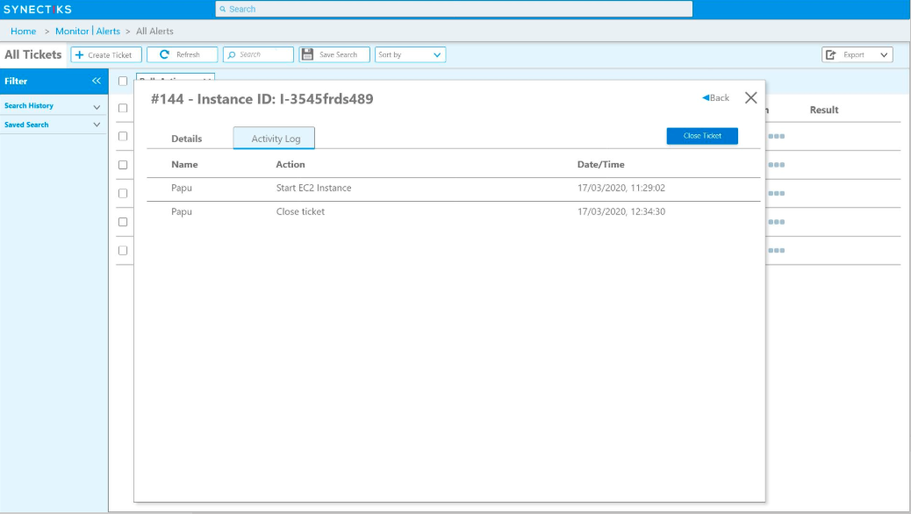

Ticket Closed
Once the Automation job runs successfully, ticket will be close.
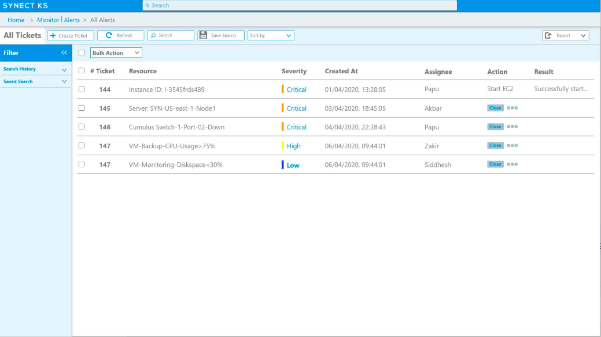

Thank You!

