IT Monitoring solution

For

Brighton Cromwell

June 19, 2020

Synectiks Inc.
300 Alexander Park Drive, Suite 215
Princeton, NJ 08540
USA

Contents
2 Introduction 3
2.1 Purpose 3
2.2 Need 3
2.3 Users 3
2.4 Location 3
2.5 Overview of the Proposed System 4
2.5.1 Performance and Availability Monitoring 5
2.5.1.1 Collector Catalogue Management 5
2.5.1.2 Collector Library Management 5
2.5.1.3 Collectors Configuration and Lifecycle 5
2.5.1.4 Dashboard Management 6
2.5.1.5 KPI based Alert Rule Management 6
2.5.1.6 Preference for Performance and Availability Management 6
2.5.2 Log Monitoring 6
2.5.2.1 Log Streams Catalogue Management 6
2.5.2.2 Log Streams Library Management 6
2.5.2.3 Log Steams Configuration and Lifecycle 6
2.5.2.4 Dashboard Management 7
2.5.2.5 Log based Alert Rule Management 7
2.5.2.6 Preference for Log Management 7
2.5.3 Compliance Monitoring 7
2.5.4 Alert and Automation Workflow 7
2.5.4.1 Search & Act 8
2.5.4.2 Manage Alert Rules 9
2.5.4.3 Manage Workflows 9
2.5.5 RCA Central 10
3 Generic SLA’s 10
3.1 Reliability 10
3.2 Usability 10
3.3 Performance 10
3.4 Security 10
4 Customer Use Cases 10
1.1. Monitor ISP provided Network Backbone 10
1.2. Deliver Alerts and warning for stated Performance sla violation 14
1.3. Deliver Alerts and warning for stated Availability sla violation 16
1.4. Monitor the performance, availability and network consumption of each server nodes 17
1.5. Deliver Alerts and warning for stated Performance sla violation of Server Nodes 19

Introduction

Purpose

This is a Requirements Specification document for a new web-based IT monitoring system for Brighton Cromwell. This document describes the scope, objectives, and goal of the alerting system for Brighton. In addition to describing non-functional requirements, this document models the functional requirements with use cases, interaction diagrams. This document is intended to direct the design and implementation of the target system using Synectiks Monitoring Platform.

Need

There is a business need to monitor and act on different alerts so that overall systems and application meet the desired SLA. The goal is to monitor the system characteristics and proactively work on the alerts so that we can maintain improved system SLA’s and reliabilities.

Users

Those who will primarily benefit from the new system and those who will be affected by the new system include,

IT Administrator: The new system will provide IT admins with more detailed, accurate and up-to-date network and system performance insights and data for improved RCA of system.

Location

The system will be available to internal IT department using the Intranet. IT employees may also use the system from any location and will be able to access restricted areas of the site through a password protection scheme & Role based access control mechanism if they get connected with VPN.

Overview of the Proposed System

The proposed system is a purpose-built monitoring solution for data collection, data analysis, alerting, triage, Ticketing, RCA, Automation & Workflows and Decision-support platform that ensured applications, systems perform within the desired SLA’s. The key functionality offered by the system includes:
- Aggregate Performance, Availability, Compliance KPI and Logs data from numerous endpoint sources (Nodes/ Apps / Network / Clusters / Jobs )
- Define collector catalogue and ability to create library of collectors to collect data specific to any environment and maintain the collector and data lifecycle.
- Enhance data with automated analyses, add tags for efficient search.
- Define alert generation rules based on which alerts are generated.
- Generate alerts with push notifications based on alerting rule
- Inhibit / silence / dedup alerts based on certain rule
- Throttle alerts and bundle related incidents
- View alerts by category, priority, and source
- Investigate alerts and track work performed
- Remediate on alerts based on defined workflow automations.
Finally, the system should enable analysts to quickly investigate incidents by correlating other data sets against indicators that matter. They can then annotate alerts with the results of their analysis and take any remediation actions on them.
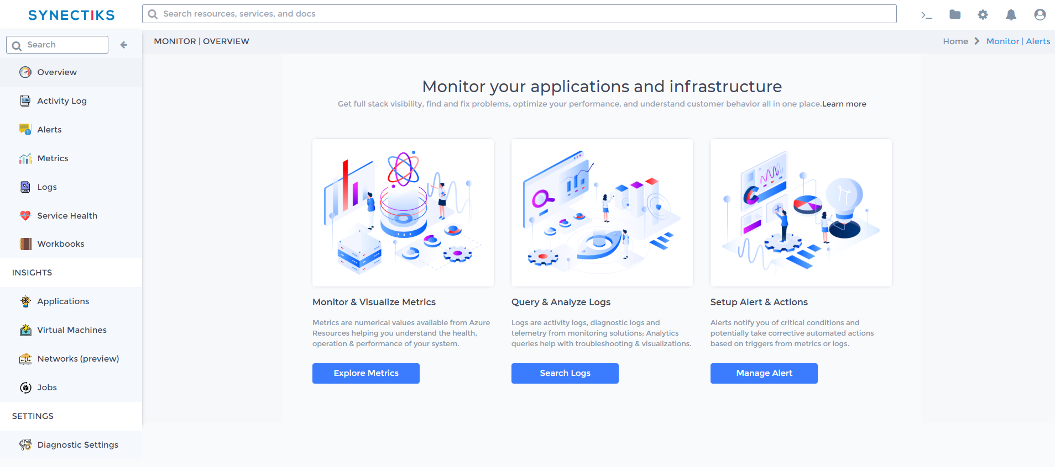
The key modules and use cases offered by the system includes:

Performance and Availability Monitoring

The system will provide the set of collectors to collect KPI data from endpoint periodically and define dashboard and alert ruling ability for decision support system. The key use cases offered by the module includes:

Collector Catalogue Management
Maintain the catalogue of KPI collectors to collect the KPI’s pertaining to performance and availability of the monitored entity.

Collector Library Management
Create and Manage the collectors to run from the available catalogues and schedule them.

Collectors Configuration and Lifecycle
Provide the system details and credentials so that collector can talk to end point entity and collect the data. The key use cases offered by the module includes:

Dashboard Management
System will allow to create searches and view search results based on KPI data available through a search. Users can add panels and create dashboards and put them inside folders.

KPI based Alert Rule Management

System will allow to create Scheduled Searches and set up alerts to notify users of changing conditions in your collected KPI data

Preference for Performance and Availability Management

Customize the data collection and any transformation by defining runtime configuration.

Log Monitoring

The system will provide the set of Logs Stream source to collect log data from endpoint periodically and define dashboard and alert ruling ability for decision support system. The key use cases offered by the module includes:

Log Streams Catalogue Management
Maintain the catalogue of log collectors to collect the logs pertaining to performance / reliability / security and availability of the monitored entity.

Log Streams Library Management
Create and Manage the Log Streams to run from the available catalogues and schedule them.
Create and Manage the collectors to run from the available catalogues and schedule them.

Log Steams Configuration and Lifecycle
Provide the system details and credentials so that system can talk with the log streams and collect the log data that is stored in some log database.

Dashboard Management
System will allow to create searches and view search results based on log data available through a search. Users can add panels and create dashboards and put them inside folders.

Log based Alert Rule Management

System will allow to create Scheduled Searches and set up alerts to notify users of changing conditions in your collected log data.

Preference for Log Management

Customize the log data collection and any transformation by defining runtime configuration.

Compliance Monitoring
TBD.

Alert and Automation Workflow

The system will allow the user to create alerting ruleset to create and transform the alerts , make easily searchable based on tags and attributes and define the ruleset to associate the automation workflows with specific set of alerts and deliver visibility on the services logs performed in alerts. The key use cases offered by the module includes:
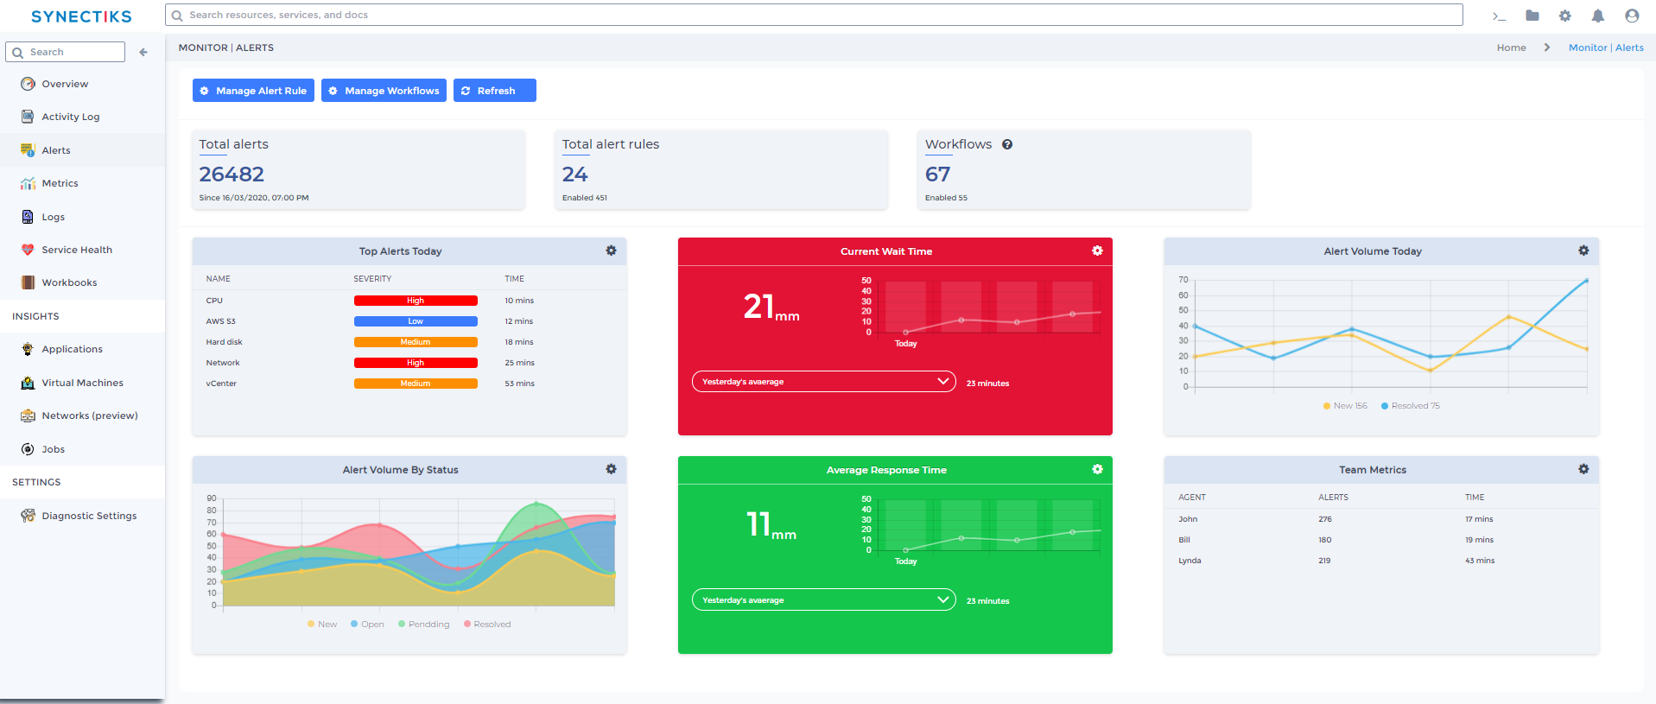

Search & Act
Ability to Filter the generated alerts for better insights and take actions on them by triggering automation bots.

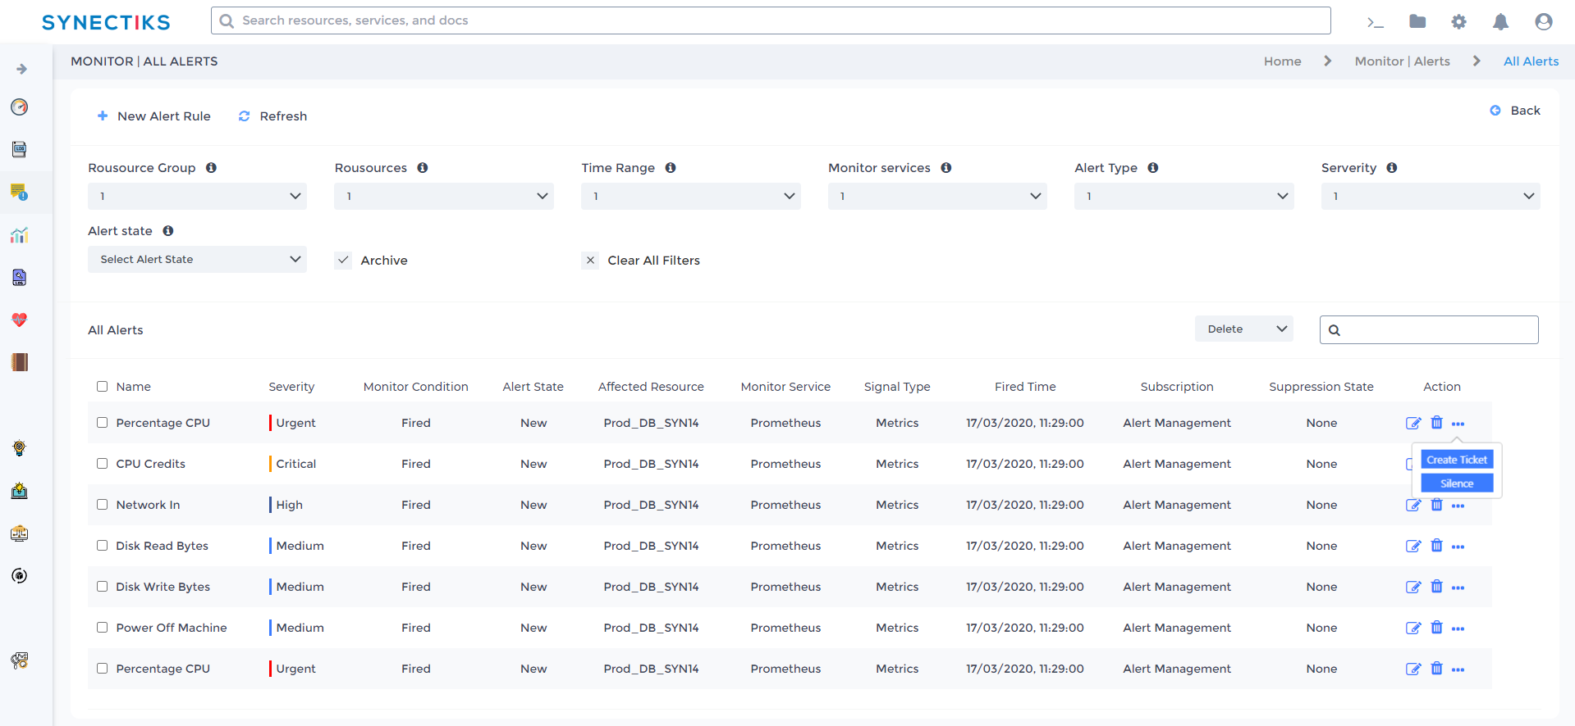

Manage Alert Rules
Create / Update / Delete the KPI or Log based alert rules based on which the alerts are generated.

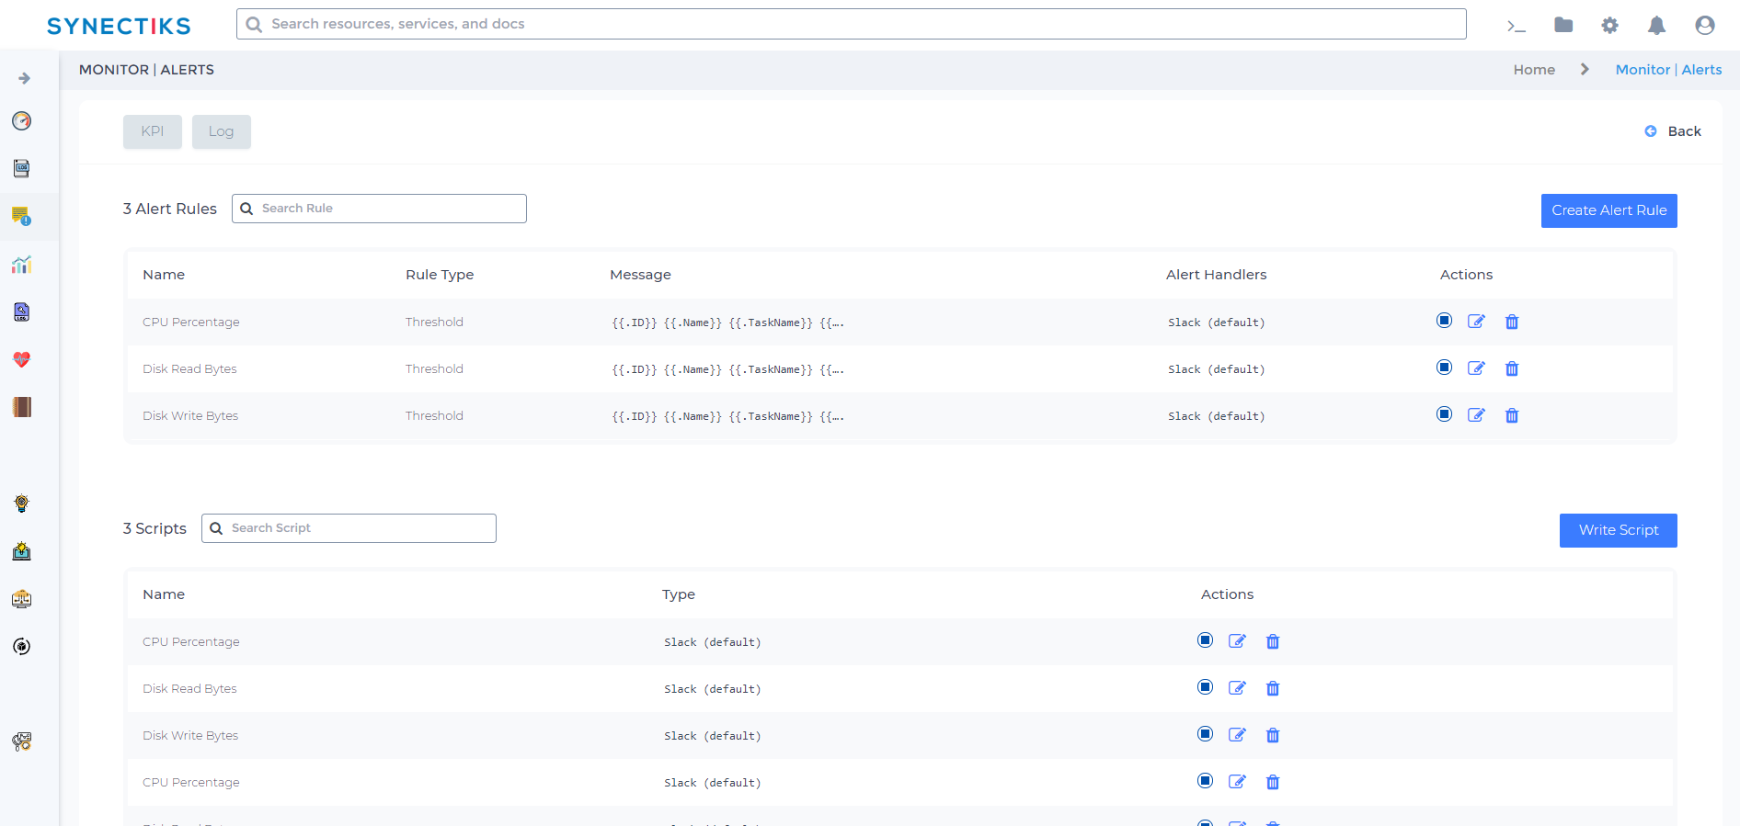

Manage Workflows
TBD.

RCA Central
RCA central offers tools and utilities to help the RCA of system malfunction. Take an example use case, you see that a 3 Tier application had latencies and system allow you to follow this sequence:
- Receive an alert for latency.
- Drill down and examine metrics.
- Drill down again and search logs related to the metric and time interval and distributed traces.
If you just want to explore your data and do not want to create a dashboard then Explore makes this much easier.

Generic SLA’s

Reliability
- The system shall be completely operational at least 99% of the time.
- Down time after a failure shall not exceed 30 mins.

Usability
- A monitoring L1 employee should be able to use the system in his job after 7 days of training.
- A user who already knows what product he is interested in should be able to locate and view that page in 10 seconds.
- The number of web pages navigated to access product information from the top page should not exceed 3.

Performance
- The system should be able to support 100 simultaneous users.
- The mean time to view a web page over a VDI machine shall not exceed 10 seconds.
- The mean time to upload a dashboard shall not exceed 10 seconds

Security
- The system is accessible in Synectiks DC, via a VDI framework. To access the system , Admin need to access a VDI terminal protected by MFA and password.
- The system shall provide RBAC based access dashboard and any provisioning components
- Any provisioning would go through appropriate approval process

Customer Use Cases

Performance and Availability Management Use Cases

Monitor Storage Usage Of AWS RDS Postgresql

Use Case Details

Use Case Name: | Monitor the Storage space usage of AWS RDS postgresql database and generate alert depending on usage rule.
Actors: | Network Administrators
Summary: | Have dashboards to monitor the filesystem and disk usage of AWS RDS instance and make sure that we alert rules placed against those KPI dashboards.
Triggers: | It Admin logs in the monitoring solution as Administrator and navigate to the RDS Postgresql monitoring dashboard.
Pre-Condition: | The user has admin rights to log in to monitoring system and access to wan monitoring dashboards.
Basic Flow: | - Using credentials Admin logs in to monitoring application.  - System will check login credential and validate the role of user.  - System will then display the home page of the application with a drop-down link of different available dashboards.  - Admin will then select the RDS storage Dashboard from the list of available dashboards.  - System will then display the Network Monitoring Dashboard
Alternate  Flows: | None
Post-Condition: | The actor can see the detail KPI of two internet connected ports and bandwidth usage.
Extension Points: | None
Prototype Link: | NA

Dashboards

AWS RDS STORAGE CONSUMPTION

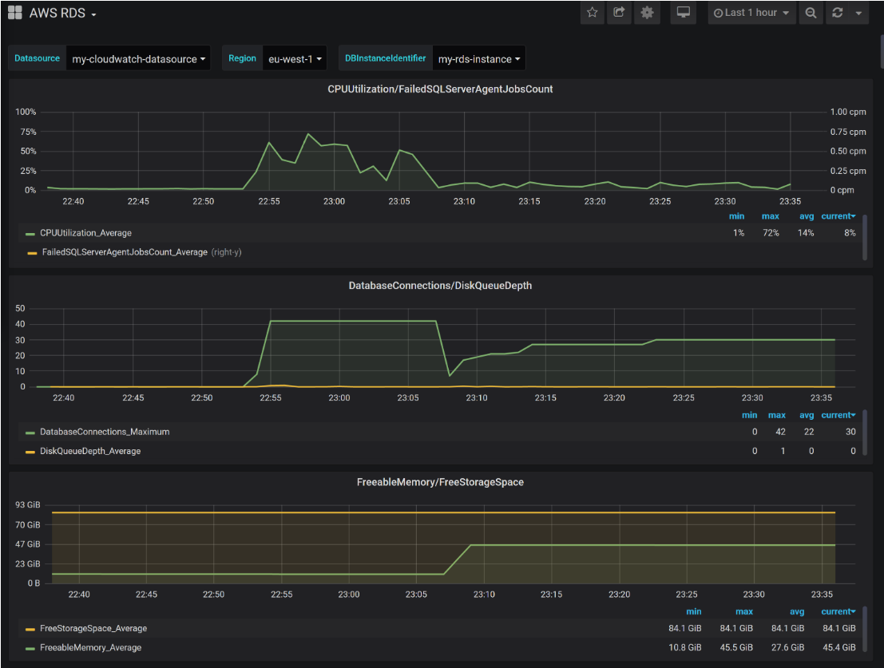

Alert Correlation
Alert rule associated with the Dashboard is
Storage usage > 90%
<Resource Group><Resource><Source-Type><ip/id><message><status code> <severity> <Type>
Source-Type – Ex. Node / Application / Database / Jobs / IAM /
Type – Performance / Reliability / Security / Vulnerability / Data Protection

Steps for RCA

- Receive an alert for storage consumption SLA.
- Go to kpi dashboard of alert
- Identify which database filesystem getting filled up

Remediation

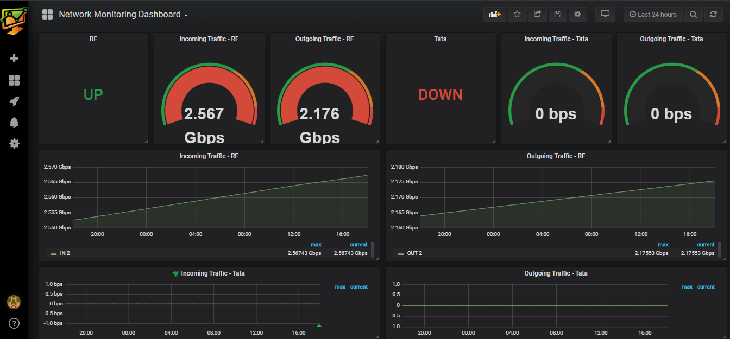

Site wise Network Details
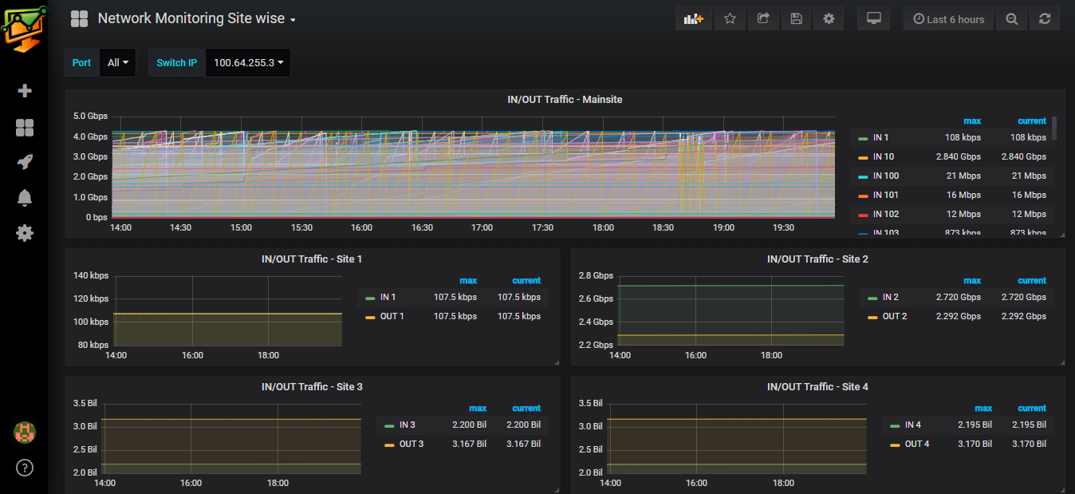

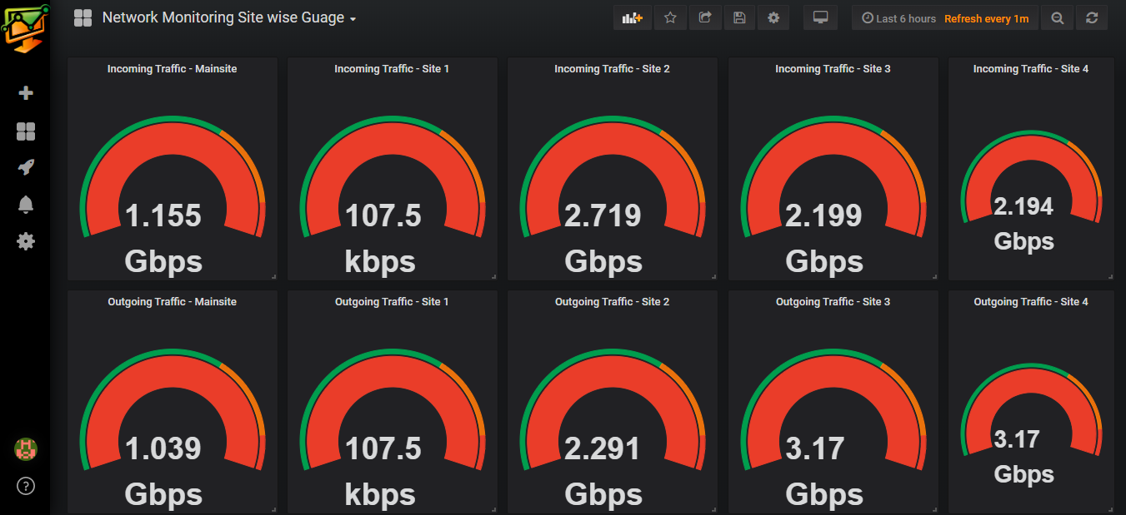

  - Deliver Alerts and warning for stated Performance sla violation

Use Case Name: | Alerts and Warning for Network Performance degradation.
Actors: | Network Administrators
Summary: | In order to effectively monitor the WAN network, the IT admin should have alert and alarm in case any sla pertaining to the main site and child site network is violated.
Triggers: | Any performance SLA violation, sla’s are stated in Basic & Alternate Flows
Pre-Condition: | The user has admin rights to log in to monitoring system to see the alerts also has access to email system to see email alerts and have access to slack in mobile to receive slack alerts in mobile.
Basic Flow: | - Using credentials Admin logs in to monitoring application.  - System will check login credential and validate the role of user.  - System will then display the home page of the application with a drop-down link of different available dashboards.  - Admin select the site wise network performance Dashboard from the list of available dashboards.  - System will then display the SITE WISE NETWORK DASHBOARD  - SITE WISE NETWORK DASHBOARD will show every site L3 switch port wise incoming and outgoing traffic details as depicted in dashboard.  - Admin will be able to set the threshold for any ports inbound & outbound traffic and create alerts by visiting to any specific site switch performance statistics.  - System generates the alerts and warning as and when ports traffic goes beyond or below the threshold mentioned in alert templates.  - System send the email alerts and mobile alerts as specified in the sample format. ( email-alerts & mobile-alerts ).
Alternate  Flows: | 7A1 :  - Admin sets the thresholds for master site dashboard ports, primarily the WAN ports connected to ISP  - System generates the alerts and warning as and when ports traffic goes beyond or below the threshold mentioned in alert templates.  - System send the alert to the destinations with a message formatted as “The outbound traffic of WAN1 port of master switch has exceeded its threshold limit of X MB/s”  7A2 :  - Admin sets the thresholds for master site dashboard ports, primarily the ports connected to different sites.  - System generates the alerts and warning as and when ports traffic goes beyond or below the threshold mentioned in alert templates.  - System send the alert to the destinations with a message formatted as “The inbound traffic of site1 connected port of master switch has exceeded its threshold limit of X MB/s”  7A3 :  - Admin sets the thresholds for every sites switch dashboard ports, primarily the ports connected to main site.  - System generates the alerts and warning as and when ports traffic goes beyond or below the threshold mentioned in alert templates.  - System send the alert to the destinations with a message formatted as “The outbound traffic of site1 has exceeded its threshold limit of X MB/s”
Post-Condition: | The actor can see the alerts in email and slack.
Extension Points: | None
Prototype Link: | NA

Email Alerts Sample

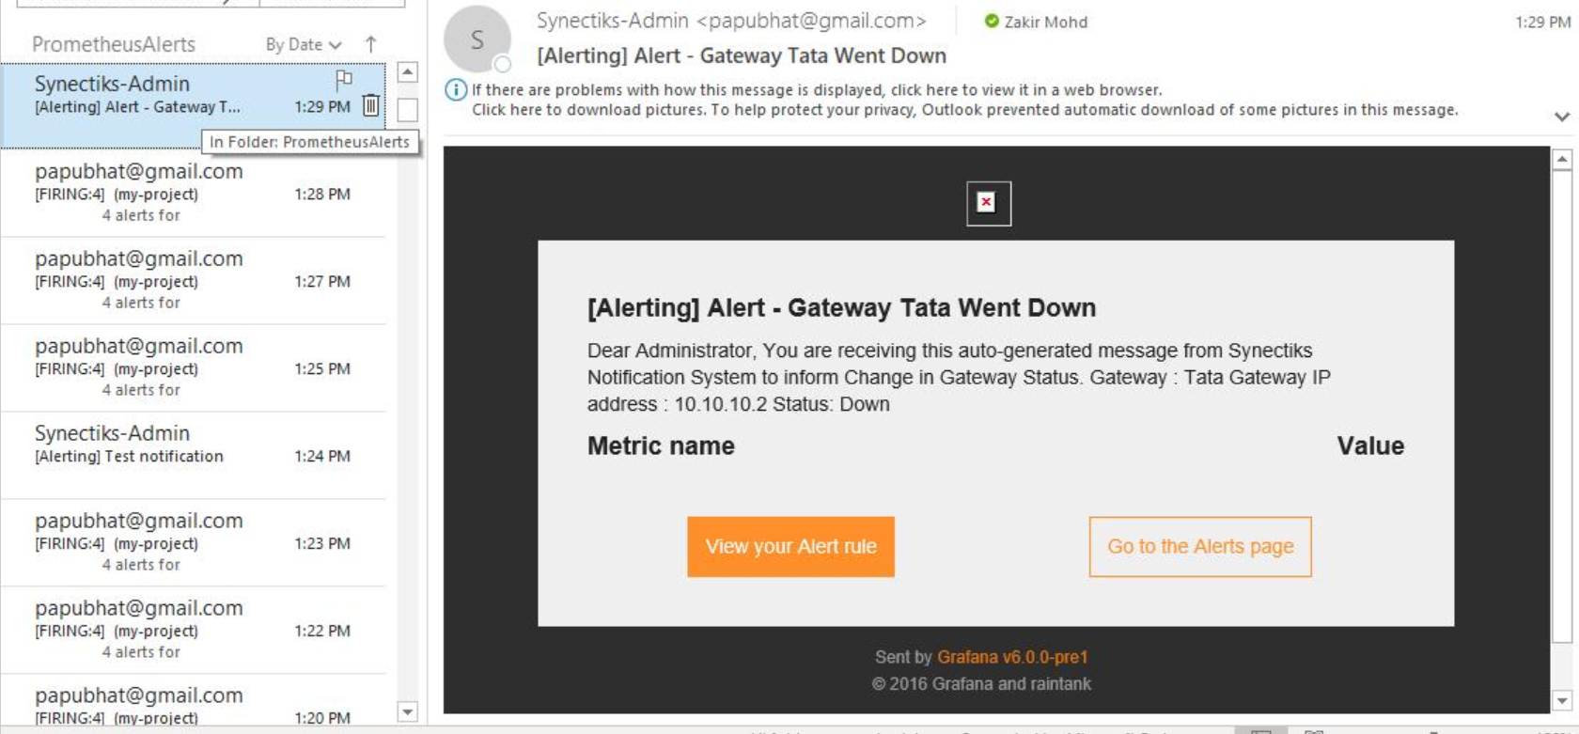

Mobile Alerts in SLACK
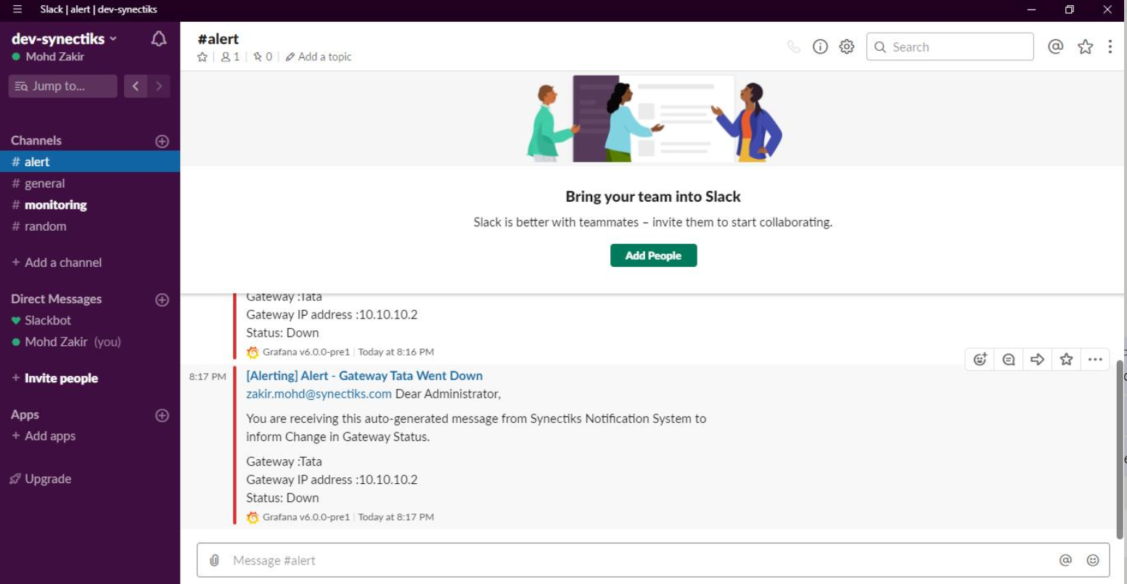

  - Deliver Alerts and warning for stated Availability sla violation

Use Case Name: | Alerts and Warning for ISP Network availability.
Actors: | Network Administrators
Summary: | In order to effectively monitor the WAN network, the IT admin should have alert and alarm in case any sla pertaining to the main site ISP availability is violated.
Triggers: | Any performance SLA violation, sla’s are stated in Basic & Alternate Flows
Pre-Condition: | The user has admin rights to log in to monitoring system to see the alerts also has access to email system to see email alerts and have access to slack in mobile to receive slack alerts in mobile.
Basic Flow: | - Using credentials Admin logs in to monitoring application.  - System will check login credential and validate the role of user.  - System will then display the home page of the application with a drop-down link of different available dashboards.  - Admin select the site wise network performance Dashboard from the list of available dashboards.  - System will then display the Network Monitoring Dashboard  - Network Monitoring Dashboard will show the UP/ DOWN status of both the ISP provided WAN connection.  - Admin will be able to set the alerts for the connection status toggle.  - System generates the alerts and warning when the connection status is changed.  - System send the email alerts and mobile alerts as specified in the sample format. ( email-alerts & mobile-alerts ).
Alternate  Flows: | None
Post-Condition: | The actor can see the alerts in email and slack.
Extension Points: | None
Prototype Link: | NA

  - Monitor the performance, availability and network consumption of each server nodes

Use Case Name: | Monitor Server Nodes
Actors: | Network Administrators
Summary: | In order to effectively monitor the WAN network, the IT admin should have real time analytics dashboard showing the important KPI to monitor the server nodes performance.
Triggers: | It Admin logs in the monitoring solution as Administrator and navigate to the WAN monitoring dashboard.
Pre-Condition: | The user has admin rights to log in to monitoring system and access to wan monitoring dashboards.
Basic Flow: | - Using credentials Admin logs in to monitoring application.  - System will check login credential and validate the role of user.  - System will then display the home page of the application with a drop-down link of different available dashboards.  - Admin will then select the Linux Server Monitoring Dashboard from the list of available dashboards.  - System will then display the LINUX SERVER MONITORING DASHBOARD  - LINUX SERVER MONITORING DASHBOARD will show the Uptime, CPU Usage, RAM utilization, Processor, Disk Details, Disk Activity, System Temperature as depicted in dashboard.
Alternate  Flows: | 4A1 :  - Admin select the Windows Server Monitoring Dashboard from the list of available dashboards.  - System will then display the WINDOWS SERVER MONITORING DASHBOARD.  - WINDOWS SERVER MONITORING DASHBOARD will show the Uptime, CPU Usage, RAM utilization, Processor, Disk Details, Disk Activity, System Temperature as depicted in dashboard.
Post-Condition: | The actor can see the detail KPI of server nodes.
Extension Points: | None
Prototype Link: | NA

Linux Server Monitoring
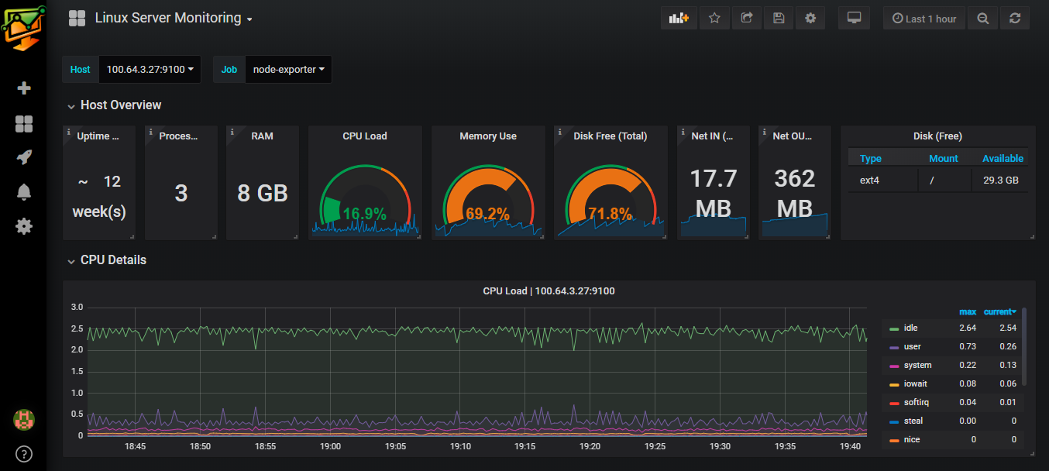

Windows Server Monitoring

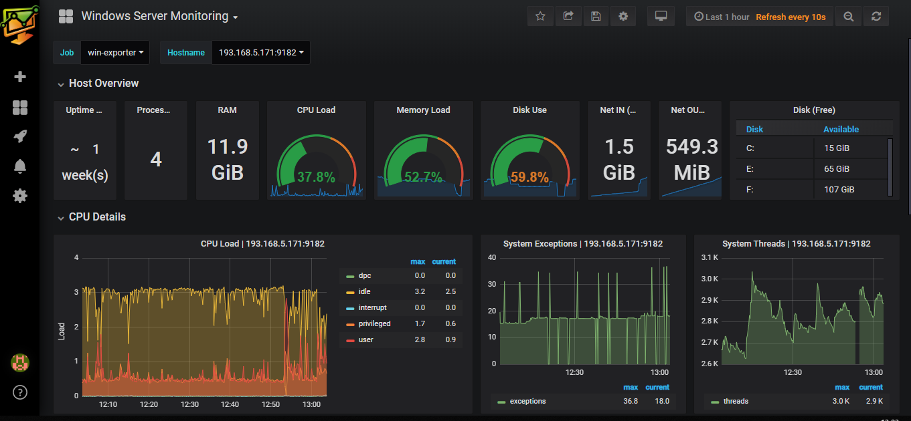

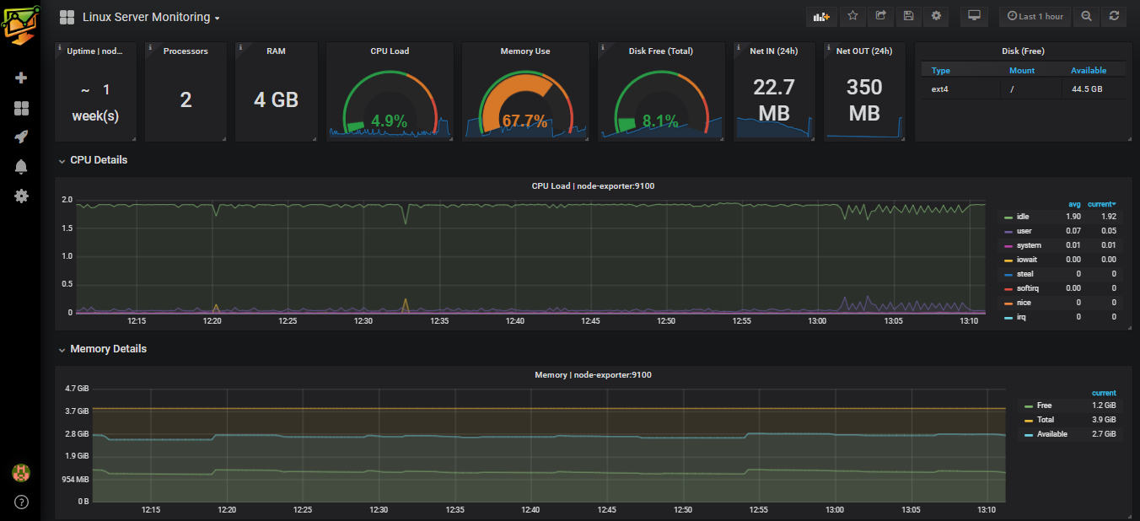

  - Deliver Alerts and warning for stated Performance sla violation of Server Nodes

Use Case Name: | Alerts and Warning for Server Nodes Performance.
Actors: | Network Administrators
Summary: | In order to effectively monitor the WAN network, the IT admin should have alert and alarm in case any sla pertaining to the server performance is violated.
Triggers: | Any performance SLA violation, sla’s are stated in Basic & Alternate Flows
Pre-Condition: | The user has admin rights to log in to monitoring system to see the alerts also has access to email system to see email alerts and have access to slack in mobile to receive slack alerts in mobile.
Basic Flow: | - Using credentials Admin logs in to monitoring application.  - System will check login credential and validate the role of user.  - System will then display the home page of the application with a drop-down link of different available dashboards.  - Admin will then select the Linux Server Monitoring Dashboard from the list of available dashboards.  - System will then display the LINUX SERVER MONITORING DASHBOARD  - Admin will be able to set the threshold for CPU / Memory / Disk and create alerts by visiting to any specific performance dashboard.  - System generates the alerts and warning when the SLA is violated.  - System send the email alerts and mobile alerts as specified in the sample format. (node performance alerts ).
Alternate  Flows: | 4A1 :  - Admin will then select the Windows Server Monitoring Dashboard from the list of available dashboards.  - System will then display the WINDOWS SERVER MONITORING DASHBOARD  - Admin will be able to set the threshold for CPU / Memory / Disk and create alerts by visiting to any specific performance dashboard.  - System generates the alerts and warning when the SLA is violated.  - System send the email alerts and mobile alerts as specified in the sample format. ( node performance alerts ).
Post-Condition: | The actor can see the alerts in email and slack.
Extension Points: | None
Prototype Link: | NA

Node Performance Alerts

