執行說明： 請用jupyter notebook 打開

討論：

regularization 會有punishment，使model減少overfitting

做法：

Import numpy and matplotlib

I wrote some functions as below

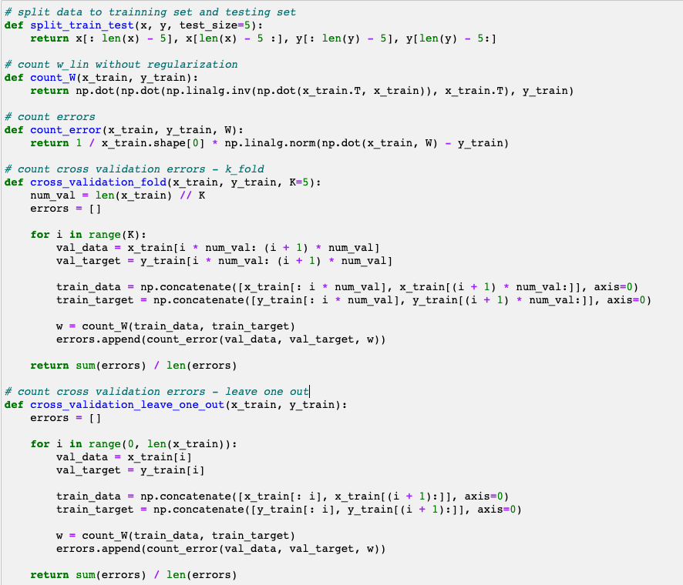

(a)

I use np.linspace to generate 20 data points with (equal spacing) x ∈ [−3, 3].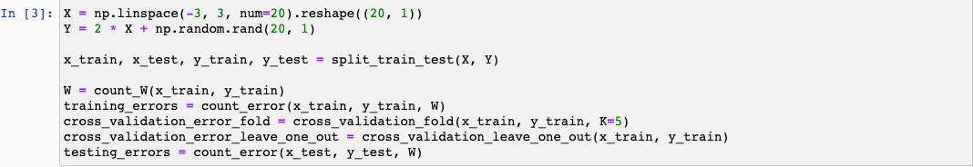

Result:

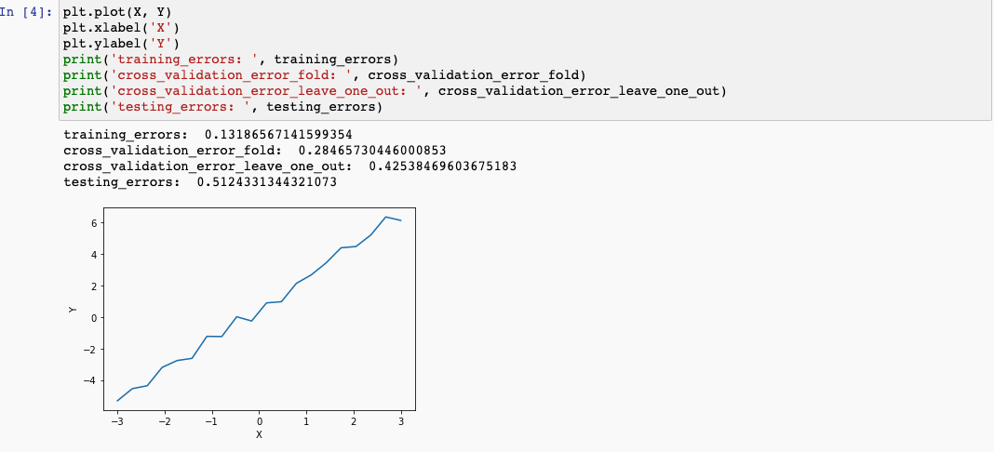

(b) Compare regression with degree 5, 10, 14.

(1) degree 5

I use the approach like (a)

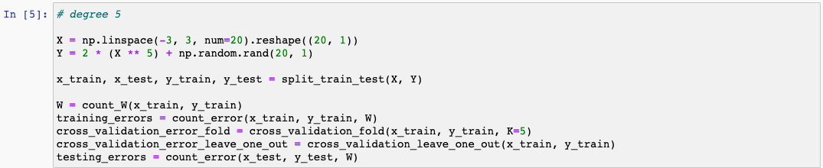

result:

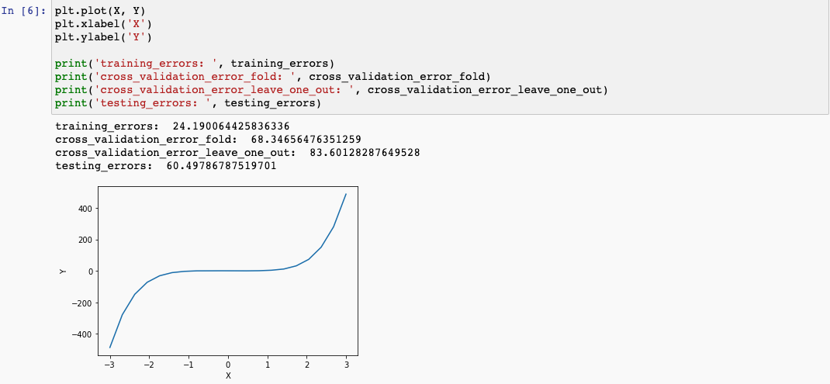

(2) degree 10

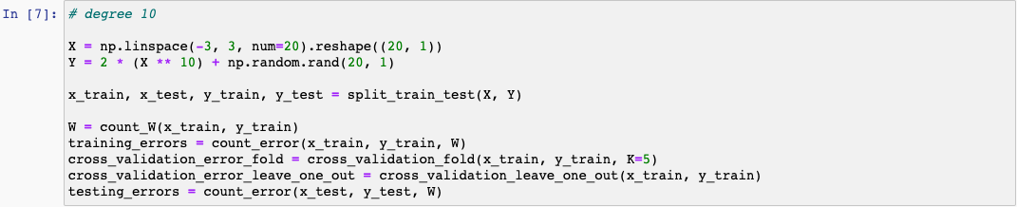

result:

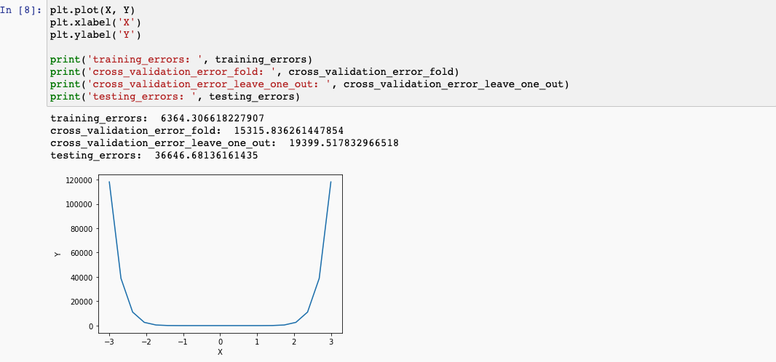

(3) degree 14

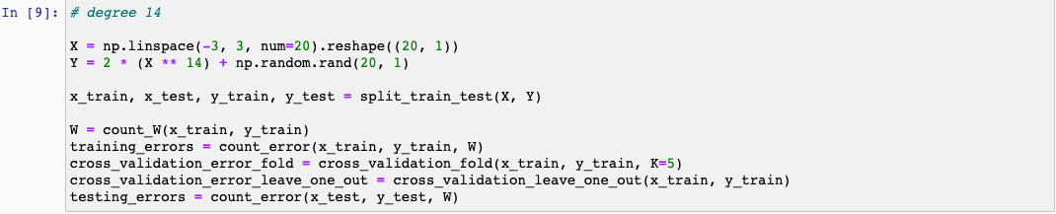

result:

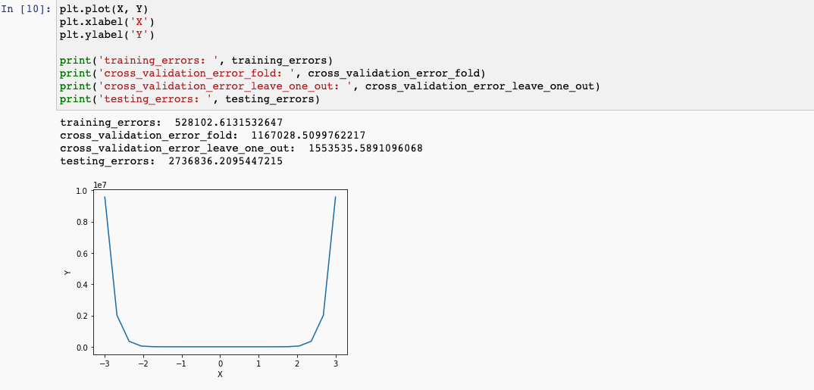

#### (c) y = sin(2πx) +ε

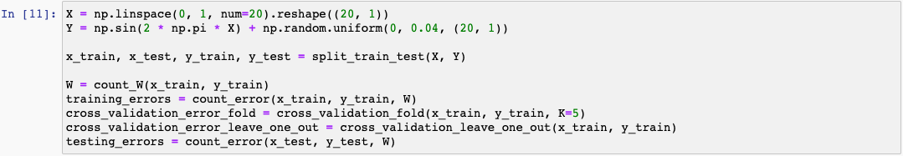

result:

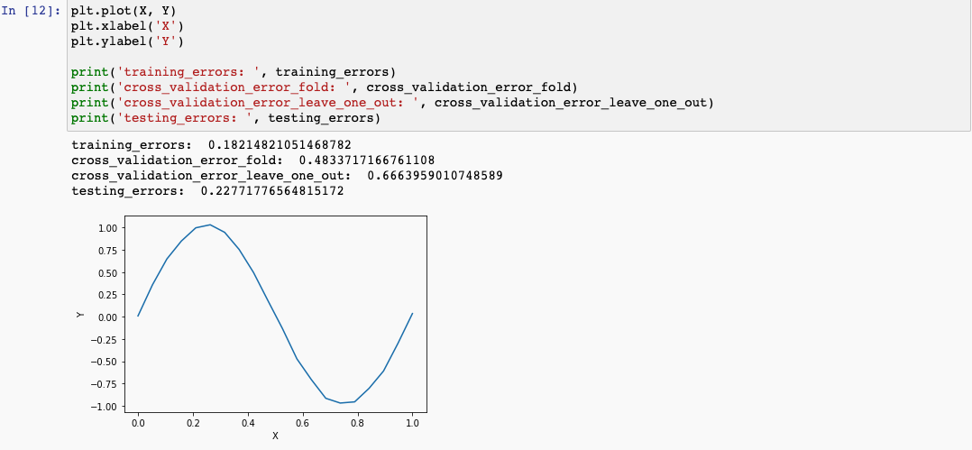

(d) Compare m = 60, 160, 320 with degree 14

(1) m = 60

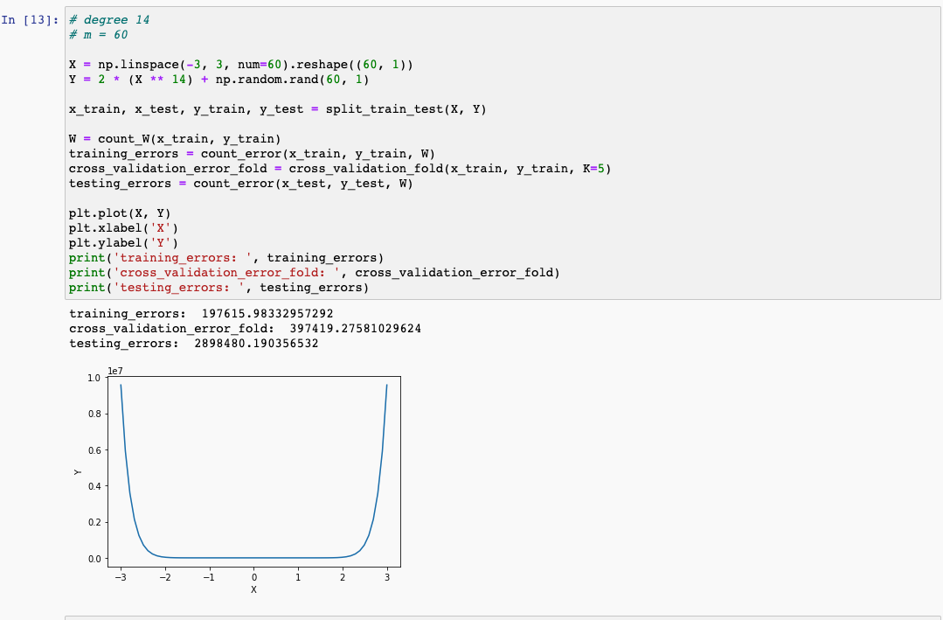

(2) m = 160

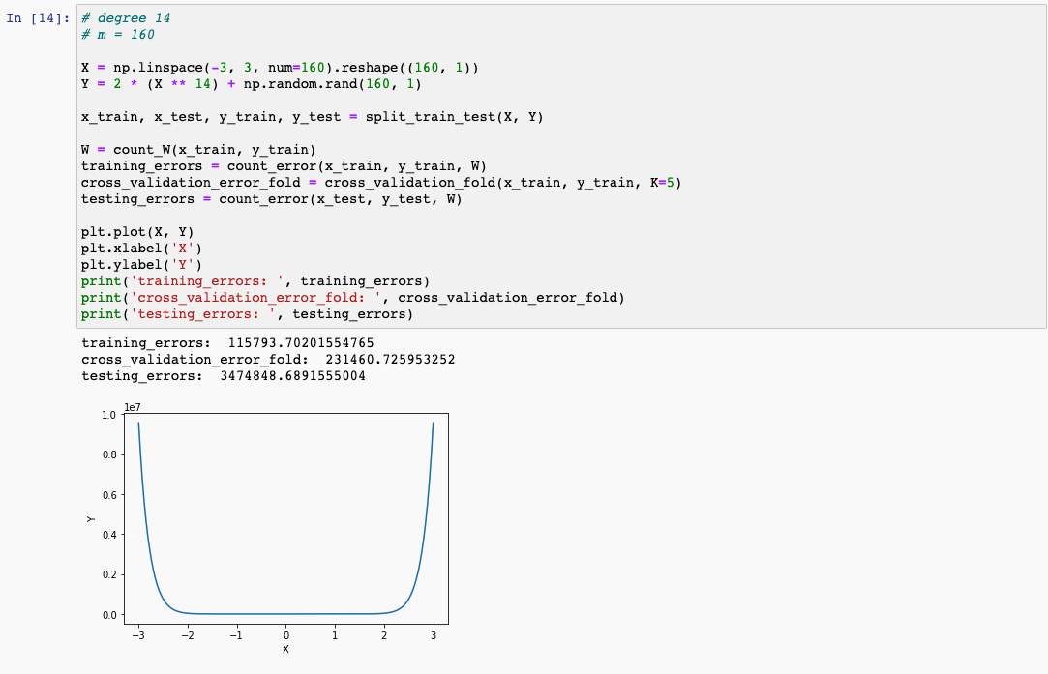

(3) m = 320

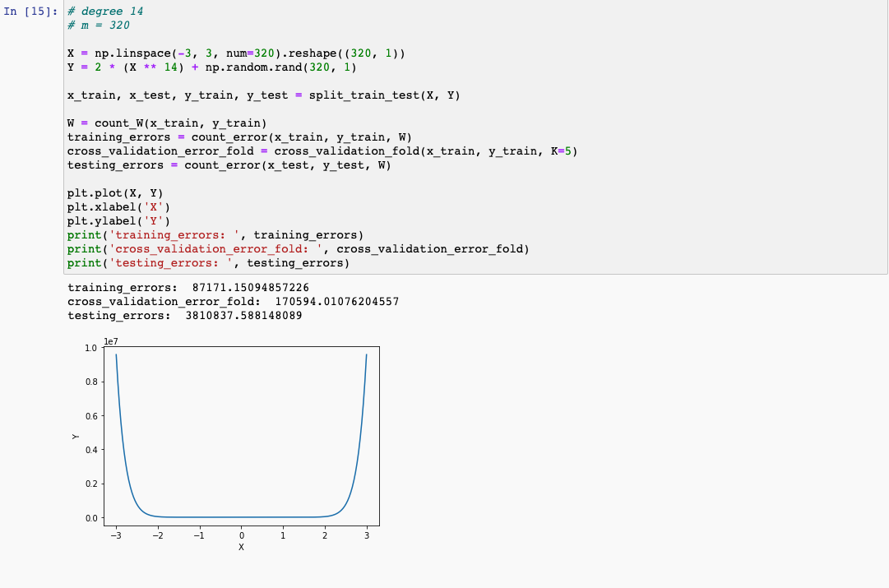

#### (e) Compare lambd = 0, 0.001/m , 1/m, 1000/m

#### Firstly, I write a function to compute W with regularization

#### 

#### (1) lambd = 0

#### 

(2) lambd = 0.001/m

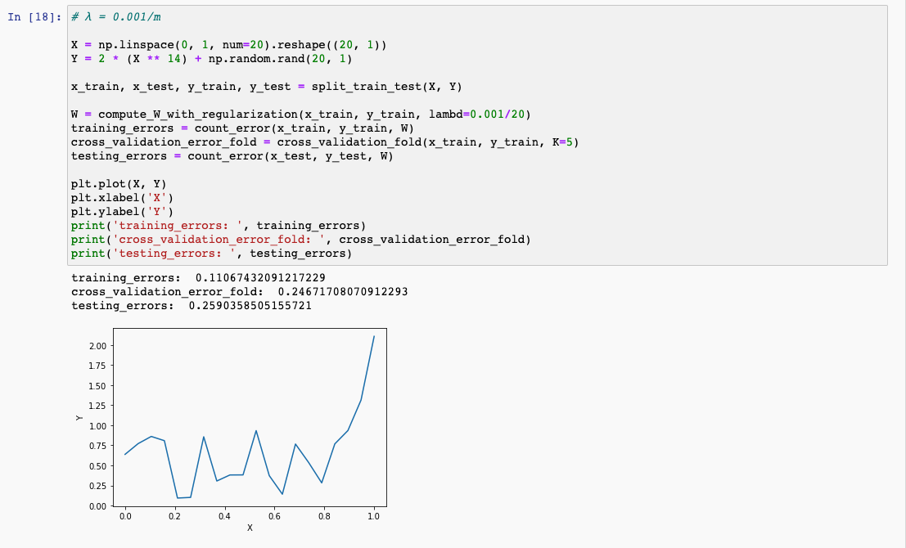

(3) lambd = 1000/m

