This is our architecture for doctor-patient app.

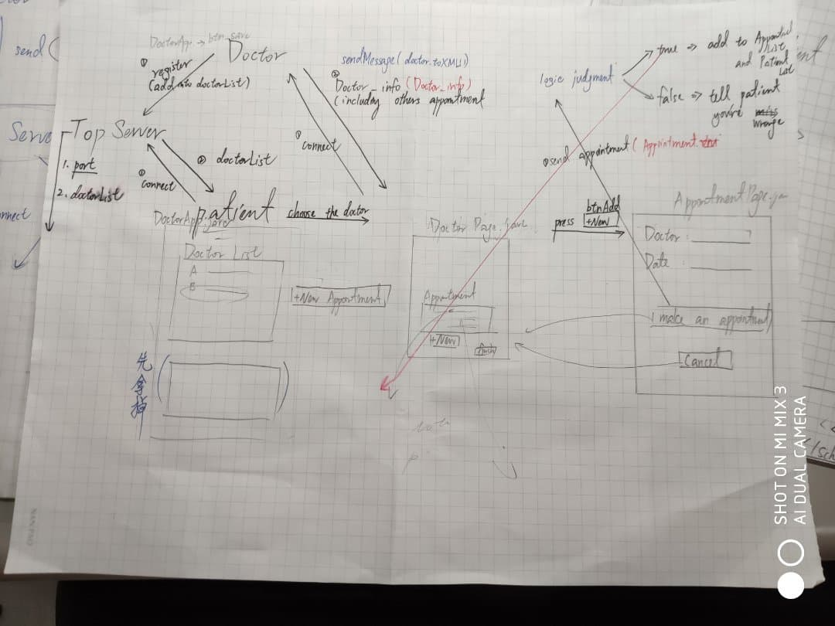

Doctors will register to top server. Patients will request doctor list from top server.

Top server: handle doctors information and send doctor list to patients

**Doctor:**

DoctorApp.java

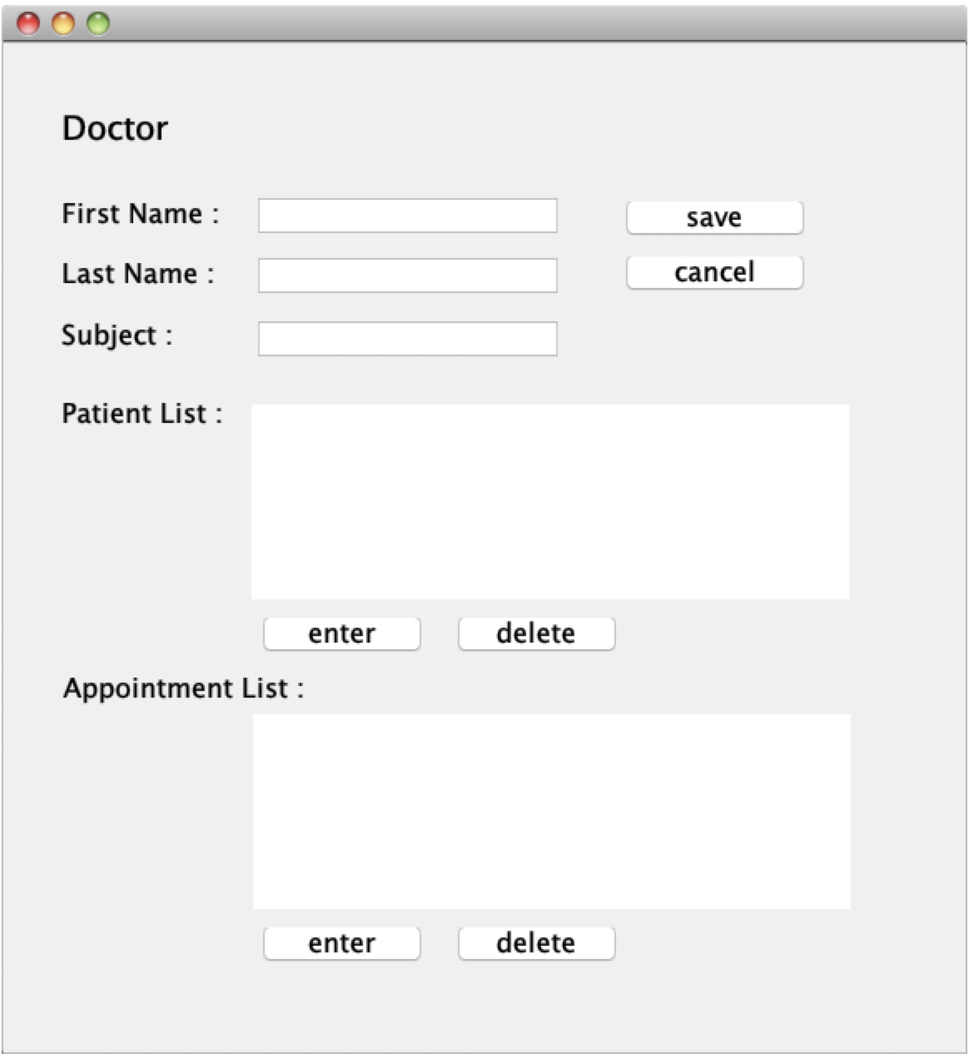

save button: register to top server

Patient List: patients for this doctor and you can enter patient data(PatientD.java)

Appointment List: appointments for this doctor and you can enter appointment data(AppointmentD.java)

PatientD.java

the patient data

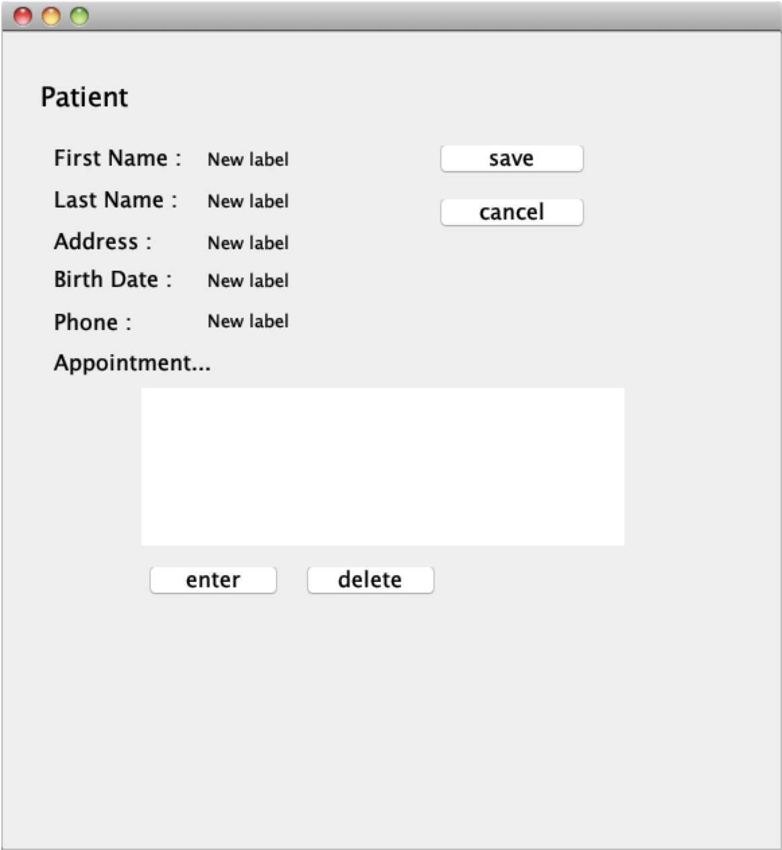

AppointmentD.java

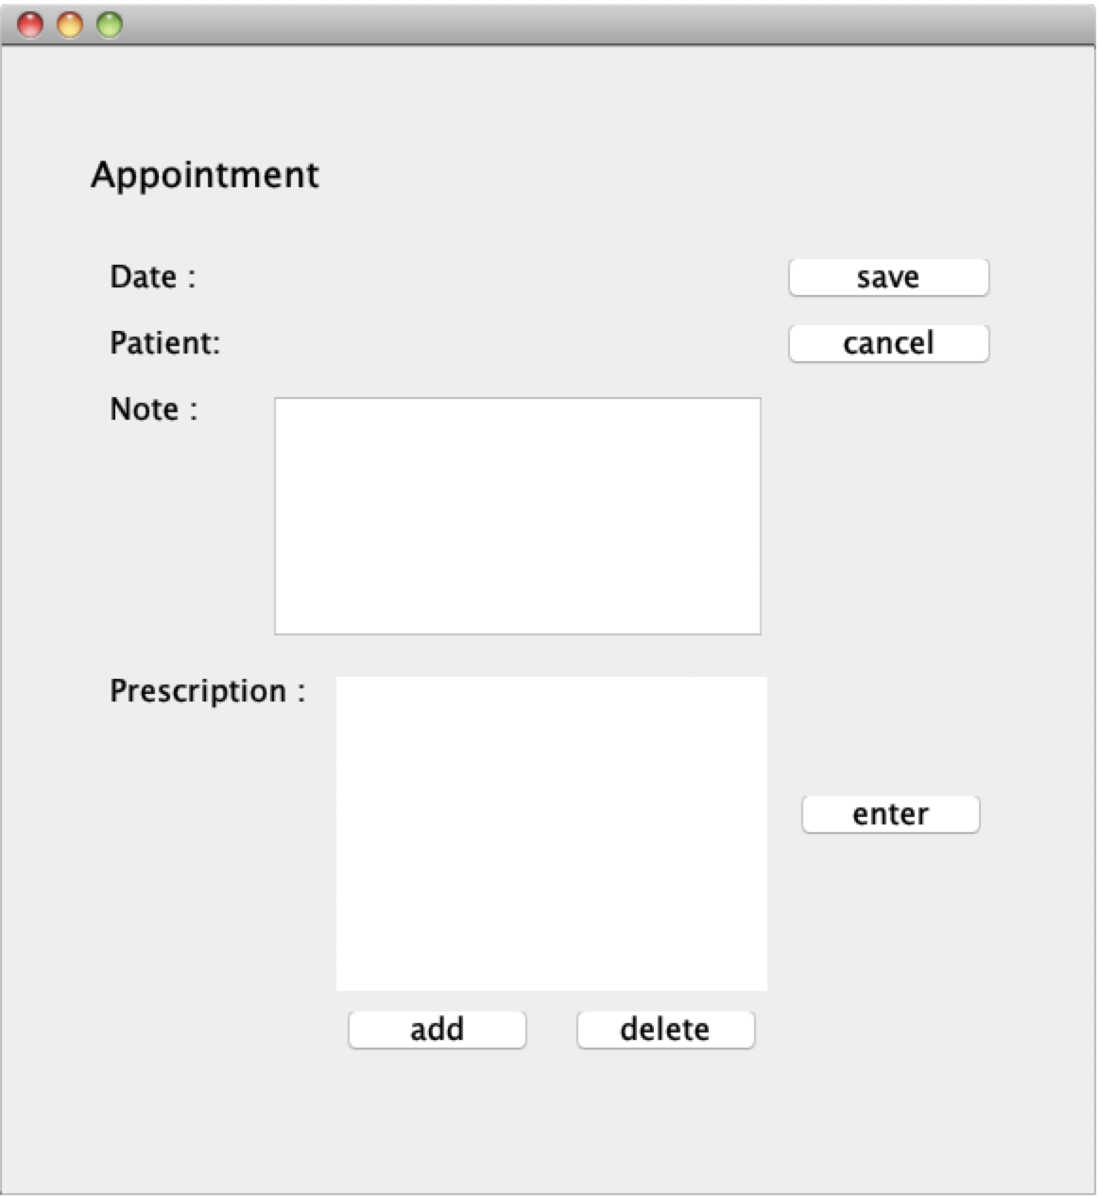

**Patient:**

PatientApp.java

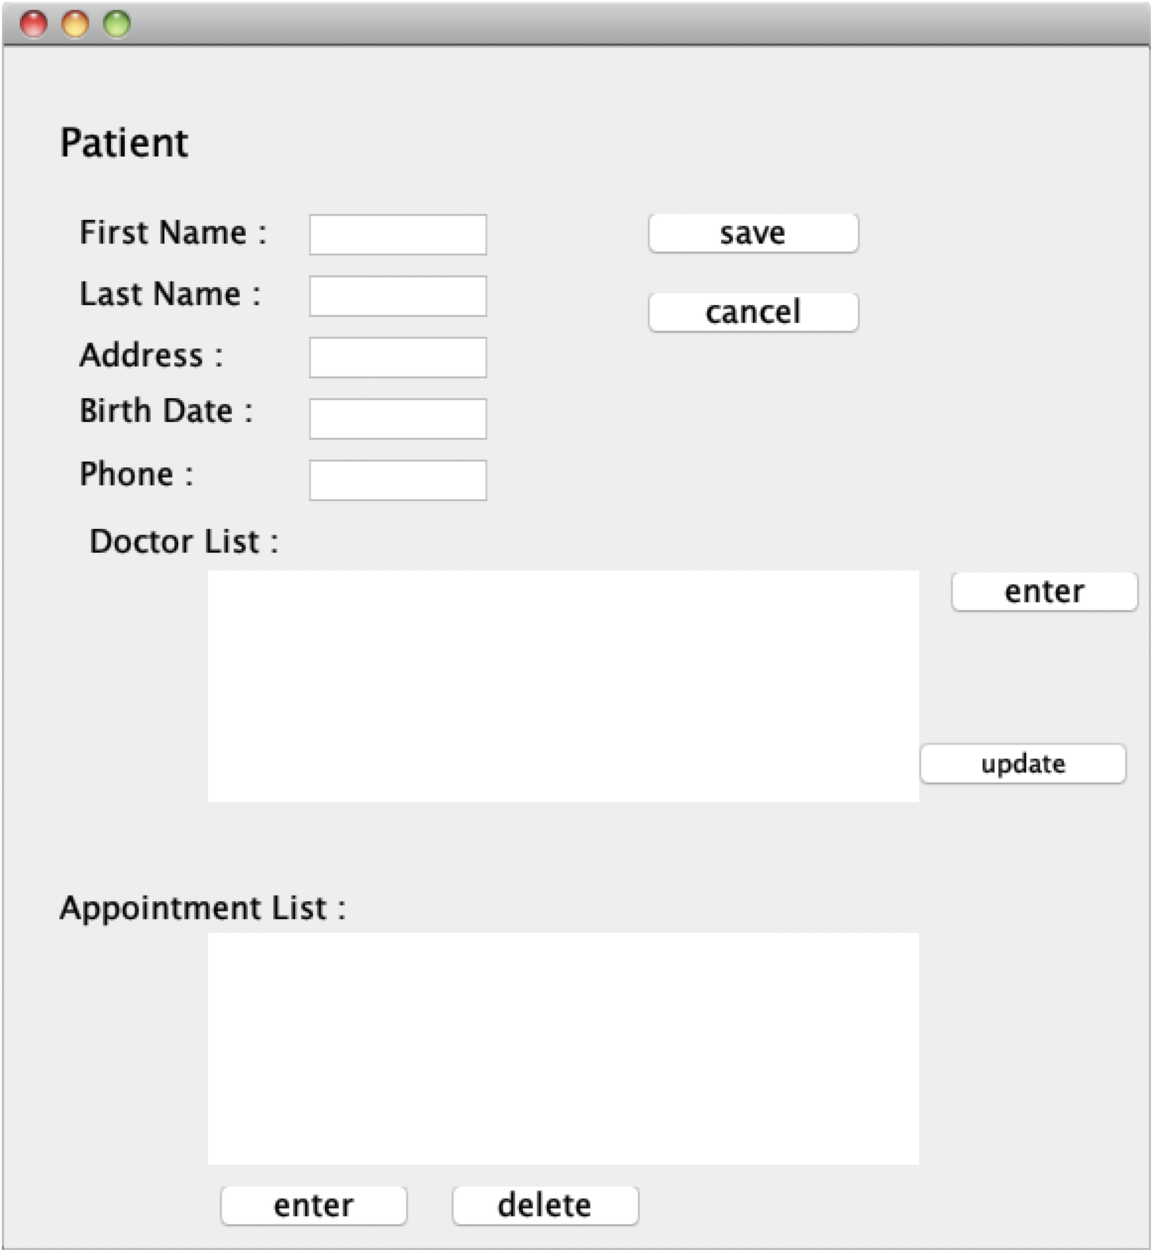

Doctor List: get from top server . when you choose the doctor and click enter, the patient will connect to the doctor and then enter DoctorPage.java

DoctorPage.java

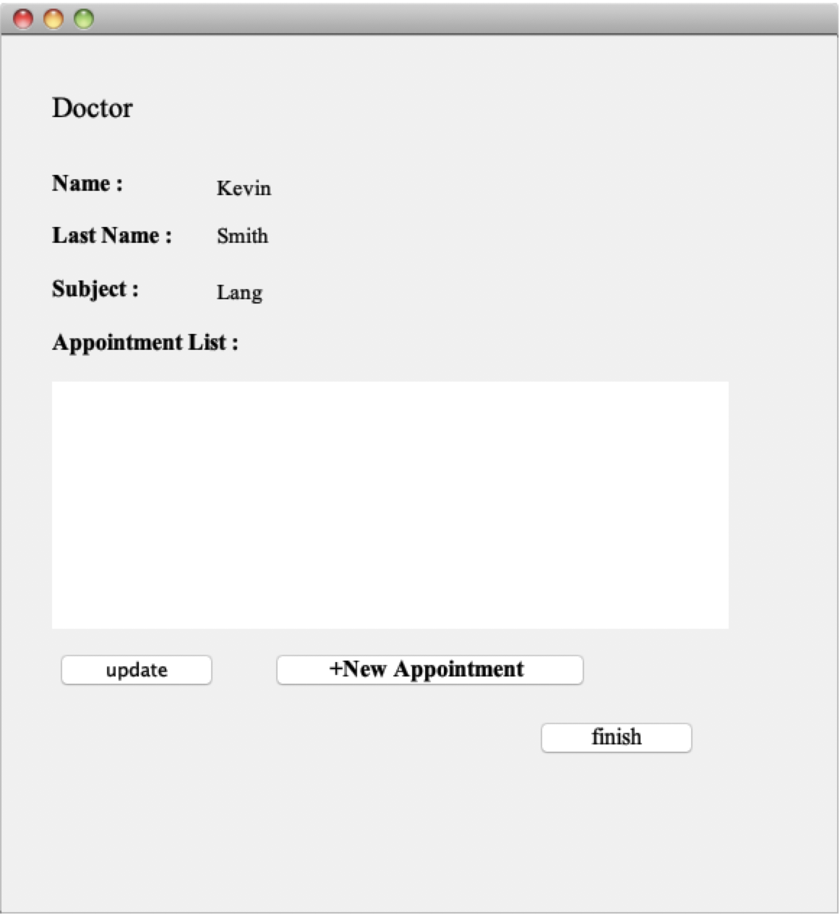

+New Appointment: you can reserve an appointment