SETU: Network Analytics Engine
An End-to-End NLP Topology System for Non-Linear Entity Extraction, Canonical Normalization, and Modularity-Based Community Profiling
Core Architecture: Data Extraction Engine (Setu-engine) & Raw Corpus and Relational Graph Asset Storage (Setu-dataset)
Developer: Ram Mishra
Compilation Timeline: May 2026
Repository links: Setu-Engine: https://github.com/AppleDinger/Setu-engine
Setu-Dataset: https://github.com/AppleDinger/Setu-dataset

PART I: CORE SOFTWARE ENGINEERING & PIPELINE ARCHITECTURE
The SETU Engine is a high-throughput, production-grade text mining and network analytics platform engineered to transform large-scale, unstructured natural language text into multi-dimensional, weighted graph representations. The system architecture uses a decoupled structure, separating the computational extraction pipelines (Setu-engine) from the underlying text data assets and tabular output metrics (Setu-dataset). This configuration ensures the platform remains scale-invariant, allowing developer teams to interchange backend entity models, tracking dictionaries, and target text repositories without creating breaking code dependencies.
1. Production Features and Technical Capabilities
- GPU-Accelerated Core NLP Processing: Utilizes an optimized spaCy processing pipeline integrated with PyTorch CUDA hooks to execute fast text mining passes on an NVIDIA RTX 4060 GPU with a target batch size of 2,000 windows.
- Deterministic Entity Resolution Framework: Employs an injection layer using an EntityRuler component to map raw variant text spellings and alias profiles into single, canonical node IDs, resolving duplicate entry fragmentation.
- Tumbling Window Co-occurrence Matrix Generator: Implements a sliding text window framework that sweeps across unstructured character strings to extract entity associations based on proximity, avoiding false connections across text boundaries.
- Localized Topological Optimization (Pruning): Uses a degree constraint algorithm via Pandas to prune line noise by capping relationships to the strongest connections per node, keeping the output highly readable.

2. Algorithmic Pipeline and Data Mechanics
Pipeline Stage | Algorithmic Implementation | Data State Output
1. Preprocessing & Cache Ingestion | Regex sweeps clear verse markers and metadata noise before combining texts using strict double-newline syntax. | Merged Master Text String Cache
2. Relationship Extraction Matrix | Sliding window extraction runs via spacy.pipe with multi-threading. Co-occurring nodes compile inside a sorted tuple schema. | Raw Pandas Co-occurrence DataFrame
3. Network Topology Engineering | Computes centrality vectors via NetworkX, using Louvain community detection to isolate distinct structural clusters. | Centrality Metrics & Modularity Indices
4. Relational Asset Export | Saves separate tables for nodes and edges, using Gephi's preferred case-sensitive schemas to ensure fast data imports. | Valid CSV Tables & Comprehensive GEXF Maps

PART II: SYSTEM CASE STUDY (INDIC VS. ABRAHAMIC TEXTS)
To validate the engine's data extraction and graph structural profiling capabilities, a macro-cultural study was executed across fourteen foundational historical texts, split into Indic and Abrahamic repositories. The analysis measures how different socio-cultural traditions organize narrative networks, identifying structural differences in centralization profiles, community splitting, and topological distance metrics.

Texts Used:

Indic Sources | Abrahamic Sources
Mahabharata | King James Bible
Ramayana | Quran
Bhagavad Gita | Full Talmud
Rig Veda | Josephus Antiquities
Vishnu Purana | Josephus Wars
Garuda Purana | Legend of the Jews
Panchatantra

1. Comparative Matrix Analysis
Topological Vector | Indic Repositories | Abrahamic Repositories | Empirical Distinction
Nodes (Entity Pool) | 78 | 110 | Core vocabulary and unique entity sizes.
Edges (Pruned Links) | 588 | 728 | Total validated interaction paths.
Graph Density | 0.19580 | 0.12143 | Interconnection rate across the structural canvas.
Clustering Coefficient | 0.0211 | 0.0095 | Local clustering probability within neighboring factions.
Network Diameter | 3 | 4 | Maximum structural steps between separated entities.
Average Path Length | 1.91 | 2.24 | Average separation distance between any two nodes.
2. Core Macro-Topographical Differences
- Centralization vs. Node Uniformity: The Indic cluster relies on major central hubs surrounded by small background figures, whereas the Abrahamic cluster features consistently sized, evenly distributed character nodes.
- Cross-Referencing vs. Linear Trajectories: The Indic network uses non-linear, recursive cross-referencing within its factions, while the Abrahamic network matches a linear structural timeline trace defined by chronological generations.
- Faction Segregation vs. Blurry Boundaries: Indic faction lines are clearly segregated by independent text boundaries and traditions (Vedic, Epic, Puranic). Abrahamic faction boundaries are structural continuities with high cross-reference levels between different historical contexts.
- Theological Modeling: The Indic system tracks multiple distinct names and contextual roles for divinity (including Brahman mentions). The Abrahamic model organizes relationships around a primary shared entity.
3. Indic Repository Deep-Dive Profile
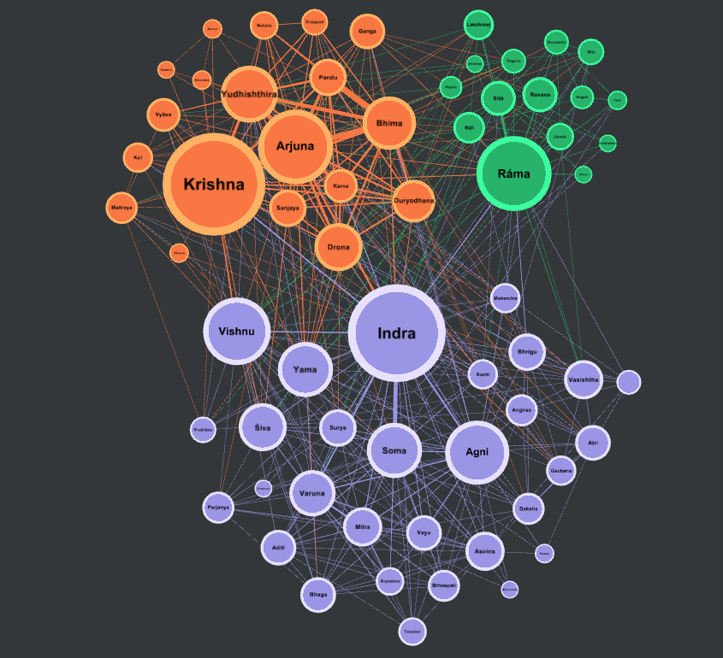
Figure 3.1: Full macro-topography of the Indic repository using the ForceAtlas2 algorithm.
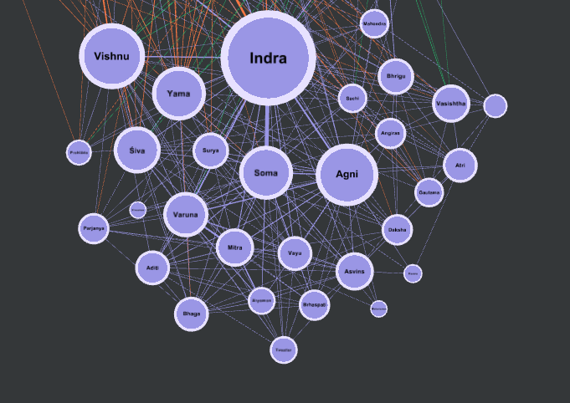
Figure 3.2: The Rig-Vedic Pantheonic Faction, highlighting many nodes with lower relative edge weights (Indra, Vishnu, Agni, Yama).
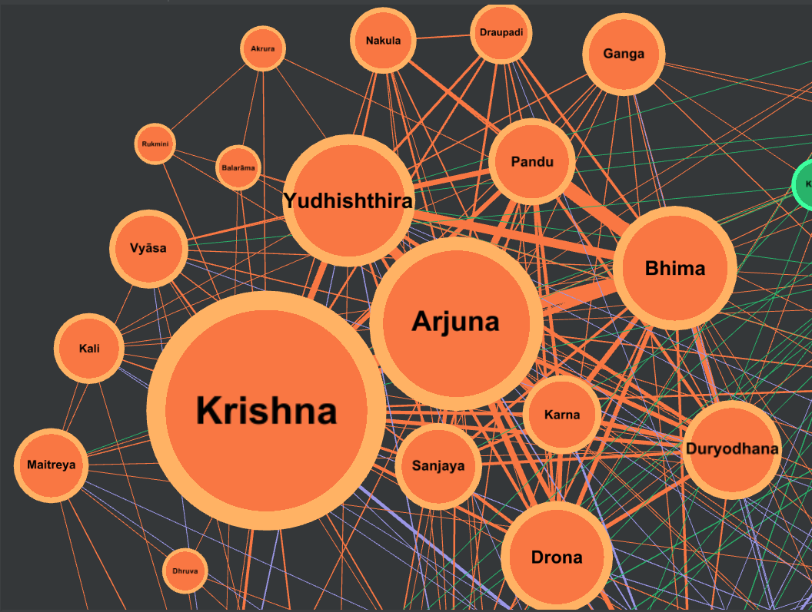
Figure 3.3: The Mahabharata Epic Faction, revealing dense clusters and heavy connection weights around primary hubs (Arjuna, Krishna, Bhima, Yudhishthira).
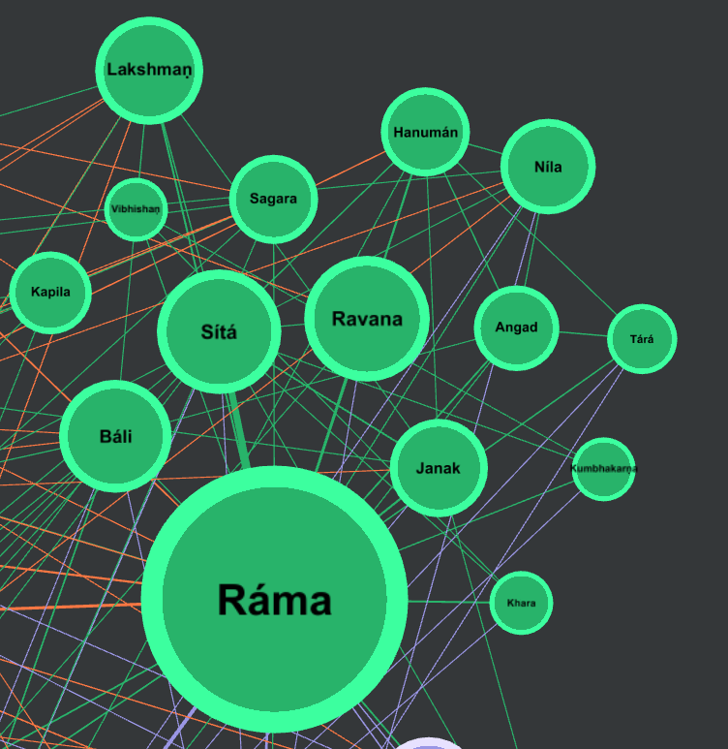
Figure 3.4: The Ramayana Narrative Faction, showing a localized structural layout centered on Rama, Sita, and Ravana.
4. Abrahamic Repository Deep-Dive Profile
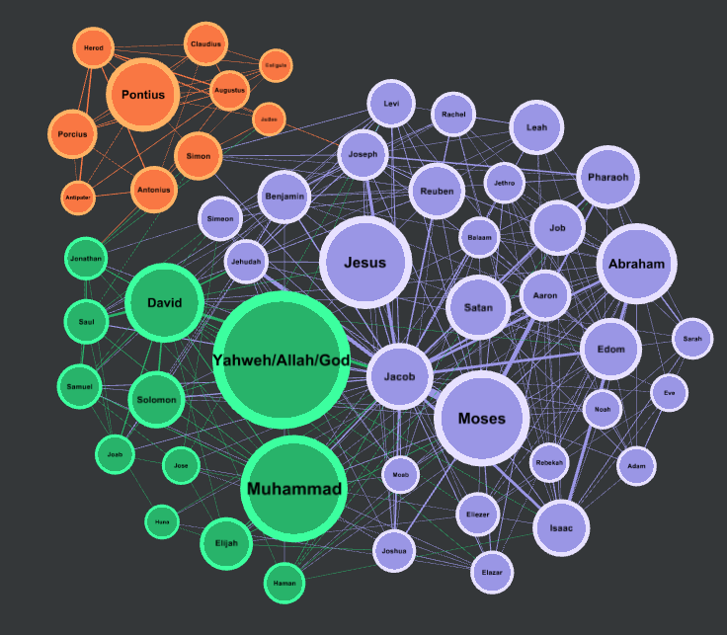
Figure 4.1: Full macro-topography of the Abrahamic repository displaying chronological structural continuity.
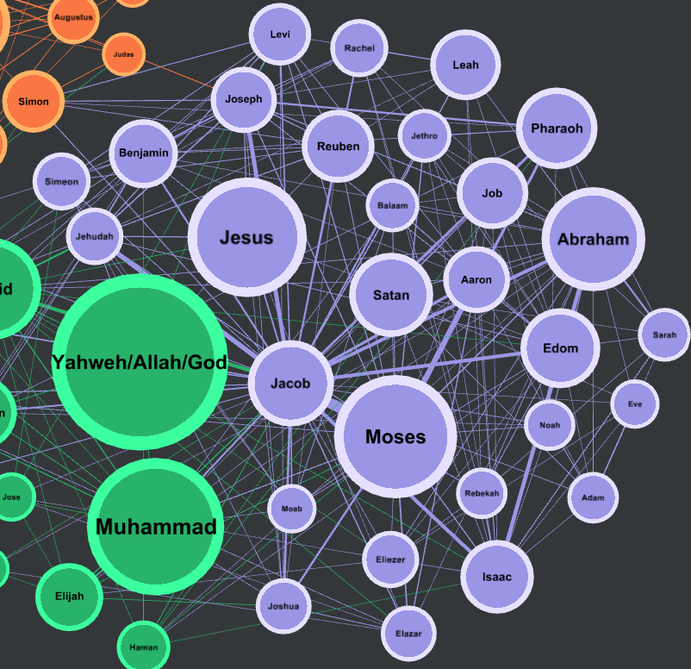Figure 4.2: The Biblical and Talmudic Faction, highlighting steady node distributions across historical successions (Jesus, Abraham, Moses).
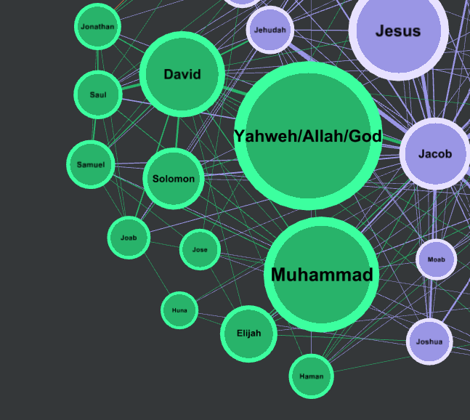
Figure 4.3: The Islamic Narrative Faction, showing shared baseline entities connecting to a single central focus node.
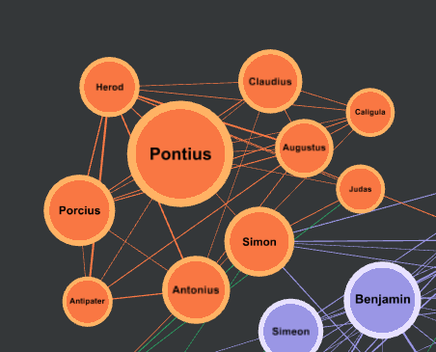
Figure 4.4: The Roman Administrative Faction, detailing the localized entry of historical and geopolitical entities (Pontius, Porcius, Antonius).
5. Technical and Academic Literature References
Bastian, M., Heymann, S., & Jacomy, M. (2009). Gephi: an open source software for exploring and manipulating networks. International AAAI Conference on Weblogs and Social Media.
Bird, S., Klein, E., & Loper, E. (2009). Natural Language Processing with Python. O'Reilly Media.
Blondel, V. D., Guillaume, J. L., Lambiotte, R., & Lefebvre, E. (2008). Fast unfolding of communities in large networks. Journal of Statistical Mechanics: Theory and Experiment, 2008(10), P10008.
Hagberg, A. A., Schult, D. A., & Swart, P. J. (2008). Exploring network structure, dynamics, and function using NetworkX. Proceedings of the 7th Python in Science Conference.
Mac Carron, P., & Kenna, R. (2012). Universal properties of mythological networks. EPL (Europhysics Letters), 99(2), 28002.
Moretti, F. (2011). Network Theory, Plot Analysis. New Left Review, 68, 80-102.
Newman, M. E. J. (2010). Networks: An Introduction. Oxford University Press.

