9

The Knee

Structure and Function
Tibiofemoral and Patellofemoral Joints
Anatomy
The knee is composed of two distinct articulations enclosed within a single joint capsule: the tibiofemoral joint and the patellofemoral joint. At the tibiofemoral joint, the proximal joint surfaces are the convex medial and the lateral condyles of the distal femur (Fig. 9.1). Posteriorly and inferiorly, the

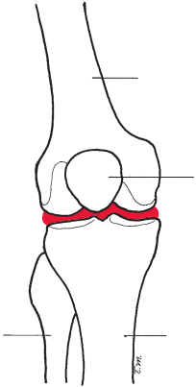
Femur

Lateral condyle
Tibiofemoral joint
Lateral condyle

Intercondylar
tubercles

Fibula
Patella
Medial condyle
Medial condyle
Tibia
FIGURE 9.1 An anterior view of a right knee showing the tibiofemoral joint.

longer medial condyle is separated from the lateral condyle by a deep groove called the intercondylar notch. Anteriorly, the condyles are separated by a shallow area of bone called the femoral patellar surface. The distal articulating surfaces are the two shallow concave medial and lateral condyles on the proximal end of the tibia. Two bony spines called the intercondylar tubercles separate the medial condyle from the lateral condyle. Two joint discs called menisci are attached to the articulating surfaces on the tibial condyles (Fig. 9.2). At the patellofemoral joint, the articulating surfaces are the pos- terior surface of the patella and the femoral patellar surface (Fig. 9.3).
The joint capsule that encloses bothjoints is large, loose, and reinforced by tendons and expansions from the surround- ing muscles and ligaments. The quadriceps tendon, patellar ligament, and expansions from the extensor muscles provide anterior stability (see Fig. 9.3). The lateral and medial collat- eral ligaments, iliotibial band, and pes anserinus help to provide medial–lateral stability, and the knee ﬂexors help to

Anterior cruciate ligament
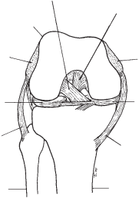
Posterior cruciate ligament
Femur

Lateral epicondyle

Lateral condyle
Lateral meniscus

Lateral (fibular)
collateral ligament

Fibula
Medial epicondyle
Medial condyle
Medial meniscus
Medial (tibial)
collateral ligament
Tibia
FIGURE 9.2 An anterior view of a right knee in the ﬂexed position showing femoral and tibial condyles, medial and lateral menisci, and cruciate and collateral ligaments.

241

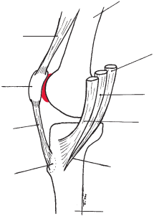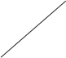
Femur

Patellar
joint
Semitendinosus

Patella
Gracilis

Sartorius
Patellar ligament

Pes anserinus
Tibial
tuberosity

Tibia
quadriceps tendon
Patellofemoral
FIGURE 9.3 A view of a right knee showing the medial
aspect, where the cut tendons of the three muscles that
insert into the anteromedial aspect of the tibia make up the pes anserinus. Also included are the patellofemoral joint,
the patellar ligament, and the patellar tendon.

provide posterior stability. In addition, the tibiofemoral joint is reinforced by the anterior and posterior cruciate ligaments, which are located within the joint (see Fig. 9.2).
Osteokinematics
The tibiofemoral joint is a double condyloidjoint with 2 degrees of freedom. Flexion–extension occurs in the sagittal plane around a medial–lateral axis; rotation occurs in the transverse plane around a vertical (longitudinal) axis.1 The incongruence and asymmetry of the tibiofemoral joint surfaces combined with muscle activity and ligamentous restraints produce an automatic rotation. This automatic rotation is involuntary and occurs primarily toward the end of extension when motion stops on the shorter lateral femoral condyle but continues on the longer medial condylar surface. During the last portion of active extension range of motion (ROM) automatic rotation produces what is referred to as either the screw-home mecha- nism, or “locking,” of the knee. For example, during non– weight-bearing active knee extension with the tibia moving on the femur, the tibia laterally rotates during the last 10 to 15 degrees of extension to lock the knee.2 Therefore, in the fully extended position of the knee, the tibia is laterally rotated in relation to the femur. To unlock the knee, either the tibia has to rotate medially or the femur has to rotate laterally to unlock the knee. This rotation is not under voluntary con- trol and should not be confused with the voluntary rotation movement possible at the joint when the knee is ﬂexed.
Passive ROM in ﬂexion is generally considered to be between 130 and 140 degrees. The range of extension beyond 0 degrees is about 5 to 10 degrees in young children, whereas
0 degrees is considered to be within normal limits for adults.3
The greatest range of voluntary knee rotation occurs at 90 degrees of ﬂexion; at this point, about 45 degrees of lateral rotation and 15 degrees of medial rotation are possible.
Arthrokinematics
In non–weight-bearing active motion, the concave tibialartic- ulating surfaces slide on the convex femoral condyles in the same direction as the movement of the shaft of the tibia. The tibial condyles slide posteriorly on the femoral condyles dur- ing ﬂexion, and the tibial condyles slide anteriorly on the femoral condyles during extension.
The incongruence of the tibiofemoral joint and the fact that the femoral articulating surfaces are larger than the tibial articulating surfaces dictate that when the femoral condyles are moving on the tibial condyles (in a weight-bearing situa- tion) the femoral condyles must roll and slide to remain on the tibia. In weight-bearing ﬂexion, the femoral condyles roll posteriorly and slide anteriorly. The menisci follow the roll of the condyles by distorting posteriorly in ﬂexion. In exten- sion, the femoral condyles roll anteriorly and slide posteriorly.1 In the last portion of extension, motion stops at the lateral femoral condyle, but sliding continues on the medial femoral condyleto produce locking of the knee.
The patella slides superiorly in extension and inferiorly in ﬂexion. Some patellar rotation and tilting accompany the sliding during ﬂexion and extension. 1
Capsular Pattern
The capsular pattern at the knee is characterized by a smaller limitation of extension than of ﬂexion and no restriction of rotations.4,5 Fritz and associates6 found that patients with a capsular pattern, deﬁned as aratio of extension loss to ﬂexion loss between 0.03 and 0.50, were 3.2 times more likely to have arthritis or arthroses of the knee. Hayes reported a mean ratio of extension loss to ﬂexion loss of 0.40 in a study of 79 patients with osteoarthritis.7,8

CHAPTER 9 The Knee 243

RANGE OF MOTION TESTING PROCEDURES: Knee
Range of Motion Testing Procedures/KNEE

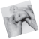 Landmarks for Testing Procedures

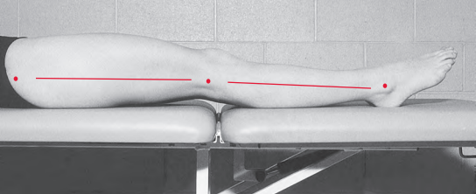
FIGURE 9.4 A lateral view of the subject’s right lower extremity showing surface anatomy landmarks for goniometer alignment.

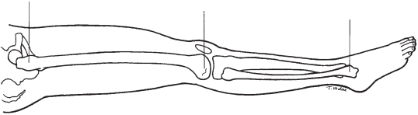
Greater trochanter
of femur Lateral femoral
epicondyle Lateral malleolus
of fibula
FIGURE 9.5 A lateral view of the subject’s right lower extremity showing bony anatomical landmarks goniometer alignment for measuring knee ﬂexion ROM.
for


Range of Motion Testing Procedures/KNEE
244 PART III Lower-Extremity Testing

KNEE FLEXION
Motion occurs in the sagittal plane around a
medial–lateral axis. According to the American
Medical Association (AMA),9 the normal ﬂexion
ROM for adults is 150 degrees. According to Boone and Azen,10 the mean ﬂexion ROM for males age
18 months to 54 years is 142.5 degrees. Roach
and Miles11 found a mean knee ﬂexion range of
132.0 degrees for males and females 25 to 74 years of age. Please refer to Tables 9.1 through 9.4 in the Research Findings section for additional normal ROM values by age and gender.
Testing Position
Place the subject supine, with the knee in extension. Position the hip in 0 degrees of extension, abduction, and adduction. Place a towel roll under the ankle to allow the knee to extend as much as possible.
Stabilization
Stabilize the femur to prevent rotation, abduction, and adduction of the hip.
Testing Motion
Hold the subject’s ankle in one hand and the posterior thigh with the other hand. Move the subject’s thigh to approximately 90 degrees of hip ﬂexion and move
the knee into ﬂexion (Fig. 9.6). Stabilize the thigh to
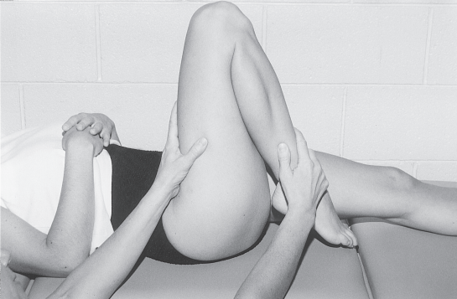
prevent further motion and guide the lower leg into knee ﬂexion. The end of the range of knee ﬂexion oc- curs when resistance is felt and attempts to overcome the resistance cause additional hip ﬂexion.
Normal End-Feel
Usually, the end-feel is soft because of contact
between the muscle bulk of the posterior calf and the thigh or between the heel and the buttocks. The
end-feel may be ﬁrm because of tension in the vastus medialis, vastus lateralis, and vastus intermedialis
muscles.
Goniometer Alignment
See Figures 9.7 and 9.8.
1. Center fulcrum of the goniometer over the lateral epicondyle of the femur.
2. Align proximal arm with the lateral midline of the femur, using the greater trochanter for reference.
3. Align distal arm with the lateral midline of the
ﬁbula, using the lateral malleolus and ﬁbular head for reference.
FIGURE 9.6 The right lower extremity at the end of knee ﬂexion ROM. The examiner uses one hand to move the subject’s thigh to approximately 90 degrees of hip ﬂexion and then stabilizes the femur to prevent further ﬂexion. The examiner’s other hand guides the subject’s lower leg through full knee ﬂexion ROM.

CHAPTER 9 The Knee 245
Range of Motion Testing Procedures/KNEE
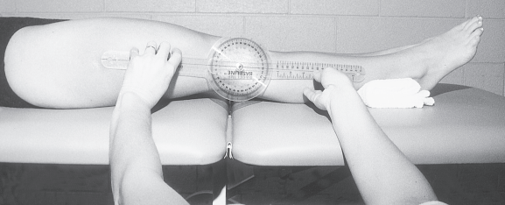
FIGURE 9.7 In the starting position for measuring knee ﬂexion ROM, the subject is supine with the upper
thigh exposed so that the greater trochanter can be visualized and palpated. The examiner either kneels or sits on a stool to align and read the goniometer at eye level.

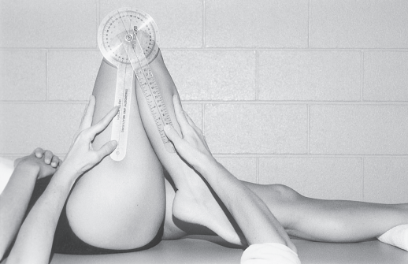
FIGURE 9.8 At the end of the knee ﬂexion ROM, the examiner uses one hand to maintain knee ﬂexion and also to keep the distal arm of the goniometer aligned with the lateral midline of
the leg.

Muscle Length Test ing Procedures/KNEE
246 PART III Lower-Extremity Testing

KNEE EXTENSION
Extension occurs in the sagittal plane around a
medial–lateral axis and may be described as a
return to the 0 starting position from the end of
the knee flexion ROM. Knee extension is usually
recorded as the starting position for flexion. An
extension limitation (inability to reach the 0 starting position) is present when the starting position for
flexion ROM does not begin at 0 degrees but in
some amount of flexion. When extension goes
beyond the 0 starting position, it may be within
normal limits in children, but when it exceeds 5 or more degrees in the adult, it is called hyperexten- sion or genu recurvatum. See Table 9.2 in the
Research Findings section for normal extension
limitations in neonates, and see Table 9.3 for normal extension beyond 0 in children 0 to 12 years of age.
Normal End-Feel
The end-feel is ﬁrm because of tension in the poste- rior joint capsule, the oblique and arcuate popliteal ligaments, the collateral ligaments, and the anterior and posterior cruciate ligaments.
MUSCLE LENGTH TESTING PROCEDURES:
Knee

RECTUS FEMORIS: ELY TEST
The rectus femoris is one of the four muscles that
make up the muscle group called the quadriceps
femoris. The rectus femoris is the only one of the four muscles that crosses both the hip and the knee joints. The muscle arises proximally from two tendons: an
anterior tendon from the anterior inferior iliac spine and a posterior tendon from a groove superior to the brim of the acetabulum. Distally, the muscle attaches to the base of the patella by way of the thick, ﬂat
quadriceps tendon and attaches to the tibial tuberos- ity by way of the patellar ligament (Fig. 9.9).
When the rectus femoris muscle contracts, it ﬂexes the hip and extends the knee. If the rectus femoris is
short, knee ﬂexionis limited when the hip is maintained in a neutral position. If knee ﬂexionis limited when the hip is in a ﬂexed position, the limitation is not due to a short rectus femoris muscle but to abnormalities of
joint structures or short one-joint knee extensor mus-
cles. In a study by Piva and associates, the mean of four tester’s measurements of the length of the rectus
femoris in 30 patients with patellofemoral pain
syndrome aged 14 to 47 years was 138.5 degrees, with a standard deviation (SD) of 12.3 degrees.12
Starting Position
Place the subject prone, with both feet off the end of the examining table. Extend the knees and position the hips in 0 degrees of ﬂexion, extension, abduction, adduction, and rotation (Fig. 9.10).
Stabilization
Stabilize the hip to maintain the neutral position. Do not allow the hip to ﬂex.

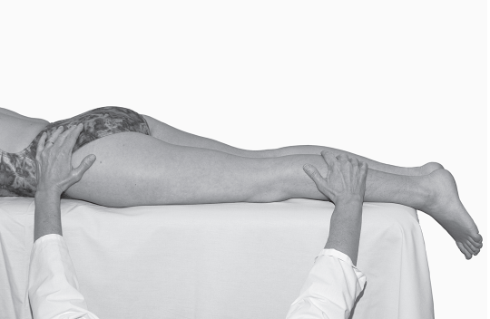

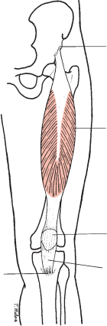
Muscle Length Test ing Procedures/KNEE
Anterior inferior iliac spine

Rectus femoris

Patella

Patellar
ligament
Tibial tuberosity
FIGURE 9.9 An anterior view of the left lower extremity showing the attachments of the rectus femoris muscle.
FIGURE 9.10 The subject is shown in the prone starting position for testing the length of the rectus
femoris muscle.

CHAPTER 9 The Knee 247


Muscle Length Test ing Procedures/KNEE
248 PART III Lower-Extremity Testing
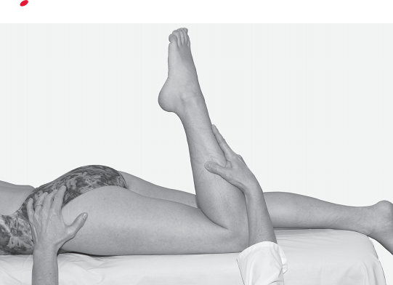
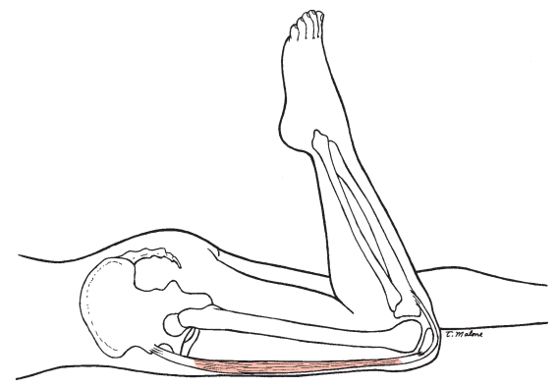
FIGURE 9.11 A lateral view of the subject at the end of the testing motion for the length of the left rectus femoris muscle.
FIGURE 9.12 A lateral view of the left rectus femoris muscle being stretched over the hip and knee joints at the end of the testing motion.

CHAPTER 9 The Knee 249
Goniometer Alignment
Muscle Length Test ing Procedures/KNEE
Testing Motion
Flex the knee by lifting the lower leg off the table. The end of the ROM occurs when resistance is felt from tension in the anterior thigh and further knee ﬂexion causes the hip to ﬂex. If the knee can be
ﬂexed to at least 90 degrees with the hip in the
neutral position, the length of the rectus femoris is normal (Figs. 9.11 and 9.12).
See Figure 9.13.
1. Center fulcrum of the goniometer over the lateral epicondyle of the femur.
2. Align proximal arm with the lateral midline of the femur, using the greater trochanter as a reference.
3. Align distal arm with the lateral midline of the ﬁbula, using the lateral malleolus and the ﬁbular head for reference.

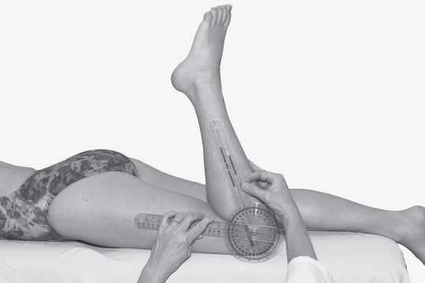
FIGURE 9.13 Goniometer alignment for measuring the position of
the knee.

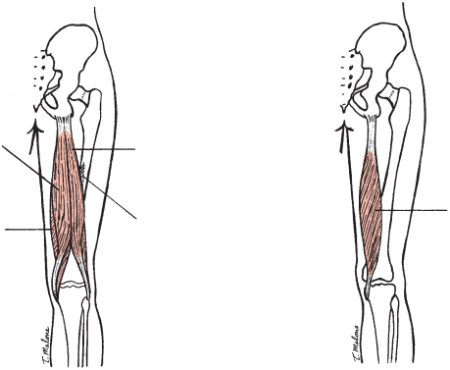

HAMSTRING MUSCLES:
SEMITENDINOSUS,
SEMIMEMBRANOSUS,
AND BICEPS FEMORIS: DISTAL HAMSTRING LENGTH TEST
OR POPLITEAL ANGLE TEST
The distal hamstring length test is also called the
popliteal angle (PA) test because the angle that is
being measured is the popliteal angle between the
femur and the lower leg. The hamstring muscles are composed of the semitendinosus, semimembranosus, and biceps femoris. The semitendinosus, semimem- branosus, and the long head of the biceps femoris
cross both the hip and the knee joints. The proximal attachment of the semitendinosus is on the ischial tuberosity, and the distal attachment is on the proxi- mal aspect of the medial surface of the tibia
(Fig. 9.14A). The proximal attachment of the semi-
membranosus is on the ischial tuberosity, and the dis- tal attachment is on the medial aspect of the medial tibial condyle (Fig. 9.14B). The biceps femoris muscle arises from two heads; the long head attaches to the ischial tuberosity and the sacrotuberous ligament,
Muscle Length Test ing Procedures/KNEE
250 PART III Lower-Extremity Testing

whereas the short head attaches along the lateral lip
linear aspera, the lateral supracondylar line, and the lat- eral intermuscular septum. The distal attachments of
the biceps femoris are on the head of the ﬁbula, with a small portion attaching to the lateral tibial condyle and the lateral collateral ligament (see Fig. 9.14A).
When the hamstring muscles contract, they ex-
tend the hip and ﬂex the knee. In the following test, the hip is maintained in 90 degrees of ﬂexion while
the knee is extended to determine whether the mus- cles are of normal length. If the hamstrings are short, the muscles limit knee extension ROM when the hip is positioned at 90 degrees of ﬂexion.
Gajdosik and associates,13 in a study of 30 healthy males aged 18 to 40 years, found a mean value of
31 degrees (SD = 7.5 degrees) for passive knee exten- sion during this test with a large range of values from
17 to 45 degrees. Testers noted that knee extension
end-feel was ﬁrm and easily identiﬁed. Intrarater reliabil- ity intraclass correlation coefﬁcients (ICCs) for the test
were 0.86 when knee extension was performed actively and 0.90 when performed passively. Some researchers have reported the supplementary angles to those noted by Gajdosik and associates. Youdas and colleagues14
used a 360-degree universal goniometer to measure the
Ischial tuberosity
Semitendinosus
Biceps femoris (long head)

Semimembranosus
Biceps femoris (short head)

Head of Head of
fibula Tibia fibula
Ischial
tuberosity
Semimembranosus
Tibia
A B
FIGURE 9.14 A: A posterior view of the thigh showing the attachments of the semitendinosus and the biceps femoris muscles. B: A posterior view of the thigh showing the attachments of thesemimembranosus muscle, which lies under the two hamstring muscles shown in A.

CHAPTER 9 The Knee 251
of abduction, adduction, and rotation (Fig. 9.15). Ini- tially, the knee being tested is allowed to relax in ﬂex- ion. The lower extremity that is not being tested rests on the examining table with the knee fully extended and the hip in 0 degrees of ﬂexion, extension, abduc- tion, adduction, and rotation.
Muscle Length Test ing Procedures/KNEE
PA in 214 subjects (108 women and 106 men) between the ages of 20 and 79 years. The mean value for the
women of 152.0 degrees (SD = 10.6 degrees) was
greater than the mean value for men of 141.4 degrees (SD = 8.1 degrees). The supplementary angles of these values for women and men are 28.0 and 38.6 degrees respectively, which is generally consistent with the val- ues noted by Gajdosik and associates.
Two testers in a study by Fredriksen and colleagues15 found that passive knee extension angle measurements for a single female subject tested 16 times per side
ranged from 153 to 159 degrees for the left leg and from 154 to 165 degrees for the right leg. The supplemen-
tary angles of these values range from 27 to 21 degrees for the left leg and from 26 to 15 degrees for the right leg. A standardized force using a dynamometer was
used to extend the knee, and the pelvis was stabilized by a belt. The hip was positioned in 120 degrees of ﬂex- ion, which is a considerably larger angle of ﬂexion than the 90 degrees of hip ﬂexion used by both Youdas and associates14 and Gadjosik and associates.13
Starting Position
Position the subject supine with the hip on the side being tested in 90 degrees of ﬂexion and 0 degrees
Stabilization
Stabilize the femur to prevent rotation, abduction, and adduction at the hip and to maintain the hip in 90 degrees of ﬂexion.
Testing Motion
Extend the knee to the end of the ROM. The end of the testing motion occurs when resistance is felt from tension in the posterior thigh and further knee exten- sion causes the hip to move toward extension
(Figs. 9.16 and 9.17).
Normal End-Feel
The end-feel is ﬁrm owing to tension in the semimem-
branosus, semitendinosus, and biceps femoris muscles.

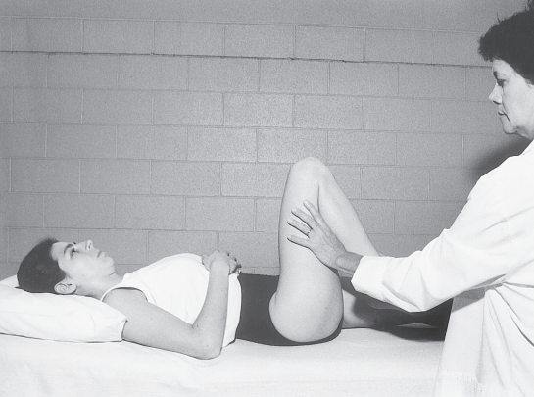
FIGURE 9.15 Starting position for measuring the length of the hamstring muscles.

Muscle Length Test ing Procedures/KNEE
252 PART III Lower-Extremity Testing
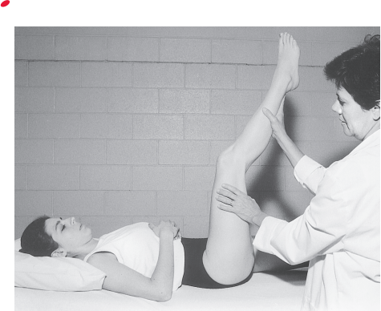
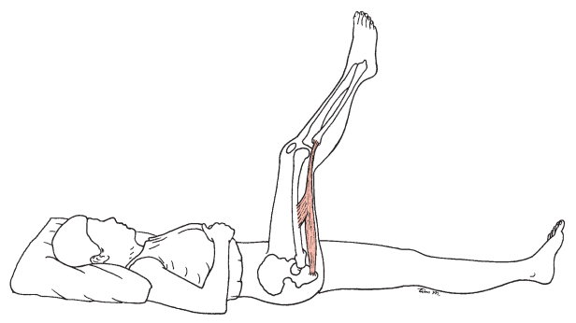
FIGURE 9.16 End of the testing motion for the length of the right hamstring muscles.
FIGURE 9.17 A lateral view of the right lower extremity shows the hamstring muscles being stretched over the hip and knee joints at the end of the testing motion.

CHAPTER 9 The Knee 253
Goniometer Alignment
Muscle Length Test ing Procedures/KNEE
See Figure 9.18.
1. Center fulcrum of the goniometer over the lateral epicondyle of the femur.
2. Align proximal arm with the lateral midline of the femur, using the greater trochanter for a reference.
3. Align distal arm with the lateral midline of the
ﬁbula, using the lateral malleolus and ﬁbular head for reference.

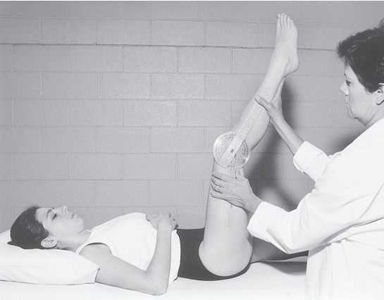
FIGURE 9.18 Goniometer alignment for measuring knee position.

Research Findings

This section of the chapter includes not only age and gender effects on knee ROM but also the effects of body mass. Also included is the range of functional knee ROM required for stairs and other activities of daily living followed by a sam- pling of reliability and validity studies in normal and patient populations. Table 9.1 provides knee ROM values from selected sources.9–11 See Tables 9.2 to 9.4 for additional ROM values by age and gender.

Effects of Age, Gender, and Other Factors
Age
Knee extension limitations at birth are normal and similar to extension limitations found at the hip joint at birth. The term “extension limitation” is used rather than “ﬂexion contrac- ture” because contracture refers to an abnormal condition caused by ﬁxed muscle shortness, which maybe permanent. 16 Knee extension limitations in the neonate gradually disap- pear, and extension, instead of being limited, may become excessive in the toddler. Waugh and colleagues17 and Drews
  TABLE 9.1 | Knee Flexion Range  of Motion: Normal Values in Degrees

AMA9 Boone10 Roach and Miles11
Males Males and Females
18 mos–54 yrs 25–74 yrs n = 109 n = 1683
Motion Mean (SD) Mean (SD)
Flexion 150 142.5 (5.4) 132.0 (10.0)
(SD) = standard deviation.

and coworkers18 found that newborns lacked approximately 15 to 20 degrees of knee extension. Schwarze and Denton, 19 in a study of 1000 neonates (527 girls and 473 boys) in the ﬁrst 3 days of life, found a mean extension limitation of 15 degrees. These ﬁndings agree with the ﬁndings of Wanatabe and associates,20 who found that newborns lacked 14 degrees of knee extension. The extension limitation grad- ually disappears, as shown by comparing Tables 9.2 and 9.3.
Broughton, Wright, and Menelaus21 measured extension limitations in normal neonates at birth and again at 3months and 6 months. At birth, 53 of the 57 (93 percent) neonates had extension limitations of 15 degrees or greater, whereas only 30 of 57 (53 percent) infants had extension limitations at 6 months of age. The mean reduction in extension limitations was 3.5 degrees per month from birth to 3 months and 2.8 degrees between 3 and 6 months (see Table 9.3). The 2 year olds in the study conducted by Wanatabe and associates20 (see Table 9.3) had no evidence of a knee extension limitation.
Knee extension beyond 0 degrees (often referred to as hyperextension) is considered to be a normal ﬁnding in young children but is not usually observed in adults,3 who may have slightly less than full knee extension. Wanatabe and associates20 found that the 2 year olds had up to 5 degrees of extension beyond 0. This ﬁnding is similar to the mean of 5.4 degrees of extension beyond 0 noted by Boone22 for the group of children between 1 year and 5 years of age. Beighton, Solomon, and Soskolne,23 in a study of joint laxity in 1081 males and females, found that joint laxity decreased rapidly throughout childhood in both genders and decreased at a slower rate during adulthood. The authors used a ROM of greater than 10 degrees of knee extension beyond 0 as one of the criteria of joint laxity. Cheng and colleagues,24 in a study of 2360 Chinese children, found that the average of 16 degrees of knee extension beyond 0 in children of 3 years of age decreased to 7 degrees by the time the children reached 9 years of age. A comparison of the knee extension beyond 0 mean values for the group aged 13 to 19 years in Table 9.4 with the extension values for the group aged 1 to 5 years in Table 9.3, demon- strates the decrease in extension beyond 0 that occurs in childhood.

TABLE 9.2 |  | Knee Extension Limitations in Neonates 6 Hours to 7 Days of Age: Normal Values in Degrees
 | Waugh et al17  6–65 hrs n = 40 |  | Drews et al18  12 hrs–6 days n = 54 | Schwarze and Denton19  1–3 days n = 1000 | Broughton et al21  1–7 days n = 57
Motion | Mean (SD) |  | Mean (SD) | Mean | Mean (SD)
Extension  limitation | 15.3 (9.9) |  | 20.4 (6.7) | 15.0 | 21.4 (7.7)
(SD) = standard deviation.
All values were obtained from passive range of motion measurements with use of a universal goniometer.

CHAPTER 9 The Knee 255

TABLE 9.3 Knee Range of Motion in Infants and Young Children 0 to 12 Years of Age:
Normal Values in Degrees
Broughton et al21 |  |  |  | Wanatabe et al20 | Boone22
 | 3 mos |  | 6 mos | 0–2 yrs | 1–5 yrs | 6–12 yrs
 | n = 57 |  | n = 57 | n = 109 | n = 19 | n = 17
Motion | Mean (SD) |  | Mean (SD) | Range of means | Mean (SD) | Mean (SD)
Flexion | 145.5 (5.3) |  | 141.7 (6.3) | 148–159 | 141.7 (6.2) | 147.1 (3.5)
Extension | 10.7 (5.1)* |  | 3.3 (4.3)* |  | 5.4 (3.1)† | 0.4 (0.9)
(SD) = standard deviation.  * Indicates extension limitations.  † Indicates extension beyond 0 degrees.  In Table 9.4 the mean values obtained by Boone22 are from male subjects, whereas the values obtained by Roach and Miles11 are from both genders. If values presented for the oldest groups (those aged 40 to 74 years) in both studies are compared with the values for the youngest group (those aged 13to 19years), it can be seen that the oldest groups have smaller mean values of ﬂexion. However, with aSD of 11 degrees in the oldest groups, the difference between the youngest and the old- est groups is not more than 1 SD. Roach and Miles11 concluded that, at least in individuals up to 74 years of age, any substan- tial loss (greater than 10 percent of the arc of motion) in joint mobility should be viewed as abnormal and not attributable to the aging process. The ﬂexion values obtained by these authors were considerably smaller than the 150-degree aver- age value published by the AMA.9  Walker and colleagues25 studied active ROM of the extrem- ity joints in 30 men and 30 women (ranging in age from 60 to 84 years) from recreational centers. No differences were found in knee ROM between subjects aged 60 to 69years and subjects aged 75 to 84 years. However, average values indicated that the subjects had an extension limitation (inability to attain a neutral 0-degree starting position). This ﬁnding was similar to the loss of extension noted at the hip, elbow, and ﬁrst metatarsopha- langeal (MTP) joints. The 2-degree extension limitation found |  |  |  | at the knee was much smaller than that found at the hip joint. According to the American Association of Orthopaedic Sur- geons (AAOS) handbook,3 extension limitations of 2 degrees are considered to be normal in adults. Extension limitations greater than 5 degrees in adults maybe considered as knee ﬂexion con- tractures. These contractures often occur in the elderly because of disease, sedentary lifestyles, and the effects of the aging process on connective tissues.  Mollinger and Steffan26 used a universal goniometer (UG) to assess knee ROM among 112 nursing home residents with an average age of 83 years. The authors found that only 13 percent of the subjects had full (0 degrees) passive knee extension bilaterally. Thirty-seven of the 112 subjects (33 per- cent) had bilateral knee extension limitations of 5 degrees or less bilaterally, which the AAOS considers to be normal in older adults. Forty-seven subjects (42 percent) had greater than 10 degrees of limitations in extension (ﬂexion contrac- tures). Residents with a 30-degree loss of knee extension had an increase in resistance to passive motion and a loss of ambulation.  Steultjens and coworkers27 found knee ﬂexion contractures in 31.5 percent of 198 patients with osteoarthritis of the knee or hip. (It should be noted that these authors considered knee ﬂex- ion contractures as an inability to attain the horizontal 0 position
  TABLE 9.4 |  | Age Effects on Knee Motion in Individuals 13 to 74 Years of Age: Mean Values in Degrees
 |  |  | Boone22 |  | Roach and | Miles11
13–19 yrs |  |  | 20–29 yrs | 40–45 yrs | 40–59 yrs | 60–74 yrs
n = 17 |  |  | n = 19 | n = 19 | n = 727 | n = 523
Motion Mean (SD) |  |  | Mean (SD) | Mean (SD) | Mean (SD) | Mean (SD)
Flexion 142.9 (3.7) |  |  | 140.2 (5.2) | 142.6 (5.6) | 132.0 (11.0) | 131.0 (11.0)
Extension 0.0 (0.0) |  |  | 0.4 (0.9) | 1.6 (2.4)
(SD) = standard deviation.

starting position for measuring ﬂexion.) Flexion contractures of the knee or hip or both were found in 73 percent of patients. Generally, a decrease inactive assistive ROM was associated with an increase in disability but was motion speciﬁc. The motions that had the strongest relationship with disability were knee ﬂexion, hip extension, and lateral rotation. Ersoz and Ergun28 found that in a group of 44- to 76-year-old patients with primary knee osteoarthritis, 33 out of the 40 knees tested (82.5 percent) had extension limitations ranging from 1 to 14 degrees.
Despite the knee ﬂexion contractures found in the elderly by Mollinger and Steffan,26 many elderly individuals appear to have at least a functional ﬂexion ROM. Escalante and coworkers29 used a universal goniometer (UG) to measure knee ﬂexion passive ROM in 687 community-dwelling el- derly subjects between the ages of 65 and 79 years. More than 90 degrees of knee ﬂexion was found in 619 (90.1 percent) of the subjects. The authors used a cutoff value of 124 degrees of ﬂexion as being within normal limits. Subjects who failed to reach 124 degrees of ﬂexion were classiﬁed as having an abnormal ROM. Using this criterion, 76 (11 percent) right knees and 63 (9 percent) left knees were below this value and thus had abnormal (limited) passive ROM in ﬂexion.
Nonaka and colleagues30 examined age-related changes at the hip and knee in 77 healthy male volunteers aged 15 to 73 years. The authors found that passive range of motion (PROM) of the hipjoint decreased with increasing age but the knee joint PROM remained unchanged. However, interactive motion of the hip and knee showed an age-related reduction, which the authors attributed to shortening of muscle and connective tissue.
Gender
Beighton, Solomon, and Soskolne23 defined more than 10 degrees of knee extension beyond 0 as hyperextension and included this criterion in a study of joint laxity in 1081 males and females. Females in the study had more joint lax- ity than males at any age. Loudon, Goist, and Loudon31 operationally defined knee hyperextension (genu recurva- tum) as more than 5 degrees of extension beyond the 0 posi- tion. Clinically, the authors had observed that not only was hyperextension more common in females than males, but that the condition might be associated with functional deficits in muscle strength, instability, and poor propriocep- tive control of terminal knee extension. The authors cautioned that the female athlete with hyperextended knees maybe at risk for anterior cruciate ligament injury. Hall and colleagues32 found that 10 female patients diagnosed with hypermobility syndrome had alterations in proprioceptive acuity at the knee compared with an age-matched and gender-matched control group.
James and Parker33 studied knee ﬂexion ROM in 80 men and women who ranged in age from 70 years to older than 85 years. Women in this group had greater ROM in both ac- tive and passive knee ﬂexion than men. Overall knee ﬂexion values were lower than expected for both genders, possibly owing to the fact that the subjects were measured in the prone

position, where the two-joint rectus femoris muscle may have limited the ROM.
In contrast to the ﬁndings of James and Parker,33 Escalante and coworkers29 found that female subjects had reduced passive knee ﬂexion ROM compared with males of the same age. However, the women had on average only 2 degrees less knee ﬂexion than men. The women also had a higher body mass index (BMI) than the men, which may have contributed to their reduced knee ﬂexion.
Schwarze and Denton19 observed no differences owing to gender in a study of 527 girls and 473 boys aged 1 to 3 days. Likewise, Cleffken and colleagues34 found no gender differ- ences inactive and passive knee ﬂexion and extension ROM in 23 male and 19 female healthy volunteers aged 19 to 27 years.
Body Mass Index
Lichtenstein and associates35 found that among 647 community- dwelling elderly subjects (aged 64 to 78 years), those with high BMI had lower knee ROM than their counterparts with low BMI. Elderly subjects who were severely obese had an average loss of 13 degrees of knee ﬂexion ROM compared with their counterparts who were not obese. The authors determined that a loss of knee ROM of at least 1 degree occurred for each unit increase in BMI. Escalante and coworkers29 found that obesity was signiﬁcantly associated with a decreased passive knee ﬂexion ROM. Knees of subjects who were overweight had a ﬂexion ROM that was 5 degrees less than subjects who were not obese. Sobti and colleagues36 found that obesity was signiﬁcantly associated with the risk of pain or stiffness at the knee or hip in a survey of 5042 Post Ofﬁce pensioners. Knees of subjects who were overweight had a knee ﬂexion ROM that was 5 degrees less than subjects who were not obese.

Functional Range of Motion
Table 9.5 provides knee ROM values required for various functional activities. Figures 9.19 to 9.21 show a variety of functional activities requiring different amounts of knee ﬂex- ion. Of the activities measured by Jevsevar and coworkers37 (stair ascent and descent, gait, and rising from a chair), stair ascent required the greatest range of knee motion.
Livingston and associates38 used three testing staircases with different dimensions. Shorter subjects had a greater maxi- mum mean knee ﬂexion range (92 to 105 degrees) for stair ascent in comparison with taller subjects (83 to 96 degrees). Laubenthal,Smidt, and Kettlekamp39 used an electrogoniomet- ric method to measure knee motion in three planes (sagittal, coronal, and transverse). Stair dimensions used by McFayden and Winter40 were 22 cm for stair height and 28 cm for stair tread. Similar dimension stairs were used by Protopapadaki and associates,41who used a rise height of 18 cm and a stair tread length of 28.5 cm to determine the knee motion during stair ascent and descent of 33 young healthy male and female sub- jectsranging in age from 18 to 39years. The mean knee ﬂexion

TABLE 9.5 Knee Flexion Range of Motion Necessary for Functional Activities:
Normal Values in Degrees
  Motion  Walk on level  surfaces  Ascend stairs Descend stairs Rise from chair Sit in chair  Tie shoes  Lift object from ﬂoor | Jevsevar et al*37  Healthy Subjects  (6M, 5F)  Mean = 53 yrs  n = 11  Mean (SD)  63.1 (7.7)  92.9 (9.4)  86.9 (5.7)  90.1 (9.8) | Livingston et al38  Healthy Women  Range 19-26 yrs  n = 15  Mean range  2–105.0 1–107.0 | Laubenthal et al39  Healthy Men  Mean = 25 yrs  n = 30  Mean range (SD)  0–83.0 (8.4)  0–83.0 (8.2)  0–93.0 (10.3)  0–106.0 (9.3)  0–117.0 (13.1) | McFayden and Winter40  Healthy Male*  n = 1  Mean range  10–100.0 20–100.0 | Rowe et al42  Normal Elderly  Mean = 67 yrs  n = 20  Mean (SD)  64.5 (5.9)  80.3 (8.1)  77.8 (8.3)  89.8 (9.4) 91.0 (11.8)
(SD) = standard deviation.
* Sample consisted of one subject measured during eight trials.

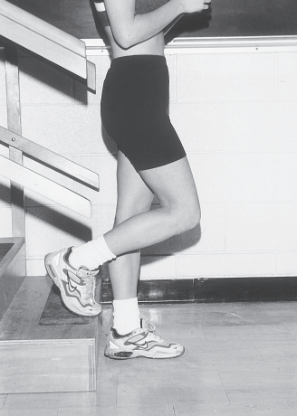
FIGURE 9.19 Descending stairs requires between 86.937 and 10738 degrees of knee ﬂexion depending on the stair
dimensions.

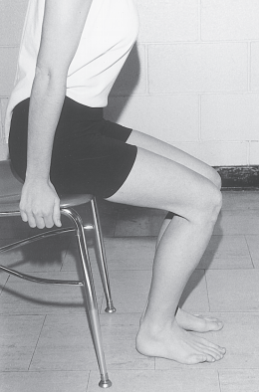
FIGURE 9.20 Rising from a chair requires a mean range of knee ﬂexion of 90.137 to 95.0 degrees.41

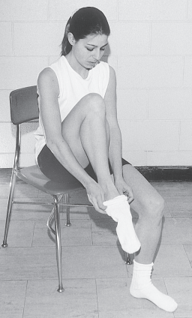
FIGURE 9.21 Putting on socks requires approximately
117 degrees of knee ﬂexion.39

angles were 93.9 degrees for stair ascent and 90.5 degrees for stair descent.
Rowe and associates42 used a flexible electrogoniome- ter to measure knee joint motioningait, stairs, and getting in and out of a chair and a bath. Walking required the least amount of knee flexion for the 20 elderly subjects (aged 54 to 90 years) in the study, whereas getting in and out of a bath required the most knee flexion (135 degrees). The authors suggested that a clinical guideline of at least 110 degrees of flexionis necessary to allow patients to be able to walk, negotiate stairs, and get in and out of chairs. A goal of 90 degrees of knee flexion is not adequate to allow patients to carry out normal activities.
Lark and colleagues43 compared knee ROM in stair descent in six healthy elderly males (mean age = 64 years) and six height- and weight-matched young males (mean age = 25 years). Knee ﬂexion ROM was 12 percent less in the elderly group than in the younger group, but there was no dif- ference between the groups in knee extension. However, the elderly group used 80 percent to 100 percent of their passive knee ROM, whereas the younger males used only 70 percent to 80 percent.
Oberg, Karsznia, and Oberg44 used electrogoniometers to measure knee joint motion in midstance and swing phases of gait in 233 healthy males and females aged 10 to 79 years.

Only minor changes were attributable to age, and the authors determined that an increase in knee angle of about 0.5 degrees per decade occurred at midstance and a decrease of 0.5 to 0.8 degrees in knee angle occurred in swing phase. According to Rancho Los Amigos Medical Center,45 the mean range of values for knee motion in gait on level surfaces is 5 to 60 degrees; however, the age, sex, and health status of the pop- ulation used to obtain these values is unknown.
Mullholland and Wyss46 reviewed the literature on the functional range of knee motions that are required in non- Western cultures for normal activities of daily living. The review revealed that in many parts of Asia, chairs were not commonly used and ﬂoor sitting, squatting, kneeling, or sitting cross-legged were the preferred positions. Hemmerich and colleagues47 usedanelectrogoniometry motion tracking device to determine the range of motion needed to perform some of the activities identiﬁed by Mullholland and Wyss.46 Thirty healthy Indian subjects (10 women and 20 men) with an aver- age age of 48.2 years performed squatting with the heels up and down, cross-legged sitting, and kneeling with ankles dor- siﬂexed and plantarﬂexed. The authors found that medial rota- tion at the knee accompanied hip ﬂexion in all activities. The greatest mean maximum knee medial rotation (33 degrees) was necessary for sitting cross-legged. Mean maximum knee ﬂexion angles reached values greater than 150 degrees for both types of squatting and for kneeling with the ankles dorsiﬂexed. The maximal angle of knee ﬂexion needed for kneeling with ankles plantarﬂexed was 144.4 degrees, whereas the mean maximum angle of knee ﬂexion for squatting with the heels up was 156.9 degrees. The ranges of motion results found in this study are far greater than can be accommodated by any exist- ing prostheses and are many degrees more than the clinical guideline of 110 degrees of knee ﬂexion suggested by Rowe and associates.42

Reliability and Validity
Reliability studies of active and passive range of knee motion have been conducted in healthy subjects48–52 and inpatient populations.53–59 Similar to ﬁndings at other joints, the results of knee studies show that intratester reliability is higher than intertester reliability.48,55 Reliability and ROM values also appear to be affected by measurement instruments and testing positions and by the type of motion (active or passive) tested. Factors that have been shown to improve reliability include training of testers, use of more than one person to assist with stabilization (especially in the presence of spasticity), holding of heavy extremities, and marking of landmarks.
Reliability: Universal Goniometer in Healthy Populations
Boone and associates48 had four testers use UGs to measure active knee ﬂexion and extension ROM at four weekly ses- sions. Intratester reliability was higher than intertester reliabil- ity, and the total intratesterSD for measurements at the knee was 4 degrees, whereas the intertesterSD was 5.9 degrees. The authors recommended that when more than one tester

CHAPTER 9 The Knee 259

measures the range of knee motion, changes in ROM should exceed 6 degrees to show that a real change has occurred.
Rheault and coworkers50 found good intertester reliability for the UG (Table 9.6) and the ﬂuid-based inclinometer (r = 0.83) for measurements of active knee ﬂexion. However, signiﬁcant differences in the ROM values were found between the instruments. Therefore, the authors concluded that, although the universal and ﬂuid-based goniometers each appeared to have good reliability, they should not be used interchangeably in the clinical setting.
Bartholomy, Chandler, and Kaplan51 had similar ﬁndings. These authors compared measurements of passive knee ﬂex- ion ROM taken with a UG with measurements taken with a ﬂuid-based inclinometer and an Optotrak motion analysis sys- tem. Eighty subjects aged 22 to 43 years were measured. Individually, the UG and the inclinometer were found to be

reliable instruments for measuring passive knee ﬂexion. ICCs for the UG were 0.97, and ICCs for the ﬂuid inclinometer were 0.98. However, there were signiﬁcant differences in the ROM values obtained among the three devices used, and the authors caution that these instruments should not be used interchangeably.
Mollinger and Steffan26 collected intratester reliability data on measurement of knee extension made by two testers using a UG. ICCs for repeated measurements of knee exten- sion were high (see Table 9.6), with differences between mea- surements averaging 1 degree.
Brosseau and associates60 used a UG and a parallel goniometer (PG) to measure two ﬂexion-angle positions in the right knees of 60 healthy subjects (44 females and 16 males). Intratester reliability of the smaller-angle (about
20 degrees) and larger-angle (about 100 degrees) positions

TABLE 9.6 Intratester and Intertester Reliability: Knee Range of Motion Measured
with a Universal Goniometer
Author | n | Sample | Motion | Intra ICC | Inter ICC | Intra r | Inter r
Boone et al 48 | 12 | Healthy adult males  (25–54 yrs) | AROM Flexion | 0.87 | 0.50
Brosseau et al60 | 60 | Healthy  adults (mean age 20.6 yrs) | Flexion ﬁxed angles | 0.86–0.97 | 0.91–0.94
Rheault et al 50 | 20 | Healthy adults (mean age 24.8 yrs) | AROM Flexion |  |  |  | 0.87
Gogia et al 49 | 30 | Healthy adults (20–60 yrs) | PROM Flexion |  | 0.99 |  | 0.98
Drews et al 18 | 9 | Healthy infants  (12 hrs–6 days) | PROM Flexion |  |  |  | 0.69 left 0.89 right
Rothstein et al 53 | 12 | Patients (ages not reported) | PROM  Flexion  Extension | 0.97–0.99 0.91–0.97 | 0.84–0.99 0.59–0.80 | 0.97–0.99 0.91–0.96 | 0.83–0.92 0.57–0.79
Watkins et al 54 | 43 | Patients (mean age 39.5 yrs) | PROM  Flexion  Extension | 0.99 0.98 | 0.90 0.86
Pandya et al 55 | 150*  21† | Duchenne  muscular  dystrophy  (<1 yr–20 yrs) | PROM  Extension | 0.93 | 0.73
Mollinger and Steffan 26 | 10 | Nursing home residents | Extension | 0.99 | 0.97
Beissner et al 56 | 10 | Nursing home and Independent  living residents (mean age  81.0 yrs) | PROM  Flexion  Extension |  |  | 0.70–0.93 0.70–0.93
AROM = active range of motion; ICC = intraclass correlation coefﬁcient; PROM = passive range of motion; r = pearson product moment correlation coefﬁcient.
*150 subjects were used to calculate intratester ICC. †21 subjects were used to calculate intertester ICC.

were good to excellent for the UG and good for the PG. Intertester reliability was lower than intratester reliability for both positions and goniometers, however, the smaller angle had lower intertester reliability compared to the large angle (see Table 9.6).
Reliability: Universal Goniometer inPatient Populations
Rothstein, Miller, and Roettger53 investigated intratester, intertester, and interdevice reliability in a study involving 12 patients referred to physical therapy for their knee. Intratester reliability for passive ROM measurements for knee ﬂexion and extension was high. Intertester reliability also was high among the 12 testers for passive ROM measurements for ﬂexion but was lower for knee extension measurements (see Table 9.6). Intertester reliability was not improved by repeated measure- ments but was improved when testers used the same patient positioning. Interdevice reliability was high for all measure- ments. Neither the composition of the UG (metal or plastic) nor the size (large or small) had a signiﬁcant effect on the measurements.
Watkins and associates54 compared passive ROM mea- surements of the knees of 43 patients made by 14 physical therapists who used aUG and visual estimates. These authors found that intratester reliability with the UG was high for both knee ﬂexion and knee extension. Intertester reliability for goniometric measurements also was high for knee ﬂexion but only good for knee extension (see Table 9.6). Both intratester and intertester reliability were lower for visual estimation than for goniometric measurement. The authors suggested that therapists should not substitute visual estimates for goniometric measurements when assessing a patient’s range of knee motion because of the additional error that is intro- duced with use of visual estimation.
Pandya and colleagues55 studied intratester and intertester reliability of passive knee extension measurements in 150 chil- dren aged 1 to 20 years who had a diagnosis of Duchenne mus- cular dystrophy. Intratester reliability with use of the UG was high, but intertester reliability was only fair (see Table 9.6).
McWhirk and Glanzman57 had two physical therapists measure the knee ROM and the popliteal angle in 46 knees in 25 children (aged 2 to 18 years) with spastic cerebral palsy. The intertester reliability of knee extension measurements was an ICC of 0.78 with a 95% conﬁdence interval (CI) = ±1.75, and the popliteal angle measurement had an ICC of 0.93 with a 95% CI = ±1.47. The therapists helped each other during the measurements by having one or the other either provide support for the test leg or stabilize the other extremity.
In a study by Lessen and associates,58 two physical ther- apists used along arm UG to measure active and passive knee ﬂexion and extension in 30 patients within the ﬁrst 4 days after total knee arthoplasty. Measurements were taken with the patients supine in a hospital bed and in the sitting position on an examination table. The highest levels of agreement between the testers were found for passive ﬂexion and exten- sion in the sitting position. The lowest level of agreement was found for passive ﬂexion in the supine position with 16.2 to

19.0 degrees difference between the two testers. ICC values for intertester reliability were highest for active and passive ﬂexion while sitting.
Kilgour, McNair, and Stott59 had three pediatric physical therapists measure bilateral knee extension in 25 children with spastic cerebral palsy ranging in age from 6 to 17 years and 25 age- and sex-matched controls. Intrasessional absolute differences ranged from 0 to 2.7 degrees in the control group and 0 to 2.4 degrees in the cerebral palsy (CP) group. Intrases- sional ICCs were good in the control group (ICC = 0.79 to 0.87) and excellent in the CP group (ICC = 0.97 to 0.99). Inter- sessional ICCs were lower for both the control and CP group, but only the control group had unacceptable ICCs (0.34 to 0.67) compared to an ICC of 0.89 to 0.92 for the CP group. The authors concluded that sagittal plane ROM measures have sim- ilar levels of reliability in children with spastic CP compared with healthy controls both within and between sessions.
Reliability: Electronic Digital Inclinometer (CYBEX EDI320)
Cleffken and associates34conducted a study to determine both intratester and intertester reproducibility for measurements of active and passive knee ﬂexion and extension in 42 healthy volunteers. Each motion was measured by two testers three times in four measurements sessions. Measurements of pas- sive maximum ﬂexion of the knee resulted in a smaller detectable difference (SDD = 0 ± 6.4 degrees) than active knee ﬂexion (SDD = 0 ± 7.4 degrees) for intertester compar- isons. Intratester reliability showed better reproducibility with SDDs reduced by 0.4 to 1.9 degrees over intertester values.
Reliability: Electrogoniometer
Piriyaprasarth and colleagues61 assessed intratester and intertester reliability of measurements using a ﬂexible electro- goniometer of two different ﬁxed ﬂexion angles (45 and 75 degrees) in sitting, supine, and standing positions Thirty- seven healthy volunteers (mean age 31 years) participated in the intratester study, and 35 healthy volunteers (mean age 30 years) participated in the intertester reliability study. Ten repetitions of joint angles were taken by two testers. Intra- tester reliability of measurements ranged from fair for supine (ICC = 0.75 to 0.76), good in sitting (ICC = 0.86 to 0.87), to very good in standing (ICC = 0.87 to 0.88). Intertester relia- bility was poor to fair for supine (ICC = 0.58 to 0.71), poor to fair for sitting (ICC = 0.68 to 0.79), and poor to good for standing (ICC = 0.57 to 0.80). The sitting position had larger ICCs and lower standard errors of measurement (SEMs) for both intratester and intertester reliability compared to the supine position. One drawback of the study was that only angles less than 90 degrees were measured. The SEM was less than 1.7 degrees when the same tester repeated the measurements.
Reliability: Inclinometer
The mean knee ﬂexion ROM for the Ely test was 138.5 degrees for four testers using an inclinometer in a study by Piva and associates.12 Measurements were taken of 30 patients with patellofemoral pain syndrome ranging in age from 14 to 47 years. The intertester reliability ICC was 0.91.

CHAPTER 9 The Knee 261

Validity: Universal Goniometer
Gogia and colleagues49 measured knee joint angles between 0 and 120 degrees of ﬂexion. These measurements were immediately followed by radiographs. Intertester reliability was high (Table 9.6). The ICC for validity also was high (0.99). The authors concluded that the knee angle measure- ments taken with a UG were both reliable and valid.
Enwemeka52 compared the measurements of six knee joint positions (0, 15, 30, 45, 60, and 90 degrees) taken with a UG with bone angle measurements provided by radio- graphs. The measurements were taken on 10 healthy adult volunteers (four women and six men) between 21 and 35 years of age. The mean differences ranged from 0.52 to 3.81 degrees between goniometric and radiographic measure- ments taken between 30 and 90 degrees of ﬂexion. However, mean differences were higher (4.59 degrees) between gonio- metric and radiographic measurements of the smaller angles between 0 and 15 degrees.
Ersoz and Ergun28 used a UG with 25-cm arms and 1-degree increments to measure the ROM in both knees of 20 patients with bilateral knee osteoarthritis. Radiographs were taken of tibiofemoral, lateral tibiofemoral, and patellofemoral compartments of the same knees. The authors found a clear relationship between knee ROM measurements of ﬂexion,

extension, and medial and lateral rotation taken with a UG and radiographs. For example, limitations in internal rotation ROM provided a prediction of advanced disease in the lateral knee compartment. The authors concluded that measurements ofjoint ROM were helpful in the determination of the compart- mentor compartments that were affected by the disease process.
Brousseau and associates60 measured active knee ﬂexion in two positions in 60 healthy university students (44 females and 16 males) with a mean age of 21 years. Two trained testers alternately used either a universal (UG) or a pendulum (PG) goniometer for the measurements. Eight measurements were taken with the knee ﬂexed in the supine position and eight with the knee in the ﬁrst 20 degrees of ﬂexion in the supine position. A radiograph was taken of each subject in each knee position. Criterion validity was determined by calculating Pearson prod- uct moment correlation coefﬁcients between each goniometric and radiologic measurement. Results showed that both the PGs and UGs had higher validity when measuring the larger ﬁxed knee ﬂexion angle compared to the smaller angle when using radiographs as the gold standard.
Rheault and coworkers50 investigated the concurrent validity of a UG and an inclinometer for measurements of active knee ﬂexion. Each instrument had good validity, but instruments could not be used interchangeably.

