**Project Description**

Gogo rent is a car rental web application that allows users to reserve cars online. Once logged in, user could search the cars they want according to car model and type. Users could add cars to their wish list for later rental as well. Once they decided to rent a specific car, they can go and proceed. Users could also check his order histories by checking his profile.

There is one admin account who is able to add new cars and edit the listing cars. Once the count of some car is 0, this car will not be shown to users and guest.

**Database Design**

We are using MongoDB as our non-relational database. There are 4 collections in the database, which are Accounts, Cars, Orders, and Wishlist.

In Accounts collection, there are basic information about the user and an array of objects as this user’s favorite cars. Cars collection has detailed information about each car. Orders and Wishlist have similar structure with the information about the user and pairing car as an object.

**Languages/frameworks used for implementation**

Language: Node.js, JavaScript, HTML, CSS

Framework: Express

**Screenshot for Main Functionality**

Ajax car search from listing page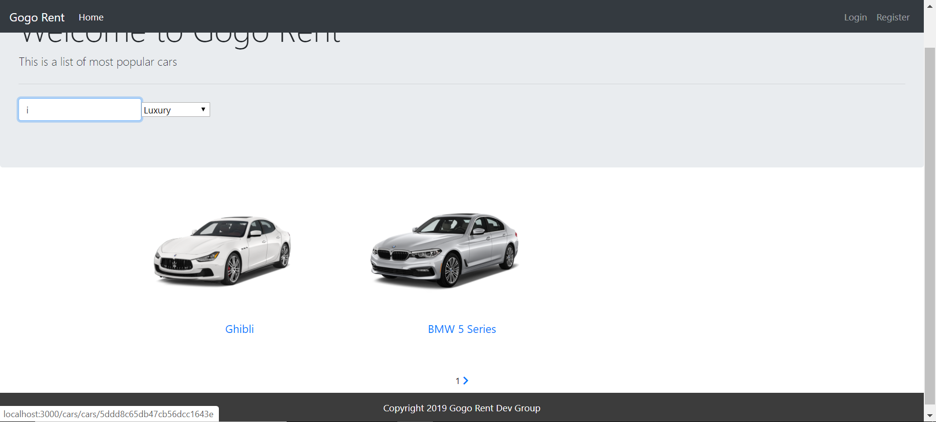

Wishlist of user1

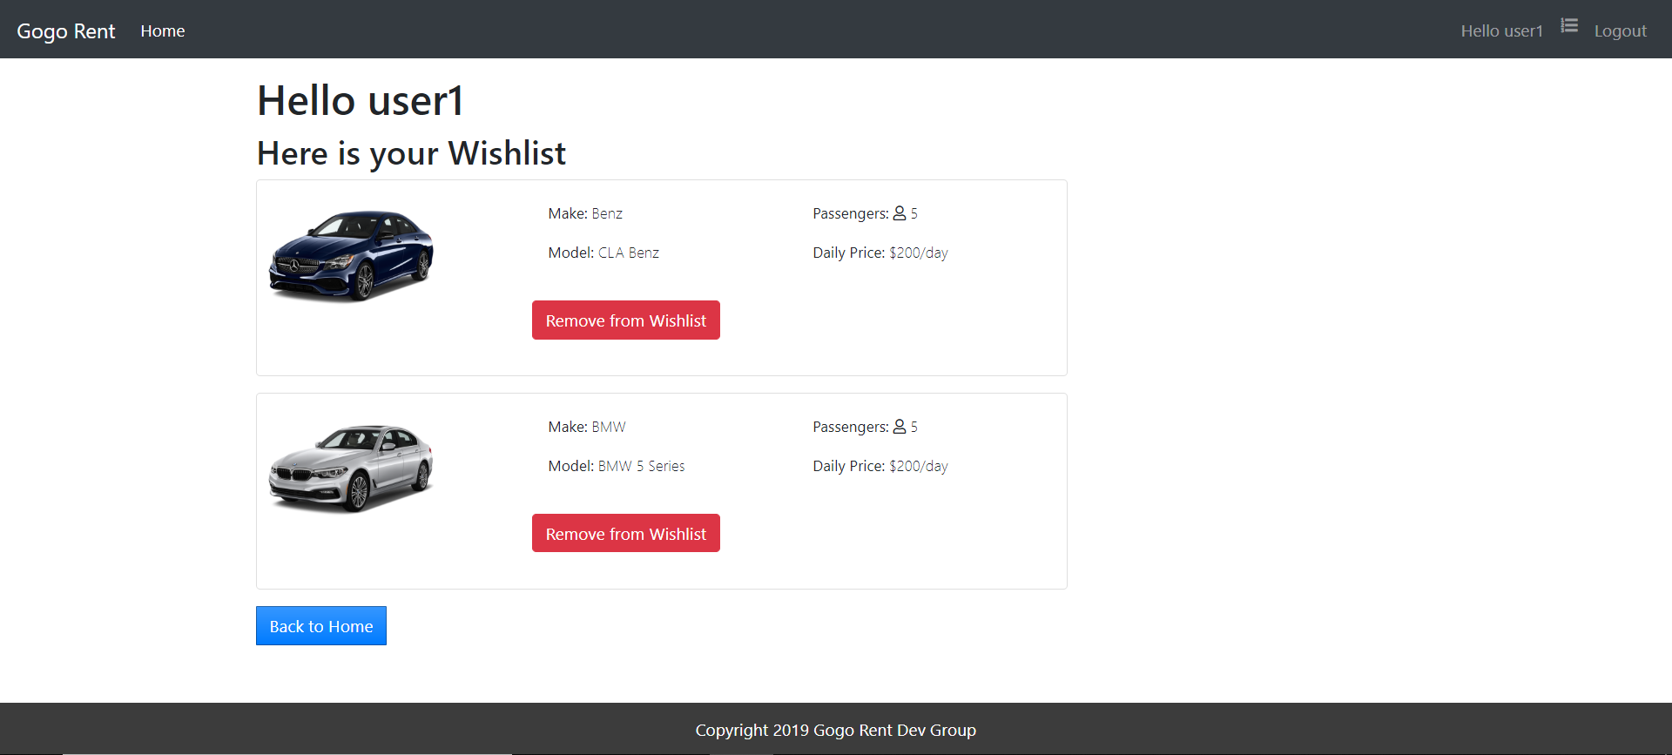

Car Detail Page

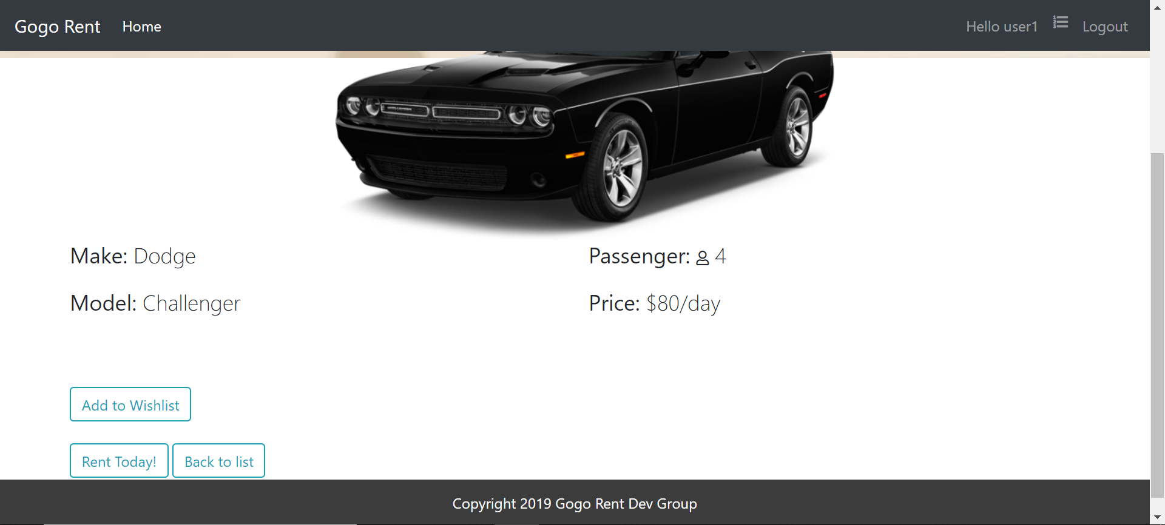

Car Renting Page

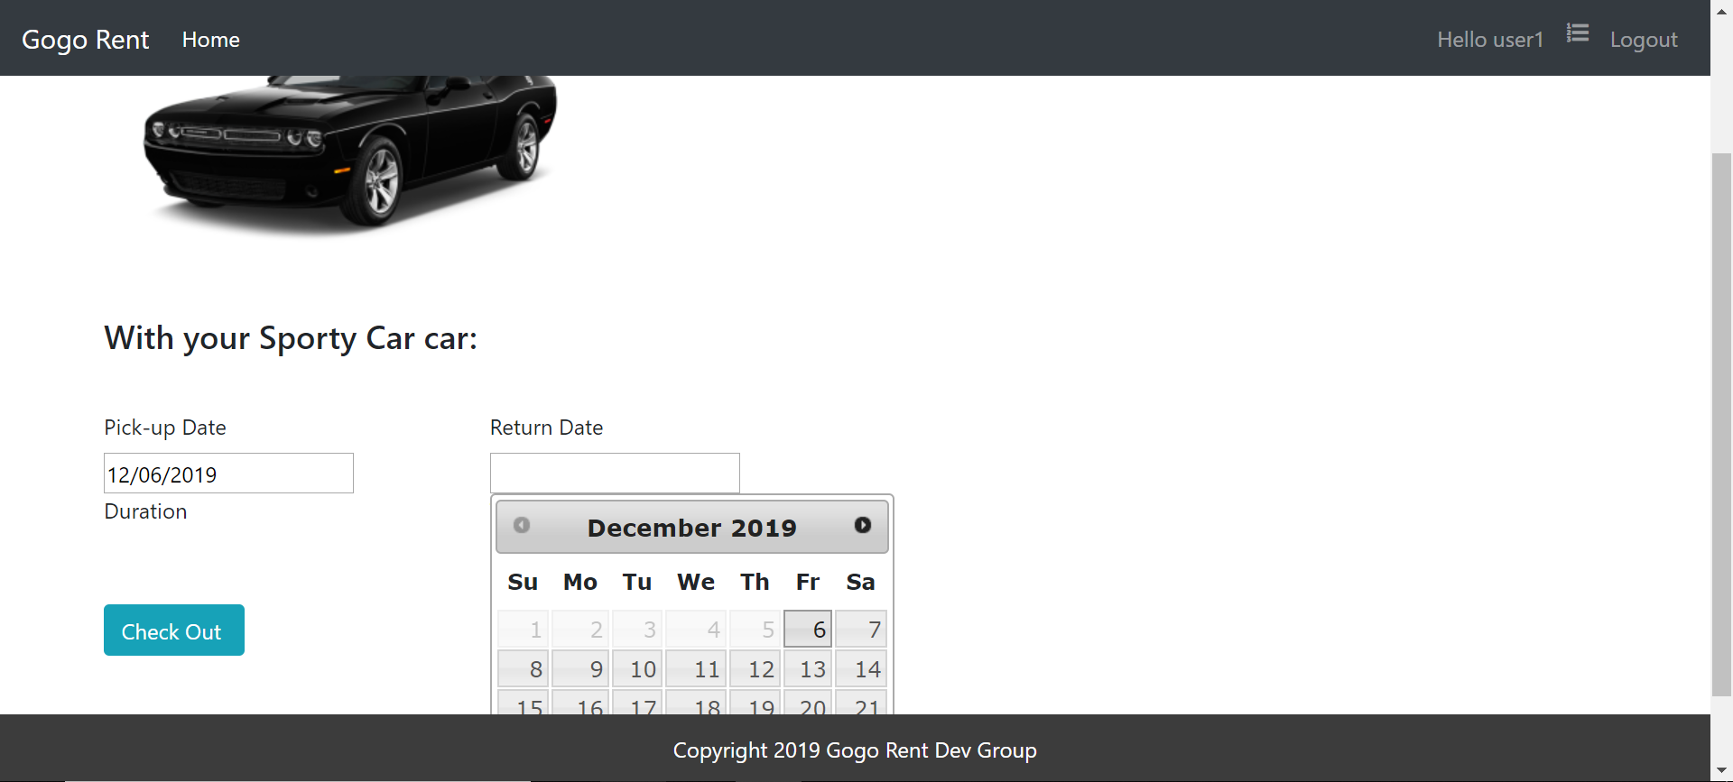

Order History of user1

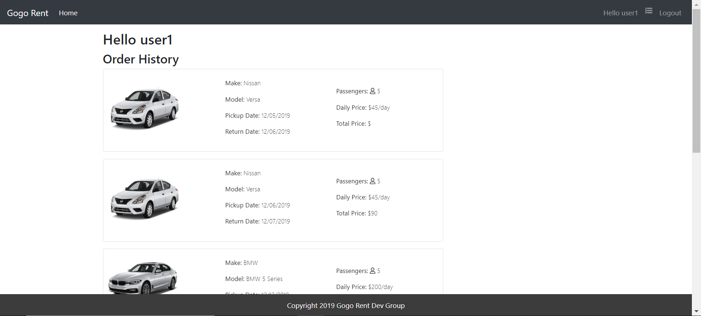

Edit Page from Admin

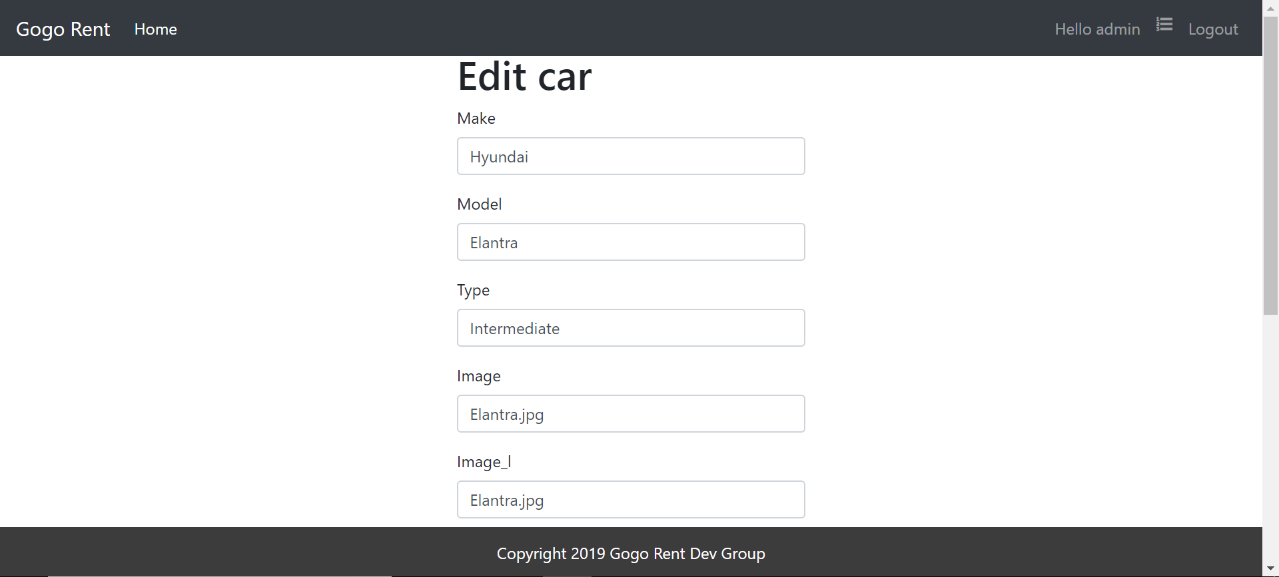

**Work Division**

Jing Chen

* Ajax check for the registration and login.
* Pagination for listing page.
* Web page styling.
* Routes design and implementation.

Qi Wang

* Type filter combined with Ajax fuzzy search.
* Database design.
* Car details showing page.
* Wishlist.
* Routes design and implementation.

Shen Zhang

* Renting page.
* User order history and order details.
* Database information collection.
* Routes design and implementation.