 



Mission Space Lab Phase 4 Report

Team Name: ApplePi

Chosen theme: Life on Earth

Country:Poland

# Introduction

The main purpose of our experiment is to detect the shoreline in order to show the effects of global warming. We used the OpenCV library for this purpose and with the use of it we analysed the pictures of Earth's surface.

In our eyes, global warming should be of the utmost importance. Finding ways to increase awareness of this progressing threat is not only important, but also interesting to us. We feel obliged to the Earth, so we try to protect it for future generations.

For this reason, showing the rising ocean level in satellite images seemed like a great way to illustrate the scale of the problem. In these photos, we marked the coastline and then compared it with photos from previous years. We expected that this difference would be noticeable if we managed to get a picture of the coast with a clear sky, which would make it easier to recognize elements of the Earth's surface.

# Method

Our program photographed the surface of the Earth every 31 seconds. This allowed to obtain non-overlapping photos and optimize the space needed for their recording and analysis. We gathered 343 photos during program's operation.

Each photo was analysed by the program outlining the shoreline, created colour land-water-cloud maps showing the content of surface components below the station and saved in three versions: original, with the outlined coastline and masks that show surfaces of water, clouds and land. Then, it saved the coordinates and the time each photo was taken in the data01.csv file to help identify it on the Earth.

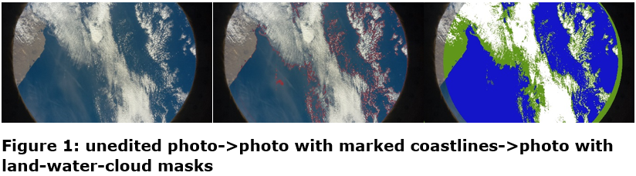

In addition, the program displayed on the LED matrix the percentage of each of the three aforementioned components of the image. It also showed the Moon whenever the night was detected which significantly hindered the analysis. Before each photo was taken, the logo of our team was also displayed.

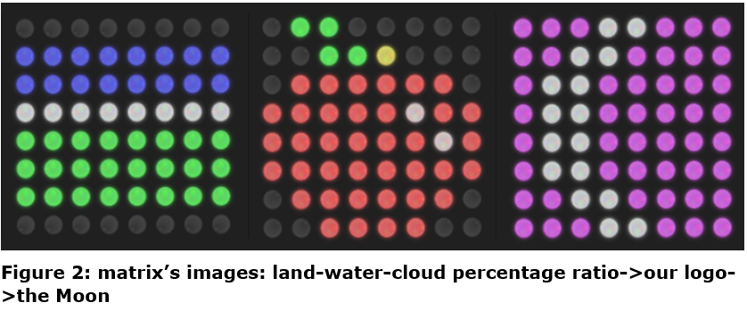After collecting all the data, we started to analyse the photos and compare them with photographs of the coasts from year 1984 (available at https://earthengine.google.com/timelapse/) using graphic programs.

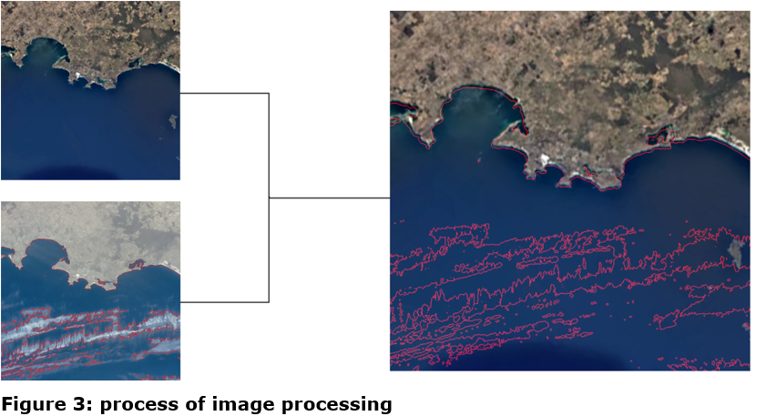

 

# Results

Of the 343 photos taken, 156 were rejected because of the night during which the photo was taken, and 177 due to the lack of data we sought.

We have not noticed any changes in the shoreline that have been caused by sea level rise over the years in the photos taken with weather conditions suitable for analysis. The only noticeable changes were caused by erosion.

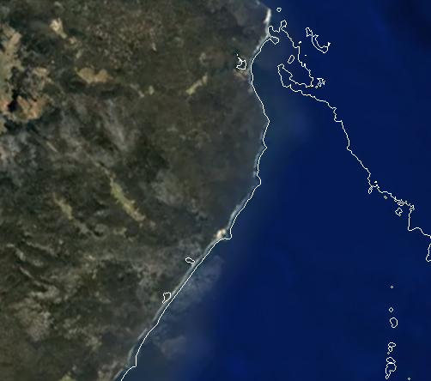

**Figure 4: comparison between a photo from 1984 and an outline of the coastline from 2019**

What is more, our experiment encountered problems that prevented the detailed analysis of the photos and the results we obtained are inaccurate.

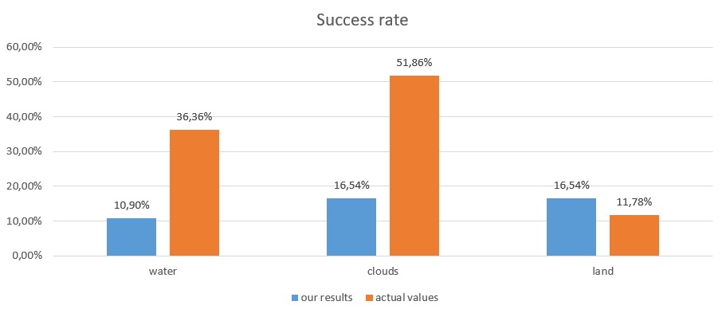**Figure 5:** **effectiveness of our program**

The main problem was finding a proper coastline that was necessary in our research. Furthermore, some of the photos taken at night as well as photos taken during full cloud cover or on which the sun reflected on the surface of the water were not suitable for any processing.

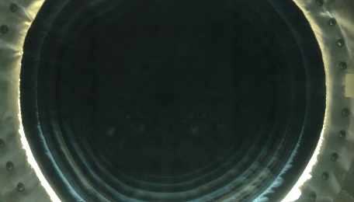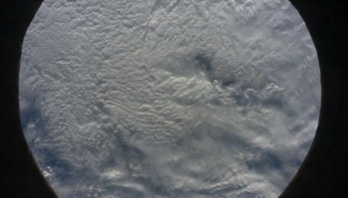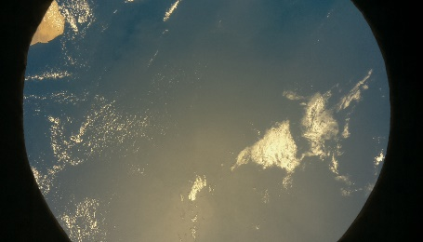

**Figure 6: photos taken: at night->during full cloud cover->with sun rays reflecting from the Earth**

Unfortunately, sometimes in the photographed area there was an unsuitable season of the year. As a result, the camera wasn't able to take a picture that would help us obtain the necessary data.

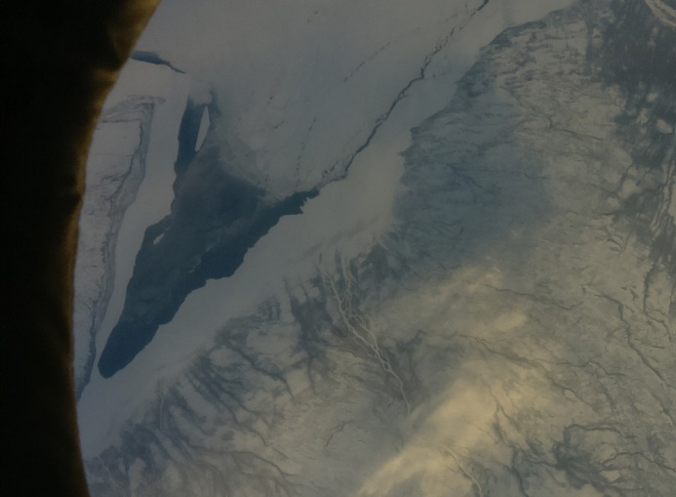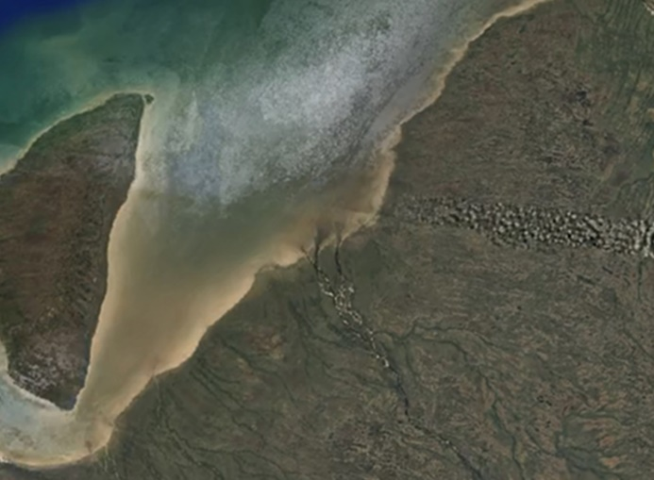

**Figure 7: an example of photo taken in winter and its equivalent in summer**

# Conclusion

The experiment was successful but the findings were different than we thought and we could not clearly show effects of global warming.

Unfortunately, sensitivity of the camera prevented us from observing the Earth at night. That combined with the complications mentioned in the previous point narrowed the amount of data on which we could conduct research.

The result we received was surprising, because most of the shorelines coincide with those from 35 years ago, and changes that happened were sometimes only caused by human infrastructure.

We realised that the distance from which we proceeded with shooting and sensitivity of PiCamera could not show the change of coastline. In order to do that you have to conduct observations at lower levels.

Nevertheless, we do not give up and we are still working on a program capable of showing global warming.

We would like to thank ESA and RaspberryPi for giving us the opportunity to carry out the project in such an inaccessible place, and for the fact that we could feel the excitement of being a scientist that strengthened our passion in this direction incredibly. The program we used, output, photos analysed and details of our project are available on: https://github.com/ApplePi-Crew/AstroPi_MissionSpaceLab_2018-19