IMPLEMENTATION PLAYBOOK

From Template to
Working Test Automation
  - A tester's guide to configuring a new application repository, local execution, GitHub Actions, and Allure Report 3
.NET 10 | Playwright | NUnit | REST | SQL Server | Allure 3
DUMMY GUIDE All names, URLs, identifiers, credentials, schedules, and expected outcomes in this document are examples. Replace angle-bracket placeholders only after the application owner confirms the real Test-environment values.

Prepared for application test teams
Guide version 1.0 | 21 July 2026

How to use this guide
Work through the stages in order for a new repository. The guide deliberately separates non-secret configuration, secrets, application automation, test intent, and CI administration so that responsibilities stay clear.
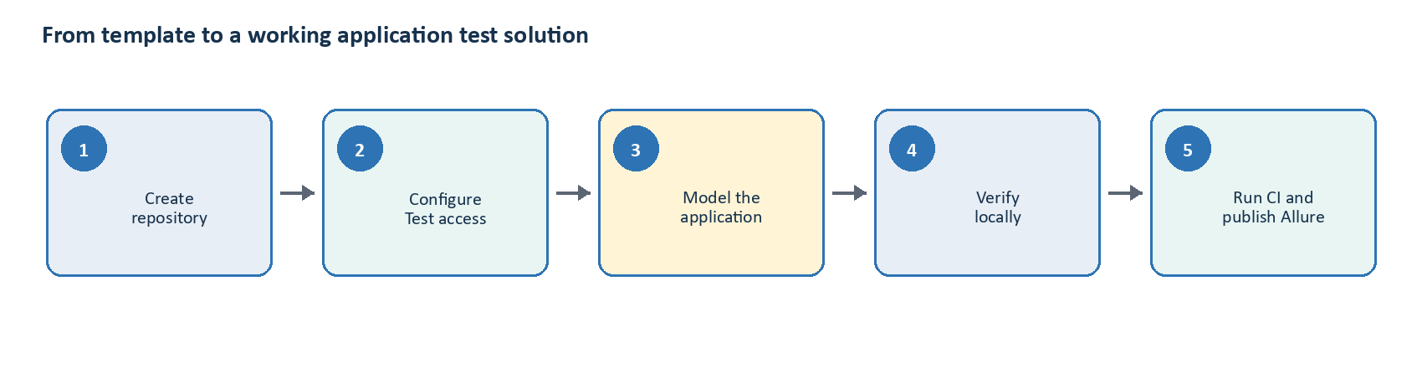
Figure 1. The recommended path from template to a working application test solution.

Guide map
Stage | Outcome | What the team does
1 | Discover | Confirm application behavior, Test endpoints, authentication, data, network reachability, and ownership.
2 | Create | Generate a new repository from the GitHub or .NET template and record its template version.
3 | Configure | Set non-secret defaults, local secrets, GitHub Environment values, Pages, and workflow permissions.
4 | Implement | Replace sample Pages, components, API clients, DTOs, SQL resources, workflows, and tests.
5 | Verify | Run locked restore, build, unit tests, browser smoke, product smoke, and safe Allure generation.
6 | Operate | Run manual GitHub Actions, inspect Pages and diagnostics, triage failures, and maintain history.

Roles used in this guide
Role | Primary responsibility
Application owner | Confirms expected behavior, Test URLs, credentials process, data rules, and acceptable evidence.
Tester / automation engineer | Implements application automation and tests, configures local execution, and verifies results.
Database owner | Provides a SELECT-only identity and approves reviewed read-only queries.
Repository administrator | Creates GitHub Environments, variables/secrets, Pages settings, permissions, and branch policies.
Template owner | Publishes template releases, closes compliance findings, and provides upgrade guidance.

STOP CONDITION Do not enable real tests until the application owner has supplied expected outcomes. Do not guess production behavior, credentials, database schema, schedules, or network access.

1. Understand what the template provides
The template is a reusable foundation rather than a finished product suite. It already supplies browser lifecycle, REST transport, read-only SQL execution, configuration, logging, evidence collection, reporting, and CI orchestration. The application repository supplies the product-specific behavior and assertions.
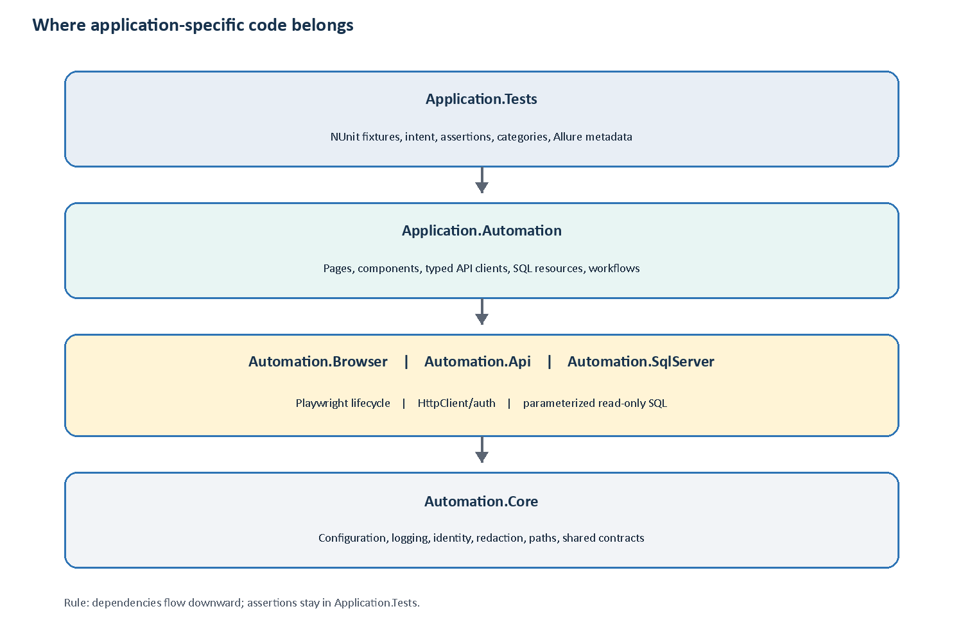
Figure 2. Application-specific code belongs in the two upper layers; framework mechanics remain reusable.

Capabilities at a glance
Capability | Provided by template | Application team adds
Browser | Playwright lifecycle, fresh context/page, tracing, screenshots, console and URL evidence | Pages, components, locators, user actions, UI assertions
REST API | HttpClient factory, bearer handler, JSON, timeouts, sanitized diagnostics | Typed clients, endpoints, DTOs, response assertions
SQL Server | Parameterized query-only client, validation, safe evidence | Reviewed SELECT resources, row DTOs, state assertions
End-to-end | Shared dependency injection and evidence model | Business workflows that compose channels and tests that assert outcomes
Reporting | Allure 3 results, sanitized publication copy, Pages workflow, durable history | Stable hierarchy names and application-safe evidence decisions

Non-negotiable design rules
- Assertions stay in Application.Tests; Pages, clients, adapters, and workflows return information but do not decide pass/fail.
- Each UI test receives a fresh Playwright BrowserContext and page.
- Use semantic locators and Playwright auto-waiting; do not add fixed sleeps or self-healing locators.
- SQL remains parameterized and read-only. Never add DML, stored-procedure execution, schema changes, or a public raw connection.
- Tests must run alone, in any order, and in parallel without shared mutable data.
- Do not commit or print tokens, cookies, passwords, connection strings, or secret payload values.
TEMPLATE READINESS CHECKPOINT Before adopting a particular template release, read its latest compliance review. Close or formally accept open publication-security and dependency findings. For the revision analyzed for this guide, use the safe PowerShell report script, keep binary report attachments off, validate custom redaction end to end, default-deny unknown evidence types, and review the current npm advisory status.

2. Complete application discovery
A reliable repository starts with confirmed inputs. Complete this worksheet with application, platform, database, and repository owners before editing sample tests.

Required application decisions
Decision | Dummy example | Owner / confirmed value
Repository and root namespace | Northstar.CustomerPortal.Automation | <REPOSITORY_NAME> / <ROOT_NAMESPACE>
Web Test URL | https://portal.test.northstar.example | <WEB_TEST_URL>
API Test base URL | https://api.test.northstar.example | <API_TEST_URL>
Bearer token process | GitHub Test secret populated by platform team | <TOKEN_SOURCE_AND_ROTATION>
SQL Server and database | tcp:test-sql.example,1433 / CustomerTest | <SQL_SERVER_AND_DATABASE>
SQL authentication | Dedicated SQL identity with SELECT only | <SQL_AUTH_MODE>
GitHub runner reachability | GitHub-hosted Ubuntu can reach web/API/SQL | <NETWORK_DECISION>
Initial smoke outcome | Registered test customer can sign in | <FIRST_SMOKE_OUTCOME>
Pages visibility | Internal/access-controlled | <PAGES_ACCESS_POLICY>
Schedule | Disabled until approved | <DAYS_TIME_IANA_TIMEZONE>

Test data questions
- Which test accounts and records are stable enough for smoke tests?
- How does each parallel test obtain unique data?
- Which supported application API creates or cleans data when required?
- Which fields contain personal or commercially sensitive information?
- Which flows display credentials, tokens, payment data, or personal data in screenshots or traces?
- Who owns failures caused by unavailable Test systems or expired credentials?
DATABASE RULE Database access verifies state; it does not create, repair, or delete test data. Setup and cleanup use supported application behavior or APIs.

Runner decision
Preference | Use when | Recommendation
1. Ubuntu 24.04 | Chromium/Firefox/WebKit, REST, and SQL over TCP | Default and lowest-maintenance choice
2. Windows 2025 | Integrated authentication, Windows certificates, native dependencies, or installed browser channels | Select only for a confirmed dependency
3. Self-hosted | Test systems are unreachable from GitHub-hosted runners | Use only with an explicit security and maintenance owner

3. Create the application repository
Create a new repository for each application. Do not copy generated build output, Allure output, node_modules, local settings, or credentials from the template workspace.

Preferred: GitHub template repository
01 Create the repository
Open the approved template in GitHub, select Use this template, choose Create a new repository, and set the application repository name and visibility.
02 Clone and create a working branch
Clone the new repository locally, confirm the default branch, and make application onboarding changes in a reviewable branch.
PowerShell / terminal
git clone https://github.com/<ORG>/<REPOSITORY>.git
cd <REPOSITORY>
git switch -c setup/application-automation
03 Record provenance
Set TEMPLATE_VERSION to the release/tag used to generate the repository. Keep CHANGELOG.md and the upgrade guide so future template fixes can be assessed deliberately.

Alternative: .NET custom template
Generate from the .NET template
dotnet new install <PATH_OR_PACKAGE_TO_APPROVED_TEMPLATE>
dotnet new test-automation -n <ROOT_NAMESPACE> -o <REPOSITORY_FOLDER> --reportName "<APPLICATION_NAME> Test Automation"

First repository validation
Run before product changes
dotnet restore <SOLUTION>.slnx --locked-mode
dotnet build <SOLUTION>.slnx -c Release --no-restore
dotnet format <SOLUTION>.slnx --verify-no-changes --no-restore
dotnet test tests/Automation.UnitTests/Automation.UnitTests.csproj -c Release --no-build
pwsh ./scripts/Validate-Template.ps1
- The solution restores in locked mode.
- The Release build has zero warnings and errors.
- All framework unit tests pass.
- Template validation reports no remaining source-name tokens.
- The working tree contains no generated or secret files.

4. Configure the Test application locally
Configuration precedence is intentional: committed non-secret defaults are overridden by local non-secret settings, user-secrets, environment variables, and validated command inputs. Keep the environment name fixed as Test.

Committed non-secret configuration
tests/Application.Tests/appsettings.json (dummy values only)
{
"TestEnvironment": { "Name": "Test" },
"Browser": {
"BaseUrl": "https://<WEB_TEST_HOST>",
"DefaultBrowser": "Chromium",
"Headless": true,
"NavigationTimeoutMs": 30000,
"ActionTimeoutMs": 15000,
"CaptureVideo": false,
"CaptureHar": false,
"CapturePageHtml": true
},
"Api": {
"BaseUrl": "https://<API_TEST_HOST>",
"TimeoutMs": 30000
},
"SqlServer": {
"CommandTimeoutSeconds": 30,
"ApplyReadOnlyIntent": true
},
"Artifacts": {
"AttachScreenshotToReport": false,
"AttachTraceToReport": false,
"AttachHarToReport": false,
"AttachVideoToReport": false
},
"Redaction": {
"SecretFieldNames": [
"password", "token", "access_token", "client_secret",
"<APPLICATION_SPECIFIC_SECRET_FIELD>"
]
}
}
EVIDENCE DEFAULT Keep every binary report-attachment flag false during onboarding. Screenshots, traces, HAR files, and video remain available in restricted workflow artifacts but are not suitable for Pages publication unless the application owner explicitly approves the data exposure.

Local secrets
Use .NET user-secrets for developer credentials. Do not place tokens or connection strings in appsettings.local.json, shell history shared with others, screenshots, tickets, or commits.
Store local secrets
cd tests/Application.Tests
dotnet user-secrets init
dotnet user-secrets set "Api:BearerToken" "<LOCAL_TEST_TOKEN>"
dotnet user-secrets set "SqlServer:ConnectionString" "<READ_ONLY_TEST_CONNECTION_STRING>"
Secret | Dummy format | Control
API bearer token | eyJ...DUMMY... | Test-only scope, least privilege, known expiry/rotation
SQL connection string | Server=<HOST>;Database=<DB>;User ID=<READ_ONLY_USER>;Password=<SECRET>;Encrypt=True | Dedicated SELECT-only identity; never a developer/admin account
Test user password | Stored through an approved secret provider | Use a dedicated synthetic account; never a personal account

Validate connectivity one channel at a time
- Run the framework Chromium smoke before navigating to the application.
- Enable one small UI test only after the real page and outcome are confirmed.
- Run API tests without installing a browser and confirm bearer acquisition works.
- Run a single parameterized SELECT query using the least-privilege SQL identity.
- Add end-to-end composition only after each underlying channel is independently stable.

5. Configure GitHub for working pipelines
Repository administration is part of the solution. The workflows cannot reach the Test application or publish Pages until variables, secrets, permissions, network routes, and Pages settings are configured.

Create the Test environment
01 Open environment settings
In the new repository, open Settings > Environments and create an environment named exactly Test.
02 Add environment variables
Add the web and API base URLs as non-secret environment variables.
03 Add environment secrets
Add the bearer token and SQL connection string as environment secrets. Confirm rotation ownership and runner access.
GitHub setting | Exact name | Example / purpose | Secret?
Environment variable | WEB_BASE_URL | https://portal.test.example | No
Environment variable | API_BASE_URL | https://api.test.example | No
Environment secret | API_BEARER_TOKEN | Test-scoped bearer token | Yes
Environment secret | SQL_CONNECTION_STRING | Read-only Test SQL connection | Yes

Enable GitHub Pages
- Open Settings > Pages and select GitHub Actions as the deployment source.
- Confirm the organization/repository plan and policy support the required internal or private visibility.
- Confirm the github-pages environment can be created/used by the deployment action.
- Ensure repository or organization policy permits the workflow's explicit contents, pages, and id-token permissions.
- Ensure branch rules do not block the serialized workflow from updating the dedicated allure-history branch, or configure an approved automation bypass.
HISTORY BRANCH The report workflow intentionally maintains a single-file history.jsonl on the allure-history branch. Do not use that branch for application source and do not allow concurrent report workflows to race.

Verify runner reachability
Check | Expected result | If it fails
Web/API DNS and TLS | Runner resolves hosts and trusts Test certificates | Fix network/DNS/certificate path; do not disable TLS validation
SQL TCP route | Runner reaches SQL Server on the approved port | Use an approved self-hosted runner or private networking solution
Authentication | Token and SQL identity authenticate with least privilege | Correct secret source/permissions; do not broaden privileges
Pages deployment | Workflow can upload and deploy the static report | Review Pages source, environment, token, and organization policy

6. Replace the sample application automation
Replace the sample customer/login/order scaffolding with application-specific names and behavior. Keep framework projects generic; product selectors, endpoints, DTOs, SQL, workflows, and expected outcomes belong in the application layers.

UI: Pages and components
- Create one Page Object for a coherent page and one Component Object for each reusable region.
- Prefer role, label, placeholder, text, test ID, and stable CSS locators in that order. Use XPath last.
- Expose user behavior such as SignInAsync or SubmitOrderAsync, not raw click sequences.
- Expose locators needed for test assertions, but keep the assertions in the test fixture.
Illustrative Page Object - replace path and accessible names
public sealed class LoginPage : PageObject
{
public LoginPage(IPage page) : base(page) { }
protected override string Path => "/login";
public async Task SignInAsync(string username, string password)
{
await ByLabel("Username").FillAsync(username);
await ByLabel("Password").FillAsync(password);
await ByRole(AriaRole.Button, "Sign in").ClickAsync();
}
public ILocator WelcomeHeading => ByRole(AriaRole.Heading, "Welcome");
}

API: Typed clients and DTOs
Build typed product clients on IApiClient. Use relative URIs, escape route/query values, accept cancellation tokens, and return ApiResponse<T> so the test owns assertions.
Illustrative typed API operation
public async Task<ApiResponse<OrderDto>> GetOrderAsync(
string orderId,
CancellationToken cancellationToken = default)
{
ArgumentException.ThrowIfNullOrWhiteSpace(orderId);
using var request = new HttpRequestMessage(
HttpMethod.Get,
new Uri($"/orders/{Uri.EscapeDataString(orderId)}", UriKind.Relative));
return await _apiClient.SendAsync<OrderDto>(request, cancellationToken);
}

SQL: Reviewed resources and row DTOs
Keep SQL in reviewed embedded .sql resources. Bind every variable as a named parameter. Match selected aliases to the row DTO and keep the database identity SELECT-only.
Illustrative read-only query
-- Customers.GetById.sql
SELECT
c.Id AS Id,
c.FullName AS FullName,
c.Status AS Status
FROM dbo.Customers AS c
WHERE c.Id = @id;
Bind the named parameter in C#
public static SqlQuery GetById(string customerId) =>
SqlResource
.LoadQuery(ResourceAssembly, "Customers.GetById", "Customers.GetById.sql")
.WithParameter("id", customerId);
FORBIDDEN SQL Do not add INSERT, UPDATE, DELETE, MERGE, schema changes, stored-procedure execution, NEXT VALUE FOR, multiple batches, interpolated values, or a public SqlConnection. Application APIs own setup and cleanup.

Register application services
Register each typed client and workflow in ApplicationServiceCollectionExtensions so fixtures can resolve them from Services.
Application.Automation registration
public static IServiceCollection AddApplicationAutomation(
this IServiceCollection services)
{
services.AddTransient<OrdersApiClient>();
services.AddTransient<CustomerJourney>();
return services;
}

7. Write application tests
Each test needs exactly one type, at least one suite, stable Allure hierarchy, independent data, and a clear business assertion. Remove [Ignore] from a sample only after its configuration and expected outcome are real.

Classification
Dimension | Allowed values | Rule
Type | UI, API, Database, E2E | Exactly one per test/fixture
Suite | Smoke, Regression | At least one per test/fixture
Feature category | Feature:<name> | Optional and repeatable; used for filtered execution
Allure hierarchy | Epic, Feature, Story | Stable business language; independent of execution categories

Illustrative UI smoke test
Dummy test - obtain credentials from an approved test-data/secret abstraction
[TestFixture]
[AllureNUnit]
[AllureEpic("Customer")]
[AllureFeature("Authentication")]
[TestType(TestType.UI)]
[Suite(Suite.Smoke)]
[Feature("Login")]
public sealed class LoginUiTests : UiTestBase
{
[Test]
[AllureStory("A registered test customer can sign in")]
public async Task RegisteredCustomer_CanSignIn()
{
var login = new LoginPage(Page);
await login.GotoAsync();
await login.SignInAsync(TestUsers.Customer, TestUsers.CustomerPassword);
await Assertions.Expect(login.WelcomeHeading).ToBeVisibleAsync();
}
}

API and database assertion examples
Assertions remain in Application.Tests
ApiResponse<OrderDto> response = await orders.GetOrderAsync(orderId);
Assert.Multiple(() =>
{
Assert.That(response.IsSuccess, Is.True);
Assert.That(response.Data, Is.Not.Null);
Assert.That(response.Data!.Status, Is.EqualTo("open"));
});
CustomerRecord? customer = await QuerySingleOrDefaultAsync<CustomerRecord>(
CustomerQueries.GetById(customerId));
Assert.That(customer?.Status, Is.EqualTo("active"));

Test data and parallel safety
- Generate a unique correlation/data suffix per test when the application supports creation.
- Never require one test to run before another.
- Do not share mutable browser sessions, request headers, database state, or artifact directories.
- Keep stable reference data read-only and document its owner and refresh process.
- Use supported APIs for setup/cleanup; use SQL only to verify state.
- Keep smoke tests small, deterministic, and focused on business-critical reachability/outcomes.

8. Verify the solution locally
Use the repository scripts so humans, Codex, Claude Code, and CI execute the same path. Start with the smallest check and expand only after it passes.

One-time workstation setup
Install pinned dependencies and the routine browser
dotnet restore <SOLUTION>.slnx --locked-mode
npm ci
pwsh ./scripts/Install-Playwright.ps1 -Browser chromium

Recommended validation ladder
01 Framework gates
Build, format, and run framework unit tests before diagnosing product tests.
dotnet build <SOLUTION>.slnx -c Release --no-restore
dotnet format <SOLUTION>.slnx --verify-no-changes --no-restore
dotnet test tests/Automation.UnitTests/Automation.UnitTests.csproj -c Release --no-build
02 Framework Chromium smoke
Prove the Playwright stack can start independently of the Test application.
pwsh ./scripts/Invoke-Tests.ps1 -Type UI -Suite Smoke -Browser chromium -Workers 1
03 Smallest application test
Run one uniquely named test with an explicit matching type when browser=all is used.
pwsh ./scripts/Invoke-Tests.ps1 -Type UI -Browser chromium -Workers 1 -TestName <UNIQUE_TEST_NAME>
04 Relevant suite
Run the affected type/suite in Chromium, then add browsers only for shared UI behavior.
pwsh ./scripts/Invoke-Tests.ps1 -Type API -Suite Regression -Workers 4
pwsh ./scripts/Invoke-Tests.ps1 -Type Database -Suite Smoke -Workers 2
pwsh ./scripts/Invoke-Tests.ps1 -Type UI -Suite Smoke -Browser chromium -Workers 4
pwsh ./scripts/Invoke-Tests.ps1 -Type E2E -Suite Smoke -Browser chromium -Workers 2
05 Cross-browser confidence
For framework, locator, or shared UI changes, run Chromium, Firefox, and WebKit.
pwsh ./scripts/Invoke-Tests.ps1 -Type UI -Suite Smoke -Browser all -Workers 1
06 Safe local report
Use the PowerShell path that sanitizes a publication copy before generating Allure. Do not invoke raw allure generate against allure-results.
pwsh ./scripts/Generate-Allure.ps1

Local pass criteria
- The command exit code matches the test result.
- No test is skipped because a required application value was forgotten.
- The run manifest records the intended type, suite, browser, workers, and result.
- Allure contains only the current run's intended results.
- No fake or real secret appears in logs, text evidence, sanitized results, report, or history.
- Raw binary evidence stays outside the report under default policy.

9. Run GitHub Actions
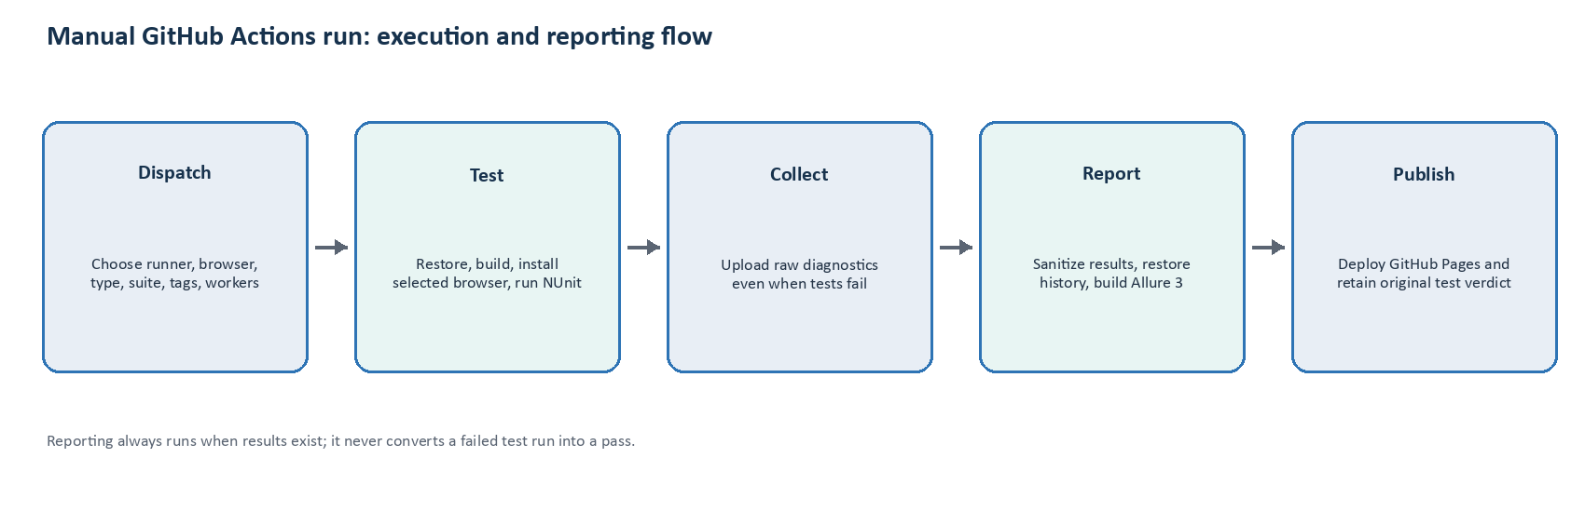
Figure 3. Reporting executes after test failure without changing the original verdict.

Pull-request validation workflow
The validate workflow uses no Test secrets and installs no browsers. It performs locked .NET restore, Release build, formatting, unit/structural tests, NUnit discovery, exit-contract verification, npm ci, the Allure CLI probe, template validation, and generated-repository validation.

Manual test-and-report workflow
01 Open Actions
Select the test-and-report workflow and choose Run workflow on the intended branch.
02 Choose inputs
For the first real application run, use Ubuntu, Chromium, the smallest relevant type/suite, no extra tags, and parallelism 1.
03 Observe every job
Confirm test execution, diagnostics upload, sanitized report generation, history persistence, Pages deployment, and the final verdict.
Input | Allowed values | Recommended first run
runner | ubuntu-24.04, windows-2025 | ubuntu-24.04
browser | chromium, firefox, webkit, all | chromium
type | ui, api, database, e2e, all | smallest configured type
suite | smoke, regression, all | smoke
tags | validated comma-separated categories | empty
parallelism | 1, 2, 4, 8 | 1, then increase after isolation is proven

Scheduled execution
The schedule is intentionally disabled. Enable it only after the owner approves days, local time, and IANA timezone, and the team records the UTC conversion. Scheduled runs use one browser: Chromium.
Disabled YAML example
# Enable only after approval; GitHub cron is UTC.
# schedule:
# - cron: "0 18 * * 1-5" # EXAMPLE ONLY

10. Use reports and diagnostics safely
The solution creates two evidence surfaces with different trust levels. GitHub Pages is the human report. Workflow artifacts contain deeper raw diagnostics for authorized debugging.
Output | Audience | Contents and handling
GitHub Pages | Test stakeholders | Sanitized Allure 3 HTML, hierarchy, trends, and approved attachments
Diagnostics artifact | Authorized engineers/agents | Raw Allure results, TRX, JSONL logs, screenshots, traces, HAR/video when captured, run manifest
allure-history branch | Report workflow | Single durable history.jsonl used for trends; not application source

Artifact map
Repository-local diagnostic layout
artifacts/<run-id>/
run-manifest.json
test-results.trx
tests/<test-id>/
test-log.jsonl
screenshot.png
trace.zip
page.html
current-url.txt
browser-console.jsonl
api-evidence.json
sql-evidence.json
allure-results/ # raw restricted inputs
allure-results-sanitized/ # publication copy
allure-report/ # generated static HTML
allure-history/history.jsonl

Failure triage loop
- Read run-manifest.json and confirm the exact selection and result.
- Find the first meaningful failure rather than secondary teardown noise.
- Inspect the relevant log, URL, console, HTML, API/SQL evidence, screenshot, or trace.
- Reproduce the smallest failing test with the same inputs.
- Diagnose root cause before editing code.
- Apply the smallest correction that preserves test intent.
- Rerun the failing test and then its relevant suite before declaring success.

Evidence safety decisions
Evidence | Default report policy | Tester action
Sanitized text | Attached | Add application secret-field tests and scan report output
Screenshot | Withheld | Assume pixels may contain secrets or personal data
Trace | Withheld | Treat as raw DOM/network evidence
HAR | Withheld | Treat as raw request/response evidence
Video | Withheld | Treat as a full-session recording
Unknown binary | Must be withheld in an approved release | Do not publish without explicit classification and approval

11. Work effectively with Codex and Claude Code
The repository is designed so AI assistants and humans follow the same architecture, commands, and evidence-led debugging process. AGENTS.md is canonical; CLAUDE.md points to the same shared documents.

Give an assistant enough context
- Name the application behavior and expected outcome; do not ask the agent to invent it.
- Identify the test type, suite, browser, and relevant feature.
- Provide the smallest failing command and the run-manifest path.
- Point to authorized artifacts without pasting real secrets into the conversation.
- Require the smallest fix and verification of the failing test plus relevant suite.
- Ask the agent to preserve read-only SQL, module boundaries, parallel safety, and exit status.

Example implementation request
Prompt pattern for Codex or Claude Code
Implement the confirmed Test-environment login smoke test.
Behavior: a registered synthetic customer enters valid credentials and sees
the Welcome heading. Use the existing Playwright Page Object pattern.
Type: UI
Suite: Smoke
Feature: Login
Browser verification: Chromium
Do not invent selectors. Inspect the supplied DOM/evidence first. Keep
assertions in Application.Tests, preserve a fresh BrowserContext, and run
the named test plus the UI smoke suite before reporting completion.

Example debugging request
Prompt pattern for evidence-led diagnosis
Diagnose this failing test without weakening it:
<FULLY_QUALIFIED_TEST_NAME>
Inputs: browser=<BROWSER>, suite=<SUITE>, workers=<N>
Manifest: artifacts/<RUN_ID>/run-manifest.json
Evidence: artifacts/<RUN_ID>/tests/<TEST_ID>/
Find the first meaningful failure, reproduce the smallest test, explain the
root cause, make the smallest correction, and rerun the test and suite.
Do not add sleeps, retries, self-healing locators, or broader SQL privileges.
INTERACTIVE ONLY CI does not send artifacts to an external model. A human downloads or opens authorized workflow artifacts and chooses what an AI assistant may inspect.

12. Troubleshooting quick reference
Symptom | Likely cause | First action
Options validation fails | Missing/invalid URL, timeout, token, or connection setting | Read the validation message; correct the named Test setting without committing secrets
Browser does not start | Playwright browser missing or sandbox/OS dependency issue | Run Install-Playwright for the selected browser; treat startup as environment failure first
UI timeout | Wrong locator, page state, navigation, or Test outage | Inspect URL, trace, screenshot, HTML, and console; avoid fixed sleeps
API status 0 / transport failure | DNS, TLS, routing, refused connection | Inspect sanitized API evidence and runner reachability
API 401/403 | Expired token, wrong audience/scope, insufficient permissions | Confirm secret rotation and Test-only authorization
SQL connection fails | Network, TLS, authentication, or database name | Validate runner route and read-only credentials with database owner
SQL validator rejects query | Unsupported/mutating SQL or multiple batches | Rewrite as one parameterized SELECT; do not bypass validation
No Allure results | Empty selection, failed setup, or artifact path issue | Check test logs, filters, and workflow Detect results step
Pages deployment fails | Pages source, permissions, environment, or policy | Review github-pages environment and workflow token permissions
History missing | allure-history branch absent/inaccessible or report generation stopped | Inspect report job restore/persist steps and branch policy
Secret appears in report | Unsafe report command or incomplete redaction/classification | Stop publication, remove exposed artifact/history, rotate the secret, and fix the security contract

13. Application onboarding release checklist
The repository is ready for routine Test execution only when every applicable item is complete and evidenced in a pull request or onboarding record.

Repository and ownership
- Repository name, root namespace, application owner, test owner, and template version are recorded.
- AGENTS.md and shared documentation reflect application-specific commands and constraints without duplicating conflicting rules.
- Branch protection, workflow permissions, and upgrade ownership are agreed.

Configuration and access
- Web and API Test URLs are confirmed and reachable from the selected runner.
- Bearer token and SQL credential processes have owners and rotation procedures.
- SQL identity has only required SELECT access and queries are parameterized/read-only.
- No real secret exists in source, committed settings, test names, assertion messages, or sample data.

Application automation
- Sample Pages, clients, DTOs, SQL, workflows, and ignored tests have been replaced or deliberately removed.
- Locators are stable and semantic; no fixed sleeps or runtime self-healing exist.
- Tests are independent, order-free, and safe under configured parallelism.
- Smoke coverage represents confirmed critical application outcomes.

Local verification
- Locked restore, Release build, formatting, framework unit tests, and template validation pass.
- Framework Chromium smoke and every enabled application smoke test pass.
- Relevant API/Database suites run without browser installation.
- Firefox and WebKit selection works where cross-browser coverage is required.

CI, reporting, and security
- validate.yml passes on a pull request without Test secrets.
- Manual test-and-report workflow uses the Test environment and correct inputs.
- Diagnostics upload after both passing and deliberately failing runs.
- Allure Pages deploys a sanitized report and durable history updates once per serialized run.
- Binary attachments are withheld by default and unknown evidence fails closed.
- A fake-secret publication scan covers configured application secret fields.
- Current .NET, npm, Allure, Playwright, actions, and security advisories have been reviewed.
GO-LIVE DECISION A green pipeline is necessary but not sufficient. The application owner must confirm that enabled tests assert the intended business behavior and that the published evidence policy is acceptable for the application's data classification.

Appendix A. Placeholder register
Search the generated repository and onboarding records for these placeholders. Replace each only with a confirmed Test value or an approved configuration reference.
Placeholder | Meaning | Where it belongs
<ROOT_NAMESPACE> | Generated .NET namespace and solution identity | Template generation / source
<APPLICATION_NAME> | Human-readable application/report name | Allure configuration and documentation
<WEB_TEST_URL> | Test web origin | Committed non-secret config / GitHub variable
<API_TEST_URL> | Test API origin | Committed non-secret config / GitHub variable
<LOCAL_TEST_TOKEN> | Developer bearer token | .NET user-secrets only
<READ_ONLY_TEST_CONNECTION_STRING> | SELECT-only SQL connection | .NET user-secrets / GitHub secret
<FIRST_SMOKE_OUTCOME> | Confirmed critical business expectation | Test intent and onboarding record
<DAYS_TIME_IANA_TIMEZONE> | Approved schedule definition | Documentation and UTC-converted workflow cron

Appendix B. Worked dummy profile
FICTIONAL EXAMPLE Northstar Customer Portal is not a real system. Values below illustrate how a completed onboarding profile might read; they are not credentials or deployable endpoints.

Item | Dummy selection
Application | Northstar Customer Portal
Repository | northstar-customer-portal-automation
Root namespace | Northstar.CustomerPortal.Automation
Routine runner/browser | ubuntu-24.04 / Chromium
First UI smoke | Registered synthetic customer sees Welcome after sign-in
API regression | Existing test order is returned with expected status
Database verification | Known synthetic customer has active status via parameterized SELECT
E2E journey | Customer record and order list reconcile across API and read-only SQL
Pages policy | Internal/access-controlled; all binary evidence withheld
Schedule | Disabled pending owner approval

Appendix C. Command cheat sheet
Goal | Command
Locked restore | dotnet restore <SOLUTION>.slnx --locked-mode
Release build | dotnet build <SOLUTION>.slnx -c Release --no-restore
Format check | dotnet format <SOLUTION>.slnx --verify-no-changes --no-restore
Framework tests | dotnet test tests/Automation.UnitTests/Automation.UnitTests.csproj -c Release --no-build
Install Chromium | pwsh ./scripts/Install-Playwright.ps1 -Browser chromium
UI smoke | pwsh ./scripts/Invoke-Tests.ps1 -Type UI -Suite Smoke -Browser chromium -Workers 4
API regression | pwsh ./scripts/Invoke-Tests.ps1 -Type API -Suite Regression -Workers 4
Database smoke | pwsh ./scripts/Invoke-Tests.ps1 -Type Database -Suite Smoke -Workers 2
E2E smoke | pwsh ./scripts/Invoke-Tests.ps1 -Type E2E -Suite Smoke -Browser chromium -Workers 2
Cross-browser UI | pwsh ./scripts/Invoke-Tests.ps1 -Type UI -Suite Smoke -Browser all -Workers 1
Named test | pwsh ./scripts/Invoke-Tests.ps1 -Type <MATCHING_TYPE> -TestName <UNIQUE_NAME>
Safe Allure report | pwsh ./scripts/Generate-Allure.ps1
Template validation | pwsh ./scripts/Validate-Template.ps1

End of guide.

