Chateau Oak Red Oak Natural 7" 1st Quality
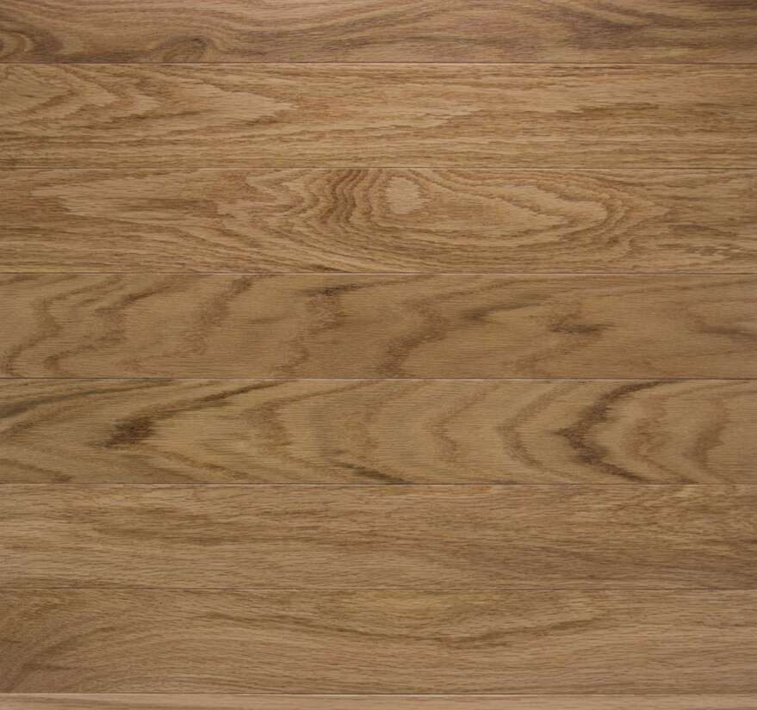
Product Detail | Information
Product Name | Chateau Oak
Color Name | Red Oak Natural
Floor Type | Engineered Hardwood
Floor Color | Light, warm natural oak
Grade | 1st Quality
Width / Thickness | 7" / 1/2"
Species / Construction | Red Oak / 7-ply cross-grained birch core with 3 mm wear layer
Surface / Finish | Low gloss / matte finish / 4-sided bevel / high color variation
Installation | Nail, staple, glue, or float; radiant heat compatible
Price | $3.49 per sq. ft.
Availability | In stock
Product page: View product page

Ambient Oak White Oak Natural 7" 1st Quality
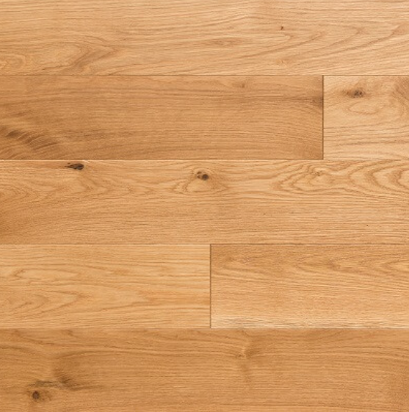
Product Detail | Information
Product Name | Ambient Oak
Color Name | White Oak Natural
Floor Type | Engineered Hardwood
Floor Color | Light, neutral natural oak
Grade | 1st Quality
Width / Thickness | 7" / 1/2"
Species / Construction | White Oak / 8-ply cross-grain core with 3 mm wear layer
Surface / Finish | Wirebrushed / low gloss / UV-cured aluminum oxide-urethane finish
Installation | Nail, staple, glue, or float; radiant heat compatible
Warranty | 50-year finish wear; lifetime structural
Price | $3.49 per sq. ft.
Availability | In stock
Product page: View product page

Winchester Low Gloss Urban Gray 4" Builder
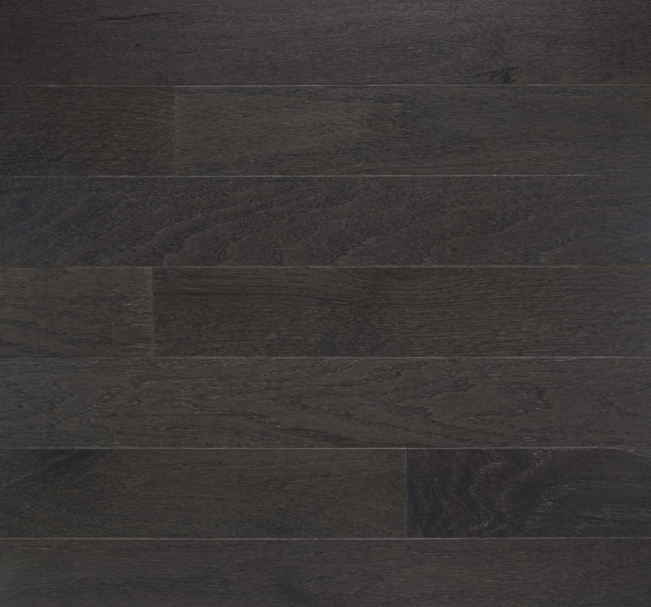
Product Detail | Information
Product Name | Winchester Low Gloss
Color Name | Urban Gray
Floor Type | Prefinished Solid Hardwood
Floor Color | Gray
Grade | Builder
Width / Thickness | 4" / 3/4"
Species | Oak
Surface / Finish | Low gloss / 4-sided bevel / UV-cured aluminum oxide abrasion-resistant finish
Installation | Nail or staple
Sale Price | $2.59 per sq. ft. (regularly $3.49)
Availability | In stock
Product page: View product page

Oak Plank Smoke 5" Builder A
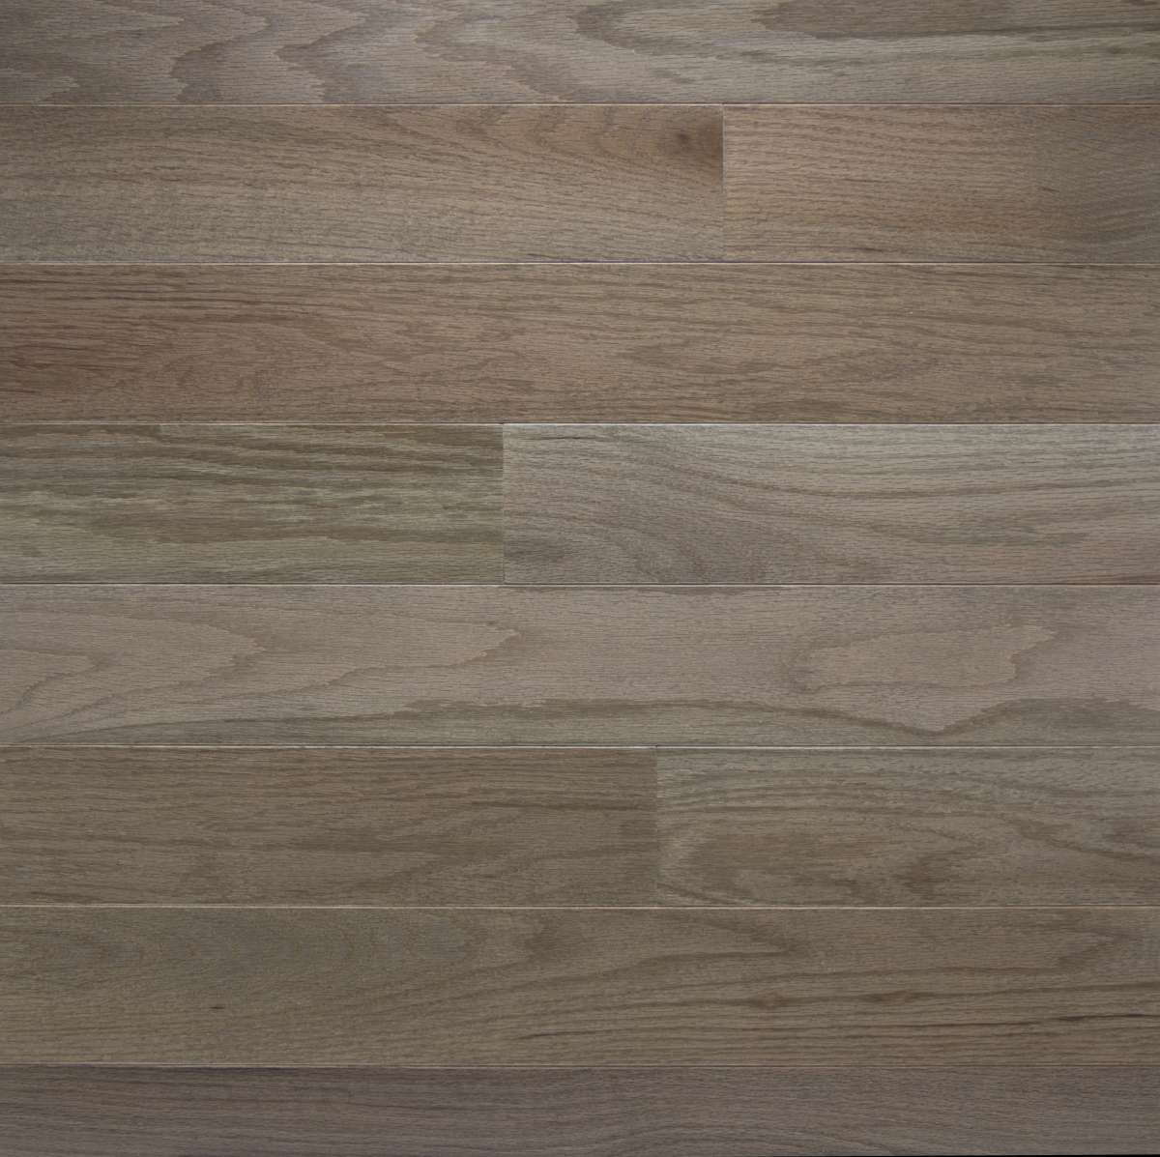
Product Detail | Information
Product Name | Oak Plank
Color Name | Smoke
Floor Type | Engineered Hardwood
Floor Color | Grayish taupe
Grade | Builder A
Width / Thickness | 5" / 1/2"
Species / Construction | Red Oak / 8-ply cross-grain core with 3 mm wear layer
Surface / Finish | Smooth / semi gloss / eased edges and ends / UV-cured aluminum oxide finish
Installation | Nail, staple, glue, or float; radiant heat compatible
Janka Hardness | 1290
Price | $2.69 per sq. ft.
Availability | In stock
Product page: View product page

Johnson City Fall Branch 20 mil Wear Layer
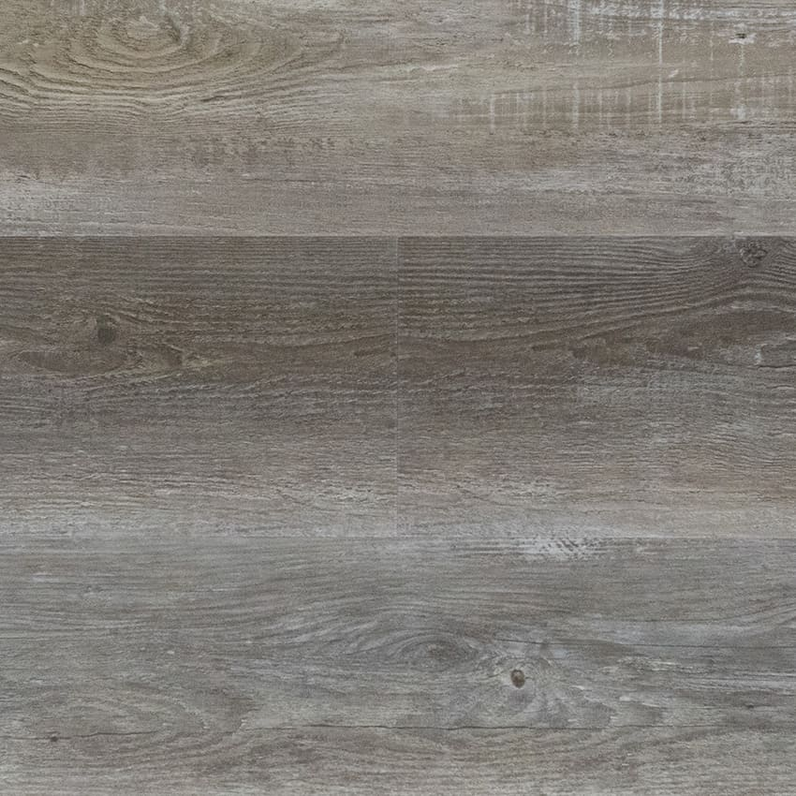
Product Detail | Information
Product Name | Johnson City
Color Name | Fall Branch
Floor Type | Luxury Vinyl Plank
Floor Color | Natural wood tones
Grade | 1st Quality Discontinued
Plank Size | 7" wide x 48" long
Construction | 5.0 mm overall thickness, including 1.0 mm IXPE attached underlayment
Surface / Profile | Embossed-in-register / micro bevel / 20 mil wear layer
Installation | Floating; waterproof and pet friendly
Warranty | Lifetime residential
Price | $1.99 per sq. ft.
Availability | In stock
Product page: View product page

Johnson City Buffalo Creek 20 mil Wear Layer
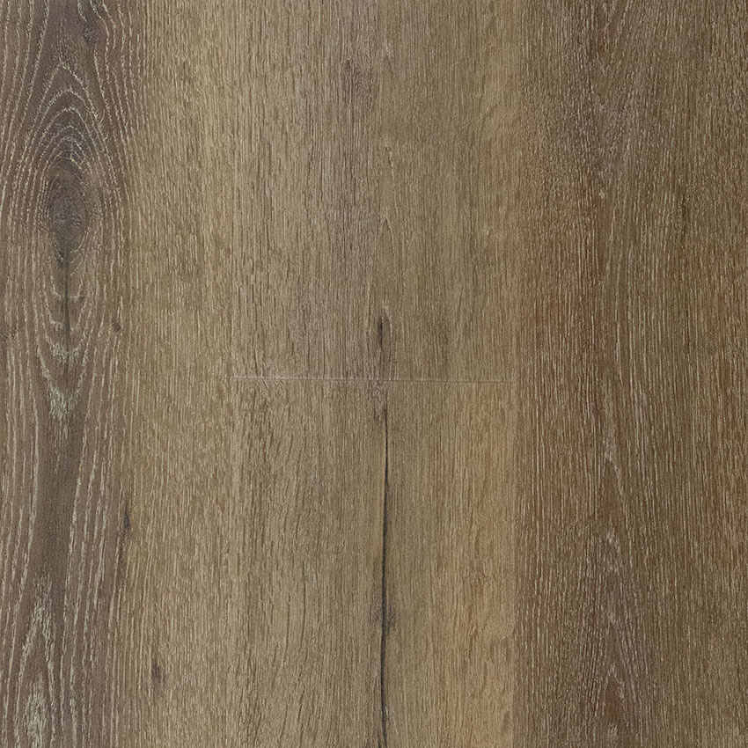
Product Detail | Information
Product Name | Johnson City
Color Name | Buffalo Creek
Floor Type | Luxury Vinyl Plank
Floor Color | Rustic natural wood tones
Grade | 1st Quality Discontinued
Plank Size | 7" wide x 48" long
Construction | 5.0 mm overall thickness, including 1.0 mm IXPE attached underlayment
Surface / Profile | Embossed-in-register / micro bevel / 20 mil wear layer
Installation | Floating; waterproof and pet friendly
Warranty | Lifetime residential
Sale Price | $1.89 per sq. ft. (regularly $1.99)
Availability | In stock
Product page: View product page

