VIDEO PROMPT CREATION
Step-by-Step Guide for Paden

What Is This Job?
You already have a finished script and a picture for each scene with the character in it. Now you are going to turn that script into video prompts. Each video prompt covers about 10 seconds of footage. You will pair each video prompt with the matching scene picture, then load both into our AI video platform.
You do NOT need to write these prompts one scene at a time. You will paste the WHOLE script in at once, and Gemini will break it into 10-second chunks for you.

Your Tools
Tool Name | What It Does
Gemini | Turns your script into 10-second video generation prompts
Google Doc / script.txt | The finished script you already saved
Scene Pictures | scene-01.png, scene-02.png, etc.
AI Video Platform | Where you turn the prompt + picture into a video

STEP 1: Turn the Script Into Video Prompts
- Open Gemini.
- Copy and paste the prompt below into Gemini. Where it says [PASTE SCRIPT HERE], paste the entire script, not just one scene.
COPY AND PASTE THIS PROMPT:
Take this video script and all the scenes it outlines inside it. I want
you to change those scenes into video generation prompts that are meant
for 10 seconds of footage. Split up the scenes if you need to so that
will cover approximately 10 seconds of video. Use the ai video prompt
format I supply later in this request. Here are the scenes to work with:

[PASTE SCRIPT HERE]

Create an ai video generation prompt using the following video prompt
text format:

Composition: How the shot is framed, we like to use a medium shot or
close-up shot.
Location: State the location, like a room or outdoor place with two
details about it, pictures on the walls, modern decor, empty hallway.
Subject: The object, person, or scenery that you want in your video,
such as cityscape or nature.
Action: What the subject is doing, I like turns to the camera, or
person looks into the camera calmly.
Dialogue: What the subject is saying.
Style: Our creative direction is always a documentary style, or home
movies style.
Camera positioning and motion: Our Camera always stays still.
Ambiance: This is a cell phone or documentary style video shot in a
flat Log profile style.

- Gemini will give you back a list of video prompts, one for each 10-second segment. Read through all of them.
⚠ If a scene got cut in a weird spot, or a video prompt doesn't match what's happening in the script at that timestamp, tell Gemini what's wrong and ask it to fix that specific prompt. Do not just accept it.
- Read the Dialogue line in each video prompt out loud at a normal speaking pace and time it. If it takes longer than 10 seconds to say, do NOT let Gemini split it into two scene prompts. Instead, paste the prompt below into Gemini to shorten the dialogue.
COPY AND PASTE THIS PROMPT IF DIALOGUE IS TOO LONG:
Look over the dialogue of these scenes. It seems like some of them have
lines that take longer than 10 seconds to say all their lines in a 10
second recording. Please shorten the dialogue if you can instead of
breaking out one scene prompt into two scene prompts. I believe some of
the dialogue is a bit wordy, and I'd like to keep the message of each
scene direct and benefit driven.

⚠ Always try shortening the dialogue first. Only split a scene into two video prompts if the dialogue genuinely cannot be trimmed down and still make sense.

STEP 2: Match Each Video Prompt to Its Scene Picture
Each video prompt needs to be paired with the correct picture from Step 3.
- Look at the timestamp/scene the video prompt came from (example: [0:10 - 0:25]).
- Find the scene picture that matches that same part of the script (example: scene-02.png).
- Keep the video prompt and the picture together. You will need both when you load them into the AI video platform.
⚠ If one scene was split into two video prompts (like a 15-second scene split into two 10-second chunks), both prompts use the SAME picture unless the location or action changed enough that a new picture is needed. If you're not sure, ask Patrick.

STEP 3: Generate the Video
Load each matched pair (video prompt + scene picture) into our AI video platform to generate the clip. Do this one video prompt at a time, the same way you did one picture at a time in Step 3 of the image SOP.

STEP 4: Screenshot the Product
Every video is promoting one specific product from ReallyCheapFloors.com. Before you finish, go to the product page for the item the script is talking about and take a screenshot of it.
- Go to ReallyCheapFloors.com and find the exact product the script mentions.
- Make sure the screenshot clearly shows the product name, price, and the specs listed in the script (width, grade, thickness, color, etc.).
- Save the screenshot into the same folder as your script, pictures, and videos.
Example screenshot:
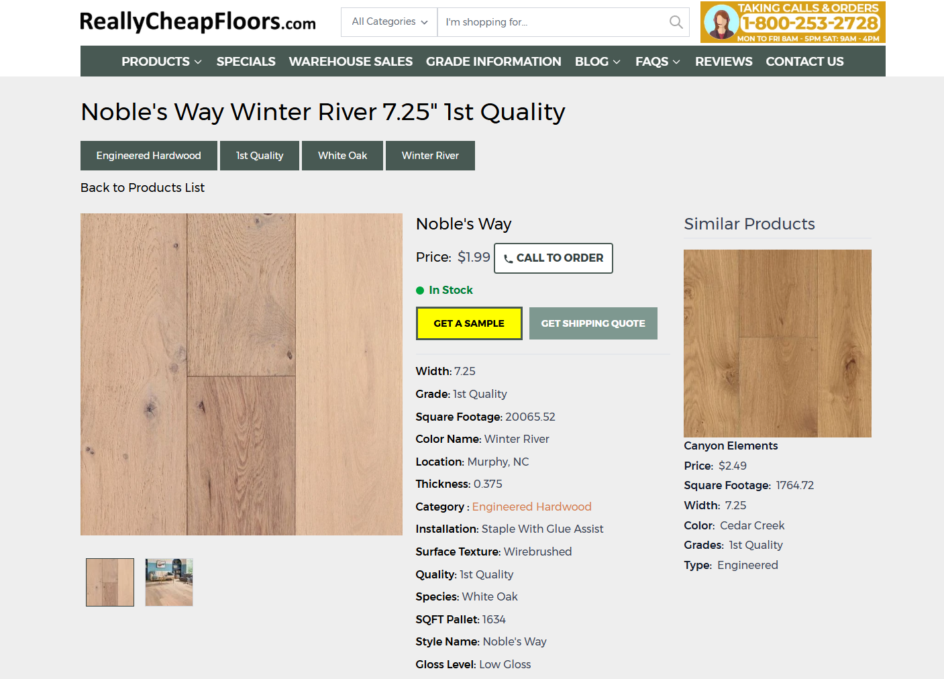
⚠ This screenshot is proof that the video matches a real, current product listing. Double-check the price and specs in the screenshot match what the script says before you move on.

STEP 5: Name and Organize Your Files
Save the finished videos, and the product screenshot, into the same folder as your script and pictures.
File names inside the folder:
video-01.mp4
video-02.mp4
video-03.mp4
video-04.mp4
video-05.mp4
product-screenshot.png

Use the same number as the matching scene picture (scene-02.png → video-02.mp4).

STEP 6: Tell Patrick You Are Done
Before you tell him, make sure you have:
☐ Pasted the full script into Gemini and got video prompts back for every 10-second segment
☐ Fixed any video prompt that didn't match its scene
☐ Matched every video prompt to the correct scene picture
☐ Generated a video for every matched pair
☐ Took a screenshot of the product page the script is promoting
☐ All video files named correctly (video-01.mp4, video-02.mp4, etc.)
☐ Everything uploaded to the shared Google Drive folder

Rules to Remember
- Paste the WHOLE script into Gemini at once — do not do this scene by scene.
- Always double-check that each video prompt is matched to the right scene picture before generating.
- If a video prompt doesn't match the script, fix it in Gemini before moving on.
- Every video prompt must follow the exact format: Composition, Location, Subject, Action, Dialogue, Style, Camera positioning and motion, Ambiance.
- Videos are 9:16 vertical, same as the pictures.
- If a scene's dialogue takes longer than 10 seconds to say, shorten the dialogue first. Only split it into two video prompts as a last resort.

