Javascipt interview questions coding:

<https://www.geeksforgeeks.org/top-50-array-coding-problems-for-interviews/>

New good website: <https://www.programiz.com/javascript/hoisting>stri

Coding interview questions:

Sorting of array:

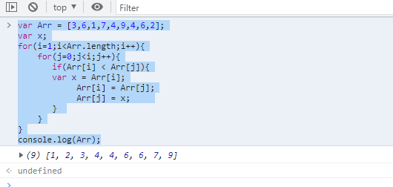

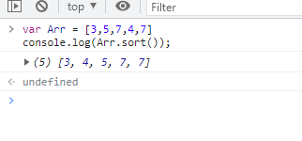

Array string sorting:

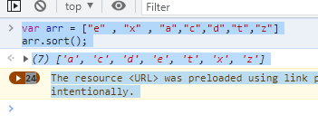

Largest number from array:

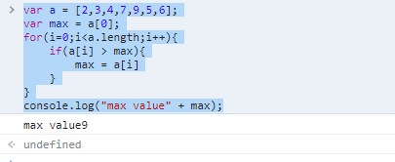

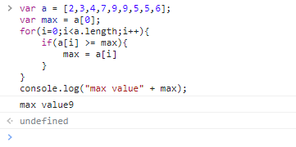

Second Largest Number from Array:

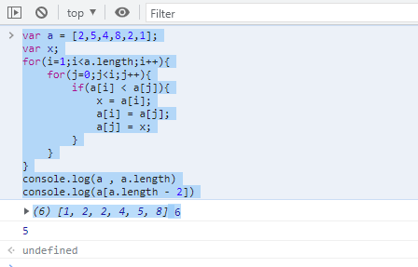

Find Min Value (smallest )from Array

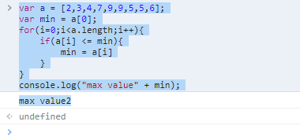

Average of array element:

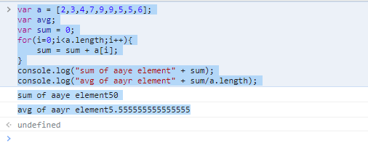

Remove duplicate elements from Array , unique values into the array

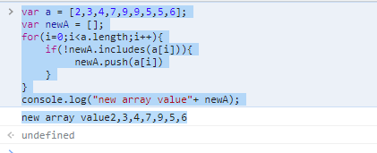

Find the index of specific character in the string

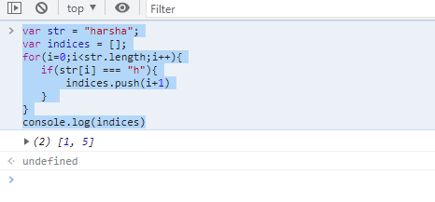

Sort the character of string

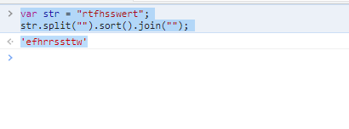

Reverse an array in JavaScript:

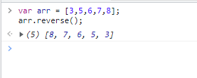

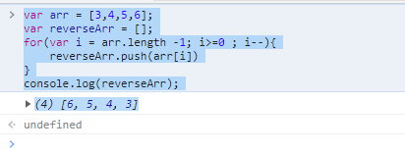

Count number of occarance of charcter in string

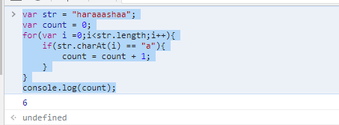

Merge two array:

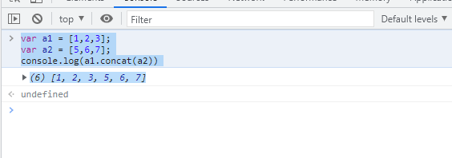

JavaScript code questions:

Difference between undefined and not defined

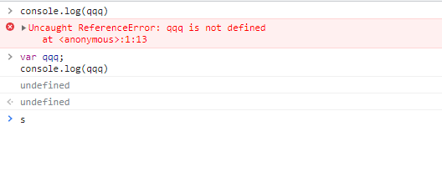

Call back function:It is mosytly used to handle the asyncrounoy opretation in js

Callbacks are a technique of ensuring that a particular code does not run until another code has completed its execution.

Function that is passed as argument to another function.

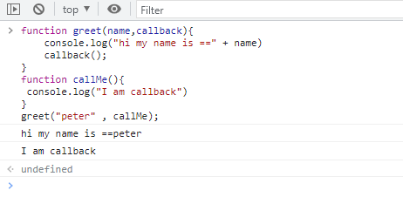

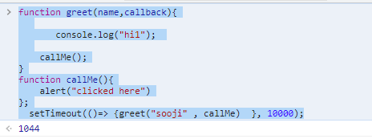

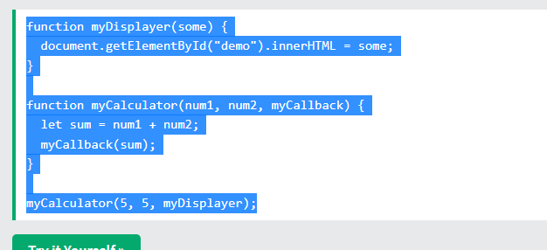

setTimeout and setinterval:

setTimeout: it will run the function after a delay

setTimeInterval: It will run the function in every pertuacle sepecitfiec interval

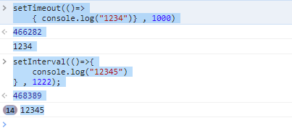

Print number greater than 5 with map function

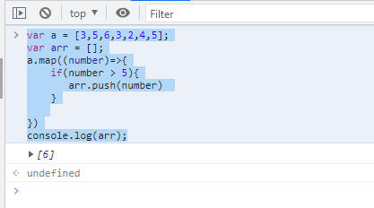

Adavnace js:

Rest parameters:

* It provides an improved way of handling the parameters of a function.
* Using the rest parameter syntax, we can create functions that can take a variable number of arguments.
* Any number of arguments will be converted into an array using the rest parameter.
* It also helps in extracting all or some parts of the arguments.
* Rest parameters can be used by applying three dots (...) before the parameters.
* 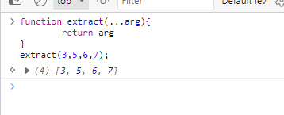
* 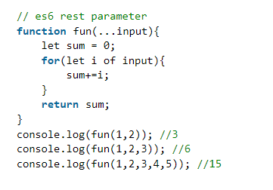
* 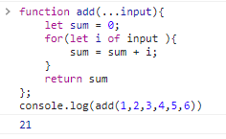

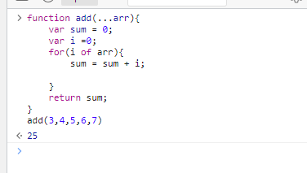

* The rest parameter has to be the last argument.

Spread Oprator:

It is use to spread the array and object literils.it is use to iterate the every element of array as well.

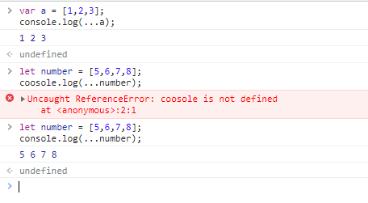

Merging of two object and arrays:

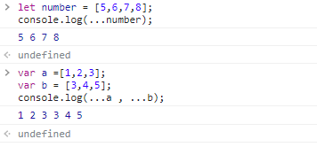

Copy array into new array:

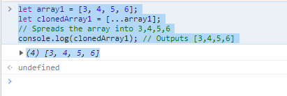

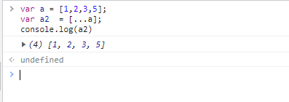

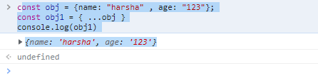

Merging the objects and copying the objects

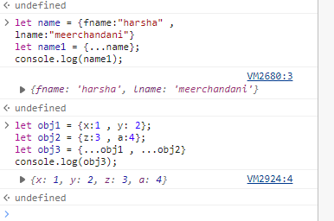

* Rest parameter is used to take a variable number of arguments and turns them into an array while the spread operator takes an array or an object and spreads it
* Rest parameter is used in function declaration whereas the spread operator is used in function calls.

**Ways to create the object in JavaScript:**

**How to copy one object to another object and add new properties/**

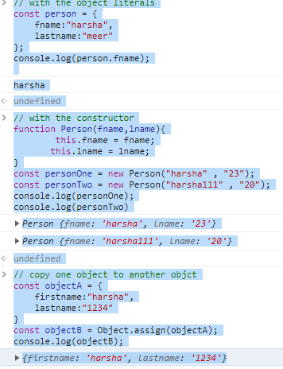



Object methods to learn

<https://www.javatpoint.com/javascript-object-create-method>

Promise in JavaScript:

It is used to handle the asynchronous(if not getting api response so it will not wait to complete that task,, even jump to other task) of javadcipt.

It is created with the Promise constructor.

It takes the call back function and pass two permeters, resolve and reject.

Var myPromise = new Promise(function(resolve, reject){  
})

We use then and catch for showing the result and error.

It have three states:

1. Pending, resolve,reject

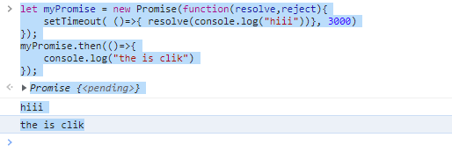

Generator function:

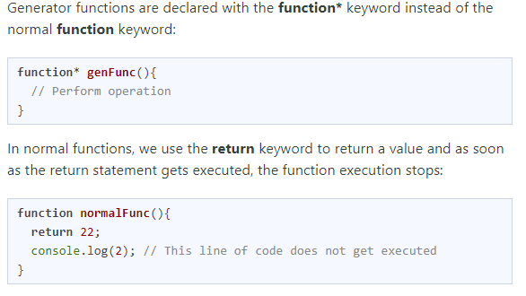

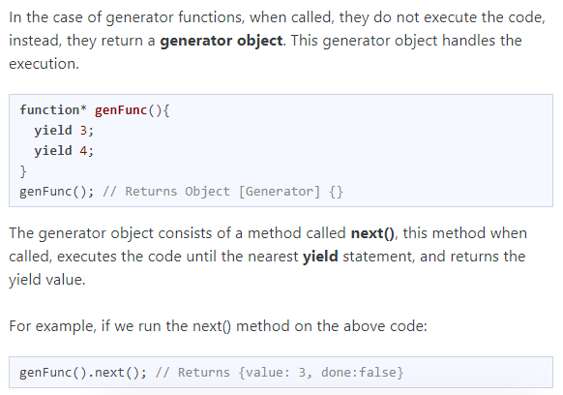

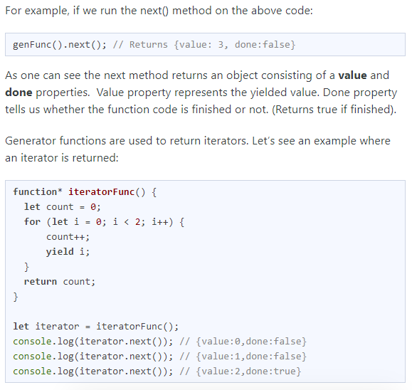

Set method:

It is collection of unique values.

Each value can occur once in the set.

A set can occur any value of any data type.

1. We can create set by passing array in set method.

Var mySet = new set([a,b,c,d]);  
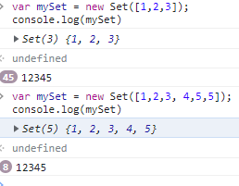

Remove duplicate elements from array.(see above exmaple)

.add() method , .size()

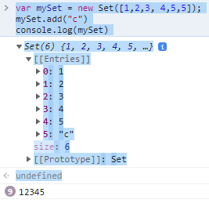

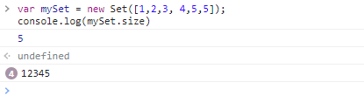

**Destructuring** :

It is the new way to extract the values from an array or any object.

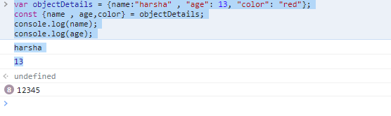

Recursion:

Recursion is a process of calling itself. A function that calls itself is called a recursive function.

The syntax for recursive function is:

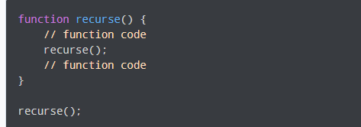

A recursive function must have a condition to stop calling itself. Otherwise, the function is called indefinitely.

Once the condition is met, the function stops calling itself. This is called a base condition.

To prevent infinite recursion, you can use [if...else statement](https://www.programiz.com/javascript/if-else) (or similar approach) where one branch makes the recursive call, and the other doesn't.

So, it generally looks like this.

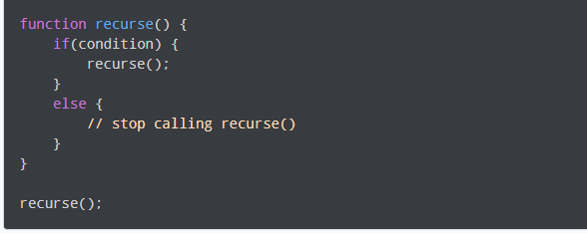

[JavaScript Interview Questions and Answers (2023) - InterviewBit](https://www.interviewbit.com/javascript-interview-questions/#difference-between-prototypal-and-classical-inheritance)

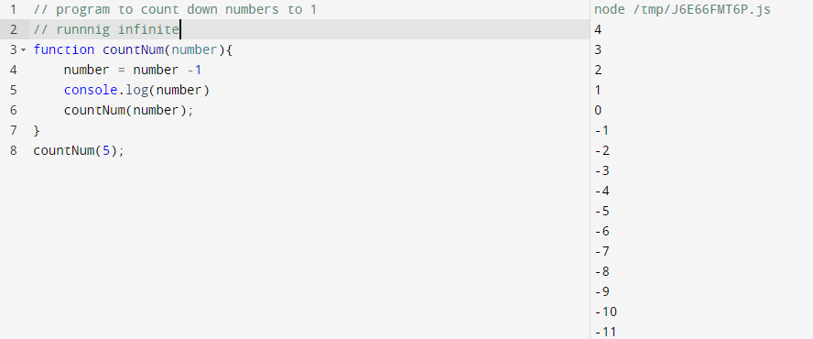

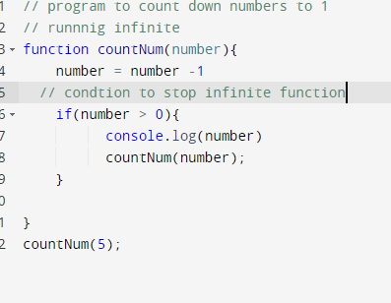

hoisting

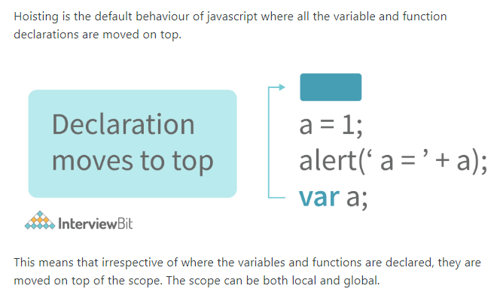

Loop methods in javascipt

useReducer

pending

Asyn/await

Lexical scope

Design pattern

Weakmap

Coding question of document.sorting of array

Clouser

Passbyvalue and passby refrence

Self invoke function,,imijetly invoke function,,anomous function

currying

bom and dom

forEach: to iterate the element of array.

Reduce()=>

Thanks & Regards

Poonam Mittal- HR Specialist

Quara Digital

Contact No- 9821022230

Tell me about your self:

What is your contribution to your company

Your resposibitlies, why do you want to change your company

Your weekness and strength

9625991153