Teaching Discrete Mathematics with Computer Algebra:

A new approach to Modern Algebra and
Error-Correcting Codes

Igor Gachkov & Kenneth Hulth
School of Engineering
Jonkoping University, Sweden

Preface

An attempt to introduce Computer Algebra in the course programme of School of Engineering, Jönköping University, Sweden, was made three years ago, as the course ”Discrete Mathematics with Computer Algebra” was given for the first time. The response from the students was very encouraging, and indicated, that a conceptually new course structure with hands-on sessions, using the powerful tools of MATHEMATICA, could make an advanced theory availible for students with a minimal background in mathematics.

In developing the course modules the authors used the MATHEMATICA package ”Discrete Mathematics”, and a set of laboratory sessions on individual basis was worked out.

The content of courses in discrete mathematics usually encompasses some theory on algebraic structures, and often, as an application of these structures, a chapter or two on how to correct errors due to ”noise” in communication channels. The demand of knowledge in this field has in recent years increased tremendously, due to the now-a-days daily use of modern electronic circuits in all kind of plastic (type credit-) cards used in Bank-Machines”, by shopping etc, as well as in CD-players, CD-ROM storage in computers, FAX-machines, i.e. practically everywhere where a reliable communication is demanded. The corresponding circuits all use error-correcting codes based on modern (abstract) algebra.

This wide-spread use of electronic circuits with error-correcting functions (practically every commercial electronic circuit today has some sort of error-correcting capacity) gave the authors the idea to develop a special course module focusing on on coding theory for engineers, not having a deep mathemathical background, but who have shosen an educational programme strongly connected with the construction, implementation and/or technical maintenence of mentioned equipment, i.e. engineers in telecommunication, electronics or informatics.

Due to the necessity of using advanced mathematical theories, like results on algebraic structures, including extension of finite fields and linear spaces over Galois Fields, courses in coding theory in general have to be allocated on postgraduate level. But having the possibilities of Computer Algebra at disposal, the authors got the idea to develop a non-standard, methodical-oriented course where hands-on sessions could add substantial understanding in the introduction of mentioned mathematical concepts. Consequently, a package in MATHEMATICA in the field ”Coding Theory” was developed at the School of Engineering, and the first course was given autumn 1994 for students on advanced undergraduate level. The hands-on sessions, worked out as a concept with introductory and problem-solving parts, usually repeated and sometimes also demonstrated the theory from the preceding lectures in another fashion.

In the autumn semester 1996 the course was given for the third time. With the experience from the previous courses, with an extended package of commands, and also using hints and suggestions from the students, the course has been further developed. Especially the previously not possible (due to complicated mathematical aspects) parts of the codes BCH and Reed-Solomon have now been included in the package. The beautiful Error-Trapping decoding is demonstrated both analytically and from a practical point of view (with construction of schemes and demonstration of the process of decoding).

Apart from the mentioned course modules, the students at School of Engineering can choose to write a (limited) scientific project in discrete mathematics using computer algebra, as the final project of the undergraduate programme in Jönköping. Also from this field the authors have positive experiences.

The first results of our courses were presented at the International IMACS Conference on Applications on Computer Algebra in University of New Mexico in 1995, along with a short presentation of the package ”Coding Theory” ,written in MATHEMATICA. Beside an overview of how Computer Algebra is introduced in discrete mathematics in Jönköping, we will in this seminar discuss experiences from our courses and present some further possibilities of the package. We will also outline how we with help of our package recently found a solution of a research problem. This result gives an indication of how Computer Algebra can be used to create new knowledge, hardly achievable without computers.

The course module Discrete Mathematics

The first course in Discrete Mathematics in Jönköping consists of three main parts:

a) Mathematical Logics
b) Sets, Combinatorics, Generating Funktions and Difference Equations
c) Graphs, including optimization problems

The course starts with an orientation of the possibilities and limits of Computer Algebra, where the programme MATHEMATICA is introduced as a tool to solve problems from a wide field, and where special attention is devoted to the package Discrete Mathematics . The course is methodical and the laboratory work sessions are problem-oriented without beeing too theoretical.

A typical task from the course is the following:

Example 1. Find all bases of the three-dimensional Linear space over the Finite field GF(2).

In[1] : = <<Combinat.m

In[2] : = Bas={};

B=KSubsets[{{0,0,1},{0,1,0},{0,1,1},{1,0,0},{1,0,1},{1,1,0},{1,1,1}},3];

(* The command KSubsets gives all 3-element subsets of the set {{0,0,1},{0,1,0},{0,1,1},{1,0,0},{1,0,1},{1,1,0},{1,1,1}} *)

Do[If[Mod[B[[i,1]]+B[[i,2]],2]=!=B[[i,3]],AppendTo[Bas,B[[i]]]],{i,1,Length[B]}]

In[3] : = Short[Bas,3]
Out[3] = {{{0, 0, 1}, {0, 1, 0}, {1, 0, 0}}, <<26>>, {{1, 0, 1}, {1, 1, 0}, {1, 1, 1}}}

We will come back to this result in the last part of our talk.

The package "Coding Theory"

The package ” Coding Theory” is a file written in MATHEMATICA Version 2.2 and will be read into MATHEMATICA with the commands (see ref nr 3) :

In[4] : = <<CodingT1.m
In[5] : = <<CodingT2.m

The package consists of two parts : one with illustrative explanations, one for scientific purposes.
The illustrative part ( commands starting with Show...) is considered to visualize the theoretical aspects of encoding / decoding , construct shift-register circuits etc. The complete information about a command is received by using the command ? Name . For example

In[6] : = ?ShowBinaryGaloisField

ShowBinaryGaloisField[g,x,b,a] shows the lists of the elements of the Galois Field which has been constructed using the irreducible polynomial g(x) with primitive element b. Also the minimal polynomials of the elements in the Galois Field are given.

The command ? Show* gives the following list of commands :

In[3] : = ?Show*

Show ShowHammingCode
ShowBinaryGaloisField ShowMeggittDecoder
ShowBurstRectangularCodeVector ShowNonsystematicEncoderCyclicCode
ShowCorrectBurstRectangularCode ShowReconstructInformRectangularCode
ShowCyclicCode ShowRectangularCode
ShowDecHammingCode ShowStandardArrays
ShowDecRectangularCode ShowSystematicEncode
ShowErrorTrappingDecoderBCHCode ShowSystematicEncoderCyclicCode
ShowTablePlus ShowTableMult

Algebraic structures: Groups, Cosets and Standard Arrays

We remind of the concepts of some algebraic structures, such as groups, rings, fields and linear spaces, which play a decisive role in the constructinon of Error-Correcting codes. We limit our discussion to Block Codes , which means codes in wich all code words have a fixed length, i.e. the code words could be seen as building blocks of equal size.

The concept of a group is maybee the most significant property in coding theory: For example, the set G = {0,1}⁴ = the set of strings of length 4 in the binary alphabet, is a group: The set is closed under addition (bitweise) modulo 2, the associative law holds, there is a neutral element and each element has an inverse. Typical elements in this set are 0011, 1110, 1010,... The group is furthermore commutative (abelian ) , as will usually be the case of the groups in coding theory.

K G is a subgroup of G if K is itself a group. A linear block code K will now be considered as a subgroup of a given group G, the code words elements of this subgroup K. In our example we set K = { 0000, 0101, 1011, 1110 } . We can easily check the group character of K, and as in the general group theory, we could use the subgroup to construct a quote group G/K:

The code words form the first element K (the coset K) in the quote group G/K. We find the other elements in G/K by adding a coset leader to K, and we chose the coset leaders as elements i G with minimal hamming weight. The elements in G/K , the cosets, are written as rows, each with 4 words.

Coset leader
0000 0000 0101 1011 1110
1000 1000 1101 0011 0110
0100 0100 0001 1111 1010
0010 0010 0111 1001 1100

We observe that all 2⁴ = 16 strings are present in the table, and that no two cosets have a word in common. We have 4 elements in K , and hence 4 elements in G/K, in accordance with Lagrange´s Theorem.

An rectangular array like this table is called a Standard Array , and provides an easy decoding of a word received from the communication channel, where, due to ”noise”, the code words sent may have been corrupted : Reciving a word y = x+e (the vector e is called the error vector) from the channel we easily find the code word x as x = y - e = y + e (binary code !). As e has minimal hamming weight ( as have also our coset leaders ), we decode as follows:

First find the recieved word y in one of the cosets of the Standard Array. Then decode by adding the corresponding coset leader to y, i.e. decode y as the code word x in the same column as y.
Example 2: Let the code word x be x= 1011 , and choose the error vector e as e = 0100. We then have the word y = 1111, which we receive from the channel. We would then decode as
x = 1111 + 0100 = 1011.

Now let {0,1}^{n} = G , K = K[n,k,d] (thus K is a subgroup of the strings of length n). As above, we divide G into cosets modulo K , where K = 0+K is one subset. From Lagrange we deduce that the number of cosets will be n/k , as k is the dimension of K.
Example 3: Consider the code given by its parity check matrix H = 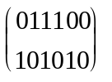 .
Construct a Standard Array and decode the word y = 110011 .

Solution: The code K will be a subgroup of {0,1}⁶. We get the code words from H x^{tr} = 0 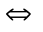 x = u G

Take H x^{tr} = 0 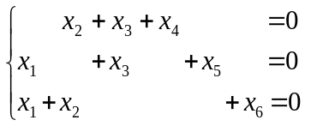 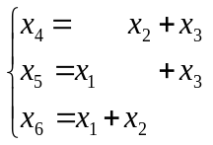

Choosing the first three bits x₁ , x₂ , x₃ arbitrarily, we get the check bits x₄ ,x₅ , x₆ from the equations, and thus the code words are: 000000 001110 010101 011011 100011 101101 110110 111000

We have 2³ = 8 code words, and thus we have (Lagrange) 8 cosets, which gives us the array :

000000 001110 010101 011011 100011 101101 110110 111000
100000 101110 110101 111011 000011 001101 010110 011000
010000 011110 000101 001011 110011 111101 100110 101000
001000 000110 011101 010011 101011 100101 111110 111000
000100 001010 010001 011111 100111 101001 110010 111100
000010 001100 010111 011001 100001 101111 110100 111010
000001 001111 010100 011010 100010 101100 110111 111001
100100 101010 110001 111111 000111 001001 010010 011100

The first row in the array constitutes the coset K, i.e. the code words, whereas the first column contains the coset leaders. Again, we could check that we have all binary words of length 6 present in the array, and that no two cosets have an element in common. The groups K and G/K have 8 elements each. We also conclude, that the code corrects all single errors, and also one dubble error (last coset).

By decoding, we find the word y = 110011 in the third coset and the fifth column, and thus decode as x = 100011 .

The Standard Array is a rectangular array containing all binary words of length n arranged so that

1) each row is one coset modulo K (K is a code),the first one is K itself
2) the first column is formed by the chosen coset leaders
3) the word in the i:th row and the j:th column is the sum of the i:th coset leader and the j:th code word.

Decoding by standard arrays is a very thorough, however very slow. This decoding would require checking the array of 2^{n}1 words ( n is the length of the code K ) .

We now use MATHEMATICA to demonstrate the method of decoding by Standard Arrays.

Example 4: Decode the received word w={1,1,1,1,1} by a Standard Array if we use the binary code with parity check matrix H = 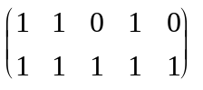.

The command ShowStandardArray[H,w,x] shows the method of decoding . If the parameters of the matrix M are large, the Standard Array will not be shown on the screen, only the parity check matrix, all code words, the received word, the coset, the coset leader and the decoded word.

In[7] :=
H={{1,1,0,1,0},{1,1,1,1,1}};
w={1,1,1,1,1};
ShowStandardArrays[H,w]

PARITY CHECK MATRIX = 1 1 0 1 0
1 1 1 1 1

Coset
Leader
00000 11000 10010 01010 00101 11101 10111 01111

00001 11001 10011 01011 00100 11100 10110 01110

00010 11010 10000 01000 00111 11111 10101 01101

00011 11011 10001 01001 00110 11110 10100 01100

RECEIVED WORD = 11111

00000 11000 10010 01010 00101 11101 10111 01111

00001 11001 10011 01011 00100 11100 10110 01110

00010 11010 10000 01000 00111 XXXX 10101 01101

00011 11011 10001 01001 00110 11110 10100 01100

DECODED WORD = 11101

Fundamentals from algebra.

We need for the construction of the linear block-codes some further prerequisites from algebra, including the method of extension of a fiite field by means of an irreducible polynomial. The linear block codes are further seen as subspaces of linear spaces over a selected finite field, a Galois Field.

Of fundamental importance are the following algebraical concepts:

* Irreducible polynomial : f(x) is irreducible over the field F, if f(x) cannot be factored as a
product of two polynomials of degrees smaller than that of f(x).

* Primitive element : is a primitive element in the field F provided that every nonzero
element in F is equal to some power of .

* Minimal polynom: If is an element of some extension of the field F, the minimal
polynomial of (with respect to F) is the lowest-degree monic polynomial M(x) over F with
M() = 0 . The minimal polynomial M(x) of GF(p^{m}) can be computed as

M(x)=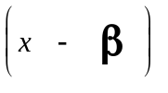 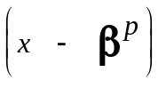 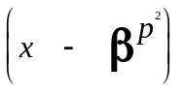 . . . 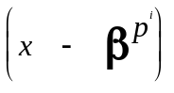,where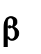= 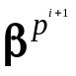.

* The Galois field GF(p^{m}) is defined as an algebraic extension of the field Z_{p} (p prime
number) by an irreducible polynomial of degree m. If g(x) is a polynomial of degree m and
irreducible over Z_{p} we construct GF(p^{m}) = Z_{p} / g(x) with p^{m} elements 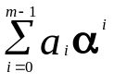, 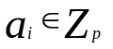.
The element satisfies g() = 0.

In MATHEMATICA we now demonstrate some algebraical constructions and computations :

In[8] :=
BIP=BinaryIrreduciblePolynomials[4,x]

Out[8] =
{1 + x³ + x⁴ , 1 + x + x⁴ , 1 + x + x² + x³ + x⁴ }

In[9] :=
r=BIP[[2]]

Out[9] =
1 + x + x⁴

In[10] :=
ShowBinaryGaloisField[r,x,b,a]

Galois Field GF(16) with irreducible polynomial 1 + x + x⁴
____________________________________________
Log Vector pr.el. polynomial min.polynomial
____________________________________________
-oo 0000 0 0 x
0 1000 1 1 1 + x
1 0100 b a 1 + x + x⁴
2 0010 b² a² 1 + x + x⁴
3 0001 b³ a³ 1 + x + x² + x³ + x⁴
. . . . . . .
. . . . . . .
12 1111 b¹² 1 + a + a² + a³ 1 + x + x² + x³ + x⁴
13 1011 b¹³ 1 + a² + a³ 1 + x + x⁴
14 1001 b¹⁴ 1 + a³ 1 + x³ + x⁴

The importance of Galois Fields in coding will be seen in the next chapter.

The double - error - correcting BCH code of length 15

Definition. By the binary double-error-correcting BCH code is meant the code of all binary words of length n satisfying v ( b ) = v ( b³ ) = 0 , where b is an element of order n in some algebraic extension of the field Z₂ .

The BCH code is a cyclic code with generator polynomial g ( x ) = M₁ ( x ) M₃ ( x ) where
M₁ ( x ) is the minimal polynomial for b and M₃ ( x ) is the minimal polynomial for b³.

Example 5. Let b = a be the primitive element of GF(16) (the irreducible polynomial
r ( x ) = 1 + x + x⁴ ). The binary code of length 15 is given by the matrix equation
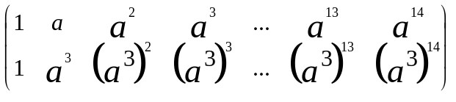 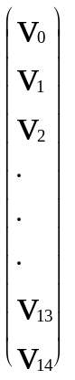 = 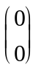

Thus we have the parity check matrix H = 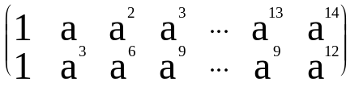

or in binary columns H = 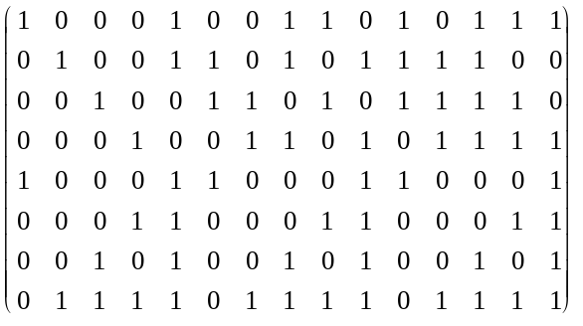

Since a has the minimal polynomial M₁ ( x ) = 1 + x + x⁴ , and a³ has the minimal polynomial
M₃ ( x ) = 1 + x + x² + x³ + x⁴ , the generator polynomial will be given by

g ( x ) = ( 1 + x + x⁴ )( 1 + x + x² + x³ + x⁴) = 1 + x⁴ + x⁶ + x⁷ + x⁸ .

Let K be a [n,k,d ]-cyclic code with the generator polynomial g ( x ) , capable of correcting double errors.

The method of construction of the binary double-error-correcting BCH code of length 15.

In[11] :=
GF16=BinaryGaloisField[r,x,b,a]; Short[GF16,3]

Out[11] =
{{-oo, {0, 0, 0, 0}, 0, 0, x}, {0, {1, 0, 0, 0}, 1, 1, 1 + x}, {1, {0, 1, 0, 0}, b, a, 1 + x + x⁴ }, <11>>, {13, {1, 0, 1, 1}, b¹³ , 1 + a² + a³ , 1 + x³ + x⁴}, {14, {1, 0, 0, 1}, b¹⁴ , 1 + a³ , 1 + x³ + x⁴ }}

In[12] :=
BCH1={Table[GF16[[i,3]],{i,2,16}],Table[PolynomialMod[GF16[[i,3]]^3,b^15-1],{i,2,16}]}

Out[12] =
{{1, b , b² , b³ , b⁴ , b⁵ , b⁶ , b⁷ , b⁸ , b⁹ , b¹⁰ , b¹¹ , b¹² , b¹³ , b¹⁴ },
{1, b³ , b⁶ , b⁹ , b¹² , 1 , b³ , b⁶ , b⁹ , b¹² , 1 , b³ , b⁶ , b⁹ , b¹² }}

In[13] :=
BCH2=
Flatten[{Transpose[Table[GF16[[First[Position[GF16,BCH1[[1,i]]]][[1]],2]],{i,1,15}]],
Transpose[Table[GF16[[First[Position[GF16,BCH1[[2,i]]]][[1]],2]],{i,1,15}]]},1];
MatrixForm[BCH2]

Out[13] =
1 0 0 0 1 0 0 1 1 0 1 0 1 1 1
0 1 0 0 1 1 0 1 0 1 1 1 1 0 0
0 0 1 0 0 1 1 0 1 0 1 1 1 1 0
0 0 0 1 0 0 1 1 0 1 0 1 1 1 1
1 0 0 0 1 1 0 0 0 1 1 0 0 0 1
0 0 0 1 1 0 0 0 1 1 0 0 0 1 1
0 0 1 0 1 0 0 1 0 1 0 0 1 0 1
0 1 1 1 1 0 1 1 1 1 0 1 1 1 1

In[14] :=
Length[BCH2[[1]]]
DimensionCode[BCH2]
DistanceCode[BCH2]

Out[14] =15
15
Out[15] =
7
Out[16] =
5
The syndrome decoding algorithm ( The analytical method )

Let us assume that we receive a word w = ( w₀ , w₁ , ... , w₁₄ ) and that at most two positions are corrupted ( say w_{i} and w_{j} ) . We compute the syndrome as
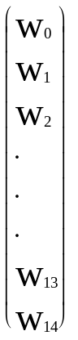 = 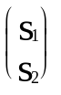

The error - pattern word e ( x ) = x^{i} + x^{j} has the same syndrome as the recieved word, i.e.

= 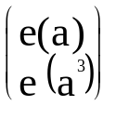 = 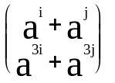

Thus we must compute the unknown elements a^{i} and a^{j} from the known syndrome ( s₁ , s₂ ) ,
using the following equations

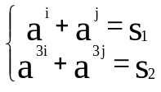

The error - trapping decoding algotithm for
the double error - correcting code of length 15

Let w be a received word when a cyclic code K is used, and assume that t symbols have been corrupted ( t < 3 ). We then have the following:

(1) If the syndrome polynomial has Hamming weight at most t, then the error pattern
polynomial is equal to the syndrome polynomial.

(2) Since we have single or double errors there is a cyclic shift of w that has a syndrome
polynomial of Hamming weight at most t ( for double-error correcting code this
is possible only if n > 2k ).

When receiving a word w , find its syndrome s, and if the Hamming weight of s is smaller or equal to t, decode as w - s . If s has Hamming weight larger than t, shift cyclically w to the right and find the syndrome s ⁽ ¹ ⁾ of the shifted word w ⁽ ¹ ⁾ 2. If the Hamming weight of s ⁽ ¹ ⁾ 3 is smaller then or equal to t, then decode the word as w ⁽ ¹ ⁾ - s ⁽ ¹ ⁾ 4 shifted cyclically to the left. If s ⁽ ¹ ⁾ 5 has Hamming weight larger than t, shift cyclically the word w ⁽ ¹ ⁾ 6 to w ⁽ ² ⁾ 7, etc.
The operations of multiplication and division by a given polynomial g(x) can be realised by a simple shift - register circuit . We will use the following signs:

---- ---- denotes a shift-register stage

a

+ a + b denotes an adder.

b
To your disposal there is an application command ShowErrorTrappingDecoderBCHCode to construct the decoder of the BCH code.

In[17] :=
ShowErrorTrappingDecoderBCHCode

1 - the shift registers
2 - the circuit of functional elements
for the checking the syndrome on (000..0),
or (000...010...0) only single 1
3 - accumulative buffer

1 The first 15 shifts. 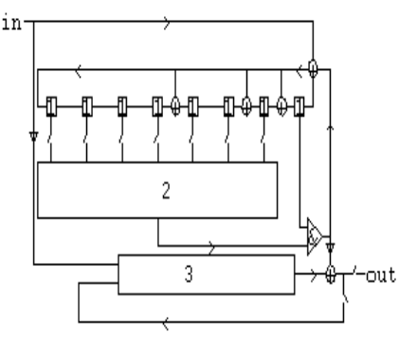 | 2 The next 15 shifts. 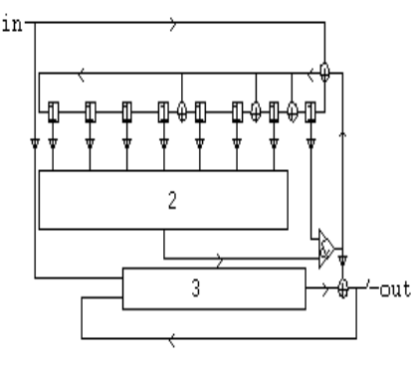 | 3 The last 15 shifts. 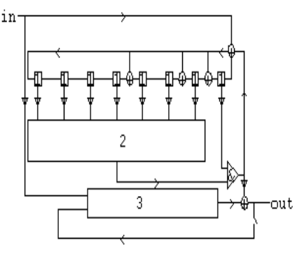

Example 6. Decode the received word w = {0,0,1,0,0,0,0,0,0,0,0,0,0,1,0} using the error - trapping method.

The command ErrorTrappingDecodeBCHCode[w,n1,n2,st] gives the method and shows the
trace of the received word w into the error trapping decoder of the BCH code of length 15 with generator polynomial 1+x^4+x^6+x^7+x^8 start from n1 till n2 steps st = 1 or 2 or 3 .

In[18] :=
w={0,0,1,0,0,0,0,0,0,0,0,0,0,1,0};
ErrorTrappingDecodeBCHCode[w,n1,n2,st]

11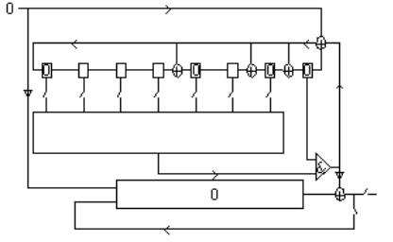 | 21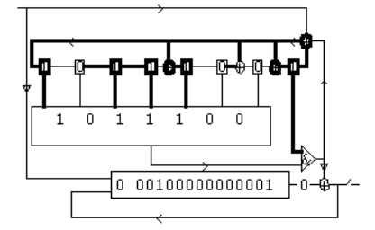 | 31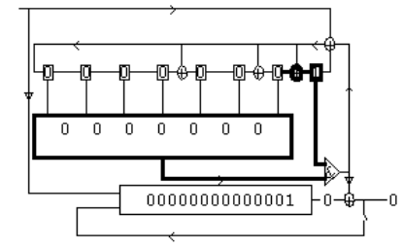
12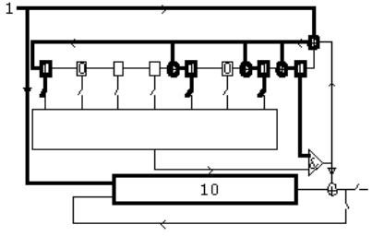 | 22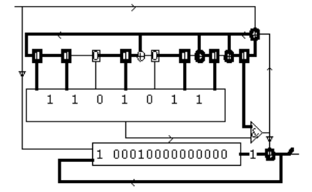 | 32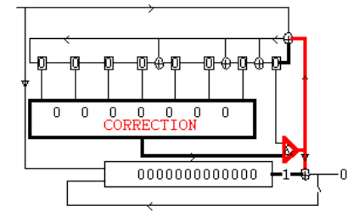
13 . . . | 23 . . . | 33 . . .
. . . . . . . . .
1.12 . . . 2.12 . . . 3.12 . . .

1.13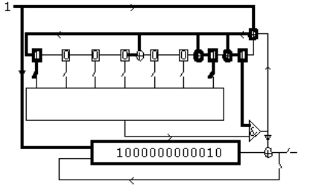 | 2.13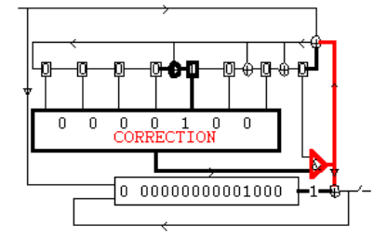 | 3.13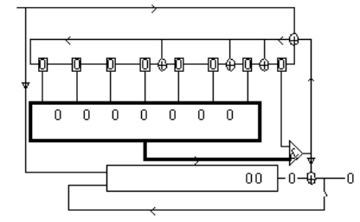
1.14 . . . | 2.14 . . . | 3.14 . . .
1.15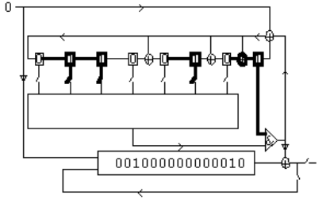 | 2.15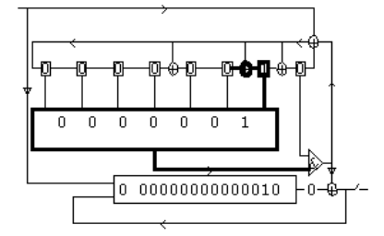 | 3.15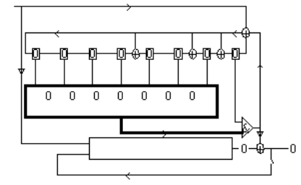

THE RECEIVED WORD = 001000000000010
THE DECODED WORD = 000000000000000

Reed-Solomon codes

A Reed-Solomon (RS) code over the Galois Field GF(q) is a special BCH - code having the length of the code words equal to the number of nonzero elements in the ground field. The RS - codes are cyclic and have as generator polynomial g(x) = (x - )(x -²) ... (x -^{2t}) , where is a primitive element of GF(q) , whereas t is the number of errors the designed code corrects.

The elements of GF(q) can be represented as m-tuples of elements from GF(p). Choosing p = 2 we get the binary codes by substituting for each symbol in GF(2^{m}) the corresponding binary m - tuple. The received code with length n m has found great practical importance due to its capability to correct burst errors of length (t - 1) m + 1 . These codes are used in CD - players, CD - rom storage of information, and other equipments where errors are likely to appear in bursts (such as mechanical damages etc). In CD - players the RS - code often corrects burst errors of length 3000 bits or more.

In[19] :=
r=BinaryIrreduciblePolynomials[3,x][[2]]
Out[19] =
1 + x + x³

In[20] :=
ShowBinaryGaloisField[r,x,a,a]

Out[20]:=
The Galois Field GF(8) with the irreducible polynomial 1 + x + x³
______________________________________
Log Vector pr.el. polynomial min polynomial
-oo 000 0 0 x
0 100 1 1 1 + x
1 010 a a 1 + x + x³
2 001 a² a² 1 + x + x³
3 110 a³ 1 + a 1 + x² + x³
4 011 a⁴ a + a² 1 + x + x³
5 111 a⁵ 1 + a + a² 1 + x² + x³
6 101 a⁶ 1 + a² 1 + x² + x³

We next construct the generator polynomial for the RS-code of length 7 over the field GF(8) with code distance 4.

In[21] :=
GF8=BinaryGaloisField[r,x,a,a]; b=1; d=4; g=Product[x-GF8[[2+b+i,3]],{i,0,d-2}]

Out[21]=
(-a + x) (-a² + x) (-a³ + x)

In[22] :=
g=Collect[PolynomialMod[PolynomialMod[Expand[g],r/.x->a],2],x]

Out[22]=
1 + a² + a x + (1 + a² ) x² + x³

We have got the RS - code with the generator polynomial g with parameters [ 7,4,4] over the field GF(8).

In[23] :=
L={0,1,a,a^2,a^3,a^4,a^5,a^6} (* The field GF (8) *)

Out[23]=
{0, 1, a, a² , a³ , a⁴ , a⁵ , a⁶ }

With 4 information bits our RS - code has 8⁴ = 2¹² = 4096 code words, and we next onstruct all these code words :

In[24] :=
RS1={};Do[AppendTo[RS1,CoefficientList[Collect[PolynomialMod[PolynomialMod[Expand
[g*Sum[L[[Table[Sum[Partition[VEC[k,12],3][[j,i]]*2^(i-1),{i,1,3}]+1,{j,1,4}][[i]]]]* x^(i1),{i,1,4}]],a^3+a+1],2],x],x]],{k,1,4095}];
Short[RS1]

Out[24]=
{{0, 0, 0, a² , a + a² , a² , 1 + a}, <<4093>>, {<<7>>}}

The effect of changing the basis.

A change of the basis ( the representation of the elements of the field GF(8) as binary vector ) may change the minimum weight of the code. If we take the standard basis : 1->(0,0,1); a->(0,1,0), a² ->(1,0,0) we get the binary code with parameters [ 3*7=21, 3*4=12,4] with the same code distance.

We will now try to find a new basis in order to produce a code with code distance 5 .

We start with counting all code words with hamming weight 4 :

In[25] :=
RRS={}; Do[If[Length[R[[i]]]-Count[R[[i]],0]==4,AppendTo[RRS,R[[i]]]];
If[Mod[i,100]==0,Print[i]],{i,1,4095}]; Length[RRS]

Out[25]=
245

This shows that there are 245 code words of hamming weight 4 . Introducing the non-standard base e₁ = {0,1,1}, e₂ = {0,1,0}, e₃ = {1,1,0} we will show that we get a code with code distance 5. We do this by :

In[26] :=
Do[If[Count[Flatten[Mod[(RRS[[j]]/.{a^2->v3,a->v2})-(RRS[[j]]/.{a^2->v3,a->v2}/.{v2->0,v3->0})+Table[If[(RRS[[j]]/.{a^2->v3,a->v2}/.{v2->0,v3->0})[[i]]==1,v1,0],
{i,1,Length[RRS[[j]]]}]/.{v1->e1,v2->e2,v3->e3},2]],1]==4,
Print["Code Distance 4 "];Break[]],{j,1,Length[RRS]}]

The weight distribution can be obtained using the procedure

In[27] :=
Do[v=Flatten[Mod[(R[[j]]/.{a^2->v3,a->v2})-(R[[j]]/.{a^2->v3,a->v2}/.{v2->0,v3->0})+
Table[If[(R[[j]]/.{a^2->v3,a->v2}/.{v2->0,v3->0})[[i]]==1,v1,0],{i,1,Length[R[[j]]]}]/.{0->{0,0,0},v1->e1,v2->e2,v3->e3},2]];
While[Length[v]<21,AppendTo[v,0]];R[[j]]=v,{j,1,4095}];
S={};Do[AppendTo[S,Count[R[[i]],1]],{i,1,4095}]
Short[Sort[S]]

Out[27]=
{5, 5, 5, 5, 5, 5, 5, 5, 5, <<4081>>, 16, 16, 16, 16, 21}

Finally we can obtain the weight polynomial of the code:

In[28] :=
W=0;Do[W=W+x^Count[R[[i]],1],{i,1,4095}];W

Out[28]=
21x⁵+168x⁶+360x⁷+210x⁸+280x⁹+1008x¹⁰+1008x¹¹+280x¹²+210x¹³+360x¹⁴+168x¹⁵+21x¹⁶+x²¹

We have found a code with parameters [21,12,5] . This code is better than the retangular code, which has the parameters [21,12,4] , and also better than the BCH-code with parameters {[21,11,5] . The found code is to be classified as a Wagner quasiperfect code (Ref nr 6) . Indeed, by presenting this code we have solved a research problem, described in MacWilliams and Sloane, page586 viii (Ref nr 5).

The computations to find the parameters of this code took several hours for MATHEMATICA, and the result adds new knowledge to the characterisation of the best known codes, results hardly achievable without computers.

We finally consider the dual to the found code. As usual we find the weight polynomial of the dual code by using the Mc Williams identity :

In[29] :=
McWilliamsIdentity[W+1,21,x]

Out[28]=
1 + 210 x⁸ + 280 x¹² + 21 x¹⁶

We see that the dual code has the parameters [21,9,8] . This code is to be classified among the Golay codes.

Conclusion

It is today hardly possible to imagine engineers working with data transmission and related fields without basic knowledges of coding/decoding of information. During preceding years courses in Coding Theory have been concidered only for students on postgraduate level. This is due to the complexity of the mathematical methods used in most codes, such as results from abstract algebra and number theory.

With the introduction of computers and computer algebra it is possible to offer methodical-oriented courses, where the learning process is supported by the rich variety of manipulations in the algebraical structures, and the simplicity to vary the parameters in specific constructions. Methods can be fairly well illustrated with applications, and thus strengthen the understanding of the mathematical ideas used.

The hands on sessions at School of Engineering, Jönköping, were based on a package of application programmes/algorithms , developed by the authors to illustrate the mathematical constructions, used in coding theory to encode and decode information.

An interesting observation during the course was that the students quickly found out, that the theoretical tasks, which had to be solved individually within the frame of the lecture programme, easily could be checked by using computer algebra.

Furthermore, the use of computer algebra beside the illustration of examples examples possible not only to illiundoutedly

Bibliography

1. Gachkov, I. , Hulth, K. : Introduction to Information Theory with Theory and Application of Error-Correcting Codes (1997).
2. Grimaldi : Discrete Mathematics
3. Gachkov, I. , Hulth , K. : Coding Theory in Mathematica ( in proceedings of IMACS
conference ,University of New Mexico ,USA, 1995 ).
4. Adamek, J. , Foundations of Coding , John Wiley &Sons,Inc 1991
5. MacWilliams, F. J. , and Sloane, N. J. A. ( 1977 ) The Theory of Error - Correcting Codes.
North - Holland, Amsterdam.
6. Wagner, T. J. A search technique for quasi-perfect codes, Info.and Control, 9 (1966) 94-99 [ 18,A]

