Formula 1 – A Mathematical Microworld with CAS
Learning Opportunities and Real Usage

Marianne Gerny*, Burkhard Alpers⁺

* dms.gerny@t-online.de, Max-Planck-Gymnasium, Heidenheim
+ balper@fh-aalen.de, FH Aalen, University of Applied Sciences

Abstract
In this article we describe a mathematical microworld for motion on a racing course and its usage with a group of grade 12 pupils. The microworld is concerned with the mathematical construction of courses and motion related functions. It is implemented in the Computer Algebra System Maple® which provides the means for representing courses and functions symbolically and graphically. We relate our observations of learning processes and working styles to the comprehensive research literature on functions. Various facets and layers of the function concept are addressed, and we think that work in the microworld can also help in overcoming some well-known misconceptions.

1. Introduction

The notion of (mathematical) microworld is used to denote a learning environment with computational objects, operations and activities “with the purpose of inducing or discovering their properties, and constructing an understanding of the system as a whole. Experimentation, hypothesis generation and testing, and open-ended exploration are encouraged” (Edwards, 1998, p. 67). In (Alpers, 2002), we investigated the usefulness of Computer Algebra Systems (CAS) for implementing such environments. Since CAS provide already a comprehensive set of mathematical objects, operations and representations, they are obviously “good candidates” for implementation but they need additional programming of higher-level objects and operations to make them more suitable for pupils as (Kent, 2000) already observed. This holds in particular for mathematical microworlds which model an application scenario. The objects and operations offered should then be meaningful within this scenario.
As an example for such an application-oriented mathematical microworld we implemented a learning environment called “Formula 1” within the CAS Maple®. The mathematical objects and operations essentially comprise geometric objects for course construction and functions as well as function transformations for modelling motion. In (Alpers, 2002) we showed that from an implementational point of view, it was relatively easy to realize this world taking into account essential properties like multiple linked representations, expressive means of the learner, feedback, adaptability and extensibility. In this article, we describe and discuss in more detail the learning opportunities provided by this microworld and how they were used in a learning unit with grade 12 pupils. This is not a statistical study with pre- and posttests and control groups. We rather observed single pupils or pairs of pupils closely in order to better understand their learning advances and obstacles, so our results clearly have hypothetical character as was the case in the study of (Weigand/Weller, 2001) on working styles.
In section 2 we describe the application scenario (car racing on a Carrera® toy course) as well as the physical and mathematical concepts used for modelling a simplified version. Section 3 provides information on the group of pupils concerning capabilities and pre-existing knowledge. Moreover, this section outlines the positioning of our trial within the curriculum and organisational aspects of equipment and sessions. Section 4 gives a short overview of the objects and operations the microworld provides for course construction. We then describe the learning opportunities and particularly how they were used in the trial, i.e. the real learning activities we observed. Section 5 contains the respective material on the second part of the microworld, i.e. motion construction. Especially, the usage of CAS capabilities for experimentation are investigated. In section 6 we discuss our findings and relate them to results from literature particularly on functions. Finally, conclusions and ways to improve the microworld are described in section 7.

2. Application Scenario and Mathematical Concepts

As application scenario to be modelled in the microworld we use a Carrera® toy course consisting of two types of pieces: a line piece of length 34.5cm and a 60°-curve piece of radius 35cm for the outer course. In general, the application scenario could be any kind of flat (i.e. two dimensional) course consisting of line segments and (circular) arc segments. Such models exist for example also for real racing courses like the Hockenheimring although the model then certainly does not describe the ideal line. From these pieces pupils constructed the simple course depicted in figure 1. For this course only the outer curve is used.
On this curve a toy car moves driven by a hand regulator. Regulation possibilities are very simple: Pressing the regulator fully gives full positive acceleration, not pressing at all provides full negative acceleration which is technically realized by the motor brake. One can try to roughly find an intermediate position where acceleration is 0. The motion of the car on the course can approximately be described by a one-dimensional distance vs time function s(t). Lateral acceleration and slipping of cars is not modelled this way.

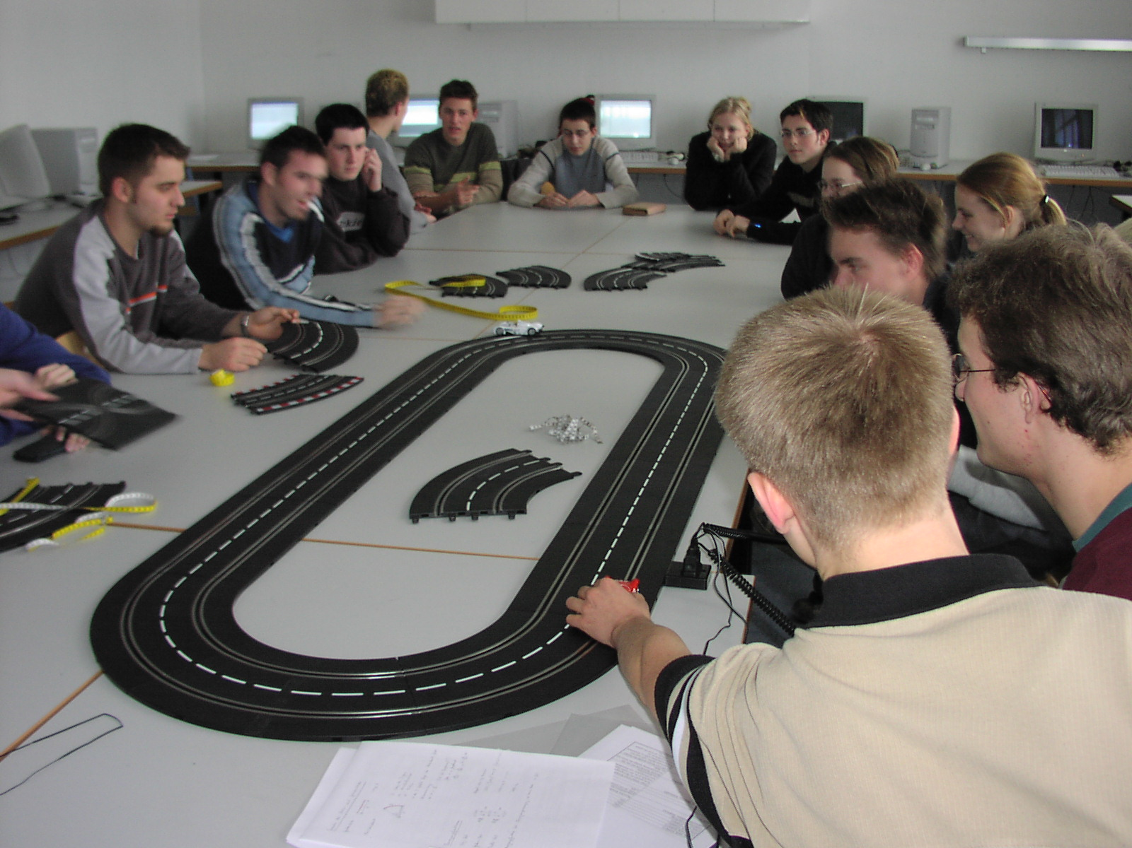

Figure 1: Carrera® toy course

The necessary knowledge in physics in order to set up motion functions taking into account reasonable restrictions comprises the following concepts:
- Description of a one-dimensional motion as a distance-vs-time function s(t).
- Relationship between distance, velocity and acceleration-vs-time functions:
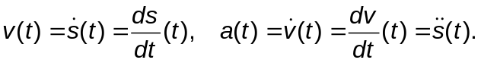
- For a simple constant acceleration scheme the respective formulae are:
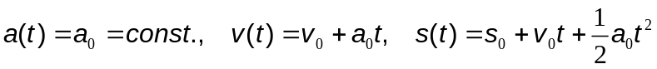
with initial values 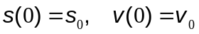.
This means in particular that when acceleration is 0, then velocity is constant.

The necessary knowledge in mathematics to describe the course and set up motion functions is strongly linked to the physics knowledge and comprises the following topics:
- Geometry of line and arc segments: for a straight line, the only characterising quantity is its length; for arc segments, there are three interesting quantities: arc length l, angle α, and radius r; each two of these quantities determine the third one according to the equation 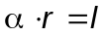, where α is given in radians. So pupils should know how to switch between degrees (α) and radians (b) according to 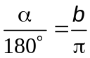.
- For constructing arbitrary courses consisting of line and arc segments learners should have knowledge on geometric constructions like bisection of angles and construction of orthogonal lines through points. The latter is to be used for finding pieces to close a course (an example is given in section 4.1).
- The concept of function should be known as well as a certain set of example classes; if restricted to the case of constant acceleration, linear, quadratic and square root functions (for interpreting v as a function of s) are sufficient.
- As to properties of functions, continuity and slope are needed. Moreover, in order to understand the physical model, pupils should at least know about differentiation. Integration as “inverse” operation is only needed when one works with more complicated acceleration schemes (not just constant).
- If one starts constructing a v(s) function, then the topic of differential equations might show up when one wants to compute s(t) from v(s) (although one can give a solution simply as an integral).
The term “knowledge” here denotes “basic knowledge” which is a bit vague and hence problematic. This will be made clearer when discussing the learning opportunities of the microworld in sections 4 and 5. There, we will describe in what respect work within the microworld leads to more advanced or “deeper” knowledge of the mathematical concepts listed above.

3. Characteristics of the Student Group and Organisational Aspects

We used the microworld with 16 high school pupils participating in a special programme called „Pupil-Engineering-Academy” (German: “Schüler-Ingenieur-Akademie”, SIA, www.sia-online.de ). This programme aims at introducing pupils to the daily work of engineers and comprises topics in mechanical and electrical engineering as well as information technology. It is organized by participating schools, universities and companies where pupils meet once a week to get information on principle engineering tasks and perform simple tasks like CAD constructions or design of electrical circuits on their own, often using simulation programs.
Pupils apply for participation in the programme which is acknowledged as a regular part of their high school curriculum. The programme has a duration of two years, and the pupils taking part in it are in grade 11 or 12 (of 13). Since they are not forced to do so, they have a special interest in solving practical problems (not necessarily in purely mathematical reasoning). Hence, one cannot assume that this group is representative for all high school students.
The pupils know the mathematical and the physical prerequisites stated in the previous section. They learn about functions, classes of functions, continuity and differentiation in grade 11, and motion with constant velocity or acceleration in one direction is treated in grades 10 and 11. They have not dealt with motion on curved tracks, and they are not familiar with Computer Algebra Systems.
Work in the microworld was performed in the first half of the second year of the programme, i.e. with pupils in grade 12. The main goal within the SIA programme was to introduce them to the important engineering task of motion design which comes up e.g. in robotics. The engineering task consists of designing the motion curve as well as the motion function and poses hence both geometric and kinematic problems.
In order to prepare the pupils to use Maple® the first author gave two lessons on CAS and Maple® in particular. Since pupils were familiar with using the computer when working with simulation programs in other SIA projects, they learned CAS capabilities, commands and syntax rather quickly. Using the available help commands supported them in overcoming initial difficulties and getting deeper into the CAS functionality. The contents of these sessions included essentially two topics:
- Basic data structures and assignments to variables in Maple (e.g. a:=x^2; or valuelist:=[1,2,3]); definition of functions, in particular piecewise defined functions, plotting functions, and differentiation and – as an “inverse” operation – integration of functions.
- Setting up functions for modelling motion with (piecewise) constant velocity or with (piecewise) constant acceleration.
After these sessions the pupils were able to work with the small set of data structures and Maple® commands used in the microworld. In the third session, the objects and operations for setting up a racing course in the microworld were introduced (see section 4.1) reactivating previous knowledge from grade 10 on geometrical quantities necessary to describe circle arcs. The pupils then measured the pieces of the toy course and reconstructed the course in the microworld.
In the fourth session the pupils were introduced to the motion modelling part of the microworld (see section 5.1). Setting up functions without taking into account restrictions is rather meaningless, so realistic restrictions on velocity and acceleration were discussed. Most of the session was dedicated to determining data for these restrictions. Pupils took measurements in order to get approximative values e.g. for the maximum value of velocity on certain parts of the course. Designing and performing the experiments for getting this data or computing it from experimental results was the main activity in this session.
During the two remaining sessions pupils then set up and experimented with motion functions using the operations available in the microworld. They finally used the real toy course to check whether model and reality provided similar results.
Each session took about 2.5 hours and we met once a week. The pupils were coached by the authors who gave hints when they got stuck. In the next sections we report on our observations. We did not capture all learning paths this way and the final worksheets do not necessarily contain all the interesting difficulties and misconceptions of the pupils. For capturing the learning process more comprehensively, a logging facility is needed.

4. Course Construction in the Microworld

4.1 Offerings
Table 1 lists the objects and operations available for constructing a course in the CAS Maple® (we have a German and an English version which was simply produced by aliasing operation names).

Course definition and construction | Commentary / Example
course_piece:=[length, radius, orientation]; | c1:=[3,5,`-`]; circle arc of length 3, radius 5, clockwise orientation; s1:=[3,infinity,`+`]; line segment of length 3 (`+` has no meaning here)
course_data:=[piece1,piece2,...,piecen]; | course_data:= [[3,infinity,`+`],[3,5, `-`]]; or: course_data:=[s1,c1];
course:=construct_course(course_data); | constructs a course for later plot
complete_coursedata:=  complete_course(course_data); | computes pieces for closing course
length:=compute_length(course_data); | computes course length
plot(course); | plots the course
Table 1: Additional objects and operations for course construction

A piece or part of the course can be represented as a list data structure comprising the length, the radius and the orientation when connected to another piece. An arc segment as such can be connected in two different ways, as a left or right curve. For line segments, the first entry characterises the piece; the radius entry must be “infinity” and the orientation can be arbitrary.
A course now can simply be set up as a list of pieces. In order to later plot the course, to check fulfilment of restrictions and to animate motion functions, the course is constructed as a piecewise-defined curve in parameter representation with arc length parameterisation. This is quite tedious when done piece by piece, so the operation construct_course does it automatically. One can look into the data structure produced by the procedure but this is only adequate if there are just one or two pieces. In order to check whether or not the anticipated (part of the) course was constructed, the plot operation provides visual feedback. For computing the length of the course, the operation compute_length is made available which only sums up the lengths of all parts.
When a course is constructed using parts of arbitrary length and radius (not just a fixed set of part types), the problem of course completion comes up. In order to help in course completion, the operation complete_course can be used which produces two or three additional connecting pieces.

Basic learning opportunities and tasks

The course pieces available in the microworld are data representations of real or imagined geometrical objects. Before introducing this kind of microworld object, a discussion on what characterises such a piece is important such that “horizontal mathematisation” (Drijvers, 2000) is not simply provided but performed by the pupils. The data structure used in the microworld then simply is a container for this characteristic information. Doing measurements or finding data elsewhere (e.g. on the internet) would be the first task to set up realistic pieces. Pieces should have a name such that they can be referenced by this name when constructing a course.
There are mainly two kinds of tasks to be performed in course construction:
- Re-construct an existing course (be it a toy or a real but idealised Formula 1 course). For a toy course, pupils should set up a fixed set of piece types and work with those.
- Free construction of a course given just by some properties or by a rough sketch. This again can be done with a fixed set of pieces (modelling the toy course situation) or with “free” design. When using the pieces pupils have to link their geometric imagination to the data characterising a piece. If there is a mismatch, the visual feedback from the plot shows this. The data items “length” and “radius” for an arc segment allow for a uniform data structure for line and arc segments but this can lead to problems when pupils rather think in terms of “angle” and “radius”. On the other hand, forcing them to set up a formula to switch between “angle/radius” and “length/radius” strengthens the image of different but equivalent data representations. Moreover, it gives reason to make rough estimates on radius and length enhancing the connection between shape and measures in geometry.
Free construction almost automatically leads to interesting geometric questions. If a course is constructed from a set of existing piece types then the question turns up whether or not it is possible to close the course and by which design principles closure can be guaranteed. For this one can also investigate properties of closed courses like “The sum of (signed) angles of all pieces is a multiple of 360°”.
If piece design is free, any course can be closed using line and arc segments. Here, the task of constructing pieces to close a course arises as well as the question of how many pieces are needed. A simple construction is shown in Figure 2 which was produced with the Dynamic Geometry System (DGS) Cinderella®. For a certain configuration (first piece BA, last piece DC, intermediate pieces not shown) a line and an arc segment are constructed using angle bisection and orthogonal lines which could also be done by pupils having the necessary prerequisites. The needed data could then be retrieved from the DGS as depicted in the figure. Having a DGS available would also allow to show that the construction in figure 2 is not always successful: Moving point C can produce a construction containing a cusp. This gives insight in the restricted validity of geometric construction rules.

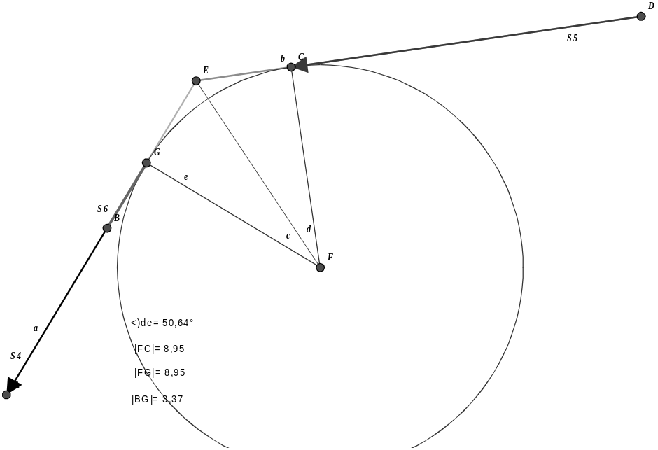
Figure 2: Closing a course
4.2 Real Usage

Identification and measurement of important data
The data needed for setting up the model of the course depicted in figure 1 within the microworld is twofold. For line segments, the only datum needed is length. For arc segments, radius and arclength must be found. Moreover, pupils had to decide whether to model the inner or outer course. Tape measures and rulers served as measurement instruments.
The measurement of line length is obvious but finding out about arc segment data revealed interesting differences:
- Some pupils put the piece on paper, drew radial lines using a ruler, measured the radius, and then measured arc length using the flexible tape. (Figure 3a); as a variation of this method, some students used line segments to form radial lines (Figure 3b).
- Other pupils did not measure arc length but used information on the angle (60° or 45°) of a piece to compute arc length. This provides more useful information for later course construction since it guarantees that the course is closed.
- One group put together 60°-pieces to form a circle and the measured the diameter. This gives more precise results and facilitates taking measurements compared to the other methods. (Figure 3c).

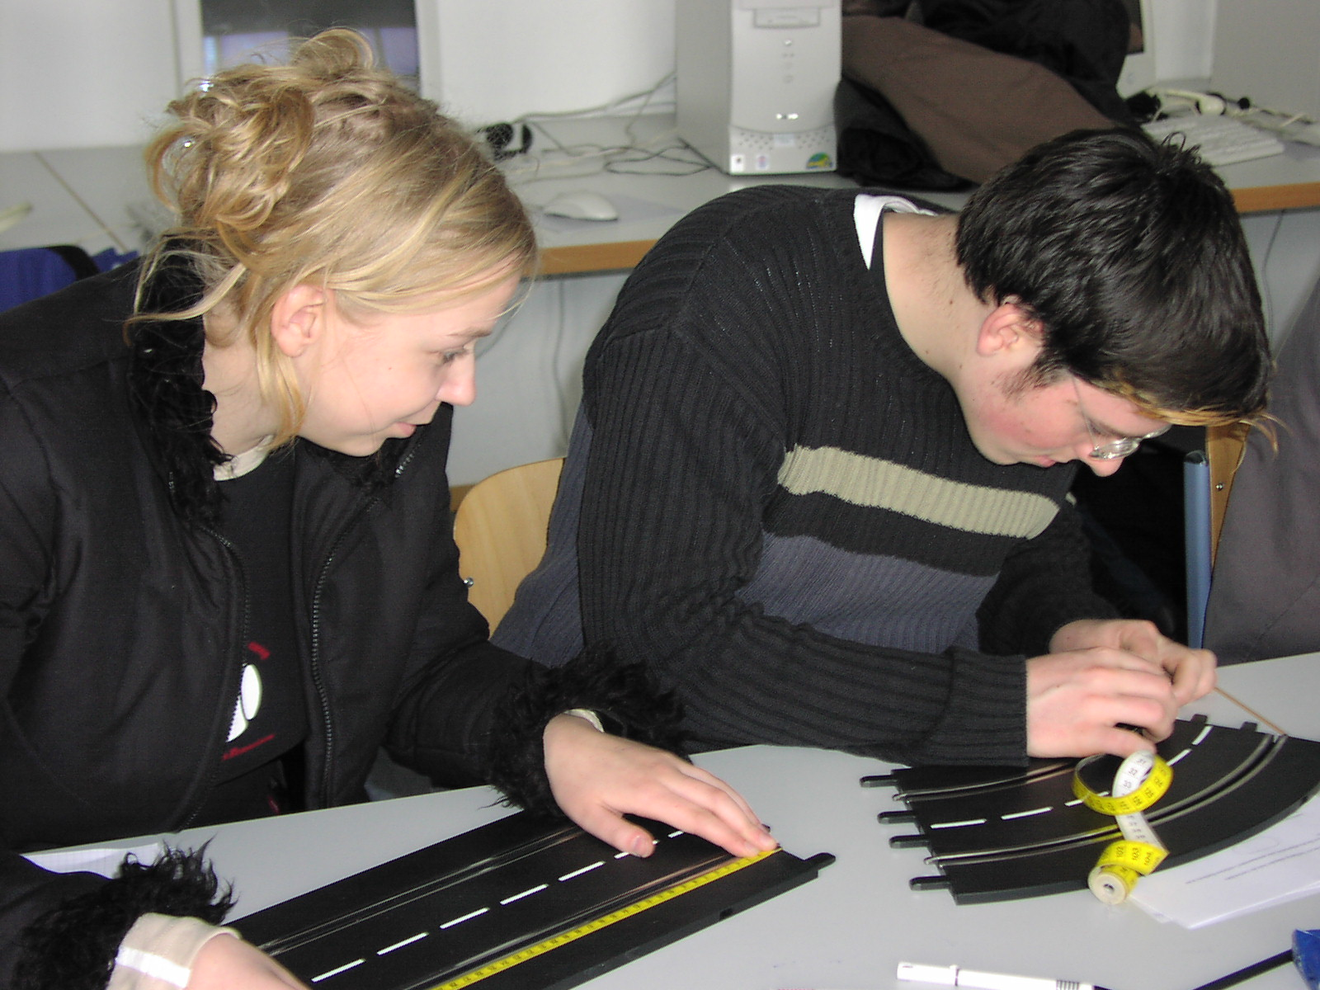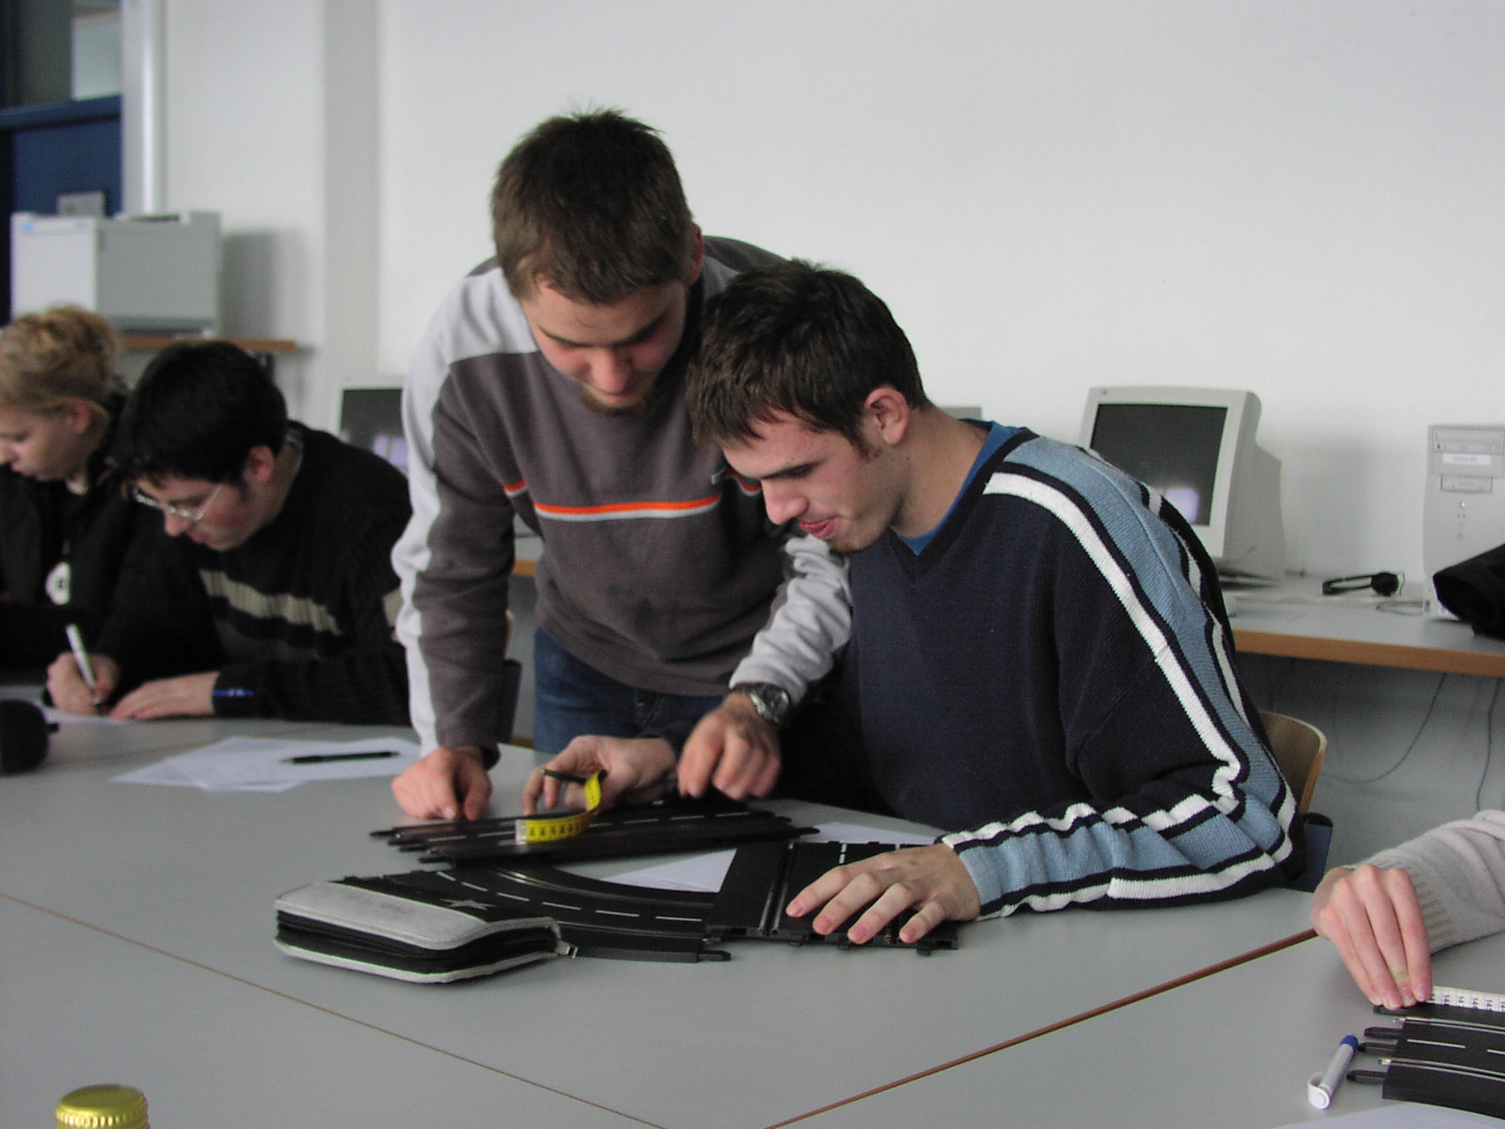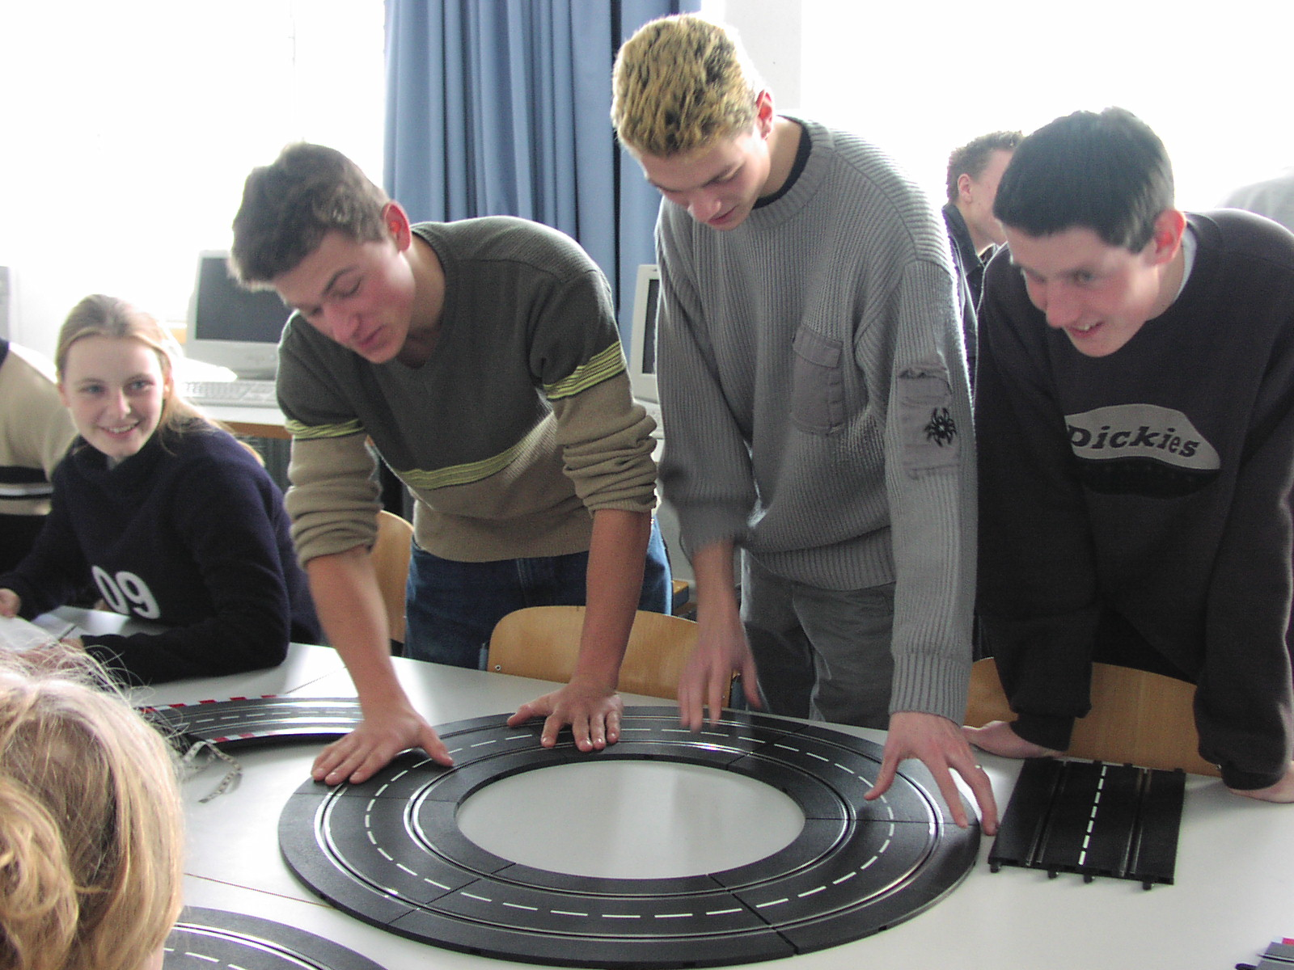

Figure 3 (a) Flexible tape; (b) Radial lines; (c) Circle construction

The different approaches show that there is not just one way to proceed as is often assumed by pupils with respect to mathematics.
After collecting the data from different measurements average values were used for modelling but it was made sure that the arc pieces had the correct degree in order to guarantee closure.

Definition of parts
When defining the parts in the microworld, we observed two approaches shown below (Note that here and in other examples drawn from the worksheets produced by the pupils we made some changes (usage of English words, usage of equal variable names etc.) to make them easy to read and to compare; this does not change the essential content of pupils’ worksheets).

Group 1:
> g:=[34.5,infinity,`+`];
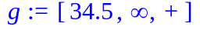
> curve_left:=[36.65, 35,`+`];
> course_data:=[g,g,g,g,g,g,g,g,curve_left,curve_left, curve_left,g,g,g,g,g,g,g,g,curve_left,curve_left, curve_left];
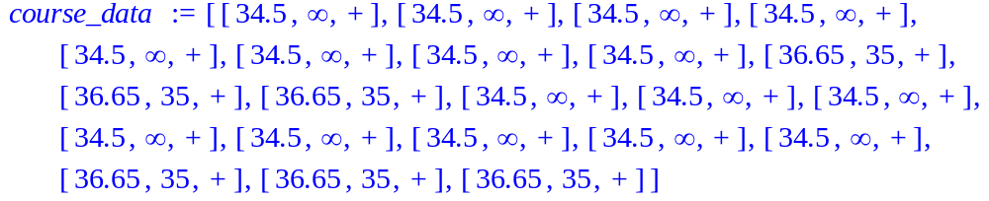

Group 2:
> g:=[8*34.5,infinity,`+`];
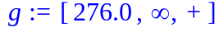
> curve_left:=[35*Pi/3, 35,`+`];
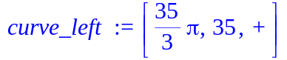
> course_data:=[g,curve_left,curve_left, curve_left,g,curve_left,curve_left, curve_left];
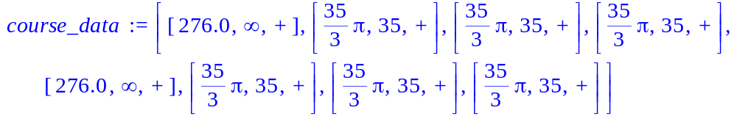

Whereas group 1 set up data structures for the single physical pieces which makes course definition more tedious, group 2 set up an “artificial” long line segment consisting of eight pieces. This act of abstraction did not seem to be self-evident since this group asked us whether it was an “allowed” procedure.

Definition of course and feedback (errors, fixes, learning events)
What is shown above is the final result of course. We do not know all the ways in which pupils came to this result (a logging facility would be desirable here, such that protocols can be analysed as suggested by (Weigand/Weller, 2001)). So, we just mention those problems which we observed:
- Sometimes the course was not closed properly with pupils using their own measured values; this gave reason to discuss problems with measuring precision (or wrong calculation with angle and arc length)
- Some pupils did not see that there are only left curves. Maybe they thought that in order to get back to the beginning the three `+`-curve pieces had to be “reversed” by three `-`-curve pieces. The visual feedback helped to remove this error.
- Sometimes there were simple counting errors in the course data structure which were found and removed after getting the curve plot.
Finally, all pupils were able to use the visual feedback for getting a correct course which is depicted in the plot below. They then computed the course length using the respective operation.

> course:=construct_course(course_data):
> plot(course);
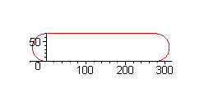
> course_length:=evalf(compute_length(course_data));
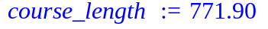

Some of the pupils found time to construct more interesting courses using “free” pieces which gave rise to the course closure problem and other problems concerning the relationship between arc length and radius. So, the microworld offers room for pupils to proceed to more difficult situations according to individual capabilities.
One very bright pupil asked a question on the mathematics behind course construction: Having in mind that a function can take only one value per argument, he recognized that real-valued functions cannot simply be used for modelling courses which also “go back”. This was a nice starting point for going into the topic of parameter representation of curves.

Choice of further opportunities
Some further questions and topics which could be discussed in this environment are listed below:
- One could have a look inside the length procedure to see how computation is done. This is very easy since the length values of all the pieces are simply summed up. If pupils have already experience with programming (as was the case in our trial, see section 3), this is feasible.
- One could look at the course description with parameter representation starting with just one piece.
- One could discuss the question which courses could be constructed with a certain set of pieces.

5. Motion Construction in the Microworld

5.1 Offerings

Table 2 lists the objects and operations available for constructing functions modelling restrictions and for transforming, investigating, and animating motion-related functions in the CAS Maple®.
In order to construct meaningful motion functions, restrictions must be taken into account. Velocity restrictions refering to certain sections of the course can be specified using the construct_restriction operation which takes as input the course data and a maximum velocity list with one entry per course piece. This can be used immediately for plotting the maximum velocity vs. distance function and also later to check for conformance to restrictions.

Restrictions
restriction:= construct_restriction(course_data, max_value_list); | max_value_list:=  [10,20,infinity,10,infinity,20];
plot(restriction,s=a..b); | shows v(s)-diagram for restrictions

Motion functions
Transformation procedures:
voft2vofs(v) ; | Input and output are functions
voft2soft(v); | dito.
vofs2soft(v); | dito.
soft2vofs(s) ; | dito.
aofs2soft(a); | dito.
Investigation of functions
lap_time(course_data, function); | computes lap time for a certain motion function

Animation
animate_motion(course, function, number_of_frames); | shows motion of a circle on the course according to motion func.;
animate_motion_with_restriction(course, function,  restriction, number_of_frames); | if velocity restrictions are not fulfilled, circle „jumps“ out of course
compare_motions(course, function1,  function2, n..m, number_of_frames); | two circles run simultaneously on the course from piece n to m.
Table 2: Additional objects and operations for motion functions

Functions prescribing motion can be set up using the already available Maple® syntax for this purpose. It is particularly useful here that functions can be defined piecewise. As mentioned above, there is a variety of possibilities to prescribe motion: For example, the independent variable can be time or distance (t or s), the dependent variable can be distance, velocity, or acceleration (s, v, or a). If one chooses one of these possibilities (e.g. v(t) below), there is often the problem that restrictions cannot be checked easily. If, for example, a velocity vs. time function has been set up, it is not possible to check velocity restrictions which refer to course sections (i.e. distance). For facilitating such checks, we offer transformation procedures, e.g. voft2vofs(v) which takes as input a v(t)-function and outputs the corresponding v(s) function. The latter can then be plotted together with the restriction in order to check for violation (see below). As in real Formula 1 (at least for qualifying), lap times serve as quality criterion for motion functions. We offer an operation for computing such lap times for a given course and motion function s(t).
For visual feedback, there are motion animation operations. They provide animations where a small circle representing the car moves along the course. If restrictions are taken into account, the circle leaves the course and stops if a velocity restriction is violated. Moreover, in order to visually compare different motion functions (where is one better than the other?) two circles can run simultaneously on a certain section of the course.

Basic learning opportunities and tasks

The basic task for a student consists of setting up a motion model and experimenting with it. This resembles the work of an engineer using a simulation program for designing and optimising motion. For doing this in a meaningful way, pupils have to first think about realistic restrictions and how to get data for these (by measurements or data search). They then have to decide on the kind of motion function they use for design. Based on their experience, pupils can apply, for example, a v(t) approach (having in mind a look at the speedometer), or an a(t) approach (having in mind the acceleration and brake pedals), or a v(s) approach (having in mind the restrictions depending on distance).
Since many realistic restrictions are defined for certain course pieces, it is quite natural to work with piecewise-defined functions. The pieces can and should be quite simple at first (e.g. linear ones). When combining function pieces, questions on continuity come up immediately. Pupils can visually “check” continuity by plotting the function graph. Moreover, pupils have to think about varying functions in order to achieve a certain behaviour, i.e. in the end: to improve the lap time. We will give an example for a variation process in the next sub-section. In such a process pupils identify by which parameters they can vary the function under consideration. This can lead to defining Maple variables for such parameters in order to facilitate experimentation.
Regardless of what is used as a modeling function at the beginning, there is always some sort of mismatch between this function and the representation of restrictions or quality criteria: If, e.g., the learner constructs a v(t) function, he/she cannot check immediately whether velocity restrictions are satisfied because the latter are specified for course pieces (i.e. depending on s), not for certain time intervals. If, on the other hand, the learner constructs a v(s) function, he/she cannot simply read off the lap time. From a didactical point of view, these mismatches are highly desirable because they foster discussion and thinking about functional relationships. Pupils can investigate these relationships in a simple example by hand (constant acceleration) and recognise that variables like time and distance can take on different roles (s(t): s dependent; v(s): s independent). For more complicated functions like piecewise functions with several pieces they can then make use of the transformation procedures provided.
Learners use the visual feedback to check correctness of functions (continuity) and satisfaction of restriction. They also see where there is potential for improvement when the function is well below the upper limit given by a restriction. This as well as comparison between lap time results of different pupils serve as an incentive to experiment with functions. When doing so, pupils should interpret functional properties in terms of application features; for example, interconnection points of pieces of functions should be interpreted as brake-times or end-of-brake-times. This way, functions are understood not simply as piecewise defined expressions but as representations of real situations. Moreover, investigating and comparing properties of functions like lap times emphasises their object character.
If one wants to avoid the v(t)->v(s) transformation one can use the animation to check velocity restrictions. The animation procedure also allows to show traces of circles (with constant time intervals) where closeness of circles corresponds to slow motion and larger distances between circles mean high velocity. This could also provide another representation of velocity. Moreover, comparison of two motion functions can foster discussion between pupils or groups of pupils on where and why one function is better than the other.

5.2 Real Usage

Identification and measurement of important data
The most important data restricting motion design for the toy course were identifed in a discussion phase: the maximum velocity of the car on the long line segment as well as on the curve segment, and the maximum and minimum acceleration of the toy car. For finding this data, an instrument for approximative measurement of instant velocity was used which was constructed by one of the pupils in a previous SIA project. It measures the duration of interruption of a light beam, and this can be done at two places such that it is also possible to measure average velocity.
The following measurement scenarios were thought up and realized by pupils:
- for maximum velocity: measure instant velocity at the end of the long straight line (this was not the maximum velocity of the car but the maximum velocity possible on the course);
- maximum velocity in curve: measure average velocity in the curve by taking time from the beginning to the end of the curve when driving “at the limit”;
- maximum acceleration: start at the beginning of a long straight line with velocity 0, give full power (acceleration) and measure velocity at the end of the line; use simple model of constant acceleration to compute this from distance and velocity;
- maximum negative acceleration: drive through a curve, measure the velocity at the beginning of the following line segment and do not apply any force; because of friction, the car stops very soon; measure the distance and compute the negative acceleration assuming that this is constant.
For all of the above, several measurements were made. Variation of results gives the pupils a sense of the uncertainty of the measurement procedure and of the model. The following results were obtained:

vmax | vmax_curve | amax | amin
500 cm/s | 236 cm/s | 365.15 cm/s^2 | - 420.7 cm/s^2

Having in mind the speedometer of a car, pupils decided to construct a v(t) function for designing the desired car motion. They worked with a simple model where acceleration is either maximum (positive or negative) or zero.

Construction of the first part of the velocity function
In the examples given below we use the course construction that works with “virtual” long line segments (see group 2 in section 4.2). The pupils first set up the list containing maximum velocities wrt. course segments and then constructed the restriction (which is a piecewise defined expression that can be plotted where the plot range is determined by the course length computed earlier):
> max_value_list:=[500,236,236,236,500,236,236,236];
> restriction:=construct_restriction(course_data,max_value_list);
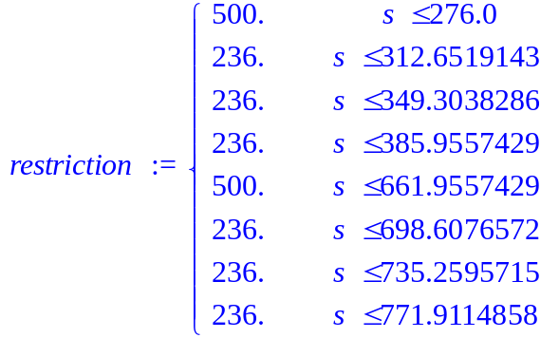

> plot(restriction,s=0..course_length);
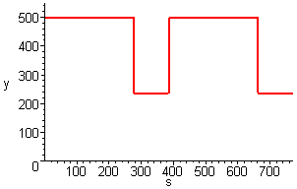

We asked the pupils how the first part of the velocity function would look like, starting at the beginning of a long line segment with v=0, then driving on the long line segment and through the first curve. Thinking in application terms (making the simplifying assumptions stated above), the pupils came quickly to the motion model: full acceleration for a certain period of time, then (before entering the curve) full negative acceleration such that the car slows down to the maximum velocity for the curve which is then held constant by having zero acceleration. Later in the function construction process one pupil asked about speeding up in the second part of the curve since this was his experience from driving a car on a somewhat “ideal line”. This led to discussion of the simplification in the model where the course is a curve with no breadth.

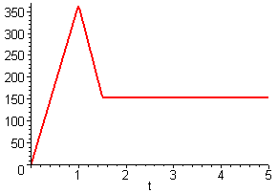
Figure 4: Zigzag function

The pupils recognised that the simple acceleration scheme results in a zigzag function for velocity over time as is shown in figure 4 since piecewise constant acceleration means piecewise linear velocity. This family of zigzag functions with its possible variations then was the object of investigation. The slopes of the linear pieces are fixed by maximum and minimum acceleration but the time values where pieces are connected are variable. So in fact we have a function family of zigzag functions with two parameters at this stage. Pupils interpreted function properties quite naturally in application terms talking about brake time, end-of-brake or time “when entering the curve”.
In a first approach pupils chose special values for the brake and end-of-brake times from experience (driving on the toy course) and set up a function using Maple’s piecewise command (containing a sequence: partial domain, expression, partial domain, expression, …) like the following one:
> v:=t->piecewise(t<=1, 365.15*t, t<=1.5, -420.7*t + 420.7
+ 365.15, t<=5, -420.7*1.5 + 420.7 + 365.15);
Plotting the function served as a feedback to check whether they really specified what they wanted. Often, this was not the case in the first try but rather pupils got a plot of a discontinuous function similar to the one below:
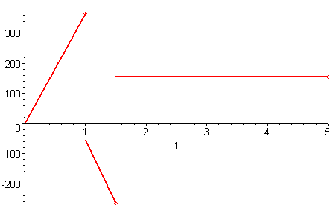
This revealed misunderstandings concerning the parameters in a linear function. For example, some pupils simply tried t<=1.5, -420.7*t + 365.15 for the second part. This fostered much discussion between group members and the plot always served to check hypotheses and suggestions. Some pupils worked with the m*x+b form of a linear expression, others used the point-slope-form m*(x-x0)+y0. Beside thinking systematically about the correct value of the v-intercept, one group also tried to fit pieces together by successively adapting the v-intercept until the plot was “visually continuous” but not precisely. This led to an error in a transformation procedure used later which showed that because of resolution effects plots can be deceiving. Another problem concerning the working style is due to the temptation to rather look at a successful neighbour than think oneself to get things done quickly. Prefering quick success to deep thinking may as well be a general cultural problem.
Once a continuous zigzag function had been set up, a comparison with restrictions was necessary. For this, pupils used the transformation operation voft2vofs in order to get velocity over distance. Then, a common plot of both this function and the restriction function as is shown below gives rise to a discussion on satisfaction of restrictions and how to vary the function in order to get a feasible or improved result. So, this plot is the central source of feedback for experimentation. On the one hand, the v(s) plot must be below or equal to the restriction plot, on the other hand should it not be completely below in order to work “at the limit” given by the restrictions.

> vofs:=voft2vofs(v);

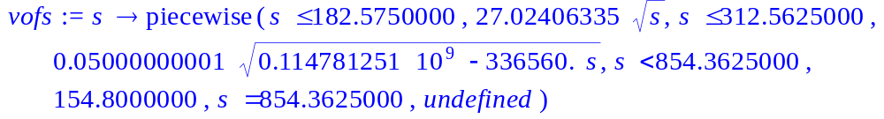
> plot({vofs(s),restriction},s=0..course_length);

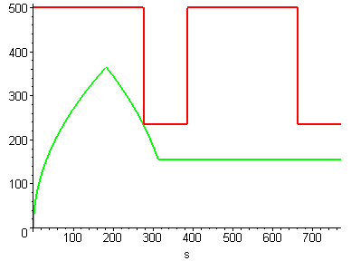
Figure 5: Comparative plot over distance

One can see that square root functions show up as was clear from the former discussion of the simple case 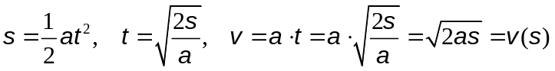 . There are essentially three situations appearing: the function is feasible but there is potential for optimisation (as in figure 5); the brake time is too late; or the end of brake is too early; the latter are depicted below in figure 6.

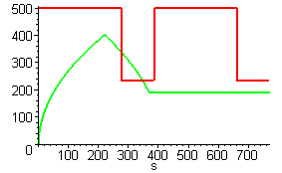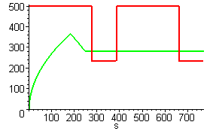
Figure 6: Brake too late, end-of-brake too early

In any case, it is necessary or desirable to change the function but not the principle shape, i.e. the function family. This can be done by changing the respective numerical values in the piecewise defined function but performing variation this way is both tedious and error-prone: Pupils have to check where the values for the quantities to be varied occur. The brake and end-of-brake times (in the following: t1 resp. t2) not only show up in the partial domain specifications (t<=t1, … , t<=t2, …) but also within the expressions for the partial domains. This is explicit in the function specification given above to make things clearer but pupils tend to simplify the expressions and input the following which makes variation much more tedious since the quantities to be varied are “buried in numbers”:
> v:=t->piecewise(t<=1, 365.15*t, t<=1.5, -420.7*t + 785.85
, t<=5, 154.8);
The didactical advantage of this situation is that it lends itself to symbolisation, i.e. to the introduction of symbols for t1 and t2 which can then be set separately. A first step in this direction would be to write the definition of v with real numbers but in a way that the values for t1 and t2 show up explicitely (pupils could be advised to do so):
> v:=t->piecewise(t<=1, 365.15*t, t<=1.5, -420.7*t + 420.7*1
+ 365.15*1, t<=5, -420.7*1.5 + 420.7*1 + 365.15*1);
The next step then consists of replacing the numerical value by a symbol which can be set separately. Since acceleration values also occur more frequently in the expressions, it makes also sense to use symbols for these quantities.
All groups defined maximum and minimum acceleration as variable. Three groups ended up with the first step mentioned above, i.e. made explicit where t1 and t2 occur and hence have to be changed. We did not push them further since they achieved “satisfying” results this way. Two other single pupils went beyond that and introduced variables for the respective times. We present the Maple commands for both approaches slightly abbreviated (the code from the final worksheets we saved already contains the specification for the whole course, i.e. some more pieces):

Approach 1: Making numerical values for times explicit
> amax:=365.15: amin:=-420.7:
> v:=t->piecewise(t<=1, amax*t, t<=1.305, amin*(t-1)+amax,
t<=5, amin*(1.305-1)+amax) ;

Approach 2: Setting up variables for times
> ap:=356.15;
> an:=-420.7;
> t1:=1.004;
> t2:=1.29;
> t3:=5;
> v:=t->piecewise(t<=t1, ap*t, t<=t2, an*(t-t1)+ap*t1,
t<=t3, an*(t2-t1)+ap*t1);

Using these approaches and the feedback from the common plot of v(s) and the restriction function, pupils ended up with an “optically” satisfying result as is shown in figure 7 below. Having achieved this, none of them felt the need to proceed further to modeling and computing the optimum. We will discuss this point below when outlining further learning opportunities.
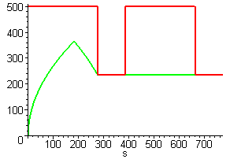
Figure 7: “Optically satisfying” function

Construction of further parts
Constructing the velocity function for the rest of the course (second long line segment and second curve) pupils proceeded similarly the only difference being that the “initial” velocity at the beginning of the second line segment is positive. They just had to compute the time for leaving the curve which they got from the time when entering the curve, the curve length and the velocity in the curve. All student groups were able to come to a satisfying result like the following one:

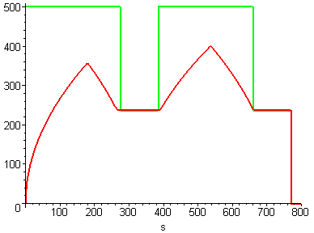
Figure 8: Near optimal velocity function

They computed lap times (first transforming v(t) into s(t) using the respective procedure and then applying the compute_laptime operation) and used these times to compare results of different pupils/groups. The results of four groups were 3.119, 3.124, 3.106, 3.129 seconds (one group erroneously used a shorter course which was revealed by their much better lap time). When one group doubted the better results of another one, again the topic of plot resolution came up. Even if the plot looks like the one shown above, the restriction might be slightly violated. This can be checked by zooming into the plot (restricting the range to the intervall 220..250 or sometimes by simply enlarging the plot graphic) and this is again a good opportunity to discuss the validity of assertions based on a plot. One could also use the animation here to check whether the car (here: circle) really remains on the course. In our trial yet, the pupils used the animation (without restriction) just as a nice visualisation of motion and not for any feedback purposes.
The theoretical optimum for the course – given the simplistic model – is 3.1038 seconds. Here, a “relinking” with reality is possible by simply measuring the real lap times achieved by pupils. When driving the car, some pupils even tried to roughly realize their function model kinesthetically: full pressure of the button (full positive acceleration), no pressure at all (full negative acceleration), some intermediate position (zero acceleration) although the latter could only be a coarse approximation. The best lap time one of the pupils achieved was 3.25 seconds. It was astonishing how small the difference between computed time and measured time is despite the coarseness of the model. We expect differences to be larger when dealing with more complicated courses.

Choice of further learning opportunities
Some further questions and topics which could be discussed in this environment are listed below:
- Model exactly the equations for determining the optimal time for braking; for a larger course where many experimentation cycles would be necessary this topic would be more likely to come up. The modeling equations for the first part of the given course are for example the following ones (where s1=s(t1), s2=s(t2), s=length_of_line_segment, v1=v(t1), v2=v(t2)):
s1 + s2 = s; v1 = amax*t1; v2 = amin*(t2 - t1) +v1; s1 = ½*amax*t1² ;
s2 = (t2 – t1)*(v1 + v2)/2
Since v2=vmax_curve one has 5 equations for 5 unknowns.
This is again a didactically valuable modelling task still within reach given the capabilities of the pupils.
v2
v1
t
t1
t2

- Pupils could start with constructing v(s) but then parabolic arcs have to be combined.
- A slightly different and more complicated situation arises when the line segment of a course is so long that the car reaches its maximum velocity before braking; one could also construct courses with adjoining curve pieces to make the task a bit more challenging.
- In order to make the model more realistic one could work with continuous acceleration schemes (piecewise linear); this is for example done in real engineering work. One then has to restrict the rate of change for acceleration.

6. Discussion and Comparison with Other Results
We will restrict the discussion in this section to the second major mathematical aspect of the microworld, the treatment of functions. During the last two decades, a vast amount of didactical literature on functions and functional thinking appeared. In order to structure our discussion, we will relate our results to this literature by attempting to answer the following questions:

- Which aspects of the function concept and of functional thinking emerge when students work in the microworld?
- Does the work in the microworld lead to an improved understanding of these aspects and their relationsships?
- Does the work in the microworld reveal and help to remove well-known misconceptions concerning the function concept?
- In which ways does the situatedness provided by the microworld help to improve the understanding of aspects of the function concept?
- Does the use of CAS support or hinder the work (advantages/obstacles)?
- Where in the curriculum should work with the microworld be positioned?

When answering the above questions it is often only possible to state hypotheses to be investigated in further empirical research since we did not use pre- and posttests and a control group to gather statistical data. So, the hypothetical character of the statements given below should be kept in mind.

- Which aspects of the function concept and of functional thinking emerge when students work in the microworld?

The function concept and „functional thinking“ have been the topic of intensive research (e.g. Harel/Dubinsky, 1992; Müller-Philipp, 1994). In order to relate the microworld to this research, we use the comprehensive and detailed model set up by (DeMarois/Tall, 1996; DeMarois/Tall, 1999) which contains the process and object character of a function widely discussed in (Harel/Dubinsky, 1992) as well as the “breadth and depth” dimensions of (Schwingendorf et al., 1992). We briefly recall this model.
The model has two “dimensions”, called facets and layers. Facets “of a mathematical entity refer to various ways of thinking about it and communicating to others” (DeMarois/Tall, 1996). These include the well-known numeric, symbolic and graphical representations but also verbal, written, notational or kinesthetic aspects. The layers, on the other hand, model depth of understanding, starting from an action or procedural understanding, advancing to a process concept and further to an object concept, ending at a “procept” understanding where students are able to flexibly change between viewing a function as a process and as an object according to the needs of the situation.
Since these layers are theoretical constructs, some explaining remarks are in order: On the action level, students can deal with functions only on a step-by-step calculation for specific values. They also have a “pointwise view” at the graphical facet where they are able to produce values if a value for the independent variable is given. When students have a more comprehensive view understanding functions as “something” which provides output given a “range” (mathematically: domain) of input values, independent of the concrete steps that might be used for computation, students have a “process” understanding of a function. This includes a global (over the whole domain) and dynamic view where varying the independent variable results in covariation of the dependent one. This covariation aspect has played a major role in the historical development of the function concept and is considered as one of the fundamental ideas of “functional thinking” (Vollrath, 1989). Dynamic or “across-time” aspects are investigated in depth by (Goldenberg et al., 1992) and (Monk, 1992). When a function is finally considered as an entity which has properties and can be operated upon, and which can also be input for “higher-level” processes, then a function is understood as an object of its own. Function families or – more general – function spaces can then be investigated.
Although this model is helpful to organize and interpret research, it should not lead to the illusion that simple classifications are possible. As (Harel/Dubinsky, 1992) and (DeMarois/Tall, 1996 and 1999) have shown, the “real picture” is far more complex: There is no clear-cut borderline between different layers of understanding and students might have reached different layers within the various facets of the function concept. Moreover, the connection between facets and the ability to switch between facets according to the needs of the problem under consideration further complicates the situation. Modelling these interconnections gives rise to “higher-order” functions as was pointed out by (Cuoco, 1994).
Which facets and layers of the function concept are addressed in the microworld? As will be treated in more detail in the answer to question (6) on curricular embedding, the microworld is not supposed to serve as an environment covering all aspects of learning the function concept. We think that it sheds light on mainly the symbolic/ notational and graphical facets and their linkage, and – to some extent – on the numerical and kinesthetic ones. We describe the occurrence of these facets and their interconnections in the microworld and the layers of understanding addressed:
- Symbolic/notational facet: As can be expected when working within a symbolic algebra environment, the symbolic facet plays a major role. Functions have to be defined symbolically for further processing and investigation. For this, piecewise defined functions have to be constructed. Since there is not a single sequence of steps to compute function values and since the function is constructed considering the across-time behavior for time intervals, the process character of a function is emphasised. This is also enhanced by the notation to be used in Maple® for function definition, in particular for piecewise defined functions:
f:=t -> piecewise( t<=t1, expression1,…);
This suggests an image of running with t up to t1 getting values using expression1 etc., i.e. the dynamic aspect dominates as opposed to a static pointwise view. The definition provides output from input but not by simply “plugging in” values; interval analysis comes first.
Naming the function and thus making it possible to refer to it emphasises the object character of a function as was already stated by (Weigand/Weller, 2001). Moreover, functions in the microworld have properties/attributes and can be operated upon: attributes are for example special points like brake points or overall properties like lap time. The latter is computed by using the respective operation which is essentially a “higher-order” function from the space of motion functions into the positive reals. Other higher-order functions are the transformation operations which map functions onto functions. So, the microworld provides an environment where the object character of functions is prominent. As (Thompson, 1994) states: “one hallmark of a student’s object conception of functions is her ability to reason about operations on sets of functions”.
Work in the microworld requires switching between setting up and modifying functions using interval analysis of motions (process view) and investigation of properties using operations on functions (object view). Hence, the dual character is to be exploited to come to results, i.e. a “procept” understanding is necessary.
- Graphical facet: The graphical facet of functions appears right from the start when pupils think about how to construct a velocity function and come to a zig-zag-shaped qualitative function graph. Once functions have been constructed symbolically, function plots are used for graphical investigation. Such plots are interpreted as describing behavior across-time hence emphasising the process character of a function. This is also the case when the function is finally animated and the change of position across time is shown.
The global view of the graph comes up when thinking about its principle shape. There are no graphical operations in our microworld whereas for example in the “SimCalc” microworld it is possible to operate on velocity function graphically (Roschelle et al, 2000). So, the object character is less clear than in the symbolic facet.
- Linkage of symbolic and graphical facets: Reasonable work in the microworld requires frequent switching between symbolic and graphical facets. When using the microworld as described in the previous section, work starts with a qualitative sketch of the zigzag function which is constructed from situative reasoning. This is similar to the work of (Monk, 1992) where pupils move from a physical model (of a sliding ladder) to the qualitative graphical representation of the motion of special points. But in the microworld, the qualitative function must then be represented symbolically for further investigation. In the definition of the piecewise function, continuity and linear expressions are important topics. One then goes back to the graphical facet for checking whether the symbolic definition is correct. When problems come up, the incorrect feature of the graph has to be linked to the “responsible” part in the symbolic facet.
Once a correct zigzag function has been set up, the graphical comparison of the constructed function and the restriction function must again be interpreted in symbolic form: What does it mean symbolically to shift e.g. the time of brake to the left or to the right?
(Eisenberg, 1992, p.154) considers this linkage as very important: “One of the main components of having a well developed sense for functions is the ability to tie together their graphical and analytical representations”.
- Numerical facet: This facet plays only a minor role in the microworld so far. Single numerical function values are of interest when pupils start to construct the piecewise defined function and use function values at brake and end-of-brake times to set up a continuous piecewise linear function. Here, also a pointwise view of functions is required. (Even, 1998) already observed that such a view can be helpful for removing misunderstandings and oversimplifications and for checking correctness of assumptions. (Goldenberg et al., 1992) and (Thompson, 1994) state that watching the graph globally can have as a consequence that consciousness of points gets lost. As Thompson puts it: graphs become “pictorial objects sans points”. Therefore, looking for particular points can be valuable although in general a global view serves to deepen understanding.
Recognising where a certain value shows up in the piecewise function definition enables pupils to switch to the symbolic facet and set up a flexible environment for experimenting with different brake times.
The numerical facet will become more important when a link to a microprocessor controlling a real toy car has been established. The link will essentially consist of a download facility for a table of values. Reading this table “vertically” emphasises the dynamic aspect and hence the process concept. Moreover, questions on sampling rates for setting up such a numerical representation come up.
- Kinesthetic facet: This facet appears when learners try to “drive” the function they have constructed or rather the underlying acceleration function. This again emphasises variation across time and hence the process concept. (Challis, 2001) similarly worked with the kinesthetic facet when he asked students to “walk a function”, measured walking data and compared those with the given function.

- Does the work in the microworld lead to an improved understanding of these aspects and their relationships?

In answering question (1) we showed that the microworld comprises a rich set of aspects of the function concept. But there is still the question whether work in the microworld leads to realizing the potential incorporated therein. Often in literature, one can find the tacit assumption that such a rich environment together with adequate tasks for pupils really acts as a “catalyst” for learning the concept and move to higher levels of understanding. For example, (Schwingendorf et al., 1992) intend to “create situations … to foster … construction necessary for the understanding of mathematical concepts” when using the mathematical programming environment ISETL and the same holds for our microworld. Yet, the research of (Harel/Dubinsky, 1992), (DeMarois/Tall, 1996 and 1999), (Thompson, 1994) and (Weigand/Weller, 2001) shows that the real learning process is much more complex. In order to better understand what is really happening we first want to specify the tasks provided to pupils (what?) using the classification set up in (Leinhardt et al., 1990), and then have a closer look at how pupils worked on these tasks following the approach of (Weigand/Weller, 2001) who investigate “working styles” of pupils when using a CAS for solving problems. They use a tool which logs all pupil activities. We currently do not have such a tool but plan to integrate such a facility, so the subsequent statements are based on our personal observations when watching pupils’ use of the microworld.
(Leinhardt et al., 1990) distinguish between two types of “actions” when working with functions: “construction” and “interpretation”. Constructions can be graphical, symbolic or numeric (setting up a table of values). Whereas construction is a synthetic activity, interpretation of a given function or situation is an analytic one. These kinds of actions can be combined in “basic tasks” like “prediction”, “classification”, “translation” and “scaling” (see below).
In the microworld, constructive work plays a major role. As in the programming environment ISETL, construction of functions having certain properties is an essential part of the work. Starting from reasoning about the situation, construction is first graphically and qualitative (zigzag function); this already contains some classification work since the class of zigzag function is used for finding an adequate motion function. From the graphical function “sketch”, the symbolic expression is constructed which is called “translation” by (Leinhardt et al., 1990). This step in “mathematization” (see (Drijvers, 2000)) is followed by a classification if pupils make the brake and end-of-brake times variable. Interpretation occurs when pupils investigate the graphs they produce: In particular, the common graph of the velocity vs. distance function and the restriction function must be interpreted in order to see what needs to be done to make a function admissible or to optimise it. When satisfaction of restrictions or continuity of velocity functions cannot be checked graphically in the plot provided automatically by Maple®, students also have to perform a scaling task to have a closer look at the “critical” sections in order to avoid what (Leinhardt et al., 1990, p.19) call “graphical visual illusions”.
The research by (Weigand/Weller, 2001) aims at understanding better how students work on such tasks by investigating their “working style”, in particular which strategies they develop and how they react to computer feedback. In their empirical studies with grade 11 pupils they set up problem scenarios (modelling a curve in ski-jumping with two parabolic arcs; approximation of monthly air-temperature data with a sine function) and then had pupils use a CAS to construct modelling functions. Work on the ski-jump problem is somewhat similar to constructing piecewise defined velocity functions in the microworld: pupils have to find the correct pieces, “bundle” them in a piecewise function, use a plot as control mechanism, and then change the function. Weigand/Weller observed different working styles when pupils searched for the correct function: some pupils thought about the solution first before experimenting with functions, some set up functions immediately and reflected on reasons for failure during the change process while others performed a searching process without much reflection. By and large, those who failed to solve the problem were among the latter who simply applied a trial and error strategy without activating any related mathematical knowledge. (Vollrath,1986) made similar observations when investigating search strategies of younger children trying to discover functional dependencies using a tool for testing assumptions.
(Meissner/Müller-Philipp, 1992) call this type of learning “one-way-learning” and emphasise its value since it builds on a working style familiar to pupils: make a guess and find out how good the guess is. If an equation for a graph is required, guess one and test it by graphing; use graphical feedback to change the equation and learn this way relations between symbols in the equation and shape of the graph. It is assumed that a lot of examples and tries will lead to a better understanding of the relationships between symbols and graphical properties, and they support their claim by some empirical data. Weigand/Weller’s conclusion is twofold. On the one hand, they “were quite surprised to find so many solutions obtained by a search process. This shows that given a choice and the appropriate tool, students tend to move away from a formal or symbolic level towards a more graphically oriented level”. (p.99). On the other hand , there is a “danger of not moving beyond an experimental level”. (p.100) or even “’thoughtless’ actions” (p.108).
In our special group of pupils interested in engineering work, we could observe two kinds of search processes: the first search process aimed at getting a continuous zigzag function; when pieces did not fit together, some pupils thought about how the pieces had to be constructed to make them fit whereas others tried to get “visual” continuity (in the resolution of the plot) by simply adding constants to pieces thus lifting them. The second search process was needed to make the velocity function satisfy the restrictions in an “optimal” way. For this, the brake times t1 and t2 were changed. This was done systematically since the pupils understood the effect of moving back and forth these time parameters. Therefore, we did not observe the problems reported in (Weigand/Weller, 2001) concerning the air-temperature task where pupils had difficulties to meaningfully experiment with the parameters in a sine function in order to fit to given data. Our pupils ended up with a visually satisfying solution but as in the experiment of Weigand/Weller, zooming is required to recognise small differences such as violations of restrictions, and this should be suggested by the teacher. Another striking similarity between the results of Weigand/Weller and our observations is the fact that pupils are satisfied by approximative solutions and “seemed to feel little need to think about this problem algebraically” (p.106). None of the pupils went further on and set up the model for an optimal solution we presented above. Perhaps, when there were more situations like this in a more complex course, pupils get tired of experimenting and try to find a model by which they simply can compute optimal solutions. Otherwise, it would be still the task of the teacher to lead pupils to such more advanced considerations as is also advised by Weigand/Weller. Moreover, they emphasise the importance to “activate … basic mathematical knowledge while working with the computer” (p.109). Different representations of mathematical concepts can be produced very quickly, so without learning how to interpret these using previously acquired knowledge the danger of meaningless experimentation is quite large.
Summarising the above considerations, we think that the tasks the pupils performed in the microworld, and their working style in doing so show that they achieved – to a varying extent – a higher level of understanding particularly in regard to the symbolic and graphical facets of the function concept and their interconnections. But again, this has the character of a hypothesis since we did not carry out any pre- and posttest.

- Does the work in the microworld reveal and help to remove well-known misconceptions concerning the function concept?

There are many investigations concerning the difference between the mathematical (“Bourbaki”) definition of a function and the imaginations of students and teachers of what constitutes a function. (Vinner/Dreyfus, 1989) call this the difference between “concept definition” and “concept image”, and this terminology has been widely adopted in the literature on functions. Even if students know the precise definition they often do not use it when solving function related problems but rather build on their partially erroneous images. (Vinner/Dreyfus call this phenomenon “compartementalization”). Typical misconceptions in concept images have been described in (Vinner/Dreyfus, 1989), (Leinhardt et al., 1990), (Tall/Bakar, 1992), (Sierpinska, 1992), and (Hitt, 1998). In the sequel, we restrict ourselves to those misconceptions which in our view can be diminished when pupils work in the microworld.
Whereas in the formal definition domain and range of a function are constitutive elements, these are often neglected when concentrating on how to get the value of the dependent variable when a value for the independent one is given. As is the case in the mathematical programming environment ISETL (cf. (Schwingendorf et al., 1992), in Maple® function definitions do not contain any specification of domain or range, so one could argue that the microworld contributes rather in the negative. But the relevant functions in the microworld are piecewise functions, and in such functions the domain where a certain expression describes the correspondence has to be specified explicitly (cf. section 5). Hence, pupils have at least to think not only about how a function value can be computed but also where this holds.
It has been reported very frequently that many students think that a function must be defined by one expression. This seems to reflect the type of functions pupils usually investigate in school: polynomial functions, trigonometric functions, etc. In the microworld the situative context leads quite naturally to piecewise defined functions. These pieces are bundled in one Maple® function definition, so we assume that pupils working with such functions will no longer have this misconception in their concept image.
Students often assume erroneously that functions must have some “regularity”, e.g. must always be continuous or differentiable. Functions not having these regularities are not accepted as such. The microworld can help to diminish this misconception since the functions showing up here do not always have the properties considered as regular. In the simple acceleration scheme reported in the previous section the acceleration function is discontinuous. This function was not used directly in Maple®, so it is probably helpful if the teacher discusses this phenomenon explicitly as was done in the introductory sessions. The velocity function is non-differentiable at certain points, so again it becomes clear that not all functions are necessarily differentiable everywhere.
(Tall/Bakar, 1992) discuss the problem that pupils carry such a limited concept image of functions using the “prototype” metaphor. On the one hand, abstract concepts like functions require a set of examples for the pupils to be able to perform the abstraction. These examples or example classes then become prototypes for the concept. On the other hand, this can lead to erroneous assumptions when non-prototypical specifics of a set of examples are considered essential. According to the studies by Tall/Bakar, students tend to rather compare a function with familiar prototypes than to apply the abstract definition when they have to decide whether something is a function. The microworld can be of some help here since it at least enriches the set of prototypes available to pupils.
When dealing with function families, students often have problems to distinguish between variables and parameters (cf. (Goldenberg et al., 1992), (Leinhardt et al., 1990)). In the microworld, students also investigate function families, in particular the family of zigzag functions with t1 and t2 as parameters and time t as variable. In the Maple® notation the difference between these roles becomes explicit since the variable t has a special position in the function definition whereas t1 and t2 are parameters which are set separately:
> t1:= …;
> t2:= …;
> v:=t -> piecewise(t<=t1,…,t<=t2, … );
So, the notation supports the pupils in distinguishing between variables and parameters although mathematically, one could also set up a function depending on three variables t, t1 and t2.
Finally, misconceptions concerning the graphical representation and its interpretation are often reported, in particular problems related to scaling which result in “graphical illusions” (Leinhardt et al., 1990). When learners plot motion related functions in our microworld, the scaling of the dependent variable is automatically done by Maple®, so there is no problem (and – on the other hand – no learning process !) when pupils start to experiment with functions. Nevertheless, the topic comes up when graphical illusions occur such as the continuity illusion or the “v(s) below restriction function” illusion. We think that discovering these illusions is important for learners since this way the restricted value of graphical representations on media with finite resolution becomes evident. This also demonstrates learners that they should not rely on just graphical representations but also see the value of symbolic and numeric facets.

- In which ways does the situatedness provided by the microworld help to improve the understanding of aspects of the function concept?

Describing the CIA (Computer-Intensive-Algebra) project, (O’Callaghan, 1998) states as an essential component of their approach that “students are presented with question-rich situations that they can explore under a variety of conditions and modeling assumptions” (p.22). That is exactly what is intended in the Formula 1 microworld. The situation acts as a “bridge” between the experiential background of pupils or students and the abstract mathematical concept to be learned and makes it possible to draw on “childrens’ conceptual resources” (Roschelle et al., 2000). Moreover, it is often assumed that one can “increase students’ motivation by giving relevant and familiar meaning to problems they encounter” (Leinhardt et al., 1990). Being able to answer practical questions by using mathematical models shows the relevance of mathematical concepts.
In the microworld, the situation does not just serve as an entry point but guides the experimentation throughout. Without the situative context, the family of zigzag functions and variation within this family would be completely meaningless for pupils. Motion related situations have often been used as application scenario (cf. (Janvier, 1982), (Leinhardt et al., 1990), (Roschelle et al., 2000)) because they have several advantages:
- Motion can rely on a rich experiential background with pupils. Moreover, motion design for machine parts is an important task in mechanical engineering. Therefore, learning more about the problems coming up in this scenario gives insight into the “daily life” of an engineer which is the special intention of the SIA project (cf. section 2).
- Motion related functions often use time as independent variable. (Leinhardt et al., 1990) state that this facilitates the construction and interpretation of functions for pupils “because the variation associated with time comes naturally and does not need special attention”. Time is a varying quantity and can thus be considered as a “prototype” for a variable; the kinematic or dynamic aspect of functions is emphasised (Weigand, 1988). We will outline the risks accompanying this “prototype” below.
- Description of motion leads quite naturally first to qualitative graphs. (Roschelle et al., 2000) provide with SimCalc a graphical environment for constructing and manipulating motion functions interactively which is quite easy and yet rich when using piecewise linear functions. Empirical studies showed that working in this learning environment “students understood curved pieces of graphs as signifying behaviors of objects or properties of events, rather than as ordered pairs of points”. Working predominantly in the graphical facet, (Roschelle et al., 2000) particularly address younger children (middle school) and involve them in “qualitative and quantitative reasoning about the relationships among position, velocity, and acceleration in complex contexts”. Our microworld addresses a different learner group since we emphasise the process of getting from the graphical to the symbolic facet which rather aims at educating grade 11/12 pupils or even undergraduates. Nevertheless, our trial also indicates that pupils worked with functions or function pieces as objects instead of having a simple pointwise view.
- (Thompson, 1994) considers situations as a necessary anchor for function representations: “We should instead focus on them as representations of something that, from the students’ perspective, is representable, such as aspects of a specific situation. The key issue then becomes twofold: (1) To find situations that are sufficiently propitious for engendering multitudes of representational activity and (2) To orient students toward drawing connections among their representational acticities in regard to the situation that engendered them.” In our view, this describes the intention of the microworld and the trial with pupils showed that such activities really occurred when working in the environment.
- There are two types of subjecting functions as objects to higher-level processes: (a) functions belonging to function families are changed by varying parameters which are interpreted as brake and end-of-brake times; (b) functions depending on time are transformed into functions depending on distance in order to check satisfaction of restrictions. In order to motivate such higher-level processes, (Cuoco, 1994) considers underlying situations as necessary: “… a prerequisite to developing activities that require high-school students to work with higher-order processes will be to develop meaningful situations in which such processes are useful” (p.133). The Formula 1 scenario with its natural restrictions provides such a scenario.
- Finally, the motion scenario sheds light on the kinesthetic facet as yet another representation. Currently, this is restricted to pushing the acceleration button, but in the future real functions will be recorded and compared with theoretic ones and the latter will be downloaded on real courses. Similar offerings are already made in the work of (Nemirovsky et al.,1998).

Although the advantages of embedding problems in situations are widely accepted in literature, some researchers have also identified potential problems:
- The experiential background is often inhomogeneous in a pupil group, and sometimes, having very detailed experience rather leads to confusion as (Janvier, 1982) observed for a car racing situation: the vast amount of experience hindered some boys to abstract and single out the essential parts of the situation under consideration. In the microworld, this could lead to applying too complex a model which cannot be handled with the available constructs: one pupil thought about accelerating in the middle of a curve since this is the case in a real racing situation where the course also has breadth but this is not modelled in the simple microworld.
- (Monk, 1992) and (Thompson, 1994) remark that one cannot simply assume students to know the underlying situation, even if just position, speed and time are involved. Monk calls this the problem of “blurred concepts”. We did not observe such problems which might be due to the fact that the special SIA group was particularly educated and interested.
- As with any other kind of prototype there is the problem of over-generalisation as (Weigand, 1988) states. Dealing with time dependent functions intensively might lead pupils to assume that functions should always be definied on a continuous, positive domain. Moreover, the dynamic view going along with time functions is not helpful when investigating static properties like symmetry. Since we did not make any posttest it is not possible to say whether or not work in the microworld promoted such misconceptions.
The potential problems stated above demonstrate that it is important to take into account the characteristics of the pupil or student group working on certain tasks in the microworld.

- Does the use of CAS support or hinder the work (advantages/obstacles)?

The microworld consists of “native” CAS objects and operations like variables, functions and plots and specific ones like courses and transformation operations. So, it shares some general advantages and obstacles encountered when using a CAS. We first state some advantages which can be found in many electronic learning environments (cf. for a summary (Müller-Philipp, 1994)):
  - Experimentation with functions is very easy. In particular, parameterization of function families is supported by defining symbols, assigning values to these, and using them in function definitions as was done by some pupils. This fosters the act of symbolization which is important when one wants to get one step further and model the situation with a set of equations for computing optimal values.
  - CAS offer several representations of functions and enable easy switching between them. (Keller/Hirsch, 1998) observed that in such “technology rich environments” the choice of representation is more linked to the specifics of the task rather than to earlier preferences of the pupils. Pupils switch back and forth between representations according to the questions to be answered (Is the function continuous? Are the restrictions fulfilled?) or the tasks to be performed (e.g.: move brake point forward in function definition). (Weigand/Weller, 2001) found a similar behaviour.
  - Several authors emphasise that external representation on the computer screen facilitate discussion among pupils (e.g. (Cuoco, 1994), (Weigand, 1995), (Kautschitsch, 1998)) . They can point to parts of a function definition, suggest changes and discuss the effects. That is exactly what happened when pairs of pupils worked with zigzag functions in our microworld. (Weigand, 1995) states that by providing a concrete manipulable representation of a mental object, the object character of mathematical terms is emphasized.
The pupils also encountered some obstacles when working in the microworld which made teacher intervention necessary. Some of the following problems are also discussed in (Drijvers, 2000):
- CAS need a special formal syntax which must not be violated. In case of violation, error messages are provided which are rather “cryptic” for pupils. Some of these problems can be alleviated by special programming but some rules are still to be followed.
- The state of a worksheet is often unclear when previous work is resumed or pupils have already experimented a lot. Current values of variables cannot be seen immediately and often pupils think that an assignment has been made simply because the respective command line is there (from previous work) but the latter has not been executed. Whether or not the line was execcuted in the current session cannot be deducted immediately from the screen. This makes it harder for the teacher to see what is going on in order to advise the pupils accordingly.
- The special procedures in the microworld act as “black boxes”. For function transformations (e.g. v(t) -> v(s)) one can take an easy example and perform the transformation by hand in order to demonstrate how the procedure works in principle. Nevertheless, it is hidden that functions must have certain properties for the transformation procedures to work correctly (e.g. v(t) must be continuous). When these properties are not given, the procedures provide cryptic error messages or “strange” results.
- When constructing the course, there might be problems with numerical inaccuracies. This results in the course not being closed although pupils worked correctly.
- The restricted resolution of graphical representation leads to graphical illusions already discussed above.
Numerical and graphical inaccuracies are – on the other hand – a good starting point for discussing the underlying problems as was already suggested by (Hillel et al., 1992). Knowing about the restrictions of these representations is a valuable qualification for pupils and students.

- Where in the curriculum should work with the microworld be positioned?

It is clear from the list of prerequisites stated in section 2 that the microworld is not meant to be positioned in an early phase of treating functions. So, it is not meant to be a “cognitive root” for the topic (cf. (DeMarois/Tall, 1999)). Working in the microworld requires previous knowledge which can then be activated in order to deepen and enrich the concept image pupils hold with respect to functions. This activation is necessary for using the microworld in a meaningful way beyond the level of “thoughtless” trial and error as was already observed by (Weigand/Weller, 2001).
The microworld addresses rather more advanced layers of understanding in the model presented in question (1): functions are treated as objects and become input to higher-level processes. It has been a topic of debate in literature whether the layers of understanding have to be passed “successively” by pupils. (Cuoco, 1994) claims that a thorough process understanding is necessary to advance to the object level understanding. In different terms, (Sfard, 1992) states that operational conceptions usually precede structural ones. On the other hand, she found it difficult to draw a clear borderline between operational and structural understanding, and the work of (Harel/Dubinsky, 1992) and (DeMarois/Tall, 1996 and 1999) shows that understanding also differs with the facet under consideration. So, the picture seems to be much more complex and it seems to be hardly possible to identify clear “stages”. Some authors like (Weigand, 1988) support a spiral model where topics are taken up again and deepened on a higher level. We can envisage such a procedure with the microworld which can first be used admitting just piecewise linear functions (and quadratics and square roots for s(t) and v(s) resp.) and later on with more complicated functions and more advanced modelling tasks. The latter could also be offered as topics of project work for pupils or undergraduate students.
Finally, the role the microworld could play within the curriculum depends strongly on the role of CAS: If CAS are integrated in the curriculum, usage of the microworld can easily be included without requiring a separate preparation concerning CAS capabilities. Otherwise, more time is needed to acquire at least a minor knowledge of CAS first.

7. Conclusions and Future Developments

“Formula 1” is a CAS based microworld which leads pupils to a situated construction of and experimentation with geometric and function objects. With respect to the latter, it addresses particularly the symbolic and graphical facet as well as their linkage, and it emphasises a higher-level understanding of functions as objects.
We tested the microworld with a group of grade 12 pupils who took part in a special program which intends to introduce them to the work of engineers. Since this group has a special interest in engineering and since we did not work with pre- and posttests and control groups, we cannot provide statistical data demonstrating that work in the microworld generally improves certain capabilities concerning functions. But the experience described in this paper shows the potential of the microworld and fits well into the research concepts on function understanding found in literature. The situatedness guides all work within the microworld; it gives reason to experiment with certain families of functions, and pupils often refered to function properties using application terminology (e.g.:“brake point”). The situation also provides criteria for setting up restrictions and determining the quality of a solution.
For better understanding how the potential of a learning environment is used, the working style must be investigated. We observed different levels of getting beyond a mere trial and error stage by applying more systematic search strategies: Some pupils stayed on a level of merely lifting the piece of a function by adding constants when pieces did not fit, others set up a numerical function model, and the most advanced ones introduced symbols for varying function family parameters making experimentation very easy. Since they achieved satisfying results by experimentation, there was no incentive to model the optimal solution; so, teacher intervention is necessary to go beyond experimentation. Moreover, as (Schwartz/Yerushalmy, 1992) pointed out, exploration is not a substitute for formal proof of function properties.
Work in the microworld enriched pupils’ concept image of functions. The piecewise defined functions showing up quite naturally in the motion design situation are different from the usual “prototypes” pupils encounter in school. Knowing such a richer set makes it more unlikely that pupils attach specifics of a certain prototype to the general concept of function.
We envisage two improvements of the microworld for the future:
- Implementing a logging facility will enable us to exactly follow the experiments and difficulties of users. This way, the investigation of “working styles” as advocated in (Weigand/Weller, 2001) can be better supported.
- A bidirectional connection with a real toy course will enable us to download a constructed motion function and to measure a real “hand-driven” motion function (cf. (Nemirovsky et al., 1998)). This will bring up questions on the quality of the acceleration scheme used (amax, amin, 0) and will probably lead to more refined restrictions. Moreover, downloading a table of function values emphasises the numerical facet thus further enriching the concept image of a function.

References

Alpers, B. (2002). CAS as Environments for Implementing Mathematical Microworlds. International Journal of Computer Algebra in Mathematics Education (to appear)

Challis, N. (2001). Expressive and explicit CAS – is it enough?, Proc. of the CAME 2001 Symposium, Utrecht, http://ltsn.mathstore.ac.uk/came/events/freudenthal/4-Presentation-Challis.pdf .

Cuoco, A. (1994). Multiple Representations for Functions, in: Kaput, J.J., Dubinsky, E. (Eds.): Research Issues in Undergraduate Mathematics Learning, MAA Notes 33, pp. 121-140.

DeMarois, Ph., Tall, D. (1996). Facets and Layers of the Function Concept. Proceedings of PME 20, Valencia, 1996, vol. 2, pp. 297-304.

DeMarois, Ph.,Tall, D. (1999). Function : organizing principle or cognitive root ? Proceedings of PME 23, Haifa, 1999, vol. 2, pp. 257-264.

Drijvers, P. (2000). Students encountering obstacles using a CAS. International Journal of Computers for Mathematical Learning 5:189-209.

Dubinsky, E., Harel, G. (1992). The Nature of the Process Conception of Function. In: Harel, G., Dubinsky, E. (1992), pp. 85-106.

Edwards, L. (1998). Embodying Mathematics and Science: Microworlds as Representations, Journal of Mathematical Behavior 17, pp. 53-78.

Eisenberg, Th. (1992). On the Development of a Sense for Functions. In: Harel, G., Dubinsky, E. (1992), pp. 153-174.

Even, R. (1998). Factors involved in Linking Representations of Functions, Journal of Mathematical Behavior 17, pp. 105-121.

Goldenberg, P., Lewis, P., O’Keefe, J. (1992). Dynamic Representation and the Development of a Process Understanding of Function. In: Harel, G., Dubinsky, E. (1992), pp. 235-260.

Harel, G., Dubinsky, E. (Eds.) (1992). The Concept of Function. Aspects of Epistemology and Pedagogy. MAA Notes 25.

Hillel, J., Lee, L., Laborde, C., Linchevski, L. (1992). Basic Functions Through the Lens of Computer Algebra Systems, Journal of Mathematical Behavior 11, pp. 119-158.

Hitt, F. (1998). Difficulties in the Articulation of Different Representations Linked to the Concept of Function. Journal of Mathematical Behavior 17, pp. 123-134.

Janvier, C. (1981). Use of Situations in Mathematical Education. Educational Studies in Mathematics 12, pp. 113-122.

Kautschitsch, H. (1999). Reaktivierung funktionalen Denkens durch computerunterstützte experimentelle Mathematik. In: Kadunz, G. et al. (Eds.): Mathematische Bildung und neue Technologien, Teubner: Stuttgart – Leipzig, pp. 175-182.

Keller, B.A., Hirsch, C.R. (1998). Student preferences for representations of functions, International Journal of Mathematics Education in Science and Technology 29, pp. 1-17.

Kent, P. (2000). Expressiveness and Abstraction with Computer Algebra Software, Journée d’étude: Environnement informatiques de calcul symbolique et apprentissage des mathématique, Rennes, France.

Leinhardt, G., Zaslavsky, O., Stein, M.K. (1990). Functions, Graphs, and Graphing: Tasks, Learning, and Teaching. Review of Educational Research 60, pp. 1-64.

Meissner, H., Müller-Philipp, S. (1993). Teaching Functions. Proceedings of PME 17, Japan, 1993, vol. 2, pp. 89-96.

Monk, S. (1992). Students’ Understanding of a Function Given by a Physical Model. In: Harel, G., Dubinsky, E. (1992), pp. 175-194.

Müller-Philipp, S. (1994). Der Funktionsbegriff im Mathematikunterricht – Eine Analyse für die Sekundarstufe I unter Berücksichtigung lernpsychologischer Erkenntnisse und der Einbeziehung des Computers als Lernhilfe, Waxmann: Münster/New York.

Nemirovsky, R., Kaput, J., Roschelle, J. (1998). Enlarging Mathematical Activity from Modeling Phenomena to Generating Phenomena, Proc. of PME 22, Stellenbosch, Vol. 3, pp. 287-294 (ed. by Olivier, A., Newstead, K.).

O’Callaghan, B. (1998). Computer-Intensive Algebra and Students’ Conceptual Knowledge of Functions, Journal for Research in Mathematics Education 29, pp. 21-40.

Roschelle, J., Kaput, J., Stroup, W. (2000). SimCalc: Accelerating students’ engagement with the mathematics of change, in: Jacobson, M., Kozma, R.B. (Eds.): Innovations in Science and Mathematics Education, Mahwah: Lawrence Erlbaum, pp. 47-76.

Schwartz, J., Yerushalmy, M. (1992). Getting Students to Function in and with Algebra. In: Harel, G., Dubinsky, E. (1992), pp. 261-289.

Schwingendorf, K. , Hawks, J., Beineke, J. (1992). Horizontal and Vertical Growth of the Student’s Conception of Function. In: Harel, G., Dubinsky, E. (1992), pp. 133-149.

Sfard, A. (1992). Operational Origins of Mathematical Objects and the Quandary of Reification – The Case of Function. In: Harel, G., Dubinsky, E. (1992), pp. 59-84.

Sierpinska, A. (1992). On Understanding the Notion of Function. In: Harel, G., Dubinsky, E. (1992), pp. 25-58.

Tall, D., Bakar, M. (1992). Students’ mental prototypes for functions and graphs. International Journal of Mathematics Education in Science and Technology 23, pp.39-50.

Thompson, P. (1994). Students, Functions, and the Undergraduate Curriculum, in: Dubinsky, E., Schoenfeld, A.H., Kaput, J.J. (Eds.): Research in Collegiate Mathematics Education, Providence, RI: AMS, pp. 21-44.

Vinner, S., Dreyfus, T. (1989). Images and Definitions for the Concept of Function, Journal for Research in Mathematics Education 20, pp. 356-366.

Vollrath, H.-J. (1986). Search strategies as indicators of functional thinking. Educational Studies in Mathematics 17, pp. 387-400.

Vollrath, H.-J. (1989). Funktionales Denken. Journal für Mathematik-Didaktik 10, pp. 3-37.

Weigand, H.-G. (1988). Zur Bedeutung von Zeitfunktionen für den Mathematikunterricht. Journal für Mathematikdidaktik 9, pp. 55-86.

Weigand, H.-G. (1995). Computerunterstütztes Arbeiten mit Funktionen als Objekten. Didaktik der Mathematik 23, pp. 37-49.

Weigand, H.-G., Weller, H. (2001). Changes of Working Styles in a Computer Algebra Environment – The Case of Functions. International Journal of Computers for Mathematical Learning 6, pp. 87-111.

