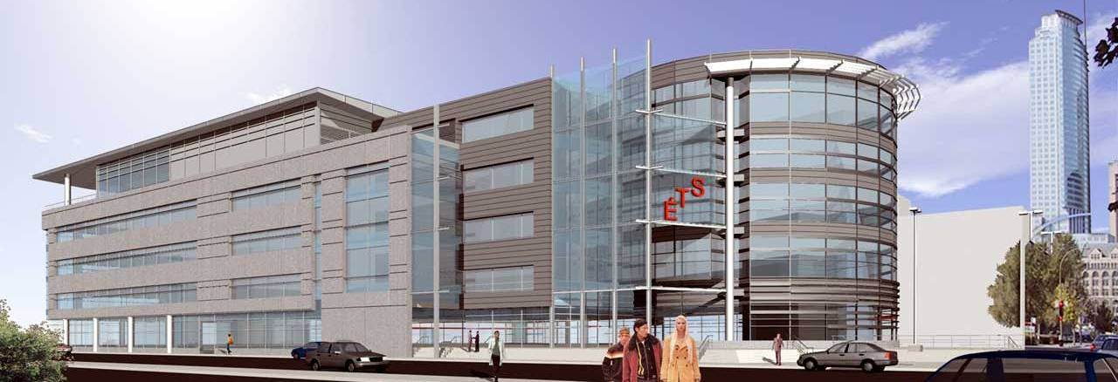
Conference Registration Form

ACA2009, June 25-28, Montréal, Canada. See http://aca2009.etsmtl.ca

Type in the requested information and send the completed form to: | Gilles Picard (ACA2009 Conference)  École de technologie supérieure  1100 rue Notre-Dame Ouest  Montréal, Canada  H3C 1K3

Conference Delegate Information

Title: ____ First Name: ____________________ Last (family) Name: ____________________________

e-mail: __________________________________________
Institution or Company: _______________________________________________
Department: ________________________________________________________
Mailing address: ___________________________________________________
___________________________________________________
___________________________________________________
Phone/Fax: ___________________________________

Accompanying Person(s) List the names of all persons accompanying the conference delegate at Wednesday’s welcome reception and Saturday’s banquet dinner :
_______________________________________________________________

Registration fees for conference delegates cover admission to all presentations and conferences, lunch on Thursday and Saturday, coffee breaks, Wednesday’s welcome reception, and Saturday’s banquet dinner.
Registration fees for accompanying persons cover Wednesday’s welcome reception and Saturday’s banquet dinner.

In order to help us plan sufficient resources, we ask that you fill in the following:

I plan to attend Wednesday’s welcome reception YES____ NO____
I plan to attend Saturday’s banquet dinner YES____ NO____

Vegetarian menus or menus for those with food allergies are available. Indicate any special needs of this sort in the following space.
_______________________________________________________________________
_______________________________________________________________________
The excursion on Friday is optional and is not included in registration fees. This was done to keep registration fees as low as possible. Please indicate below which tour of Montreal, if any, you would like to take and add the corresponding cost to your registration fees.
Registration Fees: Payment must be in Canadian Dollars ($Cnd)

 Registration fees for conference delegate
Standard, until June 1st : 270 $Cdn (approx. 160 Euro, 220 US$)
Late, after June 1st : 300 $Cdn (approx. 180 Euro, 245 US$) ....................................................______$Cnd
____ Registration for accompanying person(s) :
Standard, until June 1st : 135 $Cdn (approx. 80 Euro, 110 US$)
Late, after June 1st : 150 $Cdn (approx. 90 Euro, 120 US$) ......................................................______$Cnd

Indicate your choice for Friday’s excursion (do not forget accompanying persons for the excursion; simply indicate the appropriate number of persons and calculate the correct amount).
_____Walking tour of Historical Old Montreal 15 $Cnd per person
_____Lunch and walking tour of Chinatown 35 $Cnd per person ....................______$Cnd
_____Montreal Bus Tour Cancelled 55 $Cnd per person

Total............................................................................................................................................................______$Cnd

Payment:

Registration fees must be paid in Canadian Dollars. Confirmation of registration will be sent to you, be e-mail (or by letter), within 10 days of receipt of payment.
Please ensure you indicate the correct registration fees, consistent with the date of registration and with your choice of excursion. The delegate’s name and the mention ACA2009 must appear on all cheques or transfers. The delegate must cover any cost related to cheques or money transfers.

Total payment of _______$Cnd (registration fees for all participating persons) by the following method:

 By credit card. Check off or circle one of the following: Mastercard ____ Visa ____
(payment will be charged in Canadian funds)
Credit card number: ______________________________
Expiration date: _________
Signature: _______________________________ Date: _________________

 Transfer of the above amount to the  National Bank of Canada  600, de la Gauchetière Street West  Montréal, Québec, Canada  H3B 4L3 | Payable to: École de technologie supérieure (ACA2009)  Account number: 00011-04-160-21  Swift code: BNDCCAMMINT  ABA: 026009797  IBAN (RIB): 006000110416021

 By Cheque, in Canadian funds, payable to: École de technologie supérieure (ACA2009)

Comments:
______________________________________________________________________________________
______________________________________________________________________________________
______________________________________________________________________________________
______________________________________________________________________________________

