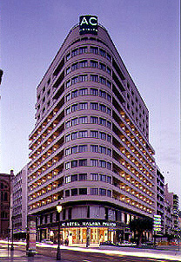
HOTEL ADDRESS

AC Málaga Palacio Hotel
C/ Cortina del Muelle
29015 Málaga
Spain

Tel. + 34 952 215 185
Fax + 34 952 225 100
grupos.mpalacio@ac-hotels.com

Please complete the enclosed hotel reservation form (Page 2) and return it as soon as possible, either by fax to 952 225 100 or by email to grupos.mpalacio@ac-hotels.com or reservas.mpalacio@ac-hotels.com

Please refer to A.C.A. Meeting , Malaga 02-03-04-05 Jul 2013

The hotel is strategically located in the city centre. The perfect location between the Malaga Cathedral and the Paseo del Parque, combined with its spectacular views of the marina, make it the most representative hotel in Malaga. Ideal for business trips or simply to enjoy the wide range of recreational and cultural activities on the Costa del Sol.
The hotel has wireless (wifi) internet connection in rooms. (12 €, 24 hours)

The AC Málaga Palacio Hotel is located 8 km from the airport, about 15 minutes by taxi and 4 minutes from the train station. The taxi cost should be 25 € approximately from the airport to the hotel.

Special rates for delegates:

Single room: 85.00 € + 10% VAT
Double room 95.00 € + 10 % VAT
Tripe room 140.00 € + 10 % VAT
Breakfast included

The deadline for reservations with this special rate is MAY 30TH 2013. After this date the rooms and rates are upon availability.

HOTEL RESERVATION FORM

AC MALAGA PALACIO HOTEL

Hotel Reservation Form – A.C.A. Meeting / Malaga July 2013

Booking Reference no. OPERA 882703

Date & Time of arrival

Date of Departure

Name

Surname

Number of nights

Room type required

Company

Mailing address

Telephone

Fax

Email

Credit card type

Credit card number

Name on card

Expiry date

Signature

Date

