Part 1
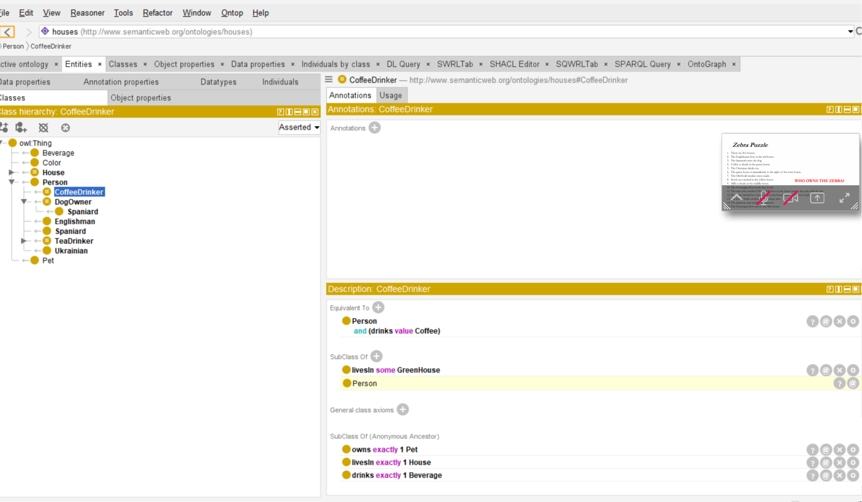
Gemini

Who owns the zebra? Make the best abductive guess you can from only these clues. Explain your reasoning, identify any assumptions you make, and state how confident you are.
The Missing Zebra
Based only on the clues and logical constraints provided in the ontology, the best abductive guess is that no one owns the zebra.

Here is the breakdown of the reasoning, assumptions, and confidence level based strictly on the provided text.

Reasoning
The provided code strictly defines the parameters of this specific logic puzzle universe. The logic dictates that a zebra cannot be owned due to the following constraints:

- The ontology explicitly defines exactly five individuals in the pet category: Dog, Bird, Cat, Fish, and Horse.

- The owns object property is defined as both functional and inverse functional.

- This functional property means each person owns exactly one pet, and each pet is owned by exactly one person.

- Because the ontology asserts there are exactly five houses (and therefore five people), all five available pet slots will be perfectly filled by the five defined animals.

Assumptions Made
- Closed Domain of Pets: I am assuming that the declaration of the five pets (Dog, Bird, Cat, Fish, Horse) combined with the owl:AllDifferent distinct members restriction represents the absolute entirety of the Pet class within this model.

- Strict Adherence to Prompt Constraints: I am assuming your instruction to use "only these clues" supersedes external knowledge of the classic Einstein "Zebra Puzzle," where the zebra is the famous final unknown pet.

Confidence Level
- Confidence: 100%

- Justification: This is a mathematically certain conclusion based strictly on the provided semantic web ontology. There is no Zebra individual defined anywhere in the provided [http://www.semanticweb.org/ontologies/houses](http://www.semanticweb.org/ontologies/houses) namespace. Because all pet ownership relationships are 1-to-1 and perfectly balanced between the five people and the five named animals, a zebra does not exist to be owned in this specific model.

Available Puzzle Elements
For reference, here are the exact entities declared in the ontology that must be matched together:

Houses | Colors | Beverages | Pets | Nationalities (Known)
House1 | Red | Coffee | Dog | Englishman
House2 | Green | Tea | Bird | Spaniard
House3 | White | Milk | Cat | Ukrainian
House4 | Yellow | OrangeJuice | Fish
House5 | Blue | Water | Horse
(Note: The table above simply lists the available distinct entities from the source code; they are not yet fully linked together, aside from the few initial clues provided, such as the Spaniard owning the Dog.)

Part 3:
Who owns the zebra? Make the best abductive guess you can from only these clues. Explain your reasoning, identify any assumptions you make, and state how confident you are. don't preserve its earlier answer merely for consistency.
The Missing Zebra
Based only on the clues and definitions provided in the houses-puzzle.ttl file, the best abductive guess is that no one owns the zebra.

Here is a breakdown of the reasoning, assumptions, and confidence level based strictly on the provided ontology.

Reasoning
The provided code strictly defines the boundaries and available entities of this specific logic puzzle universe. Based on these constraints, a zebra cannot be owned for the following reasons:

- The ontology explicitly defines the :Pet class and enumerates its distinct members.

- Those members are exactly: :Dog, :Bird, :Cat, :Fish, :Horse, and :Snails.

- The :owns object property is defined as both functional and inverse functional, meaning each person owns exactly one pet, and each pet is owned by exactly one person.

- There is no individual, class, or string defined for a "Zebra" anywhere in the provided source code.

Because a zebra is not one of the instantiated pets in this system, it cannot be assigned to any of the house residents.

Assumptions Made
- Exhaustive Domain: I am assuming that the owl:distinctMembers list for pets represents the absolute entirety of the animals available in this puzzle. Any entity not explicitly defined does not exist within this model.

- Strict Adherence to Prompt: I am assuming your instruction to use "only these clues" requires ignoring external knowledge of the classic Einstein "Zebra Puzzle," where the zebra is famously the final, deduced pet.

Confidence Level
- Confidence: 100%

- Justification: This is a definitive conclusion based strictly on the semantic parameters of the provided ontology. In this specific TTL file, there are six defined pets and zero defined zebras. An undefined entity cannot participate in the :isOwnedBy object property.

