Research on regression-based county population estimates for Colorado
(work paper)

Eddie Hunsinger, Colorado Department of Local Affairs, September 2010

Readers and reviewers: I’ll start with a brief description of the background and plan, then describe the method used, and data and results. At the end I’ll give a link to the related, simple R script (with linked data), and the sources. Skip as you like, of course—some review or thoughts are better than no review or thoughts—you can’t go wrong. It looks a little formal at first glance, but it’s not meant to (forgive any poor or mixed grammar). If more information would be useful, don’t hesitate to ask.

Especially useful thoughts would be on ideas to change or append the model (including variables and relationships) to improve the fit or logic, and any opinions on problems with the model. Please do point out mistakes if you see them.

1. Background and plan
The Colorado Department of Local Affairs, State Demography Office (SDO), used to make alternative, regression-based total population estimates for Colorado counties, and would like to start offering a form of them again for a couple of reasons: (1) They would offer something to compare the annual estimates from the current methodology to, and (2) If they fit very well, they could be used exclusively, and the SDO estimates would be less dependent on the US Census Bureau’s administrative-record-based migration numbers.

The plan is to make a regression-based estimate for 2010, then compare that to the 2010 Census data when it comes out, and have some rough idea of what level of error should be expected for future, annual estimates.

The regression-based estimates presented here rely on the very simple and well-reviewed and -documented “ratio-correlation” techniques that are described similarly in several publications (including Shyrock and Segal, 1980, and Feeney, Hibbs and Gillaspy, 1995), and described below:

2. Ratio-correlation method
The ratio-correlation method is the most widely used regression-based method for county population estimates. It is based on the simple assumption that changes in the county shares of state record-counts of “symptomatic” data, such as birth certificates and voter registrations, will correlate with change in the county shares of state population (the total state population is estimated independently). It’s been in use since the 1950’s and is currently used in some form by many state demography offices (California, North Carolina, Texas, Virginia, among others) for official county population estimates. It may be described with the following formula:

PR_{i,t} / PR_{i,t-k} = b₁ * (XR_{i,t} / XR_{i,t-k}) + b₂ * (YR_{i,t} / YR_{i,t-k}) + a

Where “PR_{i,t-k}” is the ratio of county population (“i”) to the state population at a specified time (“t-k”), “XR_{i,t-k}” and “YR_{i,t-k}” are county ratios of specified variables that are supposed to correlate with population, to the state total for that variable, at a specified time. “b₁”, “b₂” and “a” are coefficients for a multiple linear regression model that are estimated with data from the last two census years. (Note: Some users of the model leave “a” in, while others drop it.)
Independent variables that may be used for the ratio-correlation method include:

-Birth certificates
-Death certificates
-School enrollment
-Voter registrations
-Vehicle registrations
-Driving licenses
-Occupied housing units
-Employment data
-Tax records (income or sales)

To account for certain types of counties in the model, which may respond differently to the specified correlations, users can also use “dummy variables” (having a value of either 1 or 0) that indicate something about the county’s population (such as rural, or largely-imprisoned) to adjust the zero-intercept for these, and improve the overall fit (Pursell, 1970).

Additionally, it seems that users could set up an interaction for an area with a specified independent variable. For instance, if prisons are thought to be an important indicator of population change for certain counties, a prison population variable could be added to the model, and multiplied by a dummy variable that indicates whether the county was significantly affected by change in the prison population.

Stratification (multiple models) is an option if the number of counties (sample size) is large enough (Rosenberg, 1968). It should be noted that use of either stratification or dummy variables has not been shown to consistently improve ratio-correlation estimates (O’Hare, 1980).

Problems with ratio-correlation estimates include (1) Timing: Model coefficients based on censuses that are 10 years apart can’t clearly account for annual lags in the model correlations; also, data from the census years have an April 1 reference date, while data for the estimate years have a July 1 reference date, (2) Temporal instability: The modeled correlations will change to some degree over time, and this change will weaken the model, and (3) No clear interpretation and risk of multicollinearity: Rather than careful formulation and testing of a clear hypothesis, the independent variables are selected based only on some broadly-assumed relationships, and whether or not they improve the overall fit of the model (usually measured by the coefficient of determination, R²). (O’Hare, 1980.)

Based on review of estimate errors through comparison to censuses, it seems that county-level ratio-correlation estimates for 10 years after the estimate base year (last census) have a Mean Absolute Percent Error (MAPE) of approximately 5. Below are examples of ratio-correlation estimate error analyses (each for 10 years after the estimate base year) that have been conducted by different states:

-Florida 1980 ratio-correlation population estimates error:
Variables: Birth certificates, school enrollment and occupied housing units
MAPE: 5.4
(Smith and Mandell, 1984)

-Texas 1990 ratio-correlation population estimates:
Variables: Birth certificates, death certificates, elementary school enrollment, vehicle registrations and voter registrations
MAPE: 4.8
(Hoque and Murdock, 1999)

-Arizona 2000 ratio-correlation population estimates:
Variables: School enrollment, federal tax returns and driving licenses
MAPE: 5.5
(Brown, 2003)

-Texas 2000 ratio-correlation population estimates:
Variables: Birth certificates, death certificates, elementary school enrollment, vehicle registrations and voter registrations
MAPE: 5.7
(Hoque, 2008)

3. Preparing 2010 ratio-correlation estimates for Colorado counties
The steps in making 2010 ratio-correlation estimates for Colorado counties are (1) Select and create the dependent and independent variables from 1990 and 2000 for the ratio-correlation model, (2) Estimate model coefficients using multiple-regression methods or statistical software, (3) Apply the model and coefficients to 2000 and 2010 data.

The official April 1, 1990 Census and April 1, 2000 Census household population counts for Colorado counties are used to create the dependent variables (population shares of state total) for a ratio-correlation model. These data don’t include Broomfield County, which was created in 2001. Only the household (non-group quarters) population is modeled for estimation because the group quarters population can significantly affect the ratio-correlation model for certain counties, and much of the group quarters population (such as prisons and university dorms) can be tracked directly.

For independent variables in the ratio-correlation model, the following data sources are available for consideration (single variable 1990-2000 ratio-correlation model R² in parentheses):

-Birth Certificate counts for the fiscal year ending on July 1 of the estimate year (.68)
-Death Certificate counts for the fiscal year ending on July 1 of the estimate year (.29)
-Housing Units on April 1 of the census year, or July 1 of the estimate year (.71)
-QCEW Employment data for the first two quarters of the estimate year (.13)
-School Enrollment for fall of the estimate year (.79)
-Vehicle Registration counts for the previous calendar year (.90)
-Voter Registrations on November 1 of the estimate year (.74)

Some of the dummy variables that are considered are:

-Small (<50,000 people in 2000)
-Denver Metro (Region 3 counties)
-Tourism (population is significantly affected by tourism and resort communities)
-Prison (population is significantly affected by prisons)

After review of the model fit from various combinations of independent variables in the multiple regression formula, the following variables are selected:
-Birth certificates
-School enrollment
-Vehicle registrations
-Voter registrations

Neither Death Certificates, QCEW Employment data, nor any of the listed dummy variables are found to meaningfully improve the model fit beyond the use of those four selected variables. Housing Unit counts are not included , even though they do marginally improve the model fit, because instability in residential construction (across time and space) seems so great.

For a 1990-2000 ratio-correlation model (1990-2000 model) with respective census data on the household population, those selected variables give the following coefficients and error range (from the “lm” function in the R statistical software package):

Estimate Standard Error
Intercept -0.06706 0.02835
Birth Certificates 0.15033 0.02729
School Enrollment 0.31686 0.04984
Vehicle Registrations 0.39634 0.05951
Voter Registrations 0.22403 0.03798

Residuals:
Minimum First Quartile Median Third Quartile Maximium
-0.1339356 -0.0323842 0.0006768 0.0307365 0.1049861

Multiple R-squared: 0.9665, Adjusted R-squared: 0.9642

Comparison of the 1990-2000 model predictions for 2000 to the 2000 Census data gives a MAPE of 3.90.

At the end of this document are graphs describing the 1990-2000 model error:

-Figure 1 is a histogram of the 1990-2000 model’s residuals

-Figure 2 is a histogram of the residuals (percent) of population estimates for 2000, based on the 1990-2000 model

-Figure 3 is a histogram of the residuals of population estimates for 2000, based on the 1990-2000 model

-Figure 4 is a point-plot to compare the estimates for 2000 from the 1990-2000 model to the respective data from the 2000 Census

-Figure 5 is a point-plot to compare the estimates for 2000 from the 1990-2000 model, to the respective data from the 2000 Census, for areas with less than 50,000 people in 2000

The errors in the 2010 estimates won’t be known until the 2010 Census data is released, of course, but should be as large as those for the above-described 2000 estimates, plus any effect of temporal instability in the model, and error in the state total population estimate.
In reviewing the selected model’s errors for 2000, no clear biases by type of county (e.g. high tourism counties generally underestimated, Front Range generally overestimated, etc.) are discerned. Finding any of these, or recognizing any interactions of county-types with the independent variables, would be an ideal way to improve the model fit.

Using the 1990-2000 model, the next step will be to make population estimates for 2010. Because the independent variables for the 2010 estimates aren’t yet available (should all be available by January of 2011), it's not possible them at this time, but it is possible to prepare and review 2009 estimates based on the 1990-2000 model, and compare them to the official Colorado State Demography Office county population estimates for 2009 (SDO estimates). The comparison can’t give information on the accuracy of the selected model, but can provide description of the differences in shares of total population from the different estimate models.

The dependent variable for the 2009 estimates are the ratios of county populations to the state total population for 2009, divided by those for 2000, with any adjustments to 2000 for geography changes, such as the addition of Broomfield County. The independent variables are the ratios of county symptomatic data to the state total for 2009, divided by those for 2000, with any adjustments to 2000 for geography changes. The 1990-2000 model coefficients are not changed.

Comparison of the 1990-2000 model prediction for 2009 to the SDO estimates for 2009 gives a MAPE of 4.87. (Note: This MAPE includes an anomaly in 2007-2009 school district data for Sedgwick County. I’m trying to get in contact with Sedgwick County to make sense of it. With Sedgwick County removed, the MAPE is 3.84.)

At the end of this document are graphs describing the differences between the SDO estimates for 2009, and ratio-correlation 1990-2000 model estimates for 2009:

-Figure 6 is a histogram of the differences (percent) between the SDO estimates for 2009, and the 1990-2000 model estimates for 2009

-Figure 7 is a histogram of the differences between the SDO estimates for 2009, and the 1990-2000 model estimates for 2009

-Figure 8 is a point-plot to compare the SDO estimates for 2009 to the 1990-2000 model estimates for 2009

-Figure 9 is a point-plot to compare the SDO estimates for 2009 to the 1990-2000 model estimates for 2009, for areas with less than 50,000 people in 2000

4. R Code
The R script (with linked data) to make the described ratio-correlation estimates, is available at:

http://www.demog.berkeley.edu/~eddieh/RatioCorrelationEstimates/RCScript.txt

Just paste into R to run it. Unused variables are included in the script, and may be added to the model as well.

5. Sources
-W. Brown (2003). “Evaluation of July 1, 2000 County and Municipal Population Estimates
by the Arizona Department of Economic Security.” Unpublished report for the Arizona Department of Economic Security.
Available online at: http://www.workforce.az.gov/admin/UploadedPublications/1834_WABEstEvalReport- 050205.pdf

-D. Feeney, J. Hibbs, and T. Gillaspy (1995). “Ratio-Correlation Method.”
In N. Rives, W. Serow, A. Lee, H. Goldsmith, and P. Voss (eds), Basic Methods for Preparing Small-Area Population Estimates (pp 118-136). University of Wisconsin- Madison/Extension.

-N. Hoque (2008). “An Evaluation of Population Estimates for Counties and Places in Texas for 2000”
In S. Murdock and D. Swanson (eds), Applied Demography in the 21st Century (pp 125- 148). Springer Science and Business Media.

-N. Hoque and S. Murdock, (1999). “Evaluation of Texas population and estimates and
projections programs population estimates for 1990.” Presented at the Population Estimates Methods Conference, U.S. Census Bureau.

-W. O’Hare (1980). “A Note on the Use of Regression Estimates in Population Estimates.”
Demography, 17 (pp 341-343). Johns-Hopkins University Press.

-D. Pursell (1970). Improving Population Estimates with the Use of Dummy Variables.” Demography, 7 (pp 87-91). Johns-Hopkins University Press.

-H. Rosenberg (1968). “Improving Current Population Estimates through Stratification.” Land Economics, 44 (pp 331-338). University of Wisconsin Press.

-H. Shyrock and J. Segal (1980). The Methods and Materials of Demography, Volume 2. U.S. Department of Commerce.

-S. Smith and M. Mandell (1984). “A Comparison of Population Estimates Methods: Housing Unit Versus Component II, Ratio Correlation, and Administrative Records.” Journal of the American Statistical Association, 79 (386) (pp 282-289). American Statistical Association.

Figure 1: A histogram of the 1990-2000 model’s residuals
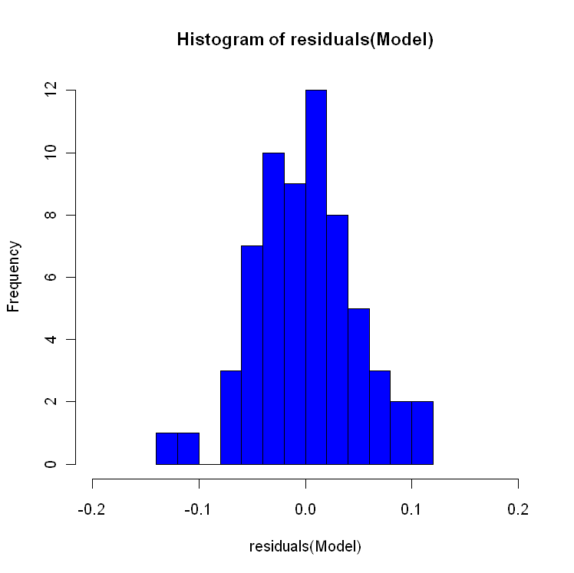

Figure 2: A histogram of the residuals (proportional to 2000 population) of population estimates for 2000, based on the 1990-2000 ratio-correlation model
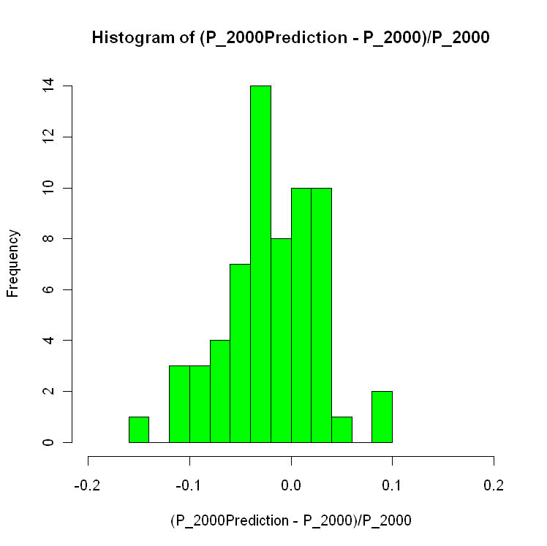

Figure 3: A histogram of the residuals of population estimates for 2000, based on the 1990-2000 model
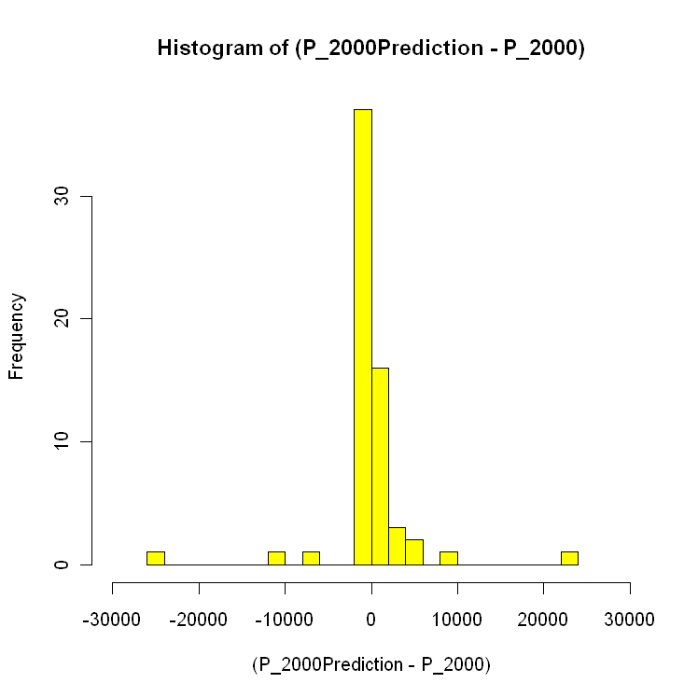

Figure 4: A point-plot to compare the estimates for 2000 from the 1990-2000 model to the respective data from the 2000 Census
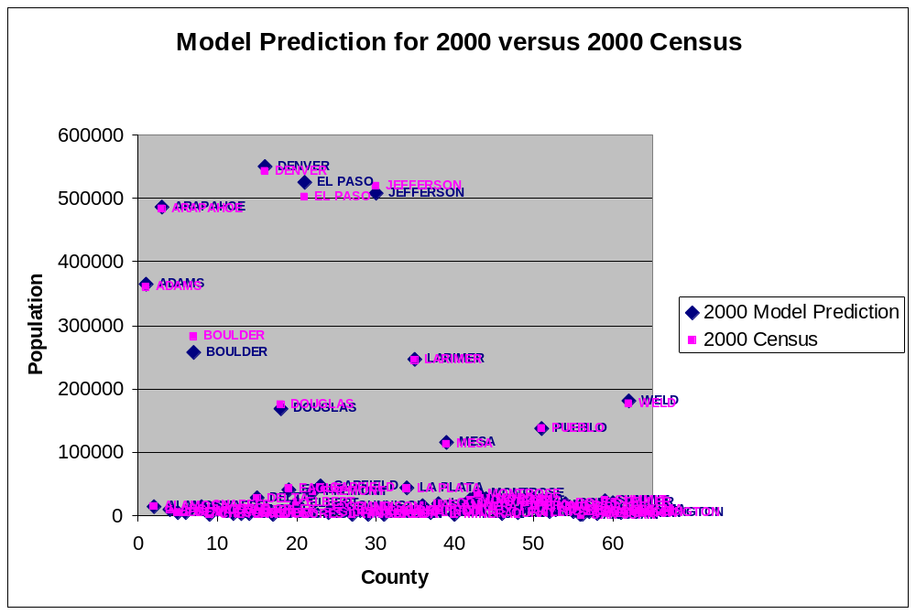

Figure 5: A point-plot to compare the estimates for 2000 from the 1990-2000 model to the respective data from the 2000 Census, for areas with less than 50,000 people in 2000
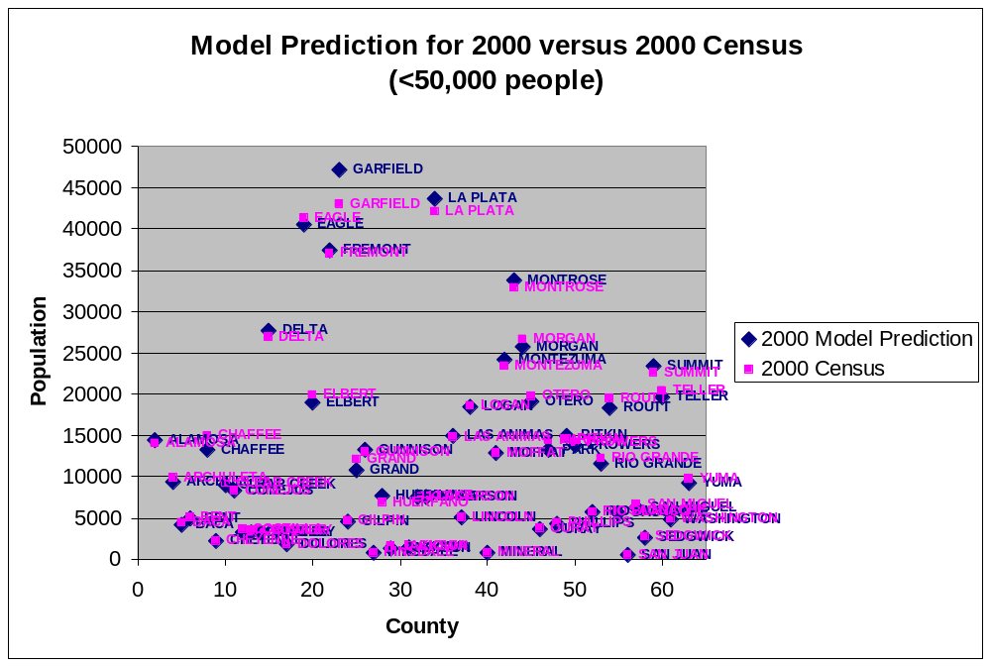

Figure 6: A histogram of the differences (proportional to 2009 population) between the SDO estimates for 2009, and the 1990-2000 model estimates for 2009
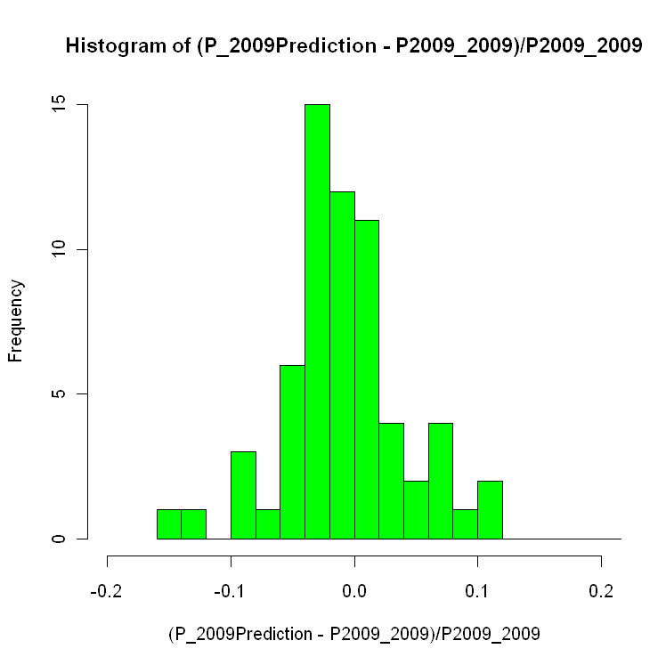

Figure 7: A histogram of the differences between the SDO estimates for 2009, and the 1990-2000 model estimates for 2009
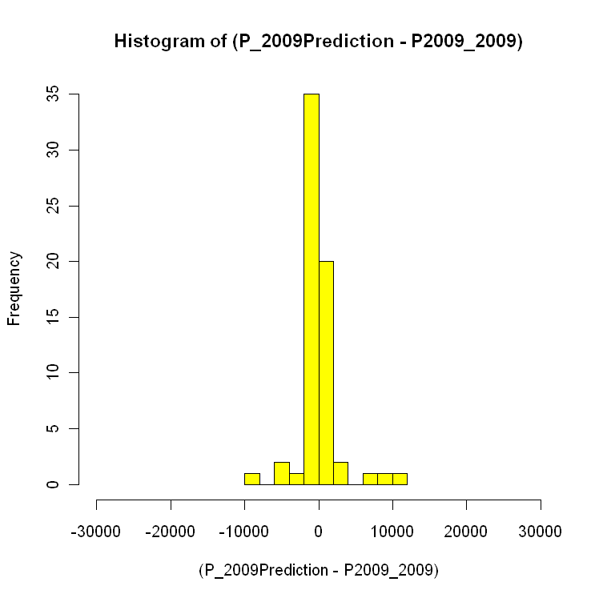

Figure 8: A point-plot to compare the SDO estimates for 2009 to the 1990-2000 model estimates for 2009
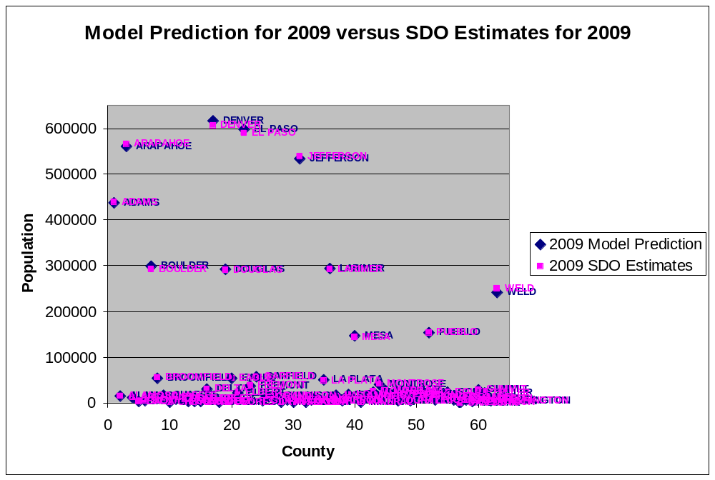

Figure 9: A point-plot to compare the SDO estimates for 2009 to the 1990-2000 model estimates for 2009, for areas with less than 60,000 people in 2009
