# Stabilization Diagram GUI

The stabilization diagram GUI is a tool to help selecting poles from experimental or operational modal analysis. The interface is simple, and lets you select and deselect poles. The GUI is based on the cursormode. For each mode you should click once one of the poles for that mode. The undamped frequency and relative damping of each selected pole is displayed in the table on the right-hand side of the GUI. If you accidentally put a cursor on one of the mode indicator functions, this cursor will be ignored.

# Short summary

Here is a quick guide to how to use the stabilization diagram:

* Left-click on the first pole you wish to select
* Hold Shift down, and left-click on the next poles(s) to select until you are done
* When you have selected all poles you want, press <ENTER> to pass control over to the parameter estimation routine.
* If you want to remove a selected pole, right-click on the cursor window of the selection, and select “Delete Current Datatip”.

# ****Main Gui****

The main GUI is displayed in Figure 1.

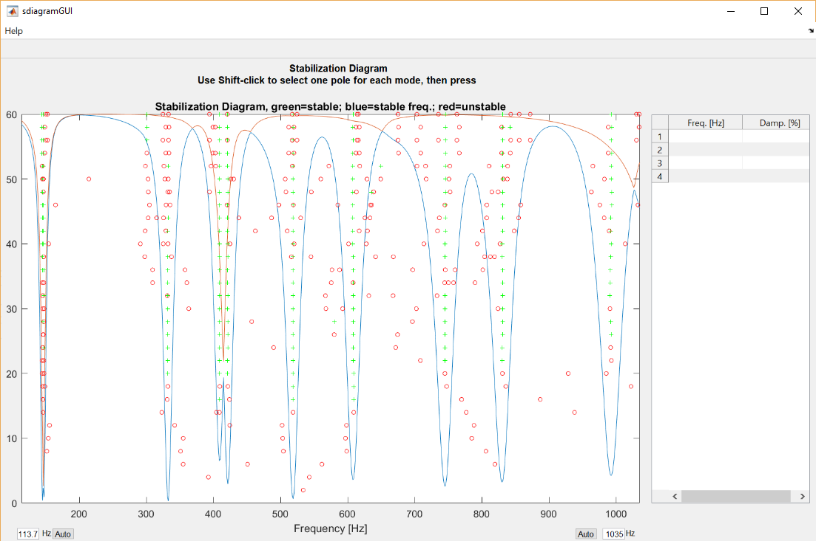

Figure 1. The stabilization diagram when you first enter it.

After you have selected, in the case shown, ten modes corresponding to all the modes (note that there are two rather close modes around 145 Hz), it looks like Figure 2.

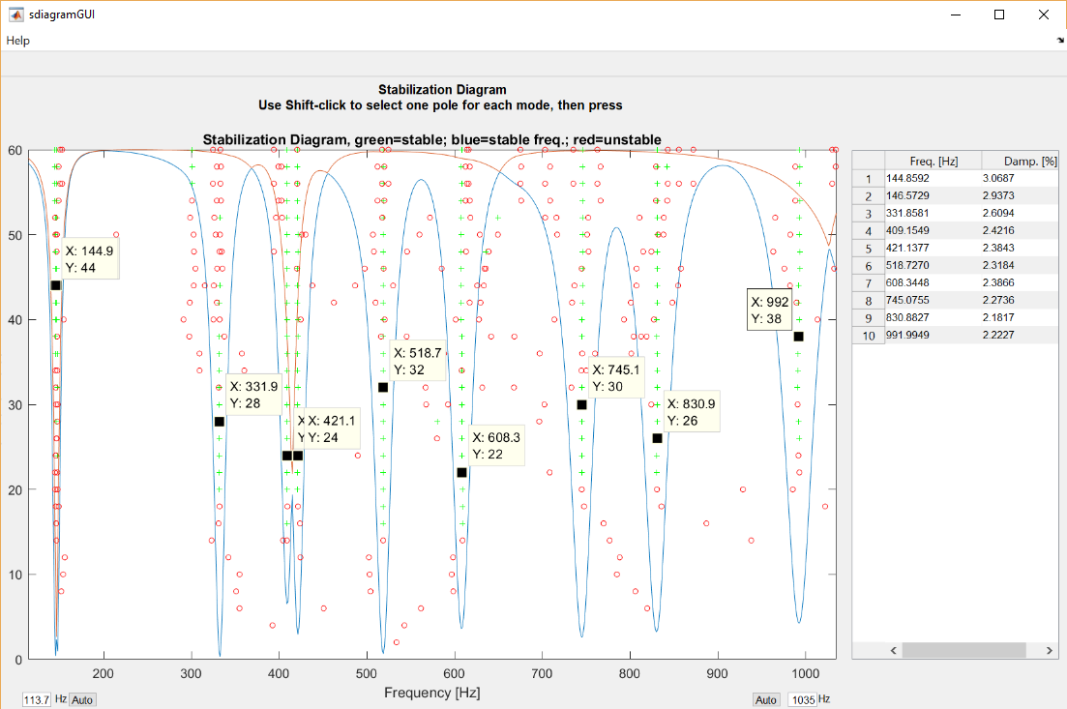

Figure 2. Stabilization diagram after selecting ten poles.

The two very close modes around 145 Hz were selected by zooming the frequency range, by entering 200 in the edit field at the lower right under the plot. This produces a zoomed-in plot as shown in Figure 3. To get back to the original frequency axis, you can click the “Auto” button next to the edit field. Similarly you can change the left frequency by the edit field on the lower left-hand side.

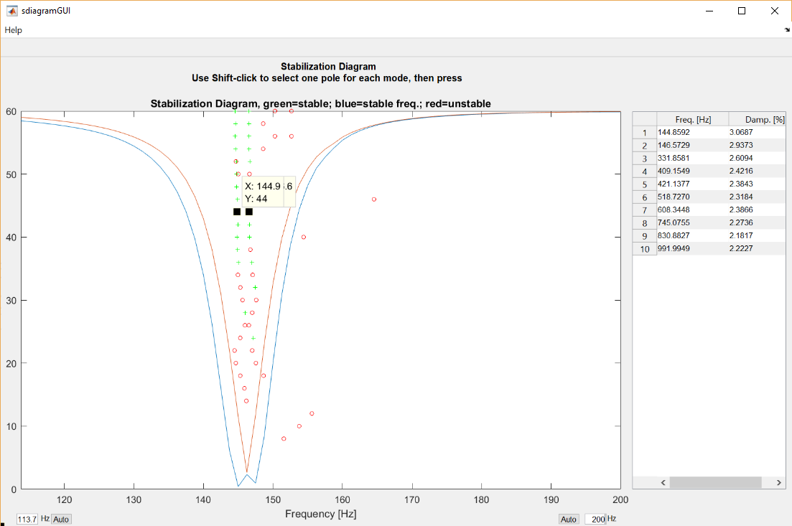

Figure 3. Stabilization diagram zoomed in to a maximum frequency of 200 Hz.

# ****Stabilization Criteria****

If you want to change the stabilization criteria, they are hard coded in the file sdiagramGUI.m in the AbraVibe folder, around line 47 ff.

Copyright © 2018, Anders Brandt.