# Tutorialanwendung

Zur Demonstration der AMrotorSIM-Toolbox

Header 1

Import 1

Clean up 1

Compute Rotor 1

Running system analyses 2

Running Time Simulation 3

## Header

% Johannes Maierhofer  
% 28.03.2017,29.03.2017,30.03.2017,31.03.2017,03.04.2017,04.04.2017,05.04.2017,06.04.2017  
%  
% .o. ooo ooooo .  
% .888. `88. .888' .o8  
% .8"888. 888b d'888 oooo d8b .ooooo. .o888oo .ooooo. oooo d8b  
% .8' `888. 8 Y88. .P 888 `888""8P d88' `88b 888 d88' `88b `888""8P  
% .88ooo8888. 8 `888' 888 888 888 888 888 888 888 888  
% .8' `888. 8 Y 888 888 888 888 888 . 888 888 888  
% o88o o8888o o8o o888o d888b `Y8bod8P' "888" `Y8bod8P' d888b

## Import

import AMrotorSIM.*

## Clean up

close all  
clear all  
clc

## Compute Rotor

Config_Sim  
  
r=Rotorsystem(cnfg,'System');  
r.show;  
  
r.rotor.mesh()  
%g=Graphs.Visu_Rotorgeometrie(r.rotor);  
%g.show();  
  
g=Graphs.Visu_Rotorsystem(r);  
g.show();  
  
r.compute_matrices();  
r.compute_loads();  
r.reduce_modal(10);

--------------- Rotorsystem --------------  
System  
Testrotor vom Feinsten  
Zusatzscheibe  
Locker lässiges Lager  
Straffes lässiges Lager  
----------------------------------------------  
--------------- Sensors ------------------------  
Sepp  
Hans  
----------------------------------------------  
--------------- Loads ------------------------  
Geplante Unwucht  
----------------------------------------------  
Mesh ....  
Rotor Gesamtsystem  
Berechne Lagersteifigkeit  
Berechne Lagersteifigkeit

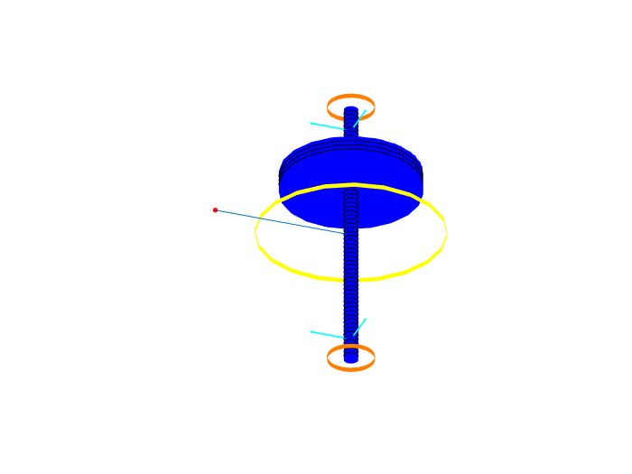

## Running system analyses

%Modalanalyse(r).show()

## 

## Running Time Simulation

St_Lsg = Experiments.Stationaere_Lsg(r,1000,[0 2]);  
 St_Lsg.show()  
 St_Lsg.compute()  
%  
 w = Graphs.Wegorbit(r);  
 w.plot(r.sensors);

Stationäre Lösung  
Compute.... ode15 ....  
 --- Plot Wegorbit ---

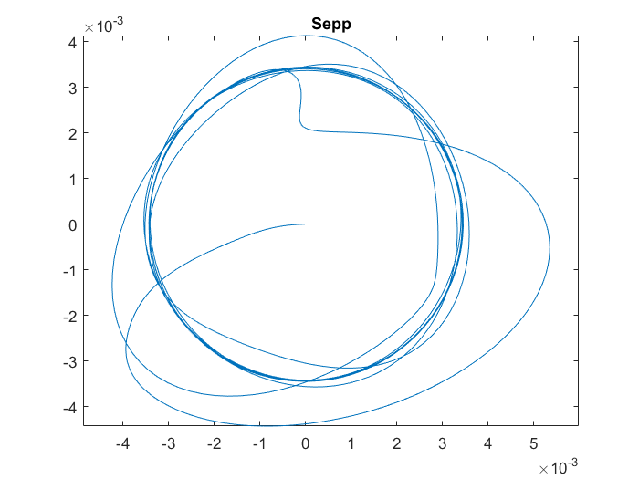

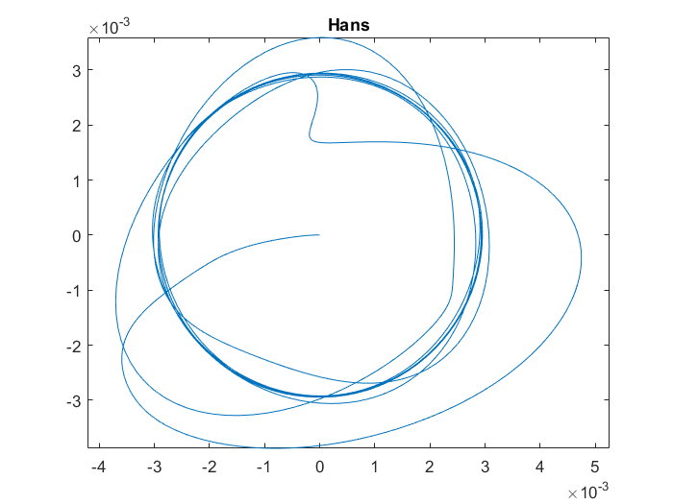

[*Published with MATLAB® R2017a*](http://www.mathworks.com/products/matlab)