AMrotorSIM – Toolbox

Vorstellung zur ICAM2017

Johannes Maierhofer

12.04.2017

# Demoanwendung

Zur Demonstration der AMrotorSIM-Toolbox

Inhalt

Demoanwendung 1

Rotor configuration file 2

Rotor 2

Massescheiben 2

Sensors 2

Lager 2

Loads 2

Header 3

Import 3

Clean up 3

Compute Rotor 4

Running system analysis 5

Running Time Simulation 7

# Rotor configuration file

## Rotor

cnfg.cnfg_rotor.name = "Testrotor";  
cnfg.cnfg_rotor.shear_def = 1; % 1 = Timoshenko or 0 = Bernoulli beam theoy  
  
cnfg.cnfg_rotor.rotor_dimensions = [0,15,0;400,15,0;450,150,0;600,15,0]*1e-3; %[m] cnfg.cnfg_rotor.shear_factor = 0.9;   
  
cnfg.cnfg_rotor.E_module = 211e9; %[N/m^2]  
cnfg.cnfg_rotor.density = 7446; %[kg/m^3]  
cnfg.cnfg_rotor.poisson = 0.3; %steel 0.27...0.3 [-]  
  
cnfg.cnfg_rotor.dz=0.01; %set elemet length for meshing

## Massescheiben

cnfg.cnfg_disc(1).name = 'Zusatzscheibe';  
cnfg.cnfg_disc(1).position = 300e-3; %disc position [m]  
cnfg.cnfg_disc(1).radius = 200e-3;  
cnfg.cnfg_disc(1).m = 5; %disc mass [kg]  
cnfg.cnfg_disc(1).Ix = 1e-4; %disc mom. of inertia [m^4]  
cnfg.cnfg_disc(1).Iz = 1e-4; %disc mom. of inertia [m^4]

## Sensors

cnfg.cnfg_sensor(1).name = 'Sepp';  
cnfg.cnfg_sensor(1).position=0.050;  
cnfg.cnfg_sensor(1).type=1;  
  
cnfg.cnfg_sensor(2).name='Hans';  
cnfg.cnfg_sensor(2).position=0.550;  
cnfg.cnfg_sensor(2).type=1;

## Lager

cnfg.cnfg_lager(1).name = 'Linkes Lager';  
cnfg.cnfg_lager(1).position=0e-3; %[m]  
cnfg.cnfg_lager(1).type=1;  
cnfg.cnfg_lager(1).stiffness=5e6; %[N/m]  
  
cnfg.cnfg_lager(2).name = 'Rechtes Lager';  
cnfg.cnfg_lager(2).position=600e-3; %[m]  
cnfg.cnfg_lager(2).type=1;  
cnfg.cnfg_lager(2).stiffness=5e6; %[N/m]

## Loads

cnfg.cnfg_force_const_fix=[];  
% Unwuchten  
cnfg.cnfg_unbalance(1).name = 'Geplante Unwucht';  
cnfg.cnfg_unbalance(1).position = 300e-3;  
cnfg.cnfg_unbalance(1).betrag = 5e-1;  
cnfg.cnfg_unbalance(1).winkellage = 0;

# Header

% Johannes Maierhofer  
% 28.03.2017,29.03.2017,30.03.2017,31.03.2017,03.04.2017,04.04.2017,05.04.2017,06.04.2017,12.04.2017  
%  
% .o. ooo ooooo .  
% .888. `88. .888' .o8  
% .8"888. 888b d'888 oooo d8b .ooooo. .o888oo .ooooo. oooo d8b  
% .8' `888. 8 Y88. .P 888 `888""8P d88' `88b 888 d88' `88b `888""8P  
% .88ooo8888. 8 `888' 888 888 888 888 888 888 888 888  
% .8' `888. 8 Y 888 888 888 888 888 . 888 888 888  
% o88o o8888o o8o o888o d888b `Y8bod8P' "888" `Y8bod8P' d888b

## Import

import AMrotorSIM.*

## Clean up

close all  
clear all  
clc

# Compute Rotor

Config_Sim  
  
r=Rotorsystem(cnfg,'System');  
r.show;  
  
r.rotor.mesh()  
  
g=Graphs.Visu_Rotorsystem(r);  
g.show();  
  
r.compute_matrices();  
r.compute_loads();  
%r.reduce_modal(10);

--------------- Rotorsystem --------------  
System  
Testrotor  
Zusatzscheibe  
Linkes Lager  
Rechtes Lager  
----------------------------------------------  
--------------- Sensors ------------------------  
Sepp  
Hans  
----------------------------------------------  
--------------- Loads ------------------------  
Geplante Unwucht  
----------------------------------------------  
Mesh ....  
Rotor Gesamtsystem  
Berechne Lagersteifigkeit  
Berechne Lagersteifigkeit

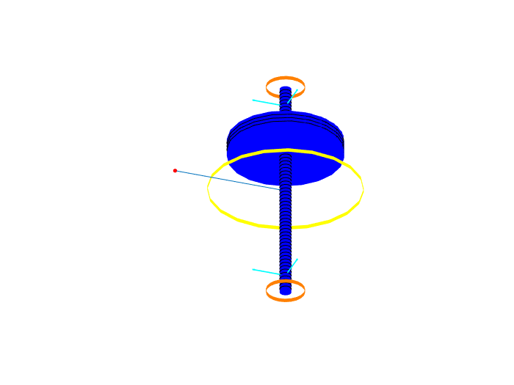

# Running system analysis

m=Experiments.Modalanalyse(r);  
  
% m.calculate_rotor_only(4,0:100:1000);  
% esf = Graphs.Eigenschwingformen(m);  
% esf.plot();  
  
m.calculate_rotorsystem(4,0:100:1000);  
esf2= Graphs.Eigenschwingformen(m);  
esf2.plot();  
  
m.calculate_rotorsystem(3,0:100:3000);  
cmp = Graphs.Campbell(m);  
cmp.plot();

Berechne Modalanalyse Rotorsystem  
Eigenkreisfrequenzen  
18.8487 Hz  
94.1186 Hz  
158.7975 Hz  
451.9409 Hz  
Berechne Modalanalyse Rotorsystem

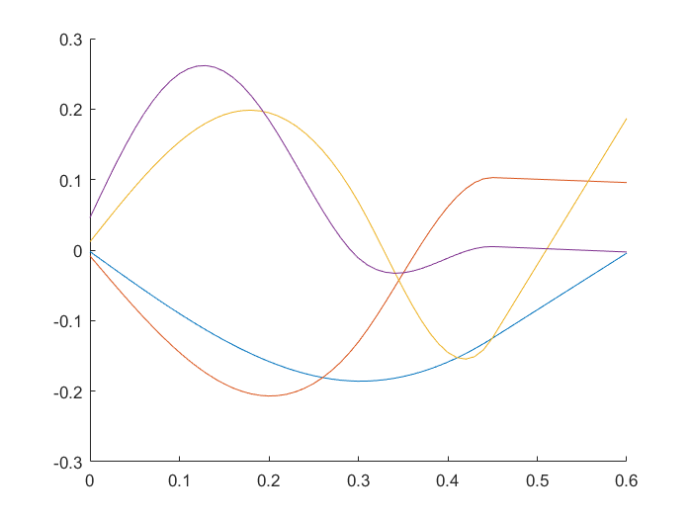

Abbildung : Eigenformen des Rotorsystems

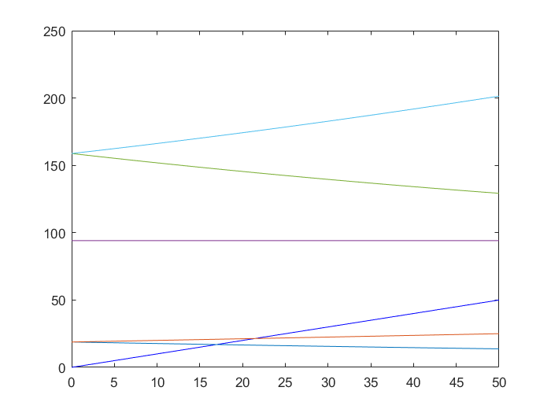

Abbildung : Campbelldiagramm des Rotorsystems

# Running Time Simulation

St_Lsg = Experiments.Stationaere_Lsg(r,1000,[0 2]);  
 St_Lsg.show()  
 St_Lsg.compute()  
  
 w = Graphs.Wegorbit(r);  
 w.plot(r.sensors);

Stationäre Lösung  
Compute.... ode15 ....  
 --- Plot Wegorbit ---

