Tutorialanwendung
Zur Demonstration der AMrotorSIM-Toolbox
Header 1
Import 1
Clean up 1
Compute Rotor 1
Running system analyses 2
Running Time Simulation 3

Header
% Johannes Maierhofer
% 28.03.2017,29.03.2017,30.03.2017,31.03.2017,03.04.2017,04.04.2017,05.04.2017,06.04.2017
%
% .o. ooo ooooo .
% .888. `88. .888' .o8
% .8"888. 888b d'888 oooo d8b .ooooo. .o888oo .ooooo. oooo d8b
% .8' `888. 8 Y88. .P 888 `888""8P d88' `88b 888 d88' `88b `888""8P
% .88ooo8888. 8 `888' 888 888 888 888 888 888 888 888
% .8' `888. 8 Y 888 888 888 888 888 . 888 888 888
%o88o o8888o o8o o888o d888b `Y8bod8P' "888" `Y8bod8P' d888b

Import
%import AMrotorMONI.*
import AMrotorSIM.*

Clean up
close all
clear all
clc

Compute Rotor
Config_Sim
r=Rotorsystem(cnfg,'System');
r.show;
r.rotor.mesh()
%g=Graphs.Visu_Rotorgeometrie(r.rotor);
%g.show();
g=Graphs.Visu_Rotorsystem(r);
g.show();
r.compute_matrices();
r.compute_loads();
r.reduce_modal(10);
%r.sichern();
--------------- Rotorsystem --------------
System
Testrotor vom Feinsten
Zusatzscheibe
Locker lässiges Lager
Straffes lässiges Lager
----------------------------------------------
--------------- Sensors ------------------------
Sepp
Hans
----------------------------------------------
--------------- Loads ------------------------
Geplante Unwucht
----------------------------------------------
Mesh ....
Rotor Gesamtsystem
Berechne Lagersteifigkeit
Berechne Lagersteifigkeit
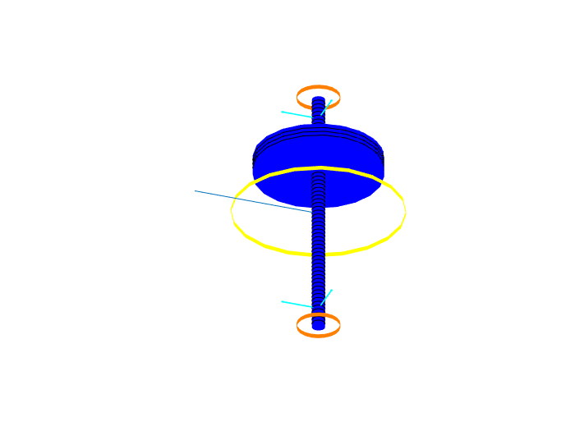

Running system analyses
%Modalanalyse(r).show()

Running Time Simulation
St_Lsg = Experiments.Stationaere_Lsg(r,100,0:1e-3:5);
St_Lsg.show()
St_Lsg.compute()
%
w = Graphs.Wegorbit(r);
w.plot(r.sensors(1:2));
Stationäre Lösung
Compute.... ode15 ....
--- Plot Wegorbit ---
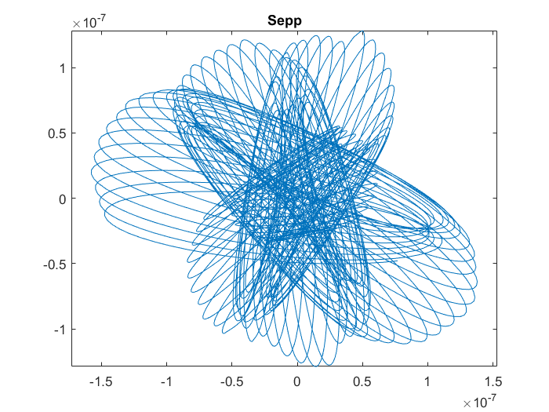
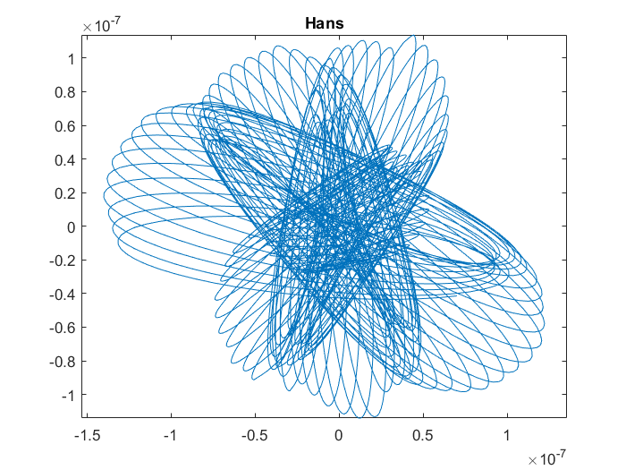
Published with MATLAB® R2017a

