**Development Contract**

The following agreement is entered and agreed upon by TEG Intl., (contractor) and **Estevao Cavalcante** on **October 01, 2025**. This agreement comprises the entirety of agreements between the parties named herein, and no other agreements, verbal or otherwise, shall be considered included in this contract. All changes shall be agreed upon in writing and shall require the signature of both parties. Contractor provides the services for Client based upon remuneration in full by the Client. The total contract amount shall be **$5,000.00** and is due in full upon signing. This shall include all services outlined in the Development Contract, and Terms and Conditions Agreement (Attachment B), and as follows:

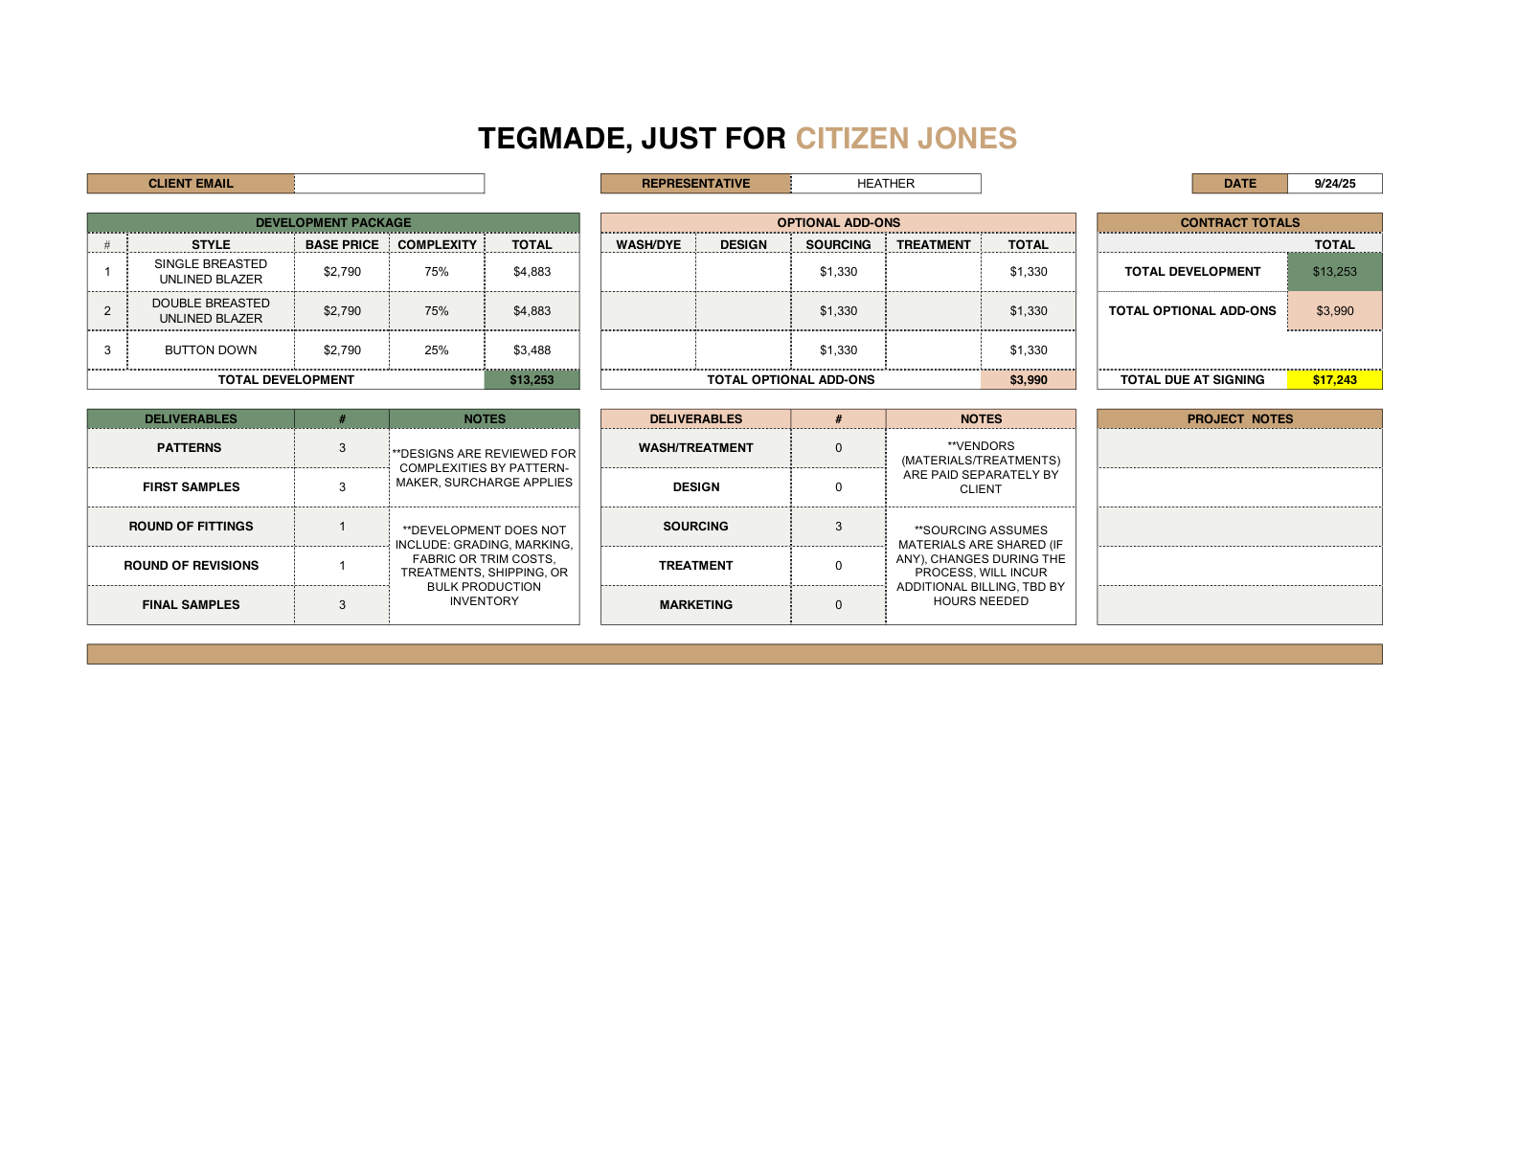

All prices are based on the specifications given on TEG Intl. Specification Sheets. Prices include project management as outlined in this agreement, and all goods are provided with a 100% guarantee to meet specified specifications and quality standards, as specified by the client. All designs, patterns and samples produced for the client remain the client’s sole property.

This contract is agreed upon as a development package, with payment due in full, valid for 1 year. Amounts due per these signed contracts are nonrefundable, non-transferrable, and non-exchangeable toward future orders or alternate styles. By entering into this contract, the development and sample production dates will be reserved and incorporated into our development and/or modular production schedule. Adjustments or change orders may be submitted to TEG Intl. but will only be incorporated into the agreement upon both parties signed written consent before changes are initiated. Estimated prices for items sent out for dye, bias, spaghetti, or other trim may be included in this proposal, but in the case that there are additional costs above the estimated amounts listed, client will be notified of additional costs and upon client’s approval, full payment will be due and payable prior to TEG Intl. releasing completed materials. Client approved and agreed-upon send-outs (outside of cut/sew) will incur management fee in addition to all normal production, shipping, supply, etc., fees paid to outside contractors.

For each style, 8 - 12 weeks are required for **DEVELOPMENT**, once all specifications, fabrics, patterns and trims are received. **PLANNING** (if contracted) may add up to 6 – 8 weeks to the schedule. **DESIGN** (if contracted) may add up to 6 – 8 weeks to the schedule. **FABRIC SOURCING** (if contracted) may add up to 6 – 8 weeks to schedule. Late delivery to TEG Intl. of any material or trim component will result in a re-scheduled delivery for that style, regardless of previously scheduled delivery dates. Any design changes in development, differing from written specification on TEG Intl.’s Specification Sheets, will be billed at the stated hourly rates.

A TEG Intl. specification sheet is required for each style and colorway, for patterns, and cutting and sewing of samples, and any production order, prior to initiation of project by TEG Intl. All specifications including, but not limited to, design specifications, specialized stitch-types, all fabrics used, any trims, fusing requirements, and any other special notations are required at time project is started. Written changes will be contemplated on a case-by-case basis, and services to provide changes may be invoiced separately. TEG Intl. guarantees its patterns and samples to be of approved quality matching only what is specified on the TEG Intl. Specification Sheet.

All efforts will be made by TEG Intl. and its employees, to ensure timely delivery. In any event, TEG shall be held liable only for the cost of production, or development, as written in this contract. This contract is agreed upon, with full agreement to TEG Intl.’s Terms and Policies. Customer agrees to notifying TEG Intl. of any quality issues within 5 business days of receipt of the samples or production. Any claims must be shipped back upon notification to TEG Intl. for review. After 5 business days, all goods are accepted as approved quality and quantity.

LIMITED LIABILITY: While TEG Intl. takes every care in producing safe products, employing safe production practices, and reviewing the preparation of all apparel, TEG Intl. makes no warranties, expressed or implied, of merchantability, fitness of purpose, or safety of purpose of the items produced by TEG Intl. Client agrees that TEG Intl. acts solely at the direction and discretion of the client pertaining to apparel production.

In the event of any discrepancy or error, TEG Intl. product liability is limited solely to the remuneration paid under contract between TEG and the client, construing the provisions of this Agreement, or due to default of any provision listed herein, the unsuccessful party in such action or proceeding shall be liable to reimburse in full to the prevailing party for all costs, expenses, and attorney’s fees.

Following are the currently scheduled contract dates for standard styles:

Signed Contract and payment in full received by:Date: TBD   
Intake Meeting (assumes payment on or before date above): Date: TBD

Fabric and trims for samples received by: Date: TBD  
Fitting at TEG Intl: (within 6 weeks of receipt of all fabrics and trims): Date:

Final samples received from TEG Intl: (within 6 weeks from fitting): Date:

Any delays in receiving necessary fabric, specifications, or payment, may result in an adjusted delivery date. Any design changes, beyond the original specifications, may result in an adjusted delivery date.

Following are the currently scheduled contract dates for rushed styles:

Signed Contract and payment in full received by:Date: TBD   
Intake Meeting (assumes payment on or before date above): Date: TBD

Fabric and trims for samples received by: Date: TBD  
Fitting at TEG Intl Date:

Final samples received from TEG Intl: Date:

Any delays on behalf of TEG outside of the above timelines will result in a reduction per week of delay for the delayed styles. This may be provided in a 10% refund or 20% credit towards new development services.  
  
TEG may not be held liable for unforeseen delays by outside vendors outside of normal timelines or processes regardless of rushed timelines.

Any delays in client deliverables including intake, specifications, fittings, or changes in final fabrics or washes may result in an adjusted delivery date. Any changes, beyond the original specifications, may result in an adjusted delivery date.

__________________________________ ________________________

**CITIZEN JONES** Date:

__________________________________ ________________________

On behalf of: TEG Intl Date: