**CS 5670: Computer Vision HW #1**

Jeff Ponnor, Daniel Reidler

**Task 1: Image Filtering and Enhancement**

1. Output of Image Convolution:

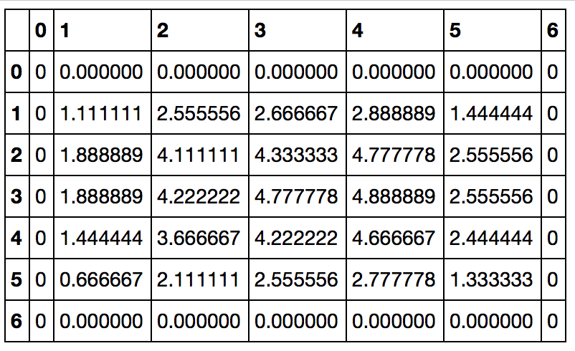

1. Output of Convolution With Median Filter:

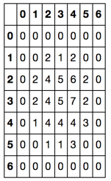

The key difference from 1:

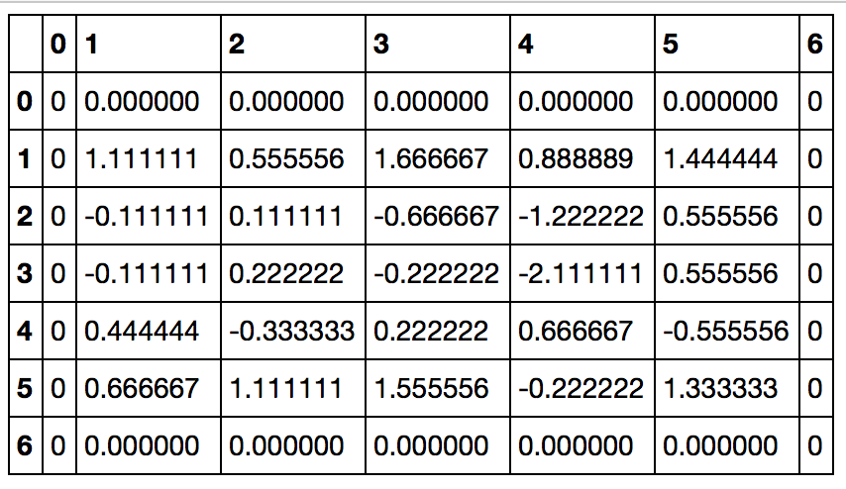

1. Gradient Magnitude and Direction using Sobel:

Gradient Magnitude: 4.472136

Gradient Direction: -1.107149

1. a) Filter using distance between pixels:

b) Filter using distance between pixel values:

c) Filter that takes into account both distances:

1. Unsharp Masking:

Image 1:

Without Unsharp Masking With Unsharp Masking

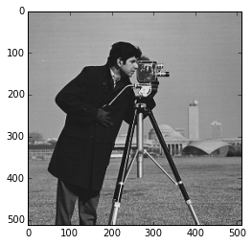 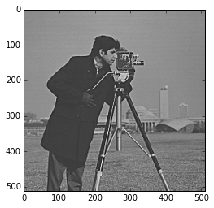

Image 2:

Without Unsharp Masking With Unsharp Masking

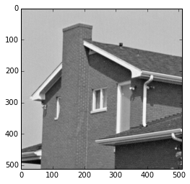 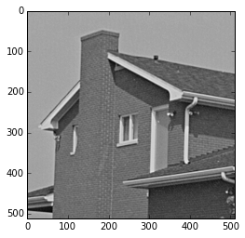

Image 3:

Without Unsharp Masking With Unsharp Masking

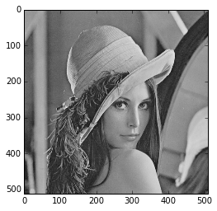 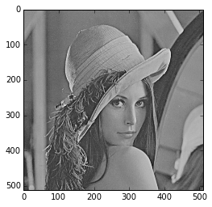

The differences in the images

**Task 2: Color Quantization with K-Means**

1. A
2. B
3. C
4. D
5. E

The results

**Task 3: Edge Detection**

1. Explain in a few sentences the way of operation of each of the three detectors.

Canny:

The Canny edge detector uses the fact that the derivative of the Gaussian Laplace can be used to approximate edges in an image. It is typically used after a Gaussian Laplace smoothing on an image. The Canny edge detector uses the sigma value as the input.

Sobel:

The Sobel edge detector is comprimsed of two 3x3 kernels that are convolved with an image to produce an edge dectected graph. This operator requires a threshold as it is not consistent

Gaussian-Laplace Filtering:

The Gaussian-Laplace Filter is a distance based filter than heavily weights the center cell and decreases in weight outward. This filter approximates the derivate of the image. Once a Gaussian-Laplace filter is applied, region’s values reflects its

2.

B)

Precision and Recall are important because Precision explains the percentage of edges reported that are truly edges and Recall explains the percentage of edges detected from all the edges. A low recall value means that we are not detecting all of the edges and may mean that we are missing critical edges from the image. This happens when a poor threshold value is used.

A low precision value means we are incorrectly classifying some points: either missing real edges (true positives) or including false edges (false positives). If we’re missing real edges, then we are simply not detecting edges. And, if we are including false edges we are adding false edges to the image.

3. Zero Crossing is taken preference over thresholding.