***Project Department scheduler***

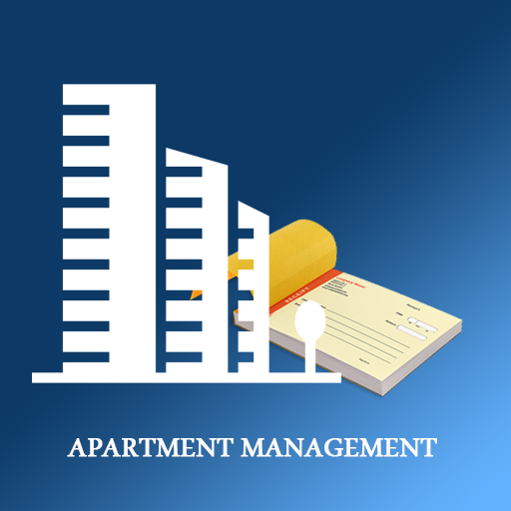

Index

Project definition 2

Project background 2

Problem definition 3

Problems: 3

Project goal 3

Project structure organization 4

Deliverables 5

Project leader 5

members 5

MoSCoW Analyze Project department scheduler 6

Must Haves 6

Should Haves 6

Could Haves 6

Won’t Haves 6

Planning 6

# Project definition

As students at the Fontys we, Alpay, Jan, Kassiia and Jarno are going to develop a solution for a department management. We all will contribute to the creation of the expected application, by dividing our group and assigning everyone a unique role. First week we going to analyse the problems and find the relevant solutions that will improve the structure of the tasks. We will discuss our strengths and weaknesses to optimise the workflow at maximum. Next weeks we will make the program using c#, other programming languages and develop a properly functioning interface. In the last week, we going to demonstrate our work, how we made it and how it is supposed to be worked with. We hope by the end of the assignment, to come up with a great outcome for the business.

# Project background

In this file we going to describe our project plan for our clients “the students” and the department management. Inside this department the tasks are not well divide and this causes frustrations

*Group leading*

As it is our second project, we are looking forward to enlarging our knowledge about ICT and our experience in practicing soft skills such as teamwork, communication skills and organisation.

# 

# Problem definition

As we analysed the problems of the student apartment, we have noticed a few problems inside the department. One of those problems is that the structure between the students, students don’t do their tasks that causes problems inside the department. Students are expected to do some tasks during the week so everyone does their part. Besides that, contemporary technology is barely used.

## Problems:

* Deep clean kitchen
* Deep clean bathroom/toilet
* Takeout the trash
* Missing grocery products
* Forgetting laundry in the washing machine

# Project goal

Nonetheless, our project goal is to achieve a simple useable system that can be used by the students and the department managers. The collaboration should be improved between the students and everyone have to do their tasks.

We will develop an application for the students and department, with which they should be able to check their tasks when they finished it. When someone doesn’t do their tasks, this will be shown on the application and there will be a punishment for it.

In addition, we will mainly focus only on the development for better communication and collaboration between the students.

We are going to use different types of code languages. These are c#/windows form app, git and SQL. We Have in total 9 weeks to succeed this project.

Tasks, you can choose your task until there are no tasks anymore, the quicker you are the more tasks there are open.

# Project structure organization

Although everybody has a different role, we agreed to help each other if somebody encounters a problem, which he/she struggles to solve.

In the beginning we as group fill in the “how to work as a group” document. With this exercise we will understand each other more and know the agreements and the values of each other. After this we will discuss the project plan. We will think about the problem and find an solution for this problem. Jarno will fill in the project plan template. During this Alpay will make some databases examples for the project. During this there will be made some examples of the prototype. We as group will decide if the prototype is good for the end result. Also we will ask some feedback from other groups. Besides this someone will make an diagram about the project. When this all is finished the preparation is done and we can start on making the real program.

Alpay will work most of the time on the database part of the project. While Jan try to make the C# program. Kassiia and Jarno does the documentation and helps the others where its needed. Therefor most of the time two people will work on the coding or the database at the same time.

In the last week we will work together to make a PowerPoint presentation and present our results together.



## Deliverables

|  |  |  |  |
| --- | --- | --- | --- |
| **Activity name** | *Project department Scheduler* | **Delivery date** | *15-01-2022* |
| **Input** | *C#, SQL, window form app* | | |
| **#0** | **Activities:** | | |
| *Process diagram*  *Final Prototype*  *An application for the students* | | | |
| **Output** | *A schedule for tasks used by the students* | | |

## Project leader

* + - ------------------
    - Responsible for communication between the team .
    - Keep track of deadlines
    - Motivate the team
    - Work on the project

## members

* + - Work on the project

# 

# MoSCoW Analyze Project department scheduler

## Must Haves

* Application
* Prototype

## Should Haves

* Diagram
* Database SQL

## Could Haves

* Login
* Email

## Won’t Haves

* Prices for students when doing there tasks

# Planning

Trello?