Payroll Module — Screenshot-Based Test Cases
Apponext HRMS — one test case per screenshot, in the order tested
Tested by: Shakyadita | Org: Kosqu Technolab (hosted) | Date: 21 Aug 2026

A. Payroll Dashboard
TC-A01 Load Payroll Dashboard
Expected Result | Dashboard loads with KPI cards, lifecycle stepper and charts, no errors.
Actual Result | Dashboard loaded correctly showing Total Outlay, Net Take-Home, Enrolled Staff, PF & Statutory, Next Disbursal cards and the Payroll Processing Lifecycle stepper.
Status | Pass
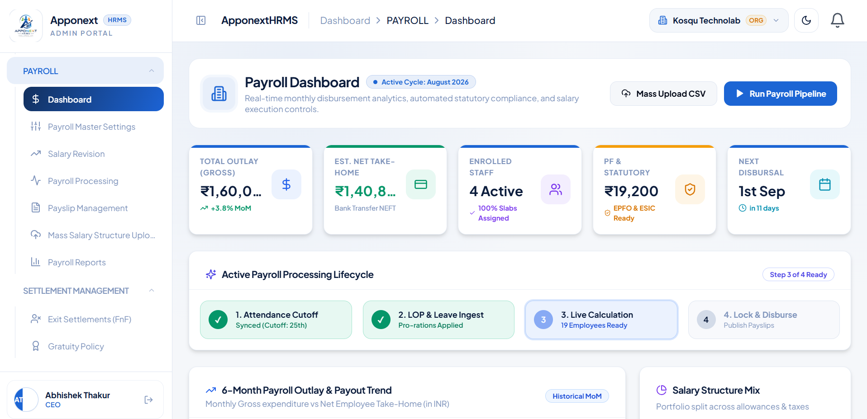

TC-A02 View Payroll Operations Hub (scrolled section)
Expected Result | Quick-link operations hub renders correctly below the KPI cards.
Actual Result | Operations Hub section rendered correctly with working quick-link cards.
Status | Pass
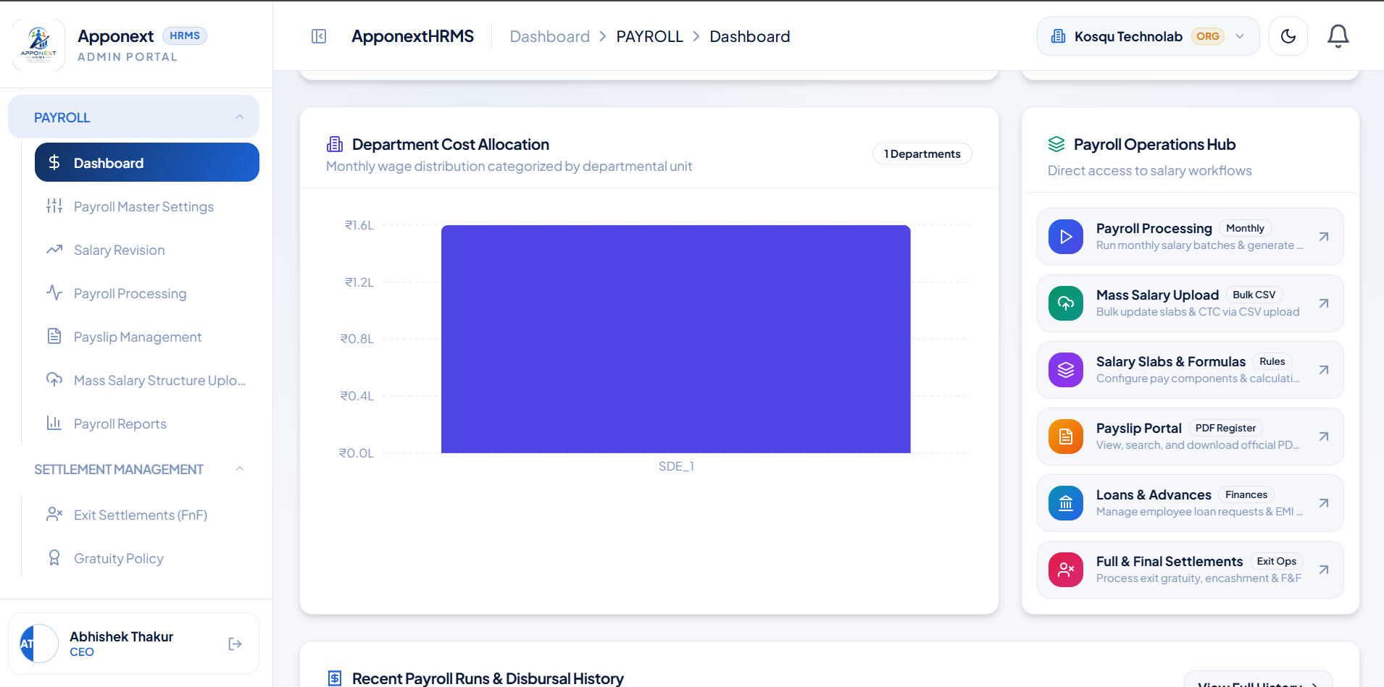

TC-A03 "Mass Upload CSV" button navigation
Expected Result | Clicking the button navigates to the Mass Salary Structure Upload page.
Actual Result | Correctly redirected to the Mass Salary Structure Upload page.
Status | Pass
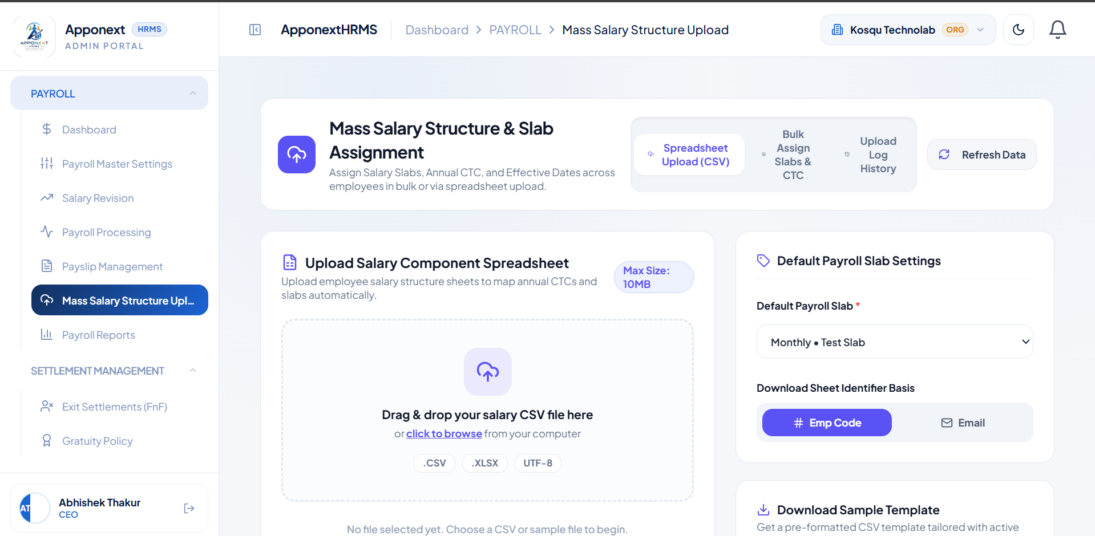

TC-A04 "Run Payroll Pipeline" button navigation
Expected Result | Clicking the button navigates to the Payroll Processing page.
Actual Result | Correctly redirected to the Payroll Processing page with filters visible.
Status | Pass
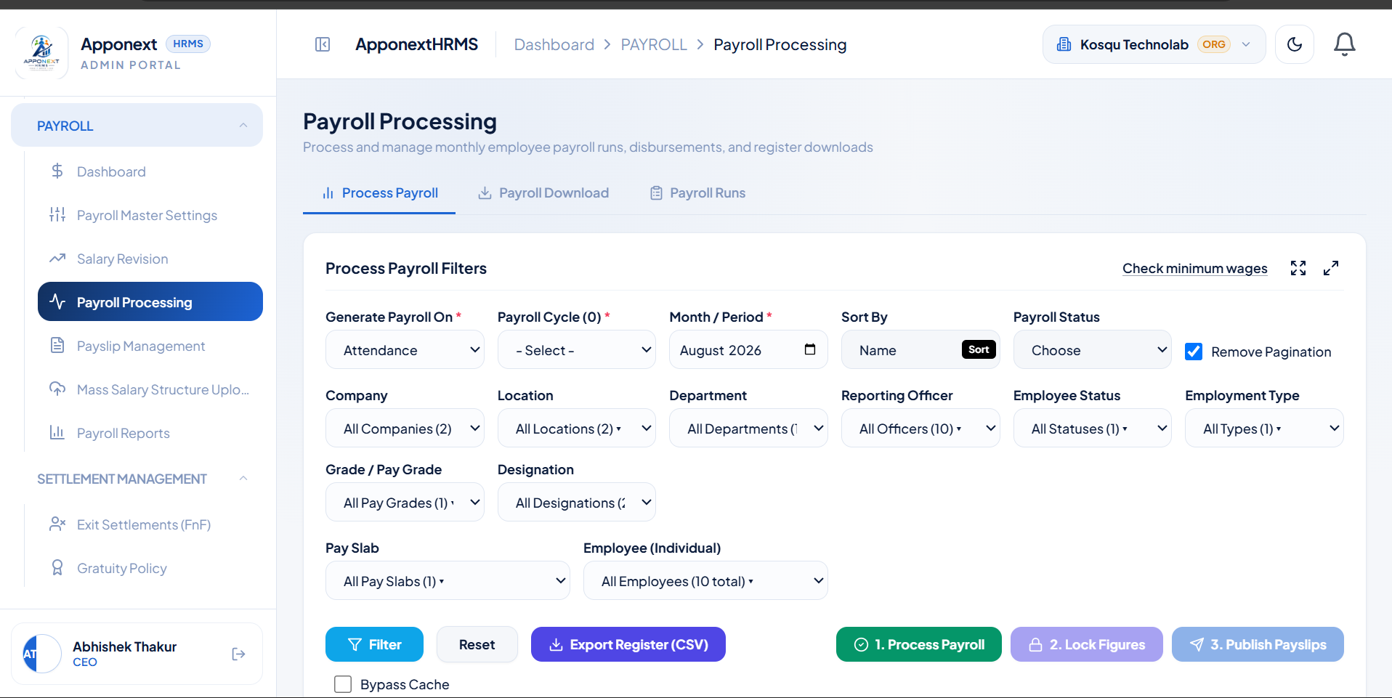

B1. Payroll Cycle
TC-B1-01 Open / view an existing Payroll Cycle record
Expected Result | Edit form loads and displays the correct existing cycle values.
Actual Result | Form loaded correctly with the existing cycle’s values populated.
Status | Pass
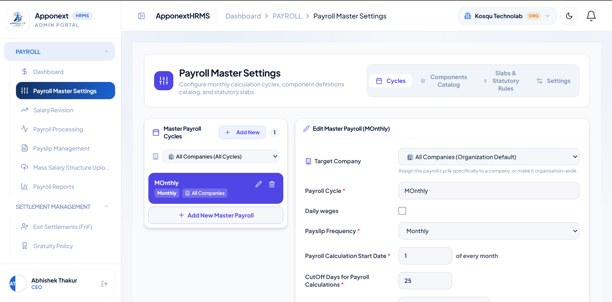

TC-B1-02 Create a new Payroll Cycle
Expected Result | Cycle is created and a success confirmation is shown.
Actual Result | "Cycle Saved" toast displayed; new cycle appeared in the cycle list.
Status | Pass
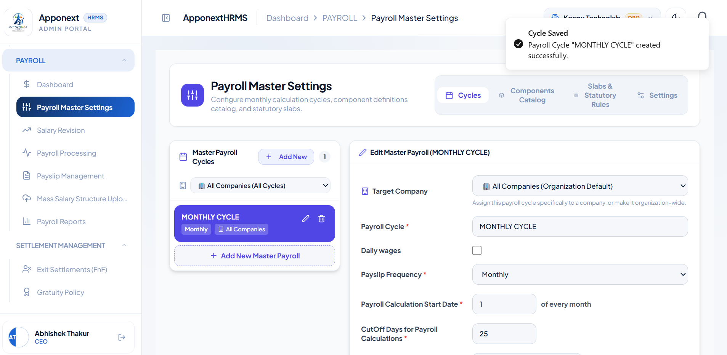

TC-B1-03 Update an existing Payroll Cycle
Expected Result | Cycle updates and a success confirmation is shown.
Actual Result | "Cycle Updated" toast displayed.
Status | Pass
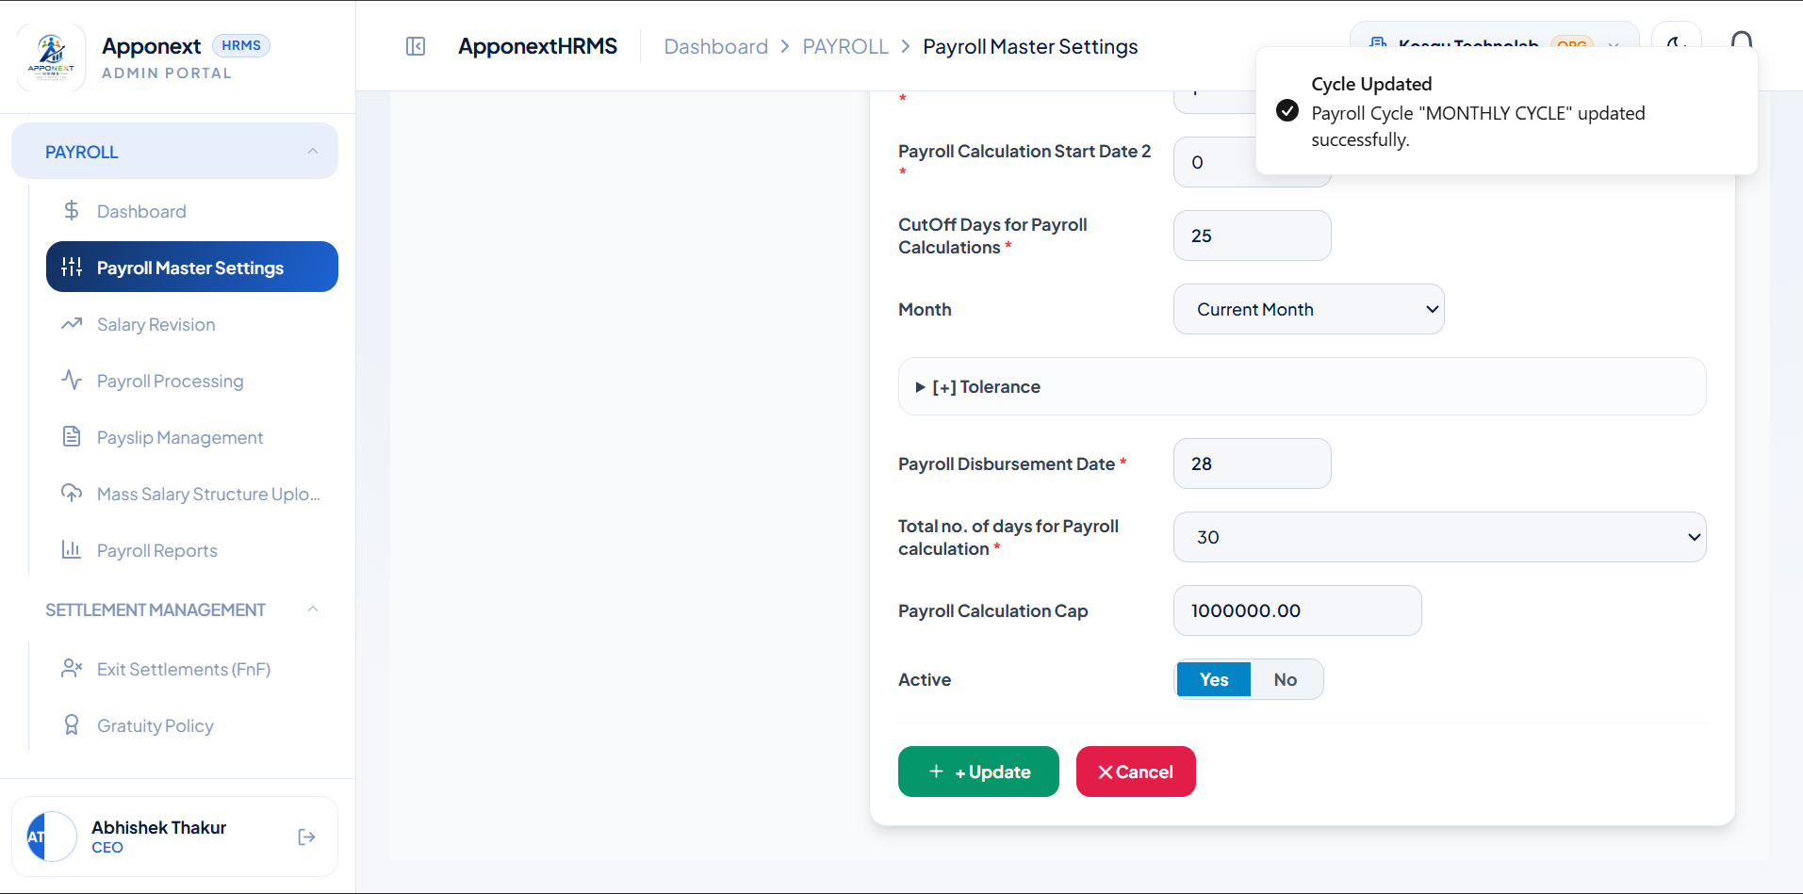

TC-B1-04 Delete a Payroll Cycle
Expected Result | Cycle is removed and a success confirmation is shown.
Actual Result | "Cycle Deleted" toast displayed; cycle list returned to 0 records.
Status | Pass
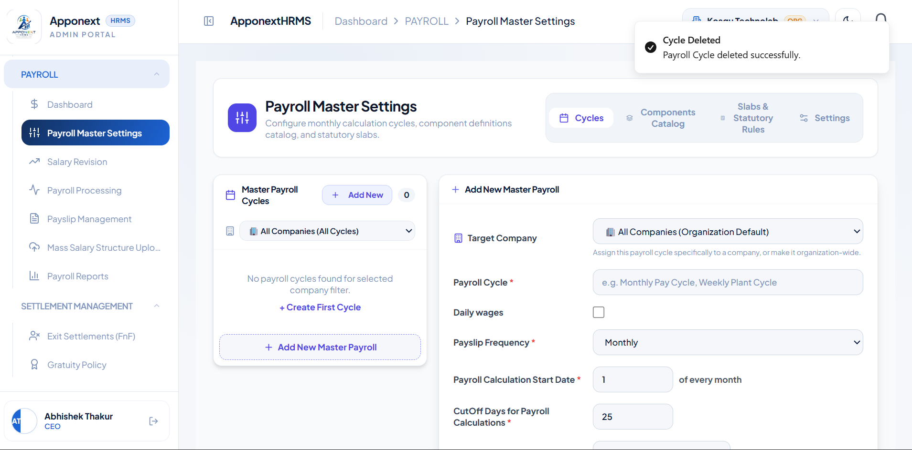

B2. Payroll Component Catalog — Earning Group
TC-B2-01 Create an Earning Component Group
Expected Result | Group is created and a success confirmation is shown.
Actual Result | "Group Created" toast displayed for the new group.
Status | Pass
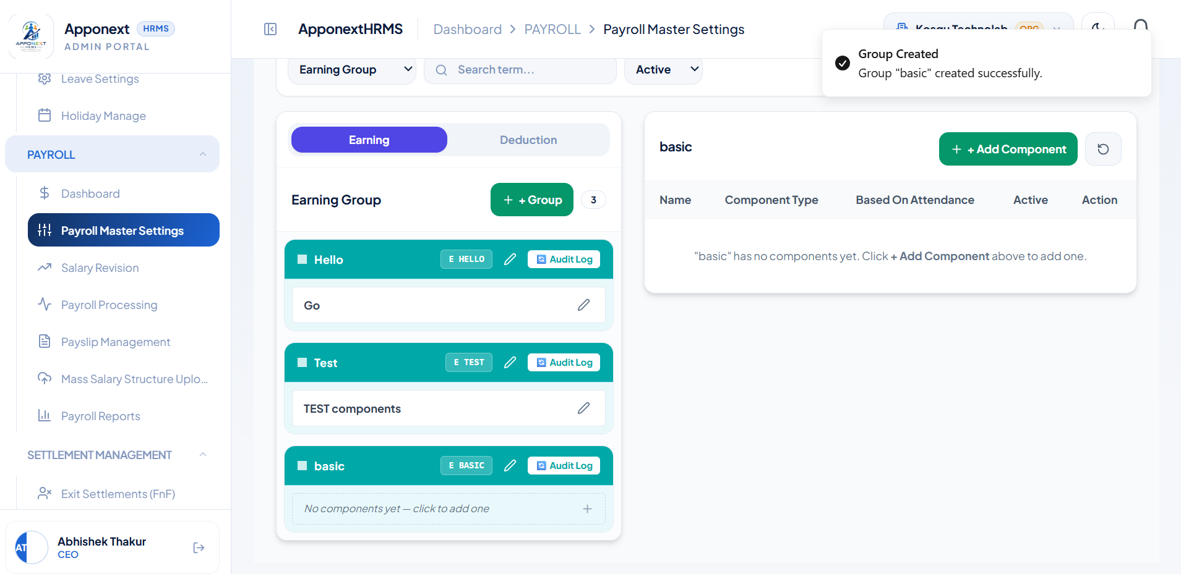

TC-B2-02 Create a Component inside the Earning Group
Expected Result | Component is created and a success confirmation is shown.
Actual Result | "Component Created" toast displayed ("basic salary").
Status | Pass
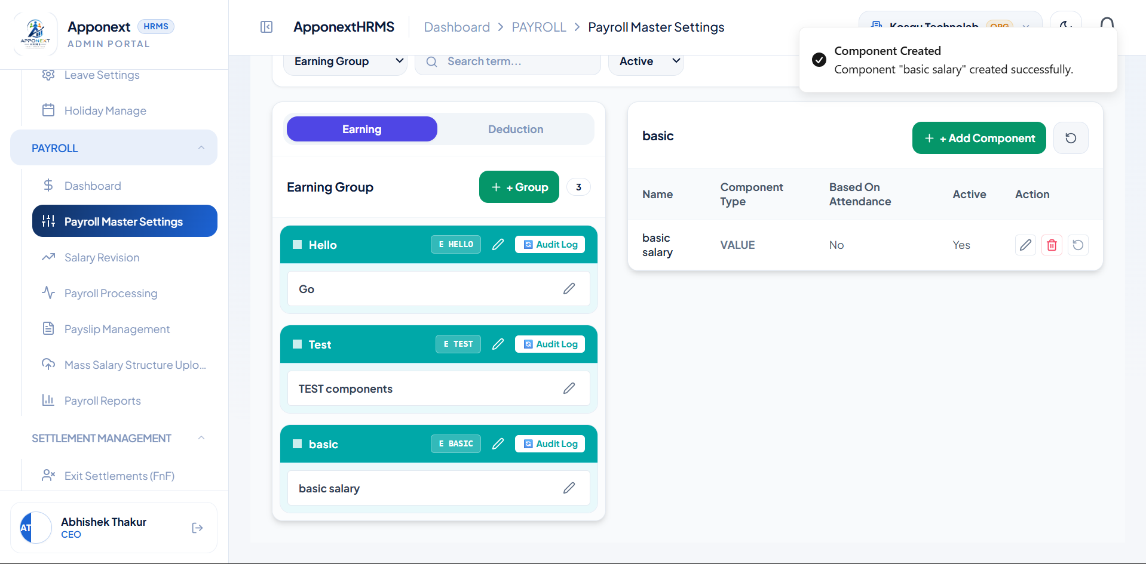

TC-B2-03 Update a Component in the Earning Group
Expected Result | Component updates and a success confirmation is shown.
Actual Result | "Component Updated" toast displayed.
Status | Pass
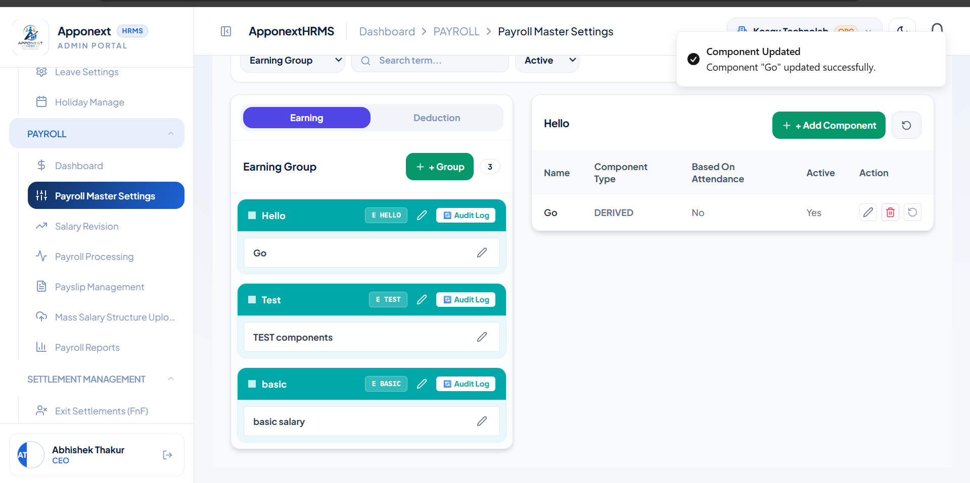

TC-B2-04 Delete a Component in the Earning Group
Expected Result | Component is removed and a success confirmation is shown.
Actual Result | "Component Deleted" toast displayed.
Status | Pass
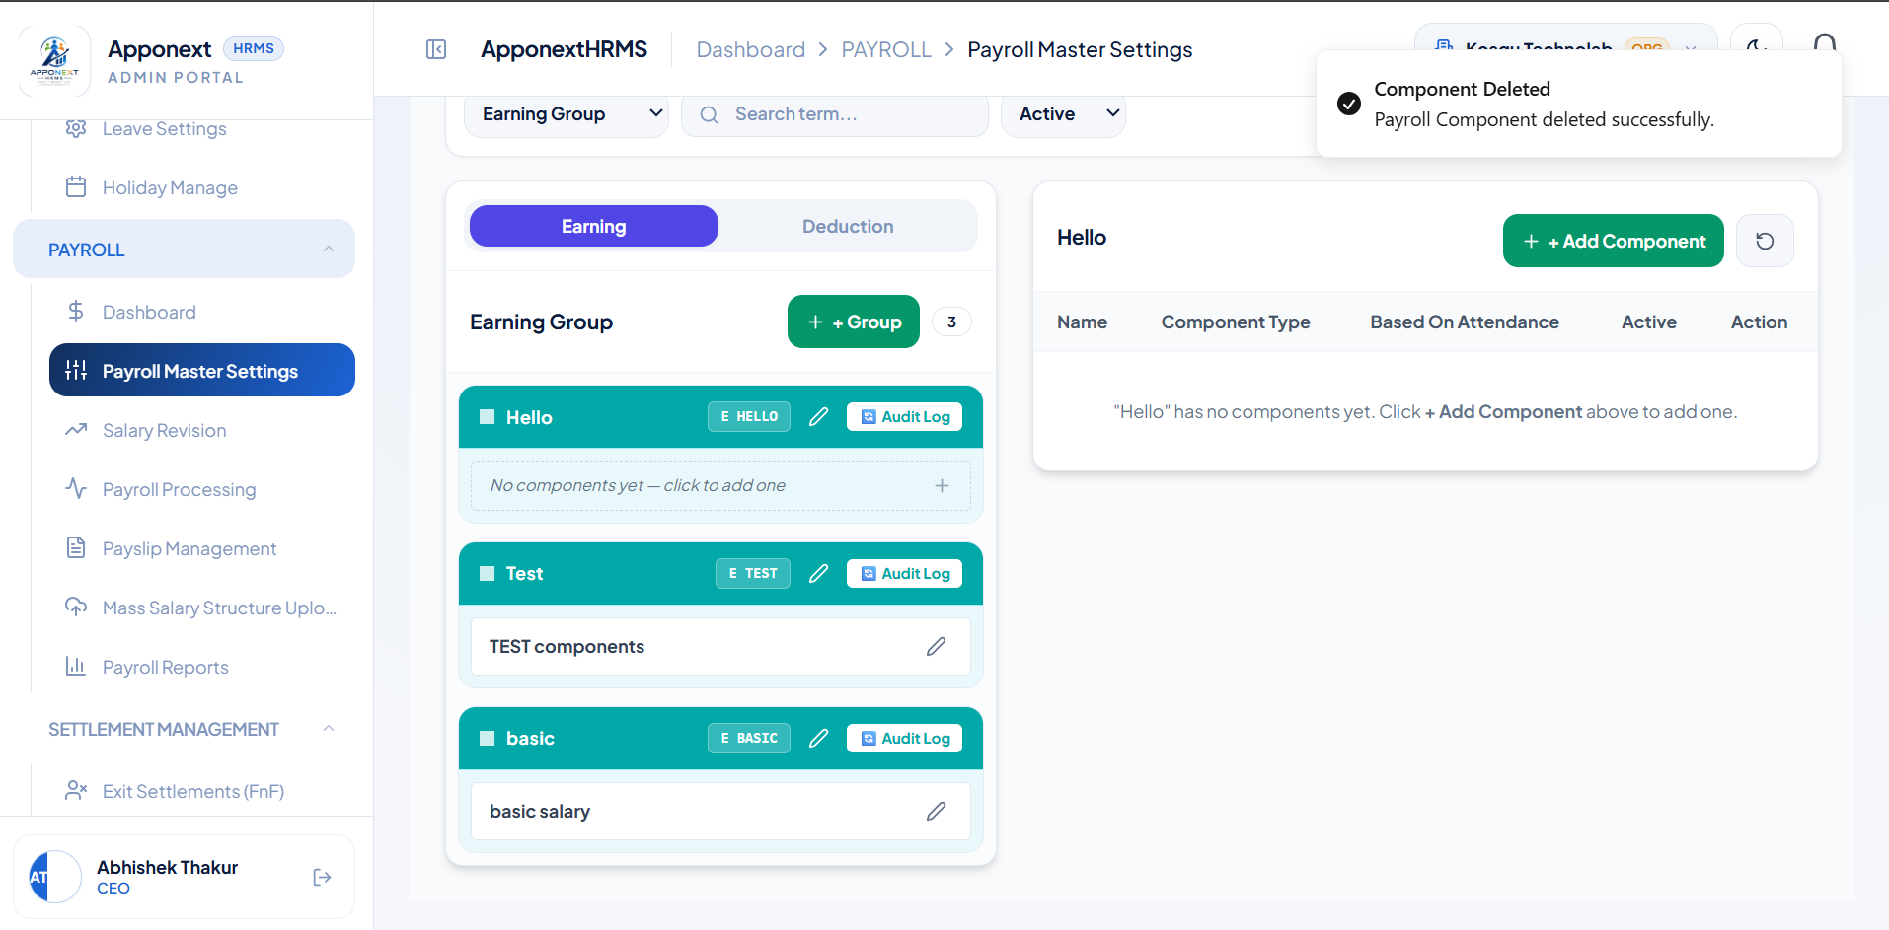

TC-B2-05 Open a blank "Add New Group" form
Expected Result | Form opens empty and ready for input.
Actual Result | Form opened correctly with all fields blank/default.
Status | Pass
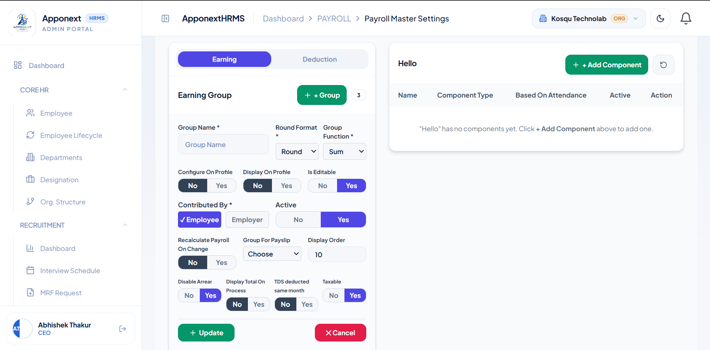

B2. Payroll Component Catalog — Deduction Group
TC-B2-06 Create a Deduction Component Group
Expected Result | Group is created and a success confirmation is shown.
Actual Result | "Group Created" toast displayed — Group "tax" created successfully.
Status | Pass
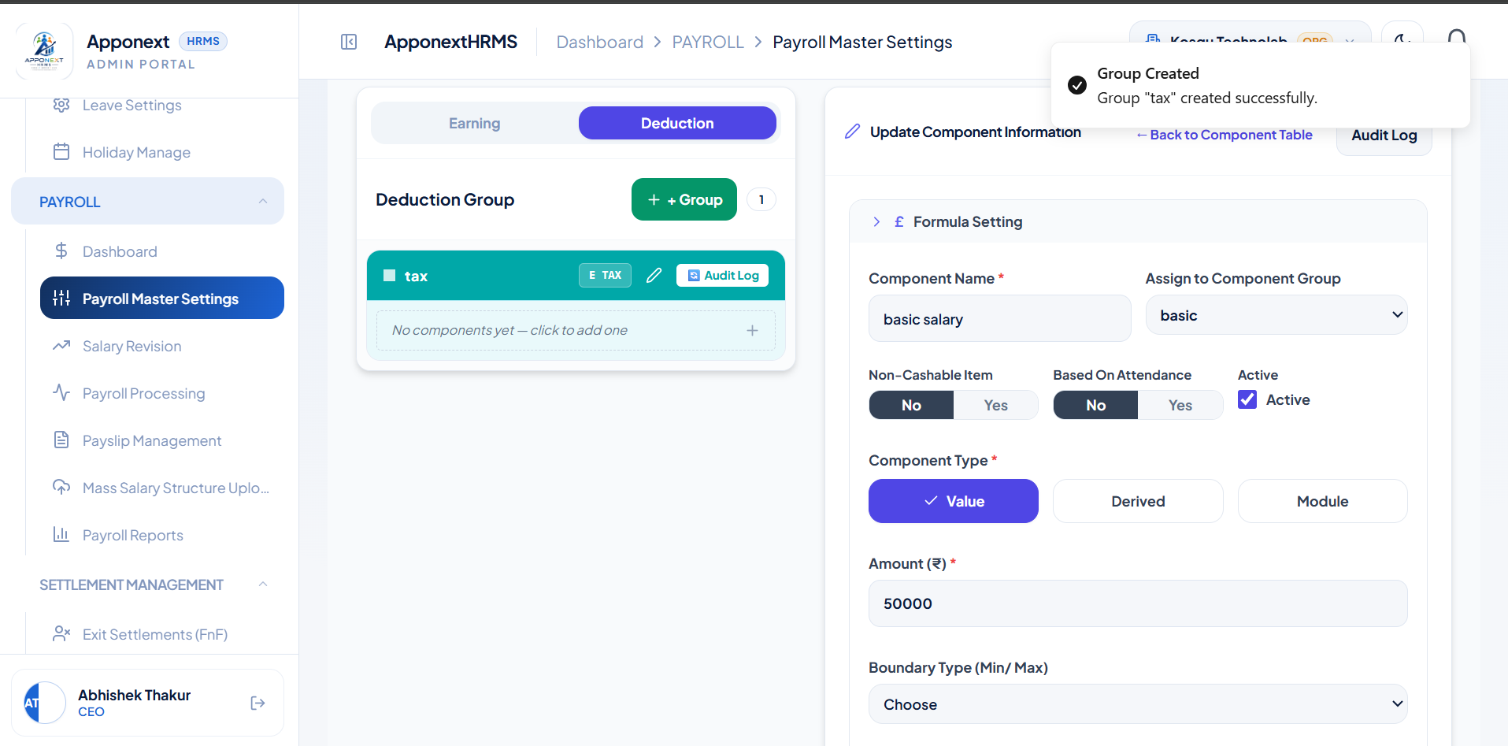

TC-B2-07 Create a Component inside the Deduction Group
Expected Result | Component is created and a success confirmation is shown.
Actual Result | "Component Created" toast displayed — Component "tax cuts" created successfully.
Status | Pass
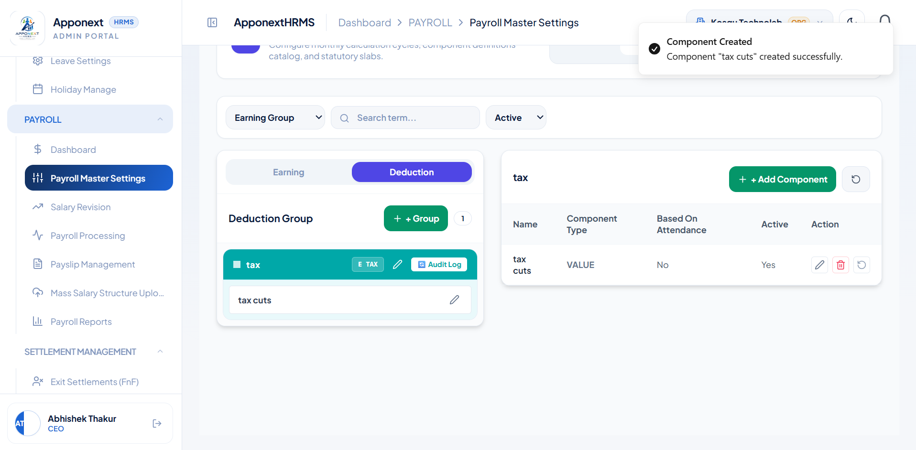

TC-B2-08 Update a Component’s type (Value → Derived) in the Deduction Group
Expected Result | Component updates and a success confirmation is shown; table reflects new type.
Actual Result | "Component Updated" toast displayed; table correctly shows type changed to DERIVED.
Status | Pass
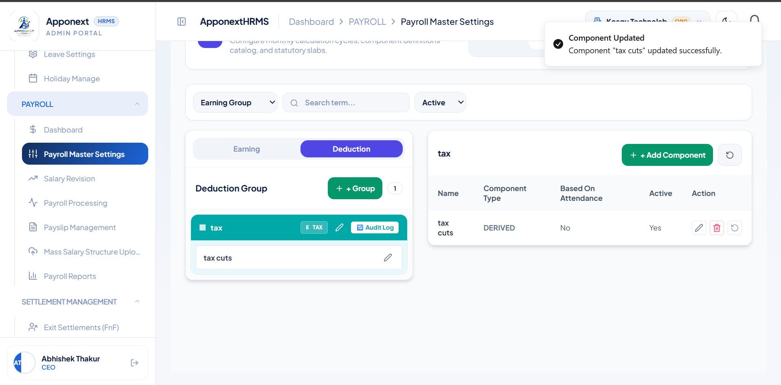

TC-B2-09 Delete a Component in the Deduction Group
Expected Result | Component is removed from the table and a success confirmation is shown.
Actual Result | "Component Deleted" toast displayed, but the "tax cuts" row is still visible in the table on the right — the list does not refresh immediately after deletion.
Status | Fail
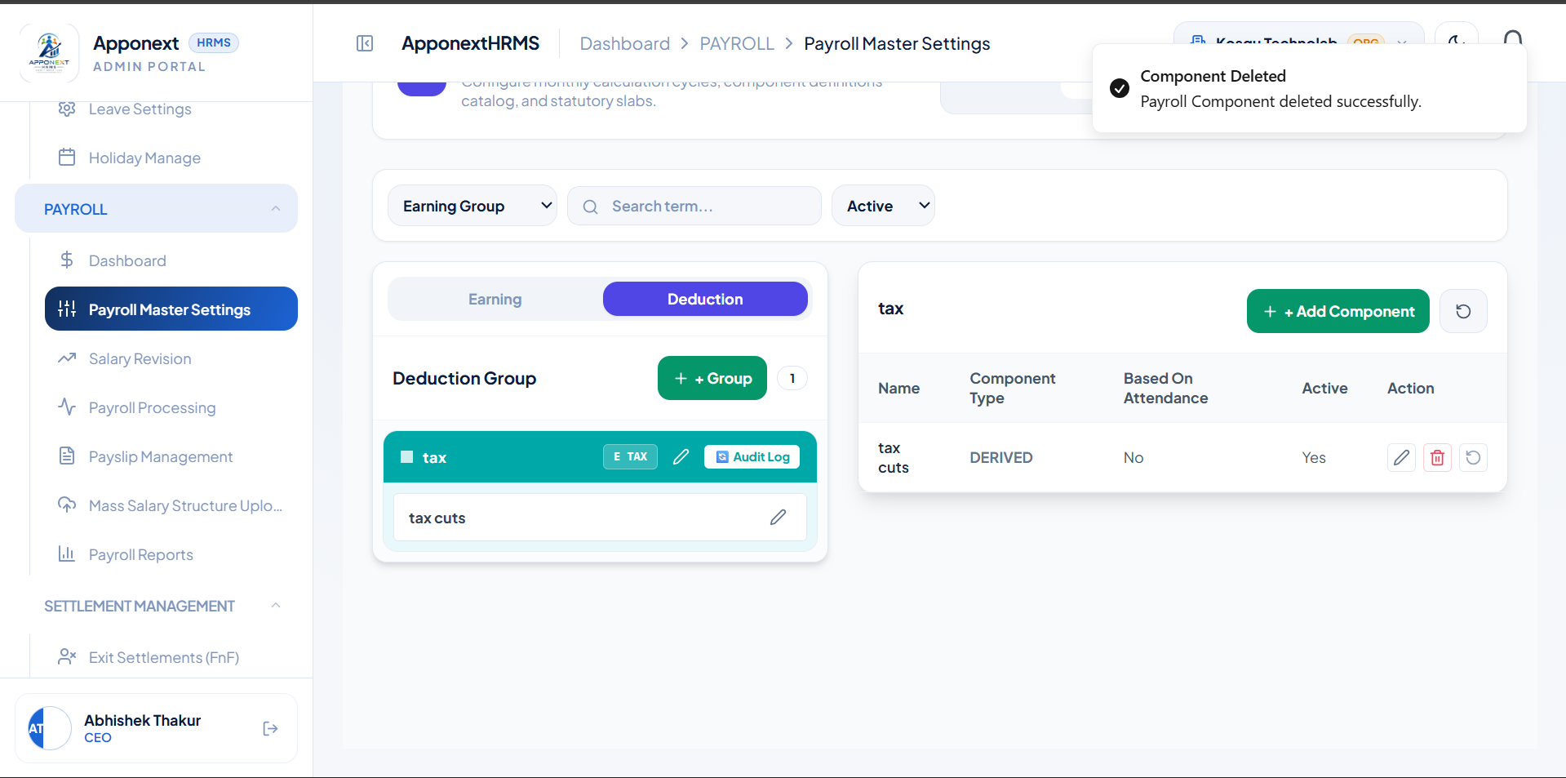

B3. Payroll Slab
TC-B3-01 Create a Payroll Slab
Expected Result | Slab is created and a success confirmation is shown.
Actual Result | "Slab Saved" toast displayed for the "monthly" slab (CTC range ₹50,000–₹22,00,001).
Status | Pass
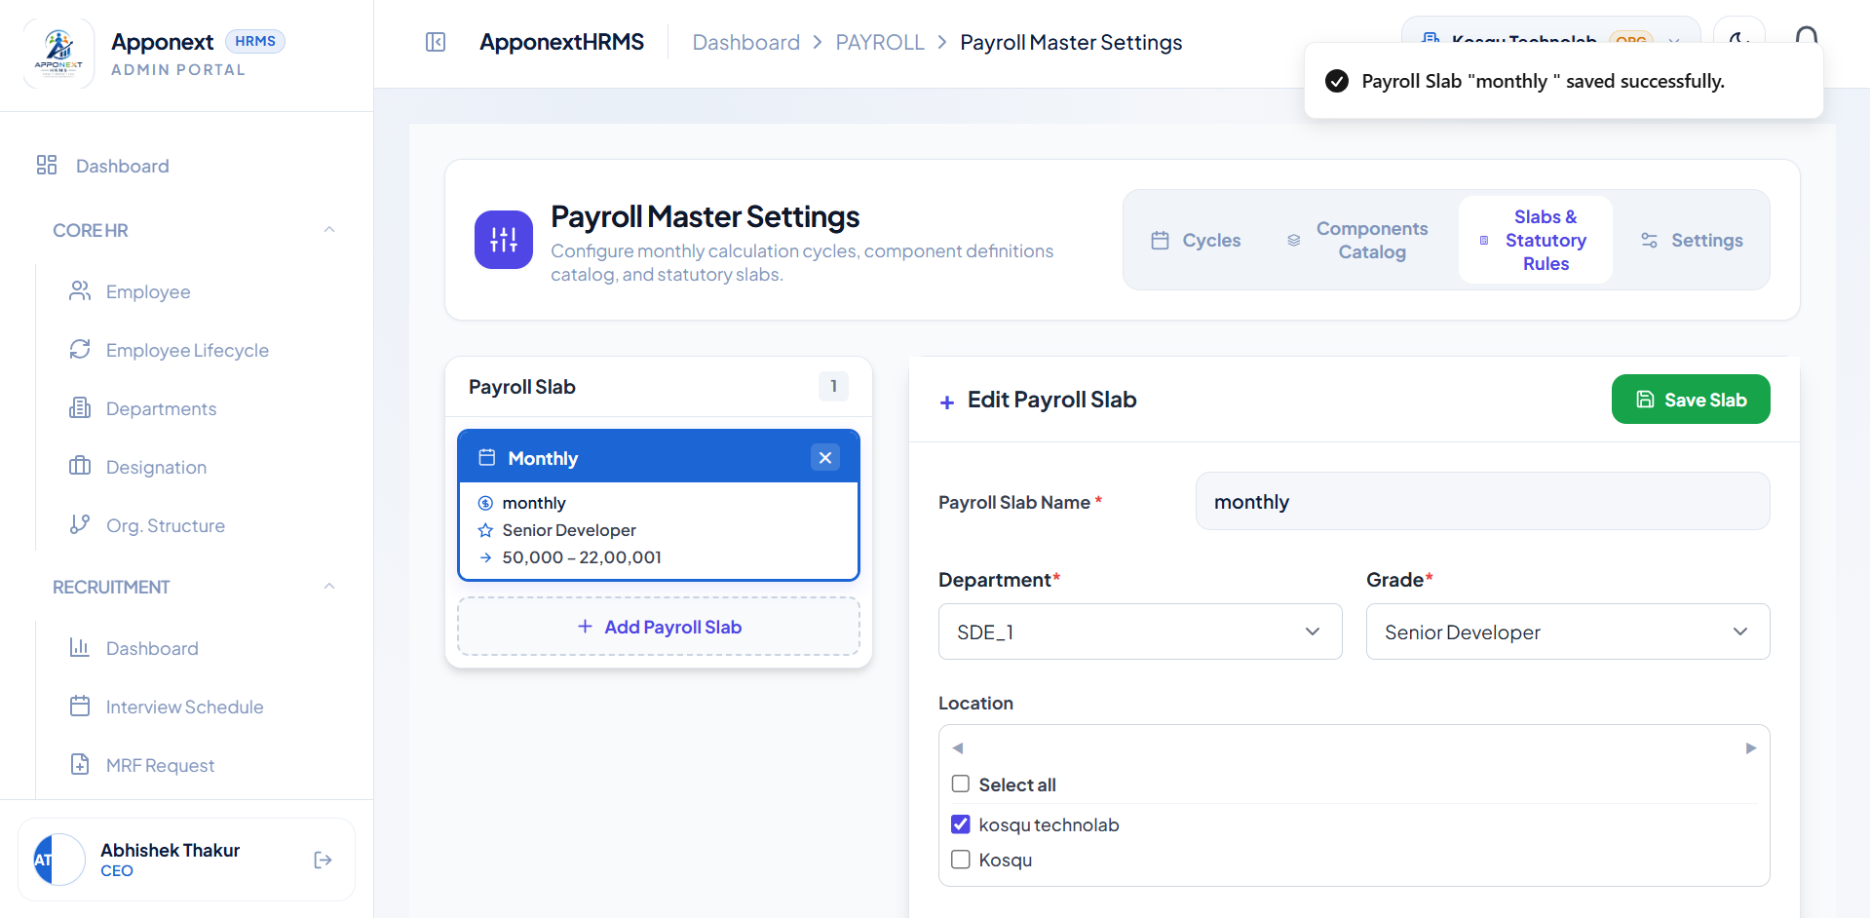

TC-B3-02 Update a Payroll Slab
Expected Result | Slab updates and a success confirmation is shown; changed values reflect in the list.
Actual Result | "Slab Updated" toast displayed; CTC max range correctly changed to ₹18,10,001.
Status | Pass
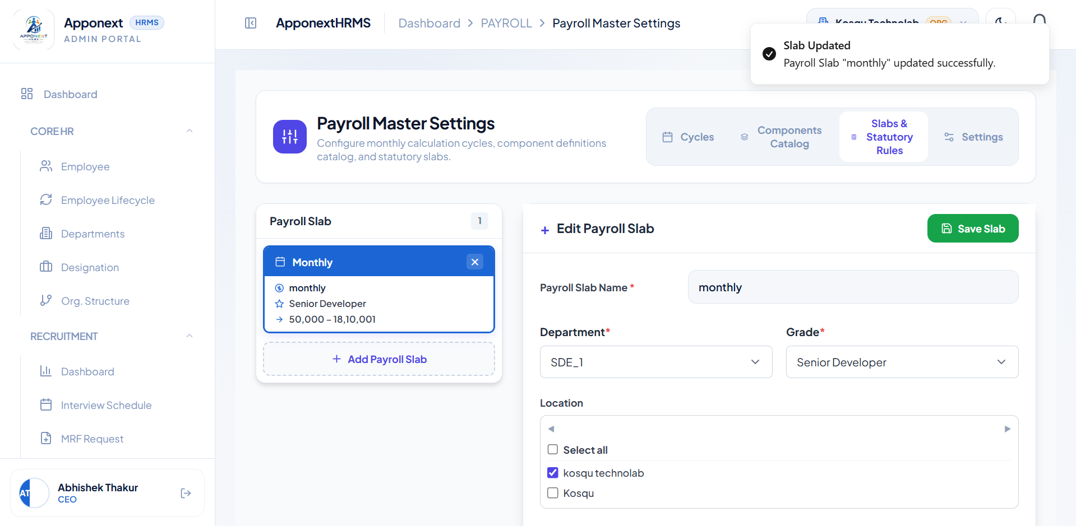

TC-B3-03 Delete a Payroll Slab
Expected Result | Slab is removed and a success confirmation is shown.
Actual Result | "Slab Deleted" toast displayed; form reset to empty "Add Payroll Slab" state.
Status | Pass
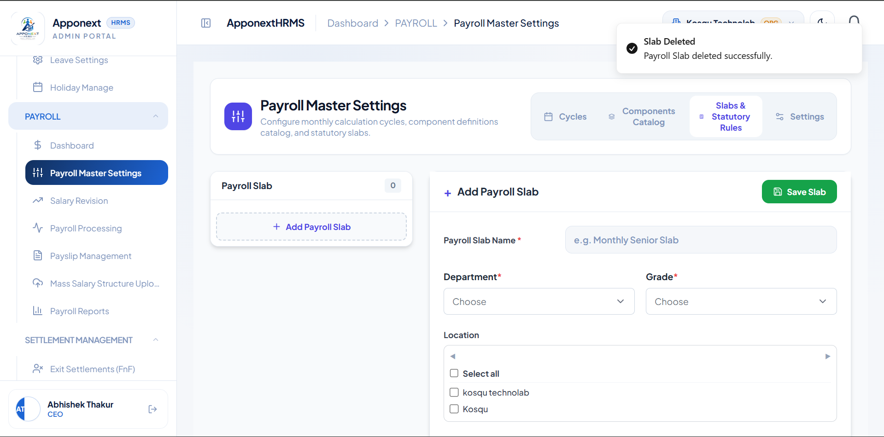

B4. Payroll Settings
TC-B4-01 Load Payroll Settings tab (clean state)
Expected Result | Settings load with Save button disabled until a change is made.
Actual Result | Settings loaded correctly; "Save Settings" button greyed out with no pending changes.
Status | Pass
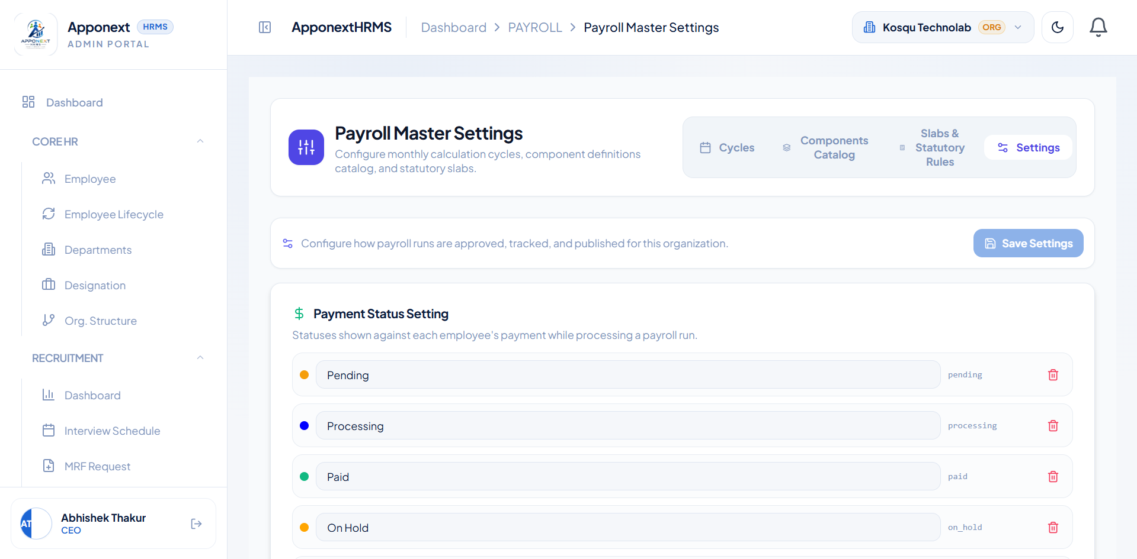

TC-B4-02 Edit Payslip Setting fields (mid-edit state)
Expected Result | "Unsaved changes" indicator appears while editing, before save.
Actual Result | "Unsaved changes" badge correctly appeared while toggles/fields were being edited.
Status | Pass
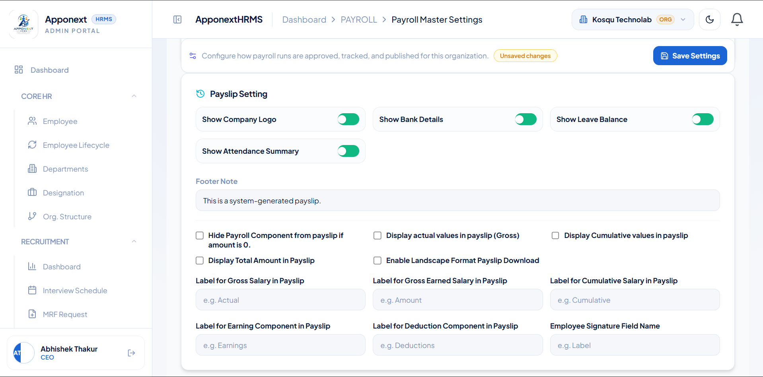

C. Salary Revision
TC-C01 Load Salary Revision page (clean state)
Expected Result | Page loads with KPI cards at 0 and an empty register.
Actual Result | Loaded correctly — Pending/Approved/Total all 0, "No salary revision requests recorded yet."
Status | Pass
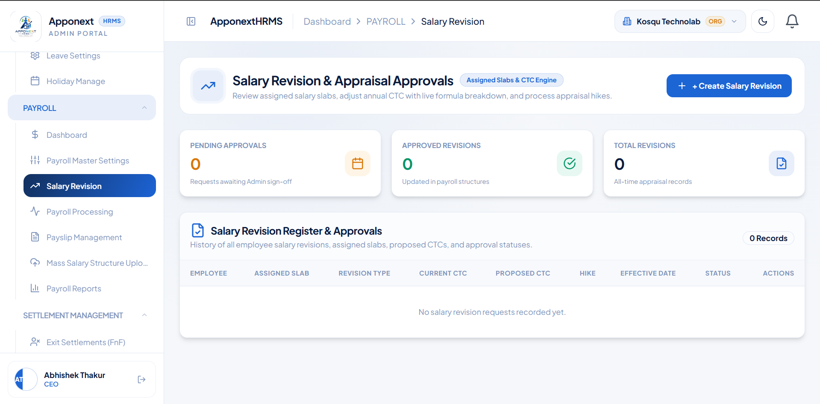

TC-C02 Fill Create Salary Revision form and verify live CTC breakdown
Expected Result | Basic/HRA/Special Allowance/Net Take-Home recalculate correctly for the entered hike.
Actual Result | Correctly recalculated: ₹6,00,000 → +15% → ₹6,90,000/yr, with Current vs Proposed breakdown matching (Basic 50%, HRA 40% of Basic, Special Allowance, PF & PT deductions, Net Take-Home).
Status | Pass
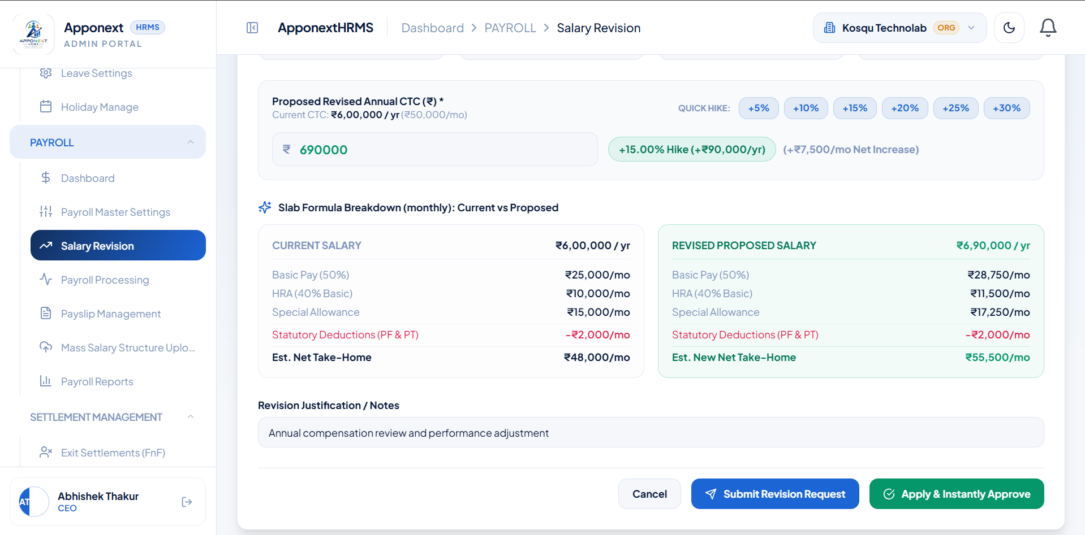

TC-C03 Submit a Salary Revision Request (Admin)
Expected Result | Request appears in the register with "Pending Review" status; KPI counts update.
Actual Result | Register correctly shows Aaqib Sheikh with Pending Review status; Pending Approvals = 1, Total Revisions = 1.
Status | Pass
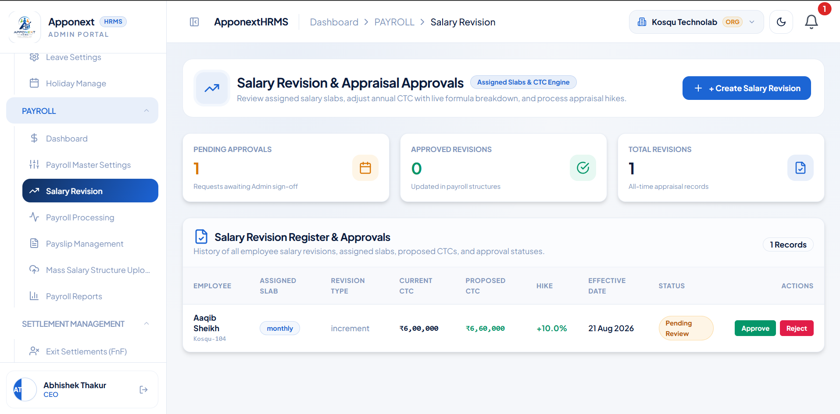

TC-C04 Approve a pending Salary Revision
Expected Result | Approve action completes with a success confirmation.
Actual Result | "Salary revision for Aaqib Sheikh approved successfully!" toast displayed.
Status | Pass
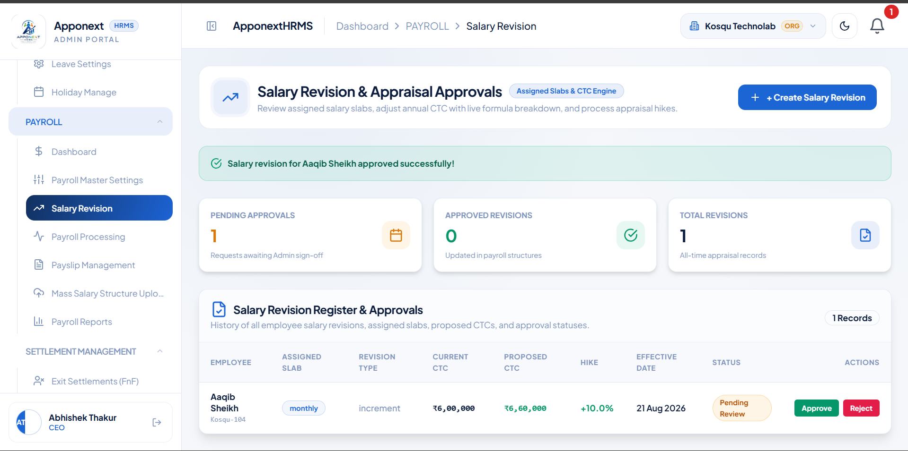

TC-C05 Reject a pending Salary Revision
Expected Result | Reject action completes with a success confirmation; status and KPI counts update.
Actual Result | "Salary revision for Pranali Patil rejected." toast displayed; status correctly changed to "Rejected / Completed"; Pending Approvals count updated from 2 to 1.
Status | Pass
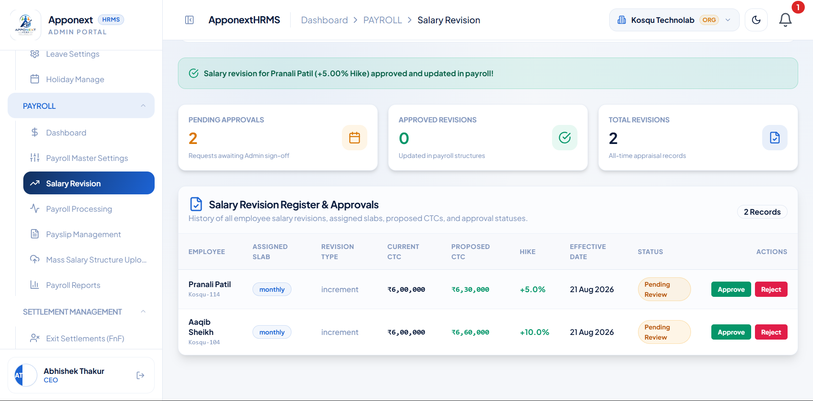

TC-C06 Non-admin (HR) user submits a Salary Revision request
Expected Result | Request should be submitted and become visible for Admin review — either in the HR user’s own register or flagged as pending for the admin.
Actual Result | Toast confirms "Salary revision request for Aaqib Sheikh (+15.00% Hike) submitted for Admin approval," but the Salary Revision Register shows "0 Records" / "No salary revision requests recorded yet." and all KPI cards show 0 immediately after submission — the request is not visible anywhere, including to the submitting HR user.
Status | Fail
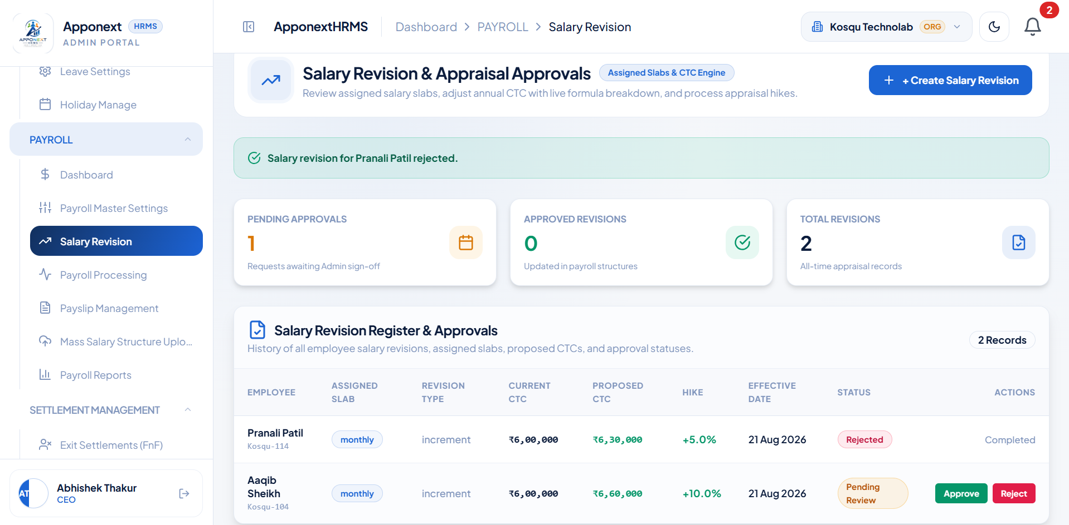

TC-C07 Verify Salary Revision Register after multiple approve/reject actions
Expected Result | All processed requests should be visible with correct statuses and counts.
Actual Result | Register correctly lists all 4 processed requests (2× Aaqib Sheikh, Pranali Patil, +1 more), each showing "Rejected / Completed" with correct CTC and hike values.
Status | Pass
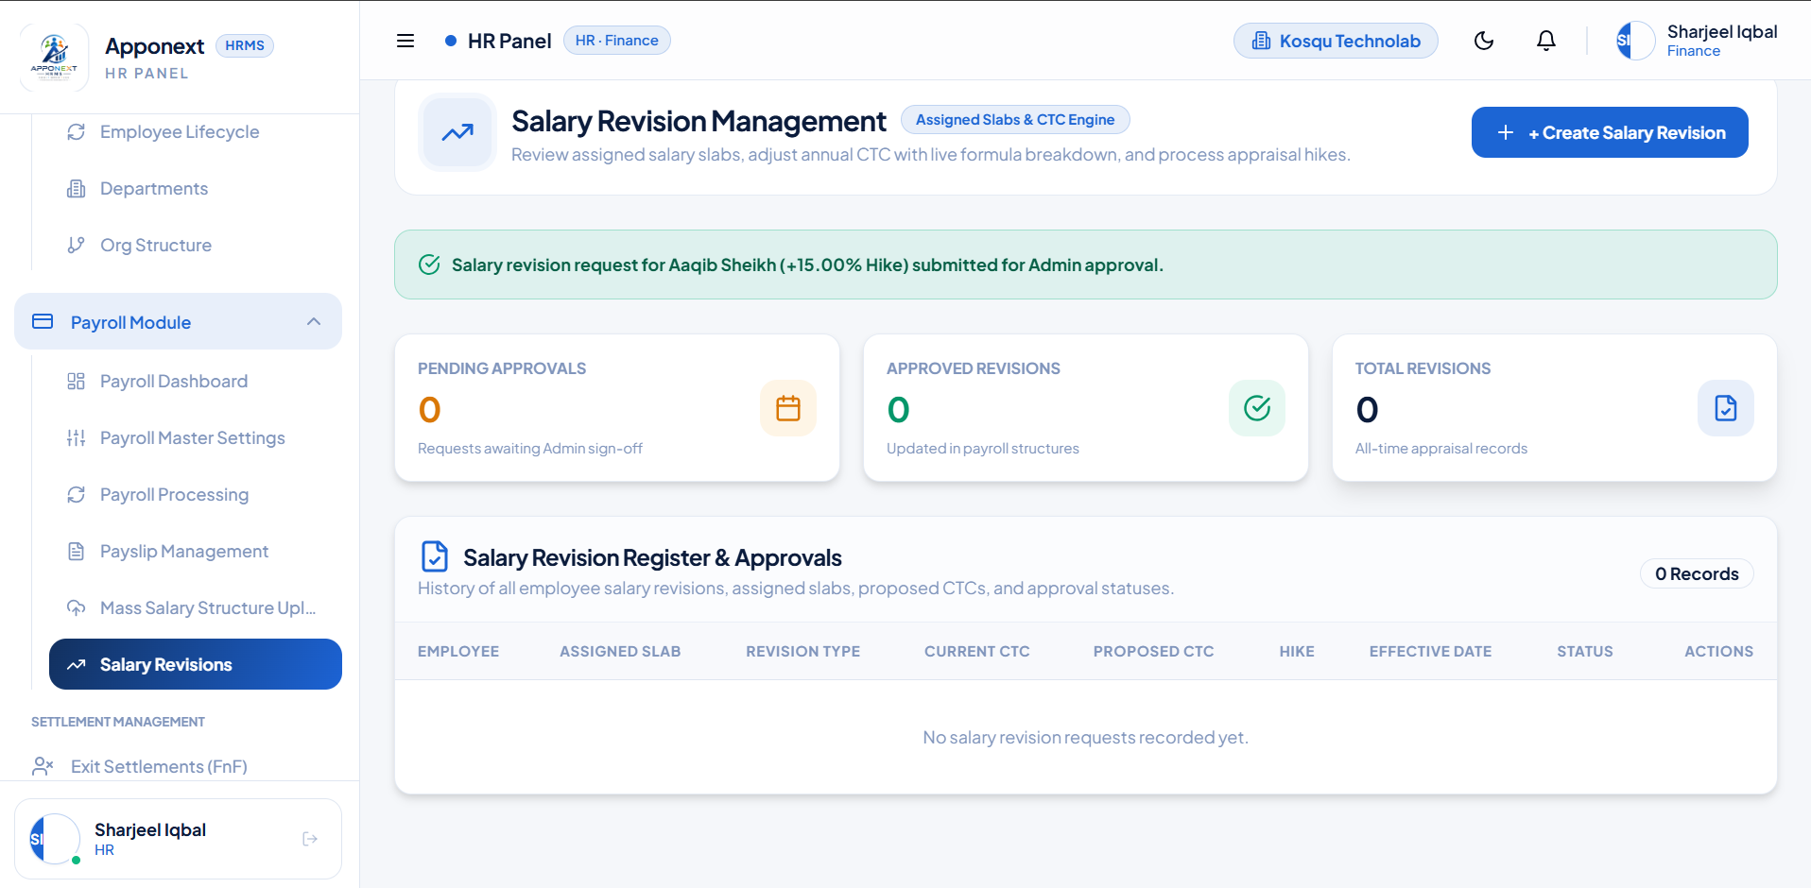

TC-C08 Reload Salary Revision page and re-verify Register persistence
Expected Result | Register data should persist and match the prior state after a fresh page load.
Actual Result | Confirmed on reload — Total Revisions = 4, all records and statuses matched the pre-reload state.
Status | Pass
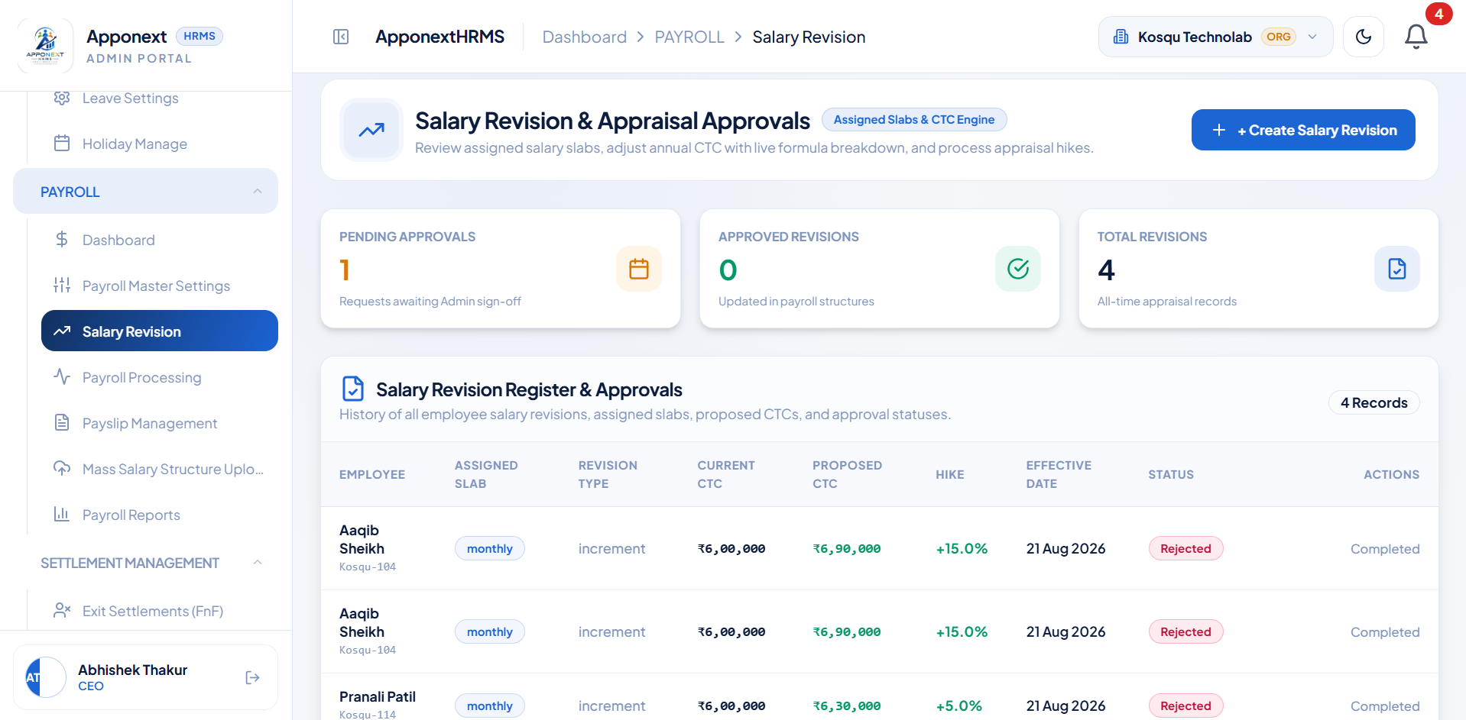

D. Payroll Processing
TC-D01 Open Payroll Processing — Process Payroll filters
Expected Result | Filters load correctly (Cycle, Month, Company, Department, Pay Slab, Employee, etc.).
Actual Result | All filters loaded correctly with real org data (2 Companies, 10 Officers, 10 total Employees, etc.).
Status | Pass
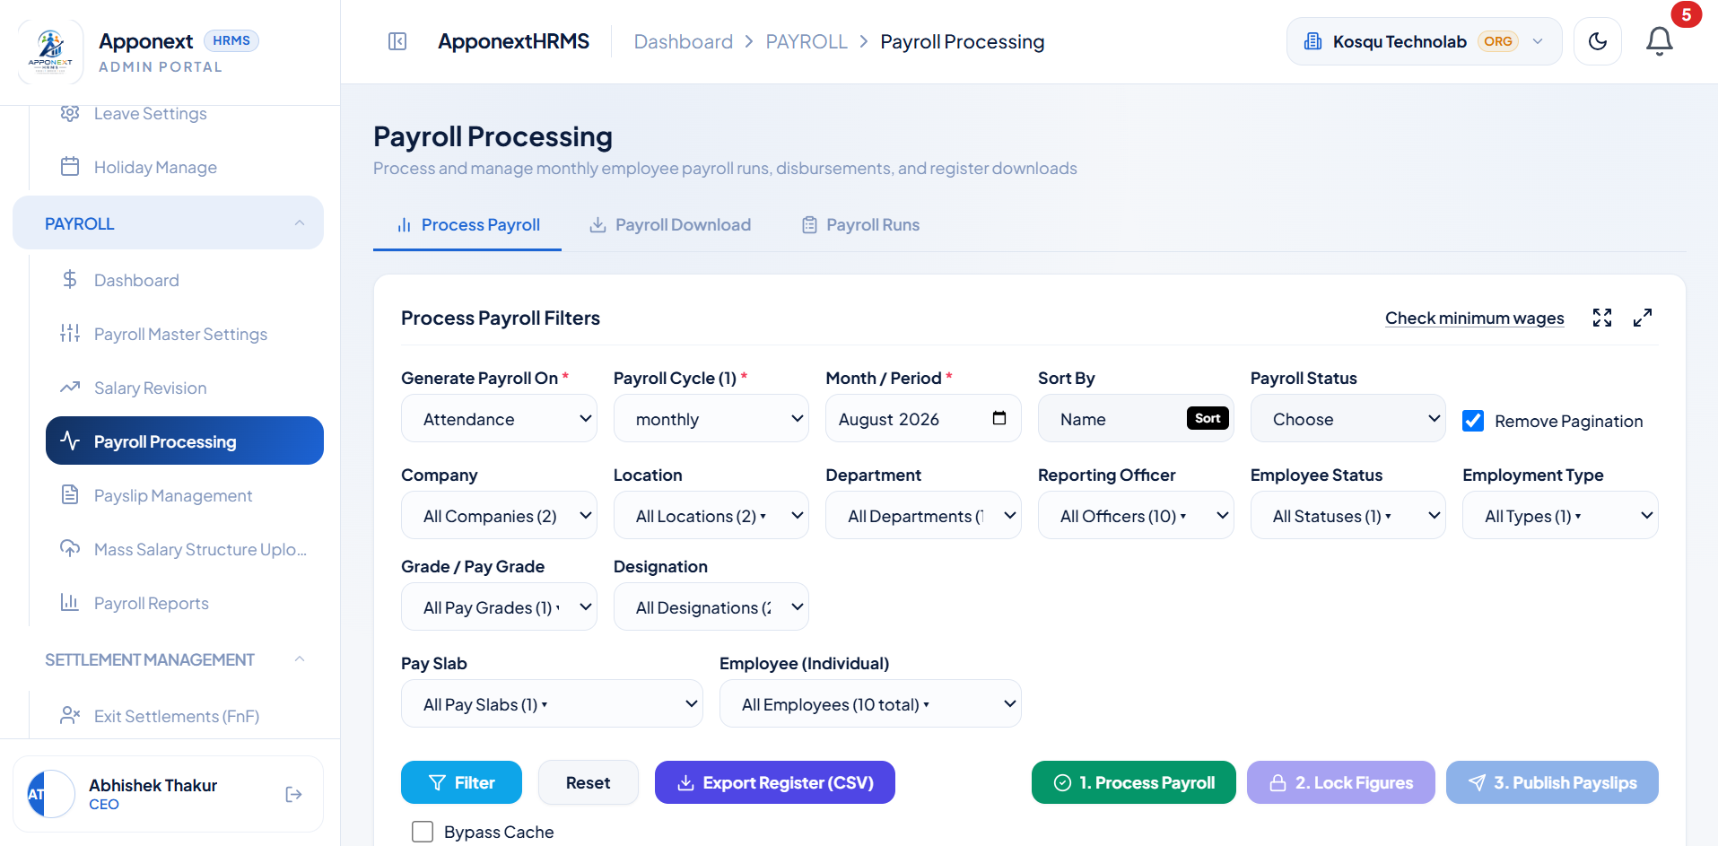

TC-D02 View Payroll Register after filtering (Pay Slab column)
Expected Result | Each employee’s actual assigned monthly slab should be shown.
Actual Result | Every one of the 17 employees shows the same generic "Standard Pay Slab" — a dummy/placeholder value, not each employee’s real assigned slab (e.g. Aaqib Sheikh’s actual "monthly" slab from Salary Revision).
Status | Fail
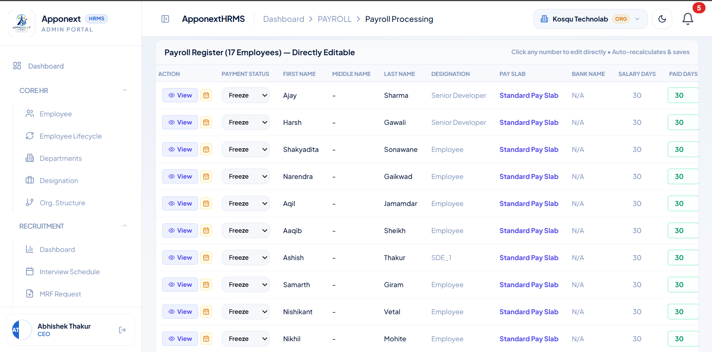

TC-D03 Process Payroll (Step 1)
Expected Result | Payroll calculates successfully with a confirmation to review the register.
Actual Result | "Payroll Processed" toast displayed — "Salaries calculated. Review the register, then lock the figures."
Status | Pass
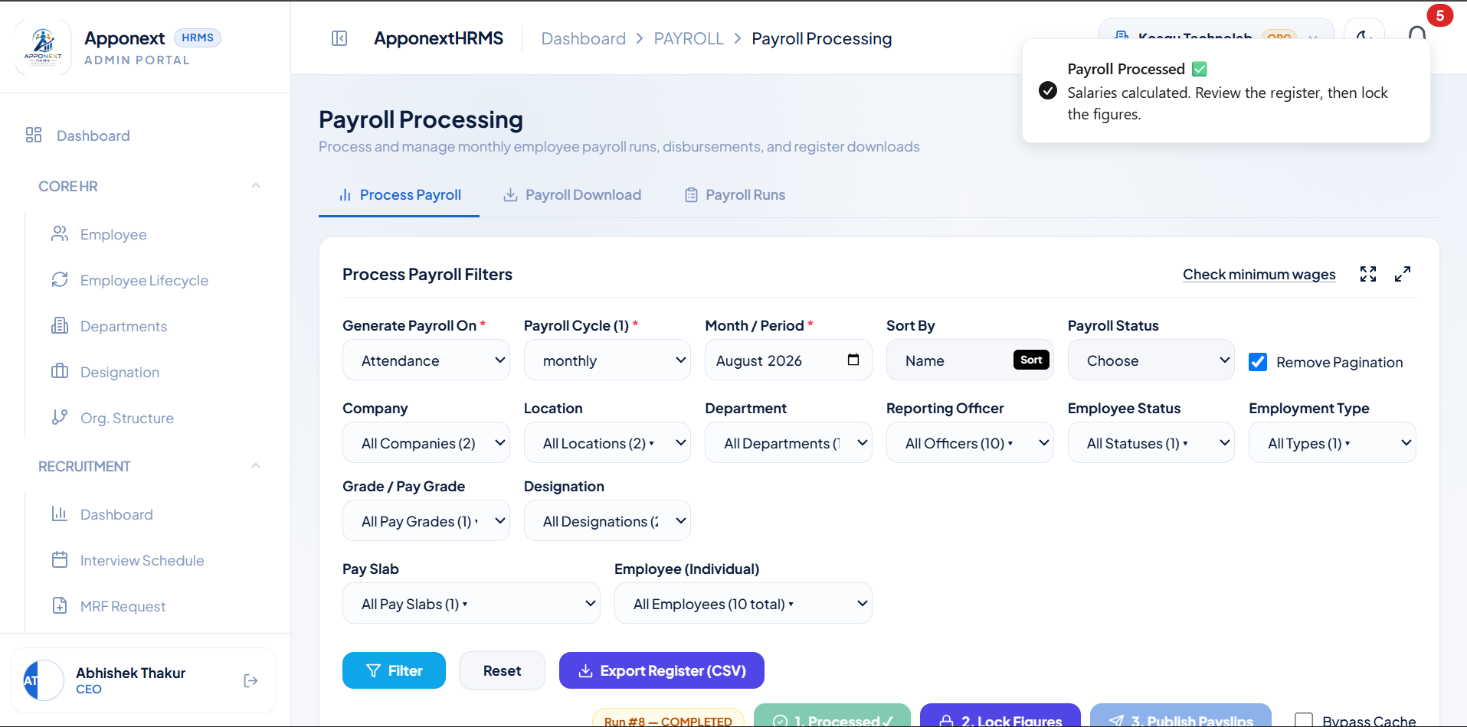

TC-D04 Lock Payroll figures (Step 2)
Expected Result | Figures freeze successfully with a confirmation, ready to publish.
Actual Result | "Payroll Locked" toast displayed — Run #8 shows "1. Processed✓ 2. Locked✓ 3. Publish Payslips."
Status | Pass
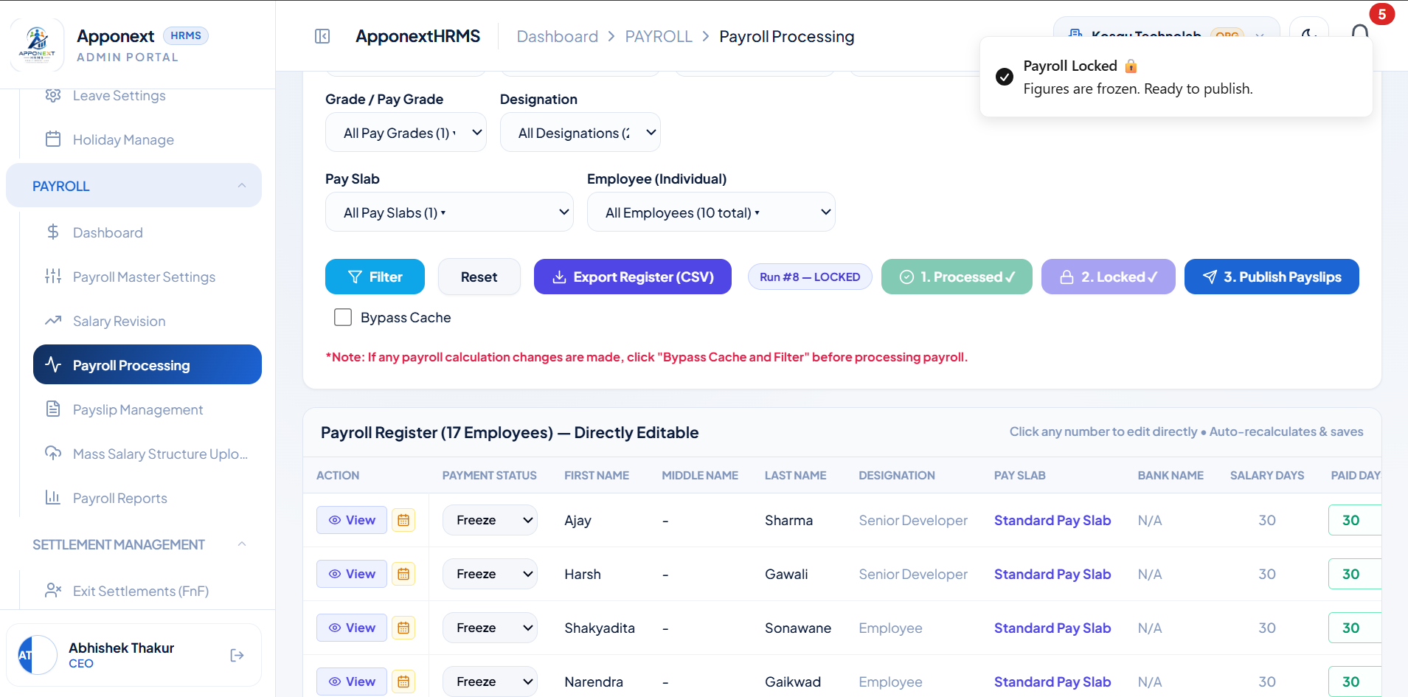

TC-D05 Publish Payslips (Step 3)
Expected Result | Payslips publish successfully and become visible to employees.
Actual Result | "Payslips Published" toast displayed — "Payslips are now visible to employees." Run #8 shows all 3 steps complete.
Status | Pass
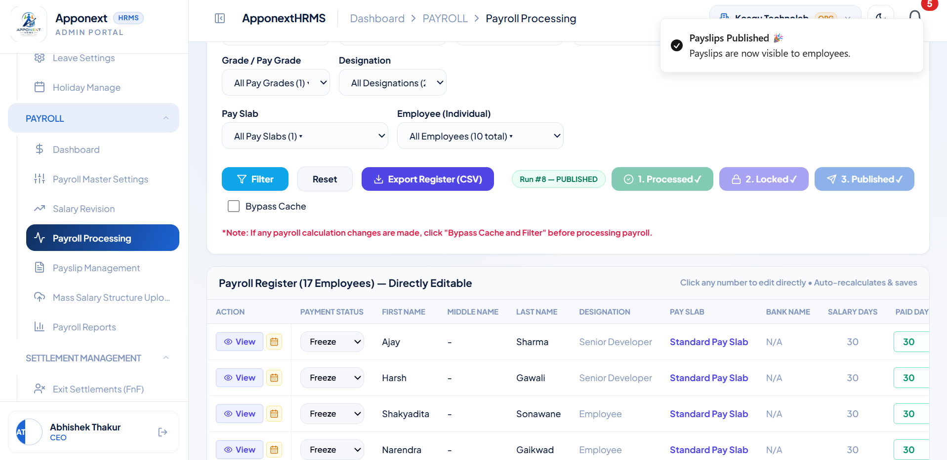

TC-D06 Generate an individual Payslip from a processed run
Expected Result | Payslip preview should show correctly calculated Gross/Deductions/Net figures.
Actual Result | "Payslip Ready" toast confirms generation for Nishikant Vetal, but the "Official Statement" preview modal shows ₹NaN for Earnings & Allowances, Total Statutory Deductions, and Net Monthly Take-Home Pay.
Status | Fail
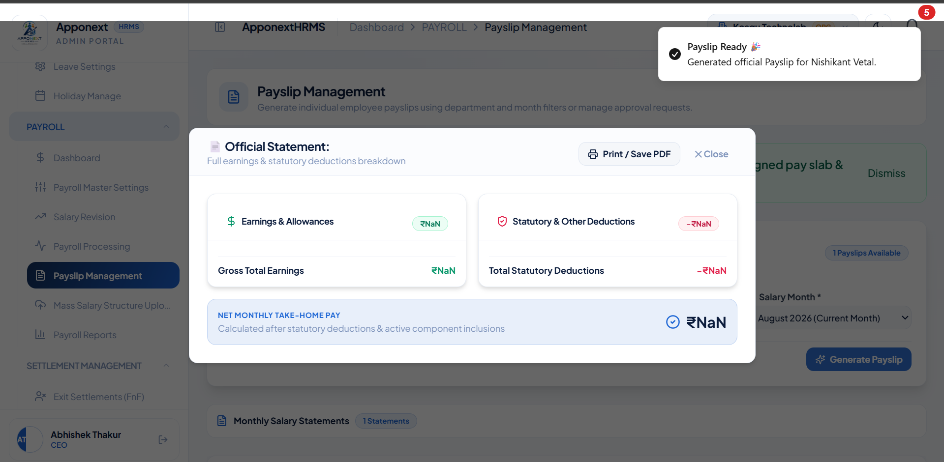

TC-D07 Download / print the generated Payslip as PDF
Expected Result | Downloaded PDF should show correct calculated figures, matching the payroll register.
Actual Result | PDF is correct: Gross Earnings ₹3,537, Statutory Deductions ₹453, Net Take-Home ₹3,084, with a full accurate Basic/HRA/Special Allowance/PF/PT/ESIC breakdown.
Status | Pass
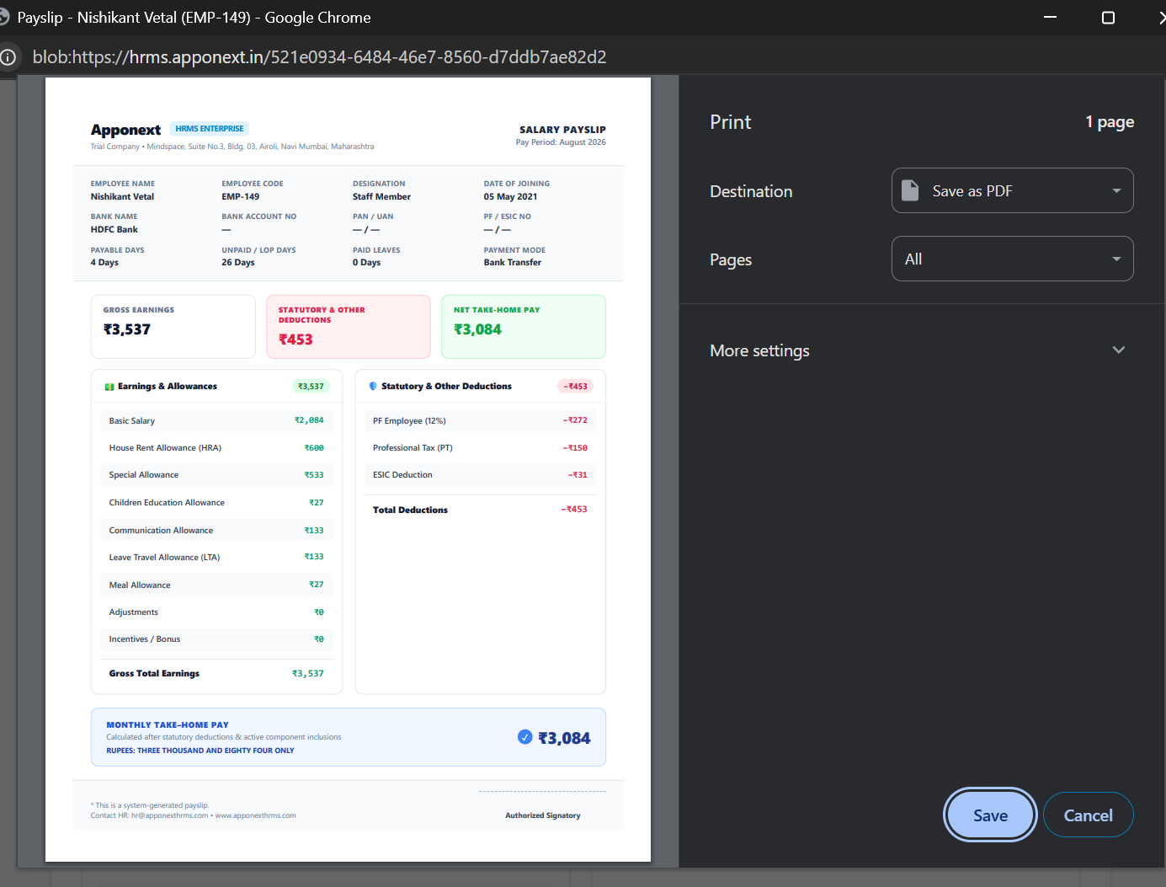

E. Payroll Management (Payslip Management)
TC-E01 View generated payslip in Payslip Management list
Expected Result | Payslip should list with correct Gross/Deductions/Net figures and visibility toggle.
Actual Result | Correctly listed — Nishikant Vetal, PS-202608-149, Gross ₹4,167, Deductions -₹1,108, Net ₹3,059, Visible.
Status | Pass
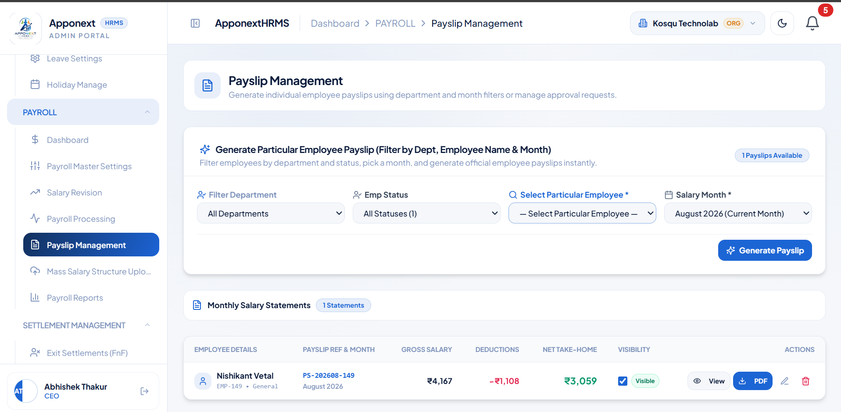

TC-E02 Edit & customize an individual payslip
Expected Result | Edit modal should open pre-filled with the employee’s current payslip figures, editable.
Actual Result | "Edit & Customize Official Payslip" modal opened correctly, pre-filled with employee/bank info and editable earnings/deductions fields.
Status | Pass
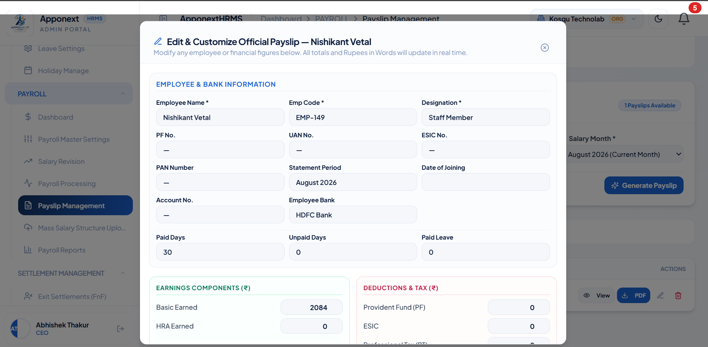

TC-E03 Delete / remove a payslip card
Expected Result | Payslip is removed and a success confirmation is shown.
Actual Result | "Payslip card removed for Nishikant Vetal" toast displayed; count updated to "0 Payslips Available."
Status | Pass
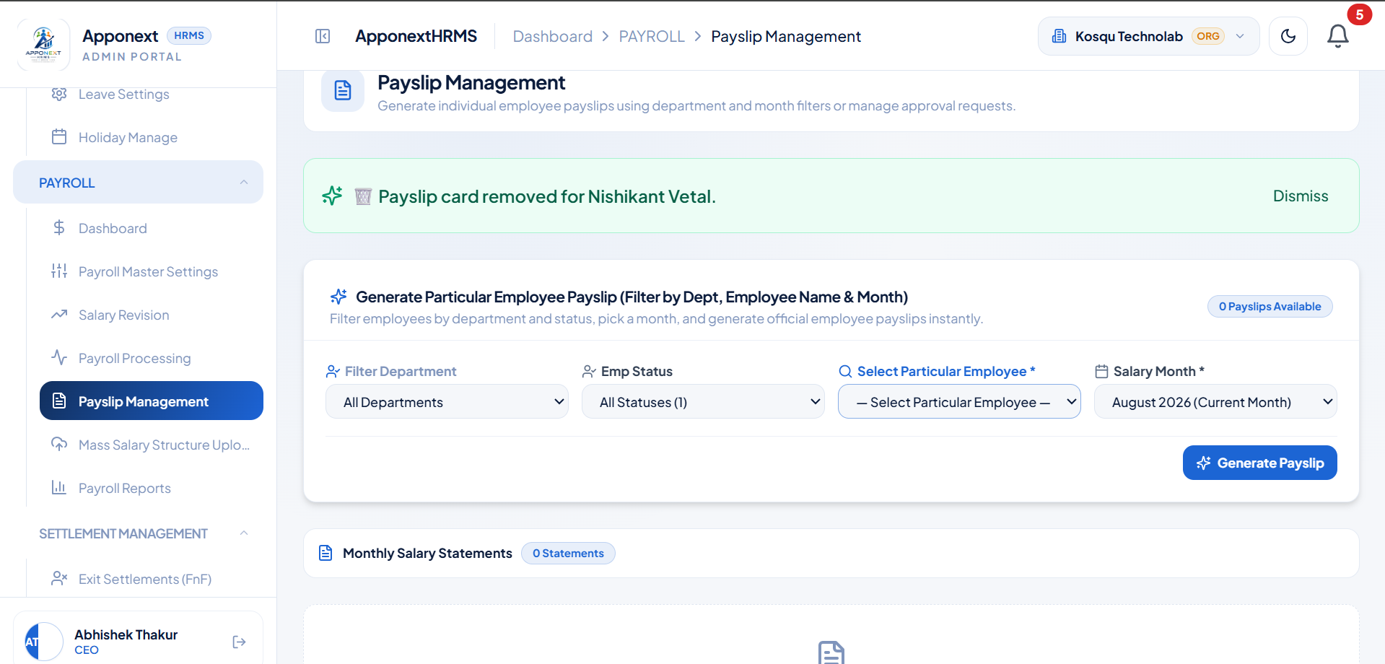

TC-E04 Download Payroll Register as Excel/CSV
Expected Result | File download completes with a success confirmation.
Actual Result | "Download Complete" toast displayed — "Payroll Excel/CSV sheet downloaded successfully."
Status | Pass
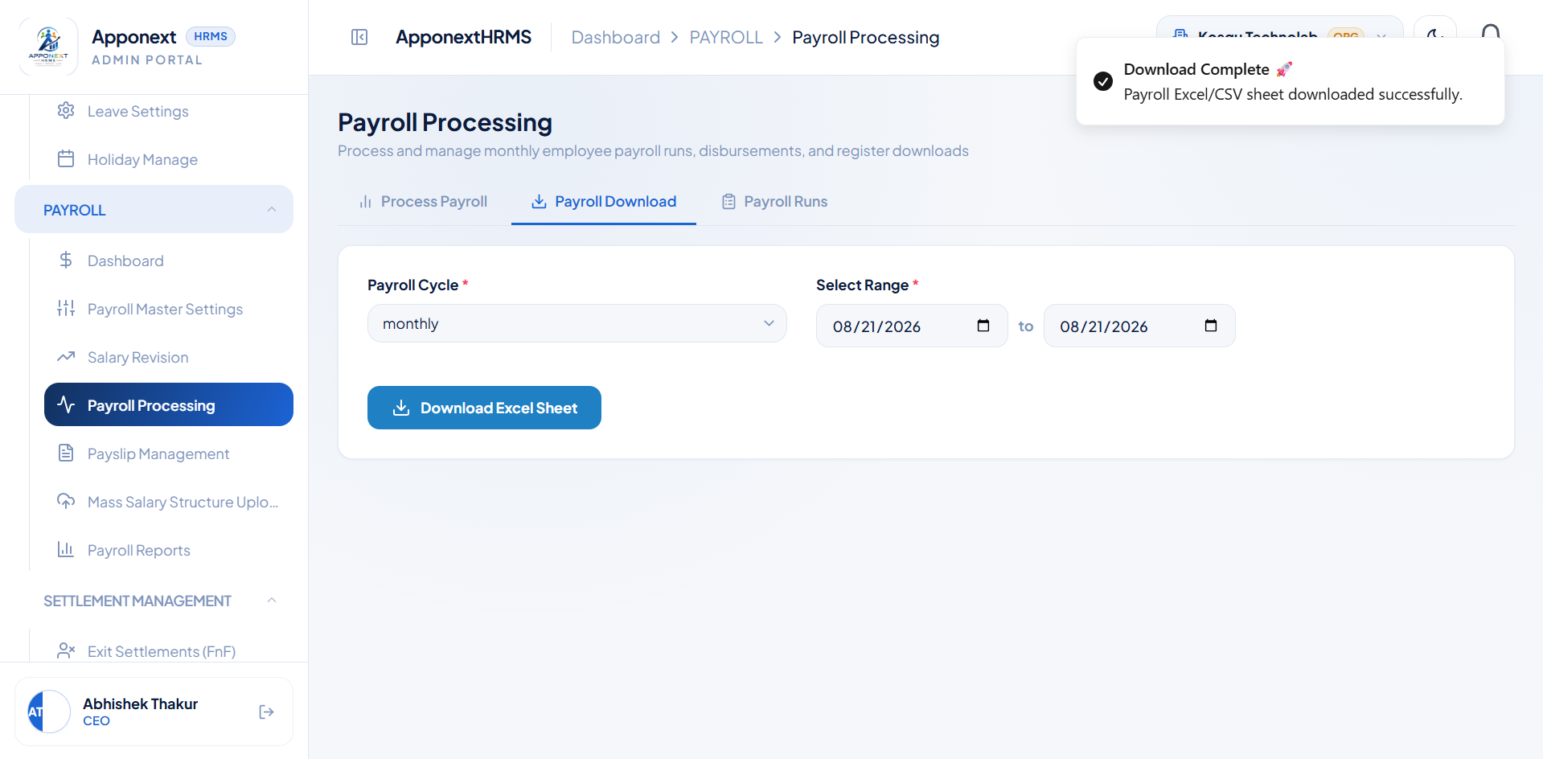

TC-E05 View Payroll Runs history
Expected Result | Historical runs should list with correct employee count, gross pay, and net disbursal.
Actual Result | Correctly listed 2 runs — #RUN-008 (15 Staff, ₹7,11,667 gross) and #RUN-007 (2 Staff, ₹60,000 gross), both Published.
Status | Pass
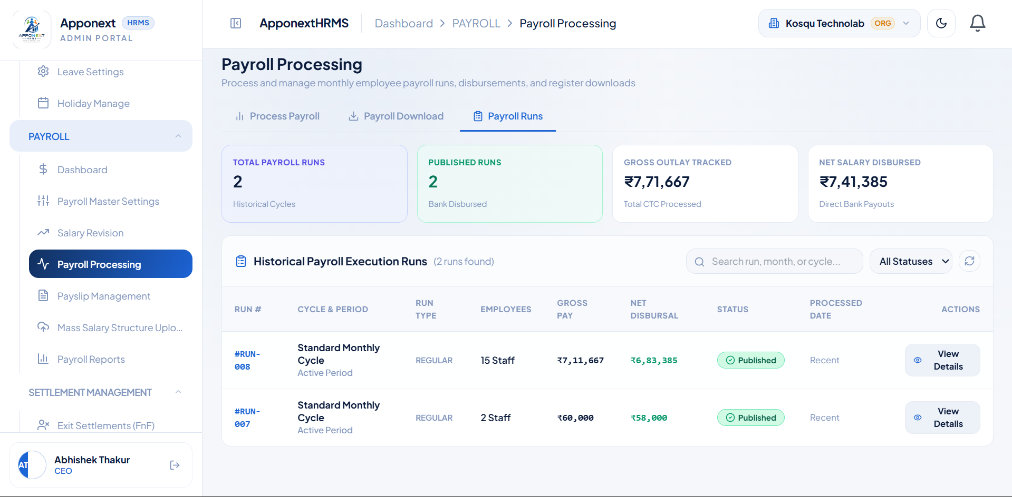

F. Mass Salary Structure Upload
TC-F01 Browse and select a salary CSV file for upload
Expected Result | System file picker opens and allows selecting a CSV file.
Actual Result | File picker opened correctly, filtered to relevant file types.
Status | Pass
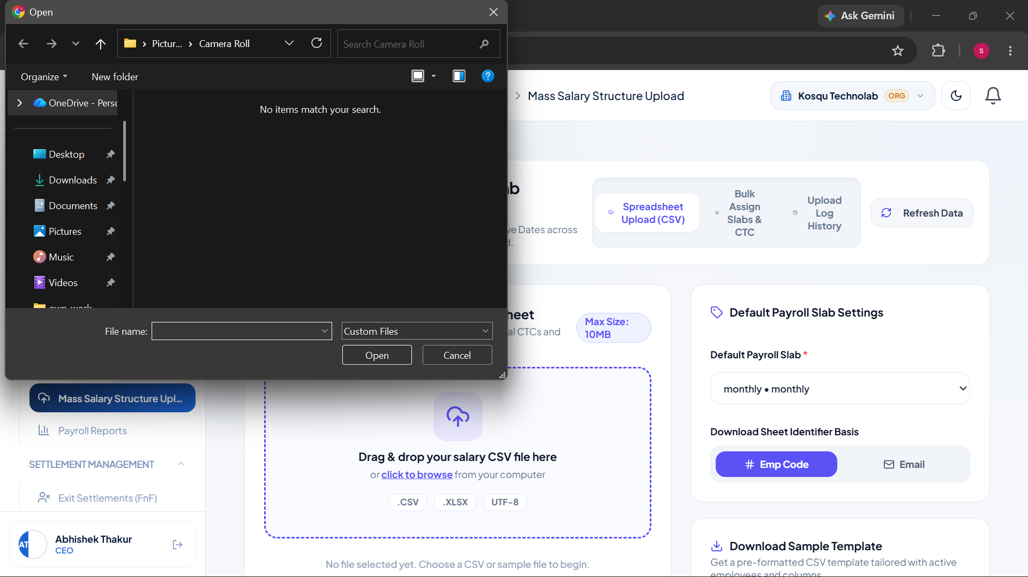

TC-F02 Upload a salary structure CSV
Expected Result | File parses successfully with a confirmation of records loaded.
Actual Result | "Loaded 20 employee records from spreadsheet!" toast displayed.
Status | Pass
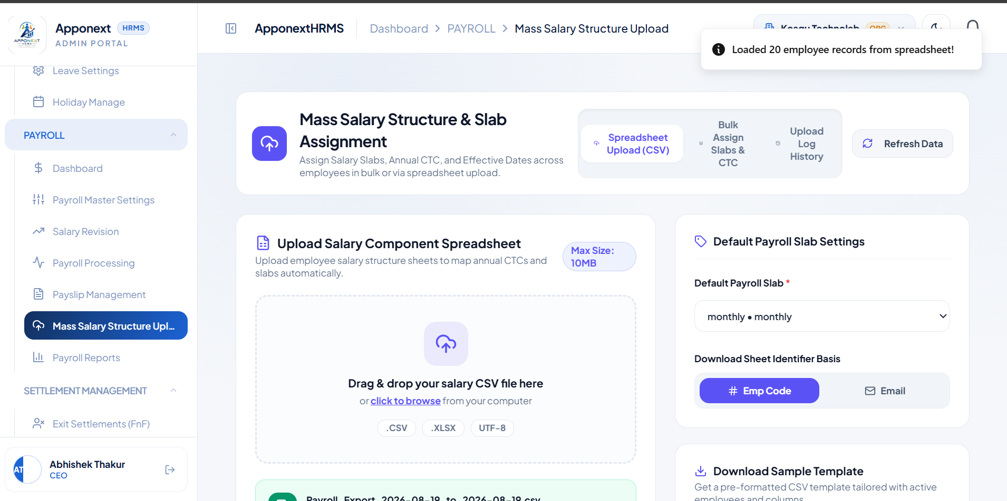

TC-F03 Preview loaded records and validate employee matching
Expected Result | Rows should be validated against real employee records, flagging any that don’t match.
Actual Result | Correctly validated — 2 rows marked "Valid" (matched EMP001, EMP002), remaining rows correctly flagged "Not Found" for unmatched identifiers.
Status | Pass
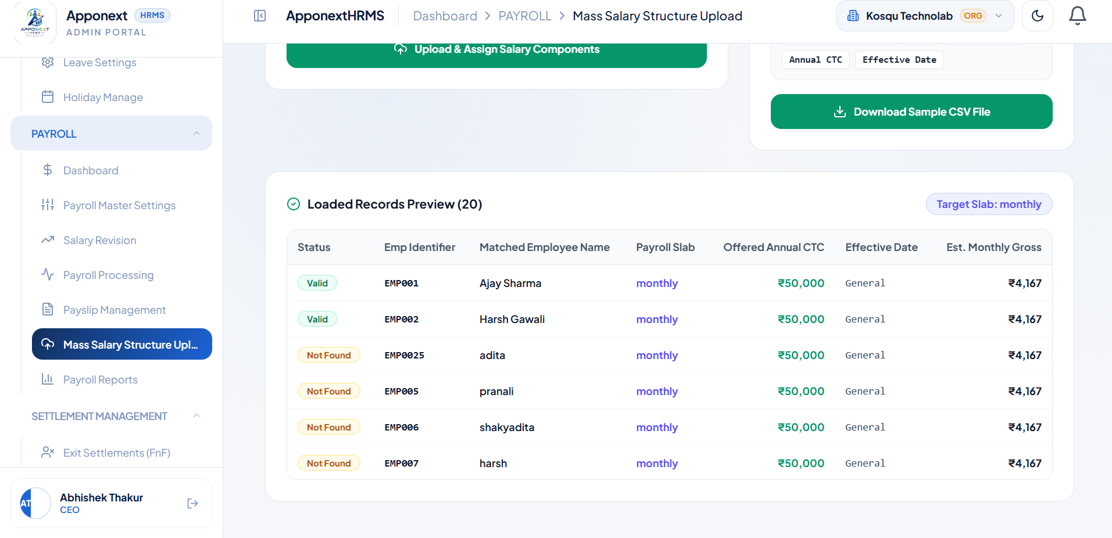

TC-F04 Bulk-assign a salary slab to selected staff
Expected Result | Slab assignment completes successfully with a confirmation.
Actual Result | "Successfully assigned salary slab to 17 employees!" toast displayed.
Status | Pass
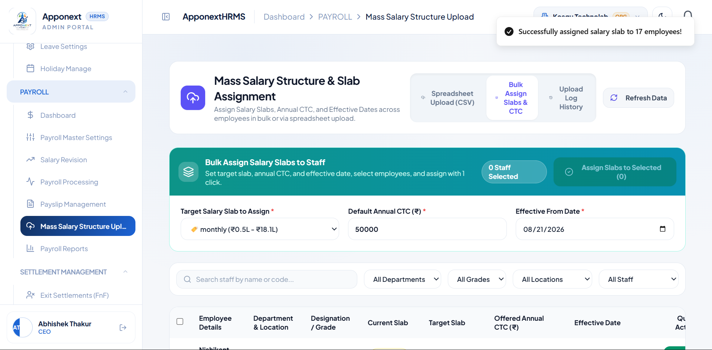

TC-F05 View Mass Salary Component Upload Log
Expected Result | Log should list past uploads with row counts and success/failure status.
Actual Result | Log correctly listed both upload attempts, each showing "Completed (2 failed)" — matching the 2 unmatched employee rows identified during validation.
Status | Pass
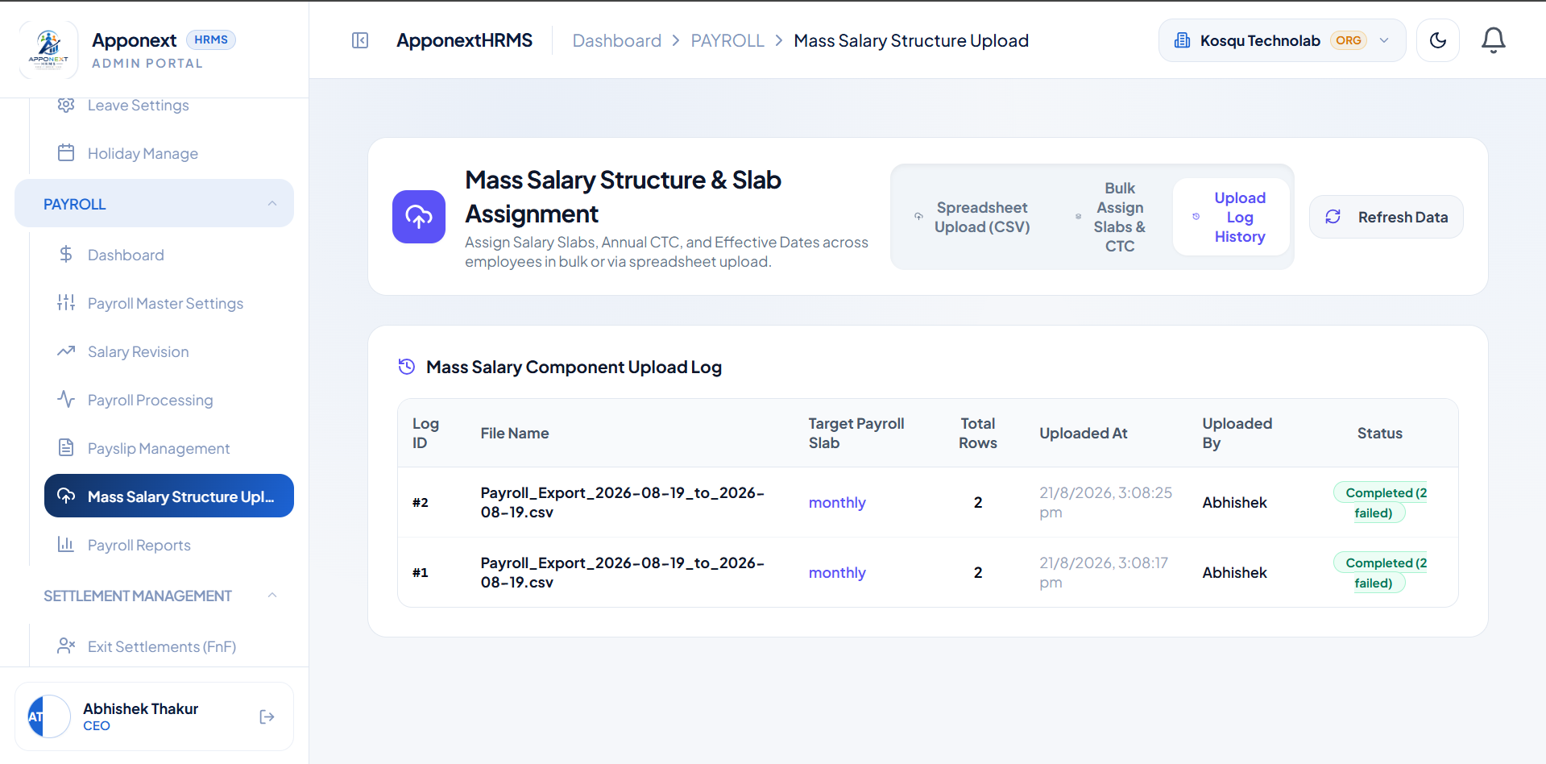

G. Payroll Reports
TC-G01 Load Payroll Reports — KPI cards
Expected Result | KPI cards (Paid Headcount, Monthly Gross Outlay, Bank Disbursal, Statutory Compliance) should reflect the org’s real 17 employees.
Actual Result | All KPI cards show 0 (0 Staff, ₹0 Gross Outlay, ₹0 Bank Disbursal, ₹0 Statutory) despite 17 real active employees existing in the org; CTC Master table also reports "No payroll records found matching current criteria for 2026-08."
Status | Fail
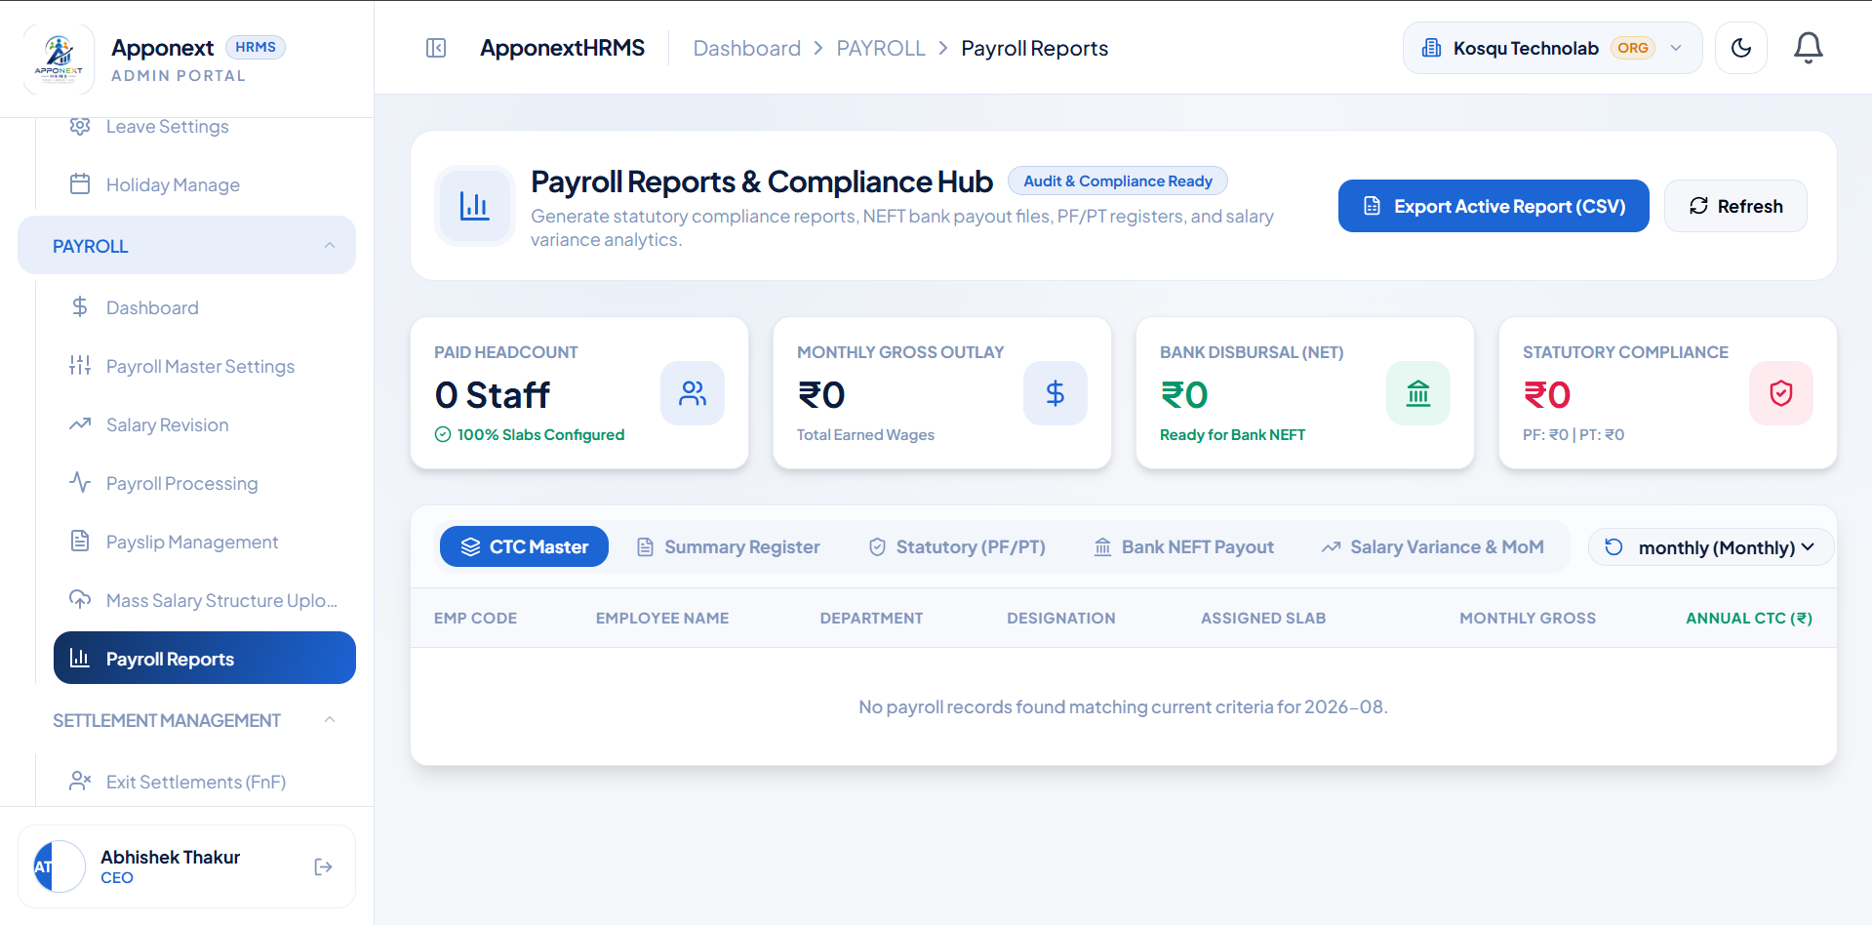

TC-G02 View CTC Master report table
Expected Result | Table should show each employee’s real assigned slab and CTC figures.
Actual Result | Table does list all employees correctly by name/code/department, but every single employee shows the identical hardcoded "Standard Pay Slab" with the same ₹4,167 Monthly Gross / ₹50,000 Annual CTC — not their real individually assigned structure.
Status | Fail
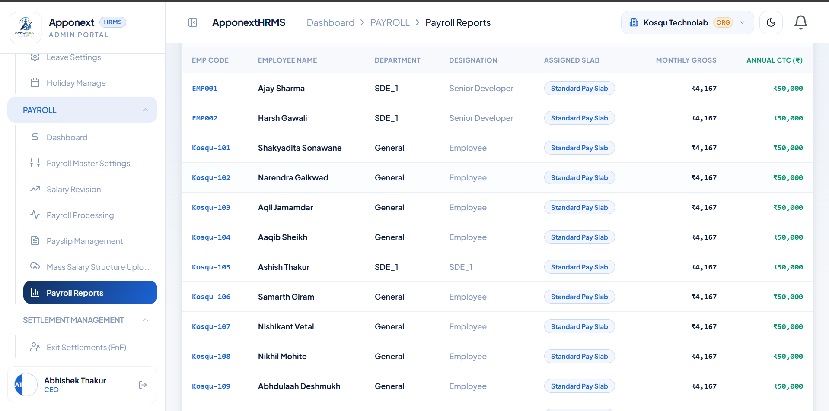

H. Employee Salary Structure (Profile → Payroll Tab)
TC-H01 View existing Pay Structure on employee profile
Expected Result | Payroll Detail table should show correct Slab, Annual CTC, Monthly Gross, Net Take-Home, and status.
Actual Result | Table displays correctly — Slab: monthly, Annual CTC ₹50,000, Monthly Gross ₹4,167 (matches ₹50,000 ÷ 12), Effective From 21 Aug 2026, Status Active.
Status | Pass
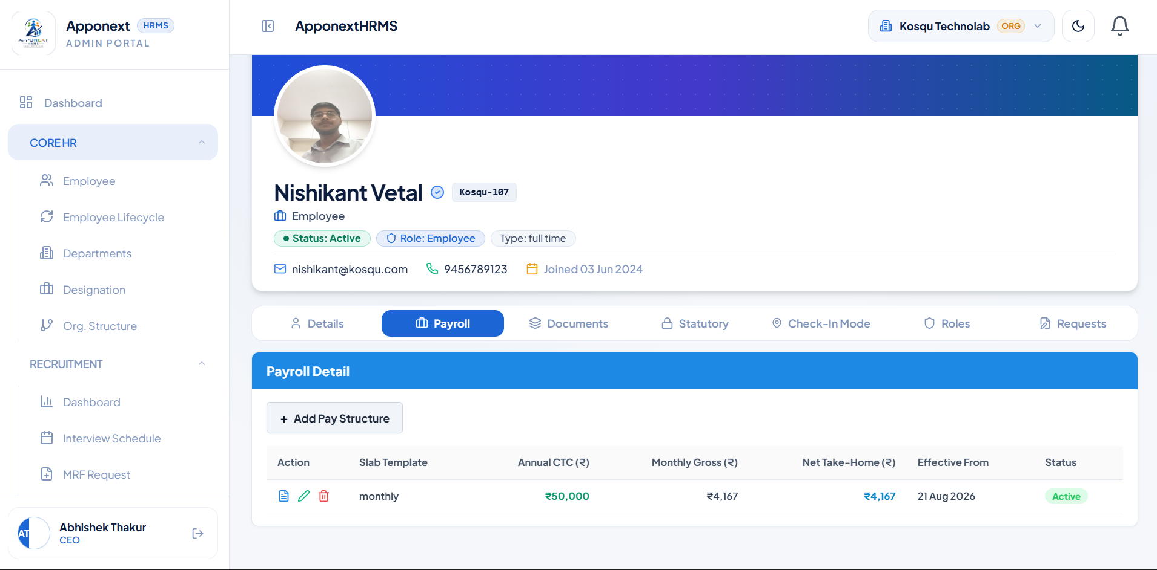

TC-H02 Open "Add/Edit Pay Structure" modal and review the dynamic breakup
Expected Result | Modal opens with Annual CTC input and component-wise earning/deduction breakdown, editable.
Actual Result | "Payroll Breakup [Dynamic Structure]" modal opened correctly for the "monthly" slab, showing Annual CTC Input, Basic Salary, and Tax component fields tied to the slab’s 4 assigned components.
Status | Pass
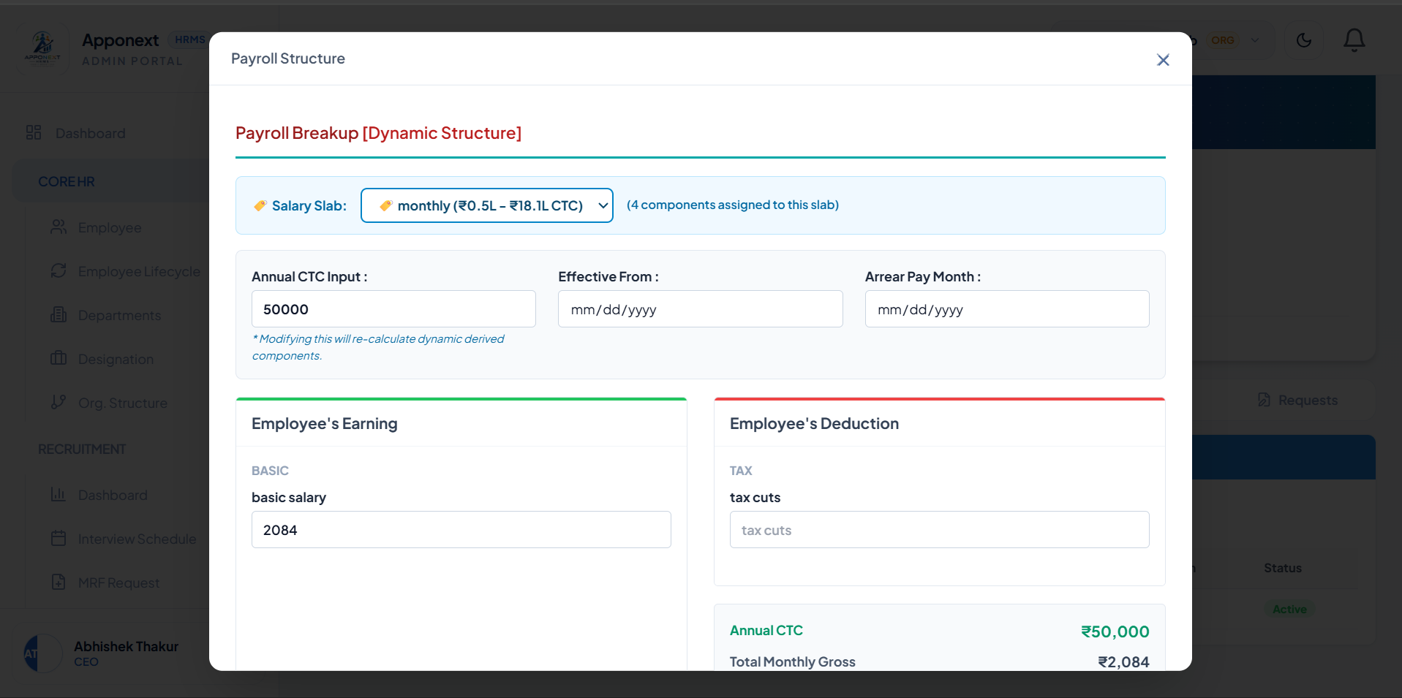

TC-H03 Update Pay Structure with a new Annual CTC (₹60,000)
Expected Result | Structure updates and a success confirmation is shown; table reflects new CTC.
Actual Result | "Pay structure updated successfully" toast shown; table correctly reflects the new Annual CTC of ₹60,000.
Status | Pass
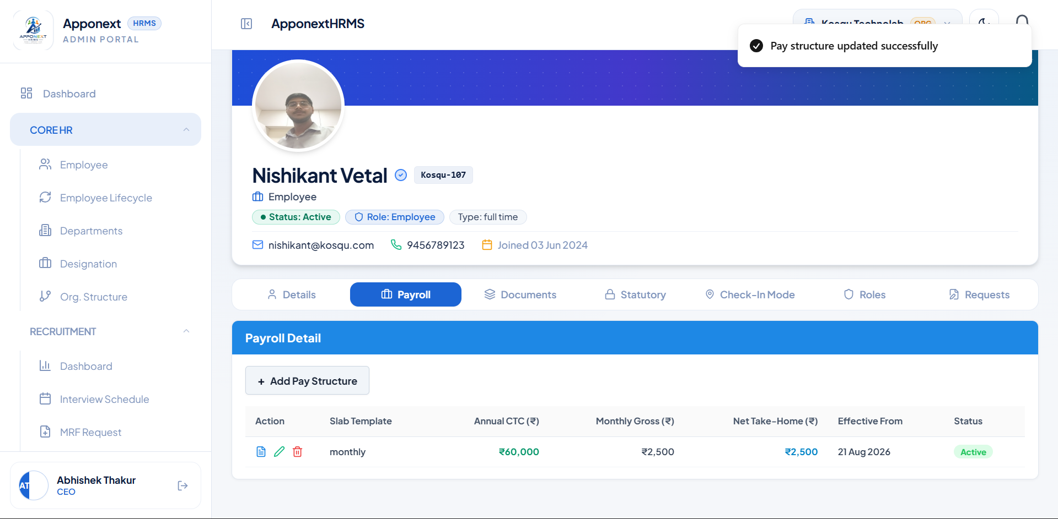

TC-H03b Delete a Pay Structure record
Expected Result | Record is removed/marked deleted with a success confirmation.
Actual Result | "Structure deleted successfully" toast displayed; row remains visible in the table with Status correctly updated to "Deleted" (soft-delete, preserved for history).
Status | Pass
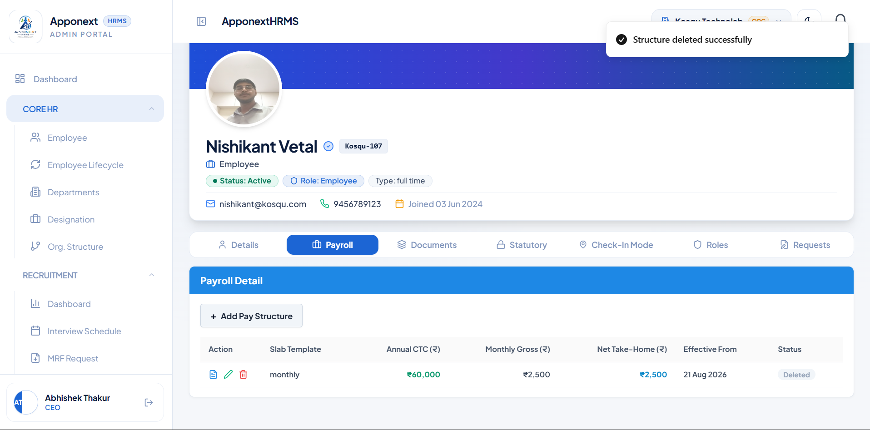

TC-H04 Reload employee profile after deleting Pay Structure
Expected Result | Deleted structure should no longer appear as an active record after a fresh page load.
Actual Result | Confirmed on reload — table correctly shows "No structure records found."
Status | Pass
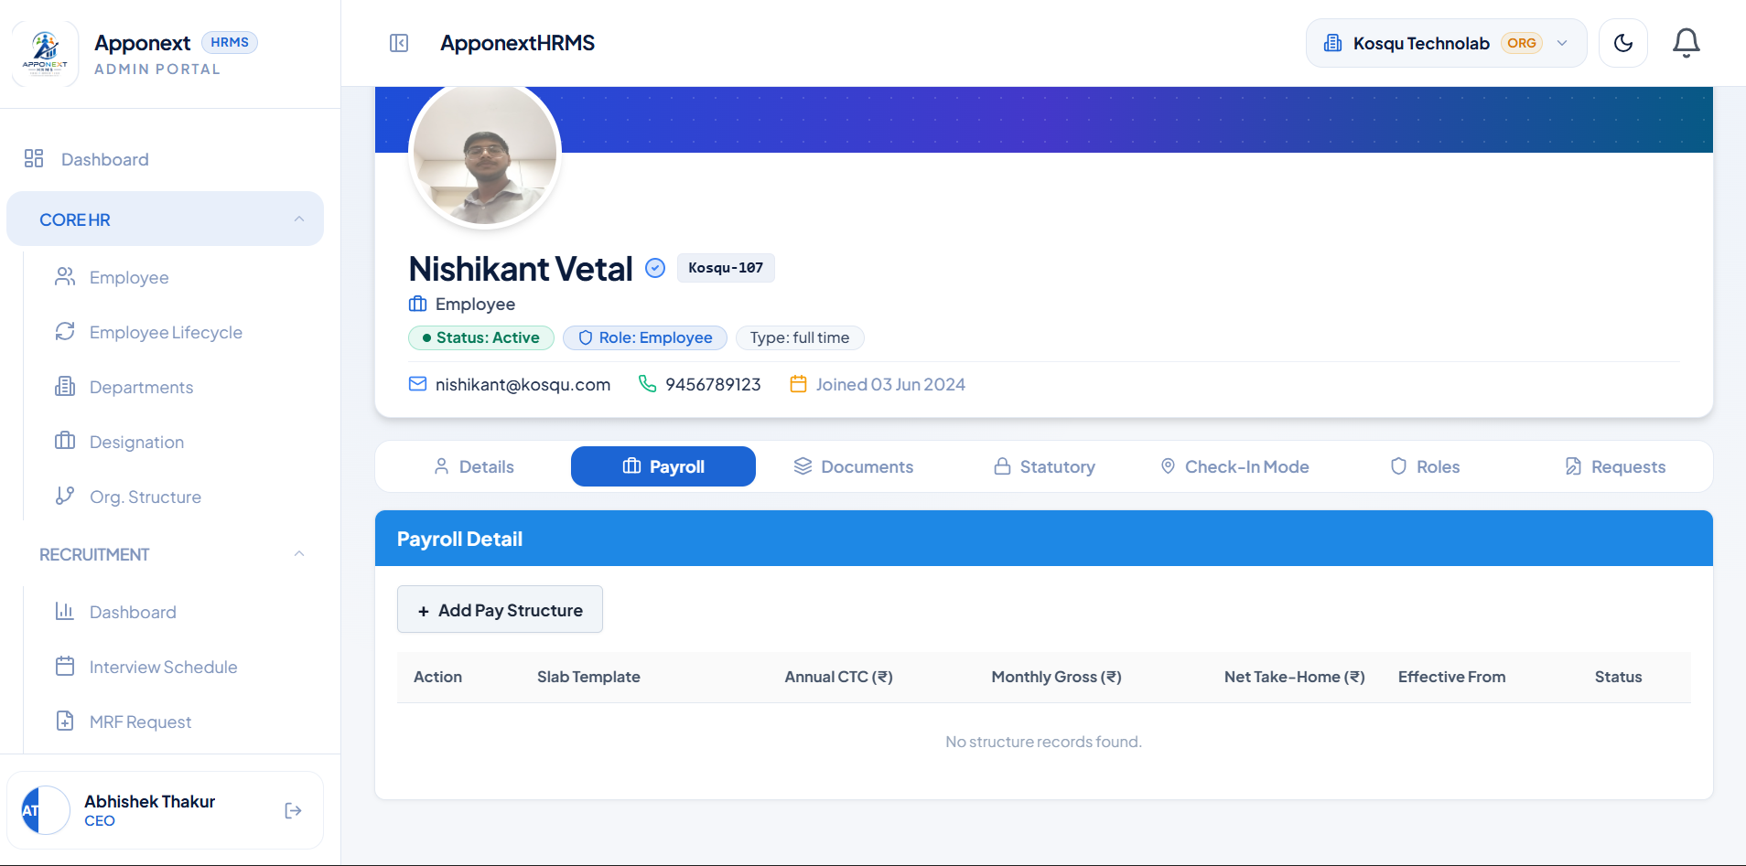

TC-H05 Add a new Pay Structure from employee profile
Expected Result | New structure saves successfully with correct Annual CTC and Slab Template.
Actual Result | "New pay structure saved successfully" toast shown; table correctly shows Slab: monthly, Annual CTC ₹4,80,000, Effective From 21 Aug 2026, Status Active.
Status | Pass
