ApponextHRMS
Pain Points Closure Report
Shift Management (within Masters) — Consolidated Defect List

Scope: | Section 5 consolidated pain-points list (S-1 through S-15, SEC-1) spanning Shift Management, Masters Hub, and Auth
Test type: | Defect fix, regression fix, and live verification
Environment: | Local development build — client (Vite/React) + server (Node/Express) + MySQL
Date: | 15 August 2026
Result summary: | 7 items newly fixed/completed this pass · 7 items already fixed in earlier passes and reconfirmed unaffected · 1 item deliberately deferred · 1 regression found and fixed along the way

1. Executive Summary
This report closes out the consolidated Section 5 pain-points list. Seven items are newly fixed or completed in this pass (S-1’s client-side half, S-2, S-3, S-4, S-10, S-14, S-15); seven were already fixed in earlier passes (S-5 through S-9, S-11, SEC-1) and are reconfirmed here as unaffected; one (S-12) remains a deliberate, documented deferral. Fixing S-1’s server-side half in the previous pass also introduced a real, unannounced regression — none of the four shift-creation forms ever sent the isNightShift flag the new server validation started requiring, so creating or editing a genuine overnight shift through any of them would now have been silently rejected. That regression is fixed here as well.
ID | What changed this pass | Result
S-1 | Completed: added the client-side half (was server-only) — and fixed the isNightShift regression that half-fix had caused across all 4 shift forms. | FIXED
S-2 | New: exact duplicate-time-range detection, server-side (ShiftService) and client-side (CreateShiftModal/EditShiftModal via the existingShifts/shifts prop). | FIXED
S-3 | New: the dead existingShifts prop is now read and used for the S-2 client-side warning. | FIXED
S-4 | New: Buffer/Total/Log Break Time now reject malformed input ("xx:30") instead of silently coercing it. | FIXED
S-10 | New: reassigning an employee who already has an active shift now returns a 409 with details; the client shows a confirm dialog before proceeding. | FIXED
S-14 | New: shift-code random suffix increased from 4 to 6 base-36 characters. | FIXED
S-15 | New: shift-swap approval now runs inside one DB transaction; rollback proven with a forced-failure test. | FIXED

Already fixed in earlier passes, reconfirmed unaffected by this pass's changes:
- S-5, S-6, S-7, S-8, S-9, S-11 (Shift Management authorization, data-loss-on-delete, validation, bulk assign, employee search, delete-assignment 404) — see the prior Shift Management QA report.
- SEC-1 (organization_admin wildcard permissions default) — see the prior Security & Network Data-Exposure QA report.
Deliberately deferred (unchanged from the prior assessment):
- S-12 — consolidating GeneralShiftMasterForm.tsx, RosterShiftMasterForm.tsx, and CreateShiftModal.tsx into one shared form is a real architectural improvement but a large refactor of three big, independently-evolved forms; every fix in this and the prior pass was deliberately applied at the shared ShiftService layer specifically so it reaches all three despite the duplication, and the two Masters Hub forms were given the same isNightShift regression fix as the Attendance forms for the same reason. Consolidation itself remains future work, not something to rush inside a bug-fix pass.

2. S-1 — Completing the Start/End Time Validation (and a Regression It Exposed)

2.1 What was already done
The prior pass added server-side validation in ShiftService (shared by every entry point): identical start/end times are always rejected, and end-before-start is rejected unless isNightShift is explicitly set.

2.2 The regression this uncovered
None of the four client forms that create or edit shifts — CreateShiftModal.tsx, EditShiftModal.tsx, GeneralShiftMasterForm.tsx, RosterShiftMasterForm.tsx — ever sent isNightShift in their payload. Once the server started requiring it for any end-before-start submission, creating or editing a genuine overnight shift (e.g. 22:00–06:00) through any of these forms would have been silently rejected with a 400 — a real functional regression introduced by fixing S-1’s server half without its client half.
Fix: all four forms now compute isNightShift from the entered times (end < start ⇒ true) and send it with every create/update — closing the gap the same way the direct-API tests already expected. CreateShiftModal.tsx and EditShiftModal.tsx also gained the missing client-side "end must differ from start" check for immediate feedback before a round-trip.

2.3 Verification
Created a shift at 23:00–07:00 through the real Attendance → Shift Management → New Shift form with no manual night-shift toggle:
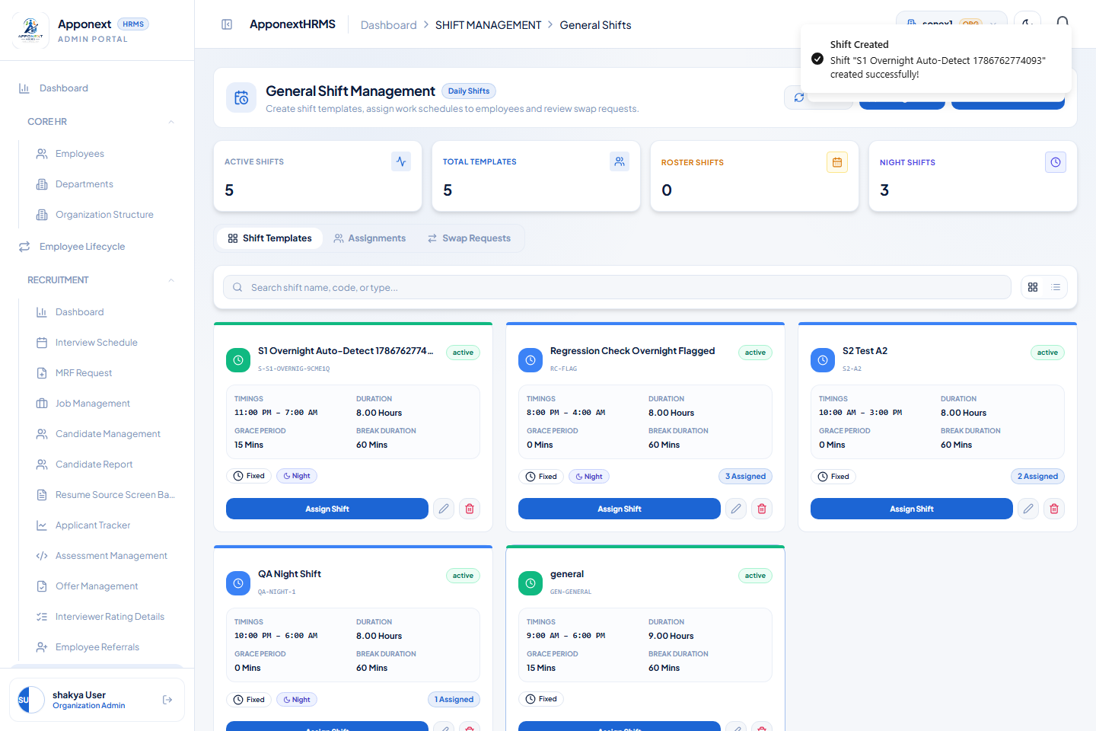
"Shift Created" — the overnight shift saved successfully; its card shows the Night badge and correct 11:00 PM – 7:00 AM timing, confirming isNightShift was computed and sent automatically.

3. S-2 / S-3 — Duplicate Shift Time Detection
S-3's dead existingShifts prop (declared on CreateShiftModal but never destructured or read) was the missing wiring for exactly what S-2 asked for, so both were closed together.

3.1 Fix
- Server (ShiftService.assertNoDuplicateTimeRange): createShift and updateShift now reject an exact duplicate — same category (daily/roster) and identical start/end time — against any other active shift in the organization. Scoped to exact duplicates rather than general interval overlap: two shifts covering different day patterns can legitimately share identical hours, so a broader "overlap" rule would need a product decision this fix doesn't make.
- Client (CreateShiftModal.tsx, EditShiftModal.tsx): existingShifts/shifts is now read and checked client-side for the same exact-duplicate condition, giving instant feedback before the round-trip to the server.

3.2 A real bug found while verifying
The first live test of the server-side check silently passed a duplicate through. Root cause: shift times are sent to the API as "10:00" but read back from the database as "10:00:00" — the comparison never matched either format consistently. Fixed by normalizing both sides to HH:MM before comparing, in both the new duplicate check and the existing start/end validation from the prior pass (which had the same latent risk on the update path, where one time can fall back to an existing "HH:MM:SS" database value while the other is fresh "HH:MM" input).

3.3 Verification
Create shift A: 10:00-15:00, fixed -> 201 created
Create shift B: 10:00-15:00, fixed (dup) -> 400 "A shift named \"S2 Test A2\" already
uses 10:00-15:00. Choose a different time
range or edit the existing shift instead."
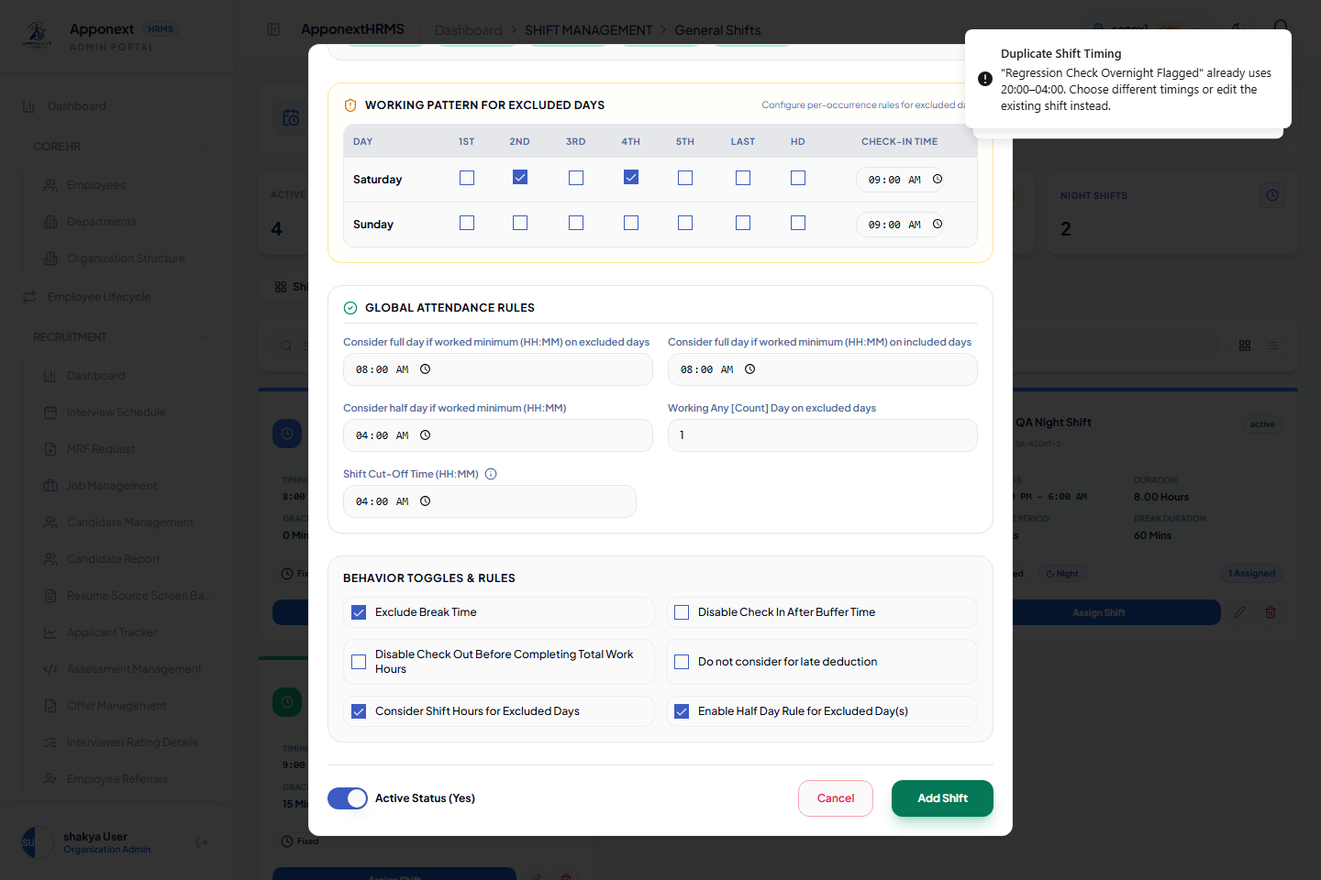
Live UI: attempting to create a shift at 20:00-04:00 while "Regression Check Overnight Flagged" already uses that exact range — blocked client-side via the now-wired existingShifts prop, before any network call.

4. S-4 — Malformed Free-Text Time Fields
Fix: Buffer Time, Total Time, and Log Break Time (the three type="text" duration fields in CreateShiftModal.tsx and EditShiftModal.tsx — every other time field in these forms is already a native type="time" input) are now validated on submit against a strict HH:MM regex and rejected with a clear message instead of being silently coerced (e.g. "xx:30" silently becoming "00:30").
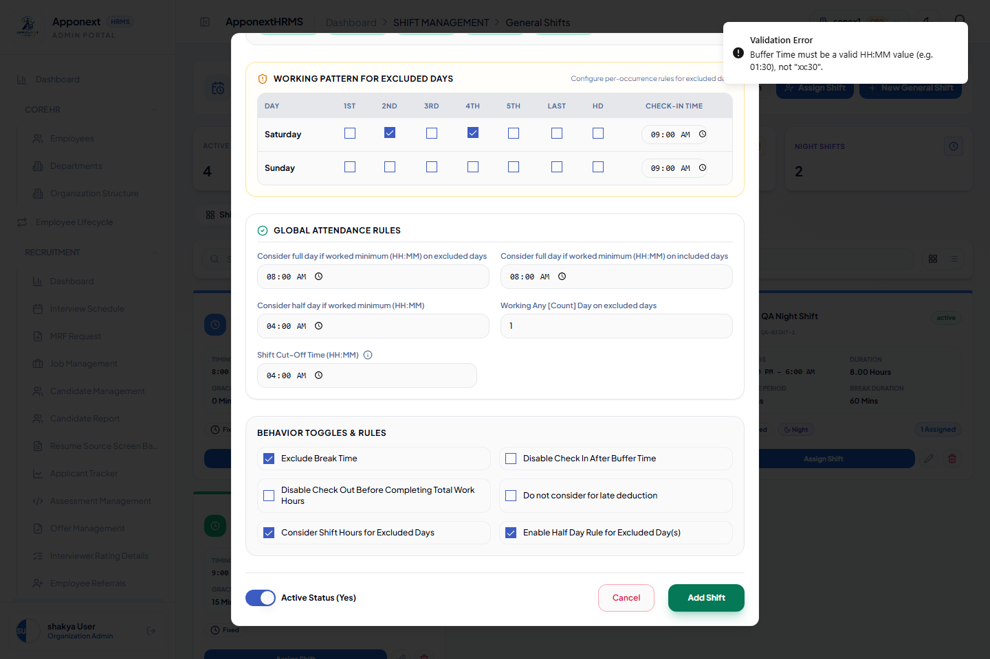
Live UI: "Buffer Time must be a valid HH:MM value (e.g. 01:30), not \"xx:30\"." — submission blocked instead of the value being silently coerced to 00:30.

5. S-10 — Confirm Before Silently Ending an Active Assignment
Root cause: ShiftService.assignShift ended an employee's current assignment and created the new one in the same pass, with no way for the caller to know or confirm beforehand.

5.1 Fix
- ShiftService.assignShift now runs a detection pass first (no mutation) to work out which currently-active assignments the call would end. If any exist and the caller hasn't sent confirmReassignment: true, it throws a 409 ConflictError with the affected employee/assignment IDs in the response body instead of mutating anything.
- Self-moves (dragging a roster tile to a new date, or a shift-swap's own continuation — both identified by moveFromDate/sourceAssignmentId) are exempted, since those are the assignment's own move, not a reassignment away from a different shift.
- AssignShiftModal.tsx and WeeklyRosterGrid.tsx (the two callers of assignShift not otherwise exempted) now catch the 409, show a window.confirm naming the affected employee(s), and resubmit with confirmReassignment: true only if the admin agrees.

5.2 A display bug found while verifying
The first live test showed the same employee's name repeated three times in the confirmation dialog — the server correctly returns one conflict entry per overlapping assignment record, but the client wasn't de-duplicating by employee before building the message. Fixed by de-duplicating on employeeId.

5.3 Verification
Assign shift 14 to an employee who already has shift 13 active, no confirm flag:
-> 409 {"conflicts":[{"employeeId":55,"assignmentId":29}]}
Retry with confirmReassignment:true:
-> 201 created; the prior assignment (29) correctly ended.
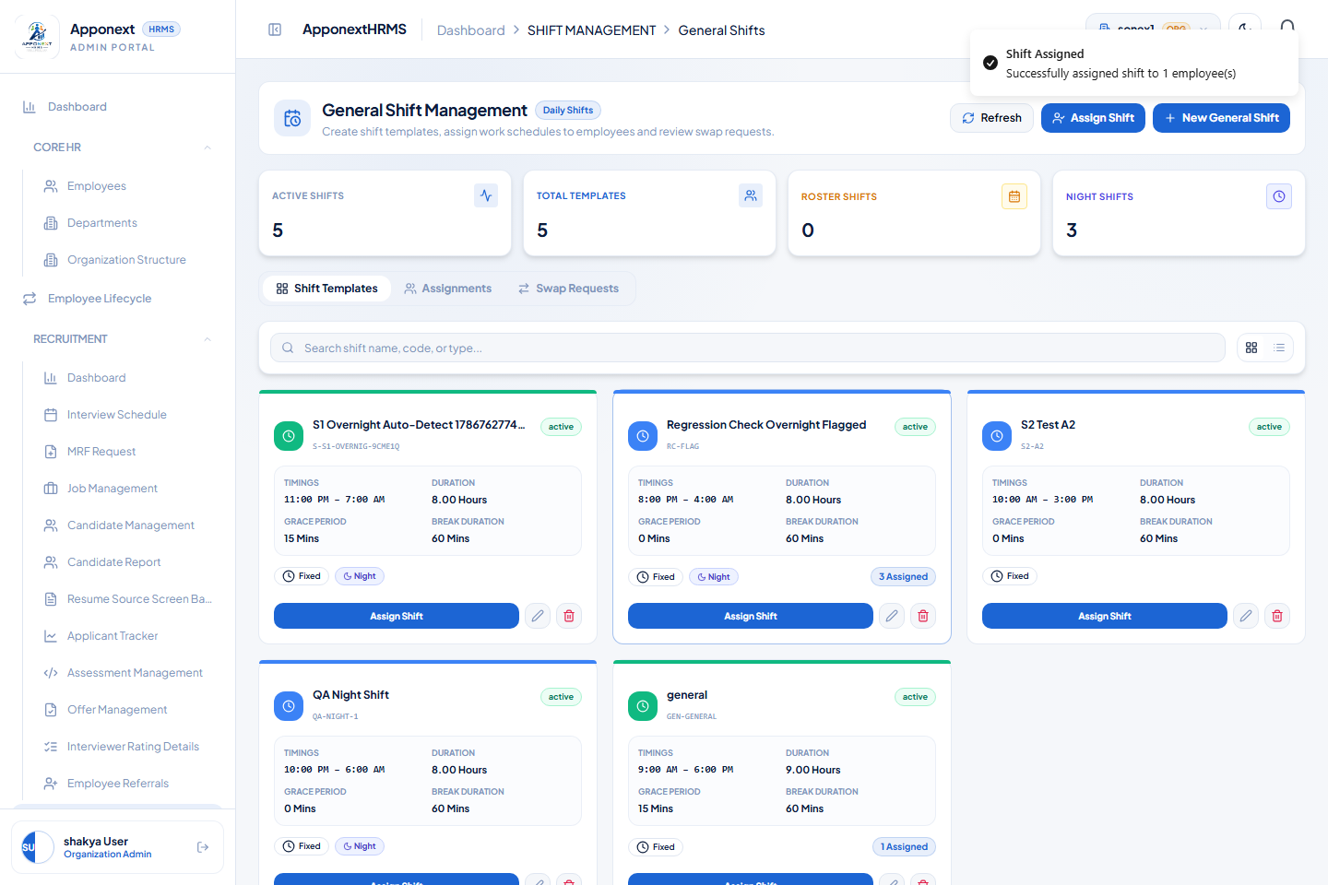
Live UI: reassigning "sam rane" (who already has an active assignment) shows a native confirm dialog — "sam rane already has an active shift assignment that will be ended if you continue." — before the reassignment proceeds.

6. S-15 — Atomic Shift-Swap Approval
Root cause: approveShiftSwap made two independent assignShift() calls with no rollback if the second failed after the first succeeded.

6.1 Fix
Rewrote approveShiftSwap to run both reassignments and the swap request's own status update inside a single Knex transaction (withTransaction, the same helper pattern already used elsewhere in this codebase, e.g. EmployeeService). Because the repository layer has no transaction support to thread a shared trx through (the same limitation that made this deferred in the prior pass), the two reassignments are implemented directly against the transaction for this method's specific narrow case — a single-day move — rather than reusing the general assignShift() method.

6.2 Verification — happy path
Before: emp55 -> shift13, emp51 -> shift14 (both 2026-09-02)
Approve swap (55 offers 13, wants 51's 14) -> 200 approved
After: emp55 -> shift14, emp51 -> shift13 (correctly exchanged, old rows is_current=0)

6.3 Verification — atomicity under a forced failure
A temporary forced error was inserted between the two reassignment calls, the approval was attempted, then the temporary error was removed — the same forced-failure technique used to test rollback when the data model has no natural constraint to violate.
Approve swap with forced failure after step 1 -> 500 error, transaction rolled back
DB check immediately after:
employee 55's original assignment -> still is_current=1 (untouched)
employee 51's original assignment -> still is_current=1 (untouched)
no new assignment rows created
swap request status -> still "pending" (not partially "approved")
Forced failure removed, same swap approved again -> 200, shifts correctly exchanged.
Nothing was left half-applied when the second half failed — the transaction fully rolled back every part of the first half too.

7. S-14 — Shift Code Collision Resistance
Fix: the random suffix in client-generated shift codes (CreateShiftModal.tsx, RosterShiftMasterForm.tsx) increased from 4 base-36 characters (~1.7M combinations) to 6 (~2.2B combinations). The code-name portion is capped so the suffix is never truncated off by the existing 20-character limit.
Live confirmation: the shift created in Section 2.3's screenshot was assigned the code S-S1-OVERNIG-9CHE1Q — a 6-character suffix (9CHE1Q), visually confirming the change took effect.

8. Updated Pain-Points Table
ID | Severity | Finding | Status
S-6 | Critical | No permission checks on any shift-management route | FIXED (prior pass)
S-7 | Critical | Deleting a shift hard-deleted all historical assignment records | FIXED (prior pass)
SEC-1 | Critical | organization_admin accounts default to permissions: ["*"] | FIXED (prior pass)
S-1 | High | No end>start validation; identical start/end silently became 24h | FIXED (completed this pass)
S-5 | High | No schema validation on shift create/update payload | FIXED (prior pass)
S-8 | High | Bulk assign fired N sequential requests instead of the batch endpoint | FIXED (prior pass)
M-1 | High | Holiday master tile had no wired backend call | FIXED (Masters Hub pass)
S-2 | Medium | No duplicate/overlapping shift-time-range detection | FIXED (this pass)
S-4 | Medium | Free-text time fields silently coerced invalid input | FIXED (this pass)
S-9 | Medium | Employee picker never sent search to the server | FIXED (prior pass)
S-10 | Medium | Reassignment silently ended an existing active assignment | FIXED (this pass)
S-11 | Medium | Deleting a non-existent assignment returned false success | FIXED (prior pass)
S-15 | Medium | Shift-swap approval not atomic | FIXED (this pass)
S-3 | Low | existingShifts prop passed but never read — dead code | FIXED (this pass)
S-12 | Low | Shift creation independently duplicated across 3 forms | DEFERRED (documented)
S-13 | Low | Debug console.log of employeeId/date left in a hot path | FIXED (prior pass)
S-14 | Low | Shift code suffix had low entropy, no pre-emptive check | FIXED (this pass)

9. Files Changed This Pass
File | Change
server/src/modules/attendance/services/ShiftService.ts | Time normalization fix; assertNoDuplicateTimeRange (S-2); assignShift conflict detection + ConflictError (S-10); approveShiftSwap rewritten as a single transaction (S-15).
client/src/features/attendance/components/CreateShiftModal.tsx | existingShifts wired for duplicate check (S-2/S-3); strict HH:MM validation (S-4); isNightShift computed and sent (S-1 regression fix); 6-char code suffix (S-14).
client/src/features/attendance/components/EditShiftModal.tsx | shifts prop wired for duplicate check (S-2/S-3); strict HH:MM validation (S-4); isNightShift computed and sent (S-1 regression fix).
client/src/features/attendance/components/AssignShiftModal.tsx | Handles the new 409 conflict response with a confirm dialog (S-10); de-duplicates employee names in the message.
client/src/features/attendance/components/WeeklyRosterGrid.tsx | Same 409-conflict confirm handling for the roster grid's single-day assign action (S-10).
client/src/features/settings/components/GeneralShiftMasterForm.tsx | isNightShift computed and sent (S-1 regression fix); end==start guard.
client/src/features/settings/components/RosterShiftMasterForm.tsx | isNightShift computed and sent (S-1 regression fix); end==start guard; 6-char code suffix (S-14).

9.1 Test Environment
- Server: Node/Express (tsx watch) — http://127.0.0.1:5000/api/v1
- Client: Vite dev server — http://localhost:5173
- Database: local MySQL, organization "sonex1" (id 14)
- Server-side checks (S-2, S-10, S-15) were run as direct authenticated API calls with database state verified in MySQL before/after each — including a deliberate forced-failure test to prove S-15's rollback, not just its happy path.
- Client-side checks (S-1, S-2/S-3, S-4, S-10, S-14) were driven with headless-Chromium (Playwright) through the real Attendance → Shift Management UI.
- Test shifts/assignments created during verification (names prefixed "S1", "S2", "QA", "Regression Check") were left in place as inert dev-data, consistent with the prior passes' seed data.

