

BUSINESS REQUIREMENTS DOCUMENT
Push Notification
Customer journey alerts in the Super App — Credit Card, Personal Loan and CASA
V1.2 / 06 October 2026
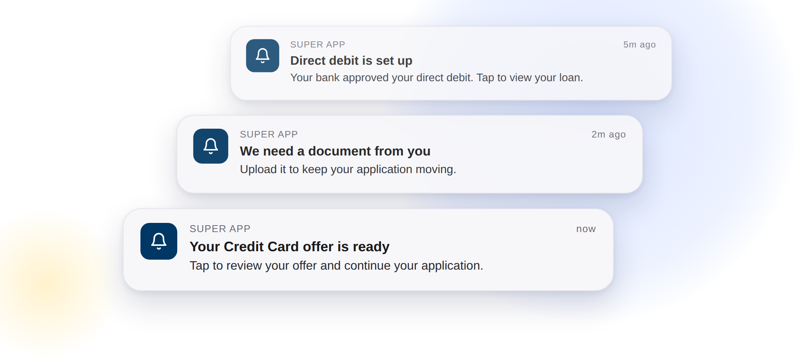

VERSION HISTORY
Date | Version | Author | Change Description
28-09-2026 | 1.0 | Hailey (Appro) | Created BRD
28-09-2026 | 1.1 | Hailey (Appro) | Trigger events and push content in one table; push results tracked in the backend only, not on the audit trail; sample request and response exactly as the middleware specification
06-10-2026 | 1.2 | Hailey (Appro) | Business review of 29/09 incorporated: updated wording for P01, P04, P05 and P09; device and session scenarios; reminder stop rules and sending time; middleware specification v0.2 values and error codes (05/10), retry values to be confirmed by Business; duplicate-prevention rule BR5; future enhancements (post-MVP, dedicated development team)

TABLE OF CONTENTS
1. FEATURE OVERVIEW AND KEY COVERED AREAS 3
2. SCOPE 5
3. TRIGGER POINTS AND PUSH CONTENT 6
4. PUSH NOTIFICATION API INTEGRATION 8
5. RESPONSE HANDLING AND RETRY 11
6. BUSINESS RULES 11
7. IMPACT ANALYSIS 12
8. FUTURE ENHANCEMENTS (POST-MVP) 13
APPENDIX 1: SAMPLE REQUEST/RESPONSE 14

1. FEATURE OVERVIEW AND KEY COVERED AREAS
This document describes the requirements for Push Notification in the Reem Bank customer journey for Credit Card, Personal Loan and CASA, on iOS and Android.
Today the customer learns about decisions and required actions on an application — a credit decision, a Direct Debit Authority response, the end of the cooling-off period — by email and in-app notification only. When the customer is outside the Super App, nothing reaches the device, and the application waits until the customer returns.
Push Notification adds a device-level alert at each agreed trigger event. The Appro platform sends the push request to the Reem Bank middleware Push API, following the same integration pattern as the existing SMS and email integration. When the customer taps the notification, the customer is navigated to the Super App login screen, and the Appro journey opens at the screen where the application continues (Resume screen) or the Super App, depending on the event.
This BRD covers the following areas:
- Trigger events and push content — eleven notifications, each with its title, body and the screen it opens
- Language — English or Arabic, following the customer’s current language
- Middleware integration — the Push API request, headers and response
- Response handling and automatic retry
- Business rules — personal data and excluded templates
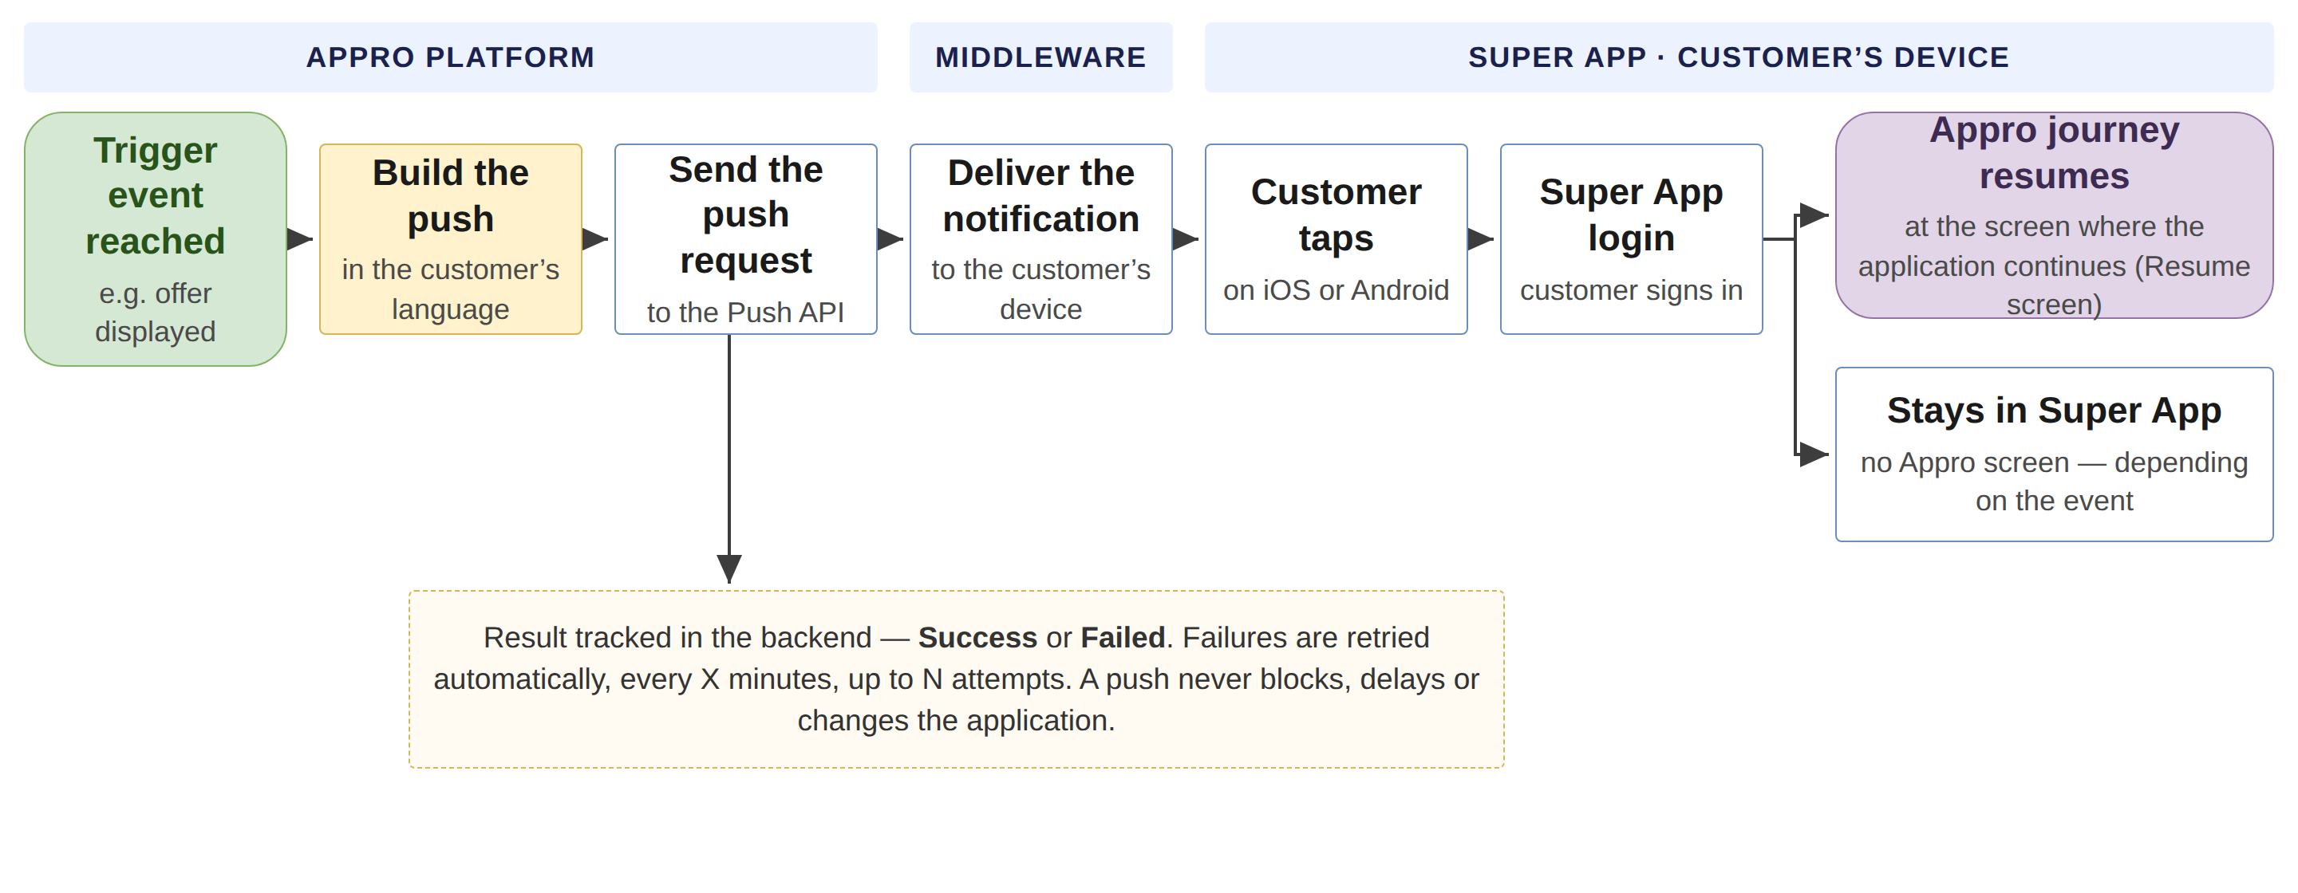
Figure 1 — How a push reaches the customer (green = start, amber = system action, blue = step, purple = end)
Key steps
- A trigger event is reached on the application, for example an offer is displayed or a document is requested.
- The system builds one push for the event: the Push ID, the title and the body, in the customer’s current language.
- The system sends the push request to the Reem Bank middleware Push API.
- The middleware delivers the notification to the customer’s device through the Super App.
- The customer taps the notification and is navigated to the Super App login screen; after login, the Appro journey opens at the screen where the application continues (Resume screen) or the Super App, depending on the event.
- The result is tracked in the backend. A failed push is retried automatically and never blocks the application.
Note: Push content is fixed per notification and is not configurable in Super Portal in this release. Customer actions on a notification (open, dismiss, ignore) are not tracked. Existing email and in-app notifications are unchanged. Business-managed configuration and Super Portal visibility are planned as post-MVP enhancements (section 8).

2. SCOPE

2.1 Product scope
Credit Card, Personal Loan and CASA, on iOS and Android. Each notification applies only to the products listed against it in section 3.

2.2 In-scope notifications
- P01 — Offer ready (Credit Card, Personal Loan)
- P01 (CASA) — Account approved in principle (CASA)
- P02 — Offer expiry reminder, once per day for 15 days (all products)
- P03 — Offer expired (all products)
- P04 — Update on the application after a rejection (all products)
- P05 — Document requested from the customer (all products)
- P06 — Application active again after the cooling-off period (Credit Card, Personal Loan)
- P08 — Direct debit set up (Personal Loan)
- P09 — Direct debit rejected by the customer’s bank (Personal Loan)
- P10 — Loan on its way after disbursement (Personal Loan)
- P11 — Product ready: card issued (Credit Card, CASA) or loan approved (Personal Loan)

2.3 Not in scope
- OTP messages — never sent as push (BR3).
- Bank and internal-user notifications — never sent as push (BR4).
- Configuring push content in Super Portal — content is fixed per notification in this release.
- Tracking customer actions on a notification — open, dismiss or ignore.
- Changes to the existing email and in-app notifications — they remain unchanged (BR1).

3. TRIGGER POINTS AND PUSH CONTENT

3.1 Trigger events and push content
A push is fired at the same trigger point as the existing email and in-app notification for the same event. Existing email and in-app notifications remain unchanged.
Push ID | Priority | Applies to | Trigger event | Title (EN, max 40 characters) | Body (EN, max 100 characters)
P01 | P0 | CC · PL | AIP given (at least one offer displayed), or Credit Queue approves / overrides the application | Your offer is ready | Review your offer and continue your application.
P01 (CASA) | P0 | CASA | Account application approved in principle | Your account is approved | Tap to continue and complete your account opening.
P02 | P0 | CC · PL · CASA | Scheduled reminder once per day for 15 days, starting after the first offer is displayed | Your offer expires in  %%COUNTING_DOWN%% days | Complete your application before your approval expires.
P05 | P0 | CC · PL · CASA | Credit or Sales team returns the case requesting documents from the customer | One more document is needed | Tap to see which document is needed and how to share it. Wording to be confirmed with Business once the document channel is agreed.
P06 | P0 | CC · PL | Cooling-off end date reached (start + 5 days, configurable) with no customer action; application returns to Approved In Principle | Your application is active again | Your cooling-off period has ended. Tap to continue or cancel.
P09 | P0 | PL | Customer’s bank rejects the Direct Debit Authority | Your direct debit needs attention | Your bank could not approve the request. Tap to review the next steps.
P04 | P1 | CC · PL · CASA | Queue user rejects (Credit, Sale, Risk or Compliance), Rule Engine filtration fails, or minimum income not met | There’s an update on your application | Tap to view the latest status of your application.
P08 | P1 | PL | Customer’s bank accepts the Direct Debit Authority | Direct debit is set up | Your bank approved your direct debit. Tap to view your loan.
P10 | P1 | PL | Disbursement Checker approves and releases the disbursement | Your loan is on its way | Funds will reach your account shortly. Tap for details.
P11 | P1 | CC · PL · CASA | Card issued (CC, CASA) or loan approved (PL) | Your %%PRODUCT_TYPE%%  is ready | Tap to see what happens next.
P03 | P2 | CC · PL · CASA | Offer validity (30 days) elapses with no acceptance | Your offer has expired | You can reapply whenever you’re ready.

3.2 Content rules
- [%%PRODUCT_TYPE%%] and [%%COUNTING_DOWN%%] must be replaced with actual values before sending. No placeholder is ever shown to the customer.
- The title must not exceed 40 characters and the body 100 characters, after replacement.
- Content is fixed per Push ID and is not configurable in Super Portal in this release.

3.3 Language
- The push is sent in English or Arabic, following the language the customer is currently using.
- Arabic title and body for every notification – To be provided by RB Business

3.4 Device and session scenarios
Each scenario has one owner. Appro rows are covered by this BRD; the Super App and middleware rows are TBC by Avanza.
Scenario | Owner | Behaviour
Customer logged out or session expired | Super App | The Super App completes the login first, then opens the Appro journey at the screen for the event.
Customer changed device, or multiple registered devices | Super App | The push follows the device-token registration held by the Super App.
Push permission disabled on the device | Super App | No device alert. The application and the existing email and in-app notifications continue unchanged.
Device token invalid or expired | Middleware | The middleware returns 404 UNREGISTERED — tracked in the backend as Failed, no retry (section 4.5).
Application completed, cancelled, withdrawn, rejected or expired | Appro | The outcome notification for the event itself is sent once (e.g. P03 offer expired, P04 application update, P11 product ready). After the terminal status, the P02 reminders stop immediately and no further push is sent for the application (section 3.5). On a late tap, the journey opens the application status screen.
Customer no longer eligible | Appro | A push is built only at its trigger event on a live application — no event, no push.

3.5 Reminder and stop rules (P02)
- P02 is sent once per day for 15 days, starting after the first offer is displayed. The interval and the maximum count are backend configuration parameters (default: daily, 15).
- P02 stops immediately when the customer selects or rejects the offer, or when the application is completed, cancelled or withdrawn, rejected or expired, or the product is booked or issued.
- A terminal status still sends its own outcome notification once — P03 (offer expired), P04 (application update), P11 (product ready). The stop rules apply to the reminders and to any further push after that notification.
- One push per Push ID per trigger occurrence per application (BR5).

3.6 Sending time
- Event-driven pushes are sent immediately at the trigger event.
- Scheduled pushes — the P02 reminder and P03 (offer expired) — are released at 10:00 UAE time (backend configuration parameter).

4. PUSH NOTIFICATION API INTEGRATION

4.1 Request details
Item | Value
Method | POST
Endpoint | http://<MW URL>/api/notifications/push  TBC by Avanza
Authentication | Bearer token  TBC by Avanza

4.2 Header parameters
Parameter | Type | Required? (Y/N) | Description | Values / Data Source
stan | String | Y | Unique system audit trace number in each request | Generated by Appro, unique per request. 6–12 characters (specification v0.2).
Authorization | String | Y | Authorization header | Bearer <token>
Content-Type | String | Y | Request format | application/json
channel_id | String | Y | Channel id of the calling system | TBC by Avanza - value assigned to Appro

4.3 Request parameters
Parameter | Type | Required? (Y/N) | Description | Values / Data Source
requestId | String | Y | Unique message id | Generated by Appro, unique per push. Every retry reuses the same requestId. TBC by Avanza: middleware de-duplication on the requestId.
timestamp | String | Y | Request date-time | ISO 8601 UTC with milliseconds, e.g. 2026-09-28T06:49:02.366Z
type | String | Y | Notification type | Fixed: APPRO_NOTIFICATION
action.id | String | Y | Push identifier | Push ID from section 3, e.g. P01. P01 (CASA) is sent as P01 with action.value = CASA
action.type | String | Y | NONE / POPUP / APPRO_JOURNEY | APPRO_JOURNEY: a tap opens the Appro journey at the screen for the event. NONE: no forced action — the tap opens the Super App; used for P03 and P09 (call of 05/10). POPUP: not used by Appro. TBC by Avanza: Super App hand-over of action.id and action.value to the Appro journey.
action.value | String | Y | Product | CREDIT_CARD / PERSONAL_LOAN / CASA, from the application.
recipient.mobilePhone | String | Y | Customer mobile number | From the application. Format 9715XXXXXXXX — country code 971, no plus sign (specification v0.2).
recipient.customerId | String | Conditional | Customer CIF — required if ETB | ETB: customer CIF. NTB: not sent.
recipient.email | String | N | Customer email | No mapping – Optional field
content.title | String | Y | Push title | Per section 3.1, in the customer’s current language
content.body | String | Y | Push body | Per section 3.1, in the customer’s current language
content.message | String | N | Notification message | Sent empty (""). Pop-up content, used only with action type POPUP (specification v0.2).
content.language | String | Y | Language — "EN" / "AR" | Customer’s current language — "EN" or "AR" (specification v0.2).

4.4 Response parameters
Parameter | Type | Description | Values / Handling
messageId | String | Message id returned by the middleware | Tracked in the backend
error.code | String | Result code | "000" = Processed Ok. Full error-code list in section 4.5.
error.message | String | Result description | Tracked in the backend with error.code

4.5 Error codes (middleware specification v0.2)
Code | Description | Appro handling
000 | PROCESSED OK | Push sent — tracked in the backend as Success.
403 | SENDER_ID_MISMATCH | Final, no retry — configuration issue, raised with Avanza. Tracked as Failed.
404 | UNREGISTERED | Final, no retry — the device token is not registered. Tracked as Failed.
429 | QUOTA_EXCEEDED | Retried per section 5.
500 | INTERNAL SERVER ERROR | Retried per section 5.
Retry classification proposed by Appro — TBC by Avanza.

4.6 Open items with Avanza
Open as of 06 October 2026 (our questions of 28/09; specification v0.2 and the alignment call of 05/10 closed the rest):
- Middleware endpoint and credentials per environment. TBC by Avanza
- channel_id value assigned to Appro. TBC by Avanza
- De-duplication on the requestId when a retry resends the same id. TBC by Avanza
- Super App hand-over of action.id and action.value to the Appro journey, and keeping the destination through the login. TBC by Avanza

5. RESPONSE HANDLING AND RETRY
- If the HTTP code is 20x and [error.code] = "000" (Processed Ok) → the push is sent → tracked in the backend as Success → the journey proceeds.
- Else → the system retries automatically after X minutes, up to N attempts. The interval and the number of attempts are backend configuration parameters.
  - “Else” covers a timeout, any non-20x HTTP code and any [error.code] other than "000".
  - Error codes 429 and 500, and a timeout, are retried. 403 and 404 are final and are not retried (section 4.5).
  - Every retry reuses the same requestId, so a retry never creates a duplicate notification (BR5).
  - Retry interval (X) and number of attempts (N) – To be confirmed by RB Business
- If the push is still not successful after the last attempt → tracked in the backend as Failed → the journey proceeds. A push failure must not block, delay or change the application status.
- The system tracks the API delivery result only, in the backend; it is not shown in the Super Portal audit trail. Customer actions on the notification (open, dismiss, ignore) are not tracked. The backend record per push: Push ID, date and time, number of attempts, final status (Success / Failed) and the failure reason. Until a Super Portal view is available (section 8), Appro support provides the status of a push for a given application on request from the Contact Centre.
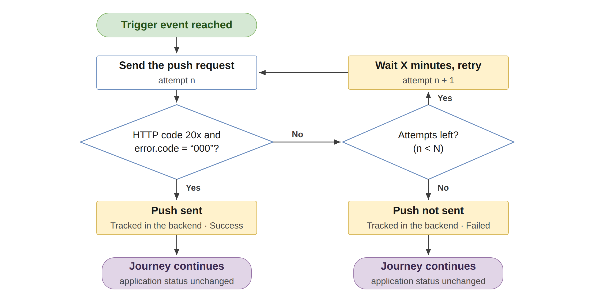
Figure 2 — Response handling and automatic retry (X and N configurable)

6. BUSINESS RULES
No. | Rule
BR1 | Push is additional; existing email and in-app notifications are unchanged.
BR2 | No personal data in the title or body: no name, Application ID, IBAN or amounts.
BR3 | OTP content (ET17, ET18, ET35, NT04, NT05) is never sent as push.
BR4 | Bank and internal-user templates are never sent as push.
BR5 | One notification per event: a push is sent once per Push ID per trigger occurrence per application, and every retry reuses the same requestId — a system retry, timeout or reprocessing never creates a duplicate.

7. IMPACT ANALYSIS
Area | Impact | Screen
Customer journey (Super App) | A device notification at eleven trigger events. A tap opens the Appro journey at the screen for that event; existing journey screens are reused as the destinations. | 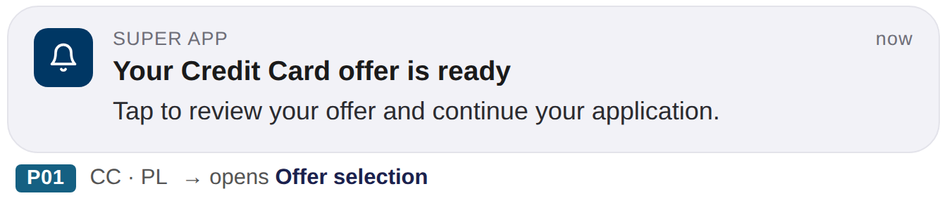
Middleware integration | New outbound call from the Appro platform to the Reem Bank middleware Push API, following the SMS and email integration pattern. Endpoint, credentials and channel id per environment: TBC by Avanza. | 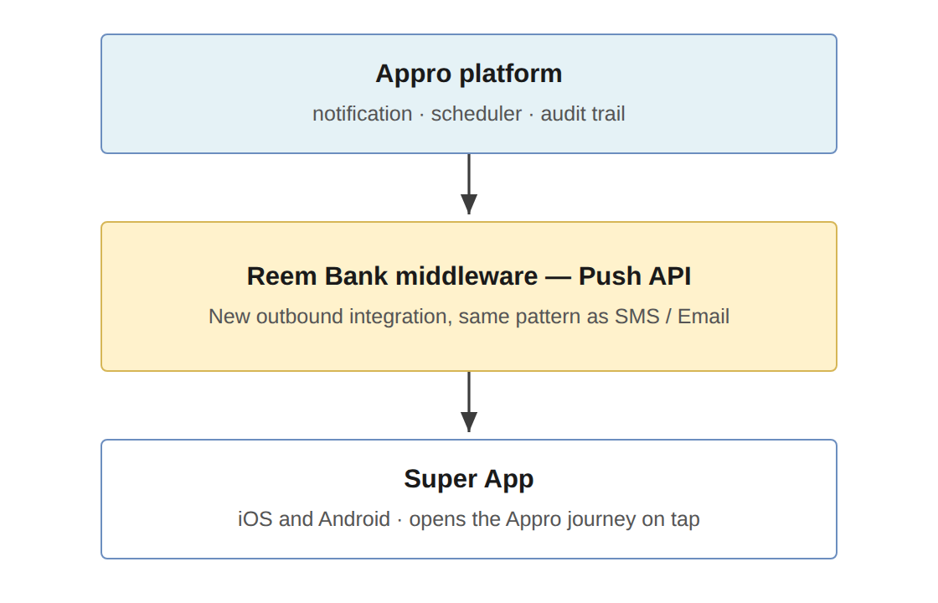
Communication Setup | No change. Existing email and in-app templates keep working as today and remain the trigger reference for each push. Push content is fixed per notification in this release and is not added to Communication Setup. | 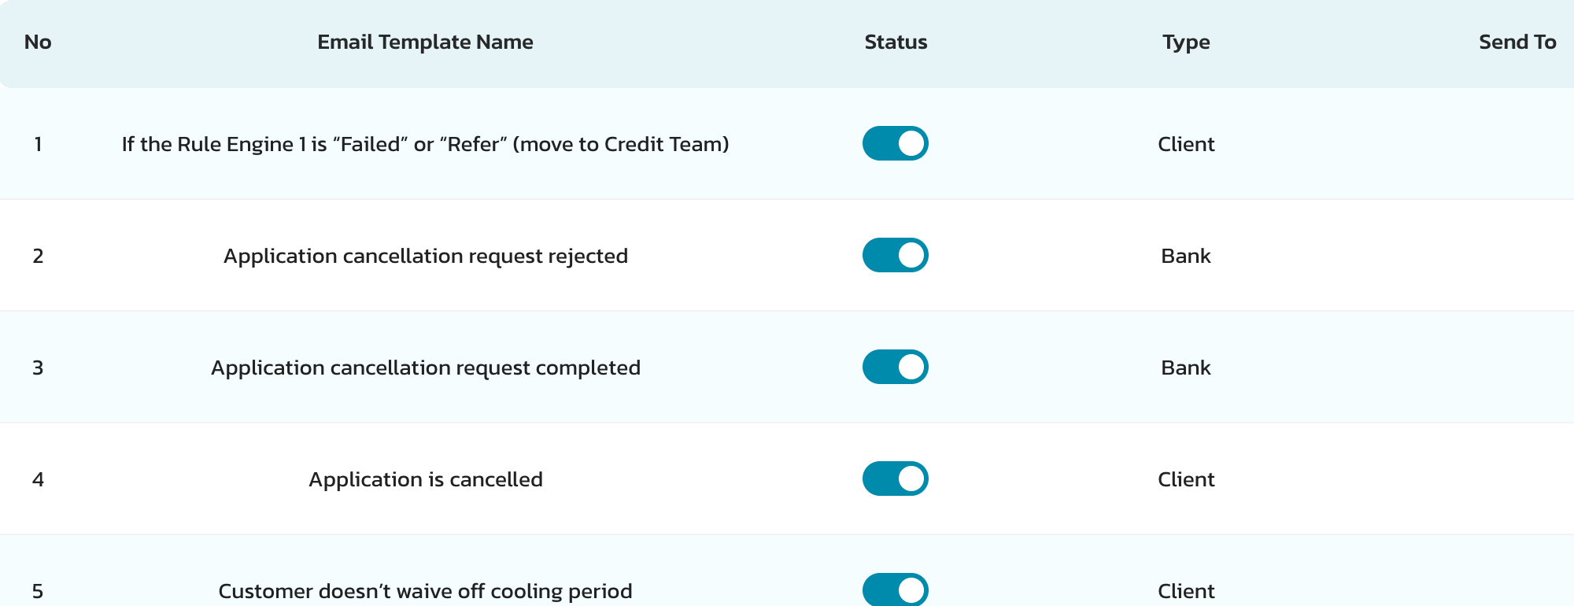
Audit trail | No change in this release. Push results are tracked in the backend only; Appro support provides the status of a push on request (section 5). A Super Portal view is a post-MVP enhancement (section 8). | No screen change
Application status | No change. A push — sent or not — never changes, blocks or delays the application. | 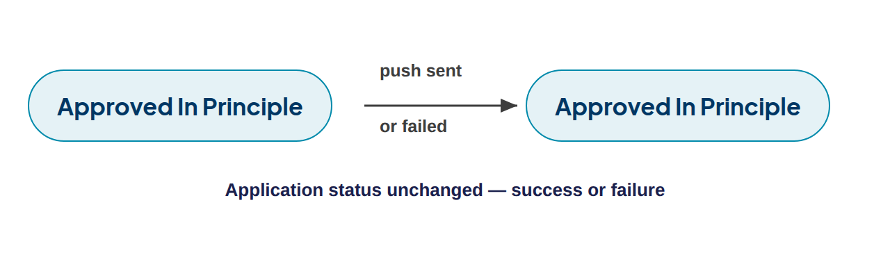
Reporting | The API delivery result is tracked. Customer actions on a notification (open, dismiss, ignore) are not tracked in this implementation scope | No screen change

8. FUTURE ENHANCEMENTS (POST-MVP)
The items below are agreed as enhancements after the MVP 1.1 sign-off, delivered by the dedicated development team based on launch feedback — not as change requests. The MVP design is scalable, so they are added on the same framework, without redesign.
- Business-managed configuration in Super Portal, wherever technically feasible without source-code modification: enable / disable per notification, English and Arabic content, reminder frequency and maximum count, validity period, priority, trigger and product mapping, and new Push IDs.
- Sending notifications from Super Portal.
- Push visibility in Super Portal: an audit-trail entry or a notification report with the sent / failed status per application.
- Configurable sending hours and customer local time.
- Additional products, journeys and notification types on the same framework.

APPENDIX 1: SAMPLE REQUEST/RESPONSE

Sample request
{
"requestId": "1234567891011121",
"timestamp": "2020-07-20T06:49:02.366Z",
"type": "APPRO_NOTIFICATION",
"action": {
"id": "P01",
"type": "APPRO_JOURNEY",
"value": "CASA"
},
"recipient": {
"mobilePhone": "971528045456 ",
"customerId": "104278",
"email": "abc@test.com"
},
"content": {
"title": "CASA Journey",
"body": "Please resume your CASA journey",
"message": "",
"language": "EN"
}
}

Sample response
{
"messageId": "0:1790341509514173%d5881a7ad5881a7a",
"error": {
"code": "000",
"message": "Processed Ok"
}
}

Product mapping
Product on the application | action.value
Credit Card | CREDIT_CARD
Personal Loan | PERSONAL_LOAN
CASA | CASA

